The Last Great Value Stock

A Shocking Announcement on May 12 Could Send One $2 Stock Rocketing Higher...

Yet Even if This Stock Traded for $50 Tomorrow... It Would STILL BE CHEAP!

BULL MARKET INTRO:

Right now... stocks are as expensive as they’ve ever been.

Barron’s has called them “ridiculously expensive.”

They say stocks are “literally more expensive than ever.”

The Buffett Indicator, too... named for famed investor Warren Buffett... says the stock market is currently trading at an all-time high...

It’s more expensive now than it was before the dot-com collapse or the financial crisis.

Stocks like Square are trading at more than 140 times earnings.

Tesla is trading at 330 times earnings.

And even Disney... a stable company long past its biggest growth... is trading at 140 times earnings.

It’s completely out of control.

The question many investors are wondering is pretty simple...

With stocks this expensive, what stock can I actually buy that still has a chance to go up?

ALT BEAR MARKET INTRO:

At their recent peak, stocks were as expensive as they’d ever been.

Barron’s called them “ridiculously expensive.”

They said stocks were “literally more expensive than ever.”

The Buffett Indicator, too... named for famed investor Warren Buffett... said the stock market was trading at an all-time high...

It was more expensive than before the dot-com collapse or the financial crisis.

Stocks like Square traded at more than 140 times earnings.

Tesla traded at 330 times earnings.

And even Disney... a stable company long past its biggest growth... traded at 140 times earnings.

It got completely out of control.

And now... many of those tech stocks that were rocketing to the moon are suddenly plummeting back to Earth!

The question many investors are wondering is pretty simple...

With overvalued stocks collapsing, what stock can I actually buy that still has a chance to go up?

[BOTH VERSIONS CUT IN FROM HERE]

Where are the BIG gains going to come from next?

Well, today I have an answer.

A $2 stock I’m calling The Last Great Value Stock.

First of all... this is not some no-name penny stock.

It’s a company you know and probably admire.

In fact, Fortune has called it one of the top 50 most admired companies in the world.

It is a business that operates across the globe in dozens of industries. It’s driving global innovation across more than 100 different countries.

It’s as recognizable as Disney or Tesla. And much more recognizable than Square.

Yet while those stocks have traded at hundreds of times earnings... this $2 stock trades for only four times earnings.

By that metric, Disney is literally 35 times more expensive than this stock. And Tesla is 84 times more expensive!

This $2 stock could trade at $50 tomorrow and STILL BE CHEAPER than Disney. And it could trade for more than $100 and still be cheaper than Tesla!

That, ladies and gentlemen, is an all-time buying opportunity.

But the question is...

Why?

Why is this one stock still cheap while so many others have soared to unreasonable heights?

There’s one simple reason.

And it has to do with this company’s business.

You probably know that some stocks were impacted more than others by the pandemic.

Companies like Tesla, Disney and Square were stocks that could succeed in the virtual world. So after the initial COVID-19 crash, they recovered extremely fast and launched to record highs.

Square went up more than 300% since the pandemic started... Disney more than doubled... and Tesla produced a whopping 1,500%!

But the $2 stock I’m talking about today operates mostly in the physical world.

Its business did not recover right away. And so it’s remained cheap... dirt cheap.

Until now.

You see... this $2 stock has finally experienced a sweeping reversal.

Income, including equity sales, swung from a $4.3 billion loss in 2020 back to a nearly $3.5 billion profit in 2021.

That’s actually a BIGGER profit than Square, Tesla or Disney.

And I think profit is about to go even higher.

Much higher, frankly.

City analysts estimate that “annual earnings will rocket more than 320% in 2022.”

It may end up being closer to 500%.

The fact is... with the global economy opening back up, business is booming again for this company.

And I mean really, really booming.

Right now, this company has a sales backlog of nearly $75 BILLION.

That’s more than five times the company’s current value.

And as this $75 billion backlog of sales starts to roll in... I believe this $2 stock is going to be the single greatest value play on the market.

The fact is... I would still be recommending it if it were $20 or even $50.

At $2... it might just be the single best value buy in the history of the markets.

That’s how strongly I feel about this.

And here’s the thing...

There is a major catalyst... an announcement coming on May 12... that I believe is going to make this one of the most sought-after stocks in the world.

So now is the chance...

Now is the opportunity to get in right as the recovery sends it soaring.

If you’re looking for a $2 stock with 10-bagger potential or better in the years ahead... this is it.

Trading Is How I LIVE!

But before I tell you more, let me introduce myself.

My name is Karim Rahemtulla.

Trading stocks is what I do.

After studying in England, Canada and the United States to get degrees in economics and foreign languages...

Followed by a master’s in finance...

I knew I wanted to dive right into the world of high-stakes stock trading.

In the 1980s, I went to Wall Street... where I became one of the youngest CFOs ever for a trading firm that cleared millions of dollars through Bear Stearns.

This was a pressure cooker environment.

And I was learning the trading skills of some of the best ever to do it.

The lessons were invaluable.

One of my initial breakthroughs was the realization that price is everything.

It’s not just about finding a great asset to trade...

You have to get in at the right price.

If you find the right stock at the right price... that’s where your big gains will come.

The second major lesson I learned is that the market is always changing.

If you aren’t adapting to the new reality, you will get left behind.

And these two lessons have served me very well.

As I began learning how to trade, not only did I ascend in my professional career...

But my personal trading success went through the roof as well.

During the early ‘90s, I was able to build a multimillion-dollar portfolio by the time I was just 34 years old.

I even used my skills to help my ex-wife make more than $1 million. (And I didn’t even charge her commission!)

Once I realized trading could provide me with everything I needed in life, I retired from Wall Street.

Today, I live off of my daily trading.

I make money on my own terms. And don’t answer to anyone.

I trade at home so I’m able to spend time with my wife and newborn.

I live off of a beautiful little main street in a small Florida town on a chain of lakes.

It’s the type of place where you walk down the street... stopping and chatting with friends and neighbors.

I’ll admit it... I love my life.

I couldn’t have asked for anything better.

Which is why... along the way... I decided to start helping regular people learn the same trading techniques I use. My goal was to help them establish the same type of financial freedom I enjoy.

I co-founded the publication Wall Street Daily, which became a viral sensation.

And most recently, I co-founded another new venture, Monument Traders Alliance... which is laser-focused on giving regular people the tools to dominate the markets.

How well have we done?

Since inception in 2019, I’ve personally recommended 204 trades through our live trading research platform... 181 of which turned into winners.

That’s a win rate of 88.7%.

Or nearly 9 out of 10.

And on the average trade, which lasts about 50 days, I’ve beaten the market on a relative basis by 4-to-1.

Okay, so that’s my story.

I’m sharing it with you because I understand if you are skeptical.

I know you’re hearing from me on the internet... probably still wondering who the heck I am.

Well, I urge you to Google “Monument Traders Alliance,” and you’ll see our many great reviews.

Take the story of Mike L., who subscribes to our top trading research service, The War Room.

“Here is my take on this platform,” he says. “The community has grown to have some exceptional contributors with one thing in mind, making money on good trades. I started with $1,000 in April of 2020. That $1,000 is now $48,600.”

He wrote that in December 2021.

So he 48X’ed his money in a little over a year and a half.

That’s the type of story I want to help people live out.

And I do that by helping them understand the most important elements of stock trading...

That is... how to buy a great company at a great price.

And that’s exactly what I have for you with the $2 stock I’m telling you about today.

It’s Nearly Impossible to Find Great Stocks at Cheap Prices Right Now

Listen, if you’re like most people, you’re probably wondering what’s going to happen in the markets next.

The tech stocks that dominated the pandemic have reached a peak.

They simply are too expensive to continue rising.

And now we are seeing major pullbacks.

Those same stocks that rose 100%... 500%... even 1,000%...

They are now dropping by 20%... 30%... 50% or more.

Look at Zoom. It was up more than 700% during the first 10 months of 2020.

Since then, it’s lost more than 70% of its value.

If you’re smart, you’re probably thinking... okay, the party is over for those stocks.

What are the next stocks to soar?

Well, there is an answer.

You see, we are experiencing a new fundamental shift in the global economy right now.

I call these shifts “inflection points.”

They are moments where money flows out of one sector and into another.

And inflection points in the market are generally the single best times to make money.

At the Beginning of the Pandemic, Money Flowed Into Virtual Economy Stocks

For instance, back in 2020, when the pandemic began, we hit an inflection point.

Suddenly, the physical economy gave way to the virtual economy.

And all the money started flowing into virtual stocks.

The big winners were work-from-home stocks like Zoom and Slack... work-out-at-home stocks like Peloton... home entertainment stocks like Disney and Netflix... medical stocks like Moderna... and home delivery stocks like Amazon.

All these pandemic stocks went through the roof.

So if you saw this inflection point, you could have made BIG, BIG money.

And that’s what we did.

We saw big success trading stocks like Clorox... Teladoc Health... Slack... Disney... and others.

On some of these trades, we saw single-day increases of 10%... 20%... even 98% on the Teladoc recommendation.

That’s how fast some of the gains were coming in at the time.

It shows the power of finding an inflection point and taking advantage.

But now something is changing once again.

We’ve hit a new inflection point.

And you need to be aware of it right away... or you might miss out on the next big profit opportunities.

In short, money is flowing out of those virtual-based pandemic stocks... and back into the stocks that operate in the physical world.

Now... Money Is Flowing Back Into Stocks That Drive the Physical Economy

Energy stocks are a good example.

As the economy comes back online... people are driving more. Airlines are scheduling more flights. The economy is ramping up in terms of shipping, manufacturing and transportation.

As a result, energy stocks have been some of the best performers.

Like Juhl Energy, which has rocketed upward by 6,501% in just a year’s time.

Or Stratos, the #1 energy stock last year. It was up a mind-blowing 11,923% over the same period!

$1,000 in those two stocks would be worth more than $185,000 in just a year’s time.

That’s how powerful it can be to identify these big inflection points when the money shifts.

And there is one key to finding the best stocks.

The Key to Identifying Which Stocks Will Rise Next

What you want to look for are companies that complete what I call a “reversal.”

This is a moment when the company swings back from a loss to a profit in a very short period of time.

When you find those situations, you can make boatloads of money.

Nintendo is a good example of this.

Through the first three quarters of 2014... the company lost about $750 million.

The stock had collapsed in recent years from almost $80 to just $13.

But in December 2014, something happened.

A reversal.

Nintendo swung from that $750 million loss back to a profit of more than $1 billion over the next three quarters.

And the stock started blasting higher as a result.

It went from $13 all the way back up to $80 at its peak.

So if you had timed it perfectly and bought the stock at $13 when the loss flipped to a profit... you could have locked in 515% over the next six years.

That’s how big the reward can be if you buy a stock right as it swings back from a loss to a profit.

And that’s happening now with the $2 stock I’m telling you about.

Income, including equity sales, just swung from a $4.3 billion loss back to a $3.5 billion profit.

Now it’s expected by City analysts to see earnings jump another 320% in 2022.

And with a backlog of $75 billion in sales coming in... the profit opportunity here is enormous.

This is setting up an epic opportunity for you to get in on a $2 stock before a very big move.

I think this company has a real chance to go to $50 in the years ahead... a 25X increase on its current value.

That would turn every $1,000 into $25,000... and every $10,000 into $250,000.

Like I said, big money is on the line here.

But here’s the thing...

The company also trades in an unusual way.

You won’t find it on the Nasdaq or New York Stock Exchange. (And it’s not a penny stock on the pink sheets, either.)

Rather, it trades on a special exchange you might not be familiar with.

I’ll explain how I can help you get in on it in a moment.

But first, let me show you why I believe this $2 stock is the single greatest value play you could buy right now.

Income Just Swung Dramatically... Here’s Why

I’ll start with the big question.

What exactly does this company do?

And why have they gone from a loss to a profit so quickly?

It’s a unique situation.

Let me explain.

In short, this company is an engineering powerhouse.

They build, supply and service world-class engines and power systems that make our entire global economy go.

- The company is working on a nearly $5 billion-per-year project to build nuclear reactors for the United Kingdom.
- They make jet engines for the Airbus A330, 340, 350 and 380... plus the Boeing 777 and 787 Dreamliner.
- They have a $2.6 billion deal to supply 650 F130 jet engines to the United States Air Force.
- The company has built a new microgrid battery container that produces 14X more energy than a Tesla Model X.
- They built a new engine for ships that uses methanol, which is both safer and easier to store than traditional fuels.
- They build massive, 2,000-horsepower super-engines for leisure fishing boats and luxury yachts.
- They’re building these amazing, hyper-quiet trains that reduce noise by 75%... while using up to 30% less fuel!
- They supply propulsion systems for Svitzer tugboats in Brazil.
- The company even recently released the world’s fastest all-electric plane.
- And they are working on giant electric passenger drones that may replace helicopters. These things can go 200 mph and are set to be released in 2024.

It’s truly stunning what this company is doing.

But I haven’t even scratched the surface yet!

What’s really exciting about this company is that while they are bringing in billions through their engineering and manufacturing businesses...

They also are developing futuristic technologies that give them massive growth potential.

The company is a leader in new machine learning and artificial intelligence technologies that make the entire global economy run more efficiently.

This company is like Tesla on steroids!

And they’ve even used their new technologies to create a Netflix-like subscription model that will bring in recurring revenue month after month.

As you’ll see in the next few minutes, we are looking at billions in profit coming in.

But first, let’s step back for a moment.

I just shared a few of the highlights of the many things this company does.

You can see why they are bringing billions of dollars in the door.

But I want to return to price for a second.

Remember, when you buy is just about as important as anything else in the investment world.

And so I want to talk about what happened to this company.

Why Now Is the PERFECT Time to Buy This Company

You can see that they are running dozens of major projects all over the world. And everything they do drives the economy forward.

The company is literally the engine that runs the economy.

So when the pandemic hit and the economy stopped moving, the company was badly impacted.

They took a huge $4.3 billion loss in 2020.

It hurt.

And just like Nintendo when it saw losses, this stock dropped to a super-cheap price.

But now, as I mentioned before, that has all changed.

The company is now extremely profitable once again.

Sales are soaring.

And billions of dollars in new sales are coming in.

This is the PERFECT time to buy the stock.

Buying right as things turn around means you get in at an ultra-cheap price with the most upside possible.

I believe that’s where we are right now!

At this moment, this $2 stock truly is the single best value investment I’ve ever seen in the markets.

I want to show you all the ways they will bring in billions of dollars in the months ahead.

Let’s go through each one at a time so you can see just how big this opportunity is.

This Company Is Dominating the Airline Industry

As I mentioned before, the company is an engineering powerhouse when it comes to jet engines.

The company built the largest and smartest indoor testing facility on the face of the Earth.

The towering facility is bigger than a football field.

And that allows the company to streamline their engines to become the most effective in the world.

In fact, the company produces “the most efficient aero engine in service in the world today.”

And the customers are lining up.

I mentioned before that the company supplies engines for the Airbus A330, 340, 350 and 380... as well as the Boeing 777 and 787 Dreamliner.

They provide the engines for 60% of A330s worldwide.

The company provides engines to Singapore Airlines... the Italian airline Italia Trasporto Aereo... the South African airline Airlink’s fleet of ERJ135 aircraft... and Silk Way West Airlines...

The company also supplies jet engines to defense departments.

I mentioned the $2.6 billion deal for 650 F130s for the U.S. Air Force.

They also provide 1,200 engines for 500 aircraft operated by defense departments in the U.K., Germany, Spain, Italy and Austria.

And finally, this company absolutely DOMINATES the private jet market.

The company provides engines for 3,600 business jets... including 700 engines for the latest Gulfstream G800.

They are the #1 engine supplier in the private business jet market.

They even have an engine used to fly jets at 51,000 feet at a speed of Mach 0.925... above commercial air traffic.

Here’s what I’m telling you, folks...

This company is absolutely dominating its market.

They are bringing in billions from all these partnerships.

But they’ve also done something totally unique in their industry.

They’ve found a way to turn the business into a Netflix model... where more and more recurring revenue comes in every month.

Let me share how.

They’ve Turned the Airline Industry Into a Netflix Model

Most engine manufacturers, like, say, Lockheed Martin, operated a static business model in the past.

They built engines and sold them for a price, and that was that.

This company changed that.

Here’s how...

You probably know that operating and maintaining aircraft engines is one of the most meticulous jobs on the planet.

An engine failing is a catastrophic problem.

And airlines want to avoid any crashes at all costs.

So here’s how things used to work.

An airline would buy the engines. And then they would hire and pay their own maintenance crews to maintain them day after day.

The company I’m telling you about today sought to change all that.

What they realized was... if they were to service the engines in addition to manufacturing them, it could end up becoming a huge profit center.

Like a service department at a car dealer.

The money would just keep coming in.

So they worked with Microsoft to create a new product that would allow them to use machine learning and artificial intelligence to perfect maintenance and engine efficiency.

Stick with me for a minute as I walk through this, because while it’s a little technical, the end result is going to be billions of extra dollars for our company.

By using this new technology, the company has turned aircraft maintenance into a subscription service that pays monthly revenue.

And they now collect tons and tons of fees all along the way.

The airlines are happy to do this because now they don’t have to hire and maintain crews to keep their engines running smoothly.

But beyond that, the maintenance and service our company provides actually improve the performance of the aircraft.

The new product this company created actually extended the life of an airline engine by 25%.

It makes the engines more fuel-efficient... which saves airlines millions.

And it allows them to keep aircraft in service for longer.

The $2 stock I’m telling you about charges an hourly fee for this service on their engines... creating a Netflix-like recurring revenue stream.

The Royal Aeronautical Society called it an “aftermarket revolution” that created a “radical change” within the industry.

And it has gone gangbusters for the company.

Think about all the different contracts I shared with you... thousands and thousands of commercial aircraft, fighter jets, cargo planes and private business jets.

In the past, the company would have sold engines to these groups, and that would have been the end of it.

Instead, this company now gets paid per hour of flying time for each engine they maintain.

I had to do some digging to get this number, but based on an internal document I obtained...

It looks like they get around $250 per hour per engine. Maybe more.

And this has the potential to land them an obscene amount of revenue.

The company has more than 16,000 defense engines and 13,000 commercial engines in operation around the world.

The same document estimates a single engine gets 4,000 hours of flying time in a year.

But let’s be conservative.

Not every engine is signed up for the recurring revenue program. And not every engine will fly 4,000 hours.

But even if these jets were to fly half of that... just 2,000 hours each... you’re looking at 58 million hours of flying time.

And at $250 per hour, that’s $14.5 BILLION in recurring revenue!

To put that into perspective, that’s more revenue than the entire company is currently worth!

It’s a massive amount of revenue coming in that would have been ZERO before this innovation.

And here’s why I believe the year ahead will be a blockbuster for this company.

Air Traffic Is Exploding Higher!

Take a look at this chart.

It shows global air traffic passenger demand.

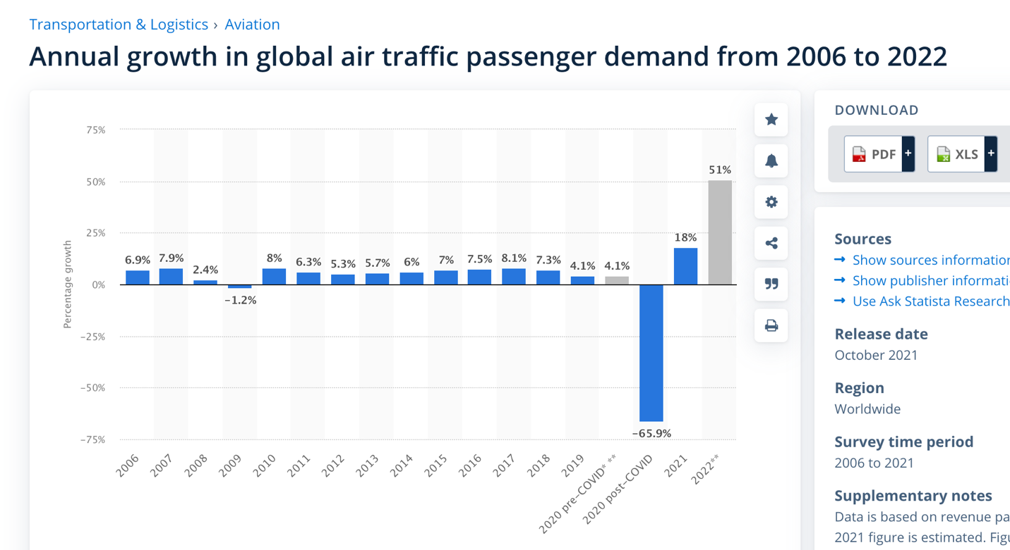

You can see that in 2020, air traffic dropped a stunning 65.9%.

That’s one reason this company had a big loss in 2020.

But if you’ve been to an airport lately, you know that the complete opposite is true now.

Airports are absolutely jammed with passengers. The skies are filled with planes once again.

And as you can see, air traffic is expected to be up 51% when 2022 is all said and done.

That’s one of the reasons this $2 stock could suddenly be so profitable again.

As air traffic comes back online, they are raking in billions of dollars.

And analysts say we could see 320% further growth in the coming year.

Which makes sense.

51% more air traffic means a whole lot more flight hours.

And every flight hour means more cash in this company’s coffers.

That alone would make it a fabulous buy at $2.

But wait, it gets better.

Not only is this company an incredible buy based on its existing airline business...

But it also is coming out with revolutionary technology that will make it the type of stock that could become a Tesla of the future.

Its Brand-New Nuclear Technology Is Set to Revolutionize the Power Industry

Few people realize this nowadays, but the cleanest, most efficient power generation doesn’t come from wind or solar.

It comes from nuclear.

The problem is... people don’t want giant nuclear power plants in their backyards.

Enter our company’s brand-new technology... the mini-nuclear power plant.

They’re one-tenth the size of a traditional reactor.

But they can power 1 million homes.

These things are safe and efficient... and because they are so much smaller, they cost less than traditional plants.

It may be that these mini-nuclear power plants become the most dominant form of power generation on the Earth.

The company has signed a deal with the United Kingdom through 2050.

They are set to build these mini-nuclear power plants all over England.

They’re expected to generate around $5 billion per year and create 40,000 jobs.

But what happens in the future if the United States makes a deal... and Germany... and France... and Japan... and Australia?

We are looking at a potential yearly revenue stream of 25... perhaps $50 billion in the future.

That’s more than what the entire company is worth today!

I believe that between their nuclear business and airline engines, this company could go to $50.

But again, there is so much more they are doing.

They Built the World’s Fastest Electric Plane

For example, the company recently made aviation history.

They built a new, all-electric plane that “smashed the electric-flight speed record.”

This is part of a concerted plan to develop key, new flight technologies.

No doubt you’re aware of the EV revolution Tesla is spearheading.

It’s one of the reasons Tesla’s stock has roared higher to more than $1,000.

Well, this company has created the EVTOL, which stands for the Electric Vertical Take-Off and Landing aircraft.

In short, this is a giant passenger drone that can fly people around cities like a helicopter.

These drones can travel at 200 mph.

They are set to be certified in 2024.

And they could replace helicopters all over the world.

Airbus estimates that this could be a $70 BILLION business!

I’ve compared the company to Tesla a few times. But this part of their business is more like SpaceX.

And in case you were unaware, SpaceX investors have seen their shares increase 100-fold since 2010.

$15,000 has turned into $1.5 million.

This company has the revenue streams to deliver on that kind of potential.

Whether it’s their recurring revenue on their jet engines... their new mini-nuclear reactors... electric planes and EVTOLs...

Or some of their other projects I haven’t gone into detail on...

Like their hyper-quiet trains that reduce noise by 70% and are 30% more efficient.

Or their battery containers that produce 14X more power than a Tesla Model X.

Bottom line, the future couldn’t look better for this company.

Income over the last 12 months has already swung to $3.5 billion... bigger even than Disney, Square or Tesla.

The company is expected to see earnings rise 320% in the year ahead.

And the projects they have underway are set to push profits even further.

So what do I believe the profit potential is here?

So What Kind of Profit Potential Are We Looking at Here?

Well, I mentioned before that this stock could trade at $50 and still be cheaper than Disney. And it could trade at $100 and still be cheaper than Tesla.

I’m predicting it will be at least a 10-bagger in the years ahead.

It has that kind of potential.

And I believe $50 is a realistic possibility on the table.

I’ve seen situations play out exactly like this before.

Weight Watchers is a great example.

At the end of 2015 going into 2016, it wasn’t doing well.

The company lost $22 million over two quarters.

And the stock went from $80 to around $10.

But then profit flipped... fast... creating a unique buying opportunity.

It jumped up to a $30 million profit the next quarter. And $35 million the quarter after that.

And that reversal kicked off a huge run for the stock.

Over the next two years, it rocketed back upward from $10 to $100!

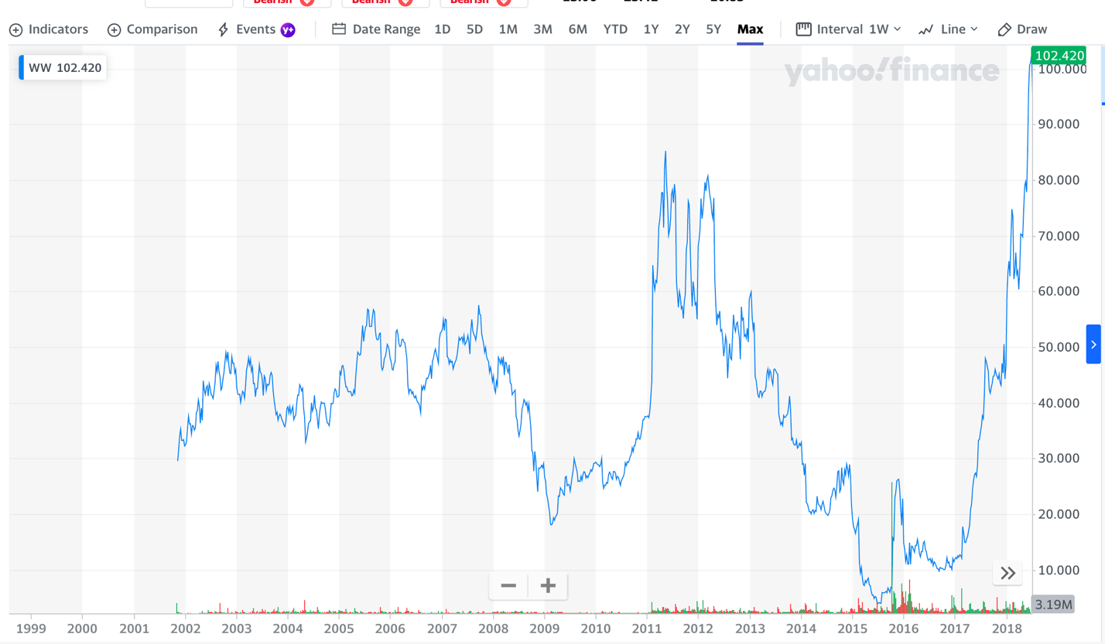

Avis is another top example.

In 2020, they lost $684 million due to the lack of travel destroying the car rental business.

But in 2021, they reversed that completely and made $813 million!

The stock went from $37 to start 2021 to a peak of more than $300 by November.

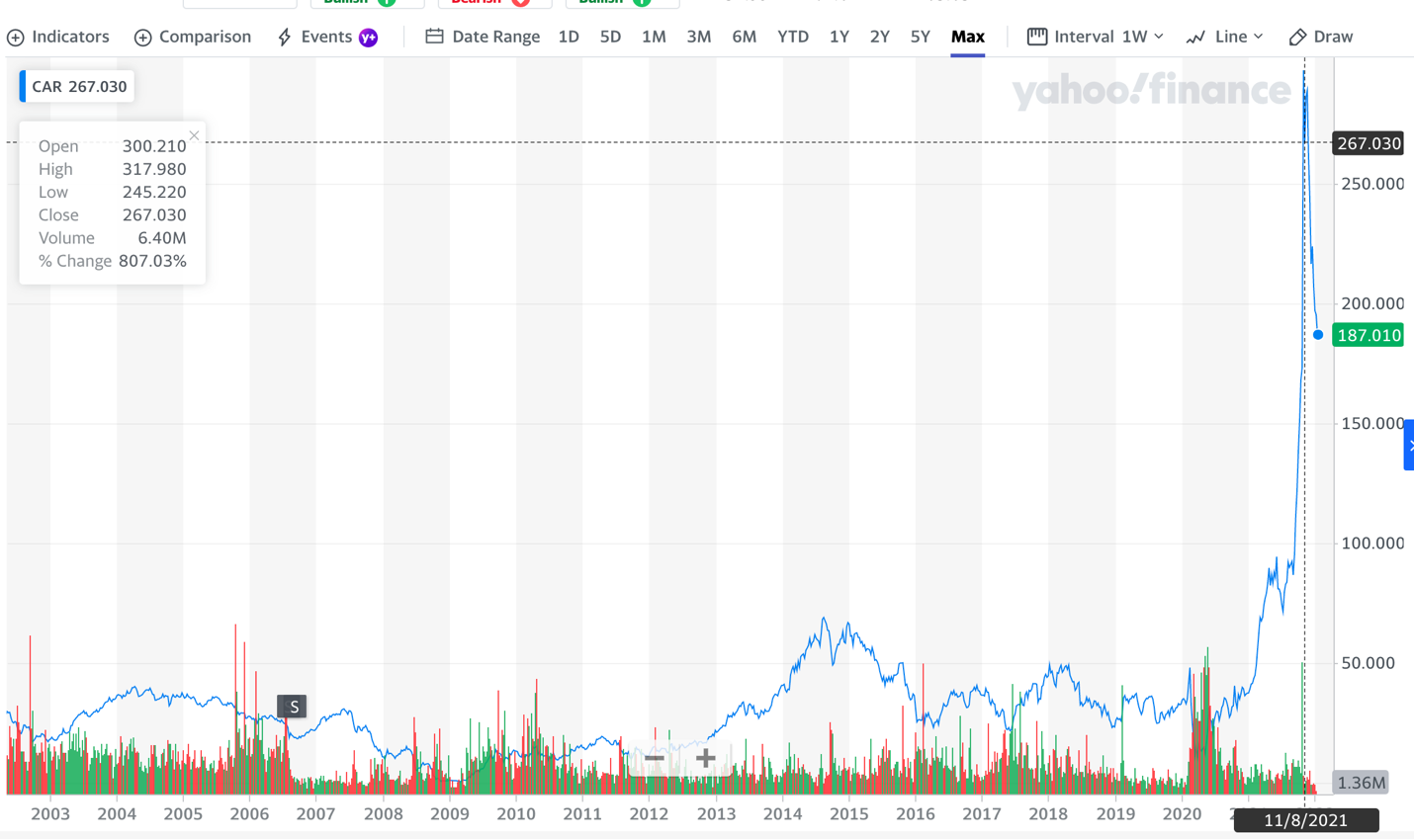

That’s the kind of profit potential we’re looking at here.

Now, is it certain that our stock will follow these best-case examples exactly?

No...

We could see something like a new pandemic that shuts things down again.

There’s always the risk of black swan events, and nothing in investing is ever guaranteed, so we never recommend you bet more than you can afford to lose.

But at $2 now, this stock couldn’t be much cheaper.

It trades at only four times earnings as is.

That’s the beauty of investing in a great value stock.

When a stock isn’t overvalued, there is much less downside.

That’s why now is the time to make a small investment in The Last Great Value Stock.

At $2, it is as big a no-brainer as I’ve ever seen in the investment world.

And I think it’s going to move up from $2 very fast.

The BIG Announcement: Why You Need the Details Before May 12

The company has a big announcement coming up... one that I believe is going to send the stock soaring dramatically.

It’s the company’s Annual General Meeting on May 12.

On that day, I’m predicting that everything I’ve talked about will result in the company smashing earnings expectations.

And when that happens, we could see a big, big move in the stock.

A giant earnings surprise can really move a stock.

Look at Puxin Limited, another cheap stock that got a massive jolt when they crushed earnings to end 2021.

At one point, the stock was up 112% on the day earnings were released!

This is why I’m telling all my followers that they need to move ASAP on this $2 stock.

But here’s the only problem...

Most investors are going to miss this opportunity.

Most Investors DON’T Know How to Buy This Company!

While this company is one of the 50 most admired in the world, the company does not trade on the usual stock exchanges like the Nasdaq or the NYSE.

Rather, it trades on a special exchange that most regular investors might not know how to access.

Only real trading pros know how to get in on this company. And that gives people like me (and my followers) a real advantage.

I’m showing them how to profit from this situation now... before the mainstream media picks up on it.

Get in now... and you have the chance to be part of that ride.

Wait and see what happens after earnings... and you may end up paying a much higher price for the stock.

That’s why I want to rush you a special report I just put together called “The Last Great Value Stock.”
Inside this report, I’ll give you all the details on the $2 stock I predict is set to dominate the year ahead in the stock market, including its name and ticker symbol.
I’ll explain the special way to buy it with easy-to-follow instructions. (Don’t worry – you can do this in a regular brokerage account.)
And I’ll break down all the revenue streams that will drive the stock higher in the months ahead.
I want to send you this report 100% free.
But that’s not all.
I’m also going to teach you some of the “secrets of the pros” that Wall Street doesn’t want you figuring out.
Bonus #1: I’ll Show You the Power of the Win-Both-Ways Trade
For example, there’s a type of trade called a Win-Both-Ways Trade that, once you understand it, might be the only type of trade you want to make going forward.
In short... with this trade...
If the stock goes up... you win.
And if the stock goes down... you ALSO win!
It just has to move!
Sounds crazy, right?
But it’s true.
For example, in our VIP research service, we completed a Win-Both-Ways Trade on Slack Technologies in June 2020, just before Slack was set to make an earnings announcement.
Now, for most traders, earnings are tough.
You’re guessing which way it will turn out. And if you guess wrong, you could get burned.
But with this special options trade, it can make you money either way.
In the case of Slack, earnings were a disaster.
Regular shareholders lost 17% the moment earnings came out.
But our Win-Both-Ways Trade?
Our member Grant V. said he made a “net 130% in three minutes!”
And newbie Steve C. said, “$1,200 profit (31% gain in one day) on my second day of trading.”
The opposite happened when we did a Win-Both-Ways Trade on Kellogg.
With that one, Kellogg got good news.
Shares rocketed upward 10% by noon.
But our Win-Both-Ways Trade?
It was up 133% in a single day!
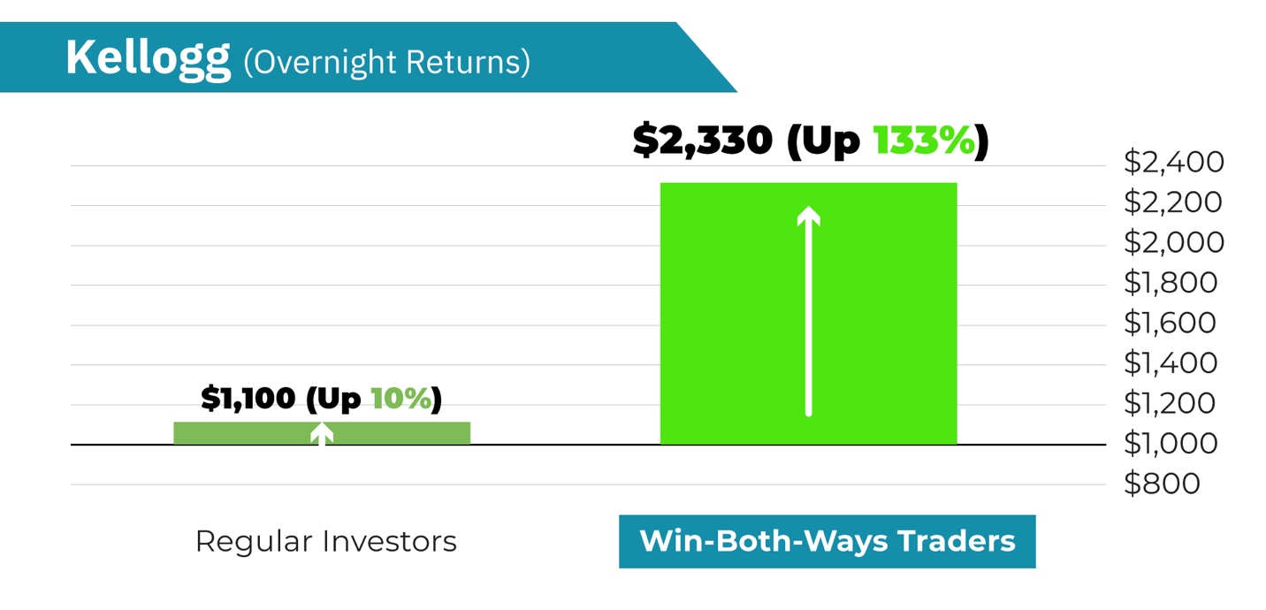
This is the beauty of this trade.
If shares collapse like with Slack, you can make money.
If shares shoot up like with Kellogg, you can make money.
That’s why I put all the details inside another special report that I’d like to send you right now.
It’s called How to Execute the Win-Both-Ways Trade.
It will explain exactly how I execute these types of trades so you can do it too.
It’s yours for free today, along with our new report on The Last Great Value Stock.

All I ask in return is that you try out my research service called Trade of the Day Plus... at no risk to you.
Trade of the Day Plus: The Simplest Way to Get My Best Trade Recommendations

I’ve been doing this both personally and professionally for 40 years.
And I’m as confident as ever in the picks I put out.
Remember, since I co-founded Monument Traders Alliance in 2019... in our VIP trading research service, I’ve made 204 recommendations.
181 turned into winners, for an 88.7% win rate.
And my average trade has produced 4X the gains of the market.
That means that for every $1 the market produces... my picks hand out $4.
That doesn’t happen by accident.
It’s the culmination of years of trading... learning from my mistakes... and studying other great traders.
I can see what’s happening on Wall Street much faster than your average investor.
And what I’ve become best at... is targeting short-term gains in just a few weeks or sometimes days.
For example, in January 2021, I saw that Ford was set to have a big year.
I recommended a number of different Ford trades throughout the year that all made money.
CHART
All told, Ford went on to become the #1 car stock of the year, beating out Tesla.

And one of our members, Michael K., said that over the whole year, he captured a total gain of 123%.

In April 2021, I saw that because of heavy inflation... gold and energy stocks were making a big move.
So I made a short-term recommendation in our live trading research platform, The War Room.
I recommended an options play on VanEck Gold Miners in April.
And by November, it was up 114%.
CHART
In 2019, I saw a group of insiders loading up on shares of General Electric.
The play I told our subscribers to enter ended up rising 123% in just 14 days!
CHART

This is the thing...
You can make substantial gains in the market, and it doesn’t have to take years either.
123% would take you as long as a decade in a mutual fund.
To do it in 14 days is game-changing.
And I have some very good news for you.
Until recently, the only way to get access to trades like this was my high-end service, The War Room.
This is where we actively show people trades on a daily basis.
It’s very expensive... at $4,997 retail.
Which is why I decided to launch Trade of the Day Plus.
It’s a far more inexpensive service that gives you access to one of my best trades every week.
With Trade of the Day Plus, I’ll do two things.
First, I’ll send you Trade of the Day emails every day, breaking down what we’re watching in the markets.
Second, I’ll take the same pro strategies I use in The War Room and send you one of my very best trades once per week.
One trade per week is simple and easy to follow.
It’s a great way to get started, learn the strategies and get some great trades along the way.

Look...

I’ve learned that the market changes dramatically every week.
Every morning, as the markets open... I’m tracking where the big money is going that day.
I look for the opportunities regular investors don’t see.
And then I show my readers how to take advantage and potentially profit.
Listen... if you wait for the mainstream media to tell you where to invest, you might as well just turn your bank account over to Wall Street.
The media loves to tell you about stocks that already went up.
So you end up buying at the tail end, just before the stock goes back down.
What you want to do is, like with the $2 stock I’m telling you about today, get in when the pros are moving in... before the public has any idea what’s happening.
That’s where I can help.
With Trade of the Day Plus, I find those ultra-cheap stocks I think are most likely to go on a big move.
And I send you my favorite trade recommendation once every week.
And as you’ll see shortly, Trade of the Day Plus doesn’t cost anywhere near what The War Room does.
It’s a fraction of the price.
And I’m doing this because I don’t want to keep regular folks out. I want to give you the chance to see what great trading can do for you.

And speaking of great trades, I have another special bonus for you.
Bonus #2: “My Favorite Small Cap Play for 2022”
We just finished a special report on our favorite small cap for the year ahead.
It’s a small cap based in an industry that’s been increasing at a compound annual growth rate of more than 50% for the past several years.
And this company is raking in cash as a result.
In the latest earnings release, product sales were up a stunning 766% over the prior year.
They also set a new record for revenue, with an increase of 607%.
These are MASSIVE growth figures.
Even at its top growth years, Netflix never saw revenue increase more than 100% in a single year.
And it was the best-performing stock of the last decade, up more than 4,000%!
This company is growing more than 6X faster than Netflix.
I’ll tell you all about it inside a new special report called “My Favorite Small Cap Play for 2022.”

I want to make sure you have everything you need to succeed.
So when you sign up for Trade of the Day Plus, I’ll immediately send you all the special reports I’ve mentioned so far, completely free.
And it gets better.
To make this as easy as possible for you, I’ll also give you an entire year to review everything risk-free.
That means that if anything doesn’t live up to the billing... you’re welcome to a prompt refund.
And this applies for the next 365 days.
Plus, even if you do cancel, I’ll still let you keep every report at no charge whatsoever.
That’s how confident I am in the work I do... and the success I’ve had teaching people.
I’m willing to put every bit of the risk on my shoulders.
If I don’t deliver, you get every penny back.
I think you’ll agree that’s more than fair.
Forget What I’m Telling You... Listen to What People Like You Have Said After Following My Recommendations
However, it’s not all about what’s fair.
Life isn’t “fair.”
Life is about results.
And so that’s what I want you to judge me on... results.
That’s how my current subscribers grade my performance. Just check out some of our top success stories!
Like Eric O. He wrote to tell us:
“Thanks for great recommendations through the Trade of the Day Plus newsletter. I am currently up 23% [in two months] in Ford Motor Company and made a solid profit today in Rocket Companies as of your recommendation. The stock is currently up 60% and I am up 45% at this time [in one month]. An easy $4k profit today.”

Or Pamela S., who bought our Rocket Companies recommendation back in February 2021.

Pamela was even late to sell, but according to her, she still “cleared a 60% profit” a month later.

Our Hertz trade in September was another one.

Daniel T. reported being up 67% in one month.

John R. landed a 52% win.

And Erik K. bought it... told us he was busy and rarely checked it... and then opened his account to see 79.5% in two months!

Those are the types of results we’re aiming for with Trade of the Day Plus.

Seeing people succeed and understand how life-changing it is to be a successful trader is all the reward I need.

Like with Jasper Therapeutics in October.

We recommended it on October 7, and by October 13, we closed out a partial top gain of 100%.

Peter H. said, “Watched your video over the weekend, bought it yesterday at $8.14. And it's OMG today.”

OMG is right.

That’s what a win like that in less than a week will do for you.

My readers say all these things because they love the new control they have.
Once you understand that the stock market can be a source of income to help provide what you need... honestly, it changes the way you view the world.
It’s like being a hunter in the 19th century, going out into the wild and bagging an elk.
Nothing matches the pride and satisfaction of going out and providing for yourself as an individual.
That’s what I want to show you.
So how can you get started?
I’ve Authorized the Best “No Excuses” Deal Imaginable
Well, I’m happy to say that a subscription to Trade of the Day Plus is not as expensive as our live trading research product, The War Room.
Instead, a one-year subscription to Trade of the Day Plus costs just $249.
It’s a great product for people who like the simplicity of receiving just one trade per week... and for those who want to learn the secrets of the best traders in the world.
But here’s the thing...
My goal is to help all of you who are watching get to that point where trading can be a regular source of profits.
And I see the $2 stock I’ve talked about today as the single most important move on that journey.
The company just swung from a loss to a big profit, marking the perfect time to buy in.
It has a $75 billion backlog of sales set to come through the door.
It sells at a fraction of the cost of some of the most expensive stocks on the market.
The Last Great Value Stock is the single best company you could bet on for the future.
And I DO NOT want you to miss it.
So I’m going to do something special today.
I don’t want price to be the thing that keeps you from benefiting from this play.
With the big upcoming announcement that could drive shares upward to $20... $50... even $100... time is very important here.
Wait a week, and this thing could be up to $5 already.
So now is the time.
That’s why I’m going to make this a drop-dead, no-brainer, can’t-miss situation.
I’m going to give you the single best deal we ever offer.
It’s so good... I’m almost regretting agreeing to it.
But before I share it with you... there’s one more thing.
Bonus #3: The “IPO Buying Guide 2022”
2021 was a record year for IPOs.
980 businesses went public... more than double the number from 2020.
And some of the returns have been staggering.
Zim, for example, IPO’d in January. And was up 381% by year’s end.
That’s how powerful a strong IPO can be.
Which is why we put together the “IPO Buying Guide 2022” for new Trade of the Day Plus subscribers.
It will detail each of our favorite new or recent IPO opportunities this year.
And yes, it’s FREE along with everything else.
Now, as I said, the normal price is $249 for Trade of the Day Plus.
But today you’ll get a HUGE discount of $200 off.
Your price:
Just $49.
That’s a full year... for less than $5 per month.
It’s $0.13 per day, people.
Now you can see why I’m questioning whether we are charging enough!
But as I said, this is important to me.
This Last Great Value Stock is one of the only truly great buys left on the market.
It’s $2.
Yet it has the type of upside potential of the very best tech stocks... many of which trade for well over $100.
And the thing is... you don’t even have to just trust me on this.
You can sign up right now, get the report, and then decide whether I’m the real deal or not later.
You will have 365 days to try everything – at zero risk.
And if it turns out my type of trade strategy doesn’t work for you, no hard feelings.
You can have a full refund.
I think you’d be crazy to do that with the track record I’ve proven to deliver.
But that’s exactly why I’m doing it.
I’m that confident you will see this is the best product ever offered for that price.
Plus, we’ll let you keep everything you received as a subscriber – at no charge – even if you do decide to quit.
Does it get any better than that?
You keep everything no matter what.
And all the risk is on me to deliver.
Which is exactly what I plan to do, starting with the $2 stock I’ve told you about today.
To receive my special report detailing that stock, just click the button below to get started now.
Clicking will take you to a secure order form.
There, you can review everything we’ve discussed.
I know it’s a lot.
It’s important to me to deliver a lot of value to my subscribers.
I never want anyone to feel lost or like they aren’t getting the help they need.
I want you to feel like I’ve got your back at all times.
So again, click the button below to get started.
Here’s everything you will get when you join Trade of the Day Plus...

- Daily Issues of Trade of the Day – Our team will send you our briefings every day, detailing what you should be watching in the markets. We’ll give you the top-moving stocks, explain trading strategies and give you an idea where markets are headed next.
- 52 Weeks of Trade of the Day Plus Recommendations – Every Wednesday at 5 p.m. ET, you’ll receive our video breakdown of the #1 investment opportunity of that week.
- “The Last Great Value Stock” – My brand-new write-up will break down everything you need to know about my favorite $2 stock. You’ll get instructions on how to buy... learn how to ensure you pay the best price... get details on the company’s growth plan... and more.
- Bonus #1: How to Execute the Win-Both-Ways Trade
- Bonus #2: “My Favorite Small Cap Play for 2022”
- Bonus #3: “IPO Buying Guide 2022”
- Access to Our Model Portfolio, With All Current Recommendations
- Access to Our Concierge Team – Any questions you have regarding your subscription can be answered quickly by our full-service staff. Please feel free to call or email them anytime.
- Plus, Password-Protected Access to Our Trade of the Day Plus Website – Here you can see past issues, access the portfolios and read our latest market breakdowns.
Again, just click below to get started.
Remember, the $2 stock I’ve told you about today is unlikely to stay cheap for long.
People are looking for the next companies to soar. And this one is in perfect position.
Consider... it brought in more income in the last 12 months than Disney, Square or Tesla.
Yet those companies trade for more than $100.
This $2 stock could move up to $100 and still be priced “normally” in this market.
That’s how crazy cheap it is.
I predict we’ll see it hit $50 in the future... which is a nearly 2,500% gain.
And it’s entirely possible it could go to $100... which would be nearly 5,000%.
That’s the potential you are looking at here.
So ask yourself...
Is that type of reward worth the risk?
Is it worth at least taking me up on my 365-day risk-free guarantee?
That’s a question only you can answer, but I believe the answer is clear.
And time is of the essence.
If you wait until this stock is already $10... going to $50 would be only a 400% gain... instead of almost 2,500%.
That’s how much of your profit can get eaten away by waiting until the stock has already started moving.
So if you miss this moment to buy The Last Great Value Stock, there may not be another chance.
I don’t see one single stock trading at this price with this much upside... in the entire stock market.
This is the one.
I have no doubt you’ll make the right call.
So click the button below to get started. I’ve added an extra bonus there that you’ll see just for clicking.
So go ahead and do so now.
I look forward to welcoming you to Trade of the Day Plus.
Thanks for watching.
Karim Rahemtulla
February 2022

