HL 1:
Bestselling global finance expert reveals:
China’s Plot to Destroy America
The Biden administration’s failed policies with China could prove catastrophic for all U.S. citizens. Here’s the #1 move you must make now to protect yourself.
“We’re playing with fire... [This could cause] an immediate Great Depression.” – Citadel CEO Ken Griffin
HL 2:
Future History Books Will Read:
“... And That’s How America Fell.”
Inside China’s Sinister Plan to Turn Americans Into 2nd-Class Citizens Within China’s New Global Order
Bloomberg: “Likely to come sooner rather than later”

HL 3:
Bestselling author and global finance expert reveals:
Biden’s American (Dis)order
How the president’s failed policies with China could quickly prove catastrophic for all U.S. citizens

“Could create global economic chaos.” – Bloomberg

It’s 8:30 in the morning...
You’re sitting in your bed shivering, wondering just how cold it is...

Perhaps 40? Maybe even in the 30s...
All because the heating unit stopped working months ago.
You called the heating company, but they delivered the bad news...

They won’t have new units for at least a year and a half... if then. And regardless, you’re at the end of a 5,000-person waiting list.
As you sit in your home freezing... contemplating just how America ended up in this predicament...
You wonder...
What’s going to break next?

First it was the car...
There haven’t been new ones for sale in two years.
Then it was the dishwasher...
Nearly everyone hand-washes these days.
Then it was the thermostat...
And to top it all off...
You accidentally dropped your phone three weeks ago... rendering it completely useless.
You tried to get a 10-year-old iPhone at your local pawn shop...
A place you never thought you’d find yourself in...
But even a 10-year-old iPhone costs $17,149...
Which, to be fair...
Is still a HUGE bargain compared with what newer models from overseas cost.
Of course... three years ago, before the 2023 China catastrophe happened...
None of this would have ever been a problem.

America was the land of plenty...

Where you could get a new car (or at the very least, a cellphone) without thinking twice!
You never thought you’d look back at the shortages of the COVID era and consider those the good old days...

But now... due to what I’m calling “China’s plot to destroy America”... there’s a shortage of virtually everything.
New cellphones, laptops and most consumer goods are a thing of the past in America...

Companies like Apple, Microsoft and Google went bankrupt much faster than anybody expected...
And after the complete destruction of 401(k)s and retirement accounts...
Many people don’t have enough money to afford even the basic necessities.
Every penny the average American makes these days goes straight toward rent, groceries and basic survival...

Of course, you worry most about what might happen if you or a family member gets sick.
Most hospitals can’t maintain working MRI machines...
Or supplies of life-saving pacemakers...
After living life in a modernized country for so long... you never knew life could go back to being like this.
Everything is so much more difficult than it used to be.
As your old products break, one by one...
With no affordable replacements available...

Life just gets harder and harder.
And the only thing Americans did wrong...
Was trust their leaders to do the bare minimum to protect America from this nightmare scenario...
They failed us all... and now here we are.

Now, what I’ve just described to you... is just a sliver of what a typical day in the life of an American could look like in the next few years...

Thanks to China’s plot to destroy America.
You may think that a world like this couldn’t possibly happen...
But I assure you it can... and it could happen faster and easier than you might think.

I am certain China is working right now to make it a reality.

And I am not alone.

Bloomberg says the threat I am going to share with you today...
“Could create global economic chaos that would make the mess produced by Russia’s war in Ukraine look minor by comparison.”

U.S. National Security Advisor Jake Sullivan said that the results of this threat “would be catastrophic.”

And even The New York Times admits that we’d see a “grinding halt [in] the electronic supply chains that make the modern world run.”

So why are some of the most clued-in people in the world so worried?
It’s because China has a chance to take total control of perhaps the single most important resource in the world today.

It’s not one of the commodities you might think, like gold or oil.

This commodity is much more important than those.

If China succeeds at gaining control of this one resource... virtually every business in America will be wiped out.

And that is not hyperbole. I will lay out how this could happen, point by point, today.

However, there is a silver lining...

There’s something you can do to help stop China... and make sure America remains the greatest nation this world has ever seen.

(And it could even help you make quite a bit of money!)

You see... as China tries to take over this one resource... I expect a single company to surge dramatically over the next couple of years.

We’re talking about 10-bagger potential here... maybe more.

It’s one of the only ways to make sure you get through the difficult times ahead.

Over the next few minutes, I’m going to explain exactly what’s going on and why this investment is the single best place to protect and grow your money for the next two years.
China’s Sinister Plan to Control the World’s Most Important Resource (Not Oil)

First, let me introduce myself.

My name is Karim Rahemtulla.

Over the past 30 years, I’ve traveled to over 100 countries... studying the movements of global supply chains.
I’ve consulted with the world’s leaders and billionaires...


Including ambassadors to India, the United Arab Emirates and China.
I even wrote a bestselling book called Where In the World Should I Invest?
It’s an insider’s guide to making money around the world.

Bill Bonner, a billionaire entrepreneur and New York Times bestselling author, said...

“Karim Rahemtulla shares not only opportunities to profit that exist now, but also opportunities for tomorrow.”
That’s why I hope you listen closely to what I have to share with you today.

I have uncovered something... a plot... that threatens the very existence of our nation.
Our ability to generate wealth and live in a free society could very well be coming to a swift end if China has their way.

Yet the current administration is only making things worse.
Now... I’m not talking about a nuclear strike... or a direct military incursion against the United States...
But rather... a stealth attack that could devastate America.
It involves building a near-total monopoly of a resource that is vital to virtually every industry in the world!
China would have a stranglehold over important technologies such as...
- Smartphones
- Data centers powering the internet
- Aircraft, including fighter jets
- Weather-predicting supercomputers
- MRI machines
- Pacemakers
- Cars
- TVs
- Laptops
- Drones
- Missiles
- And tens of thousands of other important products that we use every day.
This resource is crucial to products you have all over your home...
And yet, I’m not talking about oil... natural gas... rare Earth metals... lithium... steel... or gold.

It’s much more important than any of those.
In fact, U.S. Secretary of Commerce Gina Raimondo said that America would fall into a “deep and immediate recession” if we lost access to it.
Leading China scholars Hal Brands and Michael Beckley wrote in their new book Danger Zone: The Coming Conflict with China that “a global depression would be all but guaranteed” if America lost access to this resource.
And according to an independent national security commission, even our national security would be severely compromised.
“For the first time since World War II, America’s technological predominance – the backbone of its economic and military power – is under threat.”
Everything, and I mean EVERYTHING... is on the line if China puts a chokehold on this valuable resource.

And this is not a future threat.

It’s happening now.
According to Bloomberg...
This move by China is “likely to come sooner rather than later.”

On August 4, 2022, in videos released on their communist, government-controlled television programming...
[PRODUCTION: B ROLL From video... Let’s softly keep the audio https://www.youtube.com/watch?v=0GsvIawz3Mc&ab_channel=TheSun ]
China demonstrated to the world just how dangerously close they are to monopolizing the most important technology on Earth...

Forbes calls it a “war” that’s “just getting started.”

And that’s why I put this video together for you today.

I want you to understand what’s going on so you can share it with your friends and family.

Every American needs to know about this.

So with that, let me explain China’s plot to destroy America.
I’ll start with something very important:

We’re Dealing With a China That Is More Determined Than Ever to Control This
1 Key Technology...

I’ve personally witnessed our relationship with China worsen firsthand.
Over the years, I have traveled to China over 10 times...
But on my last trip... I wasn’t welcomed the same way that I had been before.
The Chinese Communist Party actually forced my publisher to send a signed statement saying that I would not be conducting any work to uncover investment opportunities while on their land.
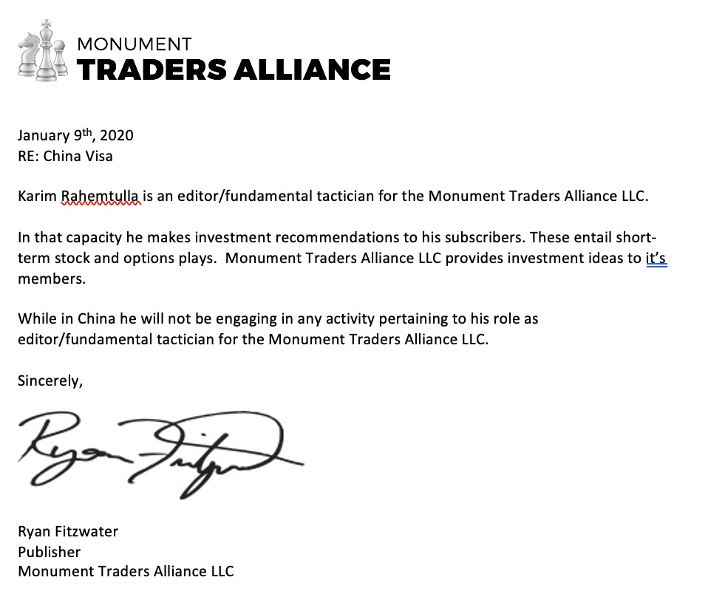
And once I got there... I couldn’t order a taxi. And I was even kicked out of certain stores.
Unlike any of my past visits... they were openly hostile to me as an American.
That’s the way China’s leadership wants it.

They are stoking anti-American sentiment in preparation for their plot to destroy us.
And here’s the thing...
They’ve never really been our friends!
The Chinese Communist Party historically governs through a series of five-year plans.
And they’ve been working to take down America since the ’70s.

Thanks to U.S. presidents like Carter, Clinton and Biden who spent their political careers enabling China...
China was able to USE America to go from being an impoverished third-world country...
Into a major rival with a GDP of $17.7 TRILLION!
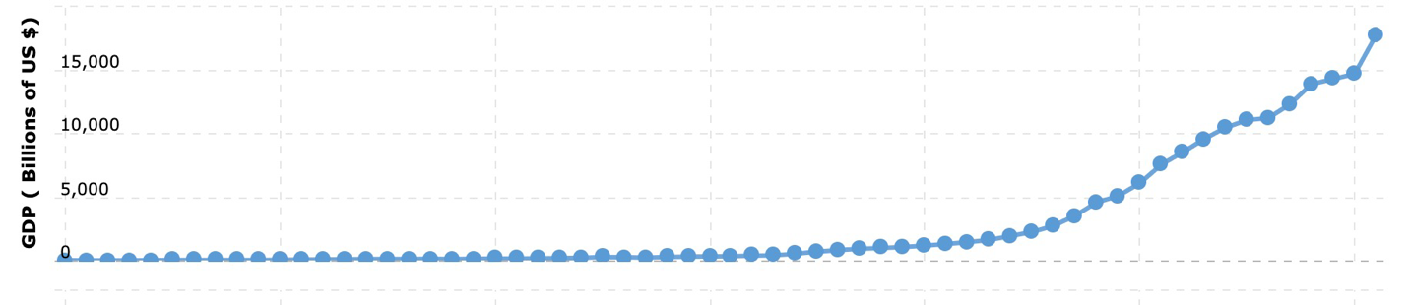

China has quickly developed one of the most technologically advanced militaries on Earth.

Their navy is now the largest in the world. They have around 280 advanced warships... over 100 more than America has.

They’re getting stronger... while our leaders have left our military in shambles.
And this is no accident.
China has weakened the U.S. economy by essentially stealing millions of American jobs...

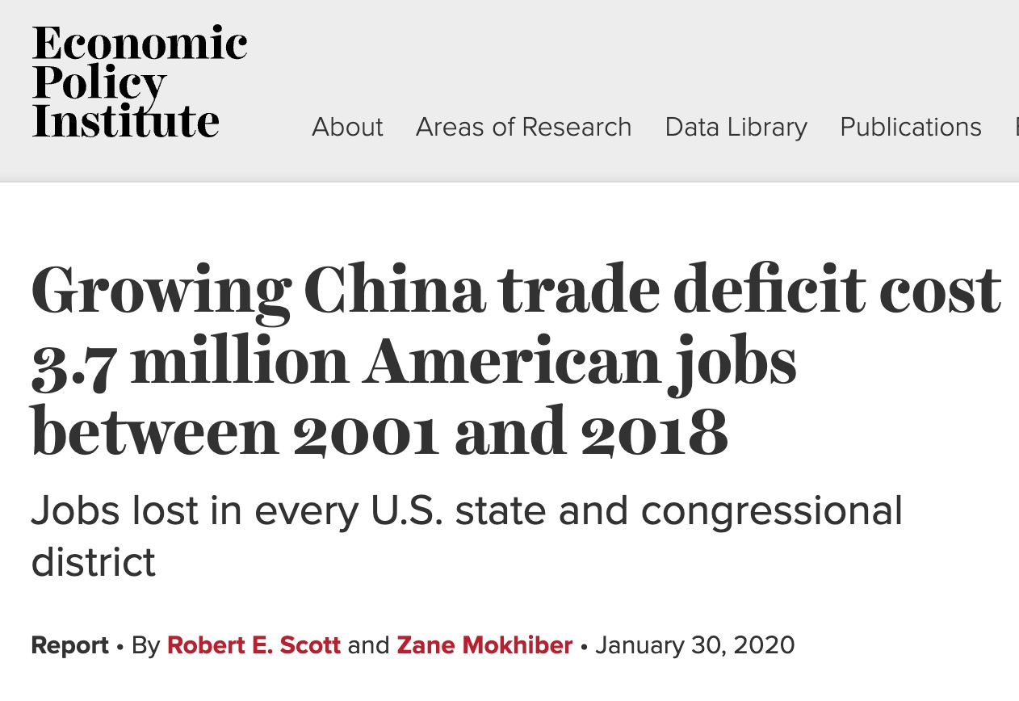
And by luring the production of many vital American industries like steel, cotton and cars overseas.
[Production Chart: Would like to show two bar charts...

Exports From U.S. to China: $151.4 billion
Imports From China to U.S.: $504.9 billion

On Top (or Bottom) have

U.S. Trade Deficit With China: $353.4 billion
Lets make sure the $353.4 billion is red.
Overlayed while he says next 3 lines]
In fact, if you look at the U.S. trade deficit with China alone (which has ballooned to $353 billion per year under Biden)...
For every $1 America brings in from China...
China takes in over $3 from us.
Leaders like Biden just keep outsourcing our economic power to them.
And if that wasn’t bad enough, we’ve watched them steal intellectual property from U.S. businesses...
Hack our most important military secrets...
And even infiltrate our phones with apps like TikTok that harvest our personal information.

It’s gotten so bad that the FBI has warned that China is now the biggest counterintelligence threat to the United States.
But again, this is all small compared with what comes next.

China is now in position to land the final blow to The Great American Dream...
By taking over the most world’s most important resource.
So what is China’s sinister plan?

Let me explain...

China’s Sinister Plan to Destroy the U.S. Economy Starts in Taiwan...

Over the last couple of years...
You’ve probably heard more and more noise about Taiwan...
A tiny island off the coast of China that is just a little bit bigger than the state of Maryland.
The Chinese communists believe that Taiwan has always been a part of mainland China...
And while the rest of the world (including Taiwan itself) views it as an independent democratic nation...

China takes this dispute so seriously that they become furious if an American politician even sets foot in Taiwan.
They now have the island surrounded, and they conduct military operations every day...
Just to prove they can bombard it with missiles if necessary.

They’ve routinely threatened the use of military force to take the island back.

But why?

Why do they care so much about a tiny island 260 times smaller than China itself?
Well, in short, it’s due to one single fact...
Within hours, China can shut down the U.S.’s access to 92% of the world’s advanced microchips...

Thanks to our leaders, who have been asleep at the wheel for the past two decades...
92% of the entire world’s advanced semiconductors come from Taiwan.
We’ve neglected to support U.S.-based chip manufacturers and have allowed virtually all of the world’s chip production to move to Taiwan.
And this is the single biggest threat facing America today...

Because if China invades Taiwan, they will essentially gain complete control of nearly the entire global supply of semiconductor chips.

And this will give them ultimate power over the U.S. economy.
Jeremy Furchtgott, the director of Baron Public Affairs, says...
“The amount of leverage that China would gain over the economy and other countries’ economies... would effectively give it a trump card.”
Chips are now the ultimate source of economic power...
More important than oil... more important than lithium... more important than rare Earth metals or gold.

Semiconductors are the true lifeblood of the modern economy.

Chips Literally Touch Every Part of the U.S. Economy...
If China Controls the Chips, It Could Destroy America.

Everything from smartphones...
Car factories...
Appliances like refrigerators and AC units...
To the computers that power the internet, our shipping infrastructure and our electrical grid...
All of these electronics REQUIRE vital semiconductor chips to power them.
In fact... new gas-powered cars have over 1,000 chips in them...
And new electric vehicles... contain a whopping 3,000 chips!
These EVs may not need gasoline... but they sure need chips!
Just look around you... how many electronics do you have at home?
You name it...
If something is electronic...
You can virtually guarantee it’s powered by semiconductor chips.

[CAN YOU GIVE SPECIFIC PRODUCTS AND THE CHIPS THEY REQUIRE HERE? LIKE TWO OF THEM?]
In fact, in 2021 ALONE... 1.1 TRILLION semiconductors were shipped worldwide...
That was a 256% increase since 1999.

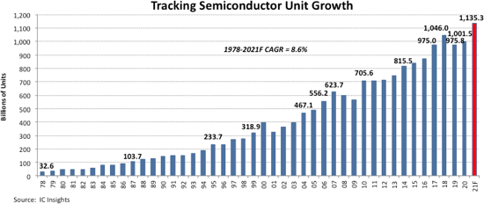

If you do the math, that is 142 chips for every person on Earth... shipped just in 2021.
But even 142 new chips per person wasn’t enough...
We actually had a minor chip SHORTAGE that year...
And we saw firsthand that even a slight dip in chip availability led to mass chaos throughout the economy.
According to the U.S. Department of Commerce, the shortage “shaved an estimated $240 billion off U.S. GDP in 2021.”
That’s the equivalent of about 1% of our entire GDP... which only grows by about 2% every year!
Because of this chip shortage, we also saw shortages in technologies like iPhones... medical equipment... and automotives.
Tesla had to halt car production for weeks. Toyota slashed production in half.
As a result, prices skyrocketed for everything impacted by the chip shortage.
But again... this was only a mild shortage.
As Time magazine points out...
“If a shortage of chips can cut economic growth in half, imagine what fully losing access to chip supplies could do.”
It’s no wonder semiconductors have become more vital than oil.
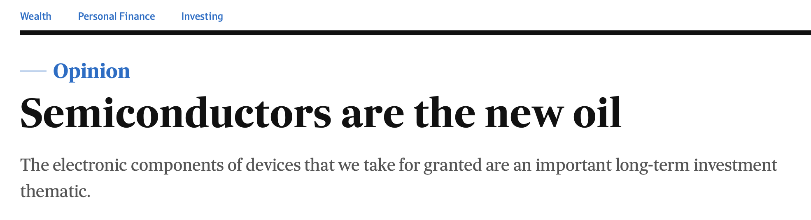
And as technology continues to evolve...
More chips will be required...
AND they’ll need to become more advanced.
These chips are becoming harder and harder to make.
You can’t just wake up one morning and decide you want to get into the chip business...
A single machine that produces chips could be as big as a bus and cost as much as $340 million.
That’s only one machine!
It’s why the world allowed chip production to be concentrated in one place.

Taiwan built all the most state-of-the-art production facilities... each pumping out billions of chips per year.
This works fine as long as Taiwan is a free country.

But if China takes it over... they are set to use their monopoly on chip production to dominate and destroy their biggest rival... America.

And don’t think for a second China won’t do it.
Take a look at this map.

*PRODUCTION: Can we make this look more doomsday? Like silhouettes of warships and planes”

Ever since Nancy Pelosi’s provocative visit to Taiwan this past August... the Chinese have been normalizing military exercises around the island...

Within hours, China showed that it could put up a blockade around Taiwan...
Including deploying fleets of surveillance drones to fly over the island nearly every day.


And China has even been caught bribing Taiwanese military leaders to surrender in the event of a war breaking out...
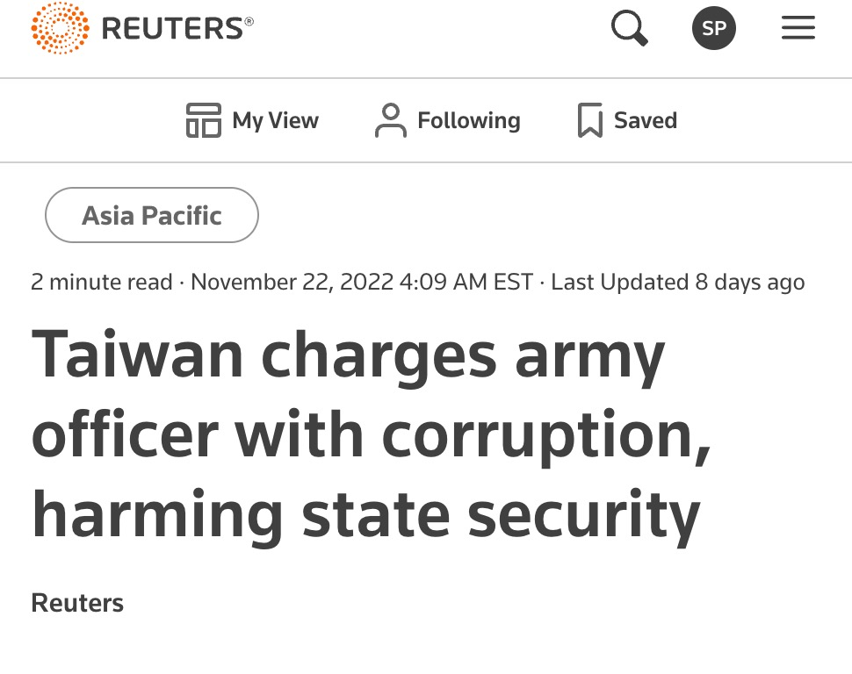
But wait...

Our military would intervene, right?

They’d stand up to China, wouldn’t they?

Well... here’s the problem.

A modern army and navy rely on billions of advanced chips to power military resources like jets, drones, helicopters, missiles, ships, submarines and other air defense systems...
And the vast majority of the chips used by the U.S. military are also made in Taiwan...
China would certainly cut off the U.S. military from its supply at the start of the conflict.
It would cripple our military instantly.
Meanwhile, after an invasion of Taiwan, China would use their newly controlled chip factories to develop more advanced military weapons of their own...
Such as supersonic missiles...


Autonomous drone swarms...

And advanced AI-powered surveillance and propaganda initiatives that they’re already using around the world...
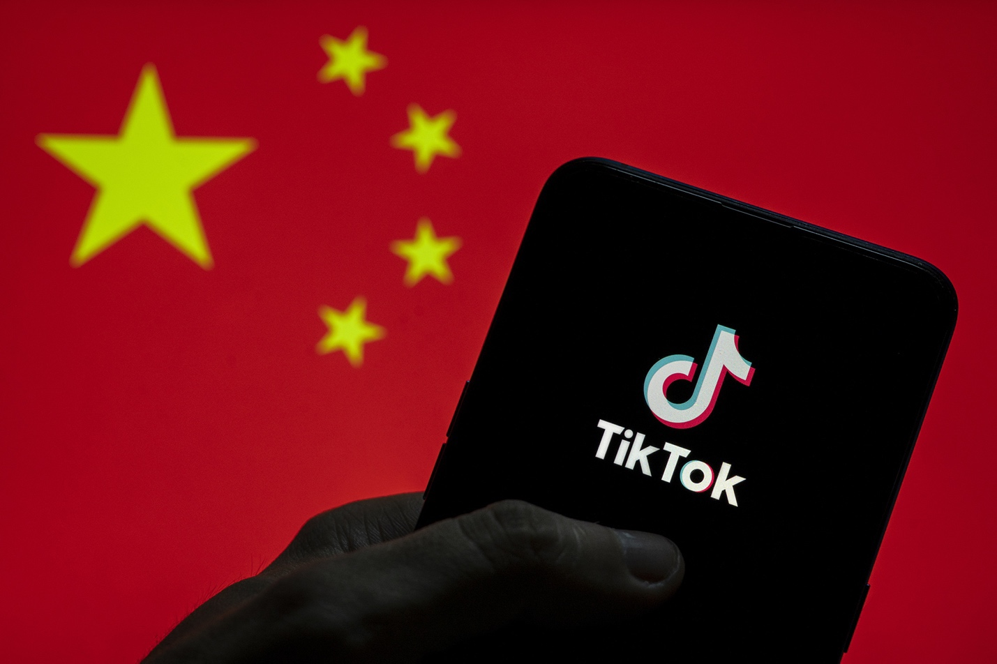

All of which would be devastating during a war.

It’s terrifying to imagine the economic chaos that would ensue.
We’re talking about a world without new cars... without new appliances... without construction equipment... without new electronics.
The shortages would mean massive sales declines for business... a complete collapse of the stock market.
We’re talking about an absolute catastrophe here.
People don’t realize how fragile our modern world is.
And if China were to take over chip production tomorrow, we could all be in MAJOR trouble.
You need to move to protect yourself, your freedom and your wealth NOW.
Not next year.
Not next week.
Not tomorrow.
Now!
I want to arm you with my plan immediately.
It starts with a series of protective investments that smart investors should move some of their money into immediately.
But it also involves a $32 investment that is primed to soar... with the chance of hitting $200 in the next two years.
Even the threat of a Chinese invasion of Taiwan would drive this investment higher.
And that threat is very real... right now.
This Isn’t a Conspiracy Theory...
President Xi Himself Has Made It Clear That He Wants to Take Over Taiwan...

China’s plan to take over Taiwan is not a secret.
In a speech given to the Chinese Communist Congress, President Xi Jinping received the most applause when he said...

“Resolving the Taiwan question and realizing China’s complete unification is a historic mission and an unshakable commitment of the Communist Party of China...
No one should underestimate the great resolve, the strong will and the extraordinary capability of the Chinese people to defend their national sovereignty and territorial integrity.”
And in a 60 Minutes interview, Taiwanese Admiral Lee Hsi-ming said...
“This is not a matter of if they will invade, it’s a matter of when they will invade.”

Let me repeat that.

It’s not a matter of if, but when.

Mark Liu, chairman of the Taiwan Semiconductor Manufacturing Company (TSMC), which produces 92% of the world’s advanced chip supply, says when that happens...
The world’s most advanced chip factory will be rendered “not operable”...
And he says a conflict would mean...
“Destruction of the world based order.”
Look, taking over Taiwan is really the only way China can reach its sinister goals.

It will give them complete dominance over the world economy.
And an emboldened President Xi, in his third term as president...
Is replacing China’s military leadership with what he calls “action men”...
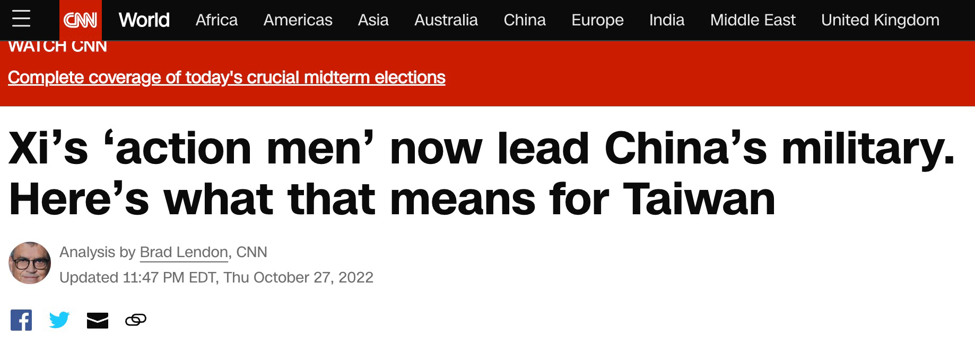
He’s not keeping it a secret to anyone that he plans to invade Taiwan!

And Biden’s own Secretary of State, Antony Blinken, recently even said that “China wants to seize Taiwan on a much faster timeline”...

Yet after all of this...
[PRODUCTION... Show 3 quotes again w/ head shots ]

Biden still hasn’t woken up about the realities of China’s master plan.
Just look at what he said after his meeting with Xi back in November...
”I do not think there’s any imminent attempt on the part of China to invade Taiwan.”
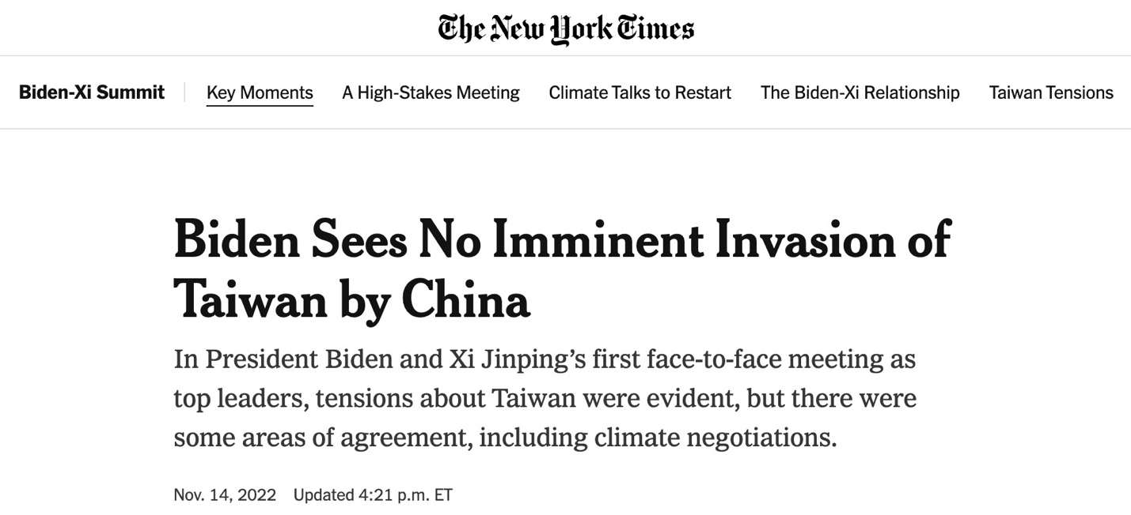
He was more interested in pretending that China actually cares about things like climate change or human rights.
This is the same repeated naïve leadership that has led us into this perilous predicament in the first place.



Our leaders are playing with fire here.

Because a Chinese takeover of the world’s chip production would be disastrous for the American economy.

If China succeeds at monopolizing chips... we’ll see shortages 9 times worse than what we saw during COVID.
COVID shutdowns gave us a taste of the chaos that would ensue.
Businesses and consumers struggled with long delays for even the most basic necessities...
All thanks to the shortage of chips.
But even those shortages are nothing compared with the consequences we will see when China completes their plan to bring America to its knees...
Chip production was impacted by only 10% during COVID.
Remember what I said earlier...
Taiwan produces 92% of the world’s advanced chips.

That’s 9 times the impact!
Everyday consumer items such as refrigerators...
Dishwashers...
Air conditioning units...
Microwaves...

Washing machines...
Televisions...
And even thermostats...

Will become virtually impossible to replace without new chips...

And smartphones?
Well, let’s just hope that your battery and screen last for a few more decades...
Because once China monopolizes chips...
You can say goodbye to any hopes of ever purchasing a new phone in America...


The same can be expected for cars and semitrucks...
Remember... some of these new cars require up to 3,000 chips!
With no more chips available...
We can say hello to the nightmare world where used Kias run for $100,000.
Carmakers like Toyota and Volkswagen have already had to trim their production because of chip shortages...


Even hospitals will struggle to get a hold of critical life-saving supplies such as MRI machines...
Ventilators...
Pacemakers...
And other patient monitoring devices.
Just like we saw during COVID...
Doctors and nurses might literally be forced to decide which patients will live and die because of these critical shortages...


Mick Farrell, the CEO of ventilator maker ResMed, told The Wall Street Journal...
“Every single chip [we get] gives the gift of breath to a person suffocating.”
But if China’s willingness to let millions of Americans suffocate doesn’t get your heart pumping...
The most damaging effect would be the eventual loss of the data centers and broadband equipment that power our internet, telecommunications and logistics systems.
As these components break with no replacements...
We could see countrywide outages of services that our economy has become completely dependent on...



The Internet & Television Association wrote...
“The reduced availability of consumer devices, which leads to increasing costs, means that users may not be able to connect [to the internet], and the situation may only become more difficult in the coming months.”

Millions of small online businesses could quickly be destroyed...
FedEx, UPS and the post office would struggle to use their computers to move packages around the world...
And even the big tech companies like Google, Amazon and Microsoft that have powered stock market growth over the past two decades...
Could quickly find themselves bankrupt as vital services like search engines, the cloud, and online shopping carts no longer work.
That’s how bad it could be.

But listen... not everything is doom and gloom.

There is one sliver of hope that China has gravely underestimated in their master plan...

And it could make you very wealthy as an investor.

America’s Last Hope Lies Here...
(And It’s “Do or Die”)

With Biden asleep at the wheel through this dangerous situation...
U.S. tech companies... all across our great country... have become extremely alarmed.
These businesses know that their very survival is at stake.

They understand that losing access to semiconductor chips would bankrupt their businesses.

The leaders of companies like Intel, IBM and Micron aren’t going to sit around and hope that Biden can solve the problem.
Instead, they’ve put together their own plan to fix this.

The only way we can stop China in their tracks is through good old-fashioned American ingenuity and entrepreneurial dominance.
And that is what’s underway right now.

In short... a handful of companies have created a plan to build an entire massive, state-of-the-art chip industry right here in America.
Over the past few months, these chip companies have been aggressively building new factories and developing new projects...
And by doing that, they are set to ruin China’s plot to destroy America.

The reality is... China can’t cut off America’s supply of critically important chips if we make them here ourselves.
And getting these projects fast-tracked is literally a “do or die” moment for the American tech industry.
There is no time to waste.
They have to get this done quickly...
Because if they don’t... the effective shutdown of our military is on the table.

Another Great Depression is on the table.

A collapse of the U.S. economy is on the table.

These are all real risks today.

China could use this moment to take over as the #1 economic force on the planet.

But if the new U.S. chip production comes online fast enough, the threat will be neutralized.

So here’s what’s happening...

A number of patriotic companies are ramping up chip production as we speak.

American Capitalism Is Striking Back...
Micron, a company that manufactures memory chips, announced it is investing $100 billion into a massive fabrication plant, or fab, in Syracuse.



IBM, just two days later, announced plans to invest $20 billion in the central New York area...

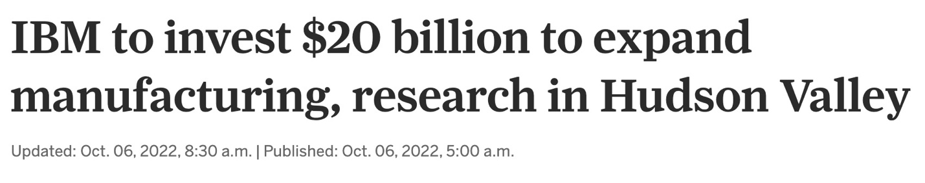

But even more notable are the projects Intel’s pursuing...
Including a $30 billion deal to fund new factories in Arizona...
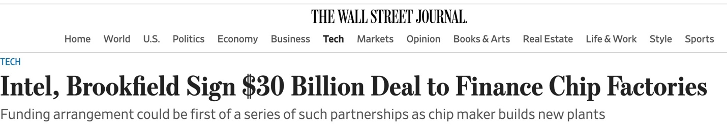

And a $100 billion investment in a top-of-the-line megafactory in Ohio.

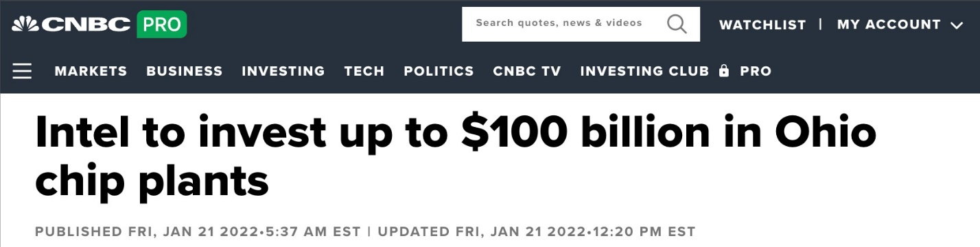
This is a major, major development to see all these chip factories coming online.
In fact, Congress is even going past the Biden administration to get something done here.

Billions of Dollars Are Now Being Pumped Into the American Chip Industry...

While Joe Biden has been helping to fast-track China’s invasion of Taiwan (and bring more potential devastation to our economy)...
Congress recently passed the Chips Act, which will do the opposite and actually HELP America.
It gives chipmakers up to $52.7 billion in subsidies and a 25% tax credit to build chip plants in the U.S...

To help them stop China’s sinister plan to deprive us of chips.
Our economy would be doomed if we were to lose access to the semiconductor chips we need.

We absolutely MUST have chip production here in America.

It is a matter of national security.

But you may be wondering... why didn’t they do this before?

And why was 92% of chip production based in Asia in the first place?

Well, there is an interesting answer to that question... and it’s one of the key reasons you could make so much money in the months ahead.

One Small, Under-the Radar Company Is Crucial to This Entire Project to Save the American Chip Industry

You see... the advanced semiconductor chips that have become the lifeblood of the American economy are some of the most impressive technological innovations known to mankind.

A single chip can hold billions of transistors... each one 166,000 times smaller than a single grain of sand.

We’re talking so tiny that you’d need an electron microscope, which can cost upward of $10 million, to see them.

Now, as you can imagine, these are not easily built.

They require extreme precision...

And beyond that, an extreme level of purity that is almost unimaginable.

A single speck of dust can ruin millions upon millions of chips.

In fact, something just like that recently happened at one of Taiwan’s factories.

An entire batch of microchips was destroyed... and it cost the company $550 million.


That is a chipmaker’s worst nightmare!
And it’s one of the reasons chip production was never scaled up here in America.

The facilities are incredibly expensive to build, and they must be run with extreme attention to detail.



American tech companies decided it was cheaper to allow Taiwan to build the facilities and produce the chips... and we’d simply buy them from there.

However, if China were to take over that chip production, simply buying them from Asia would no longer be an option.

It’s why we are seeing chipmakers like Intel, IBM, Micron and others rushing to build plants in the U.S.

But here’s the thing...
While each of those American chip companies is a solid investment bet right now... there is another company that I believe is going to be crucial to not just one or two facilities...
But virtually every new chip factory around the world.
This one small company is just a fraction of the size of Intel, IBM and Micron...
But it has a stranglehold on the industry that very few outsiders know about...

It owns 128 patents... on products ranging from innovative subsystems and components that allow chipmakers to keep their equipment clear of any contaminants...
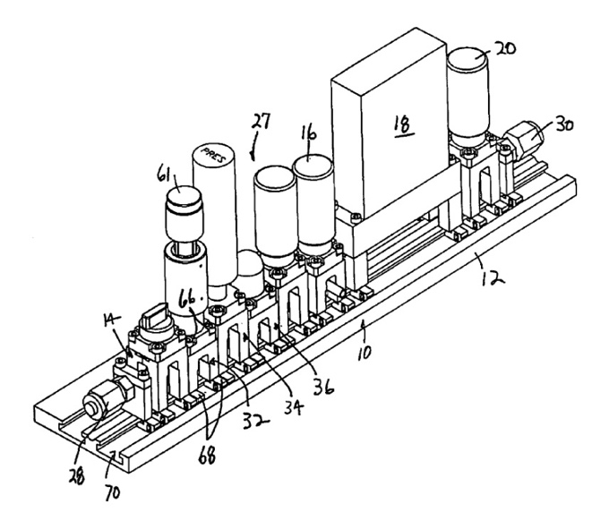

To chemical delivery modules that deliver precise amounts of gas and chemicals throughout the chipmaking process.
Without these components, it would be impossible to produce any chips.
And top chipmakers around the world have tasked this company with ensuring that no major accidents shut down operations in their facilities.
In short...
This small company indirectly touches a massive share of the trillions of chips produced on this planet every year.
The more chip factories that are built... the more this company can grow!

And because of China’s sinister plot...
American chipmakers like Intel are already lining up to work with this small company... so it can help them efficiently produce massive amounts of chips right here in America.
Not only that...
This company’s equipment and services actually allow us to build BETTER chips than what we are buying from Asia today...

This Little-Known Breakthrough... About the Size of a Strand of DNA... Will Abolish China’s Takeover Plans

Take a look at this...
Can we zoom in on my hand?
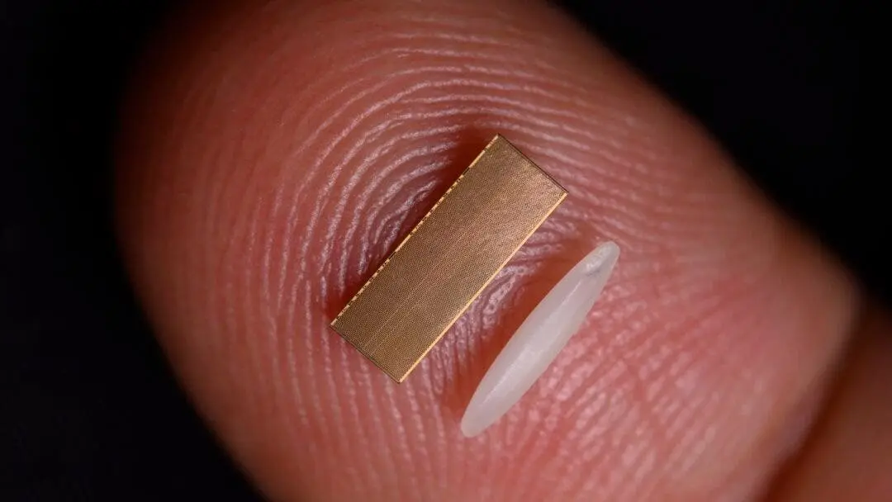
This is a single grain of rice.
As you can see... it’s small enough to easily fit on my fingertip.
It’s also the same size as the latest evolution of chips that will soon power the world.
Yes... they’ll be the size of this grain of rice.
And yet, these tiny chips will consist of over 50 billion microscopic transistors smaller than the size of a single strand of DNA.
I want you to seriously think about that for a second...
50 billion transistors all strategically packaged in a chip the size of a grain of rice...

These tiny chips will be more powerful than any chips the world has seen before.

They’re called “2-nanometer chips.”
And Intel is expected to be the first to mass-produce them.
Most importantly... they’ll be produced right here in the United States years before they’re produced anywhere else in the world.
The implications of this breakthrough development are massive.
These new chips are expected to use 75% less power than the chips that are currently on the market.
Data centers, which account for 1% of ALL energy usage in the entire world...
Will see their energy use and carbon footprint reduced drastically.
Computer performance will increase by a whopping 45%...
Making them faster than ever...
And the battery life of a smartphone is projected to QUADRUPLE!
Imagine being able to use your phone for 4 days without worrying about charging it!

It's all thanks to this incredible nanotechnology.
These tiny chips, which literally can fit on your fingernail and have billions of components that you’d need a microscope to see...

Will be so powerful that they will be the driving force behind the next generation of technologies like self-driving cars, quantum computers and advanced artificial intelligence.

Dr. Mukesh Khare, a vice president at IBM, said this development is massive...

/PRODUCTION - SCREEN ONLY. DO NOT READ
“It will accelerate AI workloads for 5G and beyond. It will unlock edge computing gains to unforeseen levels, including in areas like space exploration. This new 2-nanometer chip technology will aid the discovery of new materials, new drugs, which requires very high performance computing to simulate molecular structures. And finally, this technology will also be very valuable... towards reduced power consumption.”
////

He said this new breakthrough will be the building block for virtually all technology going forward...
And will be the competitive advantage that America needs in our chip industry here at home.
That’s why Intel and its partners are doing whatever they can to mass-produce these cutting-edge chips first.

But here’s the thing.
It simply CANNOT happen without this one small company and their patent-protected technology.
Listen... if you want to buy Intel to take advantage of this, you can.

But the real money is in the smaller company that’s providing the technology that makes these chips possible.

Because I believe their technology will be used not just by Intel... but by virtually every chipmaking company around the world.
Without this small, $32 company...
Chipmakers simply wouldn’t be able to efficiently bring chip manufacturing home to American shores...

Which is why all the big blue chip tech firms are handing this company millions upon millions of dollars.

This Company’s Revenue Could Increase by a Record $800 Million...
Over the past few years, this little-known company is growing noticeably faster than the other chip equipment makers.

In fact, Christian Schwab of Craig-Hallum Capital Group told Investor’s Business Daily that he projects this company could see an $800 million increase in revenue.

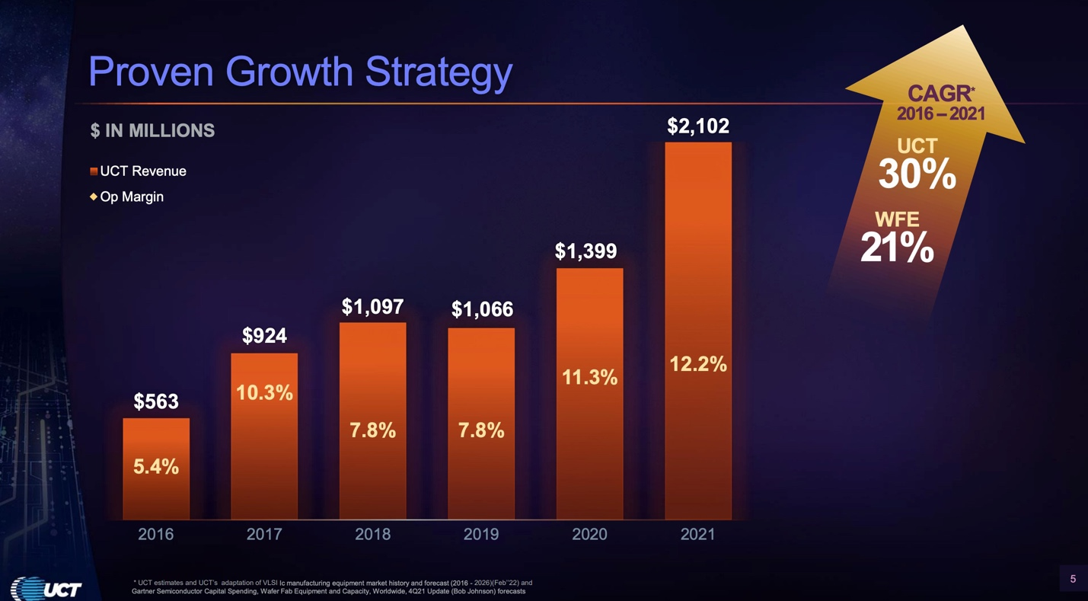
And as more factories from American companies like Intel, GlobalFoundries and Texas Instruments come online...
That figure is poised to skyrocket.
This company just keeps on growing!

Legendary investor Peter Lynch once wrote, “If you can follow only one bit of data, follow the earnings”...
And since 2017... this company has beaten quarterly earnings estimates more times than Amazon, Tesla, Google... and even Warren Buffett’s Berkshire Hathaway.

Best of all...
This company doesn’t just supply chipmakers...
It supplies other equipment makers with their own virtual monopolies...
Lam Research, Applied Materials and ASML also are adding hundreds of millions of dollars to this small company’s business...
Simply put...
This company has contracts with all of the major players involved with chip manufacturing:
********* PROUDCTION CHART:
Similar to this: https://s3.amazonaws.com/assets.oxfordclub.com/promo/oxf/plan/0122/47-graphic-sales.png
Chart title: 2022 Revenue by Contract:
Lam Research: $992 million
Applied Materials: $549.3 million
Intel: $90.7 million
ASML: $66.7 million
Samsung: $55.6 million
TSMC: $54.2 million
Micron: $41.6 million
KLA Corp: $23.2 million
Sources for compliance:
% of revenue from customers
2022 revenue is $2.42 Billion
********
Its partners are involved in every stage of the chipmaking process...
From factory construction... to equipment buildout... to ongoing production support across the entire new chip industry.
This company indirectly touches virtually every chip that is produced in the world...
When a new chip factory is built anywhere in the United States... that should mean more revenue for this company in the short and long term.
And that revenue will only grow from here as China’s plan forces America to rapidly build more chip factories here at home.
But even if China does nothing... this stock is STILL poised to explode!

At this point... the plans are already in motion regardless of what happens with China’s plot to invade Taiwan...
Intel and other U.S. chip manufacturers have already started breaking ground on new factories and ramping up production here in the United States...
Which means they’ll need the mission-critical technology and equipment this company produces no matter what.
All the growth is happening as we speak.
And for investors... NOW is the time to make a move.
Over the past few years, this company has geared up for this very moment.

They’ve optimized their supply chain and increased both short- and long-term capacity... to meet the quickly increasing demand.
And now they are establishing operations all over the world... including in...

- California
- Texas
- Arizona
- Malaysia
- The Philippines
- England
- Tokyo
- Korea
- Singapore
- Thailand
- Israel
- The Netherlands
- And France.

Now, you might ask yourself...

Why the rest of the world?

Well, because the rest of the free world doesn’t want their chips controlled by China either!

Listen... this is why this is SO BIG.

The threat of China taking control of the entire global supply of chips is forcing every country around the world to focus on building their own safe and secure supply of chips.

And this American company could end up being involved in just about all of it.
In fact, this company’s percentage of revenue produced outside of the U.S. has DOUBLED since 2015!
Its ability to be nimble from these many different locations helps chipmakers avoid supply chain issues...
Just like the shortages in 2021 that I mentioned earlier.
This company understands the value of being in close proximity to all of the major production facilities...
So they don’t need to always depend on shipping mission-critical products around the world when they’re needed.

And as Zacks reports, “The company has been continuously attracting big tech companies like Intel due to its capability to meet delivery schedules even among severe supply chain constraints.”

The importance of this company’s products and services cannot be overstated.
I believe the entire chip industry would come to a standstill without this company’s products and services.

And we’re talking about an industry that is expected to reach $1.3 trillion within the next few years.
This is a rare opportunity to get a piece of a company that holds a virtual monopoly on 128 pieces of patented, mission-critical equipment and services relied on by top chipmakers in the U.S. and around the world.
And historically, vital pick-and-shovel stocks like this $32 opportunity... that provide a vital service to the chip industry... have given investors gigantic opportunities to profit...
How large?

32 Times Greater Returns Than Large Chip Companies Like Intel or TSMC...

Well...
Just look at past pick-and-shovel chip stocks that have had similar positions in the market...
Their all-time gains are massive!
ASML’s patented technology allows chipmakers to mass-produce patterns on silicon... its stock is up 26,961% in 28 years.
All thanks to having a virtual monopoly on the vital machines they produce.
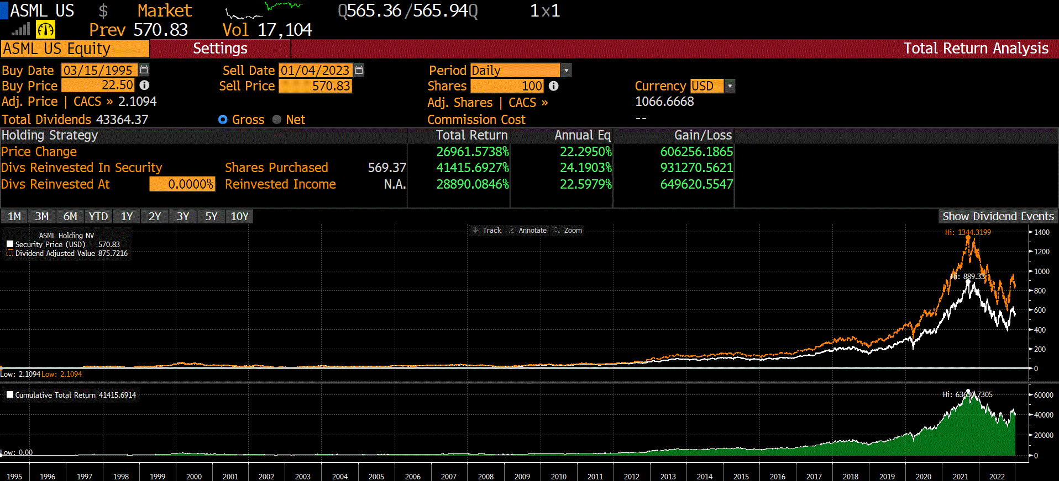
A $10,000 starting stake into ASML early on would have ballooned into over $2.7 million.

Or how about Lam Research, which has pioneered how chips are layered throughout the production process? It’s up 16,079% since 1985.
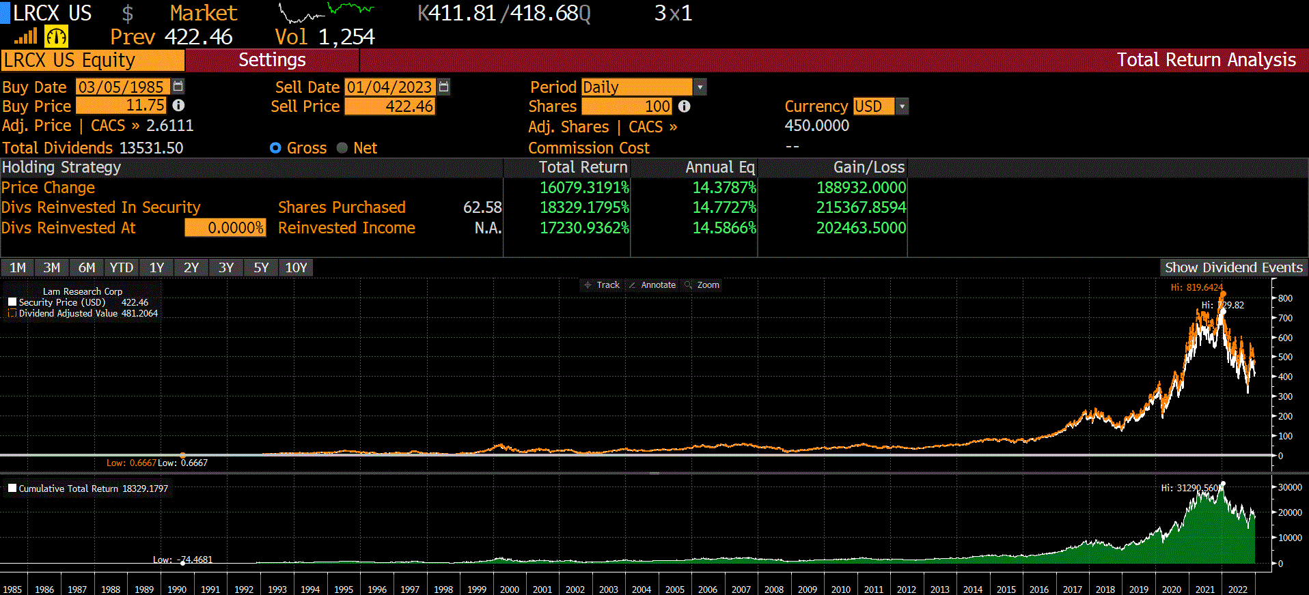
That would have turned $10,000 into over $1.6 million.

And Applied Materials, which has innovated material shaping and display creation, has seen gains of 41,577% since the ’80s!
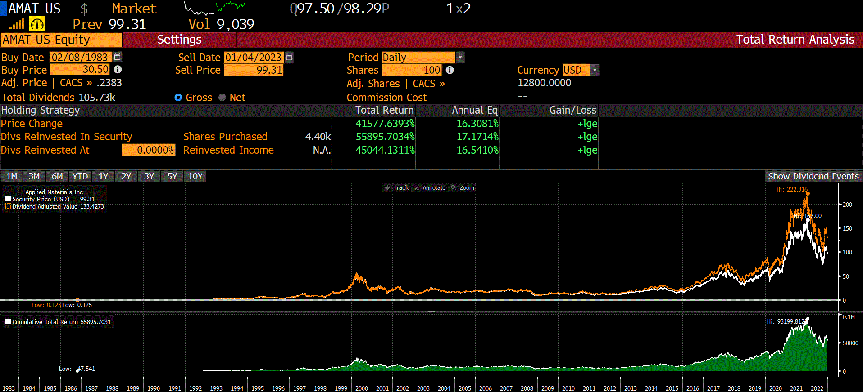
$10,000 in this stock back then would have turned into more than...
$4.1 million today!
And what’s even more incredible is...
When you compare these pick-and-shovel stocks with chipmakers themselves...
Like Intel, which is up 6,501% all-time...

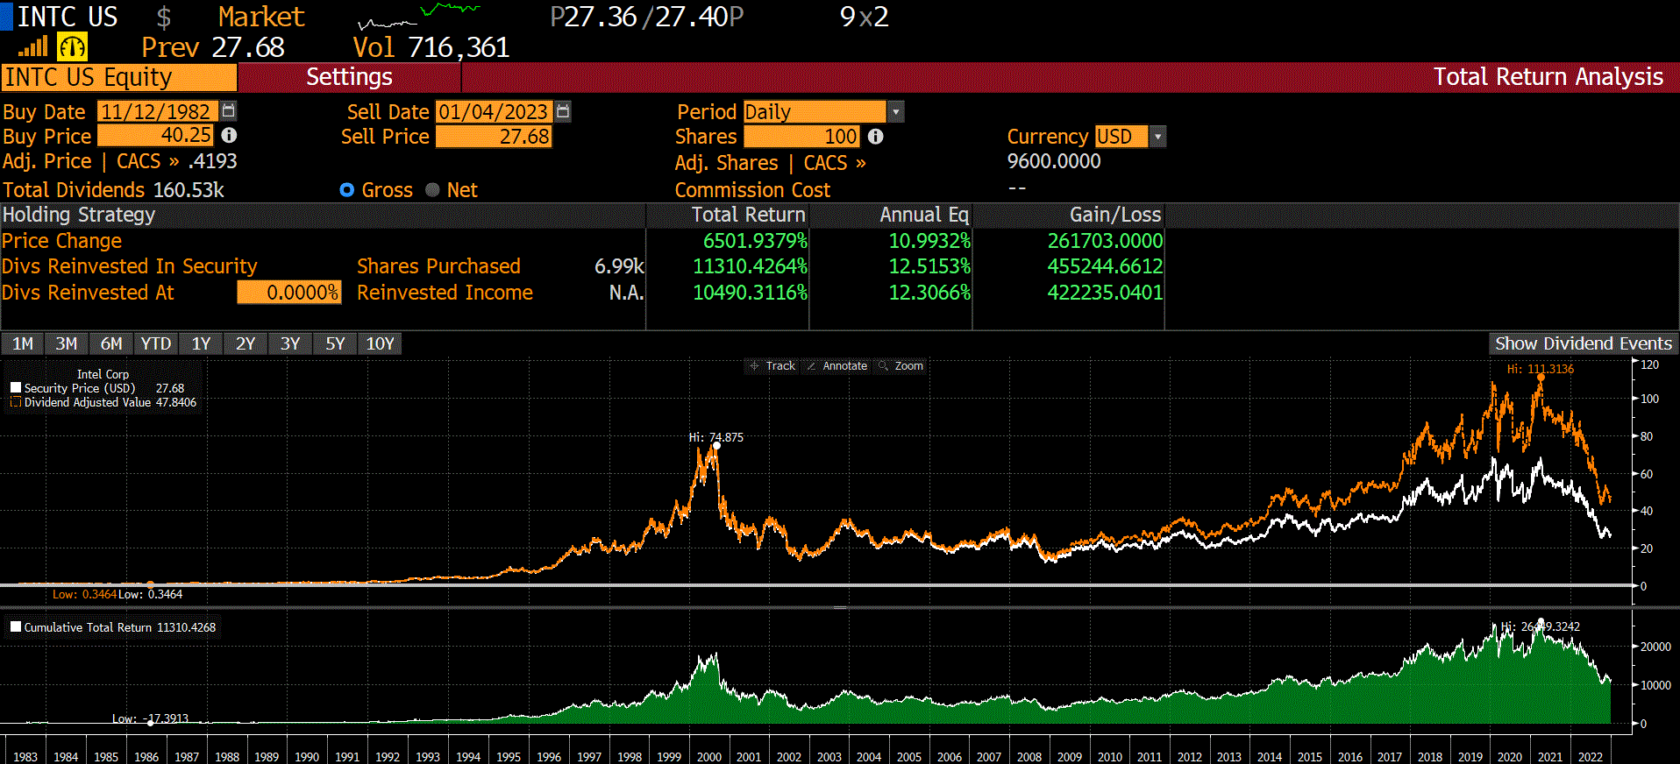
Or the largest chip manufacturer in the world... Taiwan’s TSMC, which is up 1,289%...
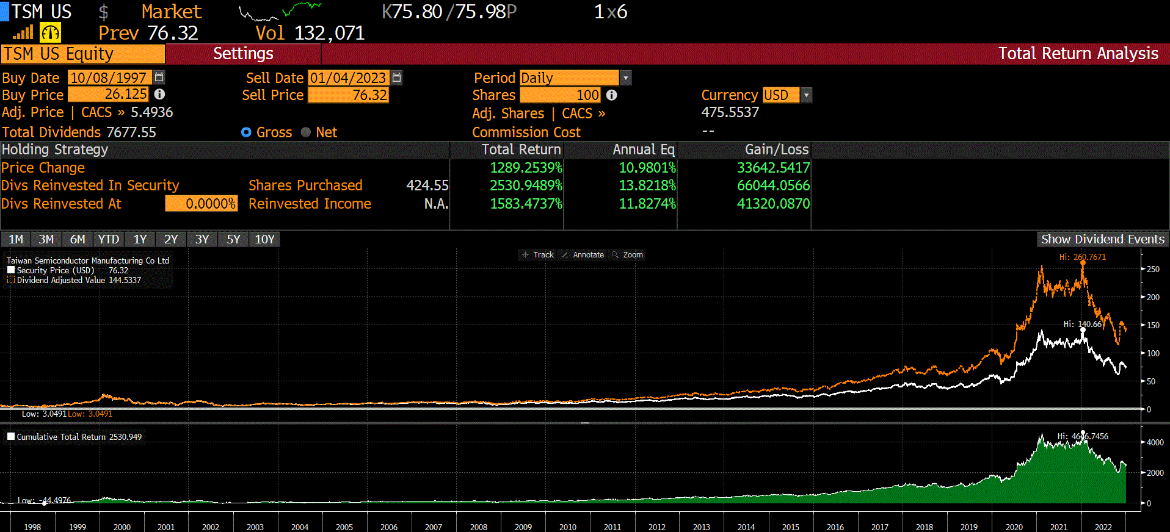

The gains are SO... MUCH... BIGGER.
Think about it...
Which would you have rather been an early investor of?
Chipmaker TSMC... which is up 1,289% over its lifetime...
Or Applied Materials, which is up 41,577%?
Now, of course, these are some of the greatest gains in the history of the market. You can’t bank on record-breaking performances like these.

But the good news is... you don’t have to!

Even a tiny fraction of those monster gains would make a real difference in your portfolio... and your life.

The bottom line is...

The big gains are in the tiny, behind-the-scenes stocks people haven’t heard about.

And the $32 company I’m telling you about today is the linchpin for the entire new U.S. chip industry.

This Mission-Critical Company Is Poised to Be the Next Breakout Chip Stock...

This stock has all the makings of becoming the next big chip stock...
And if you look at their leadership team...
It’s stacked with chip industry all-stars.
The CEO is actually a former executive of Applied Materials... He’s responsible in part for its 41,577% gain...
And several other top executives helped take Lam Research’s stock up 16,079%.
So it should come as no surprise that Applied Materials and Lam Research are now two of this small company’s largest customers.
And, as a result, the company has been consistently outperforming the entire chip equipment industry in revenue growth year after year.


Yet it’s incredibly cheap...
It’s still $375 cheaper than Teledyne Technologies, currently trading at $407...
It’s still $596 cheaper than ASML, currently trading at $628...

And it’s still $420 cheaper than Lam Research, currently trading at $452...
Clearly, the potential is massive for this company.
And I’m not the only one who believes that.
Wall Street Is Starting to Pile Money Into This Stock...

The smart money knows a discount when they see one...

And they realize the importance that this stock has to American chip production...
That’s why Invesco recently added over 336,800 new shares, making it their largest new position...


BlackRock built up a $208 million position in this stock...

Vanguard bought up another $106 million...


The point is...
It’s generally not a good idea to bet against hundreds of millions in smart money!

They are getting in now because they know the U.S. chip industry is going to grow at a breakneck pace in the years ahead.
They see the potential with this stock...
Which I believe will surge 525% within the next 2 years...
And potentially much more after that.
This company isn’t a household name like Intel or IBM...

But that’s a good thing for you!

You want to be in before it becomes a household name.

Look, major U.S. companies like Apple, Microsoft, Google and others aren’t going to sit by and let China control their supply of chips.

They realize they’ve got to have a supply here in America.

And if this little company I’ve told you about today helps the U.S. become self-sufficient when it comes to semiconductor chips...
You can bet it will be championed on every major financial television program and publication.

This Is Where You Want Your Money if China Takes Over Taiwan’s Chips...
If tomorrow, China were to send troops to take Taiwan and its extremely valuable chip industry...

You can almost certainly expect to wake up to a bloodbath of red in the stock market...

Any company that relies on Taiwan (which is almost all of them) will take a huge hit.
But the one sector of the economy that I believe will soar is the companies that provide chips here in America...

Because their chips will be in extreme demand from all other companies.
You can also bet that the government and U.S. chipmakers like Intel will go into overdrive to increase chip production.
That means exponentially more business for this company.
In short, they’re ready for their moment in the spotlight. And nothing can stop them.
And yet...
Believe it or not... what they do for the chip industry is only a part of their business!

This under-the-radar company consistently finds ways to supply the most vital industries on the planet...
Not only are they one of the most important chip companies on Earth...
They also manufacture fitting and valve products for oil and energy companies.

Their patented products are designed to boost efficiency and help energy producers meet rising demand...
And they even produce components that help with the production of hydrogen, solar and thermal energy.
For investors, there has been no hotter market than energy.

The sector was up 58% in 2022... as the stock market was down across the board.

All in all, this little U.S. company could help America achieve both energy independence...
AND semiconductor chip independence...

Which will put us on a much better path toward the future.

Thanks to these kinds of smart investments, a savvy operating model and the company’s critical chipmaking components...
The bottom line is...
This is an opportunity to get in on a company that has secretly been one of America’s most important.
So you may be asking yourself...
How Do I Get This Tiny Stock Before It Runs Up 525% (or MORE!) Within the Decade?

Before you do anything, I want you to see all the details for yourself...
That’s why I want you to get your hands on a copy of my latest report... “Defeating China: The #1 U.S. Stock to Soar From 2-Nanometer Chips”...
[REPORT GRAPHIC – Right ALIGNED]
In which I lay out all of the intel that my team and I have put together on this very rare opportunity.
If we were to sell this report by itself, it would be valued at $495...
But this is a critical moment in history, so I want you to have access to it.
Look, I’ve been helping people find ways to profit off massive global events for over 35 years...
And if we look at how similar chip stocks have played out over their lifetimes...
Like Applied Materials, which has surged 41,577%...
Or ASML, which has grown 26,961%...
Or Lam Research, which is up 16,079%...
The ceiling for this stock is absolutely MASSIVE!
This is the #1 place you’re going to want to have your money over the next two years.
Now, it should go without saying that all investing carries risk, and you never want to invest more than you can stand to lose – even in an opportunity like this one.

That being said, I wouldn’t be here pounding the table on this company if I didn’t fully believe it could easily soar 525% within the next couple of years...

In fact... I’ve already put my own personal money into this play. That’s how much I believe in it.

Here’s How to Add It to Your Portfolio... Like I Just Did!

Look, I don’t know if China will invade Taiwan tomorrow... next month... next year... or next decade.

But I know one thing for sure... it is no longer acceptable for America to rely completely on Asia to produce the chips it needs.

The mere threat of a massive chip shortage is far too dangerous to leave up to China...

So American businesses are going to have to supply our nation with these chips that power the entire U.S. economy.

And this one small company... is mission-critical to making that happen.
They indirectly touch virtually every chip on the planet.
In my special report, you’re going to get the name, the ticker symbol, my research AND my easy-to-follow breakdown of how I plan to approach this play.
And I’m prepared to send this report to you 100% FREE.

But I’m not stopping there...
I believe there will be additional profitable plays you can make BEFORE China invades Taiwan.
That’s why I am also going to give you an entire model portfolio of the top chip stocks that I think will surge because of the looming Chip War...
Special Bonus #1:
“Chip Domination Profits: My Top 6 Semiconductor Plays”
[report graphic]

You’ve probably heard the old saying...
“Rising tides lift all ships.”
I believe we’re going to see several winning stocks as America brings chip manufacturing back home from international shores...
And becomes the first country to supply the world with bleeding-edge 2-nanometer chips.

That’s why I put together a special model portfolio of the stocks that I expect to explode thanks to this Chip War...
Which is still just getting started!
In addition to my #1 chip play from my “Defeating China: The #1 U.S. Stock to Soar From 2-Nanometer Chips” report, my special model portfolio will include...

- 1 conservative ETF play that will give you exposure to all of the top chip plays right here in the United States... with 99% of the fund devoted to American chip companies
- 4 moderate plays... all chipmakers that stand to profit thanks to the Chip War that China started with the U.S... including one under-the radar stock that analysts are expecting to surge up to 130% within the next few months
- And 1 speculative play that involves a small cap chipmaker that supplies U.S. aerospace and defense companies... but still trades for less than $1 and has 1 analyst estimating a 373% profit target this year.

So all in all, you’ll have 6 opportunities to profit off America’s rise to chipmaking glory...
And my full game plans for all of them.
This report is a $295 value...
But today I’m giving it away to those who are ready to take action...
And that’s STILL not all I’m going to do to help you prepare for this pivotal situation.
As I mentioned earlier...
If China invades Taiwan... we could very well see the next Great Depression.
And outside of these American chip stocks that I’ve told you about today...

I expect that there won’t be many other safe places in the stock market to put your money...
That’s why I put together another special report...
Special Bonus #2:
“In Case of Emergency Break Glass: The Official China Invasion Contingency Plan”
In it, you’ll receive the top 3 actions that I believe every investor should take... as soon as we hear word of a Chinese invasion of Taiwan.
And here is a spoiler alert...
None of them involve investing in any one stock!
These 3 protective plays are where you’re going to wish you had your money when most of the stock market implodes.

And look, this isn’t some long research report that will take weeks or months to understand.
My team and I wrote this as a short “grab and go” report...
So you can quickly read it, take action and protect your nest egg within minutes of China sending missiles into Taiwan.
Every investor will want this report bookmarked and ready to go when this emergency situation happens...
And you’ll receive a copy of it today, along with the other reports that I mentioned...

The first, valued at $495... and these other two bonus reports valued at $295 each.
That’s a $1,085 value...
But they’re all yours... for FREE...
Just for taking a no-risk trial experience with my powerful research service called Trade of the Day Plus...

Trade of the Day Plus Is the ONLY Way You Can Get My Top Recommendations for Less
Than $1 per Week!
Tens of thousands of people pay upward of $7,500 every year to receive my high-end research services like The War Room...
And considering its 76% win rate across 490 trades in 2022... a year dominated by a bear market... $7,500 for The War Room is an absolute steal.
But I understand that not everyone is ready for that kind of commitment.
That is why I created the much more inexpensive Trade of the Day Plus, where you can still get access to one of my best trades...
Every single week!
Each of these weekly recommendations can lead to big wins.

For example, in January 2021, I saw that Ford was set to have a big year.

I recommended a number of different Ford trades throughout the year... and they all made money.

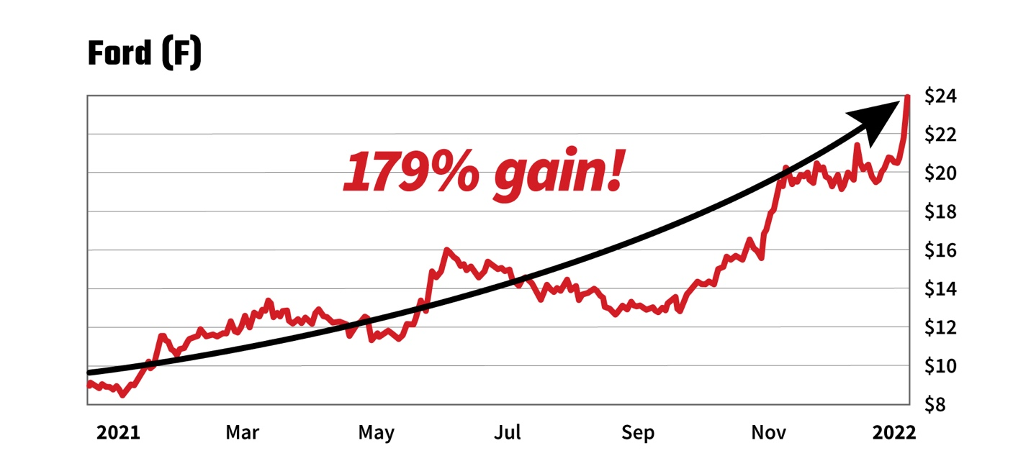

All told, Ford went on to become the #1 car stock of the year, making a 179% gain in those 12 months and even beating out Tesla.

And one of our members, Michael K., said that over the whole year, he captured a total gain of 123%.
Another play I recommended, Jasper Therapeutics, also gave readers the chance to double their money...
But in a MUCH quicker time frame.
We recommended it on October 7, 2021, and by October 13, we’d closed out a partial gain of 100%.
And even after the stock fell back down to earth while we were holding the remainder of our position...
We still were able to close out the remainder of the position for a total gain of 58%.

But not before several of my Trade of the Day Plus readers were able to cash in for profits of up to 100%...


Imagine making 130% in a single day! Incredible.
Even in a unpredictable 2022 stock market, we picked the best-performing stock in the Dow over the final quarter of the year.

Let me repeat that. The #1 stock between October 1 and January 5, which shot up 53%, is in our Trade of the Day Plus portfolio.
We recommended it to our readers 2 weeks before the start of the 4th quarter...

AND I believe it’s poised to run even higher.

Impactful results like these are what motivates me to keep sharing these Trade of the Day Plus recommendations for basically peanuts.

Frankly, the success of our readers is what drives me.

It’s my mission to help Main Street succeed.

And that’s exactly what I want for you in 2023 and beyond.
So as a member of Trade of the Day Plus, you’re going to get two things:

One...
Every day, you’ll receive my Trade of the Day emails, where my elite team and I will break down what we’re excited about in the market for that day.


Second...
I’ll send out my very best trade every week...
But I’m not just going to send you some short email with just a ticker and the price like many other research services do...
Rather, you’ll get a simple, easy-to-follow Video Alert every Wednesday at the market’s close...

It will contain the trade recommendation AND a detailed explanation of why we like the stock.
That’s 52 exclusive video recommendations per year...
That you can check on at any time with unlimited access to our transparent, easy-to-follow model portfolio.
Again, I personally have enjoyed investing for four decades...

I achieved a million-dollar portfolio by the age of 35.
I’ve made terrific connections around the world...

And I go boots on the ground for top investment opportunities...

In other words, I do all the work, and I put the opportunities on a silver platter for you.

Multimillionaire investor Alexander Green, a former portfolio manager for a multibillion-dollar Wall Street bank, said...

“Investors should seek out the best investment opportunities wherever they reside. And I know no one is more capable of uncovering them than Karim Rahemtulla. He has been there on the ground many times – in Europe, Asia, Latin America and the Pacific Rim – researching and analyzing hundreds of stocks and bonds, and recommending to his readers with extraordinary success.”
Look, I spend over $30,000 EVERY year on expensive software to get the best intel available...
So that I can wake up every morning knowing the best places to find the opportunities that most investors flat-out don’t see.
Just like my #1 play that I believe all investors should put their money into during this monumental shift to American-made chips.

As a reader of Trade of the Day Plus, you’re going to get all of this...
AND the three free reports that I’m including...

“Defeating China: The #1 U.S. Stock to Soar From 2-Nanometer Chips”...

“Chip Domination Profits: My Top 6 Semiconductor Plays”...

And “In Case of Emergency Break Glass: The Official China Invasion Contingency Plan.”
But that’s still not everything you’re going to get when you join today!
I’m also going to send you:
Special Bonus #3: How to Execute the Win-Both-Ways Trade



One of my all-time favorite strategies – which I use in our $7,500 War Room service – is the “Win-Both-Ways Trade.”
As the name suggests...
These trades allow you to win when stocks go UP...
AND when they go down!
They’re a big reason The War Room has a 76% win rate on our closed trades from 2022 despite most the market being in the red.
And some of our trades using this strategy have been massive...
Like our 291% win in just 1 day after Snap stock went UP!
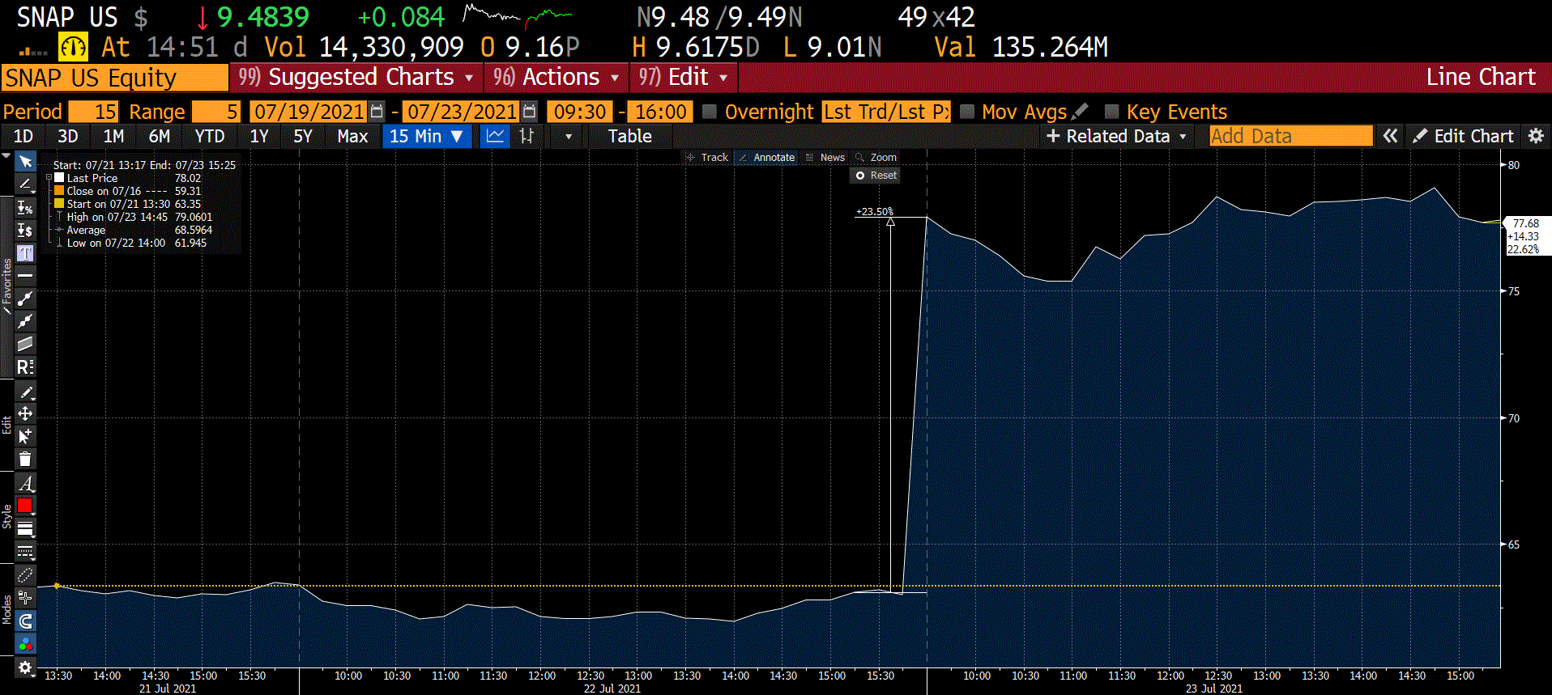
Or our 167% win in 1 day after Abercrombie & Fitch stock went DOWN earlier this year.
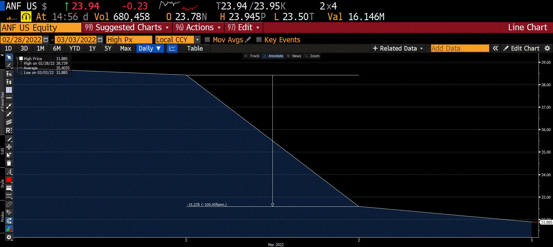

As you can see...
Regardless of the direction of the stock, we’ve been able to make huge profits quickly using this trade...
And as a reader of Trade of the Day Plus, you’re going to learn the basics of this powerful strategy...
WITHOUT having to spend $7,500 on The War Room today.

This special video training – which you can watch, rewind, pause and replay at your convenience – will help you get the tricks of the trade down pat.

And it’s yours. Forever.

But that’s not the last thing you’re going to get.
I’m also going to send you...
Special Bonus #4: “The Insider Files: The Ultimate Guide to Profiting off Insider Action”

[Report graphic]
This brand-new report that I put together goes over how I use my “Insider’s Code” strategy to make profits upward of 100% by following insider activity.
Harvard and MIT researchers conducted a 21-year study that demonstrated that insider buying has consistently beaten the overall market.
It’s one of the best indicators you can use to determine when a stock will go up.

And using my experience as an insider myself...
I’ve used my proprietary Insider’s Code strategy in one of my premium research services to crush the markets in 2022.
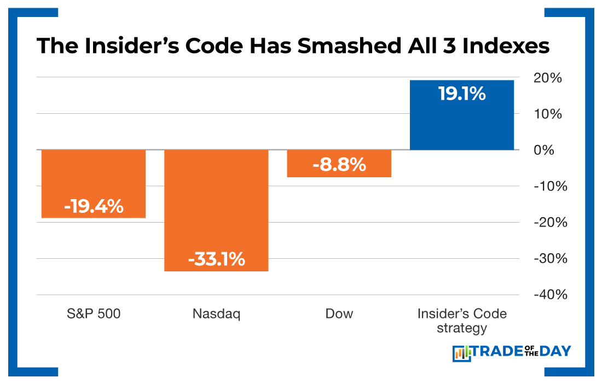
I go over my entire approach in detail inside this new report...
Which I’m going to immediately send to you for free...
Along with the other 3 reports and the training video that I promised to send when you join.
So how much does it cost to become a Trade of the Day Plus subscriber?
NORMALLY, a membership sells for $249 per year...
And as I mentioned earlier... my groundbreaking new report, “Defeating China: The #1 U.S. Stock to Soar From 2-Nanometer Chips,” would EASILY be valued at $495 if I sold it as a special on its own...
But today... I’m dropping the price for you.
I want you to get this exclusive, urgent report in your hands...

So today your price is only $49...
For an entire year!
Think about it...
That’s only 94 cents per week!
And as a member, you’ll get my best trade recommendations delivered to you weekly.
Just one small winning trade from the service could easily pay for the entire year.
There is one more thing, though...
I’m taking your risk out of the equation and including my...
[SEAL]
100% Money-Back Guarantee

If Trade of the Day Plus doesn’t live up to your expectations at any point over the next 365 days...
Simply reach out to our Baltimore-based Member Support Squad, and we’ll quickly issue you a full refund...
PLUS – I’ll even let you keep all of the free reports I’m giving you today when you join.

All you need to do to take advantage of this risk-free deal today is click on the “SUBSCRIBE NOW” button below...
It’ll immediately take you to a secure order form where you can review everything you’re going to receive today.
TRUST ME – I know it’s a lot.
But I’m doing everything I can to make this the best $49 you’ve spent in your life.

As former Money Map Press publisher Mike Ward says...

“Karim Rahemtulla is one of the smartest investing minds working in the trenches today. It’s important to listen to what he has to say – in fact your entire financial life may depend on it.

He shows in great detail and with fearlessness where the next generation of mega wealthy individuals will make their millions. Follow his advice, and you could be one of them.”
My #1 stock play to take advantage of the “do or die” resurgence of American chip manufacturing...
Could be life-changing in and of itself...
But it’s just ONE piece of what I’m sending you today...
Let’s recap everything you’re going to get when you join Trade of the Day Plus:
[BUNDLE GRAPHIC]
- Daily Issues of Trade of the Day – You’ll get our daily briefings detailing what we’re most excited about in the market. We’ll give you the top-moving stocks, explain the appropriate trading strategies and give you an idea of where markets are headed next.
- 52 Weeks of Trade of the Day Plus Recommendations – Every Wednesday at 5 p.m. ET, you’ll receive our video breakdown of the #1 investment opportunity of that week.
- “Defeating China: The #1 U.S. Stock to Soar From 2-Nanometer Chips” – This is my brand-new report that goes over the little-known chip stock that is poised to explode thanks to American chipmakers foiling China’s plot to destroy America.
- Bonus #1: “Chip Domination Profits: My Top 6 Semiconductor Plays”
- Bonus #2: “In Case of Emergency Break Glass: The Official China Invasion Contingency Plan”
- Bonus #3: How to Execute the Win-Both-Ways Trade (the First Episode in a Special Video Series)
- Bonus #4: “The Insider Files: The Ultimate Guide to Profiting off Insider Action”
- Access to Our Complete Model Portfolio, With All Current Recommendations and Status Updates
- Access to Our U.S.-Based VIP Concierge Team
- And... Password-Protected Access to Our Trade of the Day Plus Website – where you can conveniently see past issues, access the portfolios and read our latest market breakdowns.
A $1,085 value...
All backed by our 100% risk-free guarantee...
For just $49 per year when you click the button below this video!
Look...
This tiny chip stock that I’ve talked about today isn’t going to remain this dirt cheap for that much longer.
As I mentioned earlier, similar stocks are now trading for up to $600.
I could very easily see this stock reaching those marks as this fluid situation with China and Taiwan plays out.
But by then, it will be too late...
Just during the time that it took me to put this presentation and research together...
We’ve already seen the stock jump over 45% during the fourth quarter of 2022...
And that’s only the very beginning of what I believe will be a 525% surge!
The exponential gains are coming in 2023... but you must take action now!
If you wait longer...
Your once-in-a-lifetime opportunity to take advantage of this generational shift in technology could be over.
This is where you are going to want to have your money as China’s plot unfolds.
So click on the link below now...
I look forward to welcoming you into our community of smart investors.
To your success,
Karim Rahemtulla
January 2023

https://www.bloomberg.com/opinion/articles/2022-06-23/economic-chaos-of-a-taiwan-war-would-go-well-past-semiconductors
Citadel quote https://www.yahoo.com/video/ken-griffin-warns-u-faces-193315585.html#:~:text=%E2%80%9CIt's%20an%20immediate%20Great%20Depression,America%20%E2%80%9Cplaying%20with%20fire.%E2%80%9D
References: https://www.bloomberg.com/opinion/articles/2022-06-23/economic-chaos-of-a-taiwan-war-would-go-well-past-semiconductors
https://www.bloomberg.com/opinion/articles/2022-06-23/economic-chaos-of-a-taiwan-war-would-go-well-past-semiconductors
https://www.whitehouse.gov/briefing-room/speeches-remarks/2022/07/26/remarks-by-president-biden-in-meeting-with-ceos-and-labor-leaders-on-the-importance-of-passing-the-chips-act/
https://www.nytimes.com/2022/08/29/technology/taiwan-chips.html
Karim expects this stock to go to $200 within next 2 years.
https://www.cnbc.com/2022/07/20/us-faces-recession-if-cut-from-taiwan-chip-manufacturing-raimondo.html
Depression Guranteed - https://finance.yahoo.com/news/heres-what-would-happen-if-china-attacked-taiwan-214917571.html
https://www.bloomberg.com/opinion/articles/2022-06-23/economic-chaos-of-a-taiwan-war-would-go-well-past-semiconductors
https://www.forbes.com/sites/arthurherman/2022/10/17/the-chip-war-with-china-is-just-getting-started/?sh=a80d5a26a08d
Chinese 5 year plans... https://en.wikipedia.org/wiki/Five-year_plans_of_China#:~:text=Broadly%20outlined%20in%20late%20October,three%20times%20the%202020%20level.
China’s Long-Term Game https://www.brookings.edu/essay/the-long-game-chinas-grand-strategy-to-displace-american-order/
China’s military https://warriormaven.com/china/china-warships-us-navy
Jobs: https://www.epi.org/publication/growing-china-trade-deficits-costs-us-jobs/
Industries stolen by China https://www.businessinsider.com/the-us-has-already-lost-these-eight-industries-to-china-2012-1
Trade Deficit; https://www.census.gov/foreign-trade/balance/c5700.html
TikTok China Threat - https://www.cbsnews.com/news/tiktok-security-concerns-china-data/
FBI threat - https://www.cbsnews.com/video/wray-china-is-biggest-counterintelligence-threat-facing-the-u-s/
92% of chips https://www.theatlantic.com/international/archive/2022/10/taiwan-microchip-supply-chain-china/671615/
Trump Card https://www.foxnews.com/politics/china-taiwan-semiconductor-manufacturing
1000 chips in non-ev cars: https://electronics-sourcing.com/2022/05/04/how-many-chips-are-in-our-cars/
https://www.repairerdrivennews.com/2022/11/22/increasing-number-of-chips-in-evs-what-that-means-for-cybersecurity-repairs/
Semiconductor shipments https://www.icinsights.com/news/bulletins/Semiconductor-Units-Forecast-To-Exceed-1-Trillion-Devices-Again-In-2021
Ecommerce Shortage https://www.commerce.gov/news/press-releases/2022/04/analysis-chips-act-and-bia-briefing
Tesla ProductioN: https://www.bloomberg.com/news/articles/2021-02-25/musk-cites-supply-chain-woes-for-tesla-s-brief-production-halt
Toyota : https://www.motorious.com/articles/features-3/toyota-slashes-production/
Times quote https://time.com/6234566/how-us-win-the-tech-war-with-china/
SemiConductors New Oil - https://www.afr.com/wealth/personal-finance/semiconductors-are-the-new-oil-20210513-p57rlc
Chip Cost and Size (ASML’s new prototype cost $300 Million): https://www.reuters.com/technology/intel-orders-asml-machine-still-drawing-board-chipmakers-look-an-edge-2022-01-19/#:~:text=ASML's%20most%20advanced%20machines%20in,cost%20around%20%24150%20million%20each.
Fabs make billions of chips per year https://www.oreilly.com/library/view/enterprise-iot/9781491934258/ch04.html
Constant military strikes https://www.rappler.com/world/asia-pacific/taiwan-says-china-seeking-normalize-military-activities-near-island/
Drones https://www.nytimes.com/2022/09/10/world/asia/china-taiwan-drones.html
Taiwanese Colonel Bribe https://www.reuters.com/world/asia-pacific/taiwan-charges-army-officer-with-corruption-harming-state-security-2022-11-22/
US Military Chips from Taiwan https://www.barrons.com/articles/taiwan-tech-chip-stocks-nancy-pelosi-51659405620?noredirect=y https://www.csis.org/analysis/semiconductors-and-national-defense-what-are-stakes
Missile https://www.youtube.com/watch?v=yiaktrUer_U
Xi quote - https://www.newsweek.com/xi-jinping-says-china-become-dominant-world-power-within-30-years-1605848
Taiwanese Admiral Quote https://www.youtube.com/watch?v=akCU6wSLAR4” (1:30)
Liu Quote 1 https://www.cnbc.com/2022/08/02/apple-chipmaker-tsmc-warns-taiwan-china-war-would-make-everybody-losers.html
Liu Quote 2 https://www.barrons.com/articles/taiwan-tech-chip-stocks-nancy-pelosi-51659405620?noredirect=y
China action men - https://www.cnn.com/2022/10/27/china/china-central-military-commission-taiwan-intl-hnk-mic-ml/index.html
Blinken Quote https://thehill.com/policy/international/3694561-blinken-chinas-plans-to-annex-taiwan-moving-on-a-much-faster-timeline/
Biden Quote- https://www.nytimes.com/live/2022/11/14/world/biden-xi-meeting
Chip production during covid was only 10% impact by COVID. Taiwan produces 92% of chips. https://www.nytimes.com/2022/01/25/business/economy/chips-semiconductors-shortage.html
Gift of breath: https://www.wsj.com/articles/pacemaker-ultrasound-companies-seek-priority-amid-chip-shortage-11633258802
Internet Quote: https://www.ncta.com/whats-new/how-the-semiconductor-chip-shortage-could-harm-americas-universal-broadband-ambitions
Micron announcement https://investors.micron.com/news-releases/news-release-details/micron-announces-historic-investment-100-billion-build-megafab
IBM announcement https://www.syracuse.com/politics/2022/10/ibm-to-invest-20-billion-to-expand-manufacturing-research-in-hudson-valley.html
Intel Arizona Project - https://www.wsj.com/articles/intel-inks-30-billion-funding-partnership-with-brookfield-to-finance-chip-factory-expansion-11661254261
Intel Ohio Investment https://www.cnbc.com/2022/01/21/intel-plans-20-billion-chip-manufacturing-site-in-ohio.html
Chip act breakdown: https://www.whitehouse.gov/briefing-room/statements-releases/2022/08/09/fact-sheet-chips-and-science-act-will-lower-costs-create-jobs-strengthen-supply-chains-and-counter-china/
TEM Microscope - https://www.labx.com/resources/electron-microscope-price/425#:~:text=Transmission%20Electron%20Microscopes%20(TEM)%20cost,%2420%2C000%20to%20%24600%2C000%20for%20used.
128 patents: https://www.sec.gov/Archives/edgar/data/1275014/000156459021007569/uctt-10k_20201225.htm
Chips https://seekingalpha.com/article/4527242-ultra-clean-holdings-inc-uctt-ceo-jim-scholhamer-on-q2-2022-results-earnings-call-transcript
Hardware Times Article: https://www.hardwaretimes.com/intel-tapes-out-first-2nm-and-1-8nm-chips-4nm-production-planned-by-the-end-of-the-year/
75% less power https://www.engadget.com/ibm-2nm-chip-power-efficiency-100001102.html
45 percent higher performance - https://www.theverge.com/2021/5/6/22422815/ibm-2nm-chip-processors-semiconductors-power-performance-technology
IBM Chip announcement: https://research.ibm.com/blog/2-nm-chip
IBM VP quote: https://www.indiatimes.com/amp/technology/news/ibm-2-nm-chip-nanosheet-technology-mukesh-khare-interview-544760.html
$800 revenue projection https://www.investors.com/research/the-new-america/uctt-stock-stands-to-gain-as-outlook-remains-strong-for-chips/
Investor Presentation: https://s29.q4cdn.com/619069826/files/doc_presentations/2022/10/UCT-Corporate-Presentation-Fall-2022-Final.pdf
Quarterly SEC Filing - https://d18rn0p25nwr6d.cloudfront.net/CIK-0001275014/82623729-726a-4788-a3a4-2445bc0f27c3.pdf
screenshot_1667920109950.gif
UCTT 2022 revenue: https://companiesmarketcap.com/ultra-clean-holdings/revenue/#:~:text=Revenue%20in%202022%20(TTM)%3A,(TTM)%20is%20%242.42%20B.
Slide 7 of Q4 2021 presentation - https://static.seekingalpha.com/uploads/sa_presentations/132/77132/original.pdf
Q2 earnings call https://www.fool.com/earnings/call-transcripts/2021/08/02/ultra-clean-holdings-inc-uctt-q2-2021-earnings-cal/
Research Team’s Doc (Page 3) UCTT notes (1).docx
Zack’s Quote https://www.zacks.com/stock/news/1958181/ultra-clean-uctt-to-report-q2-earnings-whats-in-store?TSPD_101_R0=08d01cef9bab2000bc1cf78321c930aec97526e90d1e23d106143a26ce8472033cb0d16af8a2e0e7086d10e56d143000124ac7c6c6915c31e51c6640318d5799e72eacfdc9a770d9400
Research Team’s Doc (Page 1)
Pure monoplies are rare: https://courses.byui.edu/econ_150/econ_150_old_site/lesson_08.htm
ASML monopoloy https://seekingalpha.com/article/4563084-asml-stock-monopoly-deserves-premium-price-buy
Investor Presentation: https://s29.q4cdn.com/619069826/files/doc_presentations/2022/10/UCT-Corporate-Presentation-Fall-2022-Final.pdf
Pulled by research via Bloomberg their exact note “Invesco Small Cap Value Fund added a new position in UCTT and exited Diamondback Energy in August, UCTT was the largest new position for this Fund (aug), adding 336,800 shares for $9.86M.”
Wolf Speed Price target of $155 https://www.marketscreener.com/quote/stock/WOLFSPEED-INC-8892/news/Evercore-ISI-Initiates-Wolfspeed-at-Outperform-Rating-With-Street-HIgh-155-Price-Target-41762605/
Emcore (EMKR) trading at $0.86 as of Dec 28th. High price target of $4.50 https://www.marketbeat.com/stocks/NASDAQ/EMKR/price-target/
2022 Track Record per Research Team as o Nov 18th
War Room 07/22/21 Trade: SNAP 6 Aug 21 $62 Call
War Room 03/01/222 Trade: ANF 4 Mar 22 $36 Put
Harvard Insider study: https://scholar.harvard.edu/files/rzeckhauser/files/insider_trading.pdf

