#1

The Wall Street legend who recommended Tesla in 2012 before its 16,724% move reveals:
Elon’s Biggest Launch Ever
Musk’s Next Project Could Be Bigger Than SpaceX, Tesla, and xAI… COMBINED
Discover how to get involved today for as little as $60…

#2
This would come with some additions to the lead explaining that Tesla cars are dying in favor of his breakthrough new product
“Nobody will remember that Tesla ever made a car.”
- Angel Investor Jason Calacanis
The Death of Tesla
It’s About to Make Elon Musk Richer Than Ever… and Send Three Overlooked Stocks Soaring 25,000% or More Over the Next Decade

#3
Master trader who recommended Tesla in 2012 before its 16,724% move reveals:
Elon’s Global Takeover
Discover How Musk’s New Breakthrough Could Deliver 250X Fortunes to Early Investors Over the Next Decade

#4
Elon Says Breakthrough Could Become “the Biggest Product of All Time”
See How It Could Send Tesla Ripping 25X Higher…
And Make Early Investors RICH Over the Next Decade

#5
Elon’s Latest Breakthrough Could Create…
“Infinite Money.”
See How to Get Involved for Just $60 Today
“Sooner or later, Wall Street will accept that Elon Musk is the real deal.”
That’s what I wrote over a decade ago to readers of my first research service ever when I was pounding the table to buy Tesla.
That was back when the stock was trading at a little over $2, split adjusted.
Today – it’s trading over $400!
It’s safe to say that Wall Street now takes Elon Musk seriously.
But something strange has happened over the past few months....
You may have noticed.
After dominating the headlines nearly every day… Elon Musk has suddenly gone quiet.
The media isn’t talking about him.
No big interviews.
And he’s stepped away from politics.
So why the radio silence?
Well… because he’s been developing something brand new…
Quietly preparing for his BIGGEST LAUNCH EVER.
ALT INTRO STARTS WITH THIS LINE: As we speak, Elon Musk is urgently preparing for his BIGGEST LAUNCH EVER.
One that could outsell Tesla…
Outpace the growth of SpaceX…
And deliver 25,000% or more to early investors over the next decade.
It could send Elon’s net worth soaring…
And create what he calls an “infinite money glitch” for his shareholders.
Thanks to this new project, Tesla might soon produce 5 times as many cars for a fraction of the cost…
And SpaceX could save billions.
But it’s not just Elon who will benefit…
This breakthrough technology could soon revolutionize factories across America…
Along with warehouses, mills, farms, fulfillment centers, ports, shipping facilities, and more.
It could save retail and grocery giants a fortune…
Overhaul the slow, outdated security at airports…
Maybe one day even replace your doctor.
In total, Musk says the demand will be record-breaking…
Predicting his new product could become “the biggest of all time” – bigger than even cars or cellphones.
Now, say what you want about Elon…
I think he's off the reservation half the time.
But his track record speaks for itself.
Neuralink is up 33,000% in 9 years...
Tesla is up 36,000% in 16 years…
Starlink went from $0 to a $700 billion valuation in 8 years.
After just 3 years in existence, xAI was acquired for $250 billion… the largest private acquisition in history.
And then there’s SpaceX.
Worth just $1.3 billion in 2012…
It’s expected to IPO this year for $1.5 trillion.
That would make it the largest IPO ever!
ALT: And it just IPO’d for over $1.5 trillion – the largest IPO ever!
Every time Musk launches something new… he succeeds.
And now he’s diving into an industry that’s set to grow at record speed.
Morgan Stanley projects a “$25 trillion revolution” in the sector through 2050.
That’s 250-fold growth.
And the smart money is pushing in their chips.
Peter Thiel – the billionaire investor who funded PayPal, Facebook, Palantir, and OpenAI – has invested $1 billion…
Cathie Wood’s ARK Invest – 2025’s top performing ETF – has invested $2 billion…
And Jeff Bezos has poured in as much as $6 billion.
These are massive investments.
But today, I’ll show you how you can get involved with as little as $60.
Hi, I’m Bryan Bottarelli.
Let Me Introduce Myself…
I got my start on the trading floor of the CBOE.
It was fast-paced, stressful work…
Most couldn’t hack it.
But I loved the excitement of live trading.
I quickly discovered the key to successful investing:
The ability to recognize trends and anomalies early.
And I realized I was good at it.
So I left the trading floor and started my own service.
Every moneymaking opportunity I found… I shared with my readers.
For instance, I called attention to Apple in 2011… saying to be on the lookout for “a possible breakout.”
At the time shares were trading for a split adjusted $12.35.
Today they’re 2,100% higher.
I did the same thing with Netflix in 2012, saying there will be “higher prices ahead.”
That turned out to be the understatement of the decade.
Today it’s up over 10,000%.
That same year I called ASML “the hot property in chips.”
It’s risen 2,000% since.
But one of my favorite stocks to play was – and still is – Amazon…
I’ve written about it 113 different times, starting in December of 2009.
It’s risen 3,100% since my first article.
As you can probably tell… I’m a fan of tech stocks.
And I’ve been tracking Elon’s moves for a very long time.
Way back in 2012, I told my readers…
"No other company (aside from Apple) is redefining their current market sector quite like TSLA...
“Let’s put away some shares in long-term storage, and not even look at them for a year or two.”
That was when it was trading for less than $2.50, split adjusted.
Today it’s up 16,000%.
Enough to turn a $1,000 investment into $160,000.
Or $10,000 into $1.6 million for those that held on for the long haul.
Now, gains like this are rare and typically involve holding for many years.
But the key is to identify these revolutionary opportunities EARLY.
And that’s why I’m coming to you today.
Because if you act fast, you can get in on the ground floor of Elon’s newest venture.
It could be the smartest thing you ever do.
If it’s even 10% as big as I expect, this will easily be his most successful project ever.
I’m not the only one who thinks so.
Jason Calacanis – the angel investor who made a fortune getting into Uber early – visited Musk’s facility to see this new creation in person.
Here’s what he had to say:
“It will be the most transformative technology product ever made in the history of humanity.”
He added that it was so impressive… “nobody will remember that Tesla ever made a car.”
And then he made a stunning prediction:
Musk “is going to make a billion of those.”
A billion.
It’s going to be in every healthcare facility… every factory… every warehouse…
And ultimately… every home in America.
This technology could improve the output and efficiency of every single industry on Earth.
It could supercharge our military…
Reshape our economy…
And cement the United States as the world’s undisputed superpower.
It’s going to usher in a wave of wealth creation unlike anything we’ve ever seen.
Virtually every business on earth could reap the rewards.
It’s why I expect demand unlike anything we’ve ever seen.
Especially when you consider…
Every time Musk puts his mind to something…
He succeeds…
And early investors get rich.
Everything Elon Touches Turns to Gold… and Makes Investors RICH
It started way back in 1999 with PayPal.
Elon looked at the banking industry and saw an opportunity.
Banks were slow, bloated, and hadn’t innovated in decades.
So Elon and his business partner Peter Thiel set out to do something radical…
They created an “internet bank.”
A way to send and receive money online – instantly.
People thought they were crazy.
The big banks laughed them off.
But Musk knew he could pull it off.
Today, PayPal has over 434 million users worldwide.
Chances are you’ve used it yourself to buy something online.
And if you compare PayPal to traditional banks, it now ranks in the top 5 in the nation by payment volume.
Early investors who believed in Elon’s vision made 16 times their money over 20 years.
And Elon?
He sold PayPal for $100 million.
And here’s what I like most about Musk…
He could’ve retired and lived the rest of his life comfortably on a beach somewhere.
But instead he bet on himself, and invested his $100 million into a new, even bigger project…
Tesla.
This time, his vision was especially radical…
He wanted to build fast, beautiful electric vehicles that people would actually want to drive.
At the time, electric cars were a joke.
The batteries were awful… charging took forever…
And they were hideous.
Every EV had failed.
But Elon knew he could do it better…
And he did.
Today, Tesla is worth more than every legacy automaker combined.
Ford, GM, Toyota, Volkswagen – all of them together don’t match Tesla’s market cap.
In 2024 alone, Elon added a staggering $72.2 billion to his personal net worth… largely because of Tesla’s continued innovation.
And investors who got in early have seen gains of over 26,700% in just 15 years.
Imagine if you’d put just $1,000 into Tesla when it went public in 2010…
That single bet would be worth over $260,000 today.
If you’d invested $10,000, you’d be sitting on over $2.6 million.
Musk had revolutionized two industries…
But he still wasn’t done.
Next, he looked to revolutionize the space industry.
NASA was inefficient and outdated.
It was hindered by political red tape.
And because every rocket was single-use, it cost a fortune to launch anything into space.
Musk knew he could do better.
So he got to work building rockets that could land themselves and be reused.
Everyone said it was impossible.
Rockets don’t land… they crash into the ocean.
But on December 21, 2015, the Falcon 9 rocket became the first ever to land upright.
CAN WE SHOW FOOTAGE FROM A NEWS STATION, ETC?
Since then, SpaceX has won massive contracts from the U.S. government…
Sent thousands of satellites into orbit…
And is expected to IPO this year for as much as $1.5 trillion.
That would make it the largest IPO in history.
ALT
Since then, SpaceX has won massive contracts from the U.S. government…
Sent thousands of satellites into orbit…
And just IPO’d for over a trillion dollars.
It’s the largest IPO in history.
Early investors who got in back in 2012?
They’re up around 115,000%!
Enough to turn $1,000 into $1.1 million…
And $10,000 into $11 million.
And here’s what’s exciting…
If you missed out on those previous plays, you’re about to get another chance.
But this time, Musk is going even bigger.
His newest creation could dwarf PayPal, Tesla, and SpaceX combined…
And send Tesla rocketing to a $25 trillion valuation in the next decade.
A 250X Robotics Breakthrough
Because just like he did with banking, EVs, and rockets…
Elon is now set to revolutionize another industry…
Robotics.
The sector is red-hot right now.
MarketsandMarkets calls it “the fastest-growing frontier in industrial tech.”
And Zacks notes “unprecedented expansion.”
In the last year alone, Symbotic is up 128%...
Tower Semiconductor is up 248%...
And Ondas is up nearly 1,300%.
Imagine 13Xing your money in a single year.
That’s the kind of potential we’re seeing in robotics right now.
And it’s about to get even bigger.
See, the vast majority of today’s robots do only one thing.
B-ROLL HERE OF MACHINES IN CAR FACTORIES
These basic robots are used to install doors on cars over and over…
Move boxes from point A to point B…
Or fabricate the same piece of machinery millions of times in a row.
They’re dependable…
But you can’t ask them to do any other task.
They don’t have the ability to learn or problem solve.
They can’t move without being preprogrammed.
And they can’t think, see, or speak.
To truly revolutionize American manufacturing, - a big goal of the current administration - these robots need to change in a big way.
We need robots that can see, think, move, touch, feel, problem solve, and more… all on their own.
It’s a big ask…
And it’s something leading robotics companies have been unable to figure out for decades.
But Elon is about to change everything.
Unlike the clunky, single-purpose robots in factories today…
He’s creating Optimus: an AI-powered super robot.
It stands about 5’8” tall, weighs 125 pounds… and is the breakthrough the robotics industry has been waiting for.
Rather than being programmed to perform a specific task…
Optimus learns by doing…
And soon, it will be able to do practically anything.
Teach it to assemble a motor… and it will do it flawlessly, hour after hour, without stopping.
Show it how to load a truck, and it will get right to work.
Need it to perform quality control?
Simply teach it once, and it’s good to go.
Best of all… the same robot can do all these tasks.
It’s why Musk predicts each one will be able to 5X the productivity of a human worker.
So just imagine how quickly these things could sell once he launches publicly.
It won’t be long…
Optimus robots are already working inside Tesla’s factories.
And Elon is scaling fast.
In January he shut down production of the Tesla Model S and Model X…
To produce robots instead.
And the number he’s making will shock you.
His Fremont factory is projected to produce around 1 million per year…
And he says the Gigafactory in Texas could produce 10 million annually.
Eventually, Musk says production is “going to literally get to 100 million a year.”
To put that in perspective…
Boston Dynamics has been working on robots for over 30 years.
In that time, they’ve produced just a few thousand units total.
Tesla is planning to build a million or more annually.
These robots will be capable of doing almost any task… over and over… perfectly.
Businesses across America will be lined up for this ONE product…
Factories.
Warehouses.
Shipping yards.
Hospitals.
I believe this technology is set to supercharge American industry in a way we haven’t seen since the assembly line.
And I’ve found three little-known companies that supply critical technology that Optimus – and other robots – desperately need.
Best of all, you can get your foot in the door for around $60– at least until word gets out.
Then all bets are off.
But for now, the timing couldn’t be better...
A New Industrial Revolution
See, President Trump wants desperately to reshore American manufacturing…
But there’s a massive problem…
Labor.
It’s expensive. It’s inconsistent. And with an aging population, it’s getting harder to find.
A new study by Deloitte estimates America will have 2.1 million unfilled manufacturing jobs by 2030.
That could cost us $1 trillion – annually.
And it would be a disaster for our manufacturing race against China.
China is already considered the world’s sole manufacturing superpower.
With 28-35% of global output, the country produces more manufactured goods than the next nine largest countries combined.
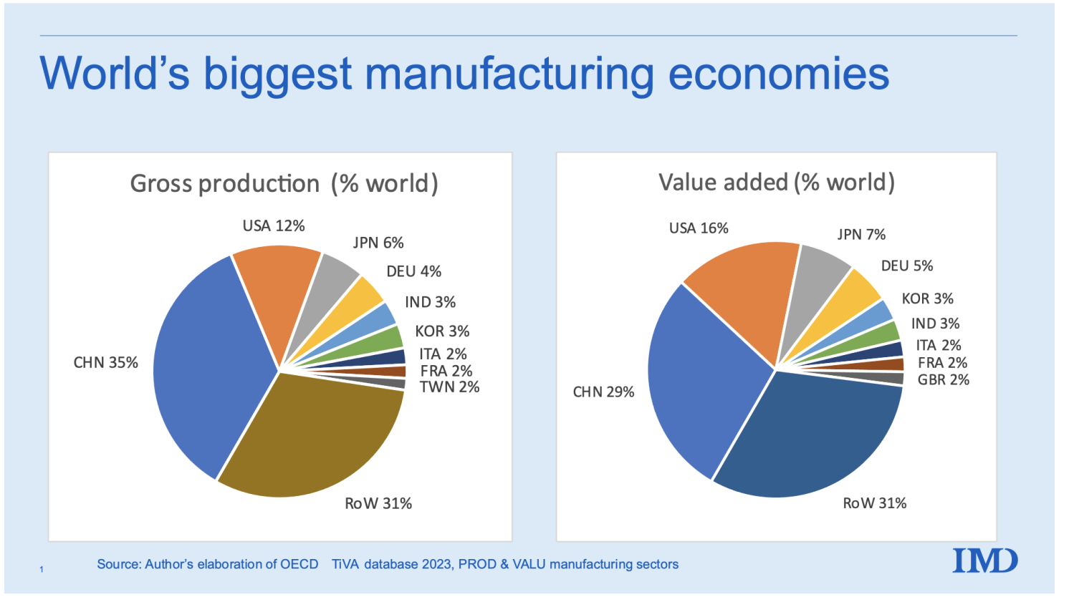
We can’t afford to lose more ground.
And Elon’s Optimus is the perfect solution.
It can be trained to do any task… never calls in sick… and never needs a break or vacation…
It doesn’t forget or make mistakes…
It won’t mind doing the boring or repetitive jobs that humans don’t want…
And it can do jobs that are too dangerous for you or me.
Best of all…
Elon estimates that Optimus can match the productivity of five human workers.
So every million robots deployed could be like adding 5 million people to the workforce.
Imagine what would happen to our economy if every facility suddenly improved its productivity by a factor of five...
Every steel factory and gold mine…
Every AI chipmaker and assembly line.
Five times more output.
It’s exactly what Trump wants for America.
Now, a few years ago that kind of improvement would’ve sounded crazy.
But thanks to AI and robotic breakthroughs like Optimus… it’s actually possible.
And get this…
Elon expects to sell them for way less than you’d think…
Somewhere between $20,000 and $30,000 each.
That’s less than one year’s salary for a minimum wage worker.
Which is why Elon predicts the Optimus will be the biggest product of all time.
“The Biggest Product of All Time” – Elon Musk
It’s no wonder that Citigroup projects the humanoid robotics market will grow by 350,000% over the coming decades.
350,000%!
Every major manufacturer, logistics company, retailer, and warehouse operator on the planet is going to want Elon’s robots.
Especially since they’re being designed specifically to work alongside humans.
Amazon has over 1 million workers in its fulfillment centers.
And Walmart has over 2.1 million employees.
What if just 10% of those workers received an Optimus assistant to help improve productivity?
We’re talking about hundreds of thousands of units sold to just two customers.
It would mean a massive payday for Tesla…
And a huge increase in production for Walmart and Amazon.
In fact, one analyst estimates a 10% Optimus workforce would save Walmart $8 billion annually...
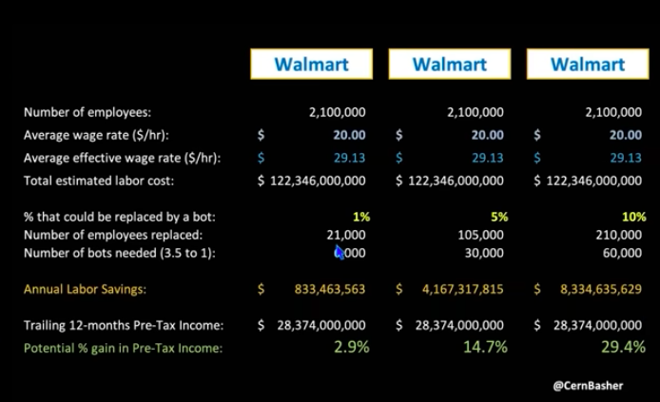
And boost their income by 29%.
Can you think of one business that wouldn’t do that?
I can’t.
Now, you’re probably thinking…
“Ok, Bryan, that’s great for Walmart…
“But won’t a bunch of folks lose their jobs?”
Actually, history gives us an idea of how it will play out.
And it’s far different than you would expect.
The concept is called Creative Destruction.
Old jobs go away as newer, better jobs are created.
And usually, far more jobs are created than destroyed.
For instance, the car quickly put the horse and buggy out of business.
Roughly 623,000 jobs were displaced between 1910 and 1950.
That’s a lot, to be sure…
But these jobs weren’t lost.
Because 7.5 million newer, better jobs were created in the process.
Same thing when the ATM was invented in the 1970s.
Bank tellers feared the worst.
Instead, banks opened 43% more branches and hired more tellers as their costs fell.
Or look at Amazon…
Online shopping essentially killed the mall.
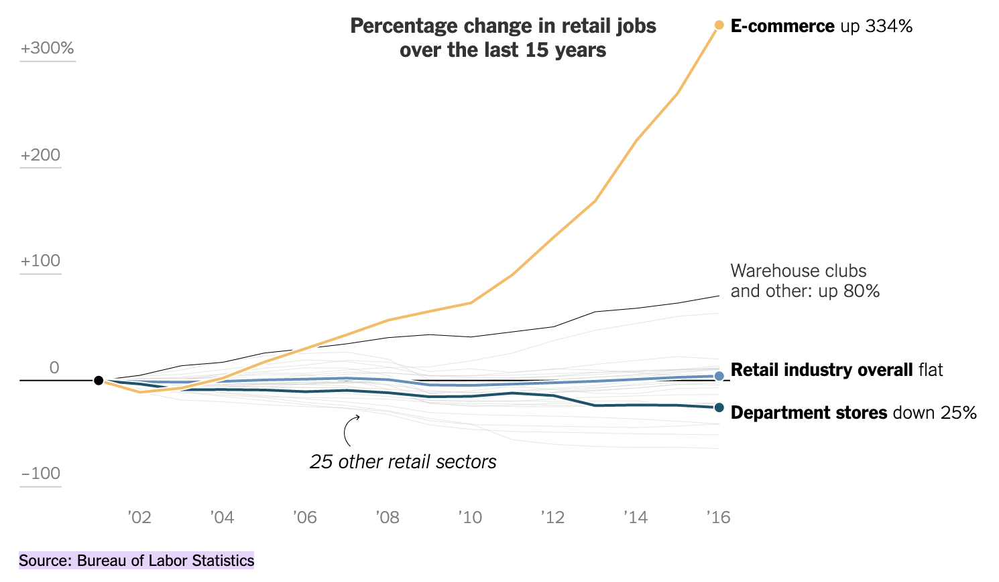
But it created countless jobs in warehousing, fulfillment, and delivery.
Amazon alone created over 2 million U.S. jobs for small businesses that sell online.
It’s exactly what’s going to happen with robotics.
And Optimus is light years ahead of the pack.
Elon says it’s “going to be by far the most advanced robot in the world.”
It’s all possible thanks to a weird shift that almost no one saw coming…
One that gives Optimus a massive advantage over every other robot.

“Tesla Used Cars as a Laboratory to Get Good at Other Things”
See, most people think of Tesla as a car company…
But it turns out, Elon has been using his cars as a technology testing ground all along.
Batteries…
Self-driving…
Data…
Artificial intelligence…
Even robotics.
Adam Jonas, a top analyst at Morgan Stanley, put it perfectly:
“Tesla used cars as a laboratory to get good at other things.”
Now, Musk says “we should be thought of as an AI robotics company.”
He’s taking everything he’s learned with Tesla…
And using it to build the most advanced robot on earth.
OPTIMUS IMAGERY HERE
It puts him light years ahead of competitors.
For instance, vision has long been a problem for robots.
#1: Vision That Actually Works
See, most robotics and car companies rely on LIDAR sensors to map the environment.
It’s bulky, expensive, and unreliable.
VIDEO SHOWS ROBOT GETTING CRUSHED BY TRAIN
https://www.youtube.com/shorts/BejQC2iyEqk
VIDEO SHOWS WAYMO BLOCKING AMBULANCE
https://www.kvue.com/article/news/local/austin-mass-shooting/waymo-blocking-ambulance-video-downtown-austin-mass-shooting/269-b0904a2c-7562-4f19-affc-c6c2a08aadc2
Case in point… you may’ve heard about Waymo cars blocking roadways during emergencies…
Or getting confused when presented with obstacles.
VIDEO SHOWS FUNNY WAYMO INTERACTION
https://www.reddit.com/r/SelfDrivingCars/comments/1rfu3mo/comical_multiwaymo_interaction_at_an_intersection/
So Tesla took a different approach.
They built a vision system using cameras alone – the same way humans see the world.
Tesla’s system can recognize objects, navigate obstacles, and react to the unexpected…
All in real-time.
And they’ve perfected it over 7 billion miles of real-world driving.
Every Tesla on the road is constantly collecting information…
Learning from millions of different scenarios…
Then using that data to improve.
They already have over 30 petabytes of training data.
If you printed that amount of text… the stack of paper would reach 150,000 miles high…
Enough to wrap around the Earth six times.
Now this same vision – the one that can already navigate chaotic city streets – is being adapted for Optimus.
It’s a huge advantage.
One that competitors can’t replicate.
In a moment I’ll show you how to get involved in Elon’s 250X revolution – before Optimus officially launches.
But first let me tell you about his second advantage.
Because this one is even bigger…
Advantage #2: The AI Brain
I’m talking about the AI brain that powers his robots.
Because while most robotics firms have to pay to use other companies’ artificial intelligence…
Musk developed his own.
xAI is one of the most impressive AI projects in the world, and it’s growing at lightning speed.
It built the world’s biggest supercomputer in just 4 months…
A process that usually takes 4 years, according to Nvidia CEO Jensen Huang…
Then doubled its power again.
This thing is so massive... it’s tough to comprehend.
For instance, have you ever heard of an exabyte?
I hadn’t.
Apparently, to record an exabyte of data, you’d have to be on a video call for 237,823 years.
And xAI has more storage than that.
But according to Elon, that’s just the tip of the iceberg.
He says that within 5 years, xAI will have more computing power than everyone in the world combined.
And it’s all funneling straight into Optimus’ brain.
Again, it’s an advantage that no one else can replicate.
So it’s no wonder the Optimus is improving so quickly.
SHOW GEN 1 VS GEN 3 OPTIMUS
https://www.youtube.com/watch?v=tUMcLbCjr0w
Elon’s proprietary technology allows his robots to see AND think better than other robots…
Of course, it doesn’t matter how good your robots are if you can’t get them to market.
And that’s Elon’s third big advantage.
Advantage #3: Unmatched Manufacturing Scale
You see, most companies simply don’t have the ability to produce robots at scale.
But as Bloomberg points out, robots use essentially the same components as electric vehicles.
Both need advanced batteries, electric motors, sensors, AI, and more.
It gives Tesla a massive head start.
And even the strongest competitors don’t stand a chance.
For instance, OpenAI makes ChatGPT – maybe the most famous AI model.
But it doesn’t have the facilities, labor, or partners it would need to make physical robots.
Likewise, Google creates AI brains and other software…
But not the robots themselves.
Then there’s Boston Dynamics.
They’ve been around for over 30 years.
But they’ve only deployed around 2,000 robots in total.
They simply don’t have the infrastructure they would need to build robots at scale.
Tesla is different.
They already operate six Gigafactories across three continents, with a seventh on the way.
These factories produce 4,700 cars daily…
Each with the same vision and navigation… same AI brains… and same battery technology that powers Optimus.
And one of these Gigafactories has already been fully converted for robot production.
Musk plans to produce a million there annually by the end of the year.
Then 10 million more per year at his Giga Texas location.
These Gigafactories are completely turnkey…
With all equipment, processes, and workers already in place.
Which means, while potential competitors take the time to build out facilities, Tesla has already hit the ground running.
And there’s still another advantage I haven’t mentioned…
Advantage #4: Massive Cost Advantage
Most people don’t know it…
But Tesla designs almost everything in-house.
Their own technology, AI chips, batteries, motors, software and more.
And they have a number of key partnerships that perfectly compliment what they do.
These small plays are critical to the work Musk is doing.
I’ll tell you about some of my favorites today.
But here’s the bottom line…
All this gives Tesla a massive cost advantage.
Analysts estimate Elon will be able to produce Optimus robots for a fraction of what competitors spend…
Making them affordable for widespread adoption.
Musk says they’ll start selling to the public by the end of the year.
Which is why it’s critical that you get in as soon as possible.
Because once these robots open up for public purchase, it’s off to the races…
Amazon… Walmart… Target… Kroger… Whole Foods… steel plants… microchip factories…
Everyone will want them.
I believe we’ll see a mass adoption event similar to the internet or the iPhone.
And those who wait will miss the biggest growth opportunity of our lives.
Now, here’s the thing…
There’s no doubt the robotics revolution is happening.
And hitching yourself to Musk is never a bad idea.
But I believe the best way to play this isn’t Tesla itself.
I’m sure its stock will do well…
But I’ve found three smaller plays that I like even more.
Here’s why…
They’re smaller… more versatile…
And they sit at critical “chokepoints” – not just for Tesla – but for the entire robotics industry.
Which means they should explode in value as America enters the age of automation.
And right now, you can get started for as little as $60 a share.
You won’t hear about these stocks on CNBC.
The Wall Street analysts haven’t caught on yet.
But I can guarantee you they will soon.
These smaller players supply crucial technology.
Without it, Optimus doesn’t work.
Neither do the robots being built by Amazon, Boston Dynamics, or any of the other tech giants pouring billions into this space.
And that’s great news for us…
It means these stocks should soar as the robotics market surges higher.
Some little-known robotics plays are already moving…
Like Ouster, up 154%...
Nextpower, up 163%...
And GSI Technology, up 131%...
All in the last year.
Cyngn even jumped 483% in just 15 minutes!
But because of their unique positioning, I believe the three stocks I’ll take you through now have even more potential.
If Optimus sends Tesla doubling from here, I could see these plays jumping 2,000% or more.
If Tesla 20Xs as Elon predicts… I think 25,000% within the decade is possible.
So let me quickly tell you about each.
The first supplies a critical material that quite literally makes Elon’s robots move.
Three Stocks Powering the $25 Trillion Robotics Revolution
STOCK #1
Optimus Needs It – Only This American Company Has It.
See, every humanoid robot needs dozens of tiny motors.
They power the shoulders, elbows, wrists… and every other joint.
And inside each of those tiny motors is a magnet made from a special type of rare earth element.
Without it?
There’s no torque.
No strength.
And no movement.
But here’s the problem…
China currently controls the majority of rare earth processing.
If America wants to dominate robotics and AI…
It needs its own supply chain.
And one American company holds the key.
It has the only U.S. mine that produces this critical material.
Which is why the government recently invested $400 million in the stock.
And get this…
The company already provides Tesla with materials for its car motors.
Which makes them the perfect choice to provide this element for Optimus robots.
And as humanoids scale into the millions of units per year…
Demand should skyrocket.
I expect this stock to be a big winner.
The stock has already shown what it can do – surging nearly 50% in a single morning after government backing was announced.
So just imagine what would happen if Tesla announced a new partnership with them for Optimus.
Better still…
Every robot that’s made in America – by Elon or anyone else…
Will need this company’s product before it can move off the line.
Now let me tell you about my next stock…
STOCK #2
Like a Toll Booth for Electronics
It makes highly specialized equipment that tests semiconductors.
Laptops… tablets… smartphones… storage devices… electric vehicles…
They all have chips that need extensive testing.
And this company controls roughly 50% of the market.
They’re like a toll booth for electronics…
They get paid as each product passes through.
And get this… it’s the only US-based company that can test advanced chips like the ones used in robots.
Which means that before Optimus – or any other robot – comes off the line…
It will almost certainly be tested by this company’s equipment.
Demand should go through the roof.
And there’s already a Tesla connection.
The AI chips in Tesla’s cars that allow Full Self Driving are tested by this company’s equipment.
These are the same chips that will power Optimus!
Most people are totally missing this story.
But the smart money is piling in.
According to Yahoo Finance, 11 billionaires have already bought in.
Meanwhile, Vanguard has snapped up 13% of all shares.
BlackRock has invested $2.2 billion.
And Cathie Wood – who’s made a fortune on Tesla – holds $456 million worth in her fund.
They know that this stock stands to be a big winner in the robotics revolution.
And I think this next stock could do even better…

STOCK #3
The Nervous System of Optimus?
It’s a key supplier to Tesla, GM, Volkswagen, Fiat, and most automakers in east Asia.
It provides wiring harnesses and other important components.
And here’s the thing…
Optimus needs many of the same parts…
Wires that send millions of unique signals exactly where they need to go each second.
Think of it like this…
If AI chips are the robot’s brain… and cameras are its eyes…
This company essentially makes the nervous system.
And there’s no better company for the job.
They have the infrastructure… the system… and the relationship – all in place.
From the auto sector alone, the company earned record revenue in 2025...
And now the firm is quickly expanding into other sectors as well.
By 2030, the firm aims to make 40% of its revenue from aerospace and robotics.
Personally, I wouldn’t be shocked if Optimus quickly becomes their biggest revenue source.
But for now, the stock is still cheap…
Trading at a nearly 40% discount to analyst price targets.
ALT: Trading at a huge discount to analyst price targets.
I don’t think it will stay that way for long.
In fact, the moment Elon officially launches Optimus, this thing could go to the moon.
It could happen as soon as XX DATE.
I’d hate for you to miss it.
Which is why I’d like to rush you the names and ticker symbols of these three stocks as soon as possible.
I’ve Put Everything You Need to Know in a Report Called 3 Stocks Behind the $25 Trillion Robotics Revolution
If they capture even a small slice of the robotics revolution Morgan Stanley is predicting…
The gains could be life-changing.
I’ve put all the details in a special report called “3 Stocks Behind the $25 Trillion Robotics Revolution.”
I’d like to send it to you today.
Inside, you’ll get the name and ticker symbol of each company…
A full breakdown of their technology and why it’s crucial for humanoid robots…
Plus my specific buy recommendations so you know how to get started with as little as $60.
But it’s not the only report I have for you…
Because while Nvidia CEO Jensen Huang predicted that humanoid robots will be “one of the largest industries ever...”
They aren’t the only kind of robots in production.
There are private and military drones, self-driving cars, cleaning and delivery bots.
There are robots that manufacture and build… others that assist in surgery… and still others designed to work on farms.
To give you an idea of the kind of growth we’re going to see…
Today there are roughly 4.6 million industrial robots in total…
And a report by Citi suggests there will be 1.3 billion AI robots by 2035… and 4 billion by 2050.
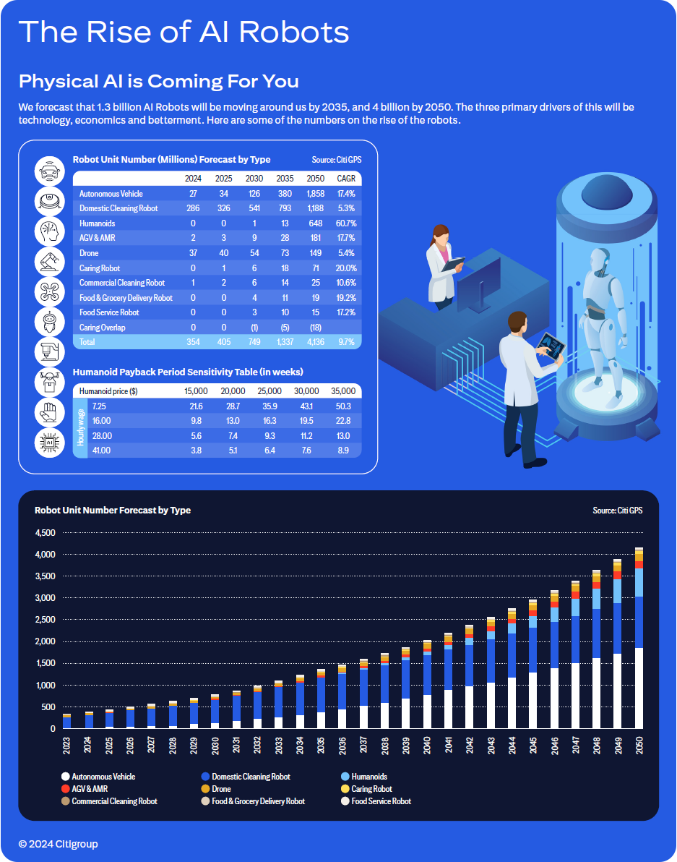
Four billion!
It will be a boon for our economy…
But there’s a problem.
Every robot uses a large amount of energy…
And with AI’s recent explosion, we’re already struggling to keep up with demand.
Every day, ChatGPT uses enough power to run 180,000 homes.
And its only getting worse…
Data-center electricity use is expected to more than double by 2030.
Meanwhile, our aging power grid is in trouble.
The American Society of Civil Engineers releases a report card each year that grades our country’s infrastructure.
In 2025 our energy sector got a D+.
That score indicates “serious concerns,” “widespread deterioration,” and “strong risk of failure.”
It needs a complete overhaul…
Particularly as AI and robotics take off.
So what’s the solution?
Nuclear.
It’s cleaner, cheaper, and safer than coal...
It’s 16,000 times more energy dense…
And the U.S. Department of Energy says “Nuclear Power Is the Most Reliable Energy Source and It's Not Even Close.”
The government is all in…
Trump has already committed $80 billion for new reactors…
And signed an Executive Order to rush their development.
Silicon Valley billionaires like Peter Thiel and Marc Andreessen have invested in promising nuclear startups…
And OpenAI, Google and Amazon have turned to nuclear power for their AI data centers.
Meanwhile, all the new demand led one company to a brilliant new design that could change everything...
It’s a special cooling tech that allows for small reactors that can power entire data centers on location.
They are quicker and cheaper to set up vs waiting for a massive full size plant to come online.
And they’re so small, they can be shipped.
Today, data centers have to be close to power plants.
That means limited space… and strained power grids.
But this company’s reactors can be installed wherever you need them.
It’s exactly what tech giants like Nvidia or Meta need.
It has already secured its place as the sole supplier of nuclear power for the U.S. Navy…
And has a record $6 billion backlog.
This guarantees the money will keep flowing in for years to come.
And now the robotics revolution could 10X this stock’s demand practically overnight.
In fact, orders are already pouring in so fast, the company is expanding production by 50%.
I’ve put everything you need to know about this company in a report called “America’s Secret Power Source.”
I’d like to send it your way along with the other report.
But there’s still one more stock you need to know about…
Because my research indicates the biggest gains over the next decade will come from three places.
We’ve already covered the first two, robotics and energy.
The third is something OpenAI CEO Sam Altman calls the “currency of the future”:
Computing power.
22X Potential from the “Currency of the Future.”
See, robots and AI systems require an enormous amount of computing power.
This power is housed in massive data centers as large as 10 million square feet!
And as the need for compute grows…
We’re quickly running out of real estate.
Thankfully, there’s a weird solution that could save the day…
Moving the data centers into orbit.
Musk says that within 3 years “the most economically compelling place to put AI will be space.”
And Starcloud’s CEO says, “My view is that in 10 years’ time, almost all new data centers will be built in space.”
In space, there’s no shortage of real estate.
Plus solar energy is constant and uninterrupted…
And cooling is far more efficient.
The shift is already happening.
An Nvidia-backed startup just launched the first AI computer into space…
Lonestar Data signed a $120 million deal to build data-storage satellites...
And SpaceX has applied to launch a "constellation of a million satellites that operate as orbital data centers.”
The market is forecasted to grow faster than Nvidia’s record-breaking run that took it from $12 to $180 in just 5 years.
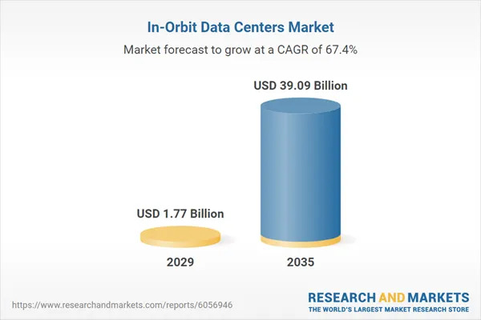
And I’ve found three perfect stocks set to benefit.
Between them, you’ll get exposure to everything you need to cash in on the growing trend over the next 6 years.
- The semiconductors that will fill the orbital data centers…
- The solar that will power them…
- The satellites that will beam the data back to earth
- And more.
I’ve put the stock tickers and details on each opportunity into a third report, called “Space Data: 3 Stocks with 22X Potential.”
I’d like to send you all three of these reports today – free of charge.
All I ask in return is that you try out my monthly research service for 60 days at no risk to you or your wallet.
It’s called Monument Trend Advisory.
And it’s the best way to keep us connected moving forward.

Monument Trend Advisory Is Where I Share My Insights on the Most Important Stocks in the Market

That’s important… because Elon’s upcoming Optimus launch is only the beginning of this revolution.
And I’d like to stay in touch so I can send you even more breakout opportunities as they come across my desk.
In Monument Trend Advisory, we discuss the top trends in the market each month, along with our recommendation on the best way to play that trend.
For instance, precious metals were red hot to start 2026.
So that was our focus.
We discussed why the boom was happening and how long it might last…
And we sent readers our #1 way to play the trend – a gold miner that’s gone up every March for five straight years.
Most people probably have no idea this stock has done so well in March.
But our research is what sets us apart – and gives us success.
And right now, our research is very clear…
Robotics is the next big trend investors should be focused on.
At Monument Trend Advisory, we’ve averaged a 67% win rate all time.
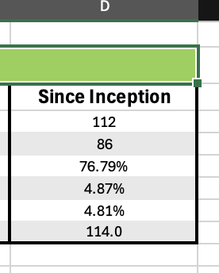
That’s 2 wins out of every three recommendations we send our readers.
Some of those wins have been life-changing.
Like in 2022, when we noticed Rolls Royce trading at crazy-low prices.
We called it, “the single best value play in the history of the markets.”
It’s up as much as 1,300% since… and has made several of our members millionaires.

Timothy wrote “I started with about $20k and [three years later] have made several hundred thousand in profit. My account is now over $1 million.”
Baron wrote, “The biggest win in my lifetime! I have a son-in-law who is going to have a very comfortable retirement now.”
And Jake really went for it… buying 65,000 shares when it was trading for under a dollar.
Three years later he wrote us to say, “My profit is right at a fat $1 million!”
Now this is our best trade yet. Not all of our winners will be homeruns.
Remember that all trading involves risk and nothing is guaranteed. So never invest more than you can afford to lose.
That said, I see the same kind of profit potential in the stocks in today’s reports.
And anyone who joins risk-free today can have them.
Then each month going forward, I’ll share my top 2-3 stock recommendations with you.
But that’s just a small part of what you’ll get.
You’ll also get alerts when we add or remove a position…
Weekly intelligence briefings…
And more.
Plus, you can join us every Tuesday at 2 pm for LIVE market analysis and commentary.
We’ll discuss the positions in our model portfolio and give you the chance to ask questions.
Just remember we can’t give personalized investment advice.
My goal with Monument Trend Advisory is simple: to help you find the best opportunities to grow your wealth.
I’ve seen members from all walks of life make real money on recommended trades.
But here’s the key…
When you see a big opportunity… strike.
Right then.
Don’t wait or the moment will pass you by.
A lot of people got rich from the internet boom by investing wisely.
But far more sat on the sidelines, afraid to act.
Thousands became millionaires from AI last year…
But again, many more sat on the sidelines, worried about a bubble.
Now robotics is set to become the biggest tech story – maybe ever.
And Elon’s Optimus has the very real chance to be the biggest product of all time…
Sending Tesla 25X higher and some of the smaller plays up as much as 250X over the next decade!
Those who get positioned early stand to make a fortune.
That’s why I’m extending an invitation to you today.
So here’s how it works…
For a full year of research and recommendations…
We typically charge $997.
Not bad considering many places charge as much as $4,000 for access to their research.
My own publisher has suggested I do the same…
Pointing out that we have members who have made millions following our research over the years.
But I don’t want anyone to miss out on the robotics revolution over money.
So I’m not going to raise the price…
I’m going to lower it.
And today, through this special offer, you can join Monument Trend Advisory for just $199.
Around 55 cents a day.
These days, you’ll pay more than that for a single fast-food lunch.
But if that’s still too much, I’ve created a way for you to get in for even less when you click through below to the secure order form.
Plus, I’ve made this completely risk-free for you.
When you join today, you’re protected by our 365-day, 100% money-back guarantee.
That means you can take a full year to review everything.
Read through the reports.
Do your own due diligence on the stocks.
Check out our Model Portfolio.
Even join us LIVE this Tuesday.
And if you decide Monument Trend Advisory isn’t right for you – for any reason – just give us a call.
We’ll refund every penny. No questions asked.
And here’s the best part…
You get to keep all three reports no matter what.
Consider them my gift to you.
I do this because I believe in the work we do.
I’m confident that once you see the quality of our research…
And once you start tracking these stocks…
You won’t want to leave.
But the decision is entirely yours.
All the risk is on my shoulders.
You have nothing to lose… and everything to gain.
In the next few minutes, you could have the names and ticker symbols of the stocks that are set to lead the coming $25 trillion robotics revolution.
All backed by a 100% money-back guarantee.
You’ll instantly get actionable plays that could change your life.
Like our member Jim, who wrote, “312% gain for $3,080 profit in 15 days! Thanks!”
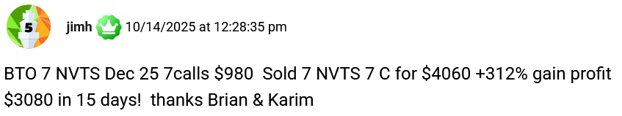
Or screen name BoilerUp, who wrote “The gift that keeps giving, up 906% [in just over 3 years].”

Or how about our member Doc, who jokingly wrote… “I hate to publicly admonish you… but I’m only sitting at a 1,001% gain [in 3.5 years].”


Now, some of our members have millions to invest.
Others have just a few hundred dollars.
But they all share one thing in common…
They recognize a big opportunity when they see one.
And right now, the opportunity in front of us is robotics.
All you have to do is find the right chokepoints to cash in.
That’s exactly what you’ll find with the stocks in today’s reports.
This is the kind of investment opportunity I live for.
And I want you to be part of it.
So let me quickly recap everything you get when you join today…
Everything You Get When You Join Today
You’ll get all three reports…
- “3 Stocks Behind the $25 Trillion Robotics Revolution”
- “America’s Secret Power Source”
- And “Space Data: 3 Stocks with 22X Potential”
- PLUS… premium access to our members-only website, LIVE weekly calls, portfolio updates, and more.
You’ll also receive one new Monument Trend Advisory issue each month… packed with my latest research and top stock recommendations.
That way, you’ll have the shot at even more wins every month.
For now I’m laser focused on robotics and related stocks.
When Elon says Optimus could become the best-selling product of all time…
I believe him.
Just like I believed him way back in 2012 when I called Tesla EVs “innovative category killers” and recommended buying the stock.
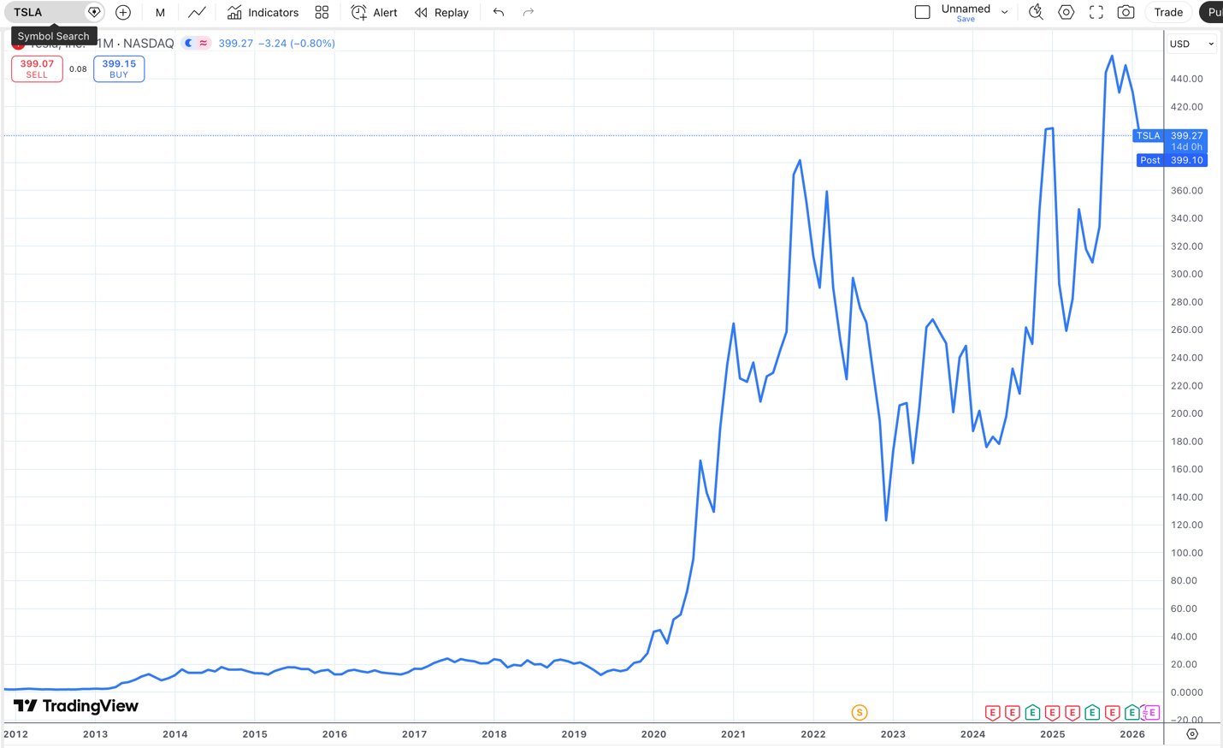
Since then it’s up over 16,000%.
Anyone who put just $1,000 into Tesla then and held on is sitting on $160,000 today.
And now Optimus is poised to dominate robotics as his next “category killer.”
So it’s important you get in early.
As he quickly scales the fleet to tens or hundreds of millions…
This will trigger the 25,000% market explosion Morgan Stanley predicted by 2036.
And the need for testing, AI systems, orbital data centers, and power should send related stocks soaring.
The best part is you can claim a stake in three little-known stocks that provide technology that is critical to Optimus.

Act Now to Get In on the Ground Floor of the 25,000% Robotics Revolution
All you have to do to get started is click the button you see on your screen.
But don’t put this off.
Because the fact is, Elon has already made people fortunes with PayPal… Tesla… and SpaceX…
And he’s about to do it again.
But this time… it’s going to be bigger than ever.
Optimus is the robotics breakthrough the world’s been waiting for.
And it’s got every advantage over its competitors.
- The proven vision technology of Tesla’s Full Self Driving cars
- A brain powered by Elon’s own market-leading AI company
- The unrivaled infrastructure of Tesla GigaFactories
- And the funding of the world’s richest man.
He’s already shut down car lines to make room for robots.
And he expects to ramp up production by the end of the year…
Then make as many as 10 million per year moving forward.
Robots are going to usher in a tremendous wave of wealth.
The only question is… will you be positioned to profit?
My research indicates that it all starts with the stocks in my reports.
So go ahead and click the button below.
It will take you to a secure order form where you can review everything one more time.
Then fill in your information, and we’ll get your reports emailed to you right away.
Within the next few minutes, you could be positioned for what could be the biggest technology shift of our lives.
That’s the opportunity in front of you.
So don’t let it pass you by.
Click the button below now.
And I look forward to welcoming you to Monument Trend Advisory.
I’m Bryan Bottarelli.
Thanks for watching.

Bryan Bottarelli
March 2026

