Backdoor Way to Claim a Stake in Gold for Under $20 an Ounce
Gold Trades at $2,500 an Ounce…

But Today, JULY XX, You Have an Unusual Opportunity to Get In at a Massive Discount.

THIS is one ounce of 24K gold.
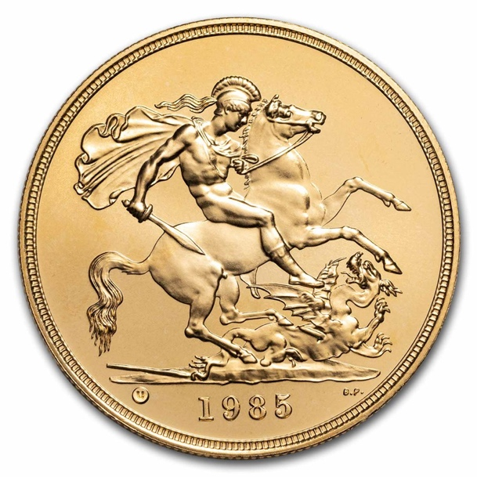

Right now, this ounce trades for over $2,500.

But today, I’m sharing a backdoor way you can invest in gold…

For under $20 an ounce.

Of course, that sounds absurd… Obviously, you can’t go out and buy an ounce of gold for $20.

So I’m sure you’re wondering what the catch is already.

But that’s the beauty of what you are about to hear.

When I reveal how you do this, I’m certain you will come to believe it is the single greatest gold investment you’ve ever seen.

If you want to make money on gold’s big bull run, there is no better path.
And there’s no time to waste.

Many of the world’s smartest investors are making huge bets on gold.
Like Michael Burry, author of The Big Short.

He’s famous for betting against the mortgage bond market before the housing crash.

But today, he’s sold his shares in big tech companies like Alphabet and Amazon…

And bought millions worth of gold.

Famous investor Stanley Druckenmiller is also betting big on gold.

After starting Duquesne Capital Management in 1981, his hedge fund NEVER had a down year…

That includes the Black Monday crash, the dotcom bust, and the great financial crisis.
He’s also sold his holdings in big tech giants Alphabet and Amazon… and is buying gold companies instead.

All in all, investment funds are more bullish on gold now than they have been in four years.

And Billionaire David Einhorn has made a massive bet in gold.

He says…

“Gold is a very large position for us. There’s a problem with the overall monetary and fiscal policies of the country… I think the deficits are ultimately a real problem.”

Goldman Sachs writes…

“We expect to see continued bullish momentum in the gold price.”

While JP Morgan believes new rate cuts could push gold higher, calling it…

“A golden era for gold.”

The world’s financial elite are piling into gold.

And because of a series of macroeconomic events that I’ll reveal in a minute, I am certain this is the beginning of the biggest bull market we’ve ever seen in gold.

Clearly, now is the time to buy gold BEFORE it soars higher…

A mad dash to buy gold is already on.

You’ll soon hear about people in your life running out to Costco to buy gold bars or coins…

Some may flock to gold-backed ETFs.

And others might invest in popular gold mining companies like Barrick Gold or Newmont.

If you choose to follow them, you may do well.

But I wouldn’t recommend any of those gold investments.

Rather, I’ve found an unusual gold investment with far more upside potential.

It’s an unusual stock that gives you exposure to over more than an ounce of gold… for under $20.

It’s – without a doubt – the most compelling gold investment I’ve seen in over 20 years…

One that positions you for extreme upside profit potential for a fraction of the cost.

Historically, this single investment has returned 10X more than gold.

When gold went up 5.4% in 2014 between June and August, this investment returned 10 times more: 54%.

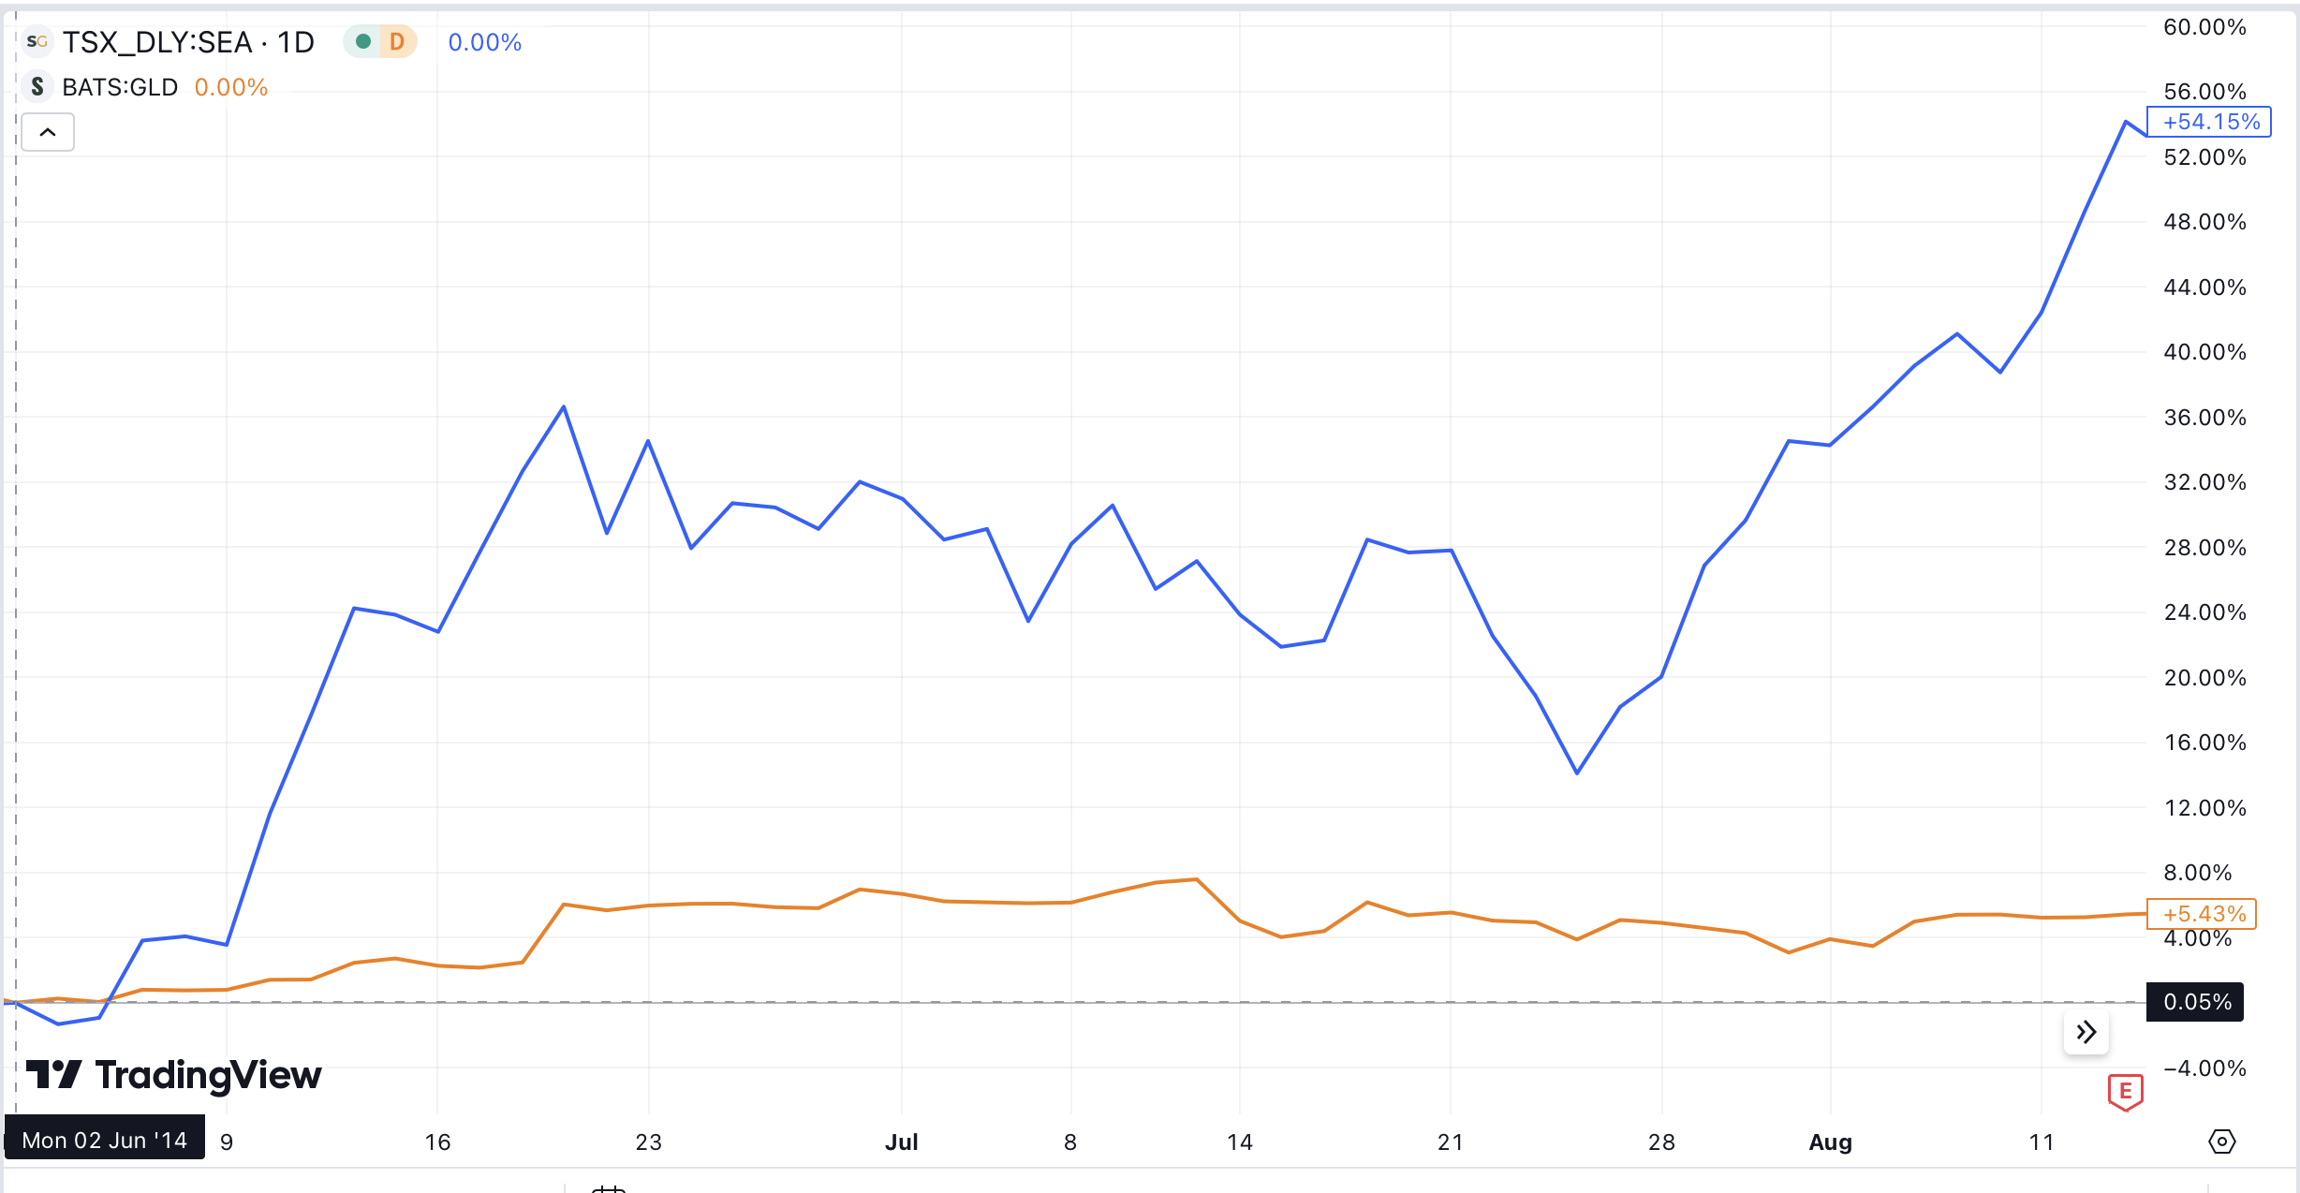

When gold jumped 23% between January and July 2016… this investment returned 133%

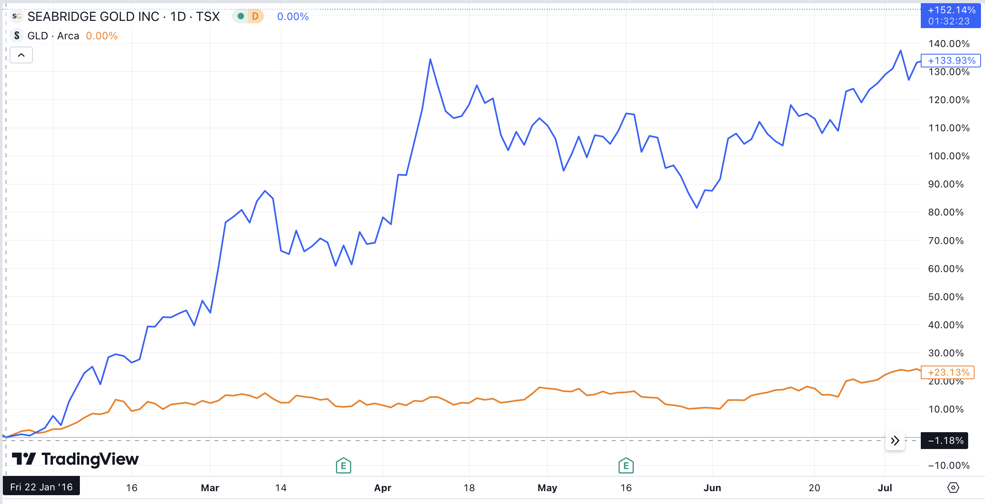

And when gold rose 19% between March and November 2020… this investment returned 119%.

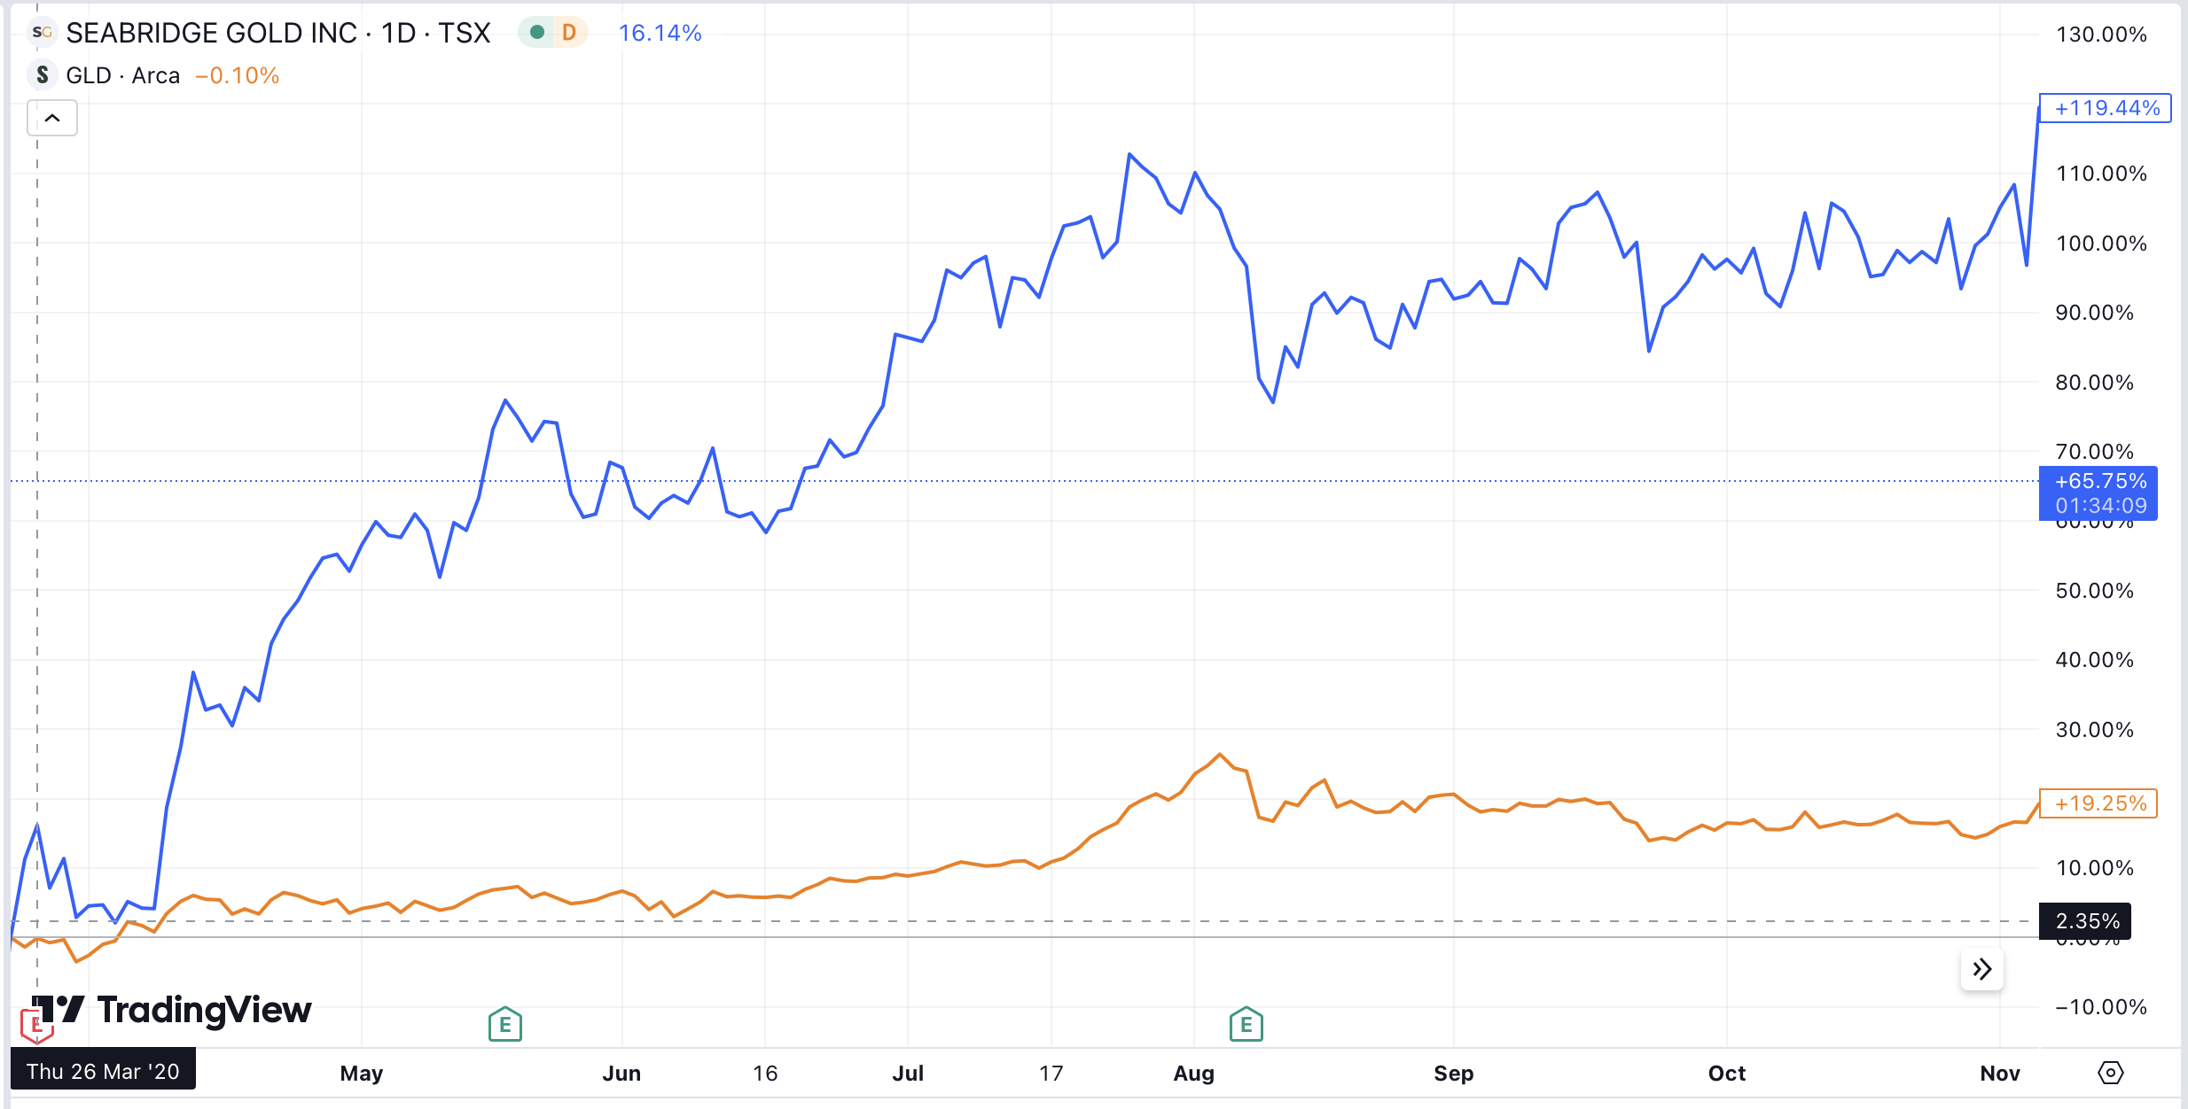

Yet despite its outperformance…

This special gold play is still virtually unknown.

And let me be clear about one thing too.

As you’re about to see, when you make this $20 investment… you gain exposure to MORE than an ounce of gold – currently valued at more than $2500.
This is the opportunity I’m going to share with you today.

But first, let me quickly explain who I am... prove to you why we’ve entered a new bull market in gold this year... and show you how this gold investment could change your life forever.

Why I’m Sharing My #1 Gold Opportunity with You Today
TEST A:
My name is Karim Rahemtulla.

Finding the most underappreciated value plays in the world – that’s what I do.
That’s my specialty.

For example, in March 2022, I saw that Rolls Royce was set to have a big year.

I spoke to my readers – just like I’m speaking to you now – and told them that it was an “all-time buying opportunity.”

I called it “The Last Great Value Stock” because it was one of the few companies that offered terrific upside while trading at a very low price.

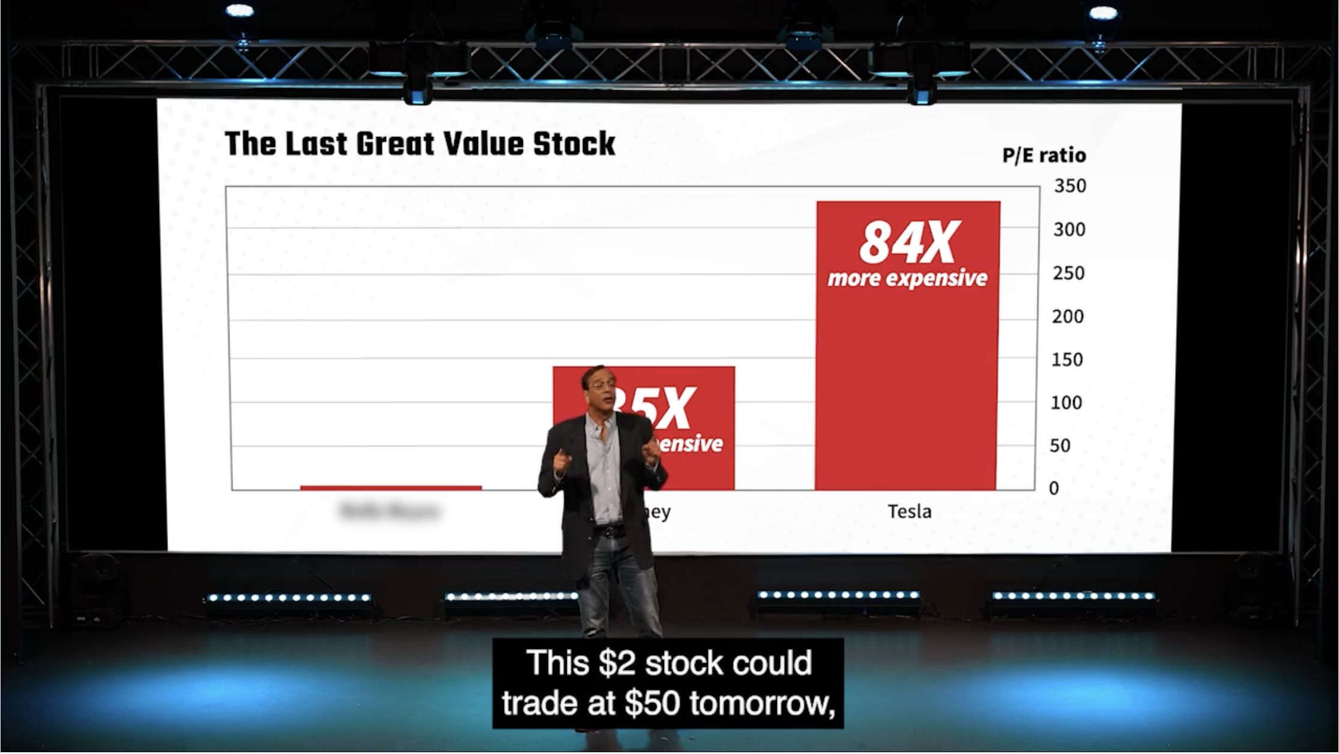

The stock traded for just $1.25 a share…

Today, it’s trading at over $6 a share.

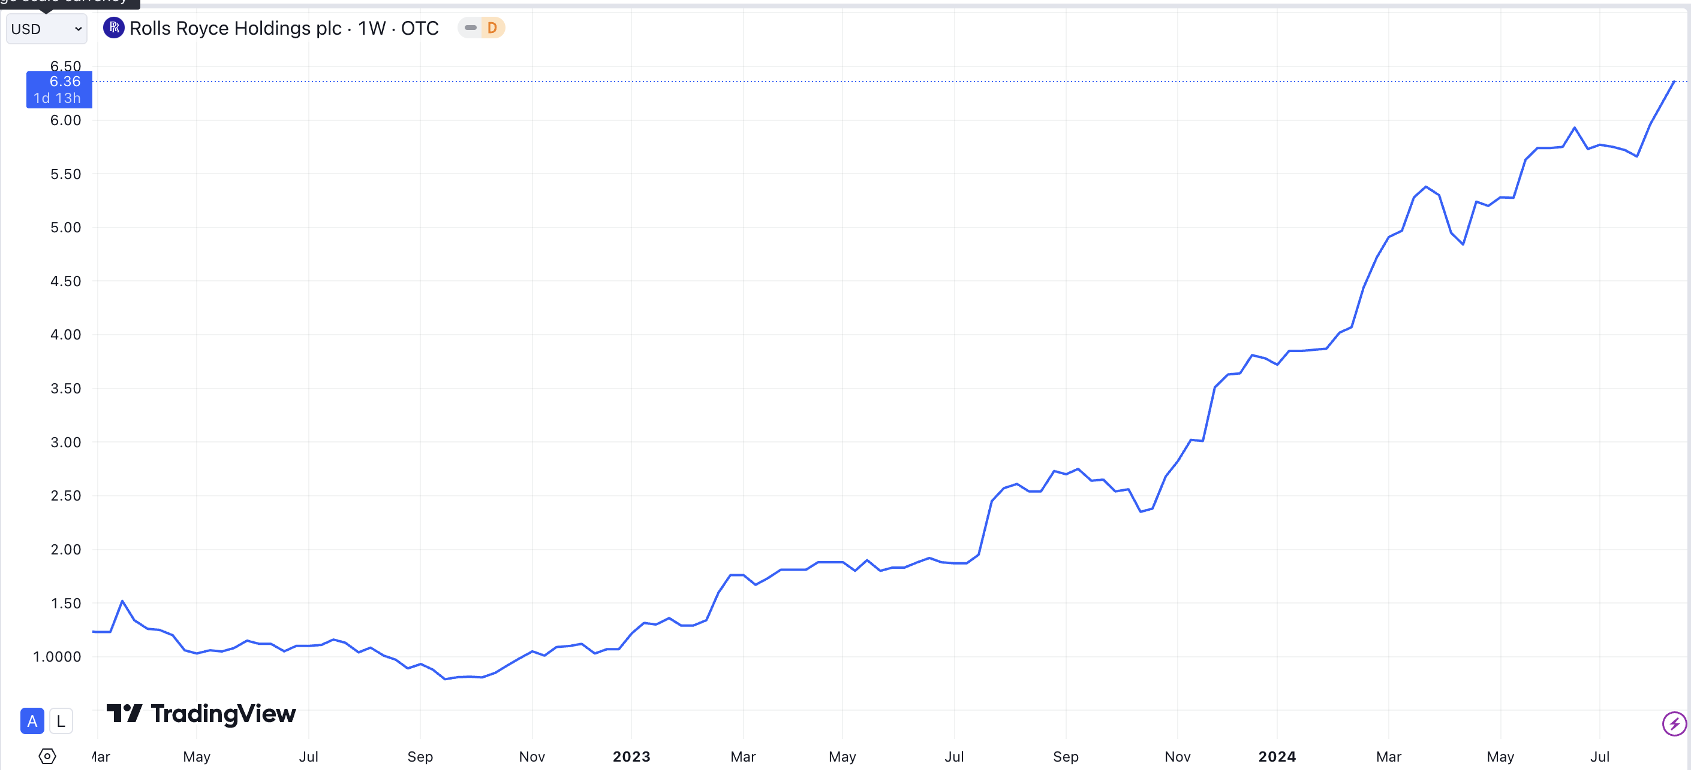

It’s up over 400% in just two years!

And my readers have posted some amazing results.

One got in for just 94 cents in November 2022.

Today, those shares are valued at $6.50...

And if he’s still holding them, they’re worth a total of over $3.3 MILLION dollars!

A member named Frank started with $58K in Rolls-Royce and was up $26,000 on this single play in just five months.

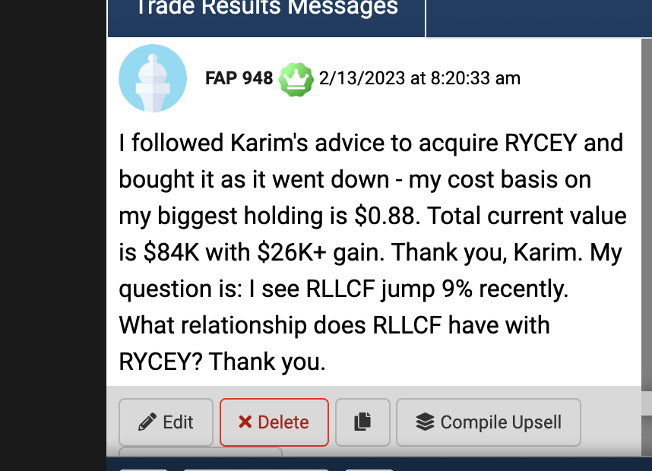

Another member, Robert, says he’s up over $100,000 on this single stock since 2022.
He said, “Just went over 500% profit on RYCEY. Up $109K Thanks Karim!”

It’s the perfect example of how I help my readers find opportunities that no one is talking about... so they can get in BEFORE the stock soars.

And I see a similar opportunity in the $20 gold investment I’m telling you about today.

I see a similar opportunity in the gold investment I’m telling you about today.

Keep in mind… this gold investment gives you a stake in MORE than an ounce of gold.

While it’s under the radar now, I believe in the coming weeks, a specific catalyst will catapult this stock to the front-page news.

I’ll reveal why in a moment.

But let me tell you why I believe we’re entering the greatest gold bull market we’ve ever seen.

END TEST A

TEST B:

My name is Karim Rahemtulla.
For most of my life, I’ve been involved in the world of high-stakes stock trading.

In the 1980s, I went to Wall Street... where I became one of the youngest CFOs ever for a trading firm that cleared millions of dollars through Bear Stearns.

As I began learning how to trade, not only did I ascend in my professional career...

But my personal trading success went through the roof as well.

During the early ‘90s, I built a multimillion-dollar portfolio by the time I was just 34 years old.

Once I realized my trades could provide me with everything I needed in life, I retired from Wall Street.

Today, I live off of my own trading.

And my gold investments are a big part of my success…

For example, I bought a gold company called EMX that traded for just $0.60 cents in 2015.

In just 5 years, it surged to $3.70… a 516% gain.

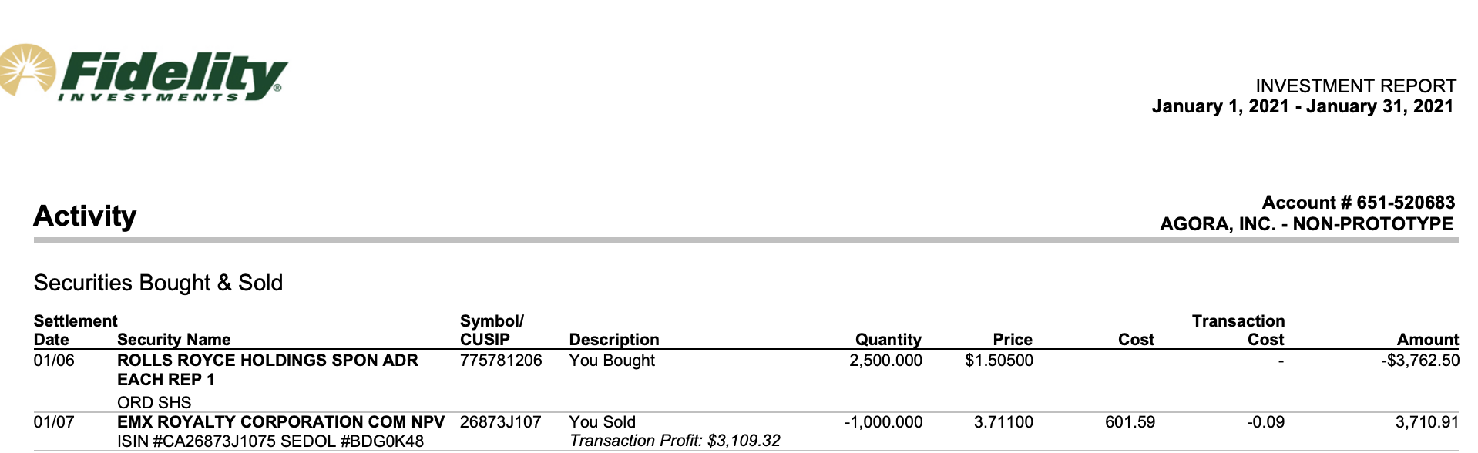

I banked a 698% win on Sandstorm Gold in 5 years…

And 381% gain on Ivanhoe Mines in just one year.

With trades like this, I can make money on my own terms.

I trade at home so I’m able to spend time with my wife and kids.

I’ll admit it... I love my life.

I couldn’t have asked for anything better.

Which is why... along the way... I decided to start helping regular people learn the same trading techniques I use. My goal was to help them establish the same type of financial freedom I enjoy.

I co-founded the publication Wall Street Daily, which became a viral sensation.

There, I traveled the world looking for the BEST opportunities for my readers to make money, from the icy Arctic Circle… to the jungles of Malaysia… to the deserts of Arizona, where mines stretch for miles.

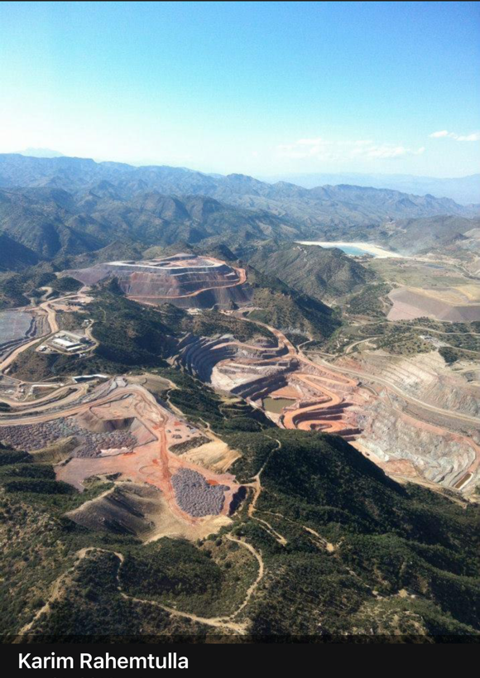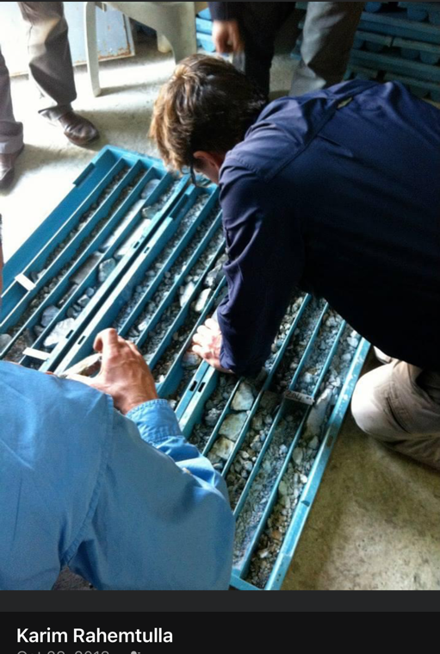





Most recently, I co-founded another new venture, Monument Traders Alliance, which is laser-focused on giving regular people the tools to dominate the markets.

One of our greatest success stories is from a reader, David D., who joined us in early 2021. He took $20,000 and turned it into $185,000 by December 2021 – making more from trading than from his day job.

He increased the value of his entire account by 9X!

Another member named Mohammed did even better…

He turned a $25,000 portfolio into over $225,000… In just four months!

That’s the type of story I want to help people live out.

And I do that by helping them understand the most important elements of stock trading...

How to find undervalued investments with BIG upside… trading at a great price.

For example, in March 2022, I saw that Rolls Royce was set to have a big year.

I spoke to my readers – just like I’m speaking to you now – and told them that it was an “all-time buying opportunity.”

I called it “The Last Great Value Stock” because it was one of the few companies that offered terrific upside while trading at a very low price.

The stock traded for just $1.25 a share…

Today, it’s trading at over $6 a share.

It’s up over 400% in just two years!

And my readers have posted some amazing results.

One got in for just 94 cents in November 2022.

Today, those shares are valued at $2.60...

And if he’s still holding them, they’re worth a total of over $1.3 MILLION dollars!

Another reader, Dave, said...

“Thanks Karim for the huge win on RYCEY! Up over 55% on 6,100 shares (within a year)!”

And Frank started with $58K in Rolls-Royce and was up $26,000 on this single play in just five months.

Another member, Robert, says he’s up over $100,000 on this single stock since 2022.
He said, “Just went over 500% profit on RYCEY. Up $109K Thanks Karim!”

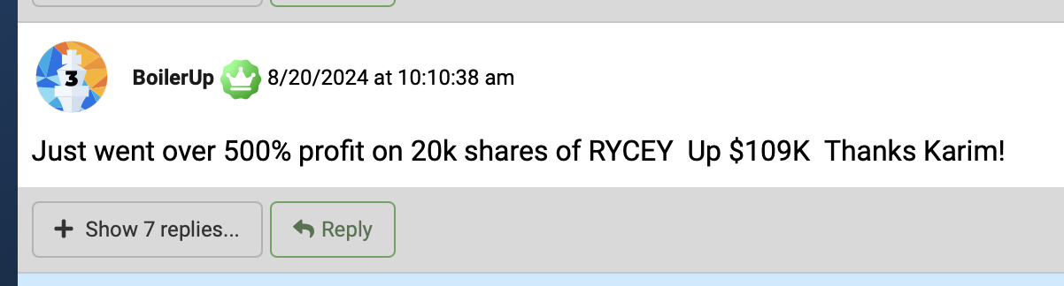

It’s the perfect example of how I help my readers find opportunities that no one is talking about... so they can get in BEFORE the stock soars.

And I see a similar opportunity in the under $20 gold investment I’m telling you about today.

While it’s under the radar now, I believe in the coming weeks, a specific catalyst will catapult this investment to the front-page news.

I’ll reveal why in a moment.

Make no mistake…

Now is the time to get in…

Not tomorrow, today.

Because I believe we’re entering the greatest gold bull market we’ve ever seen.

END TEST B

We’re Entering into the Greatest Gold Bull Market of This Century

We’ve already seen gold soar over $2,500 an ounce…

But this is just the start.

Here’s why…

First, over the past five years, our government has been on a money-printing spree….

The money supply has surged from 4 trillion in 2008… to 18 trillion today.

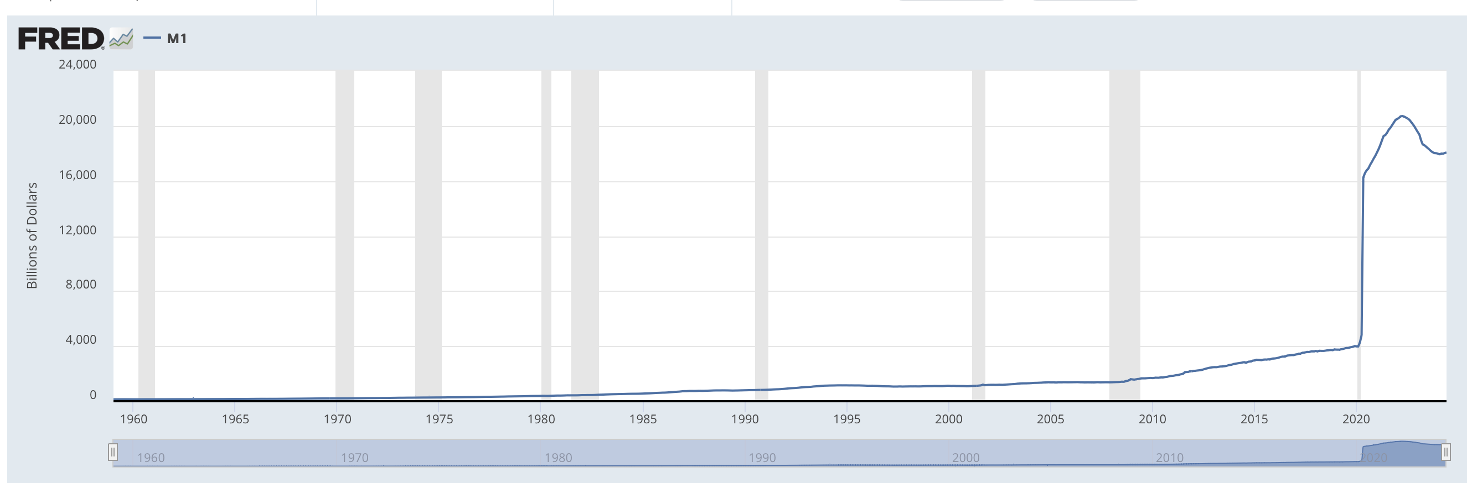

History proves this is disastrous for the currency in your pocket… but great for gold.

In the late third and early fourth centuries, the Roman Emperor Diocletian debased Roman coinage to finance needless government spending far more than collected taxes.

The result was rampant inflation.

And over the next 35 years, gold soared 40,000%!

History will tell you runaway inflation is NOT a new thing!

Issuance of less valuable token coinage caused rampant inflation…

In the end, it destroyed the economy and lead to the abandonment of Roman coinage.

While gold, once again, became the safe haven people flocked to.

Over the past few years, our government has followed Diocletian’s blueprint…

They’ve spent, borrowed, and printed trillions of dollars.

Consider…

Today, the U.S. carries $35 trillion in debt.

And we now pay $1 trillion just in interest per year.

That’s more than we spend on ALL discretionary spending combined!

The US Federal Debt to GDP Ratio was 34% in 1980. It’s now at 122%.

But… it gets worse.

This only accounts for official debt.

If you account for unfunded obligations Medicare and Social Security, this figure balloons to over $100 trillion.

If you take this into account, the real debt-to-GDP ratio is a staggering 350%!

There are three ways the government could deal with this debt…

- Directly cut Social Security and Medicare. This would be political suicide.
- Increase taxes by a huge amount. However, there are fewer people paying in compared to those who receive benefits.
- Or… they can reduce the value of the dollar. This makes debts easier to handle but reduces everyone's purchasing power. Prices go up, but their money doesn't.

You can bet that politicians are going with the third option every time…

Because it’s essentially a hidden tax on your money!

In order to pay the bills, they will continue devaluing the dollar… which they’ve done non-stop since we officially went off the gold standard in 1971.

This, of course, will make it harder for people to live on Social Security or their savings.

We’re already seeing that.
When prices go up, but real income doesn't… every dollar becomes less valuable.

It’s no wonder that U.S. credit card debt is at an all-time high of $1.14 trillion as high inflation squeezes people’s budgets...

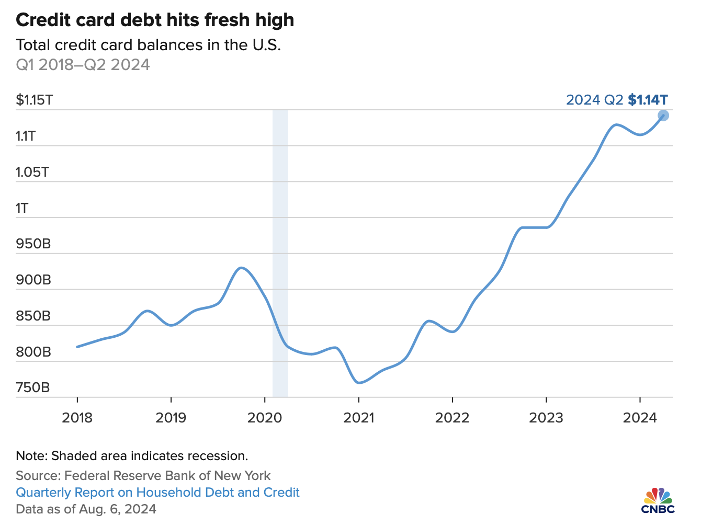

However, there is a silver lining.

Well, a gold lining really.

When the dollar loses value, gold gains value.

This has been true since the beginning of time.

And its why gold has entered a rip-roaring bull market.

And its why many of the world’s best investors… and the people who control the world’s money supply… Move away from the U.S. dollar… and into gold.

Central Banks Are Loading Up on Gold

Most U.S. dollars are held by Central banks… accounting for 60% of their foreign exchange reserves.

But central banks are starting to diversify away from the dollar… and hedge against with gold.

Central banks are scooping up gold at the fastest pace ever.

The past three years, the world’s central banks have bought more gold than they’ve ever bought before...

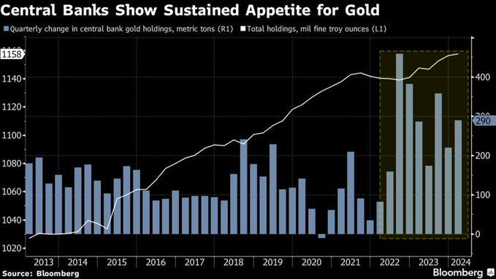

With countries like China, India, and Turkey leading the pack.

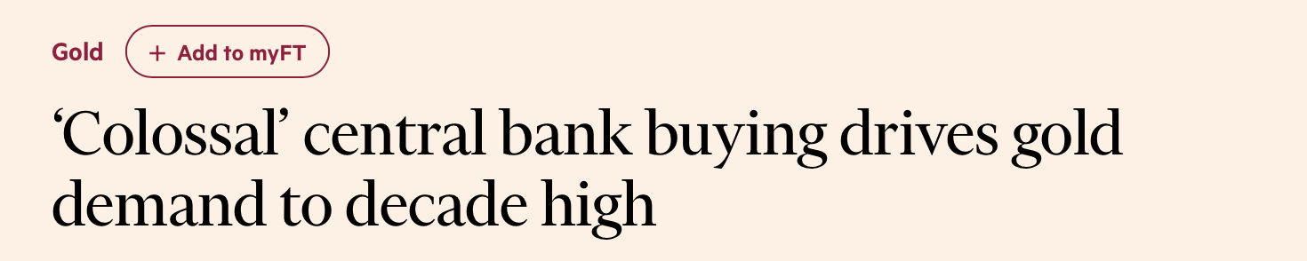

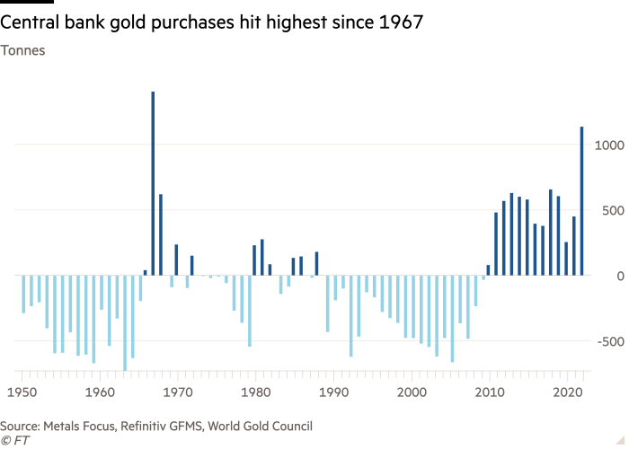

The only time banks have bought this much gold was in the late 1960s… before gold’s biggest bull market run in history...

Gold went from about $35 an ounce in 1970 all the way to a high of $878 an ounce on January 21, 1980.

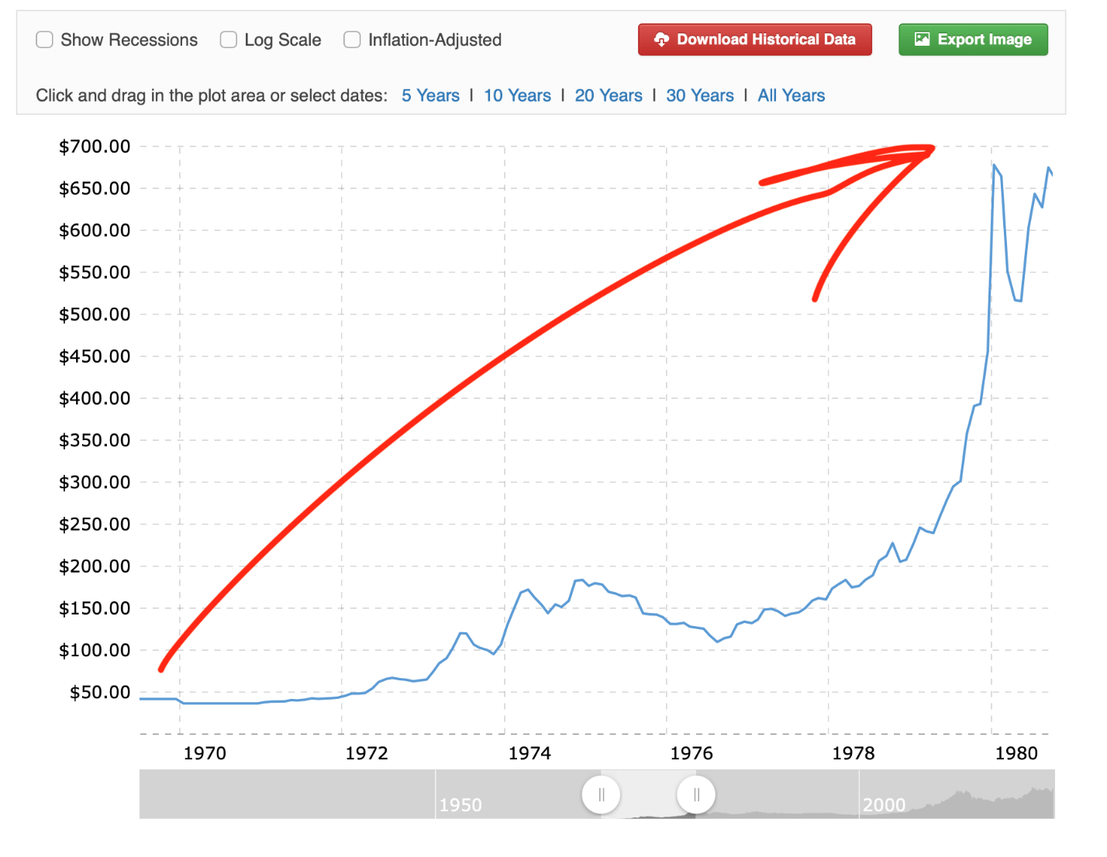

That’s a 2,417% gain in just 10 years.

Ray Dalio says he sees a “paradigm shift” in the gold market, similar to what happened in the 1970s after Nixon took the dollar off the gold standard.

This time, central banks are buying gold to offset exposure to the U.S. Dollar, because when the dollar falls, gold rises.

They obviously see some red flags with the U.S. markets.

And now the Fed is starting to cut rates after the fastest rate hike cycle in history.

ALT:
And now the Fed just cut rates after the fastest rate hike cycle in history.

This is an incredibly powerful signal.

Every single time this has occurred over the past 50 years, it has been followed by a bull market in gold.

Consider the ’70s: The Fed slashed rates from 9% to 3.3%, and gold prices surged by 392%.

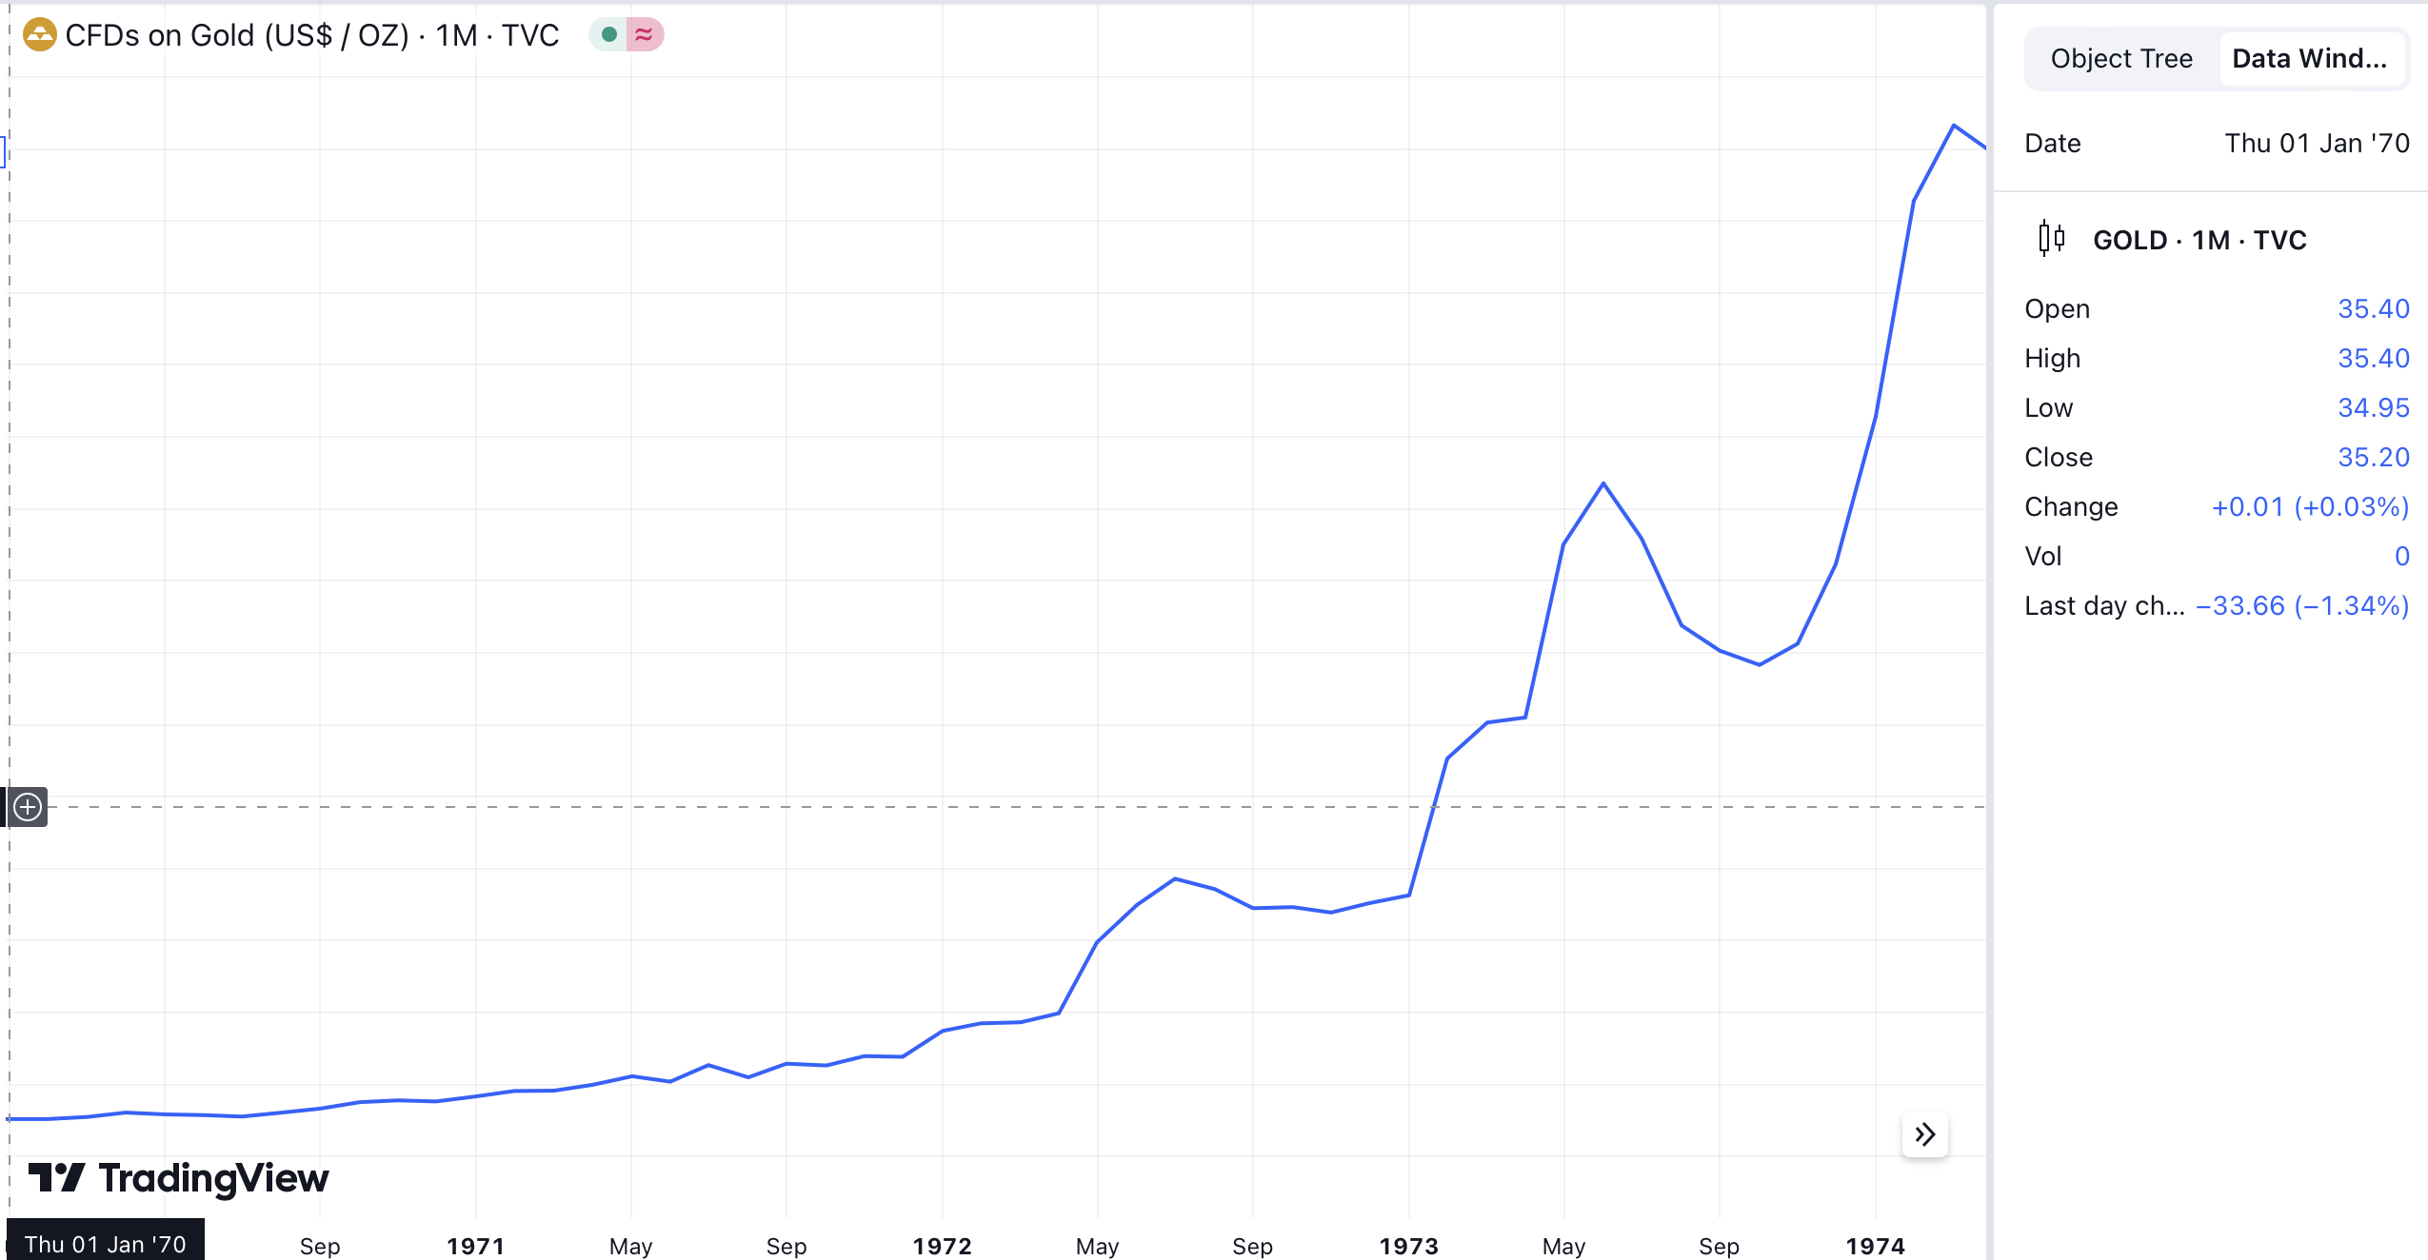
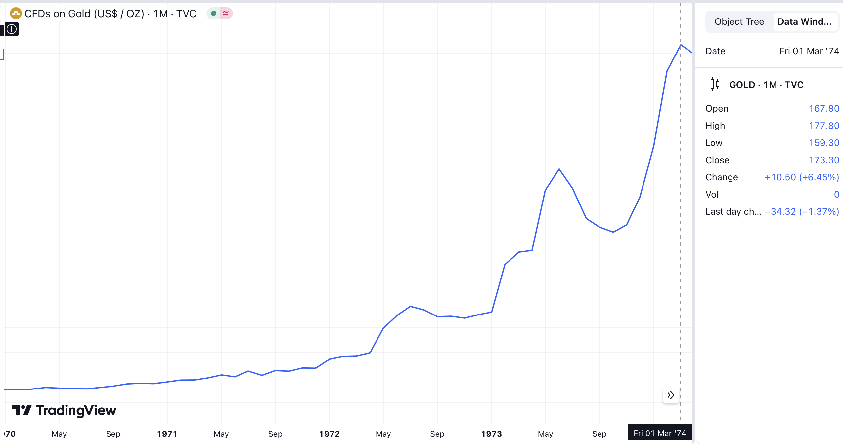

It happened again starting in 2001, with rates dropping from 6.5% to just 1%.

Gold jumped 140% by 2006.

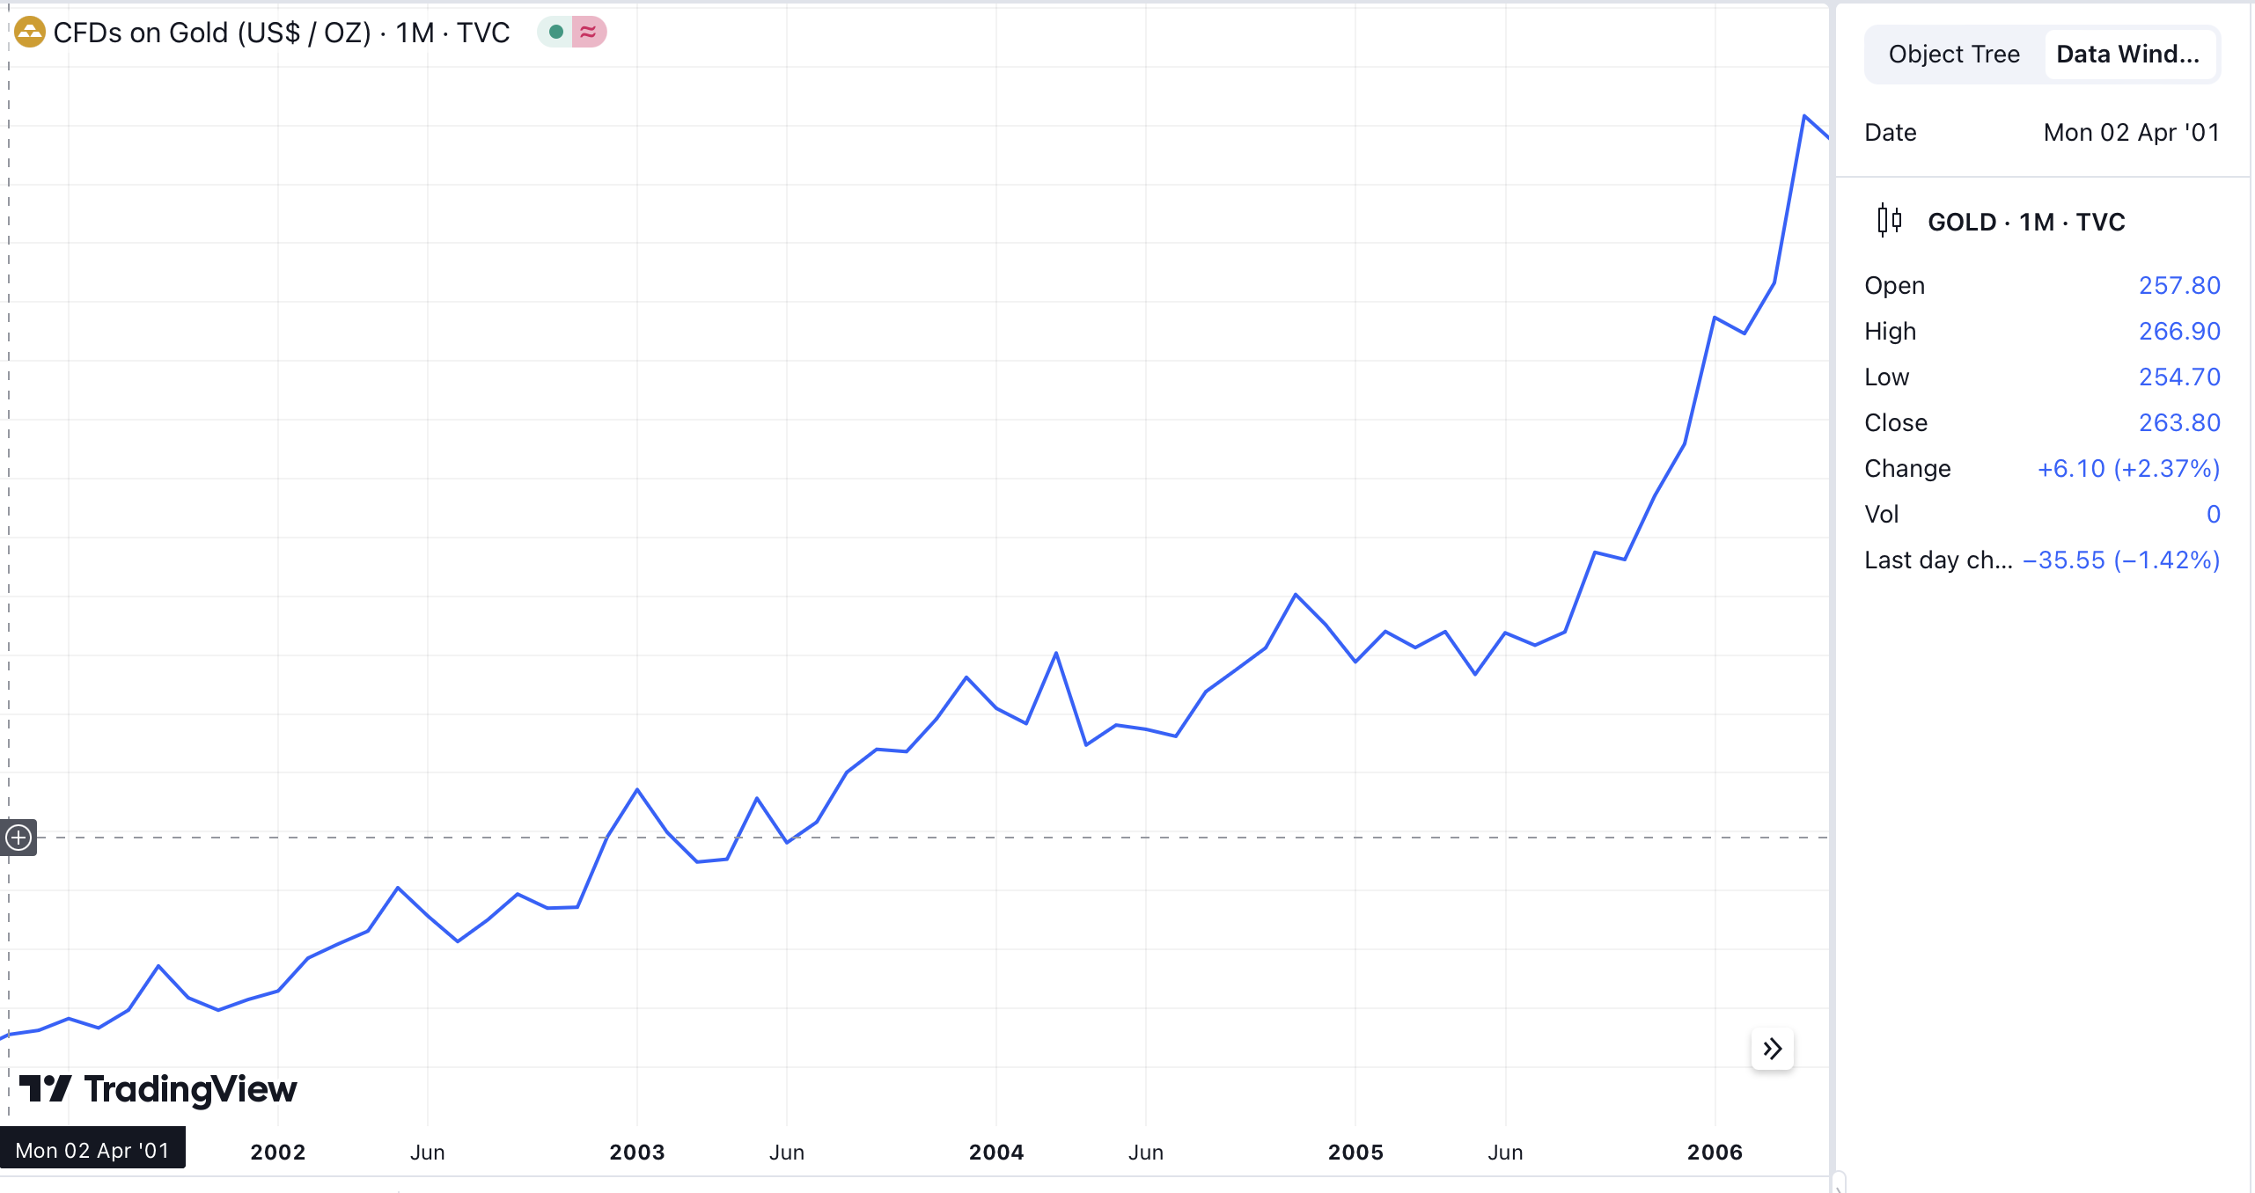
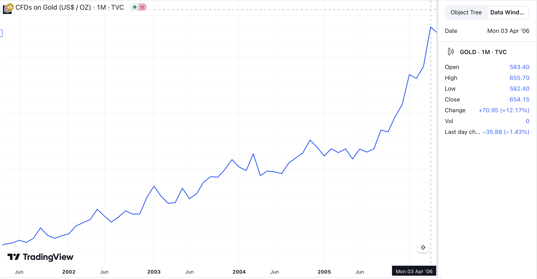

Then, from 2007 to 2008, the Fed cut rates from 5.25% to an all-time low of 0.25%.

Gold more than doubled while most stocks and other investments crumbled.

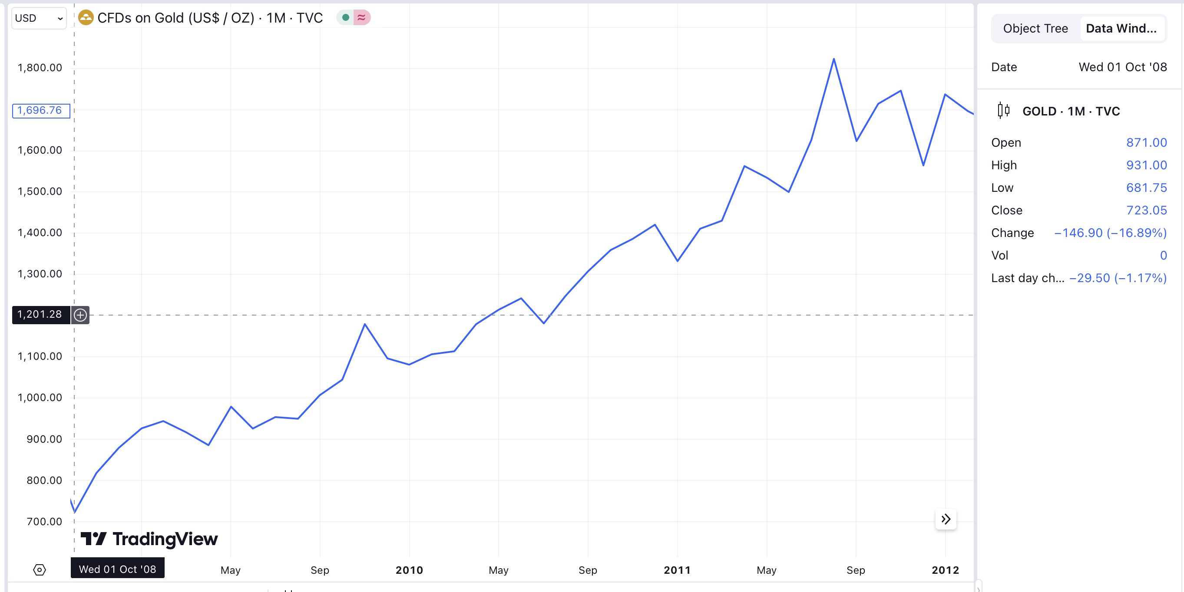

The takeaway is clear: When the Fed starts cutting rates, gold is the asset you want to own.

That’s why the message I’m sharing with you today is so important.

You see, most folks will do nothing at all with this information...

But if you act now, you have the chance to buy what I consider be the biggest upside gold investment I’ve ever seen… at a price cheaper than we may ever see again.

Get 10X The Return of Gold from This Investment

Now, I want to be clear about one thing.

If you simply rush out and buy gold bars, coins, and gold stocks, you’ll probably do pretty well.

But at the same time – and this is important, folks – you will likely miss out on by far the biggest gains.

I’ve found a far better way to profit from gold.

Unfortunately, most investors know nothing about it.

Even though the returns can be MUCH bigger.

Consider…

Between 2005-2008, gold returned 102%...

Beating the S&P 500’s return of just 15%.

However…

The investment I’m talking about today returned 775%!

Over 7X the return of gold…. And over 50X the return of the S&P.

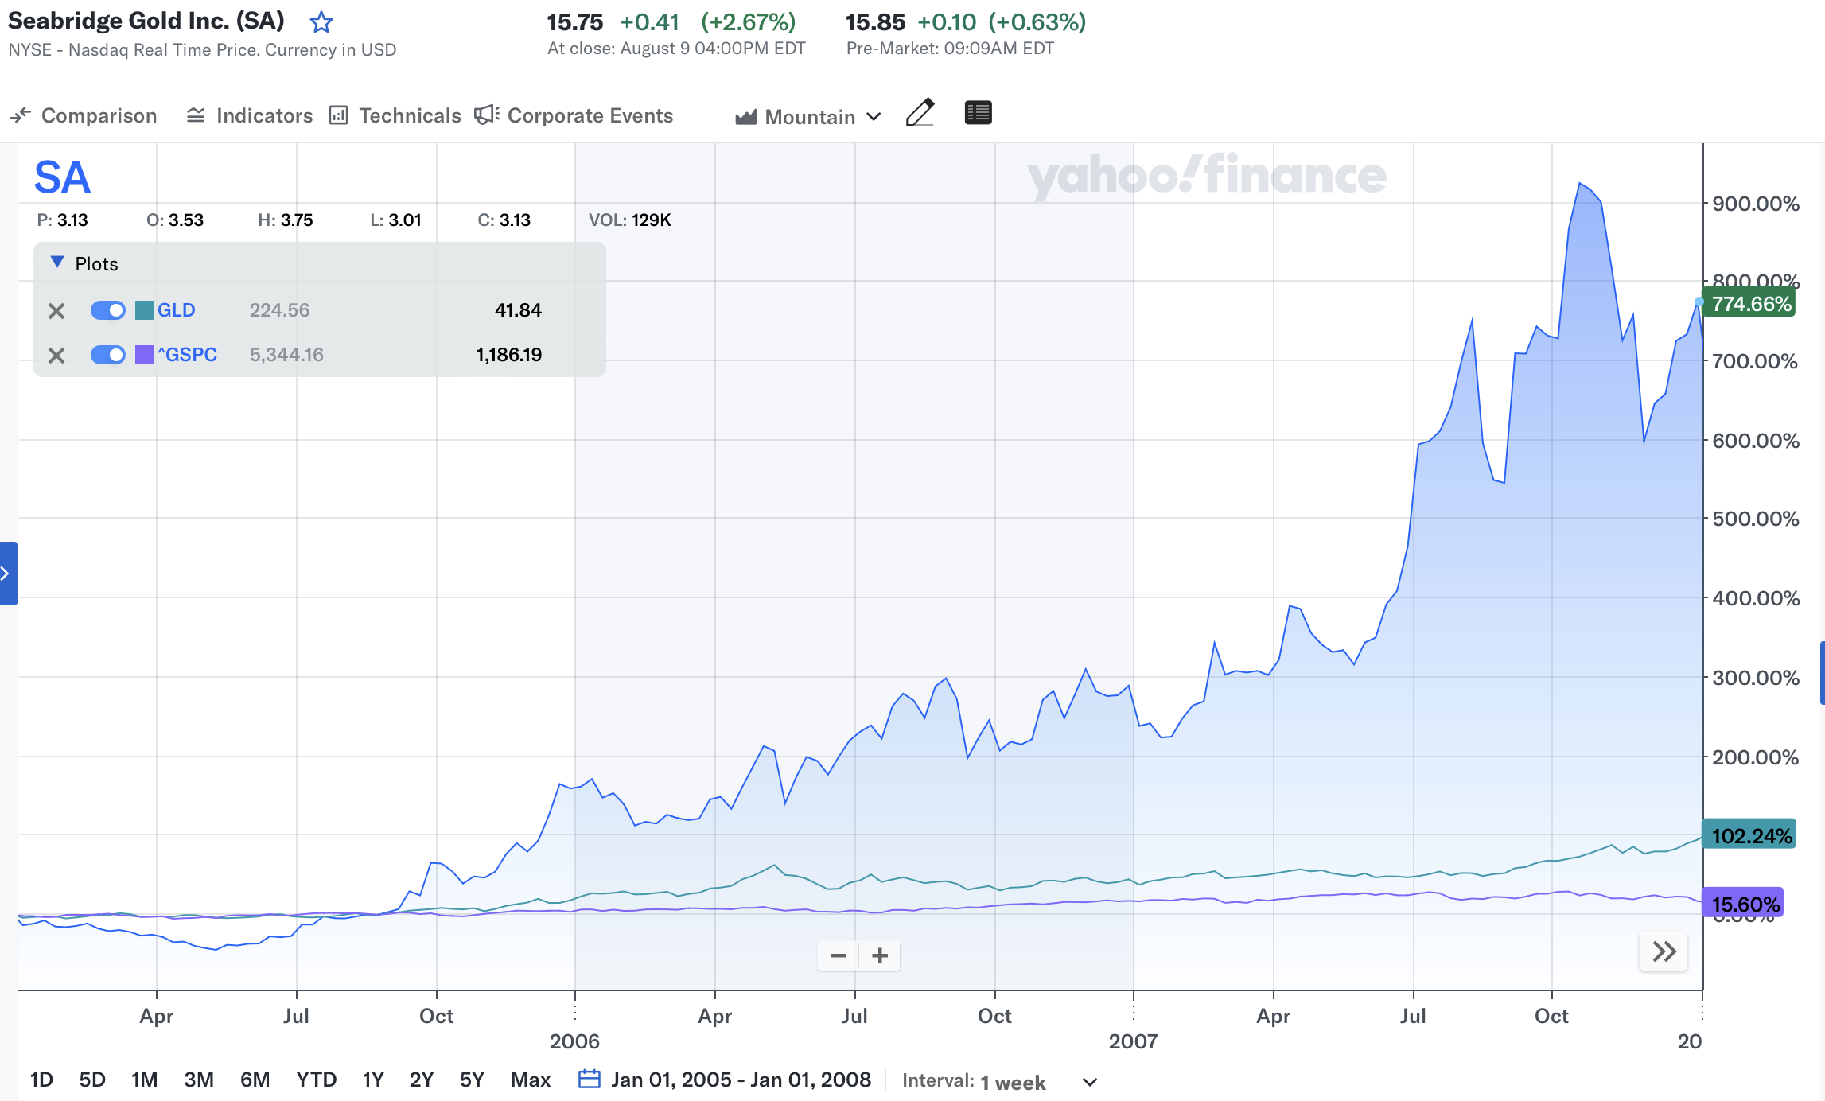

Go back even further…

And this investment has returned 8,385% since 1999.

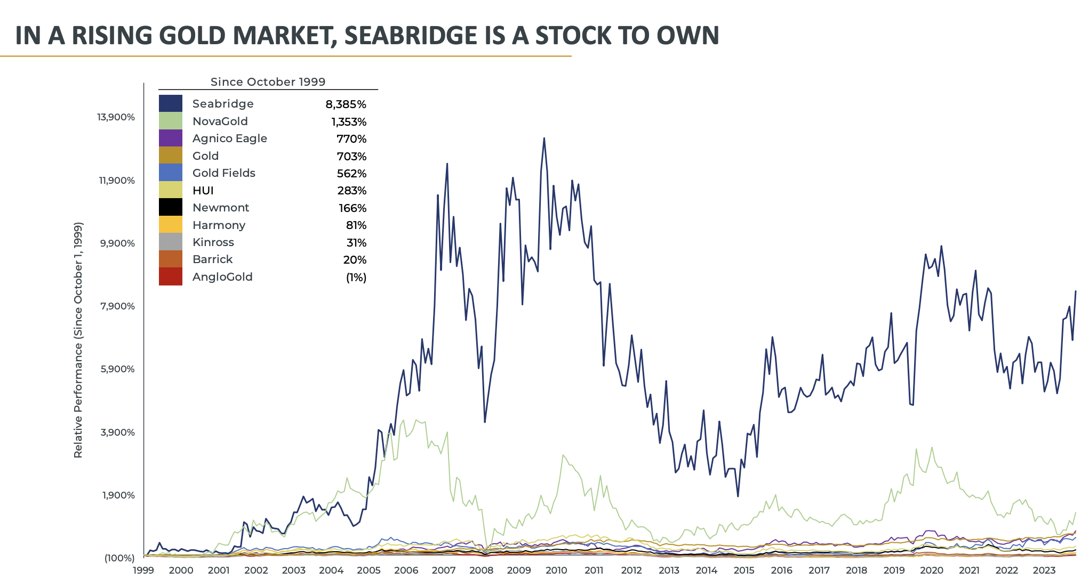

That’s over 10X the return of gold!
And that’s due to the very unique way it’s set up...

Where it can FAR outperform the regular price of gold.

Best of all, anyone can use it.

You don’t need a special account.

You don’t need to be an accredited investor.

And you don’t need a lot of money.

You can get into this little-known gold investment for under $20.

Once you know the secret, you’ll have the chance to compound your money at an extraordinary rate over time.

The World’s Greatest Gold Investment

The gold investment I want to tell you about is publicly traded.

You can purchase it in any normal brokerage account.

But it is very different than most gold investments.

Even at under $20, this publicly traded investment gives you a stake in more than an ounce of gold – currently worth over $2,500.

And it has radically outperformed all other gold investments, including gold mining stocks.

You see, the unfortunate truth is that most gold miners out there are not great investments.

Since 1999, gold has returned 678%.

However, gold stocks have far underperformed gold.

Newmont has returned 166%... Barrick, just 20%. AngloGold, negative 1%!

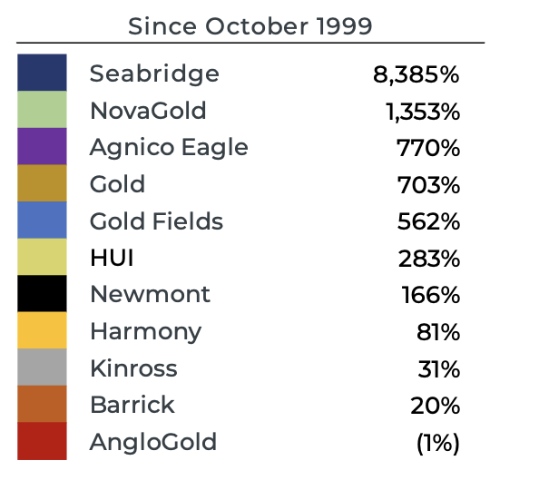

Why?

Because most gold miners simply issue too many shares.

If you look at the share counts of the major companies, they keep growing and growing.

The share counts at Newmont, Barrick, and Kinross have more than doubled.

But they aren’t backing those shares with more gold.

Take Barrick, for example.

Back in 2007, they had 8 million ounces of gold production.

Today, they have 4 million ounces.

Yet, they’ve DOUBLED their share count.

That’s why you get very little exposure to actual gold when you buy these companies.

If you buy a share of Newmont, the world’s largest gold company, you’re only getting exposure to under 0.25 ounces of gold.

It’s the same with…

Agnico-Eagle… Anglogold… And most of the gold stocks out there.

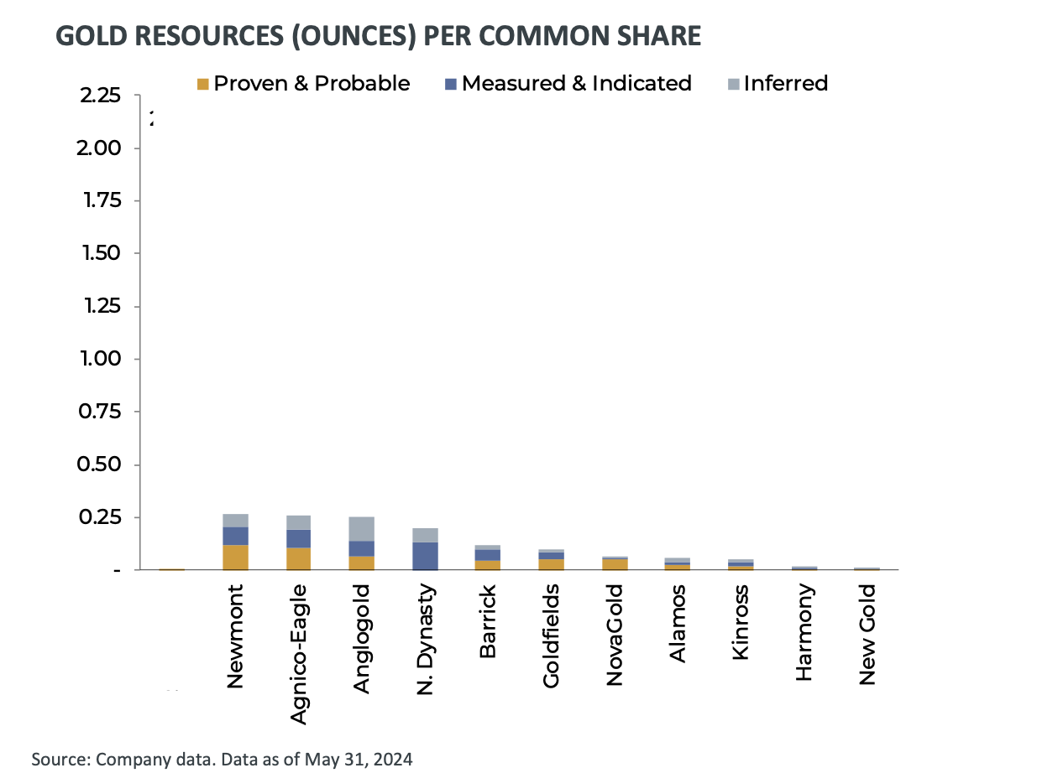

However, there is one exception.

It’s the gold investment I want to tell you about today.

It is NOT just your everyday run-of-the-mill mining stock.

Rather, it is hands down the SINGLE GREATEST MINING STOCK IN THE HISTORY OF THE WORLD.

That is not hyperbole.

This stock run completely differently than ALL the gold companies out there in the world.

For one… Instead of diluting shares, it ties the shares to the amount of gold reserves they have in the ground.

So when you buy one share of its stock at under $20…

You know going in that the company has more than an ounce of gold in the ground represented by your shares.

Just look at this chart to see the difference.

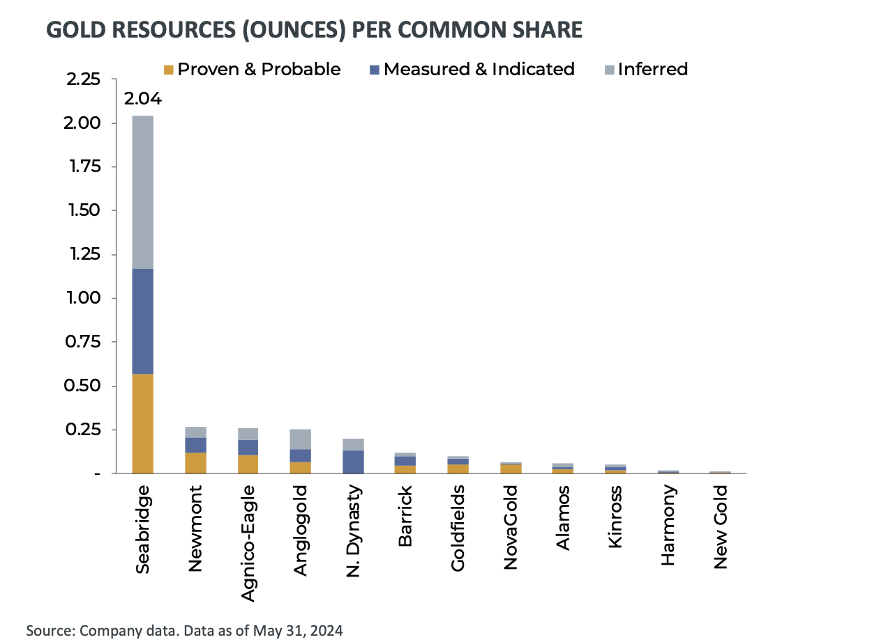

And it gets even better…

If you add in their inferred gold reserves – which means the estimated additional gold based on geological sampling…

Their gold per share figure shoots to over 2 ounces a share.

The company has 8 times more gold in reserves than Newmont… 12 times more than Barrick Gold… and a stunning 20 times more gold than Kinross.

It blows them all away.

You don’t have to be a genius to figure out the opportunity here.

You can see why the stock has crushed the performance of every other gold stock in the world.

It’s delivered almost 5,000 times more gains than Barrick.

And its outperformed gold by 10 to 1!

No gold company has come close to that.

Yet, what’s amazing is that this company is only getting better with time.

Since 2023, this company has grown its gold resources by 1,075%... and it’s made sure that there is ALWAYS more gold in its reserves than shares outstanding.

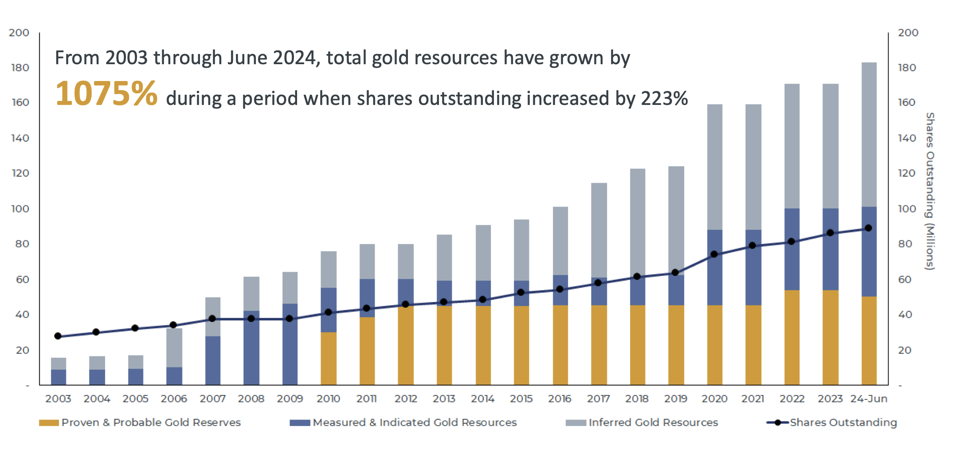

This means that when you buy shares, the amount of gold in the ground for every share you own gets bigger over time.

That’s why it’s the one gold stock that just keeps going up.

They actually care about their shareholders and reward them handsomely.

If you believe gold is going higher in the coming months and years…

Then this is the #1 gold stock to buy.

Again, it’s outperformed gold 10-1 over the past 25 years!

Even if you don’t like gold, this under $20 stock truly is the single best investment I see in the markets right now.

And anyone can get in – it’s as simple as buying a stock in your ordinary brokerage account.

You don’t have to call a gold dealer, store gold coins or bullion, or anything like that.

And because you know each of your shares has REAL gold behind it, then it’s by far the safest gold company in the world.

Now, you may be wondering…

If this company has so much gold, why is it so cheap?

The Largest Undeveloped Gold Project in the World

Well, let me explain how it works with an analogy...

Say you’re an art expert – and a very wealthy contact of yours inherited a vault full of rare art from his grandfather.

He knows some of the pieces are valuable, but he doesn’t have the time or patience to find out how much each one is worth.

Instead, he offers to sell you the whole lot for $200,000.
Before you accept his offer, you ask to take a look. And you discover the vault is filled with works by Picasso, Dali, and Pollack.

You know for a fact that just one of the Picassos is worth $1.2 million at current market prices.
Would you buy the paintings from him for $200,000?
I imagine you would!

You know from doing your homework that the artwork is worth much more than what you’d pay. Best of all, you can turn right around and sell it for a fortune.
The same situation happened with this gold company...

It bought an undeveloped gold project in a remote region of Canada’s British Columbia from a rival gold miner.

Though its rival knew the land held some gold, it didn’t know how much.
And it didn’t want to go through the expense of finding out.

After all, this was an unproven area.

After years of letting this gold sit there, they decided to quickly offload it for just $200,000.

Like in our example, my #1 gold company knew there was big potential value in the project… and they were getting it for a good deal.
But they were wrong.

It wasn’t a good deal…

It was perhaps the greatest gold bet of the century.

Because after buying it, they found something extraordinary...

This remote piece of land in Canada holds 47.3 million ounces of gold... worth more than $118 BILLION in today’s market.

So they got a treasure trove of gold for pennies on the dollar.

Just consider the entire deal for a second...

It bought 100% of this gold project for just $200,000.

And now the entire deposit is worth over $118 billion.

Now, let’s say after expenses, their profit is even just half of that.

That’s still a 295,000,000% return!

And when they start pulling chunks of gold out of the ground, it’s going to send the company’s stock soaring.

They’ve just started construction on their flagship mine…

So right now, we’re in the perfect “sweet spot” to pick up shares of this company before they skyrocket.

When you consider its current stock price and the amount of gold they have, it’s as though you’re actually paying under $20 per ounce of gold.

That’s as good an opportunity as I’ve ever seen in this business.

But it doesn’t stop there…

The Third Largest Copper Project in the World

This same project also has the third-largest copper reserves… again in the world!

And now is the perfect time to play copper…

Because there just isn’t enough copper to meet demand.

Data centers that run AI applications need copper for electricity.

JP Morgan estimates we’ll need 5 million tons of new copper by 2030 just for AI alone.

Consider this…

If you search for something on Google, it uses up 0.3 watt-hours of electricity.

ChatGPT, on the other hand, used 2.9 watt-hours a request.

The International Energy Agency estimates AI demand will mean 10 terawatt-hours of additional electricity in a year.

That’s enough to power around 700,000 homes for a year.

In order to handle all of this additional energy, we need more copper.

And it’s not just AI…

Copper is essential for electric vehicle batteries.

Over 180 pounds of copper is used in each electric car battery.

As Fortune reports, “Copper is the new oil.”
Experts expect current mines will only meet 80% of the copper demand by 2030.

Which brings us back to our under $20 mining company.

The same gold project they bought for $200,000 also has over 7 billion pounds of copper…

Worth $30 billion at today’s price.

In fact, compared to all the publicly traded copper companies, this company also has the MOST copper resources per share… by far…

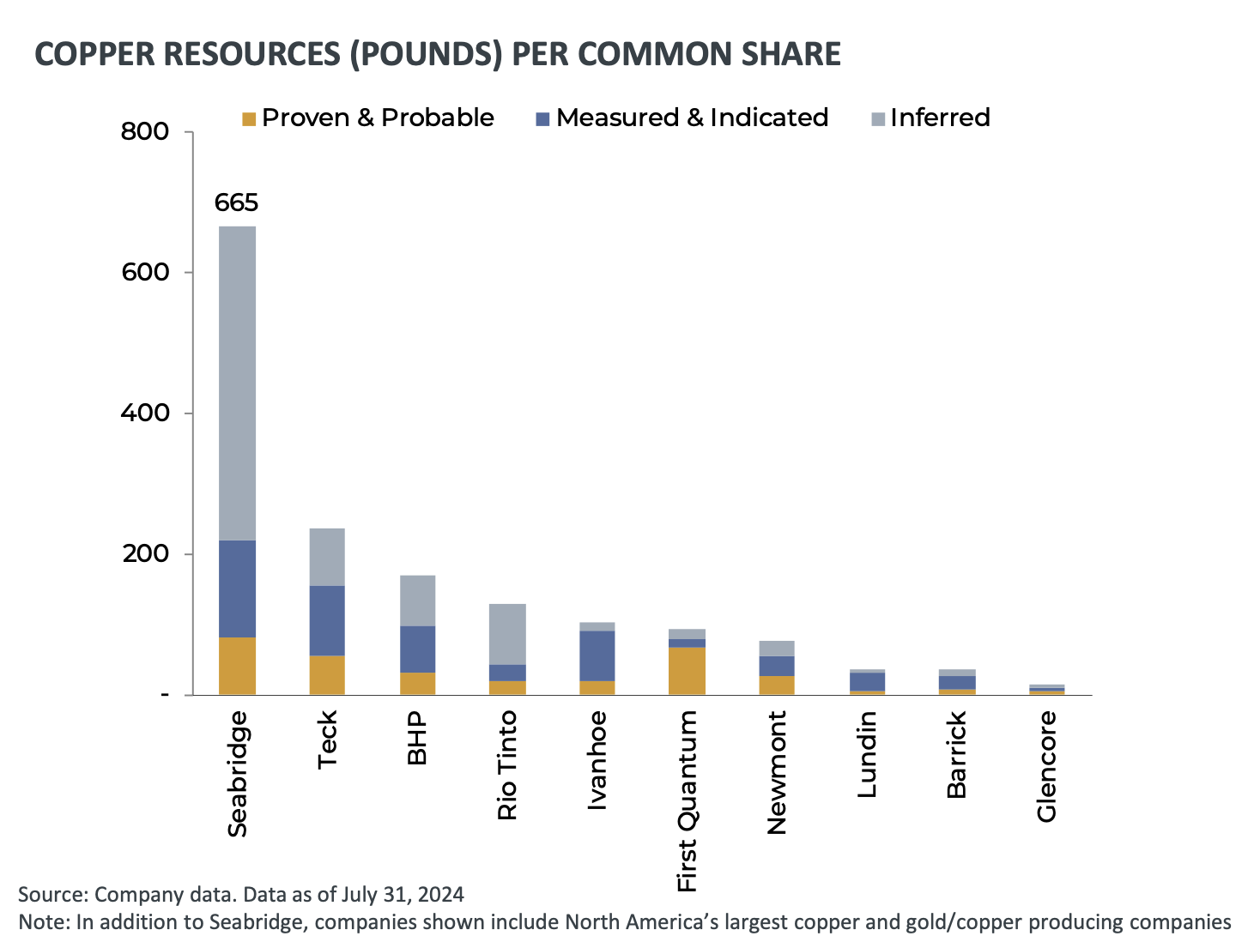

So every share of this company equates to $2,850 worth of copper!

What’s more, unlike many copper companies in, say, the middle of Mongolia, theirs is within easy reach of two Canadian ocean ports… including a port that’s just been newly built.

This massive gold and copper discovery is only the beginning...

Because we’re just talking about one of their projects.

If you add up all their mining assets, this single company controls 50 million ounces of gold and 7 billion pounds of copper…

Together worth over $155 billion.

But it gets better…

In addition to having the most gold per share… it also has far lower costs than most miners.

For example, Agnico Eagle’s all-in cost is $1,227 per ounce of gold.

Barrick Gold Corp has an all-in cost of $1,300 per ounce.

Newmont’s all-in cost is $1,485 per ounce.

But my #1 gold company?

Their all-in cost is just $600 per ounce of gold.

That’s HALF the cost of Agnico Eagle.

This is huge for investors.

Because it means any move higher for the commodity leads to bigger and bigger profits.

Let’s say gold moves up from $2,500 an ounce to $3,500 an ounce... which I expect it will do…

That would be a 40% jump higher.

If you owned gold bullion or coins, you would make 40%.

But for my #1 gold mining company, the difference could be much bigger...

Because it costs them just $600 per ounce to mine gold.

If gold is $2,500 an ounce, their profit is $1,900 for every ounce.

But even if gold rises to $3,500 an ounce, the cost per ounce for the company to mine it stays the same.

Now, instead of getting just $1,900 in profit per ounce, the company is making $2,900 per ounce... over $1,000 more per ounce!

So even though the price of gold has gone up only 50%, the company's profit has increased by over 50%!

That means as gold moves higher, their returns will increase even more.

Yet the stock is still priced incredibly low today. Its market cap is just $1.5 billion.

It’s no wonder that their CEO has 90% of his wealth invested in the company.

That’s how undervalued he sees his own company’s stock.

The upside potential is off the charts as the price of gold continues to rise.

I Expect the Stock to Surge Over 500% in 5 Yeras During This New Gold Bull Market

I’ve seen situations play out exactly like this before.

For example, when gold rose 164% from 2001 to 2006…

Top gold stocks like the one I’m sharing today did even better.

Kinross Gold was up 719%...

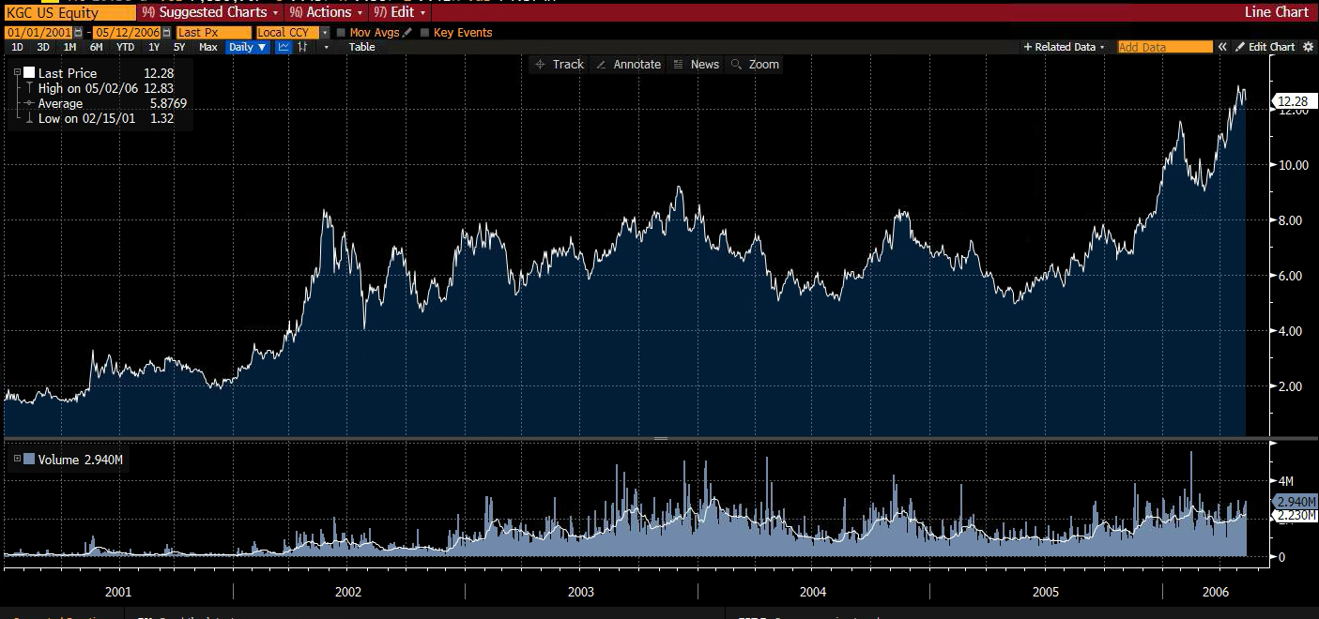

Hecla Mining, up 875%...

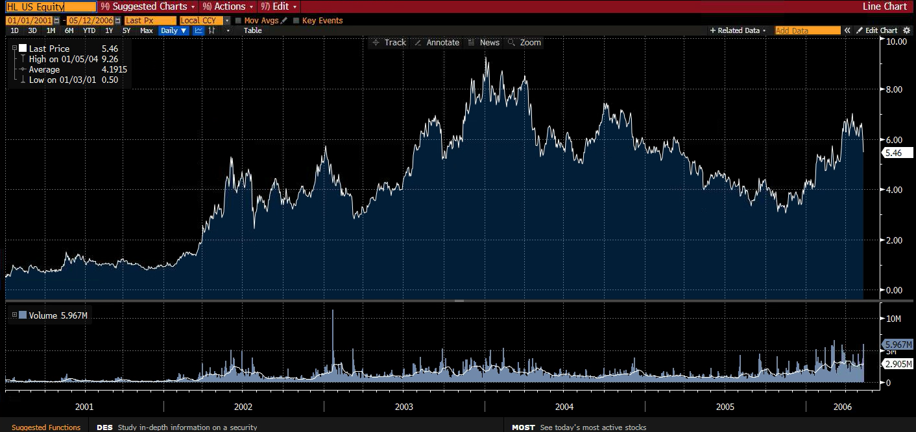

Royal Gold, up 958 %...

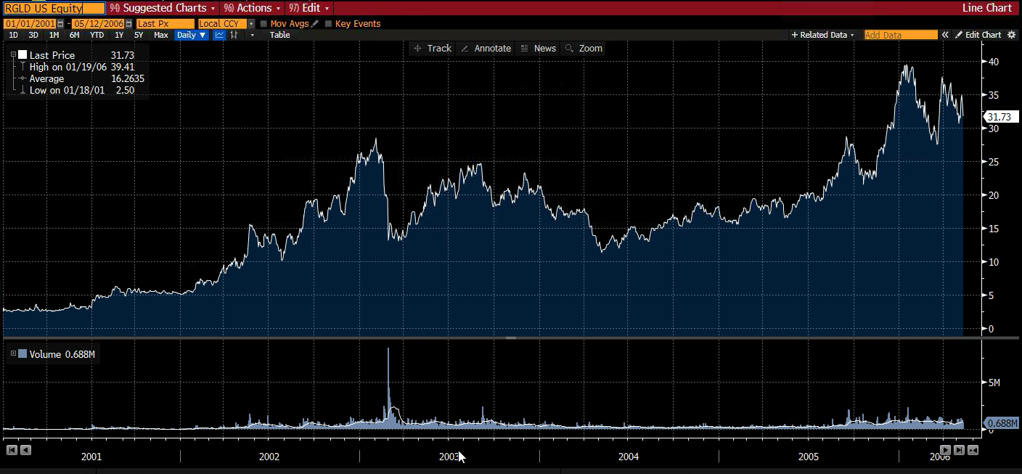

MineFinders… 1,313%...

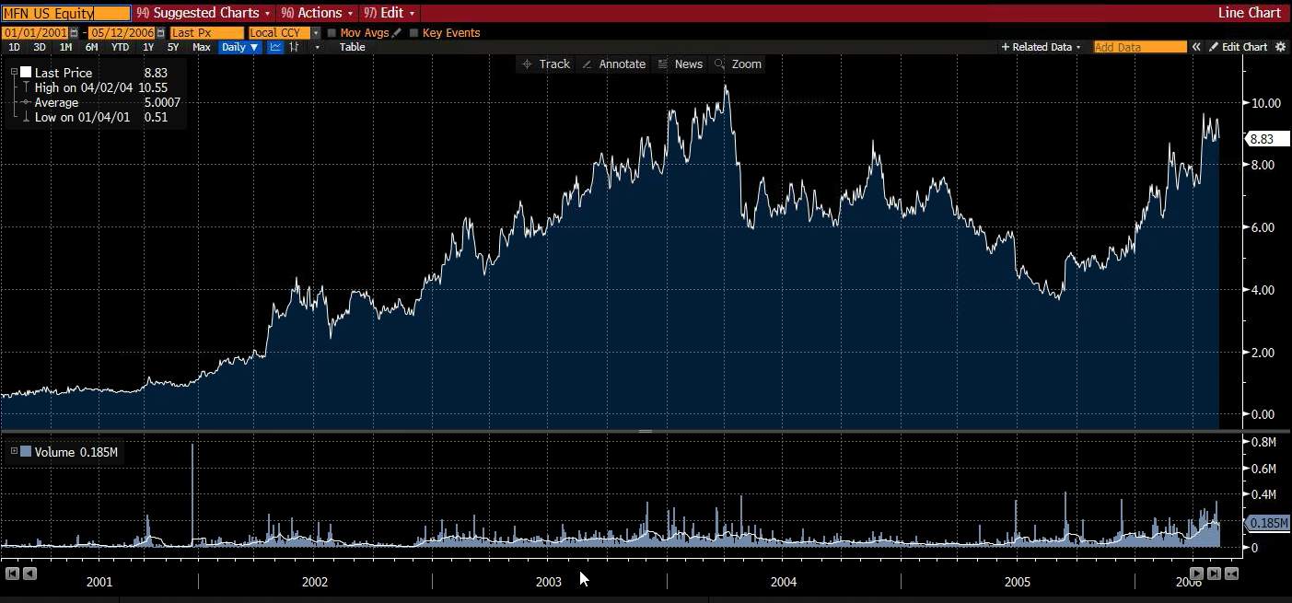

SSR Mining…1,617%...

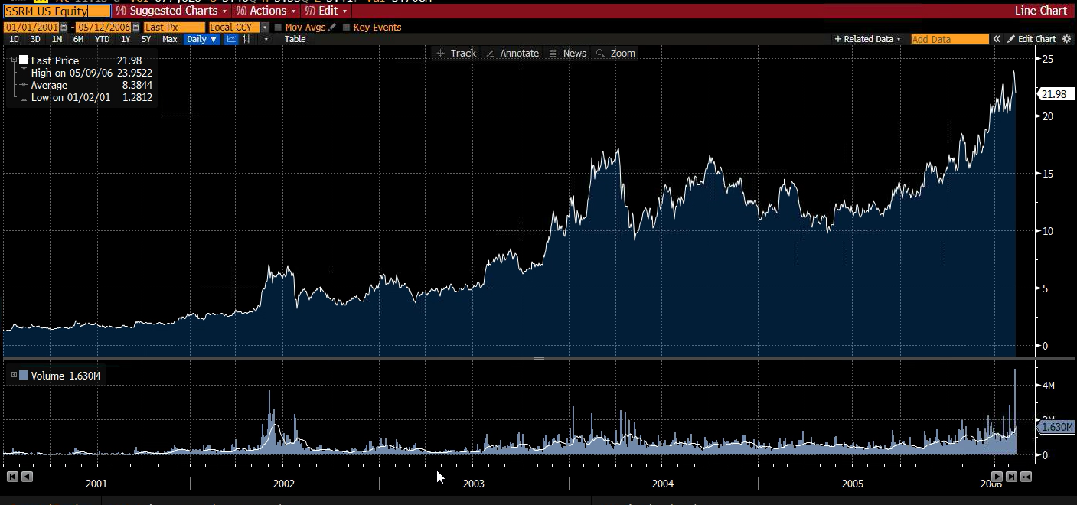

And Glamis Gold… 1,832%...

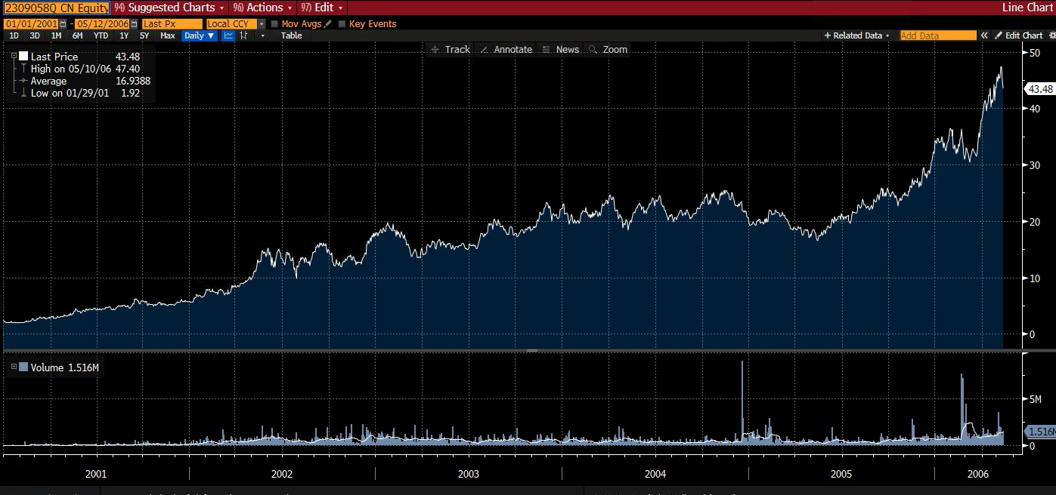

Or look at October 2008 to September 2011… When gold rose 166%.

Again, timing top gold stocks did even better…

Yamana Gold gained 339%...

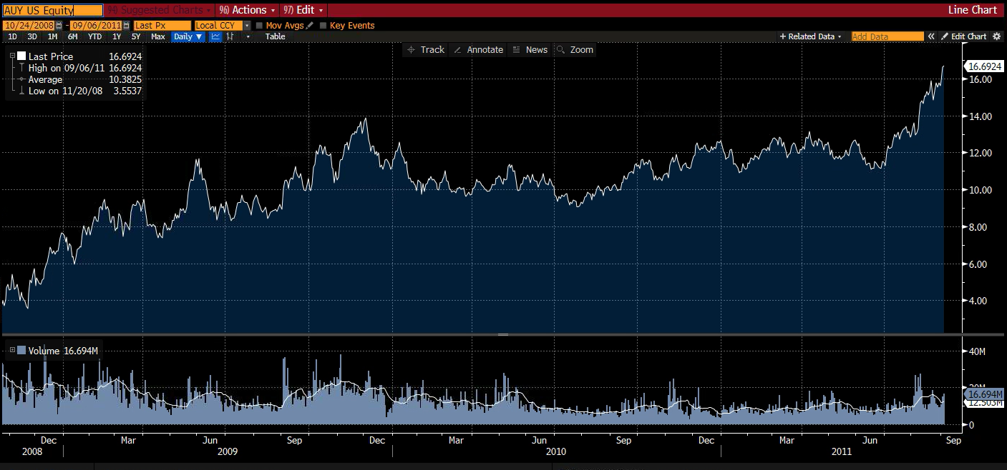

NovaGold, up 406%...

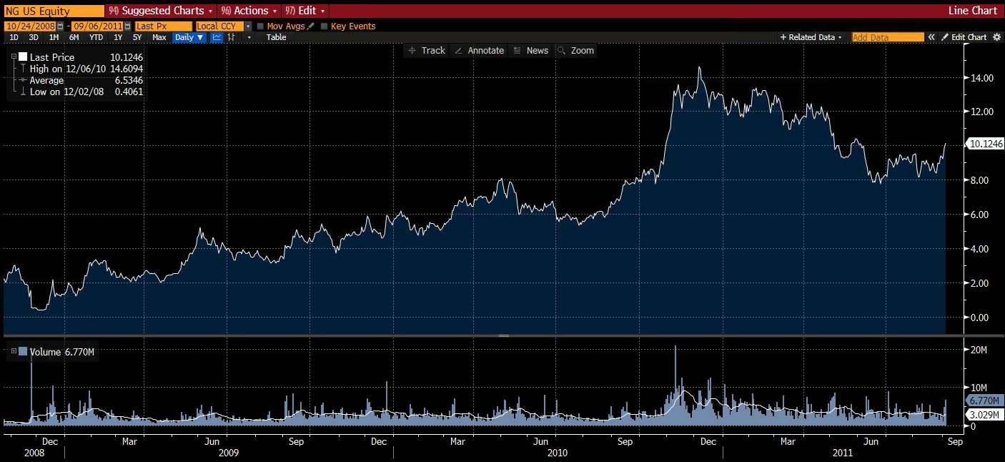

Coeur Mining was up 412%...

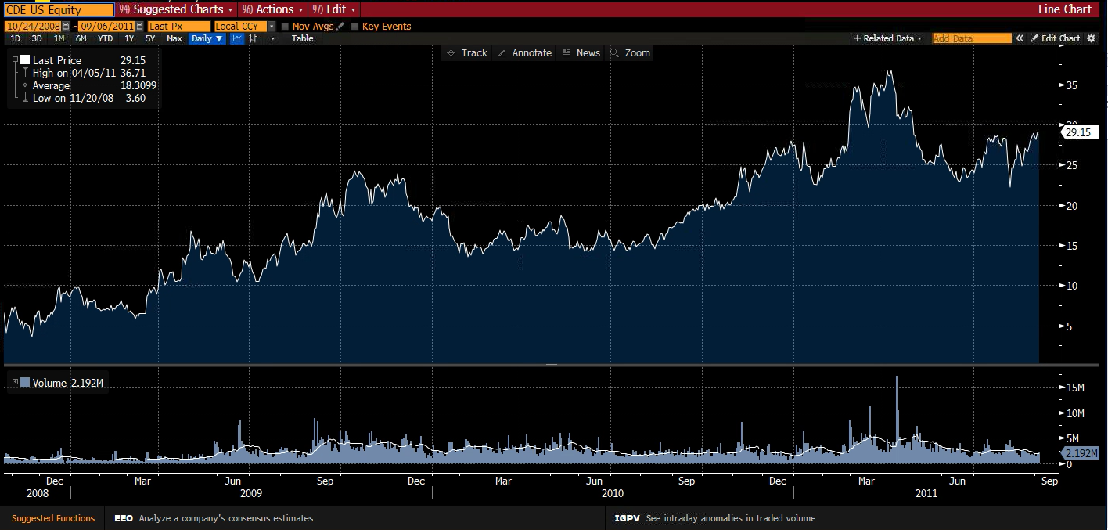

Richmont Mines… 585%...

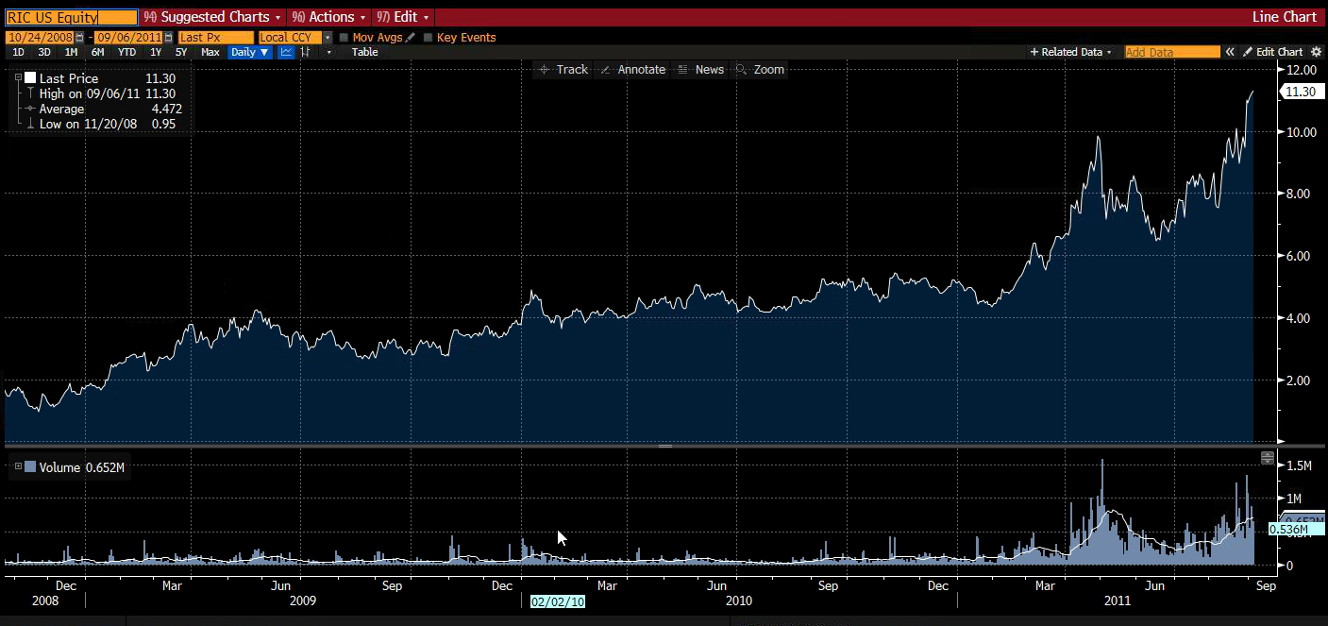

Wheaton Precious Metals… 1,072%...

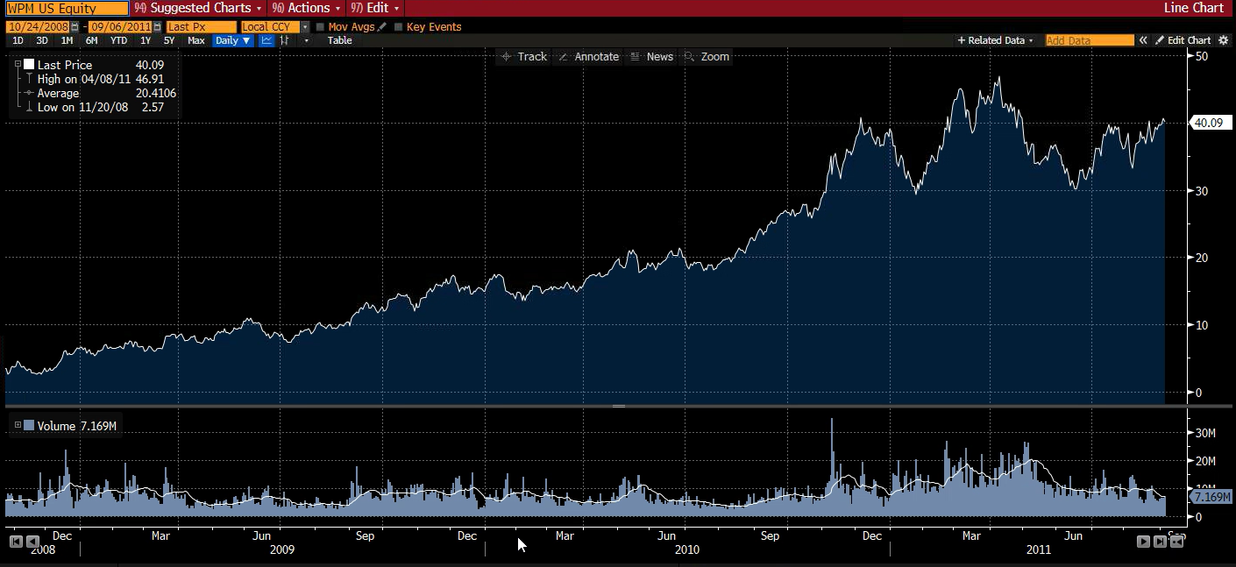

First Majestic… up 2,826%.

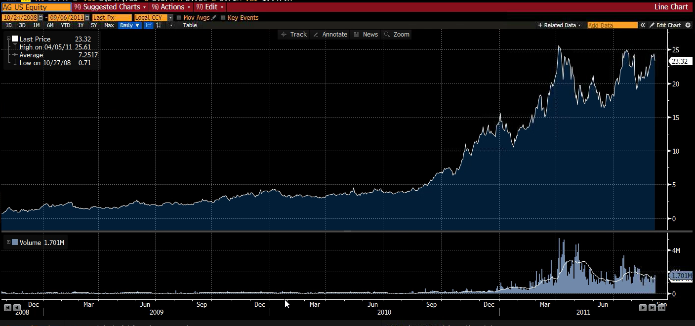

And Arizona Mining… 4,280%...

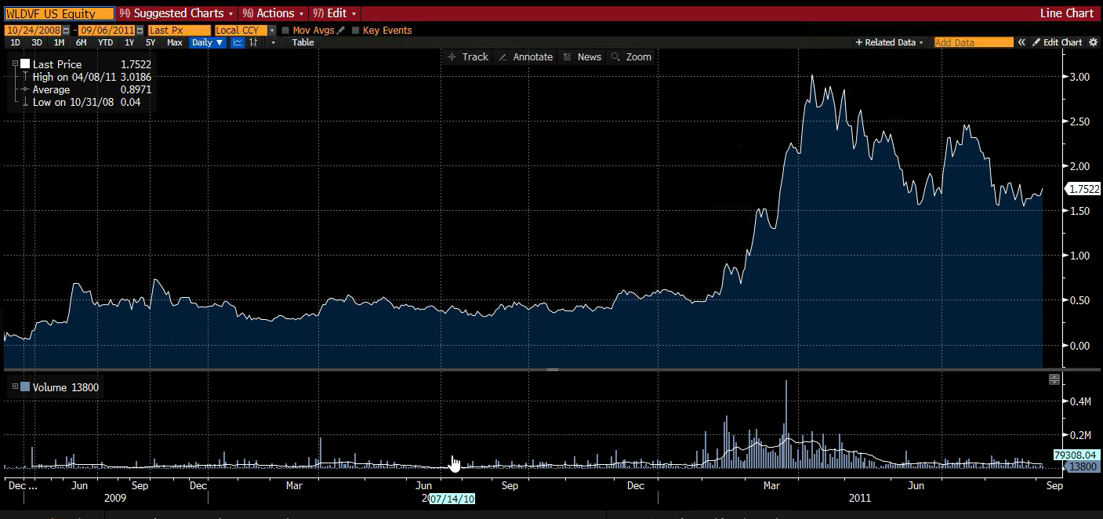

That’s the kind of profit potential we’re looking at here. Now remember all investing does carry risk and past performance is no guarantee of future success so we never recommend you bet the farm on any one trade…

But remember, this company holds more gold reserves for every share than any of the major gold mining companies.

If its stock simply traded on the same level as the other miners on a gold per-share basis…

We’d be looking at a $120 per share.

That’s over a 500% gain!

That’s why now is the time to make an investment in this little-known gold company.

Before the general public catches on.

At under $20, it is as big a no-brainer as I’ve ever seen in the investment world.

And I believe it’s going to move up very fast.

In fact, I just met with the CEO to discuss his company’s prospects…

I Met with the CEO… And I Realized That We Need to Act NOW

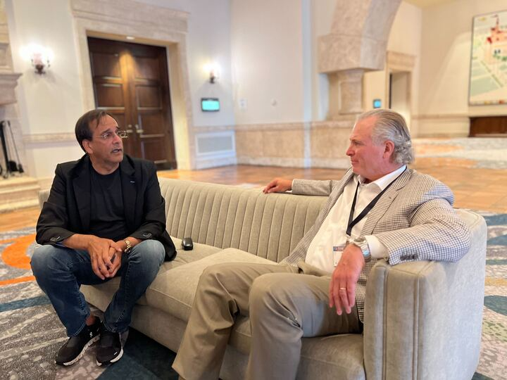

In fact, I just met with the CEO to discuss his company’s prospects…

He told me that a huge announcement could happen very soon.

He says he’s now engaged with 6 major gold mining companies in joint venture discussions… including several of the world’s largest mining companies.

You see, few people realize that the big gold companies are running out of gold reserves.

Newmont, the world’s largest gold miner, said that it might be unable to replenish its reserves of gold.

They need new projects, and this gold company has the largest gold project in the world.

So I expect he’ll partner with or be bought out by one of these big miners in a matter of weeks from now.

And when this announcement is made… the small company’s shares could skyrocket.

Look at top examples like Bema Gold…

Anyone who bought it in 2001 would’ve seen a 2,388% gain when Kinross Gold bought it out in 2006.

That would’ve turned $5,000 into $124,400 in just 5 years.

And the returns can come even faster…

Redback Mining jumped from $7.95 to $34.95 before it got bought out…

That’s a 338% gain in a single year.

This is why I’m telling all my followers that they need to move ASAP on this gold stock.

I’m showing them how to profit from this situation now... before the mainstream media picks up on it.

Get in now, and you could be part of that ride.

Wait and see what happens... and you may end up paying a much higher price for the stock.

That’s why I want to rush you a special report I just put together called “The Ultimate Gold Play.”

Inside this report, I’ll provide all the details on the gold stock I predict will dominate the market in the year ahead, including its name and ticker symbol.

I’ll explain how to buy it with easy-to-follow instructions. (Don’t worry – you can do this in a regular brokerage account.)

And I’ll break down all the revenue streams that will drive the stock higher in the months ahead.

But that’s not all.

I also want to send you my favorite way to play silver in this market.

Bonus #1: I’ll Show You a Special Way to Play Silver

In the world of precious metals, silver often stands in the shadow of its more glamorous cousin, gold.

But smart investors know that silver could hand you even bigger profits than gold during a bull market.

When gold goes up, silver historically goes up twice as much.

We saw this play out after the last Fed rate cut.

Silver exploded from around $9 an ounce in November 2008 to more than $50 by April 2011.

That's a staggering 399% gain…

While gold returned 109%.

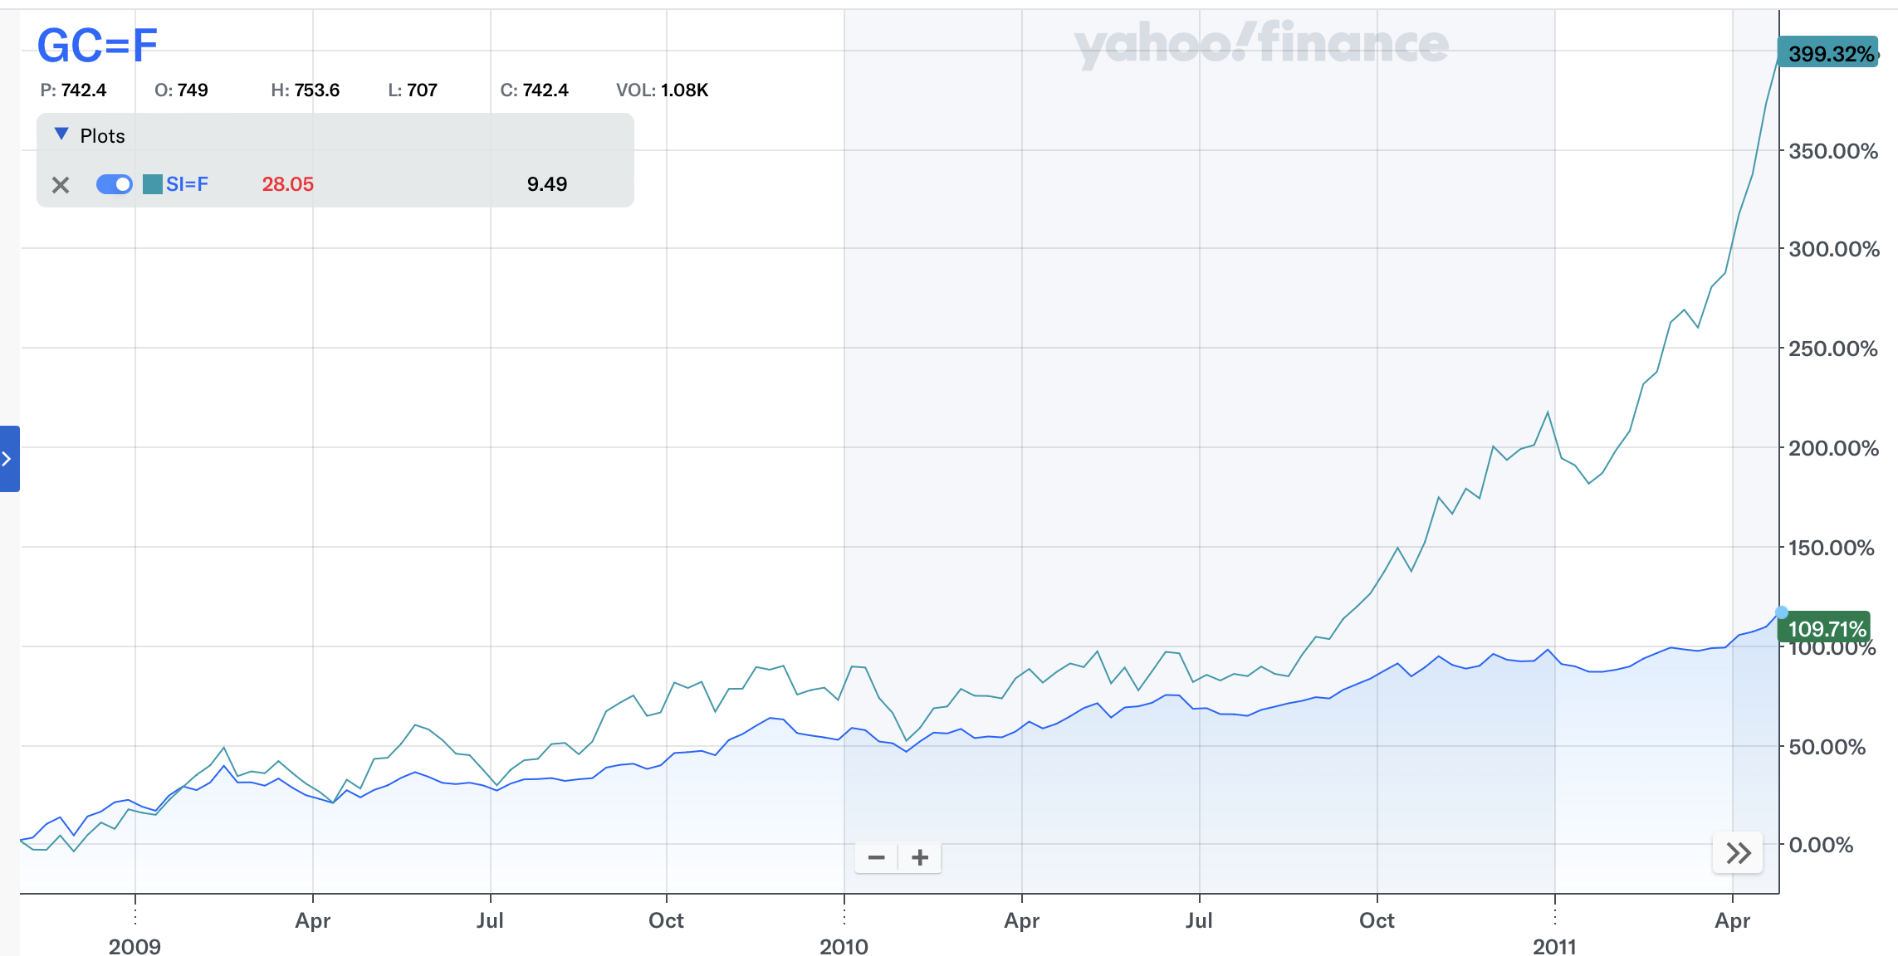

And here's where it gets really exciting.

Right now, silver is at a historical low compared to gold.

The gold-to-silver ratio, which has a 30-year average of 67, is 88-to-1 right now.

In other words, it currently takes 88 ounces of silver to buy just 1 ounce of gold.

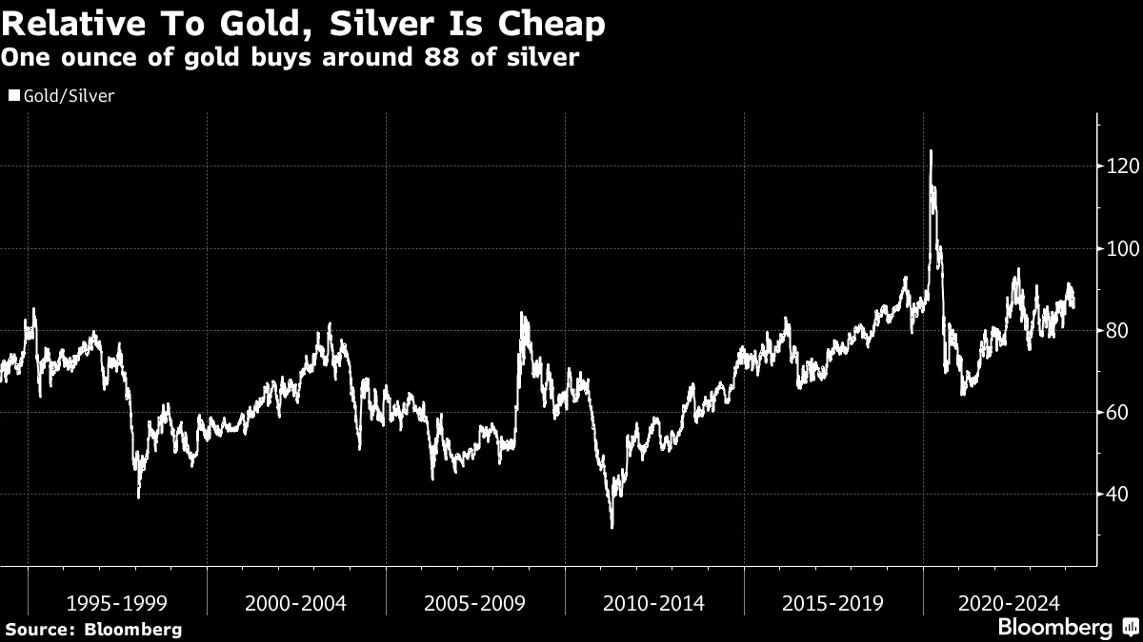
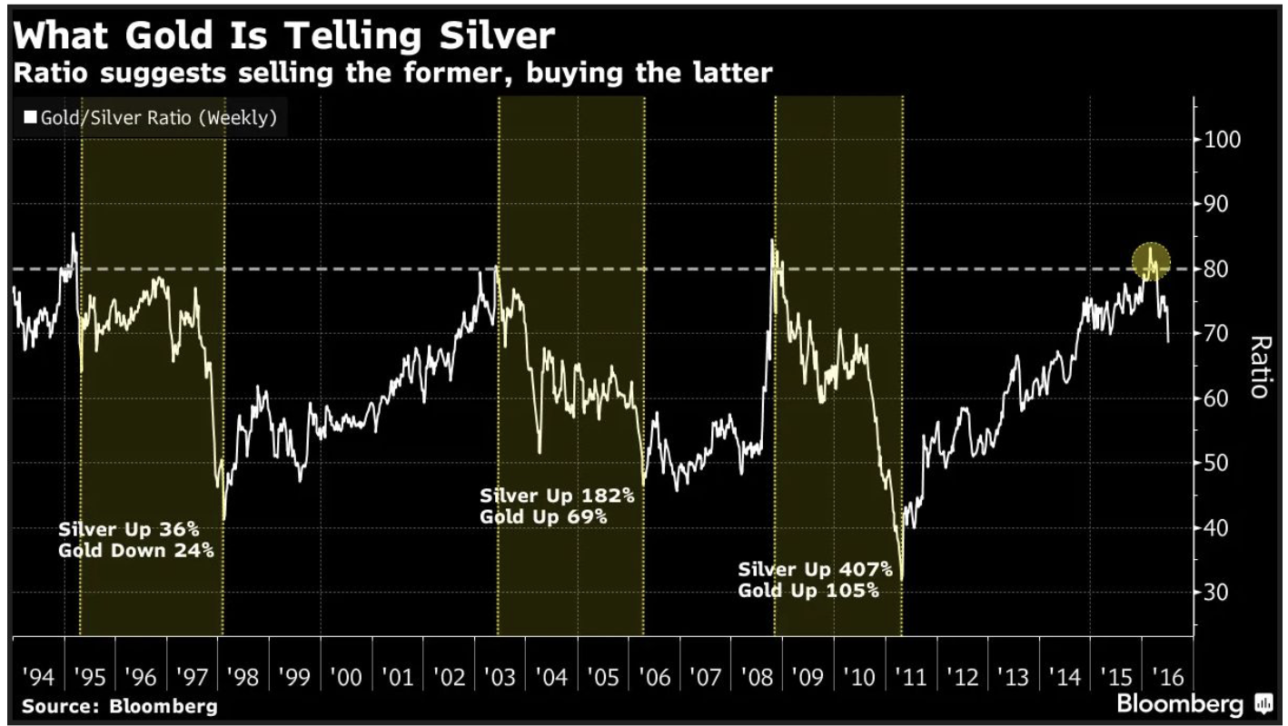

This ratio is completely out of whack, and history shows us that when it corrects, silver prices can soar.
So you’re getting two big catalysts for silver here…

First, the rate cut.

Second, the high gold-to-silver ratio.

On top of this, the fundamentals for silver are stronger than ever.

The Silver Institute recently reported that demand for the metal is expected to reach a record this year.

This is the fourth year that demand has exceeded supply… with this year’s shortage the second biggest on record.

This supply deficit, combined with increasing industrial demand for silver in electronics, could result in a price explosion for silver.

However, I don’t recommend you buy silver coins or silver stocks.

Rather, there’s a special options trade called a LEAP that could take your silver gains FAR higher.

With this trade...

If silver goes up 10% this year... you could stand to make 100%.

My readers love making these trades… Here are some of our best stories
Like Donald M., who made 266% in under 7 months using on one of my LEAP recommendations.

He said, “Love these LEAPS!”

And there’s George L.

He wrote to me saying, “Yee-ha! I still have CLF leaps from a Karim trade on 3/18/20. They're up 2548% in just a year and a half!”

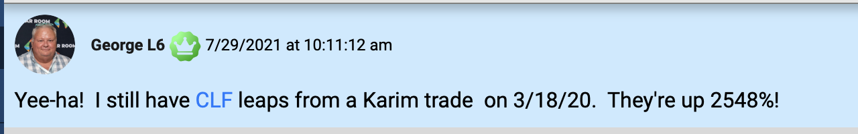

That’s why I put all the details on a special silver LEAP inside another special report that I’d like to send you right now.

It’s called The Nex Great Silver Trade.

It will explain exactly how I execute these types of trades so you can too.

This report is yours for free today, along with my new report, The Ultimate Gold Play.

All I ask in return is that you try out my new, interactive trading research service... Catalysts Cash Outs Live... at no risk to you.

Introducing: Catalyst Cash-Outs Live

In it, I give out LIVE weekly trade recommendations on the very best catalysts we see driving specific investments higher in the market – just like we’re targeting with my favorite gold play.

It all starts with our weekly livestream briefing that I host with my co-founder Bryan Bottarelli.

Like me, he is a multimillionaire trader.

But where I focus on value investing and fundamental analysis...

Bryan focuses more on technical trading and targeting faster profits.

Together... we give you multiple ways to tackle the market.

And every single week... on Tuesday at exactly 2 p.m... we go LIVE.

You’ll see us on camera discussing the week... and the setups we are most excited about.

Bottom line: We make it easy for you to succeed.

All you have to do is...

- Watch Catalyst Cash-Outs Live Tuesdays at 2 p.m. If you can’t join live... we’ll record the livestream for your convenience. You also get an email with the trade instructions.
- Decide if the investment is right for you
- And make a trade at our recommended price.

That’s it!

Then you can go on with your life for the week...

And repeat those three steps the following Tuesday!

It’s that simple.

And as gold rockets higher, I’ll be recommending you shorter-term plays where we can make huge returns alongside my #1 gold stock.

For example, in April 2021, I saw that because of heavy inflation... gold and energy stocks were making a big move.

So I made a short-term recommendation in our live trading research platform, The War Room.

I recommended an options play on VanEck Gold Miners in April.

And by November, it was up 114%.r
Ka
CHART

This is the type of gold trade I’ll target in Catalyst Cash Outs Live.

This is the thing...

By targeting stocks that have major potential news in the near-term, you can make substantial gains in the market.

114% would take you as long as a decade in a mutual fund.

To do it in under a year is game-changing.

But until recently, the only way to get access to trades like this was my high-end service, The War Room.

This is where we actively show people how to trade the markets – in real-time.

It’s very expensive... at $4,997 retail.

Which is why we decided to launch Catalyst Cash Outs Live.

It’s a far more inexpensive service that gives you access to some of my best trades each week.

With Catalyst Cash Outs Live, you get the same pro strategies I use in The War Room…

But instead of many trades a day, you get my top trade per week… at a fraction of the cost.

It’s a great way to get started, learn the strategies and win on some great trades along the way.

I look for the opportunities regular investors don’t see.

We’ll be looking at both stock plays and occasionally options setups as well.

And then I show my readers how to take advantage and potentially profit.

It’s simple and easy to follow.

Listen... if you wait for the mainstream media to tell you where to invest, you might as well just turn your bank account over to Wall Street.

The media loves to tell you about stocks that already went up.

So you end up buying at the tail end, just before the stock goes back down.

What you want to do is, like with my #1 gold stock I’m telling you about today, get in before the financial media catches on... before the public has any idea what’s happening.

That’s where I can help.

With Catalyst Cash Outs Live, I do the in-depth research to find little-known stocks with big catalysts on the horizon.

And I send you my favorite trade recommendation once every week.

We’ve designed this to work around YOUR busy schedule.

So when it is time to make a trade...

We’ll also send you an email...

And you can also get our Trade Alerts sent right to your computer or your smartphone.

And as you’ll see shortly, Catalyst Cash Outs Live doesn’t cost anywhere near what The War Room does.

It’s a fraction of the price.

And I’m doing this because I don’t want to keep regular folks out. I want to give you the chance to see what great trading can do for you.

Listen to What People Like You Have Said After Following My Top VIP Recommendations

You’re getting access to my top-level trades… without having to pay the hefty bill.

And you can join some of our happiest readers.

Like Eric O. who wrote to tell us…

“Thanks for great recommendations.... I am up 45% at this time [on one play in one month]. An easy $4K profit today.”

Then there’s Pamela S., who bought our Rocket Companies recommendation.

She said she “cleared a 60% profit” in one month.

Our Hertz trade in September was another one.

Daniel T. reported being up 67% in one month...

John R. landed a 52% win in one month...

And Erik K. told us he was busy and rarely checked his account... and then opened it to see a 79.5% win in two months!

And we think this new livestream will give you the chance at even BIGGER profits... coming even FASTER.

Seeing people succeed and understanding how life-changing it is to be a successful trader is all the reward I need.

Our recommendation on Jasper Therapeutics in October 2021 is a good example.

We recommended it on the 7th, and by the 13th, we were up 50%.

Peter H. said...

“Watched your video over the weekend, bought it yesterday at $8.14. And it’s OMG today.”
And take a look at Geno, who played one of my recommendations on the stock SOFI.

He made a 156% profit within a day thanks to an option play!

If you haven’t experienced big returns in your portfolio that fast...

It’s time you changed that.

Those are the types of results we’re aiming for with Catalyst Cash Outs Live.

Speaking of great trades, I have another special bonus for you.

Bonus #2: “Get Rich with Gold Royalties”

One of my favorite ways to invest in gold is through gold royalty companies.

Because when you own a royalty... whenever revenue is made... you get paid.

And you don’t have to incur all the costs or risks involved.

Even Warren Buffett is in on the action. He absolutely loves royalty opportunities.

In his words...

“The best business is a royalty on the growth of others, requiring little capital itself.”

This is why gold royalties are so great.

Once you own one, you don’t have to do anything. You just collect a portion of the revenue for years until somebody buys you out.

And this can create huge profits for royalty companies… and their shareholders. For example...

Between 2005 and 2010, gold went on a big bull run.

Gaining 211% in just five years.

Not bad.

But one of my favorite gold royalty streams rose 1,108% over the same period!

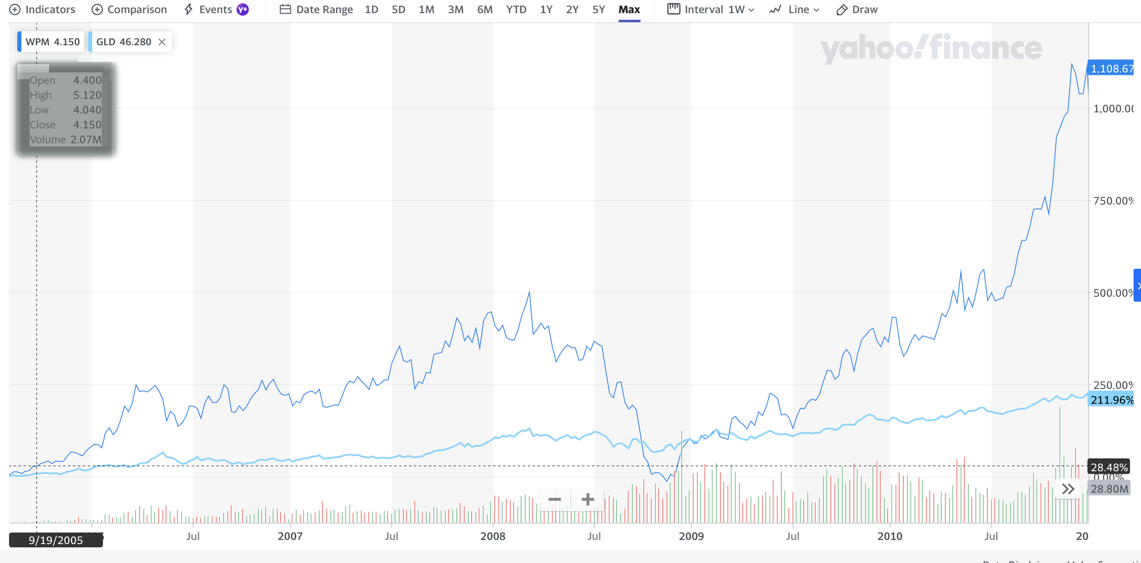

That’s why today, I also want to give you the name, ticker symbol, and the full breakdown of one of my other favorite gold royalty companies.

This company has one of the most proven track records in the industry.

For example, during the Great Recession from December 2007 to June 2009...

Stocks were down 35%...

While gold was up 22%.

But this gold royalty stock rose even faster... going up 84%...
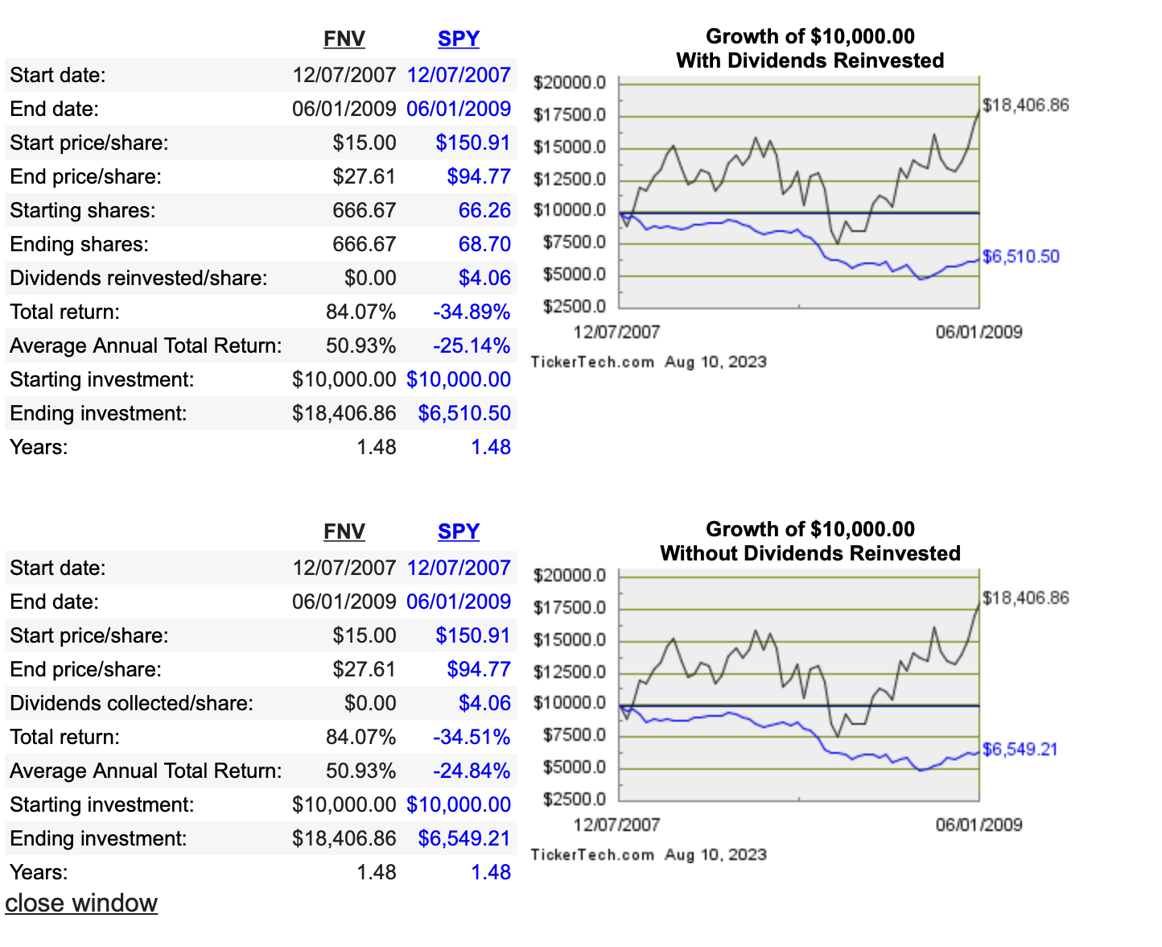

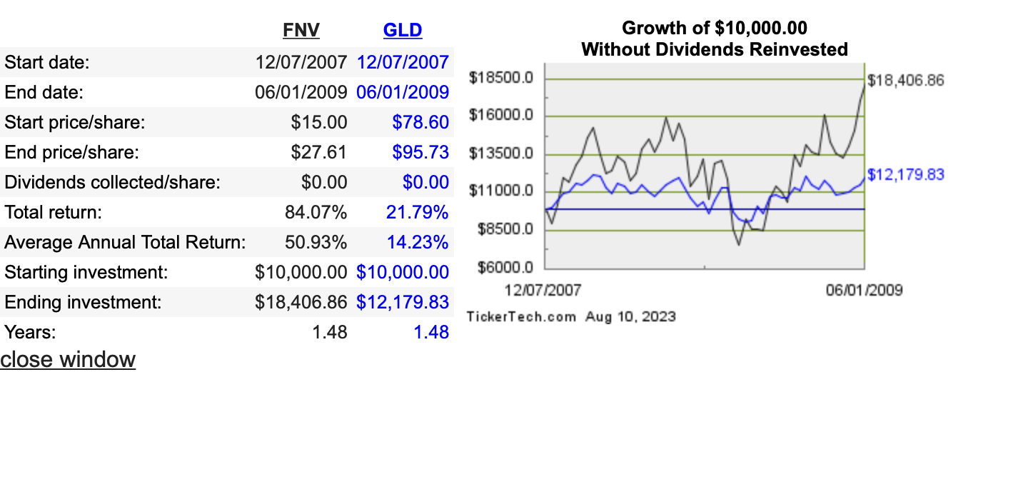
Then...

Gold continued to go up through 2011.

The precious metal went up 91%...

But this gold royalty stock again rose even more... going up 153%.

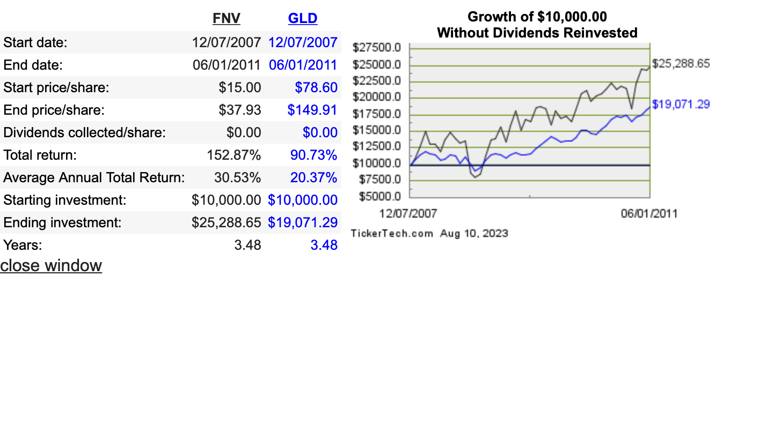

But what happens when gold goes down?

Well... that’s where the real magic happens.

From 2011 thru 2014... gold actually fell 18%.

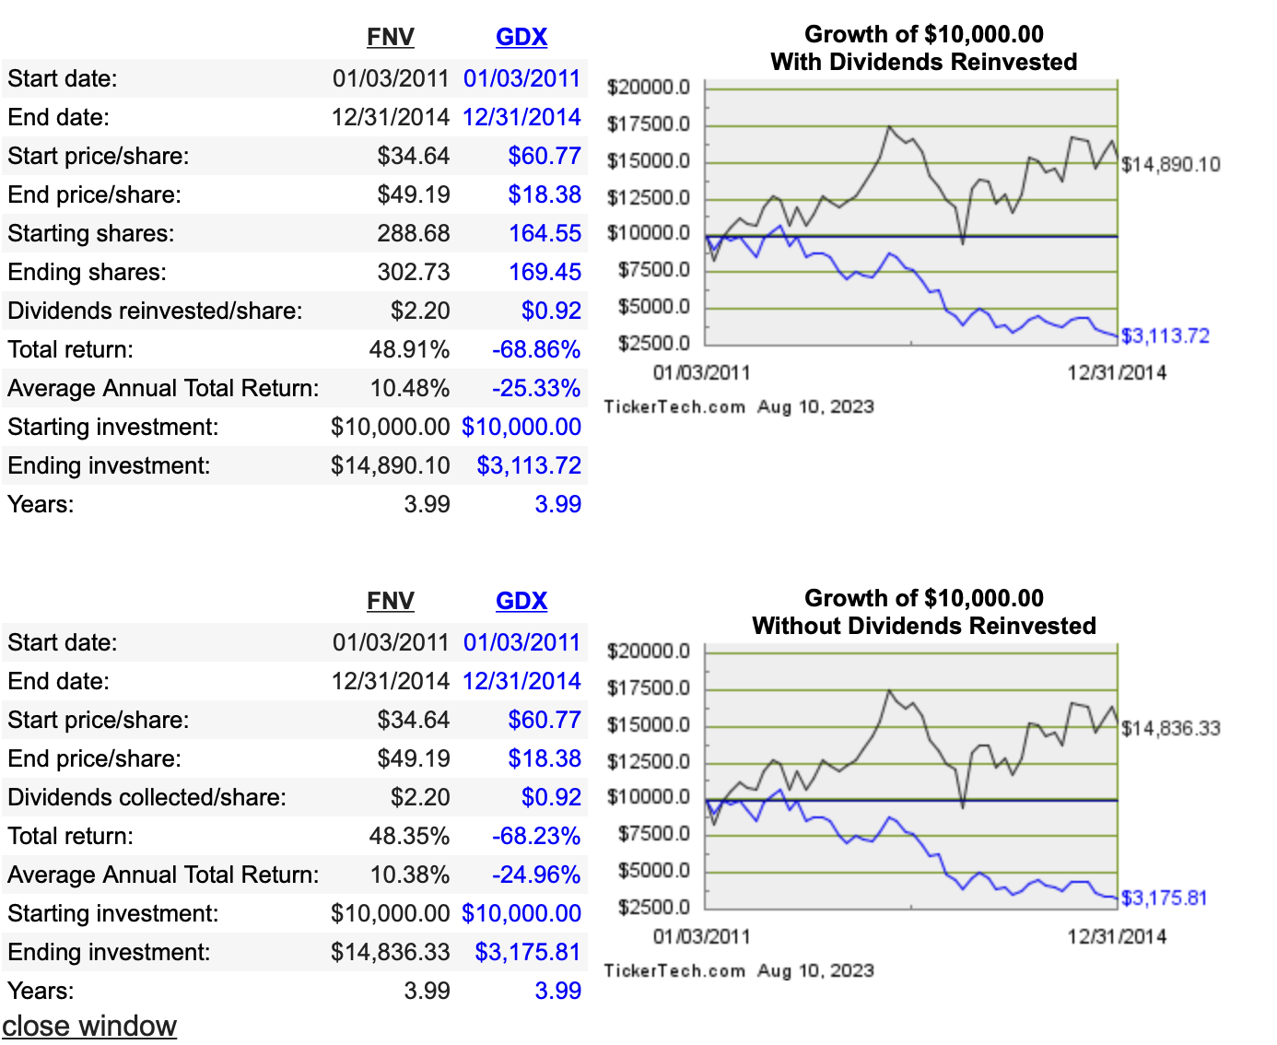

But this gold royalty stock just kept rising.

It was UP another 54%... even as virtually every other gold investment collapsed.

And the truly amazing thing is that it even beat stocks during a rip-roaring bull market.

Starting from their low in 2009...

Stocks are up 558% today.

But my favorite gold royalty stock is up 719%.

It’s just incredible. 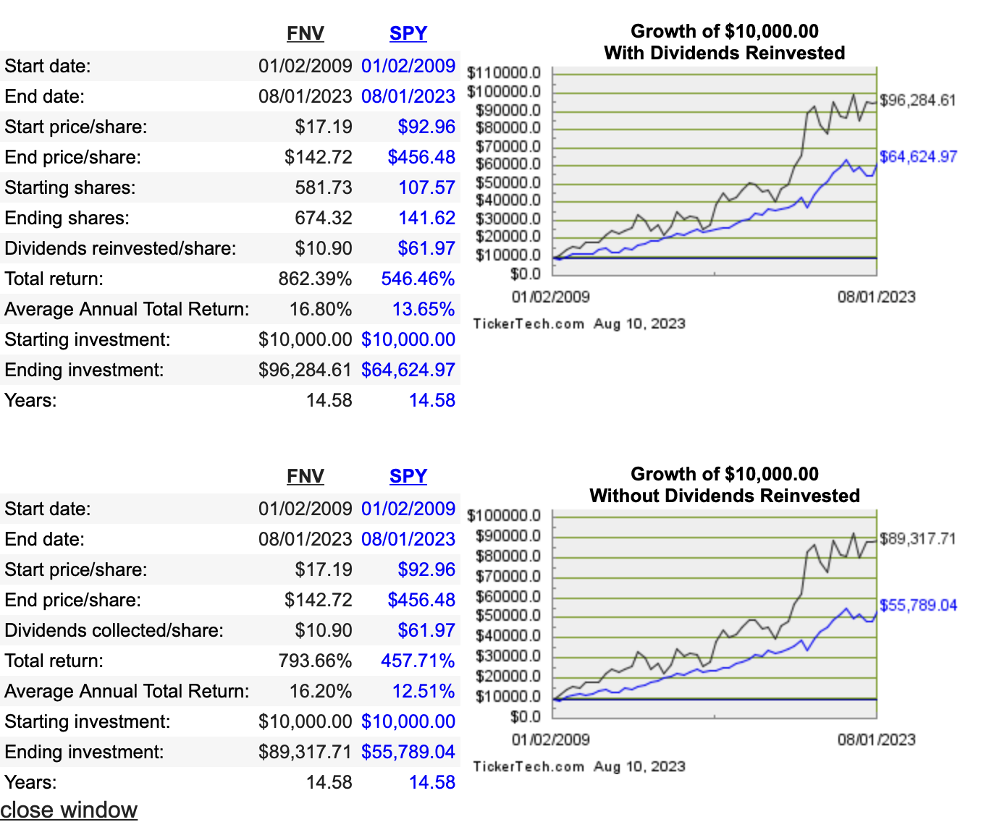

This one unbeatable gold investment has gone up for decades... through virtually every market condition.

According to founder Seymour Schulich, $1,000 in it would have been worth over $1.2 million dollars after the first 19 years.

Those are the kind of results a great royalty business can achieve.

I’ll tell you all about it in a special report called “Get Rich with Gold Royalties.”

Listen, my goal for you is simple: I want to make sure you have everything you need to succeed.

So when you sign up for Catalyst Cash Outs Live, I’ll immediately send you all the special reports I’ve mentioned so far, completely free.

As a new member of Catalyst Cash Outs Live, you’ll instantly have access to all the bonuses I told you about.

But here’s even MORE of the many benefits you’ll get by joining this new livestream service.

You’ll get access to our model portfolio, including all our current recommendations...

Plus...

Access to our Concierge Team...

Bryan and I have trained our friendly staff to quickly answer any questions you have regarding your membership...

And our moderators are trained to answer any general questions you have about our trading strategies and techniques.

Now... of course they can’t give you personal investment advice.

However... Please feel free to call or email them anytime and they will be happy to help you however they can.

Then... there’s something else I haven’t told you about...

Our new app allows you to receive recommendations and analysis while you’re on the run.

If a government report is coming up the following day, you can expect to see the full instructions how to trade it pop right up on your app.

That way, it’s easy to make the trade.

Lastly, I’m also going to teach you some of the “secrets of the pros” that Wall Street rarely shares with retail investors.

Bonus #3: I’ll Show You the Power of the Win-Both-Ways Trade

For example, there’s a type of trade called a Win-Both-Ways Trade that, once you understand it, might be the only type of trade you want to make going forward.

In short... with this trade...

If the stock goes up... you win.

And if the stock goes down... you ALSO win!

It just has to move!

Sounds crazy, right?

But it’s true.

Of course, you shouldn’t expect to win on every trade, but we often used this trade in our VIP trading research service, The War Room… and it’s resulted in many of our best trades.

For example, we completed a Win-Both-Ways Trade on Slack Technologies in June 2020, just before Slack was set to make an earnings announcement.

Now, for most traders, earnings are tough.

You’re guessing which way it will turn out. And if you guess wrong, you could get burned.

But with this special options trade, it can make you money either way.

In the case of Slack, earnings were a disaster.

Regular shareholders lost 17% the moment earnings came out.

But our Win-Both-Ways Trade?

Our VIP member Grant V. said he made a “net 130% in three minutes!”

And newbie Steve C. said, “$1,200 profit (31% gain in one day) on my second day of trading.”

The opposite happened when we did a Win-Both-Ways Trade on Kellogg.

With that one, Kellogg got good news.

Shares rocketed upward 10% by noon.

But our Win-Both-Ways Trade?

It was up 133% in a single day!

This is the beauty of this trade.

If shares collapse like with Slack, you can make money.

If shares shoot up like with Kellogg, you can make money.

That’s why I put all the details inside another special report that I’d like to send you right now.

It’s called How to Execute the Win-Both-Ways Trade.

It will explain exactly how I execute these types of trades so you can do it too.

It’s yours for free today, along with our new report on my #1 gold stock.

All I ask in return is that you try out my research service called Catalysts Cash Outs Live... at no risk to you.

By that, I mean I’m giving you an entire year to review everything risk-free.

That means that if anything doesn’t live up to the billing... you’re welcome to a prompt refund.

And this applies for the next 365 days.

Plus, even if you do cancel, I’ll still let you keep every report at no charge whatsoever.
That’s how confident I am in the work I do... and the success I’ve had teaching people.

I’m willing to put every bit of the risk on my shoulders.

If I don’t deliver, you get every penny back.

I think you’ll agree that’s more than fair.

So how can you get started?

I’ve Giving You the Best Deal Possible

Well, I’m happy to say that a subscription to Catalyst Cash Outs Live costs just $249 a year.

It’s a great product for people who like the simplicity of receiving just one trade per week... and for those who want to learn the secrets of the best traders in the world.

But here’s the thing...

My goal is to help all of you who are watching get to that point where trading can be a regular source of profits.

And I see the gold stock I’ve talked about today as the single most important move on that journey.

The company just started construction on the largest gold deposit in the world… and the third largest copper deposit… marking the perfect time to buy in.

It has more gold per share than any other gold company.

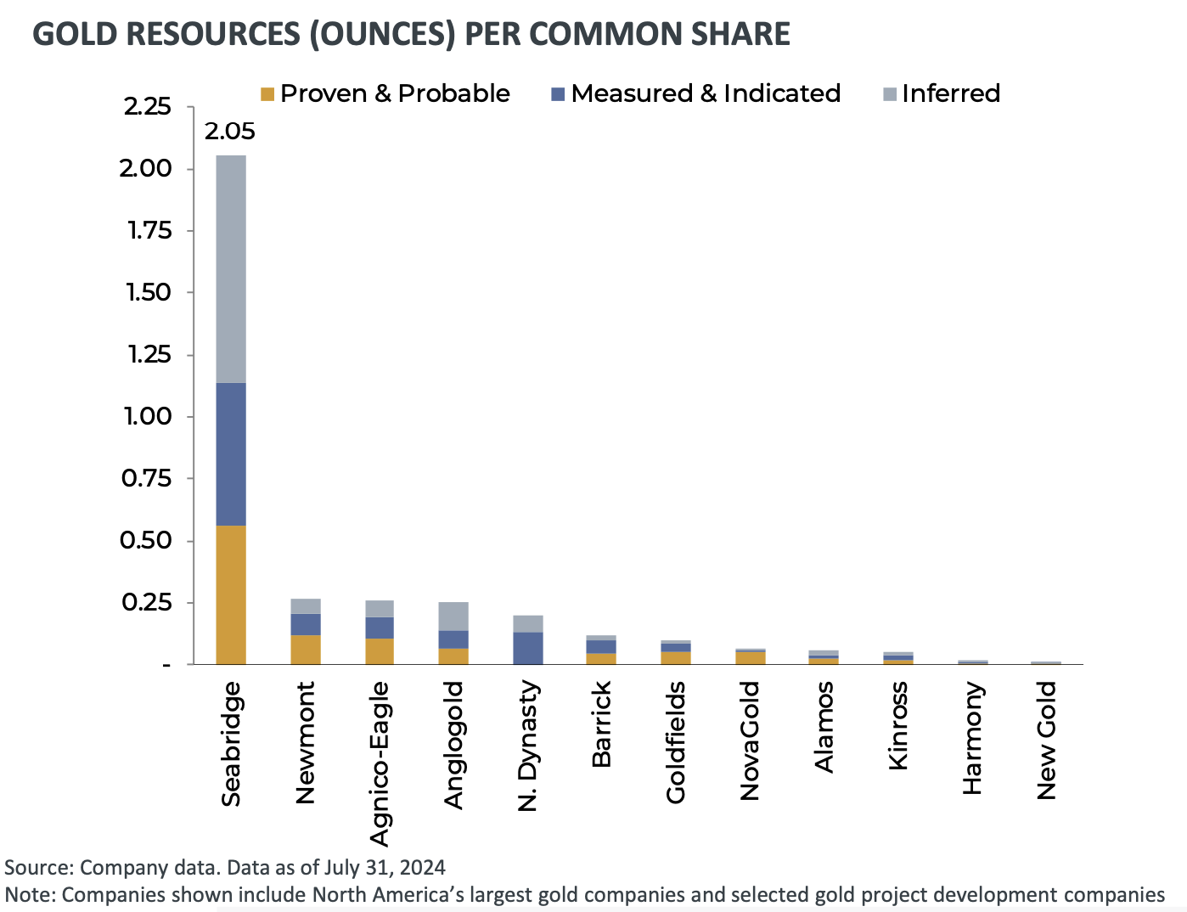

Plus, it has a huge portfolio of other projects coming that could bring even more gold reserves.

Yet… it sells at a fraction of the cost of other gold stocks on the market.

In short, I believe this company is the single best gold play you could make for the future.

And I DO NOT want you to miss it.

So I’m going to do something special today.

I don’t want price to be the thing that keeps you from benefiting from this play.

With the big upcoming announcement that could drive shares higher... time is very important here.

Wait a week, and this thing could be up to $30… even $50 already.

So now is the time.

That’s why I’m going to make this a no-brainer, can’t-miss situation.

I’m going to give you the single best deal we ever offer.

Because my goal is that you make so much money from this one stock... you can use just a fraction of those profits to join some of our other services.

And that’s why I want to extend a special discount to you.

If you say YES right now...

You can get a full year’s access to Catalyst Cash-Outs Live...

For JUST $149/79/99/49/129.

That’s less than $XX a week for our livestream.

It’s a steal, honestly.

But I’m willing to offer you this price to prove to you that this research can change everything for you and your family.

That’s why this huge discount is ONLY available right now to our new members.

Click on that button below... and join us for a YEAR of opportunities.

Remember, when you buy a share of my #1 gold stock… you’re getting exposure to over an ounce of gold for under $20…

With gold soaring over $2,500 right now, the value is obvious.

And remember, you have a full year to try it out…

365 Day, 100% Refund

You can sign up right now, get the report, and then decide whether it’s worth investing in or not.

You will have 365 days to try everything – at zero risk.

And if it turns out my type of trade strategy doesn’t work for you, no hard feelings.

You can have a full refund.

I think you’d be crazy to do wins I’ve proven to deliver.

But that’s exactly why I’m doing it.

Because I’m confident that you will see this is the best product ever offered for that price.

Plus, we’ll let you keep everything you received as a subscriber – at no charge – even if you do decide to quit.

Does it get any better than that?

You keep everything no matter what.

And all the risk is on me to deliver.

Which is exactly what I plan to do, starting with my #1 gold stock I’ve told you about today.

To receive my special report detailing that stock, just click the button below to get started now.

Clicking will take you to a secure order form.

There, you can review everything we’ve discussed.

I know it’s a lot.

It’s important to me to deliver a lot of value to my subscribers.

I never want anyone to feel lost or like they aren’t getting the help they need.

I want you to feel like I’ve got your back at all times.

So click the button below to get started.

Here’s Everything You’ll Get

As a reminder, here’s everything you will get when you join Catalyst Cash Outs Live...

- Weekly Trade Alerts 12 Months of Catalyst Cash-Outs Live Recommendations ($997 Value).
- Weekly LIVE Trading Session Catalyst Cash-Outs Live
- “The Ultimate Gold Play” – My brand-new write-up will break down everything you need to know about my favorite gold stock. You’ll get instructions on how to buy... learn how to ensure you pay the best price... get details on the company’s growth plan... and more.
- Bonus #1: “The Nex Great Silver Trade”
- Bonus #2: “Get Rich with Gold Royalties”
- Bonus #3: “How to Execute the Win-Both-Ways Trade”
- Access to Our Model Portfolio, With All Current Recommendations
- Access to Our Custom Web App
- Access to Our Concierge Team – Any questions you have regarding your subscription can be answered quickly by our full-service staff. Please feel free to call or email them anytime.
- Plus, Password-Protected Access to Our Catalyst Cash Outs Live Website – 24/7 access to our open portfolio, archives of all trade alerts, updates and special reports.

Again, just click below to get started.

Remember, my #1 gold stock I’ve told you about today is unlikely to stay cheap for long.

Gold is set to launch into a major bull run. In fact, it’s already begun. And this one gold stock is in perfect position to profit most.

Consider... where you get exposure to over 1 oz of gold… which trades for $2,500 right now.

Yet shares of this stock trade for under $20.

As I showed you earlier, this stock could easily move up to $120 and still be priced “normally” in this market.

That’s the potential you are looking at here.

So ask yourself...

Is that type of reward worth the risk?

Is it worth at least taking me up on my 365-day risk-free guarantee?

That’s a question only you can answer, but I believe the answer is clear.

And time is of the essence.

Remember, the CEO said that a big partnership or buyout is imminent.

If you wait – even days – there may not be another chance.

I don’t see one single stock trading at this price with this much upside... in the entire stock market.

This is the one.

I have no doubt you’ll make the right call.

So click the button below to get started. I’ve added an extra bonus there that you’ll see just for clicking.

So go ahead and do so now.

I look forward to welcoming you to Catalyst Cash Outs Live.

Thanks for watching.

Karim Rahemtulla

August 2024

