Urgent Investment Opportunity for 2026:
Here’s Your TICKET to ChatGPT's
Trillion-Dollar IPO
Get a Pre-IPO Stake BEFORE March 18, 2026
(Free Ticker Revealed)

ALT HEADLINE:

CHATGPT’S LEAKED DOCUMENT:
The Trillion-Dollar IPO Plan Unlock a Pre-IPO Stake
BEFORE March 18, 2026
(Free Ticker Revealed)

Hi, I’m best-selling author Karim Rahemtulla coming to you with the biggest tech and investment opportunity of the year.
As you may know…
In 2022, ChatGPT stormed into existence and instantly changed the world.
It became the fastest growing application ever.
100 million users…
In just two months.
Bill Gates called it “revolutionary… the most important advance in technology since the graphical user interface.”
Elon Musk said it was “scary good.”
Nvidia CEO Jensen Huang called it an “iPhone moment” and said it was “one of the greatest things that has ever been done for computing.”
And as Reuters reports… ChatGPT’s company - OpenAI - is set to go public as the world’s FIRST trillion-dollar IPO.
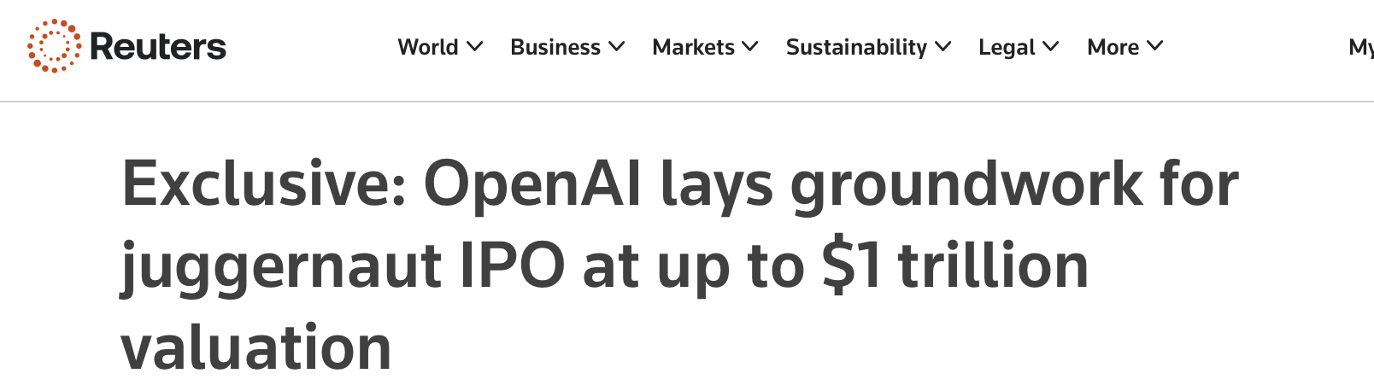
This is the biggest tech IPO in history…
The kind of opportunity that can bring truly life-changing gains.
In this short video, I’m going to give you the name and ticker symbol - for FREE - of a play that will let you get in on OpenAI BEFORE its upcoming IPO.

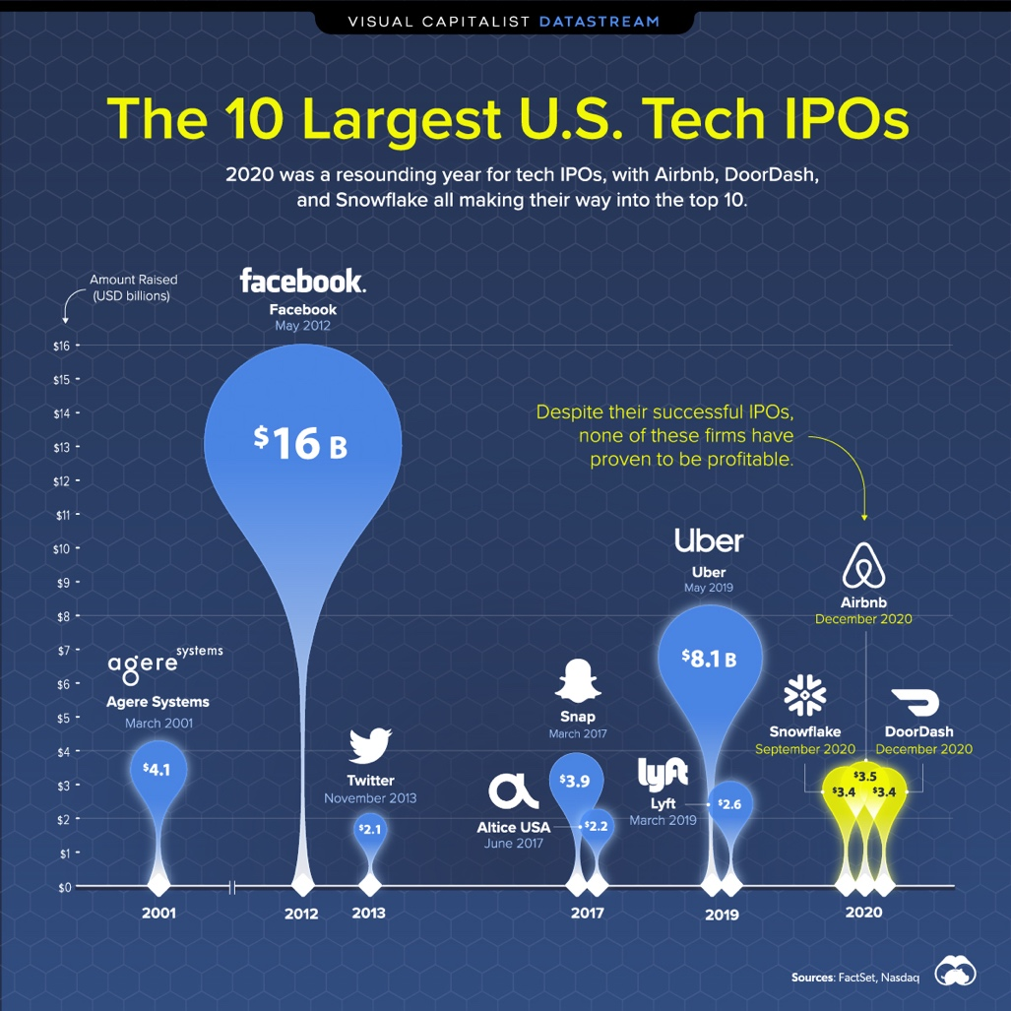
Think about Amazon’s 1997 IPO…
It was worth $438 million.
But $10,000 invested in Amazon back then would be worth $27 MILLION today!
Then there’s Apple’s IPO…
It was valued at $1.78 billion.
The biggest IPO of its time.
And $10,000 in Apple back then would be worth $26 MILLION today.
Microsoft’s?
In 1986… Microsoft was the “IPO of the Year”…
And it valued the company at $777 million.
$10,000 would be worth $48 million today.
From $10,000…
Into MILLIONS.
That’s rare… extraordinary… unheard-of types of gains.
And thanks to a set of documents quietly leaked by OpenAI itself...
I believe this IPO could be BIGGER than all of them.
But… it gets better.
Because the biggest fortunes in history usually go to people who got in before a company went public.
When Apple IPO’d, it created 300 millionaires that very day…
But that was ONLY for the people who were in BEFORE the IPO.
Which leads us to the problem I want to help you solve today.
You see…
By the time the average American is allowed to buy shares after the company goes public…
Most of the gains are already priced in.
Inc. magazine said that if you are only investing AFTER companies go public…
You are missing out on 95% of the gains!
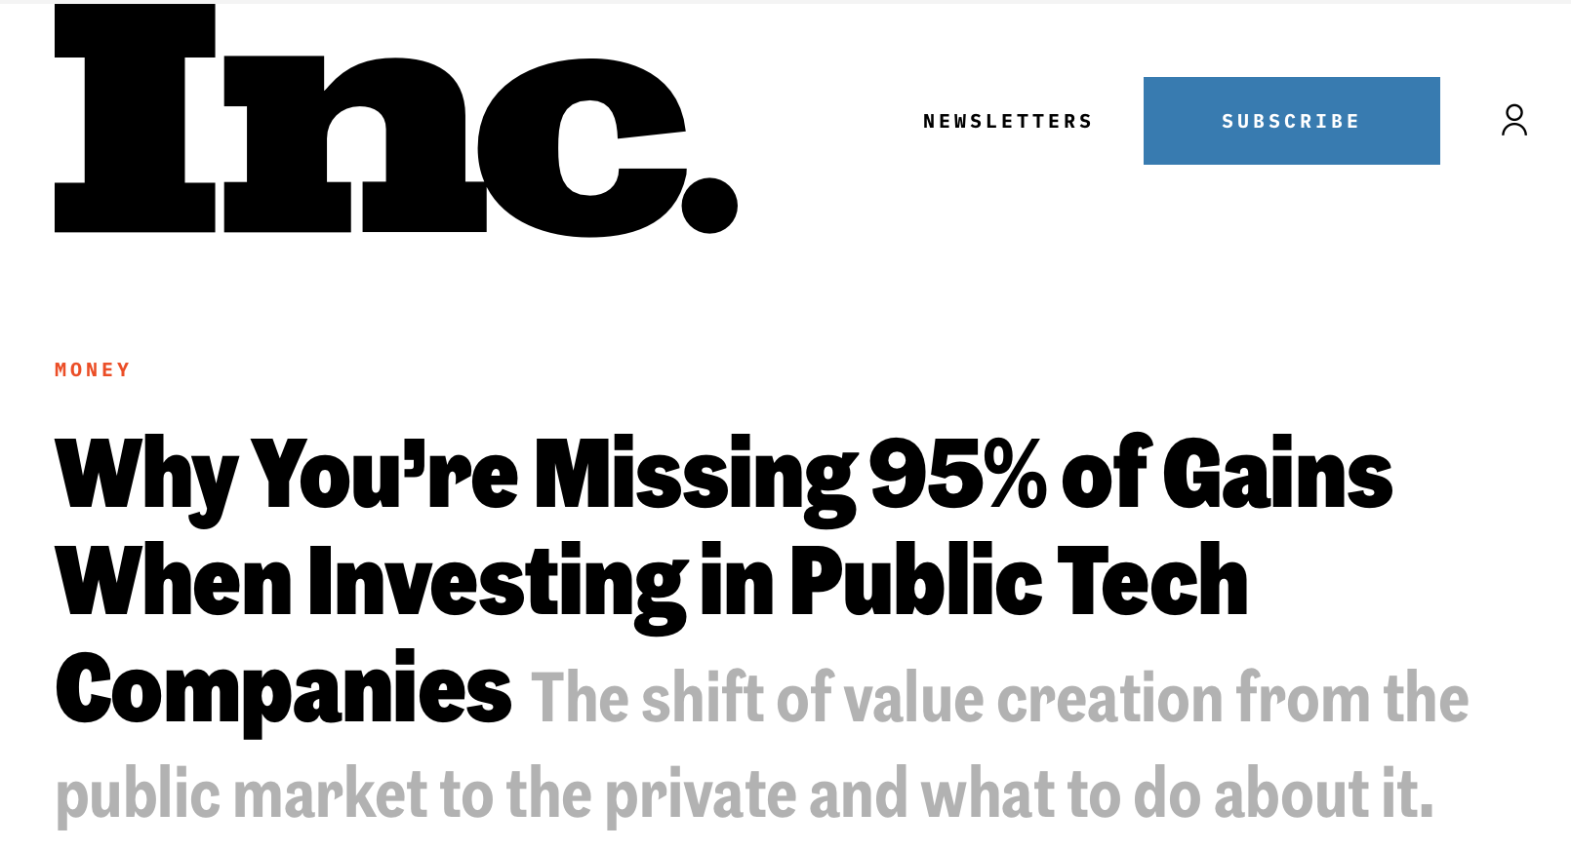
And that’s especially true with OpenAI.
Until now…
Only the billionaires and well connected have had access.
Like PayPal co-founder and venture capitalist Peter Thiel… he’s been in early on some of the biggest IPOs in history… like Meta and Spotify.
And he’s already staked his claim in OpenAI…
He’s not alone… Michael Dell of Dell Electronics and Oracle CEO Larry Ellison are also in…
And big firms like Nvidia, Microsoft, and Sequoia Capital have already gotten in Open AI… BEFORE its IPO.
But the regular investor like YOU… totally left out in the cold.
So… if you’ve ever felt like you’re always “too late”…
That changes TODAY.
Because in the next few minutes, I’m going to show you what no one else knows...
There’s a simple way to get a pre-IPO stake tied to OpenAI before it goes public…
Starting with as little as $100!
No accreditation or other requirements…
Just one simple move - one name and ticker symbol - that I’ll give you for FREE.
But if you want in...
I urge you to act BEFORE OpenAI goes public.
Graphics:
Display on screen:
Coming Up: Why It Could IPO as Soon as March 18, 2026!
So that when the opening bell rings and shares start trading… you’ll be ready to cash in along with the insiders.
Remember…
The Amazon, Apple, and Microsoft IPOs were just a tiny fraction of what the OpenAI IPO could be.
The amount of potential wealth… if you get a pre-IPO stake in OpenAI TODAY…
Is simply life-changing!
But I’m getting ahead of myself.
Before I show you how to position yourself and give you the ticker… let me explain why these leaked documents matter…
And why OpenAI will become the most valuable IPO in modern history.

We Are Witnessing the Biggest New Tech Disruption Since the Internet
As you may know…
OpenAI has created one of the greatest breakthroughs in the history of technology...
ChatGPT.
Centuries from now… it’s probably going to be mentioned in the same sentence as the lightbulb… the cotton gin… or the internet.
It’s turned the world on its head literally overnight, kicking off the AI boom.
And it’s getting users faster than any other technology in history.
Think about it…
Netflix took nearly two decades to reach 100 million users.
Instagram took two and a half years to reach this milestone.
TikTok took just nine months to hit over 100 million users.
But ChatGPT…
Hit that number in just eight weeks!
In short…
This is the fastest-growing consumer application in history. Nothing else even comes close.
Today, on average, over 800 million people use ChatGPT every week.
And it gets 5.9 billion visits per month.
But we’re still in the first inning.
As you're going to learn today, over the next 12 to 18 months, I expect OpenAI to blast off like a rocket.
And for early investors who act fast…
Its rise could unleash an extraordinary wave of wealth.

ChatGPT’s BIGGEST Disruption Is Coming NEXT!

Although you’ve seen AI in the news…
And you’ve probably heard about ChatGPT…
There’s something you might not realize.
The true disruption is just getting started.
And surprisingly… it all has to do with Google.
When Google went public in 2004, it was valued at $23 billion...
Today, the company is worth $4 TRILLION.
That's 173X growth!
$10,000 invested at Google's IPO would be worth more than $1.5 million today.
[CHART: GOOGLE]
That’s because Google dominated the search engine world.
Totally blew out the other competition.
No one uses Yahoo… Alta Vista… or Ask Jeeves anymore.
Heck… when you tell people to search for something…
What do you say?
Google it, right?
And here's the thing...
OpenAI's ChatGPT is doing to Google...
Exactly what Google did every other search engine that came before it.
For the First Time in 20 Years, Google Is Losing Its Grip on Search
For two decades, Google has had an iron grip on the search market.
At its peak, Google controlled more than 92% of all internet searches worldwide.
It seemed like nothing could ever challenge their dominance.
But then ChatGPT arrived...
And everything changed.
Google’s share of searches plummeted...
While ChatGPT's usage nearly TRIPLED in just six months!
And it’s dominating our searching behaviors now.
Over one-third of users say they’ve changed the way they search the internet because of ChatGPT.
And heavy usage of AI has exploded 7X since 2023.
Now, I know what you might be thinking...
"Google still dominates. What's the big deal?"
Well, here's why this matters...
OpenAI Is About to Capture a $237 Billion Prize
You see, Google isn't just a search engine.
It's an advertising machine.
In fact, advertising accounts for a staggering 77% of Google's total revenue.
In 2023 alone, Google raked in $237.8 BILLION from advertising.
That's more revenue than Facebook (Meta), Netflix, and Coca Cola… combined.
And here's the critical point...
Every time someone uses ChatGPT instead of Google to find information...
Google loses money.
Because that person is not clicking on ads.
They're not seeing sponsored results.
As a former Google ads executive warned:
ChatGPT could disrupt Google’s business model by preventing users from clicking on links with ads.
This is Google's worst nightmare.
And it's OpenAI's greatest opportunity.
Because here's what most people don't realize...
Leaked Documents Reveal:
ChatGPT’s $25 Billion Revenue Bombshell

On January 16, 2026, OpenAI made a bombshell announcement...
Advertising is coming to ChatGPT.
It’s a game-changer.
Why?
Right now, ChatGPT has more than 800 million weekly users.
That's about 15% of every adult on Earth.
It handles 2.5 BILLION messages every single day.
But here's the thing...
The vast majority of those users - more than 95% - are on the FREE tier.
They don't pay a dime.
But once advertising is turned on...
Those 760 million-plus free users suddenly become a MASSIVE revenue engine.
And according to the leaked internal projections...
OpenAI expects to generate $25 BILLION by 2029 from ads alone.
And Bank of America analysts predict OpenAI could capture $41 billion in new revenue by 2030.
Now, if that sounds far-fetched, let me show you why it's not only possible...
But almost inevitable.
The Pattern That's Made Investors Rich - Over and Over Again
You see, what OpenAI is about to do isn't new.
It's actually a pattern that has played out throughout history...
Creating massive wealth for investors who recognized it early.
Let me show you what I mean...
Phase 1: Radio
In the 1920s, radio was brand new.
Millions of Americans rushed out to buy radio sets, eager to tune in to this revolutionary new technology.
But in the early days, there were no ads.
Radio stations just broadcast content... and hoped to figure out how to make money later.
Then, in 1922, the first radio advertisement aired.
And everything changed.
Radio advertising revenue exploded from $4 million in 1927 to $216 million by 1940.
That's a 4,400% increase.
But it gets better.
That surge of ad revenue made some companies go parabolic.
In fact, during the 1920s… the radio boom caused RCA to rise 200X…
It was one of the largest increases in the history of the stock market.
That’s the power new advertising revenue has on stock prices!
Phase 2: Television
The same pattern repeated with television.
TVs first hit the market in the late 1940s.
By 1960, 87% of American households had one.
And just like radio, the real money came when advertising hit TV shows.
TV advertising revenue went from $1 million in 1947 to about $70.8 billion by 2007…
That’s a percent gain that’s almost too big to comprehend.
It’s 70,000X!
And when Comcast tapped into the television gold rush…
$1,000 invested when it IPO’d in 1972 would be worth over $1.4 million today!
Phase 3: The Internet
Then came the internet.
In 1994, the very first banner ad appeared online.
And then, a whole new industry was born.
In 1995, internet advertising was worth $100 million per year.
Today… it’s exploded to over $650 billion.
That’s a staggering 649,900% growth.
And the companies that dominated - Google and Facebook - became two of the most valuable companies on Earth.
Combined, they're worth more than $4 TRILLION today.
Both stocks were huge winners.
Facebook has risen over 17X since it went public in 2012…
And $10,000 invested at Google's IPO would be worth more than $1.5 million today.

OpenAI Dipping Into a $1 TRILLION Money Pot!

But that’s nothing compared to Phase 4 of this pattern...
The AI revolution.
And just like radio, television, and the internet before it...
The real money is going to be made when advertising is turned on.
Worldwide, more than $1 TRILLION is spent on advertising.
And that number just keeps going up.
If OpenAI captures even 10% of that...
That’s over $100 billion of revenue per year!
And while that seems huge… remember…
That’s actually less than Google makes in advertising right now.
And with the way people are starting to use ChatGPT more than Google…
It’s possible ChatGPT could earn even more advertising revenue than Google at some point.
But even if it doesn’t…
Keep this in mind in mind…
As Nvidia added $125 billion in new revenue over the past 10 years…
The stock exploded 26,000%!
And… it’s not far-fetched.
OpenAI is only testing ads right now.
It’s in the very beginning of mining this huge new source of income…
So the real revenue hasn’t even begun.
Remember…
OpenAI has already built the largest AI user base in history, with 800 million weekly users and 2.5 billion messages per day…
And it’s growing every day.
That means YOU have the chance to get a pre-IPO stake early… before the extra revenue is priced in!
But… you must act fast.
OpenAI is already building an advertising platform to compete with Google and Meta….
It is testing “sponsored replies”…
And putting in shopping features with product recommendations.
And when OpenAI flips the switch on advertising...
I believe it will trigger the biggest wealth creation event since the dawn of the internet.
And that’s why this OpenAI Pre IPO play could be a game-changer for you…
I’m going to give it to you free in just a second… the exact ticker symbol.
You can own it for yourself in minutes.
But first, let me back up and properly introduce myself...
So you know exactly who you're dealing with... and why you should trust what I'm telling you.
I Find Opportunities Everyone Misses…
Chances to Turn a SMALL Amount of Money… Into LIFE-CHANGING Returns!
[AUTHOR PHOTO]
My name is Karim Rahemtulla.
I studied in England, Canada, and the United States to get degrees in economics and foreign languages before getting my masters in finance.
During the ‘80s I worked on Wall Street… and became one of the youngest CFOs ever for a trading firm that cleared millions of dollars through Bear Stearns.
By the early ‘90s… I was a multimillionaire at just 34 years old.
But… I got tired of helping the rich get richer.
So… I decided to start Monument Traders Alliance to help everyday investors.
Since our inception in 2019, I’ve personally recommended 459 trades through our live trading research platform...
381 of which have turned into winners!
That’s a win rate of 83%...
Or more than 8 out of 10!
But what is most important is the type of recommendations I make.
You see…
I specialize in finding opportunities that most people miss…
Chances to make life-changing gains on just ONE investment.
For example, in 2022, I told my readers about a stock that I called “the single best value play in the history of the markets.”
The stock was less than $2 at the time.
But its new nuclear technology was so revolutionary, I knew the stock was set to explode.
And explode it did.
It climbed to over $16 in a little more than three years.
People who listened made big money.
Life-changing money.
For example, my follower Brian, who is approaching his 90th birthday, wrote that it was “the biggest win of his lifetime.”
He sold 10,000 shares for a net profit of $141,000!
Another follower, Nathan, is up well over 1,000% on 17,000 shares. At $16 per share, those are worth $272,000!
Sam bought 12,400 shares at $1.08. At $16 a share, those shares are now worth $198,400!
Jared called it his “biggest stock winner ever.”
He bought 49,700 shares and sold one-third for profits. The remaining 33,000 shares are worth over half a million dollars today!
He says with a daughter in college, “her tuition feels like a drop in the bucket now.”
I even got a note from one of my followers, Timothy, who became a millionaire from this one recommendation.
He started investing with about $20K when the stock was at $0.88. His account now stands at over $1 million!
All of these amazing gains happened in just three years!
And today, my goal is to help you have your own life-changing moment with OpenAI.
But you must act quickly.
Because insiders spent the last year preparing the company for an imminent IPO.

Preparing for Its Imminent IPO
You see, OpenAI started as a nonprofit.
When Sam Altman launched the company, its mission was to develop AI "for the benefit of humanity."
Noble, sure… but it created a big problem.
Nonprofits can't go public.
They can't sell shares to investors. They can't raise massive capital. And they certainly can't make early investors rich.
So OpenAI did something drastic…
In late 2025, it completed a massive restructuring, converting into a public benefit corporation called OpenAI Group PBC.
Why does this matter?
Because a PBC structure is specifically designed to make an IPO possible.
And OpenAI's own CFO admitted exactly why they did it.
Sarah Friar said it herself...
"The PBC structure gets us to an IPO-able event… "
And here's something else that tells you an IPO is coming…
OpenAI just renegotiated its entire relationship with Microsoft.
Microsoft agreed to reduce its equity stake when OpenAI shifted to the PBC structure…
It also agreed to take LESS revenue share - from 20% down to just 8%.
And it even gave up its exclusivity contract to provide cloud computing.
OpenAI can now work with Oracle, Amazon, or anyone else it chooses.
Why would Microsoft - OpenAI's biggest backer - agree to give up so much control?
Because even with all those reductions… the company will make way more money once OpenAI goes public.
That’s why Microsoft is clearing the path for OpenAI to operate as an independent public company.
Bottom line...
OpenAI has moved all the necessary cards around to give the green light for an IPO.
It’s engineered a revenue explosion with advertising to boost its valuation when it goes public.
It’s arranged its internal structure to be ready to go.
Now… all it has to do… is pull the trigger.
Once OpenAI Announces Its Trillion-Dollar IPO… Early Investors Stand to Make a Fortune
That’s why I’m so excited today.
You see, OpenAI isn't going to wait around.
According to Reuters' exclusive reporting, OpenAI is "laying the groundwork" for an IPO that could value the company at up to $1 TRILLION.
And now that it has announced advertising…
I believe it is set to announce its IPO very soon.
This could present the rare opportunity to make a small bet… and strike it rich.
If there's one thing I've learned about this business, it's that a chance like this really does only come around once in a lifetime.
And when it does, 99% of people do nothing… they simply sit on the sidelines and get left behind.
But for the small 1% of investors who see what's coming and take action, their lives could quickly change forever.
After all…
As you've seen, every time a revolutionary new technology like this emerges…
Investors who see what's coming have the chance to create extraordinary wealth.
Case in point, just look at some of the biggest tech IPOs in history.
Amazon went public in 1997... and turned $10,000 into more than $27 MILLION today.
Apple went public in 1980... and has soared more than 250,000% since.
And Nvidia - the company powering the entire AI revolution - has exploded more than 26,000% in the past 10 years.
Now, of course, these gains are rare and extraordinary. All investing carries risk. Because of that, you should never invest more than you can afford to lose.
However, this growth really did happen. That's important to remember.
And I believe OpenAI could be even bigger than all of these.
NVIDIA CEO Jensen Huang called OpenAI "likely the next multitrillion-dollar hyperscaler."
While SoftBank CEO Masayoshi Son said OpenAI will become "the most valuable company in the world."
But here’s the thing…
While most people are waiting to get in OpenAI AFTER it goes public…
The insiders know better… and are setting themselves up for the payday of a lifetime.
And now YOU can also get a pre-IPO stake in OpenAI.
All you need is the ticker I’m going to give you for FREE…
And you can get a piece of the upcoming trillion-dollar IPO!

You’ve Been LOCKED OUT of the Best Chance at Life-Changing Gains…
That Changes TODAY!
Insiders know the simple truth...
The biggest gains…
The REAL fortunes…
Are made by the people who get into a company before the IPO.
Take Peter Thiel, for example.
He was the first outside investor in Facebook, back in 2004 - purchasing 10% of the company for just $500,000.

And when Facebook went public in 2012… when everyone else finally had the chance to buy the stock…
He wasn’t buying…
He was cashing out.
That one pre-IPO investment made him over 1 BILLION dollars.
That's a 2,000X return… in just eight years!
That’s the power of getting in BEFORE the IPO.

SpaceX is another great example.
Its valuation has jumped a whopping 777,677%.
Meaning private investors could have turned $1,000 into over $7.7 million.
It’s already made early investors insane returns… and it hasn’t even gone public yet!
That’s the power of getting pre-IPO shares!
Let’s compare what happened for two different kinds of investors in Google.
Regular IPO investors have seen around 12,000% gains since 2004…
Which is incredible, to be sure.
But pre-IPO investors made an estimated 239,950%!
That's more than 20 TIMES the gains of people who waited for the IPO.
Do you see why it’s almost CRIMINAL that you’ve been kept out of these types of opportunities?
According to ThinkAdvisor, a research service for professional investors…
8 of the most profitable investments of all time were in PRIVATE, pre-IPO deals.
As Marc Andreessen, one of Silicon Valley's most successful venture capitalists, openly admits...
"Gains from growth go to private investors, not public investors."
That's why the ultra-wealthy keep getting richer.
They get into these deals before YOU even have a chance to get in…
Then cash out when the company goes public… and pocket millions - sometimes billions - per deal!
And the amount of money that can be made BEFORE the IPO…
Is staggering.
Databricks valuation jumped 127,344% in 11 years!
That would’ve turned just $1,000 invested into over $1.2 million.
But Uber did even better.
Pre-IPO investors made a huge 496,451% return in just 14 years.
And Airbnb's pre-IPO investors had even more dramatic returns… they saw a 1.3 million percent return in 11 years!
Those gains… are nothing short of life-changing.
And they're only possible if you get in BEFORE the company goes public.
The same is true for OpenAI.
By the time it hits the public market, everything I've told you about today…
The advertising revenue explosion…
It will already be baked into the price.
The insiders will already be sitting on huge gains on IPO day… while everyone else is clamoring to get in.
But if you act now… you get to the front of the line right along with them.
If you've been investing for a while and haven't seen the results you were hoping for…
It's NOT your fault.
You simply haven't had exposure to the pre-IPO market - where the real, life-changing returns are made.
Until now.
Here's How You Can Get a Pre-IPO Stake in OpenAI…
Starting With as Little as $100
By now… I’m sure you are dying to know how to get in.
After all, OpenAI is still a private company. You can't just buy shares on the stock market.
And until recently, you couldn't get in at all.
These deals were reserved for venture capitalists, hedge fund insiders, and Silicon Valley elites.
Regular investors like you and me? Completely locked out.
But not anymore.
You see, a brilliant man realized there was a massive unserved market when it came to Main Street America and the red-hot pre-IPO markets.
He knew that everyday investors were desperate to get into companies like OpenAI before they went public…
But they were locked out by law.
So he did something brilliant…
He set up an investment fund called the Destiny Tech100 fund… and mandated that the fund invests exclusively in the fastest-growing pre-IPO companies in the world.
He then took this investment fund public on the NYSE.
Meaning absolutely anyone could buy it inside their own brokerage account.
No accreditation required.
No insider connections needed.
Just a regular brokerage account and as little as $100 to get started.
What’s the ticker?
DXYZ.
That’s right… your free ticker. Write it down.
D… X… Y… Z.

With OpenAI going public and exploding in value…
As that advertising business kicks in…
As the company marches toward that trillion-dollar valuation…
Shares could skyrocket into the stratosphere.
Now, of course, you're more than welcome to go out and buy DXYZ shares inside your brokerage account.
Even if this doesn’t play out exactly as I’ve laid out… I think you’ll almost certainly do very well.
It’s certainly not a bad idea if you want to play it safe.
After all, as I walked you through here today, OpenAI's IPO is expected to be one of the biggest in history.
But as great as that is…
You don’t control how the fund manages its investments.
It could cash out its shares whenever it chooses…
And leave A LOT of money on the table.
Not only that…
Although you won’t likely hear about it in the mainstream media…
There’s another side to the OpenAI IPO story that's 10X bigger...
And it all starts in the Oval Office… with none other than Donald J. Trump.

OpenAI Announces MASSIVE $500 Billion Project Stargate

I’m talking about the most ambitious AI initiative in history.
OpenAI calls it Project Stargate.
It’s a half TRILLION dollar "AI Moonshot"… announced right from the oval office with the backing of Donald Trump.
OpenAI has partnered with all the major players…
Microsoft, Oracle, SoftBank, Nvidia, and JPMorgan, to name a few.
So… what exactly is Stargate?
Picture this…
Across 875 acres of Texas desert - an area bigger than Central Park…
OpenAI is building the largest data center the world has ever seen.
Here's why it’s important for OpenAI going public.
You see…
AI runs on computer power. Mountains of it.
Until now, OpenAI has been forced to rent computing power from partners like Microsoft and Amazon.
That dependency is expensive… and it puts OpenAI at the mercy of other companies fighting for computation resources.
Stargate changes everything.
No more bottlenecks. No more begging for server space.
And here's the kicker…
It could save OpenAI tens of billions of dollars per year…
And allow it to scale faster… and dominate the competition.
Or, as OpenAI CEO Sam Altman puts it… the company will be: “bigger, faster, cheaper, better.”
And Project Stargate is way more than just storing data.
OpenAI is building an AI mega campus… with financing… power planning… and long-term energy agreements.
And Texas is just the beginning.
Altman also plans to roll out Stargates across more than a dozen states - Ohio, New Mexico, Wisconsin, and more.
Then it goes international, with Stargate UAE already launching operations.
Think about what this means…
Every other AI company on Earth - Google, Meta, Amazon - is fighting over the same limited computing resources.
But OpenAI?
It’s building its own.
It's like Tesla constructing its own battery factories while Ford and GM wait in line at the parts store.
OpenAI needs Project Stargate to justify a trillion-dollar IPO valuation.
And to make Stargate work…
One company holds the key.

OpenAI's $22 Billion Secret
You probably haven’t heard about this in the mainstream media.
You may have heard about some of the other Stargate partners who made headlines…
Like Oracle… which got a $300 billion announcement.
Then there’s SoftBank… which got a White House press conference.
But there's ONE company that's quietly become essential to Stargate…
It started in March 2025 with an $11.9 billion deal with OpenAI.
Then it expanded in May 2025… with another $4 billion.
Then AGAIN in September 2025 with $6.5 billion more.
That's three expansions in less than seven months!
Do you see the pattern?
The more popular OpenAI gets… the more it shovels money into one under-the-radar company.
It’s already made contracts totaling $22.4 billion.
Now… if OpenAI grows like I think it will…
If advertising becomes a revenue gushing machine like I think it will…
Or even if it does just a fraction of what I think.
OpenAI is going to need exponentially more of what this obscure company provides.

The “Essential” Company for OpenAI’s Trillion-Dollar IPO
So what makes this company so essential?
It all comes down to one thing: computing power.
You see, AI doesn't run on software alone.
It requires massive amounts of specialized hardware called GPUs - graphics processing units.
These chips are the "brains" behind every AI model… every ChatGPT conversation… every image generated.
And OpenAI needs MORE of them than almost anyone on Earth.
The problem?
Traditional cloud providers like Amazon and Google weren't built for AI.
Their infrastructure was designed for the old internet - e-commerce, streaming video, business software.
When it comes to the raw GPU horsepower that AI demands…
They're simply not optimized for the job.
That's where this company comes in.
It’s built what insiders call "The Essential Cloud for AI."
Its entire infrastructure is designed specifically for the massive GPU computing that artificial intelligence requires.
It’s completely optimized for AI.
Nvidia - the king of AI right now - just announced an expansion of its agreement with this company to build 5 gigawatts of AI factories by 2030…
And… Nvidia just bought $2 billion of stock of the company.
That’s a massive endorsement, showing just how essential this company truly is.
And that's exactly why OpenAI also chose it for Project Stargate.
In fact, Sam Altman himself called the company:
"An important addition to OpenAI's infrastructure portfolio, complementing our commercial deals with Microsoft and Oracle, and our joint venture with SoftBank on Stargate."
This company is ALREADY part of Stargate.
It’s ALREADY powering OpenAI's most advanced AI models.
It just hasn't gotten the spotlight… yet.
But when it does…
The stock could go to the moon.
Partnerships Turn Unknown Companies…
Into 10-Baggers!
When a small satellite company AST SpaceMobile locked in strategic partnerships with AT&T and Verizon…
The stock exploded 1,550% over three years.
That's more than 15X your money.
$10,000 would have turned into over $155,000.
That’s the power of these strategic partnerships.
The same thing happened when Plug Power began supplying Amazon with forklift fuel cells in 2017.
Its stock jumped as high as 3,000% in 4 years.

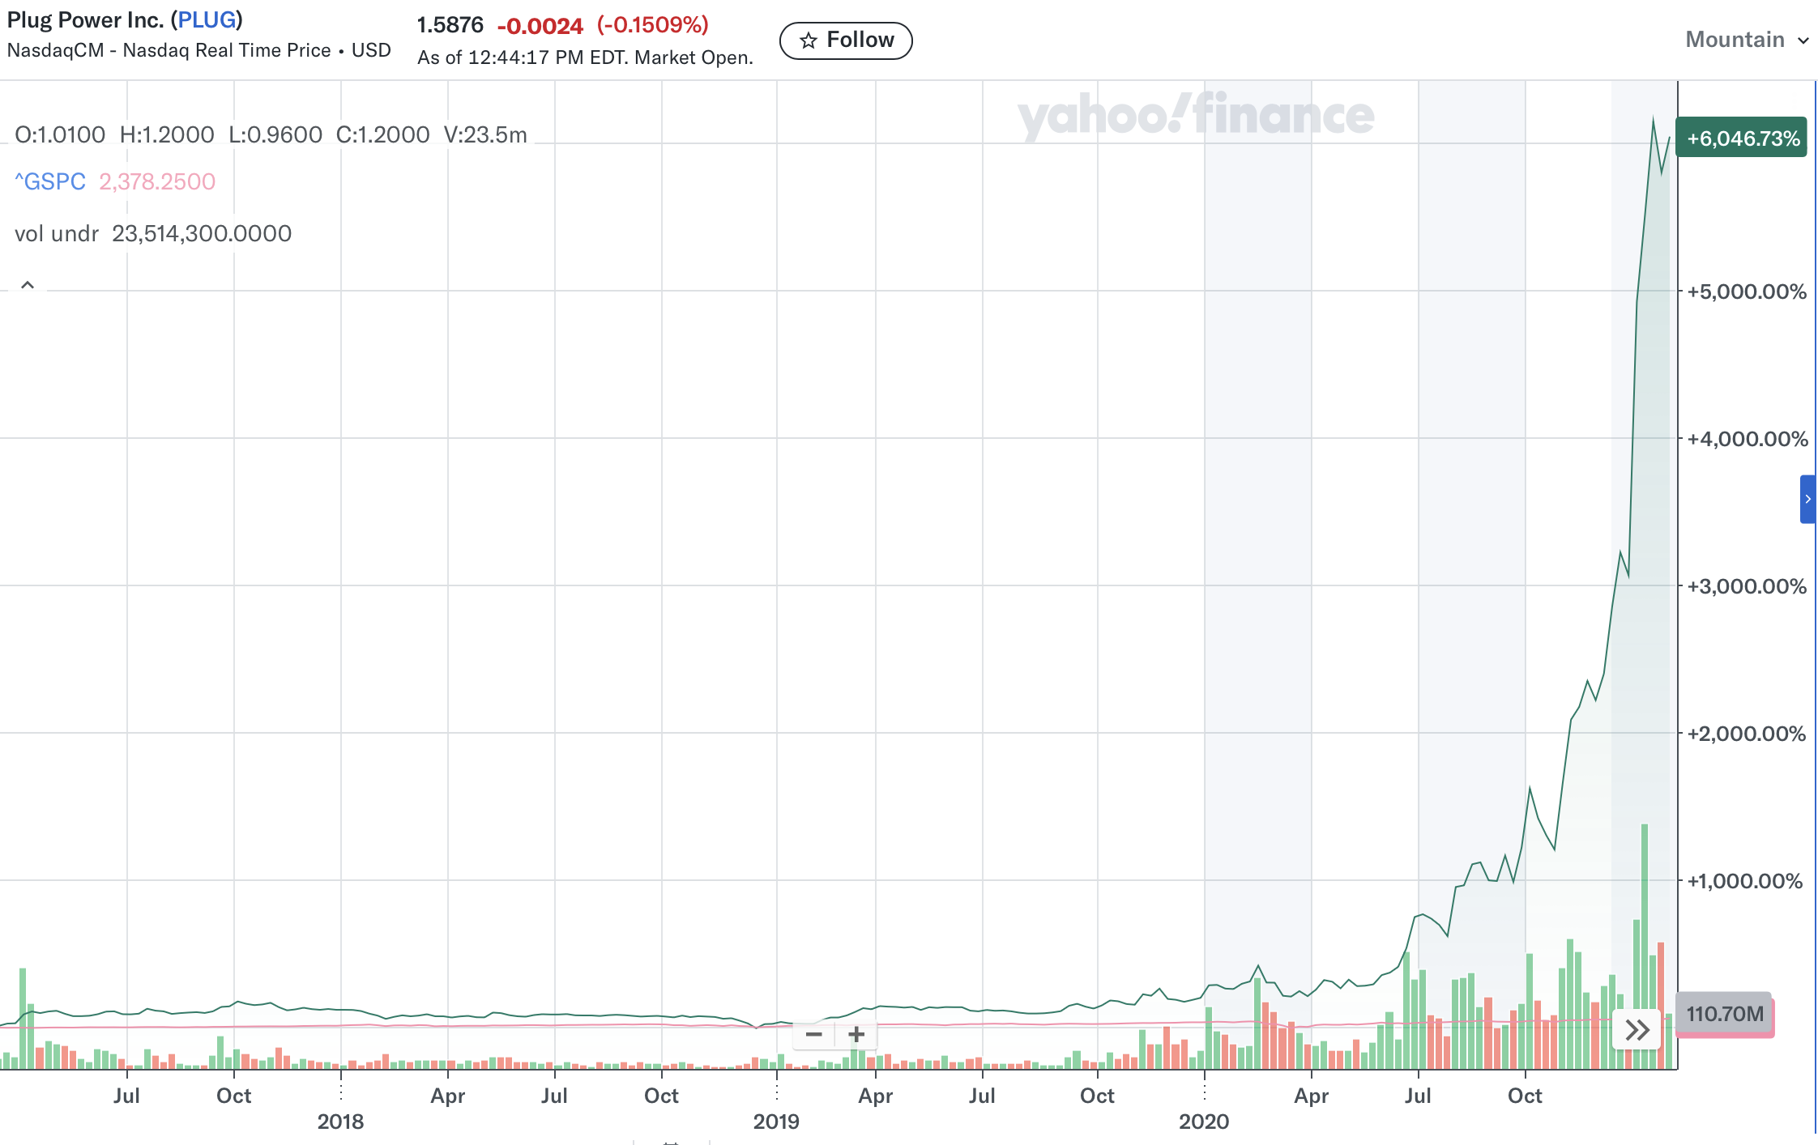
Then there’s MicroVision… it started supplying Microsoft with lidar sensors in 2020…
And its stock rose 9,000% in one year!
That’s enough to send $10,000 to more than $900,000!
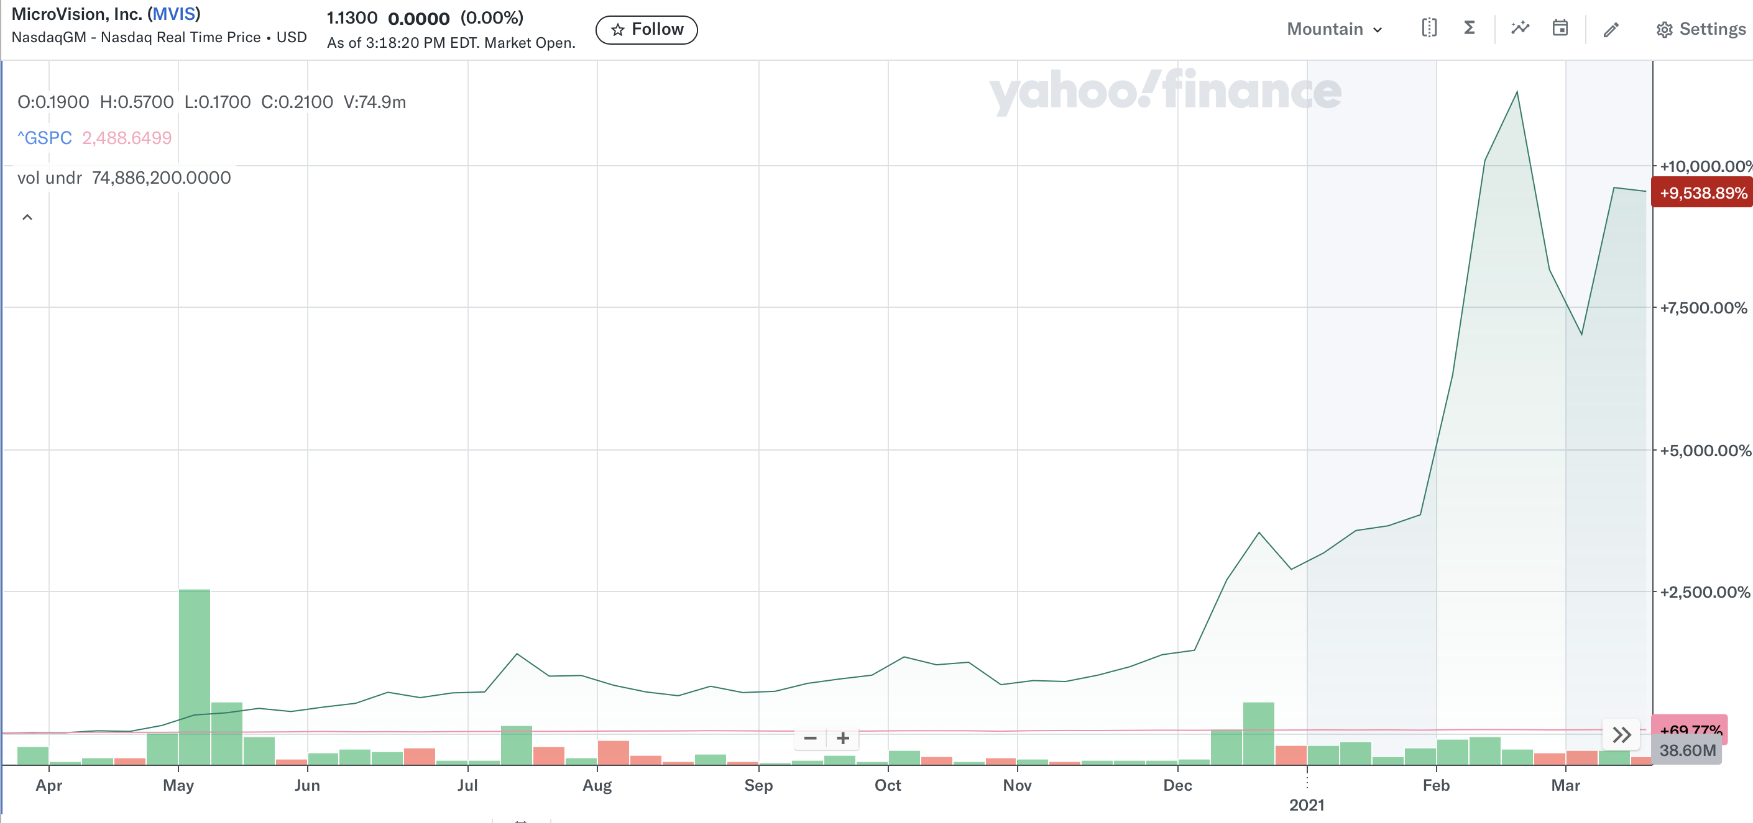
And it just happened with Nvidia.
Back in 2024… Nvidia revealed it bought just $8 million worth of shares in a small voice-AI company called SoundHound.
After that…
The stock went parabolic.
It went up 1,940% in just two years.
Investors who got in early turned every $10,000 into over $200,000!
These secret partnerships can take unknown companies… and make them soar 10X… 20X… 90X… maybe more!
Of course, these are monster gains from incredibly rare opportunities. I can’t guarantee you’ll see these kinds of gains. All investing carries risk, so don’t invest more than you can afford to lose.
But I believe with the upcoming OpenAI IPO… we have another rare opportunity.
The kind that doesn’t come around very often… maybe once in a lifetime…
And… I haven’t talked about the most exciting news of all.
You see…
OpenAI just invested $350 million of its own money into this company's stock.
That's way more than the $8 million Nvidia invested in SoundHound…
And that $8 million still ignited a frenzy that pushed the stock up as much as 1,940%.
So… while this company might not be in the spotlight yet… I expect it will be on everyone’s mind very shortly.
That’s because before OpenAI can go public…
The SEC requires a company’s IPO registration documents disclose material dependencies and risks.
That means OpenAI will reveal its critical infrastructure partners.

It would not surprise me that once Wall Street pours over those required filings…
And sees this company listed as a crucial Stargate partner…
There’s going to be a lot more buzz around this company.
And that’s why time is of the essence.

ALT: March 18, 2026
Why You Must Act BEFORE March 18, 2026
Thanks to my research, I believe Sam Altman could announce his plans to take OpenAI public as early as March 18, 2026.
Why that date?
It's the middle of NVIDIA GTC 2026 - the GPU Technology Conference - often called the "Woodstock of AI."
This is where NVIDIA CEO Jensen Huang takes the stage before a packed arena to reveal breakthroughs that send shockwaves through the entire tech industry.
Every major AI player, institutional investor, and venture capitalist will be in the room.
What better place to announce an OpenAI IPO?
ALT: April 15, 2026
Why You Must Act BEFORE April 15, 2026
Thanks to my research, I believe Sam Altman could announce his plans to take OpenAI public as early as April 15, 2026.
Why that date?
It's the middle of the TED Talk Conference "All of Us" - TED's final conference in its beloved Vancouver venue before embarking on its next evolution.
TED isn't just any conference. It's where the world's most influential minds share ideas that shape the future.
Sam Altman has spoken at TED before. And with TED's theme of "All of Us" - focusing on humanity's shared future - what better platform to announce OpenAI's transition to a public company "for the benefit of humanity"?
That's why I believe it's the perfect opportunity to announce the biggest IPO in history.

ALT: June 11, 2026
Why You Must Act BEFORE June 11, 2026
Thanks to my research, I believe Sam Altman could announce his plans to take OpenAI public as early as June 11, 2026.
Why that date?
It's the SuperAI Conference 2026 at the iconic Marina Bay Sands in Singapore - an event that brings together over 10,000 attendees and the biggest names in artificial intelligence.
An announcement in Singapore signals to investors that OpenAI is serious about global expansion. And for a company racing toward a $1 trillion valuation, that global narrative is essential.
That’s why I believe it’s the perfect opportunity to announce the biggest IPO in history.

ALT: August 5, 2026
But You Must Act BEFORE August 5, 2026
Thanks to my research, I believe Sam Altman could announce his plans to take OpenAI public as early as August 5, 2026.
Why that date?
It's the middle of Ai4 2026 in Las Vegas - North America's largest artificial intelligence industry event.
This is the city of CES, where game-changing announcements happen with theatrical flair and wall-to-wall media coverage.
And the timing is perfect. Companies that announce IPO intentions in August typically go public in September or October - historically the busiest and most successful months for IPOs.
That’s why I believe it’s the perfect opportunity to announce the biggest IPO in history.

ALT: September 30, 2026
But You Must Act BEFORE September 30, 2026
Thanks to my research, I believe Sam Altman could announce his plans to take OpenAI public as early as September 30, 2026.
Why that date?
It's the AI Conference 2026 in San Francisco - OpenAI's home turf.
This is where the company was founded. Where Sam Altman built the team that created ChatGPT. Where OpenAI's headquarters stands today.
And the timing couldn't be better. September 30 falls right after Labor Day - the classic "markets are back" moment when investors return to their desks and institutional money starts deploying capital.
That’s why I believe it’s the perfect opportunity to announce the biggest IPO in history.

ALT: November 30, 2026
But You Must Act BEFORE November 30, 2026
Thanks to my research, I believe Sam Altman could announce his plans to take OpenAI public as early as November 30, 2026.
Why that date?
It's the fourth anniversary of ChatGPT's launch.
November 30, 2022, was the day OpenAI changed the world.
Anniversaries are natural moments for major corporate milestones. And what date could be more symbolic than the anniversary of the product that put OpenAI on the map?
That’s why I believe it’s the perfect opportunity to announce the biggest IPO in history.

And once the IPO required documents are filed…
I'm predicting they will highlight the company I’ve found as a critical infrastructure partner for Project Stargate.
Of course, as I mentioned, you can go out and buy shares of Destiny Tech100 Inc. (ticker: DXYZ), which gives you pre-IPO exposure to OpenAI.
If you do so, I'm confident you could do quite well for yourself.
But I believe the biggest gains of all stand to be made with this obscure tech play.
Especially if OpenAI reveals it as an official Stargate partner in IPO documents…
Wall Street will be buzzing about this company like never before.
That's why I've put the complete details on this company, along with all my research, into a special report called:
"OpenAI's $22 Billion Secret Partner: The #1 Project Stargate Stock to Buy Now"
Inside this report, you'll discover:
- The name and ticker symbol of the company I believe is OpenAI's most critical infrastructure partner
- The full story behind its $22.4 billion contract - and why it keeps expanding
- Why Sam Altman called it "essential" to OpenAI's infrastructure portfolio
- How it’s already being counted as part of the $500 billion Stargate project
- The upcoming catalysts that could trigger a major stock surge
- Exactly how to position yourself before the next big partnership announcement.
[Begin One Report Alt Take]
And because you've made it this far, I want to rush this report to your email right now, ready for immediate download...
Absolutely FREE.
On top of that, I’d like to help you find even more successful opportunities going forward…
So, to get your free report, all I ask is that you take a risk-free trial membership of my research service Monument Trend Advisory.

Claim Your FREE Report...
With a Risk-Free Trial to Monument Trend Advisory

[End One Report Alt Take]

[Begin More Reports Alt Take]
And I want to rush this report to your email right now, ready for immediate download, and I’ll tell you how you can get it in a second...
But that’s not the only moneymaking opportunity I have for you today.

OpenAI’s Sales Partner:
The New AI Amazon
Advertising is only HALF the story for OpenAI's IPO.
You see, when OpenAI announced ads were coming to ChatGPT...
It also quietly revealed something even bigger:
A brand-new way to shop online.
They're calling it "Agentic Commerce" - and it could be as disruptive as Amazon was 25 years ago.
Here's how it works...
Instead of searching Google... clicking an ad... visiting a website... adding to cart... and checking out...
You simply have a conversation with ChatGPT.
You ask: "What are the best running shoes for flat feet under $150?"
ChatGPT shows you options - with real-time pricing, inventory, and images.
All you have to do is tap to buy.
You don’t have to search for it online…
Or even go to another website.
Just click and you’re done.
And… the recommendations are tailored to YOU.
It's like having a personal shopping concierge available 24/7.
It’s curating the most useful items and showing you the best options…
And ONE company is powering this entire revolution.
It’s partnered with OpenAI to enable "Instant Checkout" directly inside ChatGPT.
Over 1 million merchants are already integrated.
Its technology handles the real-time inventory data... the payment processing... and the order fulfillment.
The numbers are already staggering.
This company already processes $92 billion in sales volume per quarter.
It already has 50% higher converting checkout than competitors.
It’s generating $2.8 billion in revenue with an 18% free cash flow margin.
And now… it has direct access to ChatGPT's 700 million-plus weekly users.
Here's why this matters for investors...
As OpenAI's advertising ramps up... and "Instant Checkout" rolls out globally...
This company sits at the center of a massive new revenue stream.
Forbes projects revenue could hit $18 billion to $20 billion by 2030 - nearly double today's levels.
That’s 2X to 3X gains from current prices.
But I think that’s conservative.
Because if "Agentic Commerce" truly disrupts Google and Amazon the way I think it will...
My valuation models show the upside could be even bigger - potentially 4X or more.
Think about it…
Traditional ads rely on clicking and going to a different website.
But ChatGPT's in-app purchases could render them obsolete by enabling a user to buy instantly within its system.
I believe this one company is going to be the real winner in commerce in the years ahead.
Especially as AI continues to be the new way we get our information online.
In short, I’m calling this “the New AI Amazon.”
I've put together a full briefing on this company…
Including the name, ticker symbol, and my complete analysis.
And key details on why it stands to benefit from this urgent development.
I’ve put all the details in my second report:
"OpenAI's Secret Sales Partner: The New AI Amazon"

Project Stargate’s Critical Supplier
There's ONE more company I want to tell you about.
And it could be the most consequential of them all.
Because as you may have heard… we're in the middle of a new kind of space race.
Only this time, it's not about the moon.
It's about AI dominance.
The United States and China are locked in a battle for control of the most powerful technology ever created.
Right now…
China has the edge.
It controls over 90% of the world's rare earth supply.
Rare earth materials are needed for all advanced technology.
From data centers… to robotics…
Everything that makes AI work.
That’s why Open AI is scrambling to secure domestic supplies.
It’s even formally suggested that the U.S. government establish a strategic reserve of critical materials essential for AI infrastructure,
And ONE company has emerged as America's secret weapon.
It is the only rare earth mining and processing facility in the U.S.
And it is going to be absolutely crucial as Project Stargate continues to expand to more facilities across the U.S.
Apple just signed a $500 million deal with it.
As Apple CEO Tim Cook said: "This partnership will help strengthen the supply of these materials here in the United States."
But it's not just Apple.
The Department of Defense invested $400 million in this company.
Plus… it even signed a 10-year purchase commitment.
And it’s building a massive "10X Facility" to boost production capacity by 2028.
As Goldman Sachs analyst Brian Lee said: "We expect significant revenue and EBITDA growth, while vertical integration unlocks margin upside."
I've put all the details in a third special report:
"Project Stargate’s Critical Rare Earth Supplier"
In all, that's THREE Special Reports:
- "OpenAI's $22 Billion Secret Partner: The #1 Project Stargate Stock to Buy Now" - The “under the radar” computing company essential to Project Stargate
- "OpenAI’s Sales Partner: The New AI Amazon" - This commerce stock will dominate as we use AI to get our information
- "Project Stargate’s Critical Rare Earth Supplier" - The only U.S. rare earth producer that Apple and the Pentagon are betting on.
Each one reveals the name, ticker symbol, and my complete research on these under-the-radar AI plays.
It's all part of what I'm calling the OpenAI IPO Profit Package.
I want to get this in your hands immediately…
Absolutely FREE.
On top of that, I’d like to help you find even more successful opportunities going forward.
To claim your free reports, all I’m asking is you take a risk-free trial membership of Monument Trend Advisory.

Claim Your OpenAI IPO Profit Package...
With a Risk-Free Trial to Monument Trend Advisory

[End More Reports Alt Take]

Here's how the service works.
Each month we look for the most powerful trends driving the market.
Along with my co-founder Bryan Bottarelli, we target stocks and investments using what we call the "W.A.R. Trends System."
This system is based on three criteria…
W.inning Technicals
A.ccelerated Fundamentals
R.ecent/Upcoming Catalysts
The story I've shared with you today is a perfect example.
First, we identified a powerful trend - the AI revolution that's driving trillions of dollars in investment all over the world.
Then we found great stocks with momentum behind them… and the potential for massive growth as OpenAI goes public.
And finally, we looked for strong catalysts.
In this case, the upcoming OpenAI IPO - potentially the biggest in history - that could send all of these stocks soaring.
With Monument Trend Advisory, we'll deliver two of these types of opportunities to you every single month.
They’ll come to you in our Monument Trend Advisory Field Reports.
On top of that, we’ll go live on video every week on Tuesdays at 2 p.m.
We’ll give you a real-time market briefing… talk about big news… our current trading strategies… and our investments.
This gives you a chance to hear from us directly.
You can even ask questions in the chat about our strategies.
And most of all, we get to celebrate our wins together!
There's nothing more fun than getting a note like this one from our play on Rolls-Royce (ticker RYCEY)...
"I did sell most of my 37,000 shares of RYCEY. My wife and I used the money to pay cash for our retirement home in Texas."
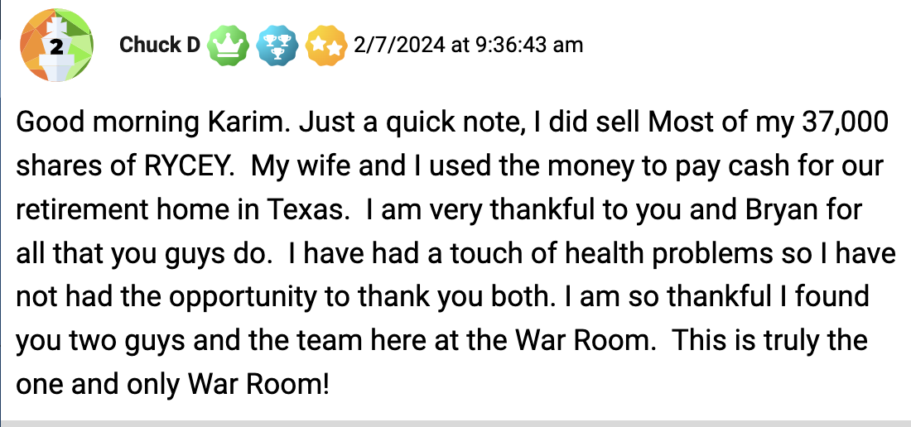
Now… with results like that… helping people make enough to pay cash for a retirement home… we could charge a small fortune for Monument Trend Advisory.
That's what they used to do on Wall Street when I worked there in the ‘80s and ‘90s.
They catered to the elite only.
But that's not what I do.
Rather, my focus is on giving EVERYONE a chance to land winning investments.
Because I know that when we change people's lives for the better, they stick with us forever.
That's why I always put together a package that is impossible to say no to.
So, when you take a risk-free trial in Monument Trend Advisory today, you'll get…

[Begin More Reports Alt Take]

OpenAI IPO Profit Package:
Free Report #1: "OpenAI's $22 Billion Secret Partner: The #1 Project Stargate Stock to Buy Now"
Free Report #2: "OpenAI’s Sales Partner: The New AI Amazon"
Free Report #3: "Project Stargate’s Critical Rare Earth Supplier"
[End More Reports Alt Take]

[Begin One Report Alt Take]
My special report:
"OpenAI's $22 Billion Secret Partner: The #1 Project Stargate Stock to Buy Now" - The “under the radar” computing company essential to Project Stargate
[End One Report Alt Take]

Plus…
- Two Top Investment Recommendations Every Month - Based on the W.A.R. Trends System.
- Monthly Issues of the Monument Trend Advisory Field Report - Our flagship publication with in-depth analysis on each recommendation.
- Weekly Intelligence Briefing Livestream: We’ll share our market intelligence in a live briefing every Tuesday at 2 p.m.
- Updates via Email and Mobile App - New intel on current recommendations delivered straight to your inbox.
- Complimentary Subscriptions to the members-only publications Unbound Fortunes and Trade of the Day Watchlist.
- Access to Our Mailbag, Chatroom, and Concierge Team - Ask any questions you might have. Just keep in mind we can't offer personalized financial advice.
Remember, people pay $5,000 (or more) for a service with a weekly livestream.
And that only gives you access to ONE market pro.
You’re getting weekly guidance from TWO veteran traders… with over 50 years of combined experience.
So… our normal price of $997 to join Monument Trend Advisory for a year really is a steal.
Especially considering how much money people made on just my Rolls-Royce recommendation.
But… I have great news.
I want to make sure nothing stands in your way of positioning yourself before the OpenAI IPO.

[Begin $79 Alt Take ]
That’s why for a limited-time you can try out Monument Trend Advisory for just $79.
But, look, if that's too expensive, I totally get it.
Click below and I'll show you an even cheaper way to get started.
[End $79 Alt Take ]

[Begin $99 Alt Take ]
That’s why for a limited-time you can try out Monument Trend Advisory for just $99.
But, look, if that's too expensive, I totally get it.
Click below and I'll show you an even cheaper way to get started.
[End $99 Alt Take ]
[Begin $199 Price Alt Take ]
That’s why for a limited-time you can try out Monument Trend Advisory for just $199.
But, look, if that's too expensive, I totally get it.
Click below and I'll show you an even cheaper way to get started.
[End $199 Price Alt Take]

Honestly… it costs us more than that to bring this message to you right now.
That’s right… we expect to lose money when you join today.
Why would we do that?
Because the only way we’ll profit is if you stick with us for the long haul.
And we like it that way.
It means that our success is directly tied to your success.
Let me give you an example of this.
We have a member named James who joined us a few years ago when Rolls-Royce was still less than $1.
He bought 65,000 shares… a big investment.
He was putting his faith in us, which means a lot.
And by September 2025, his 65,000 shares had delivered a profit of $1 million.
As he says, we helped put his retirement into high gear.
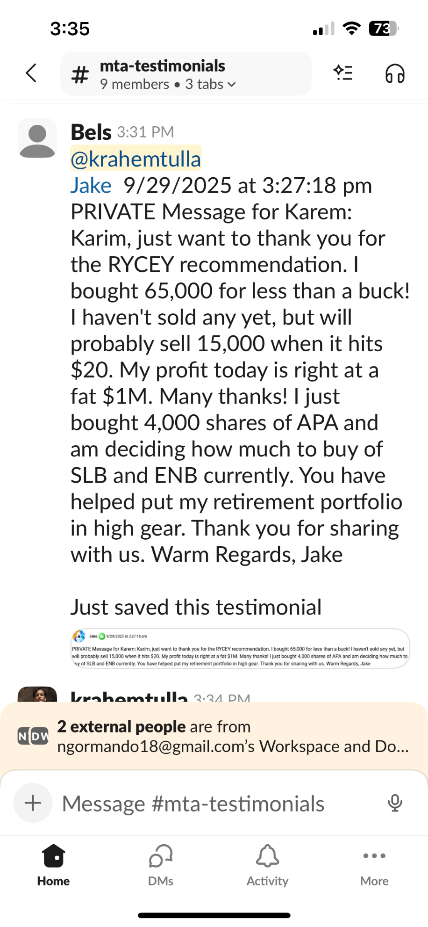
[Begin $79 Price Alt Take #2]
The point is…
When somebody has the opportunity to grow their wealth that much - over $1 million - in just three years…
A $79 subscription is well worth it… so they stick with us for life.
[End $79 Price Alt Take #2]

[Begin $99 Price Alt Take #2]
The point is…
When somebody has the opportunity to grow their wealth that much - over $1 million - in just three years…
A $99 subscription is well worth it… so they stick with us for life.
[End $99 Price Alt Take #2]
[Begin $199 Price Alt Take #2]
The point is…
When somebody has the opportunity to grow their wealth that much - over $1 million - in just three years…
A $199 subscription is well worth it… so they stick with us for life.

[End $199 Price Alt Take #2]
And remember what I’ve told you during this presentation…
I specialize in finding opportunities where you do NOT need to risk a lot.
You take small bets…
And have the chance at HUGE returns.
As you can see… even small stakes can have a big impact with wins like this.
Take the story of Frank.
He bought 1,000 shares of Rolls-Royce for $1,583. And rode that up to $10,130 in just 2-3 years.
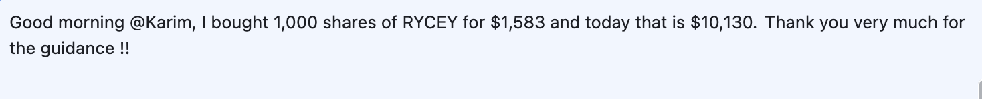
We’ve helped people from all kinds of financial situations.
And we want to help YOU as well.
Whether you have $500 to invest… or $500,000…
I’m making it a complete no-brainer to claim your OpenAI IPO Package… and join us for the weeks and months ahead.
But… I urge you to act immediately…
Because time is running out.
OpenAI could announce its IPO at any moment.
And when it does - when the world wakes up to the real infrastructure story behind AI - these stocks could surge well beyond my buy range.
I don’t want you to miss this moment.
Which is why we’re putting all the risk on our shoulders… not on yours.

[Begin 90-Day Alt Take ]

Take 90 Days to Review All the Reports at ZERO RISK.
Here’s what I propose.
Go ahead and join Monument Trend Advisory now.
And I’ll give you the next 90 days to review everything I send you.
[End 90-Day Alt Take ]

[Begin 365-Day Alt Take ]

Take 365 Days to Review All the Reports at ZERO RISK.
Here’s what I propose.
Go ahead and join Monument Trend Advisory now.
And I’ll give you the next 365 days to review everything I send you.
[End 365-Day Alt Take ]

[Begin One Reports Alt Take]
You’ll get the whole OpenAI IPO Profit Package:
Including the report I told you about:
"OpenAI's $22 Billion Secret Partner: The #1 Project Stargate Stock to Buy Now"
Plus… two other reports as my special gift to you.
One is called:
"OpenAI’s Sales Partner: The New AI Amazon"
I reveal a strategic sales partner with OpenAI. It’s a commerce stock that I’m calling the “new Amazon”. I believe it will dominate as we use AI to get our information… and as people change the way they buy things online.
Plus… I have another report on what I’m calling: "Project Stargate’s Critical Rare Earth Supplier" — It’s the only U.S. rare earth producer that Apple and the Pentagon are betting on. I think it will be a key supplier as Project Stargate moves to more states.
Both are FREE bonuses with today’s special offer…
That’s THREE opportunities I have for you when you join me today.

[End One Reports Alt Take]

[Begin More Reports Alt Take]
You’ll get the whole OpenAI IPO Profit Package:
- "OpenAI's $22 Billion Secret Partner: The #1 Project Stargate Stock to Buy Now"
- "OpenAI’s Sales Partner: The New AI Amazon"
- "Project Stargate’s Critical Rare Earth Supplier"
You can go over every one of these reports.
[End More Reports Alt Take]

[Begin 90-Day Alt Take ]
And if over the next 90 days, you feel that Monument Trend Advisory isn’t for you… then I’ll happily send you back every penny of your membership fee.
[End 90-Day Alt Take ]
[Begin 365 Day Refund Alt Take]
And if over the next 365 days, you feel that Monument Trend Advisory isn’t for you… then I’ll happily send you back every penny of your membership fee.
[End 365 Day Refund Alt Take]
Even better, I’ll still let you keep all the reports and materials you get completely free of charge.
I’m only willing to do that for two reasons.
- I’m that confident in our work.
And…
- I believe that strongly in this stock and its potential.
Because of that, I very much doubt you’ll ask for your money back.
In my experience, people who are making money don’t quit.
And I’ve received thousands of notes from people who love the work we do.
I think this message from one of our elite War Room members sums up the experience we want people to have with us.
“Until I joined the War Room I didn't know anything about investing. I'm certainly no expert and I still make real rookie mistakes but because of great instructions and explanations from Karim and Bryan as well as extremely important educational suggestions by many members here I have gained some valuable knowledge into the pursuit of value investing. It's weeks like this that make me realize that deciding to be here was a great decision and I want to thank everyone involved in my increased knowledge base for their willingness to help me improve my financial standing.”
This is what we want to help you achieve.
To increase your knowledge and success as an investor.
If we do that, and help you make a lot of money, we know you’ll stick with us.
So to join Monument Trend Advisory, you’ll see a button appearing on your screen now.
[SUBSCRIBE NOW BUTTON]
You Can Review Your Order Before It's Final
Clicking won’t obligate you to anything…
It’ll simply take you to another page where you can review this incredible no-risk offer again.
Including how to claim your discount. (In fact, there’s an opportunity to get started for even less that you won’t want to miss)
You’ll also see the full breakdown of all the perks of your memberships, including the three free reports I’ve promised today.
You’ll also see a bonus report I haven’t mentioned yet…
You see…
Many people forget… But Elon Musk was one of the original founders of OpenAI.
Love him or hate him…
He’s always been on the cutting edge of innovation.
And I’ve found a unique way to get what I’m calling The MUSK Pre-IPO.
It’s not a stock… or ETF…
You won’t find it listed your online brokerage.
But with one simple “code”… you can get exposure to ALL of Elon Musk’s biggest companies BEFORE they go public.
Including Starlink… Neurolink… Xai… SpaceX…
All of them…
While they are still private…
With ONE click of a button…
For as little as $500.
It’s all in my bonus report: The MUSK Pre-IPO: Enter This Code to Access ALL of Elon’s Private Companies.
Honestly… in my opinion, that bonus report alone is worth 10 times the price you’ll pay today.
And it is just the beginning…
Through Monument Trend Advisory…
I’ll help you kick your retirement into high gear with plenty of other opportunities in the weeks and months ahead.
Research you won’t hear about on cable TV… and ways to make money that you won’t find in the mainstream media.
[Begin 90 Day Refund Alt Take]
So again, just click that button to get started.
You’ll have 90 days to see exactly what we can deliver risk free.
[End 90 Day Refund Alt Take]
[Begin 365 Day Refund Alt Take]
So again, just click that button to get started.
You’ll have 365 days to see exactly what we can deliver risk free.
[End 365 Day Refund Alt Take ]
[SUBSCRIBE NOW BUTTON]
You Can Review Your Order Before It's Final
If you’ve made it this far, you clearly recognize that OpenAI’s Trillion-Dollar IPO could be Wall Street’s biggest event of the year…
Maybe even the decade.
The wealth that will be created will be unheard of…
And you don’t want to miss your seat at the table.
The stakes truly couldn’t be any higher.
And I’m predicting OpenAI energy partnership could make savvy investors tens of billions of dollars in windfall profits.
But as great as that is, odds are that even after everything you’ve seen today, you may still be hesitant about getting started.
And I get it…
As I said, this is probably the first time you and I have ever met.
So, I’m going to do something very special for you right now…
If you do choose to cancel, you’ll still be able to keep all of the special reports, monthly issues, and everything else you’ll receive today.
It’s my way of saying thanks for giving me an honest try.
This is the absolute best offer I can possibly make.
But only you can make the final decision.
So… just click below and get started right away.
[SUBSCRIBE NOW BUTTON]
You Can Review Your Order Before It's Final
As you’ve seen, this is one of the biggest market stories of my career… and you won’t want to miss it.
I’m predicting OpenAI’s IPO could be announced at this upcoming major industry event…
And while DXYZ shares stand to soar on the news, the real profit potential will be found in the company I believe OpenAI will make a major energy deal with leading up to its IPO announcement.
The company which you’ll get the full details on inside my new report, "OpenAI's $22 Billion Secret Partner: The #1 Project Stargate Stock to Buy Now"

I expect this elite partnership will be expanded when they go public.
That means you may only have a small window left to position yourself before the announcement is made.
Trust me, a year from now you’ll kick yourself if you put this off.
If you missed my Rolls-Royce recommendation…
One that members have made 10X or more on since 2022…
You DO NOT want to miss this.
It’s your chance to set yourself up on the ground floor - BEFORE everyone else catches on to OpenAI’s IPO.
With that said, all that’s left to do is go ahead and click
“Subscribe Now” below to get started… and I’ll see you for our next LIVE briefing on Tuesday!
[SUBSCRIBE NOW BUTTON]
You Can Review Your Order Before It's Final

Signoff
P.S. Still here?

Perhaps you still have a few questions that you want answered before getting started.

Let me quickly address them now…

Question #1: What is Monument Trend Advisory? How does it work?
Leveraging my insider network of CEOs, hedge fund managers, and other top insiders, I track down the biggest, most revolutionary new megatrends before anyone else.
Things like cryptocurrency, AI, autonomous vehicles, and more.
Then, I find the companies pioneering the new megatrend… and share them with my private readers in Monument Trend Advisory.
Every month, I'll send you a new issue, written in simple, easy-to-read language, detailing the biggest opportunity I'm looking at now… and showing you how to get a piece of it.
As I mentioned, it doesn’t matter if you’re a complete beginner or if you’ve been investing for years…
It doesn’t matter if you have $500 to start or $500,000…
Inside Monument Trend Advisory, I’ll show you how to book huge gains from the biggest, world-changing trends in the market. I’ll bring you my best new ideas every month.
You simply read through my work and decide if you want to invest in the company I’m telling you about.
Question #2: What will I receive when I join?
For starters, as a reader of Monument Trend Advisory, you'll receive monthly issues, weekly livestreams, urgent trading alerts, a special website login, "first read" access to my best new ideas and more.
Whenever I uncover a breakthrough new opportunity that has promise to change your wealth, I'll alert you and show you how to play it in the markets.
And that's just the beginning…
Within minutes of joining today, you'll get the urgent report I've promised, titled "OpenAI's $22 Billion Secret Partner: The #1 Project Stargate Stock to Buy Now."
That way, you can get started with everything immediately.
Question #3: How much money could I make from this?
If history is any guide, the amount of money you could have the chance at from this situation is nothing short of life-changing.
I showed you the best examples I could find of the rare opportunities that have come about when revolutionary new technologies emerge…
Amazon turned $10,000 into $11 million…
Apple turned $10,000 into $14 million…
Microsoft turned $10,000 into $32 million…
And I believe OpenAI could be even BIGGER than any of these over time!
By acting now, you could turn just one small pre-IPO stake into incredible wealth… by getting in BEFORE OpenAI’s potential energy agreement is announced.
And best of all, it couldn’t be any easier…
You’ll get all the details on how to get started when you click the “Subscribe Now” button below.
[SUBSCRIBE NOW BUTTON]
You Can Review Your Order Before It's Final
Question #4: Is your ordering process secure?
We use the latest encryption technology available to ensure your data is 100% protected throughout the order process.
The entire process is fast, safe and completely secure. I've made sure of it.
Question #5: What if I decide this isn't right for me?
No problem! As they say, "Nothing ventured, nothing gained."
[Begin 90 Day Refund Alt Take]
If you decide at any point in the next 90 days that my work isn't right for you, just call up my team and let them know.
They'll immediately send you a full refund, and you can even keep everything we've discussed here today, just as my way of saying thanks.
[End 90 Day Refund Alt Take]
[Begin 365 Day Refund Alt Take]
If you decide at any point in the next 365 days that my work isn't right for you, just call up my team and let them know.
They'll immediately send you a full refund, and you can even keep everything we've discussed here today, just as my way of saying thanks.
[End 365 Day Refund Alt Take]

Question #6: This all sounds too good to be true… what's the "catch"?
The mark of a smart investor is skepticism and asking questions. So, I'm not surprised if you are wondering this.
And that's why giving you the chance to try this out risk free… with more than enough time to see for yourself how valuable my work is.
If you don't get results, you can call us up and ask for a full, no-hassle refund.
There's absolutely no risk to you.
The only catch is that you must position yourself now for your best shot…
If you wait until after the IPO is announced, you'll be too late.
Don't wait… go ahead and click the "Subscribe Now" button below to get started.
[SUBSCRIBE NOW BUTTON]
You Can Review Your Order Before It's Final
Question #7: If I have any questions, can I speak to someone?
Absolutely.
If at any point you have any questions about your subscription… you can call up my Monument Trend Advisory customer care team and let them know.
You can reach them at XXXXXXXXXXXX
They're standing by 9 a.m. to 8 p.m. Eastern Time to answer any questions you may have and help you out. Just keep in mind they aren't able to offer any personalized financial advice.
Question #8: How long will it take to receive everything we've discussed?
Within minutes of joining Monument Trend Advisory today, you'll find a new email in your inbox from me. Open it.
Inside you'll find the report we discussed today, "OpenAI's $22 Billion Secret Partner: The #1 Project Stargate Stock to Buy Now," ready for immediate download.
You'll be able to download… read it… and act…
All within just a few minutes.
Additionally, you'll find your login to the special members-only Monument Trend Advisory website in that email, where you can view all the past issues, go through our portfolio, check out the full research report library, and more.
That’s where you can access your full OpenAI IPO Profit Package… and all the other reports I’ve told you about today.
The key is to position yourself as quickly as possible before the IPO is announced.
Take your time to decide, if you need to. You can still click the "Subscribe Now" button as long as you remain on this page.
I thank you for your time today, and I look forward to welcoming you inside Monument Trend Advisory just moments from now.
[SUBSCRIBE NOW BUTTON]
You Can Review Your Order Before It's Final

January 2026

From Crowdability promo
https://client.forgeglobal.com/markets/companies/databricks 09/2013 - 12/2024

