The Greatest Stock Story Ever Told
If You’re Looking for the Next Nvidia – Up 35,600% in 10 Years – Stop NOW.
One Tiny Stock with a “World’s First” Technology Could Become the Most Important Company in the World By This Time Next Year.

HL 2:
The End of the Silicon Chip
Tiny $10 Company’s New Patented Wonder Material Increases Performance Up to 100X!
"Gallium is reshaping power electronics, surpassing silicon with higher efficiency, faster switching, and superior thermal performance." – Microchip USA

HL 3:
The 100X Chip: AI's Next Leap Forward
Tiny $10 Company’s Patented New Chips Increase Processing Speed Up to 20X and Performance Up to 100X!
Here’s Why the World’s Most Powerful Chip Company, Nvidia, Had No Choice But to Partner with Them
HL 4:
Strange Crystal Metal Outperforms Silicon Up to 100X
Tech Companies including Samsung, Dell, LG, and Nvidia are Rapidly Partnering with the Tiny Company That Owns 250 Patents on the Material
“Gallium is in, Silicon is Out.” – Planet Mainframe
Without question, Nvidia has been the best stock of the last decade.
It’s up 35,600% over the last 10 years.
Just $1,000 would be worth $356,000 today.
And $10,000 would be worth $3.5 million.
If you knew to buy it in 2015…
You’d now be set for life.
The only problem?
You very likely didn’t buy it back then.
Why?
Because finding world-changing stocks like Nvidia is hard.
They are extraordinarily rare.
You might only get 2-3 chances per decade.
And you normally miss them.
Which is why I’m speaking to you today.
I am about to share with you what I consider to be The Greatest Stock Story Ever Told.
It’s about a new company.
One that is 1/2500th the size of Nvidia now.
It trades for about $10.
And yet… I believe it has the chance to become the single most important company in the world by this time next year.
In my opinion, this company is the ONLY stock in the entire market that could go from $10… to hundreds of dollars per share within the next 12 to 24 months.
As I dug into what this company does… and how their technology will impact the world… I have to admit…
My eyes got wide…
And wider…
And wider.
As a trader for over 30 years, I’ve simply never seen a situation this unique… and with this much upside potential.
Their patented technology is a world’s first.
NOBODY else can do what they do.
It will re-write history for dozens of industries.
The technology is so powerful and important that the biggest companies in the world are suddenly flocking to their doors just for the chance to access it.
Companies like Samsung, Dell, LG, Lenovo, and Xiaomi.
But here’s the big one.
Nvidia.
Nvidia just signed a groundbreaking deal with this tiny company that will revolutionize the global economy.
It will actually completely alter the history of mankind.
I’m not kidding.
That’s how big this is.
But for the moment, virtually nobody knows it exists.
That’s why my message for you is so urgent today.
In the next few minutes, I’m going to tell you exactly what this company’s “world’s first” technology is.
It’s so powerful, it was actually used to set a new Guinness world record.
In short, it solves a major problem facing tech companies.
It’s a problem that could DEVASTATE their businesses.
And yet, this one tiny company has the solution.
And the 250 patents behind it.
I’ll show you why Nvidia had NO CHOICE but to partner with them immediately.
And I’ll reveal why this company will completely revolutionize AI, energy, and dozens more industries in the next few months.
There is no time to waste here.
So let’s get started.
Why in the World Should You Listen to a Guy Like Me??
The first question you’re probably asking yourself is…
Why should you listen to me?
It’s the right question.
So let me quickly introduce myself before telling you about this amazing company and its technology.
My name is Karim Rahemtulla.
I’m the co-founder of The Monument Trader’s Alliance.
I studied in England, Canada, and The United States to get degrees in economics and foreign languages before getting my Masters in finance.
After that… I went to Wall Street where I became one of the youngest CFOs ever for a trading firm that cleared millions of dollars through Bear Stearns.
But you know what…
Forget all that stuff.
Let me tell you the real reason you should listen to me.
Because the last time I came out and made a claim like the one I’m making today… the people who listened made a fortune.
In 2022, I made a video calling Rolls Royce, ticker symbol RYCEY, “the single best value play in the history of the markets.”
The stock was less than $2 at the time.
But their new nuclear technology was so revolutionary, I knew the stock was set to explode.
And explode it did.
Just look at the chart.
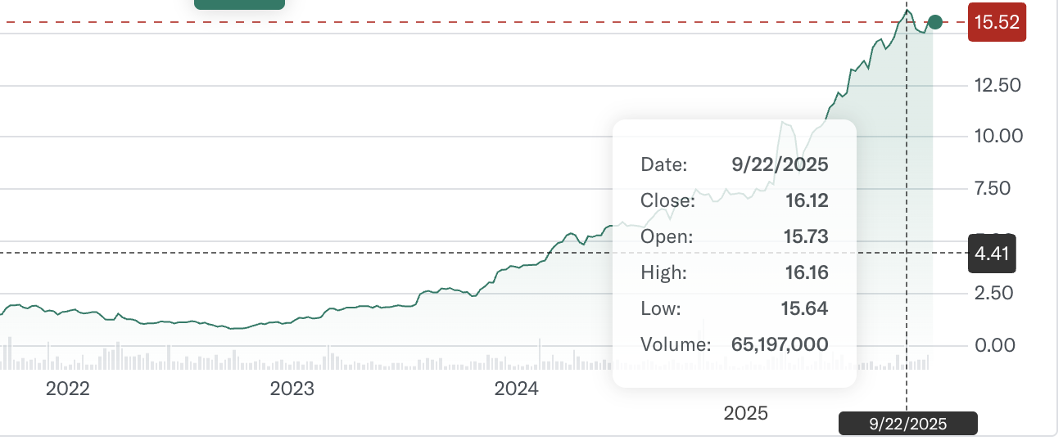
Straight up.
It climbed to over $16 in a little more than three years.
People who listened made big money.
Life-changing money.
For example, my follower Brian, who is approaching his 90th birthday, wrote that it was “the biggest win of his lifetime.”
He sold 10,000 shares last month for a net profit of $141,000!
@Baron 10/7/2025 at 1:17:04 pm
I opened 13000 Shares/Contracts at $1.38.
I am still holding 3000 shares but starting to liquid my estate as i approach my 90th birthday. SOLD 10000 SHARES FOR A NET PROFIT OF $141,567. The biggest trade of my lifetime!

Another follower Nathan is up well over 1,000% on 17,000 shares. At $16 per share, those are worth $272,000!
NavyNick 3/3/2025 at 10:11:19 am
Up over 1000% today while still holding 17k shares. Sold enough @ $6 to cover entry. All 17k are pure profit. Currently watching but holding.

Sam bought 12,400 shares at $1.08.
At $16 a share, those shares are now worth $198,400!
SM 3/3/2025 at 10:32:52 am
Bought 12,400 Shares for average cost $ 1.08. HOLDING P/L 820 %. Thanks Karim

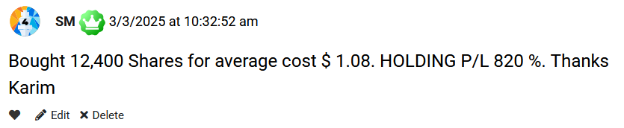

Jared called it his “biggest stock winner ever.”
He bought 49,700 shares and sold one third for profits.
The remaining 33,000 shares are worth over half a million dollars today!
He says with a daughter in college, “her tuition feels like a drop in the bucket now.”
JeromeP 3/3/2025 at 10:25:31 am
RYCEY is by far my biggest stock winner ever. I've sold about one third of my original 49.7K shares, and my profits (taken & unrealized gains) are around $290K! I have a daughter in college, so her tuition feels like a drop in the bucket now. I'll do some home improvements (roof, kitchen) with some profits. I'm so glad that I watched your on-stage presentation and went all-in!! Thank you! If I ever have a son, Karim will be a name that I consider! :)

I got a note from one of my followers Timothy who became a millionaire.
“about three years ago I watched a video from Karim talking about stock symbol RYCEY,” he says.
“I started investing with about 20K and the stock was at .88. Today it is at $7.48 and I have made several hundred thousand dollars in profit. My account now stands with this stock over one million dollars. I just want to say thanks!!!!!”
And here’s what’s crazy… since Tim sent me this note, the stock doubled again to $16!
Ok, this last one is really amazing.
A man walked up to me when I was speaking at a conference and handed me this paper showing all of his purchases or RYCEY.
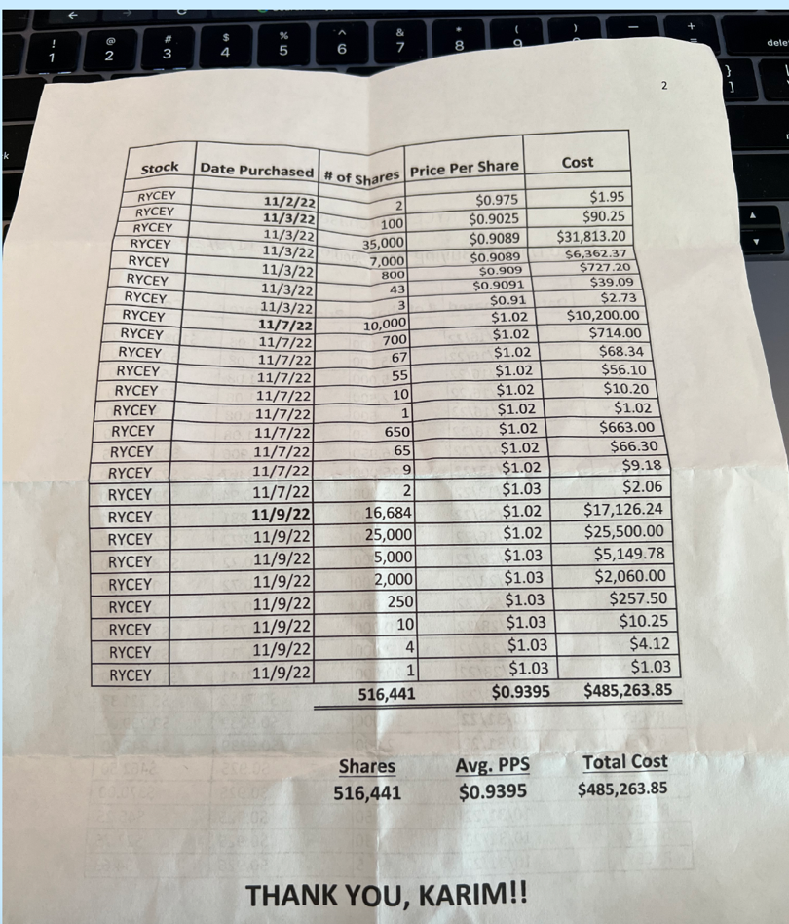
He had bought a stunning 516,441 shares for an average price of 94 cents per share.
At $16, those shares are worth $8.2 million!
Simply incredible.
Ok… why did I take the time to share these stories with you?
Because I want you to understand how life-changing it can be to truly find a great stock.
My goal is to help you have your own RYCEY moment.
And I’ve found the single best stock to do it.
It is set to solve the single biggest problem in tech and unleash a new wave of growth unlike anything we’ve seen.
So let me tell you The Greatest Stock Story Ever Told.
It starts… with a problem.
There is a Serious Problem with the AI Revolution
As you probably know… AI is in the midst of one of the biggest buildouts in human history.
Chip companies like Nvidia – the first company in history to top $5 trillion - have exploded in value.
Data centers and server farms are springing up all over the country.
Spending on data centers alone is up over 200% in just the last three years alone.

Companies like Elon Musk’s xAI are building super computers so big, it boggles the mind.
xAI’s Colossus 2 uses over 1 million CPUs and will cost between $35 and $40 billion.
Meta’s Hyperion supercomputing system is expected to be the size of Manhattan!
Tech companies are spending a fortune!
OpenAI by itself has made a $38 billion deal with Amazon… a $100 billion deal with Nvidia… and a potential $350 billion deal with Broadcom!
It’s no wonder that OpenAI CEO Sam Altman says 2026 may be “a big year for AI.”
But through all this, these tech companies are facing a serious problem.
It’s could derail everything if they don’t solve it.
Moore’s Law Might Be Breaking
For the AI explosion to continue, the tech companies need two crucial things.
Increasingly powerful chips.
And more energy.
Sam Altman, for instance, has said he needs 100 times the computing power he has now for the future versions of ChatGPT.
But the ever-growing appetite for more computing power has led to a major problem that could devastate tech.
It has to do with silicon chips and the very limits of physics itself.
Now, few people know this… but when computing chips were first invented, they did not use silicon.
The first transistor was demonstrated by Walter Brittain and John Bardeen at Bell Laboratories in 1947.
But they didn’t use silicon.
They used the 32nd element in the periodic table, Germanium.
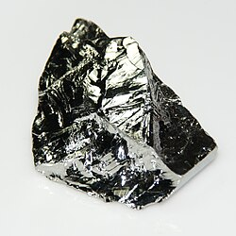
The entire first decade of semiconductor electronics was based entirely on Germanium.
Germanium worked well in some ways. But it was unstable at high temperatures and it leaked electrons.
This held scientists back.
But in 1958, that changed.
Jack Kilby of Texas Instruments and Robert Noyce, co-founder of Intel… discovered that silicon was far superior to germanium.
They patented new integrated circuits that produced better speed and power… plus they could be mass produced.
With the silicon chip, the age of the computer was born.
The first silicon microchip, the Intel 4004, was released by Noyce and his co-founder Gordon Moore in 1971.
It was just a 4-bit processor.
Unthinkably slow by today’s standards.
But Gordon Moore made a prediction.
He said that, because of the nature of silicon, microchips would get smaller and smaller… doubling in power every two years.
His prediction was so accurate, it became known as Moore’s Law.
And for 50 years it held true.

With every chip released… the transistors shrunk smaller and smaller.
Each chip packed in more and more transistors.
By 1980… the Intel 8051 chip held 50,000 transistors.
In 1990, Motorola released the 68040 with 1.2 million transistors.
By 2001, the Pentium III was up to 45 million.
And in 2008… Intel blew past all expectations with the first 2 billion transistor quad-core chip.
The growth has continued year after year…
To today when an Nvidia Blackwell chip contains a stunning 208 BILLION transistors!
But to do this, scientists had to do the impossible.
They developed transistors so small they were barely bigger than an atom itself.
Consider… a transistor on the top silicon chips today are just 5 nanometers in size.
To give you some comparison… A human hair is 80,000 nanometers wide.
These circuits are less than 5 billionths of a meter.
They are incomprehensibly small.
And this brings us to the problem.
They really can’t go any smaller.
They’ve hit the limit.
The end of the road.
And as a result, Moore’s Law is essentially dead.
Physics simply won’t allow silicon chips to continue doubling in power from here.
Nvidia’s CEO Jensen Huang has openly admitted this.

“Moore’s law is dead,” he said. “And the ability for Moore’s Law to deliver twice the performance at the same cost is over. It’s completely over.”
Now… this could be a serious problem.
To get better performance out of silicon, tech companies can no longer simply pack more transistors into a chip.
As BBC Science says “we’ve now squeezed as much as we can from silicon chips.”
But listen… Jensen Huang is no fool.
He’s not going to just give up and say “oh well, Moore’s Law is finally dead. Nothing we can do about it. I guess these are the best chips we’ll ever make.”
Rather, as the CEO of Nvidia, he must find the next breakthrough.
He needs to build better chips… one way or another.
And fortunately for him, and the entire tech industry, one tiny company that trades for less than $10 has found that breakthrough.
For the First Time in 50 Years, a New Element is Set to Replace Silicon and Reignite Moore’s Law
Just as Jack Kirby and Robert Noyce once replaced germanium with silicon… a new company is set to replace silicon with something else entirely.
And we are set to see a dramatic new shift out of silicon and into this new element.
It’s called gallium.
It’s a little-known element, but it’s actually found all over the Earth... including in a major new deposit discovered in Montana.

It’s generated as a byproduct in the mining of aluminum and zinc.
And it is set to radically change the world.
Now… scientists have known about gallium for many years.
But they never thought it had a chance to replace silicon.
It just didn’t work by itself.
But then scientists made a shocking discovery.
By combining gallium and nitrogen in a hexagonal crystal structure, a new super-compound was born.
And this super-compound, called gallium-nitride or GaN for short, is set to transform the semiconductor industry worldwide.
Let me tell you why.
Due to the crystal structure of gallium-nitride there are bigger gaps for electrons to travel through.
And because of these gaps, electrons move faster through gallium-nitride than with silicon.
This allows for faster processing speeds.
GaN can also withstand higher voltages than silicon, allowing for more compact design.
On top of that, GaN operates effectively at higher temperatures… allowing more of it to be packed in tighter in circuits.
So how much of a difference does this make?
Well… consider some of these stunning stats.
Gallium-nitride uses up to 40% LESS energy than silicon chips.
GaN enables up to 3X faster charging in half the size and weight.
And here’s where it gets crazy.
GaN chips can be up to 20X better in overall performance and 100X faster in processing power.
I did not misspeak.
We’re talking about 100 times faster processing than silicon.
And here’s the kicker…
All of this can be done without going to the atomic level like with silicon.
Remember, the top silicon chips use transistors that are only 5 nanometers.
They really can’t go any smaller.
Well… GaN chips can be built at 250-350 nm…. And still get far better performance than silicon.
That means GaN has a lot more room to increase power before it hits that atomic wall that stopped silicon.
And better yet… the machines needed to create chips at that size are FAR cheaper than the ones needed to build chips at the near atomic level for silicon.
To put it simply…
GaN is the future.
It’s not Moore’s Law that’s dead.
It’s the silicon chip that’s dead.
Thanks to gallium-nitride, chips are about to become faster, more energy-efficient, and more powerful than ever before.
This will be the breakthrough that unleashes the next stage of AI.
And that’s exactly why…
The biggest chip company in history, Nvidia, is partnering with the tiny company that owns the patents to gallium-nitride.
Why One Tiny Company with 250 Patents Could Soon Become the Most Important Company in the World
The company only IPO’d a couple of years ago.
So it’s relatively new.
And it’s small.
The stock trades for about $10.
It has a market cap of around $2 billion.
That makes it 1/2500th the size of Nvidia.
But the growth potential here is off the charts.
The company was started by a team of experts from the top semiconductor companies.
The President, for example, comes from Texas Instruments, the company that actually created the first silicon chips.
He gathered the best scientists from the semiconductor industry with one mission in mind…
To take down silicon forever.
As the company says about their mission:
“GaN is growing in importance because of its ability to offer significantly improved performance over conventional silicon semiconductors while reducing the energy and the physical space needed to deliver that performance.”
To accomplish this mission, the company developed 250 patents to protect their technology.
These range from new chips created with GaN integrated circuits… to GaN power systems for data centers… to ultra-fast charging equipment for electric vehicles and mobile phones.
GaN is being used in electrical grids, medical equipment, consumer electronics.
Virtually everything.
And this isn’t some future technology that may take off.
It’s here… right now.
The company has already shipped over 250 million GaN chips…
These chips have logged over 2 trillion field hours of real world usage.
It’s unbelievable.
That’s why the biggest company in the world, Nvidia, has come calling.
This company owns the patents.
So if Nvidia wants to continue developing the best chips on the planet, they are going to need gallium-nitride to do it.
Nvidia’s next big thing is creating massive AI super-factories…
These are ultra-elite data centers packed with the strongest computing power on the planet.
And Nvidia is relying on this tiny company to provide gallium-nitride power infrastructure for these AI super-factories.
But that’s just the beginning.
As Barron’s recently reported, the company is also “making progress on new power chips to support artificial intelligence infrastructure designed by Nvidia.”
This is MASSIVE news.
There is a very real chance that when Nvidia reveals its next superchip this year at its annual Nvidia GTC event, it will NOT be a silicon chip.
It will be a gallium-nitride chip using this one tiny company’s technology.
And the entire electronics industry will be upended forever.
That’s what makes this situation so urgent.
The company trades at a great price today.
But once its technology becomes crucial to the most powerful company on the planet?
There’s no telling how high this stock could go.
I cannot overstate this.
This tiny company essentially owns the keys to the future growth of the entire tech industry.
They are the gatekeeper of the most important technological advancement since the silicon chip in 1958!
That’s why Nvidia is just one of dozens of companies partnering with them immediately.
Everyone NEEDS access.
Or they will get left behind.
The Company is Also Working with Samsung, Lenovo, Dell, LG, Xiaomi, and More
And that’s because gallium-nitride can instantly advance virtually any electronic application and industry.
For example, look at data centers.
The biggest problem facing AI data centers right now is energy.
As Forbes reports, “AI is pushing the world toward an energy crisis.”

Well.. switching data centers from silicon to GaN would reduce energy usage by 30-40%... saving over 100 TWhrs of energy.
That’s almost double the energy needed to power all of New York City for an entire year.
That’s just one example.
Look at smart phones.
GaN crushes silicon there.
Chargers and batteries made with GaN instead of silicon charge up to 3X faster.
They are also smaller and lighter… allowing cellphone companies more space to pack in other components.
Anything that needs to be charged sees dramatically faster charge times with gallium-nitride.
That’s cars, phones, laptops, you name it.
It’s up to 3x faster.
Samsung, for example, partnered with this company to use its gallium-nitride technology in their Galaxy S22, S23, and S24 smartphones.
But it worked so well – better than expected at up to 20X faster – that Samsung then immediately expanded to the Galaxy A and Galaxy Z models.
LG used GaN to create the world record for the lightest 16’ laptop ever.
It was certified by the Guinness Book of Records.
And it was only possible because GaN can provide more power at smaller size and weight.
Xiaomi set another record using this company’s technology.
Chargers using gallium-nitride were able to fully charge a laptop from 1% to 100% in just nine minutes!
That’s why Volvo is also now working with them to create ultra-fast chargers for electric cars.
I could go on an on here.
Lenovo is using this company’s gallium-nitride technology to create ultra-fast chargers for its laptops and mobile devices.
Dell is working with them on its new family of AI notebooks.

The race to adopt GaN is moving ahead full speed.

Really, these companies have no choice but to work with this company.
They have the patents behind the technology.
They hold the keys.
And that’s why I believe when Nvidia reveals their next chip upgrades, it will likely be created using this company GaN technology.
That could send this stock on an epic run.
Just look at what’s happened with other companies that held a position of power like this in the past.
Companies That Develop Breakthrough Technologies Can Deliver MASSIVE Wins
Take ASML Holding.
Few people know it.
But it builds the world’s most advanced and expensive chipmaking machine.
They are called Extreme Ultraviolet, or EUV, Machines.
They cost $400 million each.
And these machines are the only ones capable of projecting the blueprints required to make the most advanced chips.
As CNBC says, “chip designs from giants like Nvidia, Apple, and AMD can’t be manufactured without EUV.”
In short, like the company I’m telling you about today, they hold the keys.
Business can’t be done without them.
And what’s happened to the stock?
Take a look for yourself.
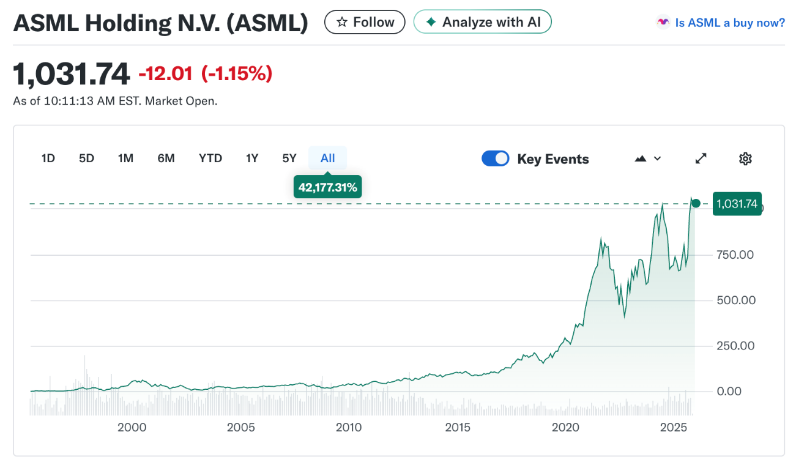
The stock is up 42,177% all-time.
And it’s increased from $86 to $1,031 over the last 10 years alone!
Just 100 shares would have turned into $103,000 over the last decade.
That’s what happens to companies that hold a key technology.
Corning Inc. is another one.
They developed one-of-a-kind specialized glass used in smartphone and laptop screens.
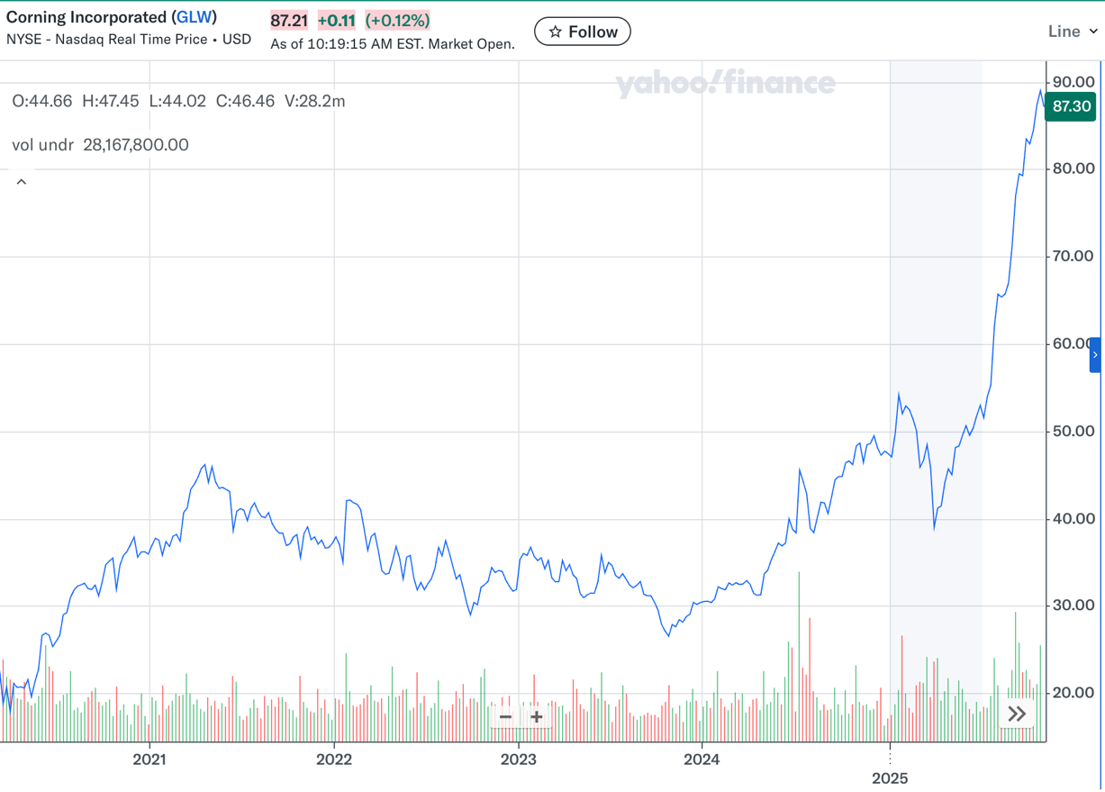
And since 2020, the stock has skyrocketed from $17 to $87.
Or take Intuitive Surgical.
They own patented technology on surgical robots.
Nobody else can do what they do.
And so the stock went virtually straight up for 20+ years.
It was $2.50 back in 2004.
Today it’s $540.
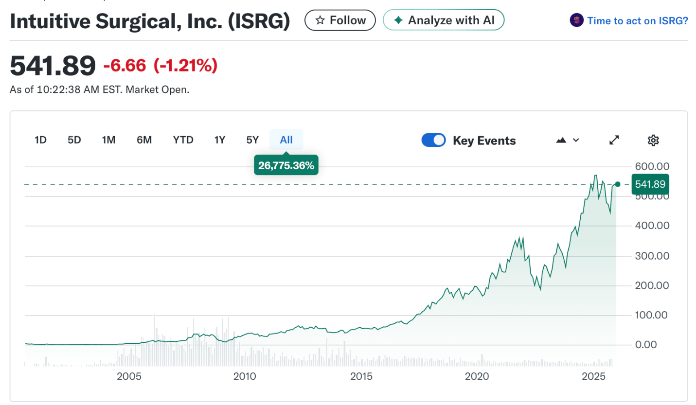
A $5,000 investment would be worth over $1 million.
Or look at Nvidia itself.
It became the biggest company in the world simply because its chips were the best.
Everybody needed them.
And so the stock is up 35,600% over the last 10 years.
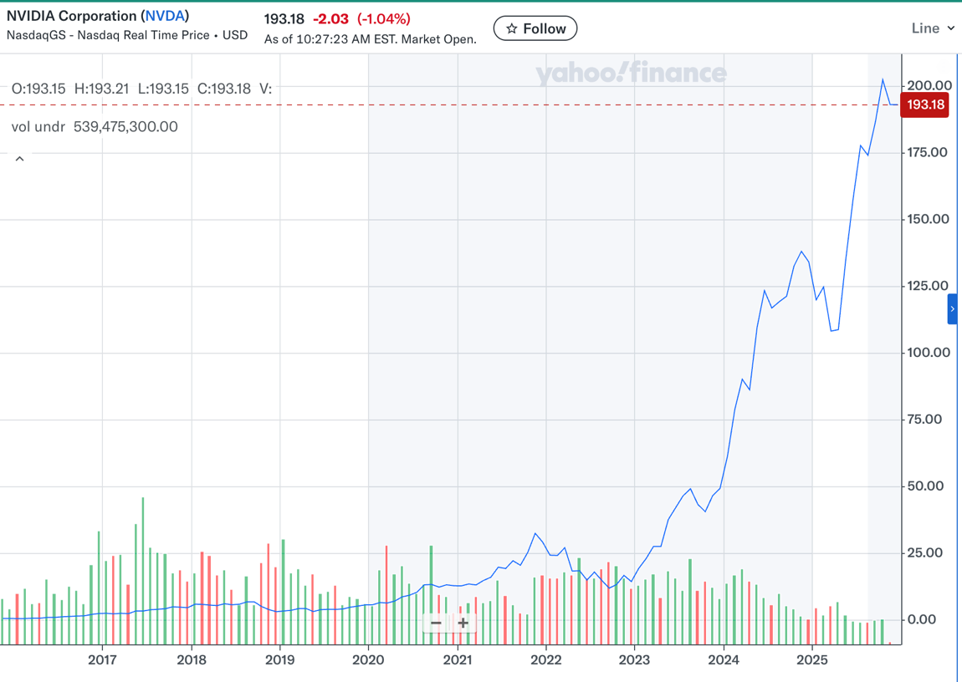
$10,000 turned into $3.5 million.
That’s the kind of potential you have with this tiny company today.
Gallium-nitride is quite simply the most important advancement in chip technology since silicon itself.
Every chipmaker in the world will need to embrace this tech or get left behind.
Every tech company in the world right now is in a race to develop the strongest AI possible.
They are spending hundreds of billions of dollars.
The winners of this AI race will be the ones who can access the fastest, most powerful, and most efficient chips.
Those chips will undoubtedly need to be gallium-nitride.
And this company holds the keys with its 250 patents.
If Tesla wants electric cars that can be charged ultra-fast… they’ll need gallium nitride.
If Amazon needs more energy to run its data centers… they’ll need gallium-nitride.
If OpenAI needs chips that are 5… 10… 50… 100 times more powerful in the future for ChatGPT… they’ll need Nvidia to make new chips with gallium-nitride.
Everything depends on this tech.
As MicrochipUSA recently said in an article about the gallium-nitride breakthrough,
“compared to silicon, which is reaching its physical limits in thermal and voltage performance, gallium-based semiconductors open the door to a new era of miniaturization and energy efficiency.”
And one tiny company controls this new era.
There’s a reason I told you this is likely to become the most important company in the world just 12-24 months from now.
And I have no doubt… this is your LAST CHANCE to get in while it’s still cheap and unknown.
Earlier I said I haven’t found a stock this good since RYCEY, which helped many of my followers make hundreds of thousands or even millions of dollars.
Many of them called it the single biggest win of their lifetimes.
Well… to be honest… I think this is better than RYCEY.
It is the greatest stock story I’ve ever uncovered.
And I’d like to help you turn this opportunity into the biggest win of your lifetime.
That’s why I’ve put together a new report that will tell you exactly how to profit from this stock.
It’s called The Greatest Stock Story Ever: How One Tiny Stock Revolutionized the Tech Industry.
Inside, you’ll get the ticker symbol and buy instructions.
I explain how to maximize profits.
I go into detail on the gallium-nitride tech… and it’s many uses in and outside the tech industry.
I’ll tell you about the existing partnerships with big tech companies like Nvidia, Dell, Samsung, LG, Lenovo, and more.
But we’ll also dive into the potential future partnerships that are coming.
I’m making this report available to all of my existing followers now.
And I’d like to send you a copy today as well…
But that’s not the only money-making opportunity I have for you today.
I’ve found two more exciting opportunities I’d like to give you as well.
The first is a special way to play Nvidia during this transition from silicon to gallium-nitride…
How to Collect Up to 400% Gains on Nvidia
There’s no question…
While the stock I told you about today has the biggest upside I’ve seen in the markets…
Nvidia itself stands to benefit mightily from this new technology as well.
There’s a reason they chose to partner with this tiny stock.
They surely see that gallium-nitride is the future.
So some people might wonder, is it a good idea to still buy Nvidia as well?
After all, new gallium-nitride chips might send the stock soaring even more.
Well, Nvidia is already the most valuable company in the world.
So while I think Nvidia could continue to climb… the upside is more limited.
The truth is… buying Nvidia stock directly doesn’t provide the kind of BIG upside I want.
But there is another way to invest in Nvidia that can deliver the big gains we want.
As Fidelity says, this investment “allows you to control a greater amount of shares with a smaller amount of money.”
It’s not high-risk call options or an Nvidia subsidiary or anything like that.
But using this special trade could deliver a shot at 400% returns in the next year if Nvidia continues to climb.
I’ve put together instructions showing you how it works.
And I’d like to send you those as well in a report titled, How to Collect Up to 400% Gains on Nvidia.
So that’s two ways you can profit from the gallium-nitride breakthrough.
Plus, I have one more opportunity for you today.
This last one is really BIG.
It’s an unusual $3 asset that, if history is any indicator, could rise to $92 within a year.
Let me explain why…
Why an $8 Billion Cash Injection Could Push One $3 Asset to $92
This one is a very straightforward opportunity.
But it’s in a rare asset that most Americans haven’t heard of.
It’s not a stock, bond, option, or a precious metal like gold or silver.
Rather, it’s an asset over 300 major financial institutions use to move money all over the world.
This includes American Express… Amazon… and even Western Union!
It’s only $3.
But there’s something very unusual about the way it trades.
Whenever a big cash injection flows in, the value of this asset tends to rise far faster than the amount of money coming in.
For example, in March of this year, an investment of just $80 million pushed the value of this asset up by $17 billion in just 4 hours!
It went up in value 212 times MORE than the investment.
That’s a 212 times multiplier.
Then, in April, a $12.8 million investment over just eight hours sent this asset up in value by $7.7 billion!
That’s a 601X multiplier!
On June 7, a $17 million inflow of cash increased the market cap by $11 billion – a whopping 647X multiplier!
This is crazy guys.
Moves of just a few million dollars are creating spikes in the BILLIONS.
But here’s where it gets really exciting.
This asset may be on the verge of the single biggest cash infusion its ever received.
Wall Street institutions are actively working to create NINE new ETFs that trade this asset.
And JP Morgan estimates that $8 BILLION could flow into this $3 asset through these nine ETFs.
Let me remind you… an investment of just $17 million this year drove the value of this asset up by $11 billion in a day!
So an $8 BILLION investment?
If it follows the 647X multiplier this asset saw in June…
That would drive the price up from $3 to $92!
That’s an increase of 30-fold in just one year!
Now… admittedly that’s using the best case scenario.
But listen… even if it follows the more conservative 212X multiplier it saw in March… this asset would still jump to $32.
The point is…
We know that cash injections drive this $3 asset higher very quickly.
And the biggest cash injection we’ve ever seen is on the horizon.
That’s why I want to send you a third report today…
The $3 Asset Set to Receive an $8 Billion Cash Injection
So all told I have three opportunities for you to profit.
I’ll send you each of my three reports:
- The Greatest Stock Story Ever: How One Tiny Stock Revolutionized the Tech Industry.
- How to Collect Up to 400% Gains on Nvidia.
- The $3 Asset Set to Receive an $8 Billion Cash Injection.
My team has a package with all three reports ready to send to you today.
But it gets even better.
On top of that, I’d like to help you find even more successful opportunities going forward with my service Monument Trend Advisory.
I want to make this research service available to you with no strings attached.
In fact, I’m offering you a risk-free trial membership of Monument Trend Advisory to go along with all three reports I’ve promised.
Get All Three Reports AND a Risk-Free Trial in Monument Trends Advisory
Here’s how the service works.
Each month we look for the most powerful trends driving the market.
Along with my co-founder Bryan Bottarelli, we target stocks and investments using what we call the “W.A.R. Trends System.”
This system is based on three criteria…
- Winning Technicals
- Accelerated Fundamentals
- Recent/Upcoming Catalysts
The story I’ve shared with you today is a great example.
First, we identified a powerful trend – the AI revolution that’s driving trillions of dollars in investment all over the country.
Then we found a great stock with momentum behind it… and the potential for massive sales growth.
And finally, we looked for a strong catalyst.
In this case, a partnership deal with Nvidia that could boost the company dramatically.
With Monument Trend Advisory, we’ll deliver two of these types of opportunities to you every single month.
We will deliver these to you in our Monument Trend Advisory Field Reports.
On top of that, we go live on video every week on Tuesdays at 2 p.m. to talk about our investments.
This gives you a chance to hear from us directly in real time.
You can ask questions in the chat.
And most of all, we get to celebrate our wins together!
There’s nothing more fun than getting a note like this one from our RYCEY play.
I did sell most of my 37,000 shares of RYCEY. My wife and I used the money to pay cash for our retirement home in Texas.”


Now… with results like that… helping people make enough to pay cash for a retirement home… we could charge a small fortune for Monument Trend Advisory.
That’s what they used to do on Wall Street when I worked there in the 80s and 90s.
They catered to the elite only.
But that’s not what I do.
Rather, my focus is on giving EVERYONE a chance to land winning investments.
Because I know that when we change people’s lives for the better, they stick with us forever.
That’s why I always put together a package that is impossible to say no to.
So when you take a risk-free trial in Monument Trend Advisory today, you’ll get.
- Free Report #1: The Greatest Stock Story Ever: How One Tiny Stock Revolutionized the Tech Industry.
- Free Report #2: How to Collect Up to 400% Gains on Nvidia.
- Free Report #3: The $3 Asset Set to Receive an $8 Billion Cash Injection.
Plus…

- Approximately Two Top Investment Recommendations Every Month… Based on the W.A.R. Trends System
- Monthly Issues of the Monument Trend Advisory Field Report
- Weekly Updates via email and mobile app – with new intel on current recommendations.
- Complimentary subscriptions to the members-only publication Unbound Fortunes and Trade of the Day Watchlist.
- Access to our Mailbag, Chatroom, and Concierge Team to ask any questions you might have. Just keep in mind we can’t offer personalized financial advice.
Remember, this is a research service for everyone.
We’re not trying to serve only ultra-elite investors.
That’s why normally it costs $XXX to join Monument Trend Advisory.
But today, you can access everything I just laid out for just $XX.
We only charge enough to offset the cost of bringing in new members.
We don’t expect to make a single dollar when you join.
In fact, we’ll likely lose money.
Why would we do that?
Because the only way we’ll profit is if you stick with us for the long haul.
And we like it that way.
It means that our success is directly tied to your success.

Let me give you an example of this.
We have a member named James who joined us a few years ago when RYCEY was still less than $1.
He bought 65,000 shares… a big investment.
He was putting his faith in us, which means a lot.
And by September 2025, his 65,000 shares had delivered a profit of $1 million.
As he says, we helped put his retirement into high gear.
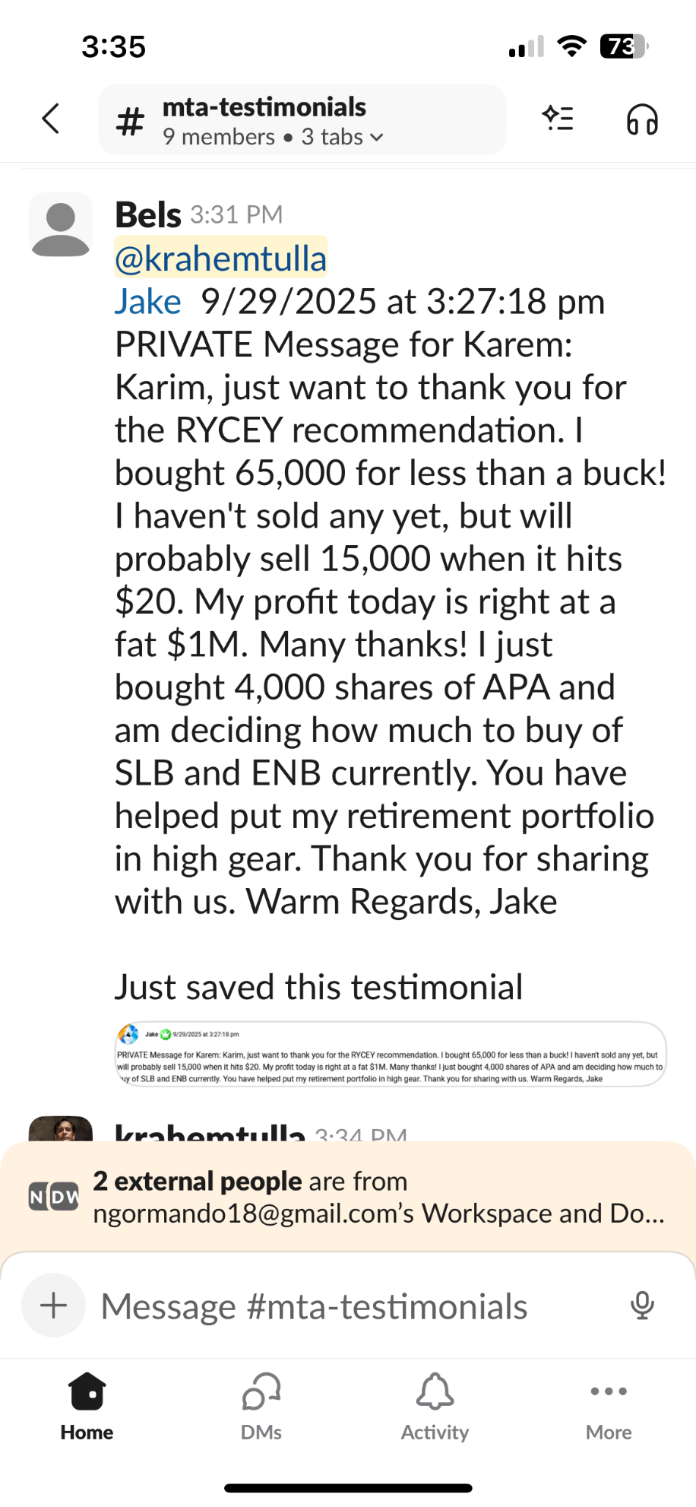
The point is…
When somebody has the opportunity to grow their wealth that much – over $1 million – in just three years… after paying just $XX for a subscription… they stick with us for life.
Of course it’s important to note… there are going to be risks when it comes to any kind of investing. I never recommend investing more than you can afford to lose.
You should only do what you’re comfortable with.
Because even small stakes can have a big impact with wins like this.
Take the story of Frank.
He bought 1,000 shares for $1,583. And rode that up to $10,130 in just 2-3 years.

We’ve helped people from all kinds of financial situations.
The only regret I have is that I didn’t make the case strong enough to get even more people to have an experience like James and Frank!
Millions watched my video about RYCEY, but only about 14,000 joined!
So now that I’ve found another opportunity with that level of upside… I’m not taking any chances.
I’m making it a complete no-brainer to join us.
Yes, we’ll lose money on every person that joins with the price this low.
But that’s well worth it.
After all, this company has 250 patents on a technology that is going to completely alter the future of our tech industry.
Gallium-nitride can reduce energy usage up to 40%.
It can increase processing speed by 20X and performance by up to 100X.
As MIT says, “The advanced semiconductor material gallium nitride will likely be key for the next generation of high-speed communication systems and the power electronics needed for state-of-the-art data centers.”
There’s a reason that Nvidia, Samsung, Dell, LG, Lenovo, and others are partnering with this one company.
And I don’t want anyone out there to miss this opportunity.
Especially with another Nvidia GTC conference coming up where they announce their latest chips.
Once Nvidia makes the shift to GaN, it’ll be like unleashing the running of the bulls for this one tiny stock.
I don’t want you to miss that moment.
Which is why we’re putting all the risk on our shoulders… not on yours.
Take 30 Days to Review All the Reports at ZERO RISK.
Here’s what I’m willing to do.
Go ahead and join Monument Trend Advisory now.
And I’ll give you the next 30 days to review everything I send you.
You’ll get each of the three reports.
- The Greatest Stock Story Ever: How One Tiny Stock Revolutionized the Tech Industry.
- How to Collect Up to 400% Gains on Nvidia.
- The $3 Asset Set to Receive an $8 Billion Cash Injection.
This way you’ll learn everything there is to know about the gallium-nitride stock I’ve told you about today.. including the ticker symbol and buy instructions.
You’ll also get the chance at 400% gains on Nvidia over the next year.
And you’ll get details on the $3 asset that could climb to $92 in the next couple years.
You can go over every one of these reports.
And if over the next 30 days, you feel that Monument Trend Advisory isn’t for you… then I’ll happily send you back every penny of your membership fee.
Even better, I’ll still let you keep all the reports and materials you get completely free of charge.
I’m only willing to do that for two reasons.
- I’m that confident in our work.
And…
- I believe that strongly in this stock and its potential.
Because of that, I very much doubt you’ll ask for your money back.
In my experience, people who are making money don’t quit.
And I’ve received thousands of notes from people who love the work we do.
I think this message from one of our elite War Room members sums up the experience we want people to have with us.
“Until I joined the War Room I didn't know anything about investing. I'm certainly no expert and I still make real rookie mistakes but because of great instructions and explanations from Karim and Bryan as well as extremely important educational suggestions by many members here I have gained some valuable knowledge into the pursuit of value investing. It's weeks like this that make me realize that deciding to be here was a great decision and I want to thank everyone involved in my increased knowledge base for their willingness to help me improve my financial standing.”
This is what we want to help you achieve.
To increase your knowledge and success as an investor.
If we do that, and help you make a lot of money, we know you’ll stick with us.
So to join Monument Trend Advisory, you’ll see a button appearing on your screen now.
Go ahead and click it.
It will take you to a new page while I wrap up this presentation.
On that page, you’ll get a summary of everything I’ve laid out for you today.
You’ll get details on how to claim your discount. (In fact, there’s an opportunity for an even bigger discount you won’t want to miss)
You’ll see the full breakdown of all your memberships, including the three free reports I’ve promised today.
Remember, you’ll get the ticker symbol of the stock with the breakthrough gallium-nitride technology… and the 250 patents behind it.
The company that is just 2,500th the size of Nvidia.
The one that Nvidia partnered with to use GaN in its new AI super-factories.
The one Samsung is using to upgrade to GaN in its smartphones.
The one that LG used to create a Guinness World Record for the lightest 16’ laptop ever.
But you’ll also get an opportunity to bank 400% on Nvidia if it keeps climbing in the next year – which we think it will.
And a rare $3 asset that is about to see an $8 billion cash injection that could drive it to $92.
These are three of the best opportunities in the entire market right now.
But this is just the beginning…
Through Monument Trend Advisory, I aim to help you kick your retirement into high gear.
So again, just click that button to get started.
You’ll have 30-days to see exactly what we can deliver risk free.
And while you get started on your membership, I’ll answer a few common questions new members have.
Frequently Asked Questions
First Question: How abundant is gallium-nitride?
When I’ve spoken about this opportunity, one of the common questions I get is whether there is enough gallium to supply this market.
There’s no question that gallium production will need to ramp up.
And the United States needs to start growing its own stockpile.
Up until recently, China controlled 98% of the production.
And they’ve used that as a point of leverage against us.
But that is about to change rapidly.
Gallium is found all over the Earth. Certainly not just in China.
As I mentioned earlier, a massive deposit was recently uncovered in Montana.
And another gigantic deposit – with rare earths totaling $37 billion – was found in Wyoming.
There is plenty gallium for us right here in America.
As The Center for Strategic & International Studies reports…
“GaN has emerged as a frontrunner in the quest to push the boundaries of electronics, ushering in a new era of energy-efficient and high-performance devices.
The growing adoption of GaN semiconductors is a major opportunity for the United States. It already leads in GaN technology research. With the correct mix of government policy and private initiative in developing and commercializing this new materials technology, the United States could be at the forefront of the next generation of semiconductor innovation.”
This is why right now is such a great time to invest. We’re right at the beginning of this new revolution.
Second Question: How long will it take this company to scale up?
I don’t believe it will take long at all.
Remember, they’ve already shipped over 250 million chips.
This is not just an idea.
It’s a business that is already supply gallium-nitride products to giant tech companies like Samsung, Dell, LG, Lenovo, and of course Nvidia.
It’s still a small company which means it will move up and down along the way.
But I think the upside is tremendous for this business.
Third Question: What happens if the stock goes down?
This is an important question.
And a great example of this is RYCEY
When I first recommended it, it was less than $2.
But over the next few months, it actually fell.
The stock dropped to as low as 88 cents.
That scared some people off.
But listen… when you believe in what a company is doing and the technology they’ve developed… drops in the share price just mean more opportunity.
In the case of Rolls, the people who bought at 88 cents saw their shares go up more than 16-fold in value over just three years.
So yes, this is investing. Stocks can drop.
But when we believe in the company, we recognize those moments as opportunities.
Fourth Question: Can’t I just wait to see what happens and invest once Nvidia announces new GaN chips?
Sure, you can always wait and see.
But the market isn’t going to wait along with you.
Once this story hits mainstream headlines, it will be too late for the big gains.
Making the biggest returns in the stock market requires recognizing the game-changing technologies early.
Now, is the time to invest in the gallium-nitride breakthrough not next year.
As the publication Microchip USA – which is at the forefront of new technologies – says: “gallium has rapidly become one of the most strategic materials in global technology.”
This is happening fast.
The big risk here is missing this moment.
Fifth Question: With Monument Trend Advisory, what if I’m not available for the live video calls on Tuesdays?
No problem at all.
We have email alerts and a mobile app that can keep you up-to-date on all recommendations.
We make about two per month so there are plenty of opportunities to profit.
And we offer a wide range of investment ideas.
We’ll do AI stocks, energy companies, gold, even some crypto opportunities. We offer something for everyone.
Sixth Question: How does the 30-day money back guarantee work?
This one is very simple.
Over 30 days, you get access to everything.
Our current recommendations, the live chats, our training materials.
And of course you get all three of our new reports.
- The Greatest Stock Story Ever: How One Tiny Stock Revolutionized the Tech Industry.
- How to Collect Up to 400% Gains on Nvidia.
- The $3 Asset Set to Receive an $8 Billion Cash Injection.
All I ask is that you give us an honest look.
Our job is to deliver good information and help you become a more knowledgeable and successful investor.
If you don’t feel we are doing that, all you have to do is call our team and ask for a refund.
And like I said, everything we sent you is yours to keep, 100% free of charge.
It’s our job to prove ourselves to YOU.
So with that in mind, if you haven’t started yet, just click the button below to start your risk-free trial now.
And get each of our three big opportunities today.
I look forward to welcoming you as the newest member of our research service, The Monument Trend Advisory.
It’s time for you to have your RYCEY moment.
And this is it.
For all of us at Monument Traders Alliance, I am Karim Rahemtulla… signing off.
November 2025

