- Former CBOE Trader Exposes Wednesday Market Trend that Has Returned 83% Winners

- [Must See] An 83% Win Rate GUARANTEE

If you’re looking for a way to potentially extract income from the market by placing 1 carefully selected trade that I give out every Wednesday, then you need to hear me out.

If you’re not interested in that, hop off!

Your time is valuable, and I’m not here to waste it.

So here we go!

In less than 7 minutes, I’m going to show three things.

First, I’m going to show you THE strategy that gave my readers the shot at an 83% win rate by placing just 1 simple trade every week.

23 closed trades, 19 of them winners.

This is a strategy that I perfected after years as a trader on the Chicago Board of Options Exchange...

Which takes advantage of a market trend that occurs every single Wednesday of every single week.

Two, I’m going to prove to you it works.

I’ll show you my entire track record since inception. I’m not going to sugar coat anything or try to hide my losses.

You will get it all.

I want you to see exactly how this single trade works week after week after week.

And lastly, I’m going to guarantee you’ll see AT LEAST an 83% win rate for the year ahead, per my model portfolio starting today.

And you’ll see that my guarantee is no small thing.

If I don’t hit it, I’m going to be giving out free subscriptions next year to anyone who
follows me starting today.

That could cost me a bundle of money.

But I am happy to do it.

Because it’s one thing for a trader to showcase a wildly successful track record.

It’s another thing for them to continue to perform at that caliber.

And today, I’m not going to guarantee that I’m going to continue at that caliber.

I’m going to GUARANTEE THAT I BEAT IT!

By the way, my name is Bryan Bottarelli. I started my trading career on the Chicago Board of Options Exchange back in 1999.

From there, I went on to run my own trading research service for the past 14 years, teaching others the strategies I’ve used day after day.

And what you’ll quickly learn is that I go above and beyond for them. I’m invested in the success of my trader recommendations. Take a look at some of the feedback I’ve received across my publications.

Like Jim who made a total of 340% and over $4000 in one day. His best day ever!

Or Michael who made $5000 in the first 8 minutes of his day. An amazing 111% gain.

Then Barbara made $7900 overnight! A 169% gain!

Or how about James who made 64% and $11,000 in just 2 days!

Point is, no matter what size account you have, I know I can help you achieve your goals.

Because it’s not about just 1 winning trade, it’s about multiple.

Like George who took a $25,000 account and turned it into $101,000 in 2 and a half months.

The key here is repetition, but it’s actually more than that!

Most want something that is relatively active, but doesn’t affect their daily routine.

And they also want some hand-holding.

They want to know my exact plan with a buy, stop, and profit range so that they could essentially “set it and forget it.”

People want easy. We all do!

An overwhelming amount of people want something super simple that fits all account sizes and all experience levels.

Whether someone had a few hundred to start trading or $100,000 to start trading.

Whether they were brand new to the market or had some experience already…

Whether they want to learn how to trade or just want to get more market research…

The wanted SIMPLE!

And the strategy and research service I created was specifically designed to address those needs.

And I hope you’re excited because I’m about to reveal how this works.

This strategy dials in on 1 carefully selected trade recommendation that I send out every Wednesday evening.

And remember, I’m so confident that I’m going to guarantee the performance of my track record for you, but first you have to understand how it works.

So first off, why Wednesday?

Well, it may sound strange to you, but after trading the market for over 20 years now, I picked up on something...really unorthodox.

Let me just walk you through it real quick.

Monday is arguably the most active trading day of the week.

We’ve got tons of news hitting us from over the weekend, everything is going haywire.

Stocks are moving up, stocks are moving down…

It's a free for all. It’s madness and almost impossible for most to trade.

Unless you can sit at your computer all day, constantly evaluating trends and picking up on sub-5 minute moves in real time, it’s not going to work out for you.

So when it comes to dialing in on 1 single trade per week, Monday isn’t the day.

However, Monday is the day that I start to develop my watch list.

This is a list of roughly 10-20 stocks that I am looking at to make my move on.

I’m targeting trades that have at least 25% or more upside potential, all in a relatively short period of time.

I build this list after I digest what happened over the weekend and the trends I’m seeing take shape on Monday.

Tuesday is what I call “weeding out” day.

This is when I weed out the stocks from my list that are no longer advantageous.

Some may have fallen, while others have gapped up too quickly, and I’m not interested in them at higher levels.

You may think, “Bryan, you missed out on an opportunity!”

So what?? I miss out on tons of opportunities in the market every day!

You can’t chase every single stock. That’s just dumb money.

And look, I didn’t get to an 83% win rate without sticking to the strategy that works.

The moment I deviate from what has worked time and time again is the moment I let greed affect my decision process, and that’s when traders fail.

I don’t want that for myself and I certainly don’t want that for you.

So on Tuesday, I like to trim that initial list down to about 5 stocks that have held up, and are still trading at prices within my technical parameters.

And NOW we’re cooking!

By the end of day Wednesday, this list gets knocked down to 1 SPECIFIC TRADE.

And that’s the exact trade recommendation I send to my readers.

This isn’t just a flip of the coin or me blindly typing in a few letters for a ticker and saying, “THAT’S THE ONE!”.

This is a hell of a lot of due diligence.

It’s 3 full days of evaluating the markets and pinpointing the 1 trade opportunity I’m taking dead aim at.

Because without those 3 days of research and analysis, there is no fricken way I’d be able to have an 83% win rate.

And here’s the best part for you.

You simply hang out while I do all the work!

It sets up perfectly if you have a full time job, children, and other obligations.

Remember when I said I go above and beyond??

I don’t just send you a boring email I send with the buy, stop, and profit range.

I take it to the next level!

I record a video that details my analysis on the entire trade.

After watching this 2-3 minute video, you’ll have everything you need.

All you have to do is open your email, decide if this opportunity is right for you, set up your buy, and you’re done!

You’re all set!

You don’t need to micromanage these trades and the profit target is pre-set.

And every new video contains updates on current positions in our model portfolio. So far my recommendations have an average hold time of 60 days.

My goal is to be active, but not overwhelming. Consistency is key.

My friends, that’s all you need to be a winning trader.

Let me show you what I’m talking about.

Here’s the full track record since it launched. I’m going to leave it on the screen for you.

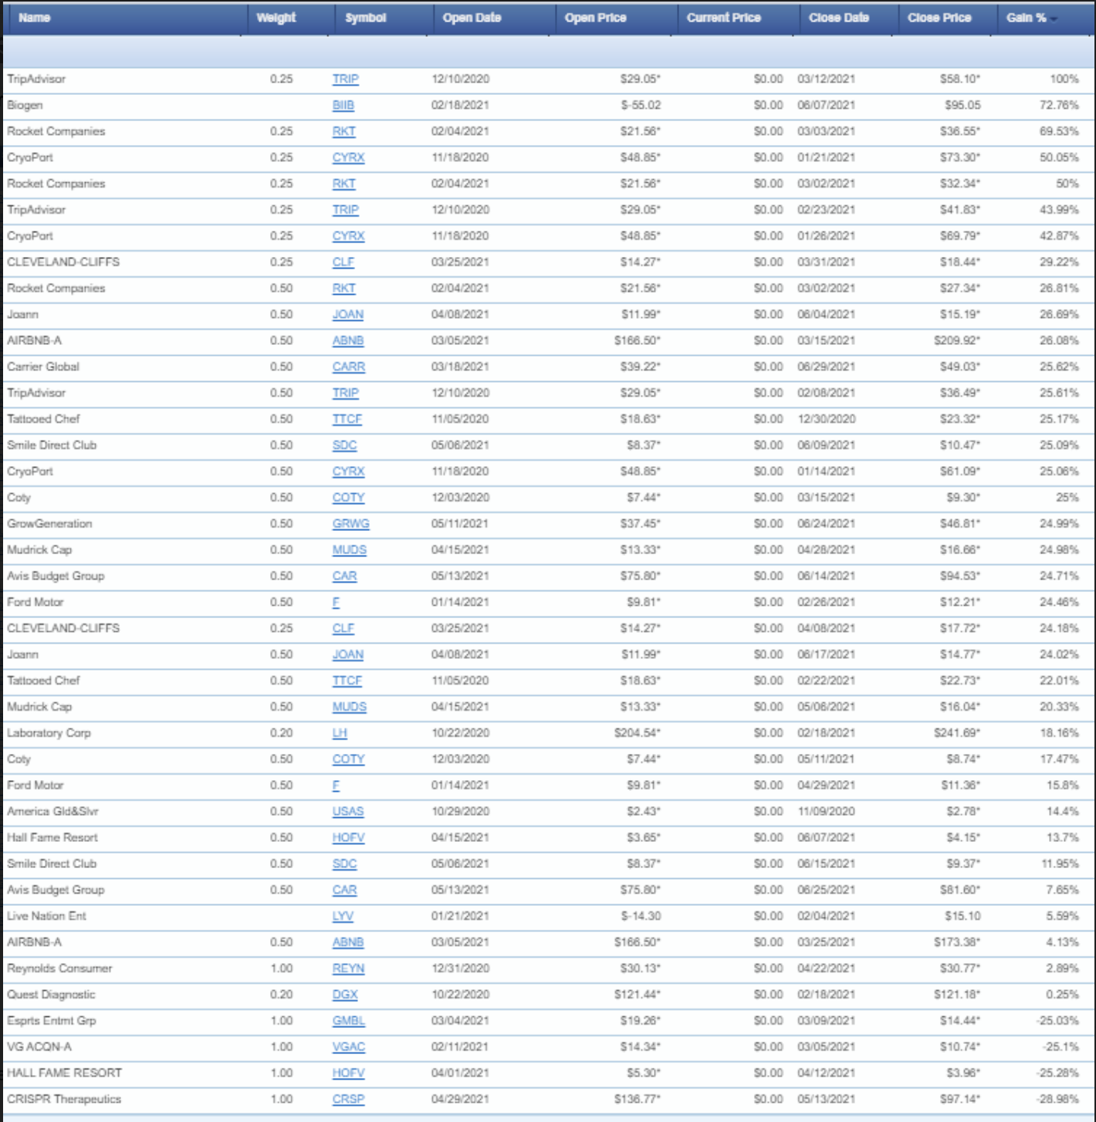

Trip Advisor!

Biogen!

Rocket Companies!

Cryoport!

Airbnb!

Coty!

Tattooed Chef.

Winner after winner after winner!

Oh shit!

How did those losers get in there??

Normally every other guru just brushes their losers under the rug.

Well, that’s not me and I can’t stand that.

No trading strategy is perfect and all investing does carry risk.

Granted, at an 83% win rate per our model portfolio, this one is close.

The big takeaway here is consistency.

It’s why I spend 3 days evaluating the market and making an informed decision before sending it out to my members.

Here, let me show you how this looks with a couple examples.

Let’s first take a look at RKT.

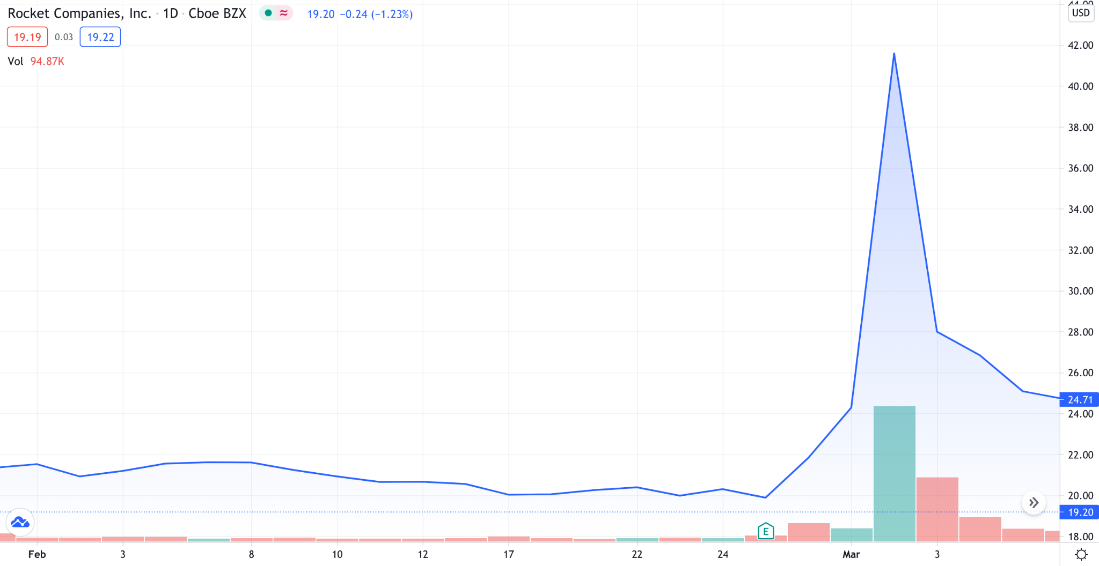

**Interactive chart that highlights the specific dates, times as mentioned in the script below**

I recommended this trade on February 4th, with a specific catalyst in mind.

The Super Bowl that took place that weekend, February 7th.

This may sound extremely simple to you and it SHOULD!

A couple things made this look like a clear winning opportunity.

For one, we had been in the pandemic for almost a year at this point.

The housing market was poised to make a comeback, and Rocket Mortgage knew how it could take advantage of this.

They transformed the way that people could apply for a mortgage by using their smartphones.

Gone are the days that you go into some office and sit face to face with some insurance guy.

Rocket Mortgage recognizes this early on.

It’s like dealing with a used car salesman.

But here’s the BIG catalyst.

Rocket Mortgage was the premier sponsor for the Super Bowl Squares Promotion.

This was the perfect moment to get their message out.

Because at the same time they were doing this, Rocket Mortgage had a high short interest, just like what we saw with the reddit community on Gamestop and AMC.

See how this is all coming together.

It was a home run on every account!

And when I tell you that we nailed this trade AHEAD of the reddit move, I mean it.

Because just a few weeks later, the stock caught fire on message boards.

After recommending the stock at $21.56 on February 4th, we were out by March 3rd, locking in profits of 26% on the first half, 50 percent on the next quarter, and the remaining quarter at 69%. The overall gain was 43%... in under a month!

That brings up an important piece to it all...the exit strategy.

We set our first profit target at 25%, cut half and then move our profit target up to 50% for the next half. We typically look for 100% on the last portion.

In the case with RKT, I recommended everyone lock in their remaining gains at a 69% win. Not bad, right??

See, anyone can buy a stock, but you NEED to know when to sell.

Luckily, this service is designed to make it easy for you, explaining exactly how to manage the trade so you don’t have to worry about selling too early OR selling too late and watching profits disappear.

That’s how my readers are able to protect their profits.

No guesswork. No emotions. No fear of missing out.

In under a month, my readers had a shot at a 43% gain on RKT, and some did even better!

Sidney made 57% on the entire trade!

Peter made 117% gain on the first half that he sold!

Jeff bought at 19.79 and sold at 38.25 for nearly 100% a week later!

Dwayne made 170% on the trade!

Again, everything is set up for a detailed plan ahead of time.

I’m doing all the hard work!

To further understand how critically important profit-taking strategy is, let me walk you through Trip Advisor.

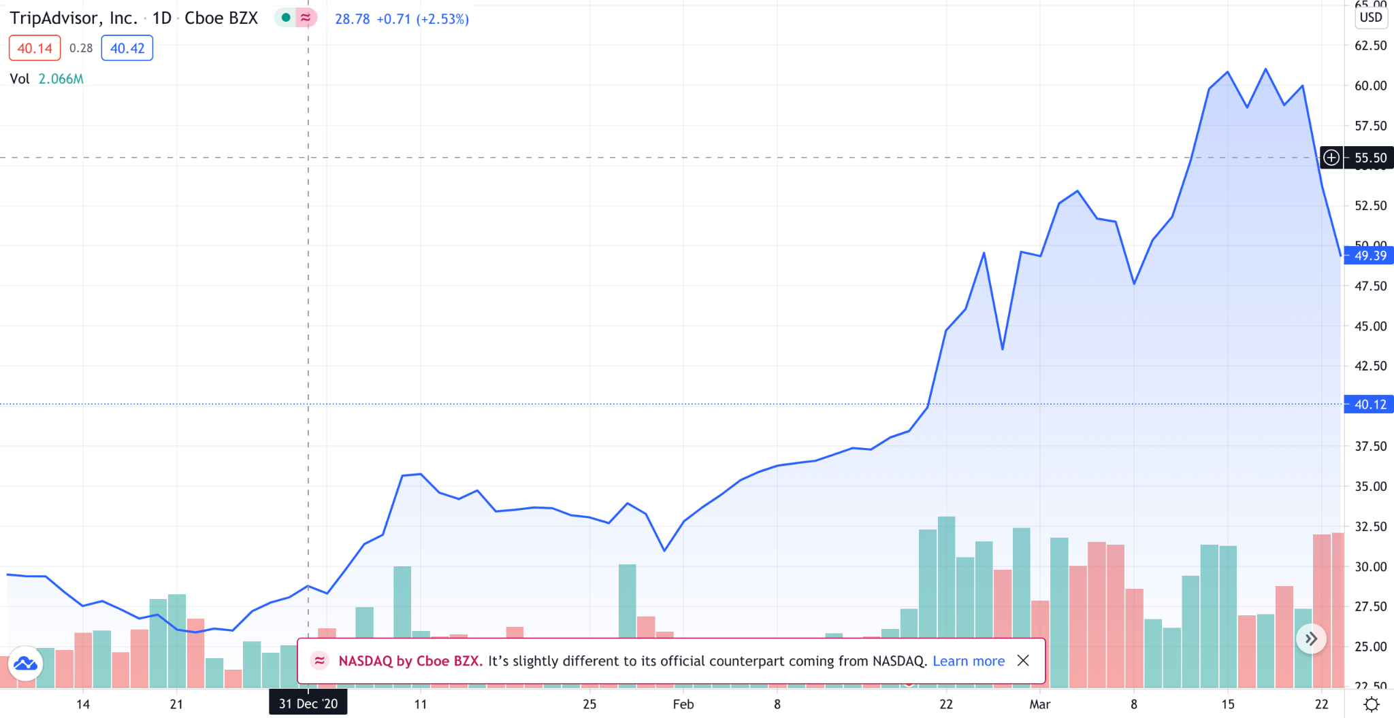

**Interactive chart that highlights the specific dates, times as mentioned in the script below**

This trade recommendation was sent out on December 10th.

The thought process here was that travel was expected to have a strong comeback.

The first step for many travelers with Trip Advisor, which helps them plan out their vacations.

Sure enough, the stock methodically started to move up.

And that’s when our profit taking strategy went to work.

We ended up trading this to perfection.

If you look at the chart when I recommended closing each leg of the trade, you’ll notice how we didn’t cut it all off at once and lose out on profits.

25% winner on the first half here in 2 months.

44% winner on half of the remaining shares in 75 days.

And a 100% winner on the remaining position right here in 3 months.

And LOOK!

After the last piece was sold, you’ll even notice that the stock retraced and fell.

The precision of this strategy is second to none. It’s what sets it apart from anything else.

And it’s how our readers do so well!

Like Tad. He decided to amplify my strategy with an options play instead of the stock and made 544% on the trade in under 3 months.

Now, think about that. Catching a winner like that can be life changing.

But even if you just stick to my stock strategy, you could see significant profits.

And remember, the plan stays consistent.

You aren’t caught in a battle of when to buy or when to sell.

It’s all spelled out for you!

I’m sure you’ve been in a similar position.

Most buy and hold investors would’ve watched profits disappear, but not my members!

We were in, watched it move up, and when our profit targets hit, we rang the register.

From there, onto the next Wednesday trade.

Since inception in October 2019 of the past 23 trades, if every trade recommendation was taken, 19 would have been winners.

Even factoring in those 4 losers, if just $1000 was put into each of these trades, you could have been sitting on nearly $3,071 in profit.

Trading with $5,000...well, that profit jumps over $15,357!

It doesn’t matter if you have $1000 or $100,000.

It doesn’t matter if you’ve been in the market for years.

It doesn’t matter if you’re brand new to the market.

And it doesn’t matter if you work a full time job.

I’m confident that this could work for you!

Use me as your resource...

Let me do the leg work…

Let me find these trade opportunities for you..

Really, all you need for the chance at an 83 percent win rate is to open an email, watch a video, and set up your trade based on my recommendation.

That takes about 5-10 minutes, MAX!

If that’s too much work for you to see the shot at making life changing money, then what are you here for??

This strategy fires on all cylinders.

And you’re probably thinking, “Well, that’s great for everyone who got those trades, but what about me?”

Well, starting today, and today only, I’m going to guarantee my track record over the next year.

And while it is true that past performance can not guarantee future success I am so confident I’m putting my money where my mouth is here..

Over the next year, if I don’t BEAT that 83% win rate that I’ve shown you in my model portfolio, call my team and I will give you a second year for FREE to make up for it.

Even if I win 80% of the time, you get a free year.

Even if I win 82.99% of the time, you still get a free year.

Why? Because a guarantee is a guarantee!

Maybe this will ruffle some feathers, but I don’t care.

At the end of the day, I stand by this strategy.

I stand by my commitment to my members.

To any other gurus out there, if you can’t guarantee success of their strategy might as well not have a strategy at all.

Let me reiterate this…

I will beat that 83% win rate over the next year per our model portfolio.

And in fact, I’ll do you one better.

Most services that have this type of success would throw some huge price tag on it so the rich can get richer.

Well, that isn’t me, either!

After my career on the CBOE, I realized that the stock market is really any man’s, or woman’s game.

So when you see the price for an entire year of this research service, be prepared to be shocked and be prepared to act quickly.

1 year subscription, 52 trade recommendations, 83% win rate guarantee…

JUST $49. That’s the Trade of the Day Plus. And a deal this good can’t last forever.

I mean, that’s less than $1 per trade!

Name something you spend $1 per week that can deliver this type of profit potential.

….YOU CAN’T!

But I’m all about integrity, and this is my way of proving that.

I don’t need to price gouge you.

I want you to succeed.

And even at the normal retail price of $249 a year, this is still a no brainer.

See, I want to prove to you that the stock market isn’t just for the rich.

It isn’t just for people with a finance or economics degree.

It’s a free market that anyone can learn to reap the benefits from, just like you.

And for $49 a year, you’re about to understand what I mean by that first hand.

And keep in mind, I’m also going to give you a full year, money-back guarantee.

Let’s say you try the service out for a couple weeks or a month and decide it’s not for you.

What do you do then?

Well, just contact my team and we’ll send you your money back.

Yea, you heard that right. Anytime over the next year, for any reason, if you’re not satisfied, you get a FULL refund.

Why would I do that?

Because I know you won’t want a refund!

With this 83% win rate, why would you leave? If anything, you’ll be begging for more!

“What’s the next pick, Bryan!”

I hear that in my sleep by now.

Which is exactly what I intend to have happen with you.

I’m giving you my research and my #1 trade recommendation for less than $1 per week.

I’m guaranteeing the win rate of those trades to be higher than 83%.

I’m giving you a full year, money back guarantee.

But, let me sweeten the deal even further.

You’ll get access to my 3 hottest reports that I’ve reserved for new Trade of the Day Plus members.

The first is my Crypto Report.

I get it, crypto is a hot topic right now and here is my favorite way to trade it.

A $95 value that you’re getting for free!

The second is my number 1 Small Cap Pick. .

I’m talking about the potential to double in value over the next 6 months and you’re getting all the insight for free.

Third is my #1 post covid pandemic winner.

This is the stock I think will benefit more than anything else.

I can’t even tease this, because I don’t want ANYONE other than you to know about it.

All the details are in this FREE report.

And I want to sweeten this deal even more, because I want you to see how to turbo-charge your growth.

And the way you can do that is with options!.

I’ve taken everything I learned from being on the CBOE and over the past 20 years I’ve boiled it all down to an Options 101 Cheat Sheet.

This is the perfect way to introduce yourself to options trading.

Sticking with the above and beyond principle, I’ve paired that with an 8-volume video course, The Secrets of Wall Street.

This alone is valued at $499, but if you act right now, I’ll throw it in for FREE.

This clearly shows you how vested I am in your future wealth.

You’re getting my crypto report.

You’re getting my number 1 stock coming out of the COVID pandemic.

You’re getting my favorite small cap play of the year.

You’re getting my options 101 cheat sheet, and my Secrets of Wall Street video course.

You’re also getting my #1 trade recommendation coming to you every single week on Wednesday.

You’re getting a full year money back guarantee.

And I’m guaranteeing an 83% win rate!

You’ve seen my track record.

And of course we never recommend you bet the farm on any trades…

But you saw what just $1000 could have made if each trade recommendation was taken.

If you recall, it was nearly 3,071 in profit!

If that was the case, the $49 subscription would have already been paid for 62 TIMES OVER…

And that was only 23 trades!

Imagine what you can do with it over an entire year and 52 trades!

But let’s just make this clear.

Of course this offer can’t be available for long.

We’re talking thousands of dollars worth of research WITH a performance guarantee.

If you don’t want this offer, I have to assume you aren’t interested in learning how to grow your wealth.

But, for the large majority of people that do want to learn, this research service is set up to perfection.

For $49, it’s not just a steal, it’s a no brainer.

It’s simple.

My #1 trade of the week, delivered directly to you with an entire game plan and video walk through.

All it takes is a few minutes per week to be able to review the opportunity and set it up!

And like I’ve said all along, the track record is proof of what it can do...

Then the guarantee of an 83% win rate throughout the next year should alleviate any future concerns that you may have had.

Opportunity doesn’t wait for anyone.

Join me today and I’ll be in touch right away!

I guarantee you’ll never want to trade again without this strategy.

July 2021

