#1

Former Chicago Exchange Pit Trading Legend Bryan Bottarelli Unveils Market Breakthrough:

Zero Day Trader

WARNING: Do NOT Attempt to Day Trade
Or Use Zero Day Options (0DTE)
Without Watching This Important Presentation!

#2

Former Chicago Pit Trading Legend and Multimillionaire Bryan Bottarelli:

“Watch Me ‘Hack’ Zero Day Options
And Target 383% Gains… OVERNIGHT!”

LIVE TRADE Tuesday DATE at 2 p.m. ET!

#3

Former Chicago Pit Trading Legend and Multimillionaire Bryan Bottarelli:

Zero Day Trader

Strange 0DTE Loophole Lets Us Target 253%... 327%... and 383% Gains… OVERNIGHT!

LIVE TRADE Tuesday DATE at 2 p.m. ET!

Hello everyone…

Pro Trader Bryan Bottarelli here.

Listen… if you have ever dreamt about making thousands of dollars in just one day…

Or doubling… even tripling your money trading the market…

This could be the most important message you’ll ever see.

Right now… TODAY… we have an unprecedented opportunity.

A brand-new type of investment is sweeping the market.

They are called 0DTE… short for Zero Day to Expiration.

You may have heard about this hot new asset in the news… or on the internet.

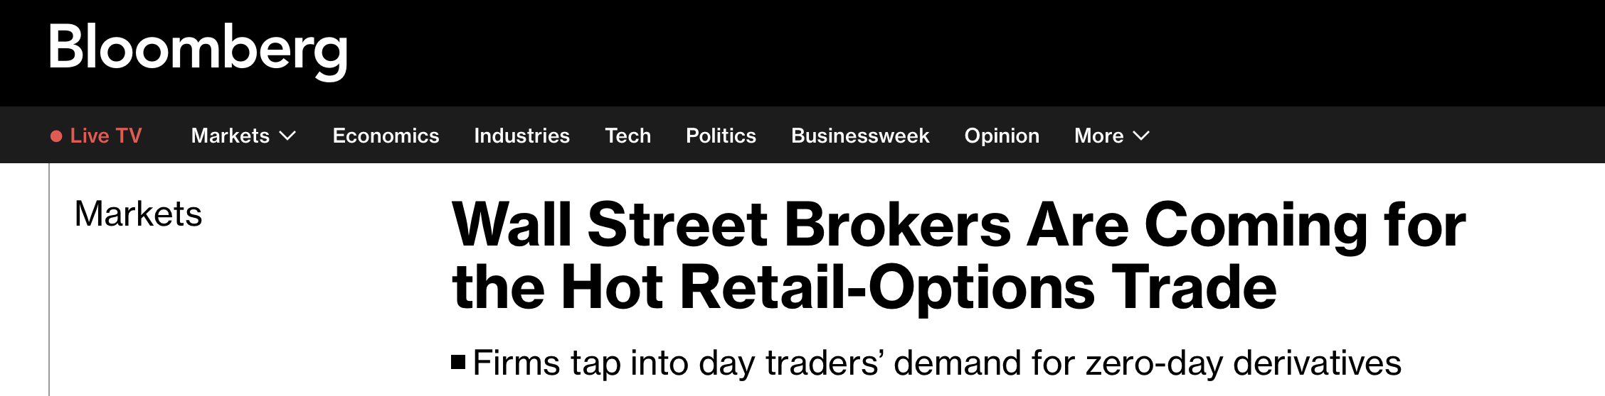
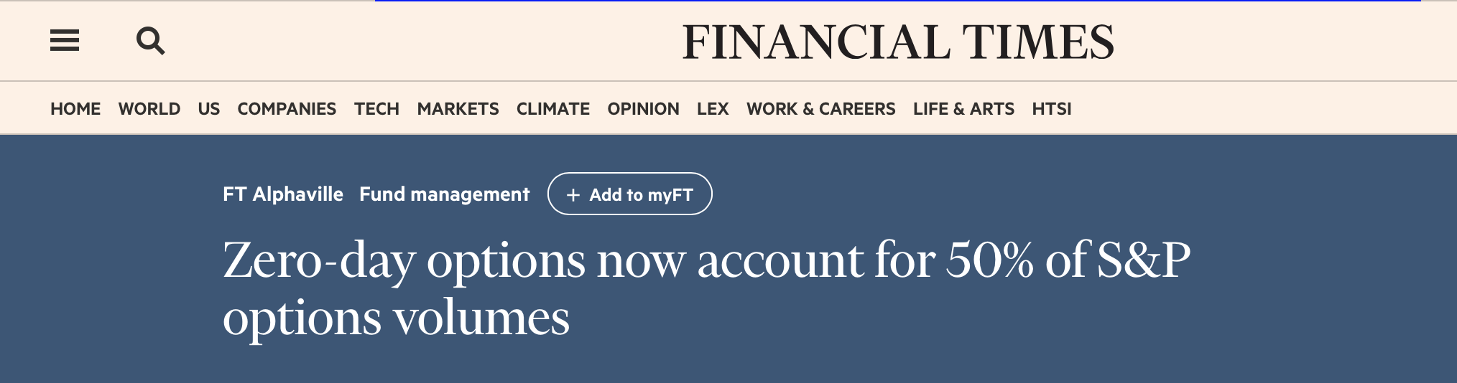

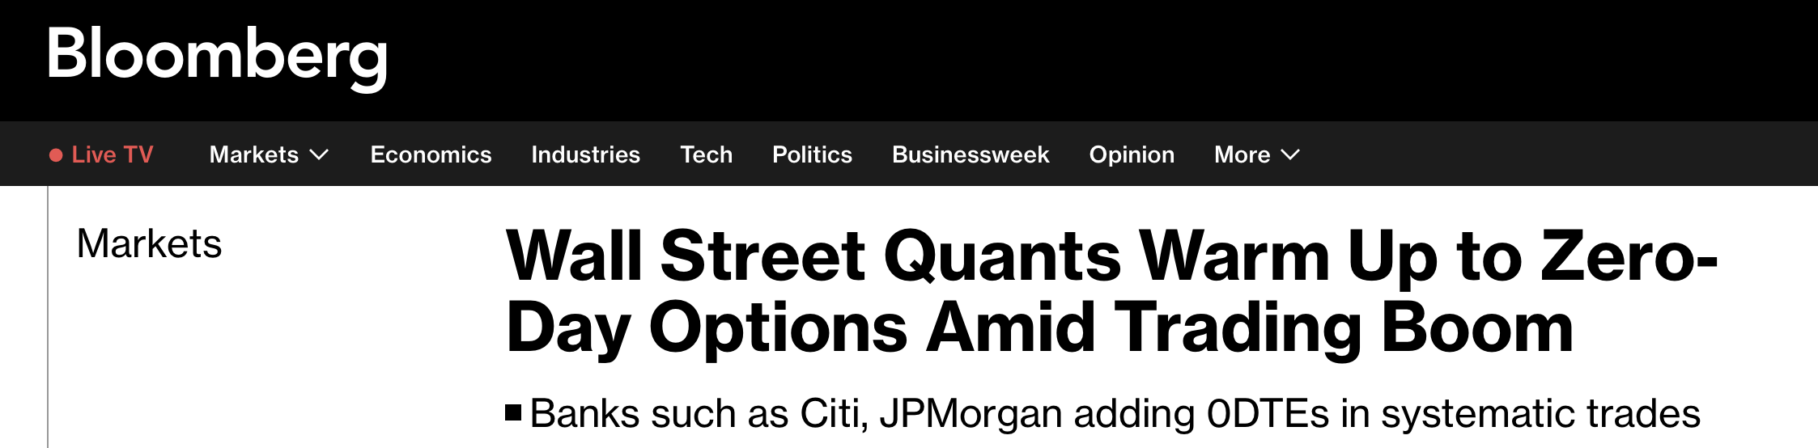
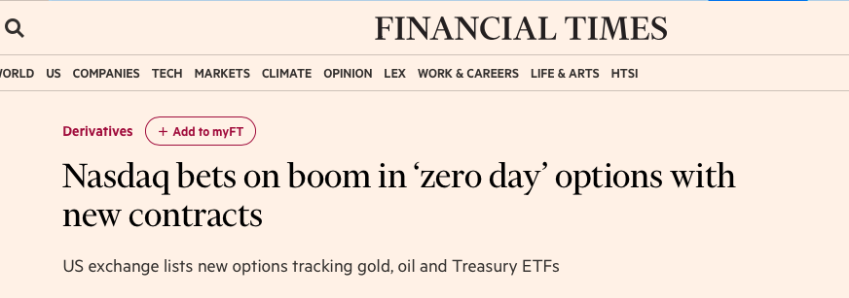
Barron’s even called them “Wall Street’s Hottest Lottery Ticket”…

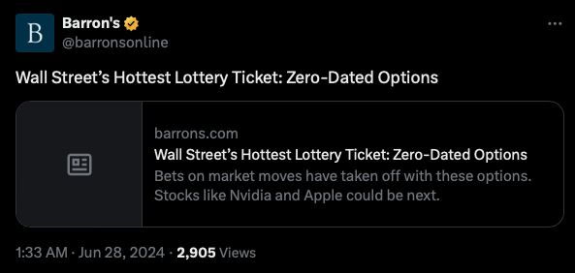

But please… do NOT attempt to trade them without watching this video first.

Wall Street has designed these options to make THEMSELVES rich at YOUR expense.

That’s why I’m going to show you how to beat them at their own game with a brand-new technique.

You’ll see how you can use 100% certain, monthly events to target 253%... 327%...

Even 383%...

All overnight…

And all with less than 15 minutes of “work”.

That's the power of Zero Day Options and the secret catalyst you’re about to discover.

Maximum money… in minimum time…

It's a trader's dream. And now, it's all possible...

This brand-new way of trading is easily the biggest change to the market since options were first introduced to the New York Stock Exchange in the 70’s.

Those who recognize the opportunity could double their money… or MORE… overnight.

And those who ignore this new development…

Well… unfortunately…

They’ll be left out in the cold.

That’s why today, I’ll show you how use this new type of option to target 383% overnight...

But a word of warning…

This is NOT day trading.

It’s NOT guessing whether a stock is about to go up… or crash down…

In fact… this is probably unlike anything you’ve likely heard of… because it breaks all the rules.

It’s ONE ticker symbol…

Traded around 100% certain events that only occur once a month...

In fact… the catalysts I’m going to show you are guaranteed by the U.S. government.

You don’t have to guess whether ticker will move up or down after the catalyst.

Because with a big move in either direction… this trade wins BIG!

I’m going to show you all my research, including how this special catalyst wins at an 83% rate.

And the AVERAGE gain was 115% overnight… winners and losers included!

Seems unbelievable right?

You simply get in one day… go to bed…

And get out the next morning.

With the potential for massive profits.

In the next few minutes…

I’ll give you all the data… so you can see everything for yourself.

Including the results of my exhaustive back test where we used historical data to evaluate my strategy.

Now of course… past data does not guarantee future results.

But looking at the zero day options applied to the specific monthly catalyst I’m going to show you…

A $10,000 portfolio could have generated over $137,000 in profits… in just ONE YEAR!

And the gains on this one simple trade… using these 100% certain events…

Can be incredible.

For example…

Overnight Payouts of $25,300… $32,700…
Even $38,300!

One of these catalysts was scheduled for May 2nd of 2023…

Remember… this date wasn’t a guess.

It was mandated by the US government.

All you need is one ticker (I’ll reveal it in just a second)…

You get in the day before…

And the next morning…

This special Zero Day Loophole Trade went as high as 383%... Overnight!

Best of all…

The 383% gain would have happened even if the ticker went down big instead.

So again… if the ticker moves UP, you can make huge overnight gains.

But even if the ticker moves DOWN, you can STILL make huge overnight gains.

It does not matter.

This sure takes away a lot of the stress of investing!

July 6 was another one.

But in this case…

The special ticker went DOWN.

Yet… the special Zero Day Loophole trade I’m going to show you still shot up 327%.

On August 29…

Once again… we knew the catalyst was coming.

It was mandated by the U.S. government.

And this time… the ticker went UP overnight.

Once again the Zero Day Loophole made overnight gains as high as 253%.

In other words… it doesn’t matter whether the ticker goes up or down.

With this Zero Day secret… you can win either way.

And the process is straightforward:

Step One: Identify the next 100%-certain monthly catalyst

Step Two: Make one trade on one ticker the day before the catalyst is scheduled to hit

Step Three: Close the trade the next day – post catalyst – for the chance at dramatic overnight profit!

Imagine…

Overnight Payouts of $25,300… $32,700…

Even $38,300!

How is this possible?

It’s all thanks to a special type of options available to everyday traders like us…

Let’s dig into Zero-Day options, also known as ODTE options… and see why they can be so lucrative…

And better yet…

See how they can put the odds in your favor 83% of the time…

Zero Day Options (0DTE)…
How a Recent College Grad Made $14,000 in ONE Day
(His Goal: Make Six Figures EVERY Month!)

If you aren’t familiar with these new options…

Their popularity has skyrocketed in the past year.

In fact… a Bank of America report states that 40% of the trading volume on the S&P 500 comes from Zero Day Options.

The Wall Street Journal calls it “one of the biggest shifts in the markets in the past decade.”

GRAPHIC DISPLAY LIKE NESPAPER CUTOUT:
“This is one of THE biggest shifts in the markets in the past decade” – Wall Street Journal

And Tip ranks says the daily value of zero day options trading is a shocking one TRILLION dollars.

In other words, there’s a ton of money out there for the taking… IF you know how to successfully trade 0 Day Options.

The Wall Street Journal even reported the story of a young man named Drayson… who just graduated college and started trading.

Using these new options…

He normally bets a few thousand dollars per trade…

And has made as much as $14,000 in just one day!

He says “it’s like winning the lottery.”

Trading 0DTE options allowed him to buy his dream car… the AMG GTR… a Rolex… travel around the world…

And his goal is to eventually make six figures… per month!

The story is just incredible.

But most people will hear his story… try to trade these new options…

And get fleeced. Because blindly trading these type of options is especially risky

The same Wall Street Journal story notes that “oftentimes the odds are stacked against you…”

That’s because normally retail traders try to bet on whether the market will go up or down during the day.

According to the National Bureau of Economic Research…

Approximately 80% of day traders lose money, with only 1% being consistently profitable.

That’s why we don’t try to day trade…

Instead…

We trade OVERNIGHT. On a single, monthly catalyst.

We make one trade… on one ticker symbol one day…

Go to bed…

And get out the next day.

It flips the script… and gives you the edge you need.

In my research… it completely puts the odds back into your favor…

With 83% win rate…

And an extraordinary, almost unbelievable 115% AVERAGE gains overnight.

How?

Well… The biggest risk in these zero day options is their extra volatility.

But by making a specific trade based around a monthly catalyst, I have found a way to turn this volatility in our favor.

These options can move BIG… up or down…

EXTREMELY fast.

If you are on the wrong side of the move… you lose BIG.

But not Wall Street.

The market makers know how to make money whether the options go up or down.

They don’t care which way it goes… because they’ve figured out how to win based on the volatility…

Not based on the direction of the move.

It’s the biggest secret in Wall Street.

I know…

Because I was on the inside…

I know the Secret to Trading Options…
Because I was on the INSIDE

As I mentioned before… my name is Bryan Bottarelli.

If you aren’t familiar with me or my work…

More than two decades ago…

I got my start in the rough and tumble world of the live trading pit in the Chicago Board Options Exchange – or the CBOE.

We were the guys you see in the pictures of the trading floor.

While retail traders may try to trade options IN the market…

We WERE the options market.

It was fast and furious.

The action was fun… and the money was incredible.

But on the inside of the CBOE… the pit traders don’t trade options like the typical retail investor sitting on the computer.

They use the biggest options trading secret of them all:

My mentors called it: “Delta Neutral.”

It may sound strange… but the meaning is simple:

Win both ways… no matter which direction the stock moves.

I know… it seems impossible.

But if you know the secret…

When a stock moves big up or down… you can win BIG either way.

It changed how I viewed the market… and trading…

Forever.

Years later… I left the pit to help regular people become Pro Traders.

I applied this “Win Both Ways” strategy to a particular catalyst that impacts stocks.

Earnings releases.

Why earnings?

Well… as many traders know…

Earnings leads to HUGE frenzies in a stock.

But MOST investors lose big if they try to trade around earnings.

That’s because it’s next to impossible to figure out whether a company would release positive or negative earnings.

Even a good earnings report didn’t necessarily translate into a surge in the stock.

But with the “Win Both Ways” strategy… you don’t have to guess.

I simply get into one day before the earnings reports drops… and then get out the very next day…

All with the goal of doubling my money in 24 hours.

So for example, when Clorox released earnings last year… I recommended an overnight trade on it.

The earnings release was positive…

The stock jumped 11% in just a day…

And yet we made a quick 80% overnight.

On the other hand, we also recommended a play on Advanced Auto Parts when earnings came out in May of 2023.

And those earnings were terrible. They missed Wall Street’s expectations and shares plummeted 35% in a day…

But because these trades win in both directions, it was still one of our biggest winners… 293% overnight!

So this has worked incredibly well for us on earnings.

However…

As much success as we’ve had trading earnings… I’ve found something even better going forward.

I developed a whole new kind of method to profit overnight… around a whole new kind of catalyst.

One that takes the special trade I developed on earnings reports to a whole new level.

Because it uses these brand-new zero-day options…

Along with my “delta neutral” strategy to “Win Both Ways”…

It’s designed to be the most consistent, effective and powerful trade I’ve found in my career.

It’s based around the ultimate catalyst:

All thanks to 100% certain events… once a month catalysts mandated by the U.S. Government

How US Government Reports Can Be Your Way to Target Overnight Payouts

As you probably know…

Every time the government releases the “jobs numbers”…

The entire market moves BIG.

I’m sure you’ve noticed it watching the news.

Every time there’s a jobs report… the market reacts.

It’s exactly what I saw with my earnings trades…

But instead of an event moving just one particular company…

These government reports move the entire market.

And the volatility caused by the jobs reports has gotten stronger and stronger over the last few years.

I’ve been able to devise a system that turns these jobs reports…
Into chances at huge overnight gains.

And you can use one stock ticker… just one… to potentially profit repeatedly.

With this method… when the market moves big… whether it’s up or down…

You win BIG.

And with my technique… the overnight gains can be huge…

As high as 383%.

All because on the one day a month the government releases these reports….

The price moves are MUCH larger than normal.

Because we have a way to turn the extra volatility into an unfair advantage.

Volatility Is Here To Stay:
Here’s How You Use it To Make Money

Now look…

In today’s market… about the only thing that is certain… is volatility.

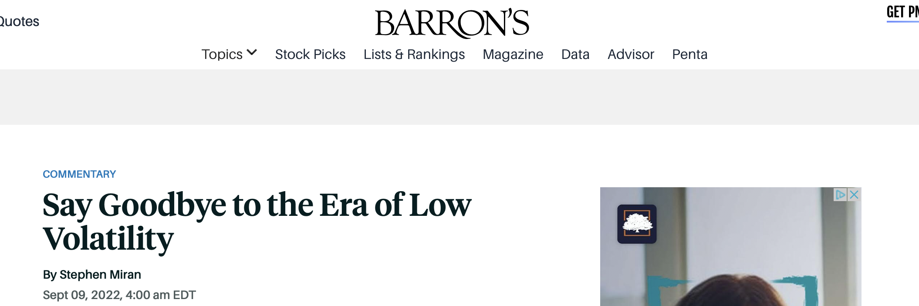

As Barron’s says… volatility is here to stay.

But…

On these government release days…

The volatility is WAY higher than normal.

Now… I never realized how big this phenomenon was until I dug into the data.

I went back over the past 10 years of market data…

Spanning across and 2,516 trading days.

And here’s what I found…

On a typical day… the market moves about .05%.

But on the 121 days the government releases jobs reports…

The market moves 222% more.

So the moves are more than triple a normal day.

However… lately the moves have been even bigger.

In the past 3 years… on the day of a jobs report release… the market moves 425% more than usual.

That means these reports make the market move 5 times bigger than the average day.

And in the past two years…

Brace yourself…

The moves have been 824% bigger.

That’s 9 times bigger swings…

This is HUGE guys.

It means we know -- with a high level of certainty -- exactly which days will feature the biggest moves in the market.

So if we have a trade that targets profits from the biggest moves… then we can make a great deal of money.

I’ll explain how that works in a moment.

But first, you may be wondering why this is happening…

Well, remember… I worked in the live trading pit.

This was back when people met physically at the exchanges and made deals.

It was wild and crazy with buyers and sellers fighting for position.

But still there was a limit to how much trading could get done.

However now… computerized trading has taken over.

And guess what…

That just makes trading frenzies even more dramatic.

Nowadays… algorithms are making the trading decisions.

Fewer and fewer actual people are deciding when to enter and exit a trade…

Instead… computers simply multiply the trades faster and faster on any big trading day.

This is not going away.

If anything… price swings will become even more dramatic as more firms use Artificial Intelligence to make trading decisions.

On CNBC, Guy De Blonay of Jupiter Asset Management pointed out that 80 to 90% of all daily trading volume is done by machines…

“As the market moves up or down, programs may look at the momentum and simply sell or buy. That can exponentially increase the volatility without any basis in fundamentals.”

“Eighty percent of daily volume in the U.S. is done by machines, so what you get is a lack of focus on earnings, a lack of focus on outlooks, and you just get short-term movements based on very specific data that is released every day, and that creates noise,” Guy De Blonay, fund manager at Jupiter Asset Management, told CNBC’s Squawk Box Europe. In fact, on some days, this program trading can account for as much as 90 percent of the volume. As the market moves up or down, programs may look at the momentum and simply sell or buy. That can exponentially increase the volatility without any basis in fundamentals.

Bottom line:

Increased volatility is the new normal of trading.

And on days when the market is in a frenzy… the moves are magnified by all the automatic computer trading.

That’s why when the government drops these jobs reports… the market moves over 800% bigger than an average trading day.

And this is our biggest opportunity.

Because I’m about to show you a special kind of trade that profits purely from volatility…

Which means you could use this secret to bank far higher profits every time one of these government mandated catalysts are scheduled.

That’s why I consider this the best way to aim to turn market volatility into HUGE payouts.

And with the technique I’ll show you…

It doesn’t matter if the market soars higher… or crashes lower…

Because all you need is big volatility… using just one ticker… and these trades are winners.

But I’m sure you are wondering:

How Often Can These Trades Make Big Overnight Payouts?

Well I’ve been researching how this phenomenon would have played out over the past year.

And compiling the data over how the market moved in reaction to these jobs reports.

Looking back, I found that these trades would have had an 83% win rate.

And the average gain for these trades was 115%...

That’s 115%... OVERNIGHT.

So I want you to imagine this right now.

Using this trade, you can lay out a calendar with every jobs report throughout the year.

There are 12 of them.

Then, you simply make the same trade each time.

And our research shows the average gain overnight came out at 115% each time.

That’s a double in 24 hours.

And you have 12 opportunities every year to do this.

It’s incredible.

All we need to generate a big winner is a move of 1%... in either direction.

And the AVERAGE daily move on days these reports came out across 10 years of market data… is 1.16%.

Well over the 1% threshold.

And over the last two years, it’s even higher.

The average move is 1.39%.

So the odds are automatically in your favor.

These reports are the best chance to move the market big… and we know EXACTLY when they come out…

And EXACTLY what kind of trade I believe has the best chance of being a winner.

By now… I’m sure you can see why I now think of these government reports as a chance to get regular payouts.

The Zero Day Trader Loophole: How To Turn Government Reports Into HUGE Overnight Payouts

For example… using my system…

We would have known that the new jobs report was coming out on November 1, 2023.

This date was set by the US Government.

It’s 100% certain.

So… this strategy would have made a special trade on October 31st, the day before the schedule announcement.

You also don’t have to guess what trade to make.

We use the same ticker every time.

I’ll tell you the symbol right now…

It’s SPY…

That’s the ETF on the S&P 500.

Go ahead and write it down.

Three letters… S P Y…

Traders often just call it the “SPY”.

But the key is the way we trade the SPY overnight… and put the odds squarely in our favor.

We are essentially taking out as many variables as we possibly can.

There’s no question on the timing…

And no question on the trade you make.

These are 100% certain.

We just use my three step process:

Step One: Identify the next market-moving government report release date

Step Two: Make one simple Zero Day trade on the SPY the day before…

Step Three: Close the trade after the report is released for the chance at dramatic overnight profit!

So… what happened for this trade on November 1st?

The report dropped… and showed little change at the number of job openings… holding at 9.6 million.

The Fed hinted that it might not need to pump the breaks on the economy any further.

And that sent the market up higher.

The Dow added 221 points.

While the S&P rose 1.1%.

But look… with my special trade… you didn’t have to fight the crowd to get in that morning.

You were in the day before.

All you would have to do is make sure you are in by 4 pm (before the closing bell) on the day before the report.

It takes maybe 5 minutes.

Then go about your business for the rest of the evening…

Go to bed…

And the next morning…

You’re at the front of the line.

So when everyone is trying to get into the trade after the report is released…

You’re cashing out.

On this trade… you could have multiplied the market’s 1% move by 52X…

And made as much as 58% gains… OVERNIGHT!

But look… that’s one of the smaller winners I uncovered in my research over the past year.

There’s actually a strange secret behind the biggest winners I uncovered… you’ll be shocked when you hear it.

I’ll tell you in just a second.

But before that…

I want to tell you about the trade from August 29, 2023.

Job openings fell more than expected.

In this case… a BAD report was actually GOOD news… because Wall Street assumed a cooling economy meant the Fed would pause interest rate hikes.

And the S&P rose by 1.5%.

But with my system…

You wouldn’t have to try to rush in while the market was soaring higher.

You get in the day BEFORE…

And then you are golden.

Because when the market did rise 1.5%...

You could have beaten the market by 168X…

And cashed out with gains as high as 253%... OVERNIGHT!

These amazing trades could have even produced winners year after year.

Let’s go back to November 30, 2022.

The report showed the number of job openings fell. and the number of layoffs and discharges increased.

This time… it was bad news.

But Jerome Powell signaled that the Fed would slow their rake hikes moving forward.

That sent the market soaring.

The Dow was up over 700 points.

The S&P was up 3%.

But this amazing trade would have multiplied that gain by over 77X…

And could have made as much as 223%...

OVERNIGHT.

Now… just consider the beauty of this kind of trade.

You don’t have to predict what the report will say… whether jobs will be added or lost.

You don’t even have to predict whether the market will react positively or negatively to the news.

Instead… you are making volatility give you a huge payday.

If the volatility is big… you win.

Simple as that.

Whether it surges higher… or crashes lower…

You win.

In fact… in 2023…

The market moved DOWN in response to these reports far more often than it moved up.

And guess what…

The gains were even BIGGER.

Let’s take a look.

How To Turn Falling Markets Into Even BIGGER Payouts
(As High As 383% Overnight!)

Ok… so using my system…

We would know that the new jobs report was scheduled for release on July 6th.

Again… those dates are scheduled by the US Government.

There’s no question.

No debate.

They are 100% certain.

So… we’d make a special trade the day before… on July 5th.

In this case…

The market reacted badly.

Fell off a cliff actually.

Now… most people freak out anytime there’s a drop.

But with this trade…

You would have gotten in the day before…

Slept soundly…

And even as everyone else was freaking out the next day as the Dow lost 366 points… and the S&P dropped .8%...

You’d be laughing all the way to the bank.

In fact… you could have locked in gains as high as 327%...

OVERNIGHT.

Imagine watching a $5,000 trade grow into over $16,000…

Overnight!

Not only that… but it was on a day when everyone was losing their minds.

This method gives you a superpower.

You get to take all the biggest ups AND downs in the market… and turn all of them into big wins.

You don’t have to guess the timing.

You don’t have to guess what is the next “hot stock”…

You use the same ticker symbol every time.

And… you get to smile and celebrate when the market soars and when it crashes.

Because with this unique trade… when the volatility is big… you win.

This eliminates almost all the uncertainty and variables when it comes to trading.

It’s all thanks to our three step process:

Step One: Identify the next market-moving government report release date

Step Two: Make one simple Zero Day trade on the SPY the day before…

Step Three: Close the trade after the government report is released for the chance at dramatic overnight profit!

As I said earlier, this trade would have won last year 83% of the time these specific Zero Day trades came out.

The average gain was 115%... more than a double each time.

It takes less than 24 hours.

And what’s great is there are 12 jobs reports that come out each year.

That’s 12 times you can target huge gains…

Even doubling your money – or more…

OVERNIGHT!

In fact…

Let’s walk through an entire year of trading around these reports and see what happens.

How $10,000 Could Have Generated $137,440 in Profits in 2023!

So let me walk you through every trade from 2023.

You’ll see the good… the bad… and the ugly.

That’s right.

I’m holding nothing back.

And this is key… because no system is perfect.

As I said earlier… our numbers show the trade working 83% of the time.

This means you have to be smart about how you trade… and never put too much on any one trade.

Some of the trades will lose.

However, when the odds are on your side… over time… the results can really add up.

I’m going to give you all the data so you can see for yourself.

So let’s start off with the first jobs report of 2023.

And let’s assume you started with $10,000 and made every trade through the whole year… including every win and loss.

Ok… the first report dropped on January 4th.

So again… knowing the report would be released…

We would make our special play on the S&P (the SPY) the day before…

On January 3rd.

Remember… we have no idea how the market will react… only that it is very likely to react big in one way or the other.

In this case… the report showed the number of job openings was higher than expected.

That made Wall Street optimistic that the economy could avoid a recession….

As a result… the S&P rose .8%

And our trade would have gone up as much as 33%.

You would have added as much as $3,350 to your account that day.

That’s over $3,300 in profit… OVERNIGHT…

All thanks to this US government report.

Now… keep in mind…

In 2023… the S&P ended up going up 24%.

So right here… you could have gotten more than a year’s worth of gains… in just one day.

But… the fun didn’t stop there.

The next report came out on February 1st.

It was another positive report… showing a strong jobs environment.

As a result… Wall Street reacted positively… and the S&P rose 1%.

And for the special Zero Day Options trade we recommend, it was the same thing…

Almost identical to January actually.

Overnight gains were once again 33%.

You would have added another $3,330 dollars to your account.

Then on March, another report came out…

This time was rare.

The market actually stayed flat which was unusual.

And this is the scenario where the trade wouldn’t have panned out.

A 31% loss.

Now look…

Losses are no fun.

I hate them too.

But… This is where most people would say “ok… this doesn’t work. I quit.”

And that would be a huge mistake.

Because if you stick with a system where the probability is on your side…

Over time… you can be successful.

And so far… even with a trade that didn’t work out… you still have $3,680 in profit on your original $10,000.

The first two wins so far have outweighed the one loss.

And more wins were about to come.

Look what would have happened if you didn’t quit… and kept going.

For April… a negative report came out with weaker numbers… once again fueling recession fears.

But despite the market falling … the gains would have been 83%...

That’s another $8,320 added to the banked profits.

And then in May… it goes bananas.

Because that’s when you would have hit a massive 383% winner.

So now you’re banking $38,300… in overnight profit.

In total, you started with $10,000… but after just five trades you have $50,023 in profit… including the loss.

See why you can’t just throw in the towel after a losing trade?

In June… the report actually dropped on May 31…

You would have made 61% for as much as $6,180 in profits.

Then the July report was another big one…

327% gains…

And $32,700 in overnight profit!

I mean… those numbers are just insane.

The next month is another $1,300 added…

And then September’s report is another huge 253% winner.

So that’s $25,300 in overnight profit going to the bank.

In October… you’re adding another $16,570…

November is $5,830…

And then December… unfortunately… a small loss of 6%.

But… you probably don’t mind that one…

Because by the end of the year… with winners and losers factored in…

The total profits are as high as $137,440!

Ok… so let’s compare.

$10,000 parked in the S&P 500 would have made you a whopping $2,400 last year.

Or… you could have traded with that $10,000 with this system… on just the 12 jobs reports that come out over the course of the year.

And bank profits as high as $137,440!

There’s really no comparison.

Now you always need to remember that nothing in trading is guaranteed and that every trade carries risk. Never invest more than you can afford to lose.

But last year there would have been 10 winners… with 2 losers…

I’ll take those odds any day of the week.

This is why I love this trade so much.

With the market moving 824% higher now when a jobs report comes out… it’s like shooting fish in a barrel.

Volatility is just so much higher on these specific days.

This 0 Day Options strategy can be life-changing for people… because you don’t have to stress out about what the market will do this next year.

It works whether the market crashes… or surges the next day.

As you saw for every trade last year…

As long as the market reacts strongly up OR down… you win.

Even with the losses… the success rate last year would have been about 83%.

And you could have taken just $10,000 and generated over $137,000 in trading profits.

This is why I love the chance at collecting overnight profits thanks to these government reports all year long.

But… there’s one thing you should know… something I HAVEN’T told you yet…

The Government Releases MORE Reports Through The Year…
For MORE Chances at Overnight Profits!

So… up until now… we’ve been discussing the jobs reports.

It’s my favorite way to play this trade.

But…

What I haven’t told you until now… is the government releases 48 different kinds of pre-scheduled reports throughout the year…

Plus… fed minutes are released throughout the year.

And ALL of them have a chance to move the markets big.

That means you have more than 48 chances to target huge gains this year alone.

For instance…

November 14th 2023..

The government released inflation numbers.

Now… as I’m sure you know…

Inflation is a hot button topic for most people.

Everyone is laser-focused on it when it comes out.

So when the government released the inflation numbers – called the CPI…

The market reacted.

The Dow rallied over 480 points…

And the S&P rose 1.9%.

That was enough to create gains as high as 215% overnight.

But that’s just one of the other government reports that can move the market.

On September 15th, the government released their import and export report.

Now… this one isn’t as widely known to most people watching the market.

But once again the day these reports are released… the market reacts.

On that day… the S&P lost 1.2%...

And as we’ve seen… falling markets can be even more profitable.

In this case… this strategy would have seen overnight gains as high as 247%!

Bottom line…

There’s a lot of big numbers that come out almost every single week.

From inflation reports…

To import reports…

Other jobs numbers…

And even Fed announcements…

That means there’s plenty of opportunities to trade around these major events… and capture overnight gains from these government releases.

Looking ahead…

There’s a lot of exciting reports I’m looking forward to right now.

Of course… I’m going to be primarily focused on the next jobs report coming out soon.

Remember the data I just showed you…

The Zero Day trades on jobs reports last year could have hit an 83% win rate for these types of trades…

With average overnight gains of 115%.

And…

You saw for yourself how just $10,000 could have generated profits over $137,000… if you just traded all 12 over the course of a year.

So I’m pumped for the next jobs report to come out soon.

But again… there’s plenty of other reports I’m watching.

The upcoming inflation numbers…

Both the CPI and the PPI…

Are scheduled to go out within the next few weeks.

I’ll be watching those like a hawk.

Plus the next Fed meeting is always a big market mover.

For example,

December 13th… the Fed released their minutes showing they rate cuts could come in 2024.

The markets shot up like a rocket.

The S&P rose 1.4%...

And the same Zero Day trade would have made as much as 165% overnight on the Fed announcement.

The opportunities are just incredible.

That’s why I’m going LIVE on Tuesday to reveal my gameplan for the next report… and how I’m going to setup a trade that can give us a chance at overnight gains.

And I want you to be there.

{I’d like to have some kind of countdown timer come up with the next Tuesday at 2 pm as the countdown}

GET ZERO DAY LIVE TRADES!

That’s right…

Today… I’m inviting you to join me in my brand-new livestream.

Every single week… I’ll discuss opportunities like these Zero Day trades I’ve been telling you about today.

It’s 100% live…. So you can watch me set up the trade live on camera.

I’ll take you through the entire three step process...

Step One: I’ll identify the next market-moving government release

Step Two: I’ll tell you the exact Zero Day trade we’ll make on the SPY for the week

Step Three: Give you an action plan to close out the trade the next day for the chance of dramatic overnight profit!

I’ll walk you through everything live… on camera… every single week.

You can look over my shoulder… as I show you the trade setup.

It’s the closest thing you can possibly get to having a Pro Trader sit next to you every week… and give you the BEST opportunity to make money.

We’ll show you:

- The exact report we are looking at to trade that week
- The exact option contract we’re entering
- And the profit plan we have for exiting the trade for the maximum payout… and maximum overnight gains

And since it’s 100% live… I can share my screen with you.

It’s like looking over my shoulder and getting a secret glimpse into how I look at the market… and find the best opportunities.

And… it won’t take much time.

It will be about 30 minutes (or less)… just one day a week.

That’s all you need for a chance at the huge overnight profits we’ve talked about…

Don’t forget…

You’ve already seen the monthly Zero Day trades that could have made as much as 253%...

327%...

Even 383%...

Overnight!

And other reports could have made gains as high as 165%... and 247%...

Again… overnight!

With the Zero Day Loophole… we’ve tried to eliminate all the guesswork.

You don’t have to guess the next big stock to surge.

Or WHEN to get in these trades.

The days are set in stone by the US Government.

You just need one ticker every time… the SPY.

You know when to get in – the day before the report comes out.

And you know when to get out… the very next day when the report drops.

Finally…

You don’t even have to guess what the market reaction will be.

Whether the market surges… or crashes…

As long as the move is big… you’ll win.

I’ll be scouring the market for the best reports to make trades on.

I’ll be watching the fed announcements…

The inflation reports…

The GDP numbers…

And, of course… the upcoming jobs report.

Whenever I think we have the best report coming up for a special Zero Day Trade…

I’ll give you the full details in our LIVE weekly briefing.

But that’s not all you get when you subscribe today…

Limited Time Bonus For New Streaming Members:
Bryan’s Pro Trader Library

As one of the first members to this brand-new livestream…

I’ve also put together a special report for you to get a running start.

I call it:

The Zero Day Loophole: The Secret of HUGE Overnight Profits from Government Reports (Value: $97… Yours FREE!)

I go into detail on how these reports move the markets… and how to turn those moves into dramatic overnight gains.

You’ll see the exact method we use to make trades on the SPY that can profit whether the market goes up or down.

I promise you… you won’t find this strategy anywhere else.

I’d guess 99.9% of traders don’t even know how to trade options like this.

And I haven’t found anyone else who has figured out how to use this strategy around the days when the government drops their economic reports.

So… you’ll be the first ever to discover this strategy for yourself.

The second thing I’ll give you is a special calendar:

Overnight Profit 2024 Calendar: The Government Reports That Could Be Your Chance for Overnight Profits (Value: $27… Yours FREE!)

In this calendar… I’ve put together the full calendar of all the major market moving dates when government reports drop.

Every one of them could be your chance to make big overnight profits.

This is the exact same calendar I’ll be using to plan out our trades every single week.

Now… I’ll be picking what I think are the very best trades.

But… with this calendar… you could do trades every single time a report comes out, if you choose.

Or… you could pick and choose the other extra ones you’d like to trade around.

With the first report… you’ll know exactly how to make these trades.

And with this calendar… you’ll know exactly WHEN.

Bottom line…

You’ll have PLENTY of opportunities to make huge overnight profits in this next year.

But… I’m still not done.

I also have a special guide to help you trade options… even if you are a complete beginner.

I call it:

The Pro Traders Options Guide (Value: $97… Yours FREE!)

This guide makes trading options as easy as buying a stock.

You’ll learn the right way to trade options… and how to avoid all the newbie mistakes.

We’ll show you how to set up an options account if you never have before…

The basic terms used in options trading…

And everything else you need to know about trading options.

Again… even if options are intimidating to you right now. I promise that after reading this report… you’ll know more than 99.9% of the traders out there.

And listen… during my livestream sessions each week, I’ll give you exact instructions on which options to trade and how.

Once you buy options… you’ll never look at the market the same way again.

These bonuses are all my gifts to you for simply taking me up on a risk-free trial in my interactive trading research service…

Introducing: Catalyst Cash-Outs LIVE.

It’s called, Catalyst Cash-Outs LIVE.

In it, we give out LIVE weekly trade recommendations on the very best opportunities we see in the market.

It all starts with our weekly livestream briefing that I host with my co-founder Karim Rahemtulla.

Like me, he is a multi-millionaire trader.

But where I focus on technical trading and targeting faster profits…

Karim focuses more on value investing and fundamental analysis.

Together… we give you multiple ways to tackle the market.

And every single week… on Tuesday at exactly 2 pm… we go live.

You’ll see us on camera discussing the week… and the setups we are most excited about.

Bottom line: We make it easy for you to succeed.

All you have to do is...
- Watch Catalyst Cash-Outs LIVE Tuesdays at 2 pm (if you can’t join live… we’ll record the livestream for your convenience)
- Decide if the investment is right for you
- And make a trade at our recommended price.
That’s it!

Then you can go on with your life for the week...

And repeat those three steps the following Tuesday!

It’s that simple.

And keep in mind…

We’ve designed this to work around YOUR busy schedule.

So when it is time to make a trade…

We’ll send you an email…

And you can also get our Trade Alerts sent right to your computer or your smartphone.

You DON’T have to sit in front of your computer all day long.

You don’t have to make the trade immediately when you see the alert.

This is designed to work around YOUR schedule.

Keep in mind…

We’ll do other “Delta Neutral” trades in Catalyst Cash-Outs LIVE that allow us to win both ways.

But instead of trading the SPY after government reports…

We’ll trade specific stocks after certain catalysts…

For example, it’s exactly what I did with Biogen.

Now, biotech can be really tough.

If a biotech wins FDA approval, the stock can soar.

But if it fails, the stock often collapses.

That’s a gamble.

However, when you make a trade that wins based on ANY big move, you can play these situations perfectly.

That was the case with Biogen.

Months before Biogen announced the results of their Alzheimer’s drug...

We gave our followers a special trade recommendation so readers were ready to bank big profits whether the stock moved up… or down.

And sure enough, when Biogen announced FDA approval, the stock jumped higher… and we had the chance to lock in 73% in under four months!

But what’s really amazing...

Is that if Biogen had announced that their new drug did NOT work...

And their shares plummeted...

Our readers could still have locked in a huge profit.

And, by the way…

That leads me to one more bonus report I have for you.

It’s called:

The Secret of The Win Both Ways Trade: How To Make Money Whether A Stock Goes Up or Down

You’ll learn exactly how I use this system to play earnings… as well as drug announcements… any catalyst really.

Again… it’s all yours today FREE when you accept this risk-free trial membership of Catalyst Cash-Outs LIVE.

And with Karim and me… you could be winning in no time.

But don’t take my word for it...

People Just Like You Are WINNING...

People just like you have used our recommendations to get many other jaw-dropping results.

Take a look at these testimonials from some of our happiest readers before we launched this new livestream.

Eric O. wrote to tell us...

“Thanks for great recommendations…. I am up 45% at this time [on one play in one month]. An easy $4K profit today.”

Then there’s Pamela S., who bought our Rocket Companies recommendation.

She said she “cleared a 60% profit” in one month.

Our Hertz trade in September was another one.

Daniel T. reported being up 67% in one month...

John R. landed a 52% win in one month...

And Erik K. bought it... told us he was busy and rarely checked his account... and then opened it to see a 79.5% win in two months!

And we think this new livestream will give you the chance at even BIGGER profits… coming even FASTER.

Seeing people succeed and understand how life-changing it is to be a successful trader is all the reward I need.

Our recommendation on Jasper Therapeutics in October 2021 is a good example.

We recommended it on the 7th, and by the 13th, we were up 50%.

Peter H. said, “Watched your video over the weekend, bought it yesterday at $8.14. And it’s OMG today.”



And take a look at Geno, who played one of my recommendations on the stock SOFI.

He made a 156% profit within a day thanks to an option play!

If you haven’t experienced big returns in your portfolio that fast...

It’s time you changed that.

Once you can see for yourself that you truly can extract money from the market far faster than you ever imagined...

A whole new world of possibilities opens up for you.

Your Exclusive Invitation to Become a New Livestream Member of
Catalyst Cash-Outs LIVE

So today…

Your invited to become a of this new livestream service.

Now… typical weekly options trading research services sell for $5,000 or more.

So the retail price of $595 for Catalyst Cash-Outs LIVE is a helluva steal.

But… as new members…

You’re entitled to an even better deal…

But… before I blow your mind with how little it will cost to join us…

I want you to really think about this invitation right now…

And everything you’re getting.

You get weekly access to two pro traders every single week…

You get to see us LIVE.

And you get access to a strategy that last year would have turned a $10,000 starting stake into more than $137,000.

Just imagine what it would have been like if you had made six figures in your portfolio last year.

What would you have done?

Taken an extra vacation?

Bought a new car?

Maybe paid off your house?

Or helped your kids or grandkids?

With results like that… the sky is truly the limit.

That’s why we are beyond excited to share these trades with our new followers every week.

And you even get to ask our moderator team questions during the livestream.

We do all the work so you don’t have to.

We tell you exactly what to buy… and when.

We sort through countless opportunities in the market… and hand deliver to you on a silver platter the very best money-making idea we can find…

And we do it every single week.

Plus… you have access to all the bonuses I told you about.

The Zero Day Loophole Report…

Where I reveal The Secret of HUGE Overnight profit from Government Reports.

And go into detail on how these reports move the markets… and how to turn those moves into dramatic overnight gains.

You get our Overnight Profit 2024 Calendar… with ALL the upcoming government report release dates for this year.

Then there’s The Pro Traders Options Guide…

And the Secret to the Win Both Ways Trade report.

But here’s even MORE of the many benefits you’ll get by joining this new livestream service.

You’ll get Access to Our Model Portfolio, Including All Our Current Recommendations…

Plus…
Access to Our Concierge Team…
Karim and I have trained our friendly staff to quickly answer any questions you have regarding your membership…
And our moderators are trained to answer any general questions you have about our trading strategies and techniques.
Now… of course they can’t give you personal investment advice… but I’m sure you know that.
However… Please feel free to call or email them anytime and they will be happy to help you however they can.
Then… there’s something else I haven’t told you about…
Our new Trade of the Day Plus app, allows you to receive recommendations and analysis while you’re on the run.
If a government report is coming up the following day, you can expect to see the full instructions how to trade it pop right up on your app.
That way it’s easy to make the trade.

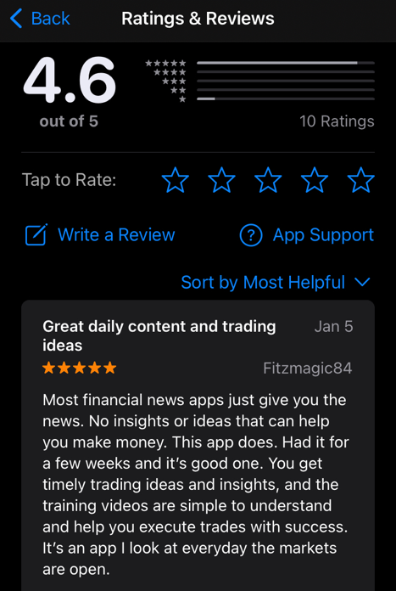

Look…

It’s worth repeating…

If you’ve ever looked at any financial research… getting trades every single week will easily cost you $5,000…

If not more.

For this level of service…

For a livestream with weekly options picks…

And live access to our moderators and our trading research community…

Our publisher thinks the retail price of $595 is insane.

Especially considering our loyal members have paid well over $10,000 for my highest level of research and recommendations.

But I want to make this affordable for everyone to join us now.

In fact… my goal is that you make so much money from this one livestream… you can use just a fraction of those profits to join some of our other services.

And that’s why I want to extend a special discount to you.

[Begin $49 Alt Take]

If you say YES right now…

You can get a full year’s access to Catalyst Cash-Outs LIVE…

For JUST $49.

That’s all.

That’s less than $1 a week for our livestream.

[End $49 Alt Take]

[Begin $79 Alt Take]

If you say YES right now…

You can get a full year’s access to Catalyst Cash-Outs LIVE…

For JUST $79.

That’s all.

That’s less than $2 a week for our livestream.

[End $79 Alt Take]

[Begin $99 Alt Take]

If you say YES right now…

You can get a full year’s access to Catalyst Cash-Outs LIVE…

For JUST $99.

That’s all.

That’s less than $2 a week for our livestream.

[End $99 Alt Take]

[Begin $129 Alt Take]

If you say YES right now…

You can get a full year’s access to Catalyst Cash-Outs LIVE…

For JUST $129.

That’s all.

That’s less than $3 a week for our livestream.

[End $129 Alt Take]

[Begin $249 Alt Take]

If you say YES right now…

You can get a full year’s access to Catalyst Cash-Outs LIVE…

For JUST $249.

That’s all.

That’s less than $5 a week for our livestream.

[End $249 Alt Take]

It’s a steal, honestly.

In fact… the cost of getting this video to you is going to be even more than that.

I’m willing to lose money on this… Simply to prove to you that this research can change everything for you and your family.

That’s why this huge discount is ONLY available right now to our new members.

Click on that button below… and join us for a YEAR of Overnight Profit opportunities.

And rest assured…

This is truly a risk-free proposition for you…

*DESIGN THIS AS A CERTIFICATE*
365 Day “No Questions Asked”
Money Back Guarantee
If for any reason Bryan’s Catalyst Cash-Outs LIVE isn’t for you... simply call his VIP Concierge Team within your first 365 days and they’ll refund your subscription entirely.
No questions asked!
You have a full year to take a look at everything…

Even attend every single livestream…

And if you feel this isn’t well worth every penny you paid…

Give my team a call… and we’ll refund everything you pay today.

I can’t think of anything fairer than that.

I’ve taken all the risk off of you…

And put it squarely on my shoulders to prove that we’re the real deal… and that we’ll deliver you winner after winner.

Now… the choice is yours.

Where do you go from here?

The way I see it…

You only have three options.

Option one…

You can ignore everything you heard today.

You can decide you don’t want to try to make overnight profits when the US Government releases their reports.

You can ignore the past data showing you have a ridiculous advantage…

And you can forget about the fact that you could have taken $10,000… and generated over $137,000 in profits last year.

Option 2…

You can try it alone.

You can dig up the dates for all the upcoming reports.

You can try to figure out the best options to trade.

And you can try to figure out whether the market will move up or down based on a report (hopefully you have a crystal ball).

Or… option 3…

You can let me do all the hard work for you through Catalyst Cash-Outs LIVE.

I’ll keep track of all the reports.
I’ll dig into the data month by month… and make sure we pick the reports that I believe have historically given the BEST chance of success.

And…

I’ll show you the exact trade to make so that you could win whether the market goes up or down.

I hope you choose to join me in my new livestream… and let me do all the work for you.

Click on that button now… and lock in your new Member Discount.

Don’t let this price pass you up.

Remember… this special price…

And these bonus reports…

Are ONLY for our Charter Members of our new Catalyst Cash-Outs LIVE.

Don’t wait another moment.

My next livestream starts soon… and I’ll be dropping my next trade.

Click on the button right now…

And I’ll see you LIVE Tuesday at 2.

Bryan Bottarelli
July 2024

