>>> TESTING NOTES HERE<<<
====================
- Control Headline

Pro Trader Who Turned $37K Into $2.7 Million in Just Four Years Reveals...
One-Ticker Payouts
New research proves trading JUST ONE STOCK over and over again could have led to profits of up to 141%, 332% and even 2,614% in under 11 days!
Get access to his next play on Monday, May 15.

- Variation 1

One-Ticker Payouts Summit
Millionaire trader Nate Bear reveals how his strategy could collect BIG WEEKLY PROFITS in 2023 using just one stock. Watch to learn how $1,000 could have turned into as much as $27,140 in just 10 days!

- Variation 2

One-Ticker Payout on Monday, May 15
Forget scanning through 8,252 stocks in this market. Discover how just one ticker could help you produce BIG WEEKLY PROFITS.

Host:

Sitting in front of me is a professional trader who’s vastly different from any trader you’ve likely met before.

He’s a former construction worker and family man... who famously took $37,000 in savings... and turned it into $2.7 million in just four years.

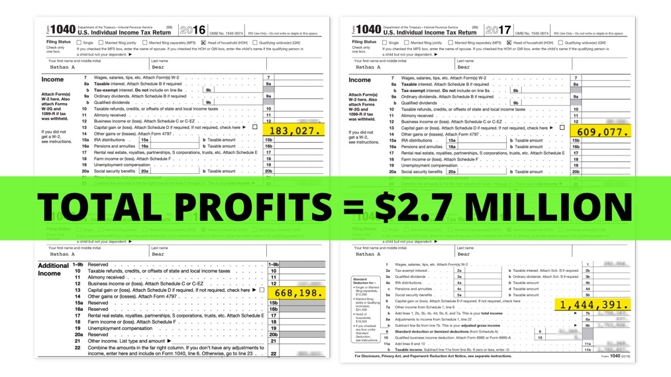
Since then, he’s become one of the most sought-after trading experts in America... with people all over the country tuning in to his live trading sessions each day.

They watch him make real trades with his own money... almost a thousand miles away from Wall Street.
His name is Nate Bear of Alpharetta, Georgia.
I’ve traveled to meet with him today for one important reason.

You see... what Nate is going to show us today is different from virtually any investment system you’ve tried before.

He doesn’t recommend buying and holding stocks like Tesla... Apple... and Johnson & Johnson.

In fact, he’s not telling people to maintain an active portfolio at all!

Rather, he advocates abandoning 8,251 of the 8,252 publicly traded stocks...

And focusing on just ONE TICKER at a time instead.

Why?

Because there is something very special about just one ticker and the way it moves
. And it allows him the potential to extract profits from the market over and over again.
He calls this strategy “One-Ticker Payouts.”
How it works is... you only trade ONE ticker every week for big potential paydays.
And when I first heard about it...
I admit, I was skeptical...

I mean... who makes money trading with just one ticker?
But our research team studied Nate’s strategy to see just how big these unusual One-Ticker Payouts can be – thanks to a market phenomenon that most investors have never even heard of.
And the results were...
In a word...

Staggering.

Looking back, we found that in November of last year alone, Nate’s strategy would have found four winning weekly trades on just one ticker.

In December, we tried again... and found three winners...
In January... three more...
In February... three wins again...
And in March, we saw four more.
I could go on and on. And not only did our research uncover all these weekly winners...
It also found that the top gains investors could have made were HUGE!
We’re talking about returns like this 543% move in just nine days...

[Full Screen. Let’s make it look like a growing bank account. Starting at $1,000 and going up to 6,403. Need to put “543% move in 9 Days! somewhere]
Enough to turn $1,000 into $6,430.
Or this 276% move in 11 days...
[Full Screen. Let’s make it look like a growing bank account. Starting at $1,000 and going to 3,760. Need to put “276% move in 11 Days! somewhere]
Enough to turn a $1,000 investment into $3,760.
Or how about this one?
The best gain we found... was a massive 2,614% return on just one trade in 10 days.
[Full Screen. Let’s make it look like a bank account. Starting at $1,000 and going to 27,140. Need to put “2,614% move in 10 Days! somewhere]
That move alone would have been enough to turn $1,000 into $27,140!

That’s the potential of Nate’s One-Ticker Payouts strategy.
How is this possible?

It’s all thanks to a little-known market force that has been studied by Harvard University...

Duke University...

And even the Federal Reserve...

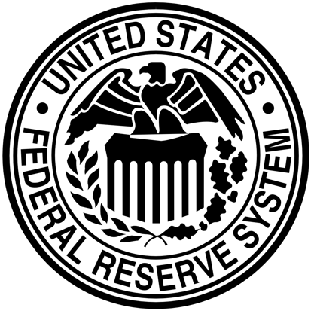
All of whom have been interested in why it creates such a powerful market advantage.
With that in mind, let’s bring in the expert behind this impressive new approach to the markets.
Please join me in welcoming the man himself...
Nate Bear!

Nate:
Great to be here! Thanks for having me, [HOST].

Let me start by saying this is, hands down... the greatest, most lucrative discovery of my entire career.

Host:
Nate, before we get too far ahead of ourselves...
Some viewers at home might not be familiar with you...
And that’s because you aren’t some Ivy League bigwig...

Or some corporate hotshot who made his name on Wall Street...

You started off as an average Joe.

In fact, you began your career working in construction with a modest $37,000 in savings...
And yet, without any professional trading licenses...

Without any experience in the trading pits...

Without any connection whatsoever to the investing world...

You turned that $37K into $2.7 million in just four years.
Nate:
Yeah... before I got into trading, I was grinding myself into the ground doing construction.
Every day I was remodeling stores like Home Depot... McDonald’s...


And all that got me was a small 1,200-square-foot home.
Once my wife and I started having kids... I knew I needed to do something different to provide a better life for my family.

I needed to find a new income source...
And that’s how it all began, really.

I joined a community of professional traders... and I was fortunate enough to find a secret that helped transform my wealth...

And my life...

In ways that I never dreamed possible.

In just four years... I turned my $37,000 in savings into $2.7 million.

I’ve secured a financial future for my four children.
That was always my ultimate personal goal...
But now, my goal has expanded.
It’s become my life’s mission to give back by helping normal people just like me reach their financial goals.
Host:

What a remarkable story...
Not many people can become a self-made millionaire like you did.

And with how difficult it is to navigate the stock market these days...

And how tough it is to actually grow a 401(k)...
The sad reality is...
Americans need help!
Thanks to the soaring cost of living, 63% of Americans are now living paycheck to paycheck.

That’s basically 2 out of every 3 people.
People are looking for ways to keep up with inflation... to produce the income they need to cover all the rising costs of life.

But here’s what surprised me.

Most investment advisors tell people to save their money... put it into stock market funds... diversify...

And then keep doing that for years.

They tell people that if they do that for 20 to 30 years, they’ll end up with a solid retirement.

But what you are advocating is quite different.

You’re not telling people to buy and hold for 20 years.

In fact, it took you only four years to personally produce a fully paid retirement...

And you say part of that nest egg could be built using just one ticker at a time.

Is that really possible?

It seems to go completely against the conventional wisdom.

Nate:
It does.

And listen... let me be clear... if people like “buy and hold” and want to keep doing it... that’s perfectly fine.

The truth is... buy and hold works.

However, what’s amazing about the one-ticker strategy I’m going to show everyone today is how much faster it can work.
Even though I personally started with $37,000 and used multiple strategies when I started trading...
Viewers at home can start with a much smaller amount and still aim to generate massive new income.
Host: So are you saying that you can take a small portion of your portfolio... and still see results with this strategy?
Nate: Yes. That’s why I’m so excited to teach this powerful one-ticker strategy today...
I think this is going to be extremely helpful for people who are desperate for a new way to make more money.
And it’s so simple.
You don’t need to trade full-time to see massive results.

This is a simple technique that you can quickly use during lunch...

Or during some boring Zoom call...

Or even while you’re out on the golf course.
All we’re doing is trading one ticker at a time...
Same time, same place, every week.

Yet the data has been spectacular.
Using this technique, everyday Americans could have turned $1,000 into rarely seen gains as high as $3,000...
$5,000...
Even $27,000...
All within a matter of days.

// PICKUP LINE FOR TEST Control (Ticker giveaway) //
In fact, I’m even going to give everyone watching at home the ticker I’m currently trading.
It’ll help you get off and running with my One-Ticker Payouts strategy.
Host:
So you’re basically giving viewers exactly what they need to start using this strategy right away?
Nate:
That’s right.
///END ALT TAKE/////

Host:
That’s incredible.

[TURN TO SINGLE CAM]
Friends, One-Ticker Payouts demonstrated that everyday people had an opportunity to unlock MASSIVE gains.
We’re talking about the power to double... triple... and, as the research suggested...
In some rare cases, even 20X an investment in just a matter of days...
Nate, I gotta ask... how did you first discover this?

Nate’s Fortune-Changing Discovery
Nate: It sure wasn’t on purpose!

Listen... I’ve had a successful career trading, and I enjoy teaching others my strategies...
But I will be the first to admit... I was a horrible trader when I first started.

I was addicted to whatever “hot stock tip” I would hear from CNBC or Fox Business.

Host: Let me guess... that didn’t work out well for you?

Nate: Absolutely not.

When you’re constantly hunting for the next big stock... and listening to all the talking heads on TV... most of the time, you end up getting in on stocks at the exact wrong time.

You get in once stocks have already moved up... because that’s when the media starts talking about them!

This is exactly what happened to me.
I once had a single trade blow up half of my entire trading account...
It was a silly earnings play on Apple that I’d heard somewhere on the news.

I expected to hit it big, but the opposite happened.
And I lost around $15,000...
Which was a lot considering I was a construction worker at the time.
Host: That’s a lot to lose for anyone!

Nate: I’m telling you... it was so bad.

And that trade blowing up on me impacted my approach to investing...
I went YEARS without making any trades related to companies’ earnings. I stopped trusting all of the analysts and financial news hosts out there.
And I’m glad I did... because it gave me the opportunity to discover a strange market phenomenon that changed everything for me.
Host: That’s when you started focusing on one stock?
Nate: One WINNING stock.
Forget about the other 8,251 stocks.
Forget about what the media is trying to hype up.
My One-Ticker Payouts strategy requires you to focus on only one winning stock at a time.
Host: What exactly do you mean by “one winning stock”?
Nate: Okay, great question.

What is a winning stock?

Let’s go back to the big loss I took on Apple.

I blew it on that play because I made a bet that Apple would have a great earnings release.

I was guessing...

Which means I was gambling.

Because if the earnings release didn’t turn out like I hoped, I was going to lose.

And that’s exactly what happened.

However... a question popped into my head.

What if I could make money on stocks AFTER earnings come out?

That way I wouldn’t be guessing.

Instead, I’d be betting on a stock that was already winning...
Or... on the flip side... betting against a stock that was already losing.
Either way, I eliminate the surprise... and I follow where the momentum is.
So that’s what I did.

My One-Ticker Payouts strategy zeroes in on just one stock that starts its move AFTER major earnings news.

HOST: But wait a second.

After earnings come out, the stock will have already moved.

If it’s a great earnings report, then the stock will move up... and you’ll be too late. Right?

NATE: That’s what most people believe.

But something else happens after earnings come out... and it leads to the single most predictable set of trades you can make in the market.
It’s a phenomenon called an “Earnings Profit Surge.”

In short... after a company beats earnings... the stock doesn’t just pop up once on the day earnings are released.

Instead, stocks with the strongest earnings reports will continue to move upward for weeks or even months.
Researchers from Harvard, Duke and Cambridge have all proven this ...
Even the Federal Reserve and the Securities and Exchange Commission have studied this powerful market force that leads to sharp rises in certain share prices.

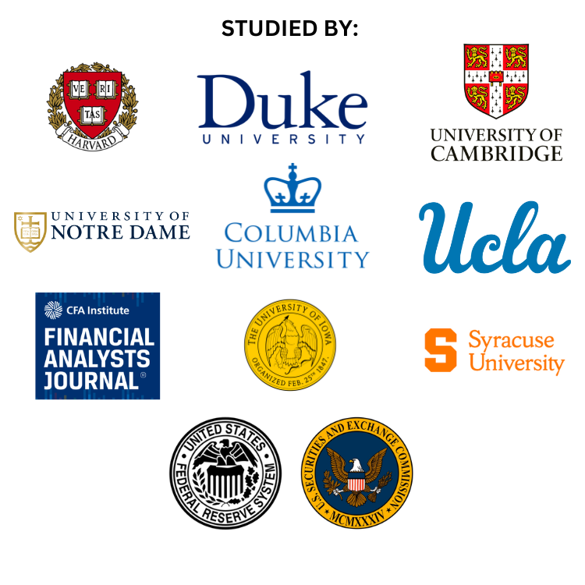.
And a 139-page study from the Florida State University College of Business showed it leads to “abnormal returns.”

Host: Interesting... so when a company beats Wall Street’s expectations... this Earnings Profit Surge causes the stock to keep rising for weeks at a time...
Can you show us some historical examples of real stocks that did this?
NATE: No problem.

Take a look at Gilead Sciences.
The stock gapped up after an earnings surprise.
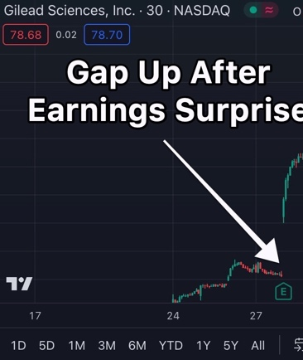
Host: I can see the gap right there... the huge big break between the lines.
Nate: Now, most traders probably would be done here. They’d get in before the earnings announcement...
And they would be thrilled that they ended up being right.
But the problem is...

If you play earnings BEFORE the announcement happens...
It’s often a 50/50 call on making money or losing money.

So do NOT play the gap. It’s too risky.
Rather, it’s better to play the Earnings Profit Surge that is proven to occur after an earnings announcement.

This is how we put the odds in our favor.
So let’s go back to the chart.
As you can see if we zoom out... Gilead continued moving up for the next month and a half.

The stock increased 19%.
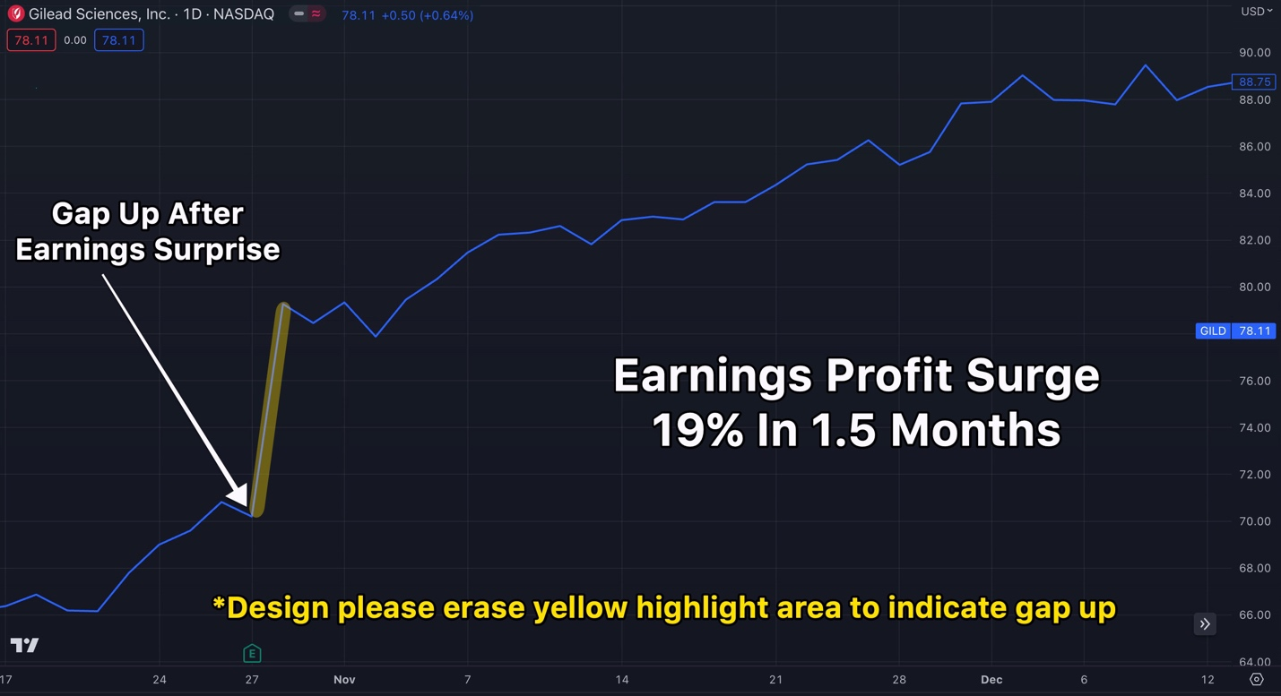
Host: So are you simply recommending that people buy stocks and hold them for a month or so after earnings come out?

Nate: Well, people can do that... and sure, they can probably do well.

But no, there’s actually more to this.

There is something else going on that allows us to consistently look for BIG short-term winners.

It takes the Earnings Profit Surge and makes it even stronger.
Host: I’m excited to see that.
Nate: I can’t wait to show it to everyone!

But first, let’s look at a couple more examples. Here’s a chart of Lululemon.
As you can see, the stock gapped up after an earnings surprise.

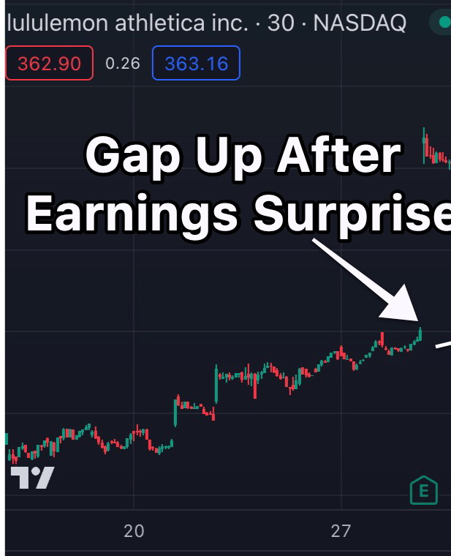
*DESIGN NOTE... SEE THE BIGGER CHART BELOW... YOU CAN JUST ZOOM IN ON THE GAP UP.*
Again, don’t risk being part of that gap, because the stock very well could tank the other way if the earnings announcement is a flop.

Instead, focus on the Earnings Profit Surge that follows AFTER earnings are announced.

Sure enough... LULU continued moving up, rising 7% in just a bit more than a month.
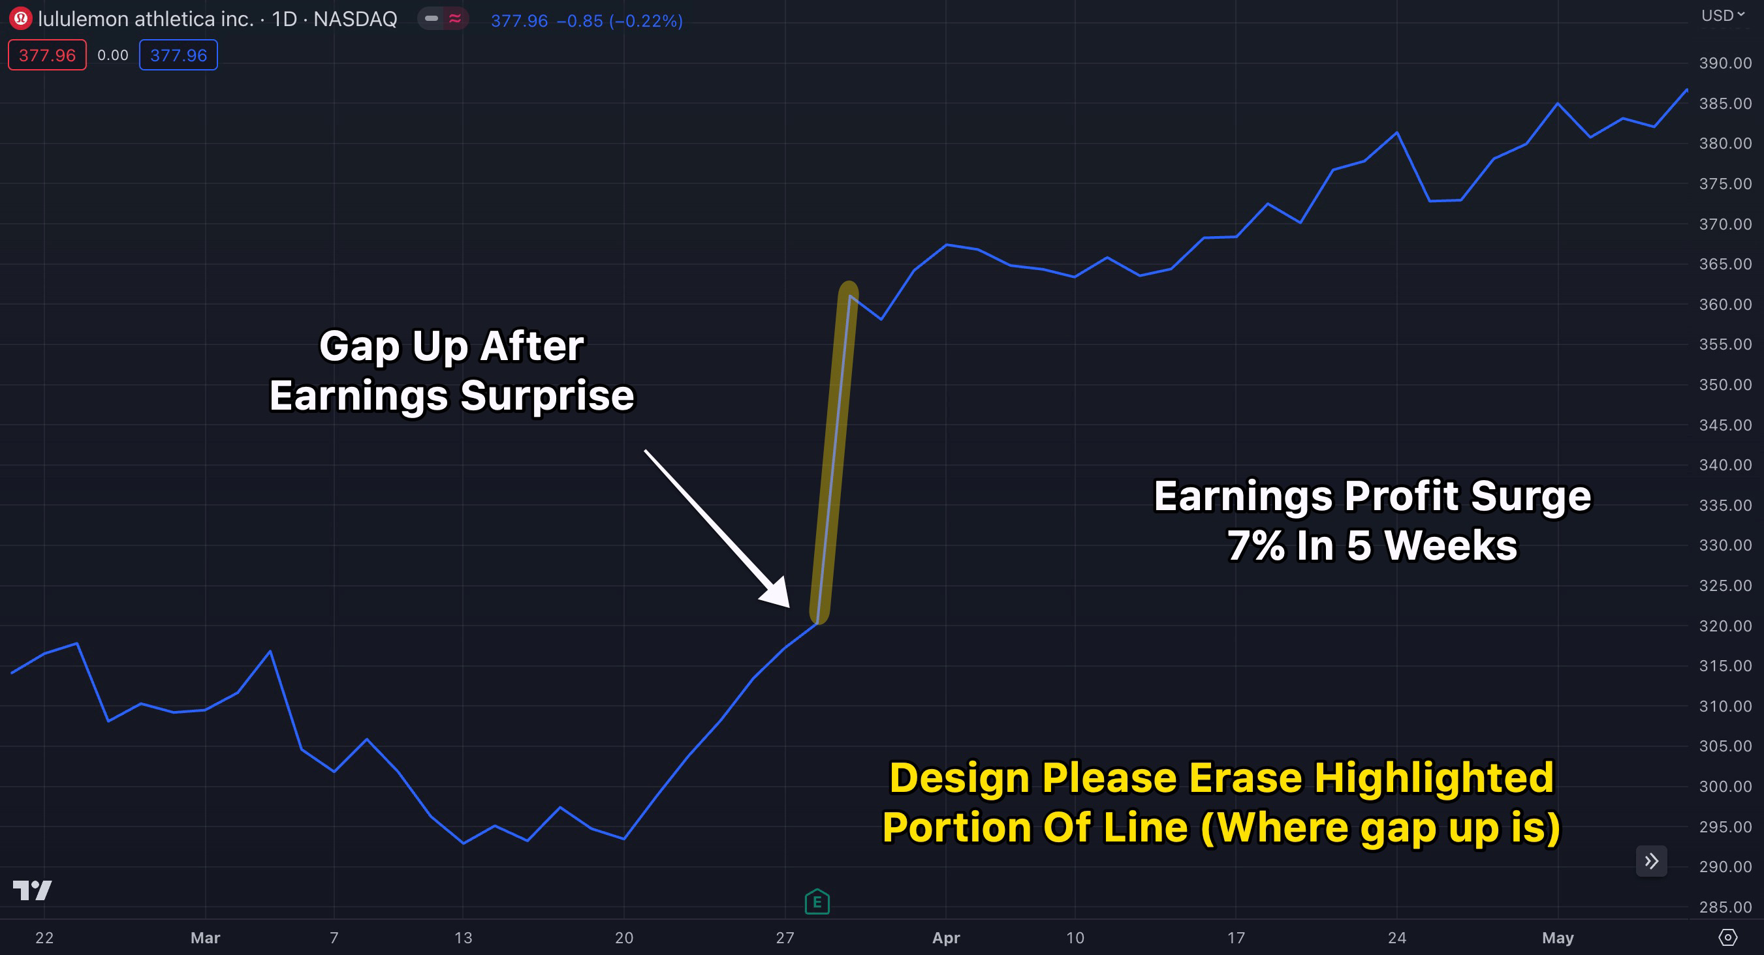
Host: That’s almost three times more than the Dow is up all year... in just five weeks
!
Nate: You’re right, but in a moment, I’m going to show you how it’s possible to make even MORE than that!
First, though, let’s look at one more example...
Here we can see Nvidia gapped up after its earnings surprise...
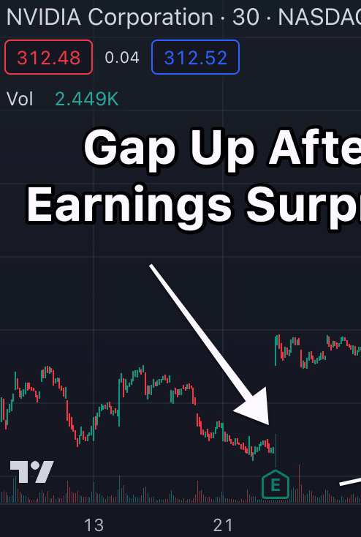
*DESIGN NOTE... SEE THE BIGGER CHART BELOW... YOU CAN JUST ZOOM IN ON THE GAP UP.*
When we zoom out...
You can see that it moved as much as 35% over the next three months thanks to the Earnings Profit Surge.
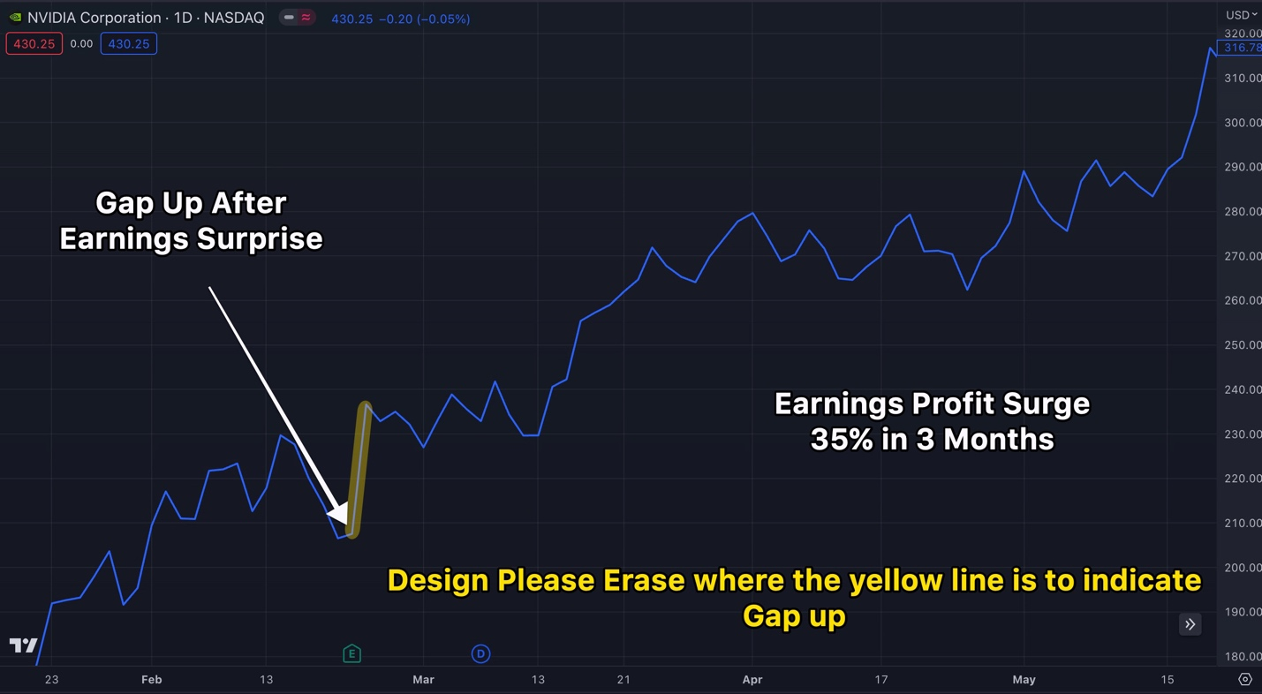
*DESIGN NOTE... SEE THE BIGGER CHART BELOW... YOU CAN JUST ZOOM IN ON THE GAP UP.*
Host: Nate... that’s roughly three years of market returns in just three months! I get why you were so excited to share this strategy.
Nate: Sure, but here’s the thing, [Host]...

While results like those would be solid for most investors...

That’s not how I turned $37K into $2.7 million in four years.
Instead, I’ve found ways to produce even bigger wins in even shorter periods of time.
I make just one weekly trade at a specific time... on one ticker that’s released a great earnings report...
And in the process, it’s possible to make FAR MORE than 35%... in a much shorter time.
Host: More than 35%? Come on now.
Nate: Let’s zoom back in to that Nvidia chart and focus on just the first month after its earnings announcement...
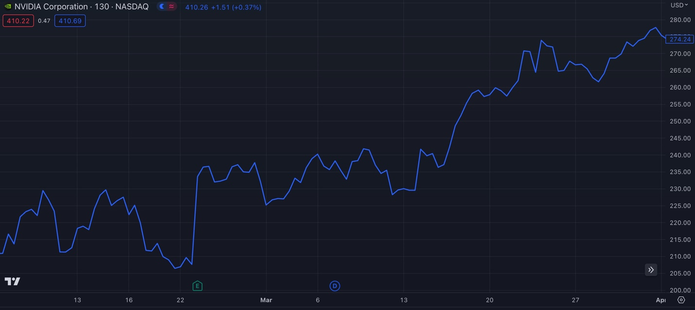
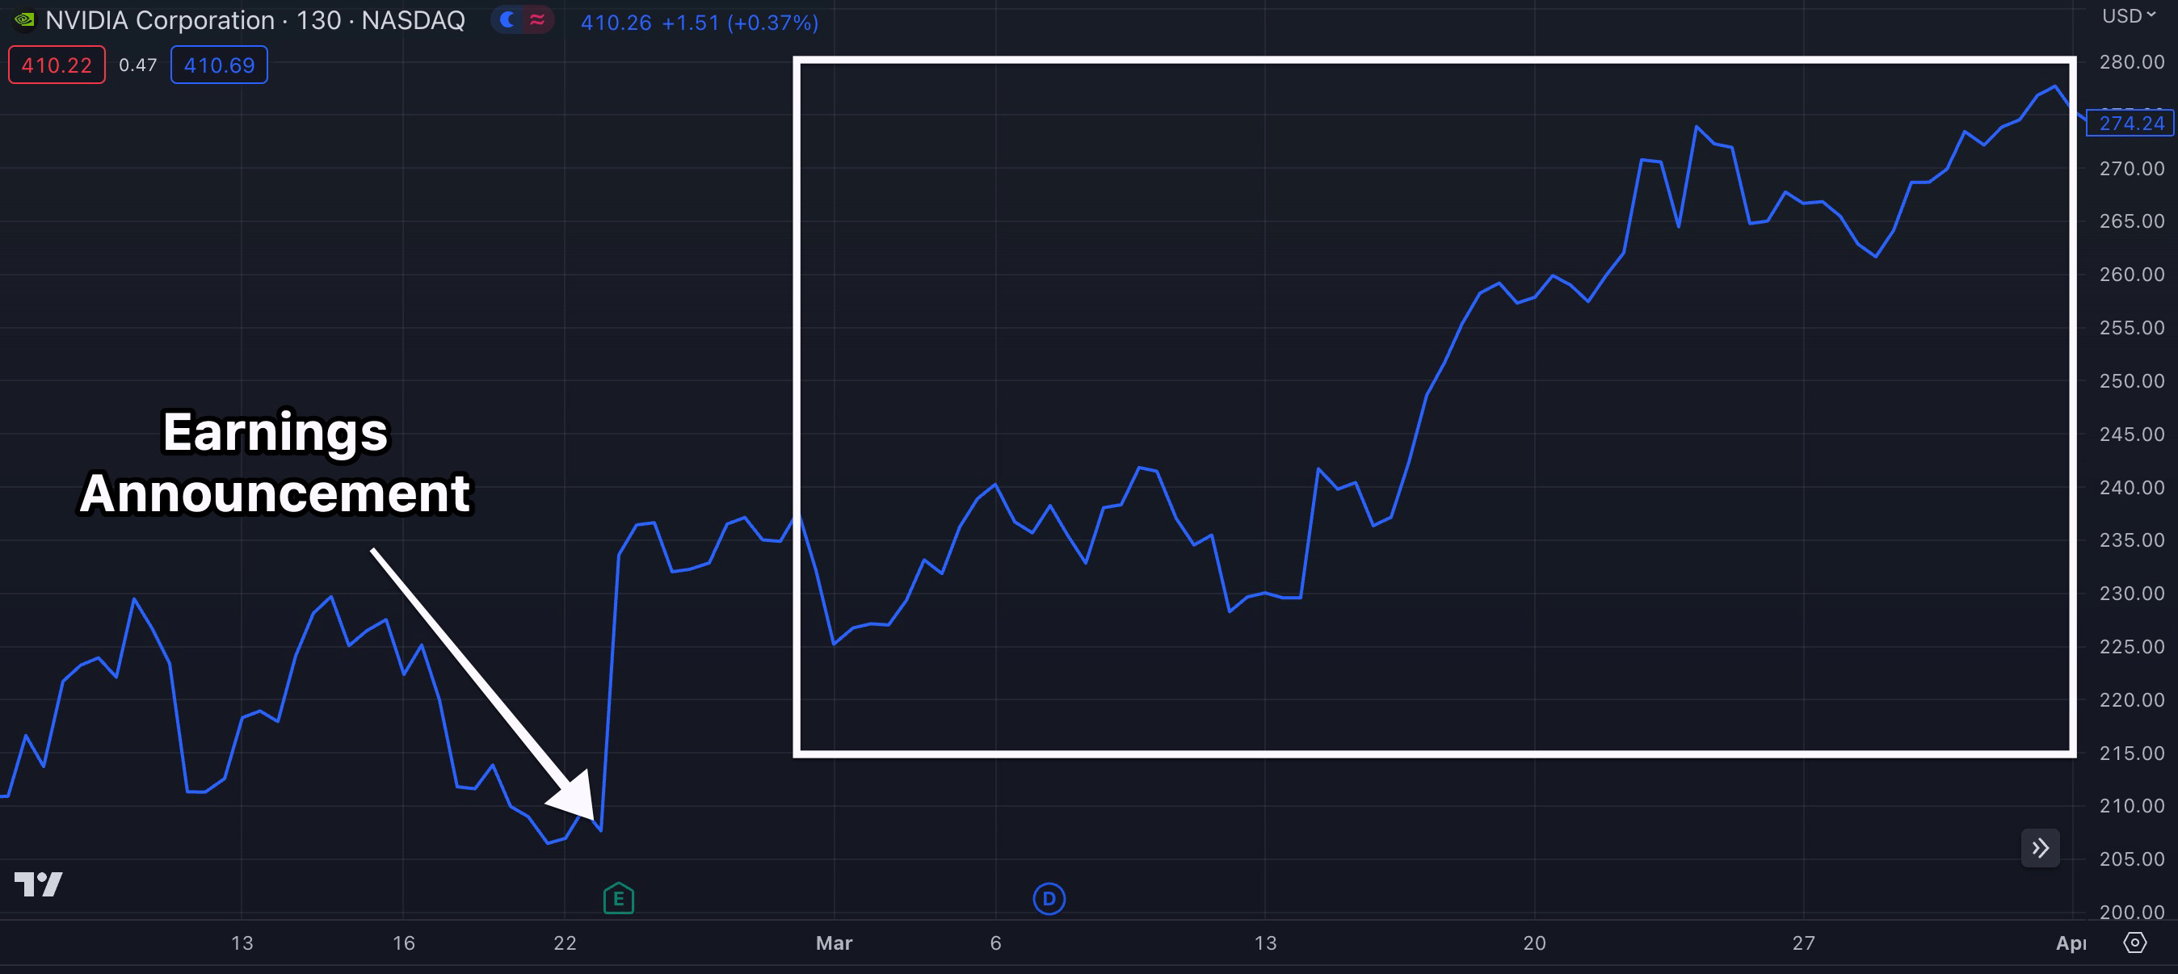
Using One-Ticker Payouts...
With the right timing, a trade entered on March 6 could have made up to 443% in just 11 days.
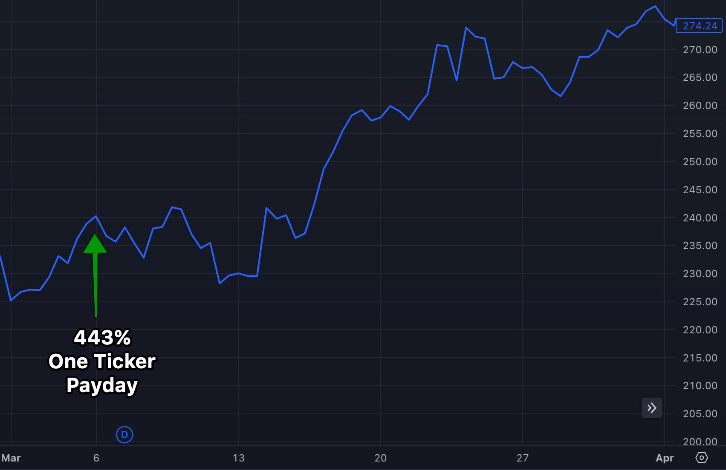
Host: Did you say 443%?
Nate: Yes, but we’re not done yet...
One week later, a trade could have made 543% in just nine days.
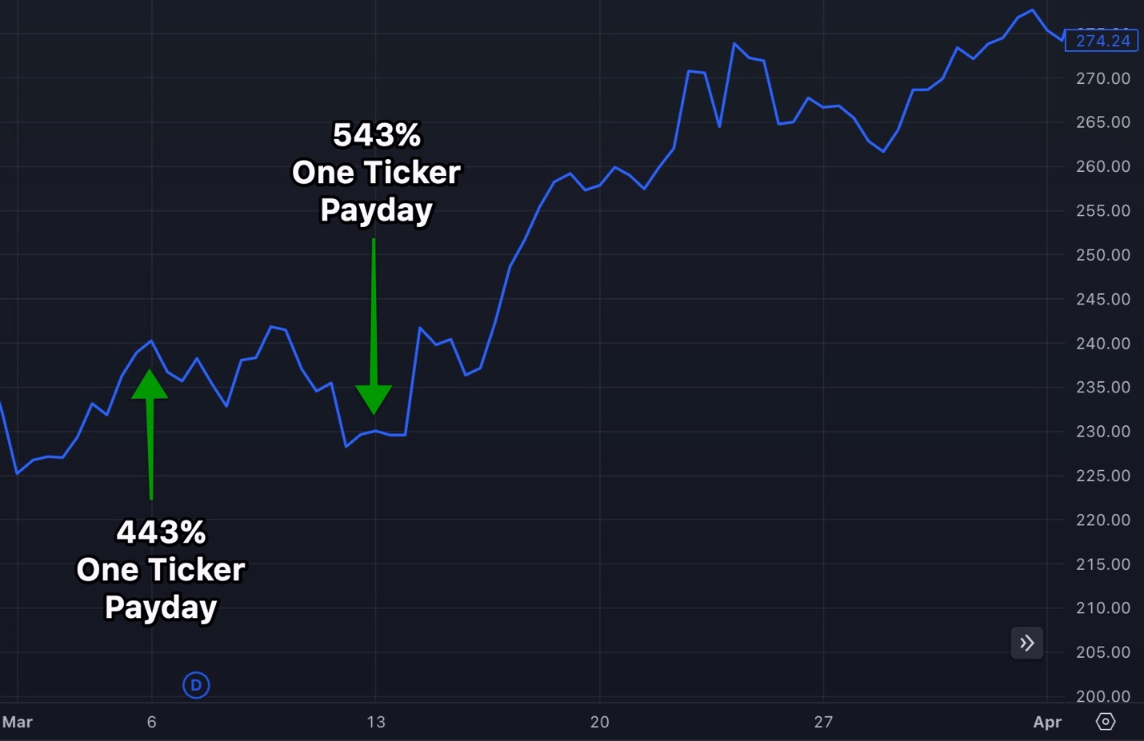
The next week, using the very same ticker... a trade opened on the 20th could have made an 89% return in 11 days...
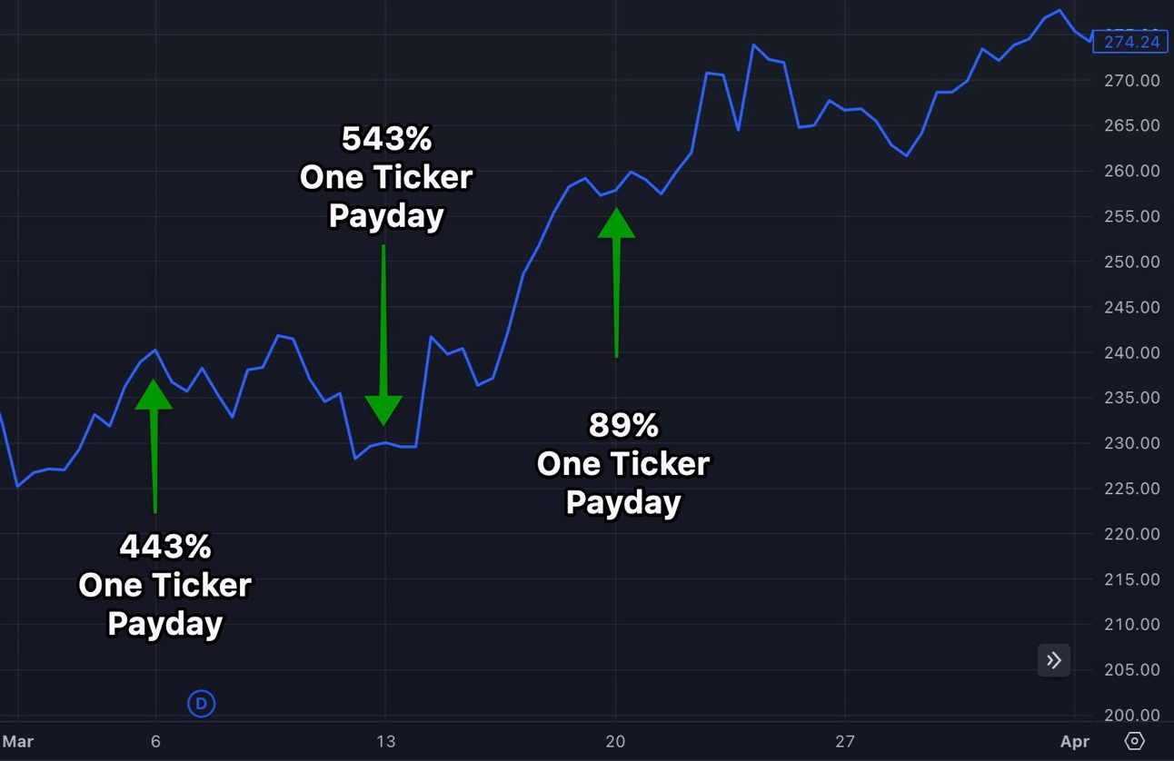
And then another trade a week later on the 27th could’ve made an 88% return within just seven days.
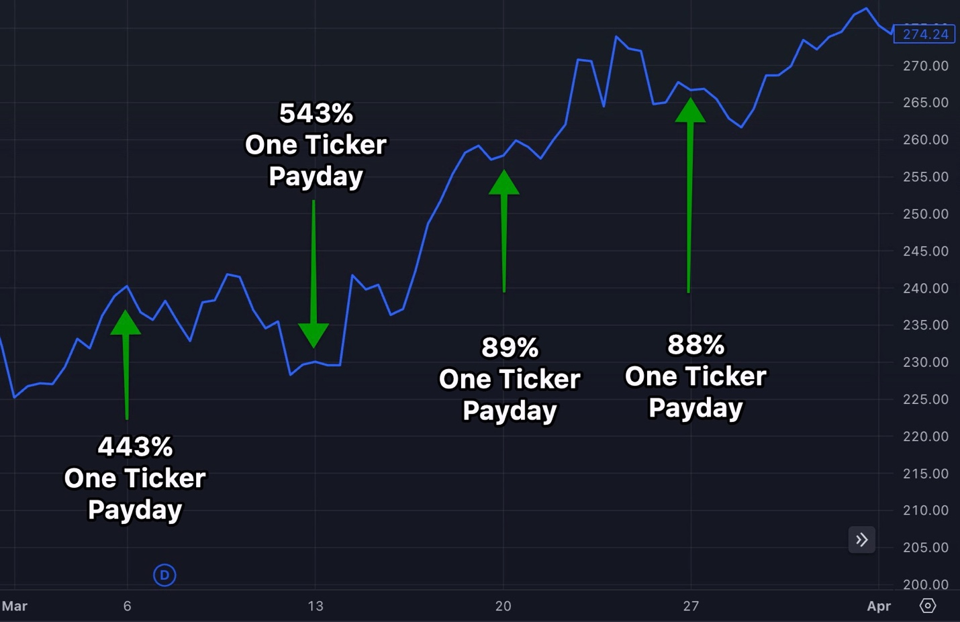
Host: Wait a second... Are you saying that investors could have made a 443% return...
A 543% return...
An 89% return...
AND another 88% return...
In one-third the amount of time that most investors would have made 35%?
Nate: Exactly. All told, by making just one trade per week... on one ticker... you could have gone 4 for 4 on Nvidia.
$1,000 into all four trades throughout the month...
Could have turned into $15,655 using One-Ticker Payouts.
And $10,000 into each of those trades would have turned into $156,550.

By comparison, regular stock investors would have made only $3,500 on a $10,000 investment.

Host: This is truly remarkable.

You’re talking about eight times more profit by trading just this one ticker over and over.

Can you show us another example?

Nate: Absolutely.

This time, let’s go back even further... to a really poor month in the markets: June 2022.
Host: That was a terrible month.
The Fed raised interest rates by 75 basis points for the first time since 1994...
Fuel costs for Americans were at an all-time high...

Inflation was getting out of control...
And the stock market was destroying retirement accounts left and right.
Nate: The S&P was down more than 8% in a single month!
Host: I don’t know too many people who made a lot back then...
Nate: Well, that’s why this strategy is so good.

We target ONLY ONE single winning stock at any given time. We leave all the rest of the losing stocks behind.

So in June, one of the only winning stocks was Snowflake.

Its earnings report was massive – it had a 700% earnings surprise.
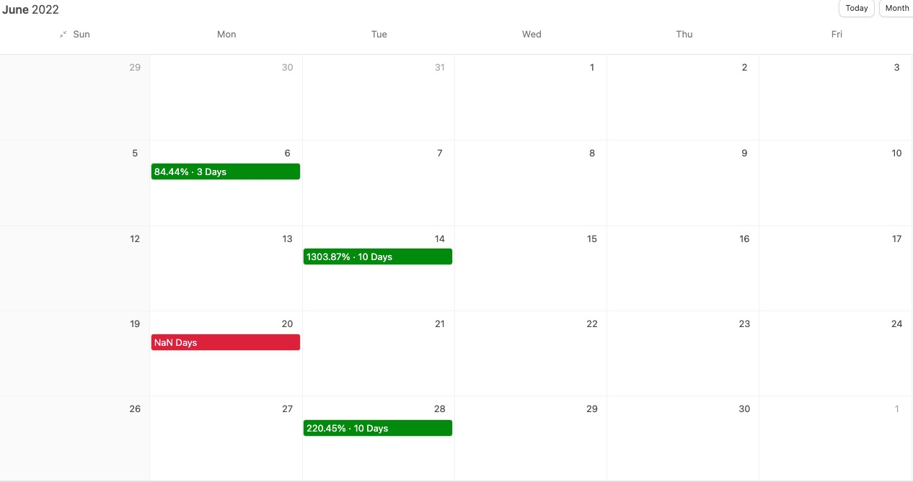

So while the rest of the market was down, Snowflake actually rose 7%.
But here’s the thing...
While there was solid money to be made following the stock...

We found the One-Ticker Payouts strategy would have produced three wins in the four weeks that followed. The only week it wouldn’t have produced a winning trade, nothing triggered for that week.

So in four weeks, there would have been three wins... and one week with no trade.

Plus, the three trades were HUGE wins.
Just look at these trades on the screen...
Host: Am I reading that right?
84% in three days...
1,303% in 10 days...
225% in 10 days...
That one 1,303% trade alone could have turned $10,000 into...
What...
$140,300 in a little over a week?
Nate: That’s correct.
Now, let me be clear... these trades would have required timing and execution.
I’m not saying everyone will make 1,303% automatically. These examples demonstrate just how massive the upside that we’re aiming for is.
But we’re talking about a month that would have caused investors to LOSE $839 on $10K if they simply were invested in the S&P.
Even if it was only a 50% win...
That’s a win you could have bragged to your friends and family about... during a horrific month for most investors!
Host: I sure would. This is truly astonishing.

Nate, why does this work?

What kinds of trades are you targeting to win week after week?
Nate: Well, it’s pretty interesting.

When I was studying the Earnings Profit Surge, my biggest question was...

Why do stocks continue going up even after the earnings information is released?

After all, investors already know the company is doing well... so shouldn’t that all be priced into the stock already?

Host: That’s the same thing I wondered.

Nate: Right, but what I discovered is that once a stock reports great earnings, something happens with the big trading firms.
Essentially, they all want to add that winning stock to their funds.
But for them, they can’t just log in to a brokerage account and make a single trade like you or I can.

After all, we’re talking about hundreds of millions of dollars.

They have to move that money in slowly.
So the moment the big earnings release comes out, they create a buying plan to add to their positions over the course of several weeks.

Every week, they are adding more and more to their positions.
This causes the stock to continue rising for the month or so after earnings come out.
BUT... it also creates an additional, more powerful opportunity for you to profit.
Basically, these huge, hundred-million-dollar money flows also increase the value of the stock’s weekly options.

What I came to realize is that if you bought into these weekly options at the beginning of each week... when the options are often cheaper... you could make a boatload by the end of each week.
Host: That makes sense. But does it really work?

Nate: Look, I get why people might be skeptical.
That’s why I brought tons of examples to show that this strategy is the real deal.

Here’s another one...
This time with the Hershey chocolate company.
It had a blockbuster earnings report in February...

Right after the announcement, the stock popped...
And the Earnings Profit Surge continued driving the stock 7% higher over the next month.

So a $10,000 investment would have produced $700 in profit... which is fine, especially in a tough month like February was.

However, using the One-Ticker Payouts strategy each week instead, an investor could have collected three wins in four weeks.

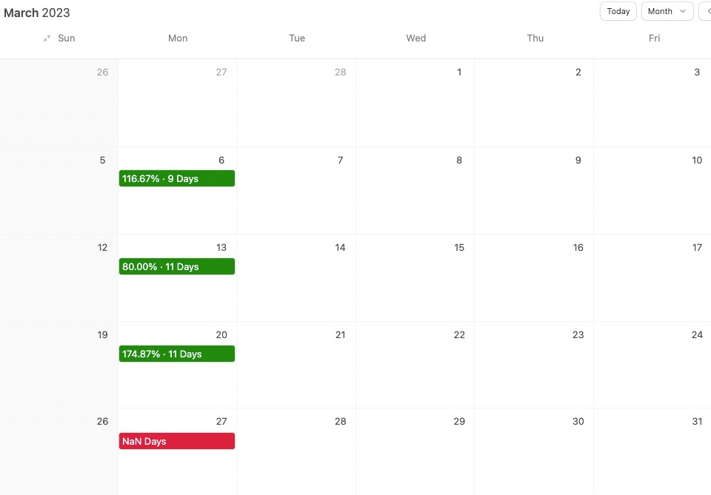

The trades went up 116% in nine days in Week 1, 80% in 11 days in Week 2 and 174% in 11 days in Week 3.

$10,000 in each of these three trades would have produced $37,154 in profit!

That’s 53 times bigger than the $700 profit you would have received by owning the stock.

This is why I focus on just one ticker each month.

It’s so much more effective than trying to guess which stocks will go up in the long term.

Host: These examples that you shared with us certainly show how massive the returns from One-Ticker Payouts can be...
But you mentioned you use options to target these remarkable wins.
And I’ll be frank, a lot of people say options are risky and too complex for everyday people.
What would you say to that?
Nate: Look... I know a lot of people are scared of options and they view them as super risky.
But look... like anything in life... they are risky if you use them the WRONG way.
Heck... lots of people think stocks are less risky than options... but starting out, I lost all of my money on STOCKS three separate times.
So stocks and options both have risks. Nothing in trading is guaranteed. You should never trade with money you can’t afford to lose.
But options do give you a huge advantage that you don’t get with stocks.
Host: What’s that?
Nate: Well, they allow you to put less money at risk while also targeting higher gains.
And that’s how you’re able make triple or even quadruple-digit gains within just days.
With stocks... that would be impossible.

But if you use options correctly, like trading them on an Earnings Profit Surge, you can actually win with potentially massive gains.
In fact, options were critical to turning $37K into $2.7 million for me. Without options, that would have never happened within four years.

Here’s the great thing about the way I play options with this part of my strategy...

All it takes is a small move upward during the Earnings Profit Surge to see a huge winner.
When a stock surges just 5% or 10%, you can target massive, money-multiplying wins.
Host: Do you have any examples to show us?

Nate: Well, remember that 2,614% example that was mentioned earlier?
Host: How could I not remember a return like that? It was on the ticker symbol AI, correct?
Nate: Correct! Well, that would have only been possible with options.
Simply investing in the stock could have made 96%...
But instead... with options...
That return could have soared to 2,614% in the same amount of time!
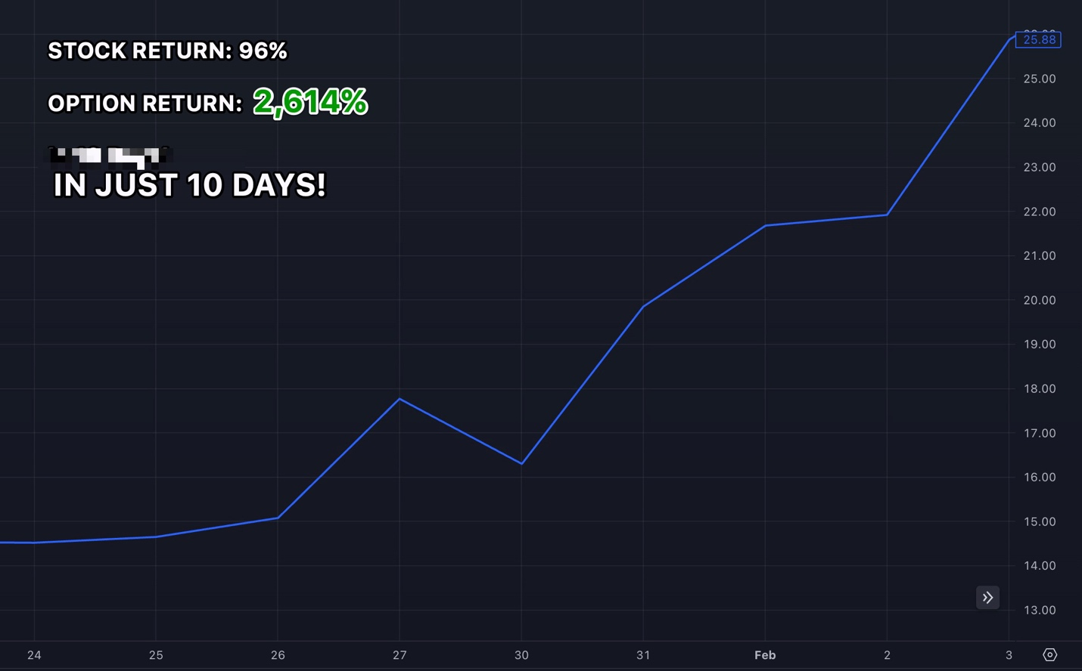
Host: Let that sink in if you’re watching at home right now.
That’s enough to turn $10,000 into an unheard-of gain of $271,400 in a matter of 10 days.
Nate: Exactly.
Here’s another example.
This time, Coca-Cola was up 4% in 10 days...

Host: 4%... that’s not a bad return in just 10 days.
Nate: Absolutely, but by playing the options during these same days...
That 4% could have actually been worth as much as 243%.
Stock: | Options:
4% | 243%
In Just 10 Days!
[BAR CHART (SEE Dave’s example below)]
Host: That’s over 60 times more than the stock returns.
Nate, I have to ask... are these extreme examples?
Nate: Yes, every one of these shows the extreme power of using options on one winning stock...
In fact, here’s another example from May... in this case, Microsoft stock was up 8%.
But, using my strategy...
An option trade could have made as much as 1,028% in just 11 days!
Stock: | Options:
8% | 1,028%
In Just 11 Days!
Host: That’s the difference between turning $10,000 into an $800 profit versus a $102,800 profit... in the same amount of time.

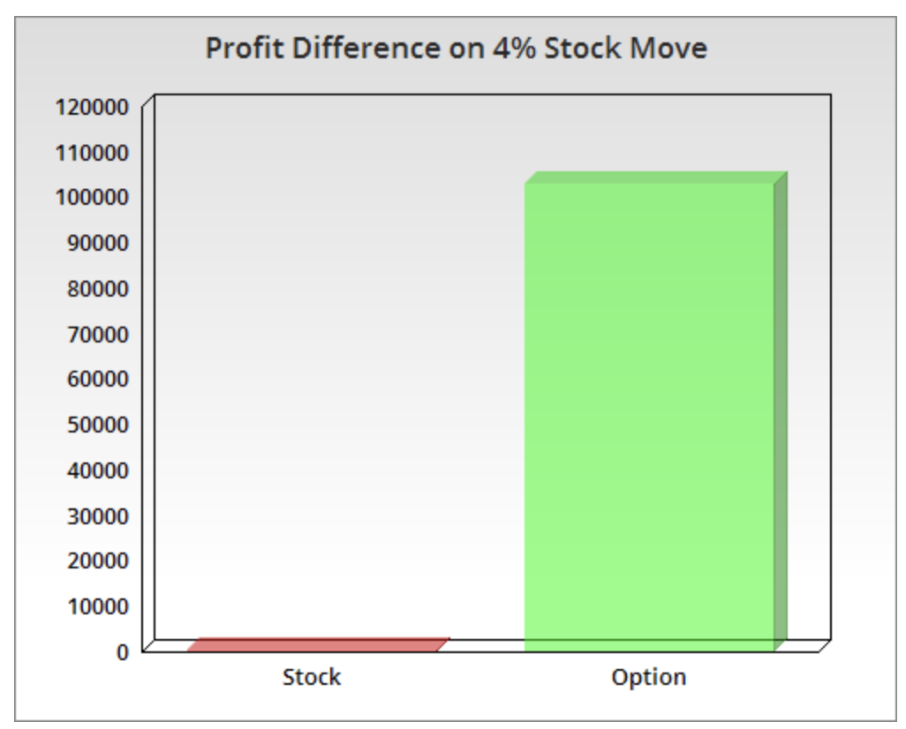
*DESIGN PLEASE FIX TO 8%*
Nate: That’s why I have been using options for years now...
And once you learn how to simplify your trading... at the end of the day, the profit potential just far outweighs trading stocks.
Just take a look at a few of the wins that could have been made this year using my One-Ticker Payouts strategy...
Recent One-Ticker Payouts:
- 106% (8 Days)
- 332% (9 Days)
- 443% (11 Days)
- 734% (1 Day)
Host: Wow... 106%, 332%, 443% and 734% returns all within just a few days?
Am I reading that correctly?
Nate: Yes, you’re reading that right. That’s the full power of using options when you time them right.

Host: Most people don’t bother to take the time to learn how to trade options properly... but you did.
You didn’t buy into the myth that options are only for professionals, and you didn’t get scared.
No wonder you were able to make millions of dollars within just a few years.
Nate: Look... even though my One-Ticker Payouts strategy calls for making just one trade once per week...
The profit potential is massive.
It’s the perfect strategy to master options with... regardless of whether you are a seasoned veteran or just a rookie.

“Experts” Preach Diversification... but Are They Hiding the REAL Way to Build Wealth?

Host: But Nate, zeroing in on one stock, rather than diversifying, goes completely against what Wall Street and retirement fund managers have been telling everyone for years.
Nate: Well, to be blunt...
How has that been working out for everyone?

That “trusty” buy-and-hold, 60-40 diversified portfolio just recorded its worst annual performance since 1937.

In fact, if you’d had $200,000 in a 60/40 portfolio in 2022, you’d have lost $36,000.

Even in 2023, as the stock market has moved back up overall... it’s mostly been driven by just a handful of stocks.
In fact, if it wasn’t for just three stocks (Microsoft, Google and Nvidia)... the S&P 500 would actually be down 2% on the year.
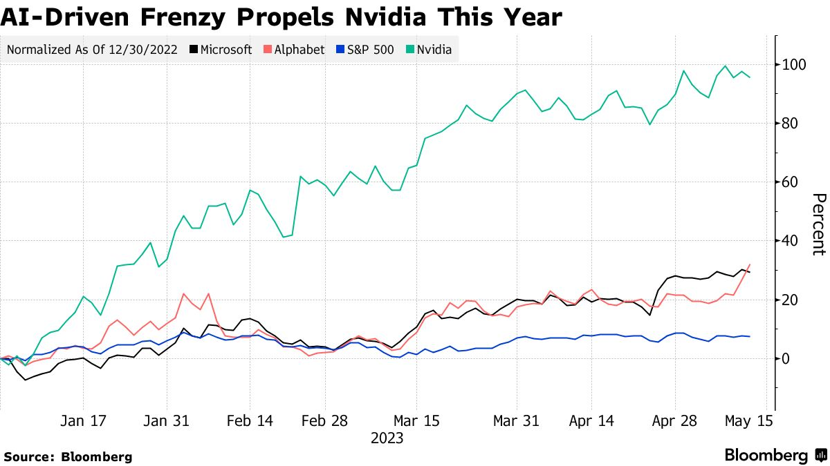
Host: So are you saying that 99% of the market’s best 500 stocks have been dead weight?

Nate: Exactly... which proves my point about diversification not working the way it used to.

Or ought to.

That’s why I wanted to share this with everyone today.
And let me be clear...
I’m not saying my One-Ticker Payouts strategy should replace your retirement strategy.
This should be in addition to your existing basket of strategies that you choose to deploy.
But focusing on one ticker at a time is the single best way I’ve found to potentially increase your portfolio much faster than the market grows.
Collecting One-Ticker Payouts
Host: So let’s be clear... You believe your strategy is a way for everyday people to succeed right now. Right?
Nate: Right. No matter your age... no matter how much money you have... no matter how much experience you have in the markets...

My One-Ticker Payouts strategy can help everyone.
Here’s how my One-Ticker Payouts strategy works...
Step 1: At the start of every month, I pick one stock that recently experienced a massive earnings surprise.

Step 2: I focus on that one stock over the course of the month as it reacts and experiences an Earnings Profit Surge... and I look to trade it one time per week.
Historically speaking, Mondays generally offer the lowest entry prices...

That’s why I’m always looking to enter new One-Ticker Payouts trades early in the week.

Then we will generally close them out in about eight days.
Step 3: Rinse and repeat.

Each month, I target the next winning stock that recently enjoyed an earnings surprise...
And we will look to profit on its ticker over and over again.

Host: So that’s it! You don’t have to buy 20 tickers at a time with this strategy.

Nate: Correct. We use...
One ticker...
And make one trade per week...

For one month.

Then we move into the next great opportunity.
Host: I gotta say, Nate, this all sounds very simple.
Can you give us some examples of what a very successful month could look like using this strategy?
Nate: Sure.
Here’s a historical example with the ticker GILD in November...

The stock itself went up 12% during its Earnings Profit Surge.
But the One-Ticker Payouts strategy could have found four trades in four weeks throughout the month of November...

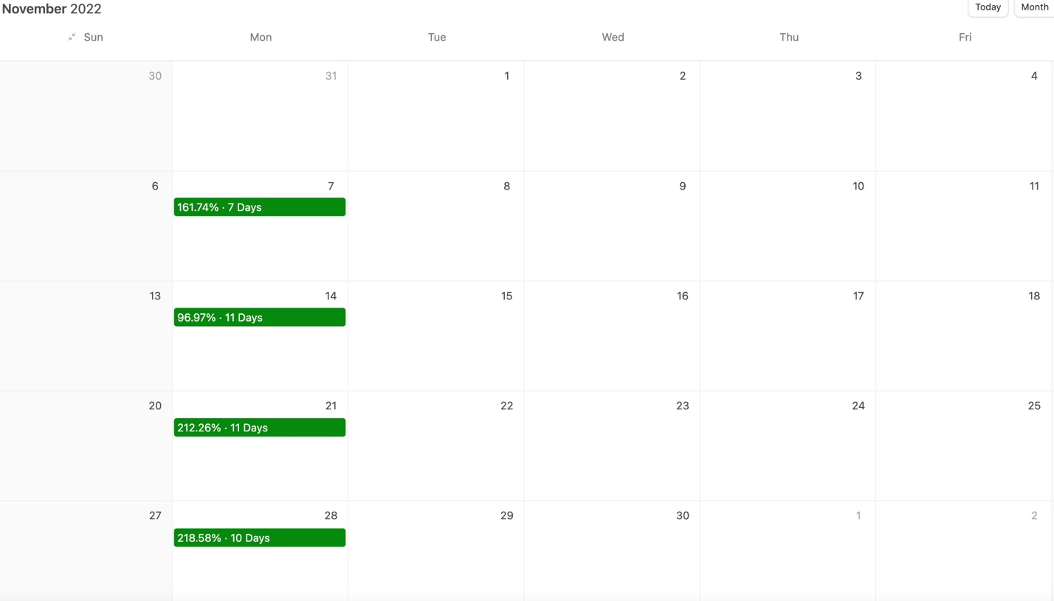
Host: For those at home who may have trouble reading that...
That’s a 161% gain in seven days...
A 96% gain in 11 days...

A 212% gain in 11 days...
And a 218% gain in 10 days...
Incredible!
Nate: $1,000 into each of these four trades could have turned into $10,895.
And $10,000 into each of those trades could have turned into $108,955.
All within a month!

Compare that with just $1,792 in profit from putting $10,000 in the stock each week.
Host: $108K within a month is remarkable...
Nate: It is!

Now, I’m not saying $100K in a month happens always. That would be incredible.

But when we looked back at how some of the best stocks moved after earnings came out, we saw a bunch of big winners regularly.

And this was especially true with stocks that released the best earnings reports.
For example, in December, the stock AI had a blockbuster earnings report.
Over the next month, the stock rose steadily by 73%.
However, the one-ticker strategy knocked that out of the park.
This type of strategy could have produced a trade opportunity in three out of the four weeks. And all three of those trades won... with gains ranging from 141% the first week to 2,614% the last week.
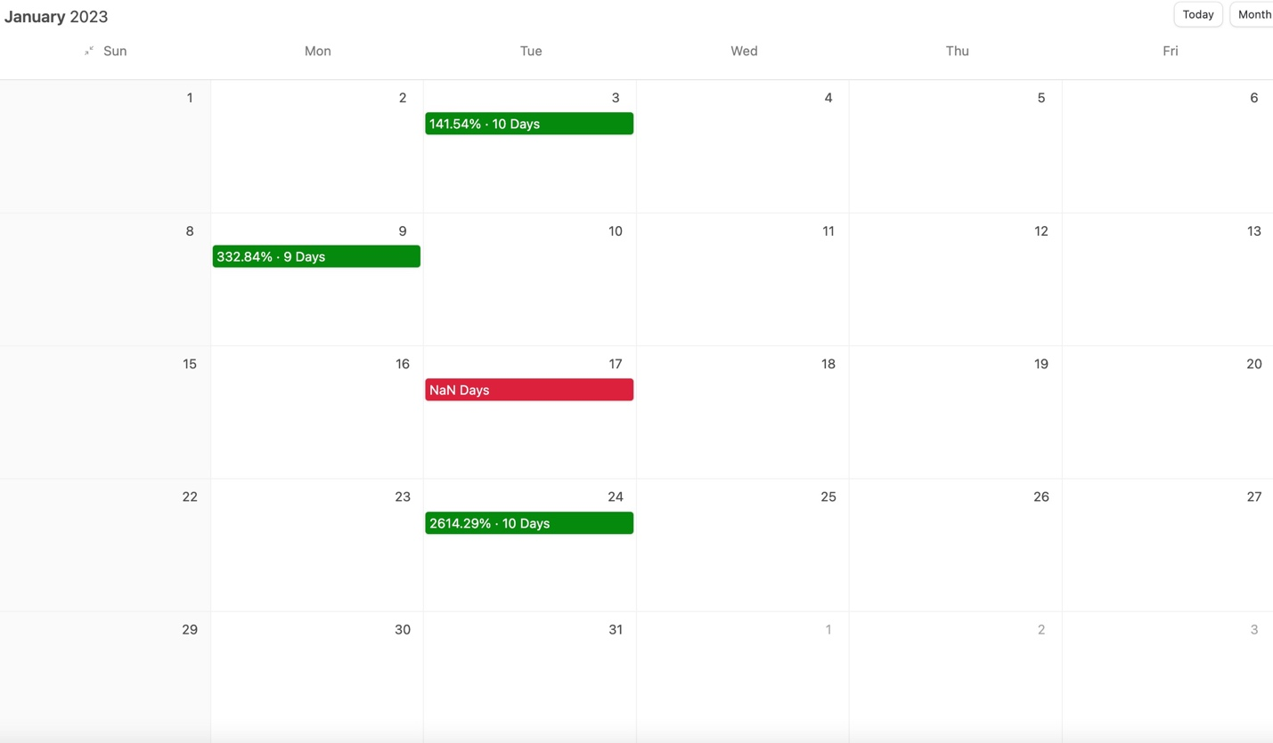
The strategy could have triggered trades on the ticker KEY in three out of four weeks in February, with gains as high as 276%...
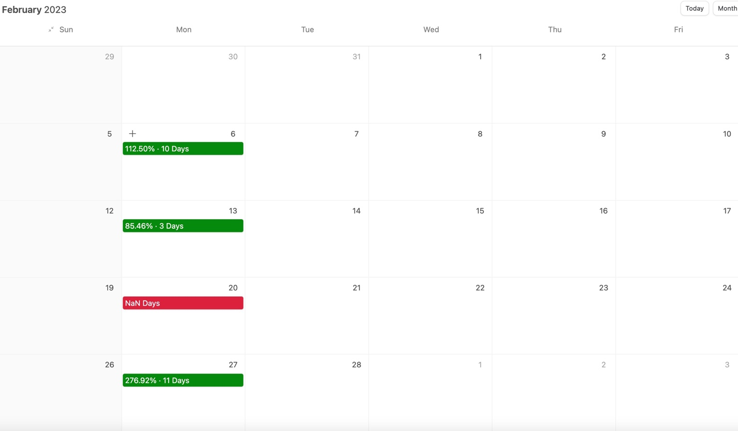
Four out of four weeks on NVDA in March, with a top gain of 543%...
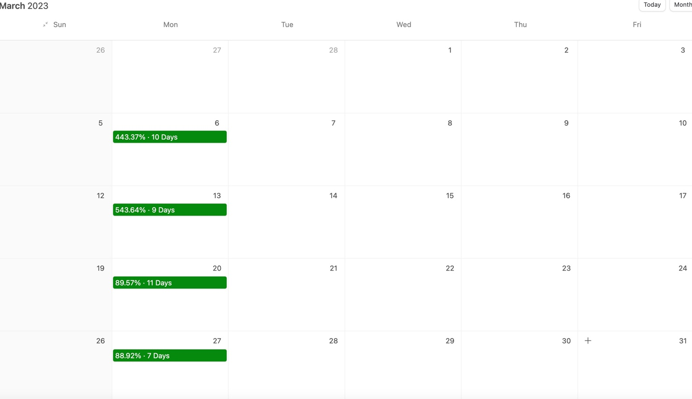
Three out of four weeks on LULU in April, with a 206% gain the third week...
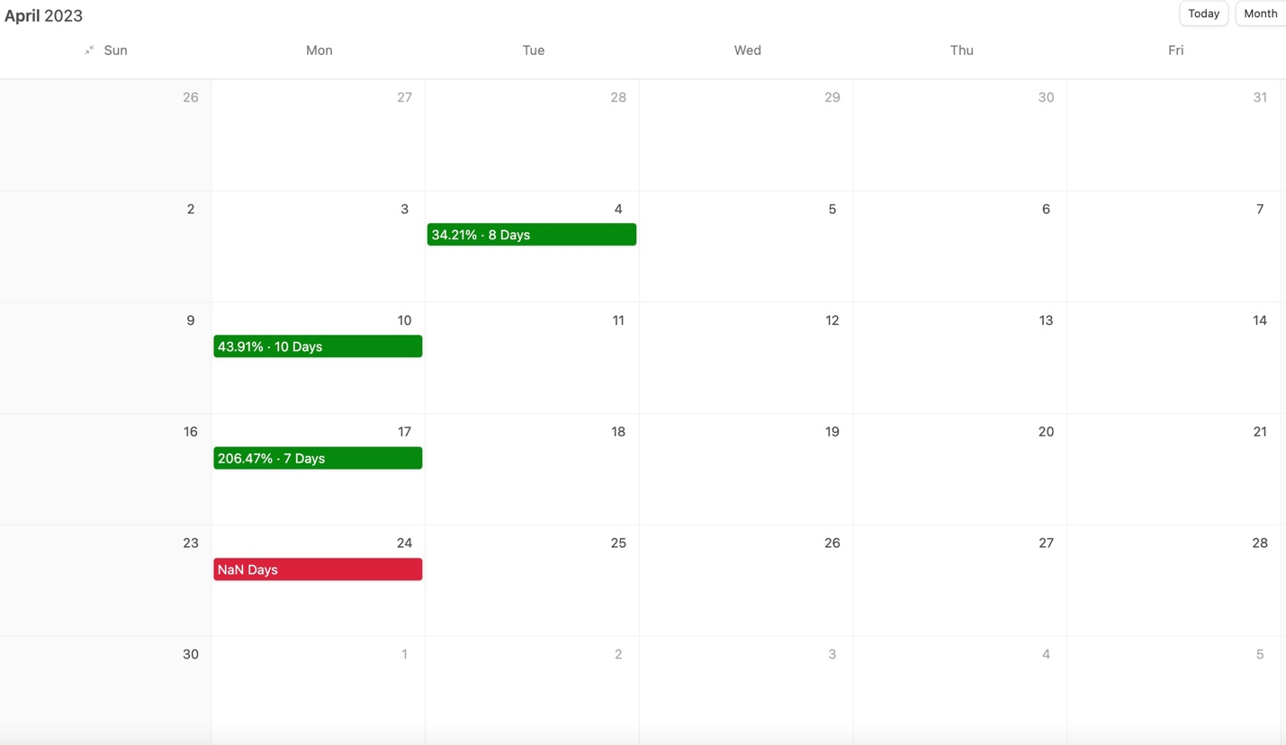
Three out of five weeks on Microsoft in May...
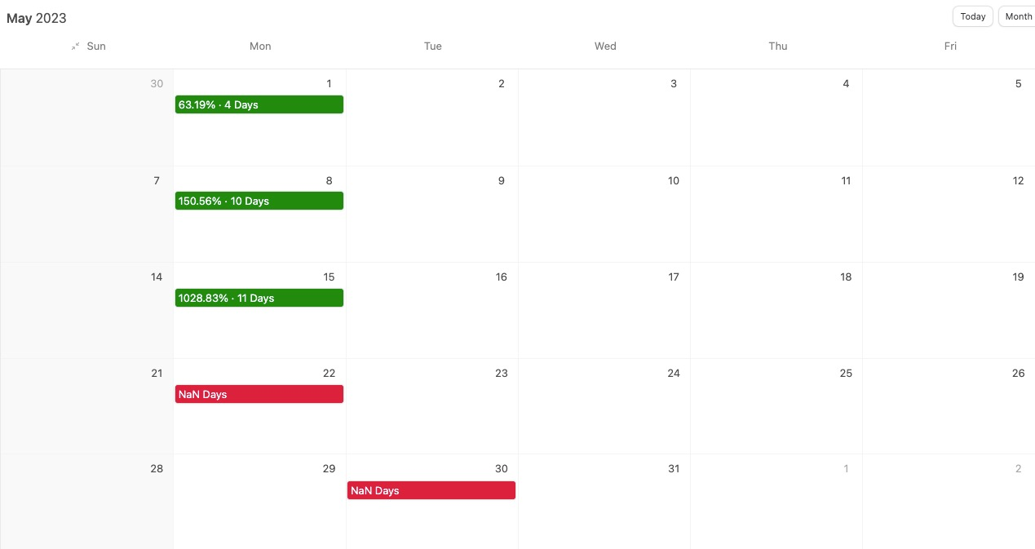
And three out of four on NVDA in June.
[CALENDAR]
Host: Look at some of those gains along the way! This strategy could have produced wins as high as...
    - 85% in three days
    - 206% in seven days
    - 150% in 10 days
    - And of course, I see those 1,028% and 2,614% gains that you mentioned earlier.
That’s extraordinary profit potential.
Nate, I did notice there were some weeks that didn’t seem to have any trades.
Nate: Look... I’m very careful about managing risk.
There will be occasional weeks when I don’t like the options available, so I will not make a trade.

To the best of my ability... I want to avoid possible losses for my members.

Now... am I perfect? Of course not.

Losses happen... any trader knows that.

But it’s my job to try to make the losses as small as possible... and as rare as possible.
And even when we analyzed this strategy with recent market data... there were times when it would have skipped a trade.
So that’s why it’s important to follow the system... and not force a trade when the odds are not squarely in our favor.
What it boils down to is...
Each month, I look for the one stock that’s just crushed earnings.
Then, each Monday, I look for the option with the most upside potential.
And then, if I find one that fits my criteria, I recommend one trade each week.
That’s it.
All you have to follow is the one ticker each month.
And here’s the best part of this strategy... the time it takes to implement my One-Ticker Payouts strategy is so minimal...
That you get all the time in the world to enjoy life... the way you want!
Imagine making one quick trade during lunch on a Monday and moving on with your week.
No one should have to live their life chained to the news or some stock scanner.
Host: Making money during lunch... I can get behind that!
Nate: Remember... this Earnings Profit Surge phenomenon that I base my strategy off of has been studied by researchers from Harvard, the Fed, the SEC and many others.
Host: And you’re doing all of this by ignoring 8,251 of the 8,252 publicly traded stocks.
Nate: That’s right. The beauty of only focusing on one stock each month is it doesn’t matter what the rest of the market is doing.
“What Happens When the Market Crashes?”
Just a few minutes ago...
I shared how One-Ticker Payouts could have triggered a trade three out of four times on KEY in February, which I’m sure many remember as a terrible month for the market.
Host: I noticed that...
Investors could have seen as much as 276% on a single trade.
Nate: That’s right... all while the Dow fell 1,000 points due to banks collapsing and recession fears.
That’s what’s great about this strategy. It works in all environments.

It even works when the market does nothing!
Look at the S&P 500 in May of last year...

It grew 0.01%...
The closest it’s been to zero in a single month since June 2006.
Host: One-hundredth of a percentage point is about as sideways as it gets.
Nate: Yet my One-Ticker Payouts strategy still could have worked wonders for investors.

The one ticker to follow that month was SNAP.

It produced gigantic winners three out of four weeks during that flat month.
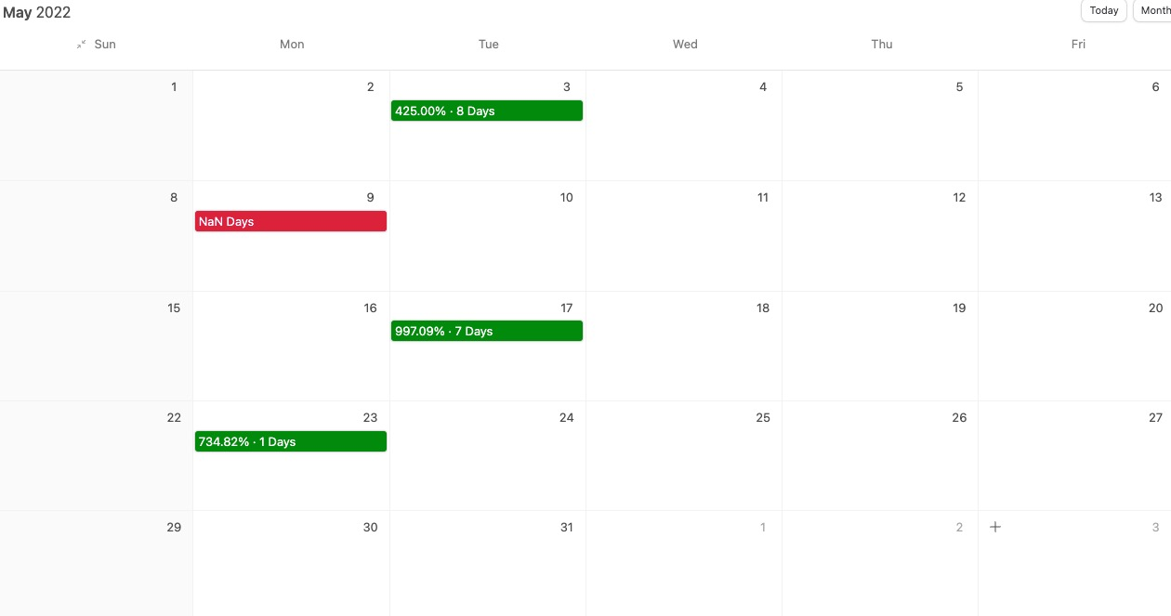
425% in eight days...

997% in seven days...

And 734% in one day.

Host: So you’re telling us that $10,000 into each of those three trades...
Could have turned into $245,600 if you were lucky enough to nail all of them with expert timing.

Nate: You can see why I love teaching people this strategy.
I’ve shown nearly 50 recent examples of how well this strategy can work in any market.

The data speaks for itself. A run like this stands out.
It’s right there for the viewers at home to see.

It’s my mission to help everyday people make a lot of money in the markets.

Host: Let’s take a look at what some of your happiest VIP students have said about following your premium services.
Phil writes...
“Nate thanks for the CVNA trade. took 450% win [within a few hours]. Happy days!”
Another user wrote...

“For those who are contemplating whether or not to join...I can share with you just Day 1 already paid for my subscription 10X! Nate is a really great teacher!”
– Orovena
And Steve wrote...

“Not to brag but because of Nate I was able to hit my first ever 1000% gain after just 5 days. Closed while on the golf course yesterday.”

Now, not all of your readers have seen results like these. But anyone can see you’re the kind of person that people can lean on when trading isn’t going their way.
That’s what being a great teacher is all about.
Nate: Thanks, [Host]. Now more than ever, people need a new approach to the markets.

Because the old ways just aren’t working anymore.

A BRAND-NEW WEALTH-BUILDING INITATIVE
Host: And after seeing your One-Ticker Payouts demonstration today... it sounds like people need your strategy NOW!
Nate: I’m dedicated to helping people weed out the noise...
Eliminate 8,251 of the 8,252 publicly traded stocks...
And master this One-Ticker Payouts strategy.
// Transition for the control (Variation without “Nate’s Current Ticker Of The Month” Section) //
That’s why, starting on Monday at noon, I’m giving people the chance to trade One-Ticker Payouts with me LIVE...
Every single week.
//End Transition for the control//
// PICKUP SECTION FOR TEST (VARIATION 1) //
And to help you get started, I’m even going to give you the ticker I’m trading this month!
Host: That’s very generous of you, Nate.
*Turn to Camera*
Folks, if you’re watching at home...
Below, there is a button that links to a new webpage – that’s where you’ll find Nate’s ticker for this month.

[YES, I WANT NATE’S ONE-TICKER PAYOUTS]
After you click that button and the new page pops up... our conversation here will continue.
On the next page, you’ll find the current stock that Nate is trading this month.
There’s no risk to click... you won’t lose your place here.

The page will open in a new tab so you won’t be bumped out of this broadcast.
Nate: And listen...
On that new page, you’ll also notice that you have the exclusive opportunity to trade One-Ticker Payouts with me... LIVE every week!
// END PICKUP SECTION FOR TEST (VARIATION 1) //

One-Ticker Payouts LIVE!

Host: You were telling me about this before the interview...
Can you tell the viewers what exactly One-Ticker Payouts LIVE is?
Nate:

Sure... Every Monday I will be broadcasting LIVE at noon to reveal my One-Ticker Payouts game plan for the week.
I’ll be talking about...
1. The exact ticker we’re trading

- The exact option contract we’re entering
- How to enter the option in your brokerage account (I’ll explain it in a very simple and easy-to-understand way)
- And most importantly, how we plan to exit the trade for our maximum payout.
This isn’t going to eat up most of your day, either.
We’re talking just 30 minutes or less... one day per week.
Host: Just 30 minutes?
Nate: Like I mentioned earlier... you can literally watch while having lunch...
And if you can’t make it... you can always catch the recording later.
Host: When you’re talking about trades with this kind of potential...
30 minutes per week doesn’t seem like much at all.
But I have another question: On those weekly calls, the viewers will know what ticker you’ll be trading and the reasons you’re targeting it as the one ticker to focus on... right?
Nate: Exactly. There won’t be any surprises there.
We’re only trading one ticker each month...
Host: The most stressful part of trading for anyone is finding a winning stock...
And yet, you’ve eliminated that stress and all of the noise that comes with picking stocks.
Nate: Exactly... My sole focus is profiting from the top winning stock that is benefiting from an Earnings Profit Surge.
One ticker...
One trade per week...

For one month.

It’s that simple.
Host: And the payout opportunities you’re looking at are tremendous.
Nate: They are.

Some of the gains we’ve uncovered looking back at the one-ticker strategy are spectacular...

Like the 274% gain in 11 days on Coca-Cola...

Or the 313% gain in 10 days on DraftKings...

And I still can’t get over that extraordinary 2,614% in 10 days on AI.

[Graphic]
[Graphic]
[Graphic]

Look, [host name], I hope by now people are getting really excited about this brand-new way to make profits.

[Turn to single cam]

Friends, all you’ve got to do is tune in to my livestream, One-Ticker Payouts LIVE, every Monday at noon.
Best of all, this weekly live event is going to be included free for all new members of my brand-new wealth-building initiative...
Which you can join right now using a special discount for Founding Members.
Host: What is this initiative precisely?
Introducing Nate’s Brand-New Research Service:
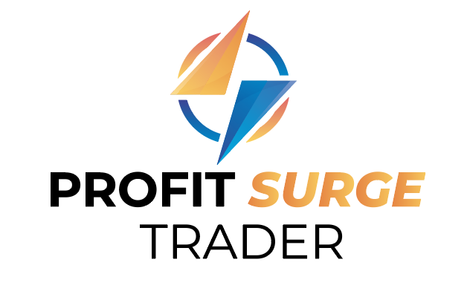
*PRODUCTION... Can we animate the logo when it enter the screen? Maybe have the bolt spin then have a “shine” quickly past over the word surge? If it’s not easy then no worries!*

Nate: I’m launching a brand-new research service dedicated to helping people target One-Ticker Payouts over and over...

The name of my new service is Profit Surge Trader.

We named it after the Earnings Profit Surges that make these One-Ticker Payouts possible.

The service is designed to help you try to make big money every week.
Host: All using just one ticker.
Nate: Exactly.
Host: So let me make sure I understand this correctly...
Every month, you’ll zero in on a single ticker...
Every Monday at noon, during your One-Ticker Payouts LIVE stream, you’ll reveal your exact game plan for your weekly trade...
And then at the end of the month, you’ll restart the process and recommend a brand-new ticker for the next month.
Nate: That’s right, but with Profit Surge Trader, it doesn’t just stop there...
I’ll also deliver instant trade recommendations whenever I buy and sell...
Via both email alerts and lightning-fast push alerts to your mobile phone.
Host: Each and every week throughout the year?
Nate: Yes. Look, my goal is to reveal the One-Ticker Payouts trade on the livestream...
So viewers can look over my shoulder and watch the entire trade as I make it.
But if it’s more profitable to wait a few hours or even until the next morning...
Then, of course, my game plan will be to wait until the most profitable moment. And I will send out an email with exact instructions when it’s time to make the trade.
The goal of my One-Ticker Payouts is to make as much cash as possible every week using just one ticker.
But these trade alerts will keep you plugged in through the entire trade.
Host: So you’ll send alerts whenever you buy and sell your One-Ticker Payouts recommendation for the week?
Nate: Exactly. And I’ll also send additional updates on the recommendation as needed.
You can expect complete transparency.
You’ll get to join and interact with me each and every Monday at noon as I break down my game plan...
You’ll get email and mobile updates whenever I enter and exit a trade...
AND on top of that, you’ll be able to see what’s active in my portfolio 24/7 in case you’re traveling or you miss a trade.
Host: Look, obviously, past performance doesn’t guarantee future returns. And as you mentioned earlier... all investing involves risk.
But I gotta say, Nate, this research service seems like it can be an absolute game changer.
*TURN TO CAMERA*
As you saw with these examples over the past few months... the results can be extraordinary.
And Nate is going to walk you through this strategy LIVE... each and every week.
Remember, this is one of his favorite strategies that he used to turn $37,000 into $2.7 million.

*TURN BACK TO NATE*
Nate, it sure seems like you really checked all the boxes when you were putting this new service together.
You’re giving folks at home everything they need to be successful at profiting from One-Ticker Payouts.
Nate: And that’s not even everything they’re going to get!
Host: Hold up... You mean there’s more?

LIMITED-TIME
Founding Member Bonus:

Nate: Yes! I put a few special bonus reports together... exclusive for people who join as Founding Members today.
They’re designed to help fast-track your success even more!

[REPORT GRAPHIC HERE]
The first report is called “One-Ticker Payouts: The Profit Rule Book.” It covers everything you need to know about my One-Ticker Payouts strategy.
You’re going to learn exactly how small moves in a stock can transform into MASSIVE gains.

This reports even dives into the many studies that prove the power of the Earnings Profit Surge...
It’s all spelled out in plain English.
Whenever you’re in doubt, you can access this exclusive report at any time for quick answers.

Host: So basically, it’s a cheat sheet to One-Ticker Payouts every week?

Nate: Exactly.
I’m also including a second report called “The $2.7 Million Profit System.”
This report goes over exactly how I turned $37K into $2.7 million.
It’s my ultimate secret that will change the way you aim to grow your money.
Host: I need to get my hands on that!
And you mentioned that Founding Members were going to get one more report?
[REPORT GRAPHIC HERE]
Nate: Yes!
Finally, I know that some people watching are new to trading options...
And that’s perfectly fine, because I put together a third report called “How to Profitably Trade Options (the Easy Way).”
[REPORT GRAPHIC HERE]
It covers everything you need to know about trading options profitably...

How to set up an options trading account (in case you don’t have one yet)...
How to minimize fees down to $0...

And how to minimize risk.
And look...
You can certainly be profitable with One-Ticker Payouts simply by investing in the stock alone...
But as I demonstrated earlier...
With options, the earnings potential is just far too massive to pass up.
We’re talking about the difference between an 8% gain and an extraordinary gain of as much as 1,028% over the same time frame... which, frankly, most investors might never get a chance to see in their lifetimes.
And with this new report... you’ll learn how to trade options successfully.
All three of these reports are yours when you become a Founding Member of Profit Surge Trader.
Your Special Founding Member Deal:
Host: So folks... this is your exclusive invitation to become a Founding Member of Nate’s brand-new research service, Profit Surge Trader.
One year of Profit Surge Trader retails for just $997.

That’s a far better deal than some of the $5,000 trading services you’ll find out there.
Nate: And today... I’ve put together an even better price that’s exclusive to Founding Members.

Host: Oh yeah?
Nate: Look, I get people are struggling right now. And even today, we talked about just how bad things could get over the next couple of years.
I really believe that this cutting-edge service can add real, meaningful profits to people’s lives every week.
That’s why, if you join as a Founding Member... you can get access to Profit Surge Trader for an entire year for just $79.
Host: Just $79??? That’s more than a $900 discount.
Nate: I’m dead serious. I’ve done everything I could do to make this service the biggest bang for your buck.
Host: You can say that again...
Nate: I know the struggle. When I was still a construction worker, I didn’t have much cash. I get it.

$79 is essentially the cost of getting this video in front of you. It’s the lowest price my publisher will allow – they have to keep the lights on too.

So if the cost is the only thing between you and a better life...

I’m more than happy to offer this discount.
Host: Nate is going to be trading LIVE 52 weeks out of the year...
Every Monday at noon...
And each of those weeks, you’re going to get a trade recommendation.
If you do the math... that comes out to just $1.52 per week!
Nate: There is a catch, though...
If you want this deeply discounted price...
And the three exclusive reports I put together...
You have to be a Founding Member.
My publisher isn’t going to make this offer available for very long.
And once this offer is closed, the pricing is out of my hands.
Host: You heard it from the man himself! Don’t wait, folks.
Click on the button below to join now. It’s right below this video.
[YES, I WANT NATE’S ONE-TICKER PAYOUTS]
Here’s a recap of everything you’re going to get today.
You’re going to get one full year of Nate’s weekly research service, Profit Surge Trader...
[WITHIN BUNDLE HIGHLIGHT GRAPHIC OF One-Ticker Payouts LIVE]
Which includes an invitation to join Nate every Monday at noon on One-Ticker Payouts LIVE.
[WITHIN BUNDLE HIGHLIGHT GRAPHIC Ticker of the Month]
You’re also going to receive Nate’s “Ticker of the Month”...
[WITHIN BUNDLE HIGHLIGHT GRAPHIC OF TRADE RECOMENDATIONS]
And of course, trade recommendations that he sends weekly via email.
Nate: That’s right. I do my best to find the best setups... and some weeks, I’ll even throw in a bonus recommendation if I think it can help my members make some extra money.
But there might be a rare week here and there that the setup doesn’t work. I’m never going to purposefully send out a bad recommendation.
Host: To top all that off...
As a Founding Member, you’re going to be receiving all three of his exclusive reports...
[WITHIN BUNDLE HIGHLIGHT GRAPHIC OF TRADE RECOMMENDATIONS]
"One-Ticker Payouts: The Profit Rule Book”...
“The $2.7 Million Profit System”...
AND...
“How to Profitably Trade Options (the Easy Way)”...

All for today’s special Founding Member price.
PLUS, it’s backed by Nate’s 365-day “No Questions Asked” Money-Back Guarantee...
Isn’t that right, Nate?

*DESIGN THIS AS A CERTIFICATE*
365-Day “No Questions Asked”
Money-Back Guarantee
If for any reason Nate’s Profit Surge Trader isn’t for you... simply call his VIP concierge team within your first 365 days, and they’ll refund your subscription entirely.
No questions asked!
Nate: Exactly right. I’ll even do you one better and let you keep all three Founding Member reports. They’re my gift for giving my new service a try.
Host: With a strategy this powerful...
One that gives you the ability to target massive gains each week...
AND not to mention direct access to Nate himself every Monday at noon...
I think people are going to want much more than to simply give this service a try.
You’ll want to get your hands on as many of these One-Ticker Payouts as you can.
Don’t let this opportunity pass you by.
Remember, as Nate mentioned...
You must act now to secure this special Founding Member deal...
Including the massive discount that Nate was able to get you today.
That’s all the time we have for today.
I want to thank Nate Bear for joining us.
After chatting with him, it’s no wonder he was able to turn $37K into $2.7 million in just four years.
And I want to thank all of you for watching today.
If you’re ready to join Nate every Monday at noon... click on the button below.

[YES, I WANT NATE’S ONE-TICKER PAYOUTS]
You’ll be taken to a secure order form where you can complete your order...
And within minutes, you’ll have access to all his latest recommendations and all the perks that he’s put together for you today.
Nate: Thanks for having me, [Host Name], and thank you to everyone watching today.
I’m looking forward to meeting you virtually this upcoming Monday!
[YES, I WANT NATE’S ONE-TICKER PAYOUTS]

-

# of stocks per FinVIZ : https://share.getcloudapp.com/mXuGZg7Q
All historical trade examples (AND backup) can be found here unless otherwise noted: https://airtable.com/shrcgD7NDMeDzxSTL
Harvard Study (involving PEAD) https://www.hbs.edu/ris/Publication %20Files/Retail%20Investors'%20Contrarian%20Behavior_9a48fa2d-ea21-44f3-9a75-b351ec8593d7.pdf
Duke Study https://dukespace.lib.duke.edu/dspace/bitstream/handle/10161/6964/SamiSaifan_HonorsThesis_v22.pdf;jsessionid=716EBB5A32885FC70F8785CAC8CF23FD?sequence=1
Philly Fed Reserve Study https://www.philadelphiafed.org/-/media/frbp/assets/working-papers/2021/wp21-07.pdf
Paycheck to paycheck: https://www.cnbc.com/2022/10/24/more-americans-live-paycheck-to-paycheck-as-inflation-outpaces-income.html
Cambridge https://www.cambridge.org/core/services/aop-cambridge-core/content/view/5EB217BB68B5FB054FE38541BAAC4679/S0022109022001181a.pdf/div-class-title-pead-txt-post-earnings-announcement-drift-using-text-div.pdf
Jonathan Sokobin was an employee of the SEC when he reported this https://www.biz.uiowa.edu/faculty/jgarfinkel/pubs/drift_JAR.pdf
UCLA - https://www.anderson.ucla.edu/documents/areas/fac/accounting/drift503.pdf
University of Iowa/SEC - https://www.biz.uiowa.edu/faculty/jgarfinkel/pubs/drift_JAR.pdf
Syracuse Study: https://surface.syr.edu/cgi/viewcontent.cgi?article=1002&context=acc
Journal Of Financial Analysts - https://www.researchgate.net/profile/Narasimhan-Jegadeesh/publication/228260286_Post-Earnings-Announcement_Drift_The_Role_of_Revenue_Surprises/links/0deec53500e1123c17000000/Post-Earnings-Announcement-Drift-The-Role-of-Revenue-Surprises.pdf
Columbia - https://www0.gsb.columbia.edu/mygsb/faculty/research/pubfiles/3737/zhang.pdf
https://diginole.lib.fsu.edu/islandora/object/fsu:168588/datastream/PDF/view
Average market return is about 10% per year. https://www.nerdwallet.com/article/investing/average-stock-market-return#:~:text=stock%20market%20return%3F-,The%20average%20stock%20market%20return%20is%20about%2010%25%20per%20year,a%20benchmark%20for%20annual%20returns.
Gas Prices: https://www.eia.gov/dnav/pet/hist/LeafHandler.ashx?n=PET&s=EMM_EPM0_PTE_NUS_DPG&f=M
SNOW Earnings Surprise: https://share.getcloudapp.com/P8uXlJnl
SNOW June 1 2022 - 126.15% June 30 173.26%....
https://sigarra.up.pt/fep/pt/pub_geral.show_file?pi_doc_id=334669 “Singal (2006) also mentions some factors that could explain the anomaly, such as information cascades where earnings announcements are immediately followed by analyst reports that will further push the price change and solidify the price momentum, strategic trading by institutional investors, whom can influence price changes due to the sizable trading volume these investors can partake “
From Airtable - 106% (ABBV 3/27), 206% trade (LULU 4/17), 332% trade (AI 1/9) 2,614% trade (AI 1/24)
https://www.fool.com/investing/2023/01/26/2022-was-the-worst-year-since-1937-for-this-invest/
AI and the market - https://www.bloomberg.com/news/articles/2023-05-12/ai-frenzy-accounts-for-all-of-s-p-500-gain-in-2023-socgen-says#xj4y7vzkg
GILD PRICE. - NOV 1 - $79.36. NOV 30 $87.83. – 10% Gain
Combined all 4 stock trades would have ben 17.92%
AI Month of January Jan 3rd - $11.07 Jan 31 $19.85 = 79% move
S&P500 Monthly returns: https://ycharts.com/indicators/sp_500_monthly_return
Same Y Chart Link. I signed up for free trial to access past 2019. June 2006 was another 0.01% momnth https://ycharts.com/indicators/sp_500_monthly_return

