Multimillionaire Pro Trader Nate Bear Uses AI to detect

#1 Trade To Make On Monday June 2

This unique (yet simple) trade beat the markets by 1,700% and achieved a 100% win rate to start the year…
And now his new AI is finding these setups faster than ever. Don’t miss Nate’s play on Monday, [Date]. See details:

Multimillionaire Trader’s NEW AI Detects Profit Surge
On Monday [Date]
Everyday Americans had the rare opportunity to beat the market by 1,700% with a 100% win-rate during the first part of the year…

On Monday, it’ll be easier than ever thanks to a powerful new AI. See the details NOW:

New AI Detects Profit Surge In:
[TIMER]
See how everyday Americans beat the market by 1,700% and notched a 100% win rate during the first part of the year:

Bill (Host):
Hi, Bill Tucker here...
Today I have an urgent update about a story that I first broke last August.

The story was about an everyday man...
And a unique new method for making serious money despite rising prices and all of the market's challenges.

It involved a simple weekly trade that produced big gains for everyday Americans...
Over and over again.
Millions of people saw my story and wrote it off...

To be honest, even I was skeptical.
But over 15,000 people gave it a real shot.

And our team contacted them to see what’s happened since they first attempted this unique strategy.

I wanted to know…

Was it a total failure?

Or…

Was it a roaring success?

Today, I’m going to share the results with you.
Including every single trade since I broke the story.

But first I want to highlight

that, during a FREE special online event he hosted for his followers...

The man who created this strategy closed a real-money 1,129% gain within just 2 days LIVE on Camera...

[SHORT 2-3 second video clip from Nate’s win – Miles has]
1,129% is a rare feat that many investors won’t accomplish in their entire lifetime...
Let alone in 2 days...
Or with the pressure of thousands of people watching them...

Look at what his followers experienced:
Like Ed who made a 1,230% gain...
Or Kirk who made 1,467%...
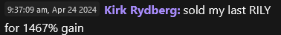
Or how about Quinton, who gets this..
Made an even bigger 1,987% gain...

That would have been enough to turn $10,000 into $198,700 in pure profit on single 2-day trade!

Clearly, this everyday man has delivered when it came to big gains.

But what about the overall performance of his weekly trading strategy?

I looked into that next… and it was equally eye-popping.
All told since inception...
It’s beating the market by nearly 4x...
With 86% total return and 81% win rate since inception...
And during the first quarter of this year he actually was perfect...
With a total return of 192% ...
That outperformed the market’s 11% return by 17X during that time period.
Anyway, you look at it...
This strategy has proven to SMASH what most investors hope to make in an entire year...
In just a fraction of the time...

That’s why I decided to come back and do this follow up story.

I want to share his strategy with the world once more.

And our guest even has a special surprise for our viewers today.

His winning trading method is being taken to another level now thanks to an incredible breakthrough in artificial intelligence.

But before we get into that, let me start by introducing you to the man behind this strategy.

Everything that you’re going to discover today...
Starts with a former construction worker who most famously turned a small $37k account into a real $2.7 Million fortune in just 4 years...
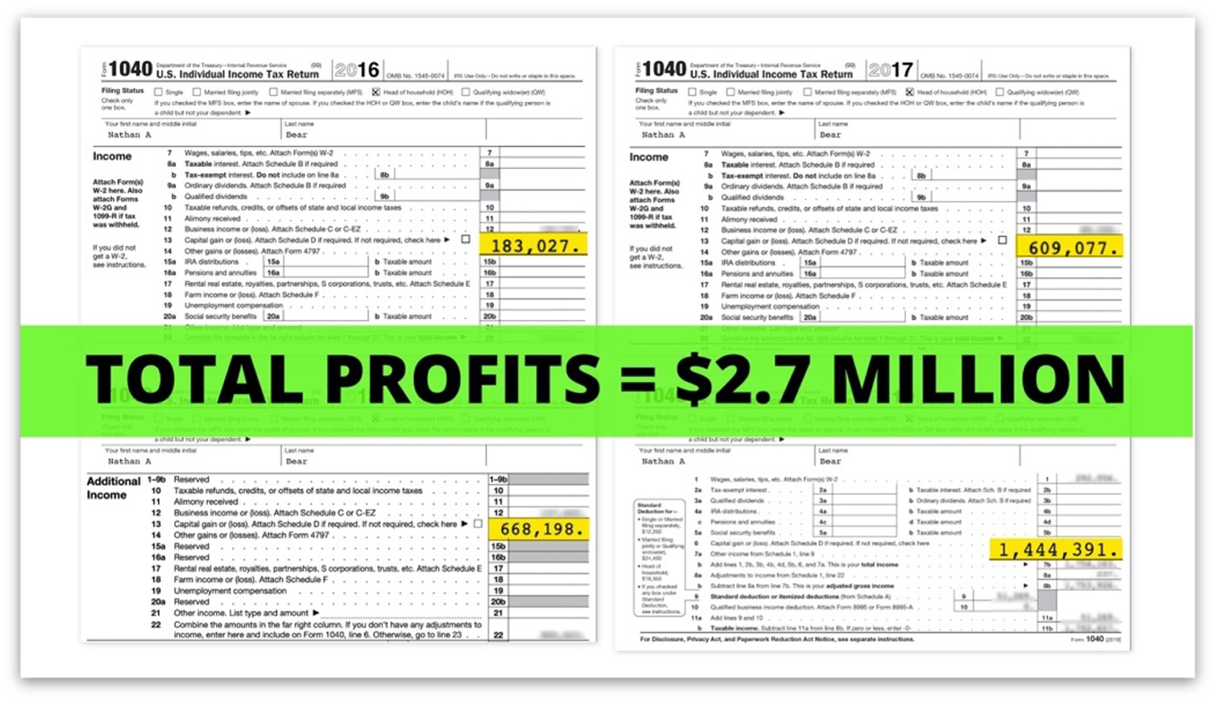

That’s a 7,197% return, which we verified with tax records and brokerage statements.
And no...
He wasn’t some Wall Street insider in a pinstripe suit...
Nor did he get rich from buying and holding some expensive tech stock like Amazon, NVDA or Apple for decades.
Nor was he born into generational wealth...
Yet that’s exactly what he is creating for his family, thanks to the power of successful trading.
His name is Nate Bear and he lives in the small-town Alpharetta, Georgia.

Population 67,000.
… 1,000 miles away from Wall Street.
Nate has gone from trading at home in-between construction jobs...
To become one of the most sought-after traders on the planet.

Thousands of people across America now follow his recommendations and market insights every day...

Those who made the smart decision to follow him and his winning strategy...
Could have turned $10,000 into...
$20,200 in 6 days...
*Show Brokerage Account Growing $10k -> $20k*
$26,389 in 2 days...
*Show Brokerage Account Growing $10k -> $26k*
Or even $23,280 in just a few hours...
*Show Brokerage Account Growing $10k -> $23k*
These are just a few of his recent REAL money-winning trades.

In fact, even if you had put just $5,000 into each of Nate’s 75 trades since August, 2023…

Wins and losses….
You could have walked away with $54,450 in pure profit.
But look - I know that doubling, tripling or 10x’ing your money within a matter of days (or even hours) might sound crazy...
And you’re right to be skeptical.
I certainly was when I first interviewed him last year.
But when I saw – in real time – how effective this trading approach has been... I was blown away.
I knew I had to get the full follow-up story.

I also needed to find out exactly how Nate plans to use AI to accelerate the profits generated by this powerful market force…

Which in Q1 was crushing the market by 17x with a whopping 192% return.
I’m thrilled he agreed to sit down with me and answer my questions...
So let me introduce the one and only Nate Bear.
*TURN TO NATE*
Nate, welcome! Great to see you again.
Nate:
Likewise, Bill. Thanks for having me.
Bill: So while we were setting this up... your team told me that you have an exciting announcement about how everyday Americans can target more profit thanks to the power of AI?
Nate:
Yeah, what we’ve done so far has worked incredibly well.

But I’m excited to demonstrate how AI is going to take my powerful trading strategy to the next level.
Let me start at the beginning though for our new viewers.

Everything I do revolves around a powerful market force that isn’t talked about by mainstream news outlets ...
Yet...
It’s been studied by the likes of Harvard, Duke, the Federal Reserve, and even the Securities and Exchange Commission...

And it’s proven to be just about he most effective and profitable approach to the markets I’ve seen.
In short, it allows regular investors the chance to collect massive payouts from stocks that are trending up… each and every week...

All thanks to one rather strange anomaly in the markets.

This anomaly appears each and every week.

And its something that we can repeat over and over.
In fact, there is an opportunity to collect a massive payout THIS upcoming Monday...
Bill:
Well, before we get into that, I want to make sure that everyone watching understands just how lifechanging this strategy has been for folks.
As I just told the viewers watching...
*Point to camera while looking at Nate*
We reached out to members of your private community to ask just how this strategy has impacted them over the past few months...
And we literally got HUNDREDS of responses.
In fact...
The amount of responses that we received was a record for any survey that we’ve ever sent out...
That’s how enthusiastic people were to share their success stories...

Like David who wrote...

“I just turned 80... I resigned myself to working until my death, with no hope of paying off my debt and leaving my wife who is 20 years younger with anything. Then I came across Nate's service and story. Frankly, it gave me hope. I have experienced more success with Nate and his community more than anywhere else.”
Or there’s Stewart L. who wrote...
“Nate has changed my trading life, from bouncing back and forth... to now up over 600% in 6 months.”

600% in six months is simply extraordinary.
Or Tony who wrote in
“Account is growing not losing. Retired and love trading. Having a 89% win rate from what i have learned. A+ [Nate is a] great teacher”
And who can forget Laura who wrote in:
“Made 1100% on Rily [in 2 days] and turned a $1300 account into $45,000 [in 4 months] since I joined with three losses”
Let me repeat that...
$1,300 into $45,000 in just 4 MONTHS....
And those are just a few of the hundreds of responses that we received...
Nate, I bet you feel great reading stories like this and knowing that you’re not only helping people master trading...
But you’re also making a real impact in people’s lives.
And here’s the thing…

Nate’s strategy doesn’t take doesn’t thousands of dollars to get started
Nate:
That’s exactly right.
And that’s why I decided to reveal this game-changing strategy to everyday folks...
It’s why I created a special community focused on trading this one powerful market anomaly...
And it’s why I developed new AI-Powered software to help me find these trade setups faster than any human trader alive…

Making it easier than ever to achieve success.
Bill:
So let’s jump right into it...

I want to see how AI is involved… But first I want everyone to understand how your trading approach works.

Can you explain to everyone exactly what this market anomaly is and how it works?

How To Trade The
“Earning Profit Surge”
Nate:
Certainly...
It all starts with earnings season…

When everyone in the market gets a sneak peek into how publicly traded stocks are performing, usually every 3 to 6 months.
Think of it like a stock’s report card...
And during earning season, everyone with an opinion goes on TV and the internet to make their predictions on how they think a company is performing and what they expect will happen next...
Bill:
Yeah, everyone always seems to be a stock market expert when earning season comes around...
Nate:
Exactly...
And frankly... it’s complete noise.
Because here’s the thing...
Contrary to what most investors assume...
When a company reports good earnings...
It’s FAR from a guarantee that the stock will go up.
In fact, we see this all the time...

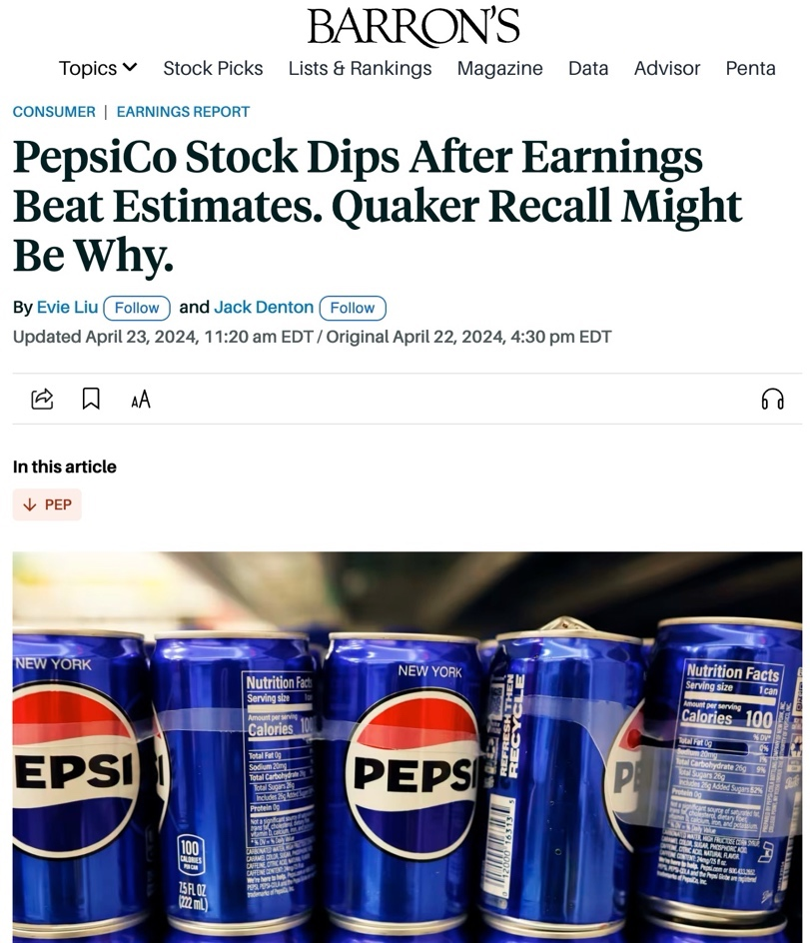
Companies come out with a gangbusters earnings report...
And beat everyone’s expectations...
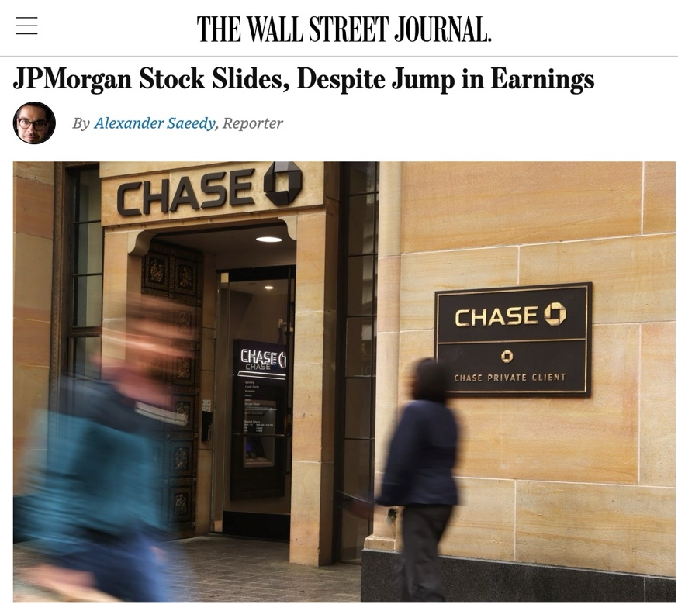
Yet still...
Despite having a positive report card...
The stock price still drops!
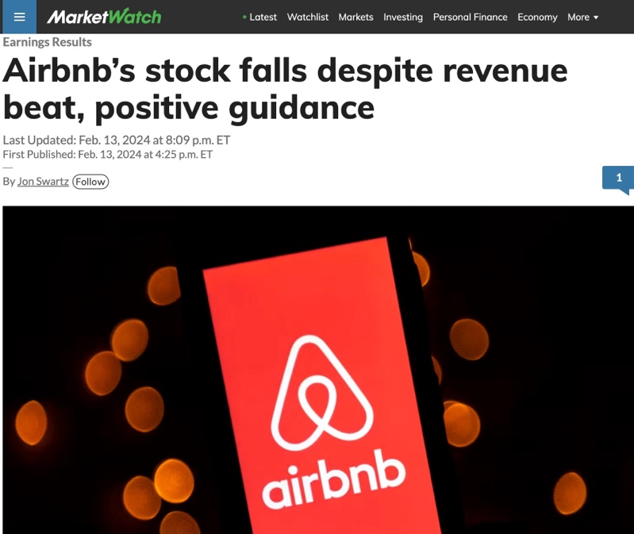
Think of it this way...
Imagine coming home from grade school back in the day with an A report card...

Yet your mom still grounds you because it’s not an A+...
That’s what the market does to these companies all the time...
And if you’re a shareholder it’s incredibly frustrating.
Bill: You bring up a great point and that’s an excellent analogy.
There are a lot of reasons that this happens...
Maybe there was one piece of information that scared investors...
Or maybe there was some other bad news that the company tried to sneak into their earnings release...
Nate:
Yeah, there are dozens of reasons why earnings announcements don’t work out the way you would expect.
In fact...
When I first started trading...
I once had a single trade blow up half of my entire trading account...
It was a silly earnings play on Apple that I’d heard somewhere on the news.

I expected to hit it big, but the opposite happened.
And I lost around $15,000...
Which was a lot considering I was in the construction industry at the time.
Bill: You’re not alone on that though Nate.

On May 6, CNBC published an earnings trade on Disney, shortly before Disney reported its earnings later that same day.

Sure enough, CNBC’s proposed trade dropped 50% before noon the next day!

So there’s plenty of people who can relate to getting hurt playing earnings.

Nate: For me personally, my failed earnings trade on Apple inspired me to change my entire approach to investing more than anything else.
I went YEARS without making any trades related to company’s earnings. I stopped trusting all of the analysts and financial news hosts out there.
Because at the end of the day their job isn’t to look out for your or my best interest...
All they care about is publicity, entertaining viewers, and gaining more advertiser dollars.
To hell with Mainstreet investors.
Bill:
So because of your horrible experience losing half of your account thanks to bad earnings news...
You say you went off and looked for a new approach? What did you do differently?
Nate: I came across some unique research on a strange market phenomenon that I call the “Earnings Profit Surge”...
There was a Federal Reserve study on it… and one by the SEC.
It had to do with stocks that go up on the day of the earnings announcement.
But they don’t just go up that day.
Instead, they go up in the weeks AFTER earnings come out.
In some cased they continue to surge higher for months after earnings.
Diving in deeper, I found that the Earnings Profit Surge has been studied by researchers from the likes of Harvard, Duke, Cambridge, Notre Dame, UCLA and Syracuse.

They all found that when certain stocks do indeed surge up after a big earnings win...
They continue to trend higher for the foreseeable future.
Bill: So what you’re saying is that you don’t need to guess beforehand which direction earnings will go...
But rather you can play it AFTER earnings are already out and STILL make huge profits?
Nate: That’s exactly right. When I’m playing the Earnings Profit Surge... I’m ONLY targeting proven earnings winners.
I’m eliminating the guessing.
Check this out...
This is a historical example from NVIDA’s Q1 earnings in 2023 that my research team pulled before I revealed this strategy last August...
I love this because it’s probably the most famous profit surge in recent memory.
Here we see AI-leader NVIDIA gap up immediately after their big earnings surprise...
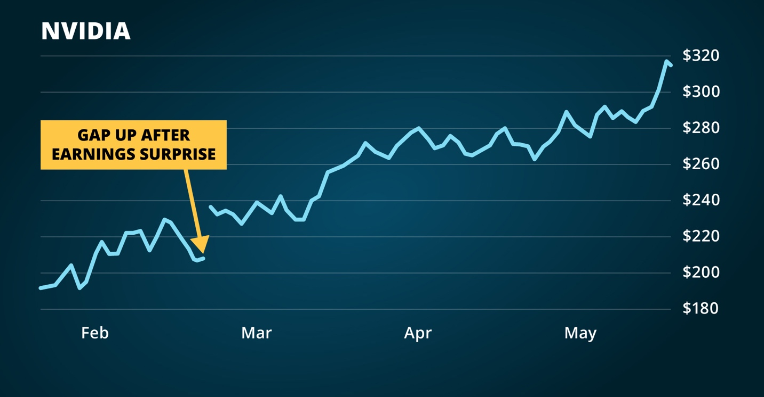
Most people would feel they missed the boat after Nvidia’s big jump.
But actually… look at what happened afterward.
Nvidia’s Earnings Profit Surge continued driving the stock higher for months afterward.
In fact, when we zoom out...
You can see that investors who simply bought and held the stock could have made as much as 35% over the next three months… even if they bought AFTER earnings already came out.
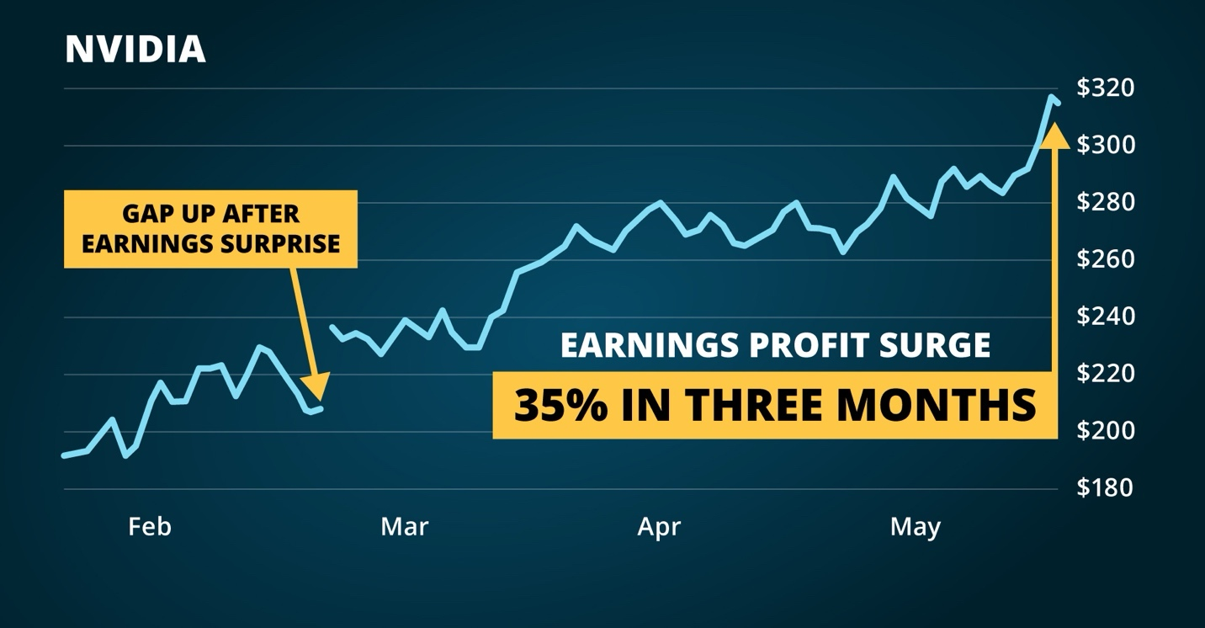
But here’s the thing...
While 35% in three months would be solid for most investors...
There was a special way to make FAR MORE money on Nvidia’s move.
And what I’m about to show you now is how I was perfect trading in the first quarter.
And its how I turned $37K into $2.7 million in four years.
Let me show you how it works.
Let’s zoom back in to that Nvidia chart and focus on just the first month after its earnings announcement...
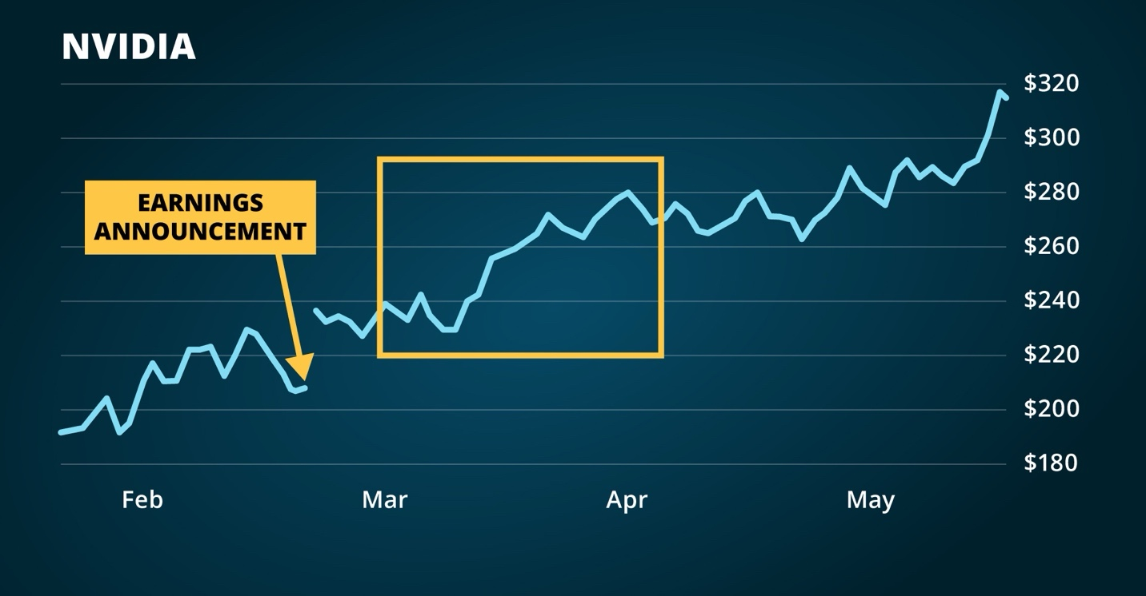
Let’s say you made a special type of trade on March 6 to benefit from Nvidia’s Earnings Profit Surge.
With the right timing, this trade would have made up to 443% in just 11 days.
Far more than 35% in three months.
Bill:
Did you say 443%?
Nate:
Yes, but we’re not done yet...
This is where it gets really cool.
Because you can make the same trade every single week.
In the case of Nvidia… just one week later, a trade could have made 543% in just nine days.
The next week, you could have played the profit surge again on the 20th... and make an 89% return in 11 days...
And then another trade a week later on the 27th could’ve made an 88% return within just seven days.
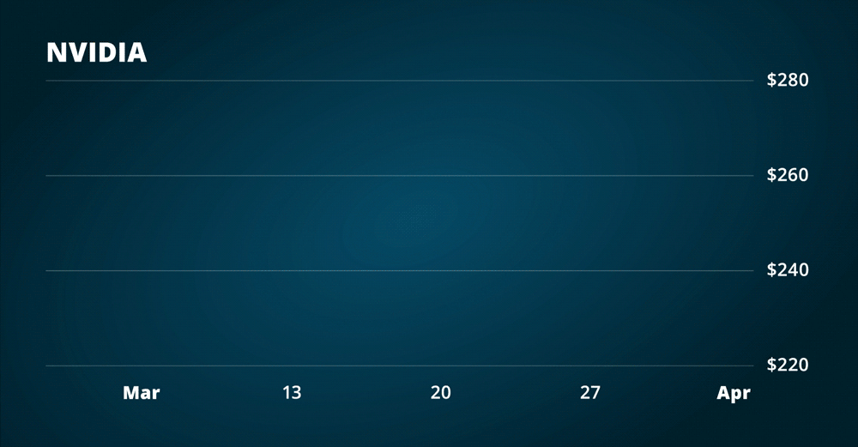

Bill:
Wait a second... Are you saying that investors could have made a 443% return...
A 543% return...
An 89% return...
AND an 88% return...
In one-third the amount of time that most investors would have made 35%?
Nate:
Exactly. Now this a best case scenario, but all told by making just one trade per week on NVIDIA during its Earning Profit Surge...
You could have won 4 out of 4 trades within that single month.
And that’s just placing one single trade per week during the FIRST month of Nvidia’s Earnings Profit Surge...
We’re talking about bigger... faster profits on a single stock than most everyday investors ever see in their lifetimes.
There is no buying-and-holding.
We place a trade...
Collect our profits...
And if the Surge still continues...
We rinse and repeat.
But here is the best part...
Thanks to my brand-new AI-powered Scanner...
Finding more of these Earning Profit Surge trades is now easier than ever...
Including two specific trade setups that I’m excited about this upcoming Monday.
Bill: I hope viewers at home are wise enough to stick around to hear about your upcoming trade on Monday...
And I’m excited to hear more about how you’re now using a powerful AI to find more of these plays...
But, before we talk about that...
Let’s be realistic...
Earnings moves like what NVIDIA pulled off are generational.
Investors will be talking about NVIDIA’s big earnings move in 2023 for decades to come...
How do we know this simply wasn’t a fluke?
Is it possible to do this on stocks that aren’t nearly as powerful as Nvidia?
The Real Deal:
Beating The Market By 1,700%...
Nate: That’s a fair question and I think it’s a smart one for everyone to ask.
After all, every type of investing or trading involves risk. There is no such thing as a guaranteed winner, and you can’t always expect past performances to be perfectly replicated...
That being said - since I sat down with you last year to launch my Profit Surge Trader Trading Chatroom ...
We’ve won nearly 9 out of every 10 trades...
In fact, during Q1 of this year...
We closed a perfect 27-for-27...
With an average gain of 39% in just 3 days.

Bill: Now, hold on...
The S&P average annual return of 10% is widely considered to be the benchmark for trading success...
And you’re AVERAGE trade crushed it...

Am I understanding that right?
Nate: Yes, but remember we are talking about my AVERAGE trade...
All-in-all we put up a 192% total return during the first part of the year.
During this time the S&P 500 made 11%.
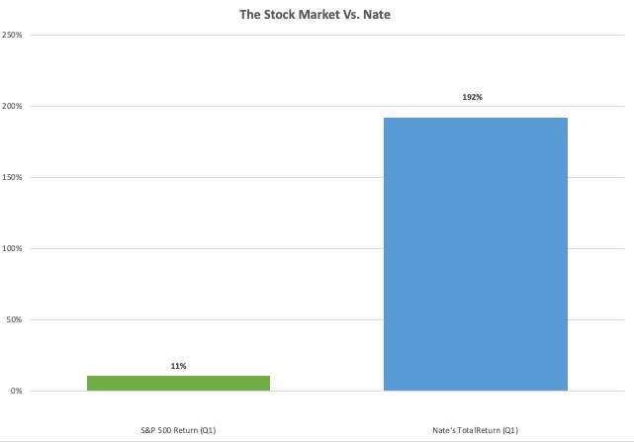

Bill: So you 17X’d the returns of the market.
Impressive.
Nate, please take us through some of those Q1 trades.
I really want to know what it was like to go 27 for 27!
Nate:
Our perfect Q1 run started by going 6-for-6 in January...
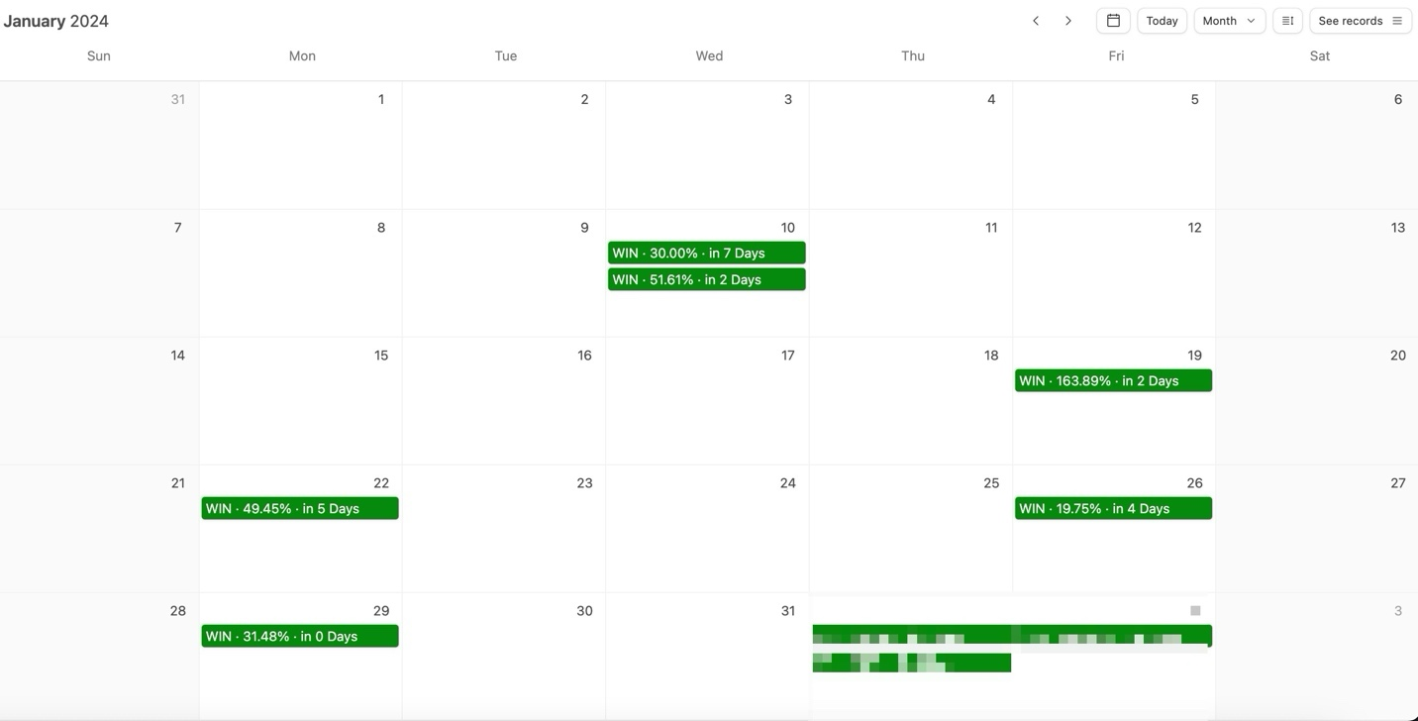
In February, we saw more of the same...
But this month we went 11-for-11
Including a 42% win in 4 days...
Plus wins of 40% and 133%...
Both closed within mere hours.
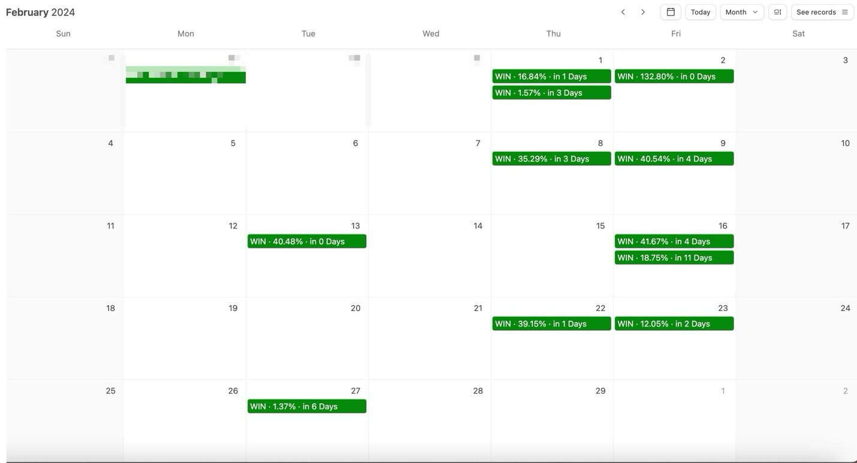

Then in March...
10-out-10 trades were closed as winners...

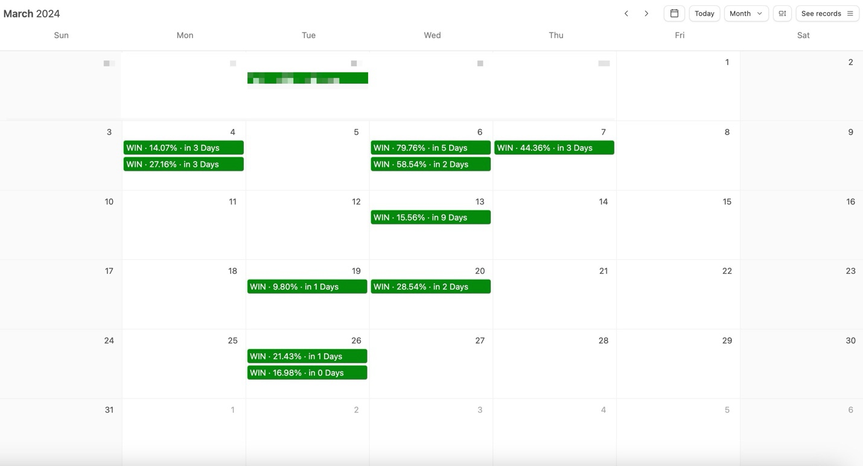
Wrapping up a perfect Q1.
Bill: Great, but can you walk me through some of those actual trades?
I’d like to see how you first spotted the Earnings Profit Surge…
And how you actually traded it.
Nate: Sure...
Let’s take a look at Amazon’s chart...
This is a real money example from back in February...
We did this in real time with real people.
So remember, the first thing we are looking for is a stock with positive earnings.
And Amazon did exactly that.
You can see on the chart that the stock gapped up after a 26% earnings surprise.
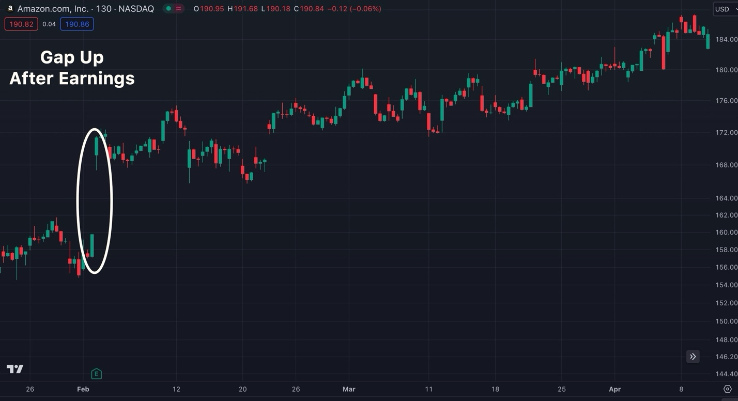
Research has proven that an Earnings Profit Surge is very likely after an earnings win that big.
So throughout the next few weeks we captured profits on Amazon with my special trade...
Including a 41% in 4 days...
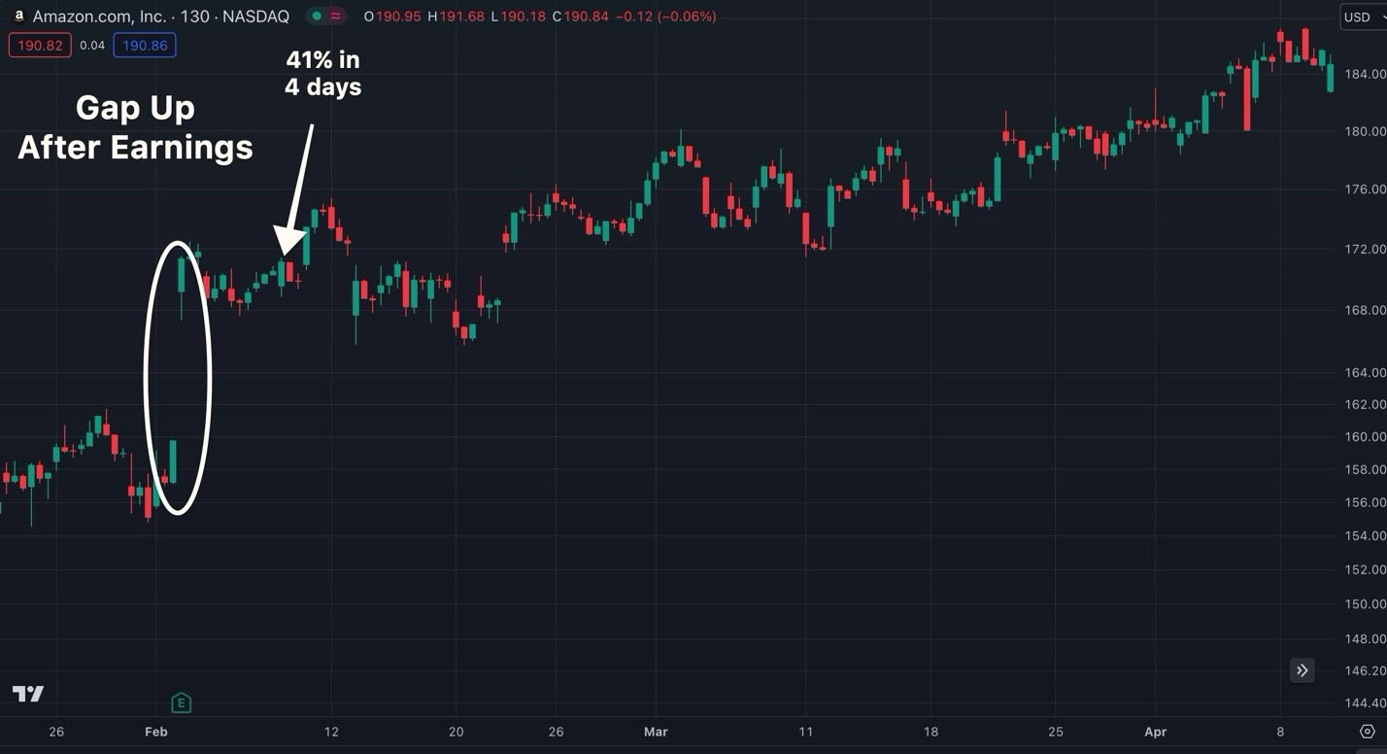
A quick 40% within just 11 minutes just one week later...
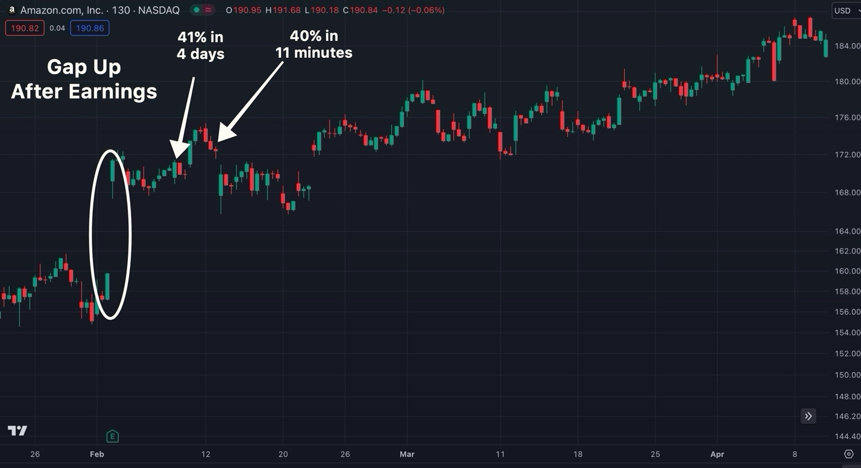
ANOTHER 39% gain the week after that.
This time overnight....
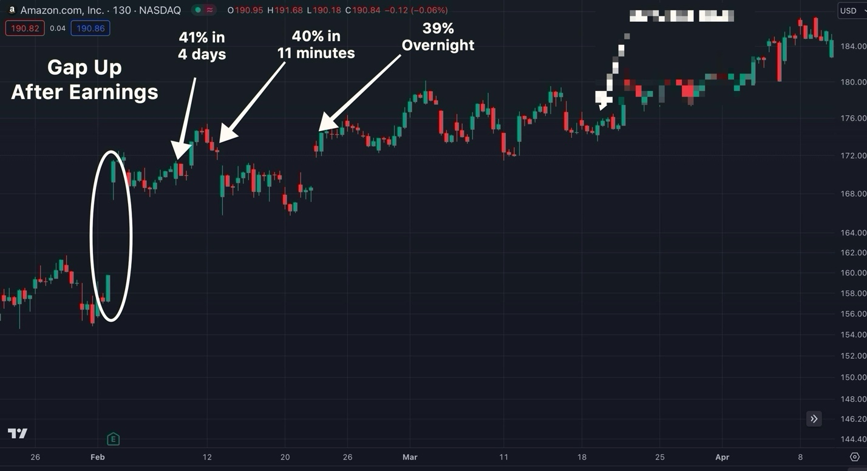
And finally a few weeks later...
We were able to snag one more gain off Amazon’s Earning’s Profit Surge
This time a 29% gain in just 2 days...
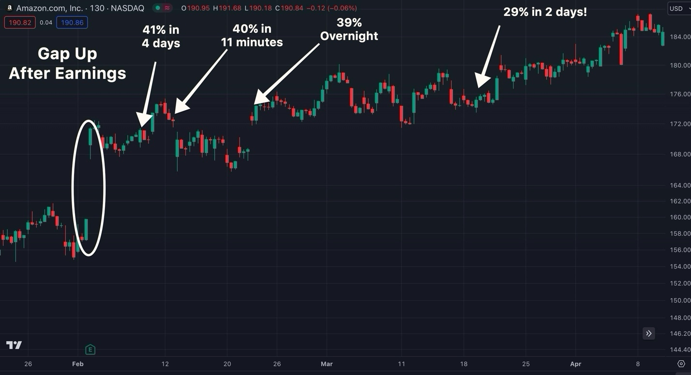
Bill: So to make sure I am following...
You waited until AFTER Amazon proved to be a positive earnings winner...
And you strategically waited for the right opportunities to capture fast profits 4 different times thanks to the Earnings Profit Surge?
Nate: That’s exactly right...
Every Monday during Amazon’s Profit Surge... I broadcasted live to my members and walked them through these exact charts so that they were clued in on every step of this trade setup.
We do this all the time...
Here is another one...
This time we’re looking at the retail giant Target.
On November 15th it’s stock gapped up after a 42% earnings surprise...
This put the stock on my radar as an Earnings Profit Surge play...
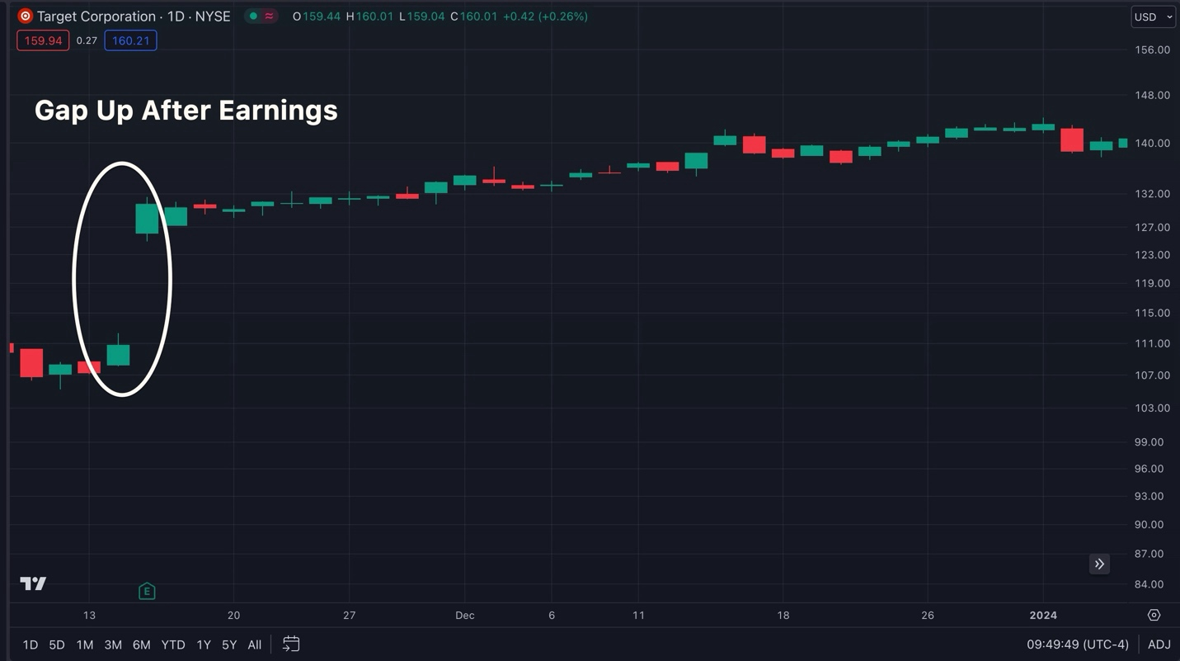
If I would have gotten into Target BEFORE earnings...
I would have been gambling...
But by waiting until AFTER earnings during the proven Earnings Profit Surge… we were able to capture multiple winners.
So I waited for the right moment and I was able to cash out for a 19% gain within 2 hours...
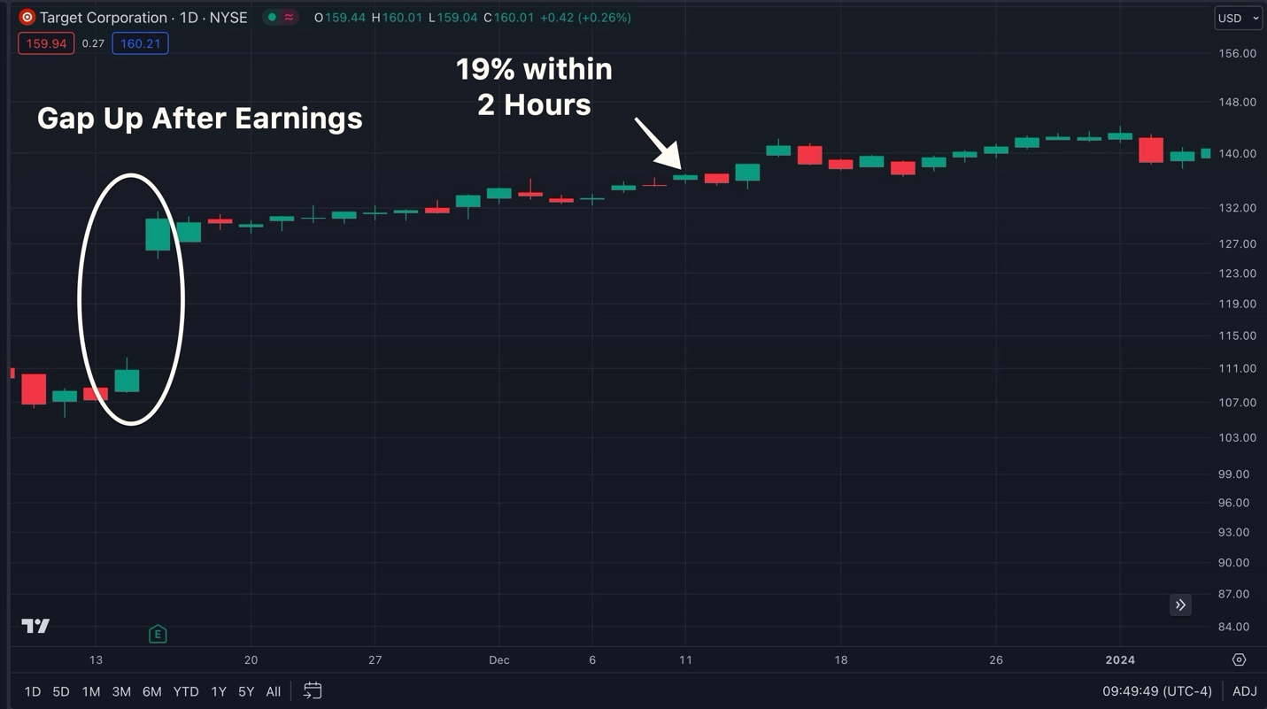
A 26% gain within 2 days...
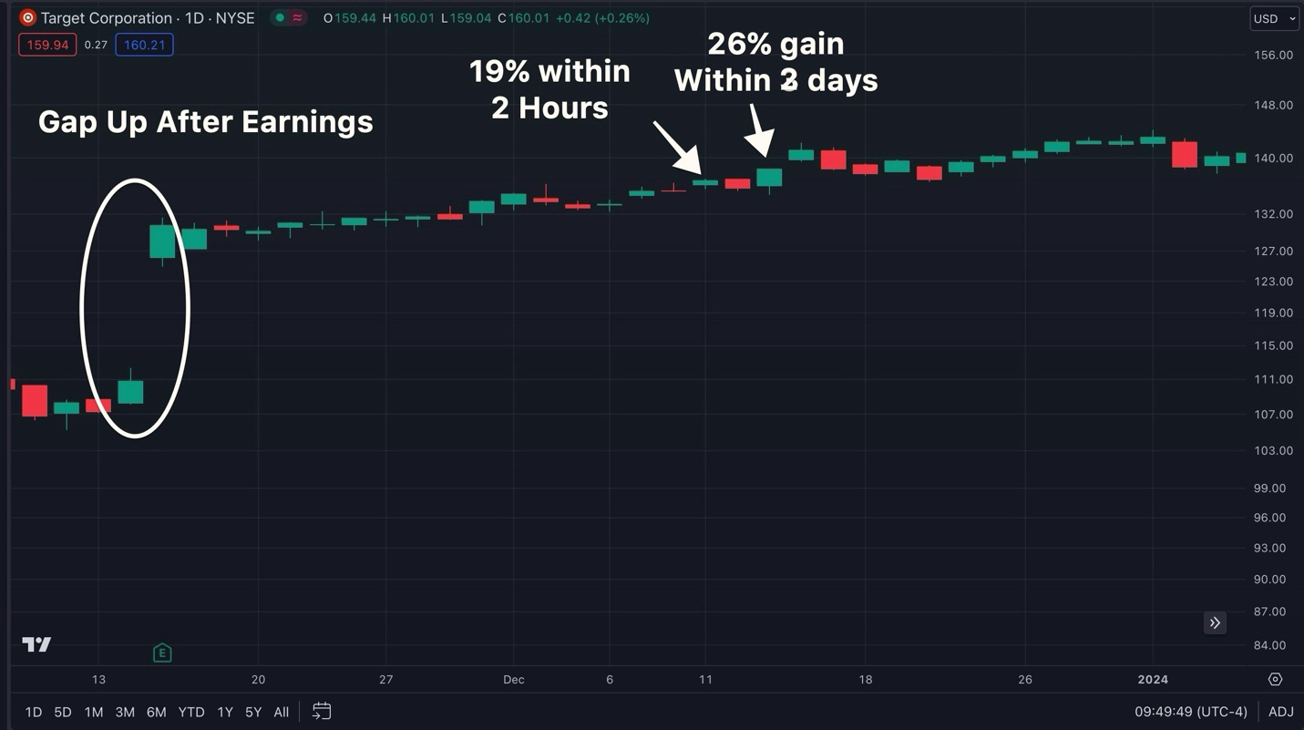
And a 102% gain within 6 days!
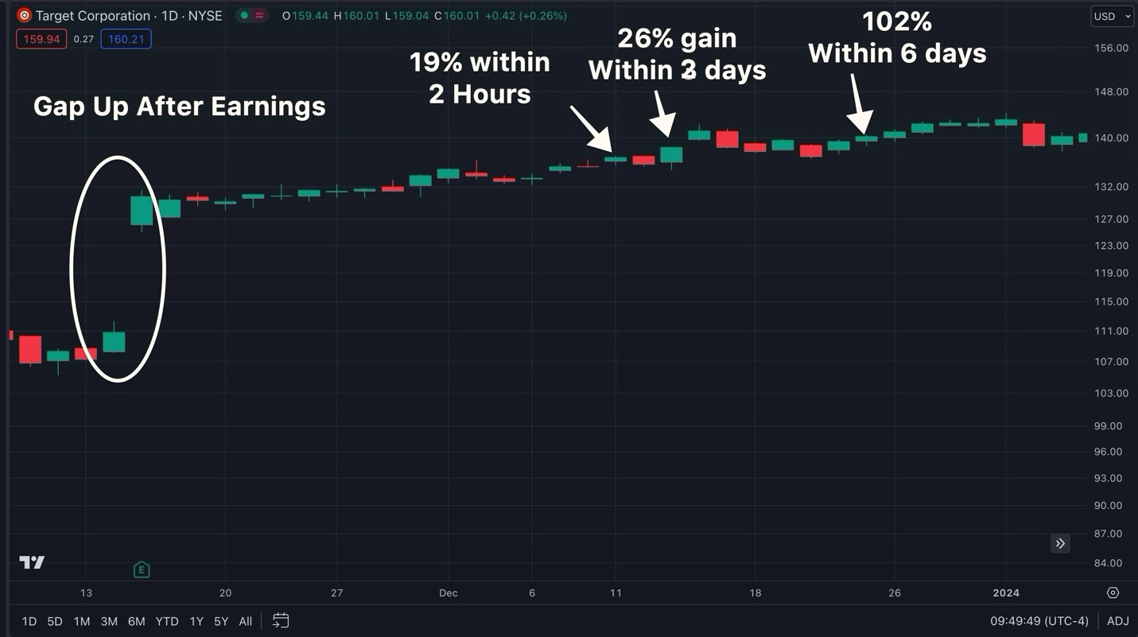
Bill: 102% in 6 days?
Doubling your money in just 6 days is a heckuva way to go into the New Year.
Nate:
Take a look a look at this example...
Immediately the morning after Meta reported earnings...
I jumped in and was able to cash out with a 133% gain within just 18 minutes!
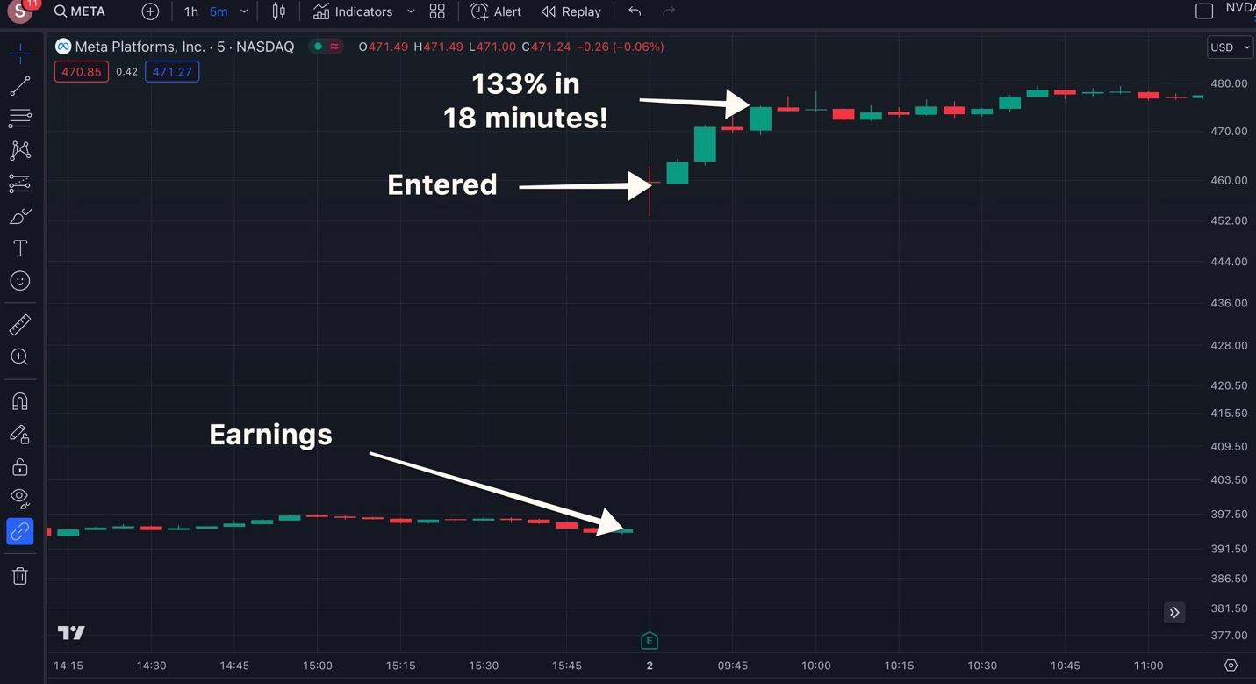
Bill: 18 minutes?
Imagine waking up...
Pouring a cup of coffee...
And before 10 am landing a gain large enough to turn a $5,000 investment into $11,640...
Not a bad start to your morning!
Nate: That’s the power of the Earnings Profit Surge.
On average most of our gains happen within just 5 days.
Bill: Alright so...
You’ve been finding all of these trade setups...
And every Monday you share your trade recommendations LIVE inside of your private chat room...
But as you mentioned earlier...
You’re now taking this strategy to the next level...
And finding Earning Profit Surge plays faster than ever thanks to a proprietary AI scanner that you built...
Can you tell us why you are turning to AI when your results from this strategy is already blowing the market out of the water?
Using The Power of AI To Find MASSIVE Earnings Profit Surge Trades...

Nate: Well here is the thing about me Bill...
I’m never content with “good enough”...
I believe that to be a successful trader over the long run...
You always need to look for ways to improve and find a better edge...
And right now the ultimate edge in the market is AI...
Bill: You know I actually recently read an article that Wall Street is already turning to AI to replace it’s junior analysts...
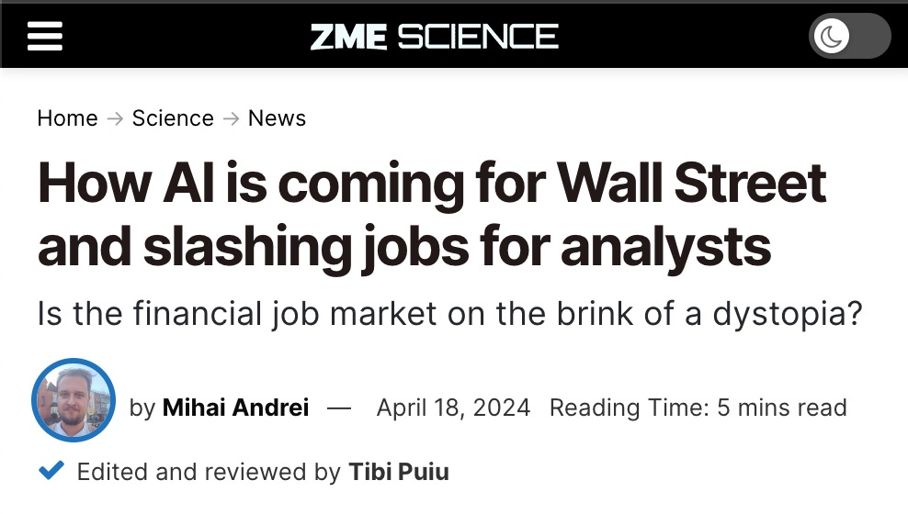
And major firms are already working on developing new tools to help retail investors...
In fact, JPMorgan just unveiled a new ChatGPT like tool that they plan on releasing within the next 3 years...
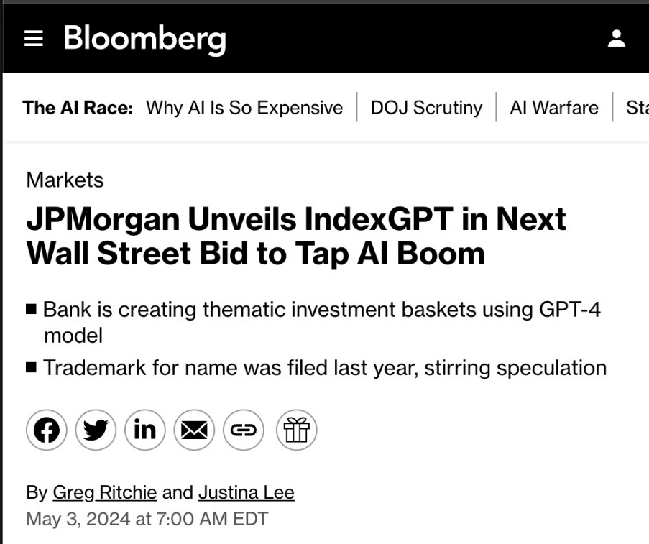
Firms on Wall Street understand that AI is the future of investing and has a head start for years.

But everyday traders have been left in the dust.
Nate: You’re exactly right, and that’s why, over the past year we spent $1.8 Million of our own money into building a proprietary AI-powered scanner to help everyday investors use the power of AI to find MORE explosive trade setups.
This isn’t some spinoff of ChatGPT or some other AI out there...
It's a completely unique tool my team built from the ground up.
We call it SAM - which is short for Stock Acceleration Monitor...
And before our recent update...
What it would do is scan the market for stocks that have momentum building...
But at ungodly speeds...
When I say fast I’m not kidding...
SAM has the ability to scan the market up to 5 MILLION times... PER SECOND!
Bill: 5 million times per second?!
It’s hard to even wrap your head around that amount of speed...
That means since we began talking today...
Your AI tool has scanned the market hundreds of millions of times??
Nate: Yeah... that’s right.
Just think about it...
There are 8,000 stocks in the US stock market...
There are only so many stocks and charts a human being can follow at any given time...
You’re going to be hard pressed to get through 8,000 charts within a week...
Let alone in within a second...
Bill: But you’re saying SAM can search the market 5 MILLION times per second?
Nate: Exactly! And now thanks to our latest update to SAM...
Our AI can now detect the companies with the biggest Earnings Profit Surges.
And that’s what gives us a truly groundbreaking advantage.
SAM isn’t just good at scanning the market. It’s also good at the most important element of stock trading…
Finding winners.
While we were developing SAM we performed extensive research on it’s performance...
And when we tested it against 5 year’s worth of peak S&P 500 data...
We found that SAM has the capability to identify an average of 1,214 profitable trade setups PER year...
That’s an average of 5 winners PER DAY!
Bill: PER Day? Most investors are lucky if they see ONE winning trade in a given week...
Let alone 5 PER DAY...
But of course, the devil is the details...
What is the win-rate of these trade setups SAM is finding?
Nate: Looking at our 5-year study, we saw that SAM was capable of winning 8 out of 10 times...
But that’s not the full story...
Already in our premium research services we’ve seen some HUGE wins after just a couple of months SAM of being live...
It’s helped us identify this 78% winner on Carvana after just a few hours... [CHART]
Or how about this 101% gain on NVDA ...
After just 4 days...
[CHART]
And my members have also cashed in too...
Like Ash who wrote in and said...
"SAM helped me get a 74% winner in three days on CE” -Ash
Or Bill who wrote in and said that he turned $8k into $18k during his first week trying out SAM...
“NATE - SAM IS FANTASTIC - $8K to $18K account [125% Return] in a week on SAM so far - - how about that ??” - Bill
Or Ron who scored a 200% win with the help of SAM after just 6 days
“200% + on AMD [In 6 days] thanks to Sammy !!” – Ron
And look we’re just scratching the surface with this new technology...
In fact, during our beta testing earlier this year...
We saw that S.A.M. had detected what could have been a 2,250% gain in just a week!
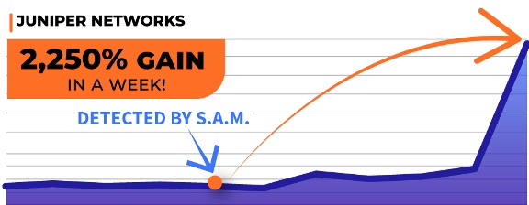
Bill: 2,250% in a week??
That’s enough to turn a $10,000 investment into $235,000...
I can understand why Wall Street is so excited about the power of AI...
Nate: That’s exactly right, Bill...
But we haven’t even gotten to the reason why I wanted to sit down and provide you with an update today...
I’m excited to announce that we’ve just released a new update where SAM is now able to find Earnings Profit Surge plays...
Version 1 of SAM was able to automatically scan the markets for trade setups...
And now Version 2 is capable of identifying which of those trade setups that specifically have an active Earnings Profit Surge...
Which I believe is the most lucrative profit opportunity in the market.
Bill: An 80% win rate based on your 5-year study on SAM is impressive...
But with the Earnings Profit Surge you’ve gone on winning streaks that have lasted an entire quarter...
And during that time, you outperformed the market average by 17X...
So why is this development such a big deal?
Nate: Well Bill... thanks to the power of SAM... we’re able to find hundreds more of these explosive plays with a lot less manual work.
It sure beats how my members and I have been finding the plays in the past...
And ultimately that means more opportunities to profit for myself and my community.
Bill: Speaking of that...
You mentioned, that you share all of your Earnings Profit Surge with members of your chatroom...
Can you walk us through how you are finding these plays and how your members are getting your very best market intel via that chatroom?
The Newest Way To Take Advantage Of Profit Surge...
Nate: Of course...
In the past...
I would manually scan the market ticker-by-ticker in search for the #1 stock that recently had a huge Earnings Surprise...
And depending on the month, there could be several tickers to choose from...
So isolating the #1 ticker can overall be very time-consuming for me...
But once I have that ticker...
My members and I meet in my chatroom every Monday at exactly 12pm EST sharp...
And I broadcast LIVE so my members can watch my computer screen as I talk through my step-by-step game plan for the trade.
I share everything including when I plan to make a trade...
When I plan to exit...
And if things don’t go according to plan or a better opportunity presents itself...
I share my Plan B so we have the best chance to profit from the Earnings Profit Surge every week.
THEN – once I am ready to make a trade...
My members will receive an email and a mobile push notification letting people know the exact details of the trade that I am making... BEFORE I place it.
Bill: So you’re not just giving people active, urgent trade recommendations... You’re actually teaching your members in the process so that they can profit from this powerful market phenomenon themselves, is that correct?
Nate: That’s exactly right...
Ultimately our goal is to leverage the Earnings Profit Surge to make HUGE profits off the ticker for several weeks.
But that all changes thanks to SAM...
BILL: So how does it work?
NATE: This AI-Powered tool scans the market...
Finds all of the stocks that currently have an active Earnings Profit Surge...
Then it scans over 5 million data points per second…
Identifying the trade setups that have historically proven to generate the strong returns…
///PLACE HOLDER///
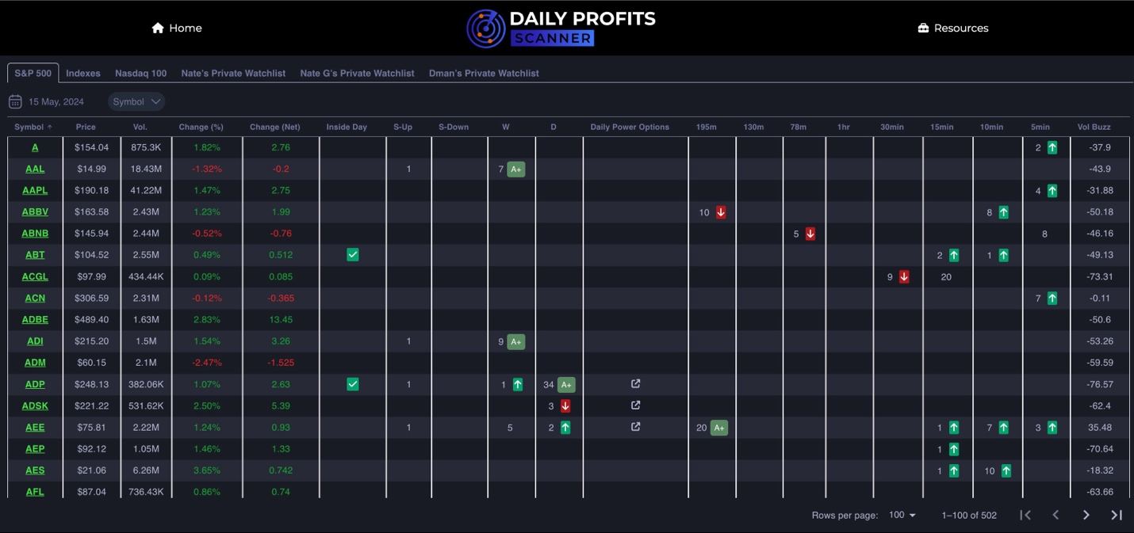
///PLACE HOLDER///
Then after I vet it and find a trade setup that I like...
I share all of the intel and my insights on it with my community.
Just like I have since we launched the chatroom.
And as you’ve seen throughout this interview...
We’ve been pretty successful with that recipe even before introducing SAM.
For example,, in August, during our very first month...
We quickly nabbed a 76% win in 3 days...

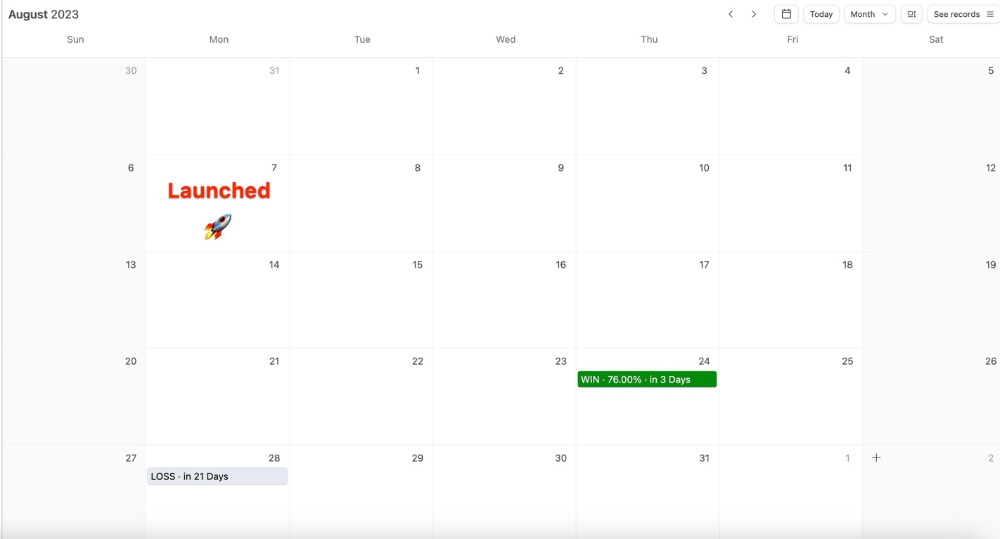
Then in September when the stock market was DOWN -5%...
The 8th worst month since 2020 ..
We were still full speed ahead thanks to the Earnings Profit Surge...
With 7 wins on 9 closed trades...
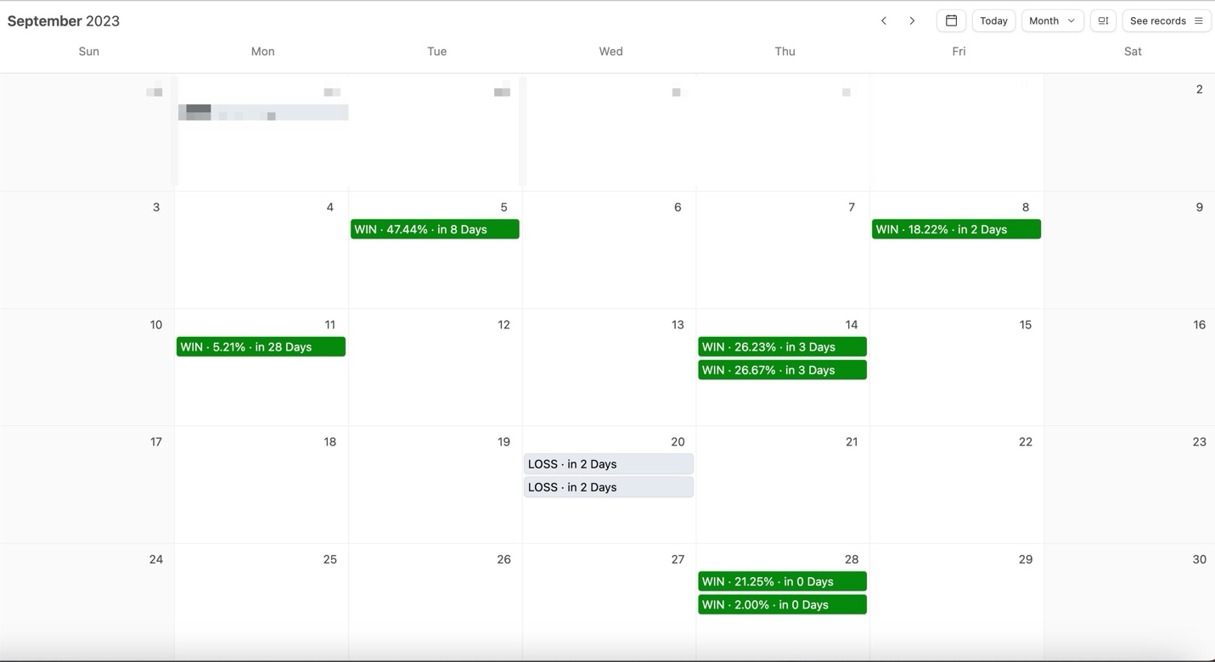
Gains as high as 21% in a few hours…
27% in 3 days…
And 47% in 8 days.
Bill: Hold on, so you’re saying that this strategy has been working even when most investors are getting crushed by the market?
Nate: That’s exactly right...
In fact, we did the same thing in October when the market was down 2%...
Except this time, we closed a perfect 8-for-8, including a 100% gain in 8 days...

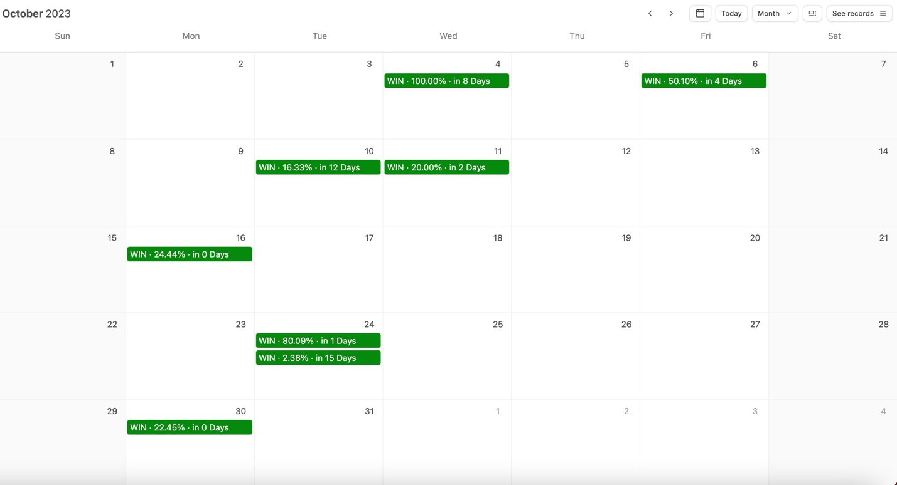
Then in November...
We went 3-for- 4.
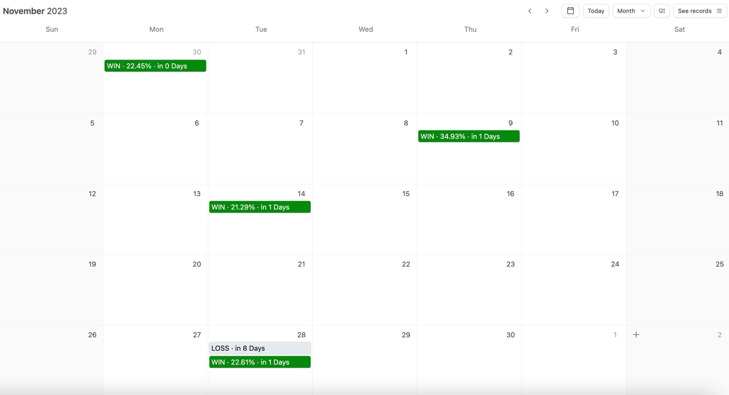
In December, we ramped things up to close out the year and went 11-for-13...
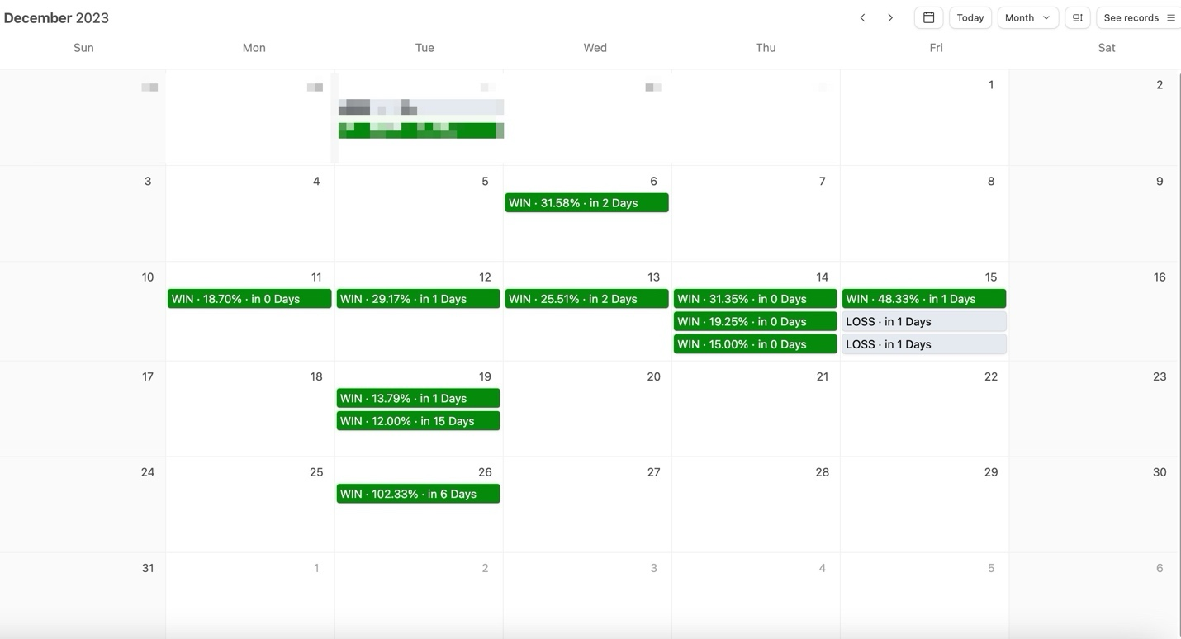
We booked a money-doubling win the day after Christmas.
An official 102% gain in six days.
Altogether, we went 30-for-36 during the first 5 months...
[Production: SHOW Q1 2024 Charts From Above quickly again]
And as I showed everyone earlier in our interview...
We started 2024 a perfect 27-for-27 during the entire Q1… January through March.
Bill: Nate – I’m not sure I have ever heard of a research service with such an incredible start...
And to think...
Now with the power of AI... the profits that you and your members bring in each week...
Could be exponentially greater.
Nate: That’s exactly right.
Thanks to the latest update to SAM... the sky is the limit.
It's finding more of these trades than ever before.
Even with this big advancement in AI trading...
I’m still going to share my best trades with my members every Monday @ 12pm EST.
Remember - this strategy was perfect during the latest quarter...
And while I don’t think it is realistic to stay perfect forever...
The goal of utilizing AI isn’t to hit the reset button...
It's to take our Earnings Profit Surge gains to the next level.
Bill: That makes complete sense...
You’re not fixing a strategy because you think it’s broken...
You’re doing the opposite and doubling down.
You’re investing in game-breaking technology, making it easier than ever to find MORE profits faster...
It’s refreshing to see a trading expert that is not only so transparent...
But also incredibly successful as well.
As I mentioned at the beginning of this interview...
If you had put just $5,000 into each of Nate’s first 75 trades…
You could have walked away with $ 54,450 in pure profit in less than a year!
Those are real game-changing results...
But I have to ask...
With gains like these...
There is no way that you are just trading stocks...
Can you explain how you’ve managed to pull in gains as much 1,000% in the past?
Supercharging Your Profits
Nate: I’m glad you brought that up...
Because all of the gains that I’ve referenced during this interview are thanks to the power of options...
And look… I know a lot of people are scared of options and they view them as super risky.
But like anything in life… they are risky if you use them the WRONG way.
Heck… lots of people think stocks are less risky than options… but starting out I lost all of my money on STOCKS three separate times.
Stocks and options both have risks. Nothing in trading is guaranteed. You should never trade with money you can’t afford to lose.
But options give you a huge advantage over stocks.
Bill: What’s that?
Nate: Well they allow you to put less money at risk while also targeting higher gains.
And it’s how you’re able to make triple or even quadruple-digit gains within just mere days.
With stocks… that would be impossible..
But if you use them correctly, like by trading them on the Earnings Profit Surge, you can actually win with potentially massive gains.
In fact, options were critical to turning $37K into $2.7 Million for me. Without options, that would have never happened in 4 years.

Here’s the great thing about the way I play options with this part of my strategy…

All it takes is a small move upward during the Earnings Profit Surge to see a huge winner.
When a stock surges just 5%, 10%, you can target massive, money-multiplying wins…

And not just triple digits…
You can potentially capture quadruple-digit gains…
Bill: Can you prove that to us?
Nate: Yeah take a look at this trade that I recently made on the ticker Carvana in one of my services...

And you could have made as much as 8% overnight by playing the stock...

But by playing the options. my members and I were able to capture an 368% gain.
[BAR CHART]
Or how about this one...
This time we’re looking at my RILY trade in April during our FREE open house...
If we had only traded the stock we could have made a 41% gain in 2 days...
Which is incredible...
But by using options we were able to close the trade for 1,129%!
[BAR CHART]
Bill: That’s a pretty big difference between using options and not using options.
It looks like investors are leaving a ton of money on the table by simply trading the stocks.

Nate: Well if you think those were impressive...
Remember that 2,250% trade setup that I mentioned SAM found during our beta testing?
Bill: How could I forget return like that? It was on the ticker symbol JNPR correct?
Nate: Correct! Well that would have only been possible with options.
Simply investing in the stock could have made you 25%...
And that’s WITH perfect timing....
But instead... with options...
That return could have soared to 2,614% in the same amount of time!
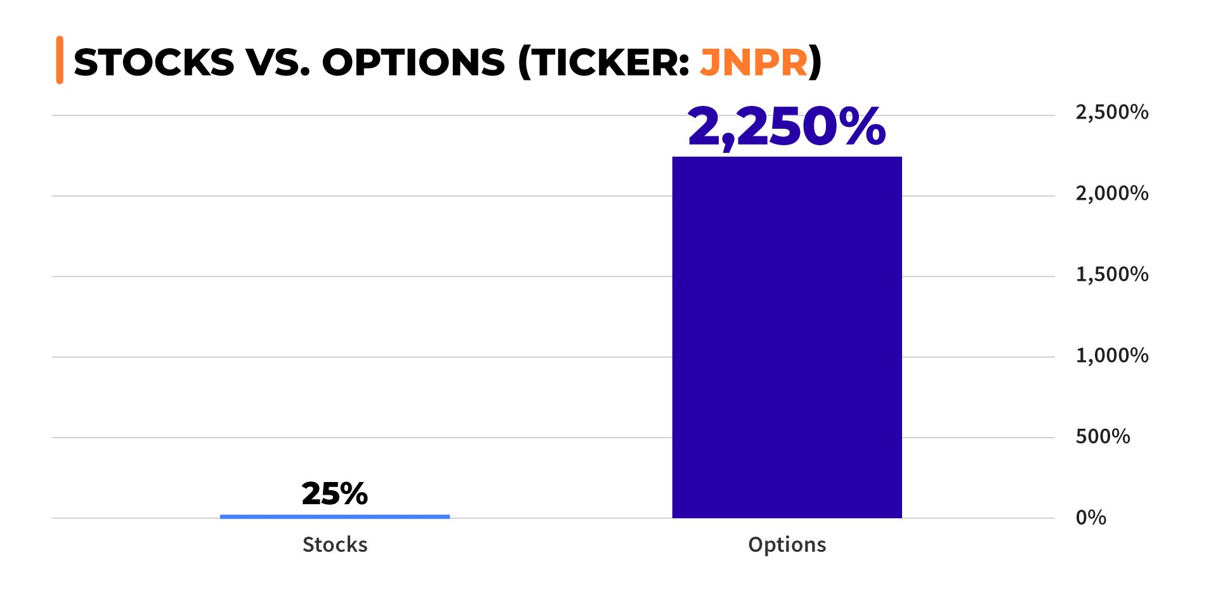
Bill: Let that sink in if you’re watching at home right now.
That’s 90X more than what the stock returns.
Remember we’re talking about the rare potential to turn a $10,000 investment into $235,000 in just week.
Nate, I have to ask… are these extreme examples?
Nate: Yes, but every one of these proves the power of using options...
Even if you didn’t have perfect timing, people still would have had an opportunity to close the biggest trade of their life.
That’s why I have been using options for years now...
And once you learn how to simplify your trading... at the end of the day the profit potential just far outweighs trading stocks.

Bill: Most people don’t bother to take the time to learn how to trade options properly... but you did.
You didn’t buy into the myth that options are only for professionals, and you didn’t get scared.
No wonder you were able to make millions of dollars within just a few years...
Why do you think so many people are being left in the dark about the Earning Profit Surge?
Why aren't other people trading the surge?
Nate: Well, quite frankly, Wall Street and the media doesn’t have a reason to teach everyday people how to use options the right way...
Think about it...
Advisors make money by helping people get their 7%-10% each year...
Do you think they want their potential clients replacing them by trading a strategy that can double or quadruple what an advisor can offer them?
Bill: You make a good point...
And I would imagine the media probably doesn’t want people to tune out of the earnings predictions made by their analysts and expert panels...

Nate: That’s exactly right...
But remember, the Earnings Profit Surge phenomenon has been studied by the likes of...
Harvard...
Duke...
The Federal Reserve...
The Securities and Exchange Commission...
And many other prestigious institutions...
The Earnings Profit Surge is real...
There is real money to be made off it...
And it’s easier than ever with the power of AI.
Bill: Not to mention your actual members are actively making money too...
At the beginning of this interview, I shared a few of their success stories...
These are REAL everyday people not Wall Street professionals or experts.
They are making real money thanks to you...
Like Angelena who wrote in
“Nate is terrific! He is knowledgeable and real. I came into the service with very little knowledge and listening to Nate every week turned me into a more confident trader.”
Or Mike G. who wrote...
“Sooooo many folks out there claiming to have "THE WINNING SYSTEM" and we all know there is no perfect system. Nate's approach and system to trading is unique and very applicable to people like me who don't have a gazillion dollars to invest and don't understand everything in the stock market. I am doing better with [the] Profit Surge than with any of the other previous systems I have tried in the past...
I've had way more wins and a lot less losses with Nate because he has educated me with new trading techniques I never had before.”
Or William who wrote...
“Well worth the price, it paid for itself the first week. I have gone from knowing nothing about trading options to making 335 trades with an 86% win rate in seven months. Nate is a fantastic teacher and I have learned to find high-quality trades on my own in addition to the weekly service recommendations. This stuff is fun”
Clearly...
You’ve been making a massive impact in the lives of your members.
Nate: That is the goal. You know, it would be a lot easier if I simply made trades privately from my office...
But if I were to do that... I wouldn’t be paying my success forward.
I want my members to have the opportunity that I had when I turned $37k into $2.7 Million in just 4 years...
And reading about my member’s success is what makes it all worth it.
I hope that in the next few weeks, I’ll be reading success stories from the people watching at home right now.
Bill: So here’s the million-dollar question...
How can people start trading the Profit Surge using the power of AI?
Get Nate’s #1 AI Profit Surge Play On Monday [Monday Date] @ Noon EST
Nate: Well, the answer to that question won’t cost you a million dollars...
In fact, it won’t even cost you thousands.
I’m excited to announce that this upcoming Monday @ Noon eastern...
Members of my Profit Surge Trader chatroom service will now get additional trade recommendations based on trade setups that I find using SAM.
100% free
And I when I say free... I mean free.
You won’t have to join another service...
And I’m not taking away any existing membership perks...
If you are a member of my Profit Surge Trader community, your membership will now be upgraded to receive my #1 AI Play from SAM every Monday.
Bill: Let me get this straight...
You’re saying starting on Monday, members will not only get your LIVE trade recommendations and market analysis that have been crushing the market...
But they’re also going to receive additional trade recommendations that you found using SAM...
Each and every week throughout the year?
Nate: That’s exactly right.
I’m ALWAYS looking for new edges for my members...
And ways to improve the service...
And with this new benefit you don’t even need to have any experience with AI...
Each Monday during our Livestream I’ll open SAM up and walk through what the tool is finding that given day... it will show me every single stock in the S&P 500 and Nasdaq 100 that has an active Earnings Profit Surge...
From there I’ll do my own deep dive to figure out what the play is and give you my own analysis so that you know why I like the setup.
But Profit Surge Trader doesn’t just stop with my weekly live streams...
I’ll also deliver instant trade recommendations whenever I buy and sell...
You’ll get the alerts via email and lightning-fast push alerts to your mobile phone.
You can expect to be in the loop every step of the way...
REGARDLESS of whether or not I’m broadcasting live inside the chatroom.
The results we’ve seen in Profit Surge Trader over the past year have been incredible and I’m really having a blast every week.
We’ve built one of the best trading chatrooms on the web...
But in order to set ourselves up for long-term success...
It's important to stay on the cutting edge and equip ourselves with the best tools available to help us find HUGE profits.
That’s why I made the decision to incorporate the power of AI into the Profit Surge Trader chatroom.
Bill: And if I remember correctly, you actually use your own real money on these trades as well?
Nate: Yeah, unlike many competitors who are promising AI trading and delivering members with junk trade ideas....
I’m putting my own real money into each and every trade...
So you always know that I have skin in the game and believe in my recommendations.

In fact, I go a step further.

I give out the recommendation, so all my members have a chance to get in first… and then I buy in my own account at least one minute later.

I often get in at a more expensive price by going later than my followers.

But guess what?

I don’t mind because the trades are so good!
Bill: Nate, that sounds like a great deal. And extremely fair to your people.
When you launched the Profit Surge Trader chat room, I remember that you made it incredibly affordable to join.
At the time, it was already a huge no-brainer...
Now you’re DOUBLING the amount of trade recommendations and research your members receive...
And improving the service by adding in the power of AI.
What about those watching today who aren’t a member of your chatroom yet...
How can they take advantage of the power of AI?
Nate: Well today is the best opportunity to become a member of my private trading community...
Because if you liked what you learned during this interview and you want to work alongside a professional trader who has done it all...
Then I want to help you take advantage of the Earnings Profit Surge with my new AI-powered scanner.
We designed Profit Surge Trader, to help you try to make big money every week.
Bill: All from the Earnings Profit Surge
Nate: Exactly.
Bill: Nate, it sure seems like you really checked all the boxes when putting this service together.
You’re giving folks at home everything they need to be successful at profiting from the profit surge...
Nate: And that’s not even everything they’re going to get!
Bill: Hold up... You mean there is more?
Nate: Yes! I put a few special bonus reports together in my ... exclusive for to people who join as a VIP member today.
Designed to help fast-track your success even more!

[REPORT GRAPHIC HERE]
The first report is called The AI Profit Surge and covers everything you need to know about how I play the Earning Profits Surge using the power of AI...
You’re going to learn exactly how AI can spot small moves that can transform a simple stock move into MASSIVE gains.

These reports even dive into the many studies that prove the power of the Earnings Profit Surge…
It’s all spelled out in plain English.
Whenever you’re in doubt, you can access this exclusive report at any time for quick answers.

Bill: So basically it’s a cheat sheet to taking advantage of the profit surge every week?

Nate: Exactly...
I’m also including an exclusive copy of my special report The $2.7 Million Dollar Profit System...
This reveals exactly how I turned $37k into $2.7 million dollars in four years.
It's my ultimate secret that will change the way that you aim to grow your money.
Bill: I need to get my hands on that!
You mentioned that new Members were going to get one more report?
[REPORT GRAPHIC HERE]
Nate: Yes!
Finally, I know that some people watching are new to trading options...
And that’s perfectly fine, because I put together a third report called “How to Profitably Trade Options (the Easy Way).”
It covers everything you need to know about trading options profitably...
How to set up an options trading account (in the case you don’t have one yet)…
How to minimize fees down to $0...

How to minimize risk...
And look...
You can certainly be profitable with the Earnings Profit Surge simply investing in the stock alone...
But as I demonstrated earlier...
With options, the earnings potential is just far too massive to pass up.
We’re talking about the difference between a 2% gain and an extraordinary gain as much as a 2,250% over the same timeframe... that frankly most investors might never get a chance to see in their lifetimes.
And with this report... you’ll learn how to trade them successfully.
All three of these reports plus my entire private training vault are yours when you become a member of the Profit Surge Trader today.



Bill: So folks... this is your exclusive invitation to become a member of Nate’s research service Profit Surge Trader.
One year of Profit Surge Trader retails for just $997.

That’s a far better deal than some of the $5,000 trading services you’ll find out there...
Nate: Well hold on...
I’m actually going to do them one better Bill. My team and I have put together an even better price for those who take action and join today.

Bill: Oh yeah?
Nate: Look I get people are struggling right now. And even with the price of everything going up thanks to inflation... gas, groceries, rent, mortgage rates, insurance, you name it…
I want this service to be affordable to everyone.
Because I really believe that this cutting-edge service can add real meaningful profits to people’s lives every week.
That’s why if you try out Profit Surge Trader... you can get access to Profit Surge Trader for an entire year for just $149....
Bill: Just $149 dollars??? That’s more than a $500 discount. Are you sure about this offer?
Nate: I’m dead serious. I’ve done everything I can to make this service the biggest bang for your buck.
And look, if you try out Profit Surge Trader and for some reason you find that this community isn’t for you during your first year...
You’re covered by my 365-day “No Questions Asked” Money Back Guarantee.
I’ll even let you keep all 3 new reports FOR FREE...
My gift for giving my new service a try.
*DESIGN THIS AS A CERTIFICATE*
365 Day “No Questions Asked”
Money Back Guarantee
If for any reason Nate’s Profit Surge Trader isn’t for you... simply call his VIP Concierge Team within your first 365 days and they’ll refund your subscription entirely.
No questions asked!
I know the struggle and I understand that there are a lot of so-called “experts” that you can’t trust these days.
When I was still a construction worker, I didn’t have much cash. I get it. You have to protect every penny.
So if that’s the only thing between you and a better life…

I’m more than happy to offer this discount and remove the risk with my money-back guarantee.
Try it and if you don’t like it...
Give us a call and we’ll issue you a full refund. RISK FREE!
Bill: Well there you have it folks...
Nate is going to be trading LIVE 52 weeks out of the year...
Every Monday at noon...
And each of those weeks you’re going to get not one...but TWO trade recommendations...
Including, his #1 pick from his AI-Powered Tool SAM.
If you do the math... that comes out to just $2.87 per week!

And imagine…

You could go an entire quarter without a losing trade…
Just like Nate and his Profit Surge Trader members experienced in Q1.

They went a perfect 27 for 27!
Nate: There is a catch though...
If you want this deeply discounted price...
And the 3 exclusive reports I put together....
You have to join today...
My publisher isn’t going to keep this offer available for very long.
And at that point the pricing is just out of my hands.
Bill: You heard it from the man himself! Don’t wait folks.
Click on the button below to join now. Right below this video.
[Join Now]
Here’s a recap of everything you’re going to get today:
You’re going to get one full year of his weekly research service Profit Surge Trader
[WITHIN BUNDLE HIGHLIGHT GRAPHIC OF Profit Surge Live]
This includes an invitation to join Nate every Monday at noon during his Profit Surge Trader broadcast...
Where you can look over his shoulder and watch him trade LIVE as he is teaching you...
[WITHIN BUNDLE HIGHLIGHT GRAPHIC Ticker Of The Month]
You’re also going to receive Nate’s Ticker Of The Month...
Which is the stock that Nate is most likely to see an Earnings Profit Surge next....
[WITHIN BUNDLE HIGHLIGHT GRAPHIC OF TRADE RECOMMENDATIONS]
And of course... trade recommendations that he sends weekly via email and his private chatroom..
Including one that has been found with the help of AI-Powered tool SAM.

To top of all that off...
You’re going to receive access to his entire Private Library...
Including his 3 exclusive reports…
[WITHIN BUNDLE HIGHLIGHT GRAPHIC OF TRADE RECOMMENDATIONS]
The AI Profit Surge...
The $2.7 Million Dollar Profit System: 2nd Edition...
AND
How To Profitably Trade Options (The Easy Way)...

All for today’s special discounted price and backed by Nate’s 365 Day “No Questions Asked” Money Back Guarantee...
Nate: There is one more bonus that I forgot to mention...
Bill: Wait you mean there is even more?
SPECIAL BONUS: Trade With Nate All DayFor An Entire Week!
Nate: Well, when you join today, I’ll also give new members VIP access to my free FULL-Day trading events throughout the next year...
Including several exclusive all-day Trading Blitz events exclusive to Profit Surge Trader members...
And at least two FREE weeklong open-house events...
Where you can trade alongside me all-day for an entire week inside my exclusive flagship chatroom Daily Profits Live.
We’re talking LIVE trading and profits from 9am to 5pm for an entire week.

And an incredible amount of powerful trade recommendations.
During our last Open House event...
We won 19 out of 22 trades that we placed..
Including a 123% overnight win...
A 141% overnight win...
A 286% win in 2 days
And that MASSIVE 1,129% trade on RILY within 2 days...
ALL WITHIN A SINGLE WEEK!
These events are a ton of fun and are usually very productive...
And when you join Profit Surge Trader today, you’ll have priority access to attending them.

100% FREE.
Bill: With a strategy this powerful...
One that gives you the ability to target massive gains each week...
AND not to mention direct access to Nate himself every Monday at noon...
I think people are going to want much more than to simply giving this service a try.
You’ll want to get your hands on as many of these Profit Surge Traders plays as you can.
Don’t let this opportunity pass you buy.
Remember as Nate mentioned...

You must act now to secure this special deal...
Including the massive discount that Nate was able to get you today...
AND his exclusive all-day trading events throughout the next year.

That’s all the time we have today.
I want to thank Nate Bear for joining us today.
After chatting with him, it’s no wonder he was able to turn $37k into $2.7 Million in just 4 years.
And I want to thank all of you watching us today.
If you’re ready to join Nate every Monday at noon... Click on the button below

[Join Now]

You’ll be taken to a secure order form where you can complete your order...
And within minutes you’ll have access to all his latest recommendations and perks that he put together for you today.
Nate: Thanks for having me Bill, and to everyone watching today.
I’m looking forward to meeting you virtually this upcoming Monday!

May 2024

[Join Now]

