Catalyst -> Force of Nature -> Result -> Mech
Operation Motherlode is going to unleash America’s mineral wealth creating a flood of new profit surge trades giving traders the chance double their money in less than a week

Former construction worker turned millionaire just announced between now and February 1st…

Operation Motherlode
The White House’s new plan to put “America first” and put China in their place will offer regular Americans the chance to target fast 100% winners over and over again.

[PI - Take a look at]

Take a look at this monstrous construction zone.

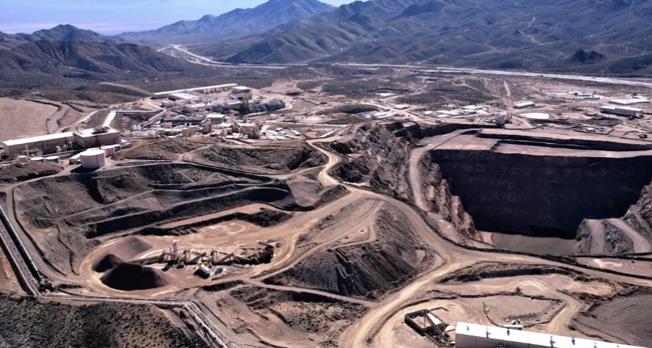
[Image 1 - Energynews]

Buried deep in this 16 THOUSAND acres site, bigger than the size of Manhattan…

And fully endorsed by the president himself…

Hides a special profit opportunity for regular Americans to target 100% gains again, and again, and again…

In as little as a single day.

Because when this site is up and running, it will house 584 Americans focused on just one mission…

To bleed BILLIONS of dollars out of China and redirect it straight into the pockets of American investors.

[Trigger BS]

It’s all part of a new Trump plan I’m calling Operation Motherlode…

And it is NOT just another run-of-the-mill, “America First” policy…

[Cred]

Trump has made it very clear with this operation: He doesn’t want to simply “boost” the American economy or “protect” our position in the world…

He wants to stomp China into the dirt while making regular Americans filthy rich.

This is about absolute and unquestionable global dominance. Plain and simple.

He’s already publicly addressed the matter, saying: we “can be so much wealthier than any country.”

Even Cornell, the kind of Ivy League college that HATES Trump, admits this plan is…

“an opportunity to make a significant amount of money.”
[Quote 1 - Cornell]

After meeting with the Department of Defense, one CEO tied to Operation Motherlode went on record saying:

“The taxpayers are going to make a lot of money.”
[Quote 2 - CEO Insider]

It’s a big win for the American people…

And all you need is a brokerage account to get in on the action.

Because thanks to Operation Motherlode, regular Americans now have a shot to target 100% gains on a starting stake in a single day, over and over again.

If you don’t want to leave a ton of money on the table, I recommend you move BEFORE February 1st.

My name is Nate Bear.

I’m the Head Technical Tactician at Monument Traders Alliance.

Every day, I help tens of thousands of students see how to make money from big market events, just like those coming from Operation Motherlode.

And while I’m probably most famous for teaching how I turned $37k into over $2.7 million in just four years…

Never in my career have I seen a bigger opportunity for regular investors to grow their wealth, FAST.

I’m talking about significant gains in just days or even hours.

Because every time there has been an update about Operation Motherlode, the market responds with double-your money opportunities like clockwork!

For example, Donald Trump quietly released the initial plans for Operation Motherlode back in March…

Most people didn’t even know what had happened.

In fact, I bet not 1 in 1,000,000 investors could look back and pick out this key moment.

But if you dig a little, you’d find that on March 5, 2025, Politico published a small story saying:

“Top White House officials are crafting policy to take on China and bolster the United States’ position…”
[quote rip]

And look what happened to ticker symbol OKTA…

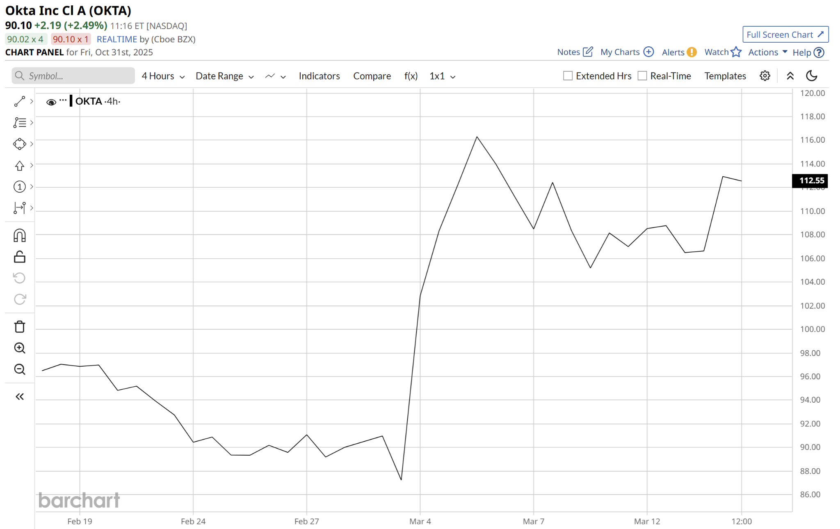
[Chart: OKTA
Start Date: 2.18.25
End Date: 3.14.25
Source: https://www.barchart.com/stocks/quotes/OKTA/interactive-chart]

See that pop?

Coincidence? Definitely not.

This company would DIRECTLY experience the ripple effect benefits from Trump’s new plan…

And in the very early innings of this operation, with just the FIRST piece of news…

I was able to quickly capture a 114% win on OKTA in just one day…

And while I bet not 1 in a million traders saw this coming…

This is the exact kind of event I love to trade.

In fact, every new update around Operation Motherlode offers the chance to double your money in as little as ONE day.

And with a project this big, OKTA wasn’t the only winner.

Around that exact same time, I also picked up fast winners like…

100% win on NVDA in two hours…
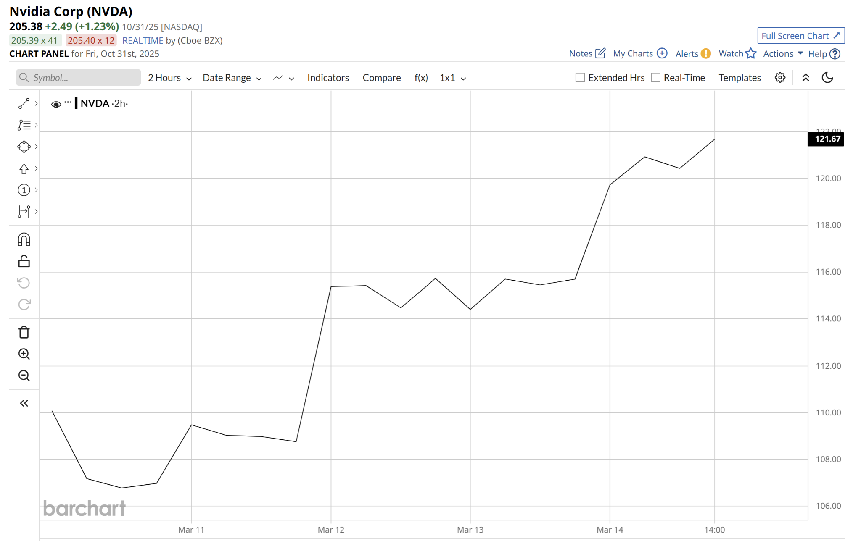
[Chart: NVDA
Start Date: 3.10.25
End Date: 3.14.25
Source: https://www.barchart.com/stocks/quotes/NVDA/interactive-chart]

And a 105% win on SPXW in four hours.
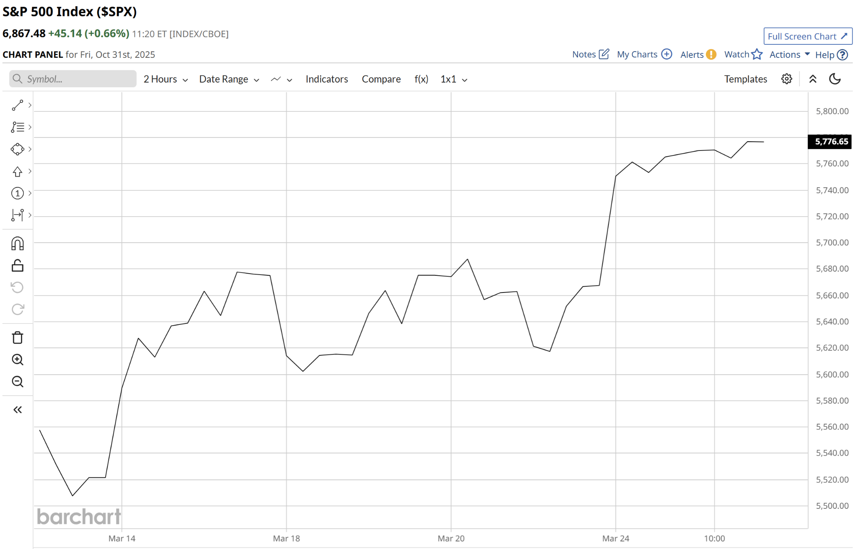
[Chart: SPX
Start Date: 3.13.25
End Date: 3.25.25
Source: https://www.barchart.com/stocks/quotes/$SPX/interactive-chart]

Isn’t that incredible?

Again, I’m sure nobody saw these moves coming, because most folks have no clue about Operation Motherlode!

But the double-your-money wins don’t stop there.

Because as Operation Motherlode continues to quietly expand right beneath everybody’s noses…

Overlooked by mainstream media and strangely ignored by Wall Street coverage…

There will be even more money-making opportunities just like these.

In fact, at EVERY milestone and update regarding Operation Motherlode, I fully believe there will be a FLOOD of brand new “double your money” opportunities that are going to hit the stock market like a tidal wave…

And they’re just going to keep coming and coming.

For example, look at what happened the very next month.

In April, Trump produced even more buzz around Operation Motherlode as he signed two executive orders expediting its progress…

Again, I bet not 1% of investors could recall that critical update…

But it was another step toward taking on China…

And another big update about Operation Motherlode.

Sure enough, certain stocks responded with double-your-money opportunities

Looking back at that month, I found and recommended trades like:

AMZN for a 129% gain in one day…
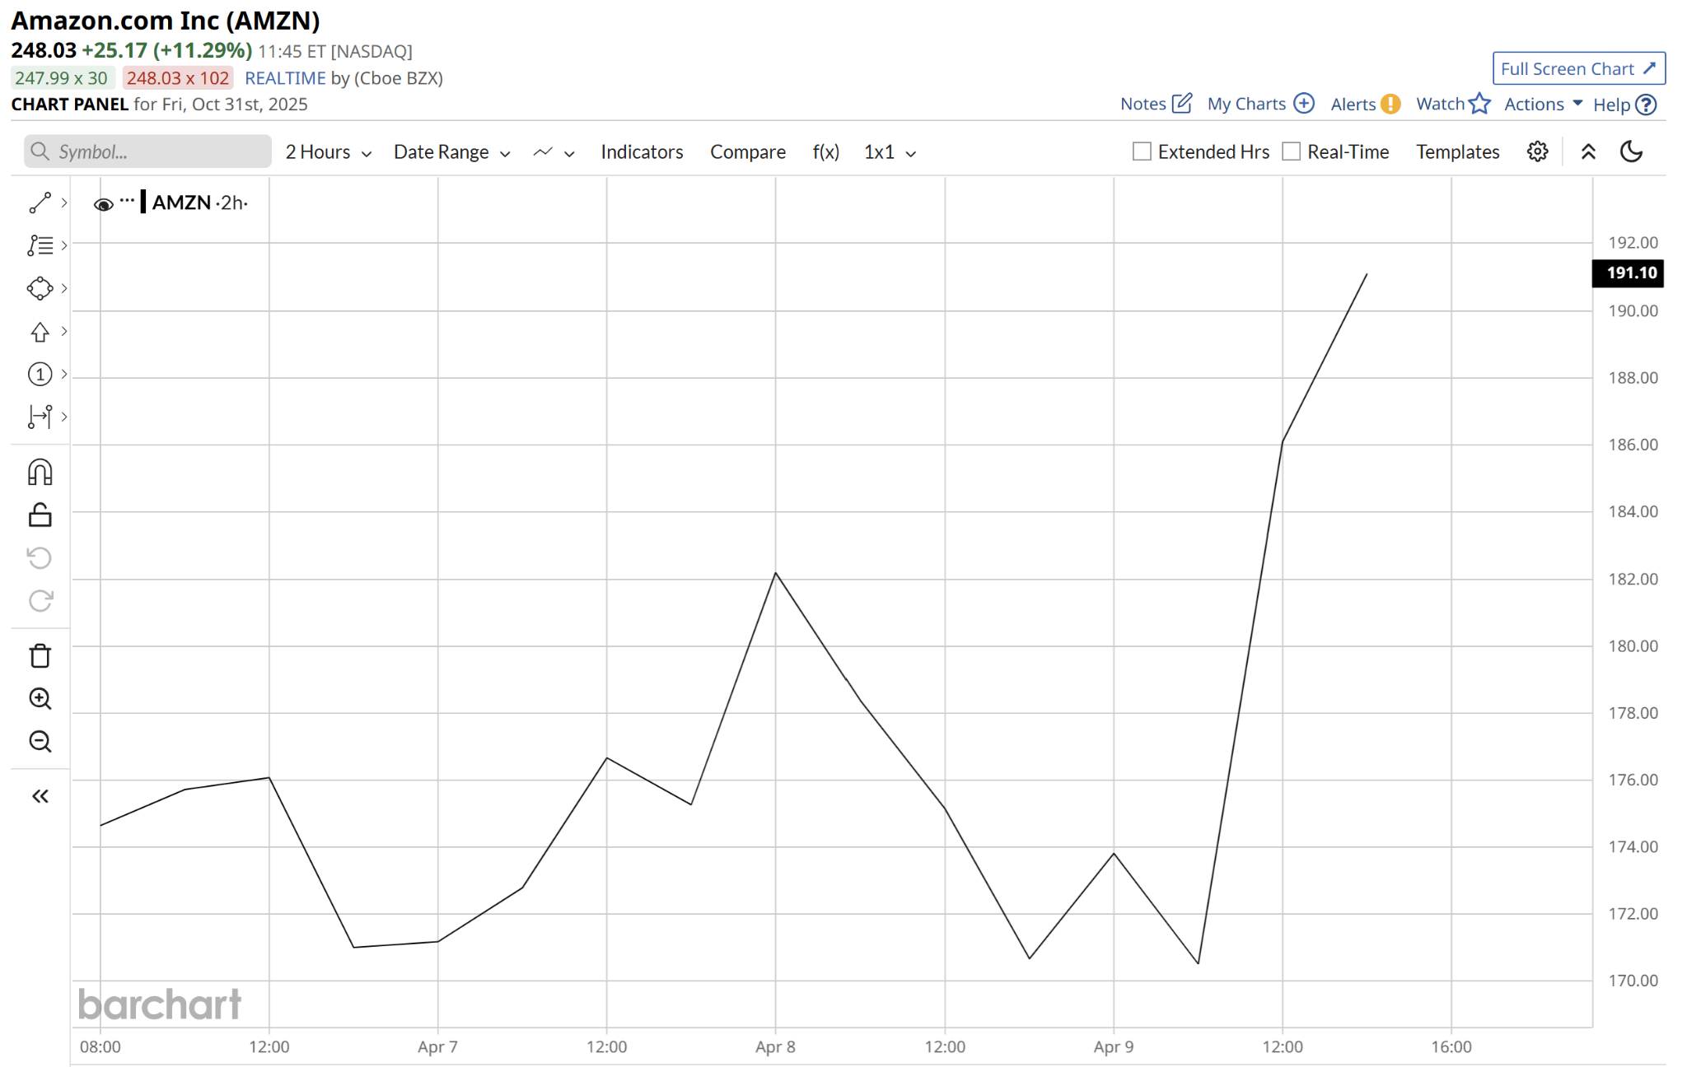
Chart: AMZN
Start Date: 4.4.25
End Date: 4.9.25
Source: https://www.barchart.com/stocks/quotes/AMZN/interactive-chart]

VRT for a 100% gain in two days
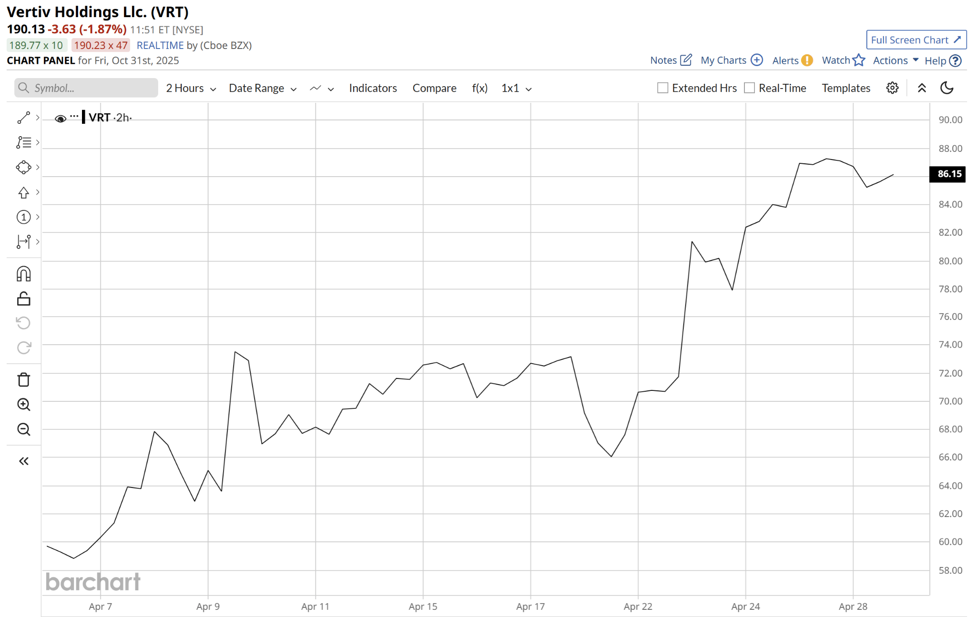
[Chart: VRT
Start Date: 4.4.25
End Date: 4.28.25
Source:https://www.barchart.com/stocks/quotes/VRT/interactive-chart]

And COST for a 100% gain in one day.

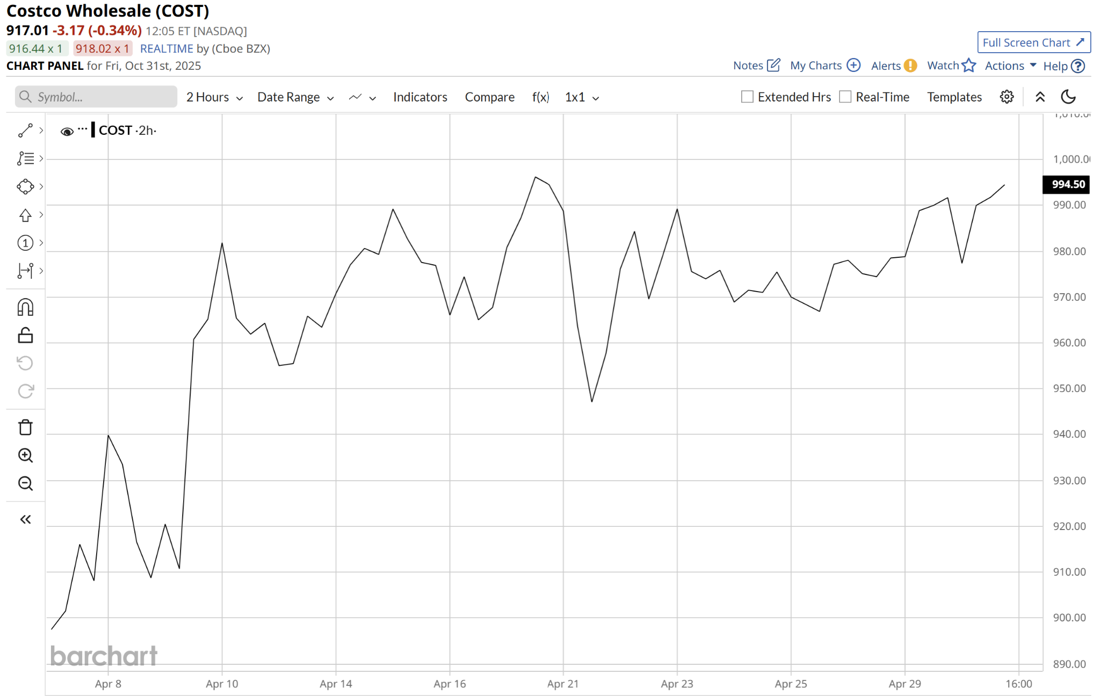
[Chart: COST
Start Date: 4.7.25
End Date: 4.30.25
Source: https://www.barchart.com/stocks/quotes/COST/interactive-chart]

Not bad, huh?

That’s THREE chances to double a starting stake. In just days or even HOURS.

Why wait weeks or even months for a stock to creep upward 5 or 10% when you can DOUBLE in a single day?

And looking back, around every new update around Operation Motherlode…

I was able to target hit after hit.

For instance, after Operation Motherlode officially went operational on July 11th, to virtually NO APPLAUSE or recognition whatsoever…

Certain stocks responded AGAIN with FAST double-your-money paydays.

And I identified…

100% on APPL in three days…
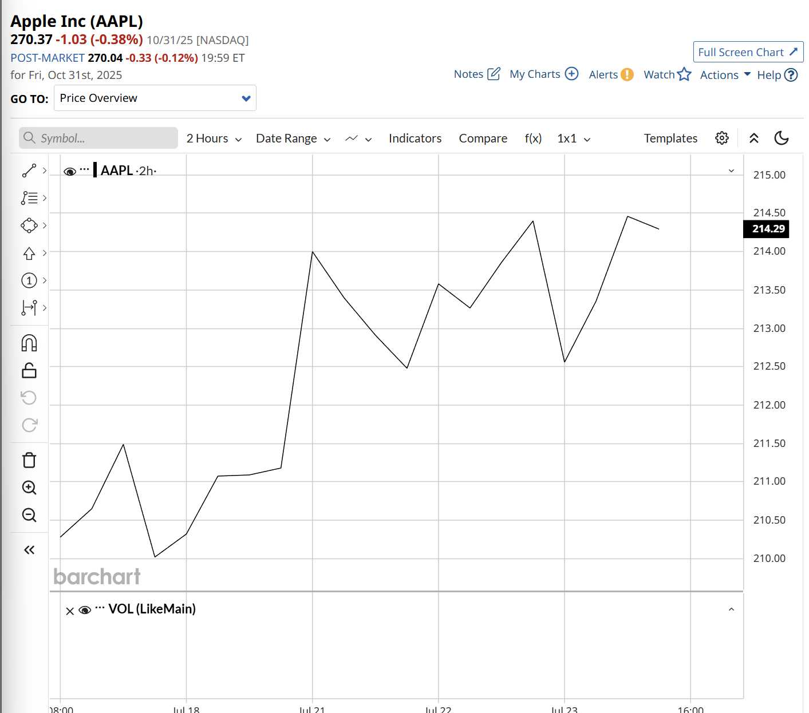
[Chart: AAPL
Start Date: 7.17.25
End Date: 7.23.25
Source: https://www.barchart.com/stocks/quotes/AAPL/interactive-chart]

101% on CEG in two days…
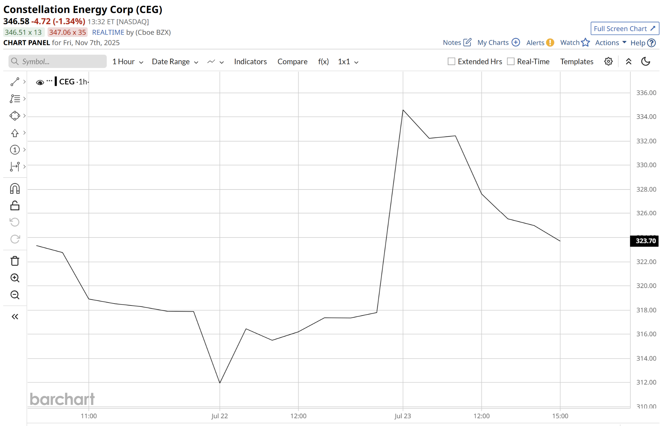
[Chart: CEG
Start Date: 7.21.25
End Date: 7.23.25
Source: https://www.barchart.com/stocks/quotes/CEG/interactive-chart]

128% on META in one day…
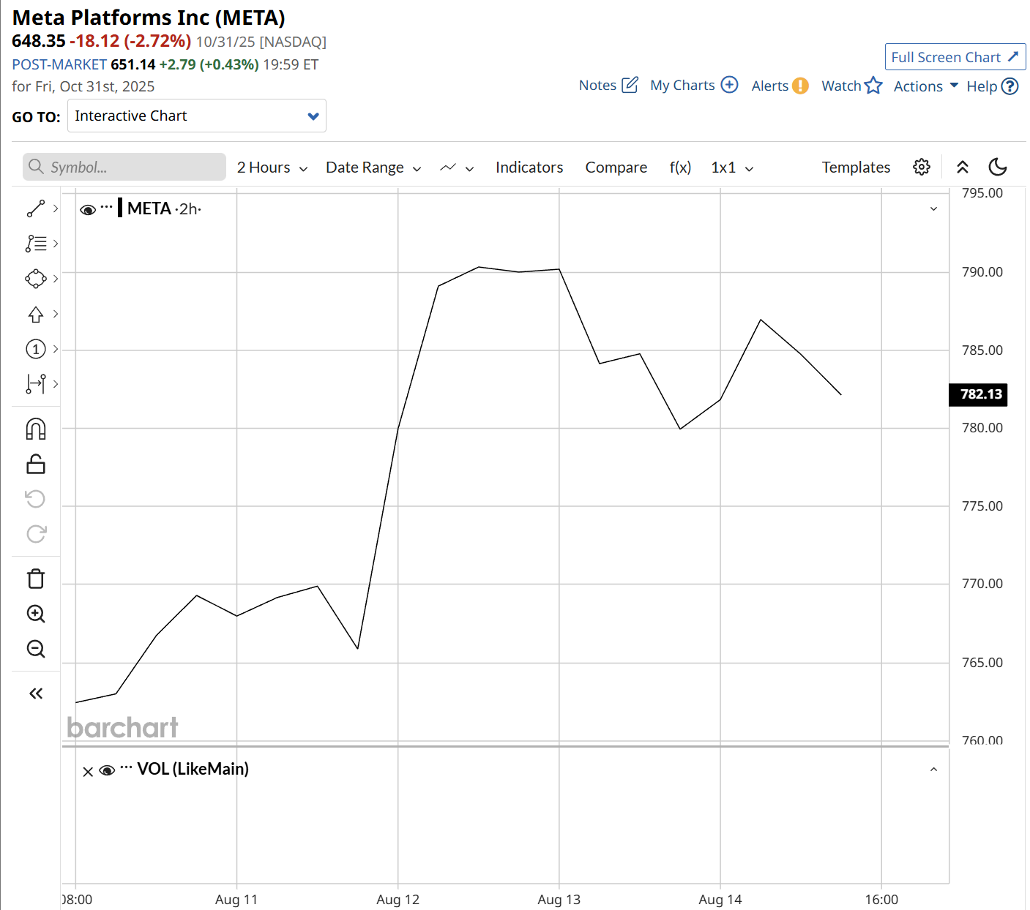
[Chart: CEG
Start Date: 8.8.25
End Date: 8.14.25
Source: https://www.barchart.com/stocks/quotes/META/interactive-chart]

133% on RGTI in one day.
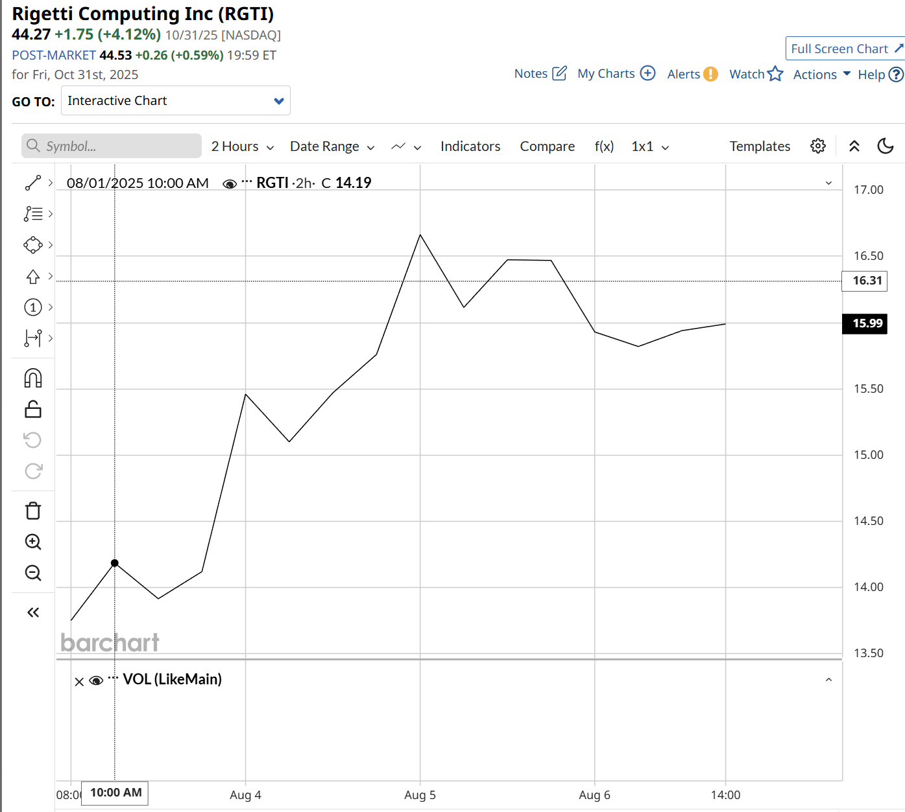
[Chart: RGTI
Start Date: 8.1.25
End Date: 8.6.25
Source: https://www.barchart.com/stocks/quotes/RGTI/interactive-chart]

And a 108% win on MSFT in one hour.
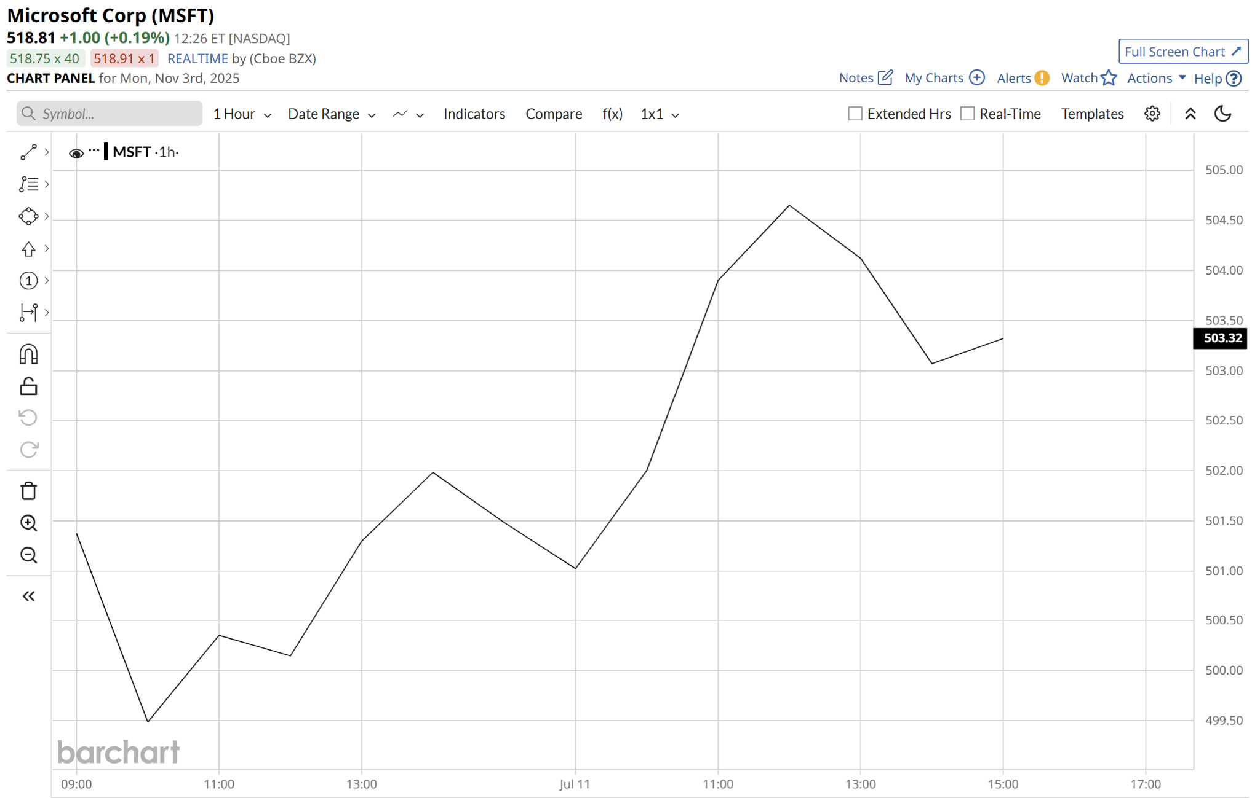
[Chart: MSFT
Start Date: 7.10.25
End Date: 7.14.25
Source: https://www.barchart.com/stocks/quotes/MSFT/interactive-chart]

See how straightforward this is?

What would you do if you knew a specific type of news would offer up FAST ways to target 100% gains over and over again?

You’d trade it, right?

This isn’t rocket science. It’s simple pattern recognition.

Every time there were new developments around Operation Motherlode, certain stocks responded IMMEDIATELY with FAST double-your-money opportunities.

That’s why I’m here today.

Because this is NOT going to slow down anytime soon.

Trump’s dedication to this project only gets stronger every single day.

In fact, his near term plan, which is already signed into action, is to multiply these opportunities in 2026 by 8-fold!

This is a historic level of opportunity for regular, hardworking Americans to get in front of life-changing profits over and over again.

And in just a moment, you’ll be able to count yourself among the lucky few who know exactly how to take advantage of these plays as well.

But don’t thank me… Thank China.

You see…

These plays are only possible thanks to Trump’s “brute-force countermeasure” to eliminate the “China Threat” once and for all.

We are here today because China left America no choice.

President Trump had to bring out the big guns.

You might have seen Trump’s recent statements that China is “holding the world captive…”

And how he called their latest moves to strong arm the United States of America: “sinister and hostile.”

He blasted them on social media, saying…

“I will be forced, as President of the United States of America, to financially counter their move.”
[Quote 3 - Truth Social, instructions: zoom in on this line]

So what was his counter move?

Operation Motherlode.

And since the first facility went operational, it has successfully siphoned hundreds of millions of dollars out of China and directly into the United States economy.

Since that time, the NASDAQ and S&P have both hit record highs multiple times…

And corporate profits also reported new highs.

Suddenly, everybody is feeling A LOT more patriotic and supportive of this initiative.

J.P Morgan praised the project calling it “America-First” and pledged over $1.5 trillion dollars in support.

Apple has already invested $500 million into the potential behind this opportunity…

The Pentagon has invested over $400 million into Trump’s plan…

And the White House is considering putting in another $2 billion.

And for you and me?

Our research shows that it could be the source of a $6.9 trillion cash injection for the American people through the markets.

That’s why Popular Mechanics.com said that Operation Motherlode has ignited a modern-day gold rush.


[Headline 1 - Popular Mechanics]

Frankly, we can thank China for this opportunity.

They constantly weaponize their position in global trade…

And this time, they finally pushed things too far.

Operation Motherlode is President Trump’s answer to China’s hostile, anti-American behavior over years and years.

It’s already taken back hundreds of millions of dollars out of the Chinese economy…and funneled it right back into American pockets.

Now the markets are booming…

And I know a simple trading strategy for everyday investors to use this knowledge to quickly target fast 100% winners over and over again.

So I hope you’re excited.

Because…

[Bribes]

Thanks to Trump’s Operation Motherlode, there has never been a better time for regular, average Joe investors to double their money – FAST.

That’s why in the next few minutes I’m going to reveal exactly what Operation Motherlode is…

Why China has forced Trump to make it his #1 priority…

And most importantly, I’m going to share how one simple strategy keeps profiting from Operation Motherlode like clockwork…

Because Operation Motherlode will cause a global cascade of ripple effects…

And whether the company is directly affected by it or even just experiencing some of the ripple effects caused by the initiative…

This simple strategy has been offering even the average Joe a unique chance to target big money wins over and over again

You don’t have to be a trading expert…

You don’t even have to care about global politics…

But very soon you might feel like a political insider – because you’ll know how to profit from a rare secret no one else knows.

All it takes to position yourself is a simple brokerage account.

But I do want to warn you…

[Expand Opp]

If you want to capture the biggest gains, it's important that you get in position before February 1st…

Don’t worry, I’ll explain everything.

But every day you wait you’re leaving money on the table…

Because Operation Motherlode is just starting to heat up…

And with each and every milestone of Trump’s initiative we’ll see more and more chances to target “double-your-money” wins.

The next milestone is right around the corner…

And if you don’t want to miss a flood of opportunities to double your stake in less than a week…

Then it's best you get in before February 1st.

If you’re just hearing about this today, you have already missed out on fast triple-digit wins like…

148% on COIN in one day…

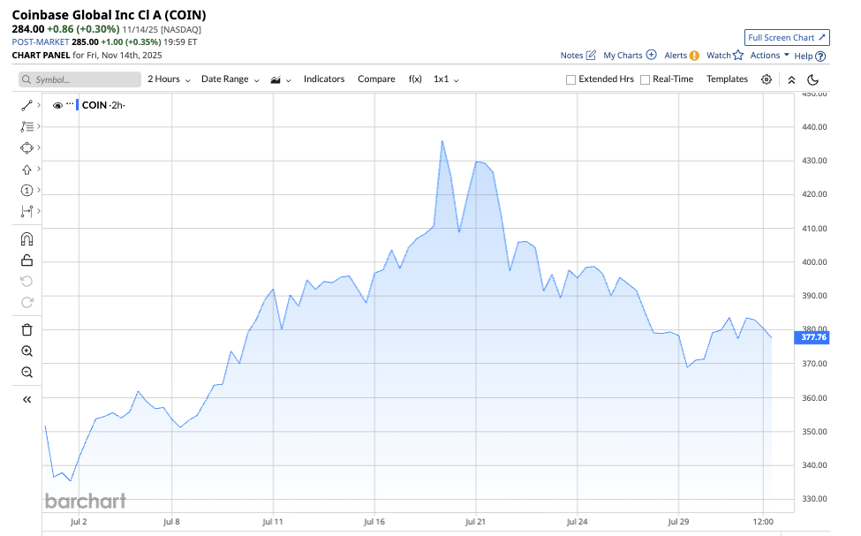
[COIN Stock Chart
Start date: 7.1.25
End date: 7.30.25
Source: https://www.barchart.com/stocks/quotes/COIN/interactive-chart]

110% on SOUN in one day…
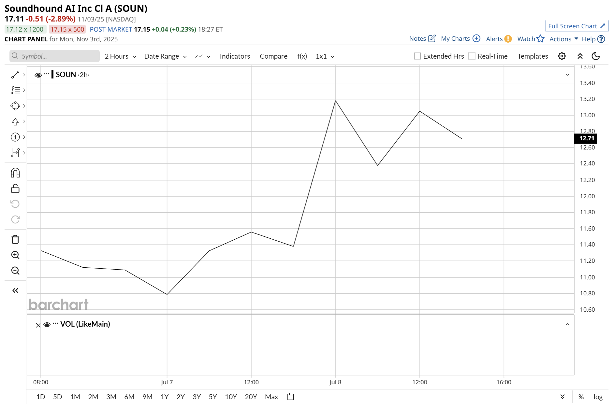
[chart: SOUN
Start Date:7.3.25
End Date: 7.8.25
Source: https://www.barchart.com/stocks/quotes/SOUN/interactive-chart]

Or 117% on VEEV in three days…
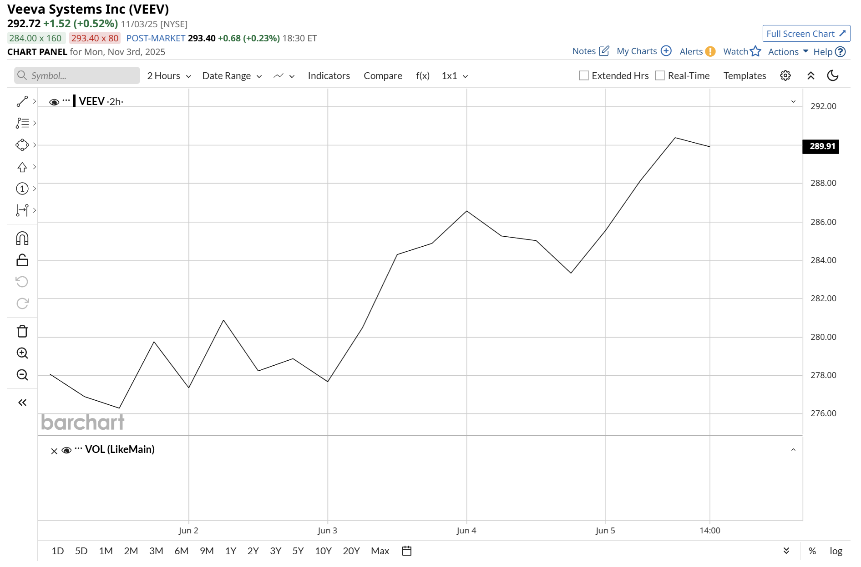
[chart: VEEV
Start Date:5.30.25
End Date: 6.5.25
Source: https://www.barchart.com/stocks/quotes/VEEV/interactive-chart]

So I urge you to drop everything you’re doing right now and pay close attention.

Close all the tabs on your computer.

Put your phone on silent and move it out of sight for just a couple minutes.

You will not regret it.

Because I believe there is nothing on the news today that’s more important to your wallet than Trump’s Operation Motherlode.

Okay let’s dive in.

The first thing you must know is:

[Super Problem]

You Need To Move Quickly, or You will be Left Behind…

Most folks have likely never even heard of Operation Motherlode.

But things have been in motion since March 2025.

If this is the first time you’re hearing about it…

I want you to know…

It’s not your fault.

The mainstream media does not like to publish anything favorable about Trump...

Even if it could help its viewers make a ton of money.

Because even though the media would never admit it…

When something like Operation Motherlode happens, investors can get very rich.

Take a look at what happened during Trump’s first presidency.

In 2018, Trump said that “China became “very spoiled” on trade” and warned Americans that…

“We have been ripped off by China.”
[Quote 4 - Reuters]

He retaliated with import tariffs…

And the mainstream media was quick to denounce the move.

The Washington Post published…

“Trumps Tariffs will hurt all Americans”
[Headline 2 - Washington Post]

And CNN tried to bring his efforts down by saying…

“The last American ‘trade war’ didn’t work out so great.”
[Headline 3 - CNN]

Folks who listened to the mainstream media missed out on one of the greatest booms in American history.

Because after Trump retaliated against China’s bullying in 2018…

More than 10 trillion dollars flooded into the stock market…

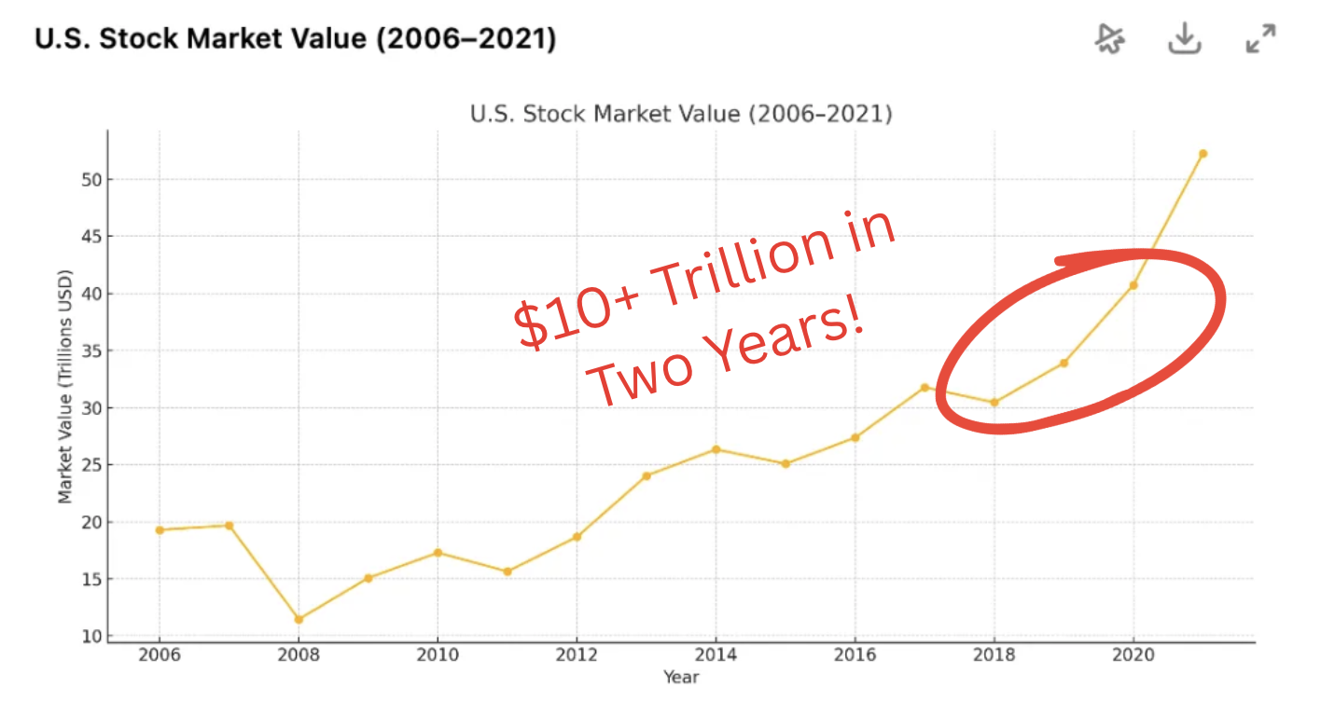
[Image 2 - Chart of Stock Market Size by Year 2018 -> 2020]

And while some folks held on to cash, scared by the mainstream media…

Over ten million everyday Americans became literal millionaires.

Let me repeat that.

The last time we saw something like today’s events happen…

Ten MILLION Americans became brand new millionaires for the first time.

While the media narrative led millions of others AWAY from the riches.

Operation Motherlode is a second chance to be one of the lucky citizens.

Just look at what happened in 2020, when something similar happened again.

Trump had just placed export controls on China…

He said it would "hold China accountable for its aggressive actions against the people of Hong Kong"
[Quote 5 - Wikipedia]

Most folks missed this…

But around that time the Washington Post published…

Trump has trapped us in a dark satire of American decline
[Headline 4 - Washington Post]

Now look at what happened to stocks one month after his actions…

Even through COVID, the S&P 500 and NASDAQ closed at record-highs, making some everyday folks a lot of money…

It was actually around this time I would recognize the opportunity in front of me, and personally used it to help make my first fortune.

Turning a small stake into literal millions in just 4 years.

Yes. I was one of those fortunate people.

So I know what is possible in moments just like this.

And now we see the same opportunity playing out again today with Operation Motherlode…

Only this time it’s going to be even bigger.

Trump is not just enacting some run-of-the-mill tariff.

This one is the real deal. The Motherlode.

Already, the NASDAQ and S&P have both hit record highs multiple times…

[chart]

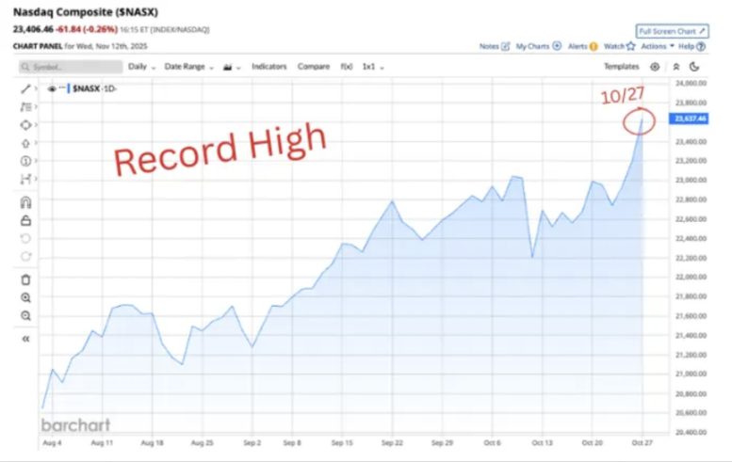
[Nasdaq Record High Chart - 10/27]

[chart]

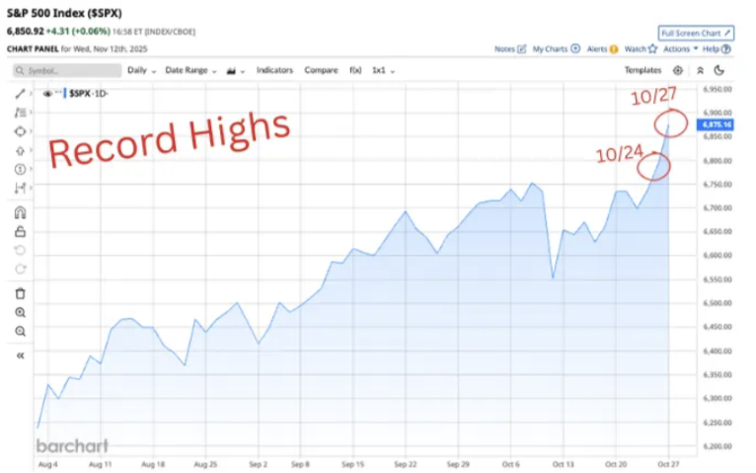
[S&P 500 Record Highs Chart - 10/24, 10/27]

Corporate profits reported new highs…

And my personal trading method has captured multiple 100% wins, including…

104% on BMNR in three days…
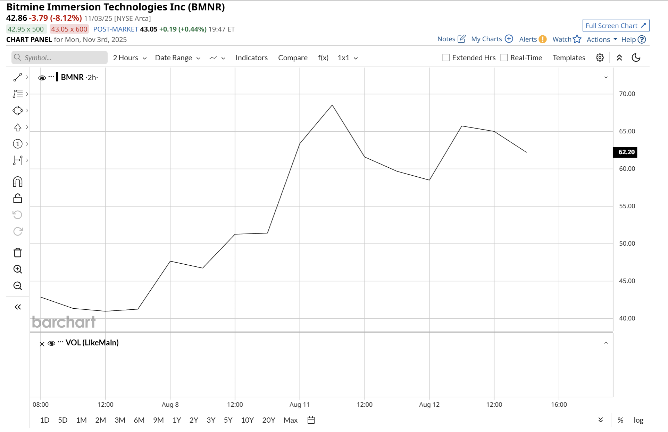
[chart: BMNR
Start Date:7.3.25
End Date: 7.8.25
Source: https://www.barchart.com/stocks/quotes/BMNR/interactive-chart

100% on RDDT in one day…
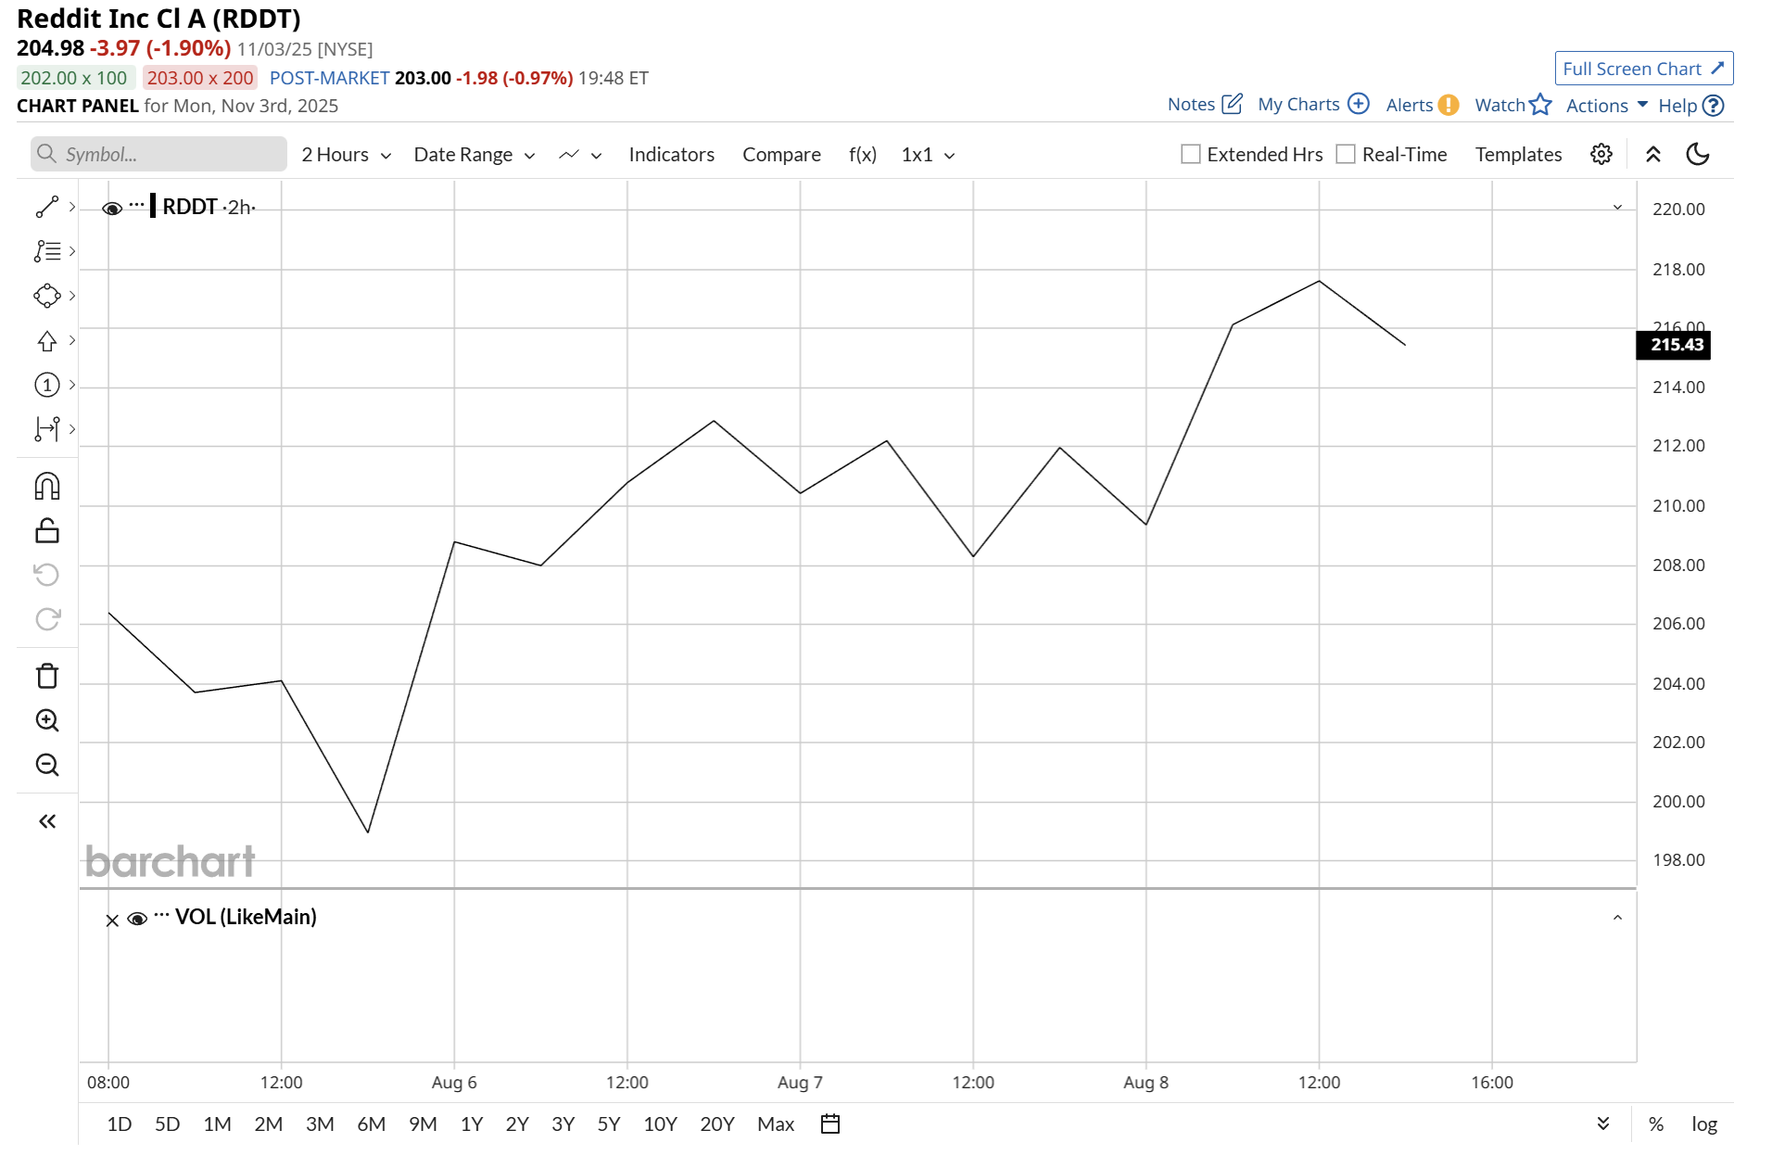
[chart: RDDT
Start Date:8.5.25
End Date: 8.8.25
Source: https://www.barchart.com/stocks/quotes/RDDT/interactive-chart]

194% on RILY in four days…
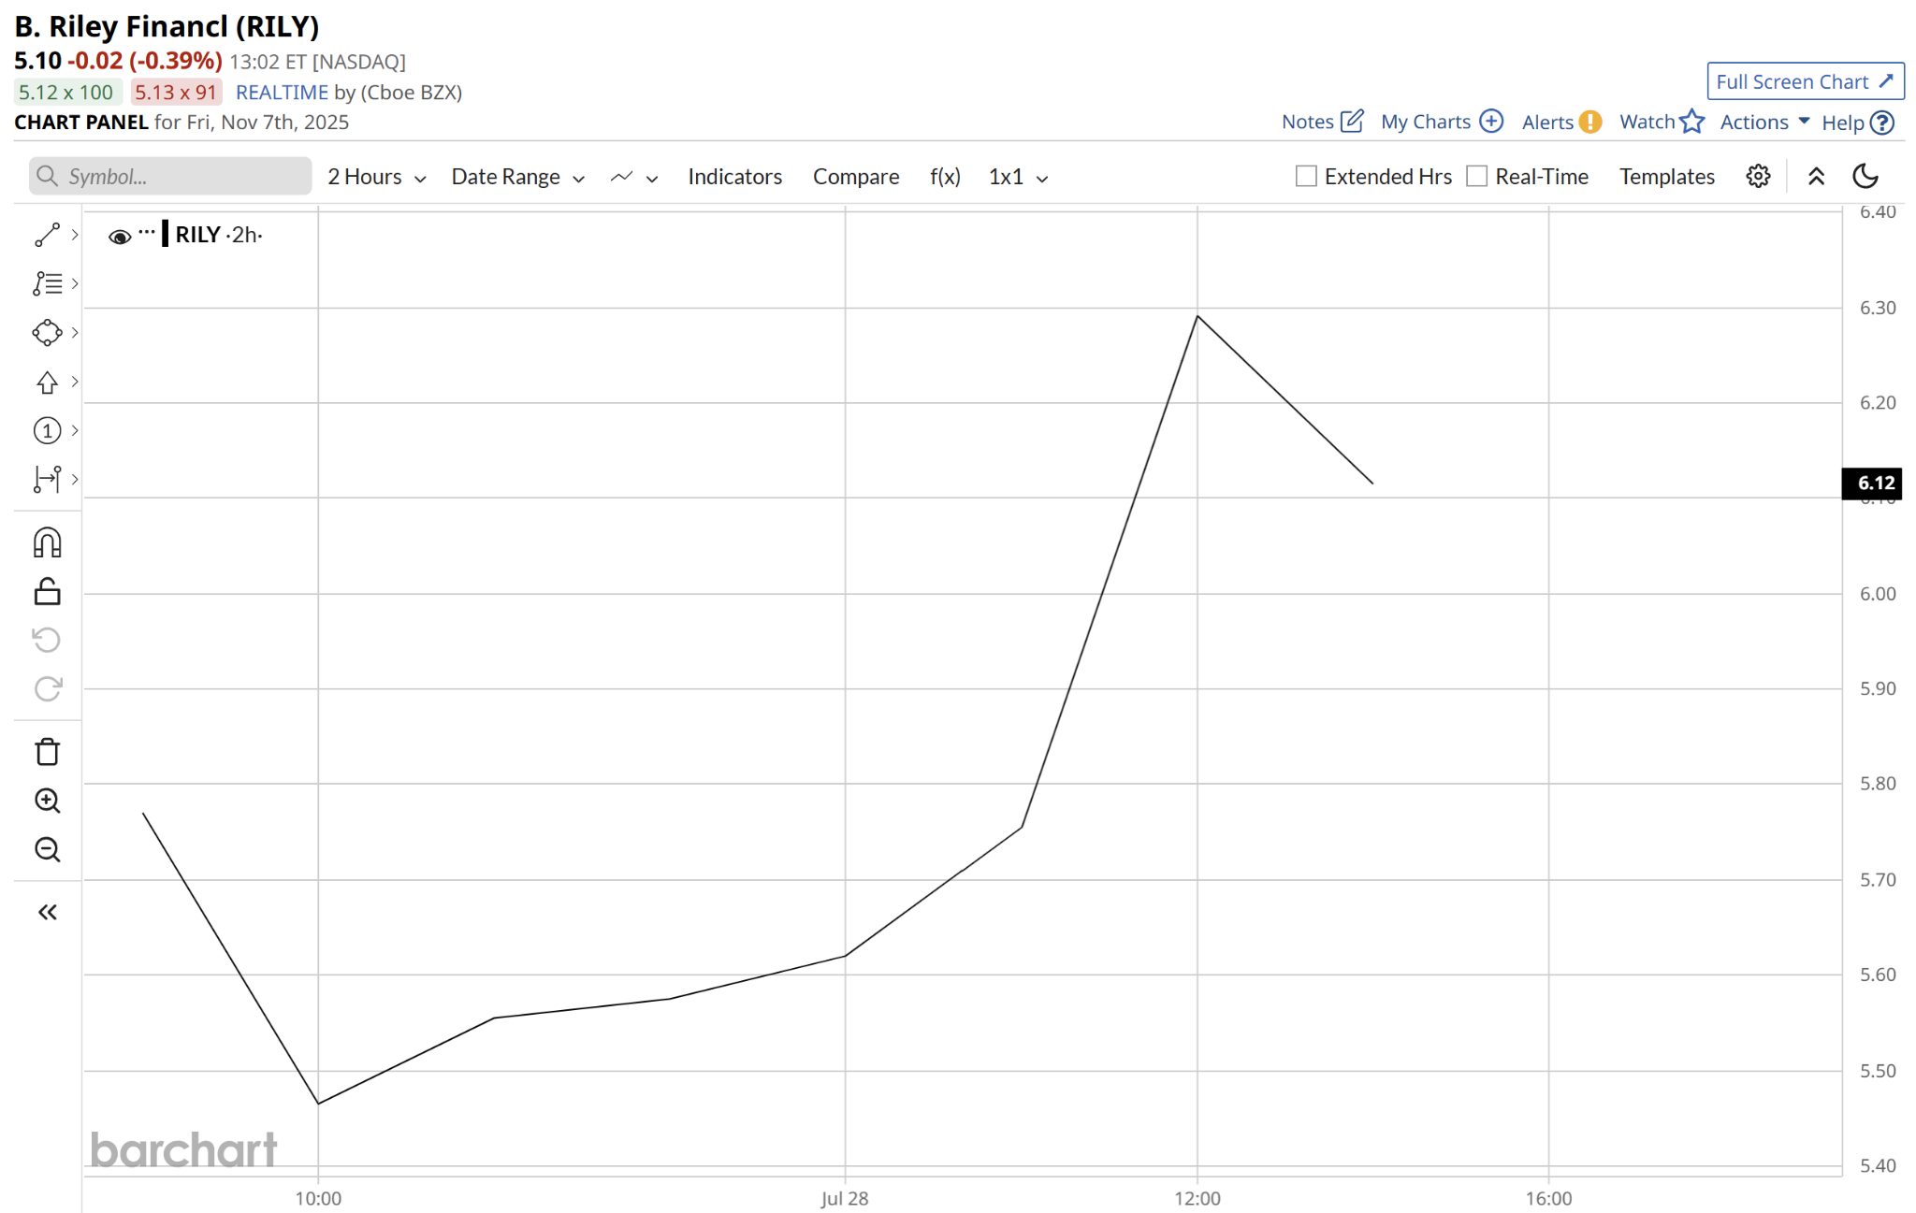
[Chart:RILY
Start Date:7.25.25
End Date: 7.28.25
Source: https://www.barchart.com/stocks/quotes/RILY/interactive-chart]

100% OKLO in two days…
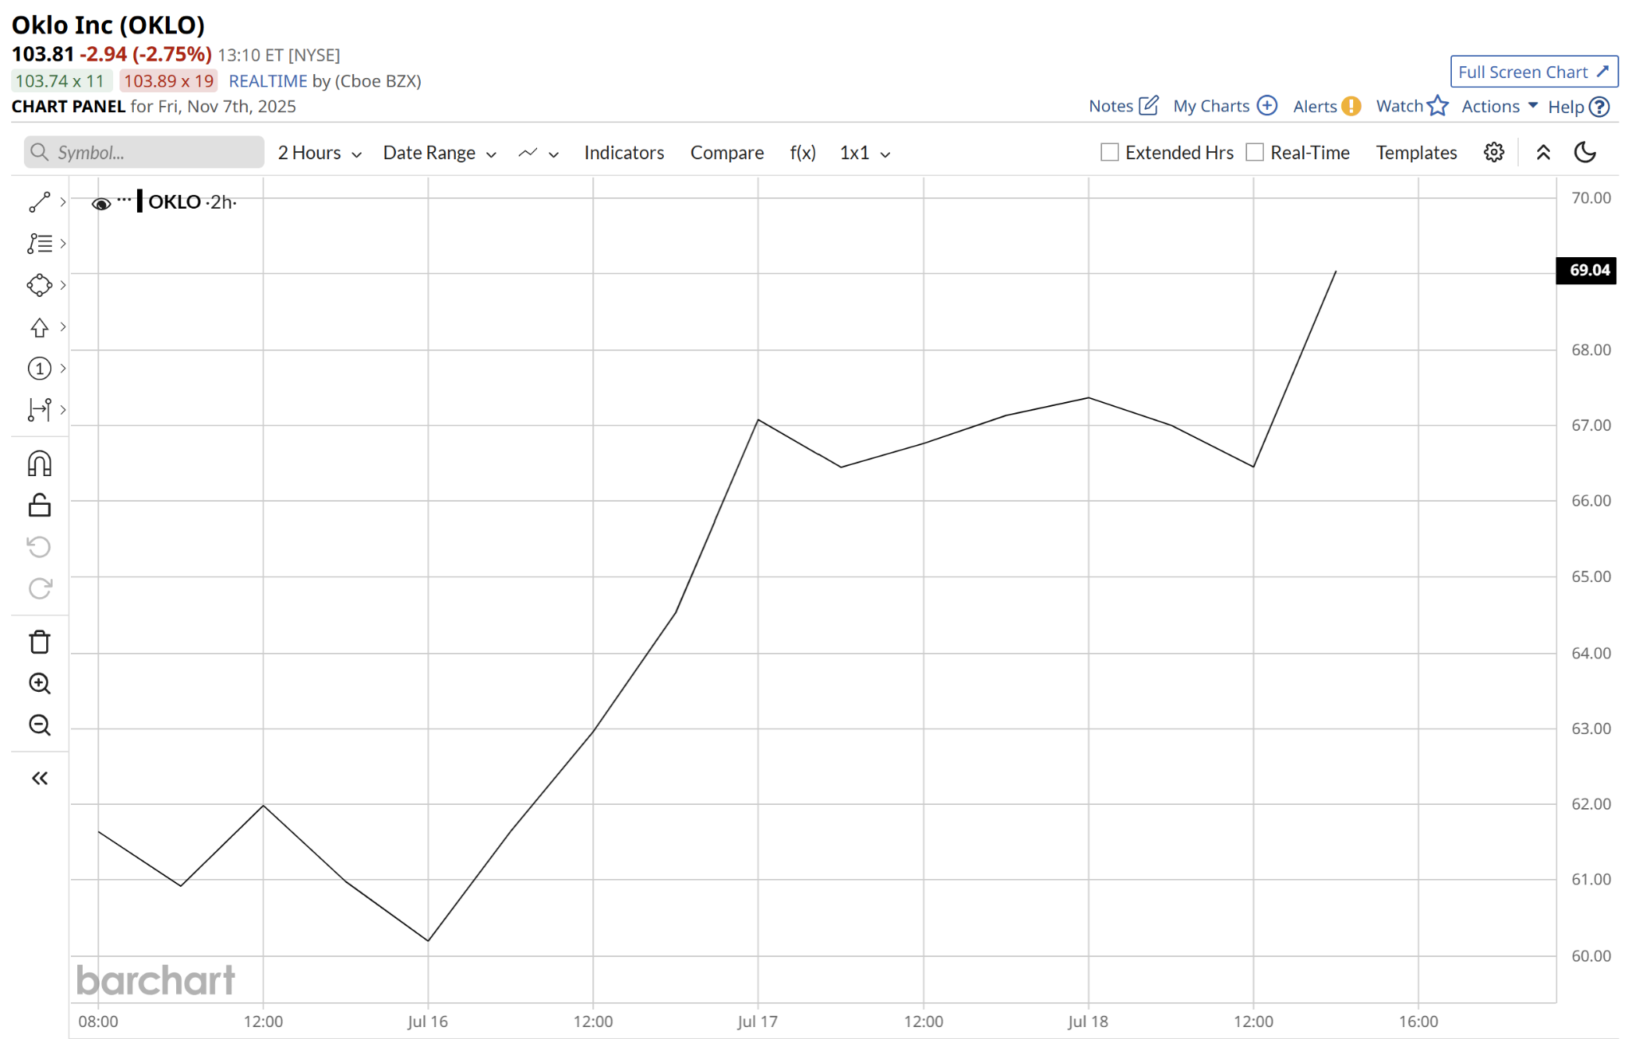
[chart OKLO
Start Date:7.15.25
End Date: 7.18.25
Source: https://www.barchart.com/stocks/quotes/OKLO/interactive-chart]

And 108% on MP in only four hours.
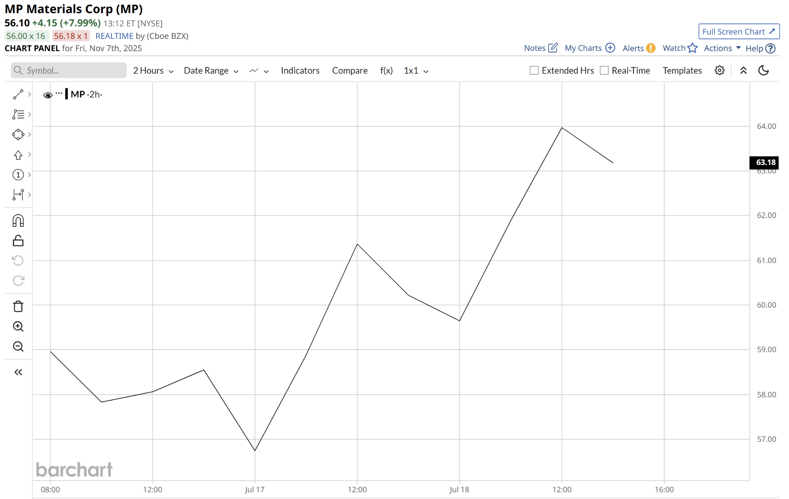
[Chart: MP
Start Date:7.16.25
End Date: 7.18.25
Source: https://www.barchart.com/stocks/quotes/MP/interactive-chart]

Here’s the bottom line:

You’ll never hear about this opportunity from the mainstream media or any of the usual places people look.

But whenever we see Trump push back against China…

It sends the markets soaring, and gives investors an opportunity to get rich.

I’ve lived it. I’ve profited off it.

And that’s why I’m here today.

I see this pattern as clear as day.

And this moment represents an opportunity for someone to dramatically change their lives, just like I did a couple years ago.

Now is the time to take a stand for yourself and use Trump’s fight with China for the most profits humanly possible…

Because the sheer volume of gains coming from Operation Motherlode is about to change the game.

And you’re one of the lucky few who knows about it.

[Catalyst]

We’re about to see Trump’s Operation Motherlode send the economy into a frenzy and make a lot of investors rich.

This Operation will be far more disruptive to the American economy than anything Trump has done in the past.

Because at the heart of the operation is a group of obscure minerals that make the modern world go round…

They’ve been called the “cornerstone of modern technology…”

Barrons said these minerals are critical to the creation of…

“everything from the iPhone and electric-vehicle batteries to wind turbines and F-35 fighter jets.”
[Barron’s - Quote]

And a professor at the University of Central Oklahoma wrote that without these minerals there would be…

“No digital revolution, no tech billionaires, no military technological edge, no artificial intelligence, no smartphones - no selfies with friends on a night out.”
[Newseek - Quote]

Trillions of dollars of American industry hinges on our ability to source these materials, including…

- $627 billion in the semiconductor space.
- $638 billion to support AI.
- $1.21 trillion worth of consumer electronics.
- $1.5 Trillion in renewables.
- $755 Billion for EVs.
- And $2.2 Trillion for Defense.

That’s about $6.9 trillion dollars worth of American industry.

Long story short: Without these minerals, America would immediately lose its position as a global super power.

And we would lose virtually all modern technology we currently enjoy.

This obscure group of minerals are called “rare earths…”

And with the boom of new AI tech, America’s demand for rare earths is projected to TRIPLE over the next couple years…

There’s only been one hold up…

For years, China has been holding the world’s rare earths supply hostage.

For decades, America, along with the rest of the world, has totally relied on China for the mining and production of rare earth minerals.

China now controls over 85% of the world’s rare earths supply.

And there’s no country at greater risk than America.

Just a few years ago, the Department of the Interior found that we rely 100% on China for 20 different key minerals…

Meaning our entire defense industry now hinges on our biggest rival.

[show don’t read]
China’s New Rare Earth and Magnet Restrictions Threaten U.S. Defense Supply Chains
[Headline - CSIS]

It was only a matter of time before something went wrong.

Last year, China sniffed out this weak spot and cut off our rare earth exports, putting our national security in jeopardy.

[show don’t read]
The U.S. Military and NATO Face Serious Risks of Mineral Shortages
[Headline - Carnegie Endowment]

The entire auto industry went into full panic mode…

[show don’t read]
Auto companies 'in full panic' over rare-earths bottleneck
[Headline - Reuters]

And Forbes called it our “next great crisis.”

[show don’t read]
America Confronts Its Next Great Energy Crisis: Rare Earth Minerals
[Headline - Forbes]

Getting the squeeze from China has continued to cause real problems for the United States.

That’s why Trump called out China’s abuse of power in front of the whole world.

He said:

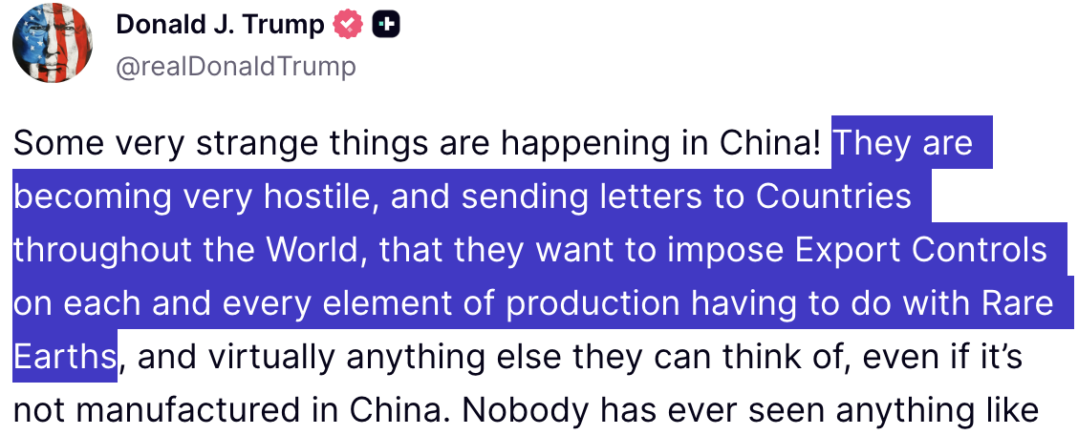
[Image 3 - Trump’s Truth Social Post]

He knew that as long as America is dependent on China’s rare earths supply…

We will always be at their mercy…

His solution?

Turn the tables with Operation Motherlode.

He said:

“We believe [it’s] possible to extract enormous amounts of critical minerals and rare earths…making America the mineral superpower of the world”
[Quote - President Trump]

And on July 11th…
After he signed executive orders to put it in motion…

And after his supreme court made landmark rulings to open these resources up for excavation…

We took the first step to securing our nation’s independence…

And opened the first rare earths mine in America in over 70 years in Sheridan County, Wyoming.

[Image 4 - Energynews (Same as image 1)]

Attorney, economist, and former advisor to the CIA, Pentagon, and U.S. Treasury – expert Jim Rickards calls it a $150 trillion “national endowment.”

Now we’re seeing any company related to rare earths go absolutely crazy.

In just the past few months…

Rare earths companies like MP Materials has seen its stock price go up 281%…

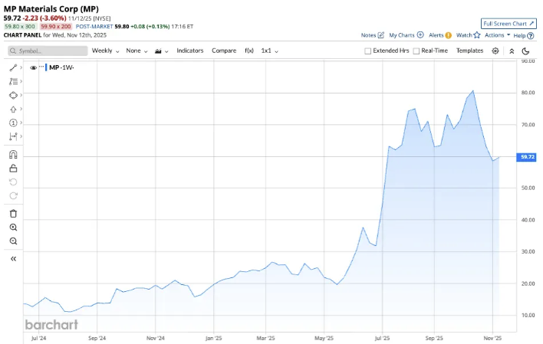
[MP Materials Stock Chart
Entry Date - 05/19/2025
Entry Price - $19.69
Exit Date - 08/11/2025
Exit Price - $75.03
Percent Change - 281%]

USA Rare Earth Inc has shot up over 209%...

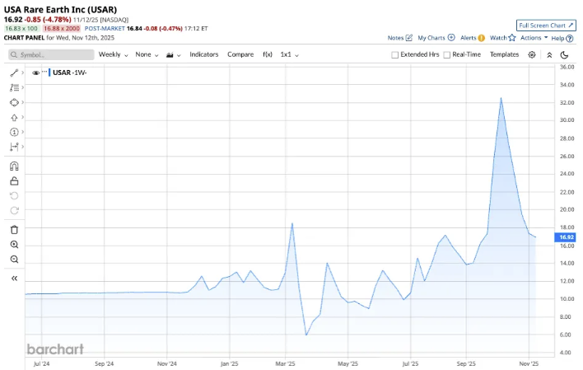
[USA Rare Earth Inc Stock Chart
Entry Date - 03/01/2025
Entry Price - $5.94
Exit Date - 10/01/2025
Exit Price - $18.41
Percent Change - 209%]

And American Resources Corp has jumped 474%!

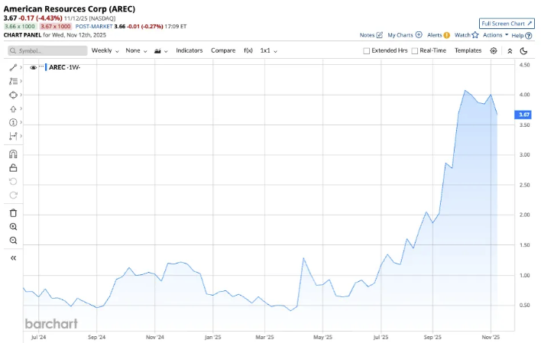
[American Resources Corp Stock Chart
Entry Date - 03/01/2025
Entry Price - $0.47
Exit Date - 09/01/2025
Exit Price - $2.70
Percent Change - 474%]

It just makes sense, right?

But it wasn’t just stocks tied directly to rare earths.

Look what happened to the broader US economy after we opened our first rare earths mine…

Every single index hit record highs…

And we saw strong earnings across the board.

The Dow hit record highs…

Dow Industrials Hit Record, Boosted by Strong Earnings
[Headline 10 - WSJ]

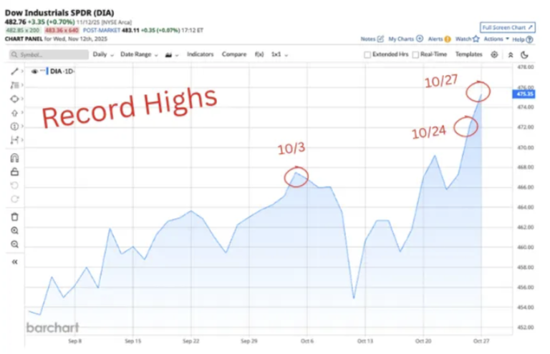
[DOW Record Highs Chart - 10/3, 10/24, 10/27]

So did the S&P 500…

S&P 500 Climbs to New Record on Strong Earnings
[Headline - WSJ]

[S&P 500 Record Highs Chart - 10/24, 10/27]

The Nasdaq 100 futures.

Nasdaq-100 futures rallied on strong earnings outlook and big tech gains.
[Headline - CME Group]

[Nasdaq Record High Chart - 10/27]

We’re even seeing some of the best corporate profits in over four years.

Early US Earnings Point to Best Corporate Results in Four Years
[Headline - Bloomberg]

All of this happened after the United States built a single rare earths mine…

But this is just the beginning…

Because Operation Motherlode is about to bring a flood of new rare earths mines in the coming months.

In fact, we’re tracking one special mine that is set to come online very soon.

A Massive Expansion Is Already Underway

You see, Operation Motherlode doesn’t stop at a single mine…

Take a look at this map…

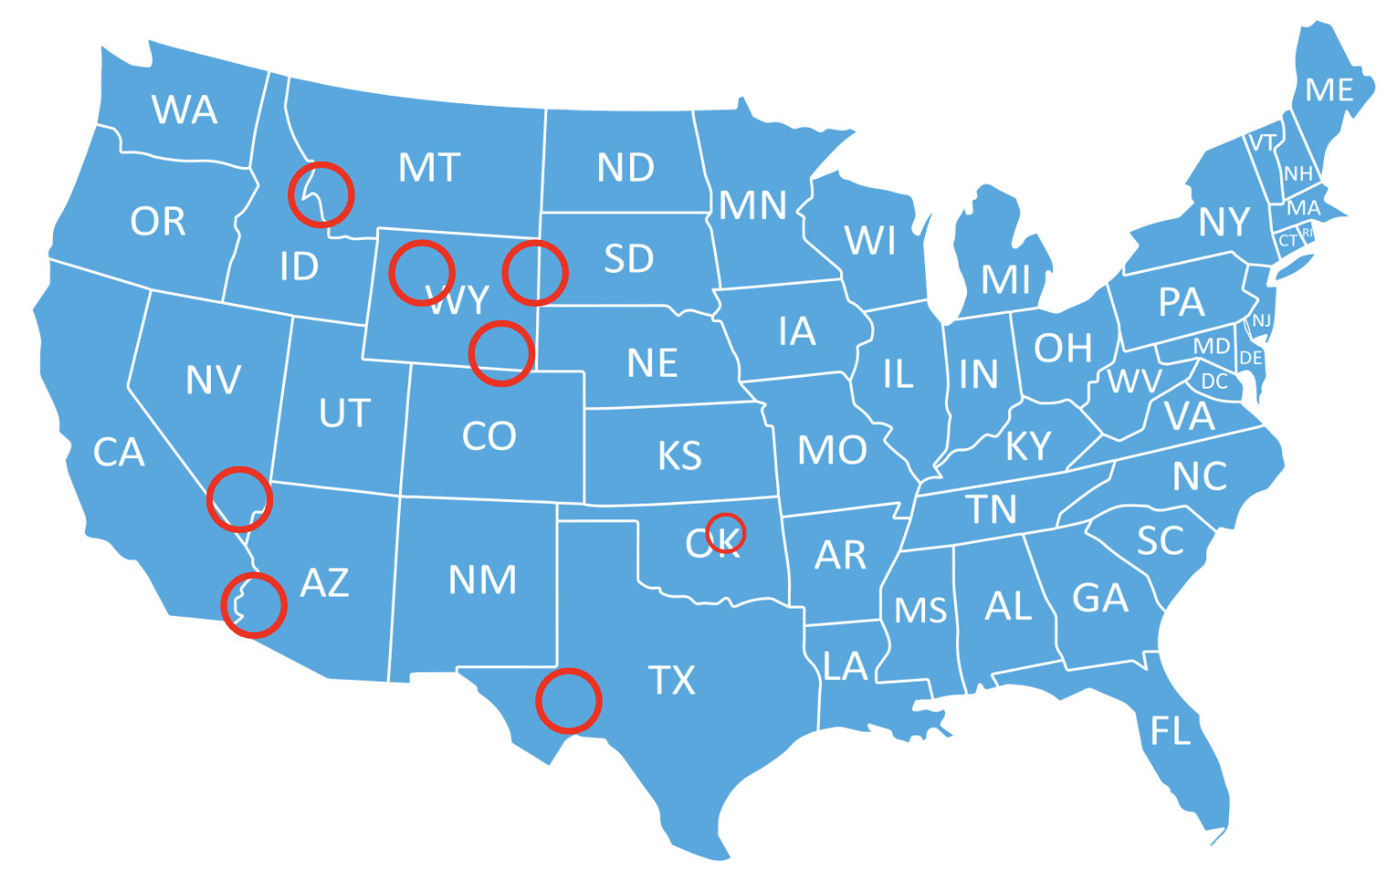
[Image 5 - Eight more planned mines]

The circles are EIGHT MORE rare earths mines that will come online very soon.

But there’s one special mine in Southern Wyoming that’s projected to have over 2.3 billion tons of potential rare earths.

It’s been referred to as the “rare-earth motherlode” and It's estimated to be the richest IN THE WORLD.

To put that into perspective…

In 2024, China produced over 270,000 tons and accounted for more than two-thirds of the global total.

This single mine holds over 8,600x that amount!

America’s dominance would reach a level unprecedented in history.

And that may happen sooner rather than later….

This next announcement about this mine’s progress could come as soon as February 1st.

So you need to move fast…

Not to mention, Trump recently signed an emergency executive reducing the approval times of mining projects from years to AT MOST 28 DAYS!

When Trump said he was going to turn America into the mineral superpower of the world…

He wasn’t playing around.

Hidden underneath our feet is a massive rare earths supply waiting to make America rich…

And thanks to Operation Motherlode…

We’ve just begun to tap into its power…

Which is why you need to be ready before February 1st .

Every new update around these new mines will unleash a flood of opportunities to target 100% gains again and again.

Those who are not ready will miss a tidal wave of profits.

But those who are in position can make a ton of money.

[Mech IN OPERATION MOTHERLODE]

And I’ve identified a simple trade for regular investors to use Operation Motherlode to potentially double their money in just a few days.

Without a doubt, I believe that there’s going to be a lot of ways to position yourself riches from Operation Motherlode.

But I’ve found a simple, straightforward way for a regular person to walk away with ungodly profits.

I call it a “profit surge” trade.

The way it works is simple…

When updates around Operation Motherlode positively impact a stock, we can use the positive momentum to trade that single stock over and over for the shot at FAST profits.

[DEMO 1]
For example, take a look at what happened with Oklo, an energy technology company that supports data centers.

Data centers need TONS of chips and components created out of rare earth minerals.

Thanks to Trump’s intervention, and the tailwinds from Operation Motherlode, Oklo’s partners have been able to secure rare earths and expand data center operations without a hitch.

This helped them secure contracts to accelerate power availability to data centers…

In short: Business is booming.

Now, Oklo is not one of the “hot stocks” on TV, so most people missed the move entirely.

But a few people who studied the earnings calendar…

What they often do is get in position before the announcements and immediately sell.

So maybe they would have spotted this opportunity for a nice 68% win in a couple weeks…

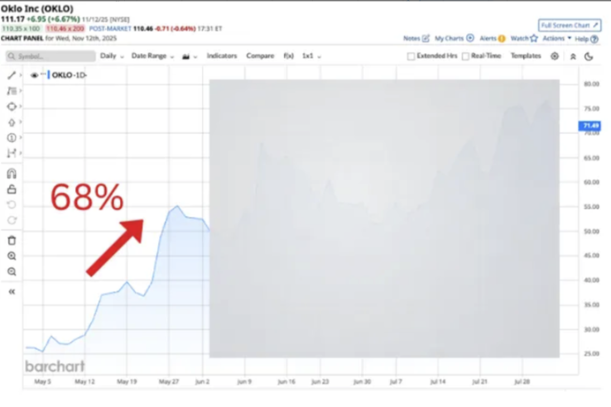
[Stock Chart 1 - OKLO
Entry Date: 5/13/2025 (earnings date)
Entry Price: $32.03
Exit Date: 5/27/2025
Exit Price: $53.90
Percent Change: 68%]

Not bad!

But they still missed the real opportunity here.

This stock had all the ingredients of a double-your-money “profit surge.”

With Operation Motherlode impacting this stock, and one kind of trade, we could ride the momentum to target FAST double your money paydays over and over again in the months following this announcement.

The exact kind of opportunity I love to trade.

So while some studious earnings traders had a shot at 68% in a couple weeks…

My “profit surge” strategy offered a 162% win in one day…

A 100% win in two days…

And even a 112% win in just 45 minutes.

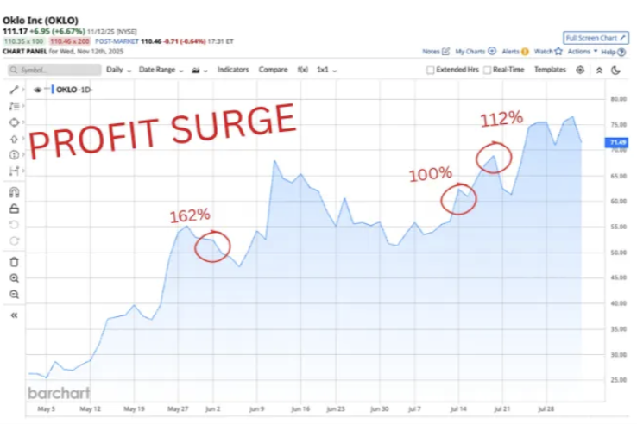
[Stock Chart 2 - OKLO Multiple Win Stock Chart]

That’s THREE opportunities at FAST double-your-money wins!

But Oklo is just one example.

Every time there’s a new update or development around Operation Motherlode, we have a shot at riding that momentum with this exact kind of special trade!

[DEMO 2]
Just look at what happened with CoreWeave, a company that operates in the semiconductor space.

Rare earths, like the ones Operation Motherlode offers, are critical for semiconductor manufacturing. And act as a crucial protective shield on chips to ensure their sustained performance.

Now, after Trump announced the first steps of Operation Motherlode back in March…

CoreWeave secured an incredible $11.9 BILLION dollar contract.

And if anyone was even paying attention to this stock’s earnings announcements, they could have seen a respectable 59% gain in about a week…

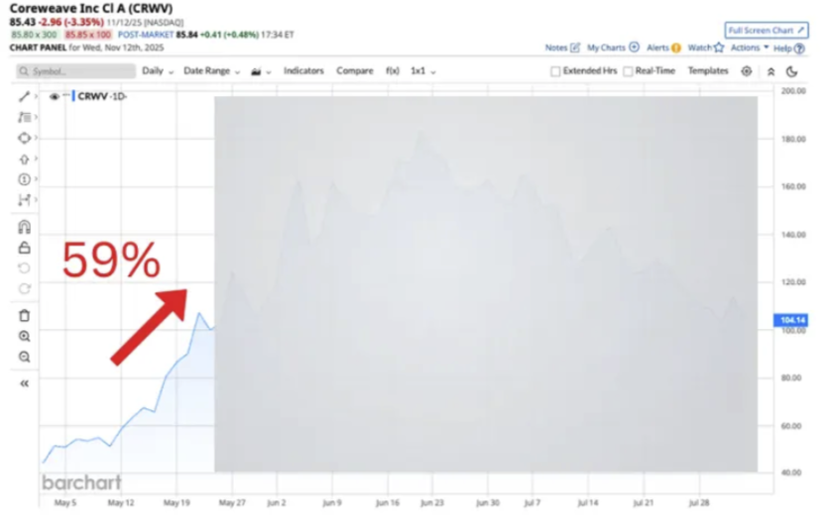

[Stock Chart 3 - CRWV
Entry Date - 5/14/25 (Earnings date)
Entry Price - $67.46
Exit Date - 5/21/25
Exit Price - $107.39
Percent Change - 59%]

But I saw a true profit surge opportunity at play here. .

Meaning we could ride that positive momentum and use a special trade to capture wayyyy more than that.

Sure enough, I jumped in for:

A 73% gain in one day…

A 198% gain in four days… Nearly a triple there.

And a 100% gain in two hours. Easy, no-sweat double. All of these over the course of a month after the news dropped.

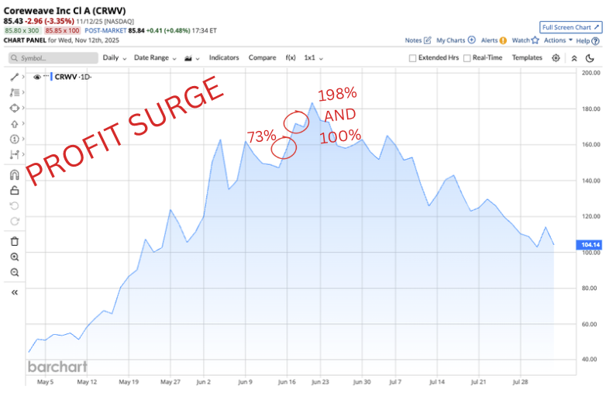

[Stock Chart 4 - CRWV Multiple Win Stock Chart]

Again, three FAST plays with a chance to double your money!

See how simple this is?

With profit surge trades, we simply use a stock’s momentum in our favor, and place a special trade to multiply our returns.

With this strategy it is possible to generate way more profits than most people make trading the stock…

And in a fraction of the time.

[DEMO 3]
The same thing happened for quantum computing company RGTI.

The Quantum Insider says that rare earth elements are the “hidden foundation of quantum technologies.”

And after Trump expanded Operation Motherlode and made it easier for companies to access new sources of rare earths…

RGTI reported a 45% YoY increase in their earnings per share…

The stock popped.

And while most people made a decent 22% gain in about 2 weeks from that good news…

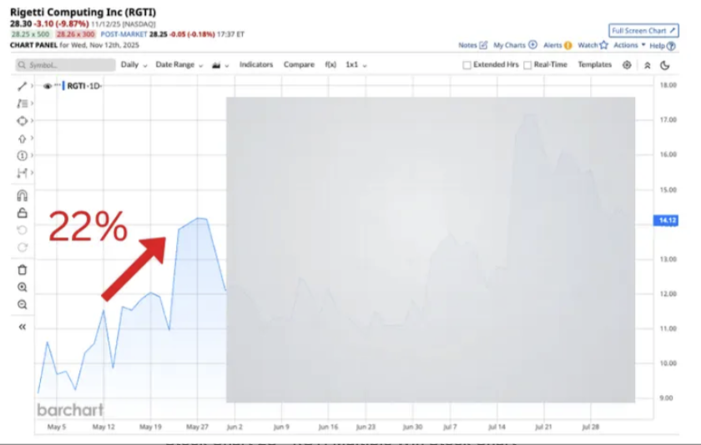
[Stock Chart 5 - RGTI
Entry Date - 5/12/2025 (earnings date)
Entry Price - $11.55
Exit Date - 5/27/2025
Exit Price - $14.19
Percent Change - 22%

I spotted a profit surge trade at play here…

Meaning we could use that positive momentum to grab some FAST double your money paydays.

And over the course of the next month, while we had both winners and losers, I was able to find a nice 100% gain in two hours…

A 133% gain in one day…

A 100% gain in five hours…

And a 104% gain in 43 minutes.

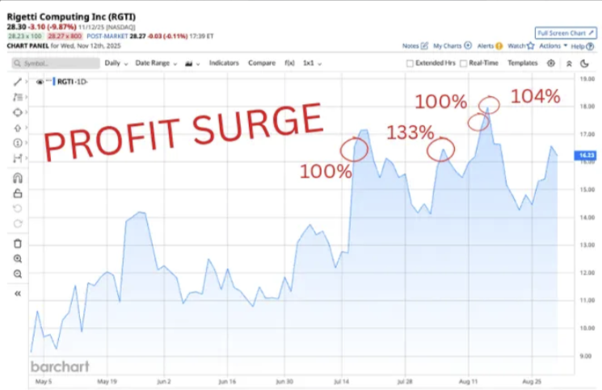
[Stock Chart 6 - RGTI Multiple Win Stock Chart]

It’s very simple. The proof is crystal clear.

Without a shadow of a doubt, I believe that Operation Motherlode is going to be the spark that ignites a flood of new profit surge trades.

For the folks who know how to find them, this is the profit opportunity of a lifetime.

But please keep in mind… All investing comes with some degree of risk. Never invest more than you can afford to lose. And don’t invest all your money in one trade, many of our options trades won’t reach 100% gains, and some will miss the mark entirely. That’s just how it goes.

But for me, the picture is clear: Being able to spot a profit surge opportunity is the single most important determining factor for dramatically changing someone’s financial future in the shortest time possible.

[MECHANISM IN THE GENERAL]

Today you have a rare opportunity to make an absolute killing from profit surges trades across the entire market...

Like I said, my name is Nate Bear and I specialize in making money from profit surge trades…

The same kind we’re seeing pop up now because of Trump’s Operation Motherlode.

But profit surge trades are not a new phenomenon.

I did not start trading them when Operation Motherlode came out.

Like I said, I’ve been making them for years.

Before I was a profitable trader and mentor to others…

I was a construction worker putting in 12-hour days.

I was able to leave that life forever after I turned $37k into over $2.7 million dollars in just 4 years.

I would say “the best years of my life…”

But since then, I’ve only gotten better at this. So they’re all great years.

The reason I’m able to make such larger gains than most people is because I make a special type of trade when I see the surge.

Instead of simply buying and holding the stock like most folks…

I place a special type of trade on the stock called a call option.

While the steps are the same as buying a stock, and it isn’t difficult to do… this type of play carries more risk than a normal stock play. But the profits can be much much higher.

When you combine the power of a call option with a profit surge, it explains why I’m able to get so much greater profits than most other folks out there.

The truth is, I owe a lot of my success to my profit surge strategy.

Over the last few years I’ve used them to enrich myself, as well as tens of thousands of my students.

So while Operation Motherlode represents the greatest boom in profit surge trades we may ever see…

I have been spotting profit surge opportunities all over the markets for YEARS.

[DEMO 1]

For example…

Back in August, I identified a profit surge trade for social media platform Reddit, after the company shared good news about their most recent quarter.

I checked and confirmed the criteria I most commonly look for in a profit surge…

And once I was confident, I alerted my students. I said:

“I think this is going much higher and up and over all time highs…”
[quote rip]

Anyone who followed my profit surge trade could’ve secured an easy 100% win in just one day.

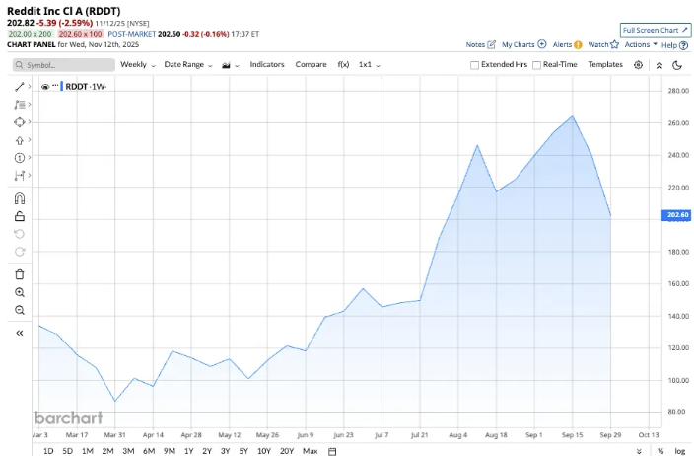
[Stock Chart 7 - RDDT
Entry Date - 8/4/25 @ 12PM
Entry Price - $2.50
Exit Date - 8/5/25 @ 10:16AM
Exit Price - $5.00
Percent Change: 100%
Instructions for all 3, draw arrow with percent gain]

[DEMO 2]
It was the same story in May.

I called out a profit surge trade on QBTS, a quantum computing company…

After I identified it as a real profit surge setup, I told my students it was time to get in now.

Those who listened to my advice could’ve walked away with a 130% win in just a couple hours.

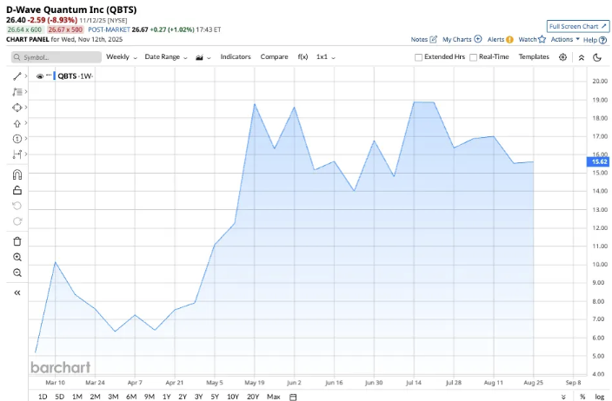
[Stock Chart 8 - QBTS
Entry Date - 5/8/25 @ 9:30
Entry Price - $0.30
Exit Date - 5/8/25 @ 11:26AM
Exit Price $0.65
Percent Change - 130%]

Simple enough, right?

[DEMO 3]
It happened again back in June with VEEV, a consulting company.

I spotted a profit surge after the company reported positive earnings…

I checked it out and verified it for myself.

Everything looked good so I notified my students…

“VEEV is an earnings winner…. and looks ready to rip”
[quote rip]

That recommendation was good for a 117% win in 3 days.

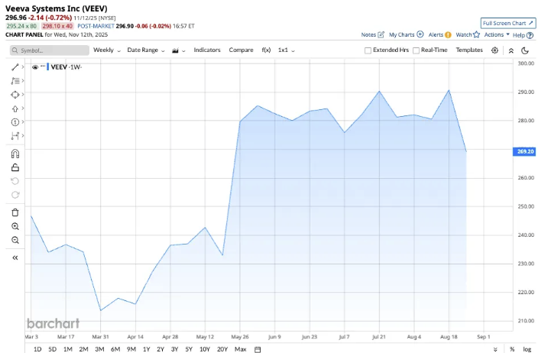
[Stock Chart 9 - VEEV
Entry Date - 6/2/25 @ 12:17PM
Entry Price - $1.38
Exit Date - 6/5/25 @ 1:40 PM
Exit Price - $3.00
Percent Change - 117%]

And that’s it! There isn’t much else to say.

I challenge you to find a more straightforward strategy than this.

And since I started making profit surge trades and sharing them to my students…

I’ve recommended over 1,852 wins with nearly 60% win rate across all my services!

Including top trades like…

324% on TSLA in one day…

427% on SMCI in two days…

368% on CVNA in one day…

420% on AVGO in one day…

321% on APP in one day…

260% on META in one day…

134% on AMD in one day…

232% on NFLX in one day.

823% on HIMS in one day…

And 1131% on RILY in two days!

Every time I make one of these trades myself, I immediately alert my students…

And just take a look at what they’ve had to say…

One student reported making over 127% on MSFT in just 15 minutes…

“MSFT in and out for 127% in 15 minutes. Thanks Nate.”
[Testimonial 1 - Joyjoy]

Another one made 100% on my ARM recommendation… in 5 minutes.

“I just made 100% in ARM in 5 minutes!!! “
[Testimonial - 4SteveT1]

And one time I even helped eight of my students make over 1000%+ in just 2 days…

“1180% on RILY. Great play Nate.”
[Testimonial 3 - Grumpy Grandpa - for these ones just flash all the testimonials at once]

“1550% on RILY”
[Testimonial 4 - web]

“1385% on Riley! Best trade of my life”
[Testimonial 5 - EricGlad]

”Nate Big thx.; Rily Lotto in $.50 Out AVG. $10.49 1987% gain”
[Testimonial 6 - QuintonE]

“Sold my last RILY for 1467% gain”
[Testimonial 7- Kirk Rydberg]

“Now up 1500% on my second call on RILY”
[Testimonial 8 - BalaV]

“RILY! 1506%”
[Testimonial 9 - Cypher00]

“Rily 20 IN. .78 Out 10.20 $18840 1206%”
[Testimonial 10 - BoilerUp]

Over my career, I’ve had over hundreds of students take the time to write in and tell me about their success…

But I have to give so much credit to the power of profit surges.

They have been a total game changer.

I personally used them in the first three years of my investing career to help me turn $37,000 into over $1 million.

And in my fourth year alone I made another $1.4 million in profits.

And today, thanks to Operation Motherlode, I predict a flurry of profit surge trades will hit the markets like a tidal wave…

Offering up one of the greatest wealth generating opportunities in our lifetimes.

But this window simply can’t and won’t stay open forever.

So it blows my mind that…

I don’t see anybody else talking about this opportunity to get filthy rich in 2026…

And while there are always losses with any strategy, I’ve recommended over 169 winning profit surge trades since the day Operation Motherlode opened its first rare earths mine…!

Including over 28 trades that could’ve doubled your money in less than a week!

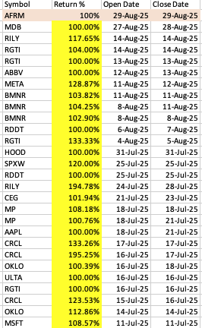
[Image 6 - 28 100%+ opportunities after July 11th, from DPL 9.5.25 Excel Sheet, when making into a graphic remove the “Open Date” and “Close Date” columns and just keep symbol + return, add title “28 Double-Your Money Winners!”]

But I believe these gains will pale in comparison to what we’re about to see…

Because Operation Motherlode has only just begun.

We have even more mines getting ready to begin operations…

[Image 5 - Eight more planned mines]

And one special mine in Southern Wyoming houses the richest supply of rare earths in THE WORLD…

So if you don’t want to leave massive profits on the table, I suggest you move before February 1st.

Trump is not slowing down…

He doesn’t just want independence from China…

He plans to make America a rare earths superpower…

Stealing China’s biggest advantage away...

And adding it to the already dominant position America holds in the global economy.

As this all unfolds, we’ll see more and more profit surges with fast, 100% profit potential.

[TTAM]

But if you don’t move by February 1st … you could miss out on some of Operation Motherlode’s biggest winners.

Operation Motherlode is about to bring a flood of new rare earths mines in the coming months.

And the biggest rare earths project…

Not just in America…

But in the WORLD…

Will be located right here, in the USA…

And it's set to announce a big milestone as soon as February 1st.

When the updates around this new mine hit the press, we are going to see a flood of new profit surge opportunities.

We saw how the NASDAQ hit multiple record highs…

[Nasdaq Record High Chart - 10/27]

The most positive revenue surprises in the S&P since 2021…

And new highs in corporate earnings.

During this run, even with the losses that are bound to happen, I’ve found over 169 winning profit surge trades.

Including over 28 double your money opportunities!

All within a few months.

Now imagine what would happen when the next rare earth mine opens....

I predict we’re going to see bigger and faster profit surge trades than ever before.

So if you take your finances seriously…

I urge you to make a move by February 1st…

Or else you’ll miss out on big and fast double your money opportunities like

114% on OKTA one day…

100% on NVDA in two hours…

133% on RGTI in one day…

100% on MDB in one day…

And 108% on MP in only four hours!

[Offer]

Today, I am personally inviting you to get your hands on my next “double-your-money” profit surge…

[Intro Service]

This pick is going to come as early as THIS MONDAY…

And the only place to find it is inside my one-of-a-kind wealth building initiative… Profit Surge Trader.

[USP]

It’s the only place on the internet that specializes in teaching regular folks how to make money specifically from profit surge trades.

These are the kind of opportunities that helped turn me into a millionaire.

And will offer many others the chance to do the same.

Because ever since the start of Operation Motherlode, I've spotted a flood of new profit surge opportunities…

And I expect the gains to be bigger and faster than ever before.

I have never seen a better time in history to take advantage of profit surges.

We will soon have the largest supply of rare earths in the world.

And if you want to catch the next wave of profits, you better move before February 1st. .

So the time to get in is RIGHT NOW…

And the only way to unlock this treasure trove is by joining Profit Surge Trader.

[What to Expect]

How Does Profit Surge Trader Work?

Once you’re inside, you’ll gain exclusive access to me and my profit surge trades every Monday at Noon Eastern Standard Time.

You’re invited to join me on a LIVE class, and chat with me via my Profit Surge Trader chatroom.…

This is where I show all my readers what I’m seeing in the market.

And I’ll recommend 2 or more trades LIVE along with exact instructions for the trade.

But it’s totally fine if you can’t make it, because I’ll also send my trades directly to you via email. You can even sign up to get a text notification every time I post a new trade.

So even if you can’t make it on the live call…

You won’t miss out on a single trade.

And I don’t believe in recommending trades that I wouldn’t put my money into…

That’s why I have a personal stake in every trade recommendation I make.

In other words, when I make money you can make money.

We’re in this together.

[Hit of Cred]

Over the course of the year you'll receive at least 104 chances to capture Profit Surge gains…

Here’s a look at some of my favorite winners.

These are some of the fast, 100% winners we’ve had over the years.

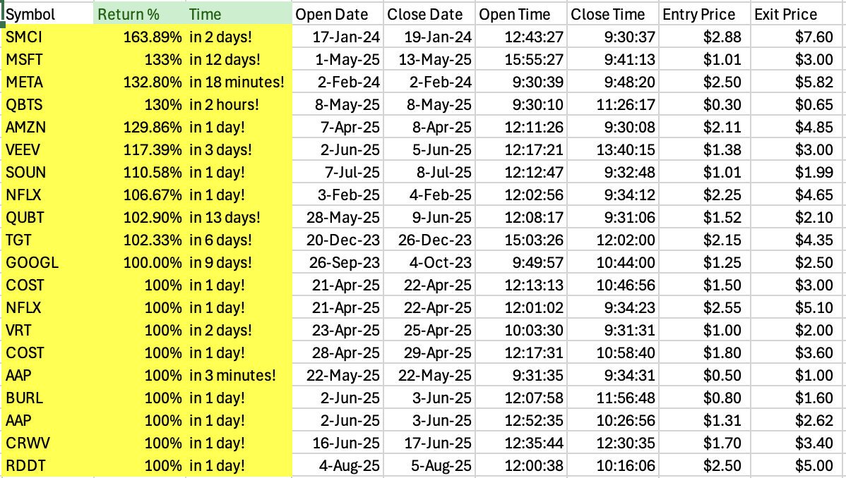

[Image 8 - Profit Surge Trader 100%+ wins table - create into a table, only keep Symbol, Return% and time columns, write in this format… “163% on SMCI in 2 days!”]

Once you’re a member of Profit Surge Trader…

I’ll send you at least two alerts every single week… it's that simple.

I will guide you every step of the way through these options trades so I can help you collect off of profit surges as smoothly as possible.
Option trading can be risky and especially if you don’t understand them yet. Which is why I suggest you pay attention to the alert instructions, and take full advantage of the trainings and resources offered inside this research service while you learn the ropes.

The next recommendation comes on Monday, and I promise – won’t want to miss it.

Personally, I think Operation Motherlode represents the best opportunity to make money that I’ve ever seen.

It wasn’t very long ago I was working a blue collar job in construction. I haven’t forgotten where I come from.

My goal is for every one of my readers to achieve the financial freedom they’re looking for.

Just like I did.

And I want to make that as easy and worry free as possible for you.

So I’m going to throw in some free bonuses to do just that.

Starting with…

[Bonus 1]

Profit Surge Trades: How To Target “Double-Your-Money” Gains During Operation Motherlode

[Product Image 1 - Profit Surge Trades: How To Target “Double-Your-Money” Gains During Operation Motherlode, turn all bonuses into images of reports for design]

In this bonus…

- You will discover exactly how I used profit surge trades to turn $37k to over $2.7 Million…

- How we’ve implemented AI to surpass human limitations and locate exactly when a profit surge trade is developing.

- And the simple steps to make profit surge trades yourself.

This guide will take you from rookie to expert at trading profit surges trades in just a few minutes.

It’s written for all skill levels… even if you’ve never placed a trade before.

This is the secret that turned me into a millionaire…

I want you to have access to it completely free.

But that’s not all…

I’m going to supercharge your profit making potential…

With a second free gift…

[Bonus 2]

One Ticker Payouts: How To Repeatedly Win 100%+ on a Single Profit Surge

[Product Image 2 - One Ticker Payouts: One Ticker Payouts: How To Repeatedly Win 100%+ on a Single Profit Surge]

Earlier I showed you how I made 162%... 100%... and 112% on OKLO…

198%... 100%... and 73% on CRWV…

And 100%... 133%... 100%... and 104% on RGTI.

That’s the purpose of this guide.

It will lay out…

- The exact phenomenon that powers profit surges trades explained in Laymen’s terms…

- How I choose a single company and continue to trade it for multiple “double-your-money” wins… and how you can too…

- And the secret behind why playing the profit surge is better than the antiquated buy-and hold diversified portfolio.

This bonus is a fast track to your goals.

The information inside is truly priceless…

But I wanted to go one step further…

And make this as beginner-friendly as possible…

So I’m giving you…

[Bonus 3]

The Profit Surge Site Introduction: How To Set Yourself Up For Life-Changing Gains in Three Minutes

[Product Image 3 - The Profit Surge Site Introduction: How To Set Yourself Up For Life-Changing Gains in Three Minutes]

In this short three minute video I am going to show you a step-by-step walkthrough of how to navigate the website.

I made this so even the least tech-savvy person will know how to see all of my latest picks.

In it you’ll find out…

- Where to go so you can interact with the community or ask questions DIRECTLY in our public chat. I’ll always try and answer the most commonly asked ones.

- The locations of everything on the website and how to access them including: My Private Training Library, all my past recordings, and all my past trades…

- Exactly what you’ll see on your screen every Monday so you’ll be prepared to capture my most recent pick

I offer all of these special bonuses to my members for FREE when they join Profit Surge Trader.

Because I’ve made it my mission to make sure every member in my community is in the best position to secure their financial future.

[Testimonials]

But don’t take my word for it…Take A Look At Some Of The Massive Gains My Members Have Made…

Just check out what happened with Steve who made his first ever 1,000% win in just 4 days… while playing golf.

Good morning, not to brag but because of Nate I was able to hit my first ever 1,000% gain while on the golf course yesterday.
[Testimonial 11 - SteveS2448]

Or Laura who wrote in after she made 1,100% on a single trade during a LIVE event that Profit Surge Trade members were invited too.. …

“Made 1100% on Rily [in 2 days] and turned a $1,300 account [into] $45,000 [in 4 months] since I joined.”
[Testimonial 12 - Laura]

And Bill who smashed multiple winners in just one week…

“In the last week: COST winners of 16%, 19%, 48%, 41%, 27%. MSFT winners of 63%, 20%. Fun times!”
[Testimonial 13 - Coach Bill]

These are everyday folks making REAL money…

But what means the most to me…is when members tell me how much their membership has changed their lives.

Take a look at William who finally feels confident taking his own trades…

“Well worth the price, it paid for itself the first week. I have gone from knowing nothing about trading options to making 335 trades with an 86% win rate in seven months. Nate is a fantastic teacher and I have learned to find high-quality trades on my own in addition to the weekly service recommendations. This stuff is fun.”
[Testimonial 14 - William]

Or Stewart who shared his success…

“Nate has changed my trading life, from bouncing back and forth… to now up over 600% in 6 months”
[Testimonial 15 - Stewart L.]

And Tony who’s finally found an income source while he’s retired…

“Account is growing not losing. Retired and love trading. Having a 89% win rate from what i have learned. A+ [Nate is a] great teacher.”
[Testimonial 16 - Tony]

I’m glad that the work I do is making a real difference for everyday, hardworking Americans.

In just a few moments, you’ll have the chance to access everything I’ve promised today…

But I know we just covered a lot…

[Recap]
So Here’s A Quick Recap Of Everything You’re Going To Get Today…

- Members access to my Profit Surge Trader recommendations and research
- Weekly Live Trading Sessions with Nate
- A Minimum of Two Profit Surge Alerts Every Single Week - At Least 104 Alerts a Year!
- Private Members Chat Room
- Secure Members Area
- Profit Surge Trader Training Vault
- Dedicated Customer Support Line
- Bonus 1: Profit Surge Trades: How To Target “Double-Your-Money” Gains During Operation Motherlode
- Bonus 2: One Ticker Payouts: How To Repeatedly Win 100%+ on a Single Profit Surge
- Bonus 3: The Profit Surge Site Introduction: How To Set Yourself Up For Life-Changing Gains in Three Minutes
[Product Image 4 - Hero Shot]
[Price Anchor]

Like I’ve mentioned before, we’ve assembled an incredible deal for anybody who decides to take us up on Profit Surge Trader TODAY.

This is the same service that helped one of my students make over 223% profit in less than a week…

He wrote in:

“Bought (5) MPC … sold (5) on 09/05 … 223%
profit – Thank You Nate.”
[Testimonial - username JosT]

And even though we helped one student make over $23,000 in just two days…

“SMCI bought 4 contract made $23,004”
[T7 - username jcas]

We’re not going to charge anywhere near the $10,000 or even $5,000 price tag we could easily justify.

[Why Tell Me]

The reason is simple.

That’s not my purpose in life.

I want to do the right thing…

Because I know what it feels like to worry about providing for your family.

I used to be a regular guy working a run-of-the-mill blue collar construction job…

And one day I wake up and I have a wife and four kids I have to take care of… so I understand the struggle.

My mission is to help everyday folks secure a better financial tomorrow…

So I convinced my publisher to put out an exclusive “new members” deal for the folks who watched this video today.

At this price anybody can learn how to leverage profit surge trades during Operation Motherlode…

So I made this an absolute no-brainer for anybody who takes action TODAY.

Since this knowledge is truly priceless and could fast track your success…

I wanted to make sure anybody, no matter their income level, could get their hands on Profit Surge Trader and begin following my profit surge trades.

[Price Minimize]

For anybody ready to get started, one year of Profit Surge Trader typically retails for $997.

And that’s a steal considering members have made that back in just ONE trade.

One student followed a profit surge trade recommendation and wrote in:

“QCOM: $1,000 in 24 hrs”
[Testimonial - Nate W]

So the usual retail rate for 3 months of my service is an absolute STEAL at only $250.

But I want to do something special for you today, since this is the best time I’ve ever seen to make profit surge trades…

I'm going to discount that price all the way down to $99. A full 60% discount from the retail price.

Now, I know we just met, and so you may not yet fully trust me.
So if that's still too expensive, click below and I'll show you an even cheaper way to get started.

CLICK HERE TO SEE OUR SPECIAL OFFER

I want this opportunity to be affordable for anyone…

No matter their income level.

At this discounted price… It's an absolute no brainer.

People who don’t accept this once-in-a-lifetime offer are simply not taking Operation Motherlode or their financial security seriously…

And that’s their choice.

[Guarantee]

But since we don’t want anything keeping folks away from an opportunity that could change their lives…

We’re going to remove any last bit of doubt with our “Profit Surge Promise.”

[Product Image 5 - Image of “Profit Surge Promise” Guarantee]

We know that it may be our first time meeting…

And you might not fully trust us yet.

So I want to give you an entire year to join our calls, take our trades, and view all our reports… FULLY GUARANTEED.

If for any reason over the next 90 days you aren’t completely thrilled with Profit Surge Trader.

Simply call our team for a complete refund - no questions asked.

Even if readers decide this service isn’t for them…

They still get to keep all the strategies and tips found in all their reports…

- Bonus 1: Profit Surge Trades: How To Target “Double-Your-Money” Gains During Operation Motherlode
- Bonus 2: One Ticker Payouts: How To Repeatedly Win 100%+ on a Single Profit Surge
- Bonus 3: The Profit Surge Site Introduction: How To Set Yourself Up For Life-Changing Gains in Three Minutes
It’s our way of saying “thank you” for giving us a try.

But don’t get me wrong…

We have no doubt that you’ll fall in love with our service…

And become a member for life.

That’s why we have full confidence in offering a guarantee like this…

Because we believe in our work and how happy it’ll make our members…

We’ve done it before and we can do it again.

[CTA]
THIS PAGE IS THE ONLY PLACE TO GET TODAY’S OFFER - OUR LOWEST POSSIBLE PRICE.
Now it's time to make a decision.
The way I see it, there’s two choices.
Choice one is to go about life willfully ignoring Operation Motherlode and how smart investors are using it to quickly double their investments.
Those who decide to make this choice will kick themselves for years as they miss out on opportunity after opportunity.
Choice number two is to take control…
Ride Operation Motherlode and the historic flood of profit surge trades…
And position yourself for big and fast wins during what could end up being the most lucrative wealth building event of our lives.
But this isn’t our decision to make.

I can only lead a horse to water… But I can’t make it drink.

This is an incredible offer…

And the ones who are decisive, fast movers…

Will be at the forefront of this once in a lifetime opportunity.

Don’t get left behind as the next mine opens and unleashes a flood of double your money profit surges…

Make sure you’re in position BEFORE February 1st.

The floodgates are finally open and now is your chance to get in.

The only question is:

Will you be ready?

Or will you be left on the sidelines watching others collect the gains?

You know where I’ll be.

Join me inside Profit Surge Trader today.
CLICK HERE TO JOIN PROFIT SURGE TRADER
[Sign off]

[PS + Questions]

P.S. Trump has commissioned Operation Motherlode to take control of rare earths back from China…

And on July 11th, the US opened its first rare earths mine in over 70 years.

Now the markets have responded by going on a frenzy…

And regular investors can repeatedly use profit surge trades to target 100% winners.

Since the start of Operation Motherlode, I’ve identified trades like…

104% on BMNR in three days day…

100% on RDDT in one day…

194% on RILY in four days…

100% OKLO in two days…

108% on MP in four hours.

In fact, I’ve spotted over twenty-eight profit surge trades that could’ve doubled your money.

And thanks to Operation Motherlode, I predict a lot more of these opportunities will arise.

The last time something like this happened, I turned $37k into over $2.7 million dollars.

And if you’re interested in making these types of big and fast gains TODAY…

The ONLY place to get these picks are from my Profit Surge Trader service.

We’ve already helped several members capture gains as high as 1,000% in just two days...

But since you’re still here, maybe you still have some questions.

So let me quickly cover some of the more frequently asked questions…

Question #1: Why am I certain Operation Motherlode will make savvy investors rich?
History shows when Trump stands up to China and targets their economy… he makes Americans rich.

In 2018, Trump claimed that “we have been ripped off by China…”

And after he retaliated with import tariffs…

Over $10 trillion dollars flooded into the stock market in two years…

Creating over ten million new millionaires in the United States.

It happened again in 2020 after China threatened Hong Kong.

Trump held them accountable by placing export controls on them…

And even through COVID, the S&P 500 and NASDAQ closed at record-highs, making some everyday folks a lot of money.

Now take a look at what’s happening now with Operation Motherlode.

The NASDAQ and S&P have both hit record highs multiple times…

Corporate profits reported new highs…

And I’ve found gains of…

104% on BMNR in one day…

100% on RDDT in one day…

194% on RILY in four days…

100% OKLO in two days…

108% on MP in four hours.

Operation Motherlode is already making people rich and if you want the biggest gains you need to get in NOW.

Just click the button on this page if you’re ready to get started today.
CLICK HERE TO JOIN PROFIT SURGE TRADER
Question #2: How much money can I make? And how fast will the money come?

As we’ve demonstrated today, when things line up perfectly it is possible to see triple digit gains in as little as a day or two.

That’s because Operation Motherlode has triggered a market boom.

And a special type of options trade I call a “profit surge trade”

can help you capture wins as high as…

[Image 9 - Profit Surge Trader 100%+ wins table - create into a table, only keep Symbol, Return% and time columns, write in this format… “163% on SMCI in 2 days!” (same as earlier)]

Thanks to Operation Motherlode, we’re looking to see a flood of new profit surge trades…

And I’ll show you exactly how you can use them to target triple-digit gains in less than a week like you see above.
CLICK HERE TO JOIN PROFIT SURGE TRADER
Question #3: Why has Operation Motherlode triggered a market boom?
Frankly, this isn’t the first time this has happened…

There’s historical precedent.

You see, every time the United States taps into its own natural resources…

The American economy experiences a historic boom and Americans get rich.

And we’re seeing the same exact setup for rare earths.

The first example is lithium when investors had the chance to…

Make 17,585% on Tesla in ten years...

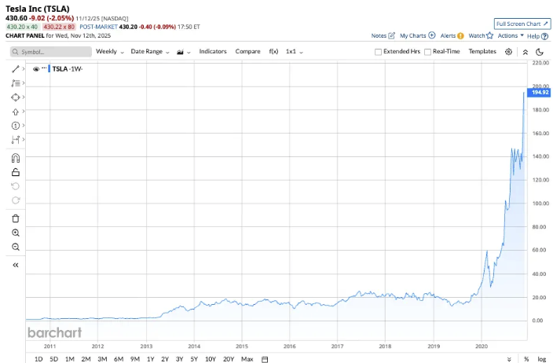
[Entry - 07/01/2010 - $1.33
Exit - 12/01/2020 - $235.22
Percent Change = 17,585%]

505% on lithium manufacturing company Albemarle in 12 years...

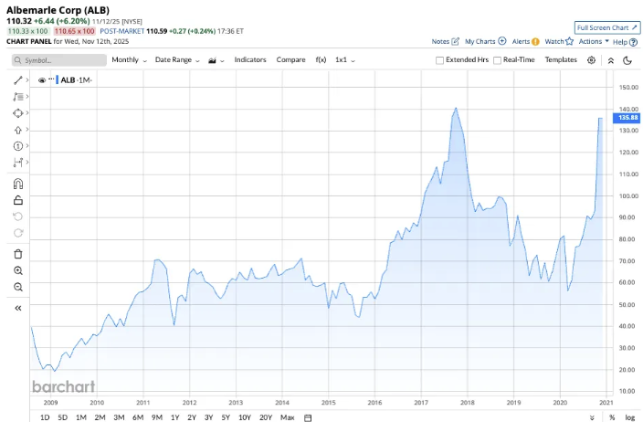
[Entry - 10/01/08 - $24.35
Exit - 12/01/2020 - $147.52
Percent Change = 505.83%]

And 7,435% on EV charging company Plug Power in 7 years.

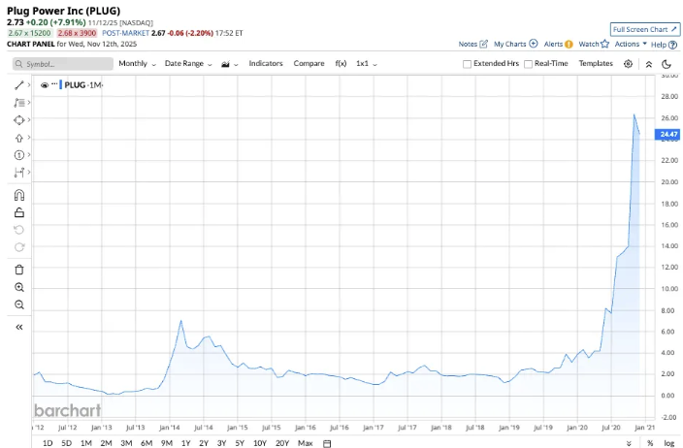
[Entry - 02/01/2013 - $0.45
Exit - 12/01/2020 - $33.91
Percent Change = 7345.56%]

It’s the same set up for the oil boom…


[Picture of oil boom]

Which triggered the Second Industrial Revolution… and pushed America into the Gilded Age…

A time when America’s GDP tripled… railroad stocks nearly 5xed in value… the stock market more than tripled…

And investors got rich.

We saw the exact same pattern play out with steel.


[Picture of steel boom]

When we saw US Steel become the first billion-dollar corporation in U.S history.

Now we’re seeing the exact same pattern play out for rare earths.
Question #4: Is this hard to do? Will I need to be in front of a computer all day?
No, it only takes a couple seconds and you can do it all on your phone if you prefer.

I got into this career because I wanted to make a lot of money while having more freedom to spend time with my family.

So I made this as fool-proof and streamlined as possible.
Whenever I spot a profit surge trade…
I will verify it and immediately send you my recommendation - via email, along with the exact entry, exit, and target prices I recommend. You can even sign up to get a text notification every time I post a new trade.
We expect at least two trade recommendations a week.
I also give you urgent alerts whenever I spot something that affects our trades.
You never have to be stressed out wondering if you missed something important… I’ve got you covered.
Whenever I do recommend a move, it’ll only take a couple minutes and a few clicks of the mouse to execute.

It’s why I get new traders like William writing to me with joy:

“Well worth the price, it paid for itself the first week. I have gone from knowing nothing about trading options to making 335 trades with an 86% win rate in seven months. Nate is a fantastic teacher and I have learned to find high-quality trades on my own in addition to the weekly service recommendations. This stuff is fun.”
[Testimonial 18 - William (same as earlier)]

And Steve who made his first ever 1,000% win while on the golf course in just four days.

Good morning, not to brag but because of Nate I was able to hit my first ever 1,000% gain while on the golf course yesterday.
[Testimonial 19 - SteveS2448 (same as earlier]
Even folks without any expert or advanced skills can profit… It’s that simple.

CLICK HERE TO JOIN PROFIT SURGE TRADER

Question #5: Do I need a lot of money to get started making trades?
Nope you don’t need a lot of money to get started.
Take a look at Tesla when our recommendation made 324% in just ONE day.

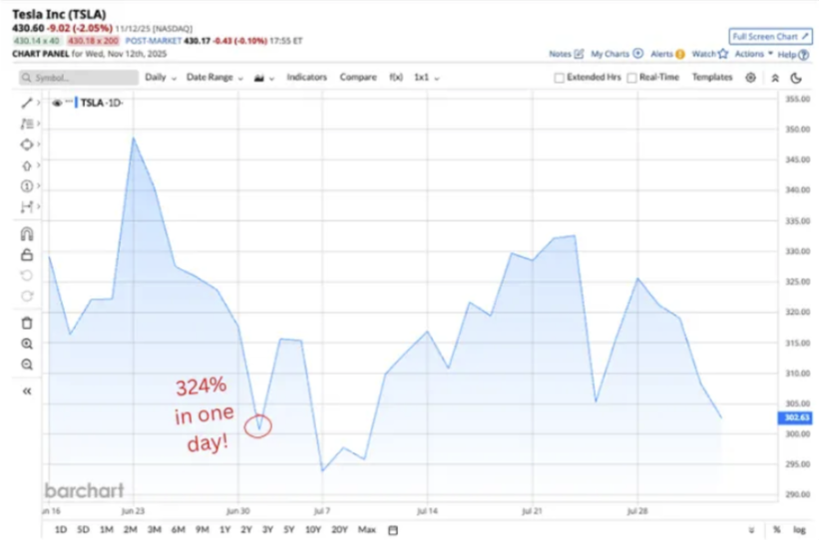
[Stock Chart 25 - TSLA
Entry Date 6/30/25 @ 3:16PM
Entry Price - $2.25
Exit Date - 7/1/25 @ 9:30AM
Exit Price - $9.55
Percent Change = 324%]

When we entered our trade on June 30th, 2025, stocks were trading for $319…
If you just bought the stock, it would’ve cost $31,900 to own 100 shares.
But using the options we recommended…
You would be able to control the same 100 shares for only $2.25 each - less than one-tenth the price of a stock.
By the time we exited the next day, we secured a 324% gain.
As you can see… It doesn't require a big investment to get started.
If you want to see an even bigger win, by all means, invest as much as you feel comfortable…
But that’s completely up to you.
The point is you can open some trades for a significantly reduced cost compared to stocks.
And when you click the button on this page, you’ll see our special discounted rate on the next page.

With our special offer priced so low that ANYONE can get started today.

CLICK HERE TO JOIN PROFIT SURGE TRADER

Question #6: If I have any questions can I speak to someone?
Yes!
If anytime you feel stuck in your trading journey you can always ask one of the members in our Profit Surge Trader chatroom.
We have a tight knit group and I’m constantly hopping in the chats to answer the most common questions.
If you need to talk to someone over the phone, you can always contact our dedicated support team.
Our support team is U.S based and open from 9AM - 4PM eastern time Mon-Fri ready to help you out with whatever questions you have about your subscription.
Question #7: Is your ordering process secure?
Yes, your information is safeguarded with industry-leading encryption technology to make sure your data is 100% protected every step of the way.
The entire process is safe, fast and completely secure.
CLICK HERE TO JOIN PROFIT SURGE TRADER
Question #8: How long will it take to receive everything?
A couple minutes.
Immediately after you join, you’ll receive a new email in your inbox from me.
Inside you’ll be given the exact instructions to login to our Profit Surge Trader exclusive members-only website.
Once you’re inside you’ll have instant access to our complete current portfolio…
The latest recommendation…
And all of our past special reports.
In our members-only website, you’ll also receive immediate access to every one of your FREE bonus reports.
- Bonus 1: Profit Surge Trades: How To Target “Double-Your-Money” Gains During Operation Motherlode
- Bonus 2: One Ticker Payouts: How To Repeatedly Win 100%+ on a Single Profit Surge
- Bonus 3: The Profit Surge Site Introduction: How To Set Yourself Up For Life-Changing Gains in Three Minutes
[Product Image 6 - Hero Shot (same as earlier)]
And as soon as you're a member…
You’ll automatically be put on the list to receive my profit surge trade recommendations.
Well that’s about all the time we have today.
Remember, Trump has commissioned Operation Motherlode to siphon billions from China and into the pockets of American investors.…

On July 11th, the US opened its first rare earths mine in over 70 years.

Now the markets have been on an absolute tear.

When you combine this massive opportunity with the power of profit surge trades…

That’s a shot at game-changing gain potential.

We’ve seen several triple digit gains in a matter of days and even hours.

And if you’re interested in seeing these types of big and fast gains yourself…

Just click the button on this page right now.

The ONLY place to get my picks are from my Profit Surge Trader service.

We’ve already helped several members capture gains as high as 1,000% in just two days...

And we’d love to add your story to our list of successes.

Once again, I’m Nate Bear.

Thank you for your time.

I look forward to welcoming you to Profit Surge Trader.

Take care.

CLICK HERE TO JOIN PROFIT SURGE TRADER

November 2025

