Please use this kind of look (need a place for Video):
https://secure.monumenttradersalliance.com/journey/FOUR4TPUYRLT/1?promoCode=3TPU5701&origin=blank&organization-abbreviation=OXC

Live Trade Alerts…
Livestream Training Sessions…
Plus Reports, Video Classes, and A FREE TRADING SCANNER TOOL…

All For Just $4!

Get My Favorite Trade Idea Every Week!
“This is my first time live and still got TWO 50% winners within just a few days”
– Member Kathy O

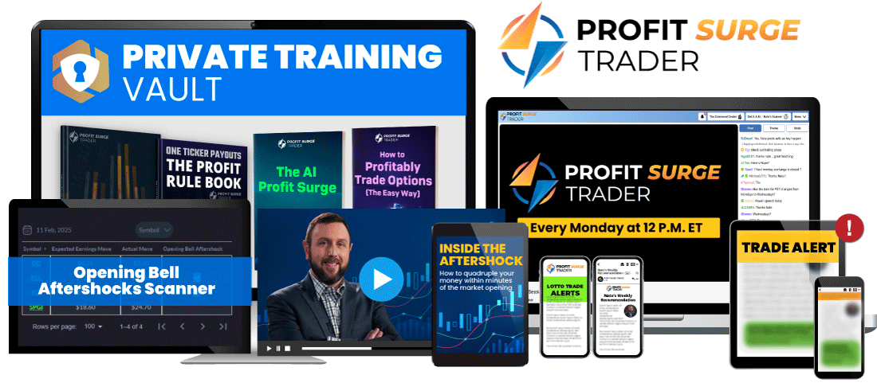

Your Four-Week Subscription Includes:

WEEKLY Profit Surge Livestream Sessions
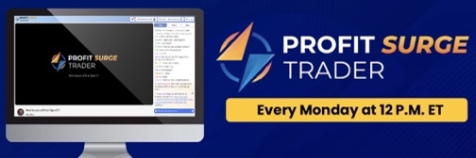
Every Monday @ 12 P.M. EST, Nate will break down the hottest trade Earnings Profit Surge setups and his top trade recommendations for the week.

Real-Time Trade Alerts

Delivered via email, mobile push, and chatroom notifications whenever Nate enters and exits a trade recommendation.

Profit Surge Trader Chatroom
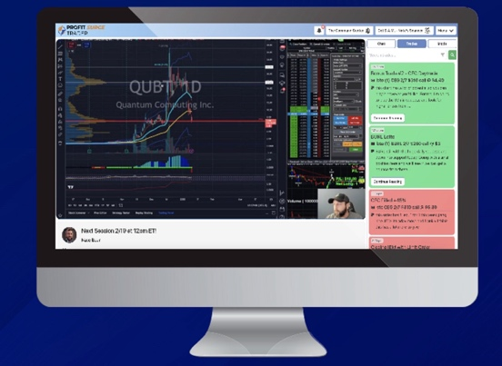
Ask questions and interact with thousands of other members during his Monday livestreams inside our exclusive chatroom community.

Nate’s Private Training Vault
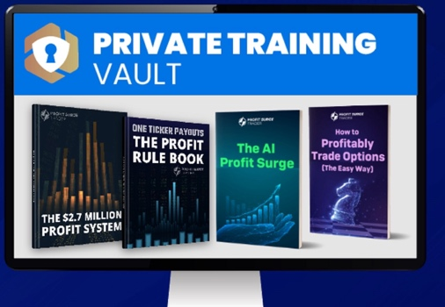
Access all of Nate’s top training sessions, special reports, and archived livestream recordings anywhere you go!

- *NEW* SPECIAL BONUS #1:
Nate’s Opening Bell Aftershock Scanner
Finding explosive earning trade setups BEFORE the opening bell is now easier than ever.  With this one-of-a-kind scanner designed to identify stocks set to experience massive Aftershocks at 9:30 a.m. | 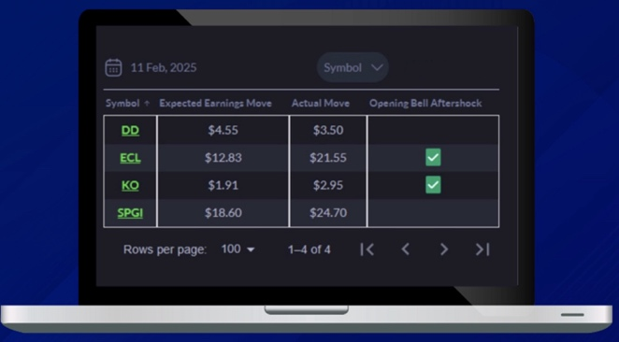

Full Disclaimer: This livestream isn’t going to be discounted this deeply for very long.

The only way to guarantee this limited-time offer to join Profit Surge Trader right now. Before the timer in your upper right corner of your screen hits ZERO.

So fill in your information below NOW to claim all the benefits that come along with this special deal.
My next LIVE session will be on Monday, [DYNAMIC DATE] at 12pm EST....
So you’re going to want to get access to the service NOW to prepare.

I can’t wait to hear from you about your first massive win!
And I look forward to seeing you this Monday at 12pm EST!
-Nate Bear

ON THE RIGHT HAND SIDE:

Join Me Today!
$4 is ALL you'll pay. NO recurring
charges. NO renewals.

Step #1: Review Your Subscription

Profit Surge Trader - 4 Trades for $4 ($1 per Trade)
- Four High-Conviction Trade Ideas – Plus Our Research – Over the Next Month
- Weekly Trading Sessions with Nate Himself
- Special Bonus #1 - The Opening Bell Aftershock Scanner + Video Case Study (how to use quickly)
- Special Bonus #2 – Nate’s Private Training Library (including his One Ticker Payouts Profit Rulebook and all of his top trainings)

Best Offer – Annual Subscription for
$249 $997 $49! (Less Than $1 per Trade) Renews at $79

You get everything above for an entire year at a DEEP discount.

That’s Nate’s

High-Conviction Trades Every Single Week... All Year (52 Trades)... Delivered LIVE every Monday.
Backed by Nate’s 365-Day Money Back Guarantee!

