 | Turned $37K Into $2.7 MILLION in just 4 years!

Weekly AI Cash Waves

Thousands of Americans are spending ONE hour per week using the power of AI to target a share of $4.8 TRILLION in new wealth.
*Learn how to tap into this breakthrough AI income stream from your home on Monday, [Date]*
ALT:

Breakthrough AI Reveals:
New Monday Cash Drop!

Discover how to tap into a lucrative weekly AI-powered cash wave on Monday, [date]
“Monday is about to become your favorite day of the week” – Georgia Multi-Millionaire, Nate Bear

ALRIGHT... LISTEN UP!
You’re probably busy, so I’m going to cut to the chase.
Monday is about to become your favorite day of the week.
That’s because in this short video...
I’ll show you how you can join me and thousands of other Americans, as we target our share of $4.4 trillion in new wealth...
EVERY Monday!
It's all thanks to a unique, AI-Powered tool that does most of the hard work for us.
I call this the Weekly AI Cash Wave...
And, let me be clear...
To start targeting newincome this upcoming Monday:
❌ You don’t need to be a pro...
❌ You don’t need to be tech savvy...
❌ You don’t even need to buy some expensive software to get started...
Heck, if you like to work...
You can even do this during your lunch break.

All you DO need is the power of ONE proven AI system that helps uncover the week’s biggest money moves!

We’re talking about the opportunity to collect top returns like…
100% overnight one week...
89% in 3 days, another week...

And even 133% in as little as 18 minutes.

And when you watch this video until the end, I’ll show you how you can use the power of AI to collect these Weekly AI Cash Waves.
I’m talking about a PROVEN wayto target money-doubling returns in as little as a few days or even within hours....
EVERY SINGLE MONDAY.
I’ll show you exactly how in just a moment...
First, let me introduce myself...
My name is Nate Bear, and I’ve been trading now for over a decade..

I first gained some notoriety as an online trader when I turned $37k into $2.7 million in just four years.
Those are my actual tax returns on your screen...
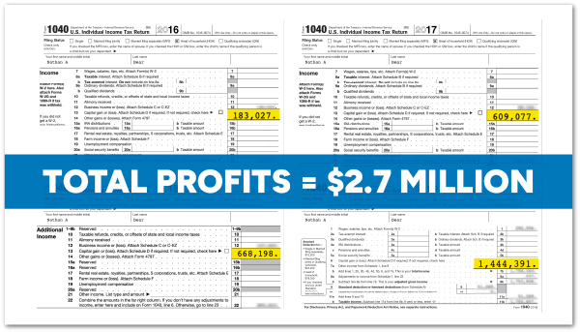
I wasn’t some financial wizard or some genius hotshot.
I started out as a construction worker...
Doing back-breaking work every day just to make ends meet for my young family.

That’s what society wants you what you have to do to become financially successful.
They want you to pay thousands of dollars to go to college...
They want you to break your back on the job site or work long days in a tiny cubicle...
And they want you to invest your savings into a 401 (k) managed by some massive Wall Street firm.
That’s the path hundreds of millions of people are stranded on.
And I was no exception.
But after seeing some people make money online through trading stocks...
I learned how to turn small amounts of money into HUGE gains.
Eventually, I was able to quit my construction job...
And trade from the comfort of my home.
This discovery completely changed my family’s life for the better.
We became financially free.
But let me be honest with you...

You may have heard crazy stories of people becoming overnight millionaires, but that’s pure luck.
It’s basically gambling.
The truth is, when it comes to building new income...
Or making money from any type of trading or investing...
You’re going to have good weeks and bad weeks.
There will be winners and losers, no matter who you are or what you do.
It’s not automatic or guaranteed.
I had to learn that the hard way.

When I first got started, I lost most of my money on a single trade listening to a so-called “expert” on TV.
IT WAS AN EXPENSIVE LESSON!
No one had my back when I was getting started...
And there weren’t any AI-powered tools like there are today.
But the game has changed!
Do I still have losing trades?
Sure...
But now I win more than I lose.
That’s why these days...
I stream live every week to help thousands of people, just like you and me...
Tap into this powerful extra income stream...
And avoid some of the costly mistakes that I had to learn.
In fact, the technique I am about to show you today...
It should take you about ONE hour every week...
Just like when we collected 111% Overnight on Soundhound...
Members like Tommy wrote in and said they locked in a HUGE win!
Another week I collected TWO 100% winners on Netflix and Vertiv Holdings in just 2 days...
With members like Jeff collecting as much as 178% off one of the plays...
And many others who doubled, tripled and even quadrupled their money


How awesome is that?!
Then there was the week I collected 164% in two days on Super Micro Computer Inc
With some members doing even better than me...
Like one member ED who turned $310 into $2,450...
A 690% return!
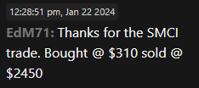
Or another who scored a 1,450% winner for $3,600.
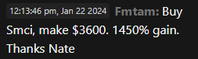
One member even turned...
Get this...
$1,152 into $23,000!
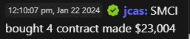
All within a single week.
Now look let me be clear...
And with the help of AI...
Finding these potential weekly cash waves on Mondays is now easier than ever.
It’s no secret that AI has been a complete game-changer.

The UN Trade and Development Organization projects that the AI market will hit $4.8 trillion within the next decade...


And the consulting firm McKinsey takes it a step further....estimating that by 2040... AI will add up to $4.4 trillion to the global economy...
ANNUALLY!

But that’s not good news for everyone.
According to Goldman Sachs, over 300 million jobs could be replaced by AI.
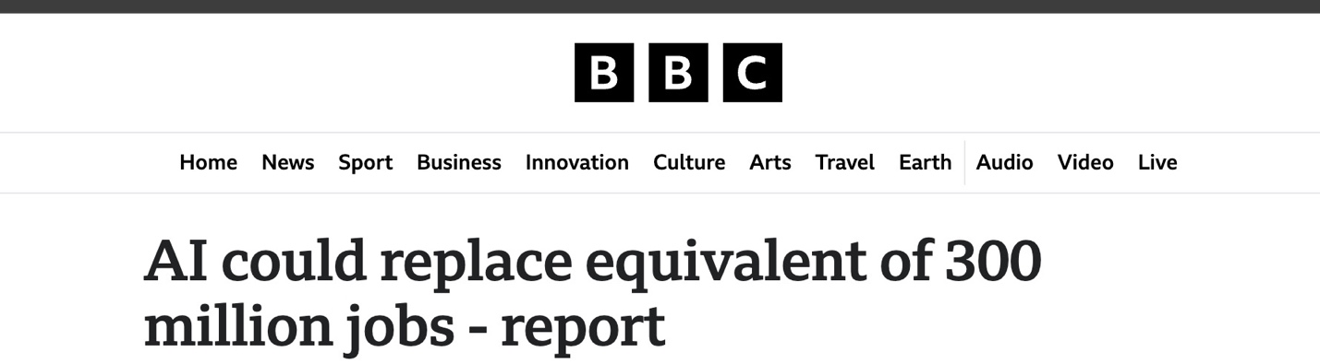
National University went even further and said that nearly 1-in-3 jobs in the United States could be automated by 2030.
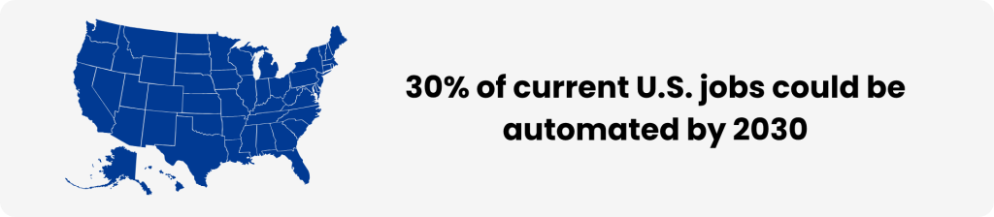
It’s more important than ever to be on the right side of this new economy.
You have two choices:
Do you want to resist and be one of the 30% of Americans who are negatively affected...
Or do you want to prosper and benefit from all of the positive changes from it?
To me, it’s a no-brainer.
In fact...
What I am about to show you is a way to use the power of AI every Monday to target Weekly Cash Waves like we did on some of my top trade recommendations like...
100% on Google in 8 days...
100% on Costco overnight...
88% on iRobot within hours...
100% overnight on Coreweave Inc...

130% on D-Wave Quantum in 2 hours!

These are just a few special trade examples...
But that’s the money-doubling potential of these Weekly AI Cash Waves.
They’re possible because of a powerful force in the stock market that has been studied by major institutions like Harvard, Duke, Cambridge, the Federal Reserve, and even the Securities and Exchange Commission.

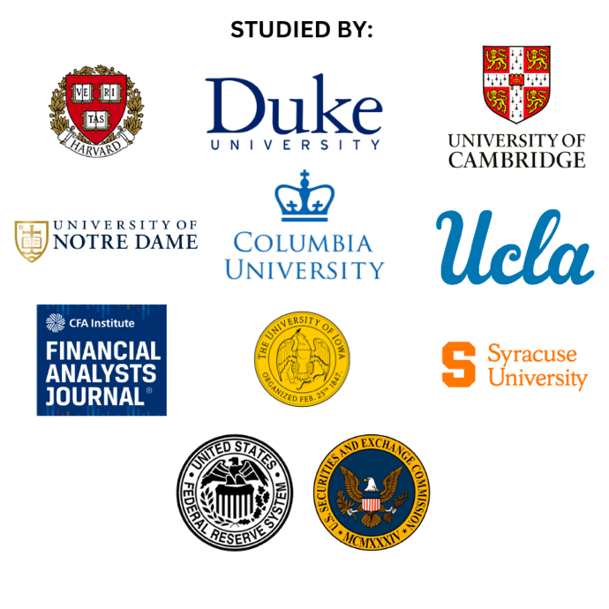
And thanks to a breakthrough new AI that my team and I developed…
Taking advantage of this lucrative market phenomenon has become easier than ever for regular people, like you and I.
Think about it...
Why would all of these government agencies and universities around the world care about this market force if there wasn’t massive profit potential?
Well, you don’t need a PHD to understand how it works.
This phenomenon has to do with one of the most talked-about events in the market.
And it’s known to make or break most everyday investors.
If you have ever paid attention to media coverage of the stock market...
You’ve probably heard of company earnings...
This is when companies go public with their results from the previous quarter…
And share their plans for the future.
It becomes a media spectacle...
And everyone tries to predict what direction a company’s earnings announcement will send the stock.
But at the end of the day, that is GUESSING!
Not even the company knows what direction their stock will move.

Here’s the truth that the mainstream media doesn’t talk about, though...
When a stock goes up because of these earnings...
Studies show the stock will continue to rise for weeks or even months afterwards.
That’s because when there is a big earnings surprise...
The market doesn’t fully incorporate earnings news right away.
It takes Wall Street weeks or even a few months to fully react.
That’s why the Journal of Behavioral and Experimental Finance says that this Earnings Profit Surge
“... continues to be one of the most prominent anomalies in financial markets”

The Oxford Review of Financial Studies calls it
“One of the most robust anomalies”
And when talking about the effects of this powerful market force even the Philadelphia Federal Reserve says:
“The magnitude is considerable”
Most importantly...
This effect is what allows us to find BIG shorterm wins from these Weekly Cash Waves using the power of AI.
Let’s see how it played out for us after Amazon’s earnings one quarter.
Now, if I had tried to play Amazon before they announced their earnings...
I would have been guessing.
Who knows what they would actually announce?
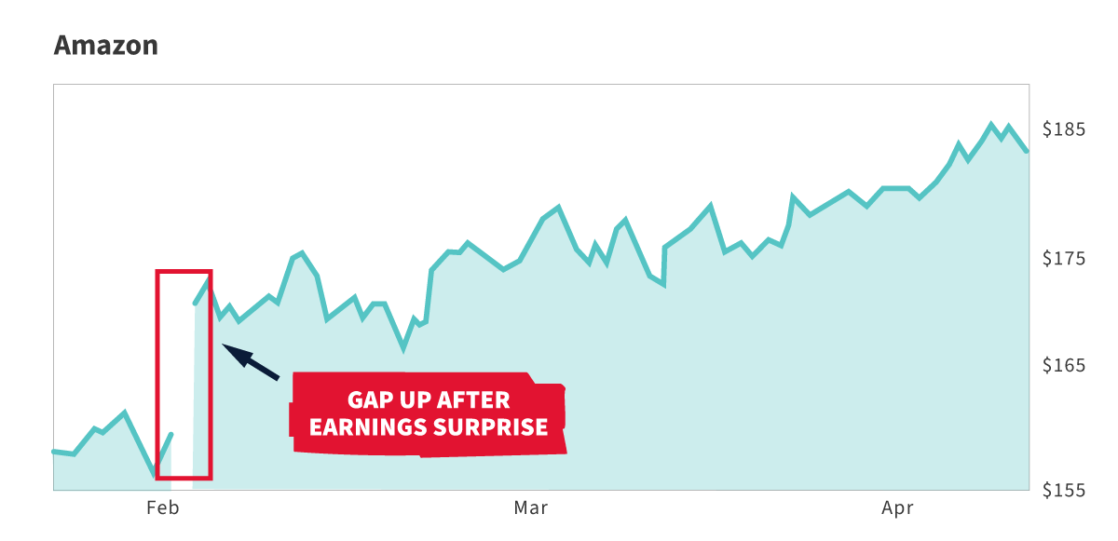
But instead of guessing...
I waited until AFTER the announcement...
And when Amazon stock shot up...
THEN I looked to target profits.
Using the Earnings Profit Surge...
I collected SEVERAL wins trading Amazon...
In week #1 I collected 41% over just 4 days...
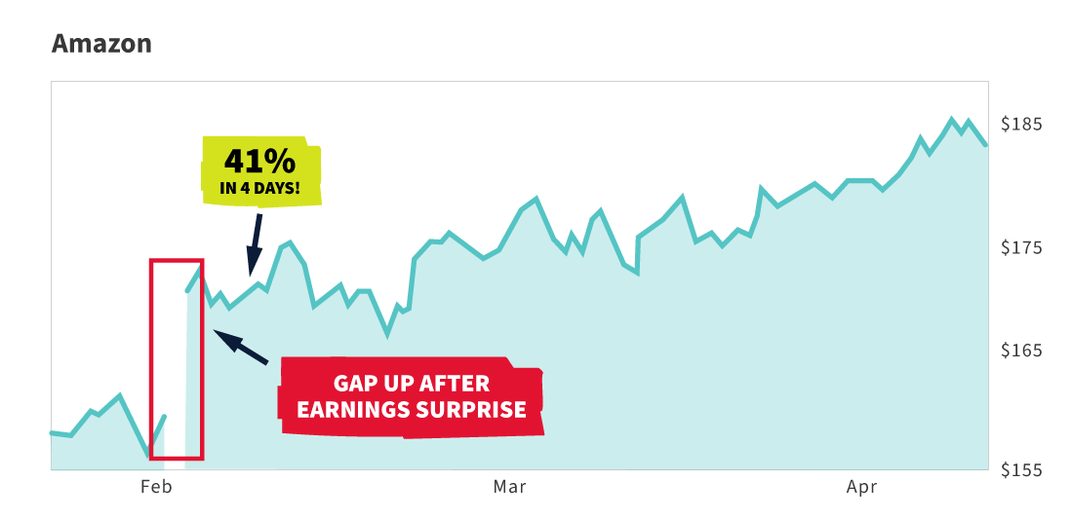
And plus an additional 35% winner overnight.
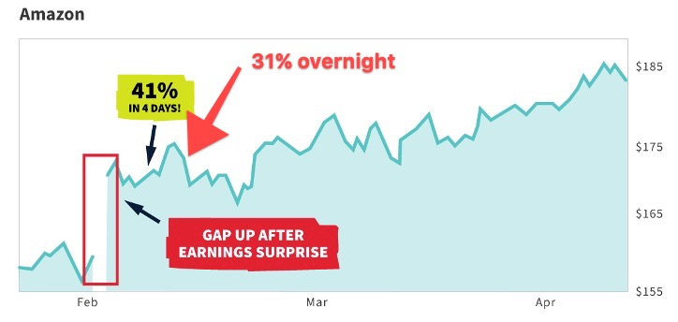
In week 2, I collected another 40% this time in just 11 minutes...
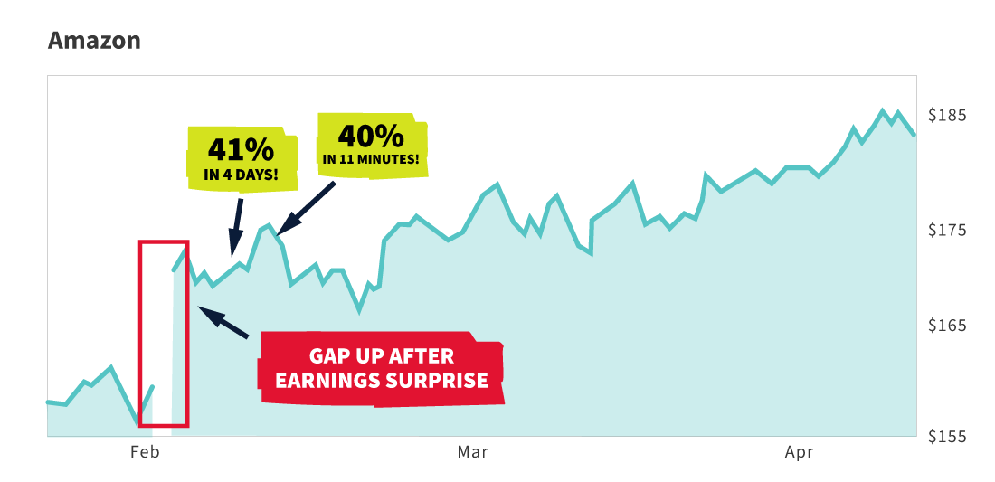
In week 3... I collected another 39% overnight...
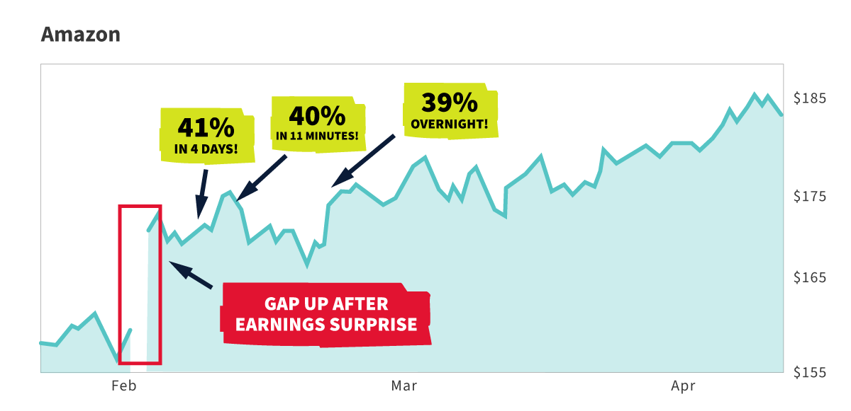
Then the on week 4 I collected another 29% in 2 days...

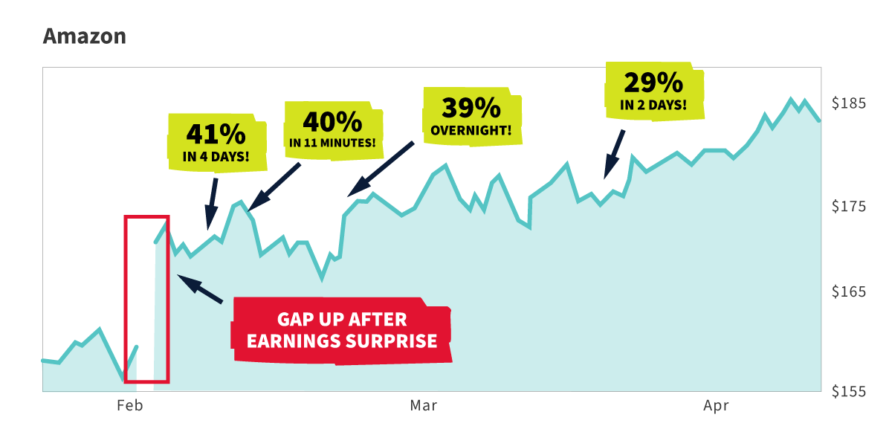
4 weeks...
5 winners...
All on the same Earnings Profit Surge move!
That is the potential of this powerful market force.
You can limit what stocks you are looking at and when you do this successfully...
You could create a weekly income stream for yourself.
And the best part is...
It gets even easier with the AI tool I am about to show you...
But first, let’s take a look at another example...
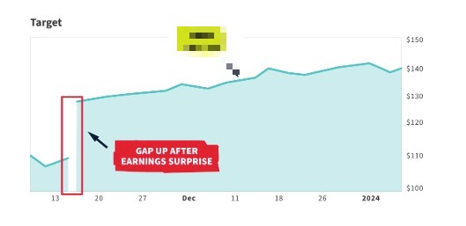
This time, on the retail giant Target after it announced earnings.
As you can see the stock shot up after their initial announcement...

You would think you missed the boat.

But notice that after the initial jump, the stock continued to rise afterward.

Again, this is the Earnings Profit Surge.
Now sure...
You could simply just buy a stock and hold it for several week or month
But that goes back to guessing.
Lots of things could happen to change the trajectory of any stock.
It’s risky.
That’s why we don’t get greedy and make quick plays.
We collect our profits...
We regroup...
And if the surge is continuing next week...
We go on the attack again.
We collect profits in waves.
In the case of target, I was able to collect profits over and over again over the next few weeks,...
Thanks to this predictable surge.
I collected 19% in 2 hours...
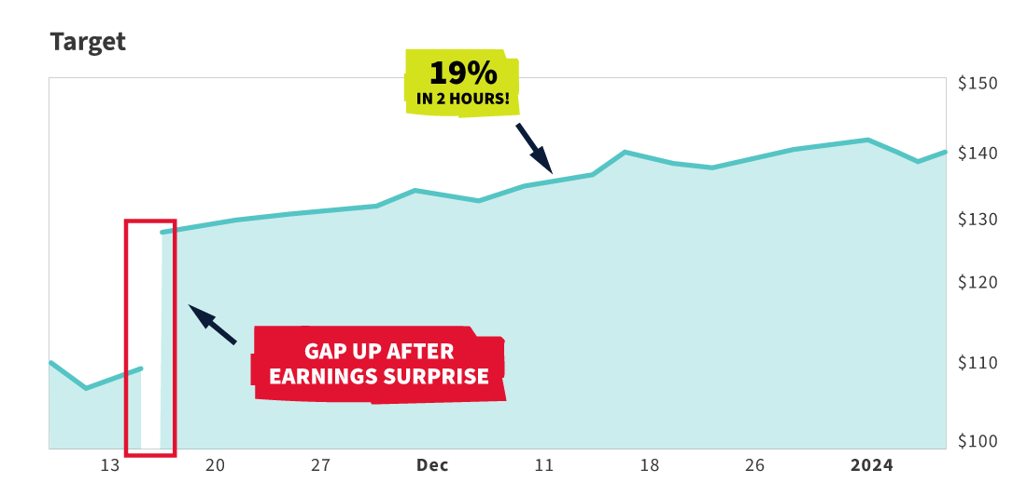O
Then 26% in 3 days a few days later...
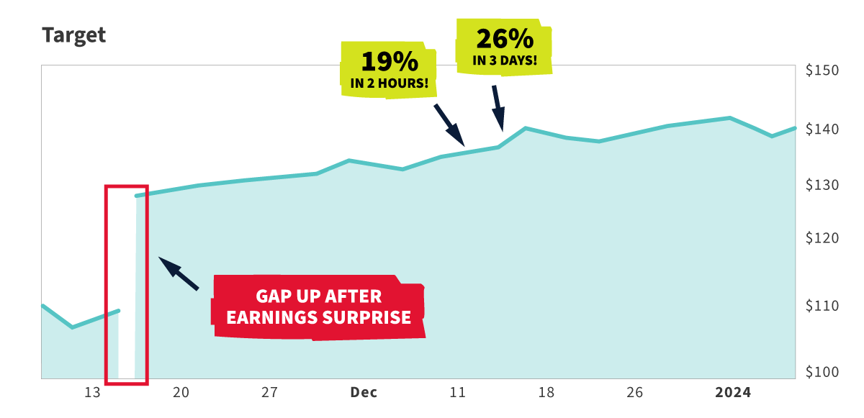
Thenthe next week, I snagged a money-doubling 102% winner in 6 days!
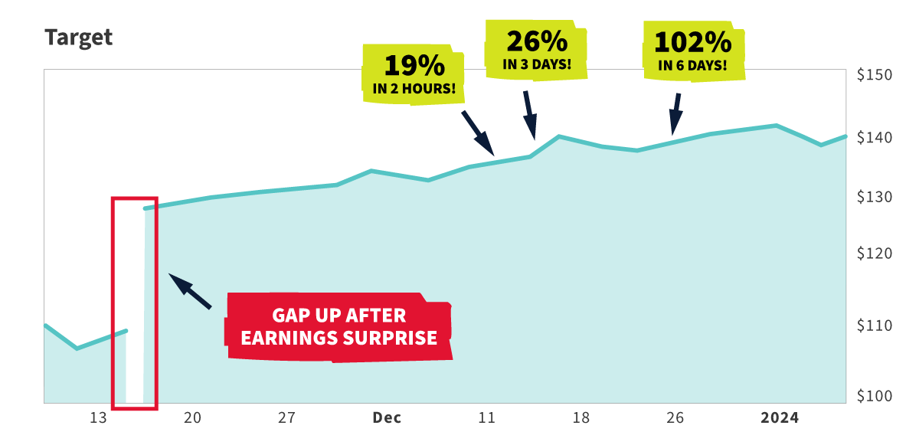
Do you see the potential here?!
Even if a company’s earnings Profit Surge only lasts a couple of weeks...
The earnings potential from that stock could be MASSIVE.
Here's an example from a company called Quantum Computing Inc.
After it announced its earnings...
It continued to soar over the next few weeks...
And there were two opportunities to collect massive Weekly Cash Wave profits.
The first was for 83% in 4 days...
AND the second 103% in 11 days.
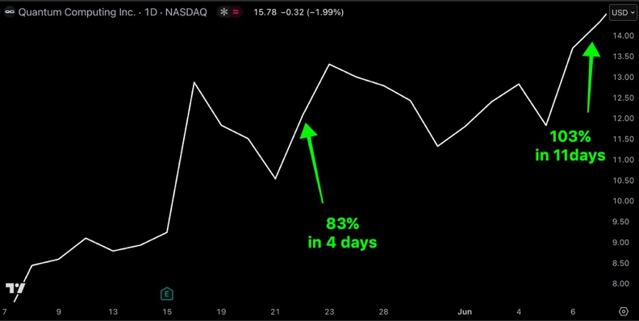
And when we’re done with a company.
We move on to the next.
[SHOW CALENDAR]
Just look at the incredible run over the course of a month recently.
Week 1: We collected gains of 43%, 41% and 107%
Week 2: We collected gains of 26%, 62% and 27%
Week 3: We took a loss... Nothing works perfectly every time.
But we capped off one of our best months with a win in Week 4 with a 41% winner.
All within just few days or even hours.
We went 7-for-8...
And just $1,000 into each of these plays closed during the month could have turned into $11,460 the course of the month.
Think about that...
That’s over $10,000 in side income created… and it only took about 1 hour per week .
All thanks to these Weekly Cash Waves.
So by now you’re probably wondering...
“How do I know when to trade a stock?”
Well that’s what I am so excited to share with you today...
Because thanks to advancements in AI...

My team and I were able to build something to find these trade setups for us.
We spent hundreds of hours and $1.8 Million of our own money building what we call “S.A.M.” - which is short for Stock Acceleration Monitor.

Simply put, S.A.M. can use its algorithm to scan markets for Earnings Profit Surge trade setups...
5 million times per second!
Seriously...
The entire stock market 5 million times in a single second.
That’s how incredible this technology is.
During our research and development, we did 5 years of back-testing to see just how powerful S.A.M. actually is...
And we found that it could identify an average of 1,214 profitable trade setups PER year...
Winning nearly 8 out of every 10 times.
That’s an average of 5 winners PER DAY!
Simply put...
A human can’t find this many trade setups on their own.
This technology is truly game-changing.
But here’s the thing...
While this makes finding these trade set-ups easier than ever...
And while many of my students learn how to use S.A.M. for themselves.
Like Buddy who called it a “game changer”
Or Billy who wrote in that he turned $8k into $18k in a week using SAM..
Or Ron who found a 200% in 6 days thanks to SAM
Or one member who said they have an 80% win-rate since using SAM
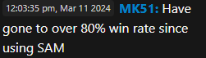

There is still a learning curve...
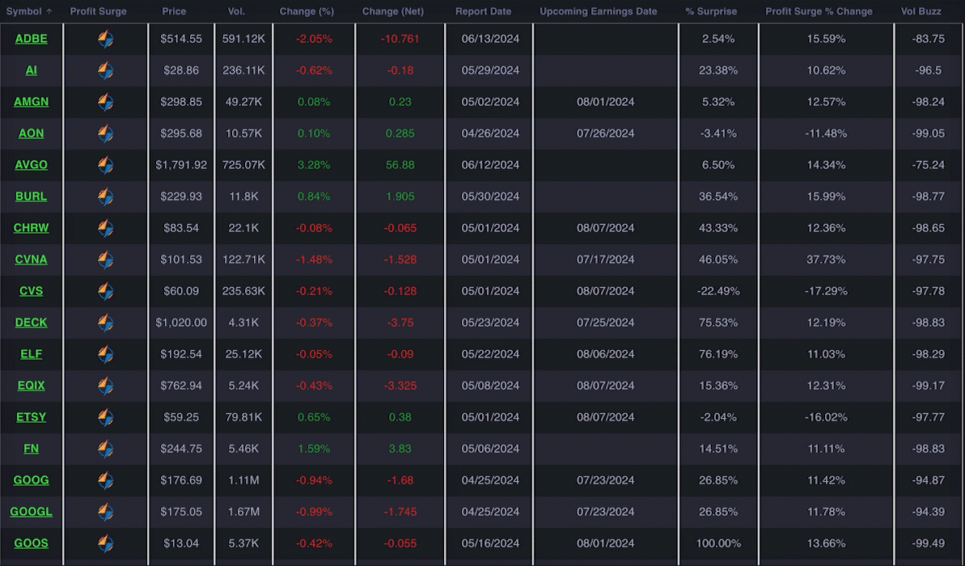
Just like mastering any income building strategy.
While I like to call S.A.M. my “money-making machine”...
It doesn’t find trades for you. Nor would you ever want it to!
I would never let a machine completely control my money.
It’s an AI-Powered tool to help find explosive opportunities to collect profits from the Earnings Profit Surge.
After using S.A.M. every day for as long as I have, I believe it’s now essential to building this extra income stream...
And collecting a share of the $4.8 trillion per year that is projected to be created by AI over the next few years..
Honestly, I couldn’t live without it.
I tell my members all the time that S.A.M. is my best friend.
.
But there had to be a simple way for everyday people to get started...
And I didn’t want the software’s cost to be a factor for anyone.
So that’s why I decided to make myself available every single week...
To make it EASIER for people like you to start targeting these Weekly AI Cash Waves found with the help of S.A.M...
WITHOUT any confusing learning curve.
That’s why I am inviting you to...
Join me LIVE inside my Profit Surge Trader chatroom every Monday at 12 pm. and receive my top trade recommendations found using my AI-POWERED tool - S.A.M.
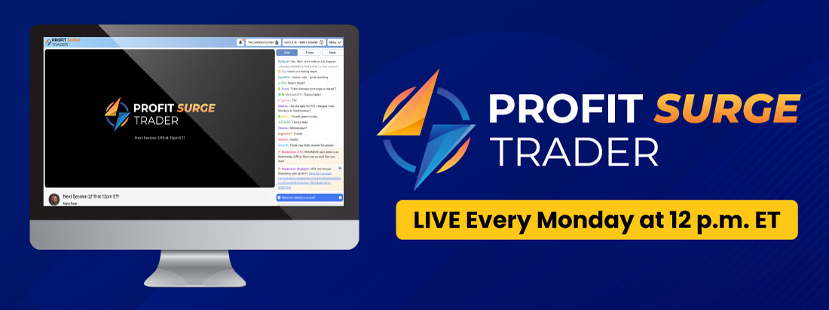
Every Monday at noon, I stream LIVE and open up S.A.M. for everyone in the chatroom to see...
And I share my intel and REAL-money trades,all while I teach my trading techniques and make recommendations.
This is your opportunity to join me and my community ofthousands of Americans inside of my private Profit Surge Trader chatroom, as we target Weekly AI Cash Waves...
Like the week where we collected 100% on Reddit overnight.
Or the week when we collected 100% on Advanced Auto Parts within a few minutes...
Then a week later...
Collected ANOTHER 100% on the same stock overnight.
Shortly after that, we collected 117% on Veeva Systems Inc after just 3 days...
And we’ve even made 133% on META within a few minutes.

And those are just a few of my best trades…
Most Americans will never get the chance to see a weekly cash flow this lucrative in their lifetimes...
In fact, most people probably will never get the chance to double their money... EVER.
So I understand that you might be skeptical.
Frankly... I probably would be, too.
But these Weekly AI Cash Waves are an absolute game-changer.
So that’s why I want to give you a risk-free preview of my Profit Surge Trader research service to see this for yourself!
If you join me in my chatroom on Monday and don’t see this money doubling potential...
You won’t have to pay a single penny.
Seriously!
Don’t just take my word for it...
Join me and see this breakthrough income stream for yourself.
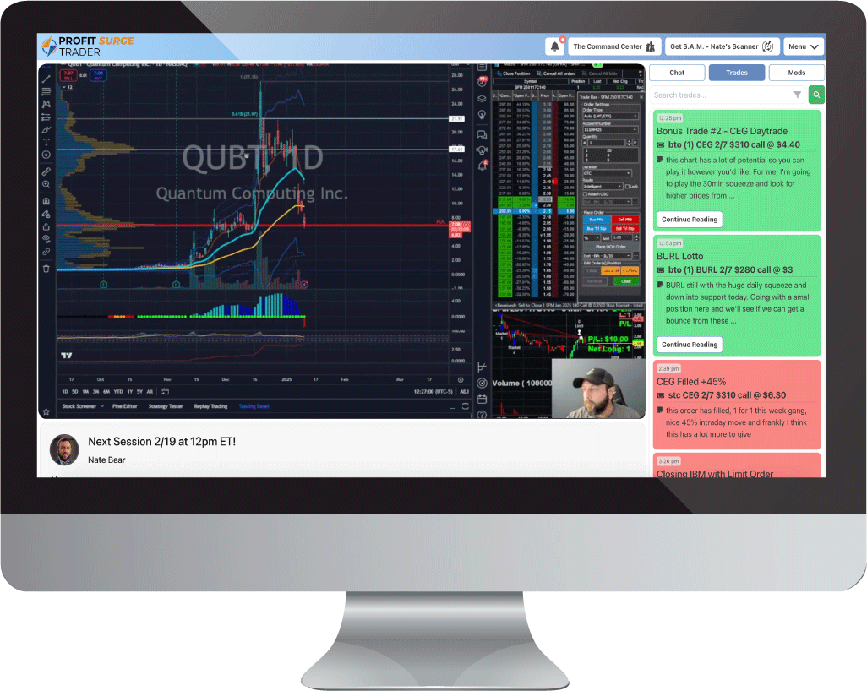
Every Monday @ 12 pm ET... I’ll stream LIVE in my private chatroom and share my favorite trade setups and intel produced by my AI-Powered tool, S.A.M.
You don’t need to download anything...
Or purchase any software to get started.
Simply show up to the chatroom every Monday...
Receive my top trades ideas that I make using the tool...
And learn how I collect these Weekly AI Cash Waves using the power of AI.
I’ll open up my AI-Powered Scanner S.A.M. and show the exact trade setups that I am looking at...
I’ll do my pre-trade analysis...
Explain why I like the set up...,
And I’ll place the trade LIVE on camera.
You’ll see all of my moves... LIVE!
Of course, if you can’t make the 12 pm ET session, you’ll also receive a replay so you don’t miss out on any of the action.
This is your opportunity to take advantage to learn how to build a additional income stream using the power of AI...
Without actually having to touch any technology.
If you decide you want to get direct access to my software later on...
My team will help you out when you’re ready...
But this is a risk-free way to get started targeting these Weekly AI Profit Waves.
And I won’t just give you my trade ideas over the livestream either.

Every time I make a trade recommendation inside of Profit Surge Trader...
Usually 3 or 4 per week...
I’ll send you a trade alert with my complete entry and exit instructions via the chatroom, email and our mobile app.
I will also share any updates to my trades that I make along the way. But as I said, once I learned how to trade… I turned $37k into $2.7 Million.
So I don’t want to simply give you the picks…
I want to show YOU what I learned…
So you can take advantage of these Weekly AI Cash Waves yourself...
That’s why I put together 3 special bonus reports for you to help you master this new income stream quickly.
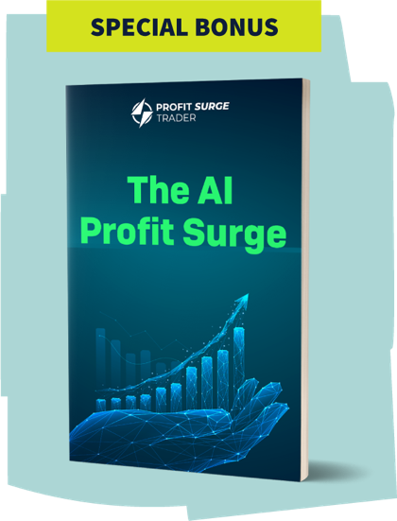
The first one is called the AI Profit Surge and covers everything you need to know about how I play the Earning Profits Surge using the power of AI...
You’re going to discover exactly how AI use to target massive GAINS... every week.
It’s all spelled out in plain English.
I’m also including a copy of my special report the $2.7 Million Dollar Profit System...
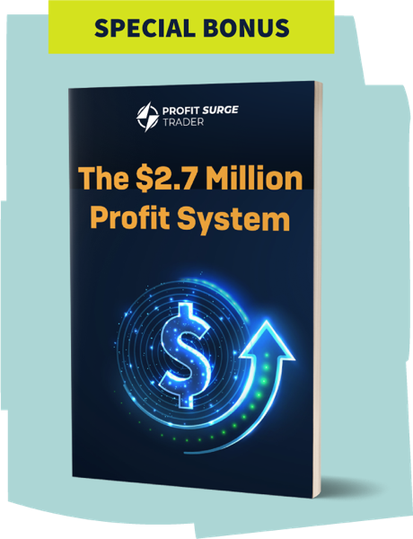
This reveals exactly how I turned $37k into $2.7 million dollars in four years.
It reveals all of my income-building secrets that will change the way that you aim to grow your money.
Which leads me to my third report.
Let me be clear...
You can use this strategy to trade stocks simply. There is nothing wrong with that...
But I’ve made nearly all of my trading profits… worth millions of dollars… by harnessing the power of “special trades” or options.
Simply put...
Options give you a huge advantage over stocks.
They allow you to put less money at risk while also targeting much higher gains.
And it’s the most realistic way to target double, triple, and heck, sometimes even quadruple-digit gains within just mere days.
Just look at this 1,129% gain that many of my Profit Surge Trader members got to witness during an open house event I hosted not too long ago. 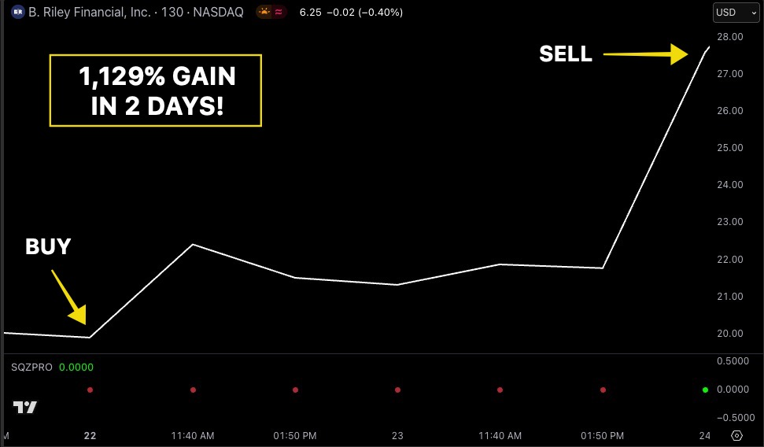
Some of my happiest members like Ed made a 1,230% gain off the trade...
Or Kirk who made 1,467%...
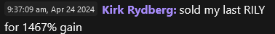
Or how about Quinton, who gets this..
Made an even bigger 1,987% gain...
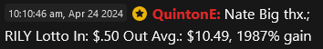
Nailing a big winner like can be truly life changing.
Imagine if you had put let’s say... $1,000 into trade.
That could have turned into $12,290...
And $10,000 could have turned into $122,900!
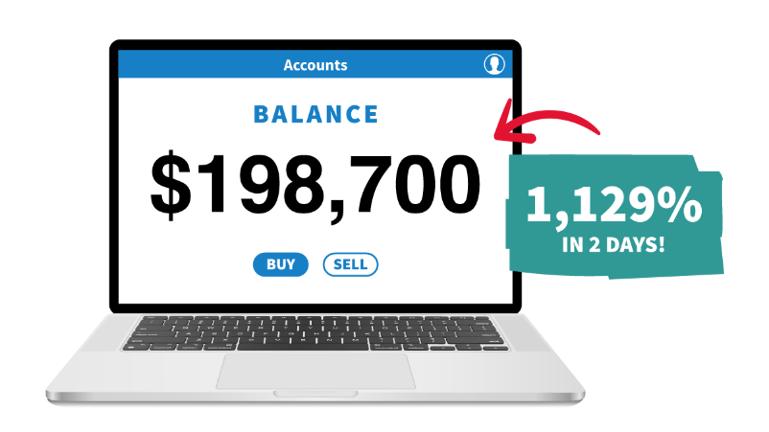
But that winner was made possible thanks to the power of options.
I would have only made 41% if I had simply traded the stock.
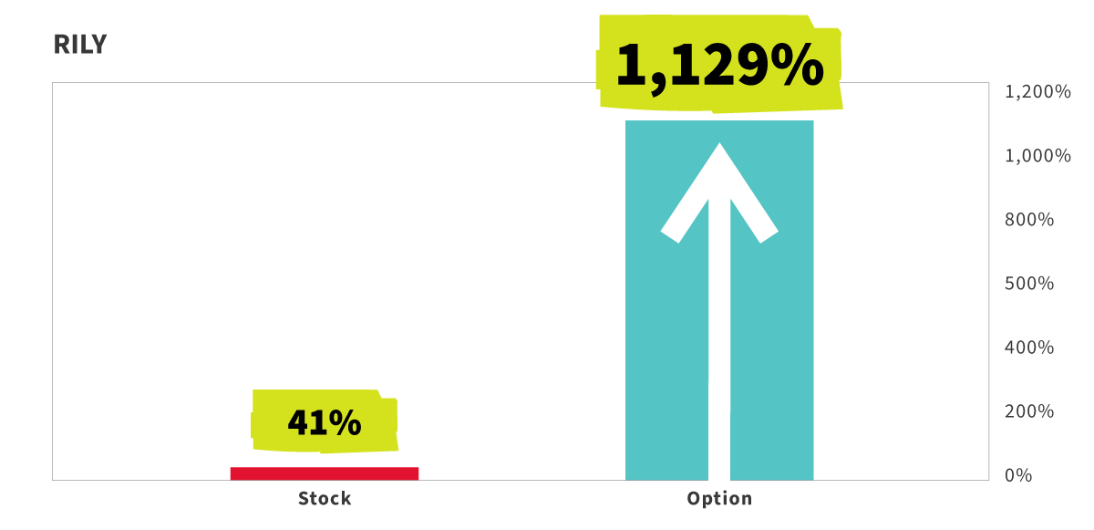
Now, I know a lot of people are scared of options and they view them as super risky.
But like anything in life… they are risky if you use them the WRONG way.
Heck… lots of people think stocks are less risky than options… but starting out I lost all of my money on STOCKS three separate times.
Stocks and options both have risks. Nothing in investing is guaranteed. You should never trade with money you can’t afford to lose.
But I want you to learn how to minimize your risk...
And learn how to potentially maximize additional weekly income...
So I am also going to include a copy of my report that has helped tens of thousands of my students called “How to Profitably Trade Options (the Easy Way).”

It's ideal for individuals new to options or those still learning.
I’ll send you all 3 of these reports
Alongside access to my entire Private Education Vault...
Filled with my best training videos and income-building information.
And if you try Profit Surge Trader and decide that it’s not for you...
Not only will I give you your money back, with my 100% Money-Back Guarantee...
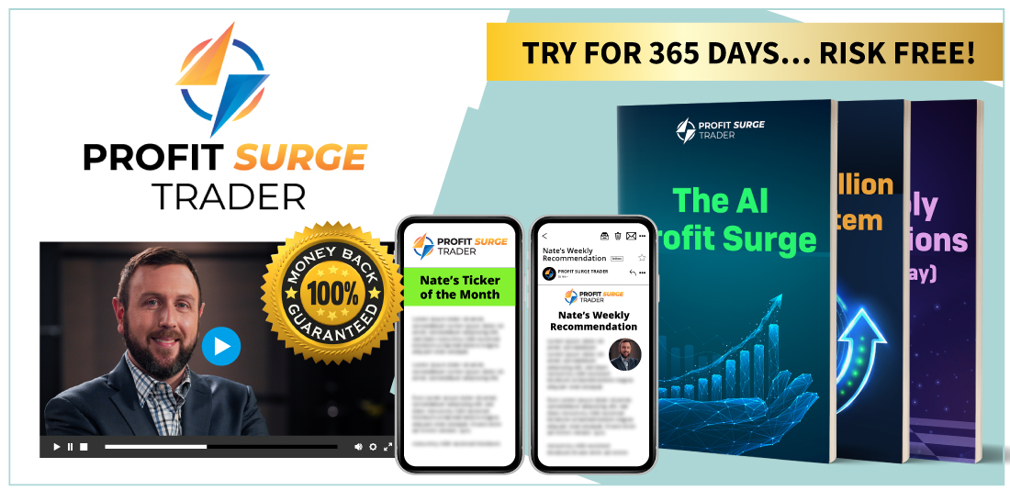
But you can keep all 3 of these reports... FREE of charge.
My gift for giving Profit Surge Trader an honest try.
I’ve taken all of the risk for you...
So you’re probably wondering what it costs to join me and receive all of my intel and trade recommendations every Monday?
Well, normally Profit Surge Trader sells for $997...
But you don’t have to pay that today.
I don’t want to give you any excuse not to target this new extra income stream.
That’s why for a limited-time you can try Profit Surge Trader, risk-free for 90 days for just $49.
And if that is too expensive for you, you have an even better option, waiting for you on the next page.
Click on the link below to get access to 3 months of my weekly live streams, recommendations, and research.
Remember it’s backed by a complete money-back guarantee...
So if this income-building opportunity isn’t for you...
Simply reach out and we’ll give you your money back and keep the bonus reports I put together for you.
No questions asked. No hard feelings, we’ll leave as friends.
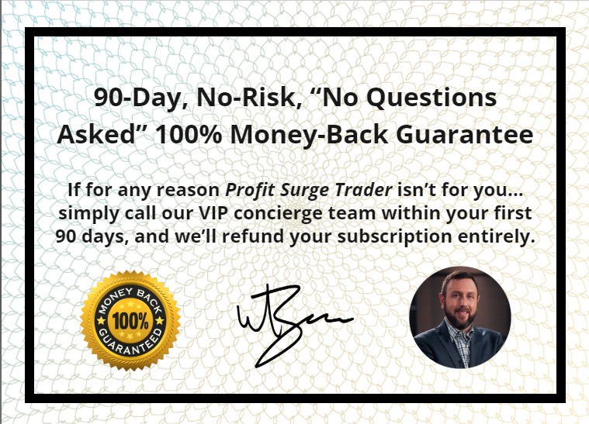
Click on the button below to see everything you’re going to get.
And if that isn’t enough peace of mind for you...
I’ll do you something even better...

Not only will I refund your money back...
If you show me that you’ve given Profit Surge Trader a good, honest try...
I’ll also give you an additional account credit worth TWO times what you paid today, so that you can try one of my other services when you’re ready.
So altogether you’re getting TRIPLE your money back.
TRIPLE YOUR MONEY-BACK GURRANTEE!
If for any reason Profit Surge Trader isn’t for you...
Simply call our VIP Concierge team within your first 90 days and, and we’ll completely refund your subscription entirely.
PLUS... we’ll give you an additional account credit worth 2X what you paid today to use on any Monument Traders Alliance service in the future.

My gift to you for giving Profit Surge Trader a test-drive.
Now is the opportunity to take advantage of the power of AI and target your share of the $4.8 Trillion that is expected to be added to the global economy over the next few years.
I’m giving you the chance to build a new weekly income stream for yourself...
And see what all of the hype around AI has been about...
Without actually having to learn how to operate any technology.
All 100% Risk Free.
I’m THAT confident that you will join the likes of some of my happiest students who LOVE joining me inside of Profit Surge Trader every week ...
Like Angelena who wrote in
“Nate is terrific! He is knowledgeable and real. I came into the service with very little knowledge and listening to Nate every week turned me into a more confident trader.”
Or Mike G. who wrote...
“Sooooo many folks out there claiming to have "THE WINNING SYSTEM" and we all know there is no perfect system. Nate's approach and system to trading is unique and very applicable to people like me who don't have a gazillion dollars to invest and don't understand everything in the stock market. I am doing better with [the] Profit Surge than with any of the other previous systems I have tried in the past...
I've had way more wins and a lot less losses with Nate because he has educated me with new trading techniques I never had before.”
Or William who wrote...
“Well worth the price, it paid for itself the first week. I have gone from knowing nothing about trading options to making 335 trades with an 86% win rate in seven months. Nate is a fantastic teacher and I have learned to find high-quality trades on my own in addition to the weekly service recommendations. This stuff is fun”
Will you be the next?
Click on the link below to join me inside Profit Surge Trader THIS Monday at 12 PM ET .
I’m doing everything my power to help you take advantage of these Weekly AI Cash Waves.
I’m going live every week to share my trade ideas from my AI-Powered scanner, S.A.M.
I’ve made the price ridiculously low.
And I’m backing everything up with my TRIPLE your money-back guarantee.
The choice is yours.
There is $4.4 Trillion In new wealth that’s going to be created every year thanks to AI.
Do you want to claim your share of it...
Or miss out on what is easily the ultimate wealth creation advancement of your lifetime?
Targeting Weekly AI Cash Waves is the perfect way to get started by spending just 1 hour per week.
Let’s target MASSIVE AI profits together.
I’ll see you in the Profit Surge Trader chatroom!
-Nate Bear
September 2025

Journal of Behavioral and Experimental Finances Study Page 3 - https://www.sciencedirect.com/science/article/pii/S2214635020303750?ref=pdf_download&fr=RR-2&rr=7cb5e1df6dc15734
Oxford Study: Post-Earnings-Announcement Drift in Global Markets: Evidence from an Information Shock on JSTOR (you can see quote in preview)
Fed study: The full quote is “The magnitude of PEAD.txt is considerable even in recent years when the classic PEAD is close to zero”. PEAD.txt just references a new more broad / qualitative way of looking at PEAD vs. just baising if a company had a quantitative earnings. In Nate’s case it does not matter. https://www.philadelphiafed.org/-/media/frbp/assets/working-papers/2021/wp21-07.pdf

