Special training from the “World’s Fastest Trader,” Bryan Bottarelli…

The 5-Stock Method
Discover How You Could “Flip” Stocks for Profits of as Much as 37% in as Little as 4 Minutes… No Matter Which Direction They Go

Ryan Fitzwater: Hey everyone, Ryan Fitzwater here… Associate Publisher for Monument Traders Alliance.

Welcome to today’s training.

I’ve got you scheduled in a moment here to meet with the World’s Fastest Trader… Bryan Bottarelli.

For my money, Bryan is the single greatest trader alive today.

He’s made around 6,000 trades in his career. And he’s won on about 75% of those trades.

Sometimes the gains are incredibly fast… coming in as little as four minutes.

And sometimes the gains are incredibly large… as big as 188% in a day.

Perhaps most impressive is the sheer number of people who follow Bryan.

He’s helped 19,000 people across 194 countries understand how to win in all markets.

And get this: Bryan’s top students – a group of just 1,283 people – together control approximately $641,500,000 in combined wealth!

It’s amazing to see what Bryan has built.

And today he’s going to show you his “5-Stock Method.”

Now, I want to give you a little word of warning before we begin…

His approach to the markets is radically different from what you’ve likely seen before.

For one, Bryan is NOT trying to identify stocks that go up.

Let me repeat that so there’s no confusion…

Bryan does not care about finding great companies.

Sales growth… profit margins… return on investment…

With the 5-Stock Method, it’s all irrelevant.

It simply DOES NOT MATTER whether stocks go up or down.

So if you’re looking for guidance on how to find that once-in-a-lifetime, lottery-type winning stock, I want to be very upfront with you.

This is NOT that.

Bryan’s 5-Stock Method doesn’t involve finding a stock you love… and holding it for decades, riding all the ups and downs along the way.

It’s not the old “buy and hold” strategy that Wall Street pushes.

It’s the opposite, really.

The 5-Stock Method is about using stock “flips” for the chance to collect quick wins every day the market is open.

No matter whether we’re in an up market… or a disastrous crash.

In either case, the 5-Stock Method has proven that you can take 15 minutes or so to make just one or two simple trades each day…

And lock in several years’ worth of gains in the process.

But even though this “flip” system is dead simple, it’s more powerful than anything I’ve seen.

It has the power to help YOU change your financial situation NOW.

We’re talking about months, not years.

I’ve seen it myself.

So it is with great pleasure that I introduce the World’s Fastest Trader, Bryan Bottarelli, to you right now.

Folks, you’ve got a life-changing event ahead of you.

And I wish you great success.

Bryan, take it away.

Introducing Bryan Bottarelli: The World’s Fastest Trader

Bryan Bottarelli: Hey everyone, I want to thank my great publisher, Ryan Fitzwater, for that introduction.

It’s a pleasure to be with you all today.

But before we begin, I want to start off with an apology.

People say I’m naturally high-energy… and I’ll be honest, in my mind, it feels like I’ve got Dick Vitale announcing a Richard Simmons workout right now.



So if I’m a little overexcited, I apologize.

But I’m just incredibly pumped up for what you are about to see.

Because I know how BIG this is going to be for you.

You’re about to see something that can completely alter your financial situation.

I know because I’ve personally lived through what I’m going to show you.

What did that Hair Club for Men guy always say?



“I’m not just the president, I’m also a client.” Right?

Well, that’s me.

The technique behind the 5-Stock Method is one I actually use in my daily trading.

As Ryan mentioned, I’ve spent decades in the markets, and I’ve made over 6,000 trades.

I started in the Apple pits of the Chicago Board Options Exchange. (I can promise you that was insane.)



Now I trade every day from the comfort of my own home.

And what I’ve learned from recommending over 6,000 trades during my career… and using those lessons in my personal trading…

Has completely transformed my life.

I became a multimillionaire at just 34.

I travel all over the world.

I spend a few months in my cabin in Big Sky, Montana, each year.

I have complete freedom to enjoy life to its fullest with my family.

And I’ll be honest… I’ve come to realize that the stock market is perhaps the greatest friend I’ve ever had.

That may sound strange, but it’s true.

The stock market has taken money worries out of the equation for me.

It’s given me the ultimate freedom in life.

I’m eternally grateful for that.

And my success is largely because of the technique behind the 5-Stock Method I’m going to share with you today.

Now, a lot of people I know view the stock market completely differently from how I do…

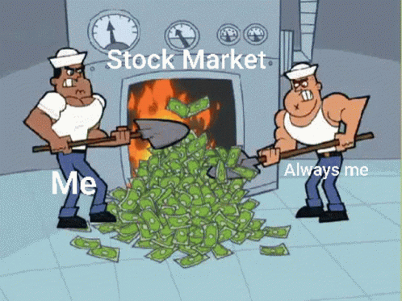

They say it’s too complex.

They call it a casino.

They say it’s too high-stress.

And listen, if you feel that way, I hear you.

When I started out in the Apple pits, battling the top traders in the world… I felt that way too!

I still remember, early in my career, being asked to complete a trade that was foreign to me.

I didn’t know what I was doing!

And I made a mistake.

A mistake that cost my company hundreds of thousands of dollars.

And I got blasted by my boss.

I mean well and truly blasted.

This guy must have set the all-time record for most expletives in a five-second outburst.

But it was those experiences early on that really put into perspective how great life is for me now.

When I trade these days, it’s with ultimate confidence.

I am calm.

I don’t worry if markets drop. (In fact, I love it... for reasons you’ll see soon.)

And everything I do is simple and easy.

As I look back on my life, I think that’s the reason thousands of people from all over the world follow me, watching every trade I make.

They want to know how it’s possible to make money with a calm, simple and easy approach.

Most importantly, they want to know how to succeed in brutal markets like the ones we’ve seen recently.

And the answer, in a nutshell, is the 5-Stock Method.

So that’s what I’m going to teach you today.

I want to start with your mentality, which is tremendously important.

We’re going to go over four stock market mental blocks that are keeping you from being successful.

Then, I’m going to lay out exactly how the 5-Stock Method works.

I’m going to show you real trades. And real results. With real money on the line.

Remember, the goal of this is to hand you an approach that can help you finish each day wealthier than you started it.

Now, as we do this… I’m also going to do something special.

I’ve gathered a number of my followers’ stories.

And I’m going to share with you how their lives – and their trading accounts – have been impacted.

One guy, George, managed to turn $165,000 into peak gains of $2.3 million in just three months using some of the methods he learned in our elite trading community, The War Room.

Another one of my students, David, turned $20,000 into $185,000 over the course of nine months.

That’s how powerful this approach can be.

Now, of course, everyone’s results will vary based on their personal situation. These results were some of the best we’ve ever seen.

But I can tell you that we’ve gotten thousands – literally thousands – of notes from people telling us about their successes.

You’ll see many of them popping up on your screen now.

But listen, I don’t want to sit here reading off the success stories of others.

I want to show you how to succeed yourself with the 5-Stock Method.

This approach is something I figured out over years of trading.

I got tired of trying to find that one stock that was going to be a home run. I got tired of watching my wealth wash away due to some crash I couldn’t control. I got tired of the Fed raising rates and wiping out gains I had spent years building up.

The 5-Stock Method eliminates all that.

It takes the fear of market downturns out of the equation.

It removes the impossible challenge of identifying those rare moonshot stocks.

And, most importantly, it shows you how to generate as many trades as you need from just 5 stocks, regardless of whether those stocks move up or down in the long term – you just need them to move.

The strategy I use has been proven to work – not just by me, but also by the thousands of others who have now used it.

For example, I have a student in our trading room who first started doing this in December 2022.

In one week… he made six trades, about one per day. And he made money on all six. He locked in wins of 16%, 7%, 13%, 32%, 20% and 27%.

Another student, Jim, said that between November 30, 2022, and January 4, he made nine trades. All nine were winners, including one that went up 112%!

And there was a student named Steve who really went after it. In one week, he made 37 trades. 32 were winners, and five were losers.

He said his entire account went up 50%... in one week!

This is how powerful the 5-Stock Method is.

It is the #1 path, in my view, to stock market success.

So let me share my screen with you and we’ll get started.

The 5-Stock Method

Now, this is going to take some time to show you.

So if you’re expecting to get the secrets I’ve learned over decades in just two or three minutes... and then, presto, you’ll be a master trader… this might not be for you.

This is really simple once you see it.

But if you can’t spend the next half-hour or so learning it, then you might be better off going to Reddit so you can trade GameStop or whatever other pipe dream stock they’re pushing today.

It takes real effort to get real results.

We’re not going to be here forever, but plan on a good 30 minutes.

Stick with me, and I promise you’ll learn something valuable.

Now, the first thing I have to do to get us started is perform a kind of “brain wipe” on you.



Seriously.

The media and Wall Street have filled your mind with untold amounts of “wisdom” that frankly is just a bunch of nonsense.

And it’s keeping you from succeeding.

So I’ve got to start by altering your mentality about building wealth...

By debunking the four biggest stock mental blocks holding you back.

Stock Mental Block #1: You Can’t Beat Wall Street

The first one is perhaps the biggest load of bull that the media pushes.

And I find it’s the one people believe most stubbornly.

“You can’t beat Wall Street.”

Never before has such a blatant lie ruined so many people’s financial lives.

Of course you can beat Wall Street.

In fact, it’s not all that hard.

One of the great realizations I want you to walk away with today is that the crooks running Wall Street are not smarter than you. And they aren’t better traders than you, either.

Consider this stunning fact…

Between 2005 and 2020, 87% of actively managed Wall Street funds underperformed the market.

87%!

These guys are TERRIBLE traders.

They’re a bunch of boneheads.

But here’s what’s even worse...

Most stock investors, who’ve been convinced by Wall Street and their media pals that they can’t beat them, just go along for the ride.

They hand their money over to these guys… pay them millions in fees… and just accept the mediocre performance they produce.

This was one of the first things I knew I had to change with the 5-Stock Method.

I had to show regular traders that they could not only beat Wall Street… they could actually CRUSH Wall Street.

And I know people can... because that’s exactly what we’ve done.

Since we launched Monument Traders Alliance in 2019, we’ve beaten every single market index… the S&P, the Nasdaq, the Dow and the Russell 2000.

And our performance during crashes has been spectacular.

For example… during the initial COVID Crash, the S&P went down 20%.

But the positions we opened and closed over the same period went up 246%!

That’s the difference between seeing a $100,000 account drop to $80,000… and seeing it grow to $346,000!

And here’s the key...

You don’t beat Wall Street by playing their game.

You don’t win by spending all day trying to find those rare stocks that go up 10X.

That’s hard!

Instead, you play a totally different game from Wall Street.

In the game we play… and this is very important… you don’t make money because stocks move up…

You make money because stocks move in either direction.

Doing this, you can capture wins every day.

Over the last four years, my followers saw the chance to get more than 1,600 wins. That’s better than one win for every day the markets were open.

It’s all part of our goal to get a little bit richer every day.

So that’s the first thing you must accept.

Say it with me… I CAN beat Wall Street.

Okay, let’s get to mental block #2.

Stock Mental Block #2: You Have to Be a Math Genius to Make Money in Stocks

A lot of people believe that you’ve got to be some sort of math genius to make money in stocks.

They picture the guy from A Beautiful Mind writing complex equations on a window.



Totally false, guys.

Here’s the beauty of the 5-Stock Method.

You don’t have to do deep fundamental research, like reading through annual reports that can be hundreds of pages long.

You don’t have to be at your computer for hours.

You don’t have to listen to earnings calls or try to guess which companies will have a great quarter.

And you don’t have to know squat about stochastics or the relative strength index or any of those other terms Wall Streeters use to try to make themselves sound smart.

Instead, what do you need to do?

Pick 5 stocks.

That’s it.

And the thing is, it doesn’t really matter which 5 you pick.

I’ll even give you the 5 stocks I use.

And after that… as you’re about to see, the 5-Stock Method makes it easy to identify trades.

Let me tell you about one of my students, David.

Now, David started out with the preconceived notion that he should “go it alone.”

He thought he needed to be the hero who figured it all out.

And lo and behold, it didn’t go so well.

Doing it his way, he lost money.

In his first three months of trading, his $20,000 stake got cut almost in half, to $11,200.

We all know that feeling, right?

It’s brutal.



It’s not even my money, and it hurts!

But then David figured out the most important lesson of trading.

You don’t need to be a hero or a genius.

You just need to find a system that has proven to work... and then follow it.

David tells us that after his initial losses, he started following our suggestions seriously for the first time.

He started using stock flips… and following the buy and sell triggers.

And over the next nine months, he grew his account all the way up to $185,000.

That’s the type of success we all want to see, right?

Well, it may be rare, but it is possible.

But you have to get out of the “hero” mentality. Stop trying to do everything the hard way.

Instead, follow what’s proven to work.

Set up the 5-Stock Method and let it do the heavy lifting.

Okay, mental block #3.

Stock Mental Block #3: The Stock Market Is a Casino

I hear this one all the time.

“The stock market is a casino.”

It’s one of the great myths that holds people back.

Let’s set the record straight.

In a casino, the games are engineered so that the house wins about 53% to 54% of the time...

Which means that you lose more than half of the time.

That’s why casinos give out free hotel rooms, drinks and more.

They want to keep you there as long as possible. Because over time, if you lose more than half of your bets, they’ll make money.

It’s a mathematical certainty.

However, with my approach to stocks, I have won at a rate of about 75%.

This is like being “the house” on steroids.

Winning 75% of the time means that the longer you play, the MORE money you make.

Now, it’s important for me to say that the market is always uncertain. I’ve maintained my win rate for almost two decades now on over 6,000 trades.

So I’m very confident in my approach.

But I want to be clear that there are no guarantees, and your money is always at risk when you trade in the markets.



And the fact that I’ve won at a rate of 75% doesn’t mean we never lose.

A great trader knows that some trades will go against them. They understand that losing is part of the game... and that some trades will result in big losses.

But they don’t care.

Because as long as they are winning at a huge rate like 75%... they know the wins will vastly outnumber the losses.

Imagine if you could get a 75% win percentage at blackjack. You would make a fortune. You’d probably never leave the casino.

Of course, that would NEVER happen at a casino.

The casino operators would take you out back and have you beaten by Robert De Niro himself if you were winning at a 75% rate.



But here’s the thing…
I’m going to show you the approach I’ve used to win at a 75% rate in the stock market.

For example, since the middle of 2019… we’ve recommended 2,112 trades to our collection of students in Monument Traders Alliance.

Not exactly a small sample size.

1,621 of them were winners… for a win rate of exactly 76.8%.

So remember this...

At that win rate, the longer you play, the more likely you are to win.

Alright, last one. Mental block #4.

Stock Mental Block #4: I Can Make Only 8% per Year in the Stock Market

The so-called experts will tell you that the stock market delivers only 8% per year on average.

And they’ll say you should be happy to get that!

Guys… this one drives me crazy.

I can’t tell you how many times I’ve seen financial planners sell people on the idea that the best they can do is make 8% or so per year…

The truth is… you can make 5 times that much in just five minutes.



We’ve done it over and over.

For example, on March 8, 2022… I alerted my followers about a trade on Digital World Acquisition.

Now, most people would need the stock to go up in order to make money.

But in this case, the opposite happened.

It dropped.

But that didn’t matter… because of the “stock flip” approach I use.

On our trade, we made about 70% in just six minutes.

We had a woman named Nina write that this was the fastest win she’d ever seen...

Which didn’t surprise me at all.

For regular people, the idea of making 70% in six minutes seems totally unrealistic. It feels unattainable.

And that’s because… with normal trading, a 70% gain can take years.

At 8% per year, it takes seven years to make 70%!

For us, it took six minutes!

And we’ve had tons of wins like this.

We’ve had gains of 37% in four minutes on Lemonade...

54% in four minutes on Roku...

27% in five minutes on Okta...

And 73% in eight minutes on Sturm Ruger & Co.

We once even had a top win of 121% on Walmart in just an hour and 20 minutes… and some of my followers were freaked out because the trade took SO LONG!

What can I say… They are a spoiled bunch!

What we are talking about here is getting several years’ worth of gains in just a few minutes.

So when they tell you to be happy with 8% per year, just laugh and walk away.



You can do much better.

Now, how exactly is it possible to trade so fast?

Well, that’s part of the secret of the 5-Stock Method. As I said before, it’s a software system I developed that tracks patterns that indicate when stocks flip.

You get the alerts telling you a flip is likely…

Then all you have to do is take a look at the setup and decide whether you’re excited about the trade.

So you don’t have to try to figure out which stocks out of thousands have seen a flip.

You just pick the 5 stocks you want the software to track, and it alerts you to when the pattern strikes.

You don’t have to waste a ton of time researching the stock… trying to figure out if sales are going up or down… or whether the CEO is properly managing the company.

Forget that stuff.

With this method, you can ignore almost everything else.

Okay, I assume everybody is ready to learn the 5-Stock Method, right?

Let’s get into the story of how I figured this whole thing out.

I Was Sick and Tired of Making Other People Money!

As I said earlier, I started my career in the 2000s as a trader on the floor of the Chicago Board Options Exchange… the CBOE.

Now, guys, I have to say… I loved the action and the energy of the pit.

And I loved the education I was getting.

Day after day, I was on the floor with the best traders in the world.

It was the ultimate education.

But it was also extremely stressful.

Listen, when you’re trading in the pits… it’s like being in one of those battles in Braveheart.



Sheer and utter chaos.

You are screaming and shouting… elbowing each other for space.

It’s totally cutthroat.

And you’re doing all this from the tiny 1-foot-by-1-foot section of territory you hold.

There is a reason guys get ulcers at 40 when they work in the pits.

The stress led to burnout… failed marriages… and heart attacks.

I didn’t want that.

Not to mention, I hated making money for other people.

There was a time in my career in the financial world when I made $1 million for my company over a very short period.

I was on cloud nine. I marched into my boss’s office and asked for a tiny $5,000 raise.

And did I get it?

No!

I was told to pound sand.

It was ridiculous.

$1 million in the door... and I can’t get $5,000 of it?

Give me a break.

So I decided pretty early on to quit working for other people and start making money for myself.

It just made sense.

I wanted to keep the lion’s share of my profits. And I sure as heck didn’t want to die of a heart attack in the pits before I was 50… all in the name of making someone else rich.

So I started trading by myself.

And let’s see if you can guess what happened.

Yep, right on cue… I lost money.

I did everything wrong.

First of all, I tried to be a hero.

My goal was to find the big, big winners.

I wanted to buy the next Microsoft.

I remember one time, I found this company called eFax.

It turned faxes into electronic messages. (So it was basically email.)

I was convinced this company was going to the moon!

But here was the problem…

The internet was filled with competitors. And once Gmail came along… it blew eFax right out of the water.

That’s the thing about trying to find the next Microsoft… It’s easy, looking back, to think you would have known to buy Microsoft. But it’s much harder to do it in real time.

You end up investing in companies like eFax and losing your shirt.

I was stuck in that “hero” mentality.

I wanted to swing for the fences and hit home runs.

The problem is… when you swing for the fences… you strike out a lot.

[MAKE GIF OUT OF FIRST PITCH IN THIS VIDEO: https://www.youtube.com/watch?v=-ozvHUtdE_o ]

So I reached out to one of my mentors, Dan.

He was a world-class trader.

When I first started trading, he was the guy I looked up to. He was sitting courtside at Bulls games… eating at the finest restaurants in Chicago… making huge money every month…

This guy was the top dog.

So I go to Dan and I say, “Dan, you’re totally clued in to stocks. Tell me… How do I find the next Microsoft?”

And Dan just kind of laughed at me.

He said, “You’ll never get rich asking that question.”

So I said, “Well okay… How do I get rich?”

Dan said, “Bryan, what’s the one thing you know for sure about the stock market?”

I thought about this for a while before I answered.

“The one thing I know for sure is that it’s unpredictable.”

Dan said, “That’s right, Bryan. We can’t know for sure which stocks will soar and which stocks will collapse, especially in the short term. But one thing we do know for sure is that stocks are going to move up… and then move down… and they’ll keep doing this day after day.”

“That is a fact.”

Then Dan said something that changed my life.

He said...

“The key to being a great trader is figuring out how you can PROFIT from that fact.”

And that was the lightbulb moment for me.

The key to getting rich in the stock market is not finding that once-in-a-lifetime miracle stock that goes from $10 to $1,000.

That’s very difficult.

The key is finding a way to make money consistently from the daily up and down movements of the market.

And I instantly knew exactly what I had to do.

You see, when I was trading in the pits on the CBOE… I learned something very interesting.

Stocks would move up and down… up and down… all day long.

But here’s what I discovered… The up and down movements weren’t random.

Every once in a while, the stocks would flip and change directions.

This flip followed a scientific pattern based on the emotional behavior of traders.

And because I understood exactly how trading worked from the inside, I soon found I could use this scientific pattern to predict when stocks would flip over the course of the day.

When the flip was triggered, stocks would change directions.

Then a new trigger would hit, and stocks would reverse again.

I knew how to identify these flips consistently… and with a high degree of certainty.

So even if I didn’t know where the stock was going in the long term… I knew where it was likely to go in the short term.

And this gave me an opportunity.

I started trading these flips. As soon as I saw the trigger that signaled when the stock would change course, I made a trade.

Then, when it triggered a sell, I’d get out.

And what happened?

Well, I started making money. And then more money. And then even more.

My bank account was swelling faster than I ever could have imagined.

I bought a beautiful multimillion-dollar home in Massachusetts... and a vacation home in Big Sky, Montana.

[PICTURE OF BRYAN IN MONTANA]

Life was grand.

But then something happened…

People started to notice.

My Friends and Family Wanted In on the Action!

At first, I felt a weird shift at parties with friends or family gatherings.

I noticed the glances people were sending my direction.

I had the sneaking suspicion people were talking about me.

And finally, one of my friends came up to me directly.

“Bryan, we want in,” he said.

“In what?” I asked.

“Whatever you’re doing,” he said.

And that was the start of it.

I explained that I had figured out a method for capturing quick daily gains in the stock market. And that I could win at a 75% rate.

My friend wanted in. And so did everyone else.

So I created an email list. And I started adding people to the list.

At first, it was just a handful of people.

But when they started making money… pretty soon others wanted in too.

It wasn’t long before literally hundreds of people were following my trades.

It was a little bit scary having so many people rely on me.

But it worked!

I ran this email list for years.

I would find the trades myself… write up instructions on each one… and send them out.

Over the years, I sent out over 4,600 trades. And we won on 75% of them.

Our average trade made 12.7% in three days.

In other words, we were making more every three days than the market usually delivers over an entire year!



It was awesome to help so many people.

But I wanted to do more.

Email was too slow to recommend many of the trades I wanted to share.

So after I met my current publisher in 2019, he and I – along with my partner Karim Rahemtulla – launched Monument Traders Alliance and created The War Room, a live trading room where I could share trades in real time.

The impact was immediate.

We had thousands of people join us.

And right away, we had some great hot streaks.

From April 4 to May 9 that year, we went on a run that would take your breath away.
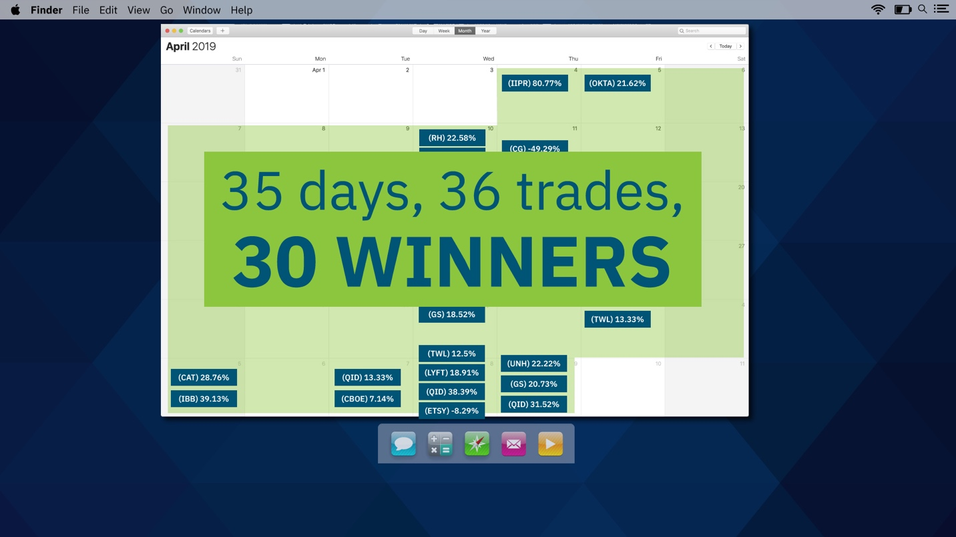
In those 35 days, we recommended 36 trades.
And 30 of them were winners.
For instance, my first play, on April 4, was on a company called Innovative Industrial Properties – ticker symbol IIPR.
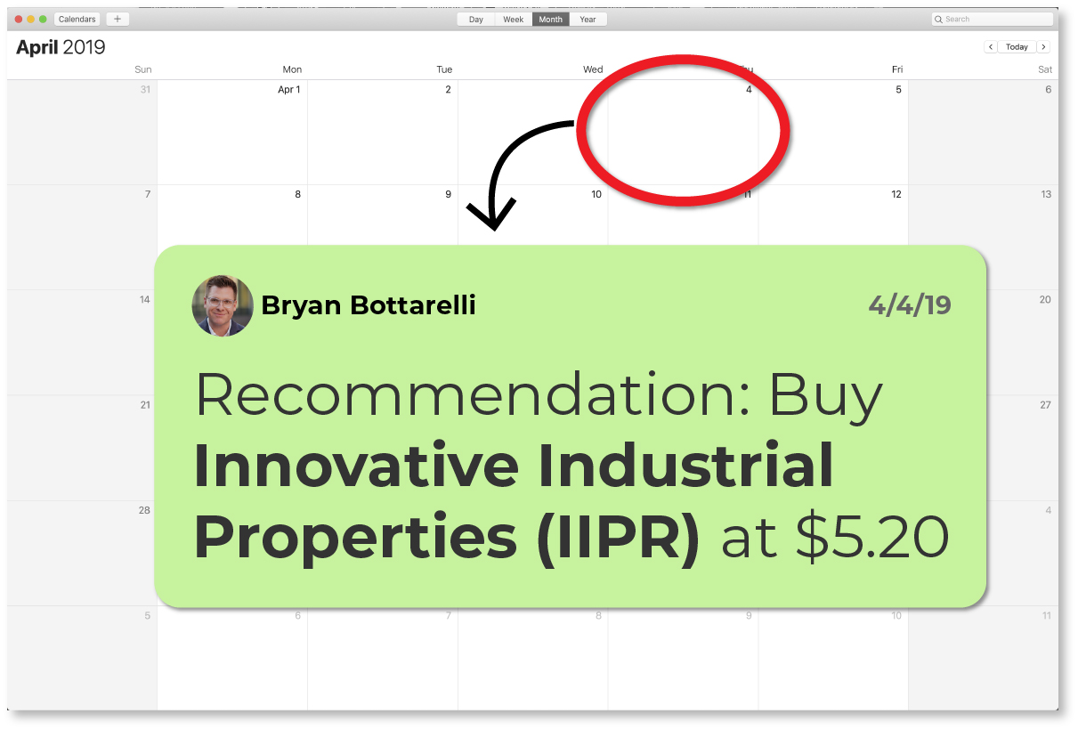
I recommended it at $5.20.
And a day later, we closed our trade with the stock at $9.40 for an 80.77% win in 24 hours.
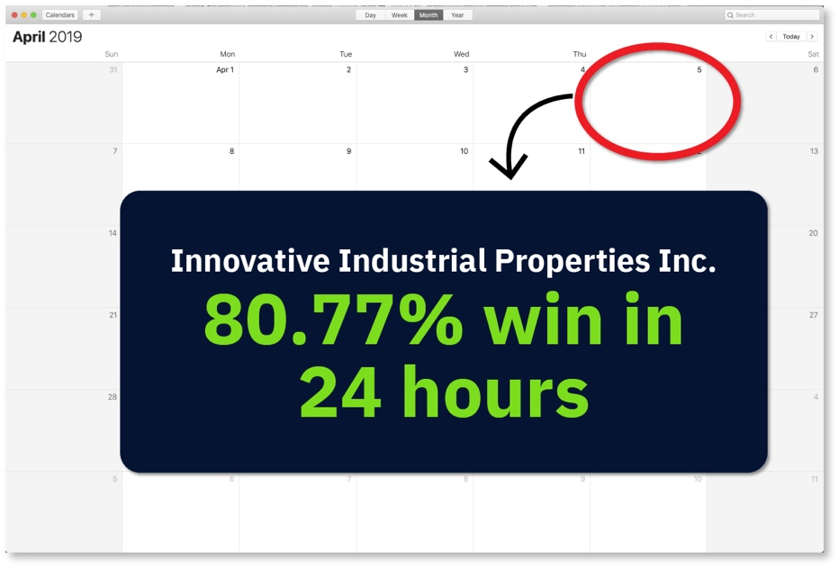
Everyone in The War Room went nuts.
Including me!
I was on cloud nine.
And the hits kept coming all month long.
On April 10, I told people to look at Lyft.
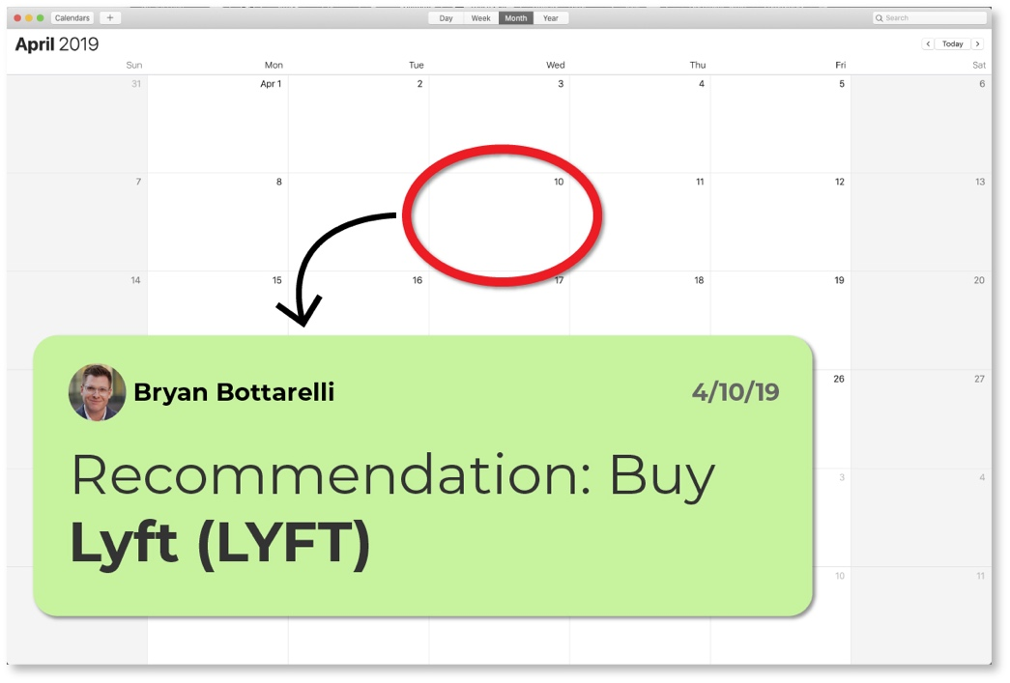
And just a few hours later, we closed out our trade for a 62% win.
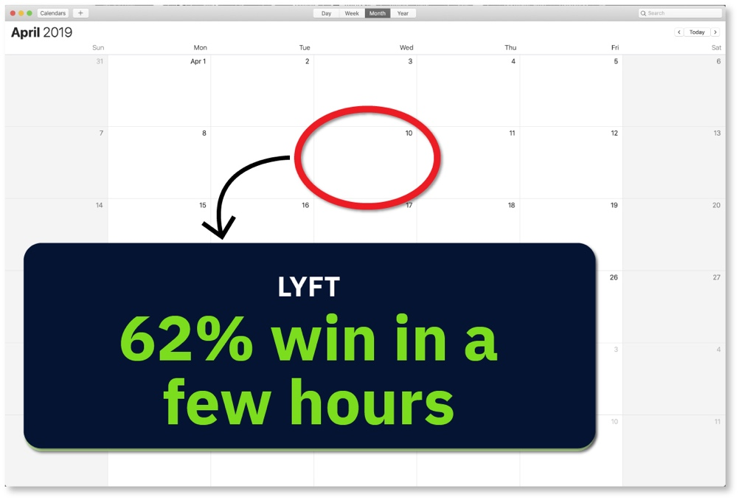
On April 15, we closed out a play on Twilio for a 27% gain in five days.
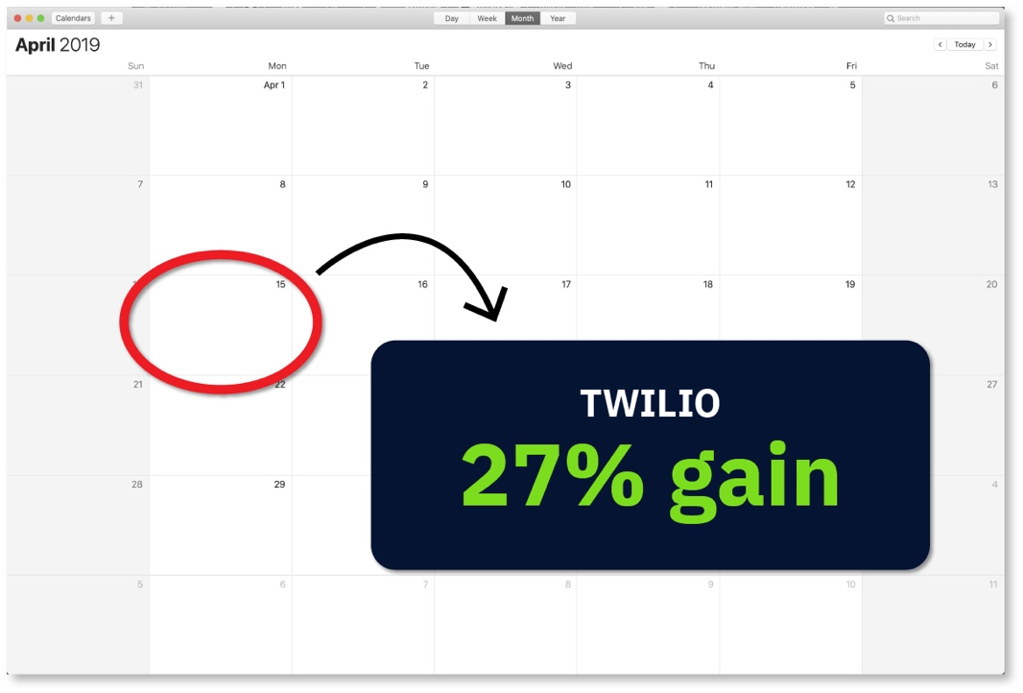
On April 17, we got out of Skechers for a 100% gain in 24 hours.
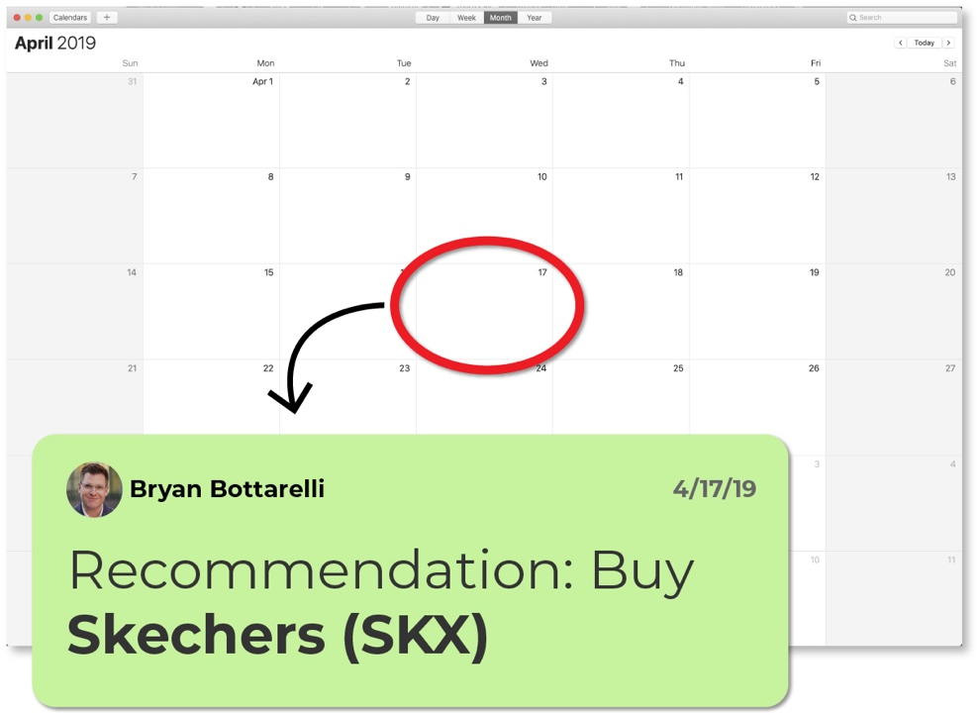
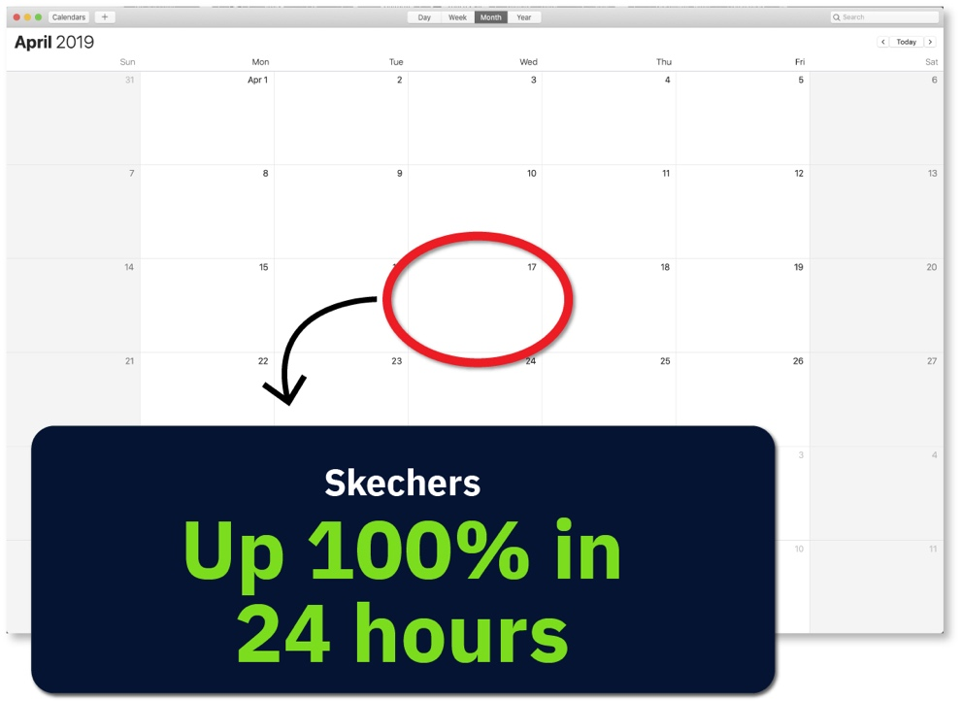
On April 23, we hit a 44% same-day gain on Restoration Hardware.
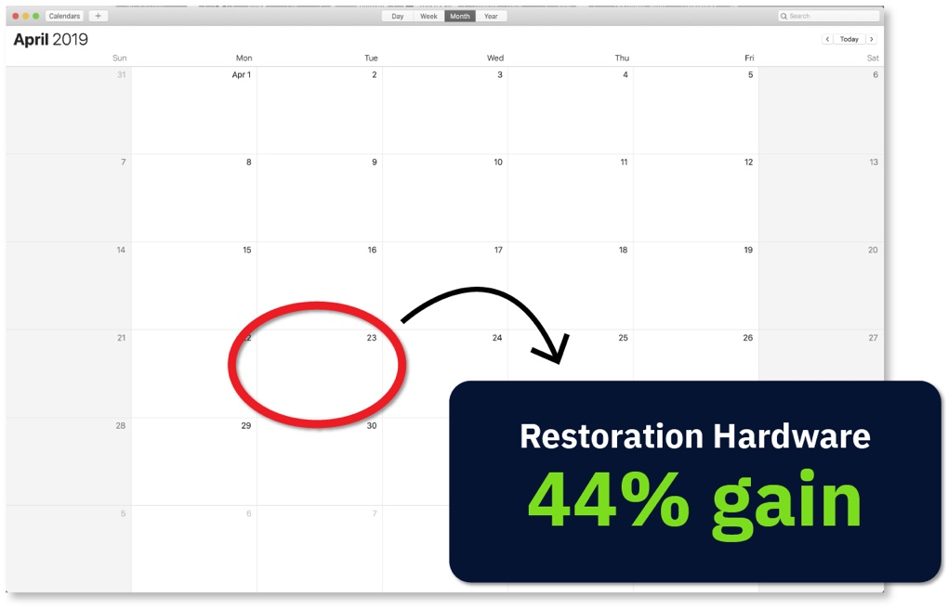
On April 25, we closed out five plays, including wins of 50% on Twitter and 100% on Microsoft, both in under a week.
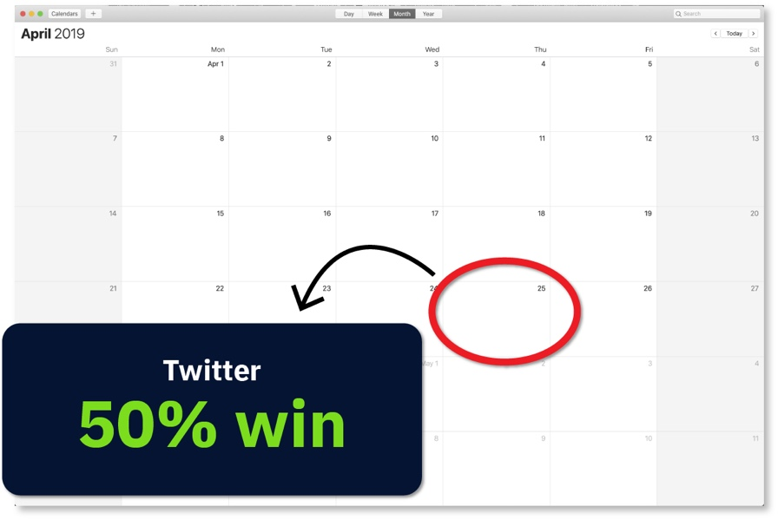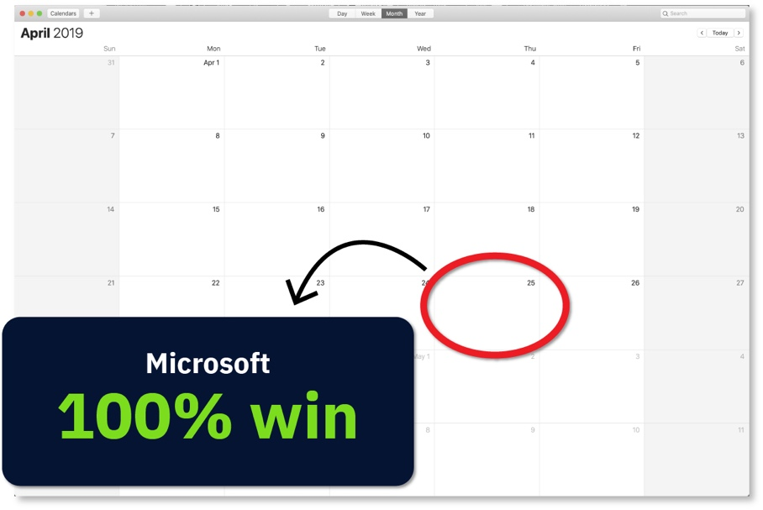
Here, let me just give you the entire list so you can see everything.
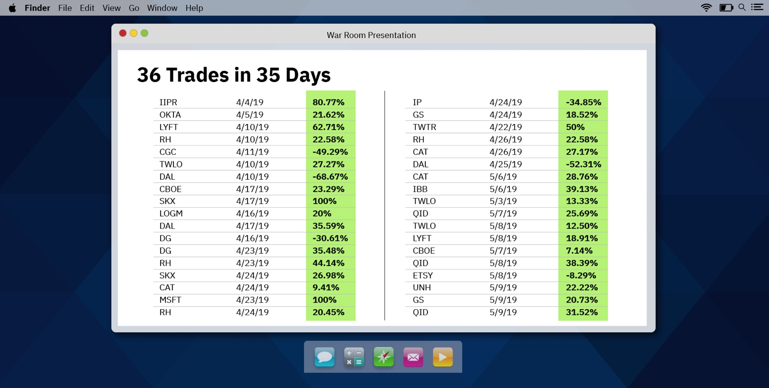

Now… if you’re wondering what these percentages mean in terms of cold hard cash, consider this…

If you had put $2,500 into every one of these trades, your profits over 36 days would have totaled $19,071.

$19,000 in basically a month… on only about one trade each day.

It took people only 10 to 15 minutes to follow these trades each day, but the results were extraordinary.

And this was just the beginning.

After our 2019 launch, we went on hot streak after hot streak after hot streak.

For example, we went on another hot streak at the end of July and into August.

Over 10 trading days, I recommended 17 trades.

15 were winners. And two were losers.

And the average gain was 44%.

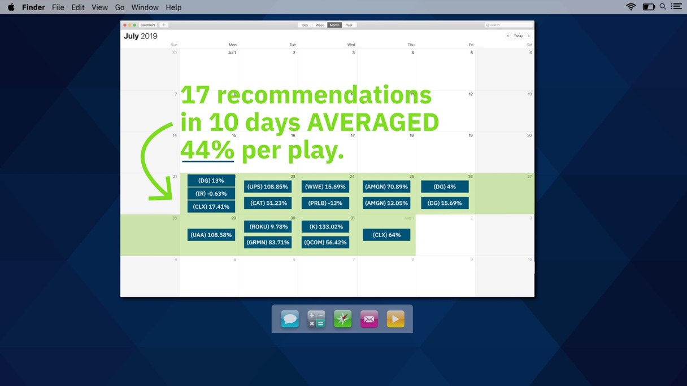

We had wins of 108% and 51% on July 23… wins of 70% and 12% on July 25… wins of 9% and 83% on July 30… and wins of 133% and 56% on July 31.

Almost all of these trades lasted less than a day.

It was like we had unlocked a cheat code for the stock market.

Consider this… Over this period, if you had just blindly put $2,500 into each of these 17 trades, you would have come away with $18,767 in profit in just 10 days.

And here’s what I love about this...

This is real money coming in the door.

When you’re trying to find the next Microsoft or Apple or Netflix or whatever… you’re looking to hold that stock for 10, 15, 20 years or more.

It’s all paper gains, not real cash you can spend now.

But that $18,000 you could have made in 10 days would have been real cash in your pocket. The trades were over. The money would have been yours to spend.

Of course, win streaks come and go. Sometimes you’re hot. And sometimes you take a few losses.

That’s one of the first lessons I always teach my students.

The truth is, 2019 was an incredible year for us and for the market in general.

But then something happened that nobody expected.

The COVID Crash.

We Were Blindsided by the Worst Market Crash in a Decade

The economy shut down.

Stocks tanked.

It was a total bloodbath.

The Dow dropped 10,000 points in just over a month!

Most investors went into total panic mode.

But as I’ve told you all day today… the system I use is specifically designed to help me make money no matter whether stocks go up or down.

The more the market moves… in either direction… the more money we make.

That makes market crashes some of the BEST times for us.

And the COVID Crash produced an absolute blockbuster month.

We made 66 trade recommendations that were opened and closed between February 24 and March 23, 2022.

64 were winners. That’s a 97% win rate.

For example, I recommended Clorox to all of my followers.

We had a guy named James who made $11,000 when his play jumped from $3.40 to $5.60 in about one day.

One of the amazing things was that our traders were learning so much that many of them were getting even bigger returns than our official closeouts!

A member named Brian posted on March 13, in the middle of a total market meltdown, “I had the best week ever trading with you all!”

Another trader, Adrien, was blown away.

He wrote...

“Had it not been for this room, I would be in the state of panic and heart attack. I’m relaxed and enjoying this ride with its up and downs.”

I recommended a play on Teladoc that led to a 340% gain for my student Jim on March 5. He made $4,019 on one trade, his best same-day gain ever… in the middle of a total market meltdown!

And I want to share this comment from Rick on March 27.

“The War Room has helped me really improve my financial well-being. This past week has been particularly amazing because in this crazy, unpredictable and baffling market, you have made real money for me. I would never have been able to do that for myself.”

I’ll leave you with one final story from the COVID Crash.

This one is about George, who I mentioned earlier.

He started with a good-sized account, $160,000.

But the trades he completed during the COVID Crash – many of which he found himself using our techniques – were so strong that he was able to grow his account to a peak of $2.3 million by the end.

That’s the power of this type of trading.

So listen, guys… I want you to sit back and think about some of those mental blocks I talked about earlier.

The idea that you can’t beat Wall Street... that you deserve returns of only 8% per year... is just outright wrong.

It’s holding you back.

The stock market is not a casino.

It’s one of the greatest friends you can ever have… if you learn how to embrace it.

George, Rick, Brian, Adrien, James… and the 19,000 other people who have joined The War Room are living proof that you can do better if you have the right guidance.

Again, since we opened The War Room in 2019… we’ve made 2,112 trades.

1,621 have been winners… for a win rate of 76.8%.

We’ve beaten every major market index during that time.

Our results speak for themselves.

And guys, I have one confession to make.

It’s about to get EVEN BETTER.

I’ve walked you through everything we’ve built so far.

But just recently, we took another leap forward.

You see, with the launch of my 5-Stock Method, I’m about to make it even easier for you to use stock flips to get the chance to lock in wins day after day after day.

Essentially, I’ve built a way for you to use my strategy on your own… with help from software I’ve built to identify the very same patterns I look for in my trading.

This is the 5-Stock Method.

And here’s how it works.
The Strategy Behind the 5-Stock Method

I mentioned earlier that I figured out a way to help predict when stocks would flip and change directions.

And this secret is the single most important element of my trading success.

The 5-Stock Method is possible only because of this flip strategy.

So here’s how I figured this out.

Back when I was in the trading pits, I noticed a trend that has to do with human psychology.

The pit has two primary groups of people...

Buyers and sellers.

And they are in battles all day long trying to determine the price of stocks.

When buyers are winning, stock prices go up.

And when sellers are winning, stock prices go down.

Pretty simple.

But here’s what I figured out...

These battles would play out in familiar patterns every day.

So let’s say the sellers mounted an attack.

They’d all start to pile in and drive the price of a stock down.

The buyers, of course, didn’t like this. They’d fight back and drive the price back upward.

But then the sellers would try again.

They’d attack once more and try to drive the price of the stock lower.

Then the buyers would rally again and push the price back up.

And that’s when something interesting would happen.

The sellers… after failing to drive the price lower twice… would give up the fight.

The buyers would win.

And the stock would flip from going down to going up.

So if I saw the sellers lose twice in a row… I would know that the stock was set to flip...

And that now was the time to buy because the sellers were going to quit and the buyers were going to take over.

Make a trade at that point, and you can make big money.

It was simple, but it worked.

And then I figured something else out.

I didn’t need to be in the pits to spot this pattern.

I could track this pattern in real time, on a live stock chart.

Here, let me show you.

What a Stock Flip Looks Like on a 3-Minute Chart

Pinterest is a great example.

On April 6, 2021, at 10 a.m., it was falling pretty fast.

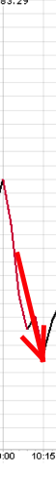

The sellers were attacking and winning.

But then the buyers fought back the first time.

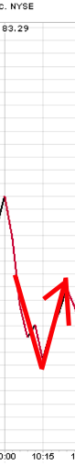

However, the sellers didn’t give up.

They rallied again and pushed the stock back down.

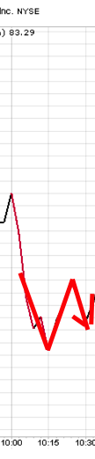

But once again, they weren’t able to beat the buyers, who pushed the stock up a second time.

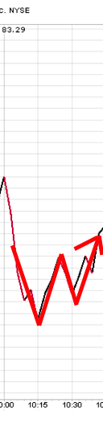

And this was the big moment.

It’s when what’s called a classic “W” pattern was formed.

Having been defeated twice, the sellers quit.

And the stock flipped from a downtrend to an uptrend.

From there, it went roaring higher.

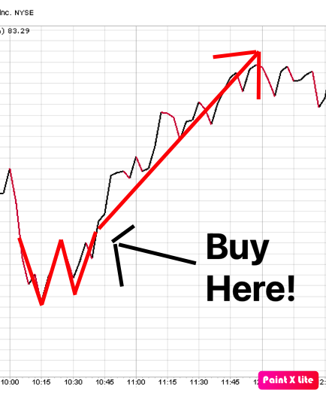

In this case, the “W” had formed by about 10:45 a.m… at which point I alerted my followers to buy it.

And by 11:33 a.m., it was already time to sell.

We had a guy, Tony, who made 20% in those 45 minutes.

Cire made 25%.

Charles collected 27%.

Now, I want to make one thing clear. These aren’t massive 10,000% gains like you might get if you find a company like Netflix and hold on to it for 15 years.

That’s not what this is.

This is about using the “W” pattern to spot when a stock will flip… and using the predictability of this pattern to capture consistent, small gains of 20% or so in less than a day… sometimes just hours or minutes.

For example, the day before the “W” pattern I just showed you appeared in Pinterest… another one appeared in Match Group.

At around 10 that morning, the sellers started attacking… driving the stock down fast.

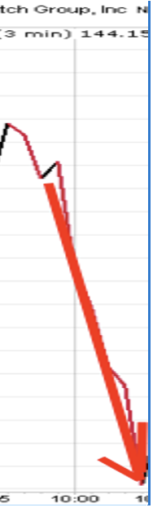

Then the buyers fought back.

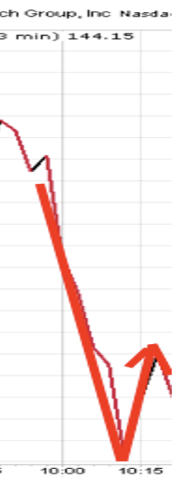

The sellers attacked again.

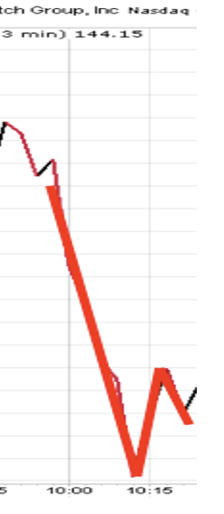

And then the buyers beat them back once more.

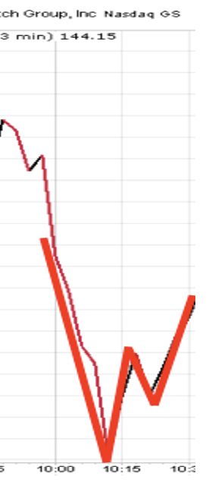

This is where the sellers quit.

The “W” formed.

The stock flipped.

And the buyers drove the stock much higher.

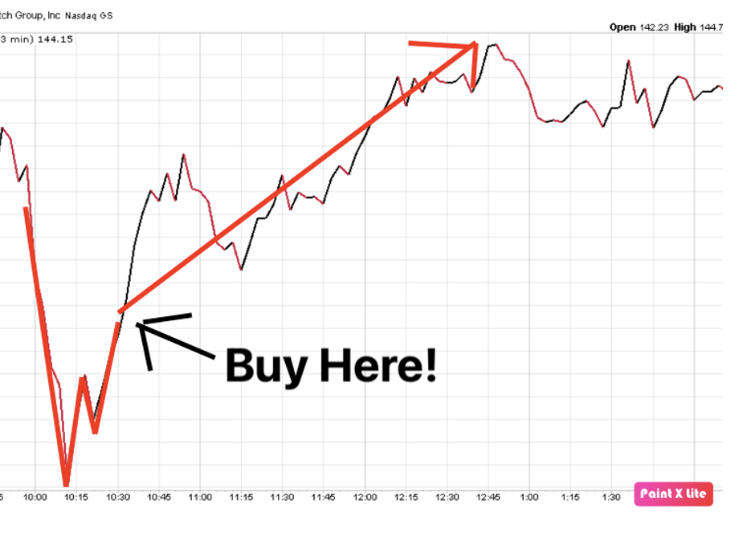

In this case, it led to a 27% gain in three hours for my student Jesse, who followed my instructions. That’s like getting three years’ worth of stock market gains in just three hours.

And as another of my followers, Michael, said... this led to a day’s pay for him on just one short trade.

And here’s the thing... these “W” patterns lead to stock flips all the time.

Here’s one in Moderna.

The “W” formed just after 1 p.m.

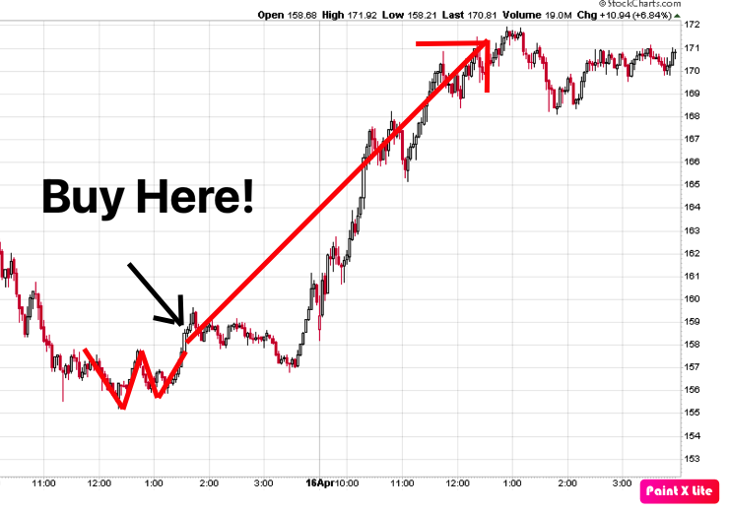

The stock had been in a downtrend, but the “W” indicated it was about to flip.

So I alerted all my followers in the live chat.

And over the next few hours, they saw even bigger gains than our official model portfolio!

Randy got in at $4.85 and out at $10.05 for a 107% gain.

And another student, Kenneth, topped that with 113%!

This is what’s possible when you see a stock is about to flip.

And what’s great is... it doesn’t matter whether Moderna goes up or down over the long term.

We don’t care whether it succeeds as a company.

All we’re talking about is making money on the predictable flips that happen as stocks swing up and down on a daily basis.

And these flips happen during bull markets, bear markets and even total market meltdowns. They happen ALL THE TIME.

And in all kinds of stocks too.

Here’s one in Caterpillar.

In the morning, the stock was in a downtrend.

But it formed a “W” at about 11:15 in the morning... and right away the stock flipped from down to up.

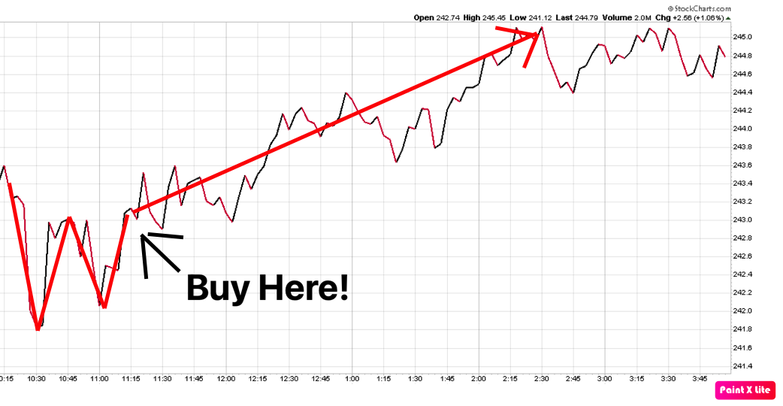
By 2:20, we had closed it out.

And my students had a chance at more than 20% in just three hours.

But sometimes the gains from a “W” can be even bigger.

Like this one we found by looking back at historical data of the best of the best “W” patterns on KE Holdings.

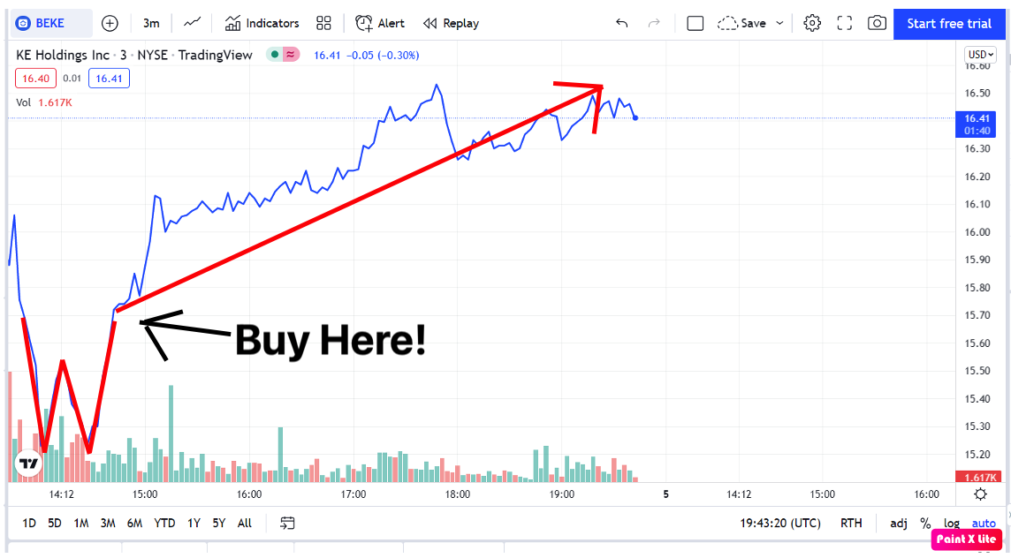

It’s a perfect example of what can happen if everything goes right.

You could have collected a rare 260% gain in just a few hours.

So listen, guys... the “W” pattern is how you know when a stock is likely to flip from a downtrend to an uptrend.

But how do you know when a stock is going to flip back from an uptrend to a downtrend?

Turn Those “W” Patterns Upside Down!

Well, all you have to do is turn the “W” upside down.

And what do you get?

An “M,” of course.

Here’s one in Coinbase.

You can see the stock was moving up.

The “M” forms as the sellers fight with the buyers.

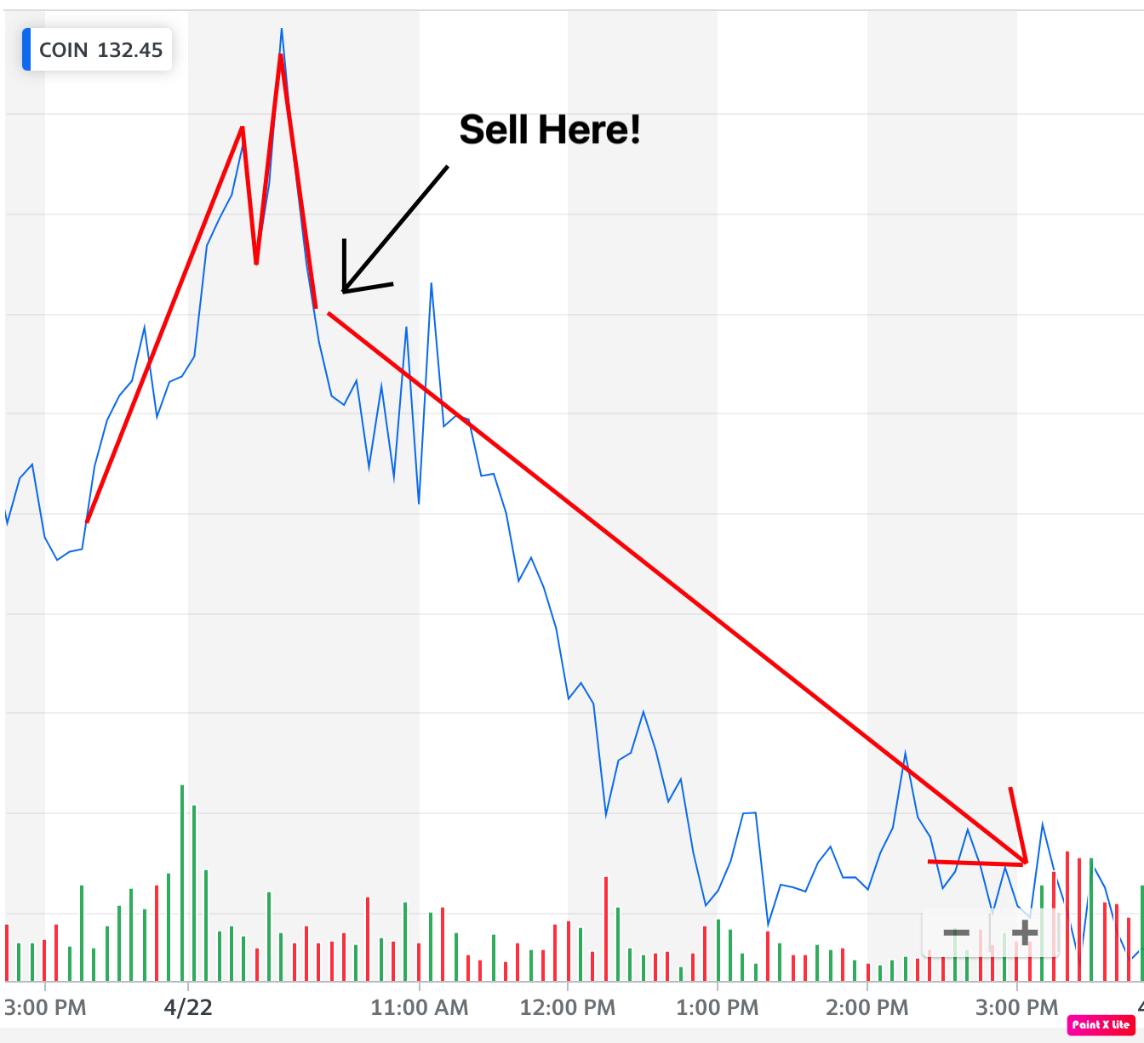

The stock immediately flips...

And starts heading downward.

Now, with an “M,” you have two options.

If you hold the stock, you can sell and get out.

Or you can make a downside trade to profit from it... which is what we do.

In the case of Coinbase, I recommended a downside trade after the “M” formed.

And in 48 minutes, we closed it out for a 22% win.

One of my students, Omar, made $5,000 on this trade.

Another, James, made almost $6,500.

That’s how much money these kinds of stock flips can produce.

And remember, it doesn’t matter what the stock does.

If it’s up a month from now... or down a year from now... that’s totally irrelevant.

We don’t care where the stock is going in the long term.

All we do is profit from these flips as the stock bounces up and down each day.

Here, let me show you another one.

This is Zoom on May 25 and May 26.

It was in a downtrend.

But a “W” forms at the end of the trading day on the 25th.

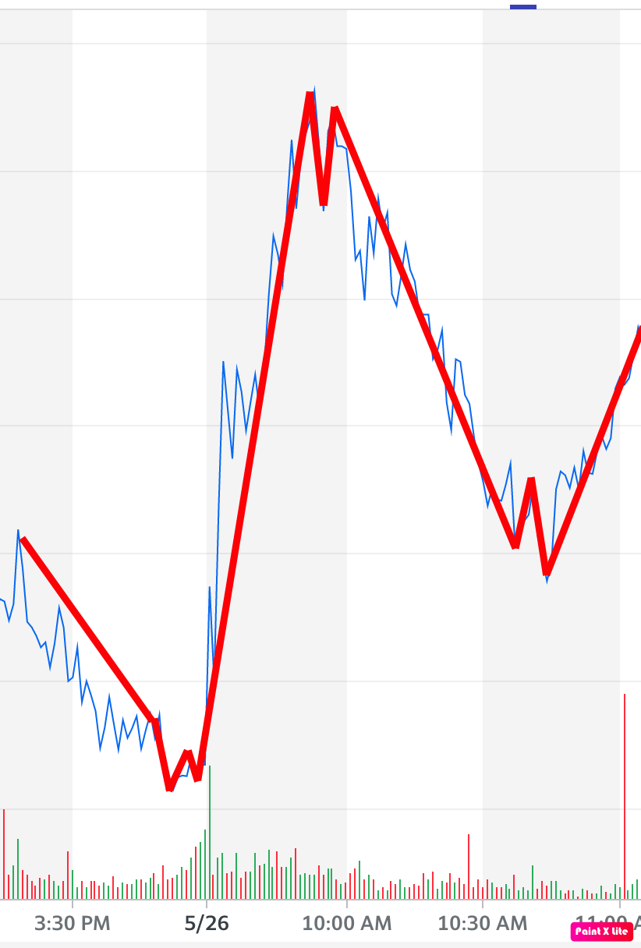

The stock immediately flips and starts moving up.

That’s a chance to profit.

But then, the “M” forms.

It flips again.

That’s another chance to profit.

After that, another “W” forms.

That’s a third chance to profit in just three hours of trading.

The stock itself hasn’t gone much of anywhere.

It’s bounced up and down, flipping back and forth.

But every flip is a chance to profit.

And it’s these flips that are the basis of my 5-Stock Method.

You see... after 20 years of doing this, I’ve reached a new breakthrough. I’ve now made it easier than ever for you to trade these flips on a daily basis.

And you can do it without ever actually having to find a single flip on your own.

Here’s how it works.

How I Built the 5-Stock Method

For years, I’ve helped people find “W” and “M” patterns so they can profit.

This took a lot of work on my end.

I would have dozens of stock charts up... searching out the “W” and “M” patterns myself.

I had to constantly scan stock charts by the minute. And then I would rush to instantly share the opportunity with my students.

It was exciting and fun.

But, boy, it was a lot of work. By the time the market closed, I was exhausted.

Now... it was worth it to see all the success my followers were having.

But I’ve recently been working on something to make it even easier... and potentially much more profitable.

In short, I’ve been building a software program called ProfitSight to detect these “W” and “M” patterns in any stocks, all by itself.

So with this software, here’s what you do.

First, you pick 5 stocks.

Any stocks will do, really... because, again, we don’t care whether they go up or down. But there are a few I’ve found to be very reliable.

And I can give you my 5 favorite stocks to use, the ones I consider to be the best for producing “W” and “M” patterns.

Or you can pick the 5 stocks you like most.

Or you can do both... Track my favorite stocks and yours as well.

But whichever ones you choose... You simply enter the 5 stocks into the ProfitSight service.

And from there, the software takes over.

The Easiest Way to Track Stock Flips

What it does is scan your stocks all day long when the markets are open.

It is programmed to identify the moment a stock flips... that is, when a “W” or “M” pattern appears.

Then it sends you an alert.

And you can use this to trade stock flips on your own.

Let me give you an example.

In March, we had ProfitSight start tracking DraftKings.

And on March 27 at about 1 p.m., it alerted us to exactly what we look for.

A perfect “W” pattern had formed.

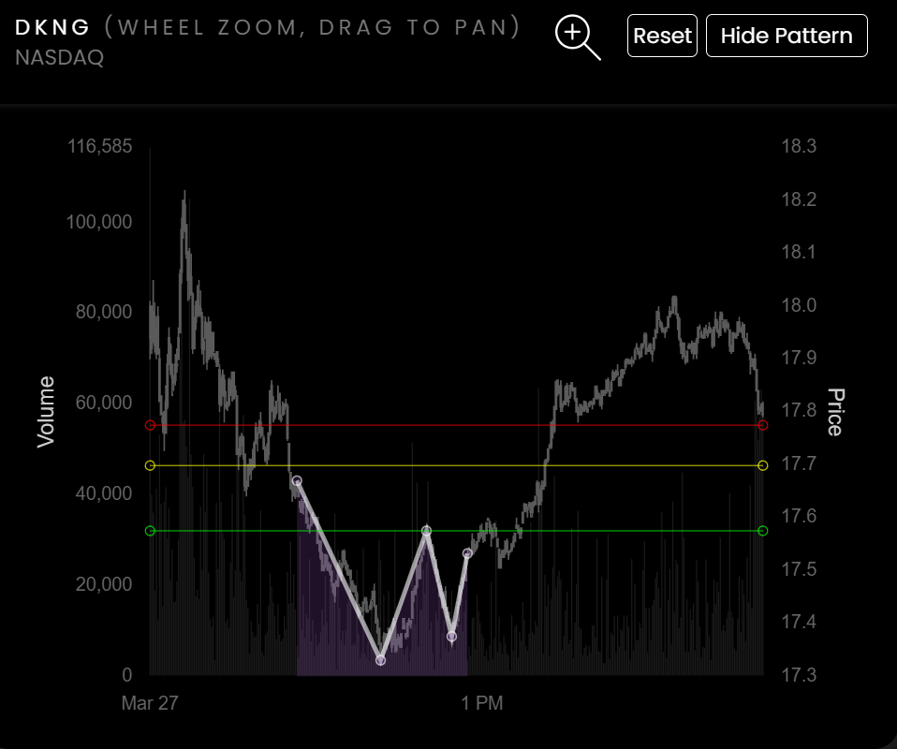

You can see that the stock was in a downtrend until that “W” formed.

But what happened next?

It flipped!

So in this case, if you had picked DraftKings as one of your stocks to track, ProfitSight would have alerted you the second the flip popped up.

And with the right play, you could have seen your money go up 34% in the next 45 minutes.

Here’s another real opportunity ProfitSight identified...

This time in Kohl’s.

Now, I have no idea if Kohl’s is a great stock to hold for the long term. But again, with ProfitSight, I don’t care.

I’m only looking to profit from its next flip.

And sure enough, ProfitSight identified when that would happen by alerting me to a “W” pattern.

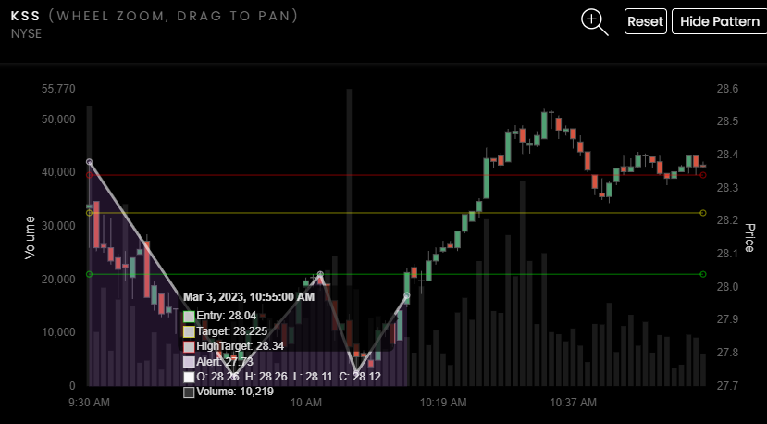

The stock was in a downtrend.

But after the “W,” it flipped and shot right back up.

On this one, you could have banked 50% in only nine minutes!

Nine minutes, people!

That’s how quickly your financial fortunes can change.

And “M” patterns work great too.

Here’s one in Snowflake.

The stock was headed up. But then an “M” formed.

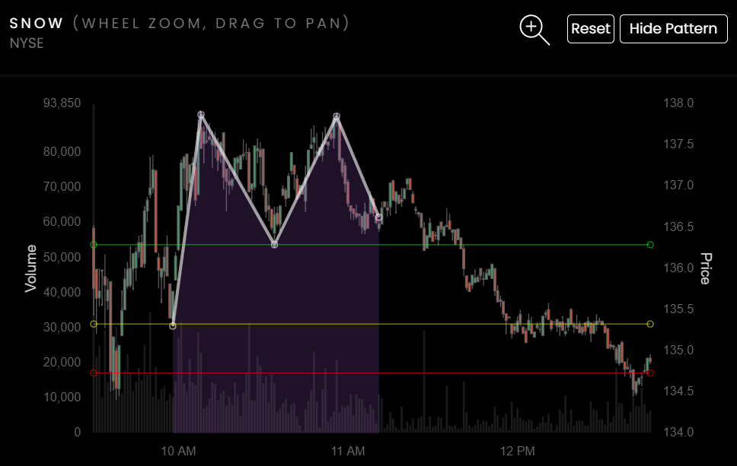

And in minutes, the stock flipped.

With the help of ProfitSight, you could have cashed out a 24% win in just over an hour.

Or how about this one in Tesla?

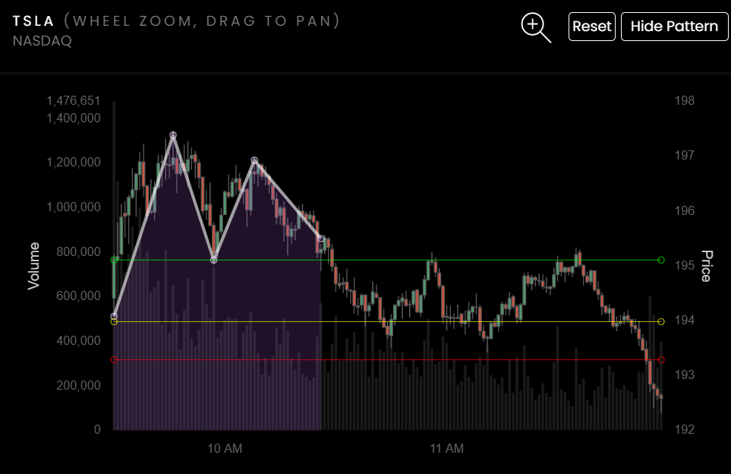

It’s the same story.

The stock was headed up when, at 10:24 a.m., it formed an “M” and flipped.

By 11:54 a.m., it was a 28% win.

Do you see how game-changing this is?

In a market like this, where finding winning stocks is so darn difficult, the ProfitSight software boils everything down to what you really need to know...

Which stocks are likely to flip and produce profits TODAY.

Not tomorrow.

Not a month from now.

Not next year.

And not over the next decade.

This is about finding new opportunities to profit every day.

And ProfitSight is changing people’s lives as we speak.

I know because I get the messages from these people every single day.

I have a Word document filled with these notes, and it just keeps growing.

It’s currently over 17,500 words... and it’s getting bigger every day.

Of course, everybody’s experience varies depending on how often they trade, what stocks they pick and other factors... but the sheer number of people writing us with positive stories is overwhelming.

What Real People Are Saying About ProfitSight

An example comes from one of our members who goes by Rick.

This guy messages me constantly, alerting me to his wins.

For example, he entered a trade on Rivian on December 30, just before the New Year’s holiday.

When the markets opened back up on January 3, he closed it for a 36% win.

Then he messaged me back the next day at 10 a.m. saying he had collected another win – this time for 41% in less than 24 hours on Fastly.

48 minutes later, he wrote back once more... this time with a 37.5% win on Bed Bath & Beyond.

ProfitSight alerted him to that one at 10:30 a.m. And he had already closed out that giant win by 10:44!

It took only 14 minutes.

And the hits kept coming for Rick.

At 3:49 that afternoon, he shared another win for 9% in just a few hours.

The next day he messaged with a win of 19% in about two hours... and a 20% win that took just eight minutes!

The day after that, it was another 24% in less than 24 hours!

This is what is so incredible about the ProfitSight software.

You simply enter the 5 stocks you want to follow. (In fact, you can do even more if you want the chance at more wins! 5 is just the number people start with.)

And then ProfitSight alerts you anytime one of your stocks flips.

It’s 100% automatic.

And 100% customizable based on the stocks you want to follow.

You don’t have to worry about trying to find the next big thing. You don’t have to guess whether tech is entering a bull or bear market.

We don’t care what the Fed does or what those fools in Washington are trying to pull.

Your goal with ProfitSight is to leave all that behind.

The wildest thing is... many people report their wins come in less than 24 hours!

We have one guy who goes by Doc... He started using ProfitSight at the beginning of the year.

Doc loves ProfitSight so much, he began teaching it to his own students as part of a finance class at Washington College!

In the first four months, he sent me 108 messages detailing his dozens of wins using ProfitSight.

March 8 was one of his best days.

He sent a message at 1:26 telling me that he was 6 for 6 that day alone.

“Have to LOVE this ProfitSight,” he wrote.

Then he sent another message at 2:47.

Now he was up to eight wins for the day!

I figured that he was done.

But nope... he wrote back again to our group at 3:04 after another 8% win. Here’s his message:

DOC S Lifetime Member 3/8/2023 at 3:04:44 pm
Thats 9 wins today and not one loss. If you are not subscribed to P$, I suggest you change your mind.

The most amazing thing is... Doc has these kinds of days pretty regularly.

On March 23, he reported six wins, including one that came in just 16 minutes!

On April 4, he let me know he got five alerts from ProfitSight and ALL FIVE turned into winners there too.

Or how about this: He cashed out a 197% win on April 28... all while recuperating over five days from eye surgery!

Now, 197% in five days is huge, but I want you to notice that these aren’t 10,000% gains here.

Most are modest gains.

We’re just collecting regular wins to grow our wealth... not shooting for the moon.

Remember, the people who try to be heroes and swing for the fences end up getting burned.

Instead, we are more than happy to rack up small wins very quickly.

I teach people that the best way to trade is to try to get a couple of small, quick wins each week. And that will really add up over time.

Consider this...

If you were able to increase your wealth by just 2% per week for an entire year...

Just 2%...

You’d end the year having nearly quadrupled your money.

And with ProfitSight, I believe you’ll certainly have the chance to beat 2% each week.

With that in mind, I’d like to invite you to try ProfitSight for yourself.

I’m Inviting You to Try Out ProfitSight Yourself

My goal with the ProfitSight software has always been very simple.

I want to take a lot of the guesswork out of stock picking.

Instead, I want you to be able to go about your life and let the software track your stocks and alert you when potential stock flips appear.

And that’s exactly what it does.

First you put in the 5 stocks you want to track.

Then you get an alert whenever a “W” or “M” appears in those stocks. When you get an alert, you check it out for yourself and decide if you want to make a trade.

You should always make sure to do your own due diligence on any opportunity. This is not an active trading system. It is an educational tool that tracks these “W” and “M” patterns.

How you trade those patterns is up to you.

And, as I’ll share with you in a moment, I’ve set up video demonstrations showing you how to use the software as well as instructions on how to make trades.

It’s the ultimate in simplicity.

In fact, you don’t even have to pick 5 stocks if you don’t want to.

New users get access to my own 5 favorite symbols, programmed in and ready to go the moment you start.

So when the software triggers, you’ll get an alert instantly telling you a “W” or “M” pattern has appeared.

And you just decide if the trade is right for you to take action.

For example, I have a student named Fred who asked the ProfitSight software to track Tesla for him.

On March 28, it told him that Tesla had just flipped.

He looked it over, made a trade, had a nice dinner and went to bed.

The following morning, he woke up and ProfitSight alerted him that the pattern had reversed.

So he got out of the trade.

And cashed in a 71% win in 24 hours.

Once you sign up today, you, too, can track Tesla or any other symbols you like, and ProfitSight will alert you immediately when a “W” or “M” signals the stock is likely to flip.

New ProfitSight users will get all 5 of my favorite symbols automatically programmed in.

PLUS, I’ll give you 5 more symbols of your own choice. So you can track all 10 of them.

From there, your only job is watching out for the alerts.

The software will track every symbol automatically whenever the markets are open.

It’s very easy to use.

And I have all the tools prepared to make sure you succeed.

Bonus #1: “7 Key Strategies to Make Winning Trades With ProfitSight”

For example, I’ve created a walkthrough showing you how to set up ProfitSight for maximum results.

It will show you how to set up alerts according to your preferences.

I don’t want anyone to feel like this is a distraction from their day-to-day life.

So if you prefer to just get one trade per day... just to keep it super simple... this guide will show you how to do that.

I also have a risk probability feature built in.

This way you can decide beforehand what kind of win rate you want to shoot for.

I’ll give you the settings that have helped me hit that 75% win rate, which I consider to be the sweet spot for maximizing gains and minimizing risk.

In the report, I’ll also show you my #1 pro technique for increasing your win rate.

So that’s the first bonus you’ll get.

My special report “7 Key Strategies to Make Winning Trades With ProfitSight.”

Second, I’m going to send you my special options video series.

Bonus #2: My Pro Options Video Series

I’m a big believer in using options to maximize your performance in the market.

And virtually every gain I’ve talked about today has been an options play.

That’s because options are the one way to collect substantial gains in a short period of time.

But listen... options in the wrong hands can be dangerous.

But that doesn’t mean options aren’t a great tool.

In fact, I believe options are crucial to beating the market.

And listen, we win on options at that 75% rate.

So we win on 3 out of every 4 trades.

That’s using options the right way...

Which is why I created a video series that teaches you all the best practices when it comes to using options.

This way, when ProfitSight alerts you to a “W” or “M” pattern, you’ll know exactly what to do.

I recommend going through the options video series first thing when you sign up today.

I think War Room member Mike C.’s experience is similar to what you’ll see.
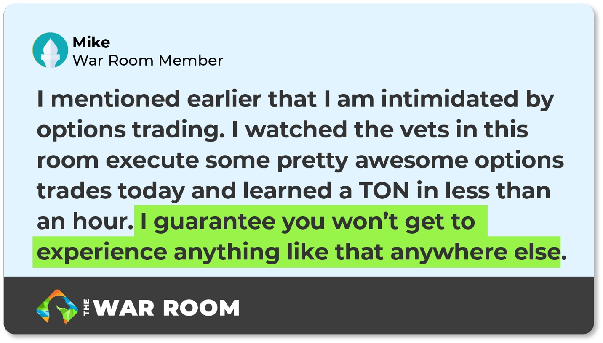
“I mentioned earlier that I am intimidated by options trading,” he posted. “I watched the vets in this room execute some pretty awesome options trades today and learned a TON in less than an hour. I guarantee you won’t get to experience anything like that anywhere else.”
Take a moment to watch my short video series on options, and I guarantee you’ll feel the same.

And I have one final bonus.

Bonus #3: My ProfitSight Video Walkthroughs

I’ve put together two video demonstrations walking you through how to set up ProfitSight.

In the videos, I’ll show you how I use it in simple terms.

It’s really very easy.

But it always pays to see somebody else do it right in front of you so you can see how it all works.

Not to mention, I have a concierge team available if you have any questions.

We want it to be as easy as possible so you can get ProfitSight looking for winning opportunities on your five stocks.

And from there, it’s off to the races.

It’s Time to Take a Whole New Approach to the Markets

When I first started working on the ProfitSight software, I had one goal in mind.

Make it easy enough that my dad could use it.

My dad is the type of guy who just wants to check his account each day and see that he’s made money.

He doesn’t want to have to learn any crazy techniques.

He doesn’t want to have to dig deep into annual reports or listen to every Fed meeting.

He doesn’t want to spend all day on the markets.

He just wants help knowing what trades to make, and he wants consistent results.

And that’s why I’m so excited to introduce you to ProfitSight today.

You pick which 5 stocks you want to follow.

The software will automatically start looking “W” and “M” patterns... and then it will alert you anytime one of your 5 stocks flips.

You just watch out for the alerts and act if you like the opportunity.

That’s it.

With this software... plus the trading strategy you’ll discover in my short training videos... you’ll have all the tools to get these kinds of consistent opportunities for yourself.

Look at somebody like “PerfectWave.”

That’s the screenname for one of our ProfitSight users.

He set ProfitSight to track Occidental Petroleum.

And on March 31, it signaled a flip.

He made the trade, and on Monday morning at the opening bell, it was already up 188%.

And he was $1,174 wealthier.

That’s the power of ProfitSight.

(Or “P$,” as my students have started calling it.)

I get messages every day from people celebrating their latest ProfitSight wins.

And nothing gives me more joy.

I want you to be the next person to start messaging me your daily wins.

To do that... you only have to do one thing.

How to Start Getting ProfitSight Alerts Tomorrow

I’ve created a special offer for new subscriptions to ProfitSight right now.

Normally, the base price is $XXXX.

But for today, the basic level is just $1,489 for an entire year.

That’s about $4 per day... less than most people spend on coffee.

And yet this $4 fee could change everything about your investing success.

At that starting price, you’ll get alerts when any of my 5 favorite symbols are about to flip.

Plus, you’ll get to choose 5 symbols of your own to track.

From there, you’ll be off and running.

ProfitSight will track everything...

I have ZERO doubt that your subscription could more than pay for itself very quickly.

In just the first three weeks using this amazing software... many members reported some incredible results.

Consider this note I received from GR in KC on November 29.

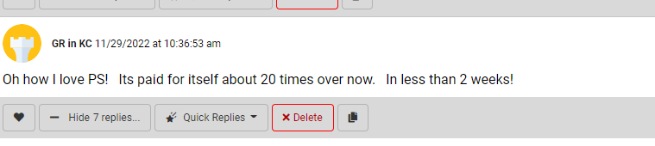

He had signed up just two weeks earlier. And in that short period, he paid off his subscription 20 times over.

He turned $12,500 into $37,758 during that time.

And GR is far from the only story we’ve seen like this.

Cindy nearly paid for her entire subscription with one trade:

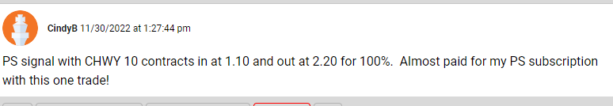

Don started with just paper trades to gain confidence. (Which I absolutely recommend.)

Then he went for it with real money and immediately cashed in four winners of 30%, 32%, 11% and another 30%.

“Love the software and have already paid for my lifetime membership in P$,” he wrote.

Last one, I promise.

We got this message from someone who goes by BoilerUp...
“I am on a cruise ship in the Bahamas,” he said. “I got a signal on ProfitSight last week to buy CRWD Puts. in $9.75 out $23.65 profit $6,943 142% gain. To borrow Bryans highly scientific term, this is frickin awesome.”
This is what ProfitSight is all about, folks.

Being able to live life to the fullest.

Go on a cruise.

Have fun.

And let ProfitSight do the work.

So if you’re ready to get a basic membership and start tracking just 5 stocks, click the button below to get started.

Or if you want to get a lifetime membership, you can do so at a heavy discount and save big bucks over time.

Whatever your choice, the goal is to just collect wins on a steady basis.

I know ProfitSight can help you do it, and I look forward to helping you along the way.

And if you do have anything holding you back, let me add just one more thing.

I’ll Give You 30 Days to Try It Out!

Let me make this very easy for you.

I know you want to try out ProfitSight.

You want to see how much cash it can help you add to your account. But maybe you’ve been burned in the past by those folks who claim to have an answer but don’t actually produce the results.

That can make anyone hesitate.

Which is why we decided to give people 30 days to try this thing out firsthand.

So go ahead and click the button below to get started with ProfitSight.

And if it doesn’t meet your expectations over the next 30 days, simply call us up for a refund (minus our $200 processing fee that we have to charge to keep the bots out).

You put your faith in me, and I promise to do everything in my power to deliver.

Again, just click the button below to get started.

Or call 888.215.5311 to talk to my team directly or ask any questions.

Guys, ProfitSight is the breakthrough of my lifetime. It’s the single best thing I’ve done in my 25-year career.

I hope it can help you going forward.

And as I close today, I want to add just one last story.

It comes from ProfitSight subscriber Rick.

Rick has completed 39 winners so far, with his biggest being 247% in just under two days.

He reports that in 30 days alone, he doubled the amount he paid for a LIFETIME membership in ProfitSight.

That’s how big this could be.

So again, click the button below and you’ll be ready to start getting your ProfitSight alerts first thing tomorrow.

I wish you the best.

And I want to congratulate you on taking the time to improve your life by learning something new today.

I look forward to hearing your success story next.

Bryan

May 2023

