Ex-Chicago Exchange Trader Blows the Whistle on Wall Street’s Best Kept Secret:

Overnight Trades

How My Members Made One Simple Trade... Went to Sleep... And DOUBLED Their Money (or MORE) When They Woke Up
Dale A. (9:35 a.m.)
In at $3.45, out at $17.10 = 396%.

Robert D. (10:41 a.m.)
In at $3.40, out this a.m. for $7.80... Made $11,520.

James C. (9:49 a.m.)
Bought Clorox at $3.40, sold at $5.60 and netted $11,000.

Ronald G. (10:20 a.m.)
Made 141% on FedEx and 508% on REAL.

Hi. Pro Trader Bryan Bottarelli here. Look, I know your time is valuable.
So I want you to watch this video only if you’re interested in a completely new way of making fast money.
It’s a simple method my members have used to make STUNNING returns... OVERNIGHT.
Step 1: My members made one simple five-minute trade before 4 p.m.
Step 2: They went to sleep.
Step 3: They then doubled their money (or more)... when they woke up the very next day.
I call these “Overnight Trades.”
These aren’t like the usual stocks that you buy and sell every day.
Instead, they’re trades that have made money even after the markets are closed.
For example, AutoNation was primed for an Overnight Trade on February 10, 2020.
So I sent a quick alert to my readers.
All they had to do was make one simple five-minute trade any time before the closing bell at 4 p.m., and then they could do whatever they wanted.
Bryan Bottarelli
Recommendation: Make your Overnight Trade on AutoNation (AN) before closing bell at 4:00 p.m.!
Maybe they went and played a game of tennis or had a nice evening with their spouse.
Perhaps they spent some time with their grandkids.
Bottom line, thanks to this Overnight Trade, my readers could go to bed, sleep soundly...
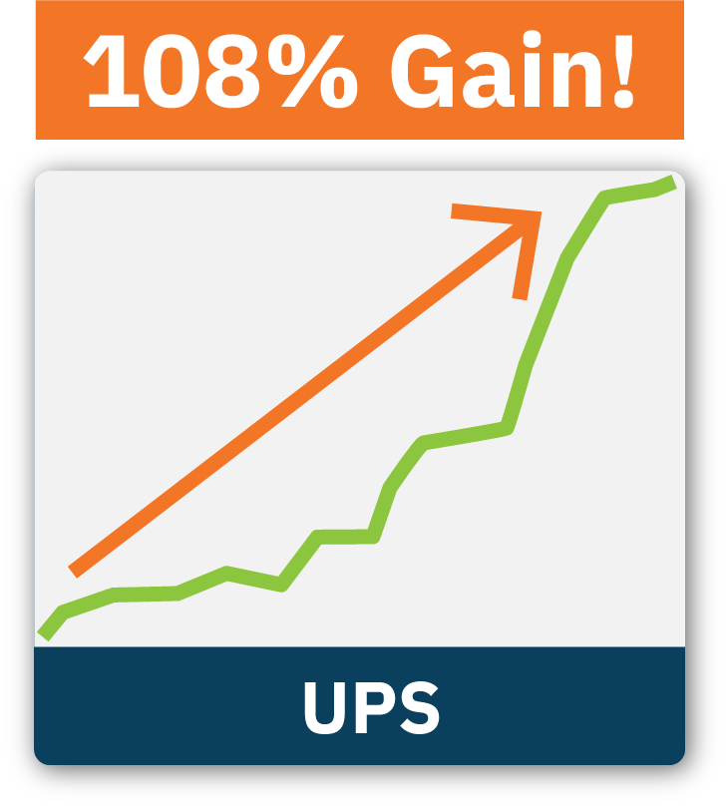
And when the market opened on the morning of February 11, that AutoNation trade was instantly up 101%.
Yeah, you heard me right.
People doubled their money overnight on one of the least exciting stocks in the universe.
A freaking auto parts company made them more money in one day than some overly risky penny stock.
Insane. And it wasn’t just AutoNation.
Abercrombie & Fitch on May 28, 2019, was another great example of an Overnight Trade.
I know, some brick-and-mortar teen retailer. Yawn, right?
Not so boring when you could have made one trade just before the closing bell, gone to sleep, and woken up 121% richer at the opening bell.
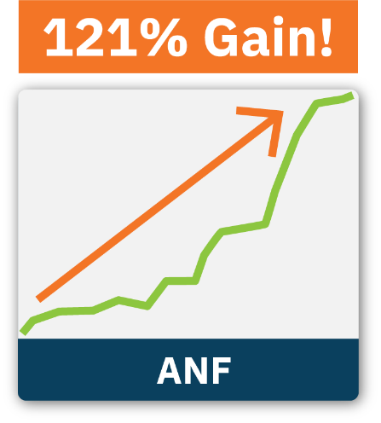

That’s not all. How about Yum! Brands?
Sure. It has popular places like KFC, WingStreet or even Taco Bell, but not even the exclamation point in its name can cover the fact that there’s no bigger snooze-fest than fast food companies.
Yet you could have made one trade before the closing bell, gone to sleep, and woken up the next morning 178% richer.
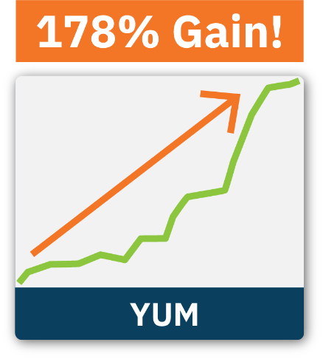
You don’t have to risk your money on a flash-in-the-pan pot stock, some super risky cryptocurrency or even an IPO that’s off-limits to regular investors.
You could have almost tripled your money overnight on a stinking fast food play. That’s right.
Regular people just like you are locking in these types of returns that would make most hedge fund managers jealous. It’s all thanks to these amazing Overnight Trades.
Just look. I showed my readers an Overnight Trade on Beyond Meat.

Fred reported that he actually tripled his money!

209% and still going! – Fred, War Room Member

Ralph got in on an Overnight Trade on FedEx.
He made 338% by 9:36 a.m.
He wrote me:

I think I’m becoming a morning person. Thank you. – Ralph, War Room Member

It’s just amazing.

Most investors don’t make these kinds of returns for years...
But thanks to some of our top Overnight Trades, our members have doubled their money as soon as they woke up!
It’s the closest thing I can think of to making money while you sleep.
I mean, just look at Ralph... He woke up to more than $3,300!
WING in yesterday at $0.45... out today at $3.36. – Ralph 6/19/2020 at 9:54 a.m.
That’s a 646% gain...
Before 10 a.m.!
That is a great way to start your day.
Ralph isn’t alone.
Michael locked in more than $5,000... in the first eight minutes of his day!
Rolled the dice on this one last night... In at $3.19, out at $6.76! Made $5,700 eight minutes into the trading day. Might cut out at lunch for golf today. – Michael K. 5/7/2020 at 9:39 a.m.
He did so well... he was going to take off and play golf!
That’s the life!
And look at what Bruce posted:
Bruce, War Room Member
$6,440.00 net profit [95% in one day] while listening to live reggae on a cruise ship with a wee dram in hand! Thanks, Bryan.
That’s right. Thanks to Overnight Trades, Bruce was able to make more than six grand on a cruise.
Life is good when you’re an Overnight Trader.

It all starts by getting the very best Overnight Trade opportunities, like FedEx, directly from me...
Every single day.

FedEx Could Have 5X’ed Your Money Overnight
To me, FedEx was one of the classic Overnight Trades.
September 2019 had all kinds of headlines about the trade war with China and tariffs.
There’s craziness going on every day in the markets, but thanks to Overnight Trades, none of it matters.
You can make money when the economy soars and when the economy is in free fall.
Thanks to my proven screening system, which I’ll show you in a second.
On September 17, I knew FedEx was right for an Overnight Trade.
I sent out a few quick sentences to tell my members exactly why and how to make a five-minute trade.
Bryan Bottarelli
Recommendation: FedEx (FDX) is ripe for an Overnight Trade. This is what you have to do...
As long as members got in before the 4 p.m. closing bell, they could do whatever they wanted with the rest of their day...
Go to happy hour, hit the gym, have dinner with their friends.
Honestly, when you use Overnight Trades, the rest of the day is completely open.
You make a simple five-minute trade before 4 p.m., then live your life.
Go to bed, sleep soundly.
Then wake up and collect any money that might be waiting for you.
That’s exactly what we did with FedEx the very next morning.
I remember I had just woken up, probably had a cup of coffee, maybe read the paper, then logged in to The War Room.
That’s when members got my alert, on September 18, right before the opening bell at 9:30.
I told them to go ahead and ring the register.
Bryan Bottarelli
Recommendation: Sell FedEx (FDX)
All they had to do was wake up and brag about all the money they had made. Our official gain was 188% overnight.
And many did even better...

War Room member Hall posted this one:
Hall, War Room Member
In FedEx at $4.13, out at $21.00. I’ll need a calculator to figure out these profits. Boom! Thanks to Bryan and the great folks in The War Room.
Hey, Hall. I have a calculator. You just made more than 400%. Nice job.
Likewise, Dale made a nice 396% and chimed in.
He said:
Dale, War Room Member
In FedEx at $3.45 out at $17.10 = 396% – Thanks BB and all the WR chatter.
By 9:35 a.m., he’d made 5X his money. But nothing beats Mark’s post...
Mark D., War Room Member
Amazing trade for FedEx. Made enough to pay for my daughter’s car!
I mean, if you’re judging a post purely on its ability to grab attention, Mark’s wins, hands down.
I guess his daughter won, too. I hope she enjoys her new car.
I wonder if she’ll put “FedEx” on the license plate.
Anyway, that morning, after members had collected their cash, we kept getting post after post from members with big wins, like Mark P.
He locked in more than $10,000.
Mark P., War Room Member
Bryan and Karim, HUGE THANK YOU for the FDX trade! Just bagged $10,350!
Robert D. is doing even better.
He made more than $11,000 on FedEx.
Robert D., War Room Member
FedEx was good for me... Bought at $3.40... out of them this a.m. for $7.80... made $11,520!
The wins just kept rolling in that morning.
Here are just a few more:
Mark P., War Room Member
That was me at $17. I was quick on the trigger... I’ll take 300% any time.
Wilson, War Room Member
Awesome Trade results... FedEx in at $ 2.56 and out at $ 13.42... generated 423%... sweet.
William B., War Room Member
THANKS! First week in and my first big winner!
Mike W., War Room Member
Thanks so much. Netted over $2,300!
And on and on...
So keep in mind...
FedEx was a REAL trade that REAL people used to make REAL money.
In fact, every single trade you’ll see today is a trade I actually recommended to my readers.
Are all my trades winners? Do they all double overnight?
You know better than that.
Nothing is guaranteed in investing.
So, there’s no way I can guarantee you’ll see the same results as these top success stories I’m highlighting today.

I’m just showing you that this isn’t theory.
I’m not giving you hypothetical examples of what my system could have produced looking back at the past.
I’m showing you REAL examples to prove this is the REAL DEAL.

And there’s no denying the success we’ve already had...
Snap Makes Members 292% OVERNIGHT
Back on July 23... Snap made an $8.5 billion move in just one day.
Most people were sitting on the sidelines...
Or worse... they were trying to get in AFTER the big move.
Not my members...
They got in the day BEFORE...
I alerted them to get in on the 22nd.
{Image: July 22, 2021 Buy Alert: Get in Snapchat}
There was no hurry... They didn’t have to worry about missing the action.
All they had to do was get in before 4 p.m...
Relax...
Have dinner...
And go to sleep.
Then... the next morning...
They locked in 292% gains OVERNIGHT.
The posts started rolling in...
In at $3.90 out at $12.45 – 219% gain on an overnight play. Absolutely awesome Bryan. Thx – Mike M.
242%... It may be a monster, but you’re a master! – Kathleen H.
I like to play it safe. A solid 259% gain is enough for me. When I get greedy I lose. – Chad P
Whoo!! For SNAP in at $3.80 out at $14.47 – Eronmonsele O
I closed the 1 Shares/Contracts I opened at $3.95 for $15.60 for a nice overnight winner of 294.9%. THX BB!!! – Tad
out at 14.00. 250% winner on 2 contracts. – AG
In SNAP at $3.90 out at $15.00! What an overnight trade! Thank you Bryan!!!!! – David B
And Mohammed made more than $3,600 OVERNIGHT on that one trade!
Ring....ring...wait a minute...yep it’s a monster, need two hands to collect! Got in $3.80 and out at $15.84 with a 317% winner!! Thank you very much Bryan!!
But that’s not all...
We can even make huge gains when the market is freaking out – like during COVID-19!

Members Quadrupled Their Money With a Retailer Even During COVID-19!
Urban Outfitters is a great example.
Back in August 2020, Wall Street was buzzing about how COVID-19 would impact retail sales.
I knew this was a perfect Overnight Trade opportunity.
After doing some market analysis, all I had to do was type in a quick explanation and a few simple instructions in The War Room and hit enter.
Instantly, my readers knew exactly why and how to make their five-minute Overnight Trade.
Once again, all they had to do was get it in by 4 p.m. and then do whatever they wanted for the rest of the day.
The next morning, our official gain was a monster 150% winner...
The posts just started pouring in...
Peter started the day with a $5,600 profit...
Thanks, Bryan - starting the day with $5,625 profit!! – Peter K. (8/26/2020 at 9:33 a.m.)
Daniel locked in his first major winner with his Overnight Double:
URBN Great pick Bryan! This is my first major winner! In at $2.35... sold at $5.00 this morning. – Daniel M. (8/26/2020 at 9:33 a.m.)
Steve made a nice $2,600 overnight:
URBN: In at $2.02 and sold at $4.55. 125% gain for a total profit of $2,600. – Steve (8/26/2020 at 9:42 a.m.)

And Stan quadrupled his money!
I got LUCKY! In at $0.95, out at $4.45. GREAT trade, Bryan. 336.6% gain after fees. – Stan (8/26/2020 at 9:38 a.m.)
Now, these are some of the best testimonials we received, and many of these readers made more than our official gains.
I could go on and on about all the winning posts we get...
Today, I’m going to show you exactly how these Overnight Trades work.
You’ll hear about the $2 million breakthrough from May 2019...
And how it helped me deliver LIVE Overnight Trade recommendations to my members...

But by now, I’m sure you’re wondering...

Why Haven’t I Heard of These Overnight Trades Before?
Well, it’s actually quite simple.
You see, I would have never discovered this amazing kind of trade myself, but almost 20 years ago, I got lucky.
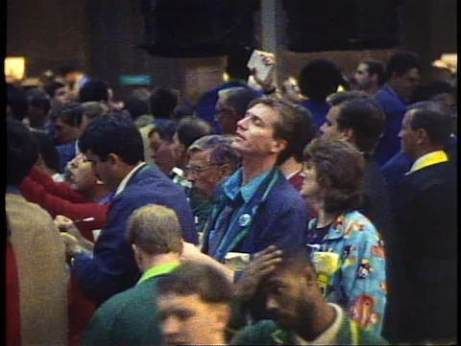
It was back in 2001. I had landed a job where I learned how to trade in the live pit of the Chicago Board Options Exchange.
Back then, I was trading in the Apple computer pit.
Every day, I personally saw $786 million trade back and forth.
In the sweat-filled floor of the live exchange, I noticed something that would change the way I traded forever.
You see, certain days would change everything in the pit.
So, for example, AT&T back in the early 2000s was a mind-numbingly boring pit.
Usually, nothing happened. But on a certain day, the pit would go from three guys playing crossword puzzles all day to a beehive of trading activity.
People would be pushing and shoving their way to get into that pit, fighting for a spot, desperate to get their orders filled. It was insane.
The most boring pit on Earth would instantly change into the most exciting spot in the whole CBOE.
The money that traders made that day on those boring companies was just as insane.
So that’s when I realized that when you see these feeding frenzies coming, you can get in the day before and lock in your gains when Wall Street starts going insane the very next day.
You don’t have to buy and hold and pray.
You don’t have to be in a play for months or years to make these types of returns.
The big money is made in just a few days of trading.
You just need to know when these magic days happen.
And you can make big gains OVERNIGHT.
All you need to look for is the moment the flurry of profits begins.
Let me show you what I’m talking about.

To get you to understand these Overnight Trades, I have to let you in on a huge Wall Street secret.
When the markets close at 4 p.m., Wall Street doesn’t just pack up and go home.
It keeps trading. It puts in billions of dollars of trades overnight.
When the opening bell rings the next day, the money comes rushing in seemingly out of nowhere.
Now, you don’t need to get in a trade after hours or stay up late to get in these Overnight Trades, because if you recognize the setup, you can simply place your trade the day before.
Then you just sit back, sleep soundly while Wall Street pushes up the price overnight, and when the opening bell rings, you can lock in huge profits.
That’s exactly what I showed my readers how to do in July 2019.
I alerted a small group of readers to an Overnight Trade in UPS.
Here, take a look.
On a typical day, there’s about $413 million trading back and forth on UPS.
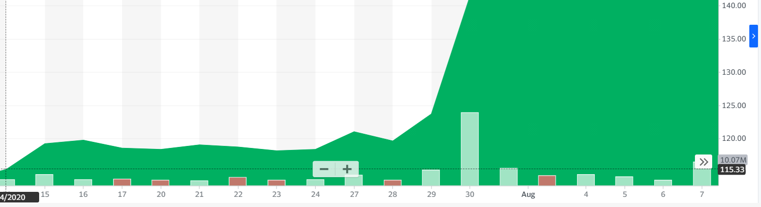
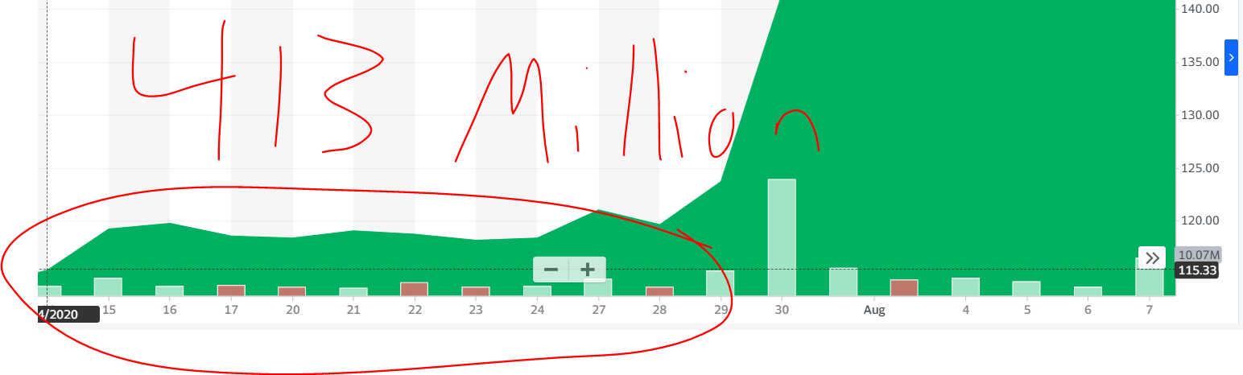

But on July 29, before the closing bell rang, I saw that Wall Street was likely to start its overnight frenzy.
And that’s exactly what happened.
All the cash was building up overnight, ready to blow the stock up first thing in the morning.
You could see the change the next day on the 30th...
A $4.2 billion surge of money.
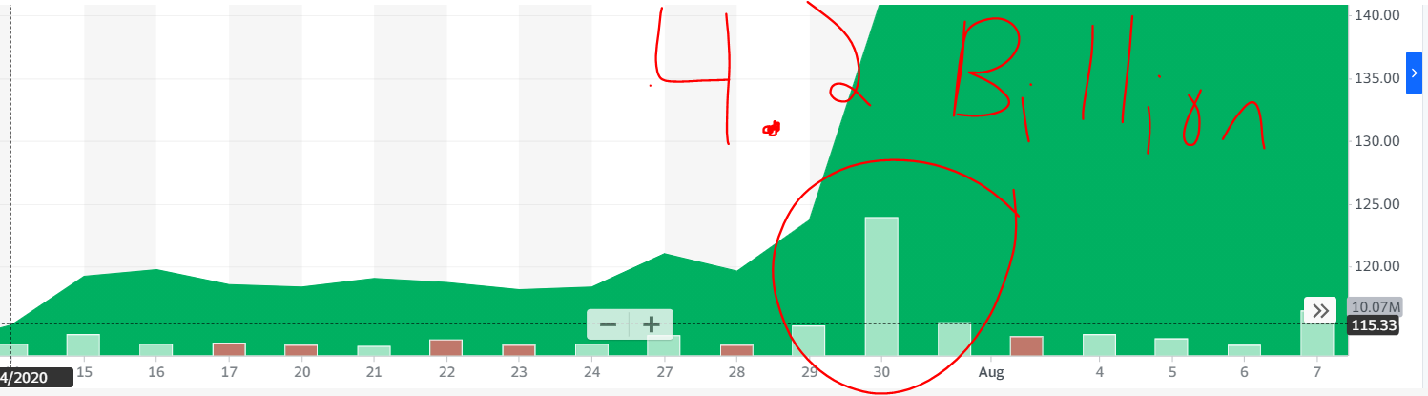

Now, look.
I told my readers the day before to make their simple five-minute trade before 4 p.m.
Here’s when my members got in.
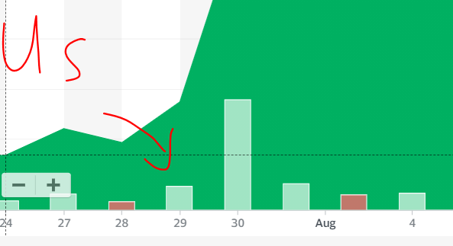
After the opening bell on the 30th, here’s where everyone else was getting in.
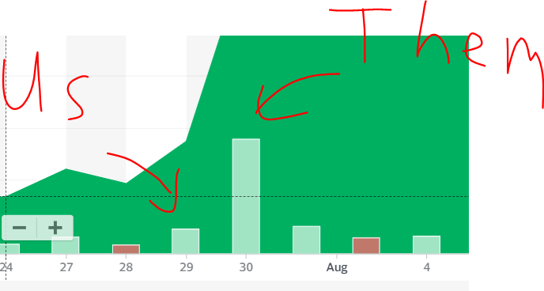

My guys didn’t have to fight their way in after the opening bell.
Instead, my readers were exiting the trade when everyone else was trying to clamber their way in.
Right after the opening bell on the 30th, we locked in a huge 120% profit.
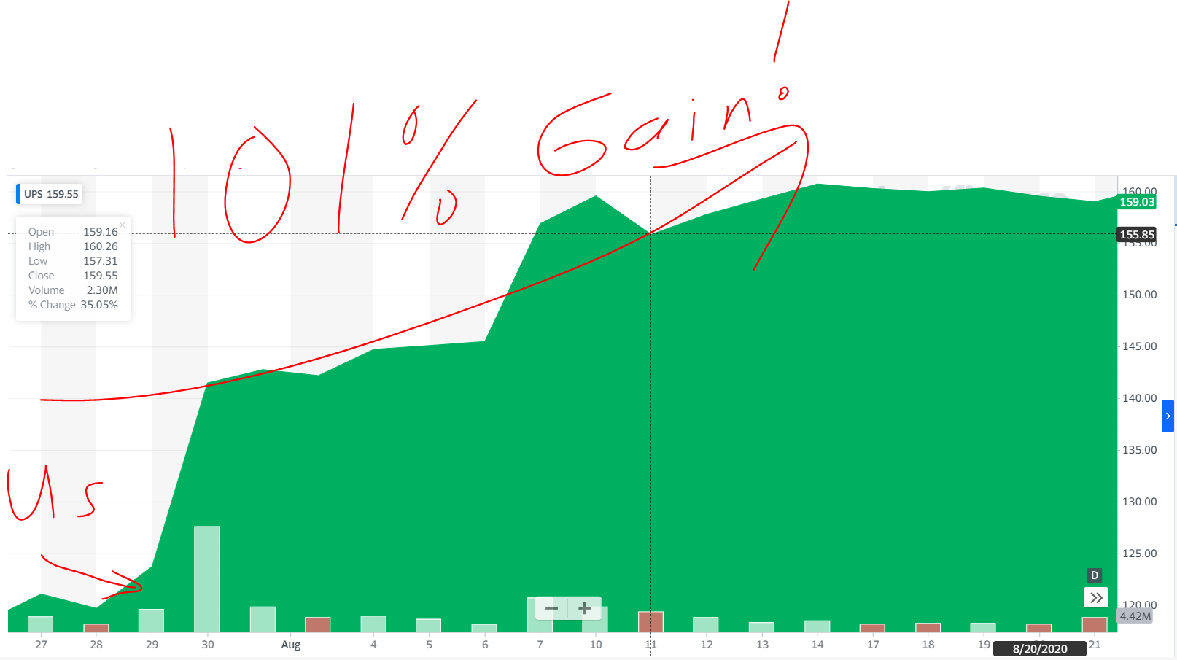

Here’s the thing.
Anyone could see the spike on the 30th.
It’s brain-dead easy to tell you to get in after Wall Street has already dumped all its money in.
Plenty of strategies and services will tell you to look for these volume spikes and then get in, but if you wait until after 9:30 a.m., the big move will have already taken place.
You’re too late. You’ve missed the big opportunity for money.
It’s like trying to be the first off the plane when you’re sitting in the very last row.
Good luck with that.
You’ll be fighting Wall Street institutional investors, big banks and everyone else throwing in their money.
If you put your trade in the day before, that’s like being in first class.
You can take your time. Move at your leisure.
Make everyone else mad because you’re rich, and they aren’t.
If you know how to spot these Overnight Trades, you have the chance to make money over and over again.
I know because I’ve used my insider knowledge to spot these Overnight Trades before anyone else.
I’ve helped my readers tap into these kinds of Overnight Trades over and over.
Just like Under Armour back in July 2019.
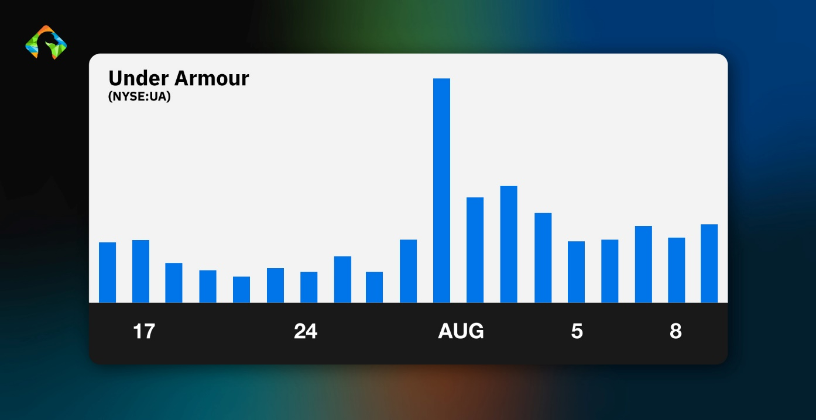
You could see where the big spike in money hits.
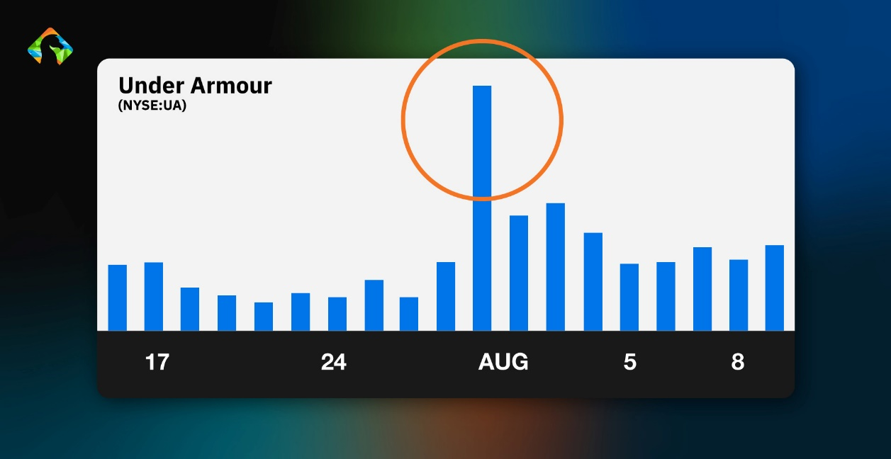
Any idiot can see the spike and tell you to get in after the money’s already been made, but I’ve used my decades of experience to help my members get in the day before.
Here’s where my readers got in on the 29th.
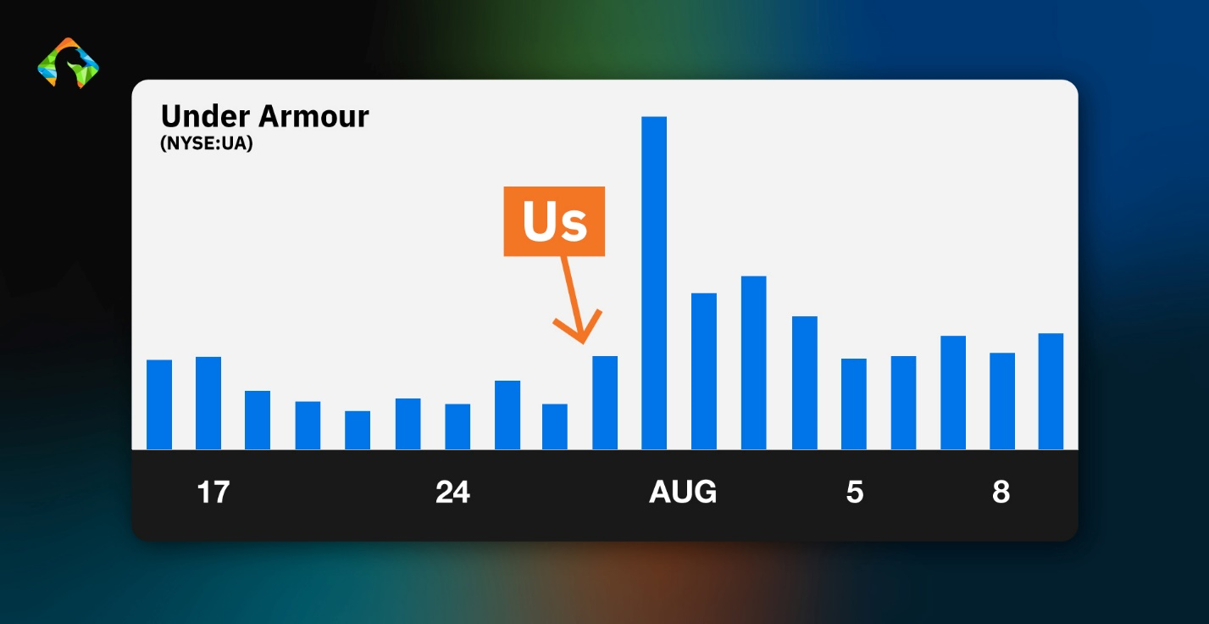
Look, here’s where the rest of the world was losing their minds trying to get in at 9:31 a.m. on the 30th.
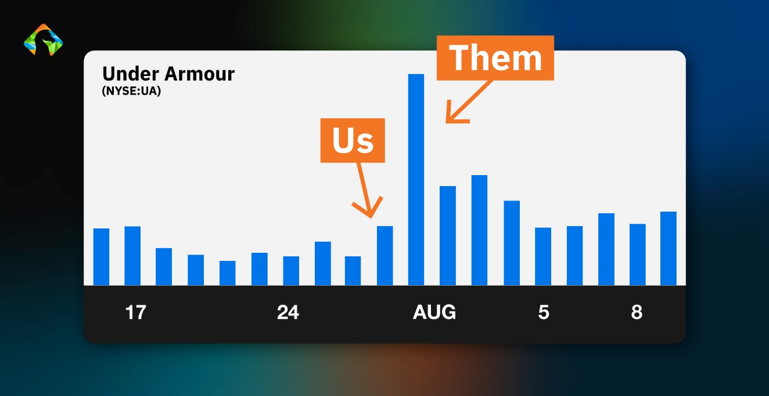
Instead of trying to get in after the move occurred and making nothing, you could have closed your trade at 9:35 a.m. and calmly walked away with 108%.
So basically, what’s happening is that when everyone else is coming in, you are getting out and locking in the gains.
Again, just to emphasize: These are real recommendations I gave to real people.
I’m not just spouting off a couple of “woulda, coulda, shoulda” trades.
These were opportunities I saw in real time that my readers had a chance to pounce on.
It’s all thanks to my Overnight Trade strategy.
Now, of course, in order to double your money overnight, you can’t just buy and sell shares of big stocks like Lowe’s or FedEx.
You have to trade options to turn small stock moves into big gains.
All while risking less money than you would if you bought the actual stock.
Plus, this gives you the leverage to do something truly amazing.
You could actually double your money – even if the stock itself goes DOWN.
That means if you follow my Overnight Trade recommendations, you can make money no matter what the economy does, in any market environment, in any type of political atmosphere.
The money you could grab with ZERO hard work... well, that’s truly mind-boggling.
In all, there’s $169 billion fueling these Overnight Trades every single day.
If you know how to tap into these cash movements, you could set yourself up for the chance to profit.
How These Trades Made Money Even When a Stock Crashed
What’s truly amazing about these Overnight Trades... is that you can make money even when the stock goes DOWN.
So even in times of uncertainty...
Even when the market crashes...
You can still make money.
Like with Cisco...
In August 2020, the coronavirus gave Cisco its worst day in nearly a decade...
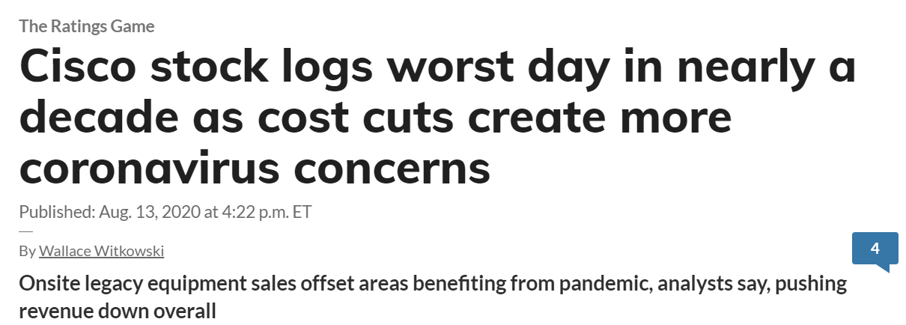
And the stock plummeted...
August 13 was a horrible day for most investors.

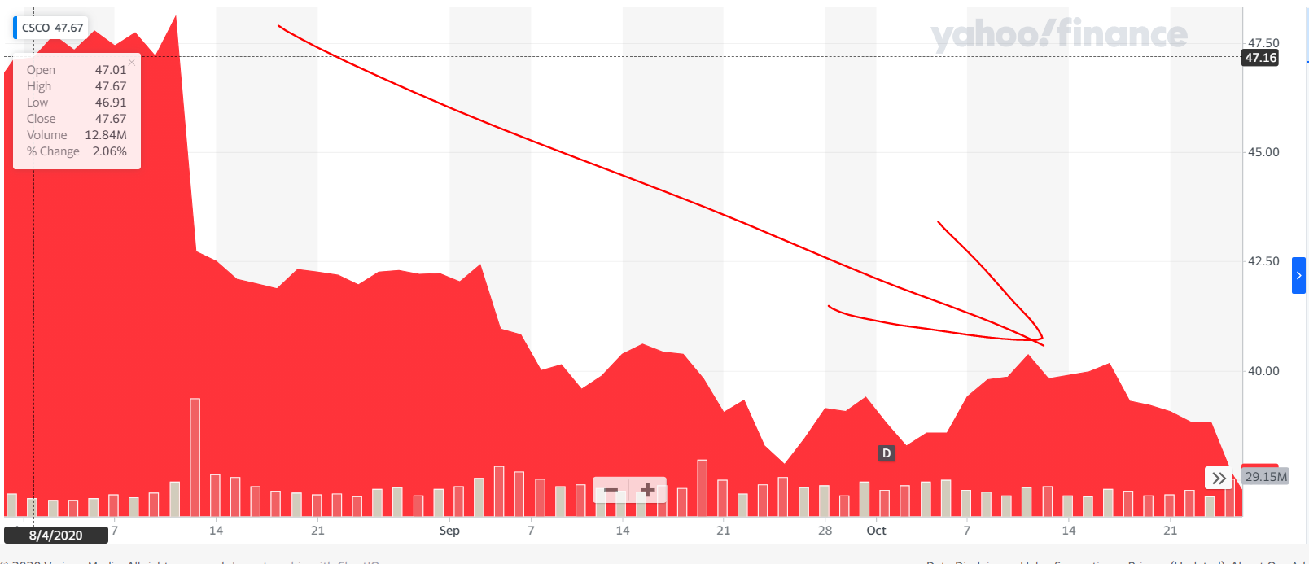
But not my readers...
Our Overnight Trade went UP 125%.
Again... it was all thanks to this spike:
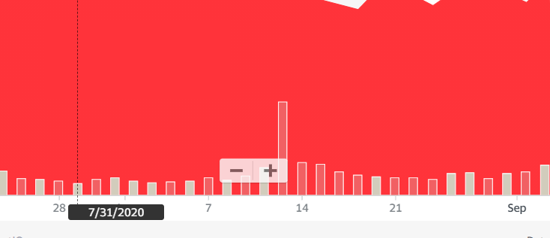
You can clearly see it on the 13th...
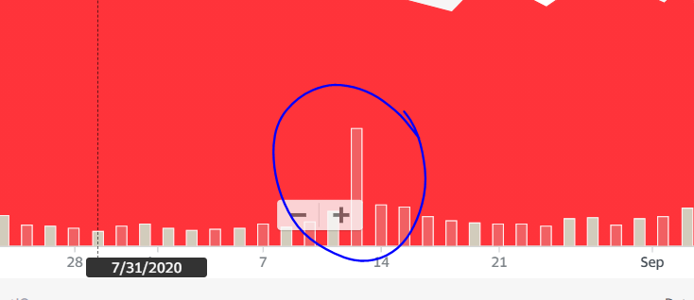
But again...
We were in the day before:
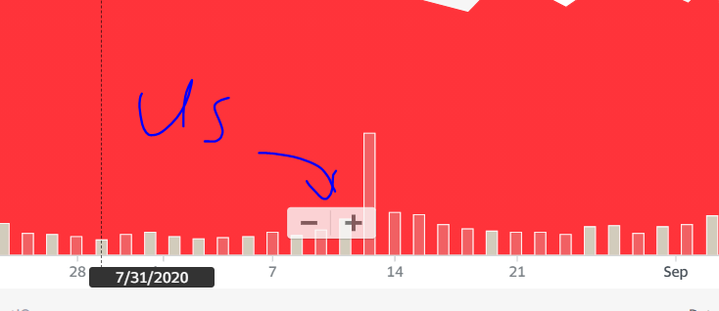
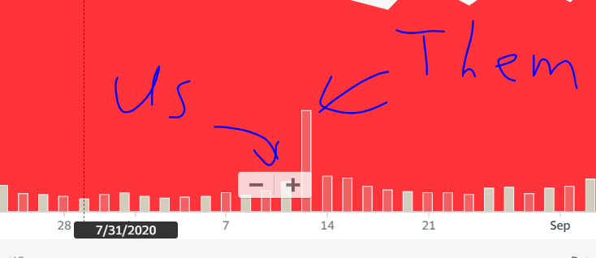
That’s right...
Thanks to this spike...
It didn’t matter that the stock fell through the floor.
My members were ringing the register...
More than doubling their money OVERNIGHT.
Arnold made 287%...
I closed Cisco Overnight Trade for 287%. – Arnold B. (8/13/2020 at 9:41 a.m.) 
Sterno made 294% gains...
In at $1.18, out at $4.65. 294% gain. – Sterno (8/13/2020 at 9:41 a.m.)

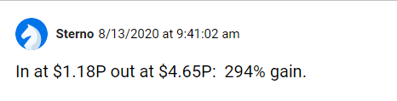
And JA said:
Bryan’s Overnight Special! Cisco – in at $1.16... out at $4.47. Best trade EVER! Thanks Bryan! Success Finally!! – JA (8/13/2020 at 10:24 a.m.)

Again, these are just regular, boring companies.
Yet, thanks to Overnight Trades, these boring companies turn into profit-gushers.
Here are just a few examples of what you could have made overnight on my top recommendations.
- 121% on Abercrombie & Fitch
- 113% on Ciena
- 160% on First Solar
- 108% on UPS
- 133% on Kellogg
- 136% on Ambarella
- 292% on Snap
- 116% on Pinterest
- 130% on Twitter
- 178% on Yum Brands
- And 188% on FedEx!
With the magic of these Overnight Trades, it’s as easy as 1-2-3.
Step 1: My members made one simple five-minute trade before 4 p.m.
Step 2: They went to sleep.
Step 3: They then doubled their money – or more – the very next day.
Now, I’m not going to insult your intelligence.
You already know that no one, not even me, has a crystal ball to predict the future.
My verified track record has almost 8 wins out of every 10 trades.
So, of course, you shouldn’t throw all your money into any one trade.
That’s just not smart trading.
But when your wins outnumber your losses almost 4-to-1...
Well, I’m sure you could see why this is by far the most lucrative investment strategy that I’ve seen in my 20-year career trading the market.
Sadly, most investors have never experienced the thrill of Overnight Trades, probably because Wall Street doesn’t want you to hear about them...
Which is why I left Wall Street forever.

Why I Turned My Back on Wall Street to Bring You the TRUTH of Overnight Trades
Sure, I loved being “on the inside” of Wall Street and dining in the nicest restaurants in Chicago.
I’ve watched Bears games on the 50-yard line.
Being a trader in the live pit was extremely lucrative.
In fact, these days... I trade with a multimillion-dollar portfolio.
But I’m not telling you this to brag... not at all.
I just want you to know I’m the real deal. I’m not some “wannabe” trader.
While I worked on the CBOE, I saw firsthand how Wall Street really worked from the inside.
I learned why regular people couldn’t make money in the market, why they were constantly getting screwed while Wall Street fat cats were making millions.
That’s when I decided...
The truth of Overnight Trades should not be reserved for the Wall Street elite.
I knew that everyone deserved a chance to make this type of life-changing money.
It’s all thanks to these amazing trades.
I wanted to share my “inside knowledge” with the “average Joe.”
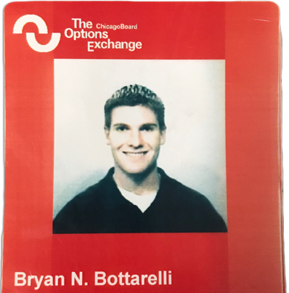
That’s why, about 12 years ago, I left the live trading floor, turned my badge in to the Chicago Board Options Exchange and started my own independent research service.
As you can probably tell, I haven’t slowed down at all, but my priorities have changed.
Look, back in the floor days, I was young. I was single.
Now I have a family. I have a wife. I have two daughters.
I learned what’s truly important in life: family... quality time with your friends and loved ones... and financial security.
Today, my life mission isn’t just about making money.
It’s about helping everyday people like you become the heroes of your families.
I want to help you achieve a level of wealth that brings peace of mind. And for more than a decade, I’ve helped people from all walks of life, from all backgrounds and with all levels of trading experience.
They’ve all had the chance to make the kinds of returns that most people can only dream of.
I’ve been sharing research and recommendations since 2006... and NEVER had a down year.
Not even in 2007... or 2008... or 2009.
During that time, I’ve recommended 6,037 trades...
And still maintained my 10% gains in less than 10 days.
But now...
Thanks to a major technological breakthrough that’s made it even easier to get my Overnight Trade recommendations to everyday people...
I could help you see the chance to make more money faster than you ever have before.

$2 Million Breakthrough Has Been Available ONLY Since May 2019...
You see, even though I ran my own research trading company for more than a decade and developed great results for my readers, I did realize that there was one problem.
Even with emails, I was getting my ideas to members too slowly. So I needed a way to get my Overnight Trades to readers faster, in real time.
So I set out to create something completely different from any other newsletter or financial publication.
In short, I’ve developed a live chat room where I can share my research and Overnight Trade recommendations with you immediately.
It’s a way for all trading enthusiasts to come together, share their trading ideas, collect big wins together and celebrate one another’s success.
I call it The War Room.
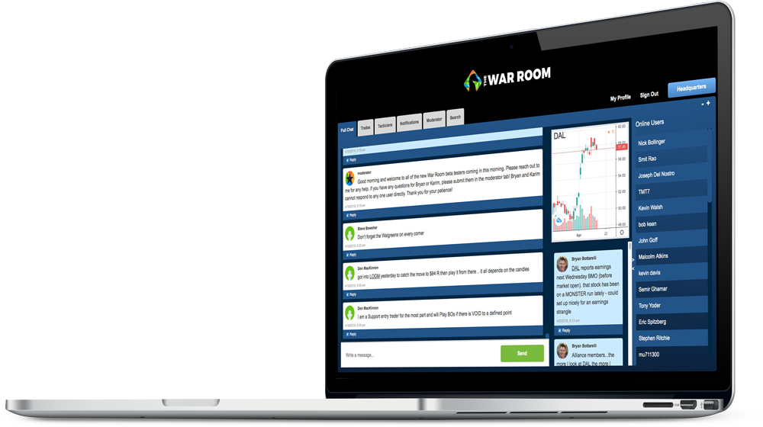
It’s fast, it’s exciting, it’s 100% LIVE and it’s as close as you could be to trading by my side.
All I have to do is type in a few words in my computer, hit enter, and, instantly, my readers like you can get a trade recommendation in real time...
Which allows me to move much faster than ever before – no waiting, no long emails, no boring newsletter.
This proprietary technology cost more than $2 million to develop.
Plus thousands of man-hours to test and refine.
It’s been wildly successful.
We’ve delivered members Overnight Trade opportunities over and over.
Now... have ALL of my Overnight Trades doubled?
Of course not.
That’s just not realistic.
But here are the facts...
All together... my members have seen more than 1,000 winners since we started.
That’s right...
1,000 WINNERS.
Now, have we been perfect?
No. No trader is.
But we’ve won far more than we’ve lost.
We’ve maintained a 76% win rate.
That’s winning on almost 8 out of every 10 trades!
Now, here’s the crazy part...
We’ve delivered a total return of 346% since May 2019.
Every $10,000 turned into $44,600.
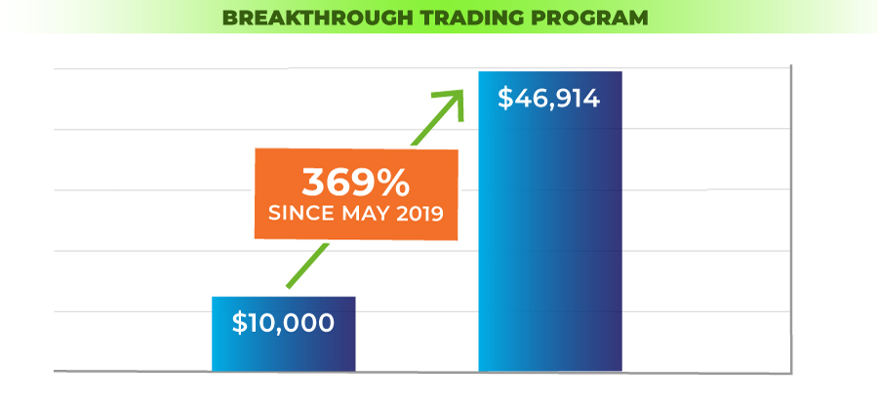
And $100,000 into $446,000.
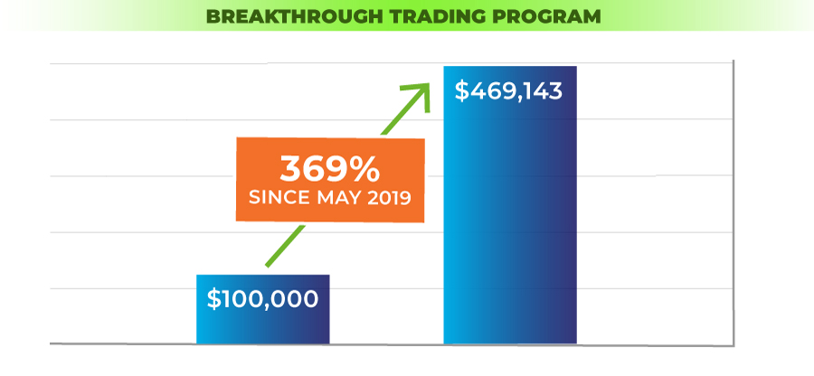
That includes winners and losers!
Now... that’s on ALL the trades we show our members...
In addition to Overnight Trades... we offer all sorts of trades... all with different hold times.
Some are lightning-fast... some play out in a day... some play out in a month or two.
Bottom line... we show you multiple ways of winning.
You can pick and choose what’s right for you according to your schedule... and according to your specific situation.
As I’m sure you know... risk is a part of investing.
And you should never invest more money than you can afford to lose.
That’s why we stress position sizing over and over again.
But when your wins outnumber your losses by almost 4-to-1...
I’ll take those odds every day.

This marvel of investment technology has helped me show readers some of the biggest Overnight Trades I have seen in my 12 years as an independent Pro Trader.

Hi-Def TV Paid Up to 444%
I found one big winner, like, right after we started The War Room in 2019.
I set my sights on Ambarella.
I saw the perfect setup on August 29 and fired off a few quick instructions in The War Room.
Sure enough, the next morning the money started pouring in for War Room members.
Bryan Bottarelli (8/29/19)
Set up an Overnight Trade on Ambarella (AMBA) before closing bell!
All they had to do was get in the trade by the closing bell, sleep soundly and let the power of Overnight Trades work its magic. Our official gain was 136%.
Rick (8/30/19, 9:42 a.m.)
Thanks, Bryan. You’ve made my long weekend with that AMBA play. My weekend surfing adventure will be that much better because of you sir!
Jeffrey (8/30/19, 9:47 a.m.)
In at $1.75 and out at $7.00 in 12 hours, not bad! 300%!
Ramesh (8/30/19, 9:36 a.m.)
444.44% on AMBA. Thanks!
At 9:42 a.m., Rick said the trade was going to make his weekend adventure even better.
At 9:47 a.m., Jeffrey posted that he made 300%.
Ramesh killed it, though. At 9:36 a.m., he said he’d locked in a 444% gain.
Those are just a couple of comments from that trade, but in The War Room, I get to see post after post of members getting great results.
Here, just look...
Russ (8/29/19, 2:24 p.m.)
Great Bryan, thank you. I bought Ambarella based on your tip and just sold at over 100% gain today. Thank you! Looking forward to more profit on Ambarella tomorrow!
Porath (8/30/19, 9:39 a.m.)
In at $3.46 (P & C), out at $7.03!
Paul S. (8/30/19, 9:49 a.m.)
Thanks BB on Ambarella. Got in at $3.60, out at $7.50. I ended up with a double. Nice way to finish the week and start a holiday weekend.

Grabbing 133% on Kellogg (While the Dow Plummeted 340 Points)
Let’s take a look at what happened with the boring stock Kellogg back in July 2019.
If you remember, on July 31, the trade war with China was giving traders migraines.
The Dow plummeted 340 points.
People saw nothing but red in their portfolios, but with Overnight Trades, none of that matters.
My screening system showed me Kellogg was right for an Overnight Trade.
So, on July 31, at 12:37 p.m., I told members it was time to strike.
Bryan Bottarelli (7/31/19,12:37 p.m.)
Recommendation: Make your Overnight Trade on Kellogg (K) before closing bell at 4:00 p.m.!
By now, you know the drill.
Members got in before the closing bell, went to bed and woke up richer.
That’s exactly what we did with Kellogg the next morning.
My members woke up, probably had a nice breakfast (maybe even a Kellogg’s Eggo waffle), then logged in to The War Room.
That’s where they got my alert on August 1, right before the opening bell at 9:30.
I told members to go ahead and ring the register for a 133% gain.
Bryan Bottarelli (8/01/19, 9:30 a.m.)
Alert: Ring the register on Kellogg (K)

Let’s look at another top Overnight Trade in the telecom company Ciena.
On June 5, 2019, I sent this notice to my War Room members.
Bryan Bottarelli (06/05/19)
Recommendation: Buy Ciena (CIEN)
Again, all they had to do was get in the trade by the closing bell, sit back and relax, and let the Overnight Trade work its magic.
In the meantime, they could catch a movie, take their dog for a walk in the park, go fishing and enjoy a good night’s sleep. Because on June 6, the very next morning, they got to ring the register again.
Nick was first up at 9:45 a.m.:
Nick (06/06/19, 9:45 a.m.)
120% gain on CIEN. Best day in The War Room.
Then Dean chimed in at 9:46:
Dean (06/06/19, 9:45 a.m.)
I got out of CIEN at $6.00. 100% profit.
Another one of our members with the username TK told us this:
TK (06/06/19, 9:47 a.m.)
100% gain on CIEN - Thanks, Bryan!
From there, it was off to the races.
Deborah (06/06/19, 9:35 a.m.)
Starting the day with a winner!
That’s what’s amazing about Overnight Trades.
All you have to do is make one trade by 4 p.m. – it takes less than five minutes...
And then go about your day.
Enjoy a good night’s sleep.
As soon as the next day, you could collect any money.

I truly love these types of trades because Overnight Trades can make huge gains even on big, boring companies like Microsoft.

$4,100 on Microsoft... Overnight
Microsoft isn’t some cryptocurrency or a flash-in-the-pan pot stock, and it certainly isn’t some tiny penny stock.
But with Overnight Trades, you could rake in big money fast, just like Bill, who posted this...
Bill, War Room Member
I just made $4,100 on Microsoft [35% gain]. Bryan, my heart is beating out of my chest right now. What a thrill ride this is.
4,100 bucks? Yeah, that would make my heart beat out of my chest too!
Heck, in one trade, he made enough to buy a Rolex. Can’t beat that.
You have to love Charles’ post:
Charles, War Room Member
HOLY CRAP, MICROSOFT! In at $0.98, sold for $2.44. BOOM, BABY!
Danny H. raked in an astonishing 235%.
Danny H. War Room Member
In at $1.40. Out at $4.70 for 235%. Great call.
He more than tripled his money on one trade OVERNIGHT.
Thanks to Overnight Trades, we even turned a gold ETF into an Overnight Double.

Barbara Made $7,944 Overnight With Gold
So I saw a perfect Overnight Trade setup in the gold ETF NUGT.
On August 14, 2020... I sent out my alert.
The next morning... I estimate we had more than 100 people posting about their wins.
Paula S. locked in more than $2,700 overnight:
132% profit / $2,723 overnight. Thanks a million, Bryan! – Paula S. (8/17/2020 at 9:37 a.m.)
And James made $4,000 overnight!
Can’t say how exciting that was! A $4,000 win for me!! Thanks, BB!! In at $2.94, sold at $8. Shaking a little bit right now! Lol. – James C. (8/17/2020 at 9:46 a.m.)
And Barbara locked in more than $7,000!
In at $2.95. Out at $7.95! +$7,944. Wow!! Thanks, Bryan! – Barbara D. 8/17/2020 at 10:02 a.m.
Now, I’m showing you some of our best examples...
But when you look at the posts in The War Room, you’ll see that they happen more often than you would think.
Here are just a few more.
Charles G., War Room Member
I went back in on ULTAS yesterday. Nice gain for 184%.

Walter Russell doubled his money on my play on the retailer Guess...

In at $1.45, out at $2.82. Overnight Double! Thank You!
Sandra quadrupled her money overnight...
DXD in at $1.15, out at $4.60 – Sandra R (2/28/2020 at 10:14 a.m.)
And Vaughn had this shocking post:
Vaughn, War Room Member
Clorox up 500% today.
That’s right, a 6X Overnight Trade – on Clorox, no less. Bleach. It’s incredible.
What made me laugh was another member’s reply:
Bruce, War Room Member
Sounds like you cleaned up on CLX! (sorry...) :-)
Hey, in The War Room, we allow dad jokes.
Look...
By now, I’m sure you can see why we’re all so excited about Overnight Trades...
But you might be wondering...

How Do You Find Overnight Trades?
I’m sure you’ve already realized that if you really want to make money, you can’t wait for them to profile a stock on CNBC or write it up in The Wall Street Journal.
By then, it’s too late. The money has already been made.
The beauty of Overnight Trades is that you beat the rush, including all of the big money from Wall Street firms.
In order to get there first, you have to find the right kinds of setups to make an Overnight Trade.
In my 20 years of experience trading the market, I’ve developed a three-step system for identifying Overnight Trades.
The first is simple:
PRICE.
Just like shopping for anything, you want a good value.
So I don’t like expensive plays.
That means I probably won’t get in plays with names that you might expect, like Netflix or Amazon or Berkshire Hathaway.
Usually those are too expensive and too heavily tracked by Wall Street for my Overnight Trades.
I want smaller plays where we can get an advantage while Wall Street’s back is turned. It often means we can get in much, much cheaper.
I like to shoot for plays my readers can get in for $500 or less.
If it’s more than that, I pass.
So that’s the first one. The second is what I like to call...
POWER.
So basically, I look for big momentum behind a move.
If there isn’t enough power behind the stock, I pass.
When I’m looking for an Overnight Trade, I look for big waves of cash pushing a stock higher...
And I like to trade on big moments like earnings announcements, insider buying or strong chart patterns... when I know these waves of cash are likely to hit hard.
Which brings me to my third and most important criterion:
PROFIT.
I don’t even look at a play that doesn’t have the potential to at least double my readers’ money overnight.
It’s not that I’m greedy. It’s just that there are so many opportunities out there, we can afford to be picky.
Especially since my system can work in any economic environment, bull or bear.
But certain plays just might not be big enough to mess around with.
If you had a mining deposit that held veins full of gold, silver and copper, you’d mine the gold vein first, right?
Let the other dummies mine for copper. Not me. I want the gold.
I’m laser-focused on finding the big opportunities that pay off.

And when you are winning on almost 8 out of every 10 trades...
I’ll take those odds every day of the week.
So to recap, in order to be an Overnight Trade...
- It has to be cheap enough to get in (less than $500 in most cases)
- It has to have enough momentum to push the stock up big
- And it has to have the potential to AT LEAST double your money.
With those three criteria, you can get into these plays before the rest of the investment world even learns about them.

Finally... Your “Unfair Advantage” in the Market

Just look at what we did with First Solar.
On October 27, 2020, my system said it was primed for an Overnight Trade.
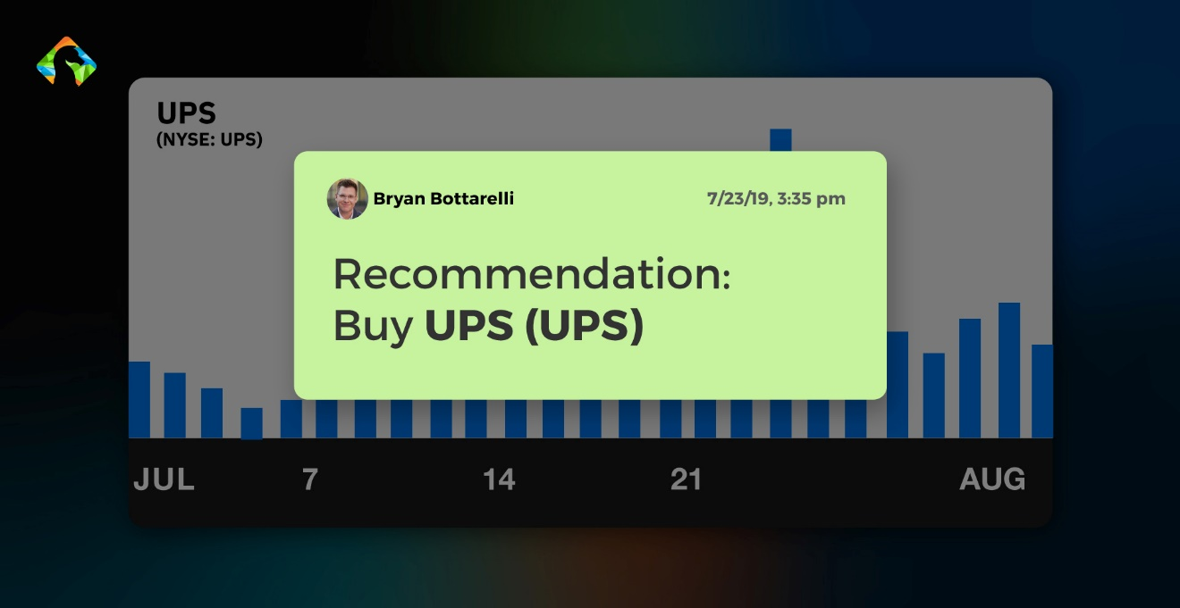
So I told my readers to get in here:
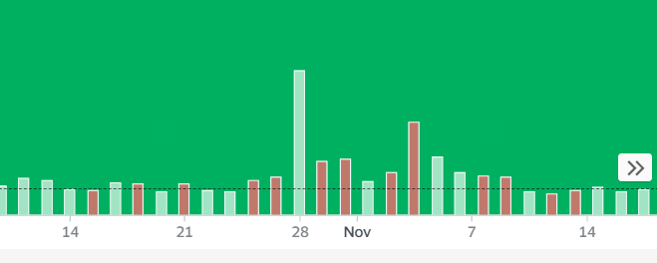
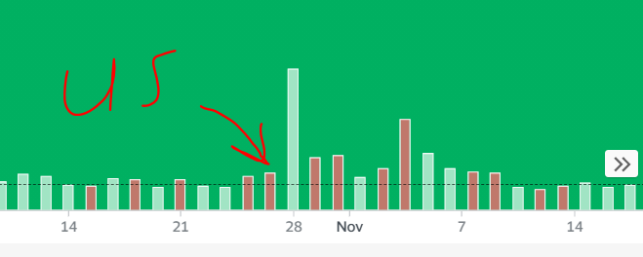

Once again, everyone else got in during the traffic jam of the morning rush.
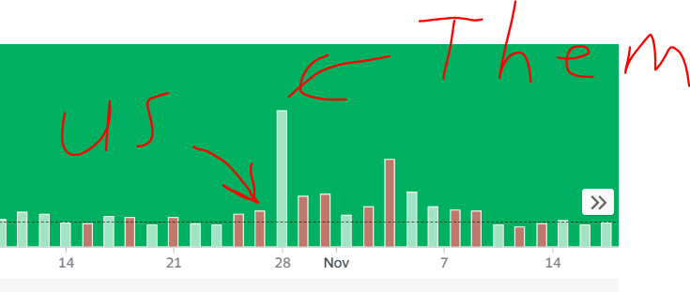
Then look at what happened...
It basically went vertical!
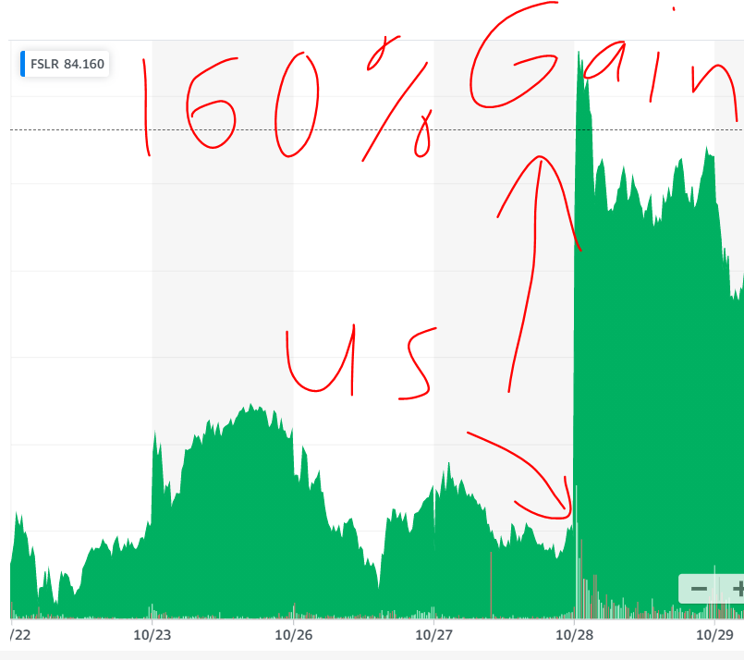
While everyone on Wall Street was trying to catch us...
We walked away with a 160% overnight gain.
And some members did even better...
Cris made a hefty 313% gain...
Woaaaaa... First Solar in at $3.11, out at $12.85 – +313%. Bryan, you’re sooooo good... thanks! – Cris D. (10/28/2020 at 10:05 a.m.)
Jared hit a personal milestone...
A 380% gain – as a newbie!
First Solar... 380%!!!! Milestone for this newbie. – Jared D. (10/28/2020 at 10:26 a.m.)
But Kevin knocked it out of the park...
With 538% on his first day...
First Solar - in at $1.80, out at $11.50. First trade with you guys. Thanks! Kevin P. 10/28/2020 at 9:48 a.m.
Best of all...
While these are some of my top plays, these opportunities happen all the time.
In fact...
The same day we cashed in on First Solar...
We had another 107% gain on Tupperware.
That’s right...
Yet another “boring” company gave us an Overnight Double.
Karen woke up that day $13,000 richer thanks to those two plays.
On her FIRST DAY TRADING!
$13K between First Solar and Tupperware. WOW! And this was my first trade! I love you, Bryan! – Karen S. (10/28/2020 at 9:47 a.m.)
Think about that...
$13,000... OVERNIGHT!
How much would that change your life?
And remember, you can make money even when a stock collapses, like when I saw the Overnight Trade setup on Twitter. It was October 23, 2019.
Here’s where my readers got in:
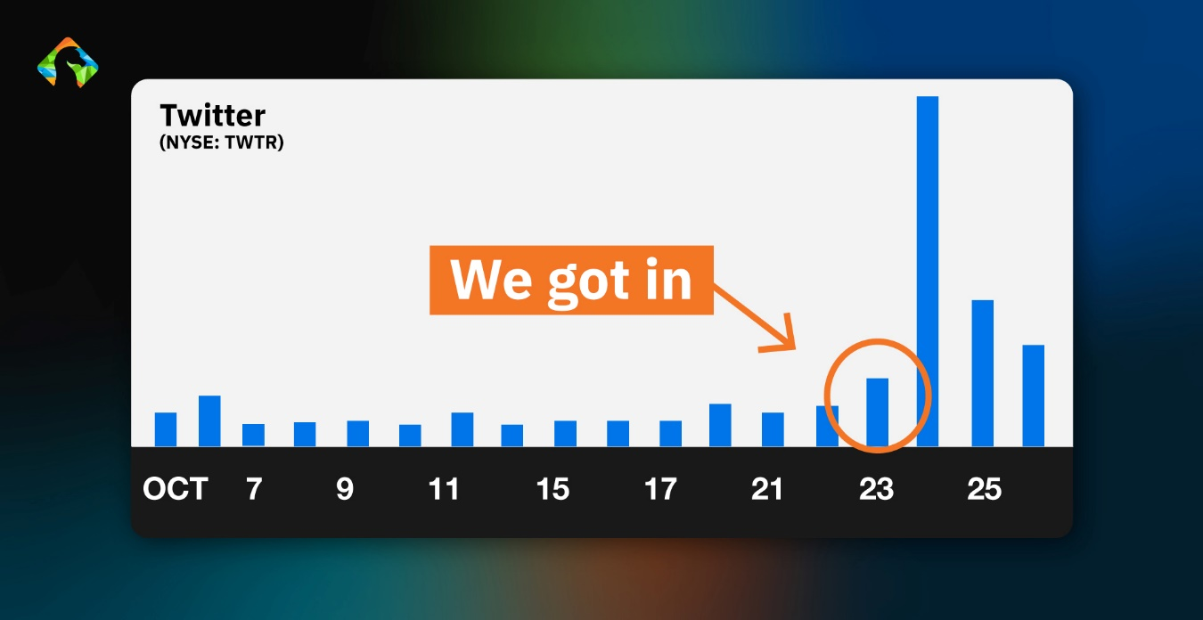
You could see, that day, no one was in our way.
We set our short options play on Twitter, and the next day, when everyone else was rushing OUT of the stock, our play skyrocketed.
Here’s the surge – the mad dash for the exits:
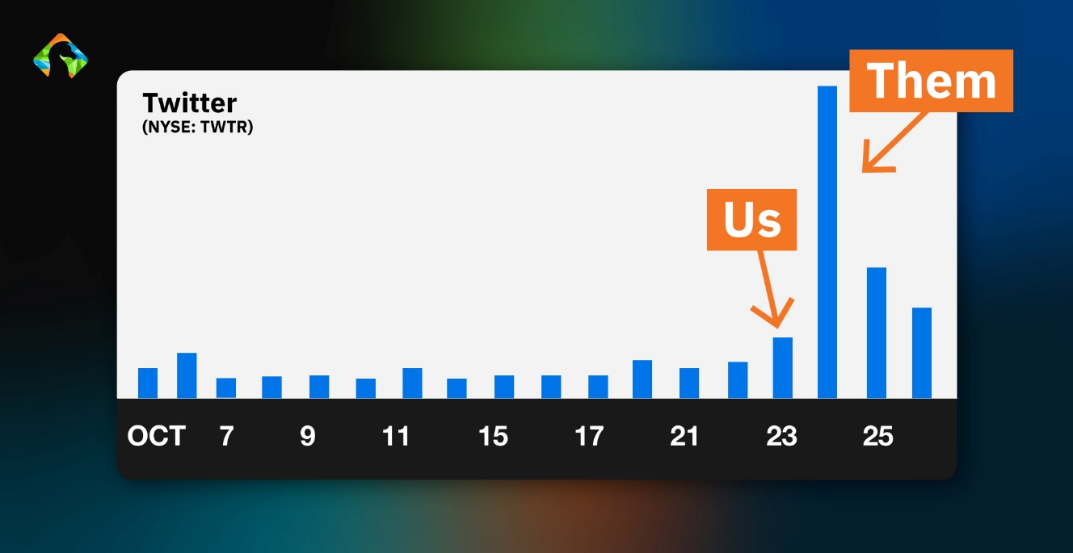
But while everyone else was running, we locked in a nice 130% gain.
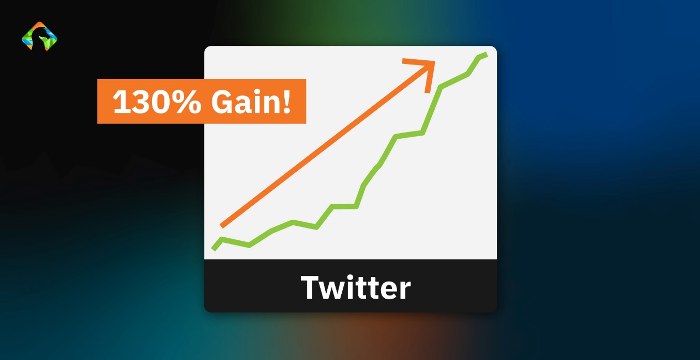
Like user SWFTex.
At 9:41 a.m., he reported a quick 114% gain on his Overnight Trade, and it didn’t end there.
SWFTex (10/24/19, 9:41 a.m.)
114% on TWTR!
At 9:50, one of our veteran members, Rick R., said:
Rick R. (10/24/19, 9:50 p.m.)
Bryan, thanks for the great play on TWTR!! Made for a great morning. Up 116%!
My favorite was Charlie, who said he got in for $1.49 and out for $6.25.
Charlie (10/24/19, 9:45 p.m.)
TWTR in at $1.49 out at $6.25. PYPL in at $1.04 out at $5.94. I am done for the day!
That’s a 319% gain.
No wonder he posted, “I am done for the day.”
Yeah, I mean, if you more than quadruple your money, I think you can celebrate for the rest of the day.
Another user, Allen, replied to Charlie’s post:
Allen (10/24/19, 9:46 p.m.)
Amazing!!
Yeah, Allen’s right. It is amazing.
The bottom line is this is the only legal way I know of to get an edge on Wall Street and beat it to the punch... because you’re in a day before...
Which gives you the chance to get out the next day with gains of 100% or more,
You Can Make a Killing... Even as a “Newbie”
Keep in mind...
You can start off slow.
Maybe trade only $100 or $200.
Just look at Chris...
Not been with you long. Started with $100, 2 weeks ago. I’m over $830 as of today. Listen to the experienced traders here. You’ll make it and be happier. – Chris F. 1/28/2020 at 1:11 p.m.
As a beginner... he started with just 100 bucks.
But in two weeks... he had already grown his money to $830.
That’s eight times his money in just two weeks.
And while $830 isn’t life-changing money for me... for someone who has only $100, growing that to $830 is HUGE.
Helping beginners get a good start is the most rewarding thing I do.
Here’s another post from KC.
Like Chris... KC was also new to trading...
He started slow...
But then posted...
Bryan, great call on Qualcomm! Bought only 10 shares and pulled up a $1,000+ profit (18% gains) in a couple of hours. Even as a very inexperienced options trader, I’m starting to see what makes Bryan tick. Good to see so many other profits.
KC

That’s right...
Even as a beginner... he still made more than $1,000 in a couple of hours. And Virginia was a complete newbie...
On her second trade, she almost doubled her money... in a little more than an hour!
Second trade for a newbie. In at $1.64, out at $2.95. Thank you, Bryan!
Virginia

People Just Like You Have Made Thousands in The War Room
So, bottom line, thanks to Overnight Trades, our members are changing their entire lifestyles.
The fun can start on your very first day, like new War Room member Robert. He said...
First full day... After QCOM (27%), I am up $4K for the day! I am REALLY EXCITED!! – Robert L. 4/15/2020 at 3:55 p.m.
$4,000 on his very first day in The War Room. That’s incredible.
And that’s what I love about the market.
The market doesn’t care about your experience level, your background, what school you went to or what degree you have.
No matter who you are, you can make a killing in this market.
Look, I know what it’s like to struggle.
I used to flip burgers at McDonald’s before I got my big break on the CBOE. It sucks.
But if you hit a big Overnight Double... you could feel free to reward yourself by going out to a nice restaurant.

The War Room has helped people make a lot of money.
Everyone, from beginners to expert traders, can use the research and trading recommendations in The War Room to finally beat the market.
Mike collected $3,000 by 10 a.m... while sitting at the airport!
Cashing in about $3K (+20% overnight) right now from the RDU airport lounge. Thanks! Michael K. 5/29/2020 at 10:01 a.m.
By now, I hope you can see the power of Overnight Trades.
They help people like Vern, who made $9,500 in their first week.
My first week on the job... +$4,500 (WSM 19% in one day) and +$5,000 (DG 34% in one day)... It’s Friday and I feel great. – Vern D. 5/29/2020 at 10:02 a.m.
Some members made a life-changing amount of money on just one Overnight Trade.
Robert made more than $11,000 overnight on FedEx...
FedEx was good for me... Bought at $3.40... out of them this a.m. for $7.80 ... Made $11,520. – Robert D.

Jock made a nice $16,000 profit on NUGT...
It’s time to THANK Bryan again. Last month I rolled back into NUGT at $5.17. At month end I bought 50 more at $0.85 and just sold all 60 at $3.80 for a profit of $16,529 (264%). Nice belated Easter present! THX. – Jock
Now, how much you can make depends on how much you invest, as well as other factors such as timing.
You could start off small and invest more as you get more comfortable.
Many of the success stories you have heard today are from our top-performing plays, so while there is no guarantee you will see similar results...

When you have an entire year of Overnight Trades...
You’ll have plenty of opportunities to make dramatic returns.
So by now, I’m sure you’re wondering...
How Can I Get These Overnight Trade Recommendations Every Day?

Back when I was trading alone, I realized something was missing.
I missed the excitement of sharing my double- and triple-digit wins with other traders live, like I did on the exchange floor...
And even more, I realized that there’s no longer any place on the planet where you can learn what I learned in the live trading pits.
The live trading floor right now is all but extinct.
Being able to sit at the feet of the trading masters is... well... impossible.
Until now... because today...
You’re invited to join us in The War Room.
It’s our live trading research chat room.
That’s where you can get my real-time updates and live trading recommendations every day the markets are open.
I’ll be in The War Room tracking the market, on the lookout for the next Overnight Trade.
But that’s not all.
We actually give our members plenty of chances to make money during the day too.
For instance, in addition to Overnight Trades, I love doing what I call “Sniper Trades.”
With these trades, we get in, cash in and get out as fast as possible.
Sometimes we get in a play and then ring the register all in the same day.
Heck, sometimes it happens within the same hour.
Here are just a few examples of our best Sniper Trades:
- A nice 44% gain on Fang in 2 1/2 hours on May 22, 2019
- A solid 73% return in 12 minutes on Sturm, Ruger & Co. on January 6, 2021

- 53% in just four minutes on Roku on September 10, 2019.
And on our Walmart play on July 7, 2020...
Members cashed in an amazing 121% gain in just one hour and 21 minutes.
Bottom line: Profit opportunities happen all day.
You’ll get them all in real time because, if you join me today, the first thing you’ll get is access to The War Room chat room.
It’s my way of immediately messaging you.
I keep in touch with members every day and alert them whenever I see a potential setup.
That way, when a trading opportunity comes, you won’t have to wait for me to write a lengthy email to you.
Instead, I can message everyone in The War Room, letting them know exactly which trade to jump in and why.
You’ll have the chance to see the power of Overnight Trades for yourself... LIVE and in real time!
My team has spent more than $2 million on research and development costs to perfect The War Room.
We’ve developed the best platform to deliver opportunities right to you.
You log in, and you have live access to my updates and analysis.
You’ll hear my thoughts every day that the markets are open, and anytime I see a perfect setup for an Overnight Trade, you’ll receive it instantly.

Let Me Make It EASY for You to Get Started
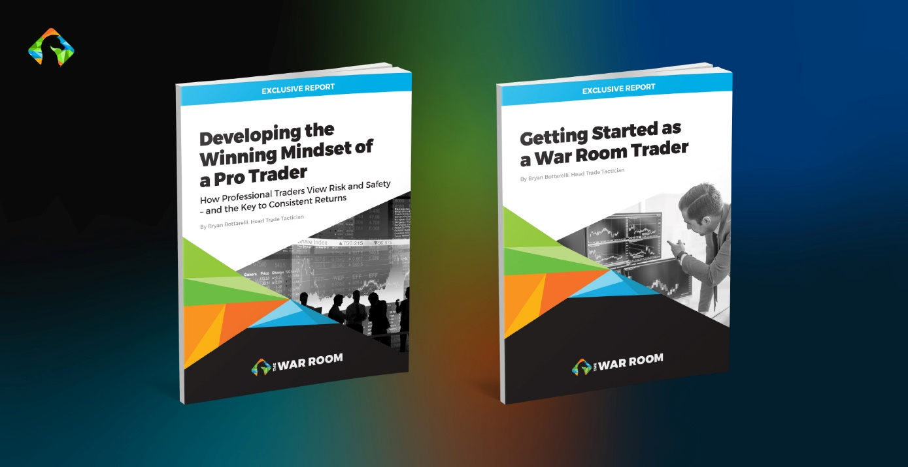
I want you to be able to start collecting your Overnight Trades as quickly as possible.
So I’ve compiled a few simple reports to help you hit the ground running.
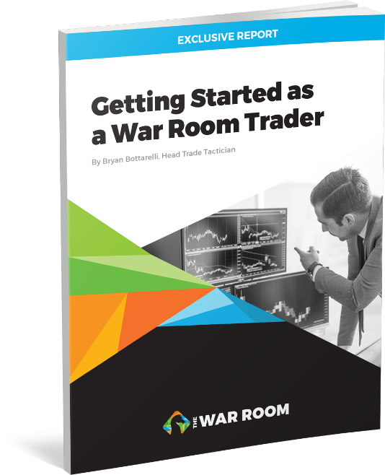
The first is a guide I created called “Getting Started as a War Room Trader.” It contains everything you need to get started following us in The War Room.
It shows you what a BUY or a SELL recommendation looks like in our chat room... and a lot more.
Give it a quick read when I send it to you.
You’ll know exactly how you could use the recommendations in The War Room to make your trades.
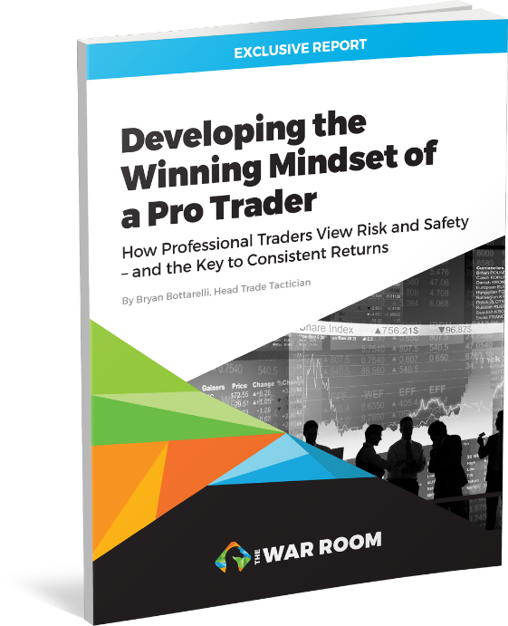
Second, I have another report for you, called “Developing the Winning Mindset of a Pro Trader.”
Standing shoulder to shoulder in the live pit with the best traders on the planet, I discovered that winning traders just think differently.
Mindset is the biggest difference between traders who are raking in millions every year...
And the traders who just blow themselves up.
I share the key to making this shift in this easy-to-read primer.
Plus, you’ll also have a whole new understanding of how to safely invest and the keys to making consistent returns on your trades.
OK, those are your first two benefits as a new War Room member.
The next is for anyone who’s worried about having time to sit in front of their computer all day.

Text Alerts for the Busy War Room Member
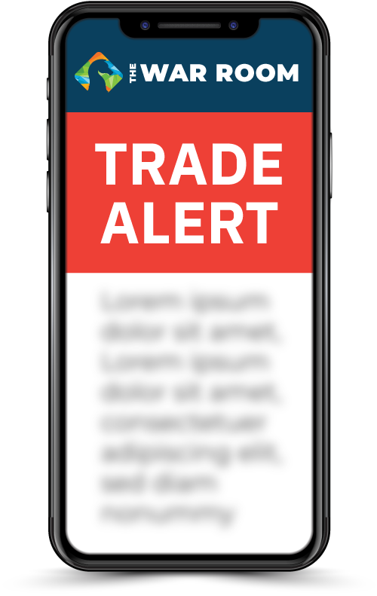
It’s the question I get most often from people who would like to be traders, which is...
Do I have to be in front of my computer all day?
Well, with The War Room trade alerts, the answer is a huge no.
When you opt in, we’ll send a trade alert right to your phone, tablet or computer every time we make a trade recommendation.
That way, even if you aren’t in The War Room, you’ll always know when a new trade goes out.
You can turn them on and off as you like. It’s totally up to you.
We have plenty of members just like you who are extremely busy.
Some have regular day jobs, some have other commitments, some simply want to enjoy their days and don’t want to be on the computer.
Bottom line: The War Room is designed to work around YOUR schedule.
You log in when you can and maybe catch an update and make a trade or two, and then you can go about your day.
Now, I have to really emphasize this with new members.
You don’t have to get in every single trade.
So many new members are used to being told to get into every trade in any newsletter service.
That’s because they get maybe 25 trades all year long if they’re lucky.
Heck, sometimes it’s just 12 trades a year.
In The War Room, you could see 12 trade recommendations in a day or two.
So don’t worry. There are plenty of opportunities.
Don’t feel like you have to post comments in The War Room.
If you want to just sit back and look at the research or maybe read the other comments from members, no problem.
You don’t have to post anything if you don’t want to.
Finally, I have something very special to share with you as a new War Room member: the Options Master Class video series.

Options Master Class
In The War Room, we recommend trades on anything that can make money.

In fact, members saw a chance at 32% gains in just three days... with a regular stock.
We love short-term plays... but we’ll also make longer-term trades.
We recommend anything that we think has a chance to make you money.
And that includes options.
That’s because options are my favorite way to make fast money in the market.
They are responsible for most of our biggest gains and our best success stories.

And they are the key to making Overnight Trades – and getting the chance to double your money while you sleep.
Now, if you’ve never traded an option before, don’t worry.
I’ve designed The War Room to work for anyone, regardless of their experience level.
If you can follow simple instructions, you can be successful.
I’ve also made this video series so that you will be successful trading either stocks or options.
I think War Room member Mike C.’s experience is similar to what you’ll see.
He said...
Mike C., War Room Member
I mentioned earlier that I am intimidated by options. I watched the vets in this room execute some pretty awesome option trades today, and I learned a ton in less than an hour. I guarantee you won’t get [to] experience anything like that anywhere else.
Now, you don’t have to learn all the technical indicators that I personally use.
However, I also know many members enjoy learning how to trade for themselves.
So I’ve created this video library to teach you the secrets I learned on the CBOE.
Each video is short. You could finish them in less than 10 minutes...
But they contain secrets that will make you more informed than 99% of traders in the market.
In the first video, I reveal one of my favorite kinds of Overnight Trades, I discuss earnings season and I let you in on a little secret.
I’ve discovered a way to make money whether the stock surges or plummets – you just need it to move.
Either way, you can make money.
It’s made earnings season like Christmas for us.
Even better, actually, because it comes four times a year.
I’ll reveal everything you need to know in my video...
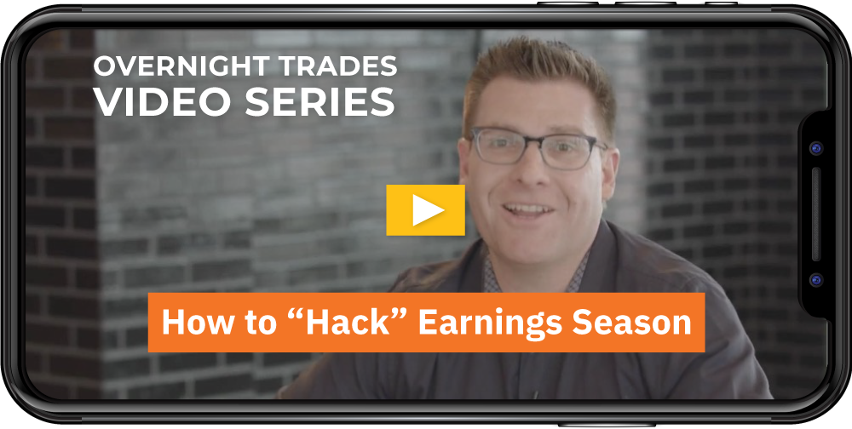
The Earnings Strangle: How Members Made 188% Overnight by “Hacking” Earnings Season.
I’ll break down how the strategy works and give you instructions on how to make the trades when earnings season comes around next.
I guarantee you’ll start to see earnings season like Christmas, too.
I have two more videos in this series.
One is about something called “fading the public.”
That’s a term most traders use for taking advantage of amateur traders during periods such as a new IPO.
My video on this one is called...

Fade the Public: Beat the Crowd and Make Windfall After Windfall With This Elite Technique.
But the last video I’ll tell you about is the most valuable by far.

Blowing the Whistle on Wall Street’s Biggest Secret
I never thought I would make this video. I’m sure it will make a lot of people mad.
Perhaps even people I know from the Chicago pit will be furious. Because in this next video, I’m going to give you the secret weapon of true professional traders.
This one tool will give you the real story of the market, the real-time look at where the market is and, most importantly, where it’s about to go next.
That way, you can get in on the huge price moves before they happen.
So please, guard the contents of this video closely.
Other War Room members and I are depending on you to keep this powerful secret to ourselves.
You’ll find it all in the video titled...

The 3-Minute Chart: Using the Pro Trader Tool to Spot “W” and “M” Patterns Every Single Day.
In all, here’s what you’ll get as a new War Room member...
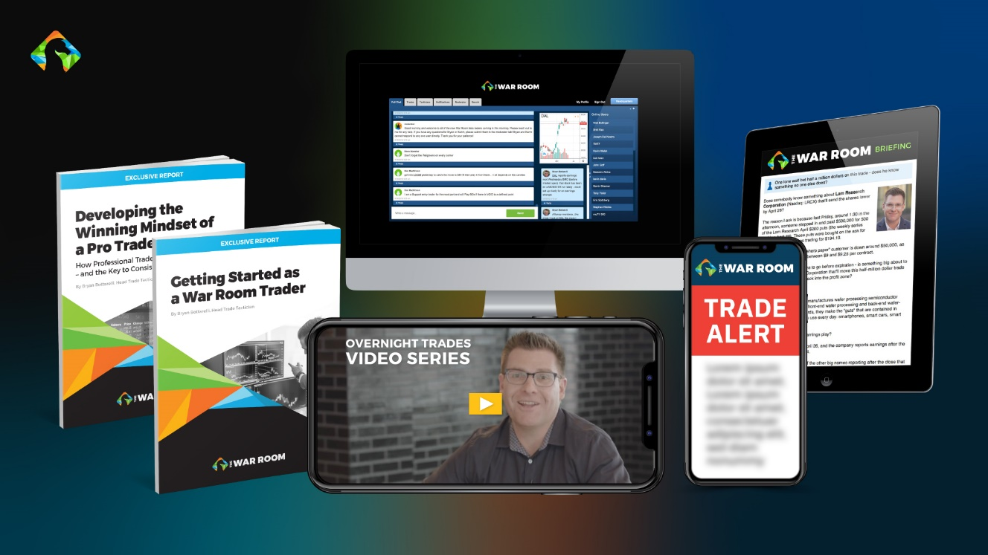
- 12 months of research and trade recommendations in The War Room
- Access to the members-only chat room
- “Getting Started as a War Room Trader”
- “Developing the Winning Mindset of a Pro Trader”
- The War Room text alert system
- The Earnings Strangle: How Members Made 188% Overnight by “Hacking” Earnings Season
- Fade the Public: Beat the Crowd and Make Windfall After Windfall With This Elite Technique
- And The 3-Minute Chart: Using the Pro Trader Tool to Spot “W” and “M” Patterns Every Single Day.
Total value: more than $6,000.
Best of all...

The Hard Part for You Is Over
Just think...
After years of struggling to make money in the market, the hard part for you is now over.
From this point on, I’ll do all the heavy lifting.
You’ll see the power of The War Room yourself...
And how even ONE day can be life-changing – as it already has been for our members!
Our War Room member Mark posted he made
$3,630 in less than 24 hours.
Nice 90% profit of $3,630 in under 24 hours . – Mark

So... take a second and ask yourself...

How Much Is Learning How to Build a Million-Dollar Portfolio Worth?
Really consider this...

So when I told my publisher that I wanted to charge $7,500 for a year, they told me it was way underpriced.
Listen... I’ve made millions from the market thanks to the mentorship and education I received in the live CBOE trading pit decades ago.
This isn’t about money for me.
This is about empowering you to transform your finances.
That’s why I’m looking for a small, elite group of like-minded members.

The First 99 People Who Say “Yes!” Will Get 50% Off Right Now
So if you’re the type of person who can make a decision quickly, I’m going to give you a huge discount.
For the next 99 people who join today, the cost of The War Room will be only $2,500.
As you’ve seen over and over from some of our top-performing plays and testimonials, you can make that much with just one trade in The War Room.
Remember...
Jim had his best day ever with a fast $4,000 gain:

Sold TDOC... Total profit of $4,019 with 340% total. My best day ever! – Jim S. 3/5/2020 at 3:12 p.m.
James made more than $2,200 on Netflix in 19 minutes...
NFLX in at 10:12 3/6 $360 C at 6.35 nest of 5. Out at 10% trailing stop at 10:31 at $10.90. $2,275.00 in 19 minutes. – James K 3/6/2020 at 10:38 a.m.
Ralph deposited $3,360 (a 646% gain) in his account before 10 a.m...
Bill Lee locked in $4,100 (a 35% gain) on our Microsoft play.
Christopher made $5,000 (a 25% gain) on just one trade...
I could go on and on...
Think of James, who made $11,000 on Clorox...
Bought CLX at $3.40, sold at $5.60 and netted $11,000.
And John, who made $38,000 (a 53% gain) on our Roku play!
Bottom line: You’re going to love The War Room. But I know from my time at the CBOE...
It’s about results, not promises.
So I’m doing something unprecedented.
I’m giving you a performance guarantee.

I’m Guaranteeing You’ll See a Winning Trade Recommendation EVERY SINGLE DAY the Market Is Open
Here’s how it works.
You will get at least one winning trade recommendation every single day the market is open over the course of the next year.

There are 252 trading days every year.
If The War Room hasn’t shown you the chance at 252 winning trades after one year, per our model portfolio, I’ll give you lifetime access for free.
Give my team a call, and you’ll get access to all of the tools, resources and trade recommendations in my War Room forever.
And remember...
We’ve given our members more than 1,000 wins since we started in May 2019...
While our wins have outnumbered our losses by almost 4-to-1!
No wonder we are so confident in our ability to deliver you wins over and over through this next year.
But I must make something clear.
I’m giving you all of the best secrets that took me 20 years of experience to discover.
I’m even revealing the proprietary methods I learned firsthand on the floor of the CBOE.
You’ll get them all immediately when you become a War Room member.
So I simply cannot have non-War Room members armed with this type of insider knowledge.
So all sales will be final.
That’s the only way I can offer such a large discount plus the performance guarantee.
Keep in mind, with our performance guarantee, we’re promising you the shot at 252 winning trade recommendations – or more! – this year.
If you accept today’s huge discount right now, on a per-trade basis, that works out to be less than $10 per winning trade recommendation.
Now, I’ve seen many other services charge the equivalent of as much as $50 per trade with no performance guarantee.
So I think this is a bargain, but I’m going to let you decide.

Will You Get the Next Overnight Trade Opportunity in The War Room?
I’ve shown you my level of commitment, as well as my confidence that I can show you how to get real results in your portfolio.
Now it’s time for you to show your level of commitment to your financial future.
It’s time to give your family the financial security you all deserve.
So it’s decision time.
The next Overnight Trade is waiting for you.
Will this be one that will DOUBLE your money overnight?

Now, as a former pit trader, I know time is money, and I’m all about speed.
So we’re not going to drag this out.
Years from now, you may look back on this as the day your wealth changed forever.
Some will look back at this as the decision that helped them build their million-dollar portfolio.
Whatever you decide will set the course of your life from now on.
Will you set yourself up for the chance at financial freedom or close the door to your chance to wake up day after day with wins of 100% or more?
I can’t make that decision for you. It’s entirely up to you.
Only you can decide to change your finances forever.
Only you can decide to become an Overnight Trader.
Only you can click the button below and reserve your spot while space is still available.
ENTER THE WAR ROOM
Remember, I can’t guarantee this introductory subscription rate will be available unless you reserve your spot right now.
In fact, we reserve the right to close this offer at any time without notice once we reach our 99-member capacity.
So it’s decision time.
Click the button below, and your road to daily wealth creation starts now.
I’ll see you in The War Room.

Bryan Bottarelli
Founder, The War Room
January 2022
ENTER THE WAR ROOM
© Monument Traders Alliance, LLC. Monument Traders Alliance is a financial publisher that does not act as a personal investment advisor for any specific individual. Nor do we advocate the purchase or sale of any security or investment for any specific individual. Likewise, our past performance does not assure the same future results. All the recommendations communicated to members during the life of this service may not be reflected in this presentation. The stated returns may also include option trades. We will send all our members regular communications with specific, timely strategies and updated recommendations; however, you should not consider any of the communications by our company and employees to you personalized investment advice. Note that the proprietary recommendations and analysis we present to members is for the exclusive use of our membership.

