It’s Time To Step Inside The War Room…

Your Journey to FAST Gains as High as 98%... 192%... and 293% Gains... In ONE Day or Less…
Starts NOW!

TODAY ONLY! RECEIVE $300 OFF WITH CODE WAR300 UNTIL MIDNIGHT.

[COUNTDOWN TIMER]
Congratulations!
Since you made it to this page...
You’re about to embark on a journey that will take you inside the breakthrough trading room that turns ordinary days into EXTRAORDINARY profits.
Minutes from now...
You’ll have access to the most powerful investment research money can buy.
You’ll have LIVE access to my market analysis...
Every single day the markets are open.
And of course...
You’ll see big opportunities for raking in fast wins... for fast money.
Like Fred A. did with my Advance Auto Parts (AAP) play.
He made one simple trade based on my analysis...
And in less than 24 hours…
Locked in a gain of 667%!
He called it his “Best Trade EVER!”

I need you to understand…
These kinds of potentially life-changing gains ARE possible…
But ONLY if you join me in The War Room.
Just fill out the membership acceptance form below, and you’ll get access right away.
You can follow me and Karim as we analyze the market and give you one to three trade recommendations every single day...
And you’ll have your chance to make fast overnight gains as high as...

- 153.27% on ADM
- 154.35% on DBX
- 160.15% on FSLR
- 178.90% on YUM
- 188.49% on FDX
- 189.70% on DG
Even FASTER same-day “sniper” gains as high as...
- 53.62% in 4 minutes on ROKU
- 69.85% in 6 minutes on DWAC
- 73% in 9 minutes on RGR
- 98.11% in 13 minutes on TDOC
- 118.26% in 4 hours and 52 minutes on RAD
- 121.12% in 1 hour and 19 minutes on WMT

PLUS… you’ll also get your shot at doubling your money recommendations on Karim’s top spreads and LEAPS trades...
Which have soared as high as…
- 121.75% in 10 months
- 128.31% in 5 months
- 194.50% in 4 months
And more!
This is YOUR chance to write your own success story… just like some of our top members have…
“My original stake of $20,000 ended up being $185,000. I have proﬁted more than my day job paycheck... and that was only [after 9 months] part-time in The War Room.” - David D.
“My War Room portfolio has gone up over 50% in the last two months, from $65,000 to over $100,000. I love The War Room and can’t think of a better trading and learning community.” - Matthew
“With this last trade in Roku today, I managed a proﬁt of $200,000 with a starting stake of $25,000 in just four months trading in The War Room. I couldn’t manage this without the trades of Bryan, Karim, and George. My son wants me to buy a lambo, but that’s not gonna happen. Maybe a beautiful classic car!” – Mohammed
“I know many here are like me, joining The War Room with the hope to improve our retirement account. I had never traded options before joining The War Room. [Yet] I can comfortably say (even with market ups and downs) that I have now achieved a 100% return from my initial capital ($150,000 into more than $300,000). The eight-month gain from trading has easily outearned my salary (before tax). This has been an incredible journey, from not knowing anything about options trading to doubling my account in less than nine months. Thank you, my TEACHERS.” - Ken W.
“When I started at The War Room, I was very new at this. But in three months, I turned $165,000 into peak gains of $2.35 MILLION!” – George
“I started The War Room back on May 25, 2020. By February 2021 I turned $90,000 into $178,000. I almost DOUBLED my entire account in less than a year!” - Tad
Honestly…
If this kind of potential doesn’t make you excited to join us in The War Room...
Well... maybe you’re okay with settling for mediocrity...
But if you want more...
The War Room might be exactly what you’ve always hoped for...
Even dreamed of...
I mean, just think about it...
In the time it takes to read this message...
Our War Room members have seen plays that could’ve DOUBLED their money.
If you’ve been looking for a way to take your wealth to the next level…
Mark my words…
THE WAR ROOM IS THE ANSWER.
When you join us, we’ll make sure you have EVERYTHING you need to succeed, including…

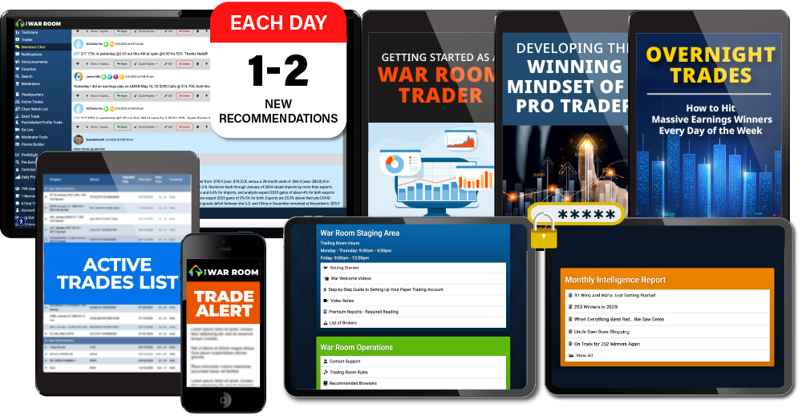
- 12 Months of Research and Trade Recommendations in The War Room
I like to give one to three trades every day to War Room members. You don’t have to trade all of them. But I want you to have the chance to get at least one winner every day.
- The War Room Alert System
Even when you can’t be in The War Room, I’ll alert you when major profit opportunities pop up through our alert system.
- The War Room Headquarters – Video Series
This includes our in-depth Options Master Class – featuring details on how to set up your options trading account, how to get approved for options trading, how to “hack” earnings season with strangles, how to read the 3-minute chart, and more!
- The War Room Headquarters – Premium Reports
Here, you’ll find easy-to-follow guidelines for some of our top trading strategies, including…
- Overnight Trades: How to Hit Massive Earnings Winners Every Day of the Week
- Magic 9 Profits: How to Play 9 Stocks for Portfolio Riches
- The 10X Profit System
- Insider Strategies for Smart Money Trades
- The Rule of 5 Profit System
- The War Room Headquarters – Monthly Intelligence Reports
Every month, I’ll feature a summary of the most important market events. I’ll outline our year-to-date progress, list our biggest winners of the month, give you a snapshot of our top member success stories… the works!

With all these resources...
You’ll have everything you need to succeed in The War Room.
This is not “go figure it out on your own.”
We show you. We guide you. We hold your hand. We teach you what you need to know. And we want to ensure you have all the tools in your toolkit to succeed.

Bottom line...
The War Room gives you an unprecedented opportunity to get success like you’ve never achieved before.

Just How Much Could You Make With Our Research and Recommendations?
How much does The War Room cost?
When you consider how much ONE TRADE can make you...
I think you’ll agree...
It’s truly a bargain.
Look at Robert D.
He got in a FedEx trade... and raked in $11,520 overnight. He said...
Robert D.:
“FDX was good for me... Bought 8 put contracts at $3.40... Out of them this a.m. for $17.80... Made $11,520.”
And then there was John...
He made a shocking $38,000 on the Roku play (a 53% gain in four minutes)!
So you can see how our normal retail price of $7,500 is more than justified.

However…
I’ve always strongly believed that trading isn’t just about money.

It’s about freedom.
Being able to vacation where you want… do what you want… help who you want.
It’s not just money.
And that’s why I don’t want money to hold you back from achieving your own financial goals.
So... for a limited-time only…

As part of our LIVE War Room demo…
We’re doing something we’ve never done before.
Today, when you buy 3 months of access to The War Room… we’ll give you 9 months free.
In other words…
You can get a full year of access to EVERYTHING I mentioned above…
For just $1,875.
I think you’ll agree...
That’s a steal.
Especially because I’m backing your subscription with TWO incredible guarantees.
First, there’s my 90-Day Money Back Guarantee.
The way it works is simple.
In your first 90 days, I promise you’ll see an average of at least 1 winning trade - every day the markets are open - per our track record, or we’ll give you your money back.
All you have to do is chat, call, or email our VIP Concierge Team after your first 90 days, and if I haven’t delivered on my promise…
You can request an immediate refund - minus a 10% processing fee - no questions asked.

SECOND…
I’m also backing your subscription with
my unheard-of Performance Guarantee.
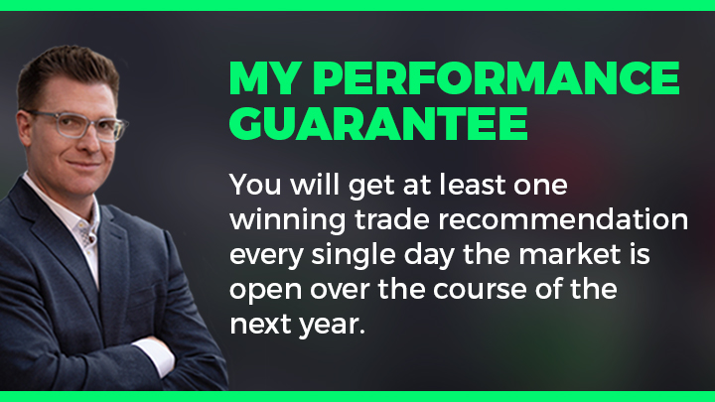
Here’s what that means...
In one year, there are 252 trading days.
And if the War Room model portfolio hasn’t shown you AT LEAST 252 winning trades after one year...
Give my team a call and you’ll get access to all of the tools, resources and trades in my War Room...
For another full year… ABSOLUTELY FREE.

Think about it…
If you accept this phenomenal offer RIGHT NOW...
On a per-trade basis... that works out to less than $8 per winning trade.
Now, I’ve seen many other services charge $5,000 to $10,000 a year...
For a measly 52 trades... or less.
So I think promising 252 winning trades makes this a bargain.
But I’ll let you decide.

To start getting our trade recommendations in The War Room today, just fill out the form right now.
Or if you’d prefer to speak with someone personally...
You can call our friendly customer service team at 888.215.5311 or 410.864.3083.
To your success,
Bryan Bottarelli
Enter Your Discount CodeSubmit Code

OPTION 1: One Year of The War Room -$7,500 $1,875 GOOD DEAL STARBURST
OPTION 2: Unlimited Access to The War Room $20,000 $2,797 BEST DEAL STARBURST
Includes everything in a one-year subscription, plus special access to our proprietary pre-earnings volume scanner so you can stay ahead of any big earnings moves!

