Trade Where Millionaires Trade

Enter The War Room & Join a Secret Group of Ultra-Wealthy Investors Extracting Up to $494,100.00 Each Day in the Markets
===============================================
Imagine a massive boardroom….
Where every trading day at 9:30 AM….
Someone walks in with $250,000.00 in cash….
Dumps it onto the table….
Spreads it around….
And then - walks out….leaving the room unlocked and totally unchecked.
We’re talking about a room with a quarter million bucks – in cash - just waiting for anyone to walk in…..claim their share of the money…..and walk out.
And now…..imagine this…..
There’s a small group of traders….
Many of whom are millionaires….
Who know about this room.
And every day….
They walk in – looking to claim a portion of this money for themselves.
Someone claims $2 grand…
Someone claims $5 grand…
Someone else claims $7 grand…
And others take $10, $15, or even $25 grand….
You’ve got a room full of millionaires just divvying up profits amongst themselves each and every day!?
Can you picture it?
Well, if a magical room like this did exist….you’d want to know a few things – like…..
Where it’s located…
How to get there….
How long the money will last….
If all this even legal…
And of course, what’s the big catch????
Alright - enough of the fantasy story – let me cut to the chase…
First off, there IS a room.
It exists. Right now.
Of course, no one is literally dumping “free money” onto a table
But every trading day – there is a room filled with hundreds of millionaire traders – who gather together from all over the world – looking for opportunities to claim huge sums of cash – sometimes hundreds of thousands of dollars at a time.
Secondly, this room has been consistently generating wealth.… behind the scenes….without much notoriety or fanfare...for the last five years.
And most importantly – this room is open to anyone who is willing to enter.
The One and Only trait shared amongst its members is a strong desire to get rich.
So…before handing you the keys to this room, let’s get a few things straight.
First, I’m professional trader Bryan Bottarelli.
And what you’re about to get plugged into is unlike anything available across the entire financial universe.
Once you enter this room….
See the other millionaire traders….
And become exposed to the wealth being created….
Your life will never be the same again.
So how exactly does all this work?
Let me show you how you can start earning your share in a massive pile of cash – just sitting there for the taking…
*Graphics: Display this Full Screen
On September 25th 2024… a Gigantic Stack of Money was Dumped ont0 the Table… Waiting for Someone Like You to Reach Out and Take It
On September 25th, I spotted a mountain of cash primed for the taking in Micron Technologies (MU).
You see… it’s my job in this millionaires’ club to find the stocks to target on any given day.
In this case, Micron was in the perfect position to spit out cash.
So, I posted one precise trade to everyone inside the room.
It was an option trade – designed to pay off no matter if MU made a big move higher OR lower.
It looked like this…
Graphics: MU BUY Alert
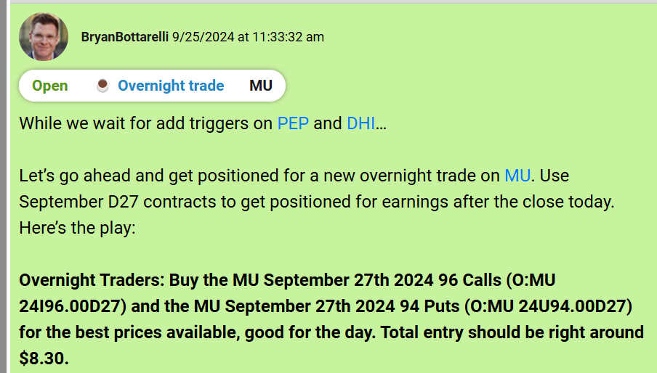
10 minutes after I posted the trade, I tracked the volume so I could estimate the amount of money potentially being generated by my followers.
I watched those exact MU contracts trade at an average entry price of $8.26
This was our millionaires club moving in.
The next day……MU blasted off.
The trade was quickly profitable….
So, I issued a sell.
Graphics: MU SELL Alert
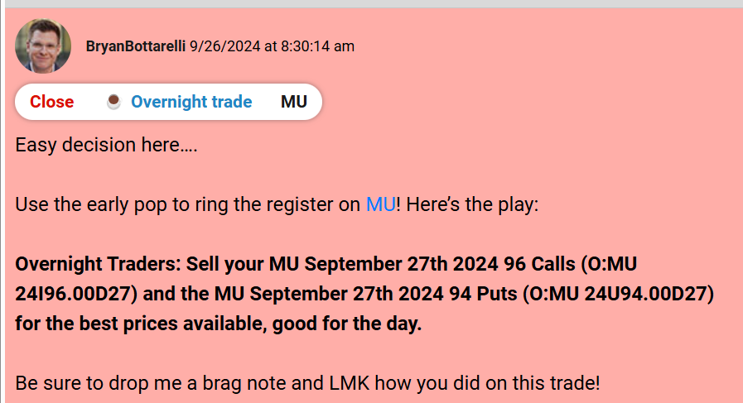
10 minutes after posting that SELL, I once again tracked the volume…
And watched those same MU contracts trade at an average exit price of $16.88.
It’s pretty safe to assume that most of this volume was generated primarily by my traders in the room.
The total profit generated in those couple of hours?
As much as $484,444.00
All of it “dumped on our table”, just ready to be divvied up.
A member called IlliniOne took over $3,400…..
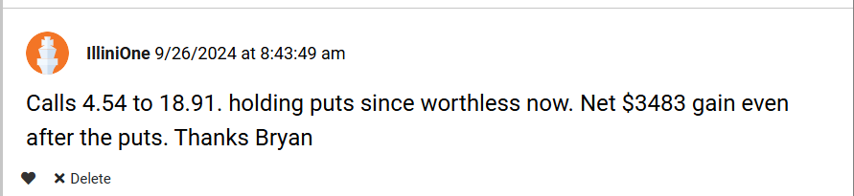
A member named Ranger6 took over $6,400….which even accounted for two losing trades.
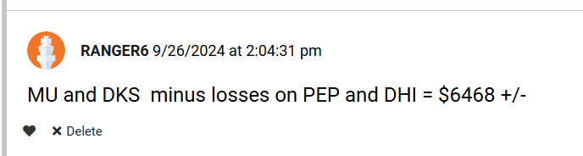
Alma reported a 99% profit….
Roadmahle reported a 176% profit….
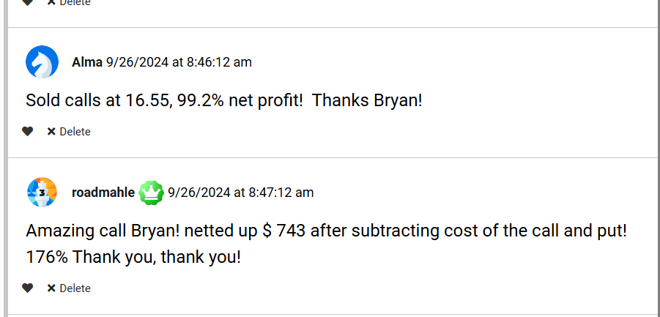
While Ljspy called the trade “one of your best yet”
Chris68 agreed….saying the trade was “outstanding”
*Graphics: Highlight these on screen as I read them off
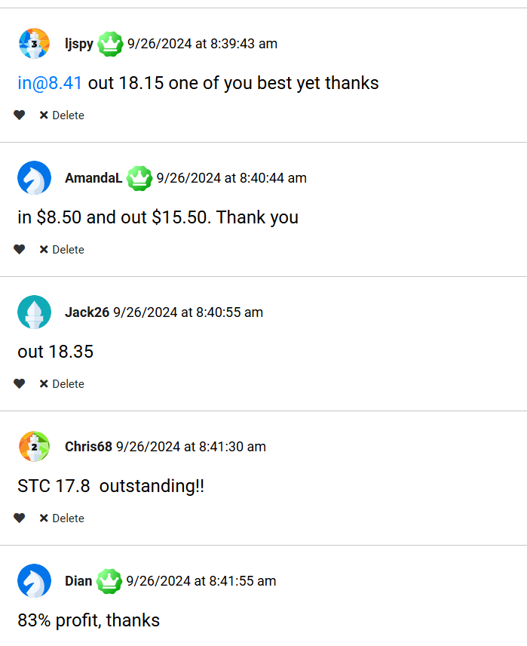
KTDID took over $880….
While scottg reported 110%....
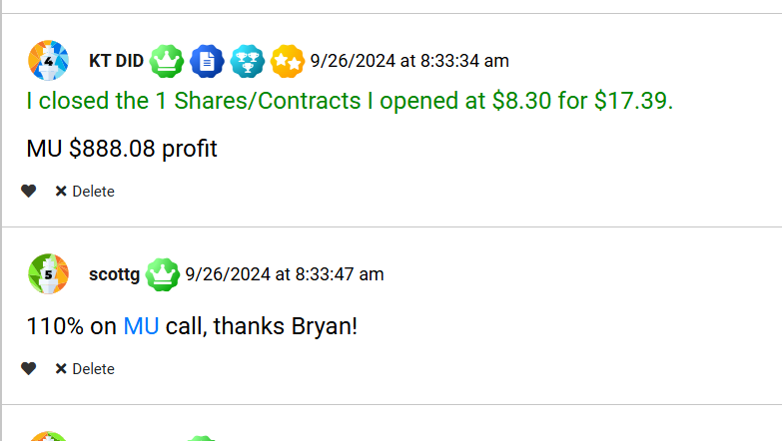
This is the sort of cash piles that my elite group of traders are divvying up day after day….
Take July 15th 2024….
*Graphics: Go Full Screen again with this headline- similar to the one from September
On July 15th 2024… Another Gigantic Stack of Money was Dumped ont0 the Table… Waiting for Someone Like You to Reach Out and Take It
I spotted a mountain of cash primed for the taking in Occidental Petroleum (OXY) – and posted a trade
To best track the entry price of my followers…
I watched these OXY contracts trade at an average entry price of $2.65.
Everyone in our room was loading up.
And then… the payoff.
Later that same day….
OXY started climbing…
The trade was quickly profitable….
So, I issued a sell.
10 minutes after posting that SELL, I once again tracked the volume…
And watched OXY trade at an average exit price of $3.14.
Once again….it’s safe to assume that this volume was generated primarily by my traders in the room.
And the total profit generated in those couple of hours?
As much as $96,873.00.
All of it dumped on our table, just ready to be divvied up.
Graphics: Highlight these as I read them
A member named “coachrogers” took $2,500 from that pile of $94 grand. He said…”already up twenty five hundred bucks”
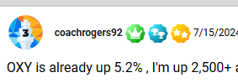
Less than a week later, July 23rd, we had another cash grab on Capital One Financial (COF)
Graphics: Full screen similar again similar to the September and July ones above
On July 23rd 2024… Yet Another Gigantic Stack of Money was Dumped ont0 the Table… Waiting for Someone Like You to Reach Out and Take It
10 minutes after I recommended our members trade it, our group started piling in….
And I watched as our members pour in around $3.68 per options contract.
And once again…
Later that same day….
COF started moving up…
The trade was quickly in the money…
So, I issued a sell.
10 minutes after the SELL post, I once again tracked the volume…
And watched as those COF contracts trade at an average exit price of $4.47.
Once again, I can reasonably guess that most of this volume was generated by my traders in the room.
End result: As much as $ $82,713 in profit was split that day among my traders in the room.
One member named “James GBS” took $1,100 from that pile of $82 grand. He said…”thanks BB, eleven hundred profit to start the day”
Graphics – Highlight this as I read it off
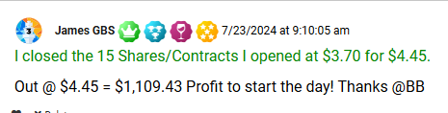
So…as you can see….
On any given day….
There are so many opportunities to stack giant piles of money on the table….and split this pile among those who choose to get in on the trade….
Graphics: Full Screen the following, Adding to each cash pile as I read it off:
Watch Our Cash Pile Grow…and Grow….and GROW!
Just take a look at what happened when we had one of our best three day stretches…
On August 12th: $79,261 got split up from my AMD trade
On August 13th: $49,210 got split up from my MNST trade
Also August 13th: Another $37,980 got split up from my UBER trade
And on August 14th: $110,448 got split up from my WMT trade
And again….that was all in just three days…
From August 12th to August 14th…
That’s over $275,000 in pure, generated trading profit that’s being split up between members in my room.
Graphics: Highlight this part as I read it off
No wonder LesP said that he’s “holding his breath while making money – KEEP GOING!”
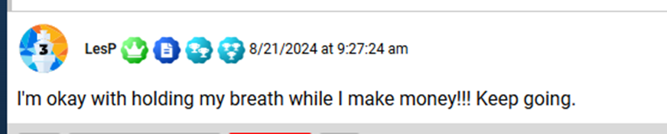
Now, I want to be perfectly clear…
This was a phenomenal 3-day stretch…
Which is what could happen if the set-ups and opportunities all work out properly.
But, please don’t expect to see a new $275,000 cash pile every 3 days.
Some days could be less….
Such as only $100K…or $50K…..
Some days – there’s no money to get dumped onto the table.
Nothing is ever guaranteed.
And please understand - you can’t judge the performance of a trade just on the size of a cash pile.
As always, it all depends on many other market factors…
Such as how many people enter the trade….
How many traders are logged into the room - and who are active that particular day….
How volatile the market happens to be….
And of course….
None of the cash piles we’ve discussed here are ever, ever, ever guaranteed.
You see, trading is an artform – which requires precise skill and years of real-world mastery.
And every millionaire trader knows…
That some trades win….and some trades lose.
But picture this for a minute…
You wake up in the morning… take a shower, watch the news, get some breakfast.
Then you hop on to your computer.
Log in…and enter the room….
And you catch some trade set-ups that I happen to like…
Or, you read the pre-market chatter….and you like some other trade set-ups that our fellow millionaire traders are discussing…
And if the timing is right, you make one simple trade.
Then, you walk away to refill your coffee…
Or get the Amazon package sitting at your door…..
And a few minutes later, if the trade goes your way, you come back to hundreds or thousands of extra dollars in your account.
For members of this room, this isn’t some hypothetical scenario.
This is happening….
Right now…
Every day….
Inside The War Room.
We’ve been locking in wins all year long.
So let’s walk through this together….
Because the enormous cash piles are getting bigger and bigger with each passing day…
Graphics: Full Screen – adding to each cash pile once again
The Enormous Cash Piles Are Getting Bigger and Bigger With Each Passing Day
On August 20th, $118,932.00 was dumped on the table… ready for our traders to pick up.
On August 21st, $111,453.00 was dumped on the table for our traders to pick up.
On September 11th, $174,369.00 was dumped on the table for our traders to pick up.
September 9th, $212,047.00 was dumped on the table for our traders to pick up.
And on November 4th, a whopping $494,100.00 was dumped on the table for our traders to pick up.
And starting today - THIS could be your new life…
Imagine if you had the chance to claim your share of these cash piles of profit….day after day.
For instance….
Just imagine if you were inside the room from August 20th to August 21st of 2024….
If so, you could’ve taken a part of a quarter-million dollar overnight windfall for War Room traders.
This time we targeted the IWM, the ETF that tracks the Russell 2000, for our cash grab.
We told our members what to do.
And then…..they went to work.
In the minutes after I alerted them to the trade, I tracked IWM trade for an average entry price of $1.99….
Which sold the next morning for an average exit price of $3.03….
This trade generated $207,272.00 in profit – which was split among any members who made the trade.
But that was just the start…
Later that day, right after I posted another recommendation, we traded TJX for an average entry price of $4.95….
Which we sold the next morning for an average exit price of $6.99…..
This trade generated another $118,932 in profit …
Bringing the total to $326,204 in pure trading profits.
Just imagine being part of the group that’s splitting that pot up amongst each other.
As you can imagine, our board was ON FIRE that morning….
Like CoachRogers, who collected $15,000…..
And BradR, who collected $8,300….
Graphics – call out the $ figures as I read them off
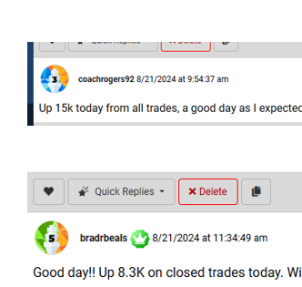

Then there’s MakePutts, who cashed in $2,400 before 10 AM….


Or Ruthann, who simply screamed with joy….“Buh-Rilliant”
Or ChuckB, who summarized it best by saying…. “That’s the way to wake up!”
Graphics – call out the language/words as I read them off

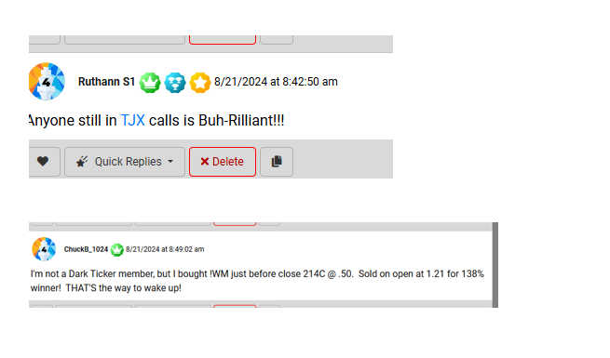
When you see notes like this…
Of ecstatic members who are generating over a quarter-million dollars in profits on any given morning….
You can truly understand why it’s time to take a moment – and imagine yourself RICH.
And I’m talking very, very rich…
Because once you see how we teach you to trade….
And once you master these simple techniques for yourself…
You can make more money than you ever thought imaginable.
Consider one of my students named John A.
He wrote me a message in June of 2024…
Saying that on one single overnight trade…
He made $317,000.00 in 4 accounts with 300 options on IWM…
And made another $180,000 with 200 options in QQQ….
He reported entering for $1.50….and exiting for $4.50….across multiple accounts.
That’s nearly half a million bucks – from one single trade – all off two simple overnight trades.
Legal note: testimonial attached with starting stake
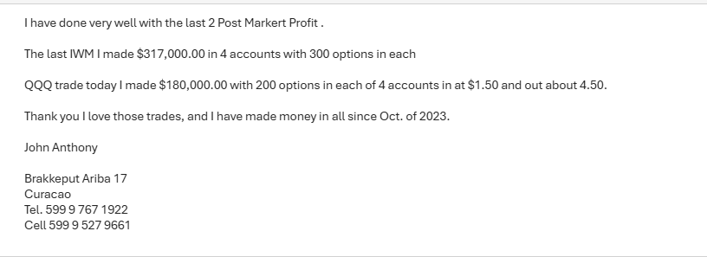

Of course….
This is one of our very best examples – and most members will not be able to generate $50K, $100K, or even $300K in profits per trade….
But as you can see….
Some of our members have grown so wealthy, they’re able to go truly BIG on these trades.
Because obviously, the more you put into the trade upfront, the greater the potential profits.
This is what’s so incredible about our community.
It has the power to rapidly multiply your wealth….
Truly making a meaningful impact on your life.
Take the story of David D...
He started with a $20,000 portfolio - and after 15 months - it grew to $185,000!
He wrote me and said…
My original stake of $20,000 (including wins, losses, and trading fees) ended up being $185,000. I have profited more than my day job paycheck... and that was only part time in The War Room. Here’s to future successes for one and all.
David D 4/5/2021 at 10:40 a.m.

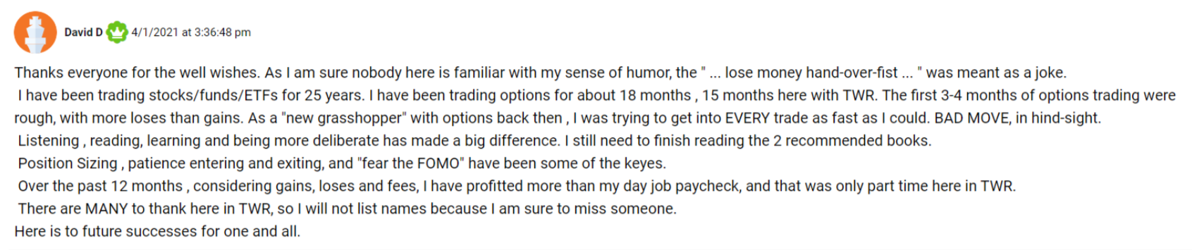

The coolest thing?
He said he made more from his War Room trades than his entire income from his regular day job!
Now David realized a 15-month return that would make even the most seasoned trader jealous.
But take notice of what David said in his note.
His report included wins, losses, and trading fees.
This is a very important point…
Because our millionaire traders recognize that not every trade will go perfectly.
Some trades will generate more profits than others…
While some trades will even lose.
However…..
When I tell you that your life could change…
And to really take a moment – and imagine yourself filthy rich…
I’m not playing around.
This is a life-changing moment that could set you on a path of future wealth – forever.
So, let’s dream for a moment.
Close your eyes….
And yes, I’m serious: Imagine yourself rich
What would that look like for you?
Would you buy a second home on the beach…or maybe one in the mountains?
That’s what I did.
Here’s my second vacation home in Big Sky, Montana – where I go to unplug…relax…and recharge after months of intense, profitable trading.
I have to say….
That sunset never gets old….
Graphics: Show Montana Pics


And…yes…..I will admit….
I also have an expensive vice….
Which is getting the absolute best seats at professional sporting events.
Because there’s nothing like sitting on the floor of an NBA game…right next to the players….

Even my kids will tell you….
The thrill of getting player autographs – from your very own seats next to the bench – is an experience you cannot replicate anywhere else.
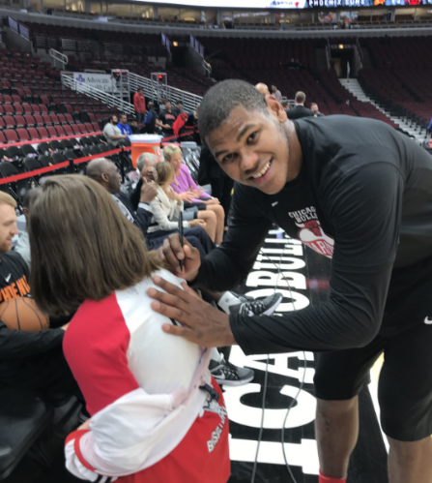
So, let me take a moment – and ask you….
What’s the first thing you’d do if you were rich?
Maybe you’d get yourself the most ridiculously expensive sports car on the market.
Well….that’s exactly what one of my members Shawn told me….
Here’s her video laying out her performance goals…
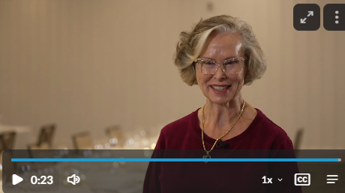
https://oxfordclub.wistia.com/medias/zavp7yf601
Show Video of “I’m going to get myself a new Bently”
Other members are excited about reporting an +80% success ratio…
Or making 3x their money on one MSFT trade overnight!
Video From the 36-second mark to the 51-second mark:
https://oxfordclub.wistia.com/medias/b6fkiyxdqw
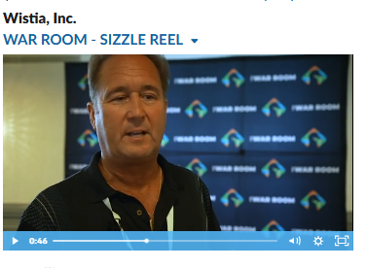
Or how about GailK….
Who speaks about having the comfort of knowing that you’re part of a community of millionaire traders – who are with you – inside the room – every day the markets are open.
Video from 4:05 to 4:11
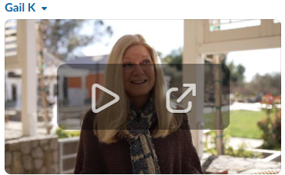
https://oxfordclub.wistia.com/medias/2kho833ctm
After seeing these testimonials…..
Take a quick moment – and ask yourself….
What’s the first thing you’d do if you were rich?
Maybe you’d pay off your mortgage…
Or maybe you’d book a first-class vacation to the Maldives…
Or maybe you’d set up a trust funds for your kids…which sets them up for life….
Maybe you’d invest in a winery in Napa….
Or - maybe you’ll do all of the above?
The point is…
When you have money – your world opens up.
Doors that were previously closed – all of a sudden become open…
People will start to listen to your stories…
Opportunities that you’ve never dreamed of are now magically landing at your fingertips.
Successful people become drawn to you…
Sharing their best ideas and intimate passions with you….
Perhaps even inviting you on trips or experiences you’ve never dreamed possible before…
That’s how you really…truly….get ahead in life.
It all starts with surrounding yourself with successful people….
Those who are at the very top of their respective craft.
And absorbing every single ounce that you can learn from them.
And my friends, that’s exactly what I’m offering you today…as part of our elite trading community inside The War Room.
Because, quite honestly….
If you listen to people who spout the “conventional wisdom” on how to get ahead in life, you’ll hear things like….
Commit years of your life climbing the corporate ladder….
Or ‘dump tens of thousands of your dollars into higher education’…
Or even, keeping it super vague by saying ‘just start your own business’….
Yes, I admit…
Those are all respectable pursuits - that I don’t judge if that’s what some people choose.
But, in my experience….
There’s a far better way to rapidly get where you want.
And that’s the big secret…
If you take nothing else from this video – take this…
The very best way to make the most amount of money…
By committing the least amount of time…
Is to surround yourself with successful, millionaire traders…
And emulate their exact moves.
Soak in every move they make.
Buy exactly what they’re buying….
Sell exactly when they’re selling….
Observe how they navigate volatile markets…and find opportunities to make money even when stocks fall…
This is how to truly get ahead in your financial life.
I can say this to you SO confidently…..because this is the exact path I’ve taken myself.
Was it easy?
No.
Did I get rich quickly overnight?
Also no.
Generating wealth is not a straight line up.
But as anyone in our room will tell you, dedicating yourself to learning from others WILL improve results.
Learn from the successes and failures of our millionaire trades…
Because every one of them will tell you that if you’re not prepared to weather some trading losses…then this isn’t right for you.
And of course, if you start with $100, then temper your expectations.
Not everyone will turn $20K into $185K like David D explained to you above….
But I can tell you…..
If you’ve been looking for a community of successful traders – one that’s littered with success stories…
Then what we’ve created is precisely the community you’ve been looking for.
Up markets…
Down markets…
It doesn’t matter.
Our goal is to generate new cash piles for you to enjoy – every single day.
For example, when Covid caused the market to crash in 2020, our millionaire members didn’t panic.
Instead….they got to work.
Dumping piles and piles of cash onto the table.
George L is a great example.
Just four months earlier, he joined us.
And he didn’t have a CLUE how an option trade worked.
But get this...
He started with $165,000... and using what he learned in the War Room…
He turned it into peak gains of over $2 million...
All during the Covid market panic!
Sure, George is a unicorn. We’re not here to say otherwise.
His experience is not typical... and we can’t promise you’ll have the same results he did.
But nevertheless….his story was incredible.
And this shows you what being among an elite group of traders can do.
Surrounding yourself with the world’s best traders – and absorbing how they think – and how they trade - will put you light years ahead of everyone else…
You will leapfrog decades of “learning from your mistakes”….
And jump the line – rapidly accelerating your wealth-building journey…
All while leaving everyone else in the dust.
And along the way, you’ll learn how some of the best traders in the world are generating life-changing wealth – day after day.
This is precisely what I did back in 1999….
When I traded in the Apple Computer put in the Chicago Board of Options Exchange.
I identified the top trader in the pit…
Pushed and shoved my way into the front of that sweat-filled crowd….
And stood shoulder to shoulder with him.
For eight hours a day….5 days a week….
I absorbed exactly how this trading master earned his 7-figure trading salary.
Throughout the dot.com boom….
And the dot.com bust….
I watched this legend put on an absolute trading clinic.
It was like my own, personal master-class in winning trading – and profiting in volatile markets….
Where I had a front-row seat – every single day.
And best of all, this master-class trading clinic was available to nobody else but me.
It was an experience that shaped me forever.
To this very day, over 25 years later, I credit all of my success to this one-of-a-kind experience.
What I learned in the Apple pits…..navigating the rapid market ups and downs…..has formed me into the trader I am today.
So, when my trading mentor passed away – I knew that I was at a crossroads.
With the CBOE trading pits all but extinct…
And electronic trading becoming the norm….
I decided to create something that wasn’t available anywhere else in the world.
I founded Monument Traders Alliance – and built the world’s most advanced trading research chat room.
And as you know…
It’s called….The War Room
Graphics – insert War Room animation and logo here
The War Room is unlike any other service you’ve belonged to…
It’s a live, real time, member’s-only, research, and chat room dedicated to trading…
Focused entirely on one thing: To Generate Wealth for All of Us.
On any given day, over half of the members logging into The War Room have said they have a net worth of over $1 million.
That means you can stand shoulder to shoulder with millionaire traders…..
Much like I did starting out on the CBOE….
Watching them collaborate…..research….and generate obscene amounts of wealth – day after day.
So here’s how it works….
Every trading day at 9:00 AM EST….30 minutes before the opening bell on Wall Street….the War Room opens….
And the most elite group of traders, speculators, and entrepreneurs log in – and begin sharing their top trading ideas for the day.
As you’ll quickly discover….
The War Room is the most unique, immersive, and profitable trading community you’ve ever belonged to.
In fact….
I created this unique platform to replicate the floor of the CBOE…
Where traders gathered in a trading pit to make enormous sums of money – simply by trading together.
But now…thanks to technology….
We’ve re-created the CBOE trading floor experience….Virtually.
Which is infinitely more powerful.
Because now….the top traders are not only gathering on LaSalle Street in downtown Chicago…
But rather…
They’re coming together from across the world to collaborate….strategize…and share their very best trading information with one another.
And it’s here….
Inside the War Room…
Surrounded by the world’s top millionaire traders…
Where I post my top trade ideas for you….LIVE…..in real time.
This is where my members can share the details of the profits that you’ve seen in this presentation after cashing in their winners.
And speaking of profits….
I just left off telling you about the $207,272.00 in profits split up on August 21st…
Followed by another profit of $ $118,932 in profits shared later that day….
Brining the one-day total to $326,204 in pure trading profits.
But why stop there?
Later that afternoon…..
After counting all the money from that morning….
I recommended two new trades.
And the cash pile continued to grow….
August 21st – 22nd: Another Gigantic Stack of Money Was Dumped Onto the Table….Just Begging For You to Pick It Up
The first new trade on August 21st was URBN options – which were entered for an average price of $3.74.
The next morning, on August 22nd, those contracts were sold for an average exit price of $4.91….
That was as much as another $111,453 in profits to split amongst our group.
The second trade on August 21st was DXCM – options which were entered for an average price of $3.78.
One once again, that very next morning, on August 22nd, those contracts were sold for an average exit price of $4.67….
Which generated another $86,152.00 in profits to be split amongst the group.
That’s another $197,605 in pure profit….all coming within a 2-day period.
At this point, War Room members were starting to feel generous.
Kev13 said “lunch is on me”
Graphics: Highlight these as I read them off
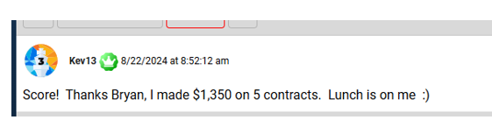
ThomI said he’s going to use his profits to splurge – and get himself a full body massage…
While A747guy doubled his weekly performance goal.
And I don’t want to forget about chrisD, who made $12K on the day…..and wanted to gain $20K on the week…but ended up closing the week up +$19,000.
Still….pretty darn strong.
He said it best when he posted that trading inside the War Room is the ”best job in the world”
Graphics: Highlight these as I read them off
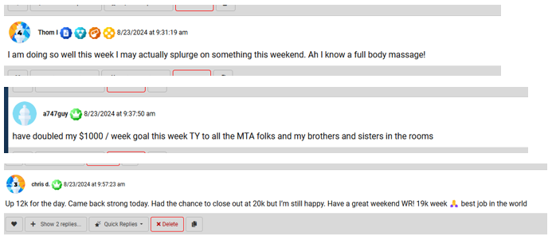
And look….
I really want to stress this…
I’ve only shown you a small, small fraction of the profits that have been generated inside The War Room.
I could walk you through similar stories on Dollar Tree (DLTR)….
Which generated a cash pile of $191,664.00 on September 3rd….
Graphics: show arrow on DLTR from $95 down to $65 and flash copy on screen “This Down Move Generated Over $191,664 in Profit for War Room Members”
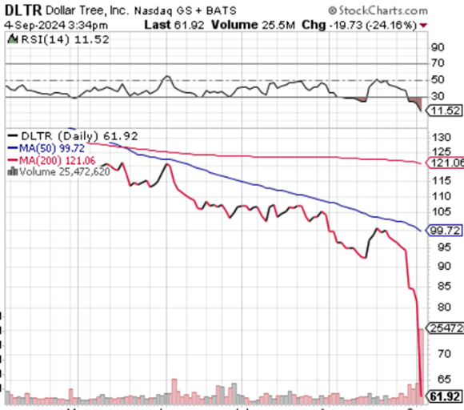
The amazing thing with Dollar Tree?
Traders actually generated these profits because the stock dropped like a rock!
Truly elite traders find ways to make money no matter which direction the markets go.
Which is exactly what happened with DLTR.
Or look at Hormel Foods (HRL), which generated a cash pile of $105,879.00 when it also got crushed on September 3rd….

Graphics: show arrow on HRL from $33 down to $30 and flash copy on screen “This Down Move Generated Over $105,000 in Profit for War Room Members”

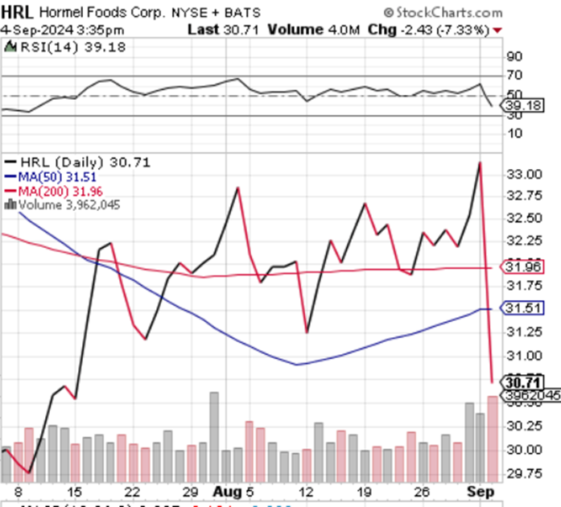
That’s another $297,543.00…..
Nearly one third of a million dollars…
All generated in one day – off two stocks that were falling.
And once again…
These winners on DLTR and HRL still only represent a fraction of the wins that we’re taking.
Just scroll through this list…
And you’ll see winner after winner after winner…
In fact, let’s scroll through our very best overnight winners….
So you can see for yourself…
Advanced Auto Parts….+293%
FedEx….+189%
Cisco….+125%
UPS….+120%
Ciena….+113%
And guys, please realize…
Every single one of these winners represents a massive pile of cash that my members are splitting up.
Just look at all these winners!
Graphics – scroll through this list on full screen
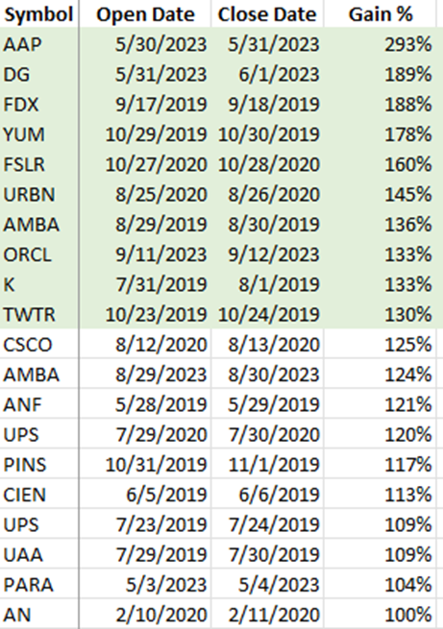
Of course, not every trade will be a 100% winner.
Year to date, our short term trades are averaging +6.4% every 3 days.
Guys….that really adds up.
Plus our longer-term trades are averaging +21.3% every 152 days.
When you add the short-term winners with the longer-term winners, that’s how you generate yourself some very substantial cash.
And that’s my #1 goal with The War Room…
Finding opportunities to generate massive profits in any market condition.
You see, anyone can make money when stocks are moving up.
But only the most skilled, talented traders can ALSO MAKE MONEY when stocks are moving down.
That’s the unique skill I was taught being on the CBOE floor during the dot.com boom…and also during the dot.com bust.
Learning how to trade both sides of the market – while maintaining profitability – is what separates the true traders from the imposters.
Living through this unique and volatile time period taught me that most people didn’t have my CBOE trading experience.
Sharing a $300,000.00 pot amongst a small, elite group of traders – while two stocks are getting absolutely crushed….isn’t’ something people get to experience in their entire lifetimes….let alone on a random Tuesday in September.
That’s why I set up The War Room with two things in mind…
1) I wanted people to be able to see exactly how I learned how to trade on the CBOE. That way, they could be by my side... and receive my real-time market analysis and trade recommendations.
And...
2) I wanted The War Room to be easy.
I know how much work it took for me to become a professional trader. It was tens of thousands of hours….easily.
But with The War Room, I wanted people to be able to jump in for 20 minutes... make a trade... lock in a profit... and then go on with their lives.
I didn’t want people to feel like they had to be glued to a computer screen all day.
So, that’s exactly what I did...
And in the five years that followed….
The War Room has turned into the premiere spot for anyone who wants to learn how to make significant amounts of cash in a very short period of time – directly from millionaire traders.
The most gratifying part?
Seeing people turn into Top Gun traders - blasting out winners like they’re F16 Fighter pilots taking down Russian MiGs over the Indian Ocean.
Like Keith...
All he had to do was log in... follow my moves... and soon he was hitting home run after home run
He wrote me and said…
By following War Room strategies….
He turned $1,200 into over $31,000 in just over 1 year!
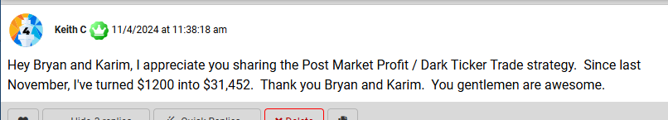
That’s what gets me FIRED UP about The War Room.
Remember at the beginning….
When I told you that trading allows you to make the most amount of money – for the least amount of committed time?
Well…..here’s Keith….…..
Who didn’t have to develop any special skills to trade like this.
He just logged into the room….mirrored a few trades…..
And he 30x’d his account in just over 1 year!
And again…..I want to be very clear…..
Watching your trading account grow by 30X is certainly one of the most extreme success stories I’ve heard. But I couldn’t be prouder to know he was able to do it.
Thanks to The War Room, all he did was follow my trade recommendations.
Using the same techniques that I share with you every day inside the War Room, I’ve personally built up a $6 million trading portfolio from scratch.
I bet everything – my entire livelihood – on my ability to trade.
And it’s these exact same proven methods and strategies that I’ll share with you….every single day…inside The War Room.
And speaking of proven strategies…
This perfectly leads into one of my very best trades – which occurred just a few days after we made all those profits on September 3rd.
Graphics: Add another Cash Pile Graphic
September 9th: Another Massive $212,000 Cash Pile – Just Waiting For You
On September 9th….Oracle was setting up for a big, big move.
So, War Room traders entered ORCL calls for an average entry price of $ 9.71….
And when ORCL blasted higher the very next day….
They were sold for an average exit price of $13.78
This was another monster profit day – which generated $212,047 amongst our group.
Graphics: show arrow on ORCL from $140 up to $1600 and flash copy on screen “This Up Move Generated Over $220,000 in Profit for War Room Members”

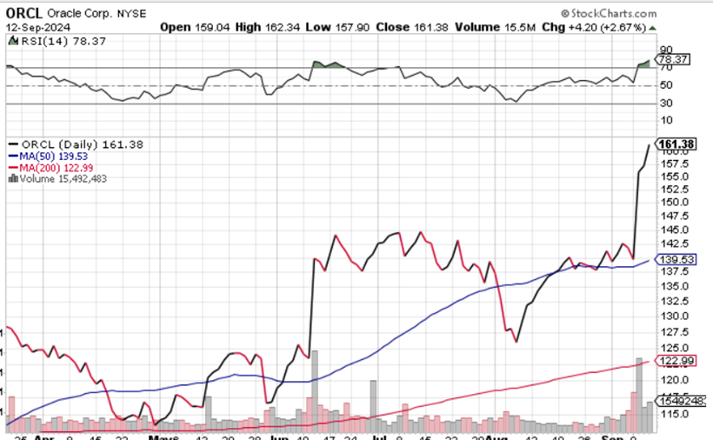
But an even more explosive blastoff came just a few days later on Signet Jewelers (SIG).
Graphics: Another Cash Pile Full Screen
September 11th: Another Massive $174,000 Cash Pile – Just Waiting For You
On September 13th….just four days after splitting up nearly a quarter million dollar pot on Oracle….
War Room traders entered SIG calls for an average entry price of $7.69.
The very next day, the online jewelry store shocked Wall Street – and blasted aggressively higher.
Members sold calls for an average exit price of $9.90, good for a jaw-dropping profit total cash pile of $174,369.00.
Just imagine….
On a random Friday in September, you and your fellow traders are all divvying up a pot of just under a half-million dollars.
Graphics: show arrow on SIG from $75 up to $86 and flash copy on screen “This Up Move Generated Over $174,369.00 in Profit for War Room Members”
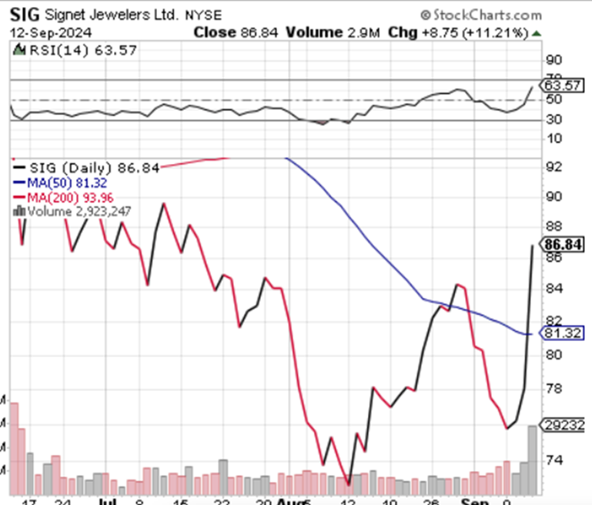
Well, you don’t have to imagine it.
Because it’s here.
Right now.
Just waiting for you to enter…
With the chance to start claiming your share of the profits.
Like I said above, the only trait shared amongst everyone in the War Room is a desire to get rich.
If you are not interested in learning how to claim your share of all the profits I just showed you, then I totally understand.
No hard feelings.
Thank you for your time – and I respectfully ask that you exit out of this presentation right now.
But if you want to know more, and you are interested in claiming your share in the profits that we’re generating on a day-to-day basis…
Then I’d like to officially invite you to join our elite group of millionaire traders inside The War Room.
The moment you join our community….
You’ll receive a wealth of trading resources, intelligence, and educational materials.
This entire Master Class trading library is designed to help you hit the ground running….
So you can start taking your share in profits immediately.
The first report you’ll receive is titled….
Overnight Trades: How to Hit Massive Earnings Winners Every Day of the Week
Graphics – please create an image for this report
This new report gives you a step-by-step guide on how to trade Overnight Trades…
Which are the monster winners I just showed you on ORCL and SIG.
This easy-to-read guide breaks this entire strategy down – step by step…
So…if you chose, you can start making these trades alongside us…the moment you join.
After that….
I wanted to make it as easy as possible for you to get comfortable being part of our group.
Because at this point, you might be thinking….
What exactly is all of the “option” and “contract” language that you’ve been hearing me talk about?
This next report answers that exact question….
Stock options are a great tool that you can use to get in much cheaper on a stock and produce very big gains.
Each option play is based on contracts - rather than shares of stock.
Call options are simply bets that a stock moves up.
Put options are simply bets that a stock moves down.
But instead of buying 100 shares of stock…or shorting 100 shares of stock…
You can use a call or put option to CONTROL 100 shares of stock….all for a mere fraction of the cost of buying or selling that stock outright.
This is how to leverage your money at a very high rate….
Which is the true secret to most of the explosive gains you’ve seen throughout this video.
I explain it all to you in this easy-to-read guide titled…
“Getting Started as a War Room Trader”
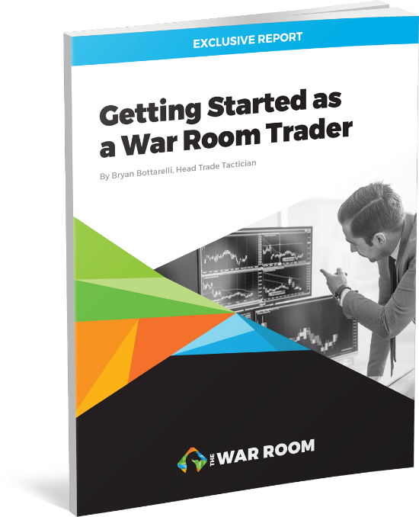
This manual contains everything you need to get started following us in The War Room.
For instance….
It shows you all the basics you need to hit the ground running, such as….
What a BUY or a SELL recommendation looks like in our trading room...
It also gives you a full Options Glossary – which is explained in plain English – so you know exactly what every trading term means.
You’ll also get my exit strategy, which is called….
Secrets of the Scaled Selling Technique
This technique is the very best way to limit your risk – all while maximizing your profits.
And it’ll also reveal how you can use one simple number to know – at any given moment….
Your trades’ Percent Chance of Winning.
Taken all together….
This simple to read guidebook will tell you exactly how to start using War Room recommendations to make winning trades.
But that’s not all…
You’ll also get a 3rd report titled….
“Developing the Winning Mindset of a Pro Trader”
And this one’s really unique….

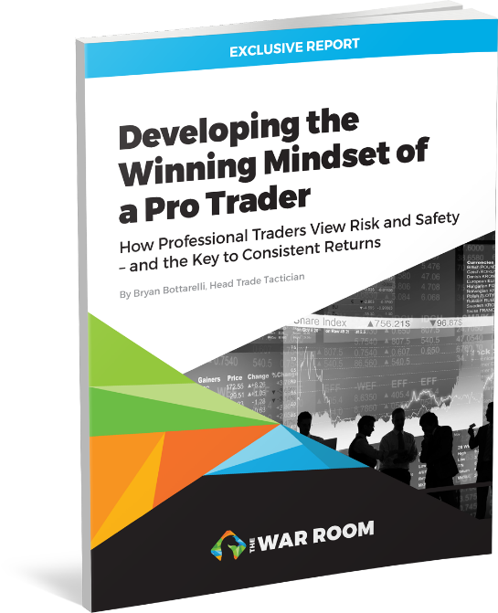
Because being inside the Apple Computer pit….
In the heart of the Dot.com boom and bust cycle….
Prepared me to trade volatility in a way that still influences my trading today.
You see, I was lucky enough to stand shoulder to shoulder in the live Apple pit – next to one of the top traders on the planet…
Standing next to him….
As his personal trading clerk….
Logging all his trades by hand….
And seeing how he positioned himself to profit off market volatility….
Taught me valuable lessons that you simply cannot replicate today.
In short….
I discovered that winning traders just think differently.
They’re always thinking about “what if” scenarios….
And using those various scenarios to protect themselves….
And ensure that they’ll come out profitable no matter what situation plays out.
In short….
It’s a mindset that sets the millionaire traders apart from everyone else…
And in this report…
I share all the keys to adopting this special mindset into your own trades….
All in one easy-to-read primer.
So, let me quickly review all the benefits you’ll instantly receive as a new War Room member…
- First, you’ll get immediate access to The War Room LIVE trading forum…
- Second, you’ll get my newest report: Overnight Trades: How to Hit Massive Earnings Winners Every Day of the Week
- Third, you’ll also get access to the report Getting Started as a War Room Trader…
- And fourth, you’ll receive another report Developing the Winning Mindset of a Pro Trader.

Just alone….this trading package is enough to set you on the path to massive profitability….

But….the benefits doesn’t stop there…

If you’re worried about not having time to follow all the commentary throughout the day…
Then you’re going to love this feature….
It’s called our War Room Mobile Trade Alert Service

If you don’t think you’ll have time to engage in the War Room trading board all day….
Or if you’re busy with travel or appointments….
Then don’t worry… you don’t need to sit in front of the computer all day – waiting for the next trade recommendation to come in.
Instead….
You can opt in to receive our special…..real time….trade notices…..directly to your phone or email.
Whenever there’s a new trade recommendation…. (We generally do 1 or 2 each day)
No matter if it’s a Buy or Sell…..
You can instantly receive notification right to your phone, tablet or computer alerting you that it was posted.
That way, even if you aren’t logged into The War Room, you’ll always know when a new trade goes out - and you’ll be able to quickly log in to get the full details the moment it happens.
And best of all….
You can turn these alerts on and off as you like. It’s totally up to you.
So…even if you’re extremely busy….
With a regular day job….
Or on the go with other commitments….
You can still get notified when all of our recommendations are sent out…..
Without being anchored to a computer screen.
We created this valuable new feature so that the War Room can work around YOUR schedule.
And keep in mind…
The biggest winners…..
The Overnight Trades…..
Typically get issued in the last hour of the day (between 3:00 to 4:00 EST)
For example…our best Overnight Winners include…
- +293% on Advanced Auto Parts
- +189% on Dollar General
- +188% on FedEx
- +178% on Yum Brands…
- Or +160% on First Solar….
So…if you only jump in to check these trades during the last hour…
That’s fine too!
And I want to really emphasize this with new members.
If you’re interested in acting on these recos, then in most cases, you can get into these trades for $500 or less.
This tells you that our community doesn’t only cater to the mega wealthy…
Yes…..we attract some of the big whale traders, but our membership ranks are also filled with people who are just getting started.
These are people who’ve made a commitment to growing their wealth no matter what dollar amount they started with.
Like SugarDoc, a member who wrote us on August 16th of 2024 – and reported making “the best trade of my life”
He entered for $900….and sold for $30,000…..all in just 5 days.
SugarDoc’s story is so important…
Because being inside The War Room is about learning…
It’s about growing richer by following people who’ve successfully done it before…
It’s about getting your piece of the pie when we find a trade that produces hundreds of thousands in profits.
And look at these results!
$900 exploded into $30,000 in just 5 days!
Way to go SugarDoc!
The fact is, we’ve created our War Room trading community to be accessible to anyone…
No matter of you’re a War Room veteran like BoilerUp…
Who just reported a +500% profit – good for $109,000 – on his 20,000 shares of Rolls Royce….which he entered 3 years ago….and he’s still holding for more!
Or “AmcTom,” who reported paying for his service after hitting 80% on one Dollar Tree trade in one day…..
The point is…
You can easily see that everyone….
From the most novice trader – who’s just getting started…
To the most sophisticated pro traders….
To even the members who simply hang around the board to soak in the experience….and to learn….or to observe what others are trading…
The War Room is truly a community that can benefit everyone – top to bottom.
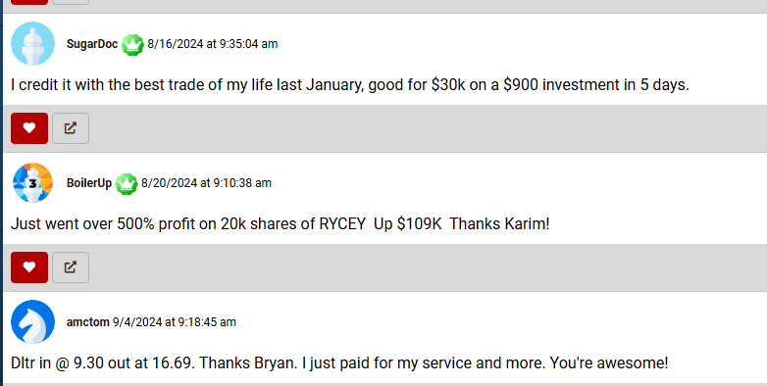
And I can tell you….
The atmosphere lights up in The War Room every time we get to tell members…
“To Ring The Register!”
[DESIGN: Have “It’s time to ring the register!” appear on screen.]
I cannot wait for you to experience this for yourself…
Because there’s nothing else like hitting a monster overnight winner….
And celebrating alongside fellow War Room traders who also won….
Splitting up pots of money ranging from $50K to half a million on any given day….
It’s truly a rush of adrenalin that becomes very, very addictive.
But I’m getting ahead of myself….
Because there’s a ton of other benefits for you to enjoy as a new War Room member…
And the biggest one that I haven’t even hit on yet is my partner….Karim Rahemtulla.
Karim is the perfect complement to me….
Because while I focus on short term technical trading….
Karim trades on fundamentals.
This means that his trades play out over a longer term… like 3-4 months.
Whereas my trades have an average holding time of 2-3 days…
This offers you a perfect compliment of short-term trades…
Combined with longer term trades.

[DESIGN: Pictures of Karim on the news.]

Put us both together…

And The War Room offers you access to a plethora of trading strategies that win in any market environment.

Case in point…

Karim’s value stock pick on Rolls Royce (RYCEY) will go down as one of the greatest investments you’ll ever seen in your lifetime.
It’s so good, in fact, that it has out-performed Nvidia (NVDA).

Graphics – please re-create this chart and say “Karim’s Rolls Pick Has Gained +522% over 2.5 Years – While NVDA Gained 418%”

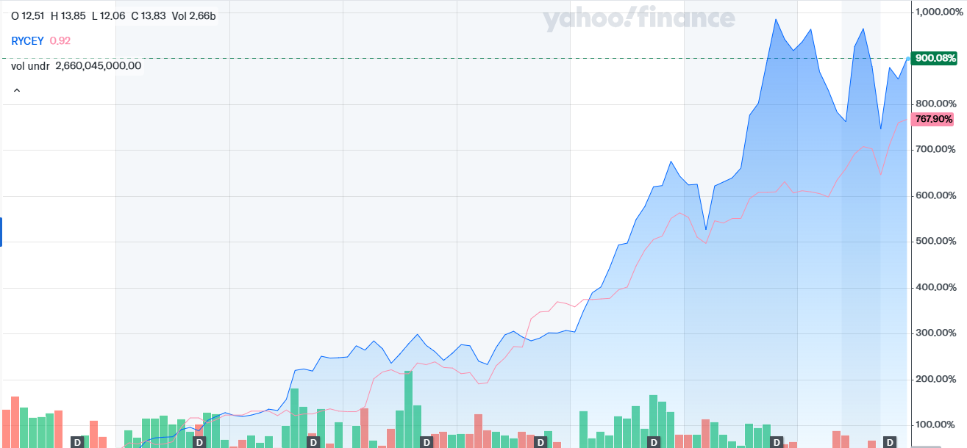

Karim’s Rolls pick has gained +522% over 2.5 years – while NVDA gained 418%”

That’s the thing…

Everyone talks about NVDA on the financial media…

But NOBODY talks about Rolls.

Now….ask any of our members who got in on that trade, and they’ll tell you how life-changing this that pick was.

Case in point….

This one Rolls pick generated enough profits for one of our members to buy themselves a brand-new house.

Consider this note below….
It was from a member named Chuck D – who wrote this….
“Karim, my wife and I use the money (from RYCEY) to pay cash for our retirement home in Texas. I am very thankful to you and Bryan for all that you guys do”
Graphics – full screen this testimonial – and highlight the section I read off
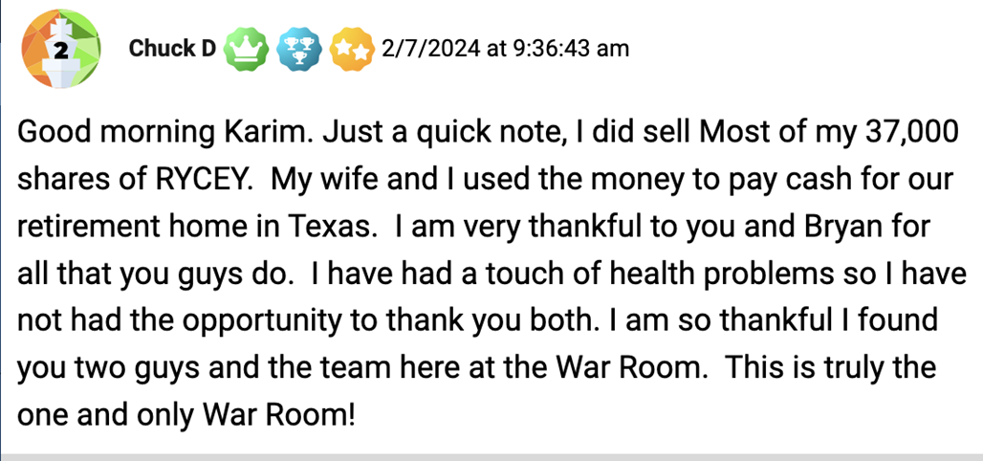
How amazing is that?
We even reached out to him to verify his story….
And he sent us a picture as proof!
Here’s the actual picture of ChuckD’s new Texas retirement home….
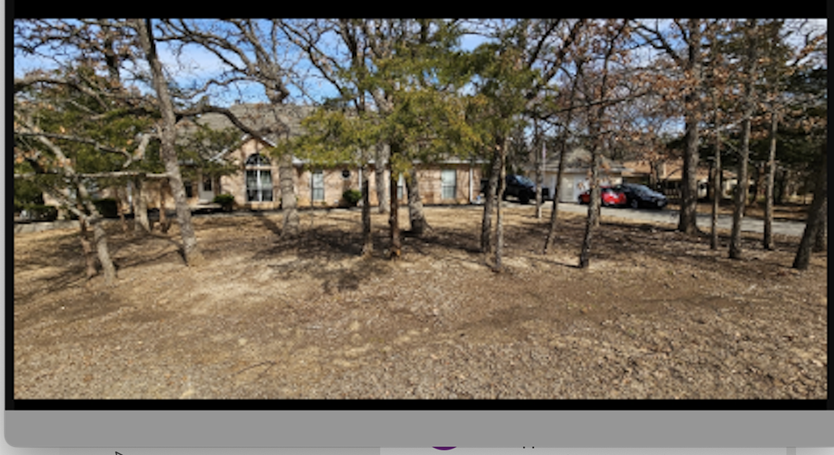
Just imagine being part of a trading community that helps you generate enough money to buy yourself a new house….all off ONE SINGLE PICK!
Well….it happened!

Bottom line…

I asked you to imagine yourself rich.

And I meant it.

So, if you’re serious – today is your chance to turn that dream into a reality.

When you enter The War Room, profit opportunities are happening all day, every day.
And no matter if they’re short-term trades with me…
Or longer-term trades with Karim…
The War Room offers you the best place to be part of a community……focused entirely on teaching you every tool you could need to find and make winning trades.
And the great thing is… since we offer trades every day, you can play them when it fits into your schedule.
Want to take a vacation with your winnings?
Feel free.
Then just jump back in when you get back.
Or… and don’t tell your family about this… you may want to sneak away every once in a while and make another trade while on vacation!
Like BoilerUp….
Who was on a cruise ship in the Bahamas….
And used the tools he learned from being inside The War Room…
To find…and make….a trade on his own.
He wrote us…..
Saying that he snuck away to take a $6,900 profit on CrowdStrike puts.
That was a +142% gain in a week – which he called “frickin’ awesome!”
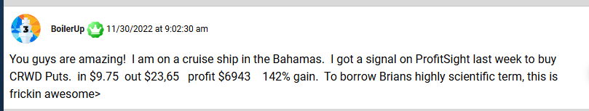
Or how about JamesT5…
Who hit his weekly trading goal
And said “thanks guys, off to the golf course!”
Or then there’s AnOldDuffer….
Who was just getting back from the golf course…
In time to hit a 70% winner overnight.
He said the trade, “hit my sell limit at 11:40 AM – thanks BB”
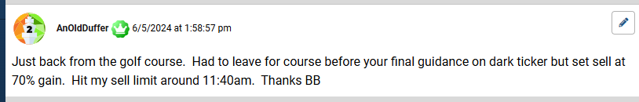
Just imagine….
If you’re like BoilerUP…while on a cruise ship in the Bahamas….
Saying to your family….
You know when I “went to the bathroom” for 15 minutes and you all wondered where I was?
Well… I was paying for the entire vacation on just one trade!
Or imagine you’re like AnOldDuffer…
Who’s on the golf course…..and receiving notices on his phone that his trades are getting sold for winners.
The point is…
Nothing should hold you back from collecting your share of the profits in our group.
Anything that we think has a chance to make you money…
We’ll share it inside The War Room.
You just make the trades…and collect your share of the profit if the trades go your way.
Sometimes that’s an explosive stock pick like Rolls Royce….
Other times, its’ faster overnight trade opportunities that involve options…
Nothing is off the table…
Which is why I’ve written another bonus report for you – called….
The War Room Options Primer
[Graphics, please create a REPORT COVER]
In this primer, I detail everything you need to know to start trading any pick you’ll see inside The War Room.
And let me tell you…
This isn’t some dense, mind-numbing textbook full of technical options lingo.
Forget that!
This is a simple-to-understand guidebook on how to get started trading options – written in plain, easy to understand language.
Within minutes of skimming through this primer…
You’ll be ready to place your first options trade.
And let me tell you….
We’ve had a ton of people join the War Room….
Many with little to NO options trading experience….
Who joined us…..reviewed all our Masterclass materials, and ended up hitting big winners on their very first trade!
Like a guy named Bernie…
He told us he made +138% in two days on his first trade…
He bought SNAP calls for $1.12…and sold them the next day for $2.67.
What a way to get started!
[DESIGN: Please blur out the trader’s last name “Cousino.”]

Then there’s Franz…..
Who made +158% on his very first trade…
He got in at $2.01…and out the next day for $5.20.

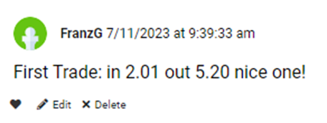
The point is….
Karim and I designed The War Room to work for anyone, regardless of their experience level.
If you can follow simple instructions, you can be successful.
Once you join us…
You’ll immediately see that trading options is incredibly easy…
But, just to make entirely sure you’ll get everything you need to hit winners….
I’ve also created an entire video library to teach you the secrets I learned on the CBOE.
Each video offers you a quick-hit bullet on trading….
Which gives you a unique trading perspective you won’t find anywhere else.
You could finish each video bullet in less than 10 minutes...
But they contain secrets that will make you more informed than 99% of traders in the market.
The first video bullet is called….
How to Hack Earnings Season
This video bullet digs deeper into why earnings are the ultimate trigger catalyst for our highly-profitable Overnight Trades.

The second video bullet reveals a trick I call “Fading the Public.”
That’s a term pro traders use for taking advantage of amateur traders.
This powerful concept has helped me produce more than +252 winning trades – EACH YEAR - all over the last five years.

Guys… this is an invaluable secret that you’re not going to want to miss out on.
But the last video bullet is the most valuable….by far.
In it, I give you the secret weapon of true professional traders.
I call it…
“The Secret 3-Minute Chart”

In this video bullet…
I reveal the one tool that can tell you – more than any other in my experience – which way a stock is about to go next.
I’m not kidding when I say… this video could get me cancelled within some veteran, old-school CBOE trading circles.
Some of the people I know from the Chicago pit would be furious if they knew I was divulging this secret to the public.
So please, guard the contents of this video closely.
Other War Room members and I are depending on you to keep this powerful secret to ourselves.
To summarize….
Here’s everything what you’ll get as a new War Room member...
[DESIGN: We need an updated “product cluster” image with everything mentioned above – all three videos – and the news reports. ALSO, please include the sales phone number on it
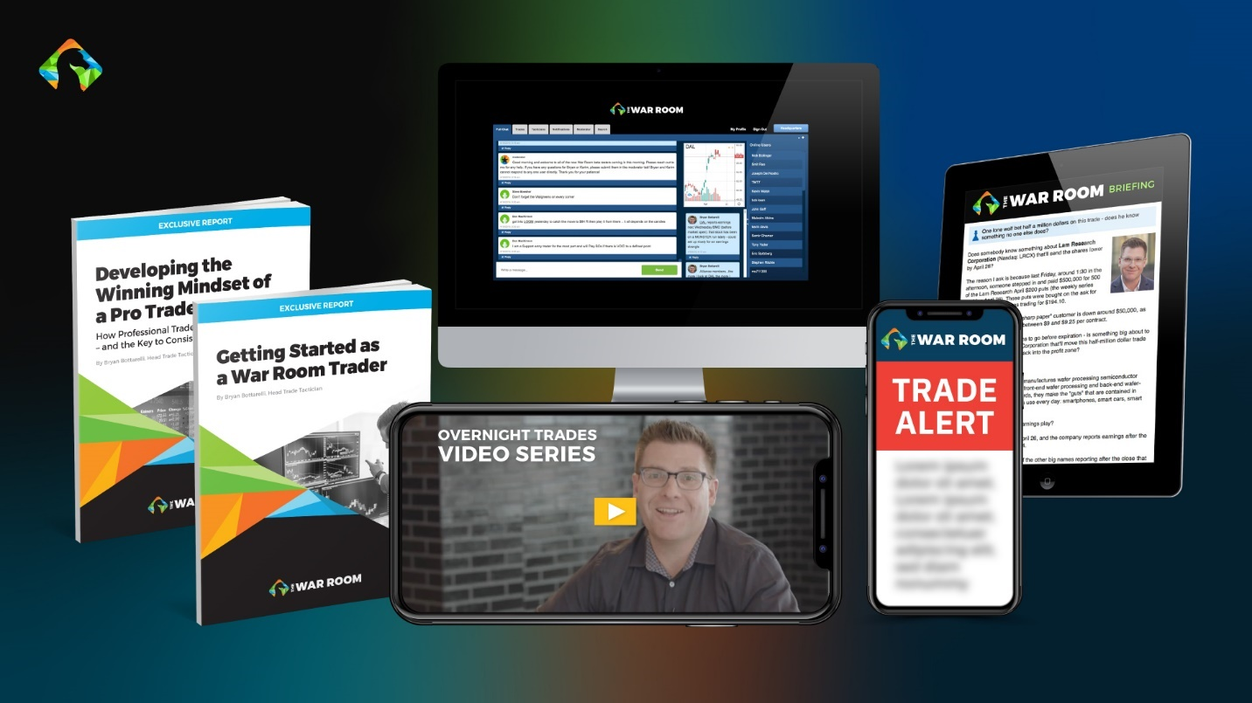
Member Benefit #1: Full Access Inside The War Room
- 12 Months Of Research And Trade Recommendations Inside The War Room – Which Includes FULL ACCESS To Our Members-Only Trading Forum
Member Benefit #2: Our Entire Library of Master Class Training Reports – Including….
- Report #1… Overnight Trades: How to Hit Massive Earnings Winners Every Day of the Week
- Report #2… Getting Started as a War Room Trader
- Report #3… Developing the Winning Mindset of a Pro Trader
- Report #4… The War Room Options Primer
Member Benefit #3: Trade ON THE GO With our Special War Room Mobile Trade Alert Service
Member Benefit #4: Our Complete Master Class Video Library Series
- Video #1… Hacking Earnings
- Video #2… Fade the Public
- Video #3… The Secret 3-Minute Chart
This entire Master Class Trading Suite EASILY has a cash value of $5,000.
In fact…
I’ve seen some other groups charge upwards of $10,000 for access to this type of trading material.
But for you…
It all comes FOR FREE when you enter The War Room
But the VERY best part is…
Once you become a War Room member…
The hard part is over.
From that point on, my team and I will do all the heavy lifting….
Handing you every trade recommendation….the instant it triggers…..anytime the markets are open.
So, anytime a profit opportunity comes up….
You’ll be the first to know.
Now, you’ve already heard from some of our most successful readers…
And I’ve highlighted some of our top performing trades today so you could see actual, real world results from the War Room…
But, just to make this decision BRAIN DEAD easy for you….
And to give you peace of mind that I’ll continue delivering winners at a high consistency rate….
I’m giving you something that NO OTHER trader will ever agree to…
It’s called….
My Iron-Clad Performance Guarantee
Here’s how it works…

Excluding holidays and weekends….
There are 252 trading days every year.
Today…right now…. I’m promising you to deliver - on average, at least one winner every single day the market is open.
And guess what….
If The War Room hasn’t shown you the chance at 252 winning trades after one year, per our model portfolio…
I’ll pay your renewal fee to get a SECOND year of service…..totally free.
That’s one bold promise…
But….I know I can deliver.
I’ve hit this guarantee for 5 years straight…and I have no intention of slowing down.

So, if you’re serious about joining our group….
Then here’s the offer…
For the next 99 people who join the War Room today…
You can get a special, 1-year trial offer for $1,499
That’s Over 60% Off the published rate.
And for that low price….
You could easily make that much back with just one or two trades.
Many have done it…
Like Jim, who made a +340% gain on TDOC in less than one day.
He made more than $4,000 on that one single trade…
Which would’ve more than doubled today’s reduced trial rate…
Jim S. (3/5/2020,3:12 p.m.)
Sold TDOC... Total profit of $4,019 with 340% total. My best day ever!

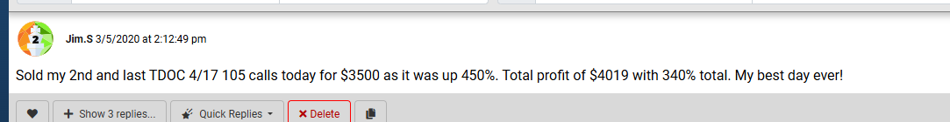
Or remember BoilerUp?
Who just reported making $6,900 on the cruise?
Well, he wasn’t done…
He also reported another winner of $3,500 overnight!
That +140% gain would’ve also doubled today’s trial rate….
BoilerUp Lifetime Member 1/18/2023 at 10:04:39 am
MRNA from yesterday : 4 contracts In $6.32 Out $15.23 $3558 profit 140% Thanks Bryan
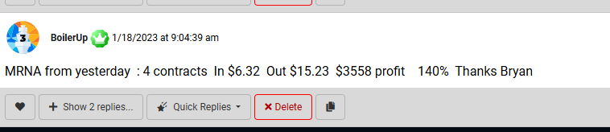
I could go on and on...
But you get the idea…
If I learned one thing on the CBOE...
It’s that talk is cheap.
Big-time traders deliver BIG-TIME results…..not promises.
So today…
Right now….
I’m going to step it up…
And take this one step further…
To ensure that you see amazing results…..FAST
Set me a timer….
Graphics – start a 15 minute count-down timer on screen
And if you’re one of the first 99 new members to join in the next 15 minutes….
I’ll give you an extra special deal…
In addition to the 252 winner guarantee…
I’ll combine that with a new, Overnight Trade guarantee.
Here’s how it works….
Graphics: Create an image that says “NEW SPECIAL BONUS! Overnight Trade Guarantee”
If you join today…in the next 15 minutes….
Take the first 3 Overnight Trades that you see…
And if those 3 trades don’t show you the chance to double your total membership cost…
Call us up….and you can get a full refund.
So….you either have the ability to double your membership cost after 3 Overnight Trades…
Or, you can get a full refund.
I simply cannot offer you a stronger incentive to join than that…
Or…any stronger proof of how much I believe in our wealth building mission.
But I’m willing to do it…
Because I know that all it’ll take is 3 trades to prove that War Room membership will have a profound impact on your future wealth.
So….it’s time.
Let’s get started.
Display order Button
Join The War Room right now…
And you’ll be on your way to understanding how to generate substantial wealth…..and piles of cash profits…..day after day.
Now….
If sticking around for 3 trades is asking too much…
Or if paying $1,499 is too expensive to gain exposure into a room of smartest traders, speculators, and millionaires….
Then respectfully, please close out this video right now.
This trading community is not right for you – and quite frankly, you’re not serious about aggressively growing your future wealth.
But….if you are interested in taking your share of profits….
Which could be upwards of $500K…on any given day….
Then click the button below…
And be among the first 99 people to place your order.
Or, if you prefer to talk with a real human…
You can do that too…
[DESIGN: Please put this phone number on the screen with the discount code. And leave it on screen for the remainder of the presentation.]
Quickly pick up the phone….
And call our VIP Sales Team at XXX-XXX-XXXX.
We have plenty of people standing by, so you won’t have to wait long.
As you’re locking in your spot…
And placing your order…
I’ll leave you with this…
Every single trading day, when I wake up and check the pre-market futures…
It ignites my speculative fire – and challenges me to be the best trader possible.
And today, by joining our War Room trading community, you’ll be plugging yourself into a truly life-changing group.
Without exaggeration…
What you’re about to experience is a game changer…

So let me state very clearly…

If you truly want the best shot at getting rich – this is your chance.

War Room members are splitting massive piles of cash – dumped onto their laps - day in and day out.

And the next big cash dump could be coming in your imminent future.

It’s an awesome feeling…

And I can’t wait for you to claim your share in our next massive pile of money.

Bottom line: If you’re ready to begin a new chapter of your life…..which now includes accelerated wealth creation….

Then let me be the first to welcome you into The War Room.

From this day forward, the way you trade will never be the same.
I’m pro-trader Bryan Bottarelli.
Thanks for watching…
And I look forward to seeing you post about your first big trade winner….
And seeing you enjoy your share in our cash piles of profits…..
Inside The War Room!
Click below – and get started today!
P.S. Oh…I forgot to mention…
Once we reach our 99-member capacity, we reserve the right to close this offer - without any advance notice.
So, if you have any interest in taking the 252 Winner Guarantee…
Combined with the new Overnight Trade Guarantee….
And taking advantage of the opportunity to share in the daily “cash dumps”…
All for today’s special introductory rate…
Then you MUST lock in your spot right now.
Click the button below….
Or call the number on your screen…
And join our elite trading community.
The moment you lock in your spot….
Your journey to daily wealth creation….surrounded by other millionaires inside The War Room….will begin.
So, make your move.
Join The War Room, and then – get ready to claim your share of our next massive cash pile.
Click below – get started today – and then, I’ll see you inside The War Room!
=========================
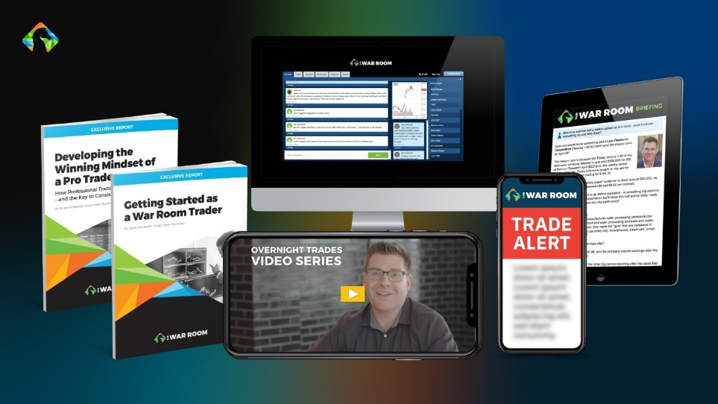


===============================
Legal notes, trades, and research calculations below for reference.

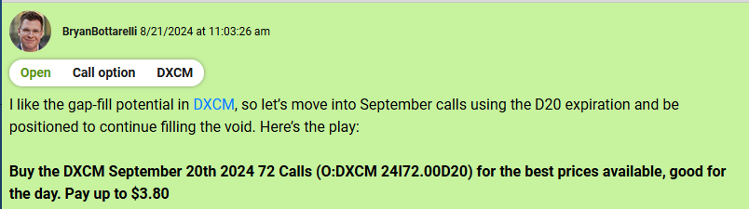
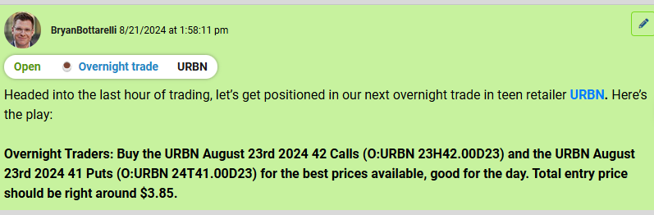
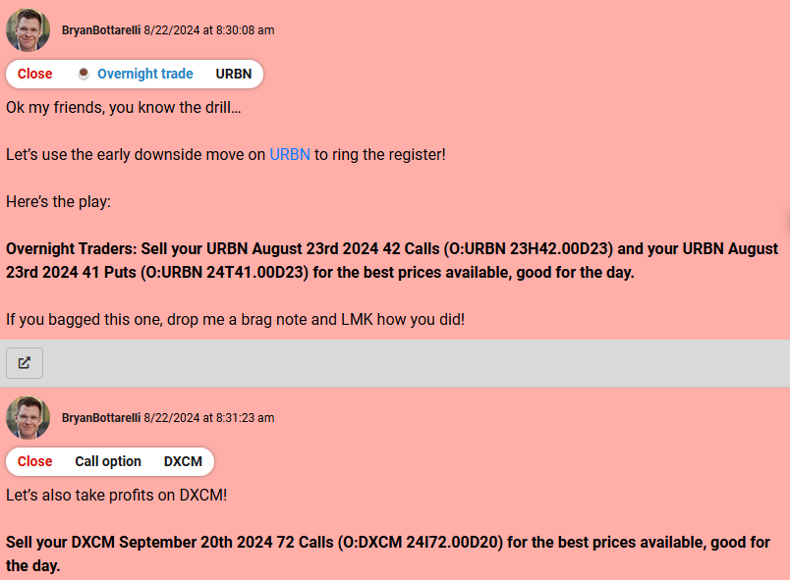

Survey showing that of 51% of War Room members have a net worth of $1 million or more.
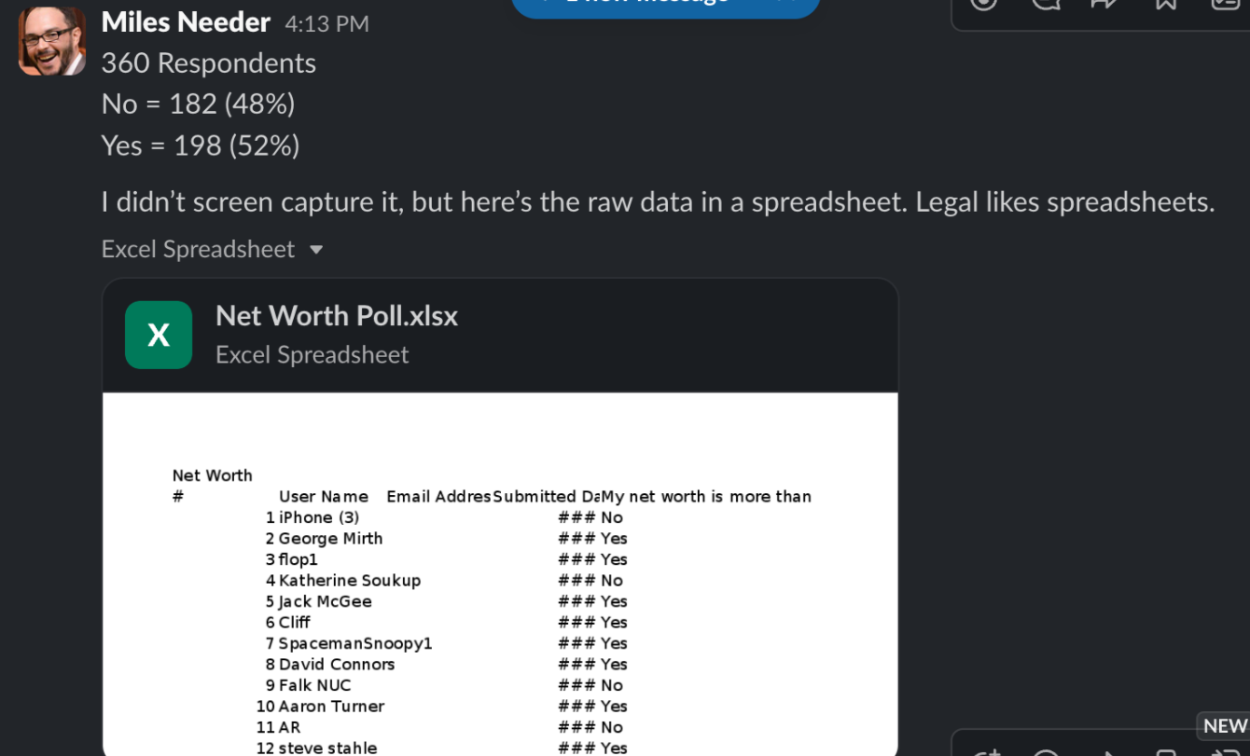

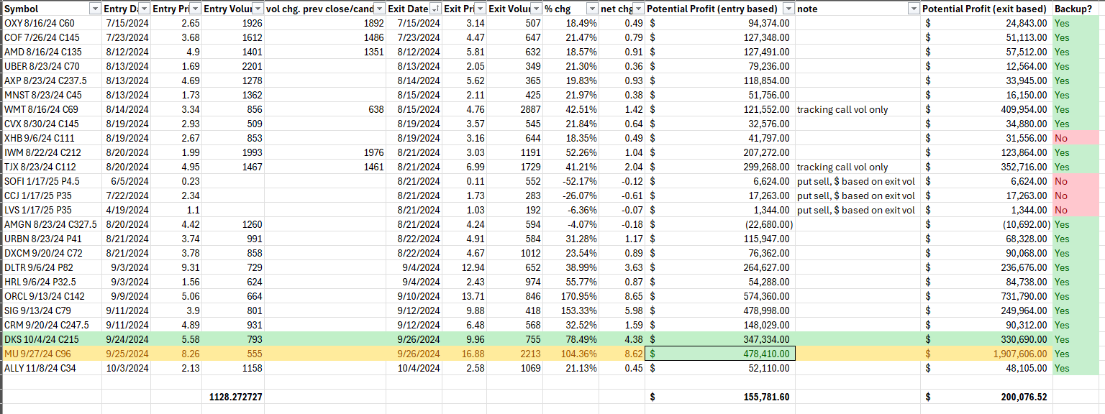

Here’s a picture of my trading statement so you can see I’m the real deal.

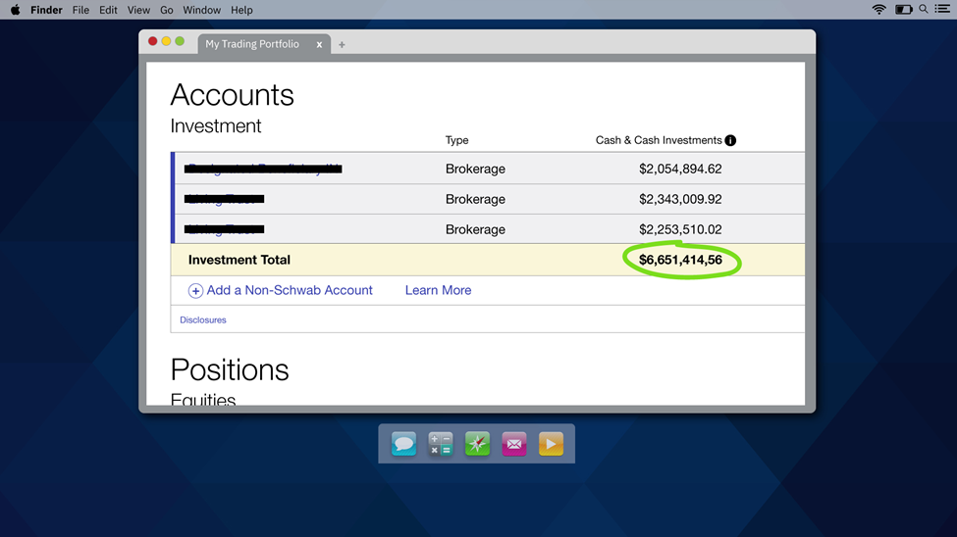

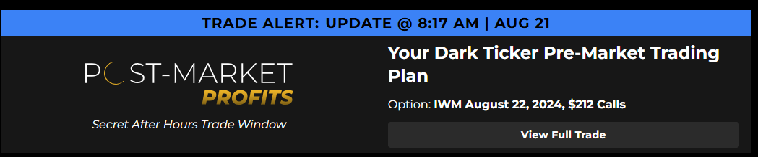
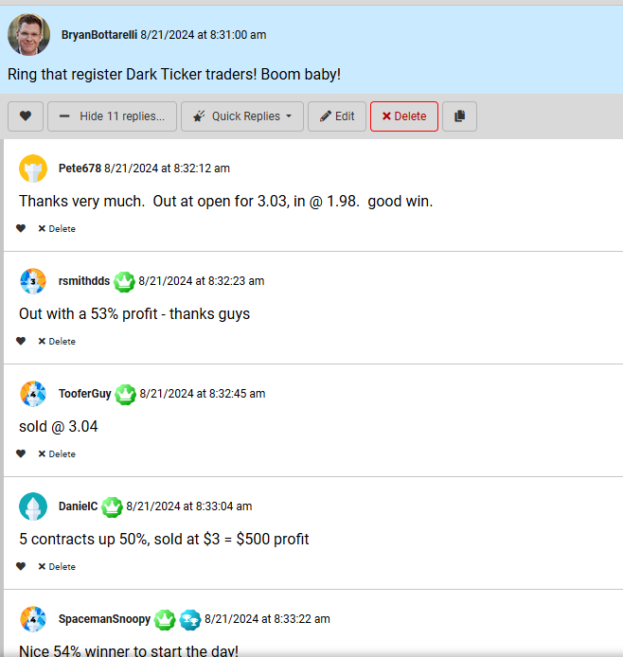

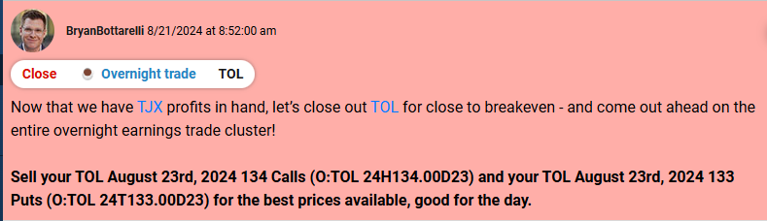

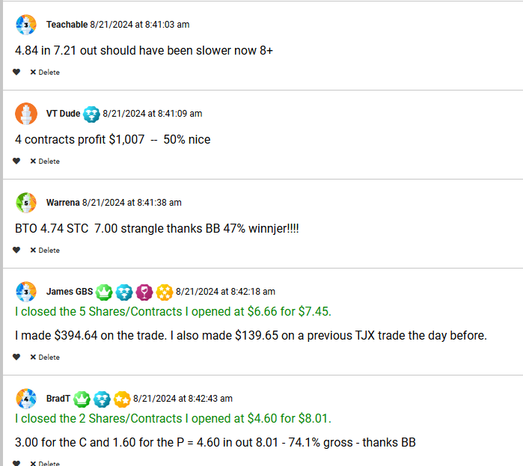

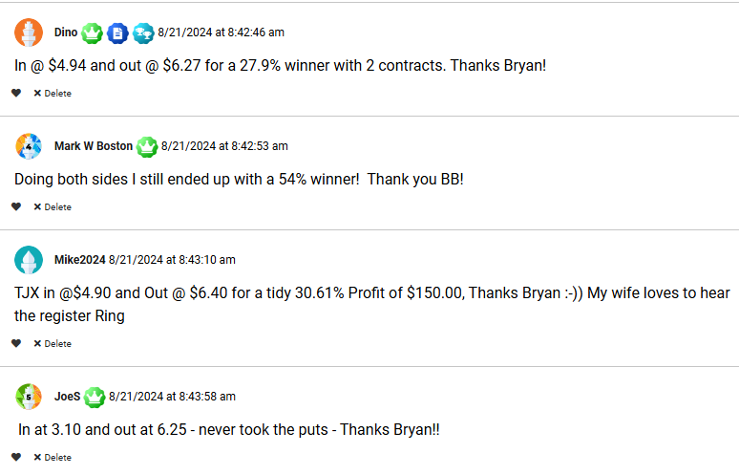

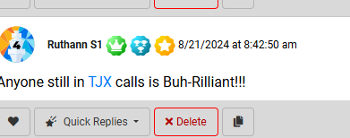

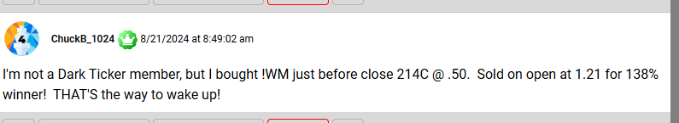
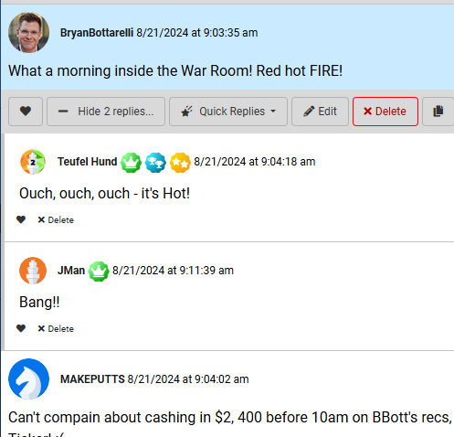

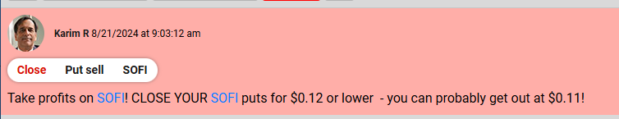

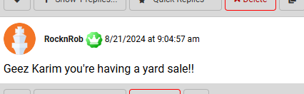

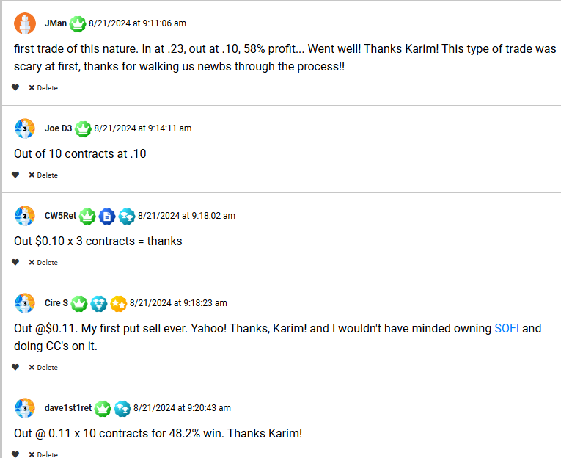

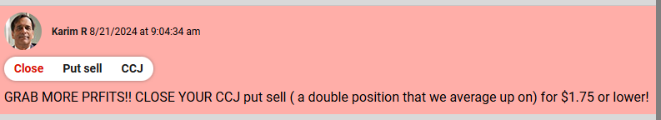

And that all happened before 10:00 AM CST

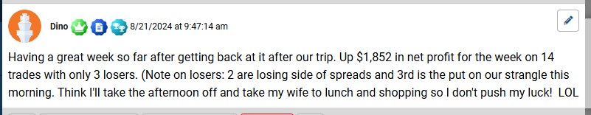

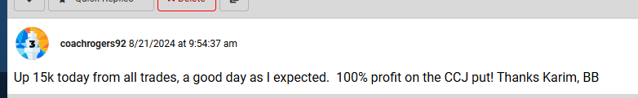

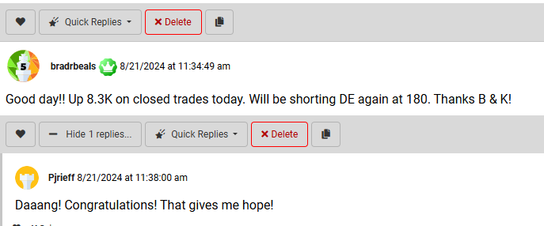

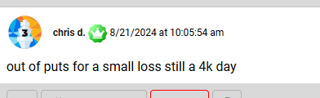

Volume calculations from War Room Trades
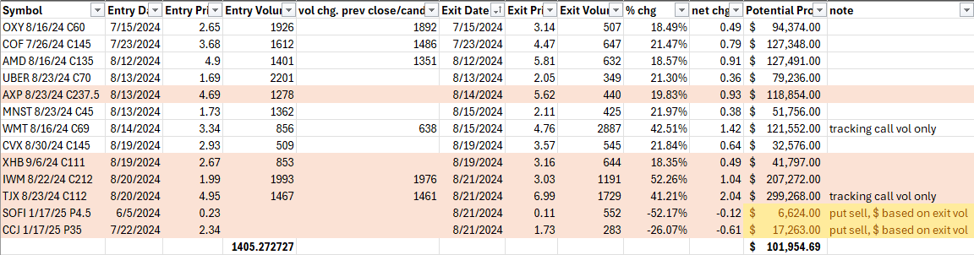

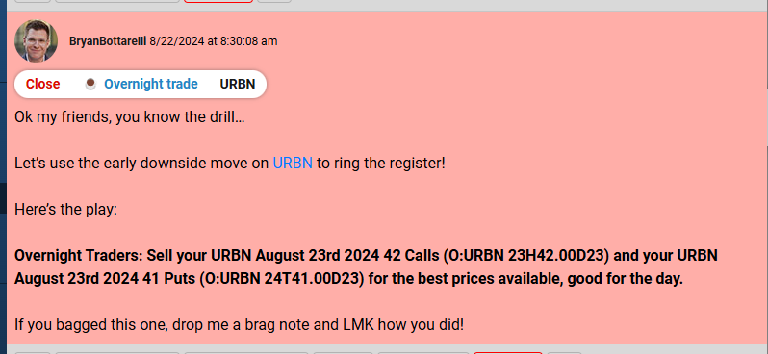
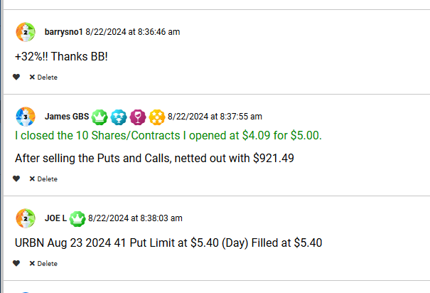

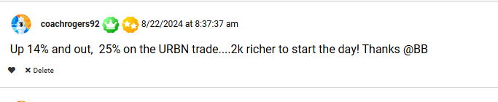
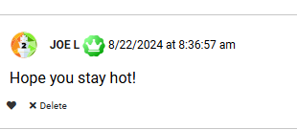

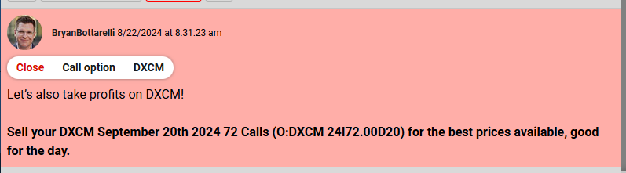

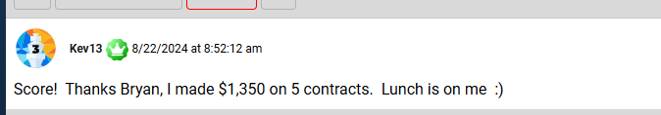
Volume Calculations from War Room Trades
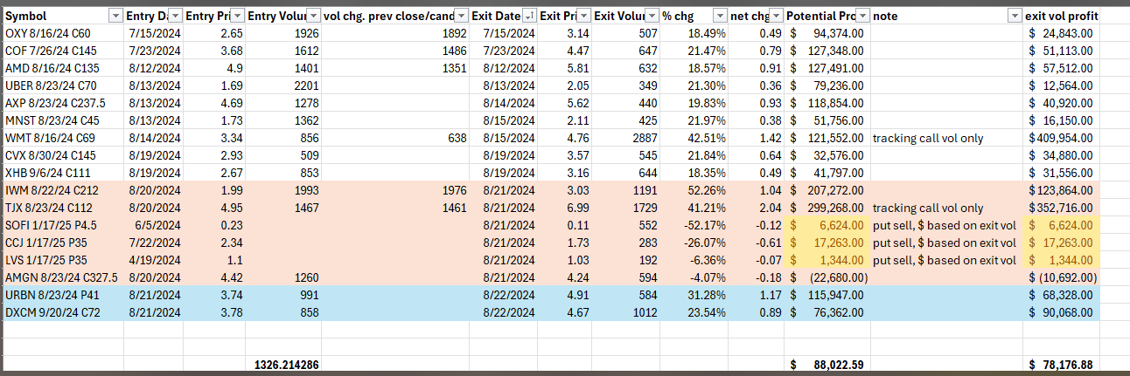


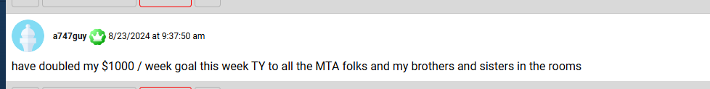
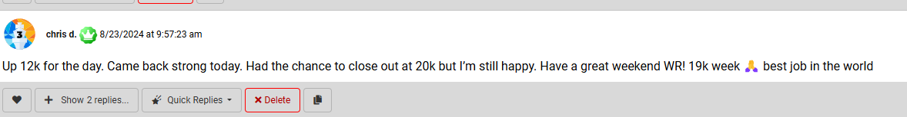

John A note

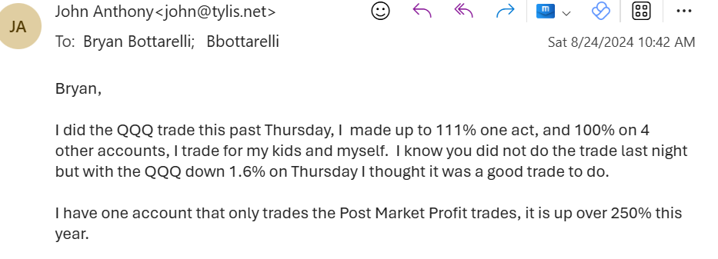

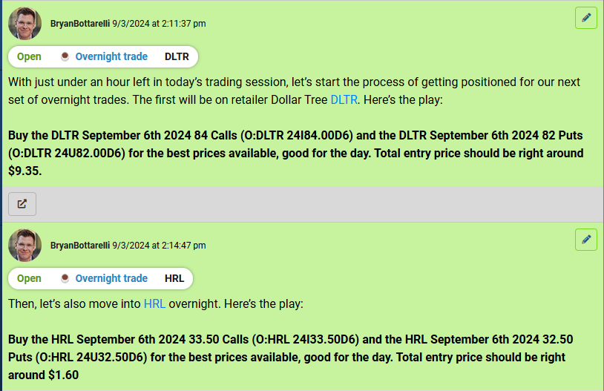

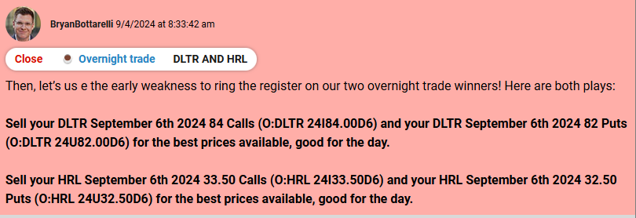

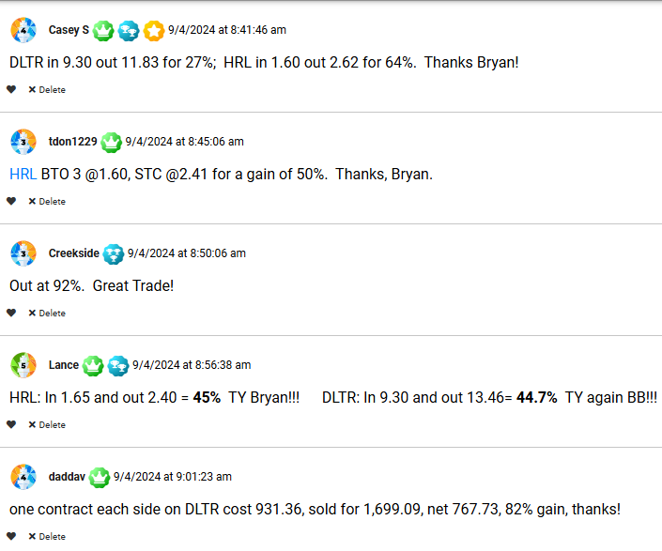

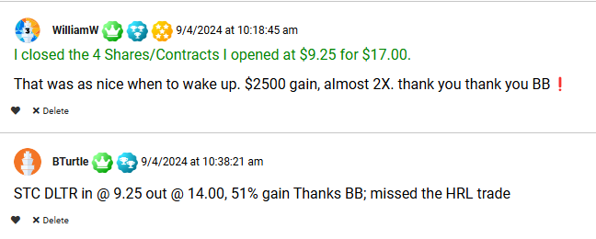

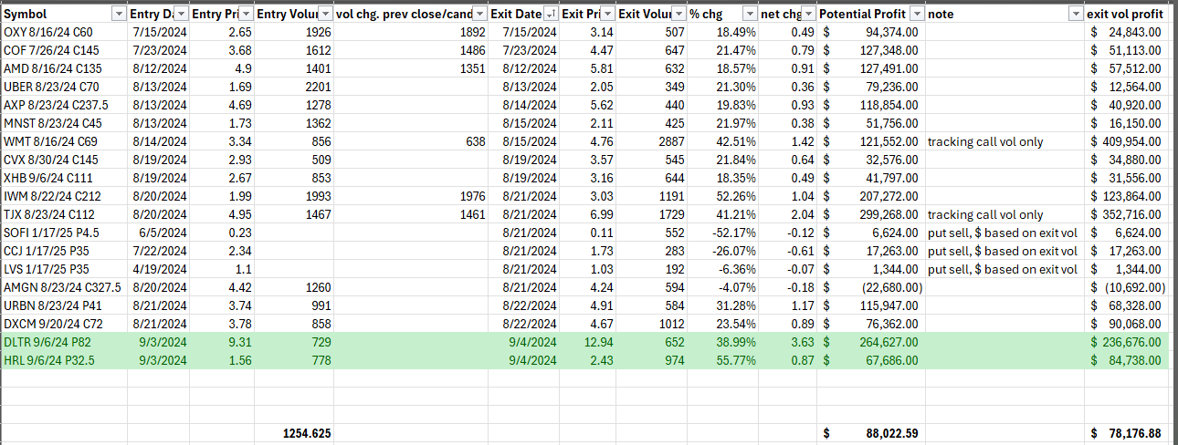

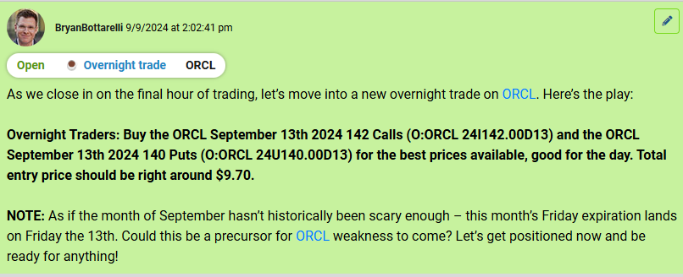

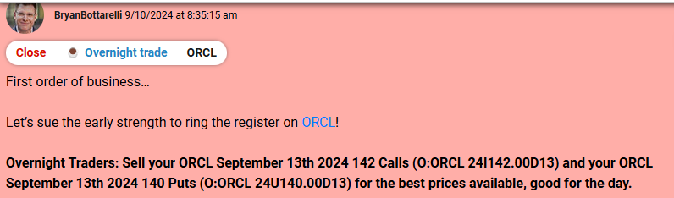

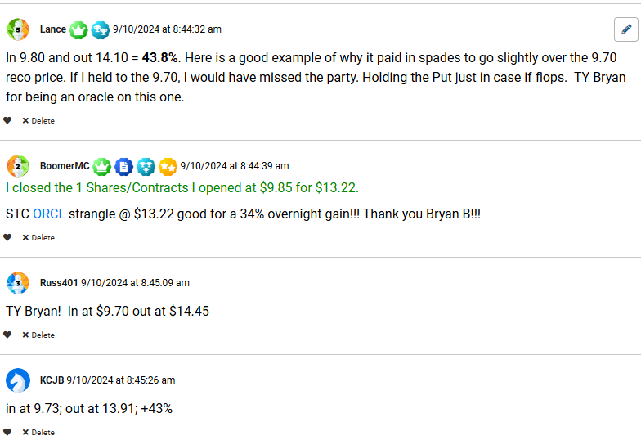

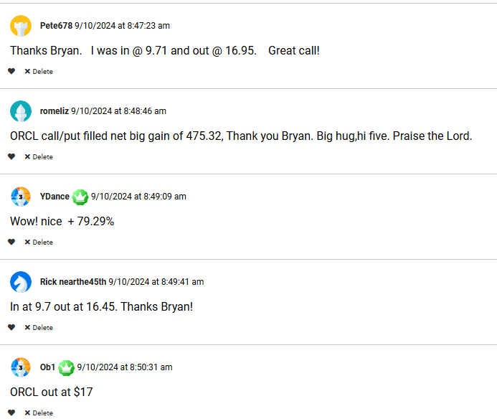

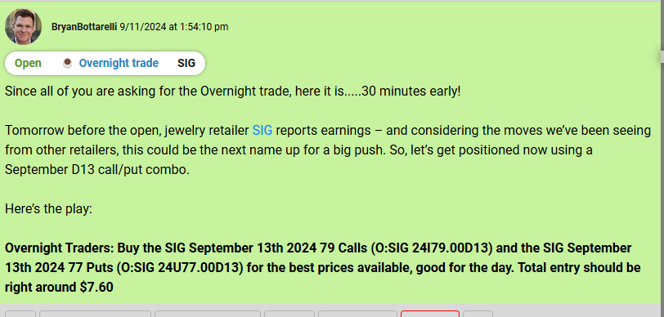

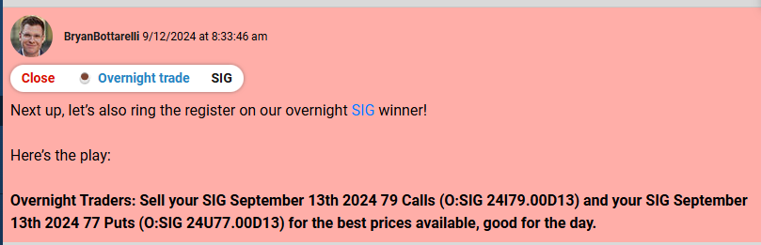

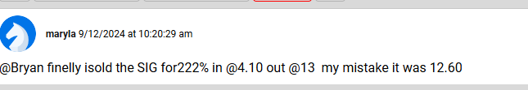

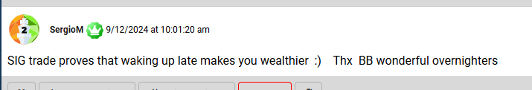
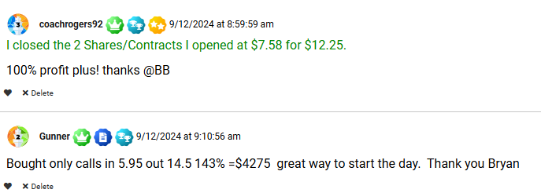
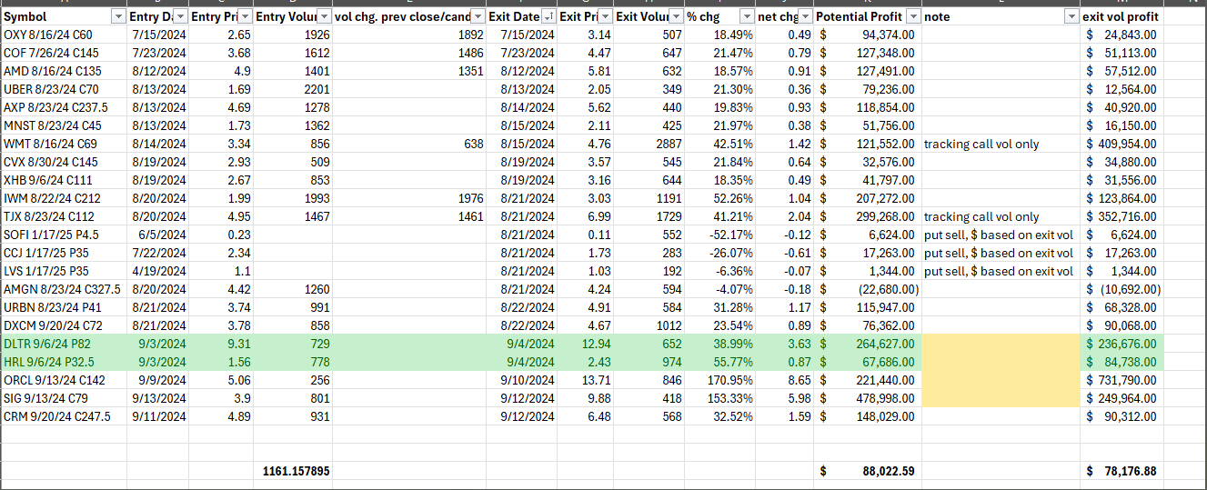

War Room 2024 Performance: 8.95% every 32 Days
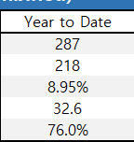
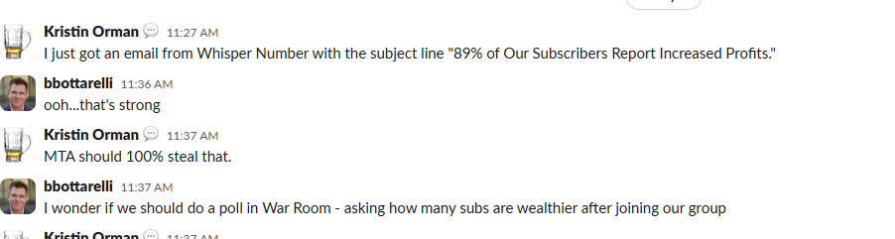

Sell Wealth
https://www.instagram.com/reel/C9NdxlhML0p/?igsh=bWRqejllZDF4ZTMx

*LEGAL NOTE: All trades and volume data shown below – which shows you the exact volume and timing data for each trade outlined above using Bloomberg real time data New Examples PLTR 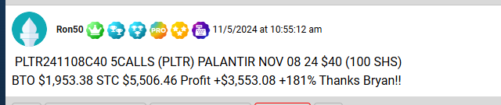 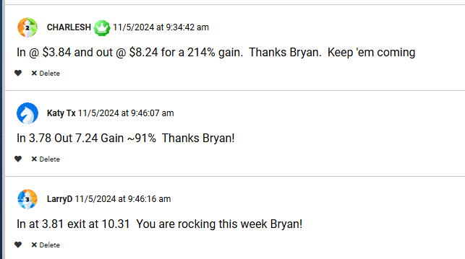 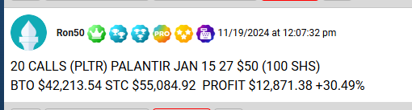 One day – 11/6/2024: Booked $100K in profits 