URGENT: America’s #1 Bear Market Trader Reveals:

How To Safeguard Your Money with
This Special Crash-Proof Asset


It’s Programmed to Go Up as Much as 10X As the Market Goes Down

I can’t hold my tongue any longer!

The crap the financial media is telling investors is complete b***sh*t!

The markets are getting hammered, and all the media says is, “Oh, you lost money? Well, just buy more stocks.”

It makes me freakin’ pissed off!

Look at this...

On June 5, CNBC published an article saying...

“A bad stock market can be a good time to invest more.”

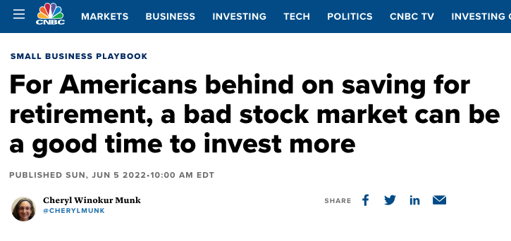

A “good time,” huh?

Over the next two weeks after that was published, the Dow tanked another 3,000 points!

Is that your definition of “a good time to invest”?

Right before a 3,000-point drop?

I mean, come on...

This year the Dow has gone down over 18%.

The S&P has plunged into a bear market.

And the average Nasdaq stock is down over 50%.

Some are down 80% or more!

Altogether, over $11 trillion has been wiped out from the market.

That’s over $3 trillion more than the 2008 crisis...

And all these b***sh*t talking heads in the media can say is...

“Well, it’s a good time to buy.”

Such garbage.

What I’ll reveal today will blow a 10-foot hole in that BS narrative...

That’s because I’m gonna show you something powerful...

An asset that is PROGRAMMED to go up – as much as 10X – every time the stock market goes down.

This is something the corporate media does NOT want you to see.

