Overnight Whale Trades
“The Single Best Way To Turn Earnings Releases Into Monster Paydays – Even If Your Stocks Crash” – Pro Trader Bryan Bottarelli
======================================
Overnight Whale Trades….
These are trades designed to take a known earnings release date...
And turn it into a massive overnight payday.
I’m talking gains of +124%... +189%... even +293%... all within 24 hours.
Hi, I’m pro trader Bryan Bottarelli….
After 20 years of trading for a living…
I can guarantee you 2 things….
First…..the most explosive stock moves almost ALWAYS occur on earnings day.
And second….
The very best way to turn those explosive earnings moves into massive profits…
Is by using my Overnight Whale Trades.
In the next few minutes….
I’ll show you a simple and precise way that could up to 3x your starting stake - all within 24 hours of a stock’s earnings release day.
And here’s the thing…
The absolute beauty of Overnight Whale Trades is….
It doesn’t matter if a stock moves up….
Or moves down.
You have the chance to WIN EITHER WAY.
That means you’re sleeping easy at night…

Not stressed out about which way a stock will move after announcing earnings.

If it explodes up…..you win.
And if it crashes and burns…..you STILL WIN
As you’re about to see….
The trades that I’ve opened and closed within 24 hours….
Dating back to 2019….
Have won +90% of the time.
I’ll repeat that…
Over 9 out of 10…..short term trades….opened and closed within 24 hours…..have all been winners.
That’s why I’ve traded so successfully for over 20 years….
Winning far more often than losing is largely how I’ve become a multi-millionaire independent trader.

And by far….

The most POWERFUL strategy I’ve ever used is…..Overnight Whale Trades.

You see….
Using this precise methodology….
You’re NOT trading a stocks’ direction.
But rather, you’re trading a stocks’ movement.
In other words…
The way I teach you to trade….
You can make 100% overnight if a stock moves up 10%
Or….
You can make 100% overnight if a stock moves down 10%.
This puts you in a very powerful position.
Kinda like…
Heads you win….tails you also win.
The only criteria you need to win is movement….
Which is precisely why I only implement this strategy one day before earnings releases.
Because that’s when the biggest moves happen….
So that’s exactly when you’ll make these Overnight Whale Trades.
Once you see how this works….
And you start using it yourself…
It’ll open your eyes to an entirely new opportunity that you can tap into nearly every single day the markets are open.
Just imagine making an Overnight Whale trade a day before earnings…
Not caring if a stock moves up or down….
And waking up the next day to a massive triple-digit winner sitting in your account!
But here’s the thing…
Most traders have no freakin’ clue how to execute these trades…
Which is why most traders end up guessing….
And struggling to grow their wealth in any meaningful way.
But if you’re looking for a new strategy….
One that has consistently delivered for me over 20 years of trading…
Then I invite you to stay with me for a few minutes…
Because I’m about to reveal the exact strategy behind this life-changing method.
In fact….
Let’s dive right in now – starting with the biggest advantage you’ll have with Overnight Whale Trades.

Here’s the most exciting secret….

The biggest wins you could see using this strategy comes from stocks that are crashing lower on earnings day.

That’s right.

Historically speaking…

Our very biggest winners….

The true life-changing monsters….

Have all come from stocks that moved down.

I admit…
Hitting your biggest winners on stocks that are crashing lower….
That’s very unusual.
But that’s exactly what you’re about to do – starting now.
You’re about to see some truly amazing examples…
But before I begin…
I need to be crystal clear….
Every single Overnight Whale trade you’re about to see IS REAL.
By “real” – I mean that these are all trades that I’ve recommended….live, in real time…to real people.
Nothing you’ll see here is hypothetical….
Nothing you’ll see here is a back-tested result…
Whenever I see BS like that…it pisses me off to no end….
When these wanna-be trading hacks all over YouTube present a BS system that’s all based on BS returns and cooked-up back-tested nonsense – it makes my blood boil.
Yes, a back test can help you get an idea how a strategy might work.
But nothing compares to doing it in real time… with real money on the line.
A back test can’t hold a candle to the real thing.
So forget back tests.
With me….everything you’ll see today is real.
Every trade I’ll present to you happened live, in real time.
Every gain is backed-up and fully documented.
That means….you’ll know with 100% certainty that the profits I’ll show you from my followers using my Overnight Whale Trades are ALL money in the bank.
Today, I’ll share some of our top options winners…
So let’s dive in….
Last May, I made an Overnight Whale Trade on Advance Auto Parts (AAP).
The very next day, AAP got slaughtered.
Look at this crushing fall…
The stock dropped over -37%....
Falling from $110 down to below $80.
Graphics – please annotate this chart to display the copy as I’m taking
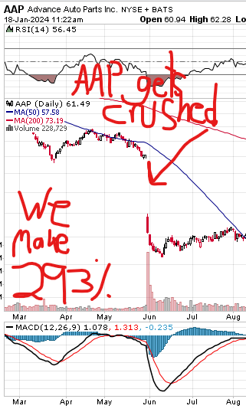
You can bet that this one down move – based on a poor earnings report….lost “buy and hold” investors a ton of money.
But for us…
One simple Overnight Whale Trade made +293% within 24 hours.
$10,000 ballooned into nearly $40,000 the very next day.
Think about that.
In one day…..
AAP shareholders lost $3,000 on a $10,000 investment.
Yet – on the same exact move…
My followers were able to BANK nearly $30 Grand in profit with that same starting stake…
All within 24 hours.
Amazing right?
As you can imagine…
My followers were ecstatic.
A gentleman named Fred made over +300%.
He called it his “Best Trade EVER!”
[DESIGN: Please add “[a 326% gain]” after “me.”]
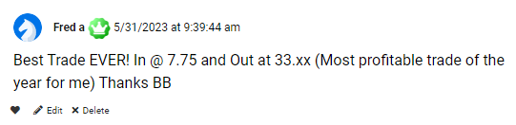
Another follower – named Wade - made a staggering +620% on the same trade…
He called this Overnight Whale trade “awesome.”
Just look at that return….
His $4.30 entry price exploded to $31.00 the very next day!
[DESIGN: Please blur out “Only went with puts.” And add “(620% overnight gain)” after “Awesome.”]
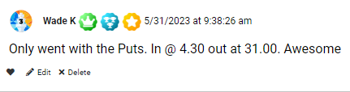
But when it comes to Overnight Whale Trades…
This monster AAP gain was just the beginning…
Shortly after that trade…
I recommended another Overnight Whale Trade on Dollar General (DG).
And once again, a similar thing happened…
DG reported a poor earnings report – and the shares got slaughtered.
Shares dropped over -17%....
From $200 down below $170….
So again…
Most “buy and hold” investors lost a ton of money.
But for us…
One simple Overnight Whale Trade made +189% within 24 hours.
Graphics – please annotate this chart to display the copy as I’m talking
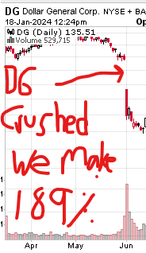
And once again…
My followers cleaned house.
Like Nina, who posted a 450% overnight win on Dollar General…
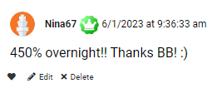
Or Omen, who made +163% as Dollar General fell....
He turned a $10.85 entry price into $28.55 – overnight!
And then, he said as a joke…
“that’s more than a dollar….in general”
[DESIGN: Please change the green line to say, “I opened at $10.85 and closed for $28.55”]
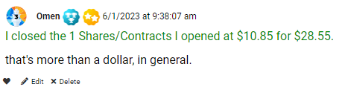
Look…I get why my followers are in a joking mood….
On a day where a stock is getting clobbered…..
And most “buy and hold” investors are crying about how much they’re losing…
My Overnight Whale Traders are cracking jokes…
Because they’re turning these crushing losses into a monster overnight winners.
Just imagine if you’re the one making +189%....or even +293%.....OVERNIGHT…..all as a stock is crashing.
While most investors are whining about how unfair Wall Street is….
You could be making my Overnight Whale Trades….
And rake in $30K in profit.,

And when it comes to profits…
We’re just getting warmed up!
On August 29th, I issued another Overnight Whale Trade on Ambarella (AMBA)
And by now, I’m sure you know what happens next…
AMBA released earnings…..
The numbers were bad….
And the stock got crushed.
For the “buy and hold” crowd, it was a very bad day….
Shares fell from $75.00 down to $60…
A one-day haircut of -25%
But for Overnight Whale Traders like us…
We made +124% in less than 24 hours.
Graphics – please annotate this chart to display the copy as I’m taking
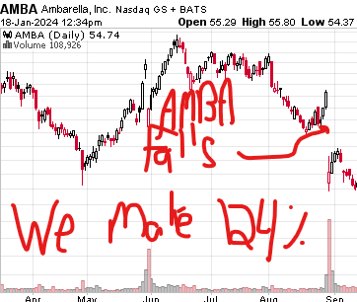
And once again…
My followers loved it.
LesP made 120% overnight…
Turning his $6.70 entry into $14.70…
[DESIGN: Blur out “on the strangle”]

Or Buckeye-in-Georgia, who made +134% overnight…
Turning every $6.82 entry into $16.00 overnight…
He said it perfectly when he wrote….”ring ring ring the register!”
[DESIGN: Blur out “x2 contracts”]
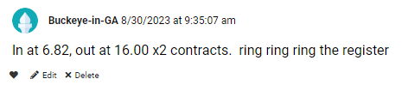
So, let’s quickly review these Overnight Whale Trades….
Graphics – display this as a full image as I’m reviewing it
- Advanced Auto Parts (AAP): A -37% stock drop resulted in a +293% gain within 24 hours

- Dollar General (DG): A -17% stock drop resulted in a +189% gain within 24 hours

- Ambarella (AMBA): A -25% stock drop resulted in a +124% in less than 24 hours
Now, it’s extremely critical that you fully understand the power of the Overnight Whale Trade strategy….
So, let’s do something a little unorthodox….
I’m going to take those three examples above…
And let’s flip them on their heads….
And consider what would’ve happened if the exact opposite move occurred.
For example….
Let’s say that instead of these stocks going down….
All three stocks WENT UP.
So, instead of falling 37%.....let’s say AAP blasted higher 37%...
And instead of falling 17%...let’s say DG blasted higher by 17%...
And instead of dropping 25%, let’s day AMBA rallied by 25%...
How would that impact your Overnight Whale Trades?
Well…..as amazing as it sounds….
It wouldn’t matter.
Yes…I’ll repeat that...
You could’ve still made the same MONSTER overnight returns – even if the exact opposite move occurred in every example above.
So, even if AAP moved up 37%.....you still could’ve made 293% overnight
And even if DG moved up 17%....you still could’ve made 189% overnight
And even if AMBA moved 25%....you still could’ve made 124% overnight
That…my friends…is why trading Overnight Whale Trades offers you such a massive competitive advantage.
No matter if stocks move up….or move down….
You can still win big.
As long as it doesn’t trade flat….you’re in position to profit.
That’s why I consider Overnight Whale Trades – on earnings day – as the top trading strategy I’ve ever used in my 20 years of professional trading.
And remember….
This isn’t just a trade I make every quarter during earnings season.
That’s a common misconception…
The truth is….
You Can Use Overnight Whale Trades Every. Single. Day.
In other words…
Earnings are NOT a seasonal event, as most investors believe.
Each day, hundreds of companies could be reporting earnings.
Just take a look at the upcoming earnings calendar for May of 2024…
May is NOT considered one of the big months for earnings announcements.
But as you can see…
On May 6th, , 295 companies are expected to report earnings…
On May 7th, 425 companies are expected to report earnings…
May 8th, 352 companies are expected to report earnings…
And on and on and on on….
You can see the first week of May below…
Graphics – annotate this calendar – circling the dates and calling out the number of earnings releases – as I read the copy above
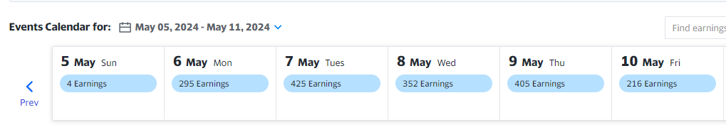

**Delete all the calendar images below (I deleted them, but it’s hard to see the line edit in track changes – so I just wanted to clarify that the images below are deleted. The image above is correct for May 2024)

The point is…
Pick a month…any month….
And odds are…
Every single day offers you the opportunity to hit a big earnings winner using Overnight Whale Trades.
The trick….
Of course….
Is choosing which company to trade.
For instance….of the 295 companies scheduled to report earnings on May 6th…
Which ones are best suited for an Overnight Whale Trade?
How Do You Know Which Companies to Trade?
That’s where I come in…
After fine-tuning this strategy for over a decade…
I’ve now developed a way to pin-point ONLY the stocks poised to make the biggest moves.
And that’s why my Overnight Whale Trades work so well…
By knowing which stocks make could make the biggest moves….
I can narrow down the 295 companies scheduled to report earnings on any given day….
And only send you the one or two poised to make the most explosive move.
From there, you simply make the Whale Trade that I recommend…
And then, you wait for the stock to blast higher…or crash lower….the very next day.
And If we DO see a BIG UP – or BIG DOWN move, by the time you wake up the next morning, you’ll be cashing in for a huge overnight payday.
Like Oracle (ORCL) – which I recommended back in September.
This Overnight Whale Trade played out perfectly…
ORCL released earnings…..
The numbers were bad….
And the stock got crushed.
For the “buy and hold” crowd, it was a punch in the face.
Shares fell from $125.00 down to $110…
A one-day drop of -13%
But for Overnight Whale Traders like us…
We made +133% in less than 24 hours.
Graphics – display this as a full image as I’m reviewing it

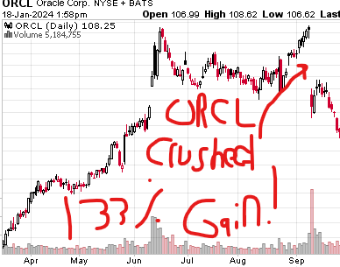
So once again…
Regular “buy and hold” shareholders panicked….
But using the Overnight Whale Trade strategy….
We’re taking our money to the bank.
With ORCL….a starting stake of $5,000 ballooned into $11,650….all within 24 hours.
A member with the handle “BartMan” pulled an overnight double…
His $5.97 entry blasted into $13.28.
He said “double woot!”
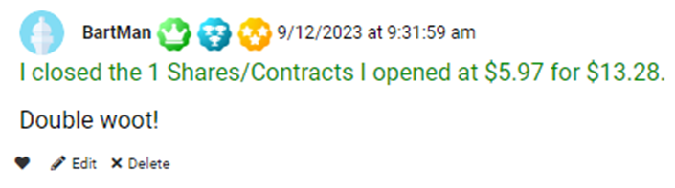
Then RDScherer chimed in…
Saying his +270% gain was the largest win of his time.
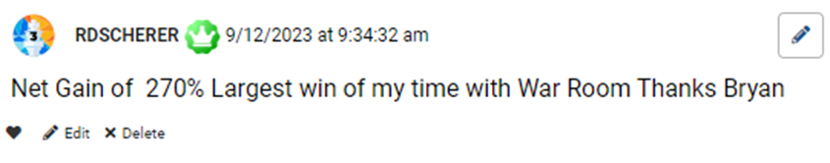
And BoomerMC turned his $5.95 entry into $14.05…
A 136% winner overnight.
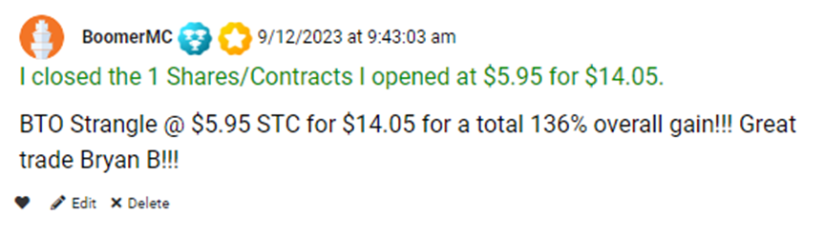
And here’s the thing to remember…
Every Overnight Whale Trade you’ve seen so far….
Every monster winner….
Have all come on stocks that MOVED LOWER on earnings day.
That means you’ve only seen HALF of winners generated using this method.
So….in addition to what you’ve already seen…
We’ve also hit enormous winners on stocks that moved UP in reaction to earnings…
Such as….
Win HUGE When Stocks Move Up Too!
Upside Overnight Whale Trade Winners
Ciena (CIEN): Stock Gapped Up We Made +113% in one day
AutoNation (AN): Stock Gapped Up We Made +101% in one day
Urban Outfitters (URBN): Stock Gapped Up We Made +145% overnight
Kellogg’s (K): Stock Gapped Up We Made+133% overnight
United Parcel (UPS): Stock Gapped Up We Made +120% in one day
Look guys…
I could go on and on and on with all the gains we’ve made using Overnight Whale Trades…
But here’s the bottom line…
I looked back at every trade I closed out…
In the past four and a half years, we’ve won +75% of the time across thousands of trade recommendations.
But my specialty is fast trades…
Trades that I’ve opened and closed within 24 hours.
In total, we’ve made 1,404 of those fast trades that lasted one day or less.
And I’ve won on +90% of those trades.
Now…
Among that +90% are many of my Overnight Whale Trades…which have made up some of the biggest winners we’ve ever seen.
Now of course….
You can’t expect to win 90% of the time on every single Overnight Whale Trade.
When we see big profits early, we take them fast. So it's no surprise our biggest ratio of winners came in 24 hours.
But we will let some of our Overnight Whale trades ride a little longer for the chance to hit a big win.
Also…
Not every trade will make 100% overnight….
Some trades could only be 50% winners overnight….
Others could only be 25% overnight…..
Some trades could be held longer than a day….
And some could even lose if the stock stays flat.
Every trading strategy comes with risks…and this is no different.
No smart trader should ever bet more than they can afford to lose.
BUT…….
Here’s what’s so important…
After 20 years of real-life trading experience…
Through all the market ups…
And through all the market downs…
I can tell you…..very confidently…..that my Overnight Whale Trades represent the VERY BEST way I know to hit monster winners….All without worrying about which way a stock will move.
Nothing in my professional trading life comes close to replicating the results achieved using this strategy.
And that leads to the most important question of all….
How exactly do I pin-point the stocks that’ll make the biggest moves?
Well, I’ll openly admit….
This is the key component of the Overnight Whale Trade strategy….
This is what truly separates it from anything else you’ve ever used before….
That’s why it’s taken me over 20 years to develop….
It’s also why it’s so critical to start trading here in 2024….
Here’s how I pin-point the small group of stocks that have the greatest potential to make the biggest, most explosive moves.
It all comes down to this 3-part evaluation criteria.
My 3-Part Analysis to Overnight Whale Trades

The first criteria is to simply gather the day’s earnings announcement candidates.

This is easy, since the SEC has an online calendar that shows every company set to report earnings on any given day.

For example… pull up a random month.

Here’s mid-May….

Once again….as you can see…..

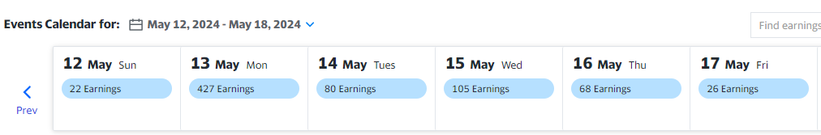

There are 427 companies reporting on Monday, May 13th, another 80 companies are reporting on Tuesday, May 14th, and 105 companies reporting on Wednesday, May 15th.

These are set in stone, so we know when they’re coming.

This is the easy part.

The second step is to study average daily volume….

But – this metric comes with a massive plot twist – which most traders overlook.

You see, most traders scan for volume spikes on any given day of the week.

But…I’ll show you how to approach volume in a far more sophisticated way….
You see, we start our analysis by scanning every company reporting earnings the next day.

And then, at precisely 3:00 EST, one hour before the market closes…

That’s when we scan for any stocks on the earnings calendar experiencing double their average daily trading volumes.

By isolating these volume spikes…

And only scanning for ones occurring 1 hour before the closing bell before earnings…

This shows you is smart money moving into….

Or smart money moving out of….

A stock right before earnings get released.

This is the most accurate way I’ve ever discovered to foreshadow stocks about to make a big earnings move either up or down.

And here’s the thing…

I don’t care if it moves up or down… I just want to see it move in either direction.

This one simple technique narrows our playing field of Overnight Whale Trade candidates down by 90%.
And now we’re cooking….
From there, we add one more critically important element….
Which is this….
Among the small handful of stocks experiencing double their average daily trading volumes 1 hour before the close of trading…

We then scan to see if any of these stocks are currently forming a daily candlestick formation that’s touching the 9-day Exponential Moving Average (EMA).

Why the 9-day?

Simple.

The 9-EMA is largely considered the most powerful indicator tool for short-term market trends .

This means that the 9-day EMA is specially designed to place greater significance on the most recent data points.

So….

By using ONLY the most recent price sensitivity…
This tells you that a stock is sitting right at a key support - or a key resistance level – which could dramatically break in either direction.
**Graphics – show this EMA chart as I’m describing it – highlighting the line where the stock begins to move upwards.
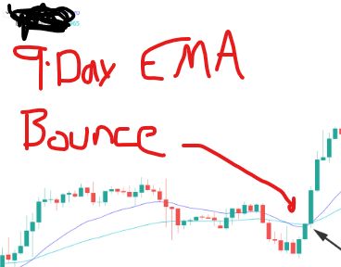
And here’s the “ah-ha” moment….
What better catalyst to trigger a dramatic move in a stock……than a known market-moving event……such as an earnings release!???
Do you see how this is all coming together – to put the odds in your favor?
Combine all three metrics….
- Upcoming Earnings Release
- Average Daily Volume DOUBLE the previous day
- And all trading at the 9-day EMA
And that’ll give you the small group of stocks that have historically made the most explosive moves on earnings day.
Case in point….
The top 10 Overnight Whale Trades winners over the last 4 and a half years all had daily volumes double that of the previous day….
And the top 20 Overnight Whale Trades winners over the last 4 and a half years all had daily volumes MORE THAN double the previous day…
See for yourself…
Here’s the top 20 Overnight Whale Trades that met this precise criteria…
Scroll this list right now…
And you’ll see for yourself….
100% winner after 100% winner after 100% winner….
Graphics – scroll this list as I’m commentating
Top 20 Overnight Whale Trades Meeting This Precise Criteria
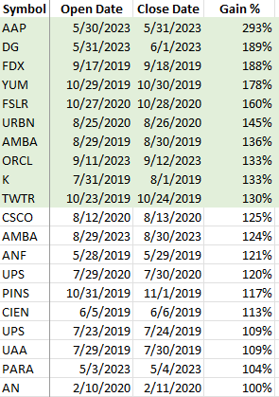
So….knowing this….
Every day, 1 hour before the close..
I receive a list of any stocks meeting those 3 criteria.
It looks like this….
The red circles at the top are my 3 criteria…
Earnings release – with a volume surge – all at the 9-day EMA.
And if any of them trigger on all three metrics, they get highlighted in yellow…..
Graphics -please re-create this image below to look sharper
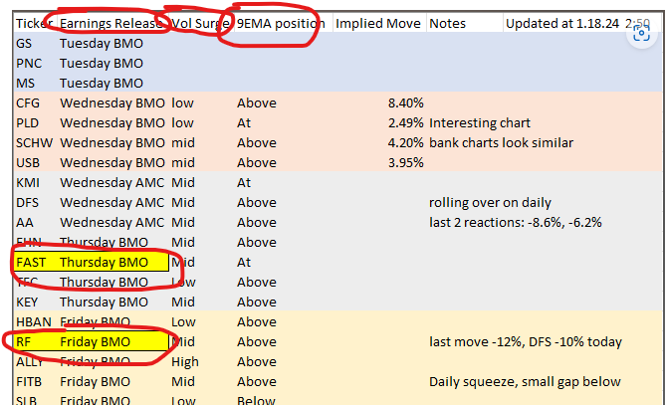
Those will be the small group of companies that are ripe for an Overnight Whale Trade…
And the instant any company matches….
That’s when I immediately write up the exact trade…
And share it with my elite group within my trading research community called….
The War Room
Graphics – insert War Room animation and logo here
The War Room is unlike any other service you’ve belonged to…
It’s a live, real time, members-only, research, trade recommendations, and chat room…
Focused entirely on one thing: To Make BIG Winning Trades
Every trading day at 9:00 AM EST….30 minutes before the opening bell on Wall Street….the War Room opens….
And our elite group of traders, speculators, and entrepreneurs log in – and share their top trading ideas for the day.
As you’ll quickly discover….
The War Room is the most unique, immersive, and exciting community you’ve ever belonged to.
In fact….
I created this unique platform to replicate the floor of the CBOE…
Where traders gathered in a trading pit to make enormous sums of money – simply by trading together.
But now…thanks to technology….
We’ve re-created the CBOE trading floor experience….Virtually.
Which is infinitely more powerful.
Because now….the top traders are not only gathering on LaSalle Street in Chicago…
But rather…
They’re coming together from across the world to collaborate….strategize…and share their very best trading information with one another.
And it’s here….
Inside the War Room…
Surrounded by the world’s top trade enthusiasts…
Where I post my Overnight Whale Trades for you….LIVE…..in real time.
This is where my members post the comments – many of which you’ve seen throughout this presentation – to verify their massive overnight winners.
And today….
I’m inviting you to join our elite group inside The War Room.
The moment you join our community….
You’ll have a wealth of trading resources, intelligence, and educational materials at your fingertips.
The first of which is my newest report titled….
Overnight Whale Trades: How to Target Massive Earnings Winners Every Day of the Week
Graphics – please create an image for this report
This new report, which I just created specifically for 2024…
Gives you a step-by-step guide on how to trade Overnight Whale Trades.
It offers you the very best opportunity to hit the ground running…
And start making these trades …
The moment you join.
After that….
I wanted to make it as easy as possible for you to get comfortable being part of our group.
That’s why I’ve created an easy-to-read guide titled…
“Getting Started as a War Room Trader”
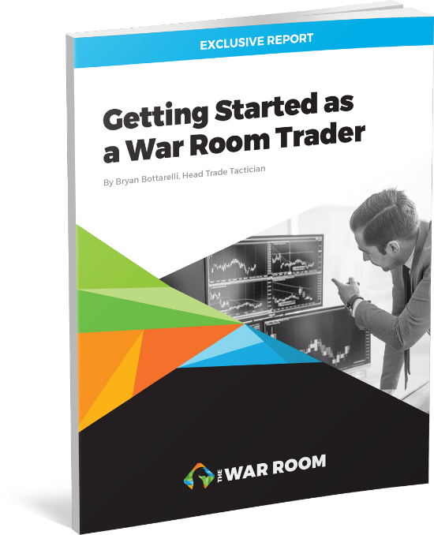
This manual contains everything you need to get started following us in The War Room.
For instance….
It shows you what a BUY or a SELL recommendation looks like in our trading room...
So you know exactly how to start using War Room recommendations to make winning trades.
But that’s not all…
You’ll also get another report titled….
“Developing the Winning Mindset of a Pro Trader”
And this one’s really unique….

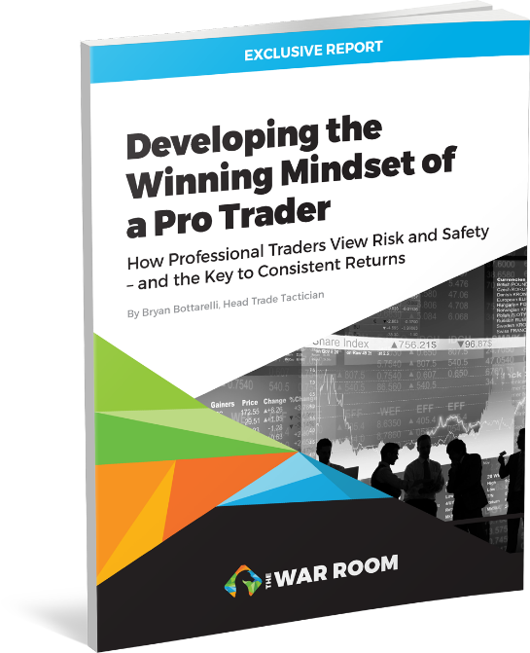
Because being inside the Apple Computer pit….
In the heart of the Dot.com boom and bust cycle….
Prepared me to trade volatility in a way that still influences my trading today.
You see, I was lucky enough to stand shoulder to shoulder in the live Apple pit - with many of the top traders on the planet…
Standing next to them….
As their trading clerk….
Logging all their trades by hand….
And seeing how they position themselves to profit off market volatility….
Taught me valuable lessons that you simply cannot replicate today.
In short….
I discovered that winning traders just think differently.
They’re always thinking about “what if” scenarios….
And using those various scenarios to protect themselves….
And ensure that they’ll come out profitable no matter what situation plays out.
In short….
It’s a mindset that sets the millionaire traders apart from everyone else…
And in this report…
I share all the keys to adopting this special mindset into your own trades….
All in one easy-to-read primer.
So, let me quickly review the first four (4) benefits you’ll instantly receive as a new War Room member…
- First, you’ll get immediate access to The War Room LIVE trading portal…
- Second, you’ll get my newest report: Overnight Whale Trades: How to Hit Massive Earnings Winners Every Day of the Week
- Third, you’ll also get access to my second report Getting Started as a War Room Trader…
- And fourth, you’ll receive your third report Developing the Winning Mindset of a Pro Trader.

But the list of membership benefits doesn’t stop there…

If you’re worried about not having time to make the trades…
Then you’re going to love this feature….
It’s called our War Room Mobile Trade Alert Service

If you don’t think you’ll have time to engage in the War Room trading board during the day….
Or if you’re busy with travel or appointments….
You don’t need to sit in front of the computer waiting for the next Overnight Whale Trade to come in.
Instead….
You can opt in to receive our special…..real time….trade notices…..directly to your phone or email.
Whenever there’s a new trade recommendation….
No matter if it’s a Buy or Sell…..
You can instantly receive that notification right to your phone, tablet or computer.
That way, even if you aren’t logged into The War Room, you’ll always know when a new trade goes out.
Then, you can hop into your account and get all the information you need right away.
And best of all….
You can turn these alerts on and off as you like. It’s totally up to you.
So…even if you’re extremely busy….
With a regular day job….
Or on the go with other commitments….
You can still get all of our trades…..
Without being anchored to a computer screen.
We created this valuable new feature so that the War Room can work around YOUR schedule.
And keep in mind…
The biggest winners…..
The Overnight Whale Trades…..
Typically get issued in the last hour of the day (between 3:00 to 4:00 EST)
So…if you only jump in to check these trades during the last hour…
That’s fine too!
And I want to really emphasize this with new members.
In most cases, you can get into these trades for $500 or less.
This tells you that our community doesn’t only cater to the mega wealthy…
Rather, we’ve created our War Room trading community to be accessible to anyone….
From the most novice trader – who’s just getting started…
To the most sophisticated pro traders….
Even for those who just want to spectate and follow along…
The War Room is a community that can benefit everyone – top to bottom.
Here’s a perfect example I just received in February,…
It was from a member named Chuck D – who’s wrote us this….
Graphics – delete or blur out “good morning Karim – just a quick note – and RYCEY” Start with “My wife and I”
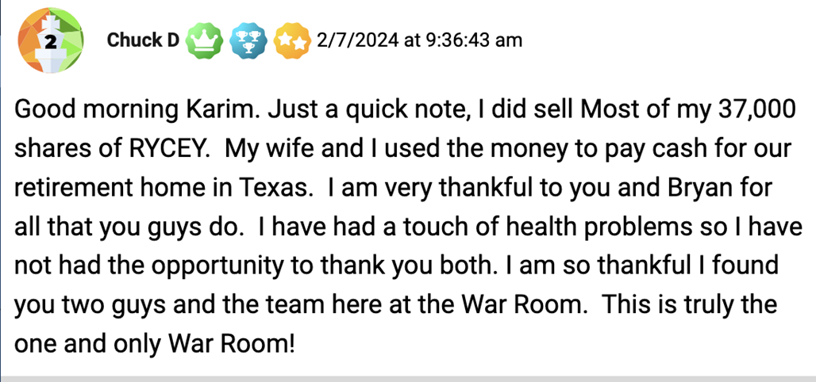
Chuck is referring to a trade we first recommend in November of 2021 and closed out for a 5% win by March of 2023….
When we first started talking about it….the stock was $1.72 per share.
Chuck bought nearly 37,000 shares at an average of 0.90 in August of 2023.
He closed his position in April of 2023 when the price hit $1.89…
And from that one trade…
Here’s an actual picture of ChuckD’s new Texas retirement home….
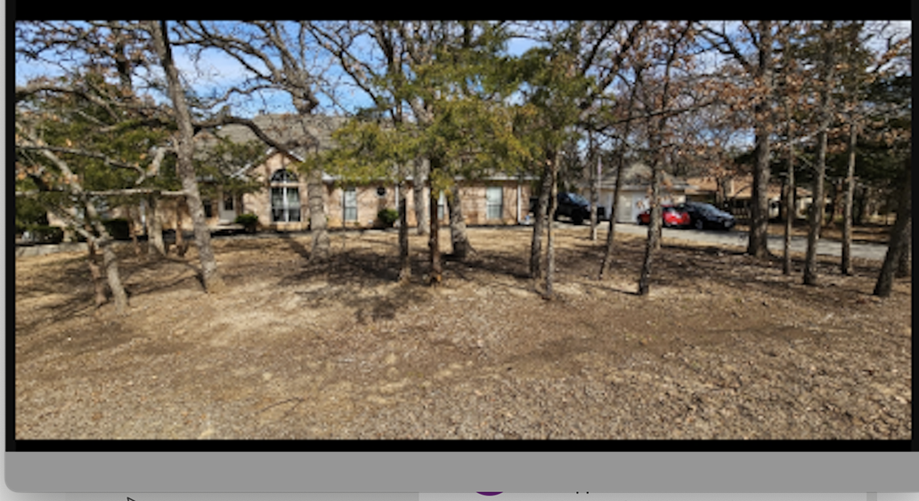
And….
If you think that’s impressive….
It gets even better….
At a conference in Florida, we had a Monument Trader’s Alliance member named Greg E. approach us with the spreadsheet that most only dream about…
He showed us a compete tally of the trades he made on Rolls over 10 days…
From August 16th 2022 to November 9th of 2022….
He bought over 516,000 shares for the average price of $0.93.
Assuming he’s still holding all of those shares today, at today’s price around $4.00….
That’s a profit of over $1.5 million!
His entire buying history is detailed below:
Graphics – please re-create this image to look sharper

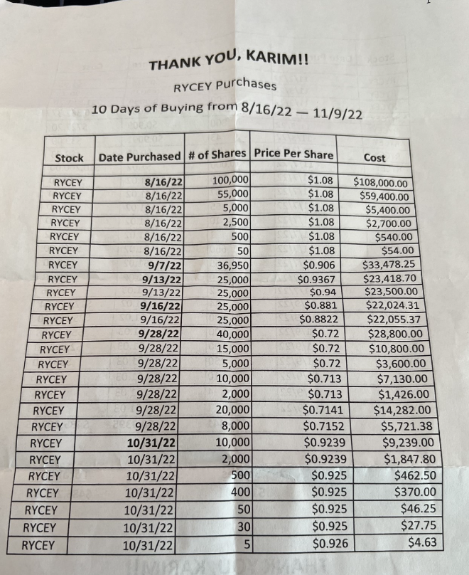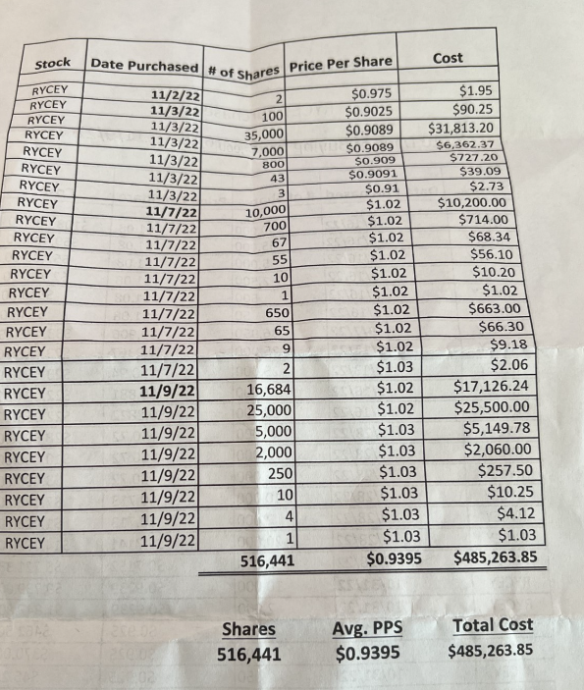
And again…
Rolls was a pick that we made in March of 2022 as part of another service inside our Monument Trader’s Alliance group…
Which was often discussed – and updated - inside The War Room.
We’re still telling those readers to hold on to the position which is currently up over +250%.
But many times, like these, members will use the information discussed inside The War Room to see incredible gains on their own.
And the results speak for themselves…
Just imagine being part of a community that helps you generate enough money to buy yourself a new retirement house….
Or…make yourself $1.5 million in profit…..
Just Off One pick!!
That’s exactly the type of research and collaboration what you get inside The War Room!
And I can tell you….
The atmosphere really lights up in The War Room every time we get to tell members…
“To Ring The Register!”
[DESIGN: Have “It’s time to ring the register!” appear on screen.]
I can’t wait for you to experience this for yourself…
Because there’s nothing else like hitting a monster 24-hour winner….
Like the +121% in one day on Walmart…
Or the +291% in one day on SnapChat…
Or the +188% in one day on FedEx…
That thrill of hitting a big winner….
And celebrating alongside fellow War Room traders who also won….
It’s truly a rush of adrenalin that becomes very, very addictive.
For instance, on that big FedEx winner….
We had a member names Hall message us and say this about his 408% gain…
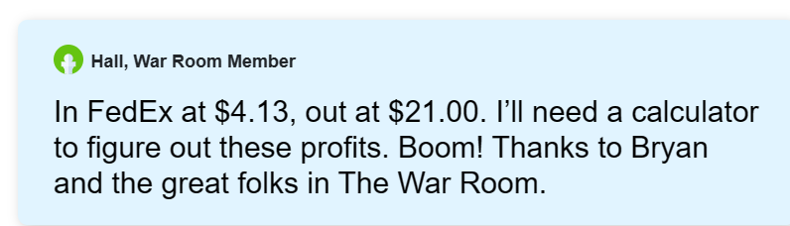
Dale said this about his 396% gain…
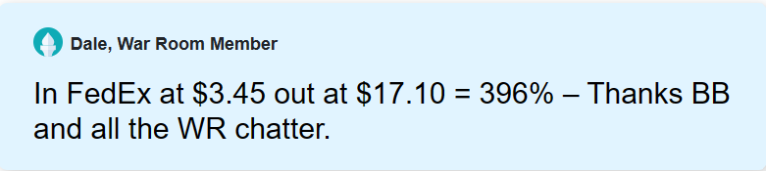
And Mark D said he made enough on the FedEx trade to pay for his daughter’s car!
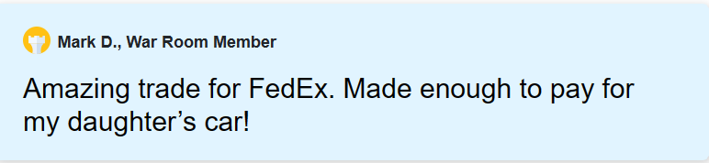
I can go on and on and on with some of our top success stories….
But I’m getting ahead of myself….
Because there’s a ton of other benefits for you to enjoy as a new War Room member…
And the biggest one that I haven’t even hit on yet is my partner….Karim Rahemtulla.
Karim is the perfect complement to me….
Because while I focus on quick-hit, overnight trade opportunities…
Karim trades on fundamentals.
He’s the mastermind behind the Rolls trade I profiled above.
Whereas my trades have an average holding time of 2-3 days…
His trades play out over a longer term… like 3-4 months.
This offers you a perfect complement of short-term trades…
Combined with longer term trades.

[DESIGN: Pictures of Karim on the news.]

Put us both together…

And The War Room offers you access to a plethora of trading strategies that have the potential to win in any market environment.

Case in point…

Karim started the 2024 trading year RED HOT….

Hitting winners on all 12 of his first 12 booked trades, including…

+58% in ten months on Charles Schwab…

+121% in 2 months on S&P Biotech spread…

And +71% in eight months on Cleveland-Cliffs
This didn’t surprise me. Karim has a win rate of 83% on 341 trades since we launched The War Room in 2019.
*LEGAL: Stats taken from War Room summary dated 2/2/24
Bottom line…
Profit opportunities happen all day, every day.
And no matter if they’re short-term trades with me…
Or longer-term trades with Karim…
The War Room offers you the best place to be part of a community……focused entirely on making winning trades.
Anything that we think has a chance to make you money…
We’ll share it inside The War Room.
Sometimes that’s stocks….
But most of our trades involve options…
Which is why I’ve written another bonus report for you….
The War Room Options Primer
[Graphics, please create a REPORT COVER]
In this primer, I detail everything you need to know to start trading options.
It’s a simple-to-understand guidebook on how to get started trading options.
Within minutes of skimming through this primer…
You’ll be ready to place your first options trade.
And let me tell you….
We’ve had a ton of people join the War Room….
Many with little to NO options trading experience….
And hit big winners on their very first trade.
Like a guy named Bernie…
On the trade I made 40% on….
He told us he made +138% in two days on his first trade…
He bought SNAP calls for $1.12…and sold them two days later for $2.67.
What a way to get started!
[DESIGN: Please blur out the trader’s last name “Cousino.”]

Then there’s Franz…..
Who made +158% on his very first trade…
He got in at $2.01…and out the next day for $5.20.

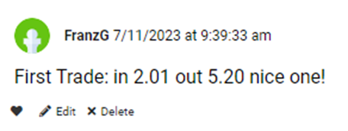
He did even better than our official gain of 35% in 6 days!
The point is….
I’ve designed The War Room to work for anyone, regardless of their experience level.
If you can follow simple instructions, you can be successful.
Once you join us…
You’ll immediately see that trading options is incredibly easy…
But, just to make entirely sure you’ll get everything you need to hit winners….
I’ve also created an entire video library to teach you the secrets I learned on the CBOE.
Each video offers you a quick-hit bullet on trading….
Which gives you a unique trading perspective you don’t find anywhere else.
You could finish them in less than 10 minutes...
But they contain secrets that will make you more informed than 99% of traders in the market.
The first video bullet is called….
How to Hack Earnings Season
This video bullet digs deeper into why earnings are the ultimate trigger catalyst for our Overnight Whale Trades.

The second video reveals a trick I call “Fading the Public.”
That’s a term pro traders use for taking advantage of amateur traders.
This powerful concept has helped me produce more than +252 winning trades – EACH YEAR - all over the last four and a half years.

Guys… this is an invaluable secret that you’re not going to want to miss out on.
But the last video bullet is the most valuable….by far.
In it, I give you the secret weapon of true professional traders.
I call it…
“The Secret 3-Minute Chart”

In this video bullet…
I reveal the one tool that can tell you – more than any other in my experience – which way a stock is about to go next.
I’m not kidding when I say… this video could get me cancelled within some veteran, old-school CBOE trading circles.
Some of the people I know from the Chicago pit would be furious if they knew I was divulging this secret to the public.
So please, guard the contents of this video closely.
Other War Room members and I are depending on you to keep this powerful secret to ourselves.
To summarize….
Here’s everything what you’ll get as a new War Room member...
[DESIGN: We need an updated “product cluster” image with everything mentioned above – all three videos – and the news reports. ALSO, please include the sales phone number on it

- 12 months of research and trade recommendations in The War Room
- Access to the members-only chat site
- Report #1… Overnight Whale Trades: How to Hit Massive Earnings Winners Every Day of the Week
- Report #2… Getting Started as a War Room Trader
- Report #3… Developing the Winning Mindset of a Pro Trader
- War Room Mobile Trade Alert Service
- Report #4… The War Room Options Primer
- Video #1… Hacking Earnings
- Video #2… Fade the Public
- Video #3… The Secret 3-Minute Chart
But the best part is…
Once you become a War Room member…
The hard part is over.
From that point on, my team and I will do all the heavy lifting….
Handing you every trade….the instant it triggers…..anytime the markets are open.
Remember, our win rate on ALL trades is +75%.
And trades that I’ve opened and closed within 24 hours….
Dating back to 2019….
Have won +90% of the time.
So anytime a profit opportunity comes up….
Including our powerful Overnight Whale Trade trades…
You’ll be the first to know.
But to make this decision easy for you….
And to give you peace of mind that I’ll continue delivering winners at a high consistency rate….
I’m giving you something that NO OTHER trader will ever agree to…
It’s called….
My Iron-Clad Performance Guarantee
Here’s how it works…

There are 252 trading days every year.
If The War Room hasn’t shown you the chance at 252 winning trades after one year, per our model portfolio…
You can get a SECOND year of service…..totally free.
So essentially….
I’m guaranteeing you 1 wining trade….
Each and every day….per average….
Over the course of one year.
It’s a bold promise…
But I know I can deliver.

So, if you’re serious about joining our group….
And you want to start making Overnight Whale Trades….starting as early as tomorrow…
Then here’s the offer…
My publisher set price of membership into The War Room at $7,500 per year…
But today….
I’ve decided to do something off the cuff…
And a little out of the ordinary…
For the next 99 people who join the War Room today…
You can get a special, 6-month trial offer for $1,499
That’s Over 60% Off the published rate.
And for that low price….
You could easily make that much back with just one or two trades.
Many have already done it…
Like Jim…
When we closed out TDOC for a 98% gain in less than one day, he had his best day ever with a fast 340% gain.
He made more than $4,000 on that one single trade…
Which would’ve more than doubled today’s 6-month trial rate…
Jim S. (3/5/2020,3:12 p.m.)
Sold TDOC... Total profit of $4,019 with 340% total. My best day ever!
I could go on and on...
But you get the idea…
If I learned one thing on the CBOE...
It’s that talk is cheap.
Big time traders deliver results…..not promises.
So today…
Right now….
I’m going to step it up…
And take this one step further…
To ensure that you see amazing results…..FAST
If you’re one of the first 99 new members to join in the next 15 minutes….
I’ll give you an extra special deal…
In addition to the 252 winner guarantee…
I’ll combine that with a new, Overnight Whale Trade guarantee.
Graphics: Create an image that says “NEW SPECIAL BONUS! Overnight Whale Trade Guarantee”
If you join today…
Take the first 3 Overnight Whale Trades that you see…
And if those 3 trades don’t show you the chance to double your total membership cost…
Call us up….and you can get a full refund.
So….you either get the chance to double you membership cost after 3 Overnight Whale Trades…
Or you can get a full refund.
I simply cannot offer you a stronger incentive to join than that…
But I’m willing to do it…
Because I know that all it’ll take is 3 trades to prove that War Room membership will have a profound impact on your future wealth.
This is my way of making sure you don’t just buy the exercise equipment…
But you actually take it out of the box and use it.
So….it’s time.
Let’s get started.
Display order Button
Join The War Room right now…
And make the first 3 Overnight Whale Trades that you see.
And from there…..
You’ll be on your way to generating substantial wealth…..day after day.
Now….
If making 3 trades is asking too much…
Then respectfully, please close out this video right now.
This trading community is not right for you.
But if you are ready to start hitting monster Overnight Whale Trades…
Then click the button below…
And be among the first 99 people to place your order.
Or, if you prefer to talk with a real human…
You can do that too…
[DESIGN: Please put this phone number on the screen with the discount code. And leave it on screen for the remainder of the presentation.]
Feel free to call our VIP Sales Team at XXX-XXX-XXXX.
We have plenty of people standing by, so you won’t have to wait long.
As you’re locking in your spot…
And placing your order…
I’ll leave you with this…
Every single trading day, when I wake up and check the pre-market futures…
It ignites my speculative fire – and challenges me to be the best trader possible.
And today, by joining our War Room trading community, you’ll be plugging yourself into a truly life-changing group.
Without exaggeration…
What you’re about to experience with Overnight Whale Trades is a true game changer…

Nearly every single day….we’ve got hundreds of earnings candidates that we’re monitoring…
Performing my 3-part analysis on each candidate…

And picking the very best ones to send to you for an Overnight Whale trade recommendation.

So let me state very clearly that you can expect MANY, many, many Overnight Whale Trades in the imminent future.

I can’t wait to deliver the next big winner for you.

Bottom line: I’m thrilled to have you right alongside me – as we begin a new chapter of wealth creation.

So with that, let me be the first to welcome you into The War Room.
From this day forward, the way to trade will never be the same.
I’m pro-trader Bryan Bottarelli.
Thanks for watching…
And I look forward to seeing you post about your first big Overnight Whale Trade winner….inside The War Room!
Yours in Smart Speculation
Bryan Bottarelli
Founder, The War Room
February 2024
P.S. Oh…I forgot to mention…
Once we reach our 99-member capacity, we reserve the right to close this offer - without any advance notice.
So, if you have any interest in taking the 252 Winner Guarantee…
Combined with the new Overnight Whale Trade Guarantee….
All for the special 6-month introductory rate…
Then you MUST lock in your spot right now.
So click the button below….
Or call the number on your screen…
And your journey to daily wealth creation….starts now!
=========================
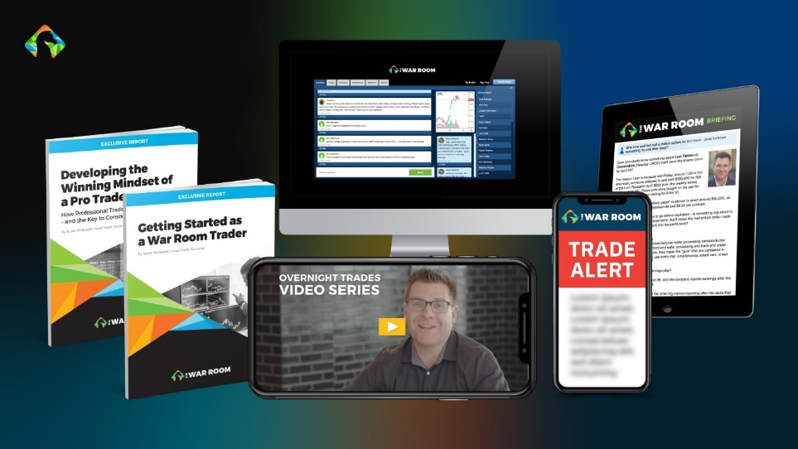


===============================
Selection Criteria Backup from JMead at Research
jmead 2:03 PM
We're looking for the daily volume to be double that of the previous day, or double the 30-day moving average. With volume typically ramping into the close pre-earnings (it sometimes makes up the majority of daily volume) I'm trying to assess where it's at around 3pm. One thing I've been using lately is a relative volume indicator to get the actual numbers, but I use it on smaller timeframes to see if the stock saw higher relative volume throughout the day. (edited)
2:04
And the daily candle ahead of earnings should be touching the 9ema
2:07
For reference, on your top earnings strangle trades of the past, the top 10 trades saw daily volume double that of the previous day, or double the 30-day moving average. And the top 20 earnings strangles had an average volume surge of 106.9% (over previous day) and 116.3% (over 30day).

bbottarelli 2:09 PM
nice, thank you
2:09

jmead 2:09 PM
There are a handful of huge volume spikes that prop up the averages though, so while using 100% is clean and would be ideal, we might need to lower that standard a bit. Upcoming earnings season should be great to fine-tune the strategy and gather more data

=========================
Order Form
YES! I Want
Overnight Whale Trades!
15 Minute Count-Down Clock
(Offer Limited to the First 99 People to Respond Today)
Congratulations!
The special introductory rate is still available.
Submit your order within the next 15 minutes, and you’ll qualify to receive the two performance guarantees below:
Iron-Clad Performance Guarantee
“NEW SPECIAL BONUS! Overnight Whale Trade Guarantee”
Here’s Everything You’ll Get as a War Room Member
- Every LIVE Trade Recommendations inside The War Room
- Full the members-only chat site
- Report #1… Overnight Whale Trades: How to Hit Massive Earnings Winners Every Day of the Week
- Report #2… Getting Started as a War Room Trader
- Report #3… Developing the Winning Mindset of a Pro Trader
- War Room Mobile Trade Alert Service
- Report #4… The War Room Options Primer
- Video #1… Hacking Earnings
- Video #2… Fade the Public
- Video #3… The Secret 3-Minute Chart
YES! I Want to Start Hitting Overnight Whale Trader Winners Like These Top Plays…
Get Started Today

Step No. 1: Review Your Subscription

Great Deal! One year for just $7,500 $2,600!

BEST DEAL! Two years for just $15,000 $3,600!

Or if you prefer to speak with someone personally... You may call our friendly customer service team at 888.215.5311 or 410.864.3083.
Have Questions? SCHEDULE A CALL

