Backed by Analysis of 5,704 Stocks Over Five Years:
The #1 Trade to Make EVERY July
It’s Averaged a 62% Gain Every July Since 2020…
Get the Ticker Symbol FREE
Plus “Unstoppable Tickers” for August, September and More!

“The Most Logical Investment You Can Make” – Bryan Bottarelli
“Unstoppable Stocks”
See Why Certain Stocks Have ALWAYS Gone Up During Certain Months…
And How to Play Them For a Shot at 119% Monthly Gains on AVERAGE!

Just One Trade a Month…
With a 119% Average Monthly Gain and a 98% Historical Accuracy Rate Over the Last 5 Years

Hi, Bryan Bottarelli here.

I’m a former CBOE trader, and a 30-year stock market veteran.

I spend 99% of my time studying the markets and day trading…

And I recently discovered a strange anomaly.

It’s an unusual group of stocks that have risen - with near-perfect consistency - during specific months each year.

Here’s what I mean…

Looking back, I found a stock that’s gone up EVERY SINGLE January without fail… for five years straight.

And another that’s gone up every February…

And another during March…

And on and on like this – for every month on the calendar.

TJX Companies is the stock for August.

It’s consistently risen every August for five years now.

ALT TAKES OR AI FOR EVERY MONTH

Which is why I suggest you check it out before the end of the month.

In all, it’s a full year’s worth of unstoppable plays…

Specific stocks that have gone up during specific months year after year.

You can imagine the impact something like this could have on your portfolio.

Some months have just one or two “unstoppable” stocks…

Other months have dozens.

I’ll give you the name and ticker symbol for many of these stocks today.

I suggest you have a pen and paper handy.

Because once you know the top stock for each month…

I can show you the best way to play them for max potential gains.

Looking back over the last five years, my research shows these special plays could have delivered 119% returns on average… every single month.

Now, there are no guarantees in investing.

But over the last five years, these specific stocks have shown remarkable consistency.

Let me give you an example.

There’s a little-known company that operates data centers.

Most of the time it’s a mediocre stock to own.

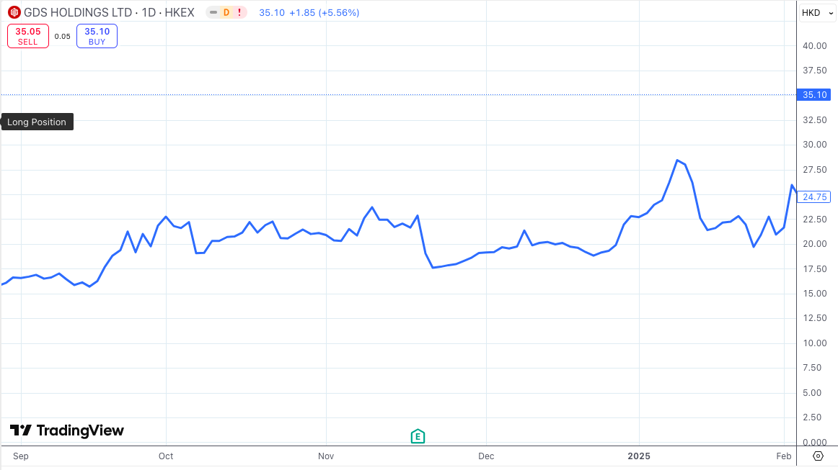

Down, then up… then down again.

But every June… something weird happens that sends the stock rocketing higher.

It’s not earnings, dividend announcements, or anything else you’ve likely heard of.

But it’s gone up every single June for the last years – like clockwork.

And one special play on this stock has averaged a 236% gain every June since 2020.

That’s just one example.

I also found a beverage company that’s gone up every single May for the past half decade.
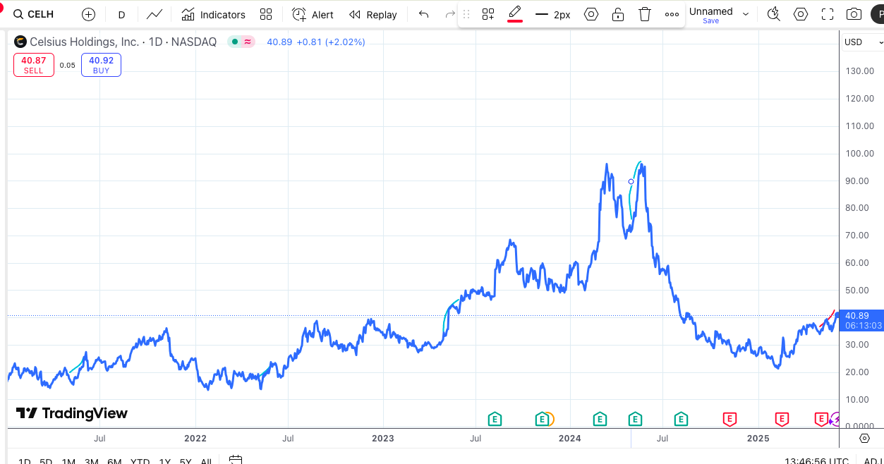
The rest of the year it’s just ok…

Nothing to write home about.

But every May it really takes off.

And I’ve found a great way to play it…

One that’s delivered a 92% average gain every May for the last 5 years.

And March’s play is even more impressive…

This one’s a gold miner.

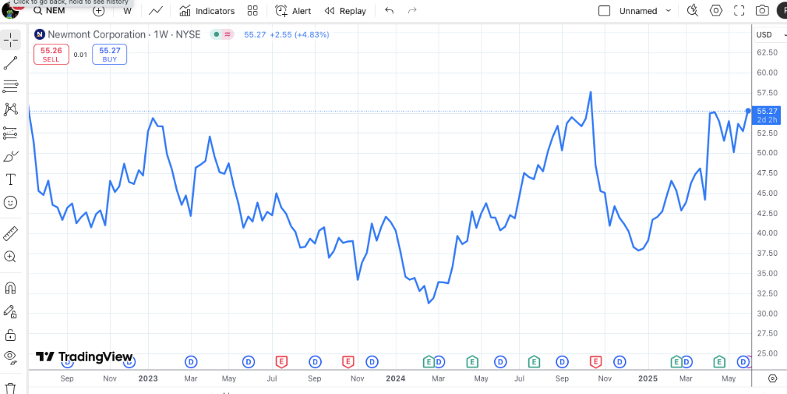

And it acts the exact same way.

Its average year is full of ups and downs…

But each March since 2021… it’s gone straight up, without fail.

That’s five wins.

Not a single loss.

And the special play I’ll outline today has averaged a 293% gain each time!

Again, I’ve found an entire year’s worth of plays just like this.

Stocks that have jumped during one particular month every single year.

These stocks have been so profitable… and so consistent…

I wouldn’t be surprised if these become the ONLY stocks you ever trade again.

Using over 200 years of data, researchers at Erasmus University in Rotterdam concluded that this type of trading outperforms ALL OTHER investment strategies.

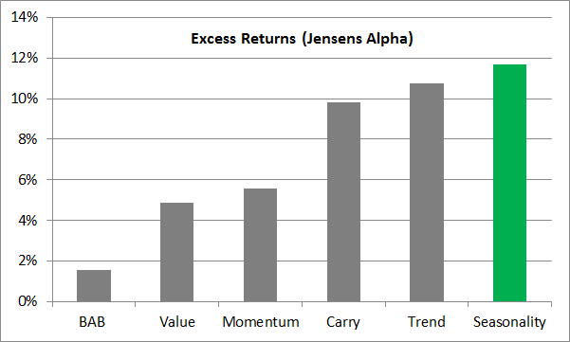

So just imagine how different the next year of investing could look, trading nothing but special, “unstoppable” plays on the stocks I’ll share with you today…

ALT TAKES FOR EACH MONTH

Starting off with January’s play that’s averaged 109% every January since 2021.

Starting off with February’s play that’s averaged 52% every February since 2021.

Starting off with March’s play that’s averaged 293% every March since 2021.

Starting off with April’s play that’s averaged 99% every April since 2021.

Starting off with May’s play that’s averaged 92% every May since 2021.

Starting off with June’s play that’s averaged 236% every June since 2020.

Starting off with July’s play that’s averaged 62% every July since 2020.

Starting off with August’s play that’s averaged 56% every August since 2020.

Starting off with September’s play that’s averaged 44% every September since 2021.

Starting off with October’s play that’s averaged 103% every October since 2020.

Starting off with November’s play that’s averaged 188% every November since 2020.

Starting off with December’s play that’s averaged 144% every December since 2020.

Then the same thing each month moving forward…

IMAGE HERE OF ALL MONTHS/AVERAGE GAINS

Just one buy… one sell… and a 119% average gain.

[Begin July-September Alt Take]

This quarter’s plays are incredible…

July’s has averaged 62% each July since 2020…

August’s has averaged 56% every August for five years running.

And look at September’s…

Just one buy… one sell… one month hold time.

And a 44% average gain for the last four years.

[End July-September Alt Take]

[Begin October-December Alt Take]

This quarter’s plays are incredible…

October’s has averaged 103% each October since 2020…

That’s 10 times better than the S&P delivers in an entire year, on average.

November’s has averaged a 188% gain every November for five years running.

And December’s play has averaged 118% for the last 5 Decembers…

[End October-December Alt Take]
[Begin January-March Alt Take]

This quarter’s plays are incredible…

January’s has averaged 109% each January since 2021…

February’s has averaged a 52% gain every February for five years running.

And March’s play has averaged 293% each March for five years…

[End January-March Alt Take]
[Begin April-May Alt Take]

This quarter’s plays are incredible…

April’s has averaged 99% each April since 2020…

May’s has averaged a 76% gain every May for five years running.

And June’s play has averaged 236% for the last 5 Junes…

[End April-June Alt Take]

If these plays continue working, I believe you could go a full year without a single loss.

All by trading these remarkable stocks one at a time for large, single-month profits.

And today I’ll show you exactly how it works…

You’ll Never Invest the Same Way Again

But first, let me tell you a bit about me…

As I said, my name is Bryan Bottarelli.

I’m the cofounder of the Monument Traders Alliance, an investment research and trading platform.

Over the years, my business partner Karim and I have picked over 2,400 winners for our members…

And we’ve averaged a win on three out of every four trades.¹

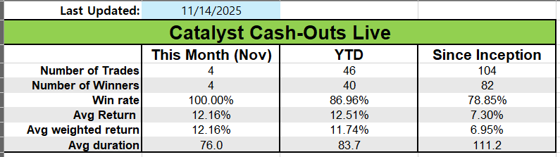
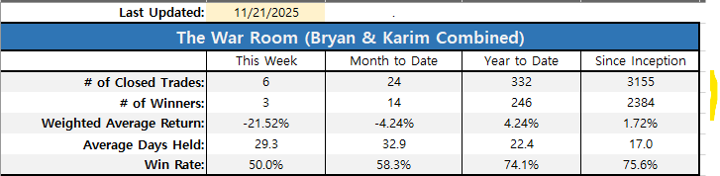

For instance, Jim said he made 312% for a $3,080 profit in 15 days…

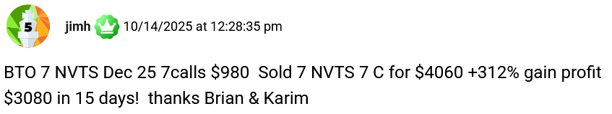

IMAGE BELOW FOR LEGAL PROOF ONLY – DELETE FROM DOC
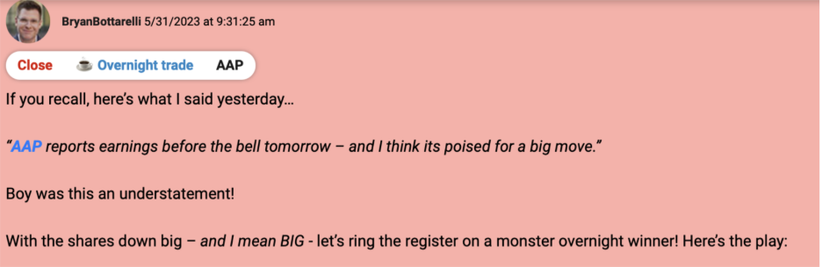

Fred made over 300% overnight and called it his “best trade ever!”

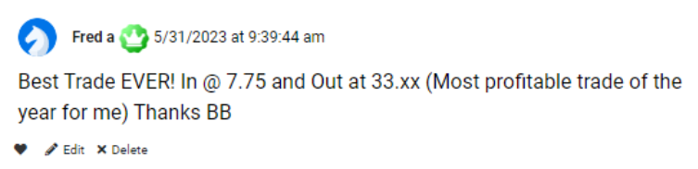

And Wade said he got “In at $4.30, out at $31.00.”

That’s 620% - and he did it overnight, too.
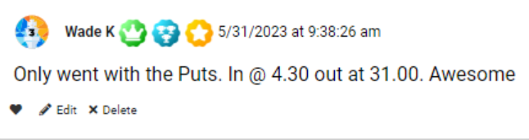

Or how about Bill, who wrote after holding around 3 years…

“I am up 656% for $142,000. Thanks!”
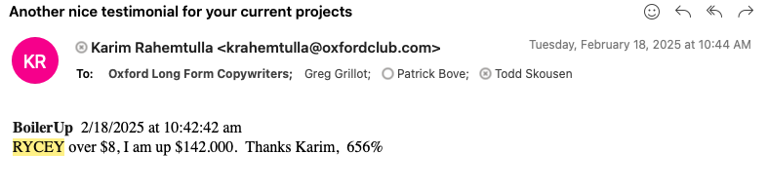
Now, if you’re like most investors, buy-and-hold is probably what you’re used to.

You buy a solid company like Coca-Cola… hold it indefinitely… and hopefully eek out 10% a year.

But that’s NOT what we’re talking about today.

These unstoppable monthly plays are all about the short term.

See, I don’t care what they do over the long haul.

Because for the last 4 to 5 years…

They’ve averaged a 119% gain – every single month of the year.

You simply get in on the 1st… get your profits… and get out at the end of the month.

Then you move on to the next month’s play.

Now, this kind of consistency is unheard of.

What you’ll discover today won’t be found in any investing book, journal, or online publication.

This is all true, groundbreaking new research.

Frankly, I hesitated to share this information publicly.

If the secret gets out, these plays could get overwhelmed with buyers that drive prices higher.

That would be bad for all of us.

So I have one request before we move forward…

Please don’t share what you’re about to see with anyone.

For now, let’s keep this secret to ourselves.

Ok, let’s get right into it…

Keep this Between Us for Now…

Most people have heard of the concept of seasonality…

Certain stocks perform best during specific times in the year.

For example, retail stocks do best in the fourth quarter… when the holidays drive sales up every year.

Energy stocks tend to do best over the winter… when demand for heating drives profits higher.

And airline and cruise stocks do best during the summer when people are traveling.

These seasonal trends have been studied many times.

However, when I started my latest research project… I wanted to narrow it down even further.

I wanted to find if there were certain stocks that always seemed to produce blockbuster results in specific months each year.

My goal was to create a calendar for my subscribers to use.

They could jump from each month’s best performing stock to the next.

Would this work?

I had no idea.

But I wanted to try… so I began digging into the research.

The first thing I did was an analysis of all 5,704 stocks in the US markets… looking for the rare stocks that performed best in each month of the year.

I wanted stocks that were perfect…

If the stock had dropped – even a tenth of a percent – during its specific month in any of the last five years, I threw it out.

And what did I find?

Perfect stocks are rare.

Sometimes only one stock was perfect in a single month like in February… other times it was 25 or more like in July.

But soon I had a strong list.

I had identified the undeniably best stocks for each month.

The next step was identifying what kind of returns were possible by playing this phenomenon.

Would these plays deliver 5% returns per month? 10? 20?

I started with January.

My research took months… and a whole lot of computing power.

But when the dust had settled, I’d boiled the list of publicly traded stocks down to a small handful.

And two stood head and shoulders above the rest.

The first is Suburban Propane Partners…

It’s gone up every January since 2014.

BAR CHART COMPARING TO S&P

That’s 12 years straight.

But get this…

I found a special play on the second stock that’s delivered 109%, on average over the last 5 years.

Now, if you want to simply own Suburban Propane Partners going forward every January… be my guest.

The stock has done well.

But it’s these special plays I’ve found that really generate the biggest profits.

109% every January on average for five straight years is world class.

And this play rose that much despite the market averaging just .8% in January.

This type of opportunity was exactly what I was looking for.

So I moved on to February.

Again, I found a stock that had risen every February for five straight years.

It has never gone down during that month!

And over that time, a special play on that stock – which I’ll show you how to make – has delivered a 52% average gain.

That’s every February.

BAR CHART COMPARING TO S&P

Meanwhile, over those same five February’s… the S&P 500 was essentially flat.

So you can see how these plays could come in handy.

And March’s “unstoppable” play is even better.

Over the last five March’s… my special plays would’ve paid out 293% on average.

BAR CHART COMPARING TO S&P

Meanwhile, the S&P averaged just 1.7%.

This is exactly the type of edge everyone’s searching for.

Huge market outperformance…

Unstoppable profits.

It’s the kind of thing that could dramatically supersize your savings…

And today I’ll show you exactly how to play these opportunities going forward.

But first, you’re probably wondering…

How Come You’ve Never Heard of this Phenomenon?

How has something this potentially profitable managed to stay a secret for this long?

After all, you’d think a group of stocks that most ALWAYS go up during certain months would be a big news item.

And the secret lies in the size of the plays.

Many of these companies are very small.

And they’re not companies you’ve probably ever heard of, either.

One of the November stocks is Builders FirstSource… its ticker is BLDR.

Ever heard of it?

I bet the answer for 99% of people watching is a resounding NO.

But every November for the last 11 years, it has moved steadily higher.

On average, it jumps around 6.5%.
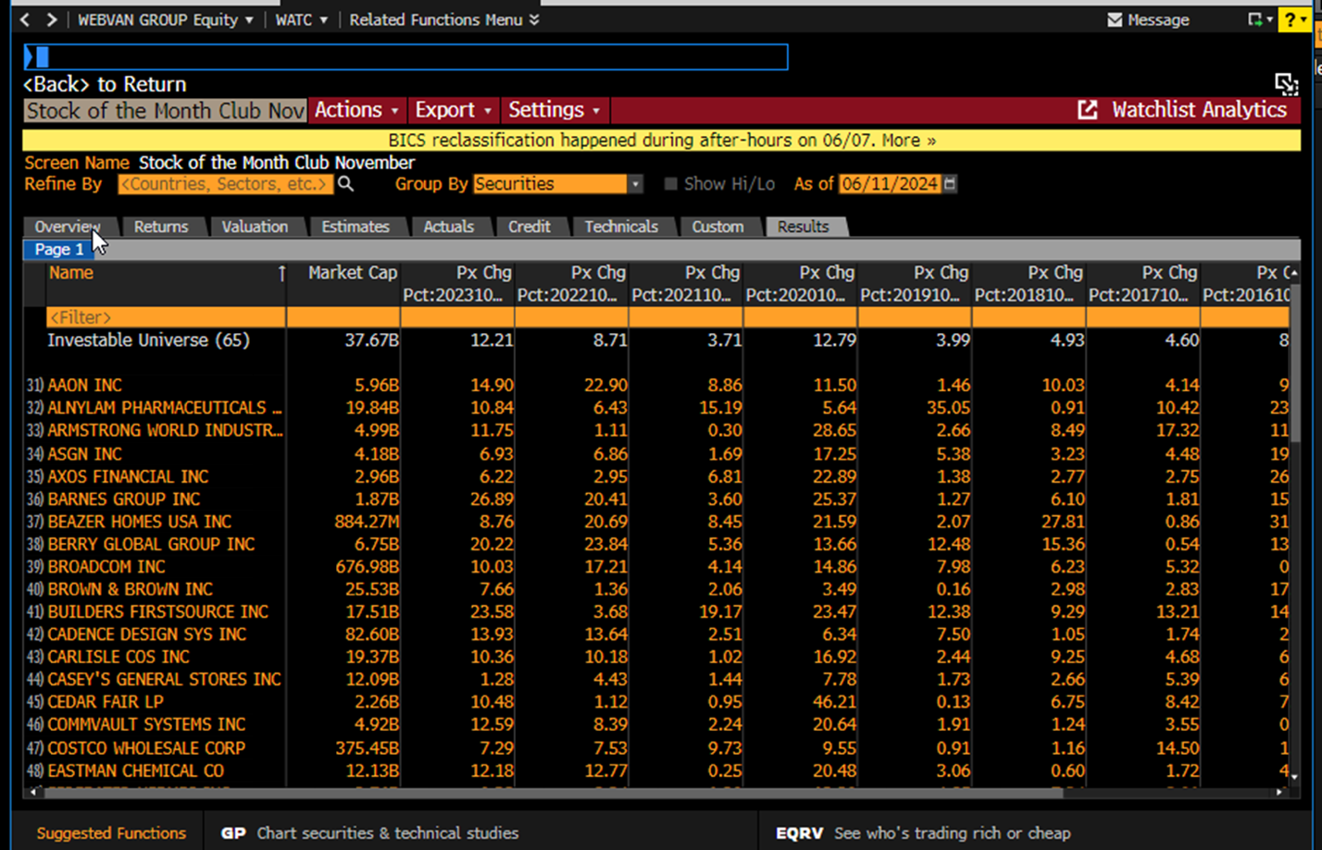
Not bad for a single month stock gain.

However, it’s the special plays we’ve been discussing where the biggest gains come in.

For Builders FirstSource, this play has averaged 162% - every November!

But most people have no clue you can trade this stock this way.

And since the media tends to focus on the big names like Tesla, Nvidia, and Apple…

Stocks like these tend to fly under the radar.

That’s good news for us.

As I mentioned, the less people that know about these plays the better…

Because once thousands of people start piling in, the best profit opportunities disappear.

It’s why I’ve never spoken about this publicly.

The truth is, I think it could wind up being the most valuable thing I’ve ever shared.

But you may be wondering…

Is this just luck?

Or is there an actual common sense reason specific stocks rise during one month each year?

Well, I’m happy to tell you…

There is a very easy-to-understand reason behind this.

Let me show you why it works…

Huge, “Unstoppable” Gains

It’s related to seasonal trading which I mentioned earlier…

Where certain companies perform better during specific times of the year.

Let’s look at retail companies, which I mentioned do best during the holidays… when people are out buying gifts... and spending their bonuses.

Look at Macy’s.

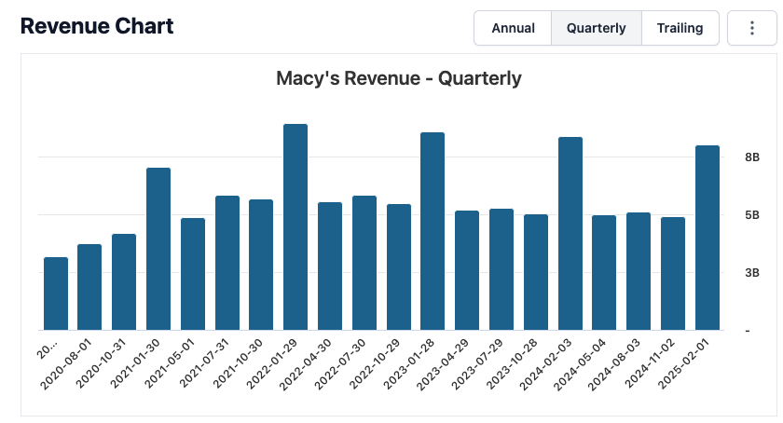
See how every 4th column is much bigger than the others?

That’s a clear revenue spike at the end of each year.

And it directly relates to the stock price.
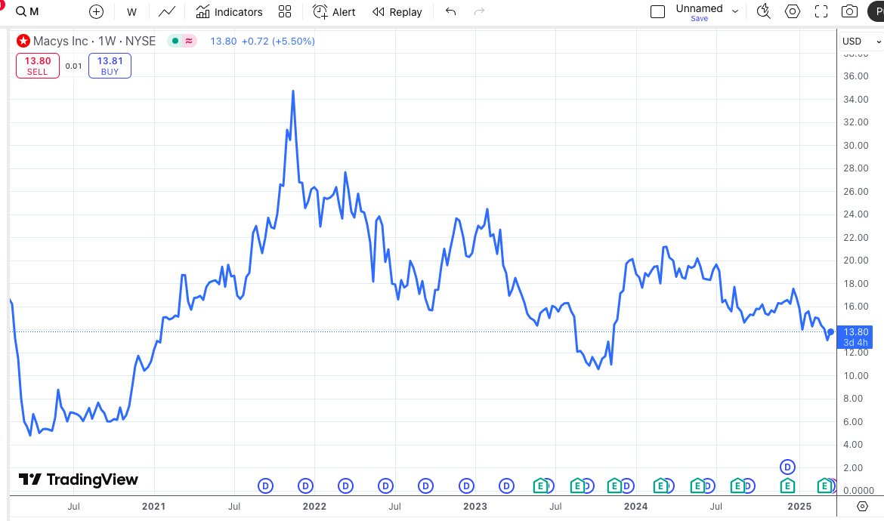

And once you know when to get in and out, you can trade this time period for big gains every year.

Kohl’s is another one.

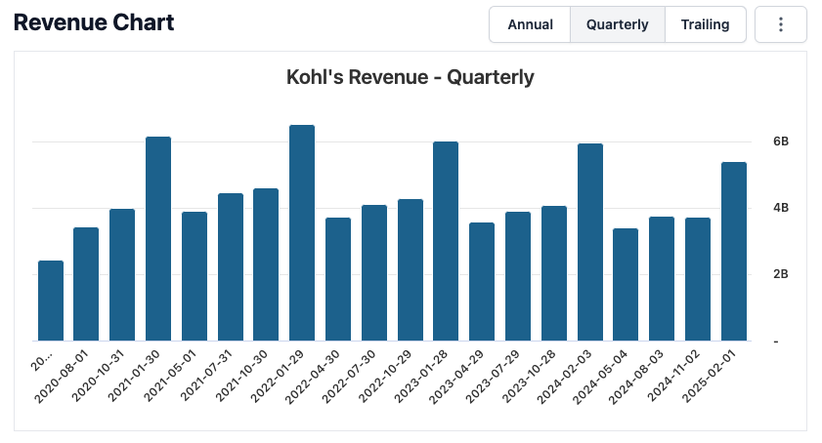
Revenue during the first 3 quarters each year are nothing to write home about…

But Q4 is always off the charts.

This revenue spike is directly tied to the share price.

From the end of the year through early January, the stock tends to do very well.

Just look at the end of 2020, where the stock doubled in value despite being extra volatile the rest of the year.
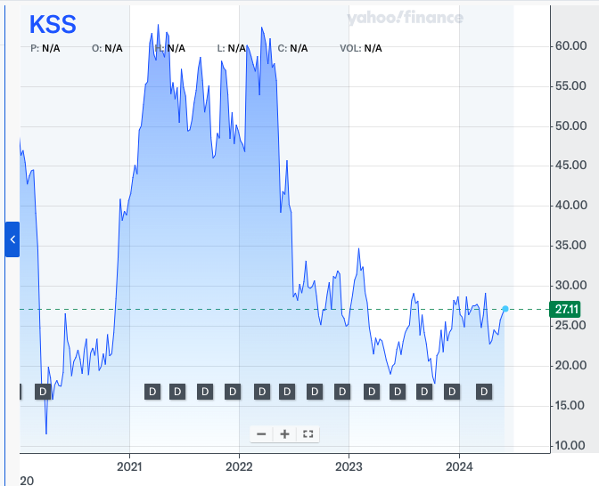

Or how about TJX Companies…

ONLY SHOW LAST THREE YEARS AS THEY’RE EASIEST TO SEE
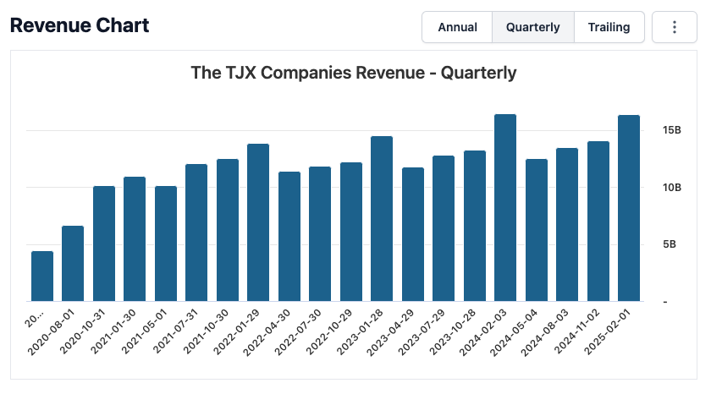
Just like the last two examples, the big spike every fourth quarter is the holiday bump.

But here’s the thing that’s interesting with TJX.

The market knows it always has a great fourth quarter… which is why investors tend to load up before the holiday season begins.

As a result, TJX has risen each August for the past 5 years.

In fact, my special trade on TJX would have delivered a 56% average gain...

Every August since 2020.

See, in order to get the best shot at huge wins, you can’t simply identify the quarters where stocks do best.

That’s too broad…

Instead, you have to identify the individual months when they do best.

So what I’ve done is gone throughout the year to identify when specific stocks receive big annual boosts from investor money flowing in.

And here’s the best part…

These gains only take one month.

You simply get in at the start of the month… and get out at the end.

Introducing… Seasonal Trading 2.0

That’s why I think of this strategy as a better version of seasonal trading.

See, I like the seasonal trading concept.

It’s logical.

It makes sense that when a company makes more revenue…

Its stock price tends to rise.

But I’ve always looked for a more specific investing window than seasonality provides.

Why keep my money tied up in the market for an entire quarter if I can get in and out with profits in a single month?

That’s why I wanted to find stocks that have always gone up during specific months… backed by years and years of evidence.

So instead of knowing a stock is likely to rise sometime in the next three months – or quarter…

You can know it’s likely to rise in the next 30 days.

And each of the plays I’ve found have gone up during their special month for 4.. 5… some even 10 years straight!

No volatility…

No ups and downs…

Just one month of “unstoppable” gains.

Now of course, all investing carries risks.

So no matter how much supporting data exists… don’t bet the house on any one play.

But here’s what’s exciting…

This phenomenon doesn’t just work on retail stocks.

It could be tech…

Food and beverage…

Manufacturing… or anything else.

And once you know how to play these unstoppable stocks, you could grab big wins every month of the year.

For instance, I discovered that December is a very good month for gold.

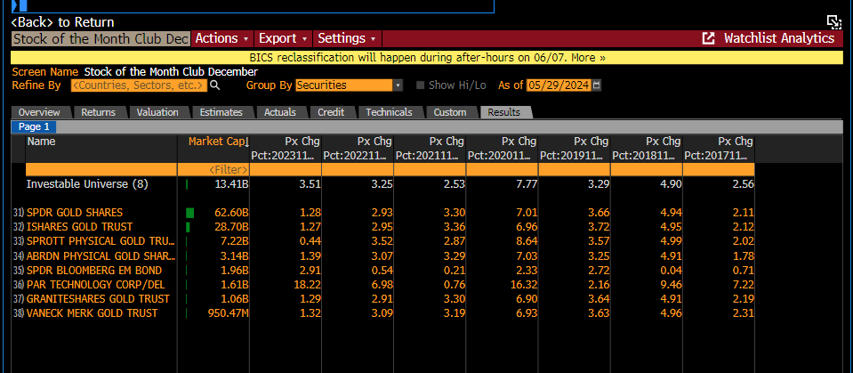
Gold, Mining, and More!

I found six gold trusts and gold ETFs that have gone up every December for at least six of the last seven years.

Why?

Maybe people worry about what might happen to the stock market come January.

Maybe they’re rebalancing their portfolios…

Or maybe it’s related to tax savings.

It could be any number of reasons.

All I care about is that these December stocks have returned consistent profits.

Even so… they’re nothing compared to my favorite play for December.

It’s delivered a 118% average gain each December since 2020.

BAR CHART HERE

That’s about as consistent as you can get.

All you have to do is make the trade I recommend on December 1. And close it out on December 31.

That’s it.

No guessing about when to get in or out.

We just follow the historical data.

And you can do this all year.

There’s the play I found for October…

Entergy Corp.

You might want to write that one down.

Because my special play on that stock has averaged a 103% gain every October for the last 5 years.

BAR CHART HERE

Imagine doubling your investment in one month…

Better yet, imagine doubling it with a play that’s been “unstoppable” for five straight years!

Now look at the gold mining stock I found for March…

Newmont Corporation. The ticker is NEM.

I believe it’s consistently risen in March for a very simple reason…

We just talked about how lots of money flows into gold stocks in December…
Well, that drives up the value of gold… which, in turn, sends gold mining shares higher.

This works perfectly for us.

We can just get in on March 1st and aim to ride that money wave all month long.

The special play I found on Newmont has gone up an average of 293% every March for the last 5 years!
BAR CHART HERE SHOWING COMPARISON

Or look at January’s play – Stifel Financial.

In January of 2025, it rose 131%... compared to the S&P 500’s 2.7%.

The year before, it rose 75%... compared to the S&P’s 1.6%.

And in 2023… it rose 183%... while the S&P made 6%.

BAR CHART HERE SHOWING COMPARISON

So you can see how this trading strategy could be valuable.

Especially since there are stocks that act like this every single month of the year.

And many haven’t lost during their special month in a full 10 years.

Imagine What this Could Do for Your Portfolio

Now, some months only have one or two “unstoppable” stocks.

Other months have a dozen or more.

Like July…

It’s got 21 stocks… that have ALWAYS gone up in July.

Collectively, not one of these 21 stocks have had a negative July since 2013.

One is a consulting company.

Last July the stock alone rose 11% on the month.

Already a great single month return… but I could’ve shown a special way to play it to really juice those profits.

Another is an investment management group.

Last July, the stock rose almost 15%.

But I almost certainly could’ve shown how to grab 100% or more on that move.

And another unstoppable July stock is a clinical laboratory.

It soared nearly 28% last July.

But again, my preferred type of play could’ve likely returned over 100%…

And here’s what’s really interesting…

The super-month strategy we’re discussing would’ve been FAR more profitable than traditional buy and hold…

Despite the hold time being just one month.

Let me show you what I mean…

Buy and Hold is CRUSHED by this Strategy…
And It Even Works When Stocks Fall!

Look at my unstoppable stock for April.

Buy and hold investors over the last 5 years would be down around 20%.

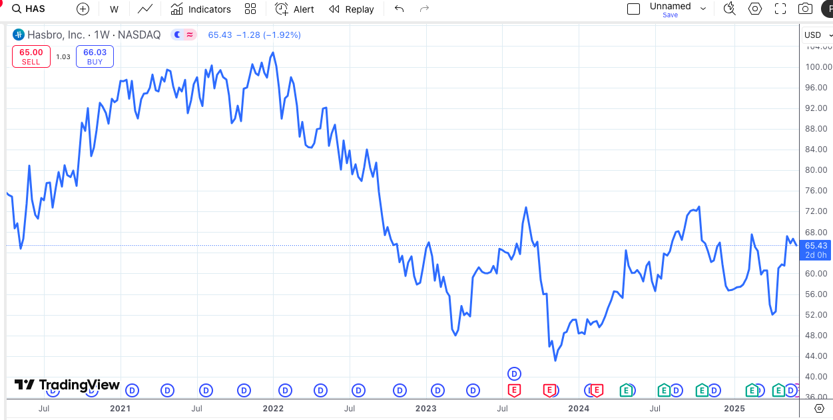

But incredibly, a special trade using my “unstoppable” strategy instead would’ve averaged a 99% gain – every single April for the past 5 years.

You get in… you get out.

With no need to keep money tied up for the rest of the year.

Now look at Medical Properties Trust – my stock for July…

Over the last 5 years, buy and hold investors are down 78%.

It’s been an awful stock to hold.
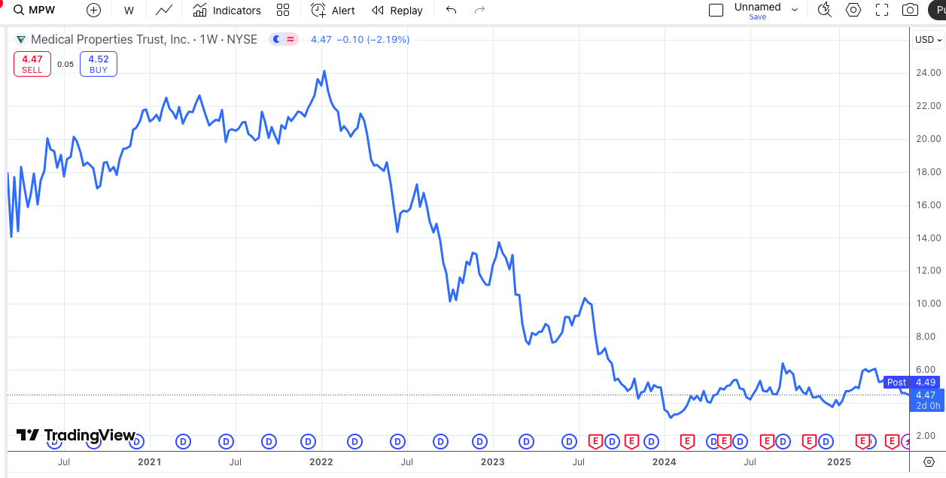
But by simply making my special trade each year in July…

Getting in July 1 and out on the 31st…

They could have averaged 62% per year!

With no concern for what the stock does in between.

For instance, June’s unstoppable stock is down 60% over the last 5 years…

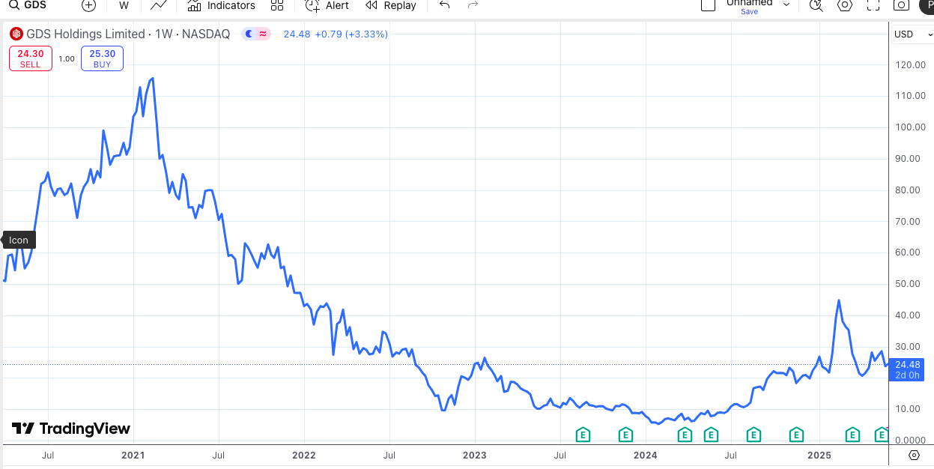

It’s another one you definitely don’t want to buy and hold.

But by using my strategy instead…

And ONLY using a special play on the stock each June for the past 5 years…

Investors could have averaged a 236% gain.

You could have simply put some cash in every June 1st, then pulled it out at the end of the month and started fresh the next June.

It’s incredibly simple, but the returns can add up fast.

Look How Fast it Adds Up

For instance, in November of 2020, my unstoppable play would’ve delivered 149%.

So whatever amount you typically invest… picture that… plus 149 % at the end of the month.

Then in November of 2021, the play returned an incredible 338 %.

Boom. Another huge single month boost.

In November of 2022 , the play produced a 49 % return...

At this point my buy and hold friends would probably be asking how I target these returns with just one month of exposure each year.

The next year, the play had a 188 % return.

Those same friends would be begging to know my secret.

Then it returned 218 % in November of 2024 .

That would be a fantastic few years.

Simply from playing November’s special trade each year.

Now as we know… past performance doesn’t guarantee future results, so let me be perfectly clear…

There are many factors that can affect a stock’s performance, which could lead to a loss even during historically promising months.

Just because this play has been incredible for 5 years straight doesn’t necessarily mean it’ll continue to be incredible forever.

So I’ll say it again… you should never invest more than you can afford to lose.

But with gain potential like that… and consistency year after year… this strategy is impossible to ignore.

And it has some major advantages over how most people invest.

STOP “Over-Investing…” and START Doing This

For instance, a friend recently told me that he has over 100 stock positions in his portfolio at any given time…

And he spends hours each day researching them.

Now, if you enjoy that sort of thing… more power to you.

But the truth is… there’s no need to spread yourself thin across dozens of stock positions.

I call that “over-investing.”

And it can be problematic.
Warren Buffett, who’s famous for owning very few stocks says, “Diversification is a protection against ignorance. It makes very little sense for those who know what they’re doing.”
Especially when a strategy like this – with just one play a month – could deliver better returns than you’ve ever seen.

In his classic book How To Make Money In Stocks, William J. O’Neil wrote…

“The winning investor’s objective should be to have one or two big winners rather than dozens of very small profits.”

That’s exactly where this strategy excels…

Just one trade a month…

With a 98% success rate over the past 5 years.

And they’re all preselected and backed by years of data, so there’s no guesswork.

While most stocks leave you wondering if you bought at the right time…

This might be the single most dependable trading strategy I’ve ever seen.

You buy at the start of the month… and sell at the end of the month.

Then you move on to the next month’s “unstoppable stock”.

After all, we know that it’s worked for years and years… in many cases for a decade straight without a single loss.

The ONLY Place You’ll Find a 98% Historical Win Rate

Now again… I’ll be the first to remind you…

I can’t predict the future.

Years of data has revealed that the plays we’re discussing today have done incredibly well over the last five to ten years.

These plays have been essentially unstoppable during their special months.

But the stock market will always have risk.

So could this anomaly quit working?
It’s possible. .. but I doubt it.

And here’s why…

There are dozens of “unstoppable stocks” in my list.

Over the last five years, these stocks have produced a positive return during their specific months 98% of the time.

You won’t find that level of consistency anywhere else in investing.

And here’s the best part…

While these stocks have averaged fantastic returns over and over for five straight years or more…

There’s a way to potentially supersize each gain even more…

And pull in maybe 10X more profit each month.

How a 293% Gain in a Single Month is Possible

I’ve talked throughout this presentation about my “special trades.

These are the trades that have delivered a 109 % average win over the last five Januarys…

A 293% average gain over the last five March’s…

And a 188% average gain over the last five Novembers.

Gains that big are typically impossible for a stock.

But if you’re confident a stock will move higher in a given month, you can maximize your potential profit with options.

So let’s say a stock goes up 10%... you might pull in 100% or more on the option in the same amount of time.

Now, some people don’t like options because they’re more volatile than normal stock trades.

And that’s fine.

You could ignore the options… trade these monthly stocks… and still do very well.

One of June’s unstoppable stocks has gone up an average of 16% over the last five Junes...

That’s a better return than the S&P generally delivers in a full year.

So that’s a nice, dependable stock that typically beats the market by a long shot.

But if you traded options on that play every June instead…

You’d have averaged a 236% gain –14 times more than if you’d only bought the stock.

Now look at October’s stock…

It has averaged a 5.8% gain each October for the last five years.

Meanwhile, its option play has averaged a 103% win – every October since 2020.

Which means you could 22X your profits compared to the 5.8% return on the stock.

Better yet, you would have only held your position for a single month each time.

Imagine what you could do trading every month’s top performing stock all year long!

Now, however you want to play these is fine with me.

Just remember that, in general, options carry a higher degree of risk.

But when you combine options with these “unstoppable” plays, the wins can be astronomical.

So I’ll always send both a stock and an options play when I make an official recommendation for my readers.

Speaking of which…

Now’s the perfect time to get positioned in the next play – before it starts to move.

I suggest you do.

ALT TAKES FOR EACH MONTH

Because it’s averaged 109% every January since 2021.

Because it’s averaged 52% every February since 2021.

Because it’s averaged 293% every March since 2021.

Because it’s averaged 99% every April since 2021.

Because it’s averaged 92% every May since 2021.

Because it’s averaged 236% every June since 2020.

Because it’s averaged 62% every July since 2020.

Because it’s averaged 56% every August since 2020.

Because it’s averaged 44% every September since 2021.

Because it’s averaged 103% every October since 2020.

Because it’s averaged 188% every November since 2020.

Because it’s averaged 144% every December since 2020.

And once you start to profit from these monthly stocks, things can move really fast.

Let me show you what I mean…

What an Entire Year Trading These Monthly Superstocks Could Deliver

2024 CALENDAR POPS UP HERE

Here’s 2024 .

Let’s pretend I got into my top plays at the start of each month… and out at the end of each month.

And let’s assume I nabbed each special play’s average gain – nothing more, nothing less.

The same way we’ve been discussing today.

At the end of January, I would’ve already been sitting on a 75% gain.

The next month, I’d have nabbed a 40% gain…

Followed by 280% in March…

115% in April…

And so on.

But look at October… 243%!

Imagine a year where you make just 12 trades… one per month… and pull in returns like these.

This is groundbreaking stuff.

Of course, this is the absolute best-case scenario based on our historical analysis.

It’s likely we will see our fair share of smaller, double-digit gains and of course even a few losses.
But with these unstoppable plays… you can improve your chances of being right – and of making a lot of money – by ONLY trading stocks during their best performing months.

That’s what this strategy is all about.

And as soon as the calendar flips… next month’s stock should start moving.

That’s why I’ve put my top 12 monthly stocks into a special report, called Unstoppable Stocks.

IMAGE HERE

I’d like to share them with you today.

You Can Access Bryan’s Entire List of Unstoppable Stocks… For Each Month of the Year!

Over the last 5 years, special options plays on the exact stocks in this report could have delivered 119% monthly gains, on average!

And there’s only been one negative monthly return out of the last 60.

That’s an insane 98% win rate!

In this report, you’ll get the names and ticker symbols of all my top monthly stocks.

You’ll see how much they tend to outperform during their special months, how they compare to the market, and most importantly…

I’ll reveal the exact type of play I plan to make on each for a shot at the biggest gains.

That way you’ll know exactly how to get positioned before the first of each month moving forward.

I’d like to send this report to you straight away.

The only problem is… I can’t share all of the information inside with a large group.

And based on the size of my email list, I’d bet 100,000 or more will see this video.

Frankly, letting that many people in on the secret would ruin it for all of us.

The plays would get oversaturated… the prices would rise before most of us got in… and the type of returns I’ve shown you today would be compromised.

Worse still, having thousands of people jump in at once could move the needle on many of these small plays, and I can’t risk a pump and dump situation.

So as much as I’d love to… I can’t reveal ALL the unstoppable plays here.
Instead, I’ve reserved that information for members of our trading research service, The War Room.

It’s a live chat room where Karim – I mentioned him earlier – and I share our market analysis, research, and live trade recommendations.

It’s where we’ve pointed members to fast gains like: 53% in 4 minutes… 73% in 10 minutes… and 121% in just over an hour.

Plus overnight wins like 179%... 188%... even 292%.

And because it’s live… you’ll never miss a trade or update.

The moment we make the trade, it’s in your hands…

You’ll know why we bought, what we paid… and what we expect to happen next.

Then it’s up to you.

You can get in alongside us…

Or you can simply observe and chat with other members to learn how to take your trading to the next level.

Either way, get ready to have some fun… and hopefully make some bigtime money like our member David.

He wrote in, “My original stake of $20,000 (including wins, losses, and trading fees) ended up being $185,000 over the last year. I have profited more than my day job paycheck... and that was only part time in The War Room. Here’s to future successes for one and all.”
David D 4/5/2021 at 10:40 a.m.
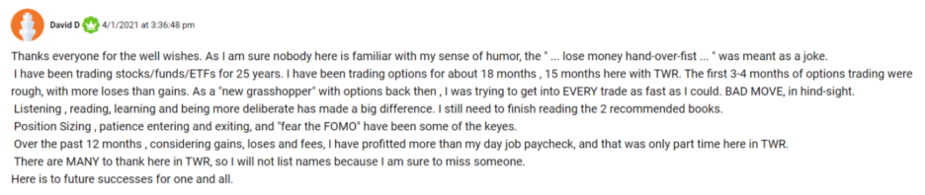

Mohammed crushed it, too.

He said he started with $25,000 and just four months later was sitting on $200,000 in profit.



Matthew started with a slightly bigger account at $65,000…

And boosted it to over $100k in just two months.
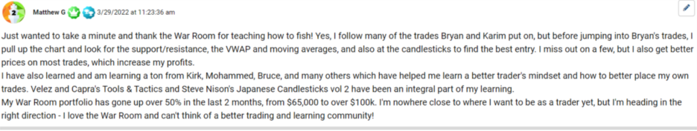

That’s over a 50% gain from following our War Room trades.

And I want to point something out…

In his note he said he has learned a ton from Kirk, Mohammed, Bruce, and others…

Mohammed is the guy we just mentioned with $200k in profits over four months.

And that’s the thing about the War Room that really sets us apart…

Our chat room is a community for like-minded people who are serious about investing.

We teach, we learn from each other, we share ideas and potential trades, and a lot of the time…

We make money together.

It’s a beautiful thing.

For example, Karim spoke highly of Rolls Royce in the War Room back in 2022.

He called it “the most undervalued/overlooked blah blah XYZ
Well, it’s risen over 1,600% since, and handed many of our members life-changing gains…

Like Timothy, who wrote:

About 3 years ago I watched a video from Karim talking about [Rolls Royce]. I started investing with about $20K and the stock was at $0.88. Today it’s at $7.48 and I have made several hundred thousand dollars in profit. My account now stands with this stock over one million dollars.

Or here’s a message we received from Jake:

Just want to thank you for the [Rolls Royce] recommendation. I bought 65,000 for less than a buck! I haven’t sold any yet, but will probably sell 15,000 when it hits $20. My profit today is right at a fat $1M. Many thanks!

Then there’s Baron, who said…

- Baron 9/23/2025 at 10:46:23 am
“The biggest win in my lifetime, well into six figures. And i have a son-in-law who is going to have a very comfortable retirement now. You have changed our lives. Saying thank you doesn't seem adequate.”

While everyone’s experience is different, we’ve had so many members hit it big… it’s hard to keep up.

Tad grew his account by nearly 100%... or $88,000 in a single year…

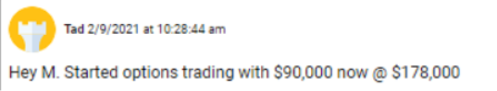

Ken doubled his account in 8 months… and wrote “The gain from trading has easily outearned my salary (before tax).”
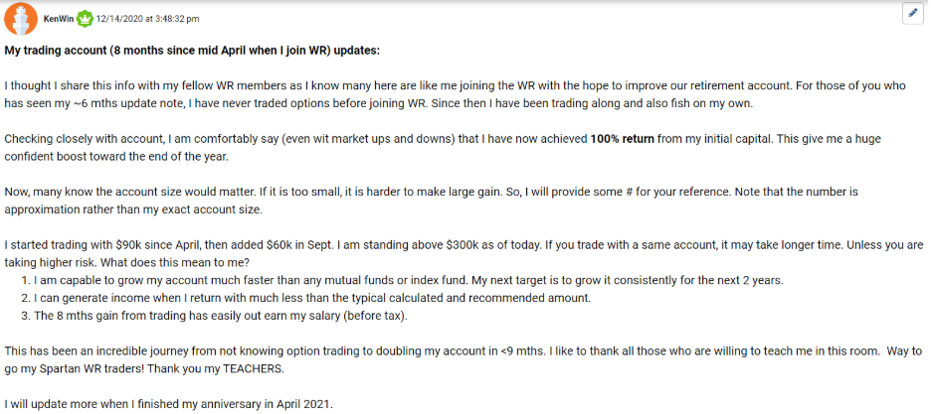
And then there’s George…

He may be our biggest success story of all.

George started with a pretty good account size - $165,000…

And within 3 months, he had it up to a peak of $2.3 million.

That’s a 14X gain.

Now, you might not have that kind of money when you start…

And that’s ok.

Because 14X is 14X.

It would turn even a $10,000 account into $140,000.

So you can get started with any amount.

Like I said, you can even paper trade at first.

But it’s important you get moving right away.

Because my next unstoppable recommendation will go live the moment the calendar flips.

And joining today is the only way to get my Unstoppable Stocks report.

How The War Room Works

Of course, Unstoppable Stocks are just the tip of the iceberg.

I’ll recommend those just before the first of each month so you can get positioned before they start to move.

But we trade basically every day the market’s open.

Here’s what you can expect…

Member Benefit #1: My Premarket Commentary

Every morning at 9 am, I deliver my premarket notes to War Room members.

I post them in the chatroom and also send them to your email in case you aren’t with us live.

I break down the big macro trends I’m seeing…

As well as the stocks I’m watching.

That way you’re ready to rock the moment the market opens.

As you’ll see, a lot of action can take place in the first hour or so.

Of course, if you can’t be at your computer every morning at 9:30, don’t worry…

You’ll also get…

Member Benefit #2: Trade Alerts

We’ll send you an alert every time we make a trade recommendation...

Right to your phone or computer.

That way you’ll always know when a new trade goes out, even if you aren’t in The War Room at the time.

Of course, to get the most out of the service, I encourage you to pop in and join us live as often as you can.

That’s the only way to really develop your own trading skills.

Teach a man to fish, right?

And that brings me to…

Member Benefit #3: Live Trades

Once 9:30 am strikes…

We’re off to the races.

I watch the markets for the perfect time and place to strike…

Then, the SECOND there’s an opportunity…

I type it up… hit enter…

And you IMMEDIATELY get all the relevant information you need.

I give you the ticker symbol… the trade instructions… the exact price target.

EVERYTHING you need to make the trade.
And when it’s time to exit the trade…

I send you a quick alert then too.

Once again -- it’s all 100% live and in real time.

Our goal is to make things dead simple.

We find the great trades… you rake in the wins.

And before each month starts, you’ll get the unstoppable stock of the month so you can play it for big potential profits.

To get you started on the right foot, you’ll get…

Member Benefit #4: The War Room Options Training Suite

We love to trade options in The War Room, because as you’ve seen, the wins can be life-changing.

So to get you up to speed, I’m including a Video Masterclass and an Options Primer.

Once you’ve spent a few minutes with these special bonuses, you’ll be ready to tackle any options trade I send your way.

Speaking of which…

I’m preparing the specifics on next month’s unstoppable play as we speak…

MONTHLY IMAGE HERE WITH STOCK NAME/AVERAGE OPTIONS GAIN
I’ll post it in The War Room before the calendar flips.

Remember, looking back, these plays have averaged 119% gains each month for the past 5 years.

So you don’t want to miss the next one.

Now given the impressive historical performance of these monthly plays…

I’m worried they might wind up being so profitable…

You won’t need me anymore.

A 98% Win Rate Over the Last 5 Years!

After all, if they continue to average returns even close to what they’ve done the last five years…

Why would you trade anything else?

Looking back over the last five years these stocks have been the most consistent, dependable opportunities in the entire market…

Delivering a 98%-win rate.

They help limit exposure to the market’s ups and downs by keeping your hold times to strictly one month…

And by utilizing the options, anyone who made these trades over the last five years could have potentially averaged a 119% gain every month.

So the fact that I’m making them available to members makes me a little nervous.

You could just refer to your reports, make the trades, and never open my emails again.

But that’s a risk I’m willing to take.

My job is to get you the very best opportunities around… and these might just be the best I’ve ever seen.

Besides, nothing makes me happier than to help my readers get rich.

As you just saw, it’s already happened for many of them…

But here’s just one more that’s really crazy…

Tim L wrote, “I started investing [in 2022] with about 20K and the stock was at .88. Today it is at $7.48 and I have made several hundred thousand dollars in profit. My account now stands with this stock over one million dollars. I just want to say thanks!!!!! It has been life changing.”

If he thought that was life changing… today the stock is around $14.

So if he’s still holding, Tim’s shares have nearly doubled again since he wrote that note.

All because he decided to give the War Room a shot.

And today you have the chance to do the same.

The War Room: Secure Your Special Discount Today!

Now, most research services charge around $4,000 annually to send you a trade or two per month…
But we’re not your average service.

You’ll typically get more trades than that in a single day.

Plus you’ll get our live chatroom, filled with members who want to help you succeed…

And LIVE research and analysis from Karim and me.

So you can see why our publisher recommended a much higher price of $7,500.
It’s certainly a fair price given the LIVE value you get each day…

But we decided to do something radical.
We already know our service is the best around…

Why not make our price the best around, too?

So through today’s special offer, you can join for just $1,497.

ALT

So through today’s special offer, you can join for just $1,997.

END ALT

That gets you a full year of access, plus everything we’ve discussed today.

And as you’ll see on the next page, there’s a way you can get an even better, “Unlimited” deal.

But you have to act quickly.

Next month’s unstoppable play goes live the moment the calendar flips, and I’d hate for you to miss it.

MONTHLY IMAGE HERE WITH STOCK NAME/AVERAGE OPTIONS GAIN

Now, these plays have proven themselves 98% reliable over the last 5 years…

Which means I expect the wins to really stack up fast.

In fact, these might be the most valuable plays I’ve ever found.

That’s great news, of course… but it also means I can’t allow refunds on today’s offer.

Too many people would take advantage by getting the report, then refunding…

And that wouldn’t be fair to you.

But I want you to be totally comfortable moving forward, so here’s what I’m going to do…

If you don’t see the chance at 252 or more wins over the next year, I’ll give you another year of access for FREE.

That’s a win every day that the market is open, on average.

That might sound crazy… promising that we’ll average a win every day…

But we do it every year in the War Room.

Now, it could be one of my Unstoppable plays… or any other trade we make.

Just know that you’re covered.

GUARANTEE IMAGE

Either you get the shot at 252 wins in the next year…

Or you get another full year on the house.

Because I don’t want anything to get in the way of you having an experience like Jock, who made over $16,000 on a 264% gain in one month…

JUST HIGHLIGHT THAT LINE

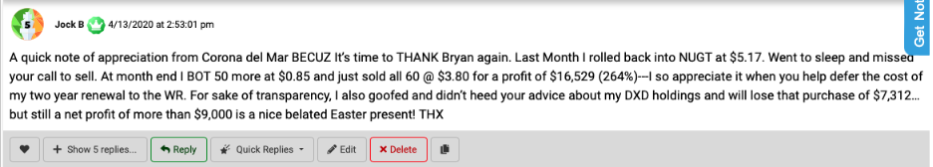

Or Jim, who cashed in even faster, writing…

“Sold for $3,500 as it was up 450% [overnight]. My best day ever!”

Or Ralph, who said he made 646% in a single day.
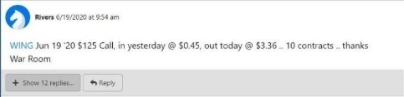

So let me quickly recap everything you’ll get when you join today.

Everything You’ll Get as a New Member of
The War Room

IMAGE HERE

- Access to Our Live Chatroom– Starting Every Day at 9:30 am Sharp. We give people our best trading ideas live in the chatroom. You’ll get “Unstoppable Stock” plays, special overnight trades, earnings opportunities, and more.

- 1-2 new recommendations each day on average

  - At least one new recommendation delivered live every day
  - Plus an “unstoppable” stock AND option play before the 1st of each month
  - Joining is the ONLY way to receive my exact options plays on each unstoppable stock… for the chance to supersize your gains

Of course, you’ll also receive…

- My report: “Unstoppable Stocks”

This is the perfect time to claim your copy.

I’ll be sending out the next Unstoppable Play before the end of the month.

ALT TAKES FOR EACH MONTH

Remember, it’s averaged 109% every January since 2021.

Remember, it’s averaged 52% every February since 2021.

Remember, it’s averaged 293% every March since 2021.

Remember, it’s averaged 99% every April since 2021.

Remember, it’s averaged 92% every May since 2021.

Remember, it’s averaged 236% every June since 2020.

Remember, it’s averaged 62% every July since 2020.

Remember, it’s averaged 56% every August since 2020.

Remember, it’s averaged 44% every September since 2021.

Remember, it’s averaged 103% every October since 2020.

Remember, it’s averaged 188% every November since 2020.

Remember, it’s averaged 144% every December since 2020.

So it’s highly likely you’ll start your War Room membership with the shot at a huge, quick winner.

You’ll also get…

- Trade Alerts: so you don’t need to sit at your computer all day

- Our Active Trades List: All current trades are posted in detail, including ticker, entry date, and more

- Access to Our Team of Moderators: Any questions you have regarding your subscription can be answered quickly.

And last but not least, you’ll get…
Our complete archive of research reports, training videos, and trading strategies.

In other words, anything members have ever paid to access… you’ll get for free starting immediately.

Image of stacked reports – on top should be Overnight Trades: How to Hit Massive Earnings Winners Every Day of the Week

You’ll simply use your password to login to our secure, private website.

Many prefer our Unlimited deal to get the best benefit of all – our Pre-Earnings Volume Scanner.



In short, one of the best ways to make money on stocks is by watching trading volume right before an earnings report.

If there’s a big spike in volume, you can bet there’s going to be major price action.

And a special type of trade we make in the War Room allows you to win whether the stock beats earnings and goes up… or misses and drops.

We call it the “win both ways trade.”

And our Unlimited deal gives you access.

You’ll get more details on the next page…

There’s No Time To Waste… Next Month’s Play has Averaged a HUGE Gain!

But with January/AI ALT EACH MONTH right around the corner, there’s no time to waste.

I expect a big win.
GRAPHIC SHOWING THE LIST/HIGHLIGHT THE UPCOMING MONTH:
Unstoppable Plays Average Gain:

109% in January

52% in February

293% in March

99% in April

92% in May

236% in June

62% in July

56% in August

44% in September

103% in October

188% in November

118% in December

So don’t delay.
If you have any outstanding questions about this offer… you can reach our team at XXX.XXX.XXXX or XXX.XXX.XXXX.

We’re available to take your call Monday through Friday, 9-5 eastern time.

But if you’re ready to get moving right away…

Click the button you see on your screen to access our secure order form.

When you’re done, I’ll rush you everything we’ve discussed today.

You won’t hear about these “unstoppable” stocks anywhere else…

They’ve been consistently profitable – each month for the last five years.

And the next one goes live on the 1st.

So click below or call now to lock in your subscription.

I look forward to welcoming you to The War Room.

Thanks for watching.

SIGN OFF,
Bryan Bottarelli
November 2025

DESIGN: WHEN THE BUTTON POPS UP, CAN WE HAVE ABOUT 25 TESTIMONIALS THAT JUST ROTATE UNDER THE BUTTON EVER 5 SECONDS OR SO?

