The Near-Impossible Setup I’ve Waited 46 Years For:
The Iranian Gold Heist
The world is watching oil. I'm watching gold.
The last time Iran threw the world into chaos, gold ran 272% in less than a year. But I’m not recommending you buy gold.

Instead I’ve found a way to “steal” gold for a fraction of the price. ￼

.
In 1979, I was 17 years old…
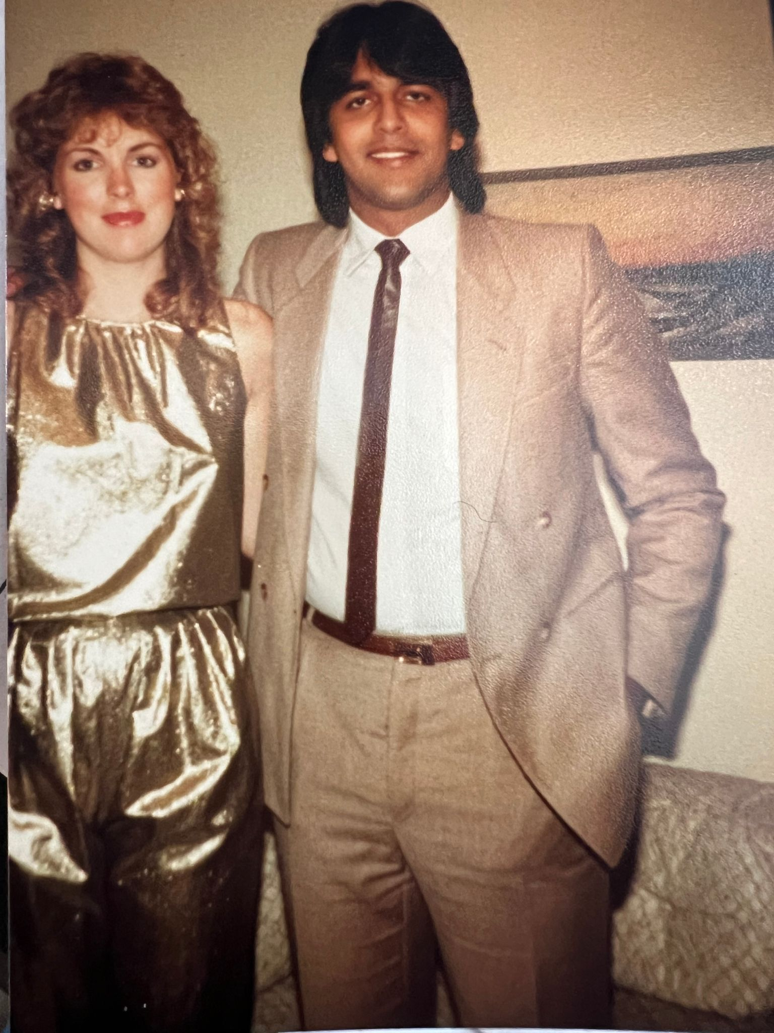
Just a senior in high school when the country sitting on top of the world's largest oil reserves was overtaken by the Ayatollahs.
- The Shah of Iran was promptly forced into exile.
- 52 U.S. embassy workers were taken hostage.
- The U.S. gov’t cut off Iranian oil.
- And investors the world over fled into gold.
But gold didn’t just “catch a safe haven bid” and then calm down a few days later.
It started repricing the whole system, going from $230 to $855 an ounce.
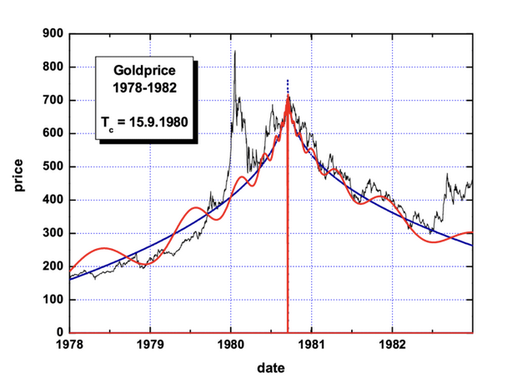
And silver did what silver always does when people are scared – it moves harder and faster than gold. That year, it went from $6 to $50 an ounce.
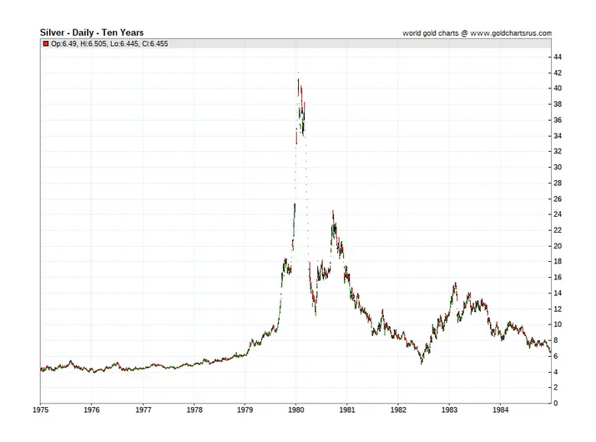
Had I been old enough to trade back then…
I could have made enough money during this frenzy to never have to work another day of my life.
Even when I was a youngin, I understood that gold was real money – and that when the world loses its mind, people always want real money.
That’s why for decades I’ve been preaching gold – and other precious metals – as a monetary lifeline to everyone I know:
- In 1994, I recommended my readers continue holding gold at $325 an ounce – the same year I told my readers that the Internet was going to reshape the world.
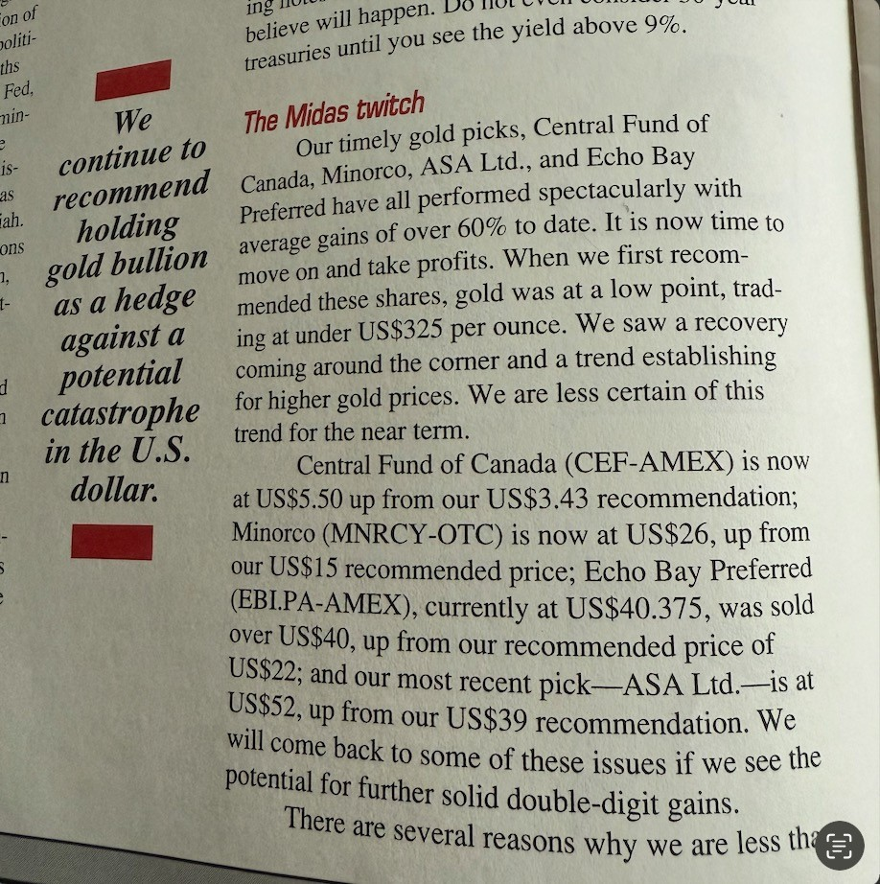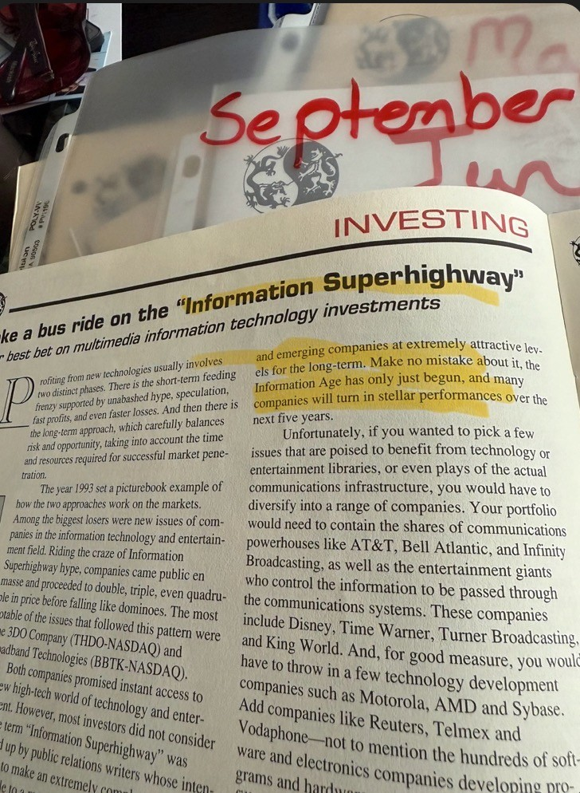
- In 2017 when Gold hit $ $1,300 I was still pounding the table, telling people it was a bargain… https://www.fool.com/investing/general/2011/12/07/gold-stocks-are-precious-metals-still-a-safe-haven.aspx

But the move I’m seeing right now – where people are fleeing into gold and precious metals like its 1979 all over again – is the perfect setup for what many believe will be a fundamental repricing of every hard asset on earth:
Only this time there's a twist.
Iran has become the world's most desperate gold buyer — and in doing so, has handed us the greatest gold heist opportunity in modern market history.
A heist that gives you the chance to “steal” the world’s best gold assets at up to half price…
And collect cash payments for simply offering to buy these assets at prices the market would normally never accept.
Inside Iran right now, 90 million people are watching their currency dissolve like paper in an acid bath…
Last year, 42,000 Rials equaled $1.
Today, it’s 1.3 million Rials to every dollar.
Iran’s currency has literally been reduced to confetti.
The Iranian Rial has collapsed so badly that $50 now buys 450 movie tickets in Tehran. Not because movies are cheap. Because their money is worthless.
But while Iranians are panic-buying gold at any price in order to protect whatever savings they have left.
I’m going to show you how to “steal” the companies that mine it.
[do not read this subhead]
This is the Trade I Was Born to Make…
And I’m not leaving a single dollar on the table.
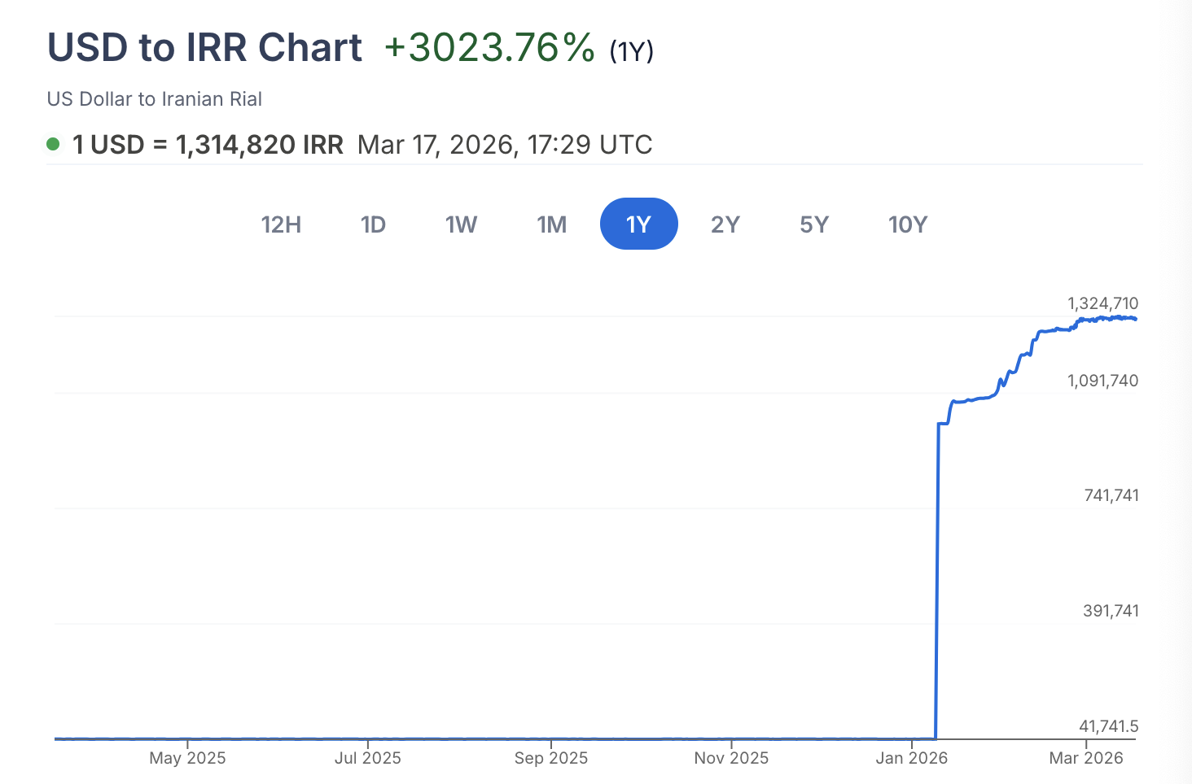
To illustrate to you just how surreal the situation has become…
- The average Iranian earns only $80 a month.
- One gram of gold in Iran costs $110.
A spec of gold is more valuable than a month’s worth of work.
And guess what, the Iranians are still buying more of it!!!! 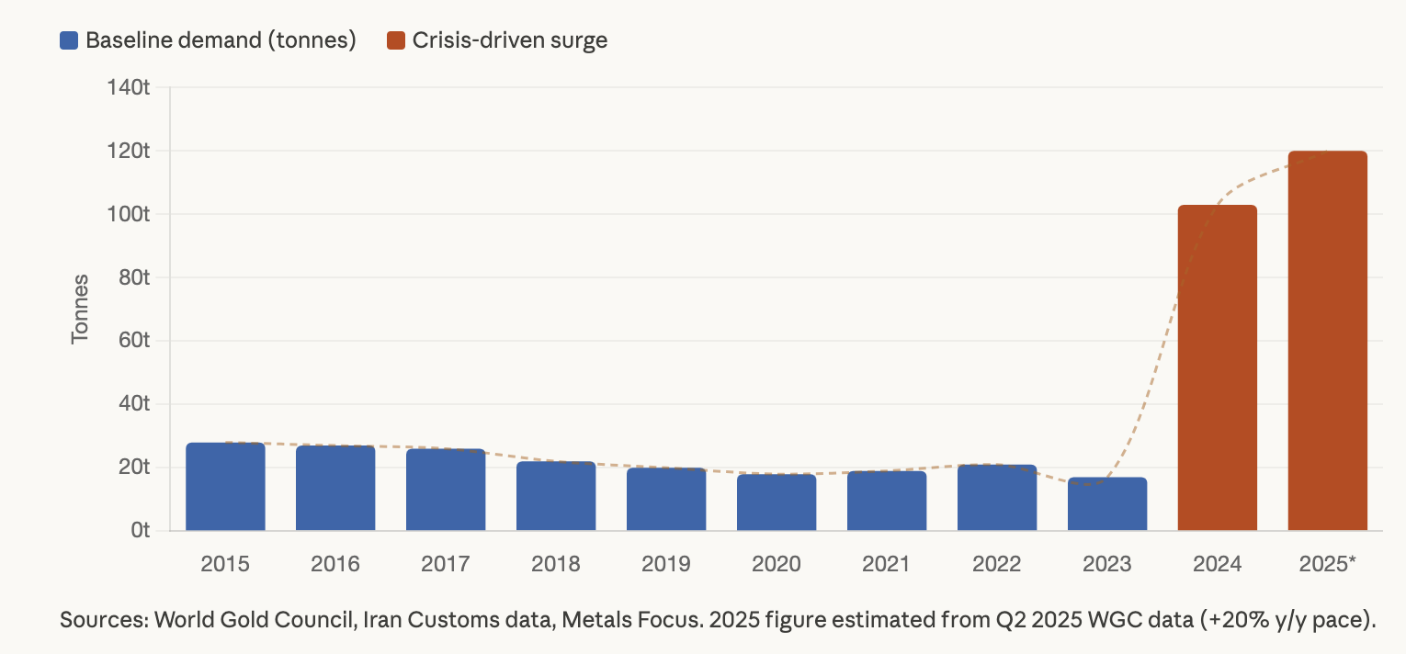
Not because they want to. Because they have no choice.
- Inflation has hit 68%, the highest level since WWII
- Food prices are up 110%.
- Cooking oil is up 207%.
When your currency is worthless and your bank accounts can be frozen overnight — gold is the only thing you can actually hold onto.
And it's not just Iranian citizens protecting their savings.
The Iranian regime is acquiring gold through barter deals just to keep the economy functioning.
- Last year the mullahs bought almost 100 metric tonnes of gold bullion, more than triple from what they bought a year prior.
For the first time in modern history, a nation of 90 million people have been forced into gold in order to ensure their survival.
Tragic for them. Enormously profitable for anyone positioned on the right side of this. As you know Gold has already hit an all-time high of $5,600 an ounce. And the biggest names in finance still believe we’re in the opening act:
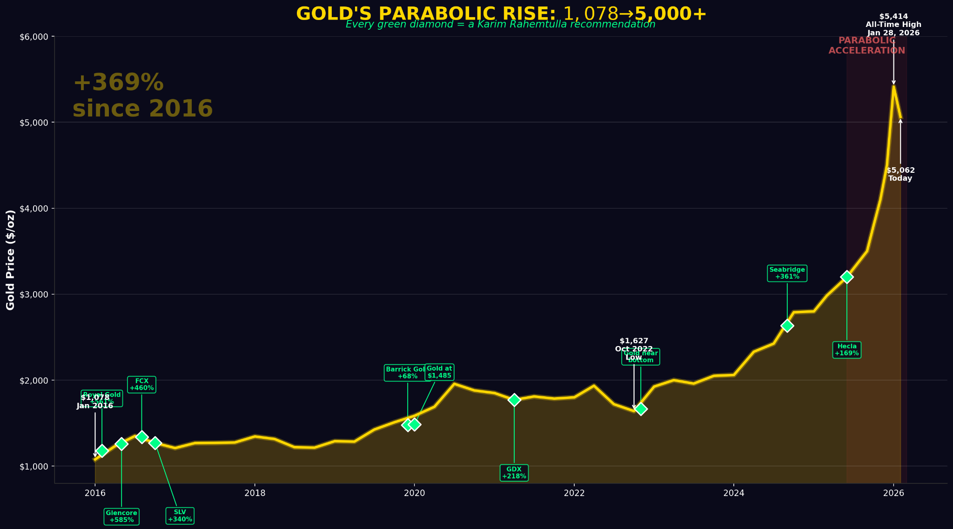
- Ed Yardeni of Yardeni Research — one of Wall Street's most respected strategists — predicts gold will reach $6,000 an ounce by year-end 2026.
- JP Morgan says we’ll see gold reach $6,300.
- UBS sees an upside scenario of $7,200 an ounce.
- Crescat Capital's macro strategist Tavi Costa predicts gold will hit $25k to $55k an ounce.
- Peter Schiff — who has been called crazy for thirty years, but has also been right for thirty years — says gold will hit $100,000 an ounce."
Frankly, it doesn’t matter what any of these guys think.
I'm not buying gold. Not a single ounce.
In fact, because of what Iran is doing to the gold market…
I've found a way to do something even better than buying gold.
[do not read this subhead]
Iran Panics. We Profit.
As Iran continues to buy physical gold — paying any price, hoarding every bar and coin they can find…
They're inadvertently driving up the price of every gold miner on earth.
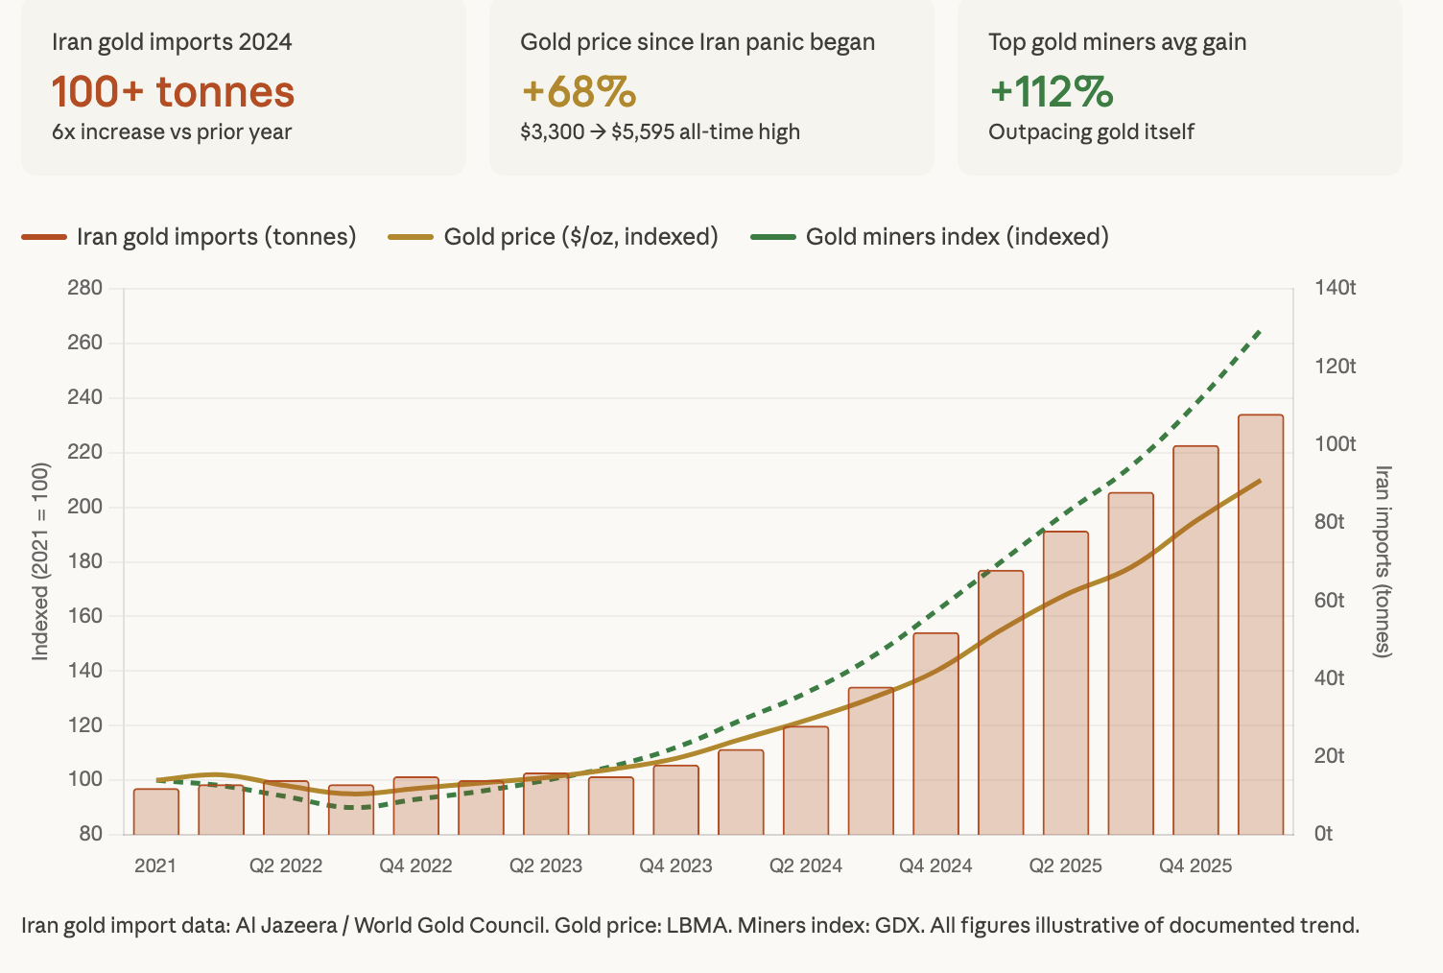
I haven't seen anything like it in 46 years.
But while everyone is chasing these stocks as they reach new all-time highs — you're going to walk in through the back door and take the world’s most sought after gold miners at half price.
That's the heist.
The obvious move is to buy gold right now. But buying gold — or even buying the miners outright — means you're completely at the mercy of the price.
There's a far better way to turn Iran's desperation into a paycheck.
Because the fact is…
Iran's appetite for gold isn't just pushing the price up — it's driving volatility to levels we haven't seen since COVID.
That’s why you can collect payouts that are way larger than normal.

And the way you do this is through something I call a gold phantom bid.
- This is when you make a laughably low offer on an asset you want to own, like gold. The market then actually pays you cash for making that offer. But because the offer is so low, it almost never gets accepted.
Instead, it disappears like a phantom. Never to be seen again.
Imagine a scenario like this…
There’s a new house on the market that you really want to buy. It's listed for $500,000.
But you put in a bid for $350,000
You know full well that the seller will likely NOT accept that offer. But amazingly, he gives you a check for $3,000 just for making that offer.
But you still keep the $3,000. You made a phantom bid that no one noticed.
Now, it may seem insane that something like this could happen.
But in the gold market, it does.
You can actually get paid just for making lowball offers on gold.
And there are only two outcomes.
One, nobody accepts your offer and you keep the money you’re paid.
Or two, somebody accepts your offer.
You get the gold at YOUR price. AND you keep the money you were paid upfront too.
And because of Iran and the chaos we’re seeing in the markets, the payouts on these phantom bids are bigger than normal.
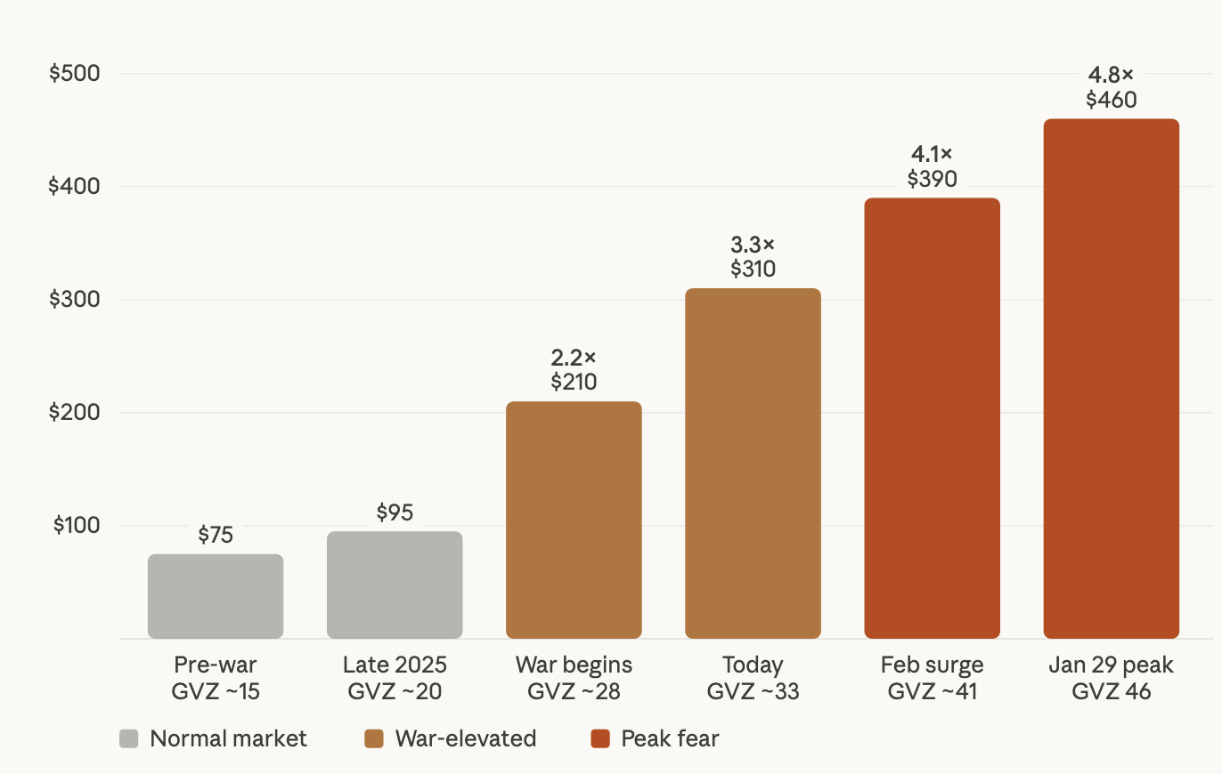
This has opened the door for you to collect what could be the most lucrative winning opportunities of your investing career — paid to you as a premium, simply for making offers the market will likely never take you up on.
The only question is…
How long do we have before these payouts shrink?
Based on my read of current events — we have until around September 2026. After that, the fear fades. The payouts shrink. And this window will likely close.
That gives us just a short time to collect as much cash… and hopefully buy as many gold assets as possible at lowball offers.
In March, the world watched as missiles streaked across the Middle East in one of the most surprising geopolitical events since 9/11.
Iran’s ruling regime suffered a crushing blow it never expected.
The Strait of Hormuz was effectively shut down in response.

Today, the headlines have quieted a bit.

The truth is, the biggest money in markets is rarely made during the crisis.

It’s made in the weeks and months that follow the crisis.

And right now, I’m going to show you how the aftershocks of war have created what I believe will be the most profitable window you’ll see all year.

If you're not positioned before the next missile flies, you'll spend the rest of your life explaining to people why you knew about this and did nothing.
I've been waiting for a moment like this my entire career.
And the reason I know exactly how to exploit this and am so confident in the outcome is because of something my father taught me…
[do not read this subhead]
Never Pay Full Price.
For Anything

Everything in life is negotiable.

My father wasn't a rich man. But he taught me the value of a dollar and how to name my own price on assets.
Some would call this "frugal." I call it being resourceful.
- In 2003 I picked up a 1965 Porsche for $12,500. It’s now insured for $125,000.
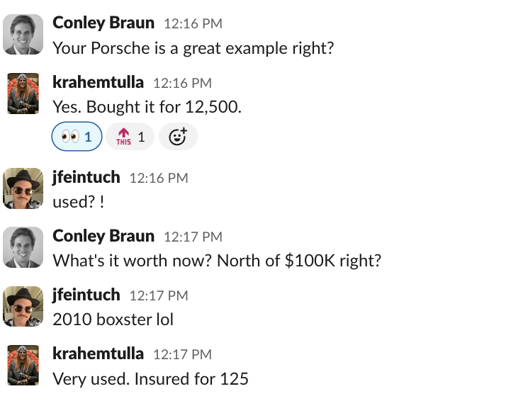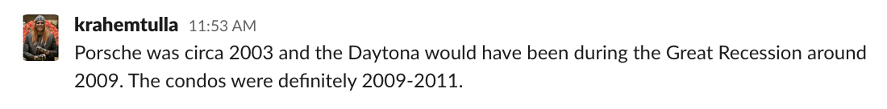
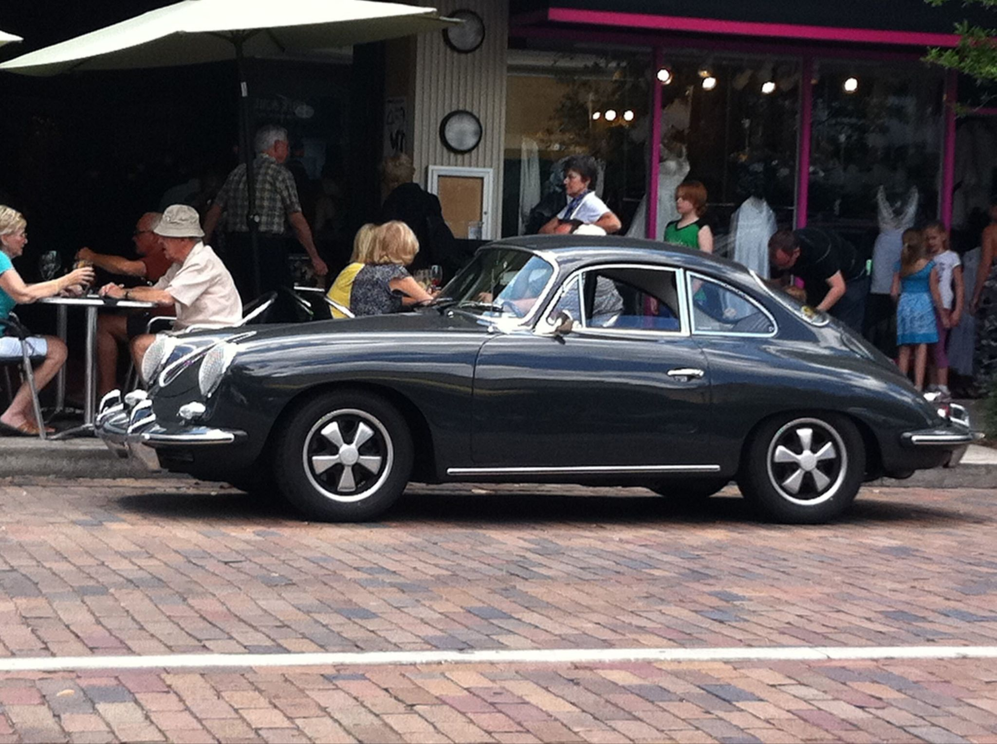
- In 2009, I got an $18,000 Rolex Daytona for $9k. I sold it a few days later for $12k.
- 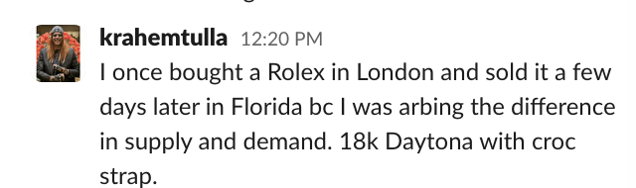
- In 2010, when the housing market fell apart, I bought four condos for around $40,000 each. I collected $12,000 a year per condo for 12 years straight. Then, I sold them for three to four times what I paid.
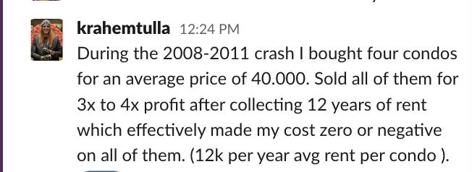

Now you know why this strategy fits me like a second skin. And you know what…
My refusal to pay full price for anything, including gold — is the reason why I have a 95% win rate.
[do not read this subhead]
95% Win Rate
When I place a phantom bid on an asset I want to own – whether it’s a stock, ETF or index…
I never intend on buying the asset.
I put in bids that are so low that I know the market will not accept them, but the market still has to pay me regardless.
That’s why of the 169 times I’ve used this strategy…
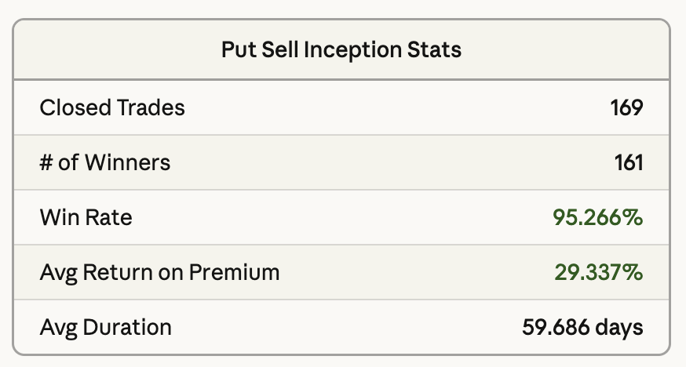
I’ve won 161 times.
Meaning, I collected my premium without having to buy a single share.
That’s a 95.2% win rate.
And I don’t expect this rate to drop anytime soon…
In fact, thanks to Iran, I think it could go even higher.
For the first time since 1979.
Gold has become the most sought-after asset in the entire world.
But again, I’m not suggesting you go out and buy gold.
Because even if you do…
The only way you’re going to make money is if the price goes up even more.
With a phantom bid you’re not tying your wealth to gold’s value.
You're offering to buy the market’s best gold miners – the ones everyone else wants to own -- but for prices that nobody else gets.
And you're getting paid for that privilege.
Now, I want to be straight with you about how this works.
There are only two things that can happen when you make a phantom bid on a gold stock.
HEADS: The stock never drops to your bid price. You keep the cash and move on to your next target.
TAILS: The stock drops to your bid price and you buy it — at 30% to 50% less than what everyone else paid.
That's the only way you "lose" this trade. You end up owning a world-class gold miner at a price Wall Street would never offer you twice.

If that's losing, I'll take it every time.
Here's why: the only phantom bids I ever make are on companies I'd be happy to own outright. That's the rule. If I wouldn't want to own the stock at full price, I won't offer to buy it at half price.
So in the worst case scenario, you end up owning a world-class company at a price nobody else got.
It won’t always be a monetary gain that you typically look for when trading, but if you’re already in the market for a particular stock wouldn’t you prefer to pay less than you were willing to pay on day one?
Call that a loss if you want. I call it a bargain.
B2Gold is a company that owns four gold mines on three continents.
Its mines produced nearly one million ounces of gold last year — a new record. Revenue hit $3 billion, a more than 60% jump over the year before. With gold now above $5,000 an ounce, this year's revenue could approach $5 billion.
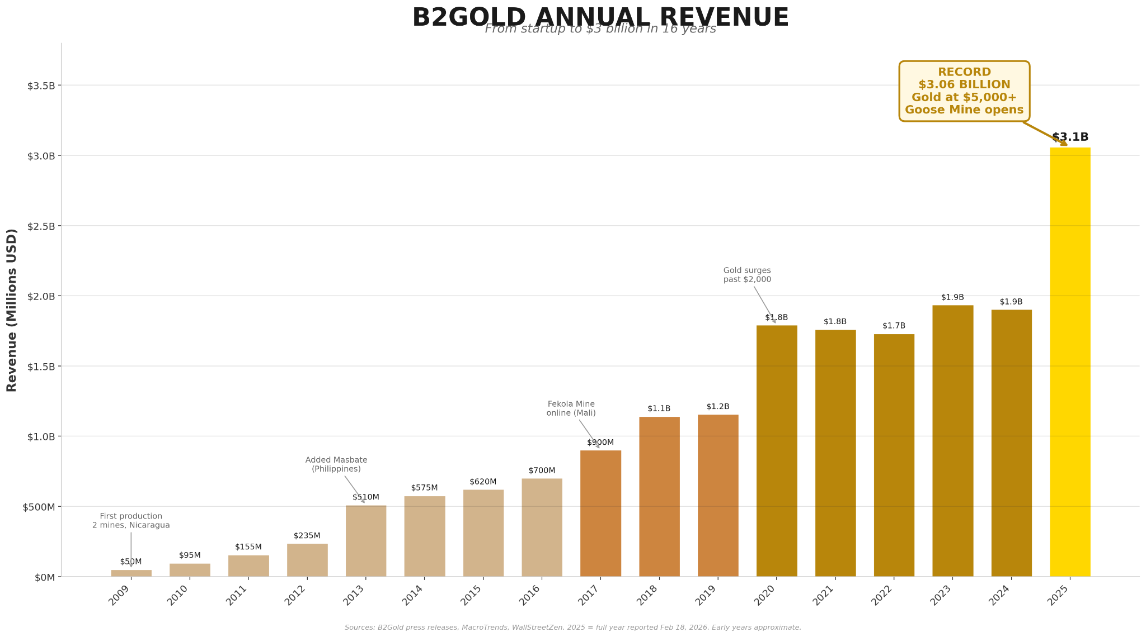
The ticker price for B2Gold is $4.50 a share.
If you want, you can buy shares and pay the full ticker price. I’m sure you’ll make out pretty well…
- Raymond James says B2Gold is worth $6.50.
- Scotiabank says it’s worth $7.
But why pay the ticker price when the market will pay you for offering to buy B2Gold for $3.50 a share. That’s half the price the big banks say it's worth.
Two outcomes. Both of them I’d be happy to accept:
HEADS: If the stock stays where it is or even drops a bit… you keep the cash and move on to your next target. That’s the ideal outcome.
TAILS: If the stock collapses to $3.50, which is hard to imagine in this climate, you get to buy one of the world's lowest-cost gold producers for way less than you anticipated.
And you still get to keep the cash.
That’s the strategy.
You get to name your own price on the world’s most profitable gold companies.
The market pays you cash upfront for putting your bid on the table. If nobody takes you up on your bid, the offer disappears and you do it all over again.
And right now, because of what 90 million Iranians are doing to the gold market…

The payouts, or premiums, you receive when making these phantom bids are in a different league entirely.
Look at this:
The bars represent the CBOE Gold ETF volatility index which is the fear gauge for the gold market. The yellow line is the price of gold. The two are intertwined.
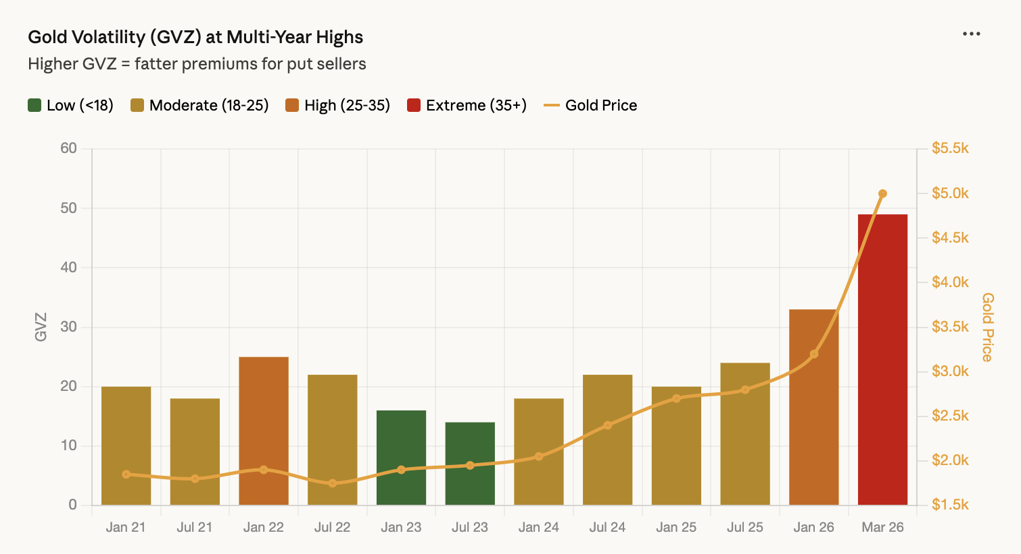
When Iran mined the Strait of Hormuz and oil spiked 35% in two weeks, every fear gauge on Wall Street lit up at once.
The entire options market repriced around a single question nobody could answer: how far does this go?
That unanswered question is why these premiums are larger than normal. Take a look:
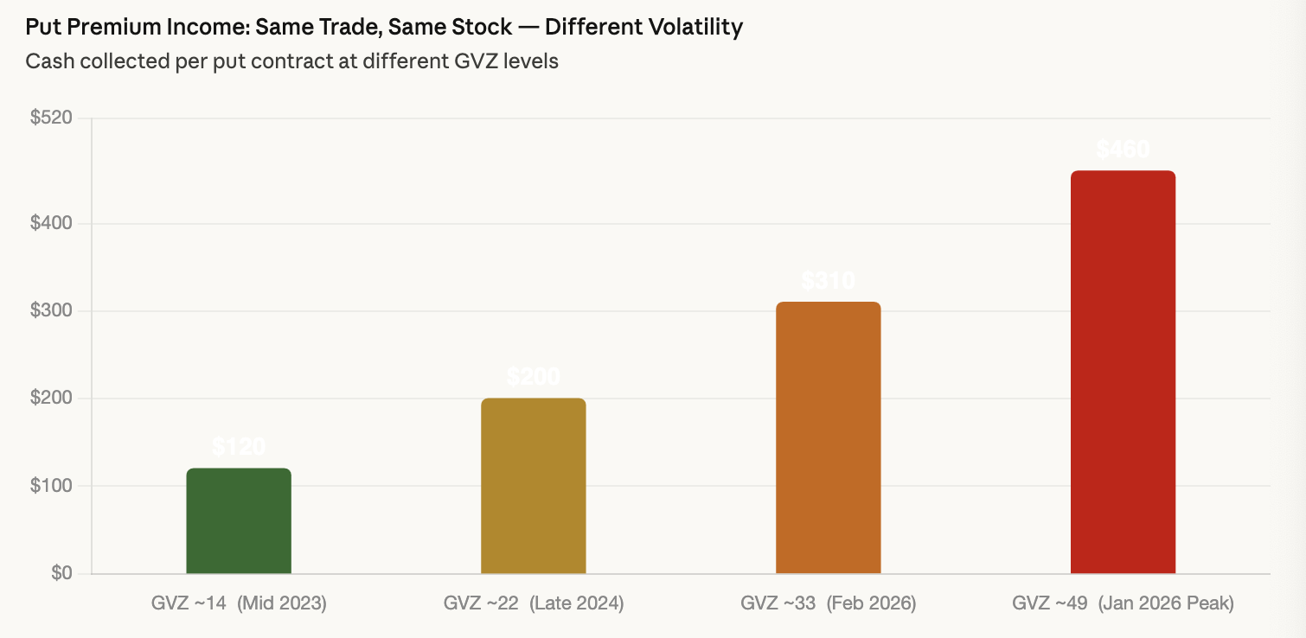
So while gold is hitting all-time highs and miners are posting record profits… the market is still paying out premiums like the world is ending.
That gap — between what these companies are actually worth and what the market is willing to pay for them — is where the phantom bid lives.
The market is so afraid it will literally pay you cash just to agree to buy these stocks at half price. Stocks that are printing money. Stocks that analysts say are worth double what they trade for today.
That's the heist. And I've been waiting 46 years for it.
This heist won’t last forever.
Like I said before…
We probably have until September 2026 until it comes to an end.
But that still gives us several months to squeeze every last dollar out of the most lucrative setup I’ve ever seen, and may ever see in my lifetime.
[do not read this subhead]
Gold Heist:
Your First Target

As Iran is spending billions to buy physical gold — driving up demand, driving up prices, driving up the value of every ounce still in the ground.
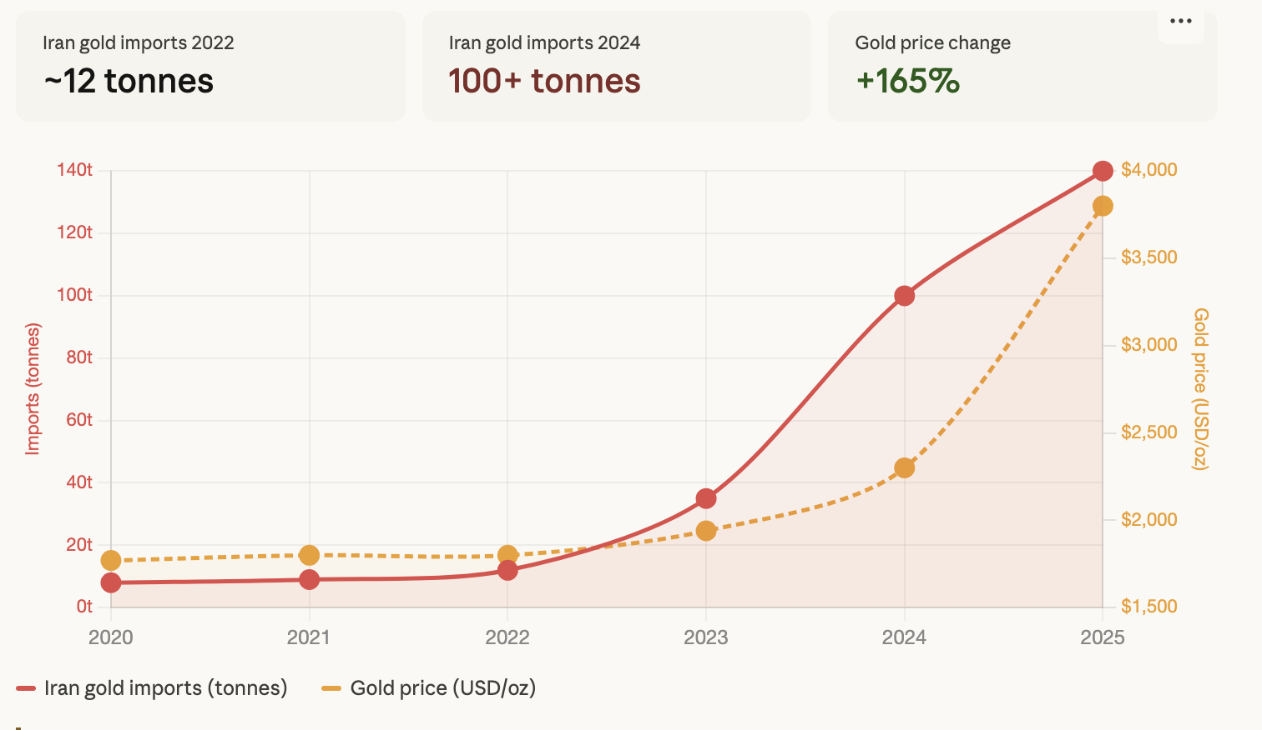
The companies sitting on top of those ounces are worth more as a result. But the market is too afraid to buy them at full price.
That blind spot is our opening. And the best place to start is with the world's second-largest gold miner — Barrick Mining.
- In 2025 Barrick made $17 billion in revenue – a new record for the company.
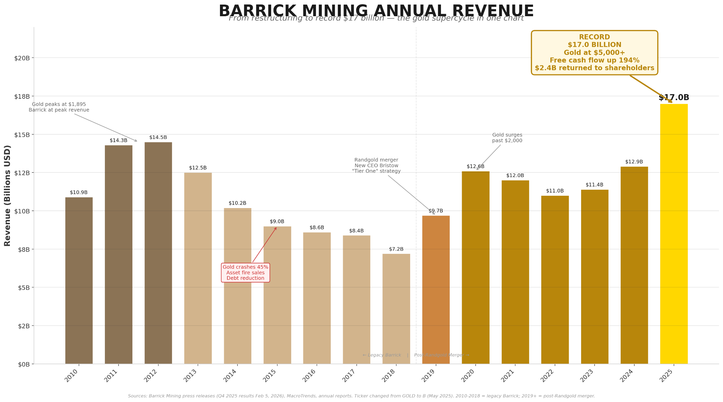
- They bought back $1.5 billion of their own stock…
- They hiked their dividend by 40%...
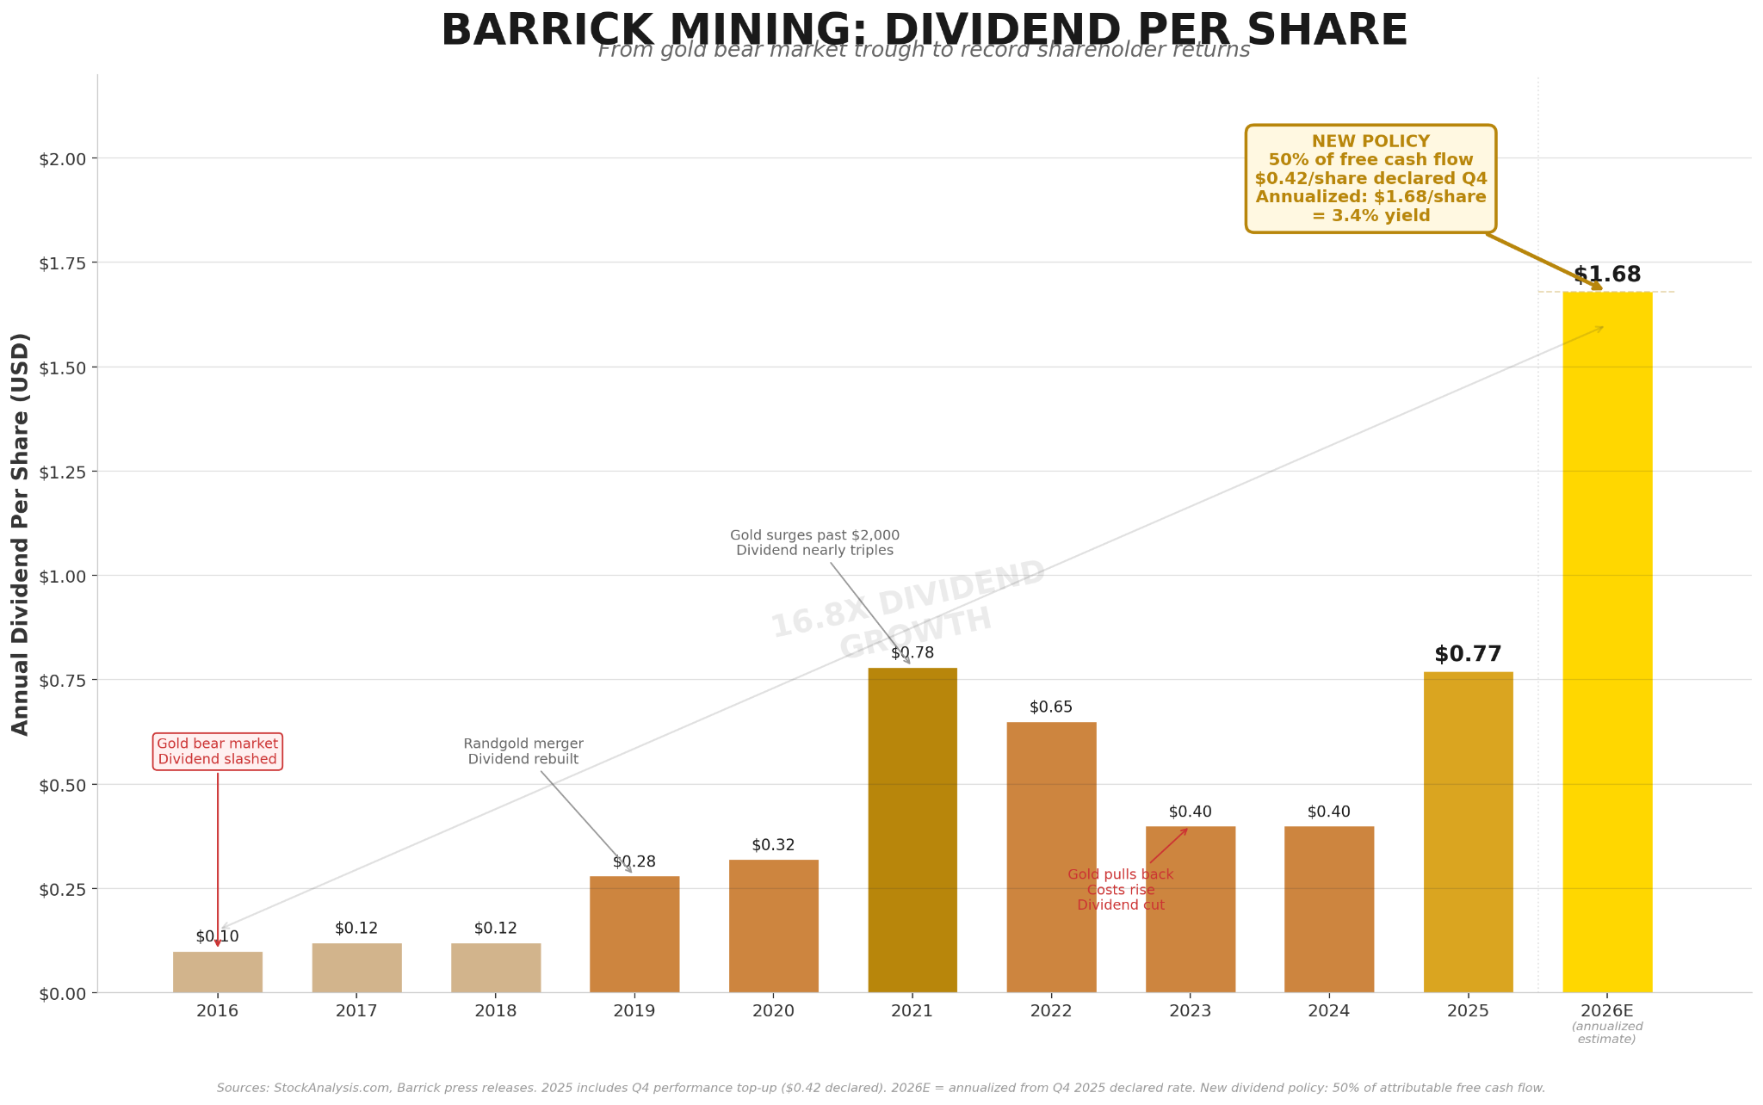
- They’ve accrued $6.7 billion in cash – a record amount.
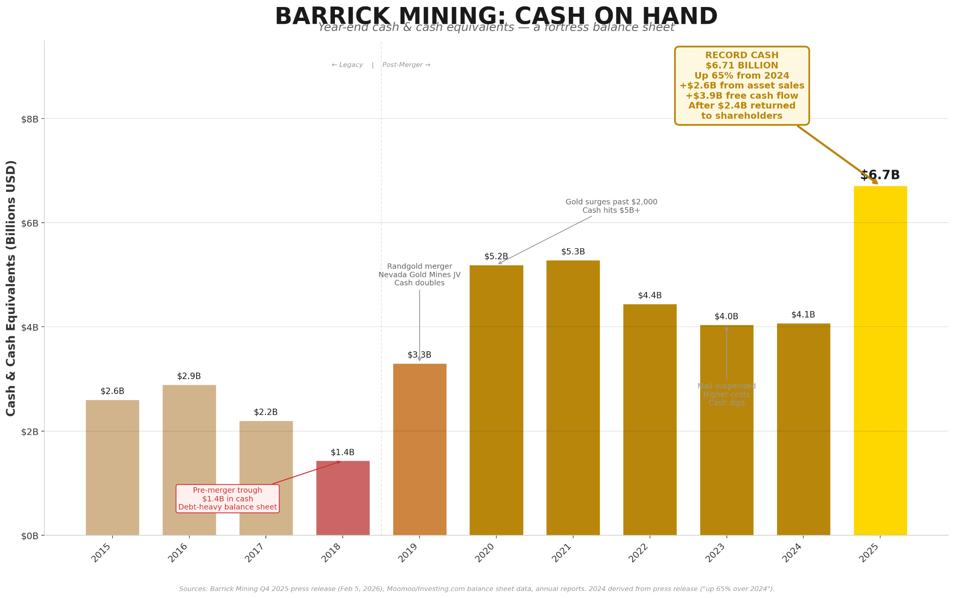
And if that’s not attractive enough…
- Barrick is about to begin production of the Fourmile mine in Nevada, which The Globe and Mail calls a “century-defining gold discovery,”
The ticker price for Barrick is $44.
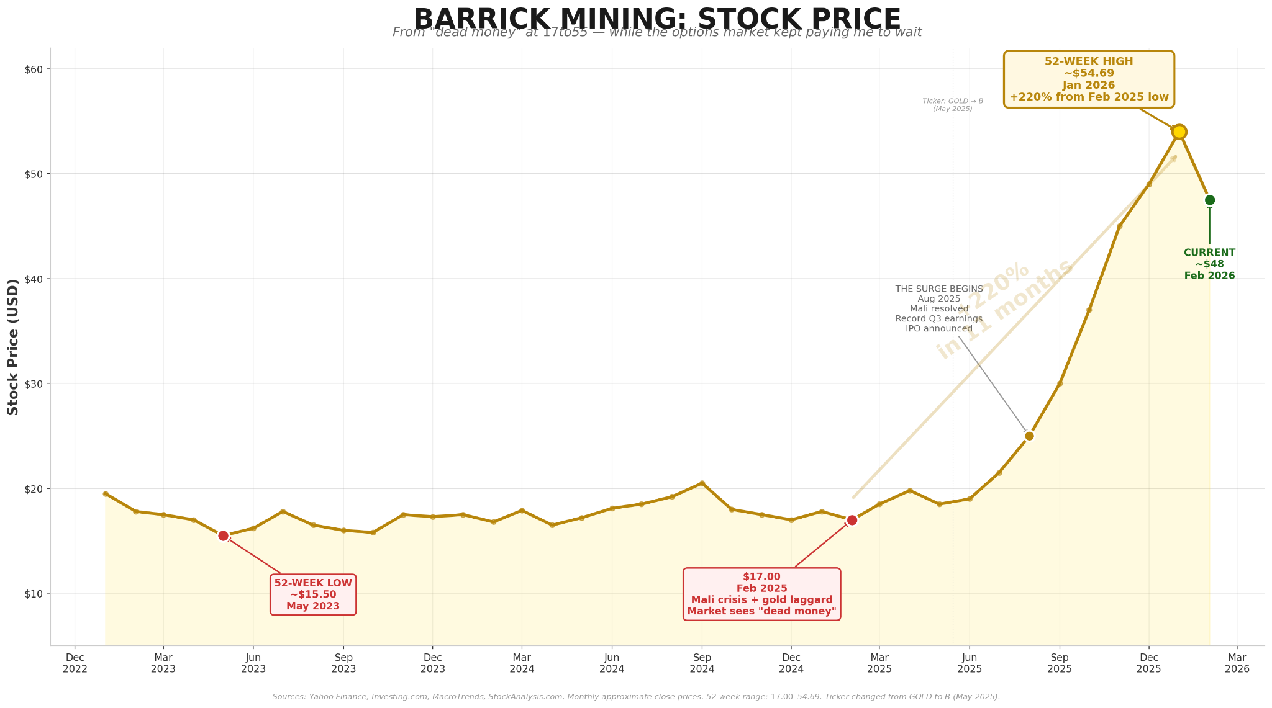
But even at this price, the company is still considered a bargain.
- JP Morgan says Barrick is worth $68 a share.
- Canadian Imperial Bank of Commerce says it is worth $71.
- Canaccord puts the stock at $77 a share.
If you want to buy Barrick and pay the full ticker price, go right ahead.
But why do that when you can place a phantom bid on Barrick for $30.
The market will then pay you cash, upfront, just for making that bid.
If the stock never falls to $30? You keep the cash.
If by some rare chance it does drop to $30– you get to own Barrick Mining for 32% less than what it’s trading for.
Either way, in my eyes, you can’t “lose.”
HEADS: The stock stays above its current price or even drops a little, you collect a premium and move on to your next target.
TAILS: The stock comes down to your $30 target price and you get to buy a stock that’s sitting on what looks to be this century’s most significant gold find at a killer discount.
Now keep in mind that this method lets you name your own price on a stock. But if that stock’s price falls to your asking price, you do have to buy it. Just remember, these are shares we would love to own anyways.
Going back to gold...
It’s in a frenzy right now. It just had its worst single-day crash in decades — and hit an all-time high in the same month…
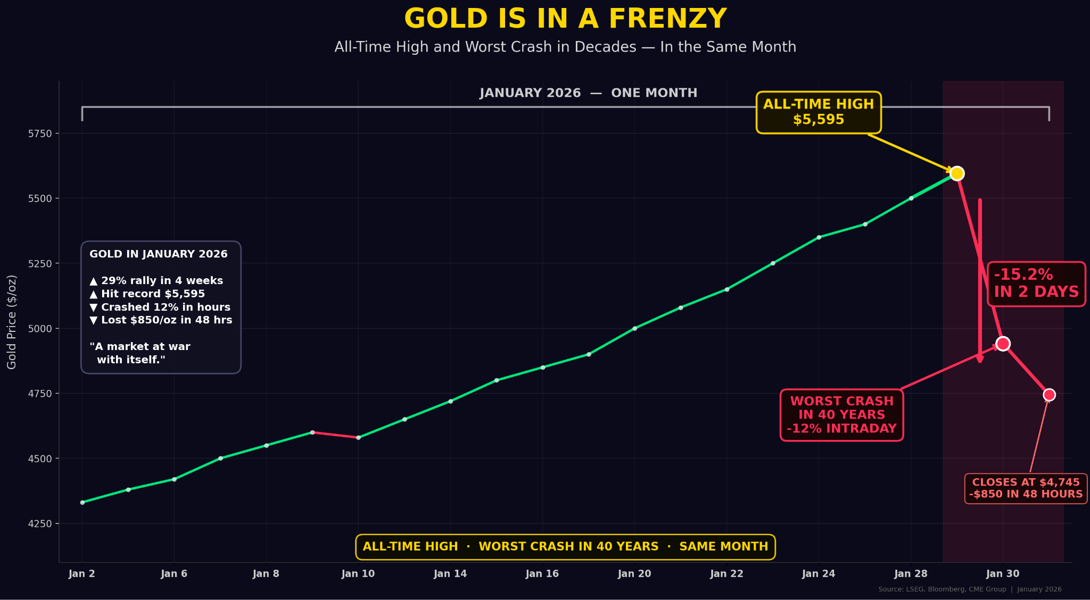
That's a market at war with itself. And when a market is at war with itself, placing a phantom bid is the only trade that has two favorable outcomes.
[do not read this subhead]
Gold Heist:
Your Second Target

Here’s your next target: Agnico Eagle. The stock is around $221 a share…
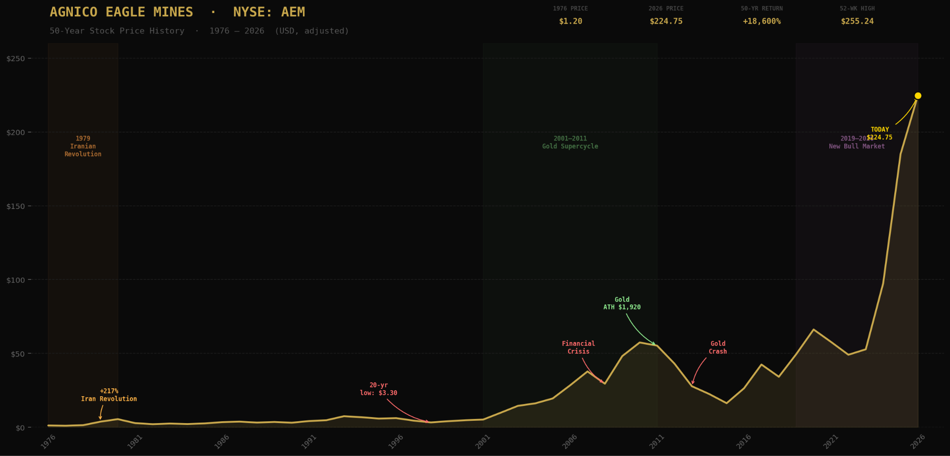
Ask any gold analyst on the planet and they'll all say the same thing: “Agnico Eagle is the gold standard of gold mining:”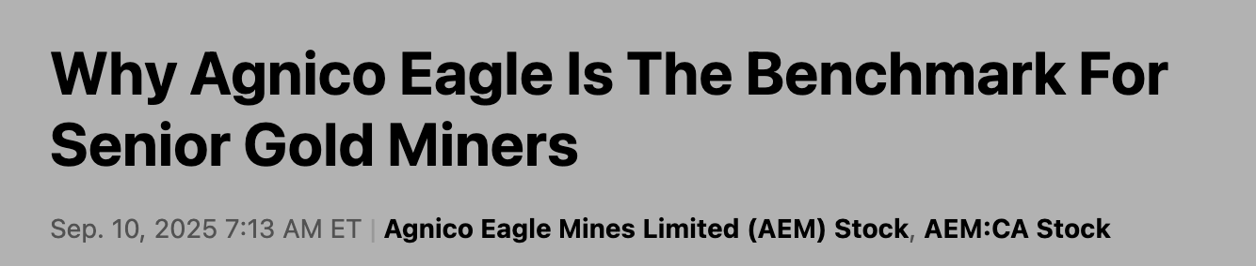
- They have 11 mines, all of which are in stable jurisdictions.
- They hit record revenues of $9.6 billion last year.
- They have record earnings of $6.9 billion.
- They have 15X more cash than debt.
- And they’ve paid out a dividend every year since 1983.
You can pay the full ticker price for Agnico and probably make out quite well…
The stock has a high target price of $333.
Or, you can name your own price and place a phantom bid on Agnico for $125.
That’s more than 50% below where it currently trades.
The second you make that bid, the market will pay you a cash premium.
At that point one of two things will happen:
HEADS: Gold will keep running and AEM will keep climbing toward $333. Your offer is never triggered and you keep every dollar the market paid you.
TAILS: Gold pulls back hard. AEM drops to $125. At that point you have to buy shares at the price you agreed to -- $125. That’s the commitment you made when you placed the phantom bid. In this case you get to own one of the world’s best gold miners at more than 50% below its current price — while it's still generating billions in free cash flow and producing on 11 different mines.
Heads you collect a premium and walk away. Tails you buy a world-class company for a price you named yourself.
You might be wondering — how does a trade like this even exist? How do you collect cash for making lowball offers on the market’s best assets…
Here’s your answer:
When you execute a phantom bid…
You’re entering into a contract with another party in the market.
That party pays you a premium in exchange for your agreement to buy shares at your chosen price -- if the stock should fall to that level.
The money you receive is compensation for the commitment you’re making. And because gold volatility is running at levels we haven’t seen since COVID, that compensation is much larger than it would be normally.

On Wall Street, it’s known as put selling.
Now…
You can sell a put on pretty much any stock you want, at any given time.
Warren Buffett describes it as getting paid to agree to buy something you want, at a price you want to pay.”

And right now, because of the highly volatile and unpredictable world we now find ourselves in…
This has become the best environment for selling puts on gold stocks that I’ve ever seen:
Four separate forces — each powerful on their own — have converged into a single, historic moment.
- We have a generational bull market in gold where the price has gone up 400% in the last decade…
- We have near-record high volatility levels (which spiked to a 5-year high in January)…
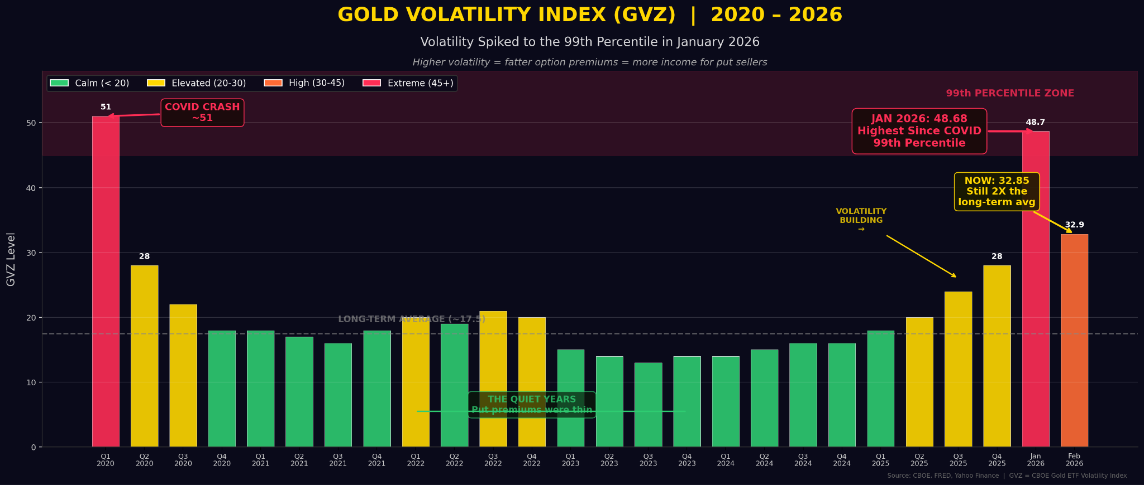
- Put premiums are larger on every major gold stock:
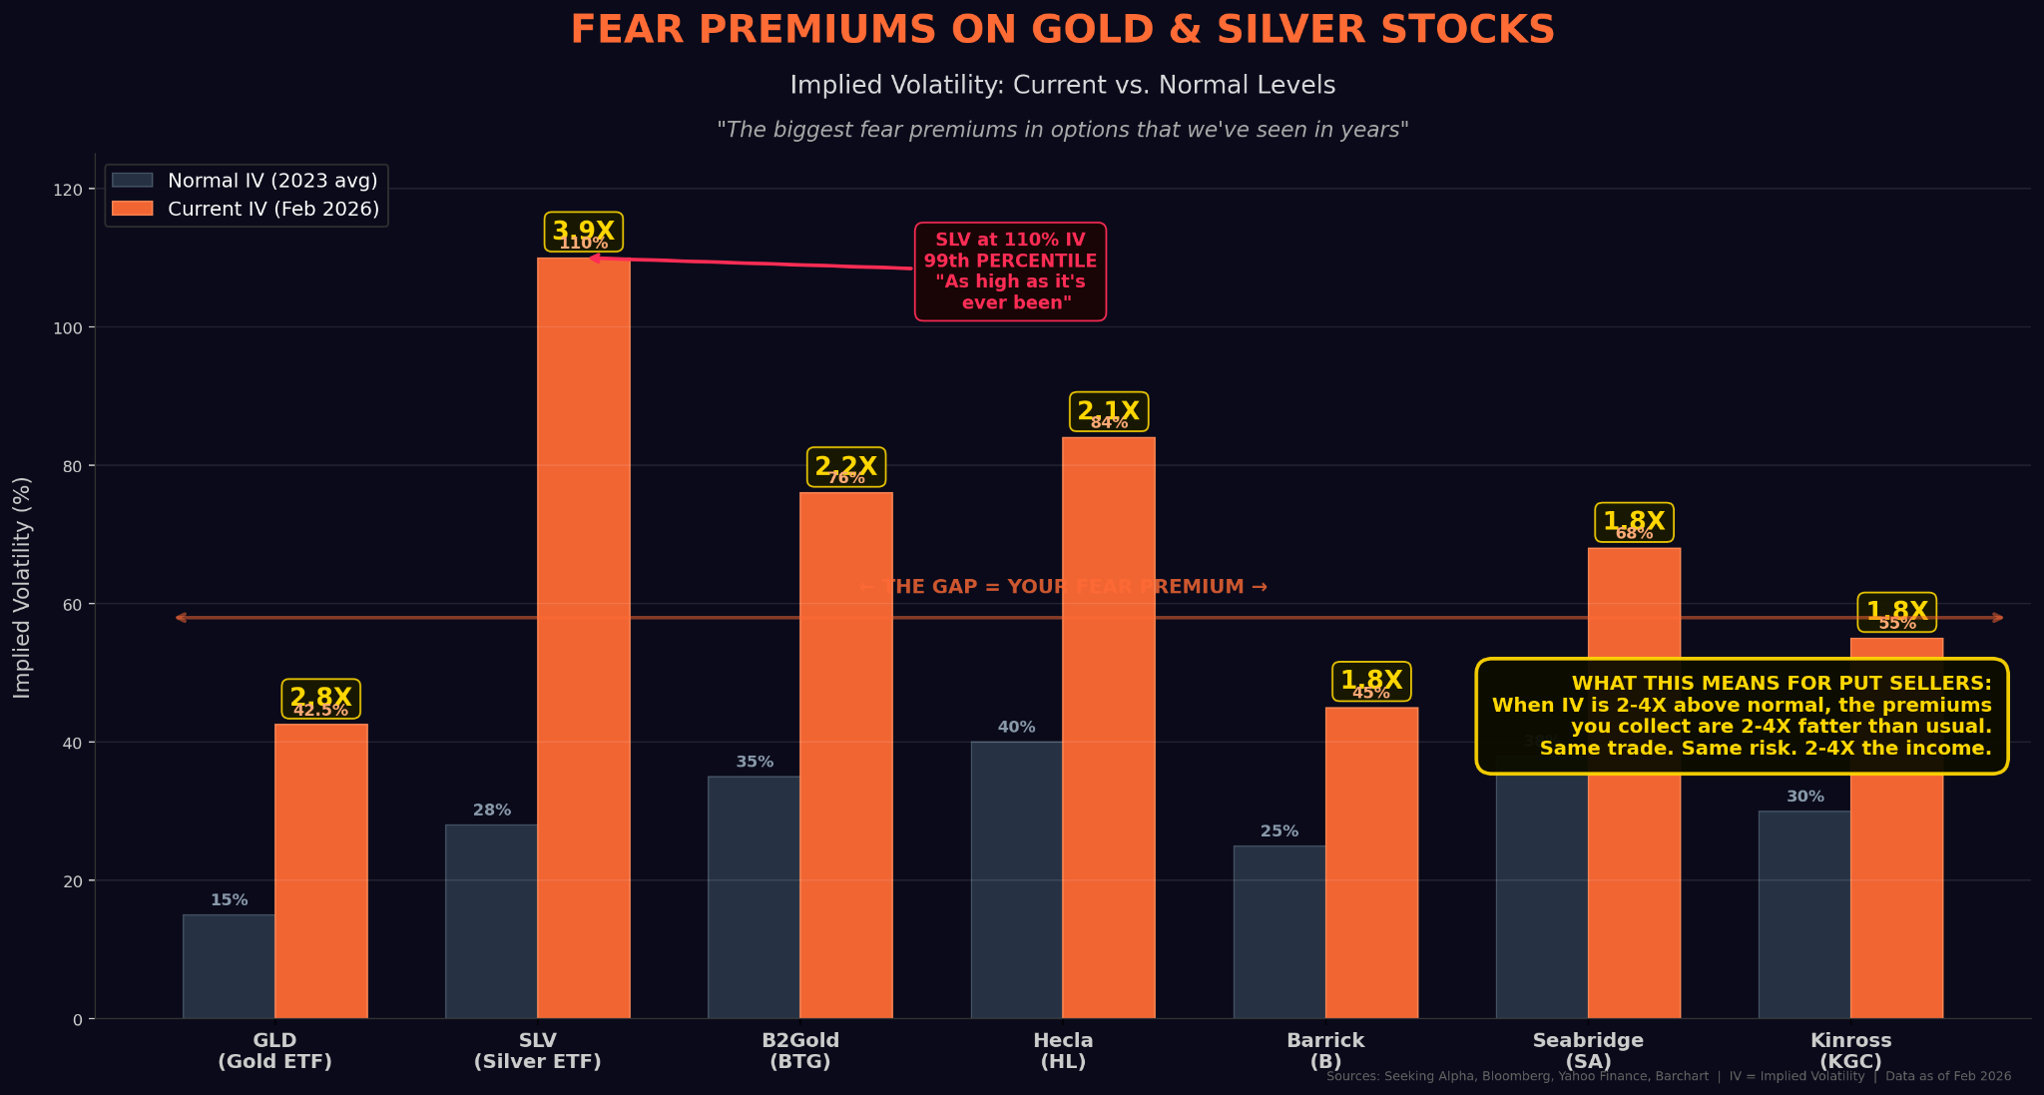
- And we have a record-breaking pace of central bank buying for gold – over 1,000+ tonnes per year…
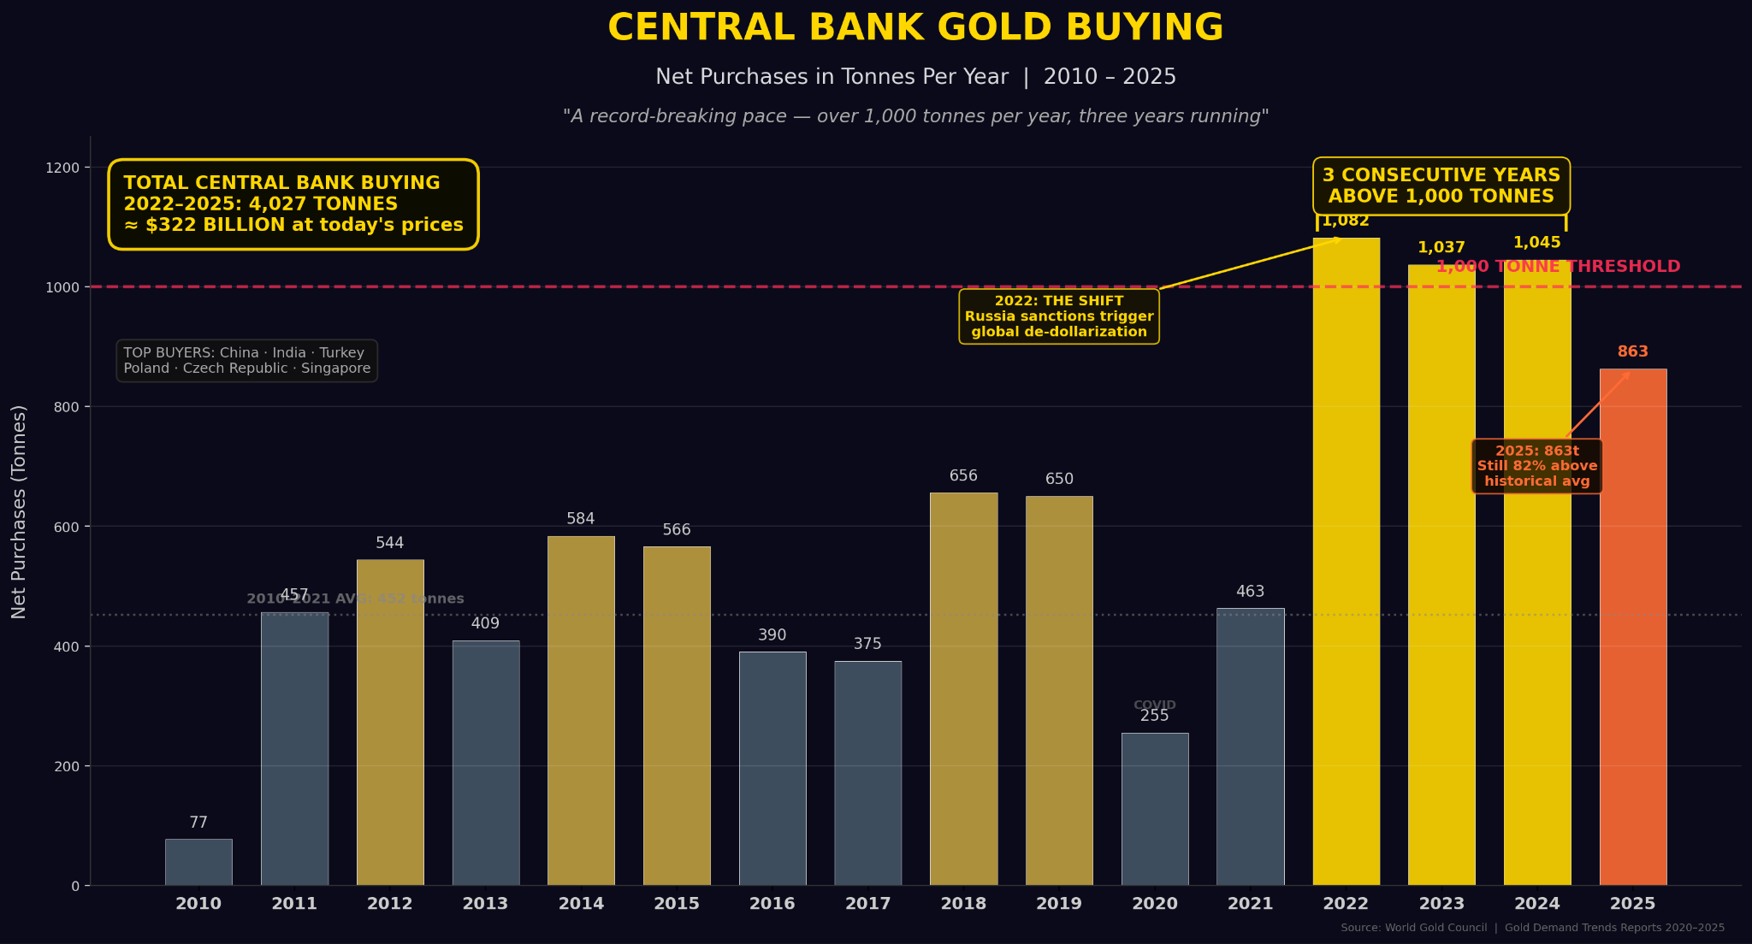
Everything I've waited 46 years for has arrived at the same time.
I get it. The headlines can be terrifying. Missiles could be flying. Markets swinging 5% in a day. Gold crashing $1,000 and then recovering it a week later.

For a lot of people it’s a scary time to think about money.
For traders, this kind of uncertainty is diesel fuel for the options market.
That’s not just my take:
- Schaeffer's Investment Research — the longest-running options advisory in the world — says gold's wild price swings have created a “fertile ground for options traders, offering ways to profit whether prices rise or fall.” ￼
- VanEck, one of Wall Street's largest gold fund managers, says miners are generating "record cash flows" while their stocks remain deeply undervalued — a "long-overdue re-rating" they say could be on the horizon, and it’s only just beginning.
- Investing.com puts it plainly: “in a bull market like this one, put premiums don't shrink. They get fatter.”
I ask you…
In what world do you get paid cash up front to put in lowball offers on the market’s most sought after gold stocks, while gold itself is soaring past $5,000?
This world, right now.
But it gets even better because we’re not just seeing this happening in gold stocks…
The same fear and uncertainty that's driving gold is affecting silver at an even faster rate. Because unlike gold, silver doesn't just get hoarded — it gets used up in the weapons, technology and infrastructure that every nation is now racing to build.
Silver is crucial to dozens of industries.
Electric vehicles, 5G infrastructure, medical devices, AI data centers, solar panels, smartphones, appliances, RFID tags…
For five years straight, demand for silver has outstripped supply:
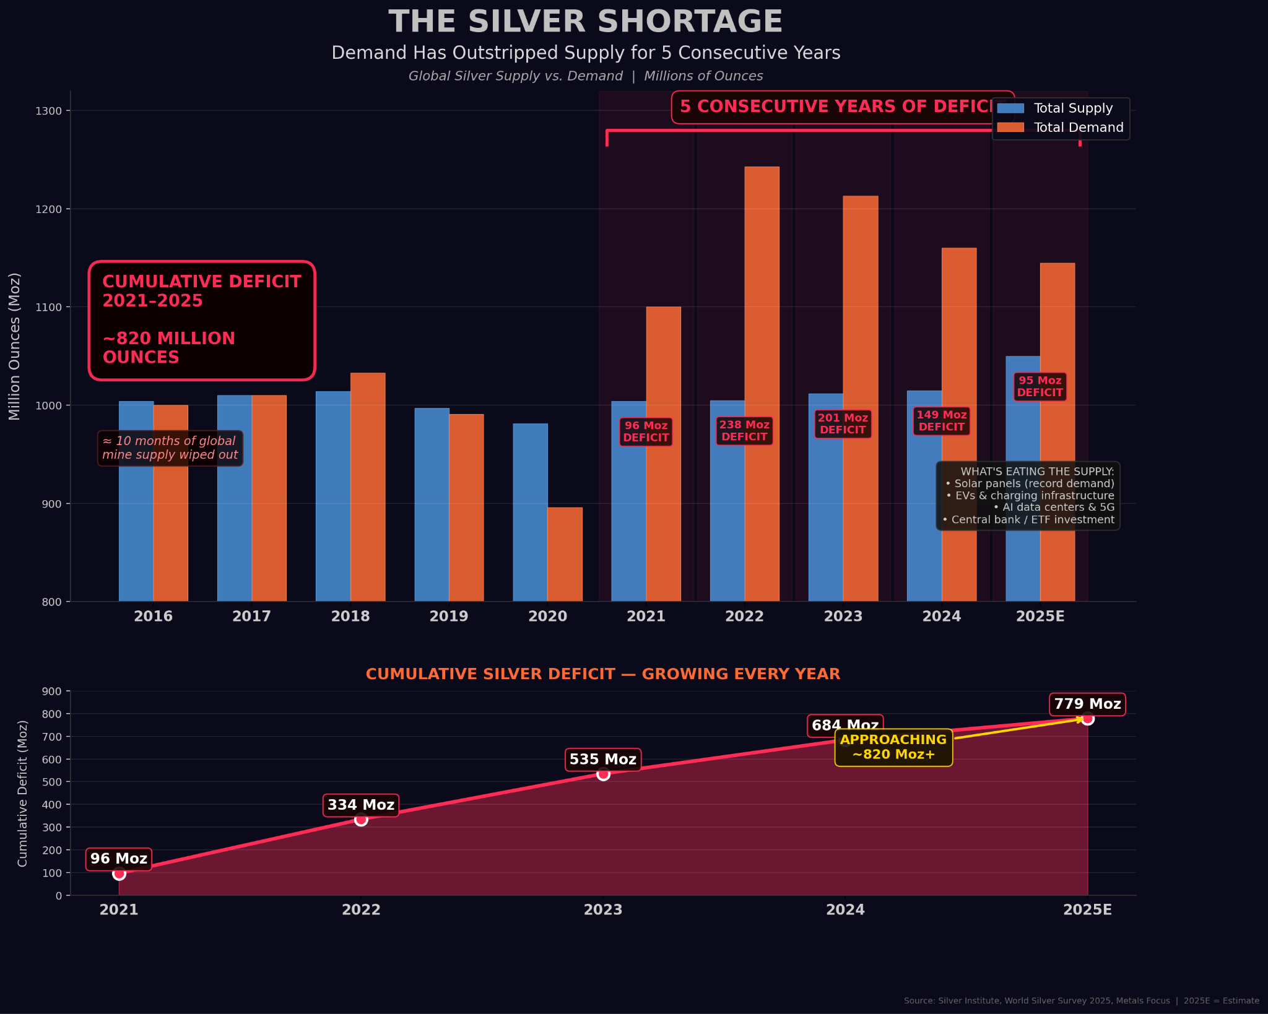
It’s gotten to the point where we now have an 820-million ounce silver deficit.
And this deficit is only growing larger as silver stockpiles continue shrinking.
According to data compiled from the U.S. Geological Survey, at the current rate of consumption, above-ground silver stocks could be fully depleted by 2035.
This means we have as little as nine years left before the vaults go empty.
[do not read this subhead]
Silver Extinction
That’s why next to gold, silver is now the second most valuable asset in the world.
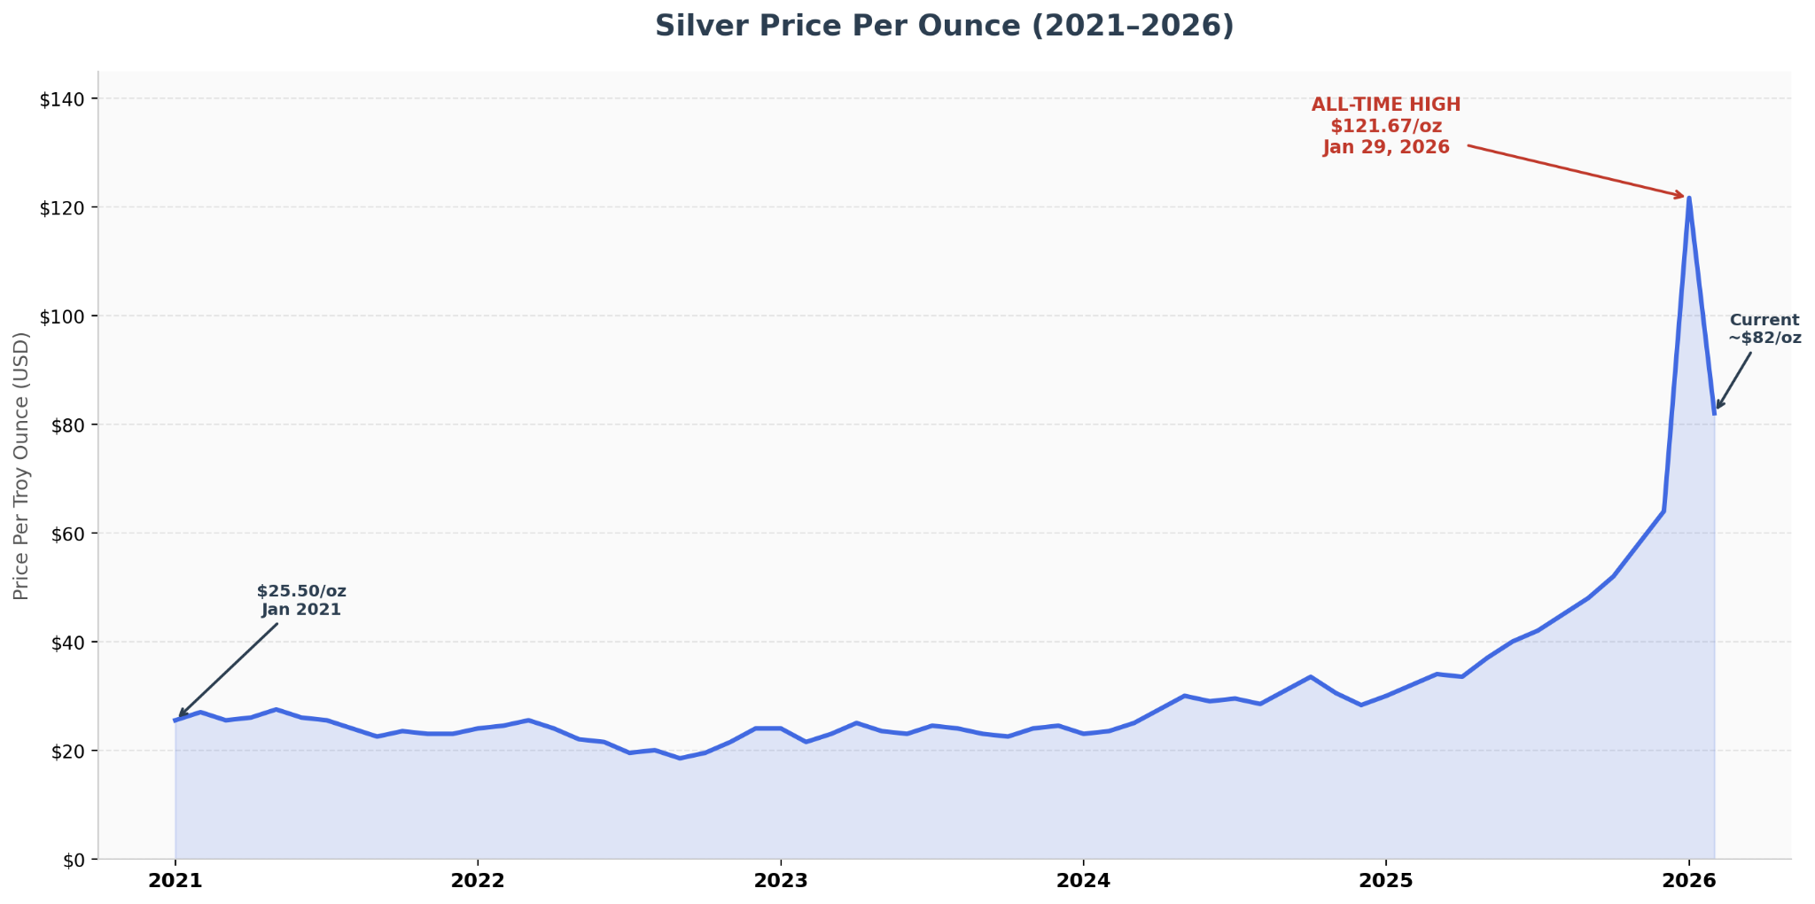
It has nine years left before every ounce still in the ground could become priceless.
Our war with Iran made this worse. Every cruise missile we fired over the Strait of Hormuz contained silver. Every nation who watched this war from the sidelines, is now accelerating its defense buildup by making weapons.
All of which use silver components.
This has put every major institution and superpower on a buying spree:
- Entrata founder David Bateman quietly bought nearly $1 billion in physical silver — 1.5% of the entire global annual supply — in a single six-month window.

- India placed a single order for 1,000 tonnes. The order was so large it literally froze the London market overnight.
- Russia's central bank just allocated $535 million to silver — the first time in history a major central bank has added silver to its official reserves.
- JPMorgan — the same bank that spent years shorting silver — just quietly amassed 750 million ounces. That's nearly a full year of global mine supply. In one vault.
- And the US Mint suspended silver sales to the public at the start of this year

These powerful players know something you don’t…
They know that silver is no longer just a precious metal.
It’s a crucial ingredient in every modern technology.
That’s why the U.S. gov’t re-classified silver as a critical mineral for national security as it’s quickly disappearing faster than we can dig it out of the ground.
This is where my strategy — the one that’s produced 161 winners out of 169 trades — meets the single best opportunity I've ever seen.
[do not read this subhead]
The Silver Miner That became a U.S. Defense Contractor
These are the coeur d’alene mountains of Idaho.
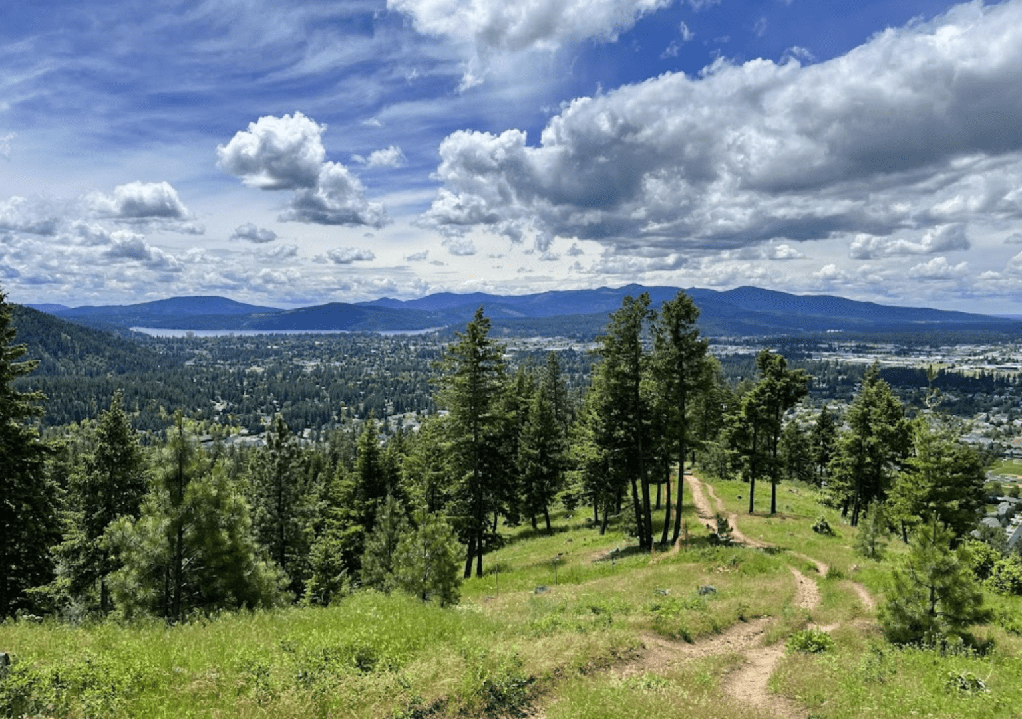
Under these mountains is an estimated 78 million ounces of silver.
At today’s prices that’s a silver mine worth $5.4 billion.
And one company owns the entire deposit.
This same company produces 37% of all the silver mined in America.
But I doubt you’ve heard of them before.
They’re called Hecla Mining.
Over the last year Hecla’s stock has gone up 340%.
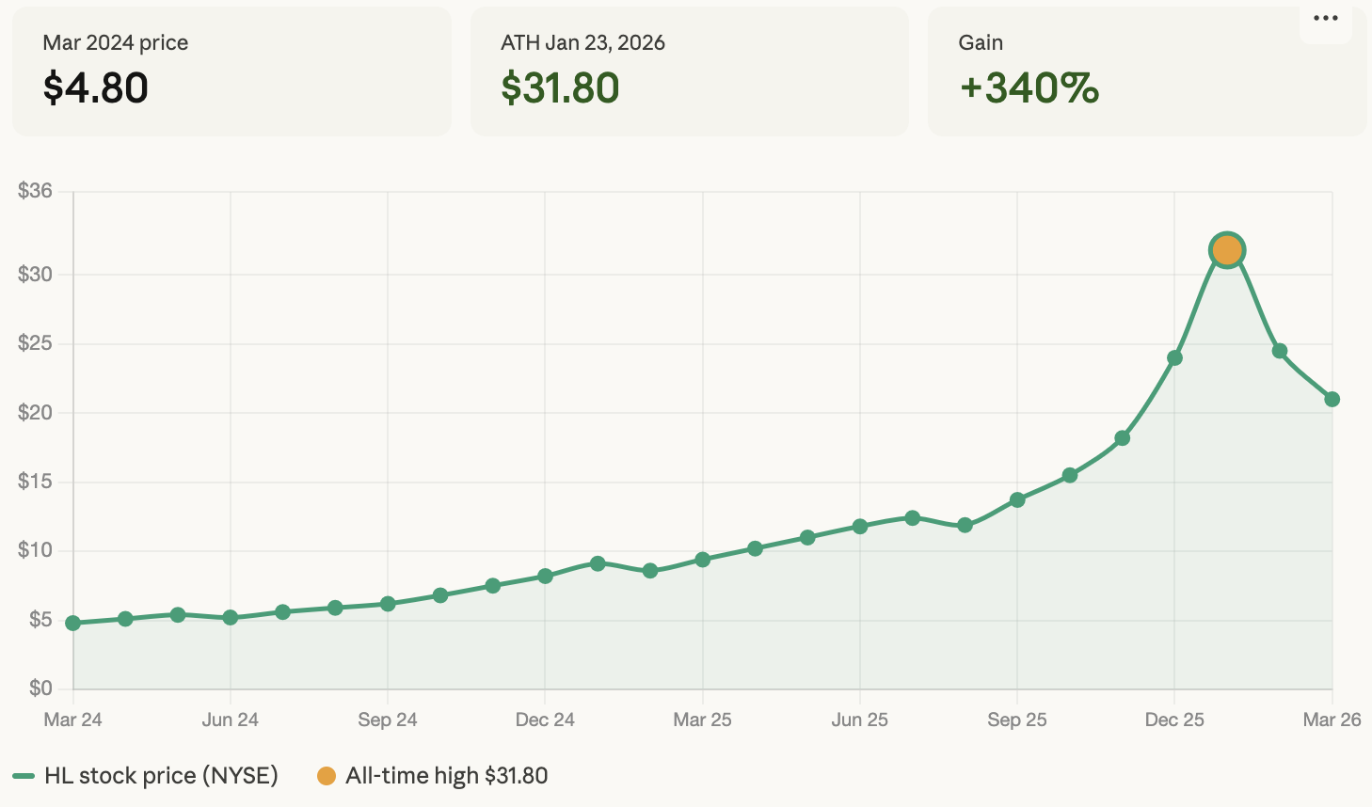
But even at its current $21 price tag, it still has plenty of room to run:
- BMO Capital believes the stock is worth $28 a share.
- CIBC says it’s worth $32.
- HC Wainwright thinks it should be $36.
I think it could be worth even more than that.
- Hecla just posted record revenues of $448 million last quarter — capping off a $1.4 billion year.
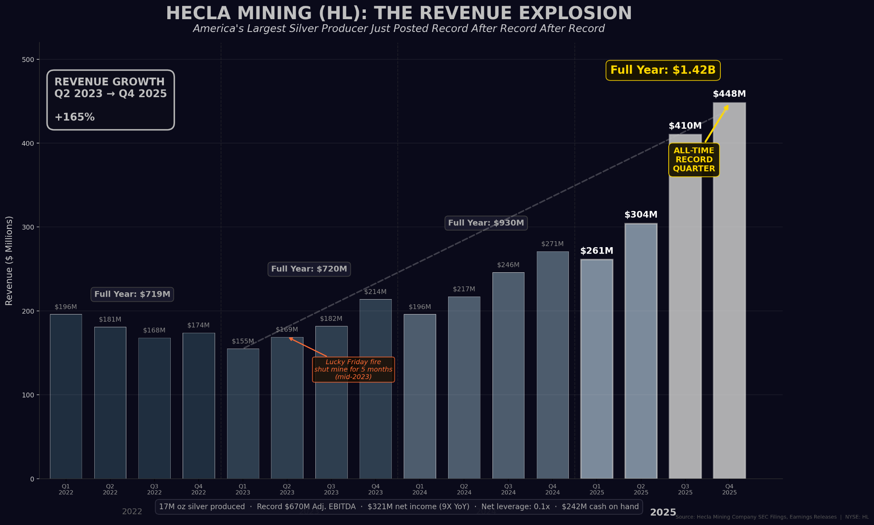
- They made $321 million in profit - a 9X increase over last year.
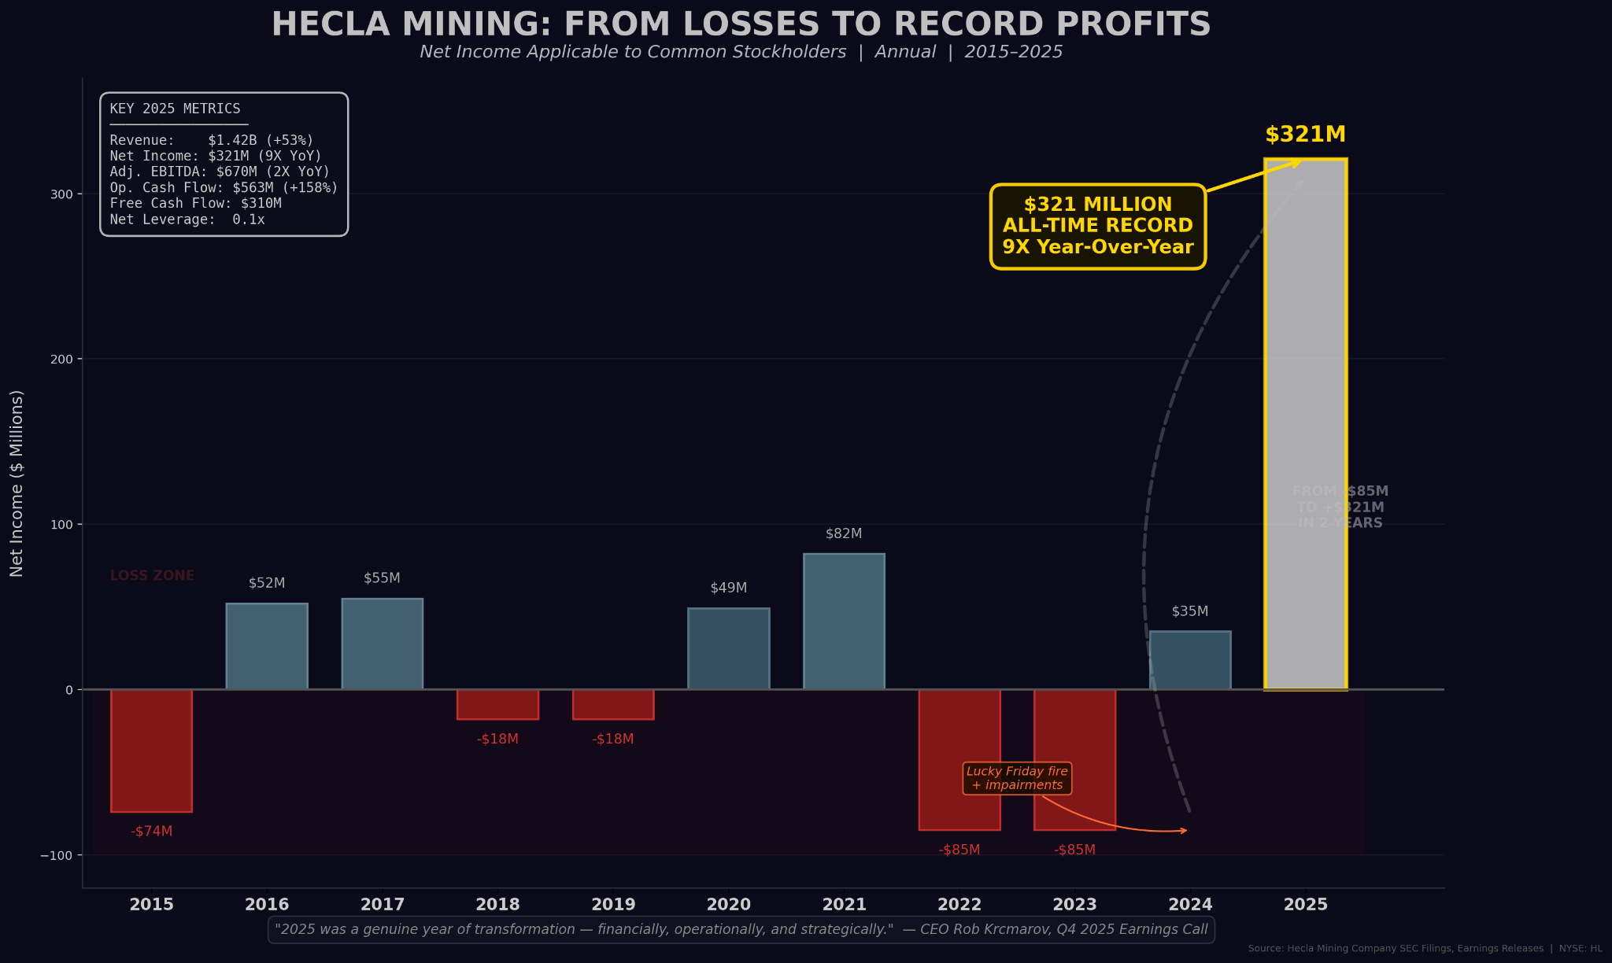
- They have $300 million in cash and $285 million in debt.

And because every time the company digs for silver, they pull gold, lead and zinc out of the ground…
Once they sell these metals, they've already effectively made $2.03 in profit on every ounce of silver due to their negative cash costs. In other words, they get paid to mine silver.
But what truly fortifies Hecla as a bulletproof enterprise is the fact that their Libby exploration project in Montana – which has an estimated 183 million ounces of recoverable silver – has been put on the FAST 41 critical minerals dashboard.
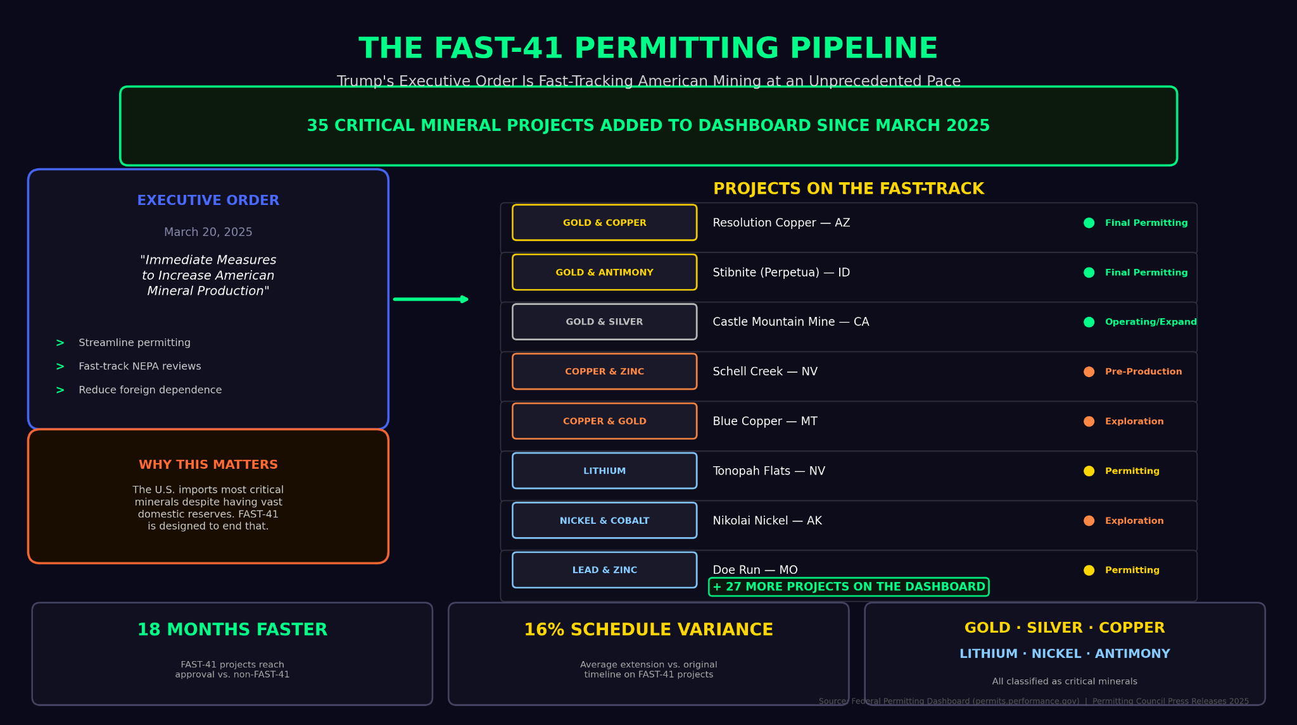
That's a federal program designed to fast-track permitting on projects deemed essential to national security.
The U.S. gov’t has effectively turned Hecla’s operations into a national priority…
Again, if you want, you can buy Hecla and pay the full ticker price of $21.
Or you can sell a put and tell the market that you’ll only buy Hecla if it drops to $14 a share – 35% below its current price.
Thanks to Iran, the fear premium on Hecla's options are running at elevated levels – comparable to what we’re seeing in the gold market.
The setup is identical.
HEADS: If Hecla stays above water or even drops a little, you collect a sizable premium and move on to your next target.
TAILS: If the stock plummets you get to buy the only silver miner – whose output is a matter of national security – at a clearance-rack price.
B2Gold, Barrick, and Hecla are three opportunities sitting in front of us right now.
Three phenomenal businesses you can offer to buy for 30% to 50% less than what they’re trading for, and get paid for that privilege.
If they drop to your bid price, you'll buy shares at that price — which is exactly what you agreed to when you placed the bid. That’s technically a "loss" though in my view, owning a world-class miner at 30% to 50% below market is a bargain most investors never see twice. That said, stocks that drop can drop further, and even strong companies carry risk which is why it’s important to never invest more than you can stand to lose.
My team and I have put together a list of 30 stocks .
I plan to recommend put trades on all of them inside The War Room over the next several months.
[do not read this subhead]
30 Targets. One Room.
For those of you who don’t know….
The War Room is a live trading floor.
It is built for people who want to be in the same room with me when the trades happen.
And we’re not alone inside The War Room either.
There are thousands of members who trade alongside us. They share ideas. They celebrate wins. They learn from each other.
That's the culture we've built.
- Last week, one member posted that he made 472% in a week from my trade on Circle Internet Group saying it was his “highest win ever.”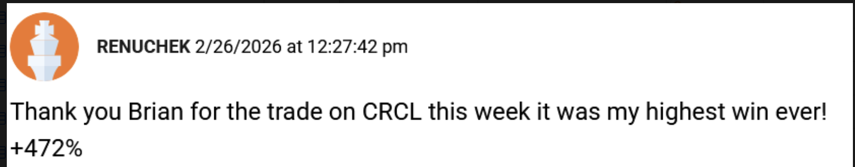
- A few weeks before that, on Jan 29, I had a member post that he made 357% from my trade on Southwest Airlines and that it was his “fastest trade ever.”
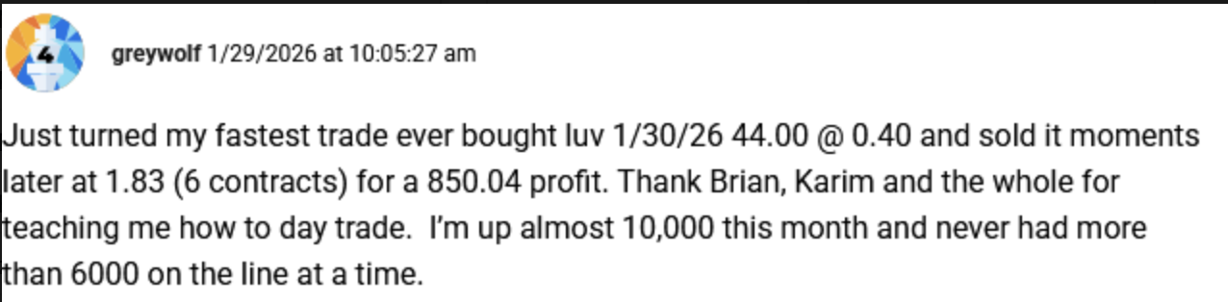
￼Another follower Nathan is up well over 1,000% on 17,000 shares of Rolls Royce. At $16 per share, those are worth $272,000!
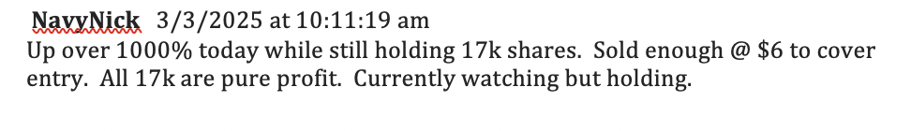And on Feb 6th we received one of the best notes we’ve ever gotten. It was from a guy who said he bought my recommendation of Rolls Royce (RYCEY) at $0.88 cents a share and just three years later it was at $7.48. Today it’s $16. If he’s still in the stock, his $20k stake would now be worth $363,000 in four years.
.
- ￼
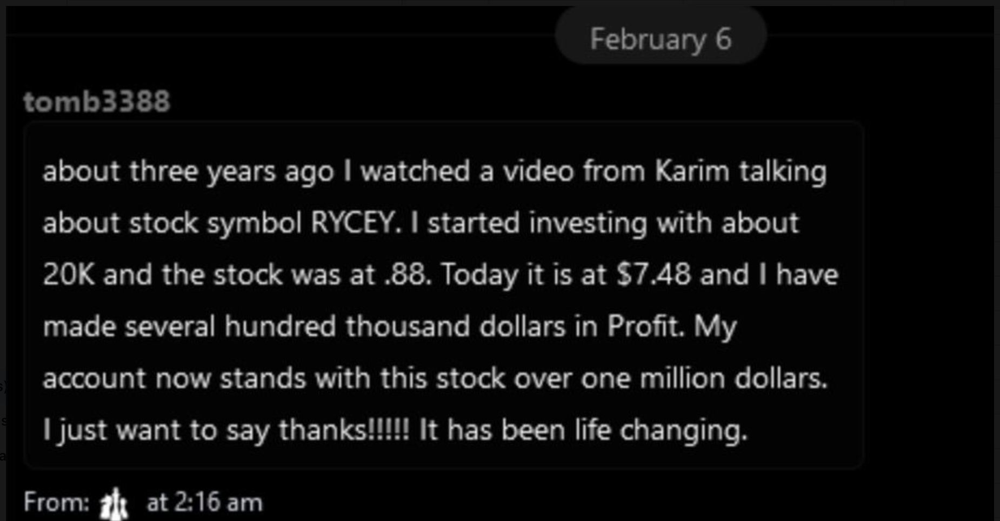
- But perhaps the most interesting one was this piece of paper I carry around with me to this day.

It comes from a man who walked up to me at a conference and handed it to me with just a hint of a smile on his face.

It was a printout of his trading account.
[IMAGE of Rolls Royce Paper]

This guy had bought 516,441 shares of Rolls Royce at an average of just 93 cents per share in 2022.

At today’s price, those shares would be worth $8 million.

The War Room has been producing winners for six years straight.
But what's coming in the next several months could make everything that came before look like we were trading with training wheels.
The volatility, the fear, premiums — they're not showing up in one corner of the market. They're showing up everywhere. All at once.
[do not read this subhead]
The Most Mispriced Energy Stock on the Planet
Oil stocks are a put-seller's paradise right now.
Here’s why…
What you are looking at is the OVX – the official fear gauge for oil.
In 2025, the index was at 27 and the premiums were good.
Today the OVX is at 89 and the premiums are obscene.
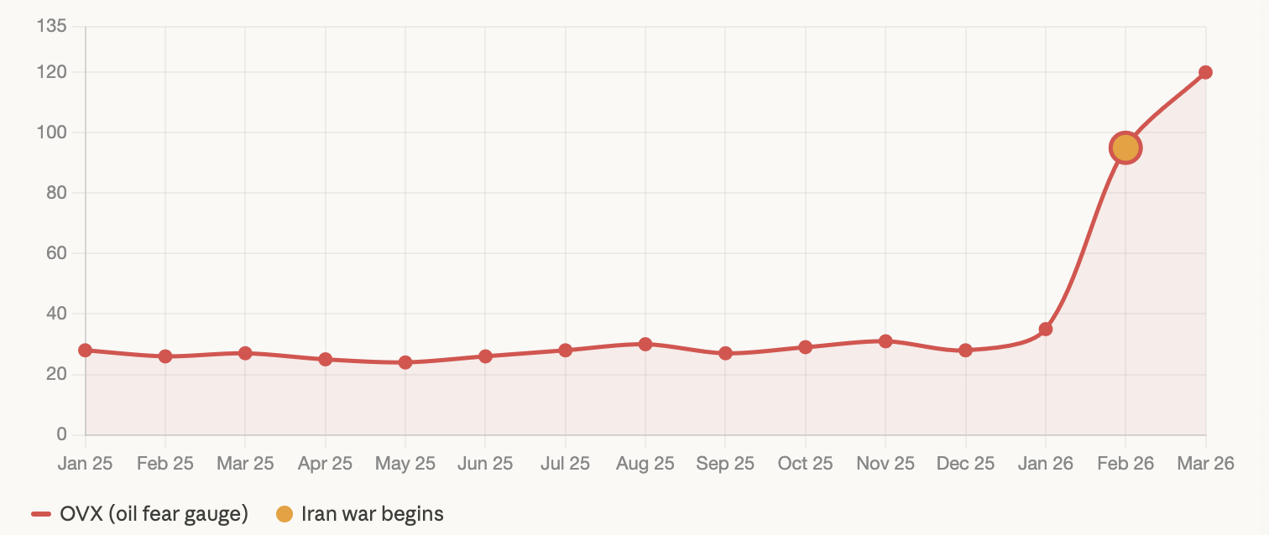
The market is so terrified of another conflict breaking out that it's handing put sellers large premiums to name their own price on oil stocks.

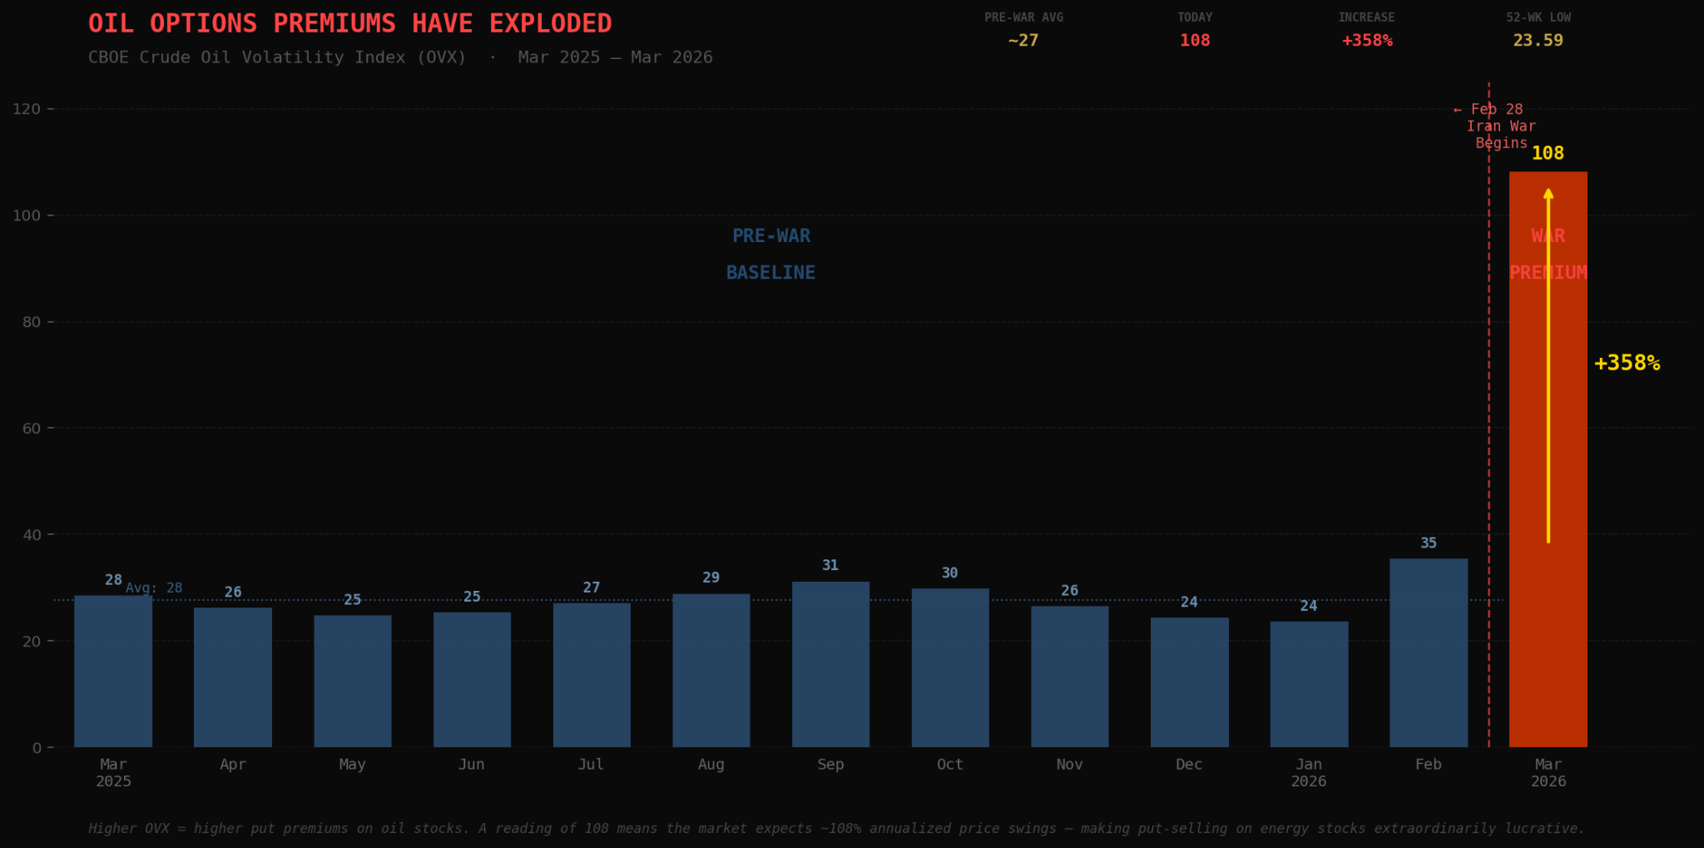
And there’s no better oil stock to sell puts on right now than APA Corp – a trade I recommended last February for $14 a share. It’s now $40 a share.

APA is one of the largest independent oil and gas producers in the world.
- Last year, they generated $9.2 billion in revenue.
- $1.43 billion in earnings.
- 460,000 barrels of oil per day.
- And they cut their operating expenses by $500 million a quarter.
That was when oil was at $70 a barrel.
Now imagine what these numbers will look like if oil hits $200 a barrel.
A ceasefire is not a peace deal.
When one round of war ends, a new round can start up just as quickly.

.
Now look, I’m not a warmonger.
I don’t like living in fear. No one does.

For put sellers, however, fear is the raw material that fuels premiums. And right now, there’s no shortage of it.
Before the Iran war, analysts had APA price targets at $45. Today, with oil at $100, the stock trades for $34.
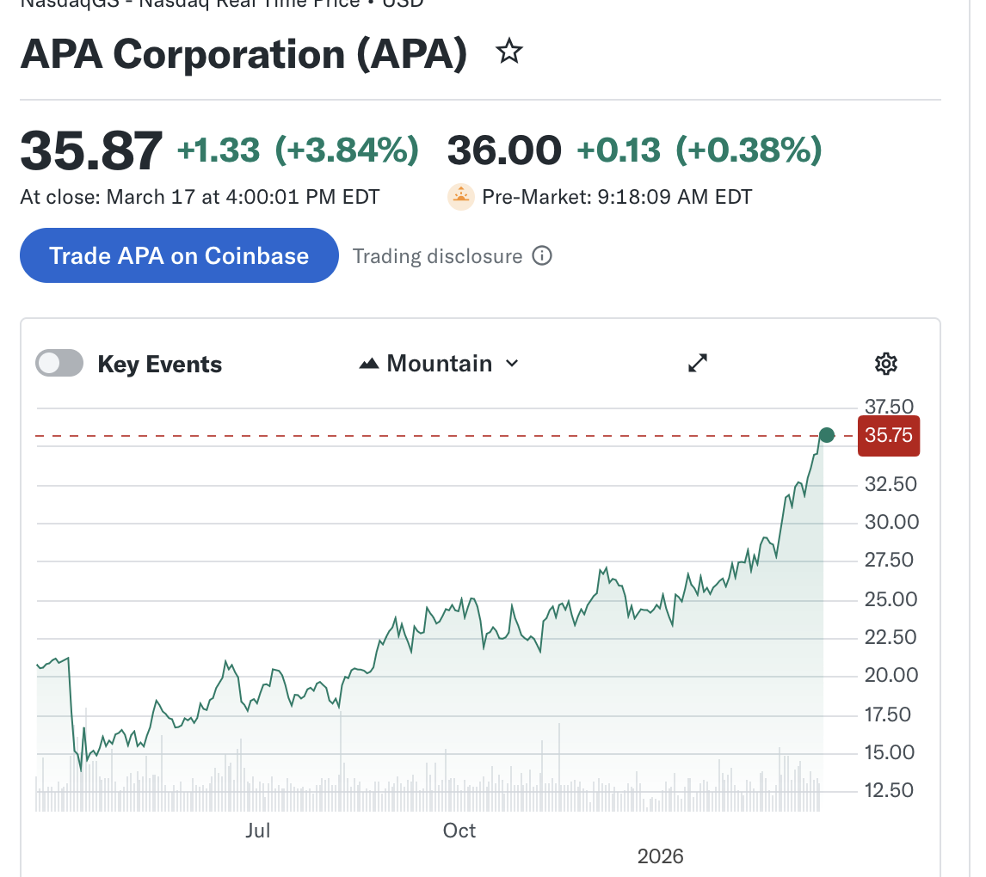
APA has already made a huge move. That much is obvious.
One of my readers just told me he made 168% in under a year.
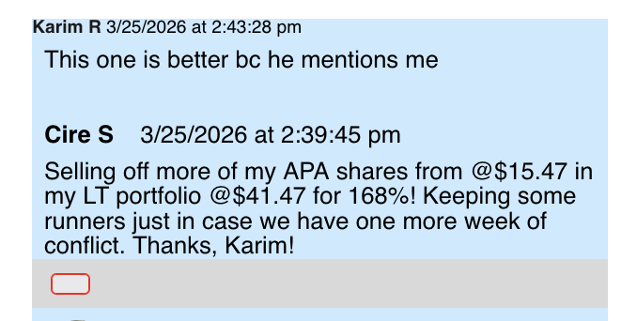
The question is... has it gone too high?
Well, what if you could get paid just for promising to buy shares if it comes back down to our price?
Let’s say you were to sell a $20 put on APA. By doing this, you’re telling the market that you’d buy this stock but only if it fell by 40% from its current price.
That’s like offering to buy a highly profitable oil refinery when gas is $8 a gallon.
Think about what would have to happen for APA to fall 40%. Oil would have to collapse — not pull back, collapse — while the Strait of Hormuz is closed and the entire Middle East is on fire.
That’s a fantasy. But let’s play it out both ways:
HEADS: If APA stays at $34, or even drops a little – which I can’t imagine happening – you collect your premium and move on.
TAILS: If APA drops to $20 – which I REALLY can’t imagine happening – you get to own a major oil producer at a price Wall Street would never offer you twice.
See the pattern here? Gold stocks. Oil stocks. It doesn’t matter. The strategy is the same.
- Find a great company that’s thriving.
- Put in a lowball bid for the shares.
- Collect the cash.
- And if the stock drops to your bid you get to buy them at a price that every other investor on Wall Street would kill for.
This is how you turn other people’s fear into income. And I have thousands of members who can prove it:
Take a look at this note we received from a member who is a High School Football coach. He joined us in December 2021 and wrote in June 2025 that our guidance was a big reason why he was able to become a millionaire in just 3 years with just $100,000!
- 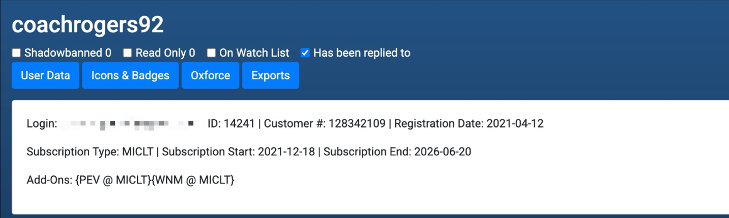￼
- Another member, Matthew G., told us that his War Room portfolio has gone up over 50% in two months, from $65k to over $100k.
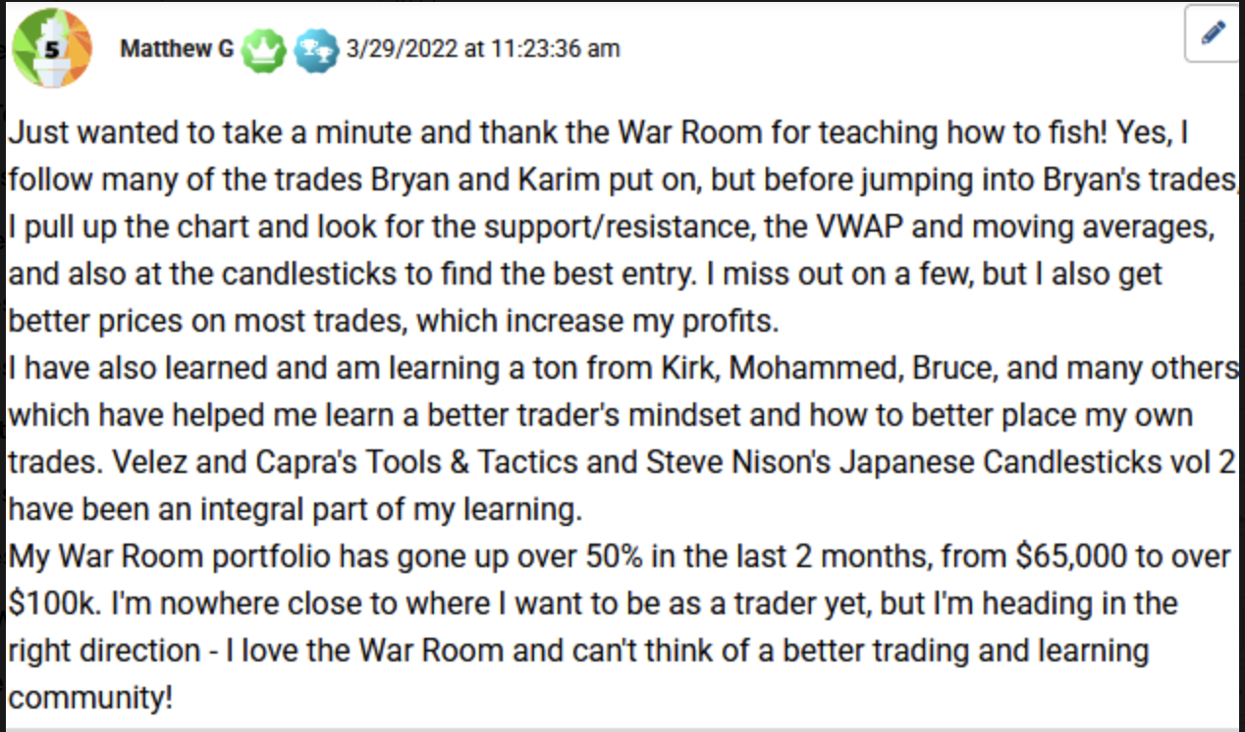
Stories like these are why my partner Bryan Bottarelli and I built The War Room.
To prove that anyone can trade like a professional if someone just shows them how. And right now, I'm seeing setups that I’ve waited 46 years to see.
One setup involves Cameco, the second largest uranium producer on the planet.
[do not read this subhead]
A Deal not Even Bill Gates Can Get
As I speak, 3,000 AI data centers are currently being built across America, in every single state.
Each data center requires 24/7 power. And at a 92% operating capacity, nuclear energy is the most reliable form of electricity on earth.
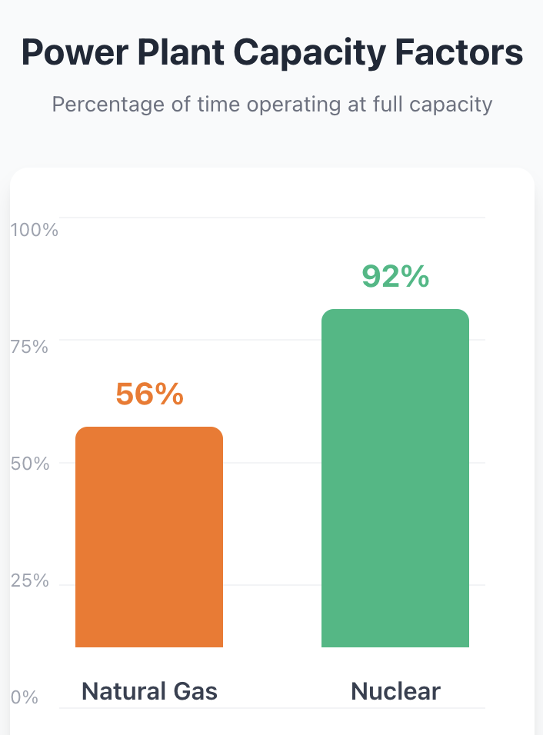
By comparison, natural gas has a capacity factor of 56%.
All the big tech companies know this.
OpenAI's Sam Altman — the man building the most powerful AI on earth — said it plainly: "I don't see a way for us to get there without nuclear.”
The U.S. gov’t knows it too. That’s why the Department of Energy wants to triple America's nuclear capacity by 2050.
The AI buildout is the single largest electricity demand event in American history — and at a 92% capacity factor, nothing runs more reliably than nuclear power.
Cameco, a uranium producer, is at the center of America’s nuclear renaissance:
- They just struck an $80 billion deal to build new reactors.
- Their earnings have surged 243%.
- Shares are up 137% over the past year. 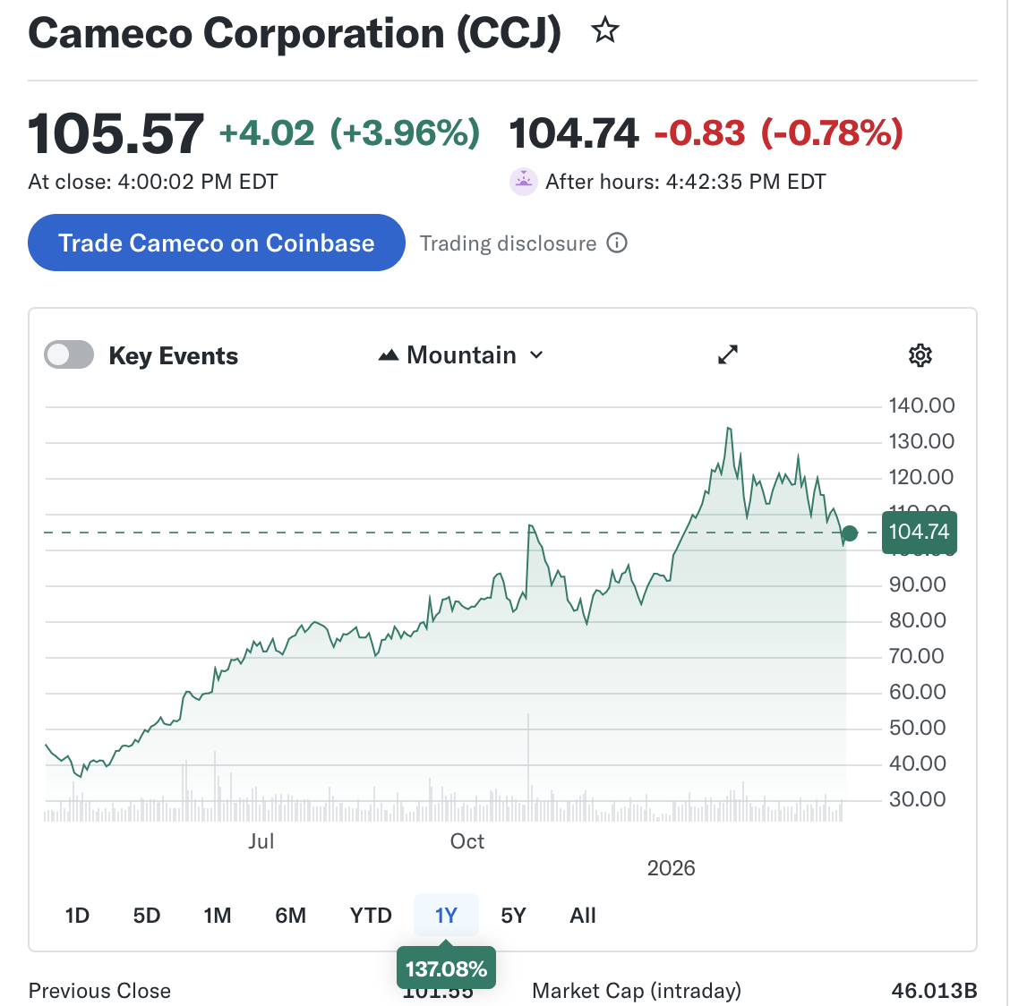
- They’re also sitting on $1.2 billion in cash — more than enough to cover every dollar of debt on their books.
Right now, you can buy Cameco and pay the full ticker price of $115.
With Iran driving uranium demand through the roof, you'd probably do fine.
- Analysts at GLJ Research just raised their target price on Cameco to $171.
- The most bullish analyst on Wall Street puts the stock at $219.
But again, why pay the ticker price when you can offer to buy Cameco for up to 50% less and collect premiums in the process.
HEADS: If Cameco keeps climbing on the nuclear buildout – which I expect it will as countries abandon coal and bet on nuclear – you pocket the hefty premium.
TAILS: If the stock drops to your bid price, you get to own the second-largest uranium producer in the world at a price that would make even Bill Gates – the guy who’s committed $1 billion to build America’s nuclear grid – green with envy.
This is what I mean when I say the war with Iran didn't just create an opportunity. It created the best opportunity I’ve seen in 46 years.
It's not just a gold heist.
It’s a heist on every precious metal and commodity that’s affected by conflict, tension, war and political chaos.
And right now, the headlines don't stop.
- Oil prices have exploded.
- Uranium is surging…
- Gold is going parabolic…
- 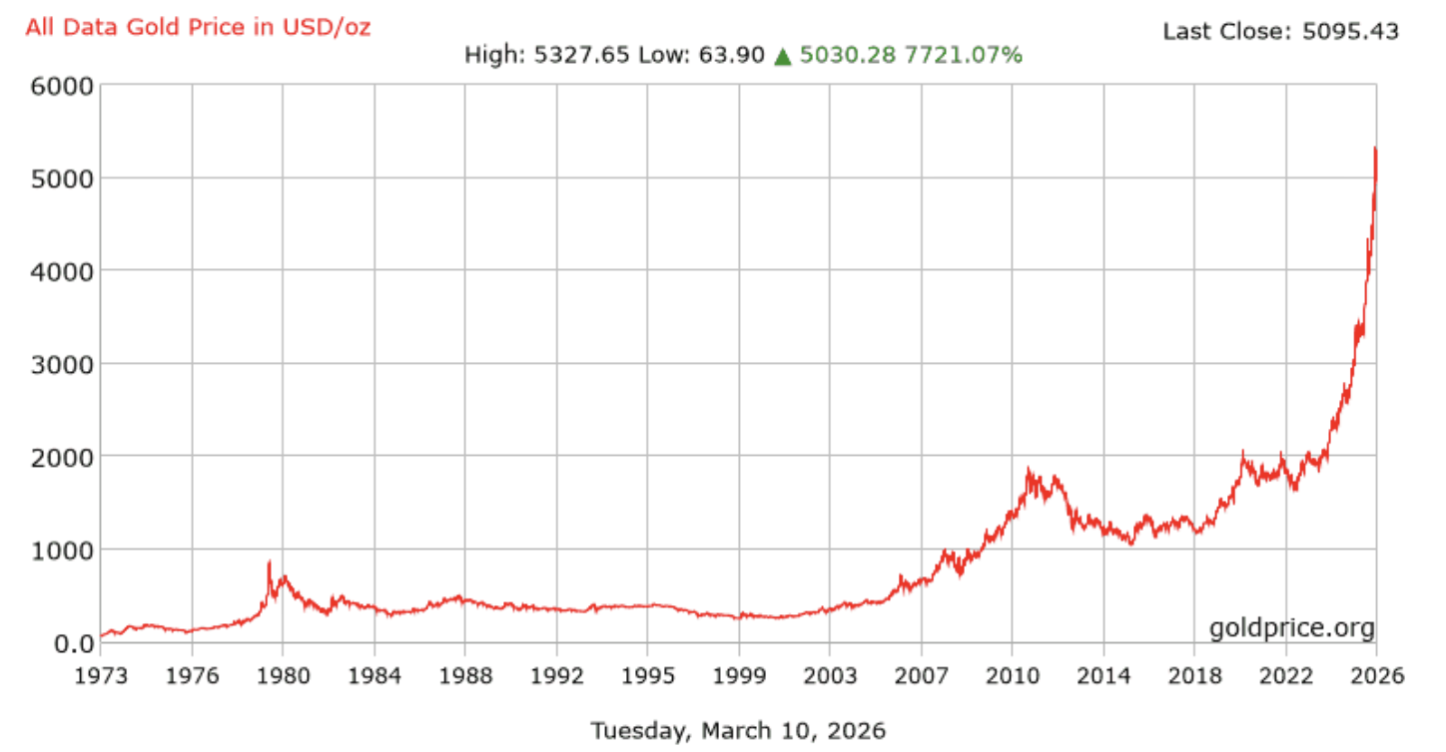
- And shipping costs have erupted.
Every single one of these headlines causes volatility to rise…
The same kind of volatility that can inflate the premiums you collect from selling puts.
But here's the one thing nobody is talking about.
The one side of this story that is making the least headway in the media.
[do not read this subhead]
The Pentagon’s
$1.6 Billion Bet

In January, the U.S. government wrote a $1.6 billion check to USA Rare Earth.
Not a loan. Not a grant. A direct investment.
This is the government’s way of telling us that this company cannot fail.
Which they can’t because USAR's rare earth deposits go into every cruise missile, every fighter jet, every AI chip, and every electric vehicle America makes.
There is no other domestic source.
If USAR fails, America's entire defense supply chain fails with it.
Washington knows this. That's why they wrote the $1.6 billion check.
You would think a company with this much support would have a relatively stable stock. But they don’t. Over the last year alone USAR swung from $5 to $44.
That’s a 700% peak price swing.
For option traders it’s exactly the kind of volatility we want to see.

HEADS: If USAR keeps climbing on government support and surging rare earth demand — which is exactly what I expect – you pocket a premium and never own a single share.
TAILS: The stock drops to your strike price. You get to own a company the U.S. government has already deemed critical to national security — at a price they'd never let you buy it for twice.
I want to be clear — USAR is a more volatile trade than Barrick or Agnico. The options chains are thinner. The spreads are wider. This one is for traders who can handle more risk in exchange for the chance at a much larger reward.
But for a put seller who knows what he's doing, USAR is sitting in the sweet spot.
Let’s take a step back and think about what you just received…
Six companies — hand-picked from 40 years of pattern recognition — each one sitting at the exact intersection of war, scarcity and record profits. The kind of research that hedge funds pay analysts six figures a year to produce.
All of them have one common thread.
Iran.
The largest nation in the Middle East has handed us the greatest commodity heist in modern market history.
Gold is at the centerpiece of that heist.
At $5,000 an ounce, the companies mining gold have never made more money — and the market has never been more afraid of owning them.
The same is also true for silver, oil, and rare earth companies.
Iran handed us this setup. Every Rial they convert into gold bars is another dollar added to the value of the mines we're targeting. They're the unwitting architects of the greatest gold heist in modern market history. And they don't even know it.
That's the disconnect I'm going to exploit inside The War Room over the next several months.
The only question is whether you'll be inside when it happens.
[do not read this subhead]
War is Hell, Unless You’re in The War Room

I've been trading through wars for 40 years — Iraq, Afghanistan, Libya, Ukraine — and I can tell you something that most people are too afraid to say out loud:
The biggest fortunes are not made when everything is calm. They're made when the world is on fire and most people are too afraid to act.
They’re made in the weeks and months that follow a major crisis.

When the country at the center of the world's oil supply is panic-buying gold with a collapsing currency — everything connected to hard assets gets repriced. That repricing is what we're monetizing.
That’s what makes a crisis like this the single most profitable environment for selling puts.
It's not even close.
Fear spikes. Premiums explode. And the companies that matter most — energy, defense, critical minerals — they don't go down. They go up. But the options market prices them like the world is ending anyway.
It’s something I haven’t seen since 1979.
Back then I saw it coming but couldn’t do a thing about it. I was a kid.
Today I have 8,000 traders standing by — and I'm not leaving a single dollar on the table.
So now that you know what the War Room is and what the battle plan is for the next several months...
I want to give you a taste of what it’s like to be inside the War Room.
- We start at 9am every day…
And when I say “we” I’m referring to myself and my co-founder Bryan Bottarelli.
Bryan started his career on the floor of the Chicago Board Options Exchange, trading options in the Apple pit during the tech boom.
He’s since built a $6.6 million personal portfolio.
Together we’ve picked over 3,190 trades for our War Room members.
Of these trades, 75.7% have been winners.
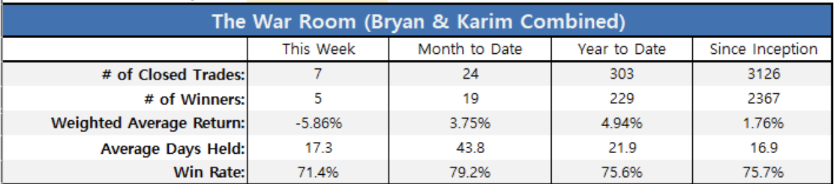
Of just my trades…
83% have been winners. 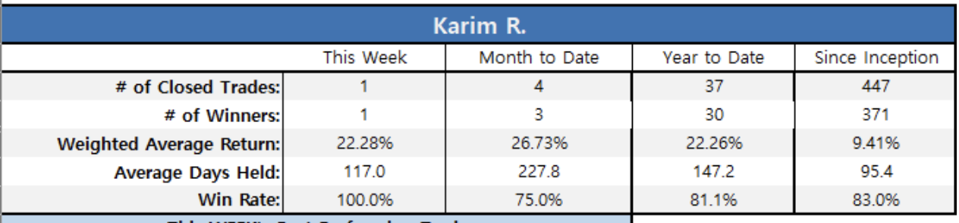
But as impressive as that may be…
So far this year, 30 of the 37 trades I’ve personally recommended to members have landed in the money.
- 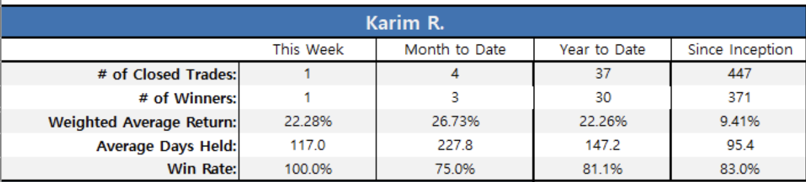
That’s an 81% win rate.
The average gain is 22.2%.
I've sat across the table from hedge fund managers at Bear Stearns, Goldman, and JPMorgan. Not a single one of them would put their win rate on paper and show it to you. I just did because when you win on more than 9 out of 10 trades, you don't hide the scoreboard — you put floodlights on it.
And that’s just the put trades…
My track record on gold goes back even further.
"In July 1996 I wrote about Ashanti Goldfields (ASL) at $17 — before it became one of the world's largest gold miners through its merger with AngloGold.

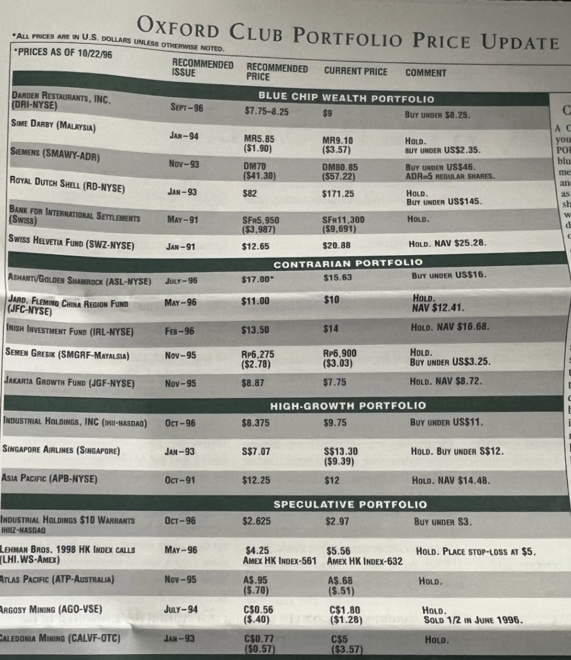

- As an aside I also recommended Darden at $9 a share around that same time. The stock is now $206 – up 2,188%.
- 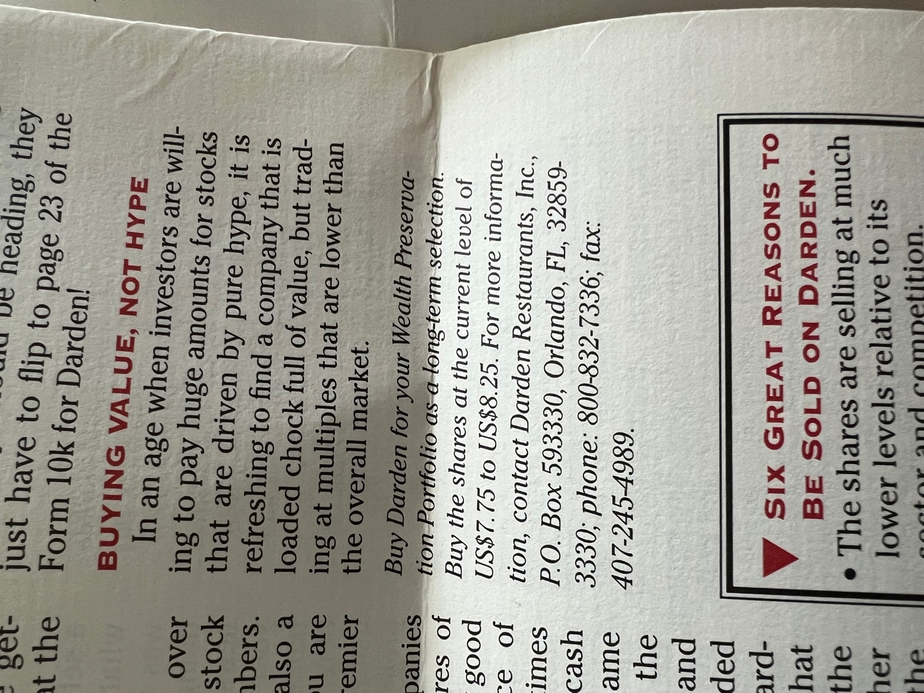
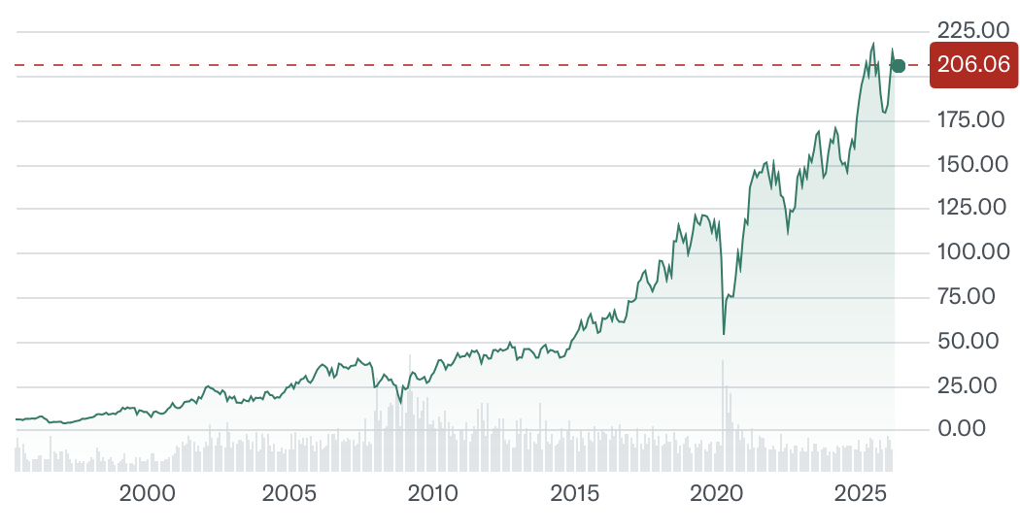
- In 2016, I banged the drum on Royal Gold at $50. It’s now up 561%.
- 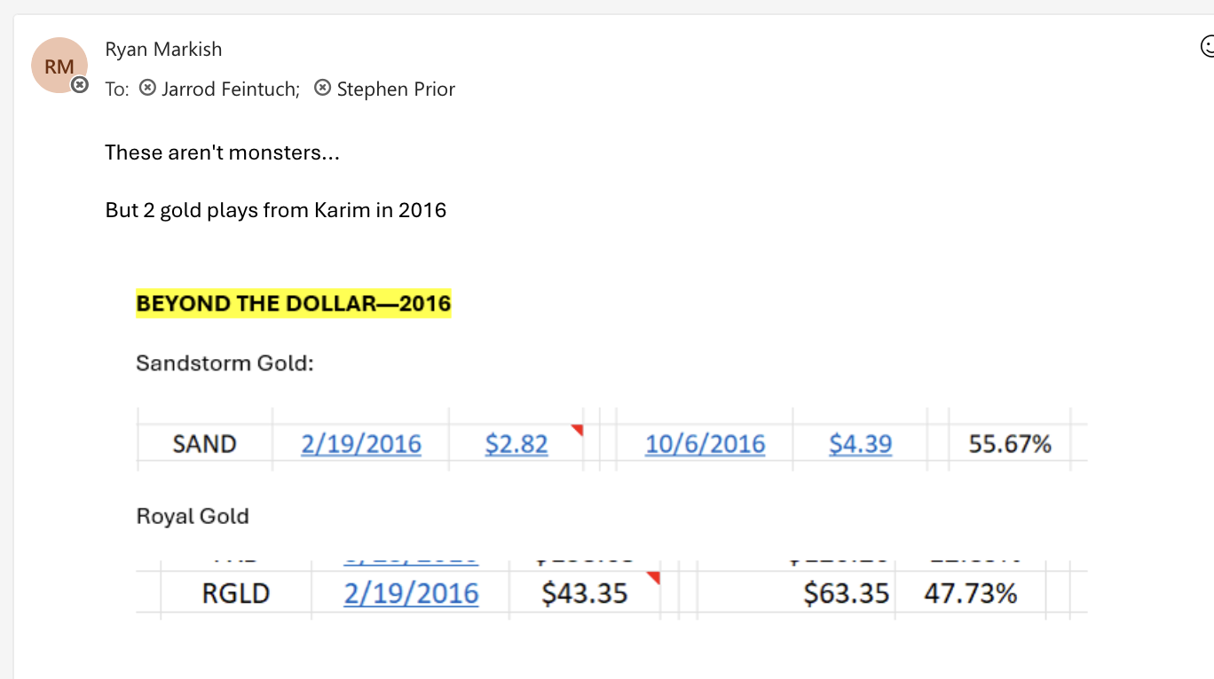
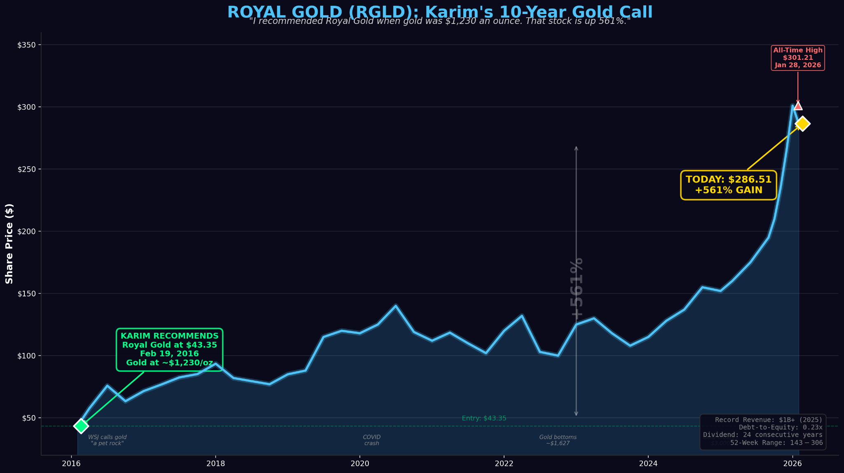
- I pushed conference attendees to buy Glencore at $2. It's now up 585%.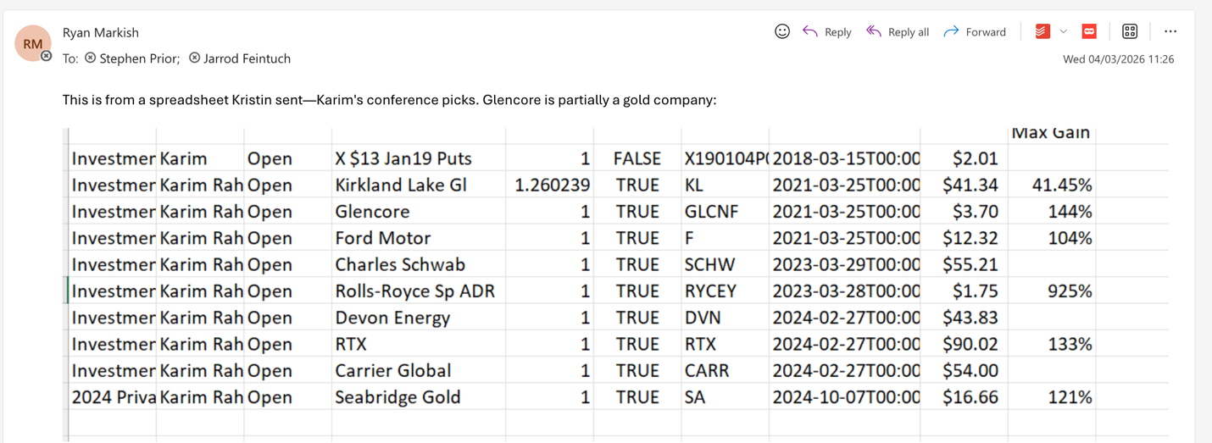
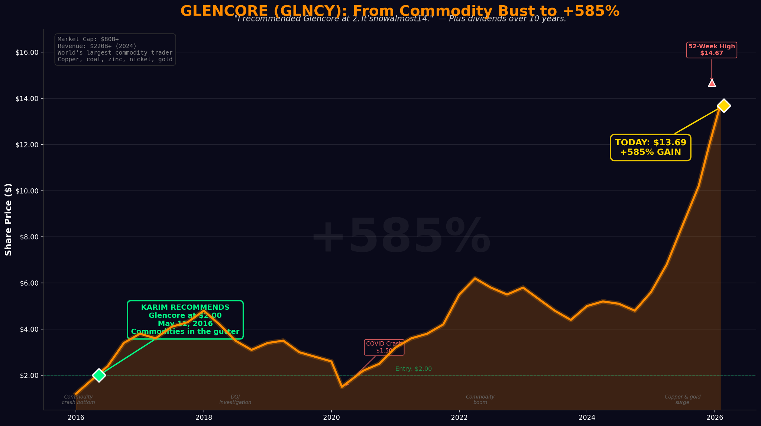
- . ￼
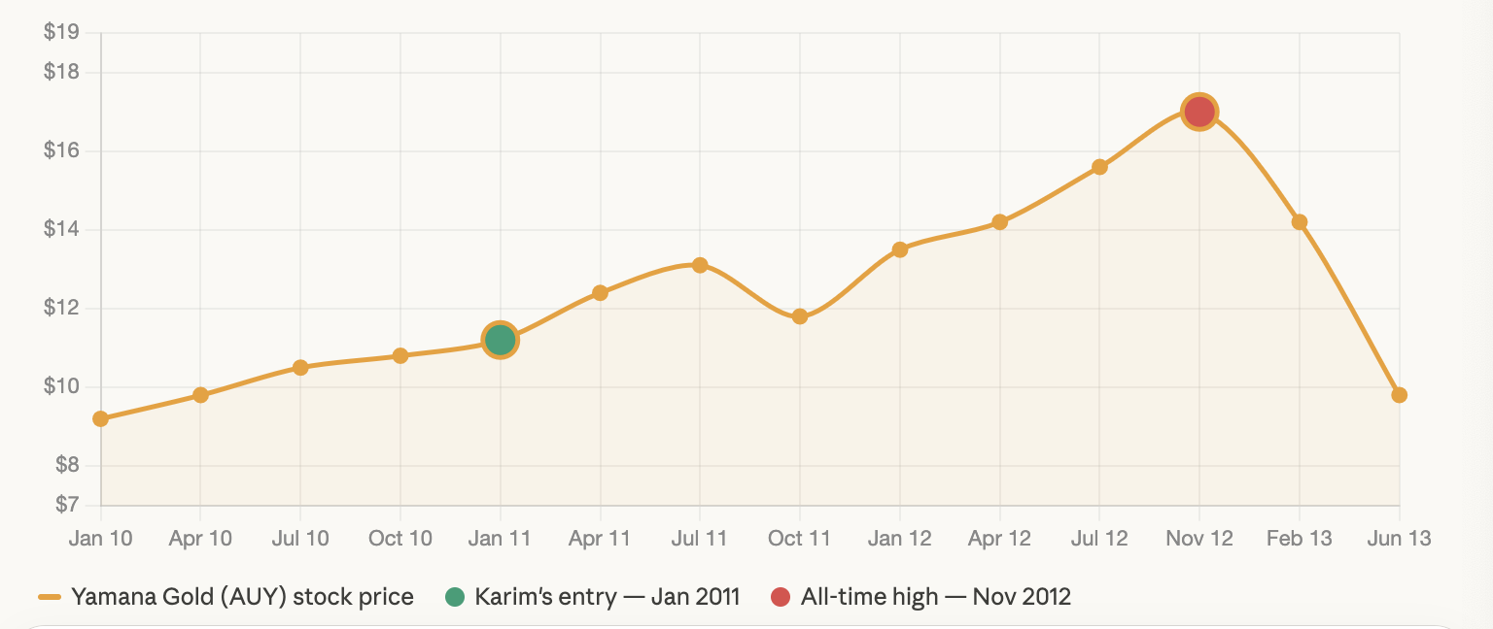
- Last September I put followers into Seabridge Gold using a trade that has returned 361%.
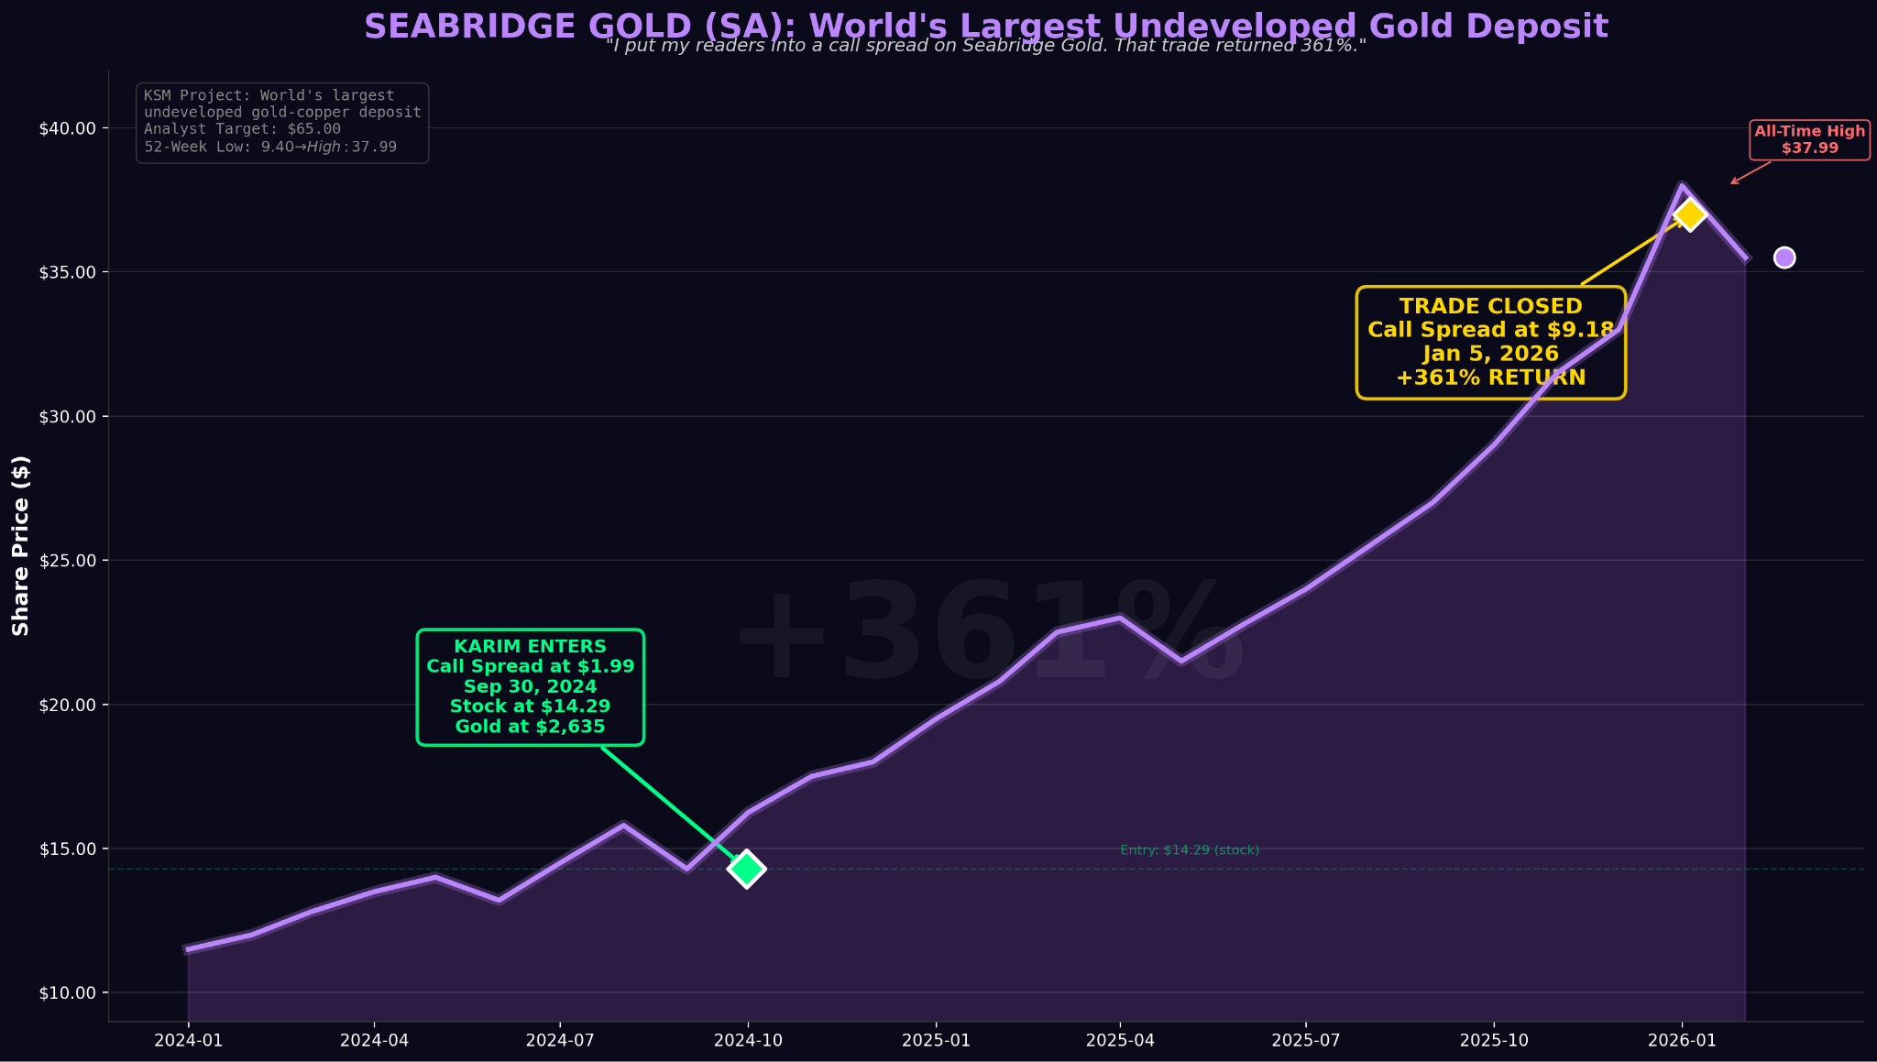
This is what 40 years of pattern recognition looks like.
I don't predict the future. I just price the present better than almost anyone – because I’ve seen this movie before.

Now let me take you inside so you can see what the War Room looks like.
[do not read this subhead]
Inside the War Room
With 8,000 active members…
The War Room is arguably the most active trading room in America.
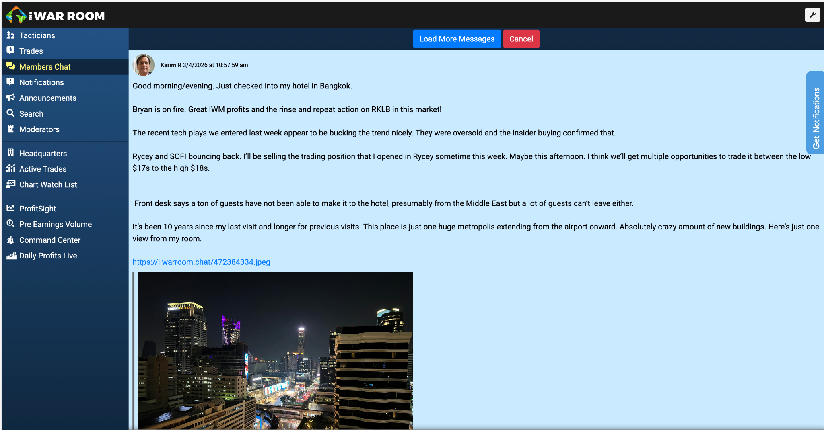
Some are former hedge fund traders. Some are retired schoolteachers. Some are complete beginners who sold their first put last Tuesday and are already asking me when the next one drops.
- Like this member who sold two puts in January. One on Wheaton Precious Metals Corp and the other on iShares Silver Trust. In a few weeks he closed out both positions for a 100% and 370% return.
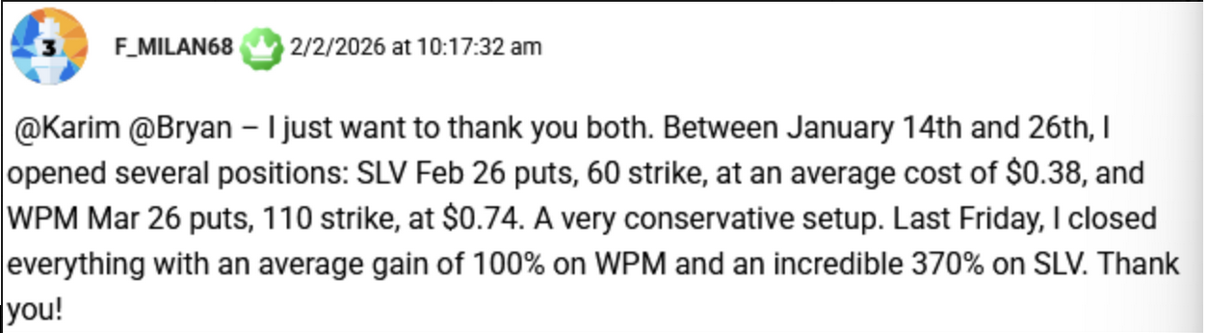
When I see a setup that I can’t resist…
I type it up and post it inside the War Room.
For me, the setup is everything. And over 40 years of trading I've distilled what a perfect setup looks like into three things — which Bryan and I call the W.A.R. system:
W — Winning Fundamentals. The company has to be genuinely great. Record revenues. Strong margins. A balance sheet that can take a punch. If the business isn't built to last, I won't touch it.
A — Accelerated Technicals. The chart has to confirm what the fundamentals are telling me. Price momentum, volume, options flow — everything needs to be pointing in the same direction.
R — Recent or Upcoming Catalyst. There has to be a reason for the move to happen now. An earnings report. A government contract. A geopolitical event. Something that creates urgency in the market.
When all three conditions align — that's when I pull the trigger.
If I don't see all three, I won't post a trade. Instead, I'll tell you exactly what needs to change before I do.
That discipline — that refusal to trade unless W, A, and R are all in place — is why I have an 81% win rate so far this year.
Every trade I make goes through that same filter. Which means by the time you get the trade, the work is already done.
And just so you know…
If you don’t want to login to a live trading room every day, you don’t have to.
Every trade that we issue inside the War Room is delivered to your inbox.
Here’s a trade I just recommended on March 9, 2026.
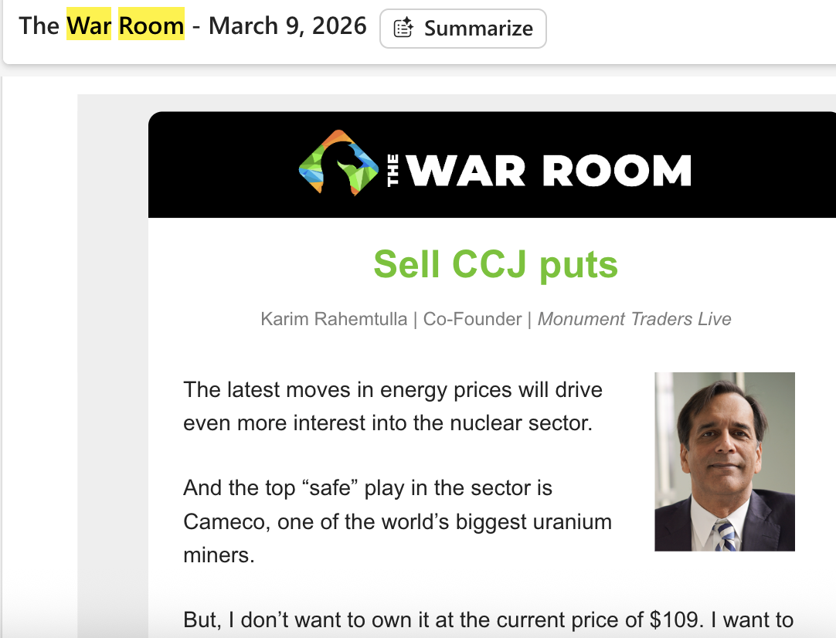
It includes all the necessary information you need to take decisive action.
The War Room, however, is where you learn to think like a trader – not just follow one.
Some of our most active members came in knowing nothing about options. But because of what they learned inside the War Room…
They've become better traders than I ever imagined:
- David started with $20,000. Within a year, his account hit $185,000. He told us he was making more from his War Room trades than from his day job.
- Mohammed put in $25,000. Four months later, he reached $200k in profit.
- George — and this one still blows my mind — started with $150,000 and ended the month at $877,000.
We even polled our members and 50% of the ones who responded said that they were millionaires.
Seeing these transformations — from novices to independent traders — is what I'm most proud of.
Because once you learn how to do this, nobody can take it away from you. Not a market crash. Not a recession. Not a change in administration. You'll have a strategy that works in bull markets, bear markets, and everything in between.
And you'll have learned it in a room full of people who are rooting for you.
There is no better time to be in the War Room than during an actual war.
And right now, in the midst of a war…
And every precious metal from gold and silver to palladium and uranium is going vertical, the deals are stacking up faster than I can trade them…
I’ve already sold three puts on stocks like the iShares Ethereum Trust, Freeport-McMoRan and MP Materials. 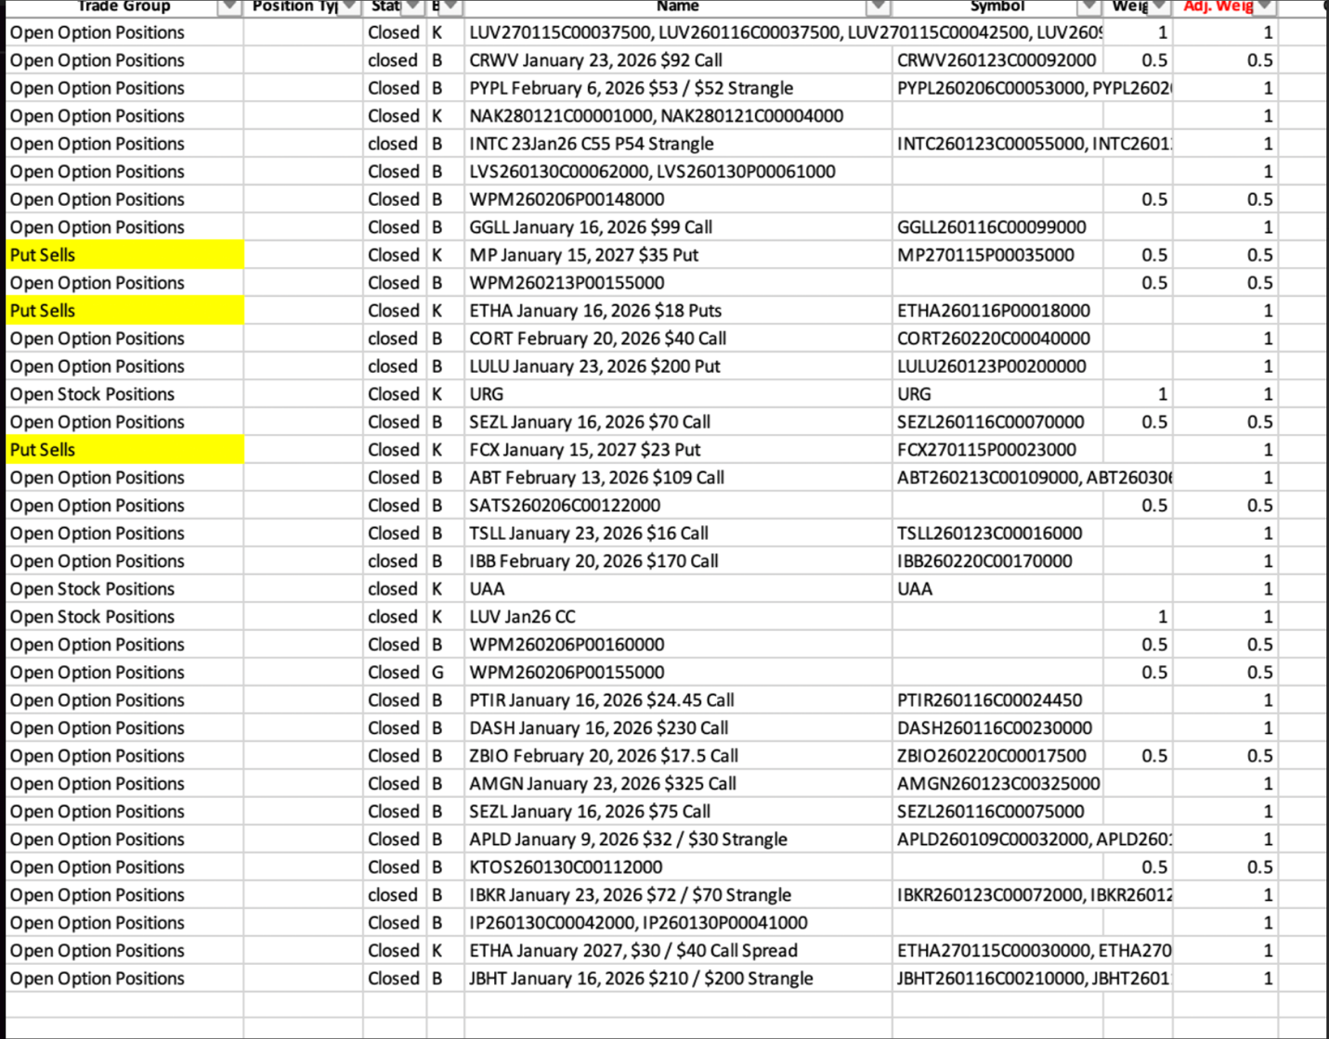
All three were winners.
And look how well some of our members have done with these trades…
Mac R. says selling puts is his favorite thing to do in the War Room. He’s made gains ranging from 22% to 278% over the last five years.
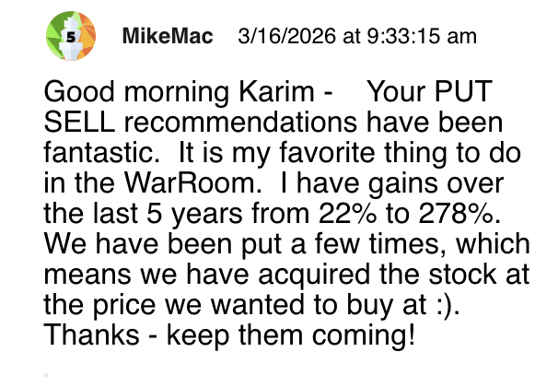
JP loves the winning percentage…
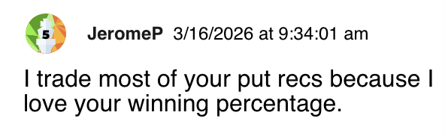
Hank sells puts on a weekly basis for weekly income and loves the strategy.
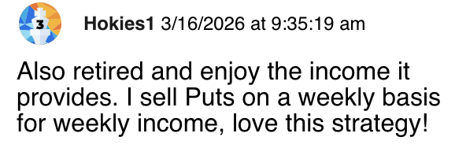
In today's presentation I gave you six different companies that are in the sweet spot for put selling. If you want, you can go ahead and trade these stocks on your own. Each one is sitting in the crosshairs of everything Iran has set in motion.
But of course, it won’t end there…
Over the next several months Bryan and I plan on recommending multiple put trades on multiple companies, both within and outside the precious metals market…
As I said before, the two of us have put together a list of 30 companies that have become prime candidates for selling puts…
***[options exist but open interest may not be there]
***[stocks with liquid options]
PFE - current levels under $25
DVN - $32 or less
NVDA - $90 or less
AMZN $130 or less
META - $500 or less
CARR - $60 or less
INTC - $18 or less
CLF - Current levels around $8 or lower
RTX - $95 or less
BA - $150 or less
CROX - $80 or less
MMM - $110 or less
WFC-Z - $19 or less
JPM-K - $19 or less
BAC-O - $18.50 or less
PGX - $10 or less
AAPL - $180 or less
OXY - $45 or less
XBI - $75 or less
DKNG - $25 or less
BTG -$2.55 or less
FLR - $37 or less
SCHW - $54 or less
BAC - $33 or less
WFC- $53 or less
JPM - $180 or less
RYCEY - $8 or less
VZ - $37 or less
GOLD - $17 or less
NEM - $38 or less
GNRC - $105 or less
ET - $11 or less
RXRX - current levels under $5 (speculative)
ABSI - $2 or less (speculative)
UPS $95 or less
AKAM $75 or less
XBI $75 or less
DOW - current levels under $28
APA - under $17.50
C- under $60
These are companies that you can offer to buy at a significant discount to their current ticker prices and receive cash premiums for making those offers -- premiums that, in the current environment, are running above their historical norms.

NVIDIA is the most important company in the AI revolution. The Pentagon has been scrambling to secure their chips for AI-enabled weapons systems, and the Iran war has accelerated that demand.
Today the stock is trading for around $180 a share. The average analyst on Wall Street says it's worth $263.
- HSBC Global put it even higher at $310.
- Evercore ISI says $352.
- Tigress Financial says $360, literally double the current price.
But you can offer to buy NVIDIA for $130 which is 27% less than what everyone else is paying — and collect a premium just for making that offer.
Sound familiar?
HEADS: NVIDIA keeps climbing on AI demand. You pocket the premium.
TAILS: The stock craters to $130 – you get to own the most important semiconductor company on earth at half price.
Every fund manager on Wall Street would beg for that entry.
Another stock on this list is Boeing…
Boeing builds the fighter jets, the missiles, and the surveillance systems being used in Iran right now. The stock is $210.
- Goldman Sachs says it's worth $280.
- Jefferies says $295.
- Robert W Baird & Company says $300.
The Pentagon just handed Boeing a $166 million contract.
But you can offer to buy Boeing at $150 — 32% below today's price — and get paid cash for making that offer.
HEADS: Boeing rides the biggest surge in defense spending since 9/11. You keep the premium.
TAILS: Boeing sinks and you get to own one of only two companies on earth that builds commercial aircraft — at a price it hasn't seen in over a year.
When you become a member of the War Room, you will have immediate access to this list of “Wartime Targets.”
- That’s 30 stocks that you can either acquire for a price that is far lower than what other investors are paying…
- Or collect a premium from, just for putting in your bid.
In this climate, where volatility is high, fear is higher and uncertainty is even higher…

Elevated volatility has pushed option premiums to levels rarely seen outside of major market crises. The gap between current prices and our target bid prices is wider than it's been historically — which, in my experience, is when this strategy has performed at its best.
And my 95% win rate on put-sells — the one built over 169 consecutive trades — is about to be tested against the best conditions of my career.
I don't say that lightly.
I've been at this for a very long time.
But I have never had this much wind at my back.
And I likely never will again…
[do not read this subhead]
1979 – Back with a Vengeance
So how much does it cost to get in?
Our publisher originally wanted to sell access to the War Room for $7,500 a year…
I didn’t argue…
When you consider the fact that what you’re paying for is a highly immersive trading room that sees more action than an aircraft carrier in the Strait of Hormuz.
I think $7,500 is more than reasonable.
But here's the thing. I didn't build The War Room for hedge fund managers. I built it for people who have been told their whole lives that markets are "too complicated" or that options are "too risky" — and are ready to find out that's not true.
So I pushed back on the $7,500 price.
And today, through this invitation only, you can join The War Room for just $1,997.
That's 67% off the published rate. A full year of access. Every trade. Every alert. Every training video. Every morning with Bryan and me. The full Wartime Targets list — all 30 companies. And the community that comes with it.
$1,997 for a service that averages more than one winning trade per day.
Let me put that in perspective.
If you sold just one put per month using the strategy I've shown you today — at the average premium levels we're seeing right now — you could potentially recoup the entire cost of your membership on your very first trade.
Tony did that…
He made a 94.5% profit in two years from my trade on EMX royalty.
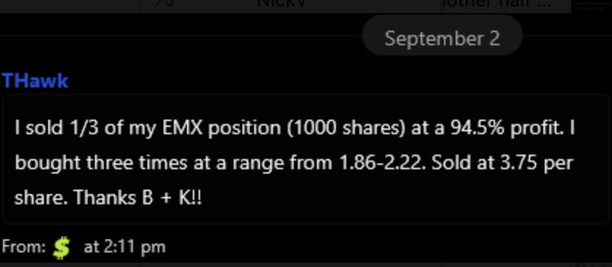
So did Jodie…
She made 105% in three months from my trade on IONQ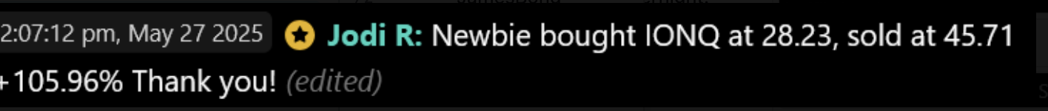
￼
JT as well. He made $5,845 in a week by selling puts on Chewy Inc, which he paid around $430 for…
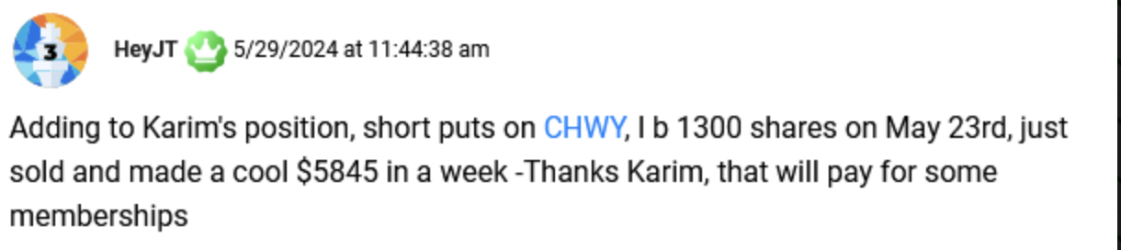
And these were on trades made before the war.
- Before the OVX hit 108.
- Before gold shattered $5,000 an ounce.
- Before premiums went up 3X.
This image tells you everything you need to know about why I'm going to war inside The War Room for the next several months.
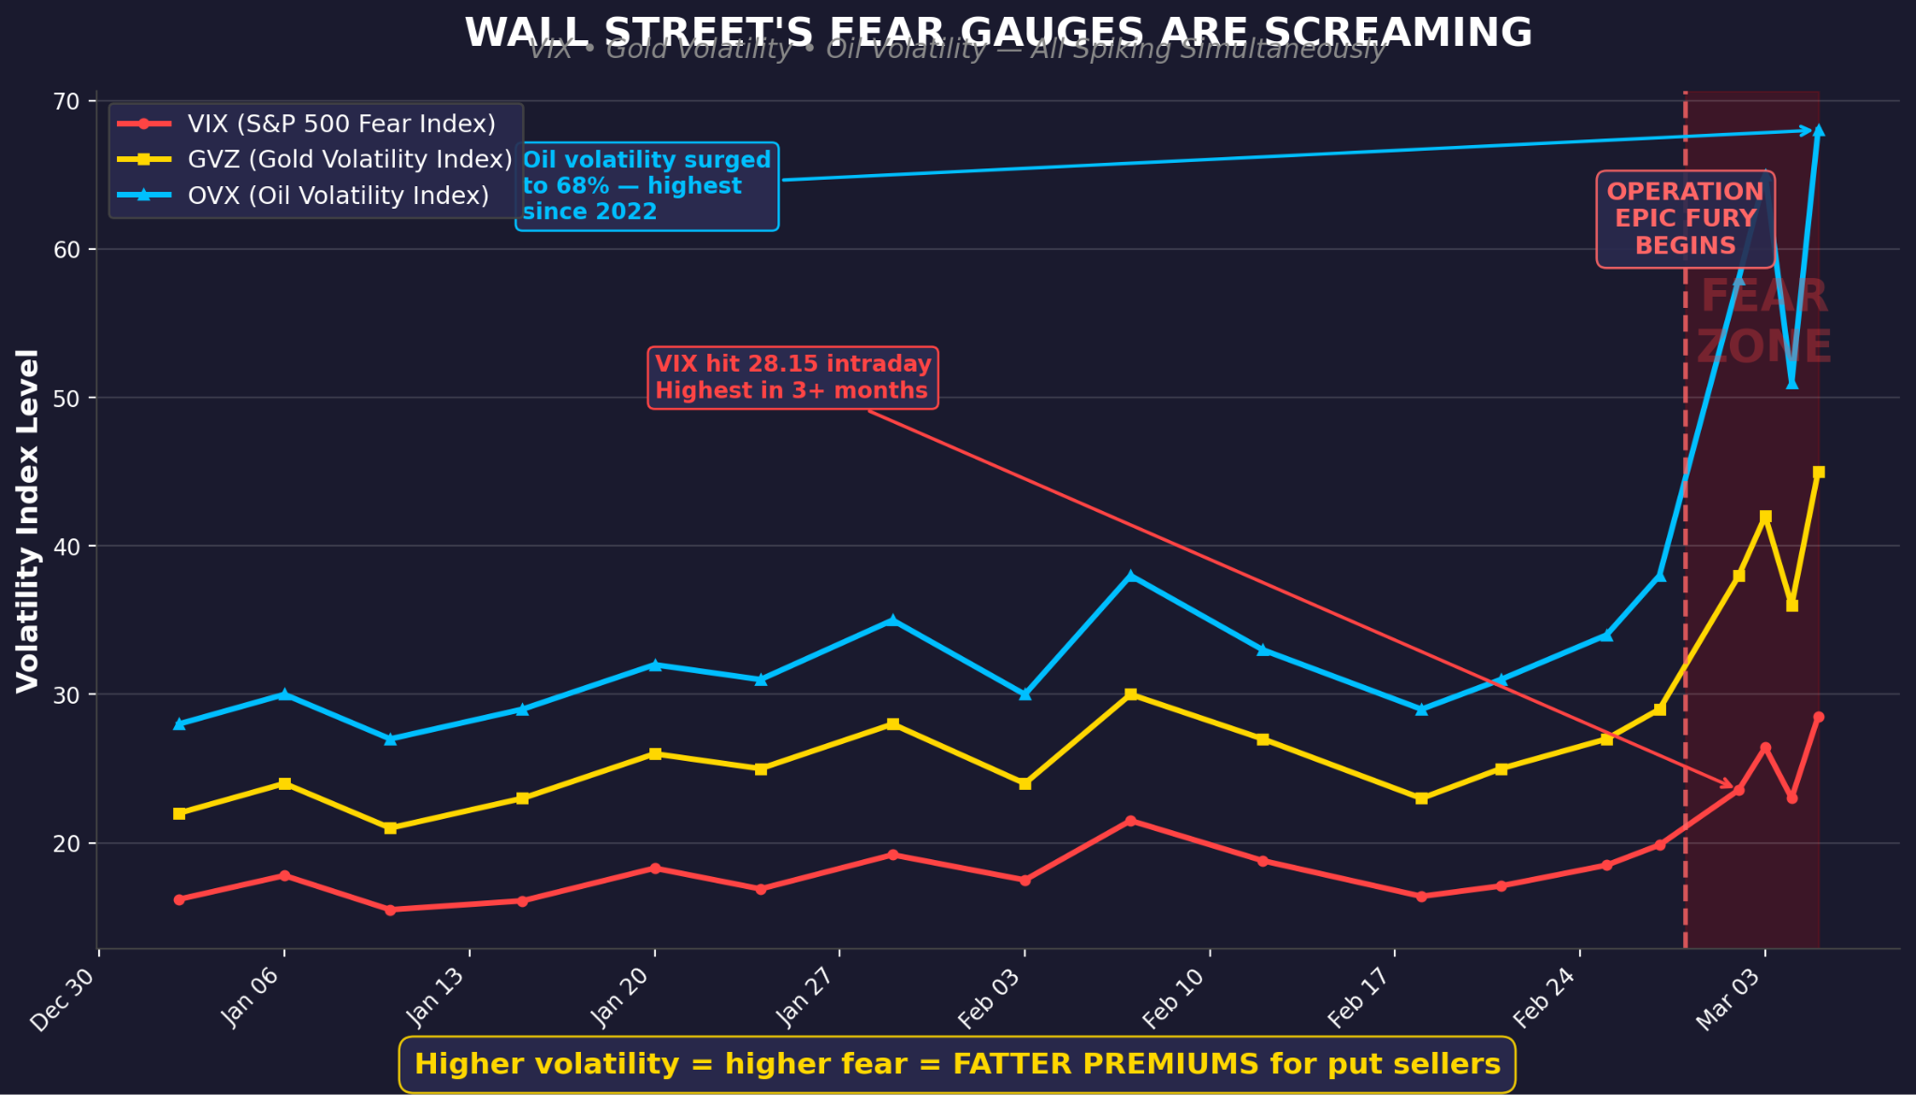
The War Room was built for moments like these…

Every fear gauge on Wall Street – the VIX, GVZ and OVX – has fractured previous records.
Gold. Oil. Stocks. They're all screaming at the same time. That's never happened before — and it's the reason the premiums I'm collecting right now are the largest of my career.
When you click the button below and join The War Room, here is a quick recap of everything that’s waiting for you:
The War Room
You get access to the most active trading room in America. 8,000 members. 2,384 winners. Over one win per trading day for six straight years.
At the core of every trade is independent research. Before Karim or Bryan ever posts a trade, they've analyzed the company's fundamentals, reviewed the options chain, assessed the technical setup, and identified the specific catalyst driving the opportunity. All of this information is yours so you can make the most educated decisions for your own portfolio.
The War Room Alerts
You will get up to three new trade ideas every day the market is open. Some of these trades are put sells. Some are call spreads. Some are stock plays.
Every trade will be delivered to your inbox and phone.
The Wartime Targets List
You’ll get the complete list of 30 companies that are sitting in the sweet spot for selling puts right now.
The Name Your Own Price Masterclass
A complete video training library that takes you from "What is a put?" to advanced strategies like rolling, position sizing, and managing assignments.
Live Chatroom
You get access to our live chatroom — which is buzzing from before the bell to well after the close.
The War Room Battle Log
You’ll get a war chest of every trade we've ever made. Study them, see the reasoning behind each one, and learn from six years of trades.
Active Trade List
You’ll get our active trades list — a live, updated portfolio showing every open position with the ticker, entry date, strike, and current status.
The War Room Command Center
And you get our concierge team. Real people, not AI bots.
If you have any questions about the service – our team is available 9am to 5pm EST, Monday through Friday. They can be reached at 1-888-215-5311.
The moment you walk in the door, you'll have access to everything I’ve told you about — the Wartime Targets list, the full trade archive, every training video, every open position. This information has taken Bryan and me six years and over 3,000 trades to build.
It’ll be yours instantaneously.
And even though we’re give you access to everything on day one...
You’re not obligated to stay if you don’t want to.
The Easiest Bet I’ve Ever Made
In your first 90 days, if you don't see an average of at least one winning trade per day per our track record — every day the markets are open — I'll give you your money back minus a 10% processing fee. And I'll add another full year of The War Room to your account, on the house.
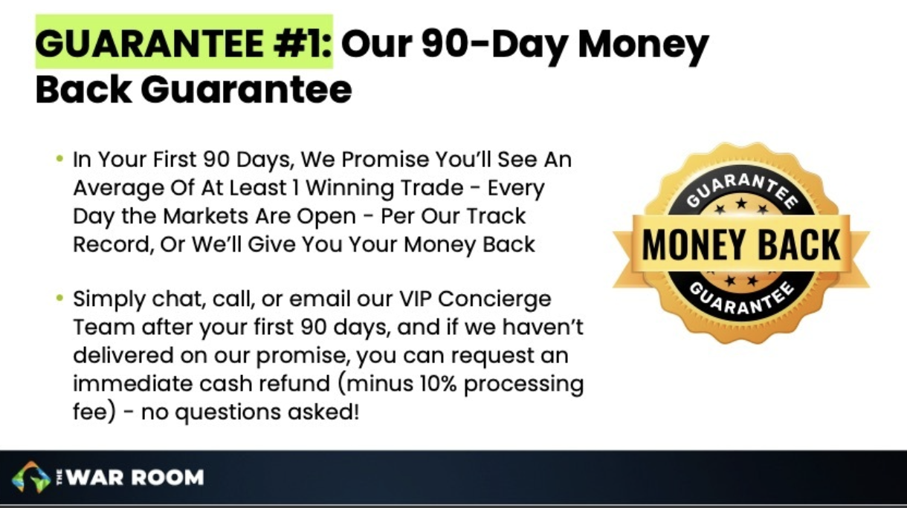
That's the guarantee. Now let me tell you why I'm not losing any sleep over it.
Regarding my put trades… I’m 161 for 169. I’ve already closed 5 winners this year. And the premiums right now are some of the biggest I’ve seen. The guarantee isn't a safety net — it's a formality.
But if I don't deliver — you have my word and my wallet on the line.
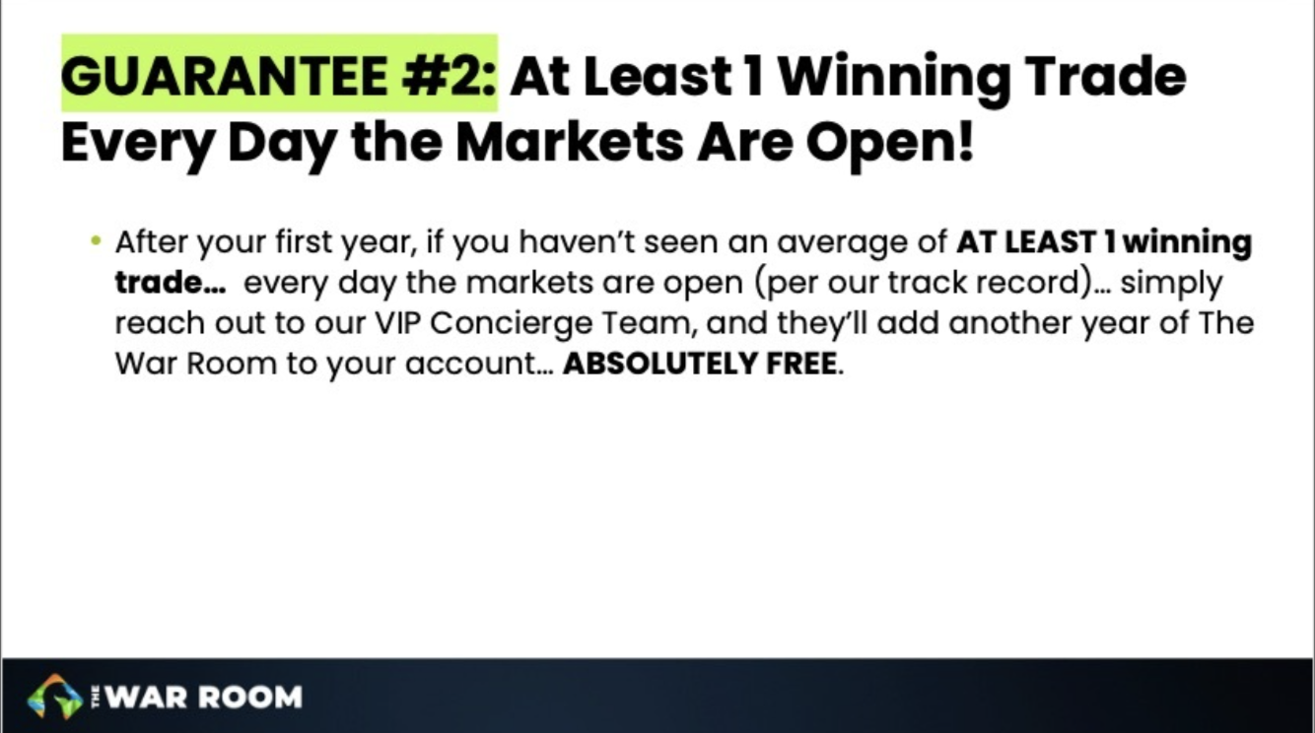
The conditions I've described to you today — the ones that make this the single best put-selling environment of my career…
They aren't going away anytime soon.
The War Room used to be a metaphor. Today it’s a mission statement.
For some members, it’s a way out of the slow lane and the catalyst that allows them to sleep well at night while everyone else tosses and turns.
The question is whether you want to be in the same room with us.
I hope you do. So I’ll make this super easy.
You can join now by clicking the button below…
[BUTTON: Join The War Room Today]
Or call our team at 1-888-215-5311.
They’re available Monday through Friday, 9am to 5pm Eastern.
I know what I'm about to say might make some people uncomfortable. But I have to say it:
War Powers the War Room
Given America's military superiority throughout the world...
We know that Iran has a 0% chance of winning any kind of war with us.
No matter how many times they break a ceasefire, attack one of our bases or start a new skirmish
But right now, the market doesn't see it that way. Right now, the market is pricing in worst-case scenarios that aren't going to happen. It's pricing in $200 oil. It's pricing in a global energy collapse. It's pricing in chaos that has a shelf life.
And every dollar of that fear is enlarging the premiums investors can collect on these trades.
This is the contradiction I've been exploiting my entire career — the gap between what people feel and what's actually true.
And right now, that gap is the widest I've ever seen.
Once this gap closes, these premiums will shrink.
But until they do, you could start stacking wins on put trades while the rest of the world is glued to their smartphones.
Most people won't recognize this moment for what it is. You just did.
In 1979 I watched this moment pass me by. I won't let that happen again. And neither should you.
Click below and let's make up for lost time.
I'll see you inside.
Karim Rahemtulla Co-Founder, The War Room
P.S. Remember — I've identified 30 companies that are prime put-selling targets right now. The Wartime Targets list is only available to War Room members. As premiums shift, some of these opportunities will disappear. The sooner you're inside, the sooner you can start collecting. [Click here to join now.]
P.P.S. My put-selling record stands at 161 wins out of 169 trades — a 95.27% win rate. The premiums are larger than normal. Don't watch from the sidelines.

Alt Headlines:
HL 1:
The Near-Impossible Setup I’ve Waited 46 Years For:
The 1979 Trade I Never Got to Make
In 1979, gold ran 272% in a year. The miners ran further.
I was 17 years old and broke. I'm not either of those things anymore.

HL 2:

The Near-Impossible Setup I’ve Waited 46 Years For:
Gold’s 1979 Signal
Nobody is prepared for what’s coming….
The last time this signal fired, a $10,000 stake in gold stocks turned into $272,000 in 12 months. This time, I've found a way to collect cash whether gold goes up, down, or sideways.

HL 3:

The Near-Impossible Setup I’ve Waited 46 Years For:
Iran’s War;
Your Opportunity
Nobody is prepared for what’s coming….
The last time Iran threw the world into chaos, gold ran 272%. This time, I've found a way to collect cash whether it runs or not.

HL 4:

The Near-Impossible Setup I’ve Waited 40 Years For:
60-Day Gold Heist
I’ve Won 161 of my last 169 trades
But my 95%-win rate is about to get even better:

The Near-Impossible Setup I’ve Waited 40 Years For:
$50 Gold?!
I’ve Won 161 of my last 169 trades
But my 95%-win rate is about to get even better:

The Near-Impossible Setup I’ve Waited 40 Years For:
Name Your Own Price For Gold?
Buy the world's best gold assets at half off

The Near-Impossible Setup I’ve Waited 40 Years For:
Access Gold: 50% Off
My 95%-win rate is about to get even better:

The Near-Impossible Setup I’ve Waited 40 Years For:
Half-Price Gold Access
I've won 161 of my last 169 trades.
The next 6 months could be my best streak ever.

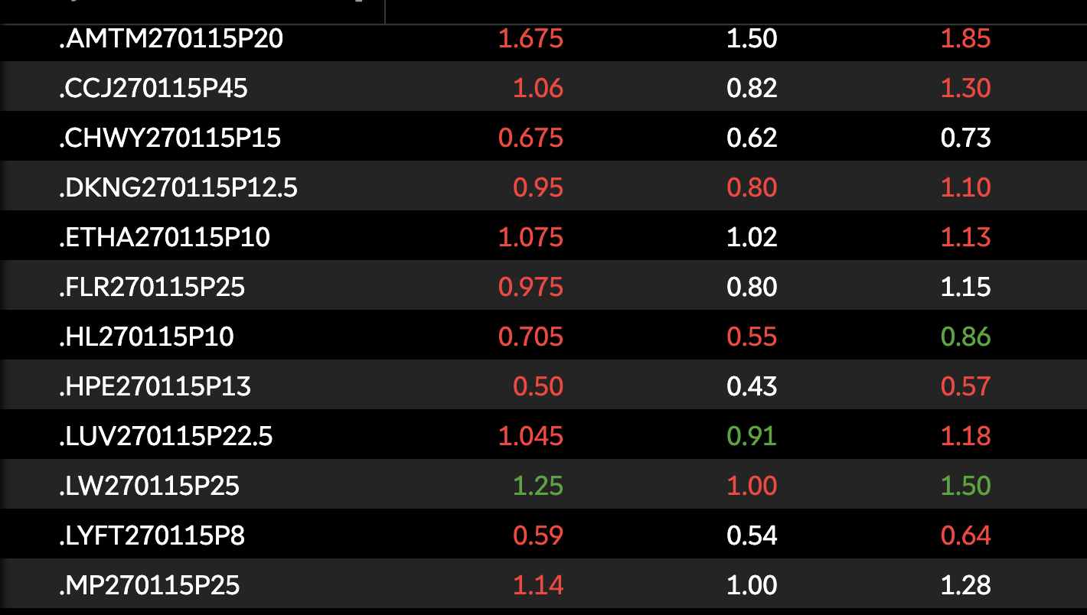

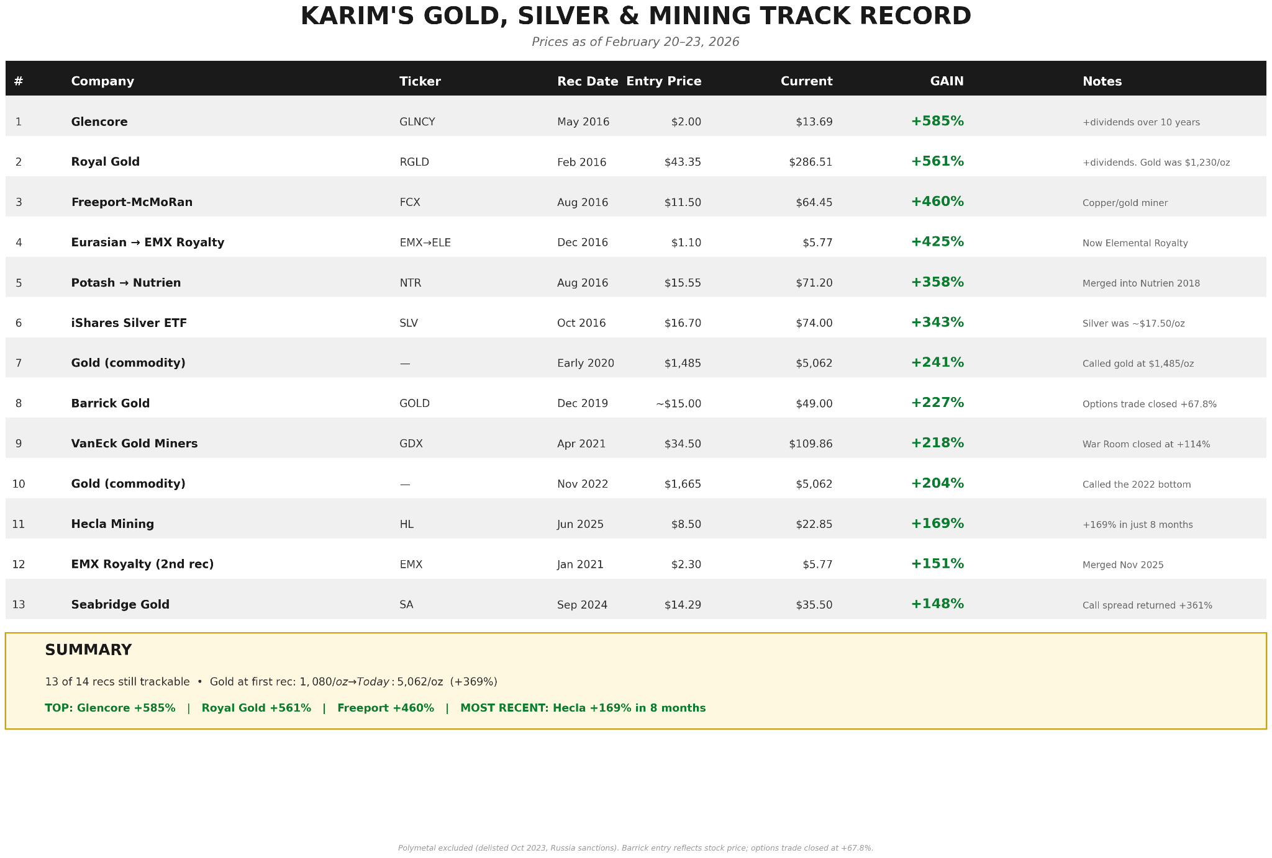

https://www.tradingview.com/chart/XAUUSD/CtTKzTRo-Gold-1979-vs-2025-When-History-Whispers-and-Markets-Listen/
https://www.miningvisuals.com/post/silver-price-history-100-years-of-ups-downs
https://felixprehn.substack.com/p/golds-1979-signal-oil-shocks-and
https://www.xe.com/currencycharts/?from=USD&to=IRR
https://newlinesmag.com/reportage/why-iran-is-witnessing-a-gold-rush/
https://iranwire.com/en/features/149636-highest-inflation-rate-recorded-in-iran-since-world-war-ii/#:~:text=Inflation%20Rate%20for%20February%202026&text=The%20Statistical%20Center%20of%20Iran%20said%20the%20overall%20point%2Dto,for%20the%20same%20food%20basket.
https://www.aljazeera.com/news/2025/3/13/iran-bets-big-on-gold-as-it-weathers-trump-turmoil
https://finance.yahoo.com/news/veteran-analyst-drops-surprising-gold-164700949.html
https://www.reuters.com/world/africa/jp-morgan-sees-gold-6300-an-ounce-by-year-end-robust-centralbank-investor-demand-2026-02-02/
https://www.reuters.com/business/finance/goldman-sachs-raises-2026-end-gold-price-forecast-5400oz-2026-01-22/
https://www.linkedin.com/posts/charles-henry-monchau-cfa-cmt-caia-4003096_china-centralbanks-gold-activity-7371898006255734784-Y7Fr/ https://www.jpost.com/business-and-innovation/precious-metals/article-844688
https://finance.yahoo.com/news/peter-schiff-predicts-gold-could-091300686.html
Every GVZ level shown — pre-war ~15, late 2025 ~20, war begins ~28, today ~33, Feb surge ~41, Jan 29 peak 46 — comes directly from the CBOE via the Federal Reserve's FRED database, which publishes daily GVZ closing values going back to 2008. Source: https://fred.stlouisfed.org/data/GVZCLS Specific confirmed data points from that series: - Jan 29, 2026: 46.02 (the exact peak) - Feb 3, 2026: 41.04 (the Feb surge level) - Pre-war baseline Dec 2025: 19-20 range - Current March 2026: 31-33 range
https://phemex.com/news/article/morgan-stanley-predicts-fed-rate-cuts-in-june-and-september-despite-market-skepticism-66867
https://www.classic.com/m/porsche/356/356-c/year-1965/
https://www.treasury.id/en/gold-becomes-the-worlds-number-1-most-sought-after-asset
https://finance.yahoo.com/news/b2gold-btg-achieves-record-3-111900095.html
https://finance.yahoo.com/news/mixed-analyst-calls-keep-b2gold-104832460.html
https://stockstotrade.com/news/b2gold-corp-canada-btg-news-2026_01_28/
https://en.macromicro.me/charts/21527/gvz
https://www.aljazeera.com/economy/2026/3/16/oil-prices-keep-rising-as-trump-seeks-coalition-to-reopen-strait-of-hormuz
https://fred.stlouisfed.org/data/GVZCLS GVZ ran at ~19-20 pre-war and spiked to 46.02 on January 29, 2026, a 2.3x increase in implied volatility. Since option premiums scale proportionally with implied volatility, a 2.3x increase in GVZ translates directly to roughly 2x-2.3x larger premiums on the same strike and expiration. The 3X claim is supportable for the January 29 peak specifically. At today's GVZ of ~35 versus a pre-war baseline of ~19-20, the current multiplier is closer to 1.75X so I’m going to rephrase these mentions in the promo accordingly
https://fred.stlouisfed.org/data/GVZCLS https://finance.yahoo.com/quote/%5EGVZ/history/ https://www.investing.com/indices/cboe-gold-volatitity
https://www.macrotrends.net/stocks/charts/B/barrick-mining/revenue https://www.barrick.com/English/news/news-details/2026/q4-2025-results/default.aspx
https://www.barrick.com/English/news/news-details/2026/q4-2025-results/default.aspx#:~:text=During%20Q4%202025%2C%20the%20Company%20repurchased%20$500,buybacks%20totaling%20$1.5%20billion%2C%20representing%20about%203.0%25
https://www.morningstar.com/news/dow-jones/202602056918/barrick-boosts-dividend-by-40-after-metals-prices-lift-4q-earnings
https://finance.yahoo.com/news/barrick-minings-cash-engine-drive-121800104.html
https://www.theglobeandmail.com/investing/markets/stocks/B/pressreleases/34860610/barricks-fourmile-project-a-century-defining-gold-discovery/ https://seekingalpha.com/article/4860767-fourmile-discovery-is-a-one-in-a-lifetime-opportunity-for-barrick-mining
https://www.investing.com/news/analyst-ratings/jpmorgan-initiates-barrick-mining-stock-with-overweight-rating-68-target-93CH-4472018#:~:text=JPMorgan%20initiates%20Barrick%20Mining%20stock%20with%20Overweight,target%20*%20GC.%20*%20HG.%20*%20B.
https://finance.yahoo.com/news/cibc-raises-barrick-mining-b-153627010.html
https://www.marketbeat.com/instant-alerts/canaccord-genuity-group-has-lowered-expectations-for-barrick-mining-nyseb-stock-price-2026-02-18/
https://seekingalpha.com/article/4821422-why-agnico-eagle-is-the-benchmark-for-senior-gold-miners
https://www.macrotrends.net/stocks/charts/AEM/agnico-eagle-mines/revenue
https://stockinvest.us/earnings-report/AEM.TO
https://www.morningstar.com/news/pr-newswire/20260212to86174/agnico-eagle-reports-fourth-quarter-and-full-year-2025-results-record-quarterly-and-annual-free-cash-flow-2025-production-guidance-achieved-total-2025-shareholder-returns-of-14-billion-dividend-increased-by-125-updated-three-year-guidance
https://www.agnicoeagle.com/English/news-and-media/news-releases/news-details/2025/AGNICO-EAGLE-REPORTS-SECOND-QUARTER-2025-RESULTS---RECORD-FREE-CASH-FLOW-WITH-ANOTHER-QUARTER-OF-STRONG-PRODUCTION-AND-COST-PERFORMANCE-BALANCE-SHEET-FURTHER-STRENGTHENED-BY-TRANSITION-TO-NET-CASH-POSITION-AND-LONG-TERM-DEBT-REPAYMENT/default.aspx
https://fred.stlouisfed.org/data/GVZCLS
https://seekingalpha.com/article/4856854-silver-and-gold-get-used-to-and-exploit-elevated-volatility
https://www.gold.org/goldhub/research/central-bank-gold-reserves-survey-2025
https://www.nasdaq.com/articles/gold-soaring-how-use-options-maximize-gains
vaneck.com/us/en/insights/blogs/gold-investing/ima-casanova-gold-bull-market-endures-early-2026-volatility/
https://www.investing.com/analysis/how-to-pick-the-right-gold-etf-in-2025-200668873
https://www.fxstreet.com/analysis/silver-demand-expected-to-outstrip-supply-202603091937
https://www.miningweekly.com/article/silver-surges-as-supply-deficits-industrial-demand-drive-prices-higher-peel-hunt-2026-01-20
https://silverpundit.com/when-will-the-silver-deficit-deplete-above-ground-stocks/
https://moneymetalsexchange.medium.com/silver-now-ranks-as-the-second-most-valuable-asset-in-the-world-cbbb3422074c
https://docs.google.com/document/d/1JexOXUMQo8FlzKbjG8S7zxA2EwBQZDfL_fPLG-GMs7g/edit?tab=t.0
https://www.cryptopolitan.com/david-bateman-1-billion-in-physical-silver/
https://goldbroker.com/news/silver-perfectly-organized-short-squeeze-3640
https://mineralprices.com/russia-reportedly-plans-to-add-silver-to-state-fund-reserves/
https://www.zerohedge.com/news/2025-12-14/jpmorgans-monumental-shift-silver-short-massive-long-position-and-its-ripple
[TS1]https://shopglobalcoin.com/blogs/blog/the-u-s-mint-just-paused-silver-sales-the-latest-shock-in-a-mounting-silver-storm
https://finance.yahoo.com/news/us-just-added-silver-critical-133119111.html
https://www.hecla.com/operations/lucky-friday-idaho
https://www.hecla.com/company/about-us
https://www.investing.com/news/analyst-ratings/hecla-mining-stock-price-target-raised-to-28-from-16-at-bmo-capital-93CH-4466726
https://www.marketbeat.com/instant-alerts/cibc-issues-positive-forecast-for-hecla-mining-nysehl-stock-price-2026-01-28/
https://www.investing.com/news/analyst-ratings/hc-wainwright-raises-hecla-mining-stock-price-target-to-3650-on-strong-production-93CH-4469895Hec
https://finance.yahoo.com/news/hecla-mining-company-hl-achieves-074408958.html
https://www.investing.com/news/company-news/hecla-mining-q2-2025-slides-record-revenue-and-free-cash-flow-drive-deleveraging-93CH-4177802 https://finance.yahoo.com/quote/HL/key-statistics/
https://www.theglobeandmail.com/investing/markets/markets-news/Motley%20Fool/286883/here-s-why-shares-in-this-silver-miner-popped-higher-today/
https://www.diyinvestor.net/silver-hits-record-high-200-next/
https://finance.yahoo.com/news/heclas-libby-exploration-project-selected-203000323.html
https://airtable.com/appxO7QZIQ0CNfe6d/shrcqApOxXbmdu1GL/tblwt5mKUnYhWToGH/viwQZxjiTYbo8vu0p - RENUCHEK
https://airtable.com/appxO7QZIQ0CNfe6d/shrcqApOxXbmdu1GL/tblwt5mKUnYhWToGH/viwk0G7djZWrI85xq - greywolf
[TS1]Karim has this in his possession.
https://finance.yahoo.com/quote/%5EOVX/
Source: Horizon Investments / Advisor Perspectives, March 11, 2026 https://www.advisorperspectives.com/commentaries/2026/03/21/awakening-crude Also: ETF Trends, March 2026 https://www.etftrends.com/etf-strategist-content-hub-crude-awakening/ https://www.advisorperspectives.com/commentaries/2026/03/21/awakening-crude https://www.investing.com/indices/cboe-crude-oil-volatility
https://finance.yahoo.com/news/apas-stock-performance-compared-other-081224165.html
https://finance.yahoo.com/news/apa-apa-earnings-beat-cost-081248343.html#:~:text=In%20late%20February%202026%2C%20APA,to%20122%2C000%20barrels%20per%20day.
https://worldpopulationreview.com/country-rankings/oil-producing-countries
https://www.reuters.com/business/energy/apa-reports-fall-fourth-quarter-profit-2026-02-25/
https://timesofindia.indiatimes.com/business/international-business/oil-price-will-reach-200-a-barrel-iran-warns-against-more-us-israel-strikes-says-will-target-all-economic-centres-in-middle-east/articleshow/128983154.cms
https://www.tipranks.com/news/the-fly/apa-corp-price-target-raised-to-40-from-33-at-benchmark-thefly-news
https://airtable.com/appxO7QZIQ0CNfe6d/shrcqApOxXbmdu1GL/tblwt5mKUnYhWToGH/viwQZxjiTYbo8vu0p - Matthew G.
https://www.axios.com/2025/12/18/data-center-growth-map-states
https://www.energy.gov/ne/articles/nuclear-power-most-reliable-energy-source-and-its-not-even-close
https://www.eia.gov/todayinenergy/detail.php?id=61444
https://www.cnbc.com/2024/05/10/sam-altman-takes-nuclear-startup-oklo-public-to-power-ai-ambitions.html
https://www.cobank.com/knowledge-exchange/all-day-digital/all-day-digital-s4e02
https://westinghousenuclear.com/strategic-partnership/
https://stockanalysis.com/stocks/ccj/
https://www.investing.com/equities/cameco-corp-historical-data
https://www.cameco.com/media/news/cameco-reports-2025-fourth-quarter-results
https://www.nasdaq.com/articles/cameco-ccj-price-target-increased-2367-14919
https://www.cnbc.com/2026/01/24/us-rare-earths-miner.html
https://www.ide.go.jp/English/Data/Africa_file/Company/guinea02.html#:~:text=Ashanti%20Goldfields%20Corporation%20was%20formed%20in%201897,confirmation%20by%20the%20High%20Court%20in%20Ghana.
https://archive.wallstreetdaily.com/?p=9993&preview=true January 24, 2011 Now onto the really big news! Our spreads on US Air, Yamana Gold, UNG and Akamai expired on Friday. Here’s how things panned out: · Yamana closed at $11.04. We had a spread based on the $10/$2.50 call. Our gain is $1.04 ($11.04 minus $10 cost) or 2,080% based on a 5 cent cost basis (for many of you, the cost basis was less than $0.00)
https://airtable.com/appxO7QZIQ0CNfe6d/shrcqApOxXbmdu1GL/tblwt5mKUnYhWToGH/viwQZxjiTYbo8vu0p/recNyDSPj5K61cWLg/fldhEta7VXKlkbpQJ/attwhIgN7jMRRF0fR F_MILAN68
https://seekingalpha.com/article/4877713-two-lines-are-being-crossed-in-iran-why-oil-could-hit-200-plus-a-barrel
https://www.barrons.com/articles/nvidia-stock-price-iran-war-chips-7dab5d09?gaa_at=eafs&gaa_n=AWEtsqfdeG3wys2xqwKLZ9L2FoSqR-eaasix1co1opElUMEh20Pf-7KSFy7b1YXXfPY%3D&gaa_ts=69baad43&gaa_sig=5vgofPaU8m-PArKFva5cEj4kDjTVRElZ03PkDgReap4S8L8vnHIKV7_RE5ImTvkukbwyPe9a6IxFpJL9TfPp9w%3D%3D
https://www.zacks.com/stock/research/NVDA/price-target-stock-forecast
https://www.gurufocus.com/news/8647779/hsbc-lowers-price-target-on-nvidia-nvda-to-310-maintains-buy-rating-nvda-stock-news
https://www.investing.com/news/analyst-ratings/evercore-isi-raises-nvidia-stock-price-target-to-352-on-accelerating-revenue-93CH-4369660
https://meyka.com/blog/maintained-strong-buy-for-nvda-nvidia-corporation-by-tigress-on-march-05-2026-0603/
https://www.tipranks.com/stocks/ba/forecast#
https://www.investing.com/news/analyst-ratings/jefferies-reiterates-boeing-stock-rating-on-strong-max-deliveries-93CH-4541822
https://www.marketscreener.com/news/baird-adjusts-price-target-on-boeing-to-300-from-250-maintains-outperform-rating-ce7e59d3d98bf722
https://finance.yahoo.com/news/boeing-company-ba-awarded-166-064156506.html
https://airtable.com/appxO7QZIQ0CNfe6d/shrcqApOxXbmdu1GL/tblwt5mKUnYhWToGH/viwjN1mrtm1nn93ch - THawk
https://airtable.com/appxO7QZIQ0CNfe6d/shrcqApOxXbmdu1GL/tblwt5mKUnYhWToGH/viwjN1mrtm1nn93ch - Jodie R
https://airtable.com/appxO7QZIQ0CNfe6d/shrcqApOxXbmdu1GL/tblwt5mKUnYhWToGH/viwQZxjiTYbo8vu0p - Hey JT

