Stock Flip Fortunes
Take GREAT Stocks…
On UGLY Days…
And FLIP Them for the Chance at up to 667% Gains OVERNIGHT!

Alt:
Stock Flip Fortunes
Discover How You Can Make $5,000 (or MORE!) Flipping Stocks for Quick Overnight Doubles!
“WOOO 300% on HD / 236% on DAL BEST MORNING EVER!!” – Lman
“HD win of 372%, TSLA win of 93%, APLD win of 90%, DAL win of 90%, Thanks Bryan” – Mr. Baseball
“Another 3 for 3 Stock Flip win. I am now 10 of 11. I made my daily profit target, so I am taking the rest of the day off!” -- Jon M.

The 3:30 Trade

A Single Trade, Placed at 3:30 PM… That Could Hand You Overnight Gains as High as 667% The Next Day

What Would an Extra $92,000 a Year Do for You?
Discover the overnight "Stock Flip" that could deliver massive payouts... starting with just $5,000.

Host:
Hello… I’m HOST NAME AND MAYBE QUICK CRED LINE
And I have a simple question…
What if you could take an UGLY day in the market…
And FLIP it into gains of 224%… 324%… even up to 667% the very next day?
That's exactly what my guest wants to show you today.
He calls it:
Stock Flipping.
He says it’s like house flipping… but better… faster… and way cheaper.
The method…
Is simple.
You buy a GREAT stock… on an UGLY day…
And cash out the very next morning… often for a quick overnight double or better!
This isn't just theory.
He’s already doing it.
Let me tell you what happened on April 7th.
As you may remember… the U.S.-Iran war was escalating fast.
President Trump had just set an 8 PM deadline… threatening to destroy Iran's power plants and bridges if they didn't reopen the Strait of Hormuz.
Oil was surging past $115 a barrel.
Iran told its citizens to form human chains around power plants.
The S&P 500 was tanking.
Fear was everywhere.
Most people were panicking… selling everything… glued to the news and losing sleep.
Not Stock Flippers.
Because on that ugly, scary day…
Bryan performed a stock flip on Home Depot.
It was a great stock… on an UGLY day.
So… he sent the trade to his members that afternoon.
And it paid off BIG.
The very next day… the stock was off like a rocket.
The official gain on the trade was 241%.
But many of his members did even BETTER.
They were flooding in with their wins all morning long.
Jake reported a 280% overnight winner on Home Depot.
MichaelJay said… and I quote… "Back flips and cartwheels… plus 340%!"
LMman scored 300% on Home Depot AND 236% on another flip the same morning… and called it his "best morning ever."
A guy with the username Mr. Baseball reported FIVE winning flips that day… including a 372% gain on Home Depot alone.
And mickeyw? 896% on Home Depot. Plus 120% on another flip. All before lunch!
One trade on HD… one ugly day… and members woke up to massive overnight gains.
That's Stock Flipping in action.
Keep in mind… like Home Depot…
These aren't penny stocks or cryptos.
These are GREAT stocks…
I’m talking about stocks like Meta… Walmart… Tesla…
All you do is get in on an UGLY day…
And cash out the very next day.
Now… in just a few minutes… Bryan will reveal how this works.
He’ll explain how to flip stocks and the historical data that shows it has an 87% statistical advantage…
With gains high as 667%.
You’ll discover how stock flips could have turned a $25,000 account into $1.29 MILLION dollars in just two years!
You’ll also see why this volatile, uncertain market… is actually the PERFECT time to start flipping stocks.
And… he’ll also talk about his top three candidates to flip right now… including the exact metrics to use.
You get it all for FREE.
No paywall.
No credit card required.
You can start trading them if the trigger hits before the next closing bell.
So shut the door… silence your phone… and pay close attention.
Because what you're about to see could completely change the way you view UGLY days in the market…
Without further ado…
Let's get started.
Joining me today…
Monument Traders Alliance's Head Trading Tactician… Bryan Bottarelli.
Bryan… thank you for being here.

Bryan:
Great to be here! I'm excited to share this with everyone at home today.

Host:
Now Bryan… for anyone who doesn't know you…
You got your start right out of college… trading stock options on the floor of the Chicago Board Options Exchange…
Right in the heart of the tech boom… in the Apple computer pit.
You were mentored by one of the country's top floor traders…
Then went on to launch your own independent trading research advisory… serving an elite group of traders for over a decade.
You've been at this for well over twenty years now.
And you've built your reputation on finding big opportunities before the crowd sees them.
In fact… over a decade ago… you were pounding the table telling your readers to buy Tesla.
You wrote… and I quote…
"Sooner or later… Wall Street will accept that Elon Musk is the real deal."
The stock was a little over two dollars a share back in 2012.
Today it trades over four hundred….
That’s a 19,000% jump… Enough to turn $5,000 into nearly $1 million.
But Bryan… you’re now saying Stock Flipping is the strategy you're MOST excited about in your entire career…
That's a big statement.

Bryan:
It is a big statement. And I mean it.
Look… I'm proud of that Tesla call. It changed a lot of lives.
But here's the thing about Tesla…
You had to hold for YEARS to see those kinds of returns.
You had to sit through crashes… bad headlines… quarters where everyone said Tesla was done…
And HOPE you didn't sell too early.
That takes patience…
But what I'm about to show you today is completely different…
And much easier.
You don't have to hold for years.
You don't have to white-knuckle through bad quarters.
You make one trade in the afternoon… go to sleep…
And you could wake up the next morning to gains as high as 224%… 324%… even 667%.
In one afternoon… out the very next day.

Host:
And you call it Stock Flipping. Where did you come up with that?

Bryan:
Well… everyone knows what house flipping is, right?
You've seen the signs… "We Buy Ugly Houses."
The idea is simple. You buy an ugly house… you fix it up… and you flip it for a profit.

Host:
Sure. Everybody's seen those signs. Seems like half the shows on TV are about house flipping.

Bryan:
Exactly. But here's what they don't show you on those TV shows.
House flipping can cost you $100,000… or more… just to get started.
It takes months. Sometimes YEARS.
You're dealing with inspections… contractors… mold… cracked foundations… paperwork… closing costs…
And after all of that… you'd be lucky to scrape out a ten percent profit.
Or worse… you lose money.

Host:
So a ton of risk… a ton of capital tied up… a ton of time… for maybe ten cents on the dollar in profits?

Bryan:
Right. And that's IF everything goes well.
So I thought… what if we took the same concept… buying something ugly and flipping it for a profit…
But did it with stocks instead?
And made it cheaper… faster… and WAY more profitable?
That's Stock Flipping.

Host:
Alright. Walk us through it. How does it actually work?

Bryan:
It's three simple steps.
Step one… you buy a GREAT stock on an UGLY day.
Not a junk stock... or a risky penny stock… not a crypto.
A great proven company… like Home Depot… Nvidia… Tesla… Coca-Cola…
A stock that has no business staying down.
But it got hit because of a bad headline… an earnings overreaction… tariff chaos… war fears… whatever it is.
The key is… The market is overreacting.
It’s punishing a great company for a temporary reason.

Step two… you log off for the day.
Seriously. Go watch TV. Go to dinner. Go to bed. Sleep soundly.
Step three… you cash out very next day for a chance at a quick double.
That's it. Three steps.
No holding for months. No day trading. No wondering when to sell.
You're in one afternoon… and you're out the next morning.

Host:
And some of these trades… you don't need a huge account to get started?

Bryan:
Not at all. Some of these trades cost as little as $250 to get into.
Unlike flipping houses… You don't need to already be rich to start flipping stocks.
And unlike house flipping where your money is tied up for a year…
You cash out the very next day.
Just 24 hours in to collect your first profits.

Host:
And you can flip the same stock over and over, right?

Bryan:
Exactly.
In fact… in a few minutes I want to show how flipping just one stock… could have taken a $25,000 account…
And turned it into over $1 million dollars in 48 months.
I’ll reveal its ticker in a moment.

Host:
Great, I want to dive into it shortly.
But first… can you walk us through an example of how Stock Flipping works in real life?

Bryan:
Sure thing.
Let's start with one of the greatest, most profitable companies in the world… Nvidia.
Nvidia is the darling of Wall Street, right? The biggest AI stock on the planet.
Let’s look back at July 30th, 2024.
On this day… the Nasdaq was down big.
Chip stocks were getting crushed ahead of Magnificent 7 earnings.
And Nvidia cratered seven percent in a single day.
One of the best companies in the world… down 7%.
That’s a huge move.

Host:
And I remember days like that.
Everyone was on CNBC freaking out. "Is AI over? Is the bubble bursting?"

Bryan:
Exactly. The sky is falling. Everyone's panicking.
But here's what most people don’t realize.
When a great stock is down 7%... it almost ALWAYS goes up the next day.
And that allows us to turn the biggest down days into 24 hour wins.
When a stock is down big, a stock flipper doesn’t see red.
A Stock Flipper sees green…
It’s a chance to buy a GREAT stock… on an UGLY day.
That seven percent drop? Classic overreaction.
Think about it…
Wall Street was punishing Nvidia… but it didn’t have anything to do with Nvidia’s earnings… or their performance.
None of that.
It was just pure emotion.
And stock flippers know how to turn overreactions… into huge paydays.
So… all you had to do was make the stock flip that afternoon…
And the very next day… that trade went as high as 224%.

Host:
Wow. 224%...
We’re not talking about years… or months… or even weeks.

Bryan:
That’s right.
Overnight.
And… If you put $5,000 into that flip…
You could have woken up to $11,000 in profit the next morning.

Host:
So while everyone else was panic-selling Nvidia…
Stock Flippers could have locked in an $11,000 payday.

Bryan:
That's exactly right. And that's the mindset shift I want everyone watching to understand.
So all of you watching… please… I’m begging you…
Pay attention to this point.
When you see a great stock getting hammered for an emotional overreaction…
That's not a disaster.
That's an opportunity.
Because we know – and I’ll show you the proof here in a minute – that when great stocks are down big…
They almost always shoot back up the next day.

Host:
I love that.
It’s not the end of the world.
It’s not the time to be afraid.
It’s actually a GREAT chance to make a huge amount of money… fast.
That’s amazing.
But I’m assuming there are more examples than just Nvidia?

Bryan:
Of course.
Thousands actually.
Let’s look at Netflix.
On March 13th, 2025… the S&P went into correction territory on tariff concerns.
Netflix got caught up in the selloff. Dropped 3.2% in one day.
Now… Netflix didn't do anything wrong. Their business was fine.
Did people stop watching TV because of Tariffs?

Host:
Of course not

Bryan:
Heck no.
They just got dragged down with everything else.
Classic overreaction.

Host:
So another great stock… punished for something that had nothing to do with the company itself.
And you say stocks like Netflix almost always turn it around the next day.
Was that true here?

Bryan:
Of course. It was a perfect setup for a Stock Flip.
And the next day… that flip trade could have gone as high as 324%.
That's enough to turn $5,000 into $16,000… the very next morning.
Boom.
Big profits.
In 24 hours.

Host:
So let me add this up.
Nvidia… $11,000 overnight.
Netflix… $16,000 overnight.
That's $27,000 on just two flips… with $5,000 in each.

Bryan:
Two flips...
On two stocks.
Way better… and way easier… than house flipping.
You make one trade in a few minutes in the afternoon… and you’re out the very next day.

Host:
Now Bryan… those are both big tech names. Does this only work on high-flying tech stocks?

Bryan:
Not at all. And I'm glad you asked that because I want to be really clear about this.
This works across all kinds of good, solid stocks. In all kinds of sectors.
Coke… Home Depot… Costco… Walmart…
Just to name a few.
I’ll give you some of those examples in a second.
But first… I want to give you one of my favorites…
Tesla.

Host:
Ah… back to the stock you’ve loved for a long time.

Bryan:
That’s right.
But if you look back at the stock on January 2, 2025…
It wasn’t pretty.

Host:
What happened?

Bryan:
The market hammered them that day.
Shares tanked over six percent in one day.
The headlines were brutal. "Tesla is done." "Elon lost his touch." You know how it goes.
But that’s the beauty of Stock Flipping.
All you need… is a GREAT stock… on an UGLY day.
And Tesla fit that perfectly.
While Wall Street punished them… the company was still in great shape.
The previous quarter had the MOST deliveries in the company’s history…
And was a record quarter overall for production and their energy storage business.
In other words…
It was still a great stock. It was just a rough day.
All you would have had to do is get in that day before closing bell…
And the very next day…
That flip trade went as high as 667%.

Host:
And… this is still overnight?

Bryan:
That's right.
Overnight… Less than 24 hours.
$5,000 in that trade would have turned into over $38,000 the very next day.

Host:
Thirty-eight thousand dollars. From a single trade.
I mean Bryan… it almost doesn't sound real.

Bryan:
I know. And look… 667% is a rare one. I don't want anyone to think that happens every time.
But that's the power of what we're doing here.
And the bigger the drop.
The better it is for us.
Because when a great stock has its worst day…
That's often when the biggest flip opportunities show up.

Host:
So let me just paint the picture for everyone watching.
Three trades. Nvidia… Netflix… Tesla.
$5,000 into each.
You could have woken up to as much as $11,000… $16,000… even $38,000 richer.
All overnight.

Host:
That’s life changing for a lot of people, Bryan.
And you’re telling me that was just from THREE overnight trades?

Bryan:
That’s right.
And for everyone watching at home…
Think about how simple this is.
You're not glued to your screen all day.
You're not day trading.
You make one trade in the afternoon. You go to sleep. You cash out the next day.
Your money's back in your account… ready for the next flip.

Host:
And that's what makes this so different from house flipping… or really any other strategy I've seen.
You're never tied up. You're never stuck holding and hoping.

Bryan:
Right. And here's the other thing people love about this.
You can do some of these trades for as little as $250.

Host:
So… Instead of tying up tens of thousands of dollars in a house… or even a stock…
For years or more…
You're out the very next day.

Bryan:
Exactly.
And best of all… you can flip the same stock over and over again.
Which brings me to something I'm really excited to show you.
Because when you flip the same great stock every time it has an ugly day…
That's when things get really interesting.

Host:
Even more interesting than 667% overnight?
I’m not sure you can top that, Bryan

Bryan:
Well… if you think you’d love turning $5K into over $38,000…
Let me show you what would have happened with Tesla over an entire year…
Now… as you may know…
Tesla recently had a rough stretch.
At one point in 2025… the stock was down as much as 50% from its highs.
The headlines were terrible. Bad press everywhere.
Most people wouldn't touch it.
And with good reason.
Buying and holding in through this stretch would have lost you money.
If you bought Tesla at the beginning of 2025 and just held it… you were miserable.
But here's the dirty little secret…
The stock flipping method is so consistent that even during a terrible performance stretch, you can still make great money.
In fact, Tesla was the single BEST stock to flip in 2025.

Host:
How is that possible?

Bryan:
Because every time it had one of those ugly days… it made a big recovery the very next day.
You could have got in Tesla one day… and flipped it for cash the very next day…
Over and over again.
Let me walk you through every single one…
January 2nd… that's the 667% flip I just showed you.
On a $5,000 trade… that's $33,300 in profit.
February 11th… Tesla was down 6.3%.
The next day… it went up.
You could have locked in 124%.
On a $5,000 trade… that’s $6,700.
February 25th… Same thing.
Tesla was down 8.4%.
The next day… back up again.
You would have collected 32%... handing you $1,615.
The same is true for the whole year.
Every time Tesla was down big… it recovered the next day and handed out profits.
March 10th… $3,505.
April 4th… $3,172.

Host:
So that's five flips in just the first four months of the year.

Bryan:
And we're just getting started.
April 10th… $1,450.
June 5th… $9,088.
July 7th… $3,634.
July 24th… a big one… $25,418.
And November 11th… $4,611.

Host:
Bryan… that’s a ton of money you are throwing at me.
What is that all added together?

Bryan:
Sure… let’s put it on the screen.
One stock.
Ten overnight flips.
$5,000 in each trade.
Total profits… over $92,000!

Host:
Ninety-two thousand dollars? Flipping one stock overnight… over the course of one year.

Bryan:
That’s right.
One flipping stock.

Host:
HOST CAN HAVE A BIT OF FUN WITH THIS LINE
Bryan… seriously... We’re doing dad jokes now?

Bryan:
Sorry… I couldn’t resist.
But yes… it’s one stock. Tesla. The same stock that buy-and-hold investors were losing money most of the year.
They were down.
But stock flippers with perfect timing could have been up $92,000.
That's the difference between buying… holding… and hoping… versus flipping.
All you have to do is trade it after the big down days.
It really is that simple.

Host:
And Bryan… I want to make sure people understand something.
This wasn't some huge account.
It was $5,000 per trade. In one day… out the next.
Over the course of a year… flipping Tesla could have added up to $92,000!

Bryan:
Exactly.
And you don't even need $5,000 to get started.
Some of these trades cost as little as $250.
And even if you have to skip some trades… you can still start small and build from there.
And that's actually what I want to show you next.
Because when you start flipping stocks consistently… and you reinvest your profits as you go…
That's when the numbers get really exciting.

Host:
What do you mean?

Bryan:
Well… before we get to that. Let’s be clear.

It’s important to remember… Not every trade wins. Not every winner will hit the peak gain.
But, as I’ll show you with the historical data… stock flipping gives us an 87% statistical edge.
So… sometimes we will lose. But with the odds in our favor… I expect we’ll win far more often.
It confirms what we already know… all investing carries risk.
And that’s why you should never invest more than you can afford to lose on any single trade.
That’s exactly why we came up with this system.
So you’re never putting all your money in one trade.
I’ve developed something I call the Rule of Five Profit System.
It's really simple.
You set aside a specific amount to use for stock flipping.
Let's say $2,500. That's your flip account.
For every trade… you divide your flip account by five.
So your first trade is around $500. It’s not set in stone, but give or take… about $500.
If you win… you add those profits back to your account.
If you lose… you subtract the loss.
Then you divide your flip account by five again for the next trade.

Host:
So you're always putting one-fifth of your account into any single trade.

Bryan:
Right. It keeps you from ever putting too much into one trade.
It's disciplined. You’re using smart position sizing.
So when you stick to it… and the wins outpace the losses…
Your account grows… and the amount you put in each trade grows.
And… most importantly… the profits compound.

Host:
So show us. What does that look like in practice?

Bryan:
Let's start with that $2,500 account.
Using the Rule of Five… your first trade on Tesla would have been just $507.
Now…
In 2025… all the stock flips on Tesla would have been winners.
But if you go back to 2024, there were two losers.
So… let’s go back and show how the Rule of 5 Profit System would have worked…
Even factoring in those losing trades.
Let’s show it on screen…
Winners and losers… using the Rule of Five to size every trade…
That $2,500 account grows to over $101,000.

Host:
Wait. Say that again.

Bryan:
That $2,500 account… starting with a first trade of $507…
Grows to over $101,000 in two years.
Just flipping Tesla.

Host:
A six figure account…
From just $2,500?
And you weren’t even risking the full $2,500 on one trade?

Bryan:
That’s right.

Host:
And that even includes the losing trades?

Bryan:
Every single one. Winners and losers. This isn't cherry-picked.
This is what would have happened if you could have followed the system… divided by five every time… and kept flipping Tesla whenever it triggered.

Host:
That's… I mean… that's life-changing for a lot of people. Especially starting with just $2,500.

Bryan:
Again… you weren’t risking the full $2,500. The first trade was only $507.
And that's the power of Stock Flipping combined with smart position sizing.
You can start where you are… and build from there.

Host:
CAN ALSO HAVE A LITTLE FUN WITH THIS INTERCHANGE
Ok…
I hate myself for what I’m about to say…
But that is a big flipping deal.

Bryan:
See! I’m glad you embraced the dad jokes.
Nicely done

Host:
Thank you. I try.
But now…
I know what some people watching are thinking.
"What if I have a bigger account?"

Bryan:
Perfect…
Let me show you what happens when you start with $25,000 instead.

Host:
But… this is the same system, right? The same Tesla trades?

Bryan:
Exact same trades. Exact same Rule of Five.
Just starting with $25,000 instead of $2,500.
So your first trade is $5,000.
And over two years of flipping Tesla…
That $25,000 portfolio grows to an astonishing… $1.29 million.

Host:
That’s actual millionaire making potential right there.
I mean…
That’s shocking.
Almost unbelievable.

Bryan:
I know.
From $25,000 into a millionaire.
From flipping just one stock.
And again… that $25,000 wasn’t actually all at risk at once.
The first trade was only $5,000.
But… the system could have still made you a millionaire in two years.

Host:
Bryan… when you first showed me that number… I honestly didn't believe it.

Bryan:
I get that a lot. And look… I'm not sitting here telling you this is guaranteed.
Past results don't guarantee future results. We can't promise that.
But I wanted to show you how real traders grow their money.
Not just looking at one trade at a time…
But what happens when you have a system… with a statistical edge… and you stick to it.
That's how small accounts become big accounts.

Host:
And this is just Tesla. One stock out of how many?

Bryan:
That's the thing.
Tesla is just one of thirty stocks we've identified for flipping.

Host:
I know the audience is dying to know the symbols… plus the exact metrics they can use to make their own flips.
And in just a second…
I know you are going to reveal the top three stocks to flip… plus the exact criteria you use to trigger a trade.
But first… why don’t we show everyone watching WHY this works.
Can they really trust this, Bryan?

Bryan:
Well… that’s a great point.
Because this isn't a gut feeling. This isn't some hunch I have.
There’s over ten years of data behind this strategy…
And the numbers are going to blow you away.

Host:
Well… the numbers you’ve shown me are amazing.
But… and I’m just being honest with you now…
I’m always a little skeptical when things sound a little too good to be true.

Bryan:
And that’s fair.
It’s smart to be skeptical… especially with something as important as your finances.
So let’s look at the data behind this system…
And why it gives us a true statistical edge.
Now…
Everything I've shown you so far… the Nvidia flip… the Netflix flip… the Tesla flips…
Those are exciting.
But… they're individual examples.
What I'm about to show you is the data foundation underneath ALL of it.
We went back over ten years.
We looked at thousands of setups dating all the way back to 2015.
And we analyzed every single time one of our thirty stocks had an ugly day…
To find out… what percentage of those drops were overreactions?
Meaning… did the stock bounce back the next day?

Host:
And what did you find?

Bryan:
Well, based on the highs the next day, out of 2,967 signals…
2,585 of them traded higher the very next day.
That's an 87% signal accuracy rate.

Host:
Nearly nine out of ten times…

Bryan:
That’s right.
When one of these thirty stocks hit our flip criteria after an ugly day…
It went UP the next day.
Nearly nine out of ten times.

Host:
Bryan… that's an incredible edge. For anyone watching who's ever traded anything…
You know that having the odds in your favor nearly nine times out of ten…
That's almost unheard of.

Bryan:
It really is. And I want to put that in perspective.
Think about it like walking into a casino…
If you could sit down at a blackjack table and KNOW your odds of winning every hand are about nine out of ten…
How much money could you make?

Host:
9 out of 10 odds? I think anyone going to Vegas would LOVE to have those kind of odds!

Bryan:
Exactly. That's the power of having probability on your side.
And that's what Stock Flipping gives you.
Now… we didn't stop there.
We dug even deeper into the data.
We broke it down by day of the week.
Because we wanted to know… does it matter WHEN you make the flip?

Host:
And… don’t leave me hanging Bryan…
What did you find?

Bryan:
It matters a LOT.
On Mondays… we had 595 signals.
559 of those were winners.
That's a 95% signal accuracy rate on Mondays.

Host:
Ninety-five percent? On Mondays alone?

Bryan:
That’s right. Even higher than the average.
And when you think about it… it makes sense.
You've got a whole weekend's worth of news getting crammed into Monday's trading.
Stocks overreact. They sell off harder than they should.
And then Tuesday morning… they bounce right back.
So flipping a stock on Monday going into Tuesday is one of the absolute best setups we've found.

Host:
What about the other days?

Bryan:
Tuesday and Wednesday are also very strong.
Even Thursday… eighty-six percent.
And Friday… eighty-one percent.
They're ALL strong. Every day of the week.
But the beginning of the week is where the real sweet spot is.
That's why I front-load my trades.
Monday… Tuesday… Wednesday.
That's when I want to flip stocks.

Host:
Now Bryan… I know a lot of people watching are thinking…
"Okay… this is great when the market is calm. But what about when things get ugly? REALLY ugly?"

Bryan:
That's the question I wanted to answer too.
Because I didn't want a strategy that only works in good times.
I wanted something that works no matter what.
So we went back and pulled the data from the single worst stretch in recent market history.
The COVID crash.
February 20th through the end of March 2020.
Everything was in freefall.
Absolute panic.
Nothing was safe.
It was the fastest correction in history.

Host:
I remember. People thought the world was ending.

Bryan:
Total chaos. Markets down thirty percent in a month.
And here's what we found…
During that exact period… there were 274 flip trade opportunities.
Eight out of ten of those signals were winners.
And here's the kicker…
The stocks that hit our flip criteria during COVID went up even HIGHER the next day than normal.
More than DOUBLE the average next day move.

Host:
Wait… so during the worst crash in recent memory…
Not only would Stock Flipping have still worked…
But it actually would have worked BETTER?

Bryan:
That's exactly what the data showed.
The bigger the panic… the bigger the overreaction…
And the bigger the overreaction… the bigger the bounce the next day.
More chaos means more opportunity for Stock Flippers.

Host:
So when everyone else is running for the exits…

Bryan:
That's when we're getting excited.
And honestly… that's one of the things our members love most about this.
It completely changes the way you think about the market.
You stop dreading red days.
You start looking forward to them.
One of our members… Joey… said it best.
He said… "It makes me wish the market would drop one percent every single day. I would make so much money."

Host:
That's a total mindset shift.

Bryan:
It is. And once you see this trade in action… once you experience your first flip…
You'll feel the exact same way.

Host:
Now Bryan… I want to make sure people understand something about the mechanics here.
If a stock goes up two percent… or four percent the next day…
How does that turn into gains as high as 200%… 300%… even 667%?

Bryan:
Great question. And this is really important.
When we flip a stock… we're not just buying shares.
We're using options.
You see… a 2% or even a 4% move for a stock in one day is HUGE.
But… it’s not going to make you a ton of money fast on the stock alone.
Options change that…
They can turn even small stock moves… into HUGE overnight gains.
So a stock doesn't have to move a LOT for your trade to make you a TON of money.
Let me give you some real examples from the data.
August 5th, 2024. Costco was down big – 2.5%.
The next day… as expected it recovered.
It went up 3.9%.
Not bad for a stock trade, right? 3.9% in a day.
But the flip trade on Costco… using a call option… went up as much as142%.

Host:
So a four percent stock move turned into a 142% gain.

Bryan:
Exactly. Here's another one.
July 19th, 2024. After a big down day, Eli Lilly went up 3.69% the day after.
The flip trade went up 153%.
And February 12th, 2025. Tesla recovered 5.45% from a big drop the previous day.
The flip trade went up as high as 135%.

Host:
So even a relatively modest move in the stock…
Three percent… four percent… five percent…
The flip trade can double your money.

Bryan:
That's the power of options… combined with our statistical edge.
You don't need the stock to go up twenty percent the next day.
You just need it to bounce.
And we've shown you… with ten years of data… that our signal was accurate 87% of the time.

Host:
And you said the sweet spot is holding just overnight?

Bryan:
That's what the data told us.
We looked at holding for longer. Two days. Three days. Even a week.
And what we found is that overnight is the sweet spot for the most profitable flips.
You get that initial bounce… that snapback from the overreaction…
And you cash out.
You take your profits off the table.
And your money is free to flip again the next time a setup shows up.

Host:
In and out. No holding and hoping.

Bryan:
Exactly. You aren’t buying… holding… and praying for weeks… months… even years.
That's the beauty of it.
And here's why I'm so fired up right now.
Because what I'm about to show you…
Is why THIS market… right now… today…
Might be the single best environment for Stock Flipping that I've ever seen.

Host:
What do you mean? What's so special about right now?

Bryan:
Look at what's going on in the world.
We've had tariff chaos… trade wars… constant back-and-forth between the administration and the Fed.
Then the war in the Middle East rattled every market on the planet.
Every single week there's a new headline that sends the market bouncing up and down.
All of that chaos… all of that uncertainty…
It creates ONE thing in the market.
Overreactions.

Host:
And overreactions are exactly what Stock Flippers need.

Bryan:
They're our fuel.
When chaos hits the market… great stocks get dragged down with everything else.
And most of the time… it has NOTHING to do with the company itself.

Host:
Can you give us an example?

Bryan:
Sure thing.
Let’s look back at January 27th, 2025.
A Chinese AI company called DeepSeek came out of nowhere and rattled the entire tech sector.
Investors panicked. They dumped AI stocks across the board.
Nvidia lost $600 billion in market cap in one day.
That was the largest single-day dollar loss for any stock in history.

Host:
I remember that day. It was ugly.

Bryan:
It was brutal. But was Nvidia broken?
Were their chips suddenly worthless? Did every data center in the world shut down overnight?
Of course not.
It was a massive overreaction.
And the very next day… the flip trade on Nvidia went up as much as 120%.
Or look at what happened on April 4th, 2025.
This time… it was tariff chaos in the news.
Markets were in turmoil.
And Broadcom… another fantastic company… dropped over 5% in a single day.
Not because anything was wrong with Broadcom.
Just because the market was scared.

Host:
Another great stock on an ugly day.

Bryan:
Exactly. And the very next day…
Broadcom recovered just as we expected.
And the flip trade surged as much as 124% overnight.

Host:
And with everything going on right now…
You're saying there's no shortage of stock flips ahead.

Bryan:
There’s only one certainty in this market…
The ONE thing you can count on no matter what…
Is that the market will overreact.

Host:
So for anyone watching who's been sitting on the sidelines…
Nervous about this market… not sure what to do…
You're basically saying… this is YOUR moment.

Bryan:
This is the moment.
This is the exact market environment that Stock Flipping was built for.
And I don't want anyone watching to miss it.

Host:
Alright Bryan… you've shown us the examples.
You've shown us the data. You've made the case for why right now is the time.
But I know people are wondering… how do I actually DO this? What stocks do I watch? What triggers a trade?

Bryan:
Perfect…
Everyone watching at home… I want you to pay close attention.
Make sure you have something to write with so you can take down this information.
Now… we track thirty stocks for flip opportunities.
We don’t have time to get into all thirty of those stocks.
But I AM going to give you my three absolute favorites.
These are the stocks I love to flip the most.
Let's start with my number one.
No surprise here…
It’s Tesla.
Tesla is a Stock Flipper's dream.
It's in the headlines constantly. And it overreacts like no other stock on the planet.
When there's bad news about Elon… about deliveries… about tariffs… about anything…
Tesla drops. Hard... And fast.
And then it bounces right back.
Now here's the key.
Not every drop on Tesla qualifies for a flip.
A one percent dip? That's just normal movement. That's noise.
For Tesla to trigger a Stock Flip…
It needs to drop six percent or more in a single day.

Host:
Six percent. That's the magic number for Tesla.

Bryan:
That's the trigger. Everyone at home… you can write it down:
Six percent.
When Tesla drops six percent or more by 3:30 in the afternoon…
That's when the data says the odds are in your favor for a bounce the next day.
And as I showed you… when Tesla triggers… the flip gains can be massive.
We're talking peak gains of 135%… 224%… all the way up to 667% overnight.

Host:
Alright. What's number two?

Bryan:
Nvidia.
The king of AI. The most important chip company in the world.
And just like Tesla… Nvidia has ugly days.
AI scare headlines. Earnings season jitters. Sector-wide selloffs.
But Nvidia's trigger is a little different than Tesla's.
For Nvidia… the flip triggers at a 6.5% drop.

Host:
So a little wider than Tesla. Six and a half percent.

Bryan:
Right. It’s a bigger company.
So it needs bigger moves.
Nvidia needs to fall six and a half percent or more in a single day to hit our trigger for a possible Flip Trade.
And when it does…
The gains are substantial.
July 30th, 2024… Nvidia dropped seven percent.
Flip trade? Up to 224% overnight.
A triple in less than 24 hours!

Host:
Alright. Two tech stocks.
I’m seeing a pattern.
I’m guessing the third is going to be another tech stock?

Bryan:
This is where it gets fun…
Because the third is NOT a tech stock.

Host:
That’s interesting.
You did say this works across all kinds of sectors.
So the third isn’t a tech stock.
What is it?

Bryan:
Home Depot.

Host:
Home Depot? Really?

Bryan:
I love the reaction. Everyone's surprised by this one.
Because Home Depot is a "boring" stock, right?
It's not sexy like Tesla or Nvidia.
But that's exactly why I love flipping it.
Home Depot is the largest home improvement retailer… making it one of the most stable… most widely held companies on the planet.
It doesn't move a lot most days.
Which means when it DOES move…
It's almost always an overreaction.
And the trigger for Home Depot is just 2%.

Host:
Two percent? That's it?

Bryan:
That's it. Because for a stock like Home Depot… a 2% drop in a single day IS a big move.
It's like Home Depot stubbing its toe. The market freaks out.
But it’s still Home Depot. It's not going anywhere.
And the next day… it bounces right back.
And here's what's great about Home Depot flips…
Because the trigger is so small… Home Depot triggers MORE often than a stock like Nvidia.
Nvidia needs over a six percent drop. That might happen once a month.
Home Depot at 2%? That's going to trigger much more frequently.

Host:
So more opportunities to flip.

Bryan:
A lot more. Our backtest showed three times more signals for Home Depot than Tesla.
And the gains are still fantastic.
Beta testers reported making gains like 65%... 87%...

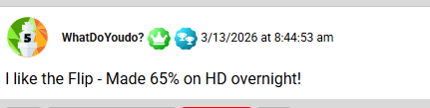
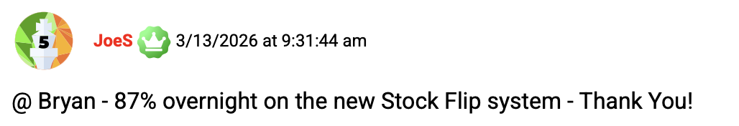

And even 129% overnight on Home Depot.
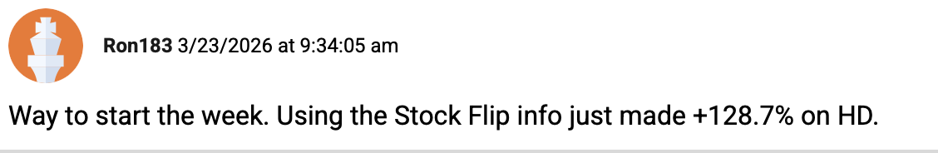
And that was BEFORE I even started making official recommendations.
Then… I recommended Home Depot to my members.

Host:
And that was the massive 241% overnight winner, wasn’t it?

Bryan:
That’s exactly right.
Maybe not as flashy as the highest 667% Tesla flip…
But when you're flipping Home Depot consistently… over and over…
That can add up fast.

Host:
So let me make sure everyone understands what they just got here.
Three stocks. Tesla… Nvidia… and Home Depot.
Tesla triggers at a 6% drop.
Nvidia triggers at 6.5%.
And Home Depot triggers at 2%.
If any of those stocks hit that trigger by 3:30 in the afternoon…
That’s your signal.
That’s when the data says the odds for a bounce back the next day are in your favor…
Giving us the best opportunity to make a flip trade.

Bryan:
That's the system. Buy an option on that stock that afternoon.
Go to sleep.
And potentially cash out the next morning.

Host:
And those are just three out of thirty stocks you track.

Bryan:
Just three. There are twenty-seven more.
Stocks like Home Depot… Broadcom… Meta… Coca-Cola… Salesforce… Netflix…
Each one with its own unique trigger.
And every single one of them backed by over ten years of data.
Our audience can start trading them right away…
Heck if one of them triggers… they could make a trade before the next closing bell!

Host:
So… I want to talk directly to our viewers at home today.
Let me recap this strategy for everyone.
Step 1:
You watch the list of stocks, waiting for them to hit the flip criteria

Step Two:
If the stock hits the trigger at 3:30… you can make a simple Flip Trade
Remember… you can make some of these trades for as little as $250!

Step Three:
You exit the next day… targeting overnight doubles!
Bryan has shown you the data…
You’ve seen the incredible examples… and the amazing profit potential.
From here…
You basically have two options.
Option one.
You take these three stocks Bryan just gave you… Tesla, Nvidia, and Home Depot…
And you do it yourself.
You watch them every single day.
You check at 3:30 in the afternoon to see if any of them hit the trigger.
You go find the right option on your own.
Figure out the right expiration… the right strike price…
Place the trade yourself.
And hope you picked the right setup.

Bryan:
And… everyone at home could absolutely do that.
I just gave you everything you need…
And I genuinely hope it works out for you.

Host:
But you’d only be following just three stocks… out of the full thirty.

Bryan:
Exactly.
With three stocks… you might see a flip opportunity once a month. Maybe less.
Tesla needs a six percent drop to trigger. That doesn't happen every week.
And…
You’d have to remember to watch every single day at 3:30. Plus check each of the three stocks.
And when it does trigger… you're on your own picking the option. You have to pick the strike… the expiration.
Factor in the Delta… the Theta…
Everything that goes into the options pricing.
Basically… you’re on your own.
You're doing all the research. All the analysis. All the heavy lifting.
Some people love that.
And if that's you… go for it.
I wish you all the best.

Host:
But…
Most people don't want to do all that work.
Which brings us to option two.
With Bryan here… you don’t have do all the heavy lifting.
Because with option two: you let HIM do it for you.
Tell them what that looks like.

Bryan:
So here's what I do every single day.
I monitor ALL thirty stocks on our flip list.
Not just three. All thirty.
Every single day… I'm watching the market… tracking which stocks are selling off… checking which ones are getting close to their trigger.
And when one of them hits…
When I see a great stock on an ugly day that meets our criteria…
I pick what I believe is the absolute best flip trade.
I choose the option. The strike price. The expiration.
And I send it straight to you.

Host:
So you're doing the work. All the monitoring. All the analysis.
And members get a message that says… "Here's the trade recommendation. And you include the exact option to buy."

Bryan:
That's precisely how it works.
It’s all part of my service called Post-Market Profits.
You get a real-time alert the second a trade triggers.
Like what happened with the Home Depot example we talked about in the beginning.

Host:
Right… let me bring that back for anyone who might have forgotten.
This was April 7th.
The Iran war was escalating. Trump set his final deadline to make a deal.
Oil was past $115 a barrel. The S&P dropped over 1% during the day.
Ugly day. People were terrified.
But Bryan saw Home Depot was down 2.4%.
It was an overreaction.
So he sent an alert to his Post-Market Profits members.
It looked like this:
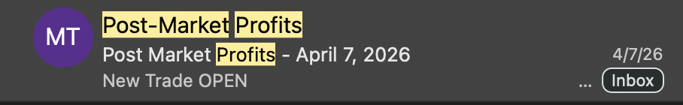
They opened it up and saw everything laid out for them.
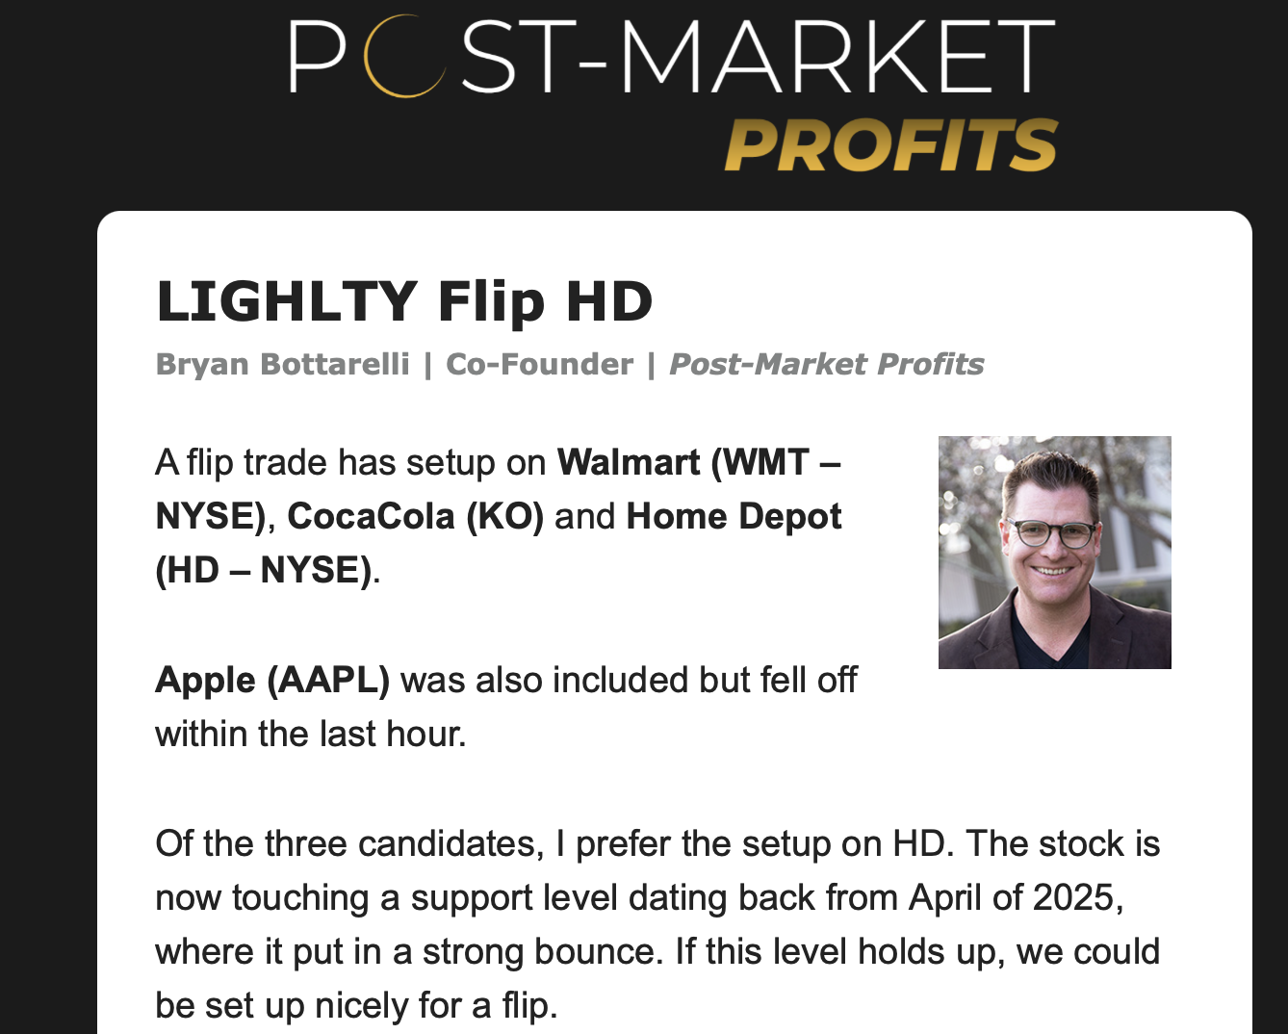
The exact option to use, including the strike price and the expiration.
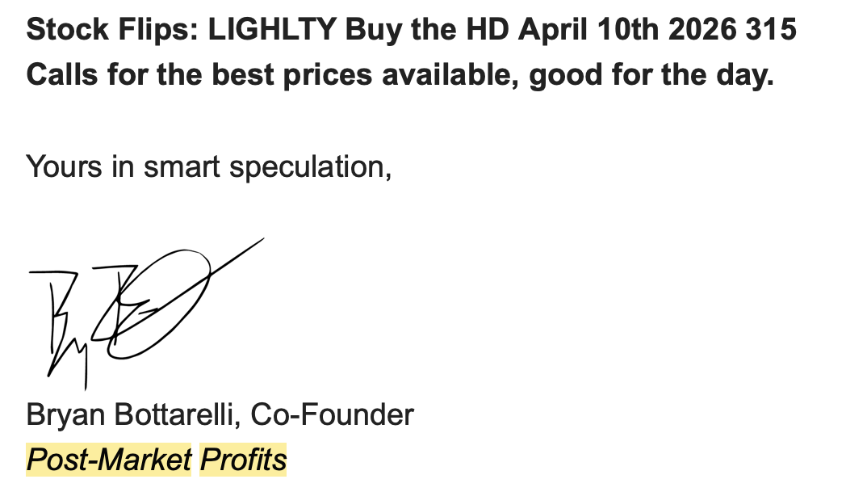
Everything they needed.
All they had to do was open their brokerage account… and place the trade.

Bryan:
Two to three minutes. That's all it takes.
If you can buy a stock… you can do this…
Even if you’ve never traded options before.
I’ve made it easy.
And we have an options blueprint you can use to get you up to speed in no time.
You’ll see buying options is just as easy as buying a stock.
And you can always begin with paper trading first, so you don’t risk anything while you learn how it works.

Host:
So it takes just two to three minutes. Around 3:30 in the afternoon.
Then you go about your day. Go to dinner. Watch TV. Go to bed.
And the next morning…

Bryan:
The next morning is when it gets fun.
The official gain on that Home Depot flip was 241%.
But our members?
Many of them had different timing and did even better.
And they couldn't wait to tell us about it.

Host:
Let's share some of those. Because I think this is the part that really brings it home for people.

Bryan:
Jake reported a 280% overnight winner on Home Depot.
SpacemanSnoopy got in at $6.76… out at $21.31… a 215% winner.
Charles sold one call for $1,590 in profit.
TerryB said… and I quote… "Right now my HD is up 224%. My best gain from an overnight trade. Thanks so much."

Host:
And it got even bigger than that for some people.

Bryan:
Rick R took 260% on Home Depot AND 22% on Walmart the same morning.
MichaelJay… "Back flips and cart wheels… plus 340%."
LMman… 300% on Home Depot and 236% on another flip… called it his "best morning ever."
Mr. Baseball reported FIVE winning flips that day. HD at 372%… Tesla at 93%… APLD at 90%… DAL at 90%… HAS at 33%.
And then there was Mickey W.
896% on Home Depot. Plus 120% on another flip. All before lunch.

Host:
I mean Bryan… that's not just one or two people getting lucky.
That's member after member after member… all reporting huge wins… all from the same trade alert you sent at 3:30 the afternoon before.

Bryan:
And that's what I love about this.
It's not me sitting here showing you what COULD have happened.
These are real people on a real trade… with real results.
All because they got an alert… spent two minutes placing the trade…
And let the flip do the work overnight.

Host:
And it wasn't just Home Depot that day. Some of these members were flipping multiple stocks at once.

Bryan:
That's right.
ALM said it was her best morning ever. Three winners. HD at 226%… Walmart at 37%… and DAL at 86%.
Her exact words were… "My trading account needed that. Thank you Bryan."

Host:
That’s an amazing one.
This was during a time when a lot of accounts were seeing a lot of RED.
But thanks to Stock Flips… this member got a much needed jolt in their portfolio.

Bryan:
These are the stories I live for… it's why I do this every single day.
But here's the important thing…
I don't just give you guidance on what to buy.
I watch for when it's the best time to get out too.
If the market pops at the open… I may recommend taking profits. Lock it in… and ring the register.
If it needs a little more time… I'll update my readers to hold.
If it's not working… I'll recommend when to cut it.
You get the entry AND the exit recommendations on every single trade.
And you get all of that as a Post-Market Profits member.
But… that's not all you get.

Host:
It's not?

Bryan:
Not even close.
As a member of this service… you get so much… I almost don’t have time to discuss everything.
But… I’ll go as fast as I can.
When you join… the first thing you're going to get is the Overnight Stock Flip Blueprint.
This is your quick-start guide.
It walks you through the entire Stock Flipping process step by step.
Everything I've covered today… but in much more detail.
You'll see all thirty stocks we track for flip trades.
Not just the three I gave you today. You get all thirty.
And you'll see exactly how to make these trades.
This blueprint walks you through everything.

Host:
So that's the full playbook? All thirty stocks… the complete breakdown of the strategy with all the criteria.
It’s the whole system?

Bryan:
The whole system. Nothing held back.
But that's just the starting point.
Because Stock Flips aren't the only trades you're getting.
You also get access to our Dark Ticker trades.

Host:
Dark Ticker.
That’s something you haven’t mentioned yet. Tell everyone what that is.

Bryan:
Dark Ticker is actually how all of this started.
It's the original flip trade. And it's been an absolute game changer for our members.
Here's how it works.
You know how Stock Flipping targets individual stocks that overreact on ugly days?
Dark Ticker does the same thing… but with the broad market.
When the overall market has a bad day…
History shows it bounces back the very next day 9 out of 10 times.
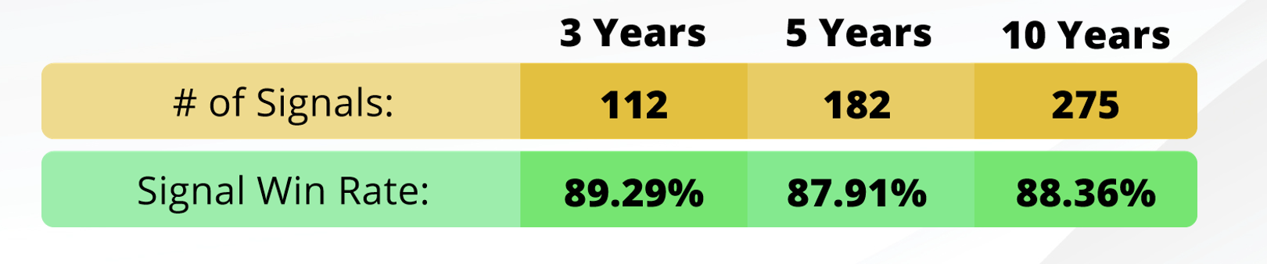
So we make a trade on one of the major market ETFs…
SPY for the S&P 500… QQQ for the Nasdaq… DIA for the Dow… or IWM for the Russell 2000.
But here's the twist.
We buy them AFTER the closing bell.

Host:
After the market closes?

Bryan:
There's a special fifteen-minute trading window… from 4:00 to 4:15 PM Eastern…
Where you can trade these specific ETFs AFTER hours.
Most people don't even know this window exists.
But we use it every time the market has an ugly day.
We get in between 4:00 and 4:15…
And look to cash out the next morning at the open.

Host:
So it's the same concept as Stock Flipping. It’s an overnight trade. In one day and out the next?

Bryan:
Same concept. Different target.
Stock Flips target individual stocks on ugly days.
Dark Ticker targets the entire market on ugly days.
And the results have been incredible.
We've made over eighty Dark Ticker trades.
We're winning about seven out of ten.
With overnight gains as high as 88%… 109%… even 157%.

Host:
And your members have been cleaning up with this.

Bryan:
They really have.
One member… Keith… turned $1,200 into over $30,000 following our Dark Ticker trades for a year.
Almost 30x his entire portfolio.
Another member… Jerry… made $20,000 on a single Dark Ticker trade.
That was a 54% overnight gain.
And one member… I still can't believe this one…
Reported making almost half a million dollars on just two overnight Dark Ticker trades.
Host:
Half a million. On two trades.
Bryan:
On two trades. 57% and 64% overnight.
And we've had big winners already this year too.
January 14th… 87% overnight.
February 5th… 129% overnight.
One member made $56,000 on that February trade alone.
And our member Budge wrote us:
“Bryan, I think the Dark Ticker is the best trading tool you guys have given us. I have made a ton of money using it.”
BACKUP NOT FOR PROMO:
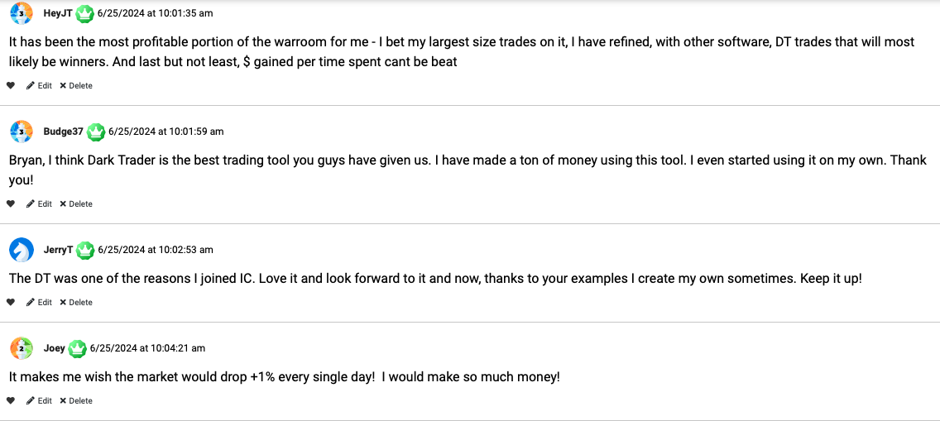

Host:
Alright. So now I'm starting to understand why you're so fired up about Post-Market Profits.
When someone joins Post-Market Profits…
They're not just getting Stock Flip trades.
They're getting Dark Ticker trades too.

Bryan:
Both strategies. Under one roof.
And I want to be really clear about this…
This is the first time EVER that we're offering both of these together.
Dark Ticker has been running on its own for over two years now.
Our members love it. You just heard what it's done for people.
Stock Flipping is brand new.
And now… for the first time… you can get BOTH.
It’s basically a two for one bargain.

Host:
So what does a typical week look like for a Post-Market Profits member getting both?
Bryan:
On any given day… if one of our thirty stocks has an ugly day…
You could get a Stock Flip trade at 3:30.
And if the overall market has a bad day that same afternoon…
You could get a Dark Ticker trade at 4:00.
That's potentially two overnight profit opportunities in a single day.
And that's actually happened. We've had days where members get an alert for BOTH types of trades.
They had the chance to go to bed with two trades on…
And wake up to two winners the next morning.
Remember Alma from the Home Depot day?
She made 38% on her Stock Flip… AND 68.5% on her Dark Ticker trade. Same day.
And Alexis? She rang the register on a Stock Flip on Walmart… AND Dark Ticker trades on IWM and QQQ. All in one morning.
Host:
So you're basically doubling the opportunities.
Bryan:
More than doubling. Because now I'm watching thirty individual stocks for flip trades…
PLUS the four major index ETFs for Dark Ticker trades.
Every single trading day.

Host:
Alright. So let me lay out what people are getting with Post-Market Profits.
First… you get a complete monthly briefing from me.
I'll cover what's working… what I'm seeing in the market… and where I think the best flip opportunities are coming.
Second… you get all of Bryan’s Stock Flip trade analysis and alerts.
Real-time. Sent to your email the second a trade triggers.
The exact option symbol. Everything you need to make the trade.
You can even sign up for text notified so you always know when to check your email.
Third… you get all of his Dark Ticker trade alerts.
Same thing. Real-time alerts and information with the exact trade recommendations… including entries and exits.
Fourth… you get the Overnight Stock Flip Blueprint.
The full system explained step by step.
Fifth… you get the Dark Ticker Strategy Guide.
A short primer that walks you through exactly how Dark Ticker works…
How we pick the index… how we pick the option… everything you need to know.
And sixth… you get live chat access with our moderation team.
Real people. Here in the U.S.A. Available all trading day.
If
you're confused about the trade recommendation or have other general questions about the strategy…
You can message our team and get help in real time.

Host:
So it's not just trades and reports.
There's actually a support team behind you.

Bryan:
They can’t give personalized investment advice, of course.
But they can hold your hand as you learn to use the Post Market Profits strategy.
From the moment you join… to the moment you place your first trade…
And every trade after that.
We've had thousands of members come to us who had never traded an option before in their lives.
And now they're flipping stocks and making money.

Host:
And Bryan… I want to address this directly because I know people are thinking it.
What if someone watching right now has never traded options?

Bryan:
You're in the right place.
Buying an option is as simple as buying a stock.
You go into your brokerage account.
You pick the option we give you… click buy… That's it.
And between the blueprint… the strategy guides… the live moderators…
We walk you through every single step.
Many of our most successful members started exactly where you are right now.
They were new to trading… they never even bought an option before.
And now they're waking up to 200%… 300%… even 400% overnight gains.
Everyone starts somewhere.

Host:
Alright Bryan. I think everyone watching can see the value here.
Let's talk about what it costs.
Because honestly… with the kind of gains we've been talking about…
I'm guessing this isn't cheap.

Bryan:
Well… let me put it in context.
Some of our members paid as much as $7,000 or more to access Dark Ticker trades alone.
That was before we introduced Stock Flips.
And they were happy to pay it… because the results justified it many times over.
As JT put it:
“It’s the most profitable strategy for me. The $ gained versus time spent can’t be beat.”
And member Jerry said it this way:
“Dark Ticker was why I joined The Inner Circle. Love it and look forward to it now. Keep it up!”
BACKUP NOT FOR PROMO
But now… we're not just giving you Dark Ticker.
We're giving you Dark Ticker PLUS Stock Flip trades.
You get both strategies…
Both alerts.
Plus all the guides…. live moderator access… my monthly updates.
Everything.
So the retail price of $5,000 for both of these together?
That's honestly a steal when you think about what others have paid for just one of them.

Host:
$5,000 for both. That does seem fair given what you've shown us.

Bryan:
But that's not what our viewers at home are going to pay today.

Host:
It's not?

Bryan:
Nope!
Because I want to get this into as many hands as possible.
I've seen what Stock Flipping can do. I've seen how the Dark Ticker can change the way people look at bad days in the market.
And with the market we're in right now… I don't want cost to be the thing that holds anyone back.
So today… you can get a full year of Post-Market Profits…
Both Stock Flip trades AND Dark Ticker trades…
Everything I just walked you through…
Not for $5,000.
But for just $1,997.

Host:
$1,997. That's a huge 60% discount!
So basically, you’re getting two strategies for the HALF the price of one…

Bryan:
And that’s for a full year of BOTH strategies!
I know our members could make a ton of money from this.
So… I’ve dropped the price down to make sure everyone has a chance to get in.
But… this price is only good for a limited time.
Now… everyone at home…
I want you to think about this for a second
ONE flip trade could cover the entire cost of your membership.
One overnight double on a $5,000 trade… and you've more than paid for the whole year.
That Home Depot trade we talked about?
Members reported gains of 241%… 280%… 300%… 340%.
Any one of those trades would have covered the cost of membership several times over.

Host:
That's a fair point. One good trade and you could be playing with house money for the rest of the year.

Bryan:
Exactly. And you're not getting one trade. You're getting recommendations week after week.
Stock Flips…
Dark Tickers... All year long.

Host:
Alright. So $1,997 for the annual membership. That's a great deal.

Bryan:
It is…
But… I have something else up my sleeve for everyone watching.
Something I think is the smarter play for most people.

Host:
Okay.
I’m intrigued…
What is it?

Bryan:
We're calling it Unlimited Access.
And here's why it exists.
With the annual plan… you get everything I just described for one year.
Stock Flips… Dark Tickers… my monthly insights… access to the moderators.
But with Unlimited Access…
You get all of that… year after year… for as long as we publish.
One payment. You're in for good.

Host:
So they lock in everything right now.

Bryan:
That's it. And here's why Unlimited is the better deal for most people.
First… you lock in your price. Prices will go up.
We’re seeing it all over the market. Data costs go up. Technology costs go up.
So we are going to have to raise prices.
But you pay once now… and that's all you pay. Forever.
Second… you're not just getting Stock Flips and Dark Tickers.
Unlimited members get something nobody else gets.

Host:
What's that?

Bryan:
Our proprietary Overnight Stock Flip Scanner.

Host:
The scanner. Tell them about that.

Bryan:
So the scanner is the tool I use every single day to find flip trades.
It tracks all thirty stocks in real time.
It shows you which ones are selling off… how close they are to their trigger…
And when they hit the criteria by 3:30 pm… it gives you a check mark.
Plus… it gives you all the data right there.
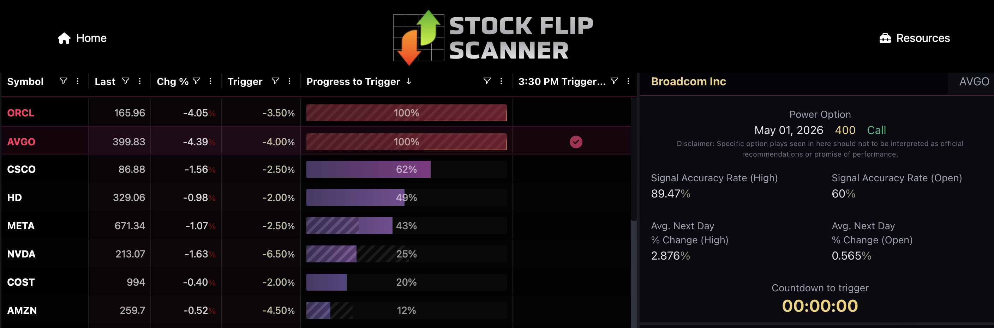
You can the stats on each ticker symbol.
It shows you the signal accuracy rate for that symbol…
The average next day move for the stock.
It even gives you what we call “Power Options.”
That’s an options idea you could consider if you’d like to make a Flip Trade.
Now to be clear…
This is just a tool for you to use to easily see which stocks hit the criteria.
They shouldn’t be considered recommendations, and you should use your own judgment before getting in any trade.
But you get this powerful new tool with Unlimited Level.
That means you can see EVERY stock that's setting up for a flip. Not just the one I pick.

Host:
So Bryan… you might send out one trade on a given day…
But the data on the scanner might show three or four other opportunities that are hitting the criteria at the same time.

Bryan:
Exactly. Remember that day we showed you with Home Depot?
There were other stocks triggering on the scanner that day.
I sent out one trade. But Unlimited members could have decided to make multiple trades.
And many of them did.
That's why Mr. Baseball had five winning flips that day.
That's why member ALM had three winners that morning.
Using the scanner to make their own trades made that possible.

Host:
So Bryan… the scanner is clearly powerful.
But you didn't just build it and hope for the best, right?

Bryan:
No way. Before we rolled this out to everyone…
We gave our Unlimited members early access.
Kind of a beta test.
We wanted to see how real people… in real time… in a real market…
Would do with this tool.

Host:
Smart. So what happened?

Bryan:
They started winning. Almost immediately.
They reported winning flips on Home Depot… META… and AVGO for 65%… 80%… 87%… 101%… even 200% overnight."

LEGAL BACKUP
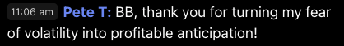
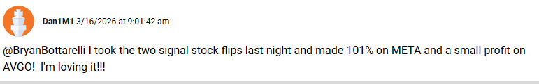

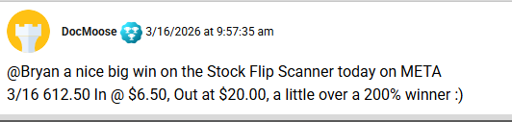
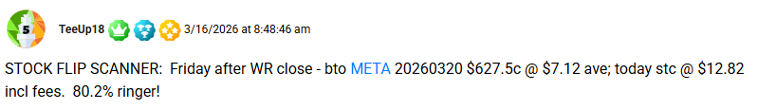

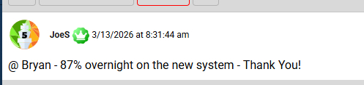

ON THESE BRYAN JUST READS THE FIRST PART, NOT THE WHOLE QUOTE
Ron made a huge 129% gain on Home Depot:
“Way to start the week. Using the Stock Flip info just made +128.7% on HD.”
Margo made a nice 51% on Netflix:
“Flip on NFLX up 51%. Thanks Bryan and Stock Flip!”
Carl made 135% on Facebook (META):
“Did a stock flip on Meta and up 135% this morning!”
Jon said he was 3 for 3 on his trades… and already met his dollar goal for the week!
“3 for 3 on Friday's Stock Flips (HD 75%, ORCL 28% and WMT 20%). Not huge wins, but I'm really satisfied with the results as I have already met my dollar goal for the week!”
Ted said he got his BEST DAY EVER with three wins!
Wins on HD, ORCL and META… best day ever!
Alexis rang the register on BOTH Stock Flip and Dark Ticker Trades!
“Just range the register. Stock Flip on WMT, Dark Ticker trades on IWM and QQQ. Thanks Bryan and Stock Flip!”
LEGAL BACKUP:

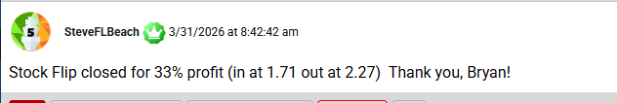

And those are just a few of the members who wrote in.

Host:
So those results weren’t from a backtest.
These were real people… using the scanner for the first time…
Placing real trades with real money…
And waking up to real profits.

Bryan:
Real people. Real trades. Real results.
65%… 80%… 87%… 101%… even 200% overnight.
In their very first week using the tool.
And that was BEFORE the monster 241% Home Depot winner we talked about at the top of this presentation.

Host:
Right. The April 7th trade where members were reporting 280%… 300%… 340%… even 896%.

Bryan:
So think about that progression.
Week one of beta testing… members are hitting 65%… 80%… 200% winners.
A few weeks later… subscribers are waking up to 300%… 340%… 896%.
That’s the power of Stock Flipping.

Host:
And these aren't professional traders. These are everyday people.

Bryan:
Everyday people. Some of them had never traded an option before they joined us.
And now they're posting wins in our community every single morning.
That's what the scanner… combined with my trade alerts… and the entire Post-Market Profits research… can do for you.
And that's why Unlimited members love having it.
Because they don't just follow my picks.
They can see every setup. Every trigger. Every opportunity.
And they can apply what they’ve learned to take as many or as few trades as they want.

Host:
So if someone really wants to maximize their flip opportunities…
Unlimited is the way to go.

Bryan:
It's the best deal we offer. And our members agree.
The most common thing we hear from annual members is…
"I wish I'd just gone Unlimited from the start."
Just one low price… and you get Post Market Profits for as long as we publish…
Plus FREE access to our Stock Flip Scanner.

Host:
Well… it sounds in credible.
But… I’m sure people are wondering how much it costs.
How much is an Unlimited Membership?

Alt Take: No Price reveal
Bryan:
That’s the best part.
Instead of the $7,000 that some members have paid in the past for access to Dark Ticker trades alone…
I have a very special price for you today to get UNLIMITED access… along with use for this proprietary trading research tool.
Click on the button below to see your exclusive discount – available through this presentation alone.
End Alt Take: No Price reveal

Alt Take: Price reveal
Bryan:
That’s the best part.
Instead of the $7,000 that some members have paid in the past for access to Dark Ticker trades alone…
Unlimited Access is just $3,997 today.
One time.

Host:
So there’s no renewal fee?

Bryan:
No renewal.
It’s a one-time subscription payment.
The only thing they’ll pay after that is a small $199 yearly data fee.

Host:
So let me make sure I have this right.
Annual is $1,997 per year.
Unlimited is $3,997… one time… and then just a $199 annual data fee after that.
End Alt Take: Price reveal
Bryan… that really is a great deal.
But… I know some people watching are still on the fence.
What if they try it and it's not for them?

Bryan:
Fair question. And we thought about that.
That's why we offer a 60-day money-back guarantee.
Try Post-Market Profits for a full sixty days.
Use the Stock Flip trades. Use the Dark Ticker trades.
See the scanner if you're an Unlimited member.
Review the research and the options primers.
Watch the alerts come in.
Place some trades if you’d like.
Test drive everything we have for you.
And if it's not right for you… for any reason…
Just give our team a call after sixty days.
We'll refund what you paid… minus a small 10% processing fee to cover our data costs.
No hard feelings. No hassle.

Host:
So there's really no risk here.
You try it for sixty days.
If you love it… you keep going and keep flipping.
If not… you get your money back.

Bryan:
That's the deal.
But I'll be honest with you…
I don't think you're going to want a refund.
Not after you wake up to your first overnight double.
Once you experience that… there's no going back.

Host:
That’s a great point, Bryan.
So to everyone at home…
I encourage you to act right now.
The button is right below this video. Click it now to lock in today's deal.
And if you'd prefer to talk to someone first… Bryan's VIP service team is standing by.
You can call them at XXXXXXXXXXXXX.
They can walk you through everything we’ve talked about today.
They can answer any questions you have about the offer. Or help you figure out which plan is right for you.

Bryan:
And guys… I'm not going anywhere.
Every single trading day… I'm watching the scanner.
I'm tracking all thirty stocks.
I'm looking for the next great stock on an ugly day.
And the second one triggers… you're going to hear from me.
Don't miss the next big flip.

Host:
Absolutely.
Host:
Alright Bryan… before we wrap up…
I know there are going to be a lot of questions. So let's run through the most common ones.
And by the way… for everyone watching…
While we go through these questions… that button is right below this video.
You can click it anytime to lock in today's special deal. You don't have to wait until we're done.
Go ahead and click it now.
You’ll go to a separate window. You won’t lose Bryan and me… we are about to do a quick Q&A for everyone.
And it doesn’t obligate you to buy anything.
You can review the details and decide which option is right for you.
Or if you'd prefer to talk to someone… call Bryan's VIP service squad at XXXXXXXXXXXX.
So now, Bryan…
Let’s take some questions!

Bryan:
Absolutely! Let’s get to it!

Host:
Alright. First question Bryan… and this one comes up a lot.
How many trade recommendations do you put out per week?

Bryan:
Good question.
It really depends on the market.
With Dark Ticker alone… I was recommending about one trade a month… give or take.
Now that we've added Stock Flips… there are going to be more opportunities.
I'd say at least one a week.
Probably more. Especially in volatile markets.
On a big ugly day… there might be multiple stocks triggering on the scanner.
Of those… I'll hand-select the one or two I like best.
I’ll look at the very best chart… the best setup. I’ll use my experience trading over two decades to zero in on the highest probability opportunity.
And that's what I send out.

Host:
And if someone has Unlimited access with the scanner… they could potentially take even more trades on their own.

Bryan:
Exactly. Remember that Home Depot day? There were several stocks triggering.
I sent out one trade. But Unlimited members could see all of them.
Some of them took multiple trades that day and woke up to multiple winners.

Host:
Alright. Next question.
Is this considered day trading? Does the pattern day trading rule apply?

Bryan:
Another great question.
And the answer is no.
We are NOT buying and selling in the same day.
We buy in the afternoon… and we sell the NEXT day.
So… the pattern day trading rule doesn't apply here.
In fact… this is actually a way to AVOID that rule.
You can make multiple trades like this per week and it won't trigger anything.
Because you're always selling the next day.

Host:
That’s a great point for everyone watching. That's going to be a relief for a lot of people.
Now… for anyone watching who hasn't clicked that button yet…
Remember… you're getting BOTH Stock Flip trades AND Dark Ticker trades.
Two strategies for the price of one.
Annual membership is $1,997. Unlimited… which includes the scanner… is $3,997 one time… plus a small $199 data fee.
And both come with a 60-day money-back guarantee.
Click the button below or call XXXXXXXX
Next question Bryan. What time do you typically close the trade? When do members get out?

Bryan:
So ideally… I’ll recommend getting out in the morning. Right at the open.
If the market is up and our position is up… I'm going to be risk-averse and suggest you take profits.
Lock the gain in… ring the register.
A bird in the hand is worth two in the bush.
Now… there are going to be times where the stock doesn't pop right at the open.
And that's where the skill comes in.
That's the heavy lifting I do for you.
I'll review my data and tell you… hey… I think we should hold this a little longer.
Or… it's time to exit. Cut it here.
Sometimes I’ll suggest holding for a day or two if I think the setup needs more time to play out.
But the goal is always the same.
Get in the afternoon. Get out as quickly as possible. Move on to the next one.

Host:
So you're not just sending the entry. You're monitoring the trade all the way through.

Bryan:
Entry and exit. Every single trade.
You don't have to sit there wondering "should I hold? Should I sell?"
That's my job.
That’s why I tell people… let me do the heavy lifting for you.

Host:
Next one.
Are you trading puts? Or just calls?

Bryan:
Just calls. This strategy is about buying call options.
We're betting that a great stock that just had an ugly day… is going to bounce the next day.
So we buy calls. Simple as that.
No complicated multi-leg strategies.
No credit spreads.
No puts.
Just… buy a call in the afternoon. Sell it the next day.
If you can buy a stock… you can do this.

Host:
That's about as simple as it gets.
And speaking of simple… let's talk about the people watching right now who have never traded an option before.
Can they do this?

Bryan:
Absolutely. And I want to speak directly to anyone in that situation right now.
You are in the right place.
Buying a call option is as simple as buying a stock.
You go into your brokerage account.
You click buy.
That’s it. You’re done.
And I’ll tell you the exact option to buy with every recommendation.
No guesswork.
And don’t forget…
You've got the Overnight Stock Flip Blueprint that walks you through everything step by step.
You've got the Dark Ticker Strategy Guide.
You've got our live moderator team… real people… U.S.-based… available all trading day.
If you have a general question about anything… how to place the trade… what something means… anything…
You can message them and get help in real time.
Again… they can’t give you personal advice. But they can help answer questions about the strategy and general trading questions.
We've been helping new traders in our live chat room – called The War Room -- since 2019…
And in Post Market Profits for over two years now.
Thousands of members have come to us who never traded an option before.
And now they're flipping stocks and waking up to huge overnight gains.
Everyone starts somewhere.

Host:
And I think that's an important point.
If you look at all those testimonials we shared…
A lot of those people were once sitting right where you are now. Watching. Wondering.
And now they're posting 200%… 300%… even 800% winners.
So don't let inexperience hold you back.
That's exactly what Bryan and his team are here for.
And remember…
You can always paper trade for the first few to get the hang of things.
That way you can see how it works and learn… but you don’t risk a penny.
We always recommend paper trading first until you feel comfortable.
So now… if you're ready to get started… click that button below this video.
You're getting Stock Flip trades AND Dark Ticker trades.
It’s basically a two for one deal.
You get both strategies… for one low price.
$1,997 for the annual plan.
$3,997 one-time for Unlimited with the scanner.
And remember…
You’re covered by our 60-day money-back guarantee minus a 10% data fee.
And you can call XXXXXXXXX if you want to talk to someone first.
Alright Bryan. Next question. How much money do you need to get started?

Bryan:
This is one of my favorites.
Because one of the best things about this strategy is the low barrier to entry.
Some of these flip trades cost as little as $250 for one contract.
You don't need a big account to start.
If you've got $500 or $600 in your trading account… you could do one trade and see how it goes.
And then as you build your account with winners… your position sizes grow.
That's the beauty of the Rule of Five system I showed you earlier.
You start small.
Then reinvest your profits.
Let your wins compound.
Plus… you’re also covered if you do hit losses along the way.
We showed you how $2,500 could have grown to over $100,000 flipping just Tesla over two years.
You don't need to start big. You just need to get started.
And NOW is the time.

Host:
Everyone at home… you just heard it.
Don’t wait.
Get started.. NOW.
You could see your very first flip before the next closing bell.
Be sure to click on the link below…
Or call our service squad now at XXXXXXXX
If you have any hesitations… give them a call.
They are waiting to help you come up with solutions so you don’t miss this amazing opportunity.
Ok…
Next question…
Can you trade these in a Roth IRA?

Bryan:
Yes. You can trade options in a Roth IRA.
You'll need to make sure your Roth is approved for options trading.
But most brokers make that pretty easy to set up.
And the beautiful thing about doing this in a Roth…
Any gains you make are tax-free.
So if you wake up to a 200% winner in your Roth… that's all yours.

Host:
That's a great tip.
Alright. Let me hit one more that I think is on everyone's mind.
Bryan showed us the 87% signal accuracy rate across ten years of data.
But what about the other 13%? What happens when a trade doesn't work?

Bryan:
It's a great question. And I want to be upfront about this.
Not every trade wins.
87% means roughly thirteen out of a hundred times… the stock doesn't bounce the next day.
When that happens… we manage it.
I might say… the option is down 25%. The stock isn't cooperating. Let's cut it and move on.
We take a small loss. And move on.
We get ready for the next setup.
That's part of trading.
No strategy wins 100% of the time.
But when the odds are in your favor 87% of the time…
And your winners are 100%… 200%… 300%… sometimes 600% or more…
The math works overwhelmingly in your favor.
Even with losses mixed in.
That's exactly what I showed you with the Tesla example.
We counted every single loser in that two-year stretch.
And , with perfect timing, a $25,000 account STILL would have grown to $1.29 million.

Host:
That's the edge.
You don't need to win every trade. You just need the wins to be bigger than the losses.
And with an 87% signal accuracy rate and the kind of gains we've already seen from Bryans’ recommendations…
The math is on your side.
Alright Bryan. One more question and then I want to let people go take action.
How do people actually receive the trades? How does it work once they sign up?

Bryan:
So the second you join… you'll get access to everything.
The blueprint…
The strategy guides.
And don’t forget… you get the moderator team.
That’s what makes us so unique… because you can always message us and get general questions answered.
And then when a trade triggers… you'll get it three ways.
First… an email hits your inbox with the full trade details.
Second… you get a push notification on your phone reminding you to check your inbox.
Third… it's posted in our Command Center online. Which is like our home base where everything lives.
Our command center has all of our trades… from all of our services…
All in one place.
So no matter where you are… at your desk… on the golf course… taking a nap…
You'll know the second a trade goes out.
And from there… it takes you two to three minutes to place it.

Host:
Two to three minutes to potentially wake up to a huge overnight gain.
Alright everyone. You've heard everything today.
Bryan showed you how Stock Flipping works.
You've seen the three-step formula.
You've seen over ten years of data showing an 87% signal accuracy rate.
You've seen how $25,000 could have grown to as much as $1.29 million flipping just one stock.
You've heard from real members waking up to gains of 280%… 300%… 340%… even 896%.
And you've learned about Dark Ticker trades… the original overnight flip strategy… that members have turned down days into overnight doubles!
Today… for the first time ever… you can get BOTH of these strategies together.
Stock Flips AND Dark Tickers. Two strategies. One membership.
Annual membership… $1,997 for a full year.
Unlimited membership… $3,997 one-time payment… plus just $199 data fee per year.
With Unlimited…
You also get the proprietary Stock Flip Scanner that Bryan and his top members use every single day to find flip opportunities.
Both plans come with a 60-day money-back guarantee… minus a small 10% data fee.
So you can get all the reports…
Get all the trades…
And see the results for yourself.
And if it's not for you… you get your money back. Simple as that.
Click the button below this video right now to get started.
Or call Bryan's VIP service team at XXXXXXX
They can answer any questions. Walk you through the plans.
They can also help you find solutions and help you pick the right option for your situation.

Bryan:
And guys… I just want to say one more thing.
Every single trading day… I'm at my desk.
I’m monitoring the scanner. Watching all thirty stocks.
Looking for the next great stock on an ugly day.
And the second one triggers… you're going to hear from me.
I've been doing this for over twenty years.
From the floor of the CBOE… to calling Tesla at two dollars… to building this community of thousands of traders.
And I can tell you… Stock Flipping is the strategy I'm most excited about in my entire career.
I want you to experience it for yourself.
I want you to wake up to your first overnight flip winner.
And I want you to see what our members already know…
That ugly days in the market aren't something to fear.
They're something to flip.

Host:
I think that’s a perfect way to end things, Byran.
For those of you at home…
Click the button below or call 888-215-5311.
Don't miss the next big flip.
Thank you for joining us today…
And we’ll see you inside Post-Market Profits.
April 2026

