HL 1:
MILLIONAIRE PRO TRADER REVEALS:
“S.A.M.”
The Next-Gen A.I. Trading Tool

See How This New A.I. Tool Could Have Identified Wins as high as 219%, 326% even 2,250% Within 9 Days!

See the LIVE demo:
Headline #2 :

Monument Traders Alliance, the world’s leading trading publisher presents:
Next-Gen A.I. Trading Summit
Research Shows New AI Tool Could’ve Unlocked Gains of Up To 219%, 326% and 2,250% all within 9 days or less!
Discover The Next Trade Set-ups on 1/31/2024


Hi my name is Nate Bear, Lead Technical Tactician of the Monument Traders Alliance.
And welcome to the Next-Gen A.I. Trading Summit.
During this special event...
You’re going to get the very first look at the future of trading...
A brand-new AI-powered trading research tool that can automatically...
Scan the market…

Help Pinpoint WHAT stocks to trade...
And even predict WHEN to get into a trade for potentially MASSIVE gains!
This new AI-powered tool is called the Stock Acceleration Monitor.

We call it S.A.M., for short.
And if you’ve ever wondered… can AI help accurately predict future moves in stocks or put more cash into your pocket, then you need to see this.
It all starts with a specific event that happens behind the scenes in the trading of a stock.

Most people overlook it… And it’s impossible to track using Yahoo Finance or any “mainstream” website.
But once you understand how to spot this specific event, the profit potential can be limitless...
In fact, in just 4 years...
I was able to use this small behind the scenes event to turn a small account of $37k into $2.7 Million...
A 7,127% return in just 4 years...
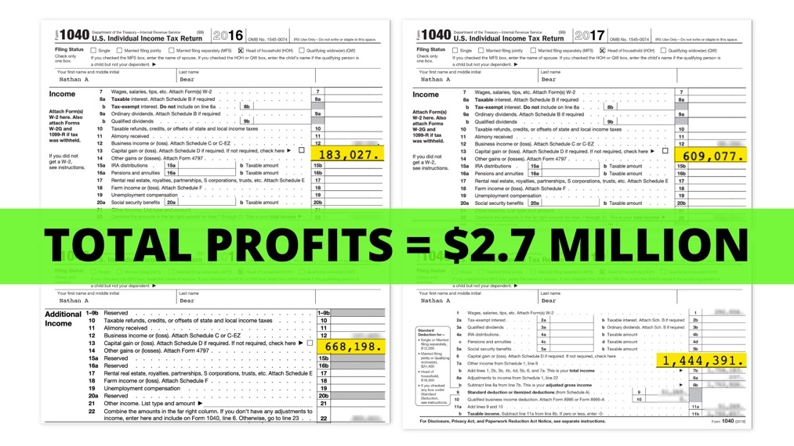
All thanks to this unique event that as of today is easier than ever to profit off of...
In short, what we’ve done with SAM is taken the proven formula behind some of the best trades of my life… and programmed this new AI system to find these same setups again and again.

We even ran last year’s stock data through SAM so we could look back and see just how well it could find the best trades in the market.

And let me tell you… it shocked even me.

It made me worry I might be out of a job if the AI is this good.

Consider this…
What we discovered is that over the past year, S.A.M. found 1345 bullish trade setups within the S&P 500.

And of those, 1068 followed by a rise in the stock...
Meaning 1068 chances to place a winning trade!
We’re talking about a stunning 79.4% accuracy rate.

And best of all… the gains mostly only took a few of days.
We looked back to show you the maximum profit potential that could’ve been possible if you had excellent timing.
I’m talking about the best case scenarios that could have happened while using S.A.M...
And the results didn’t disappoint.
Let me show you a quick example…

On December 7, SAM would have spotted the unique event I look for happening on the stock Albemarle.

This event wasn’t in the news.

It wasn’t earnings or some special meeting.

But using advanced AI, S.A.M. would have spotted it immediately.

You can see how it would have happened in real time here on Albemarle…

S.A.M.’s programming predicted a trade opportunity here…

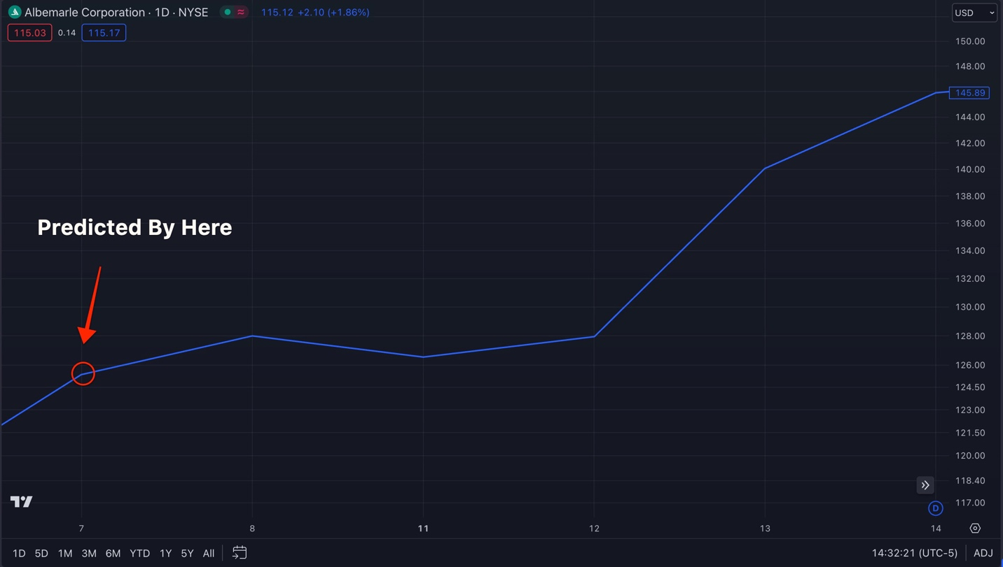
The end result?

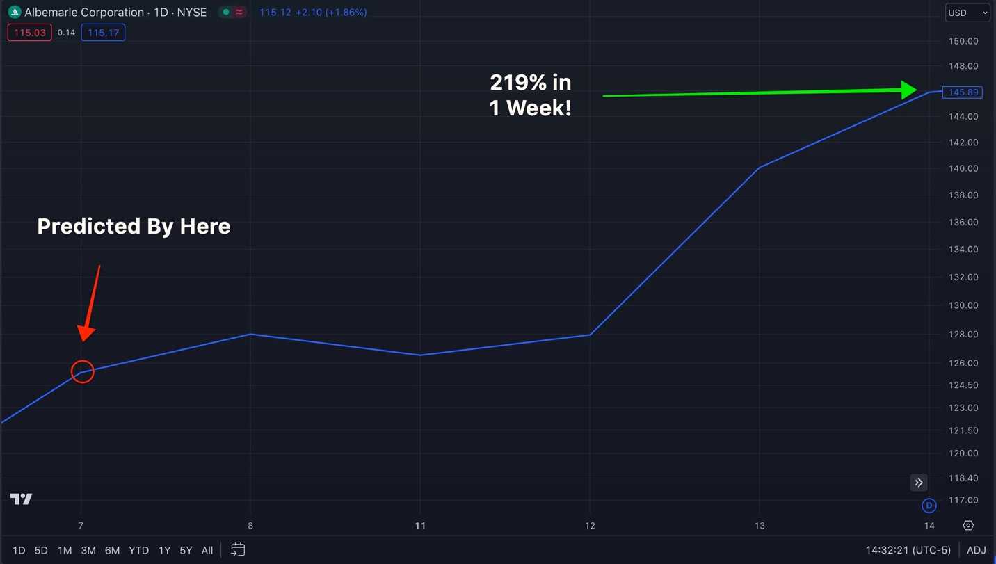

Traders could have made a special trade for a 219% gain in just 1 week!
Same with the stock PulteGroup, Inc… one not many regular investors would even know to watch…

But SAM watches everything.

And the unusual trigger came here on October 24…
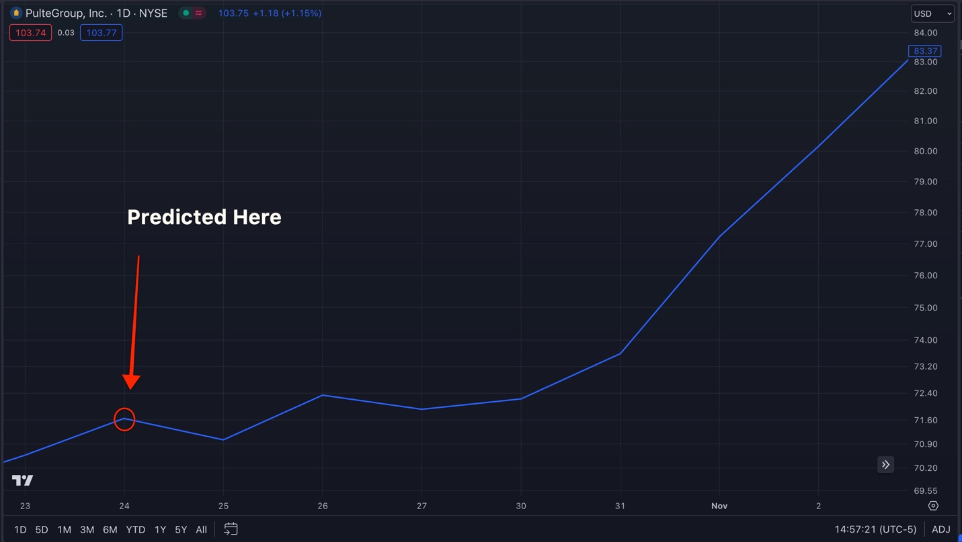
It couldn’t have been more accurate.

Stock immediately lifted off.

And could have resulted in as much as 326% gain in just 9 days...

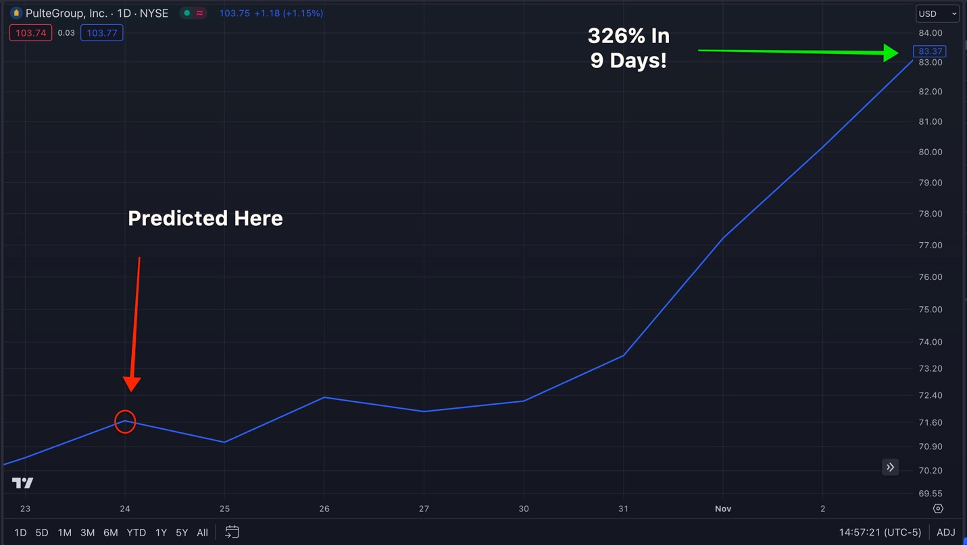
Which is enough to turn $1,000 into $4,260!

Same And look at it once again with Juniper Networks…
We actually found this example after we turned S.A.M. on and started beta testing it.
This is even more recent than our initial research!
It predicted this unusual trigger here on December 29th...
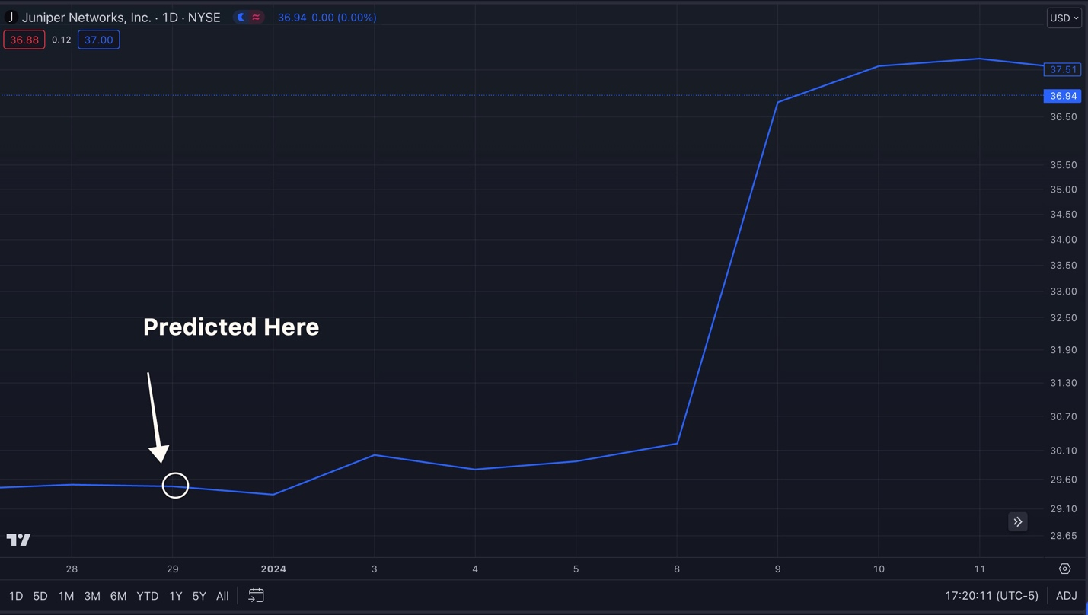
But this time, it could’ve resulted in a 2,250% gain...
Or enough to turn $1,000 into $23,500 in just 7 days.
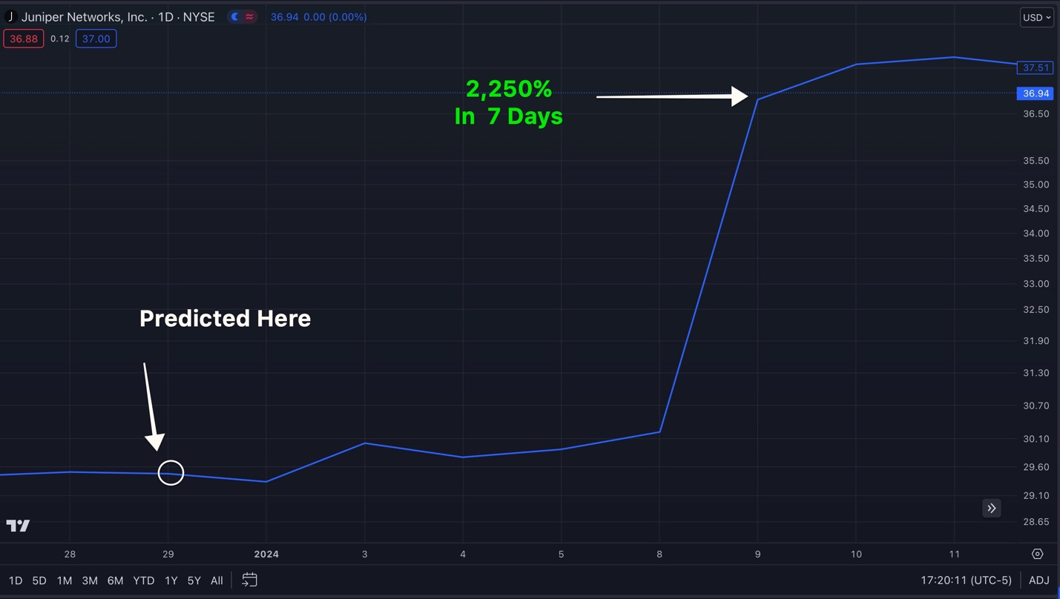
It’s truly amazing.

Now let me be clear, SAM can’t see into the future.

This is ultimately a predictive tool designed to give investors the power of AI as an edge in the market.

But this isn’t science fiction. It’s science based on a trading strategy proven time and time again.

We’re not gazing into a crystal ball, we’re searching for high-probability stock movements at a speed only AI can compute.
I never thought I’d see the day when AI truly started taking over.

But here we are…

And we must take advantage of this technology or risk getting left behind.

So that’s what I’m going to show you today.

I’ll tell you how what this unusual trigger is…

And how SAM finds it in a moment, but let me be clear about something…
For once, Wall Street ISN’T going to be the first to get their hands on this powerful tool...
We made this brand-new trading weapon so simple and accessible... that ANYONE... can use it....
Throughout history we’ve seen institutional investors pour billions into finding advantages...
That often times are just not accessible for traders like you and I.
S.A.M. levels the playing field and gives EVERYDAY traders the advantage.
Because our mission is to empower you guys *point to camera* watching at home or in the office...
Not the powerful elite...
And the mainstays on Wall Street.
This ambitious project was my way of giving back for the success that I found...
As a mere construction worker from Alpharetta, Georgia
I was just like you sitting at home...
I didn’t start off wealthy or in some plush corner office on Wall Street.
To this day...
I do all of my trading in my house next to my dog Willy...
With my wife and kids in the other room.
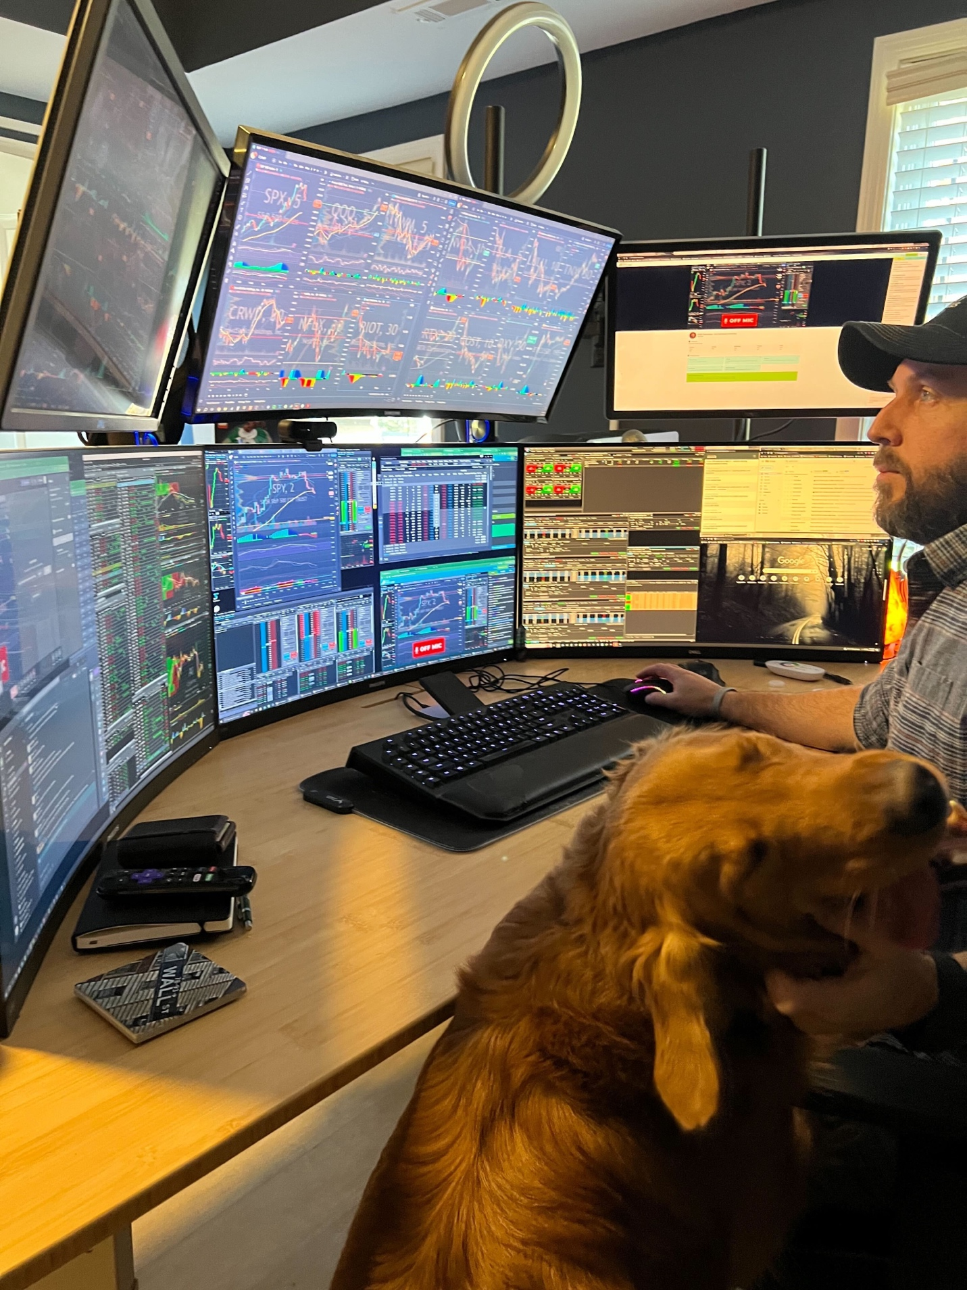
And it’s where I teach thousands of people the same exact strategies that I used to become a multi-millionaire.
But the power of A.I. trading is a complete gamechanger...
The playing field has finally been leveled...
And with S.A.M. it’s now easier than ever for people like you to find explosive trade setups
This is exactly what main street investors need in this chaotic stock market that we’ve experienced over the past few years.
Our new AI-Powered research tool,
1) Finds the perfect trade setups in real-time
2) Does it with blazing fast speed
3) And helps you perfectly time when to get in.
S.A.M. doesn’t just tell you WHAT stock to watch in real-time...
It’s helping you time WHEN exactly to get in…

And throughout our back testing, we found S.A.M. could have predicted these trade setups right an unholy 8 out of every 10 times over the past 5 years.

Just look at the profits it could have uncovered on the ticker CSGP...
To the naked eye... most people wouldn’t be excited after seeing this chart.
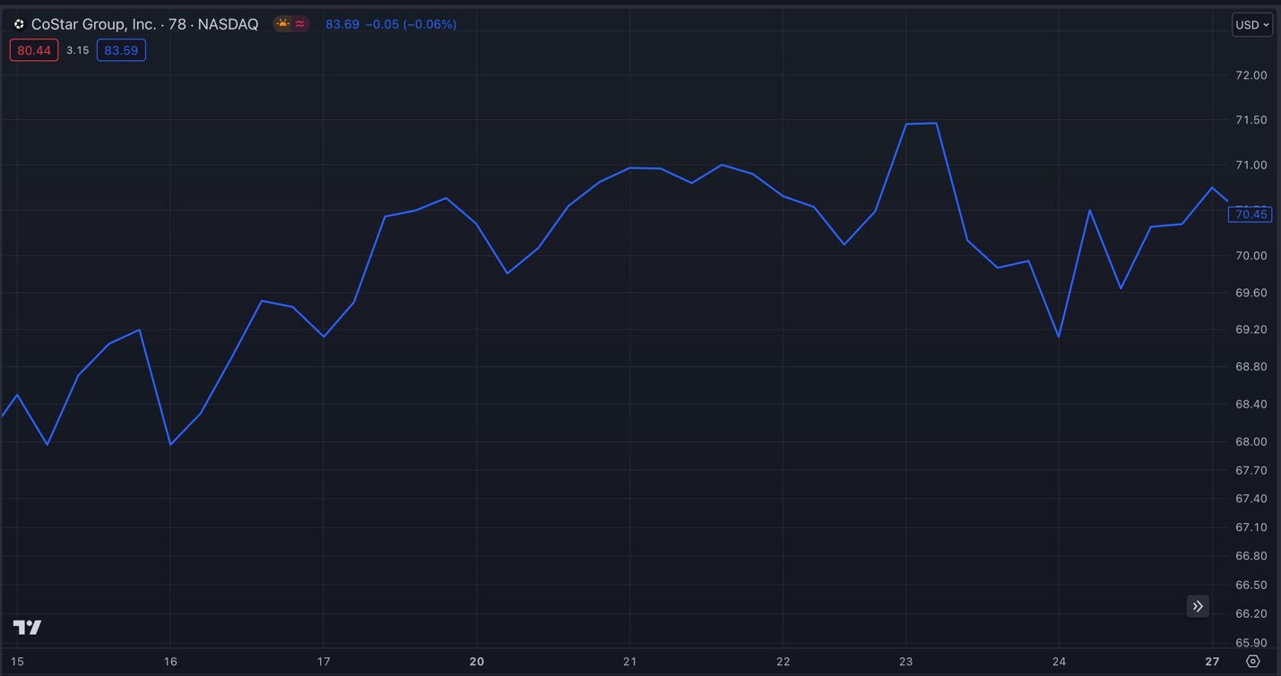

But S.A.M. spotted the trigger right there where the circle is...
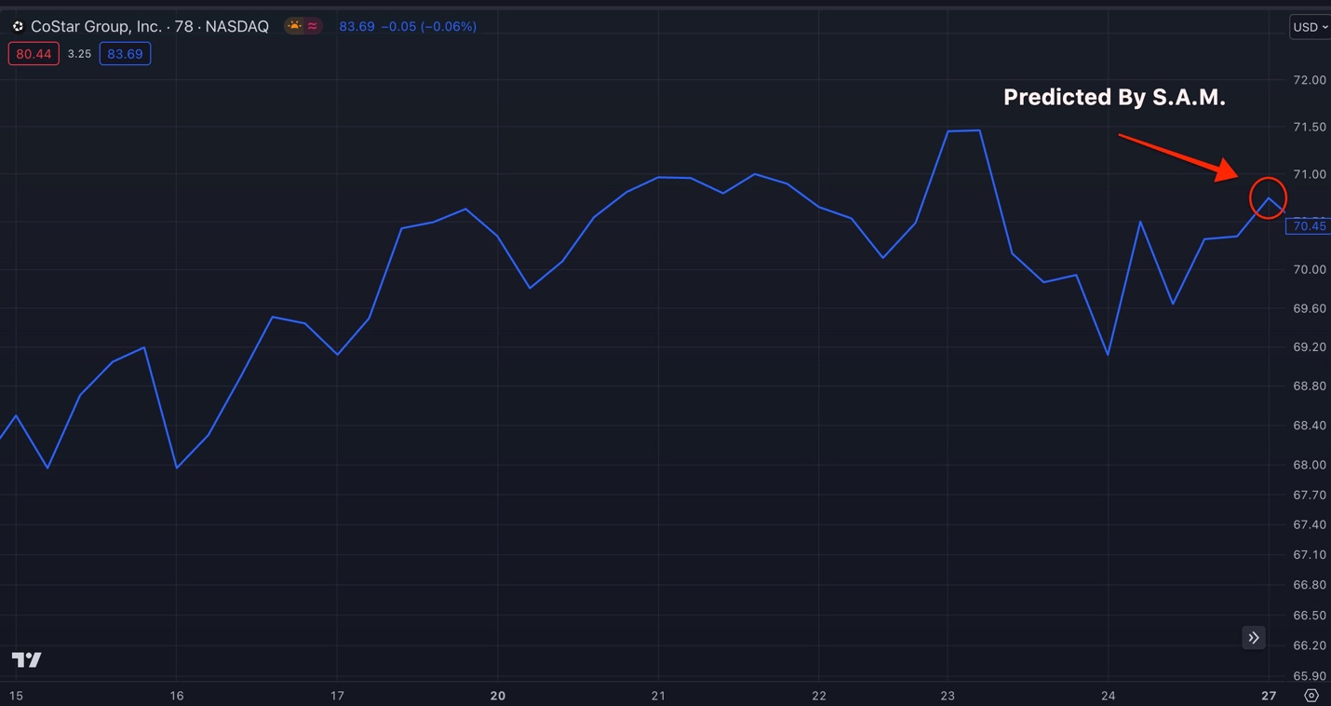
And look what happened...
It quickly surged...
Traders could have cashed out with a gain as much as 380% within 2 days....
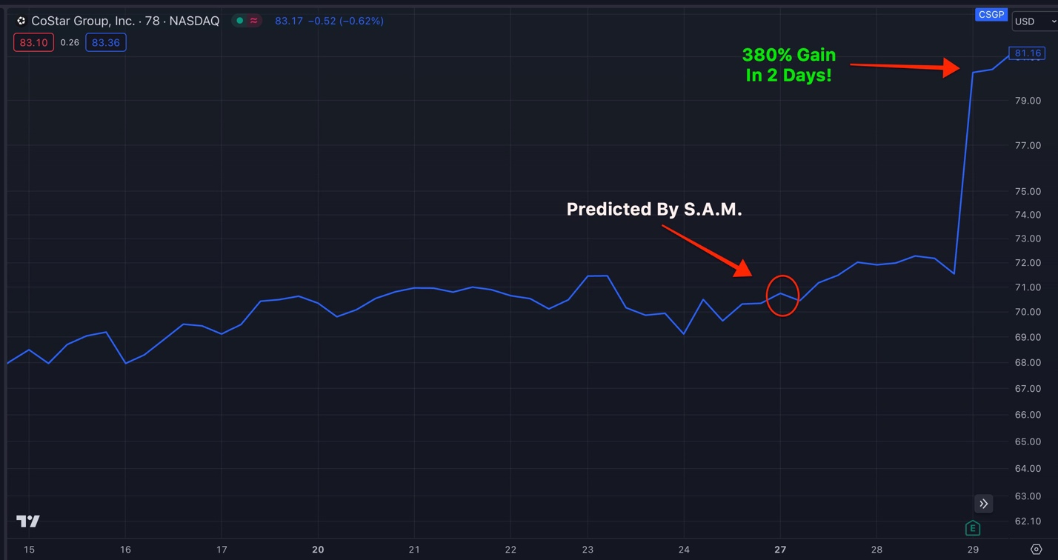
That’s enough to turn a $10,000 investment into $48,000 within just two days!
As you can see...
S.A.M. has the potential to be a REAL game changer for the everyday investor.
And it’s all thanks to the power of AI.
But before I demonstrate how you can start using S.A.M. TODAY...
It’s important to understand how it works...
How S.A.M. Finds MASSIVE Trade Setups:
From the beginning I knew this powerful new tool needed to utilize a strategy that is proven to work for everyday trader...
So we programmed the AI to use the key strategy behind my best trades.

It’s called TPS.
Which stands for “Trend, Pattern, Squeeze”...
These are 3 things I look for before every trade...

And they are extremely powerful.

In fact, within the first 10 months of opening my private trading chat room Daily Profits Live last year...
We’ve closed several triple-digit winners

Including top trades like a 260% same day winner on META...

[Chart]
A 250% winner on Carvana within 2 days...
[Chart]
And even a 295% overnight night winner on the QQQs.
[Chart]
All with my own real money.
Up until today... this was a tedious, manual process.
But thanks to the power of A.I...
It’s easier than ever to find premier trade setups...
Including what I call A+ setups...
Which time and time again, has helped me cash-in on triple-digits within mere hours or days.
I’ll explain that more during my demonstration...
But let’s first talk about the primary indicator that I use in my TPS strategy called “the squeeze”
It was first developed by legendary trader named John Carter.
And from its inception 2 decades ago, it’s become an “everyman’s indicator”…
In fact, John now trades out on his ranch in Austin, Texas with his family and pet Kangaroo...
1,700 miles from Wall Street.
He's the furthest thing from being an insider...
But that has never stopped traders like John and myself – as I trade out of a smalltown in Georgia – from having massive trading success.
Back in 2020 during all of the COVID madness...
When the entire market watched one of the most volatile trading years of our lifetimes...
John reportedly put up a 1,270% gain that year which was good for an $18.2 Million profit...
Thanks in large part to the power of the squeeze indicator.

So listen everyone… what you’re about to learn is extremely powerful.

It’s a strategy used by some of the most successful traders in the world today.
And it’s actually pretty simple...
It basically works like this.

The squeeze system measures “pressure” in a stock.

This pressure builds up and when released… creates BIG momentum that drives stocks up fast.
Take a look at this chart...
It's from an actual real-time, real-money trade that I recently made...
And at the bottom you’ll a series of dots...
They go from Green to Red.
That is the Squeeze indicator in action on the ticker Carvana...
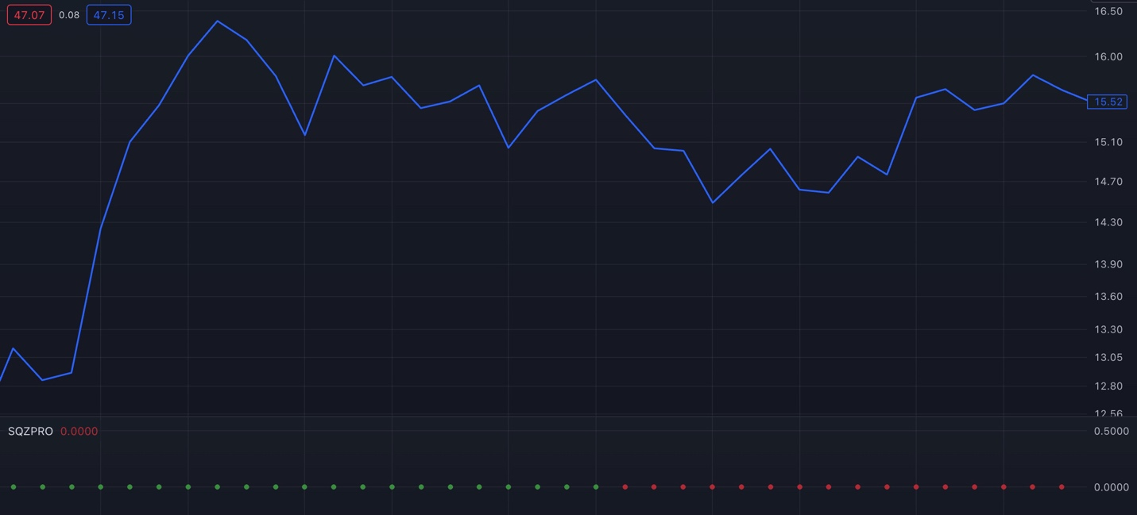
It basically measures the built up buying pressure in a stock.

Think about one of those compressed air rockets that you or your kids may have built in science class when you were in grade school...

They work by pumping up a tank up with air and creating lots of pressure.
Then once you pull a trigger...

All of that pressure releases...
Propelling your paper rocket high up into the sky.
We see a similar effect with stocks...
When a stock moves down...
It builds price compression...

Then buyers start putting in orders because the stock is available at a better price.

Now… this is key.

The more buyers who move in… the more pressure builds for the stock to move upward.
And when that buying pressure releases, the stock blasts off.
With my TPS Strategy...
I want to enter a trade when a stock is at its maximum compression...
BEFORE it bursts higher.
Not too early...
Not too late...
Let’s pull up that Carvana chart again...
If you look right where the arrow is pointing, you can see the colors change from green to red.
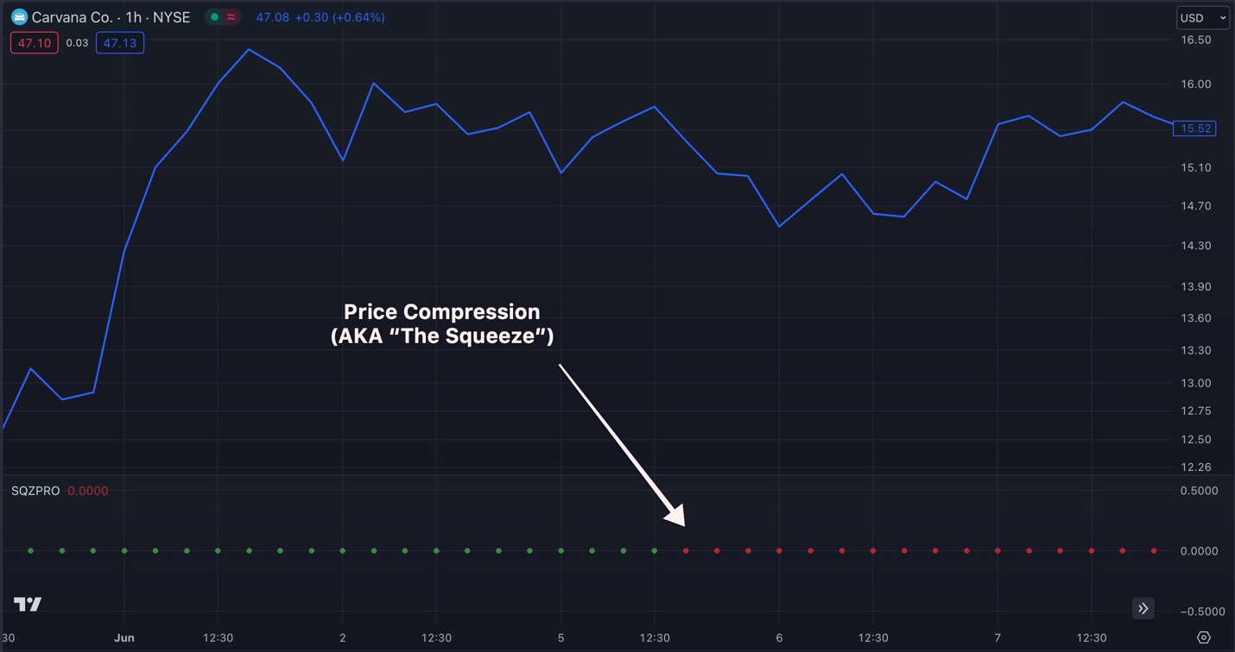
That’s the price compression or “squeeze” that we are looking for...
And after I discovered this setup...
I got into the trade.

Remember, I was tracking trades like these manually, so I wasn’t able to get in instantly.

I got into the trade about a day after the squeeze hit.
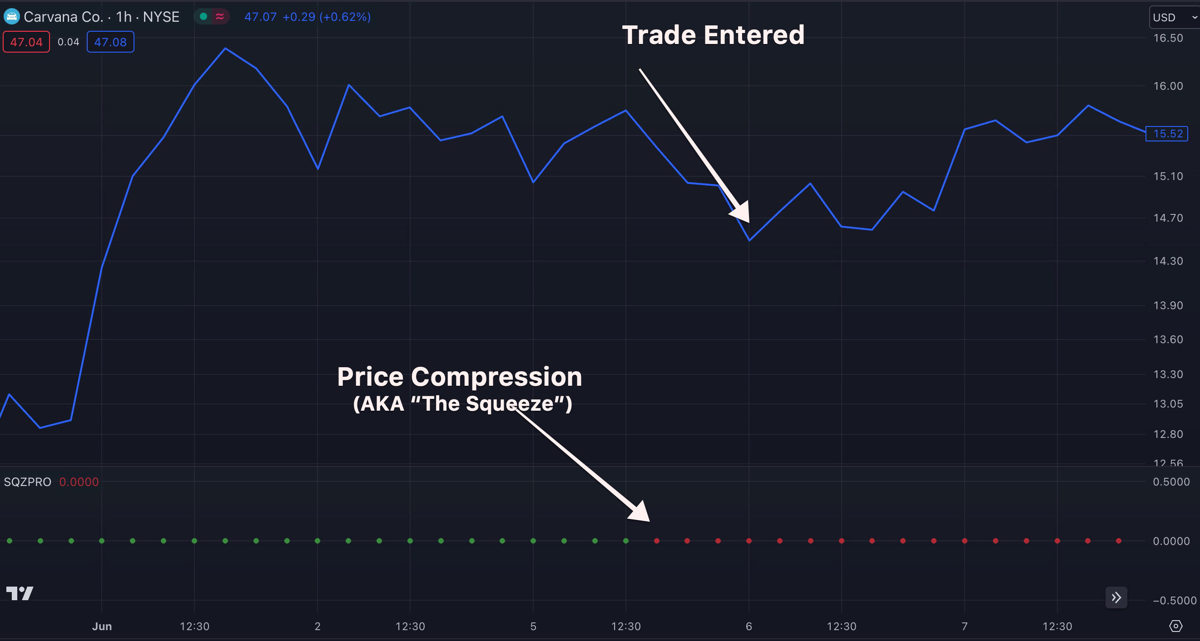
I’m glad I wasn’t too late because just 2 days later....
Look what happens...
Just like opening up a soda right after it’s been shaken up...
We see the stock EXPLODE upwards...
And I was able to close this trade out for a 250% gain...
Enough to turn $10,000 into $35,000!
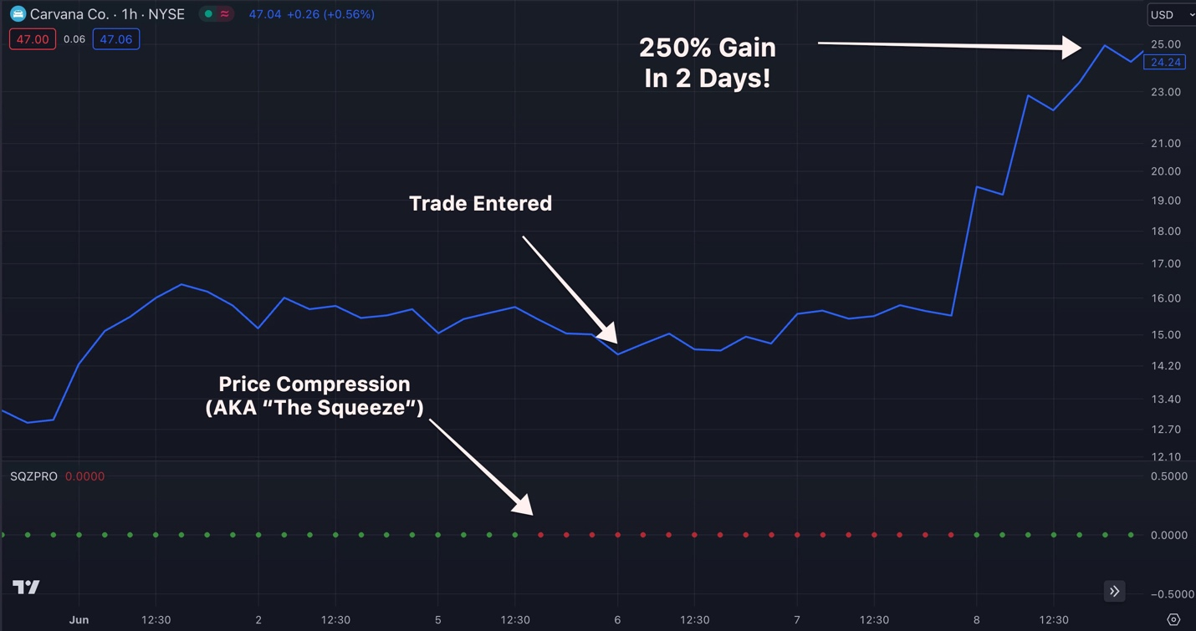
In short,
The Squeeze tells you when to enter a trade once the stock’s price starts to compress...
AND when to get out of the trade before it loses compression.
When I see a red dot, I know that a stock has enough pressure to explode higher... for big gains.
This is one of the key reasons I was able to turn $37k into $2.7 Million in just 4 years.

It's a strategy I personally follow and have enjoyed a lot of success with.

It’s changed my life.

It’s solidified my family’s financial future.

But the best part is...
It’s not just me who is cashing in on big wins by following the squeeze...
Some of my top students within my private trading chat room have been bringing in MASSIVE gains...
Like Phil who was able to make 450% on a Carvana trade within just a few hours...
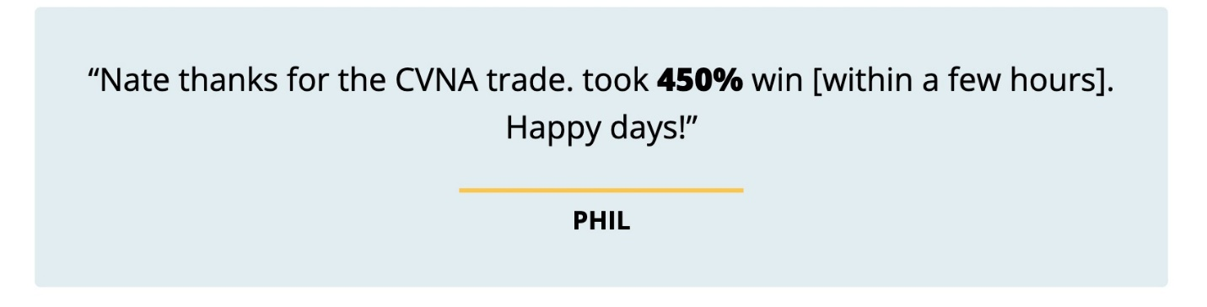
Or Ted who made 209% on a NVDA trade within just 40 days...
“Bought NVDA.... Sold for a 209% gain [within 4 days]. Thanks Nate” – Ted
Or Steve who he wrote in after he beat my official trade recommendation with his first 1000% gain... on the GOLF COURSE!

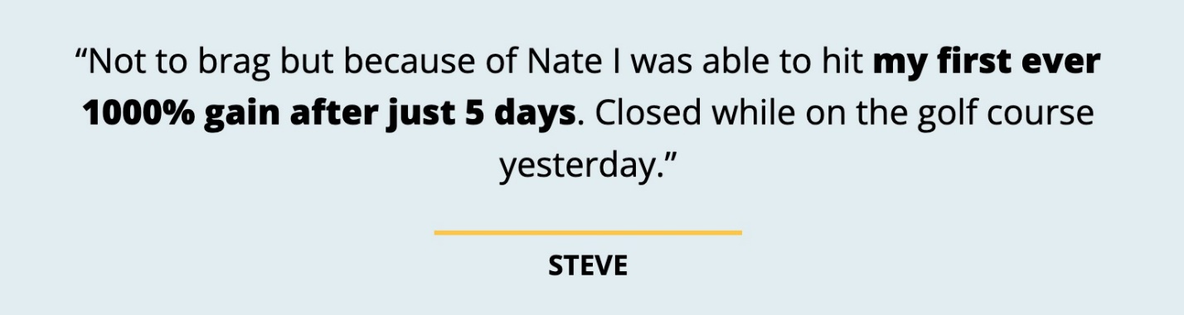

I love seeing everyday investors like these students of mine take home MASSIVE profits...
But now… the profit potential is about to get SO MUCH BIGGER.

Because before, I had to find all of these TPS setups manually. By tracking dozens of stocks on my six trading screens all at once.

Doing this worked… but it limited our opportunities.

But AI now changes all of that.

With the introduction of S.A.M...
This process has never been easier thanks to the power of AI.
Starting today you will be able to find trade setups like these automatically.
This is the next step in the evolution of trading...

And I can’t wait to demonstrate the power of S.A.M.’s artificial intelligence today.
Wall Street already understands the profit potential that A.I. can unlock...

They’re investing BILLIONS into AI programs.
According to Stanford Institute for Human-Centered Artificial Intelligence...

Companies across America are projected to invest over $68 Billion into AI in 2024 alone...
Goldman Sachs by itself has already hired 1,000 A.I. developers...
A number that they expect to expand to 12,000 by the end of 2024.
Tractica Research says..
By 2025, trading will be the #1 A.I. use case that companies will invest the most in..
And according to research by market intelligence firm AlphaSense...
There has been a 383% increase of the term “AI” in corporate earnings reports, press releases and other public filings.
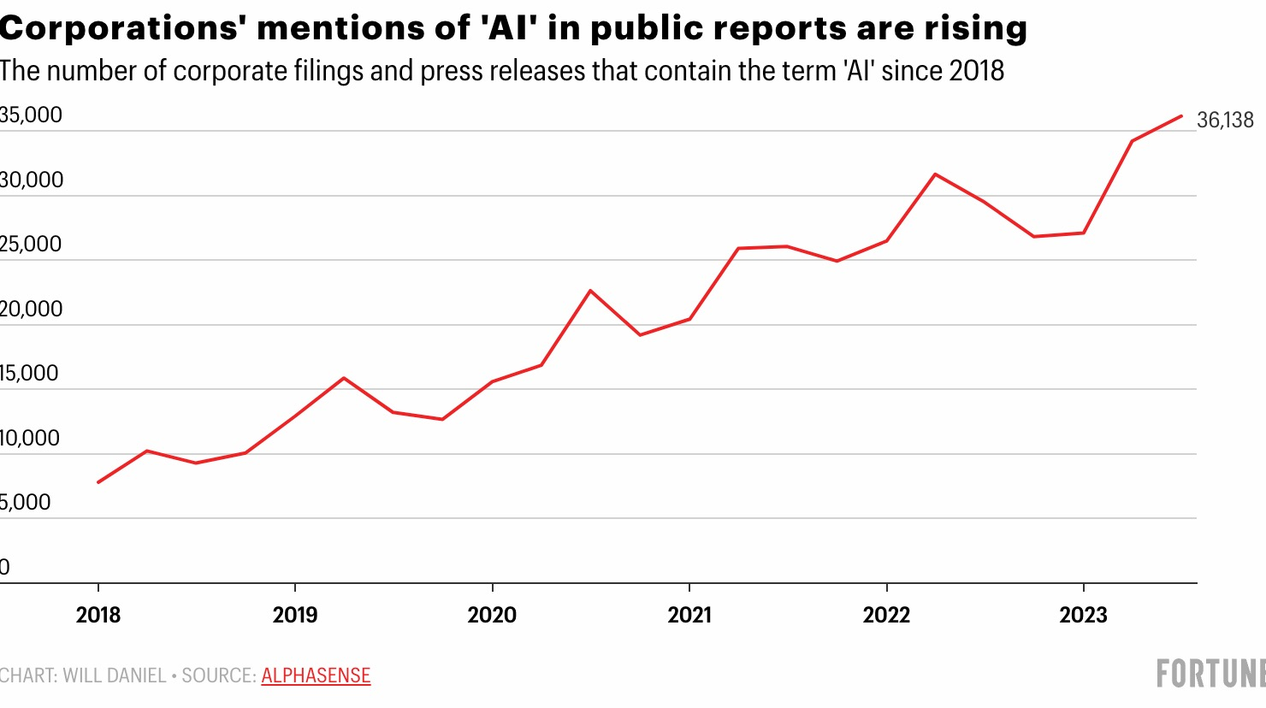
Wall Street always wants the best information on the next great windfall opportunities...
But most importantly they want speed...
Because they know that the faster you can make smart trades...
The faster you can rake in the profits!
But there’s one major problem...

Now Is The Time To Escape The “AI Wealth Gap”

The average everyday investor is getting left in the dust.
And if you think about it, it makes sense....
Most people don’t want to learn how to code...
They aren’t going to hire their own developers...
Or invest in some expensive new AI technology that hits the market like Wall Street can...

Well, you don’t have to… because we did it for you.
In fact, in 2023 alone we spent $1.8 Million to make S.A.M. a reality.
To put that in perspective...
According to Georgetown University...
The average American will make $1.7 Million from their jobs over the course of their entire LIFETIME...
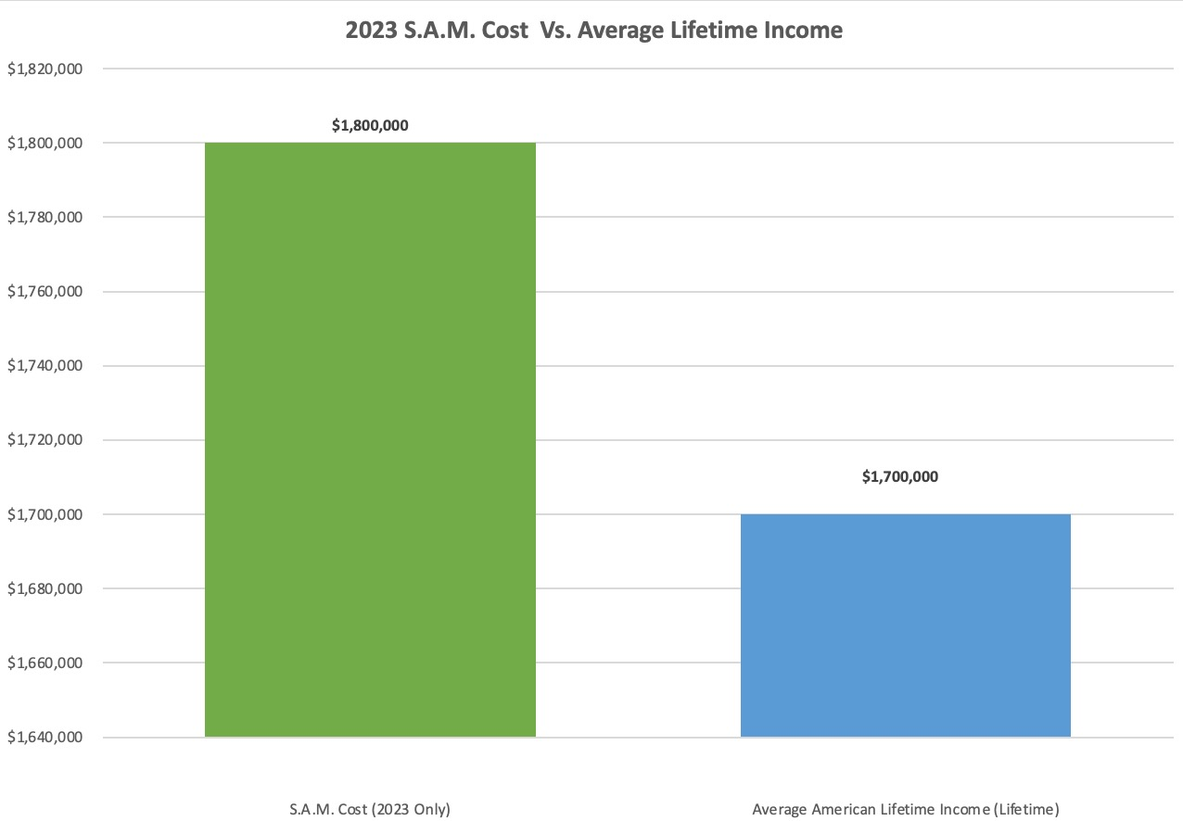
And that’s just the beginning....
We’re expecting S.A.M. to cost us several million per YEAR to maintain, upgrade and cover the massive amounts of data costs.
What we’re putting into S.A.M. is totally worth it in spades.
But you can see how this have versus have-not problem is creating what some experts are calling the “AI Wealth Gap”...
Between those who are able to get rich from A.I… and those who won’t.
I’m extremely worried about the people who fall behind. My fear is they’ll never figure out the new financial world that we live in.
We’re seeing this gap widen every single day.
Until today, most everyday folks simply haven’t been able to afford to take advantage of the lucrative AI trading profits that Wall Street has access too.
And the reality is...
Over the next 12 months, the AI wealth gap is only going to grow larger and larger...
As AI becomes exponentially more powerful.
If everyday investors don’t jump on this powerful new technology,
They will find themselves left in the dust.
This is why we built S.A.M...

It's for our passionate community to experience together…
And to share in its power together.

To close that wealth gap…

And grab a trading advantage like no other.

Just look at what S.A.M. would have spotted on Whirlpool back in June...
Here S.A.M. spotted momentum building on the ticker right before the market closed...
Right below the chart can see the squeeze indicator light up red...
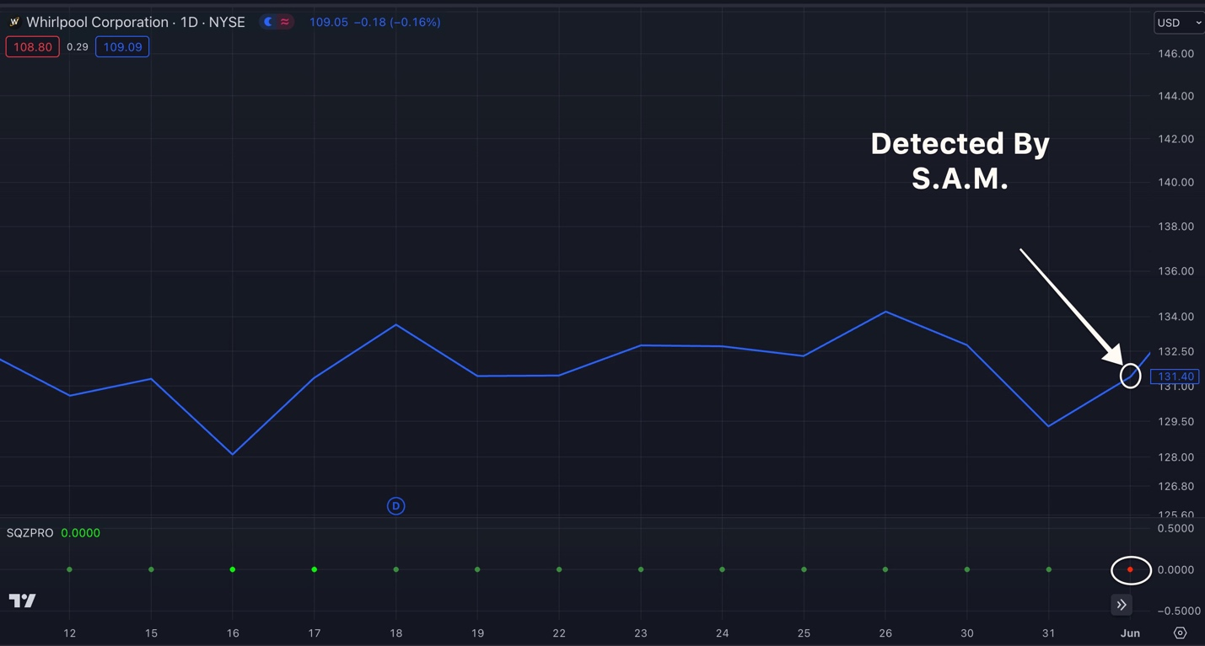
And within 6 days the stock shot up...
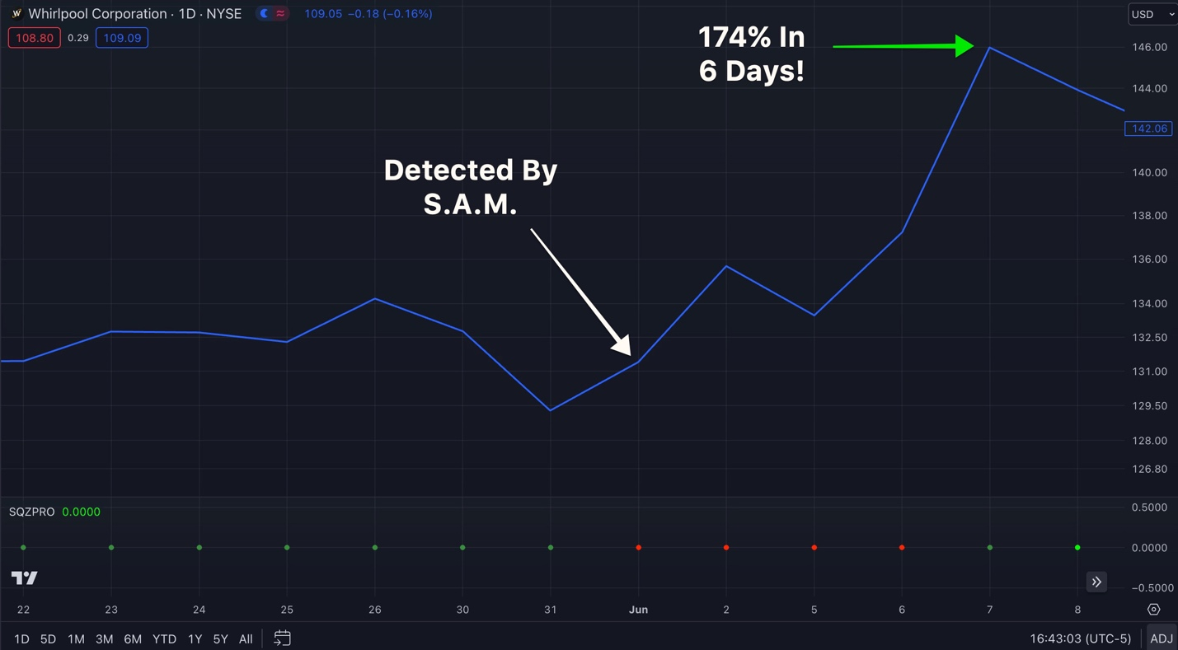
With excellent timing this could have given investors a chance to cash in for 174%!
Enough to turn $10,000 into $37,400.

Or how about this move on First Solar from February.
You can see the squeeze form on a Friday Afternoon where the red dot is circled...
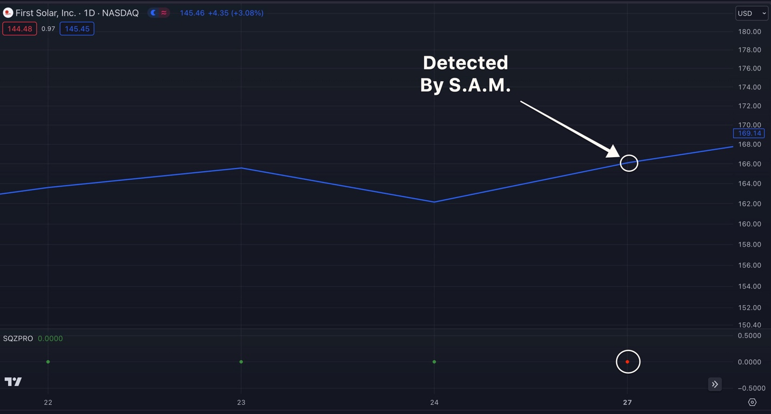
And sure enough just a few days after it was detected...

The pressure released and the stock shot up...
Giving investors an opportunity to bring home a 187% peak gain...
Enough to turn $10,000 into $ 28,700 in just 2 days!
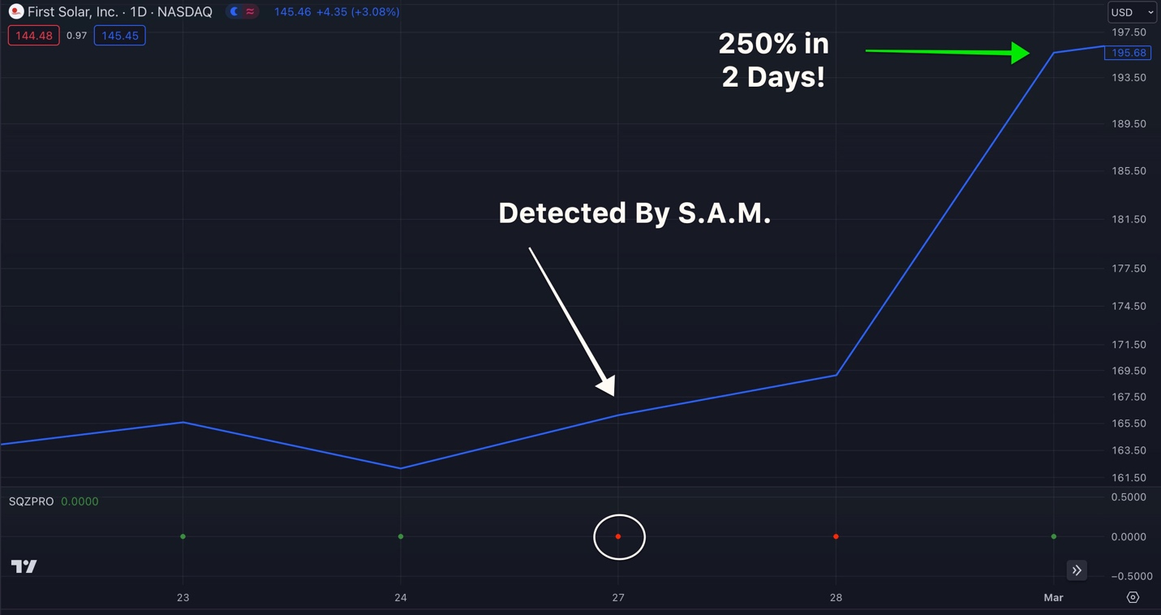
Here's one more...
This time it’s on Target from back in November.

And it’s a great example of how S.A.M. can find fast plays that take a few hours or days...
As well as slower plays that take 2-4 weeks...
Here our A.I. tool would have spotted momentum building right there where the arrow is pointing...
Right when the squeeze started forming...
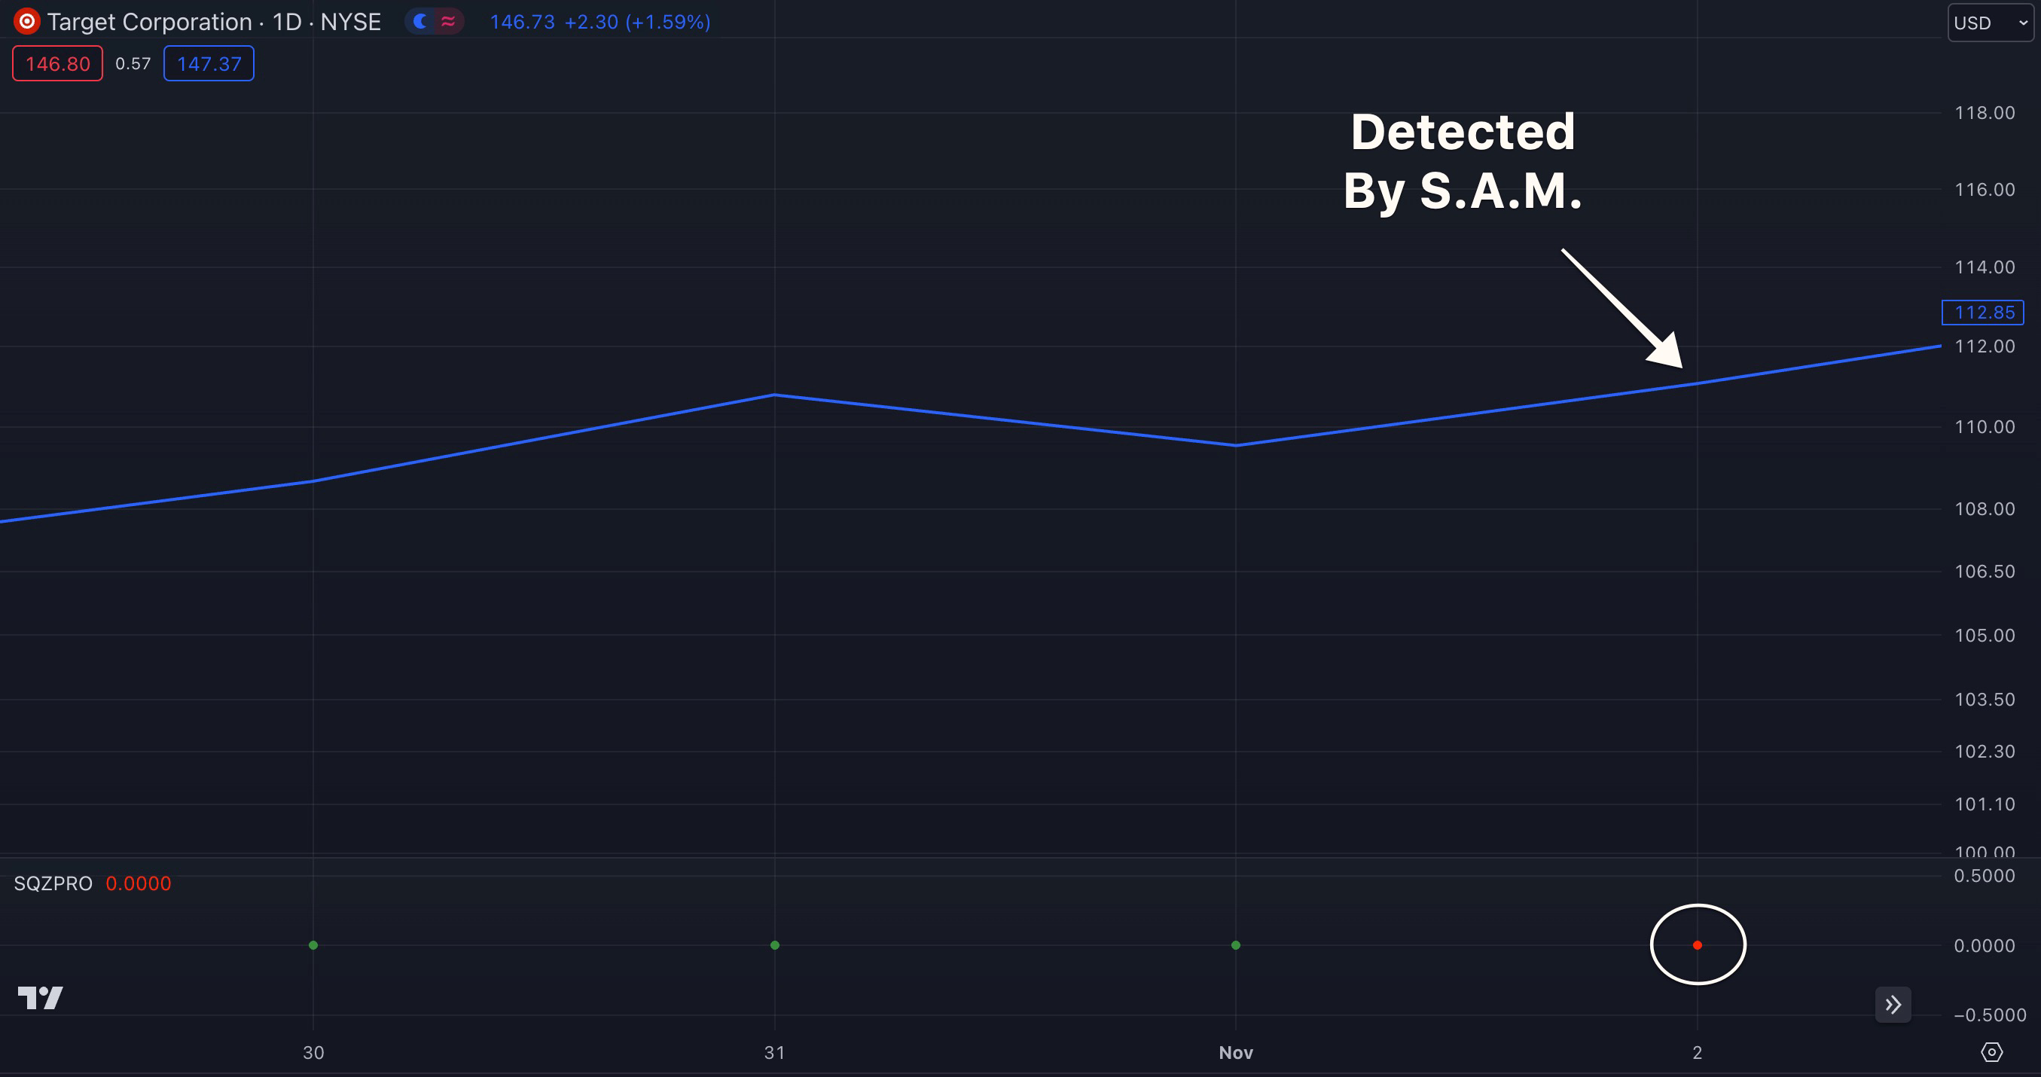
And 13 days...
The stock surged giving investors an opportunity to make up to a 322% gain....
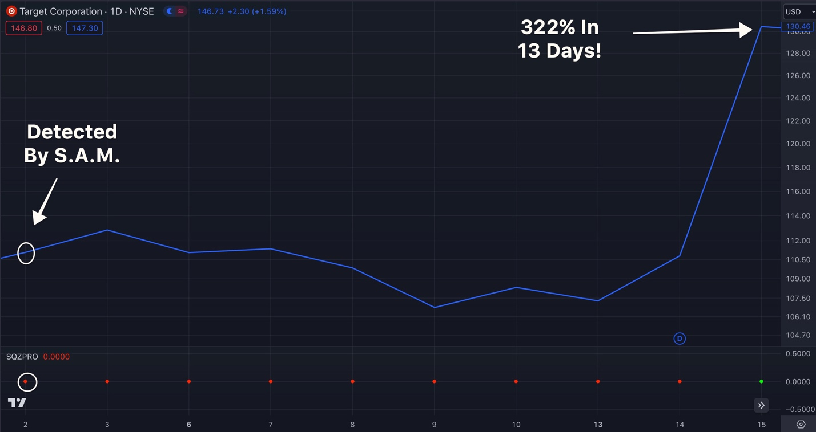
Enough to turn $10,000 into $42,200.
All thanks to the power of A.I.
Notice how in every one of these examples, S.A.M. automatically found the stocks with a squeeze and predicted it’s move up.

That’s what’s so exciting about this.

We built S.A.M. to track a single trigger that leads to these major jumps in the share price.

And with profit potential this great…
It’s time for everyday traders to take the power away from the Wall Street institutions and start experiencing AI-powered profits.
Gang, we didn’t just want to build something that was completely useless like many of the AI tools out there today…
With a project this big...
We weren’t going to just send this project off to some rookie coder or some shop overseas...
We teamed up with a proven developer and former head of trading software from New York who spent nearly 10 years doing quantitative research on Wall Street...

The perfect person for this endeavor.
He’s brilliant. Yet he’s a salt-of-the-earth American patriot too, who now spends his weekends volunteering for the U.S. National Guard.

This guy not only understands exactly how Wall Street uses this powerful technology...
But also, how my trading system works and how to program it using A.I.
Most importantly, he understood more than anyone that S.A.M. needed to work for the average reader at home.
We built S.A.M. to work with the same proven trading strategy I used to turn $37k into $2.7 Million in 4 years...
And now it can find these same powerful moves...
It can do so much faster than any human can.

1,214 Profitable Trades Setups PER Year... Using the Power Of AI!

So the biggest question you likely have is… “how well does it work?”

Well, let me give you the data.

First, we had S.A.M. take all the stock market data in 2023 and comb through it looking back for TPS trade setups.

To show the maximum profit potential with this tool, we calculated these examples in our backtest by getting in when the squeeze was first spotted and out when the trade hit it's peak.

In total, our data shows that S.A.M. would have found 1345 bullish stock and options trades.

And 1,068 of them saw the stock surge... s

The average setup lasted just 10 days.

And win-rate was 79.41%.

Truly remarkable.

But we wanted to go further.

We wanted to see how S.A.M. would have performed in down markets like 2022 and bull markets like 2021.

We wanted to see how it would perform during crashes like the Covid crash in 2020. And pre-Covid as well.

Here were the results.

Looking back at the data from the past 5 years...
8 out of 10 squeeze setups it found were followed by a stock surge....
In fact, rigorous testing shows S.A.M. would’ve found as many as, 1,214 profitable trade setups... PER YEAR!
Think about that...

That’s 5 winners per day!
Some investors who are lucky to see 1 winning trade in a single month!
Now look, let me be clear...
I’m not saying folks should go out and try to make 1,214 winning trades in a year...
If you can.... then GREAT...
But, that’s A LOT of trading and it would’ve required excellent timing and a lot of luck to see the wins I’ve shown you today.

Some people might want to make just one trade per day… others maybe one per week

Some might want to just paper trade and follow along ...
What S.A.M. does is looks for explosive trade setups within the market at a lightning-fast rate.
It’s up to you to do your research and decide when it’s personally the right time to enter and exit any trade
Nothing in trading is guaranteed and individual results will vary. You should never trade with money you can’t afford to lose.
But the point is…
When you can have AI working for you to find explosive trade setups setups all the time…

You want that AI on your side!
Not only does S.A.M. automatically scan all of the stocks in the S&P 500...

Pinpointing opportunities to profit in both the long-term AND the short term...
It also tells you the direction a stock has been moving...
So that you know if you’re looking at a bullish or bearish setup...
AND with just one single click it allows you to open a chart so you can quickly look to see if a pattern is forming.
Just to recap, with S.A.M. you can:

- See all of the active squeezes across all S&P 500 stocks...
- See the direction of every stock’s momentum...
- AND give investors an opportunity to analyze it’s chart before making a trade
All on one single screen!
You don’t even need to plug anything in or touch any code.
You literally open the page and instantly browse the trade setups.
Best of all...
It operates at lightning-fast speed.
In fact, S.A.M. is capable of scanning the market 5 MILLION times... PER SECOND

It would take a human.... year or even decades to go through all of that data just ONE time...
And by then nearly all of the information would be hopelessly outdated.
That is the power of A.I.

And it’s why the AI Wealth Gap continues to grow larger and larger everyday...

Wall Street firms have BILLIONS to invest in tools that allow them to profit on stocks...
Before investors can even blink.
And if you look throughout history...
Time and time again...
The market has been shaped by the pursuit of speed.
Like in the 17th century when we saw the establishment of the Amsterdam stock exchange...


It was the first time in history where people had ONE place to go to trade with one another...
The speed of stock trading took an enormous leap.
And in the 19th century...
We saw the invention of ticker tape on Wall Street....
-
Which meant simple information like stock prices or volume wouldn’t need to be delivered by hand or even carrier Pigeons...
And then of course, more recently in the 20th century we saw the adoption of online trading...


Which made the stock market accessible to virtually anyone in any place around the world...
Just with a few clicks on your computer or phone.
And with the introduction of A.I. powered tools like S.A.M.
We’re seeing the next generation of trading...
And just like the pigeon keepers and the traders who use to work the pits on Wall Street exchanges back in the day...
Those who don’t embrace the changes... will be completely left behind.
It's critical that you guys watching at home understand that.
And that’s why S.A.M. really couldn’t have come at a better time for everyday investors...
Especially with the growing AI Wealth Gap.

And what’s key here is that this AI-powered Daily Profit Scanner doesn’t require you to have some PHD in programing or an MBA to be able to use.
In fact, let me pull up my screen so I can show you how it works...
S.A.M. In Action
Here we are...
This is S.A.M.
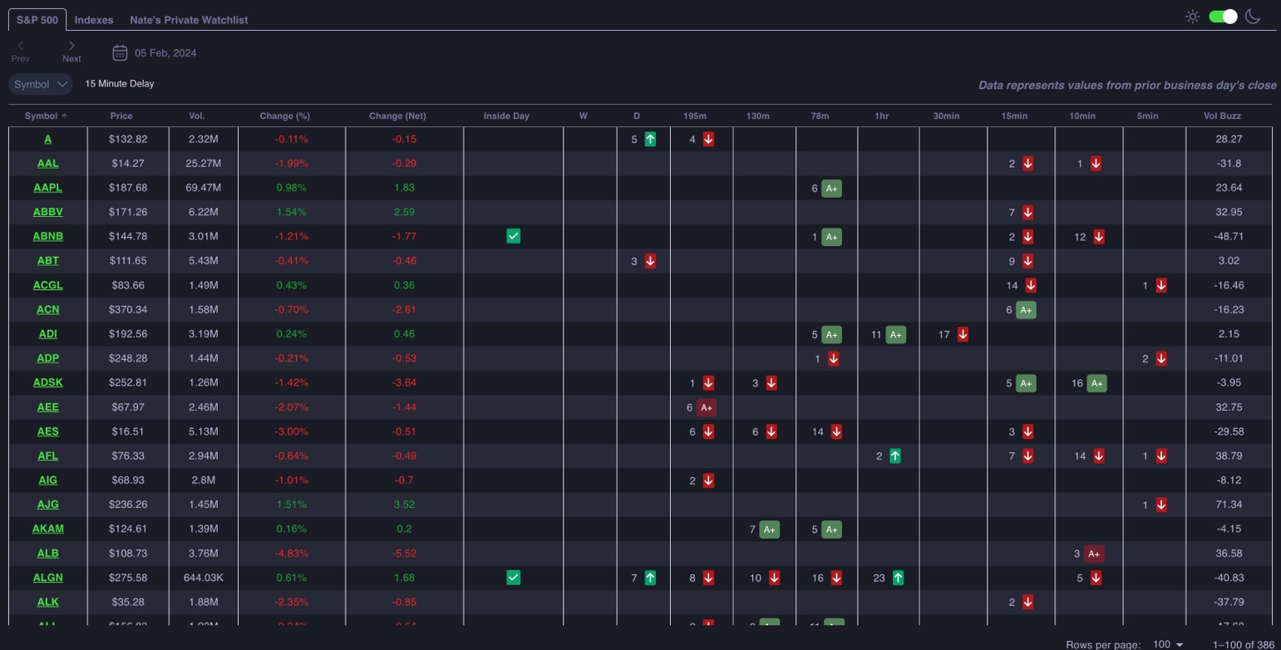
Now if this looks intimidating at first glance...
Don’t worry...
I’ll explain how easy this is to read in just a moment...
But one thing that is important to understand is that unlike most stock scanners that most people use...
Thanks to the power of AI....
You don’t have to enter any criteria....

S.A.M does it for you!
Once you open the software on the left,
You’re going to immediately see all of the active squeezes happening with S&P 500 stocks, as well as the 6 top index ETFs across different frames...
With S.A.M. you have the ability to look for both fast profit opportunities...
And longer-term profit opportunities...
And each column represents a different time frame.
When a stock is in a squeeze, it’s reflected with a single number.
Those are what I call squeeze scores...
And it represents how long a squeeze has been active...
We want to get into a setup as fast as we can... preferably if the squeeze number is 10 or under.
When this number hits 15 or 20... we’re likely too late.
So we want the number to be low.

Let’s look at a recent top example found by S.A.M. on the ticker JNPR at the end of the year...
We can see that the squeeze score in the daily column is 1 ... nice and early.

The squeeze has just begun.
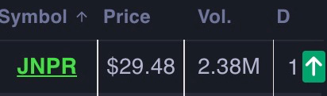
A squeeze score of “1” is great and it means that we have a new squeeze and right next to this number you’ll see a green arrow...
This reflects that this stock also has positive momentum.

In other words, its heading up.
In short, when the arrow turns green, that means S.A.M. predicts an opportunity.
So to recap...
If I we see squeeze score of 1 inside the daily column...
That tells me the pressure is now releasing and the stock is beginning its upward move.
This is the best time to buy.
And here if we pull up a chart of JNPR stock...

You can see the squeeze happening in front of us...
S.A.M. detected the squeeze right here...
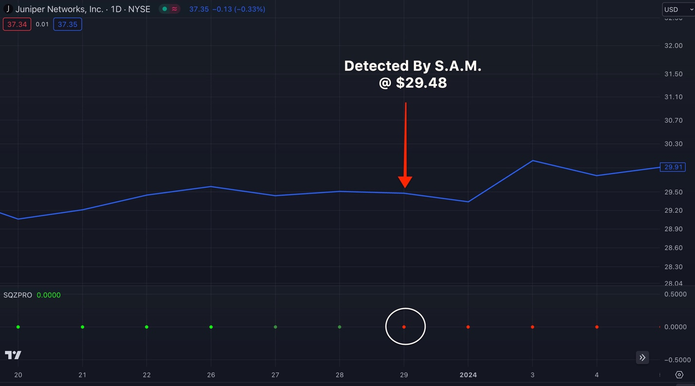
And sure enough...
Over the next week…
The stock exploded 25% higher!
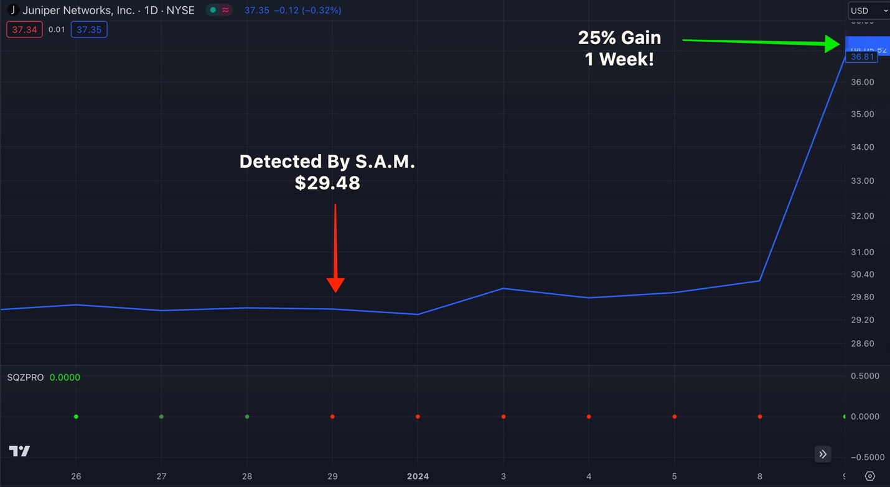
Imagine kicking a new year off by beating the S&P 500’s 2023 returns...

During the very first week of the year...
Talk about a hot start!
In fact, historically over the past 174 years...
The S&P 500 has exceeded a 20% annual return about once every five years.
But with just one squeeze setup...
On ONE ticker...
S.A.M. could have helped you capture an entire year’s worth of gains...
After just the very first week of the year.
And here is the best part...
25% isn’t even scratching the surface in terms of how much you . could have made you on this very same play...
Let’s walk through a couple more quick examples...
This time let’s look at ticker symbol PHM on October 24th...
Right when S.A.M. would have detected a on the dailies.
The squeeze score of 1 tells us that this fresh squeeze just began...
And the upward green arrow tells you the stock’s momentum is trending up and should move higher.
Which is great ...
Remember, we want to get into trade setup as soon as a squeeze starts...
And the momentum arrow is green.
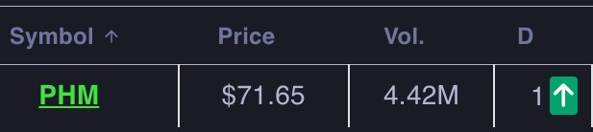
In the case of PHM...
You can see where the squeeze would have been first detected by S.A.M.
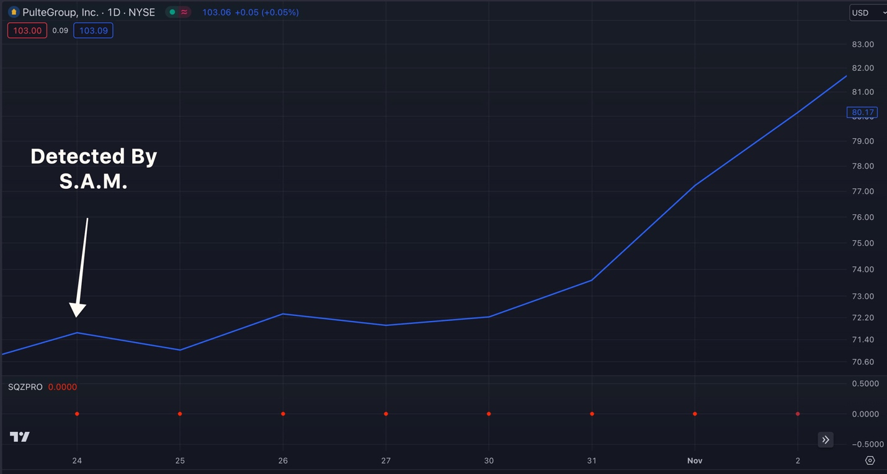
Then just 9 days later...
What do you know...
BAM! The stock gapped up 12% within just 9 days!
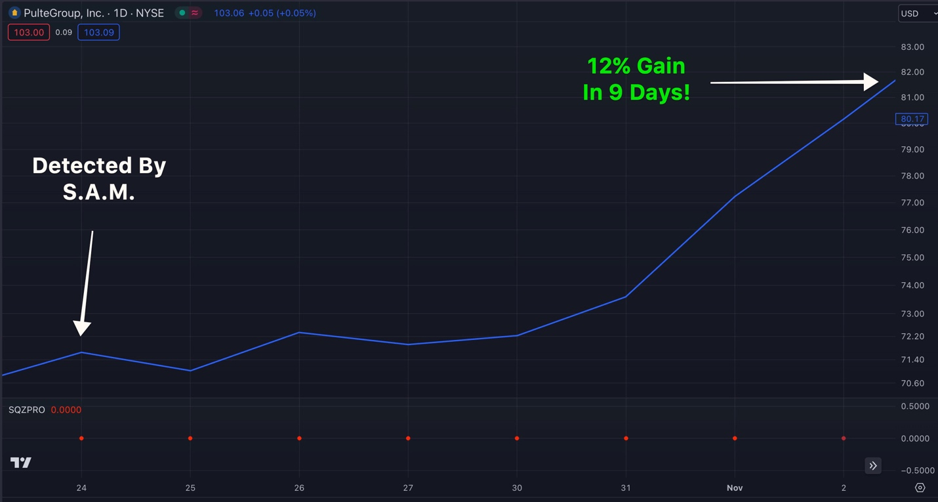
And remember...
In just moment I’ll show you how this could have been supercharged into as much as 326% gain during the same period of time!
But let’s take look at one more top example first...
Take a look at this ETSY setup from November...
Here we see a squeeze score of 2 on the daily time frame which means there has been an active squeeze for 2 days
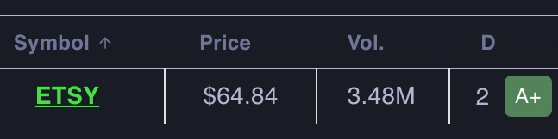
Which is still an excellent opportunity to enter the trade.

Lots of time left for this stock to run.
But now with this one... you’ll notice one thing different.
Instead of an arrow, you’ll notice an A+ next to it...
That not only means the stock trending up...
But based on S.A.M.’s proprietary algorithm it has also determined that the stock has a a higher probability setup...
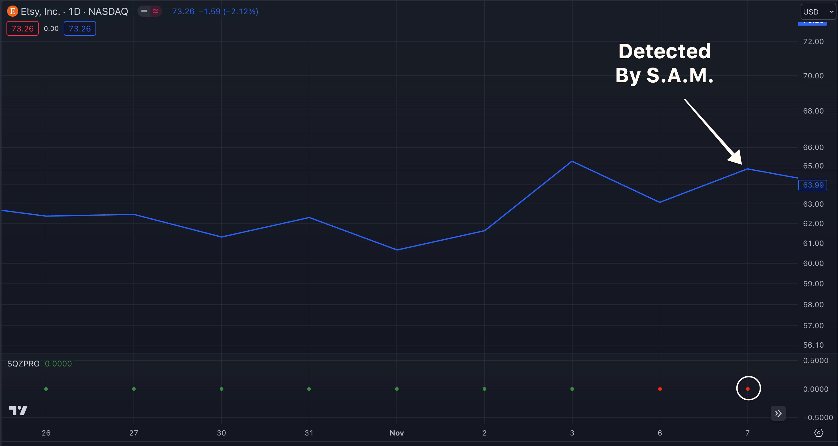
And sure enough, it exploded for an 11% gain over 8 days!

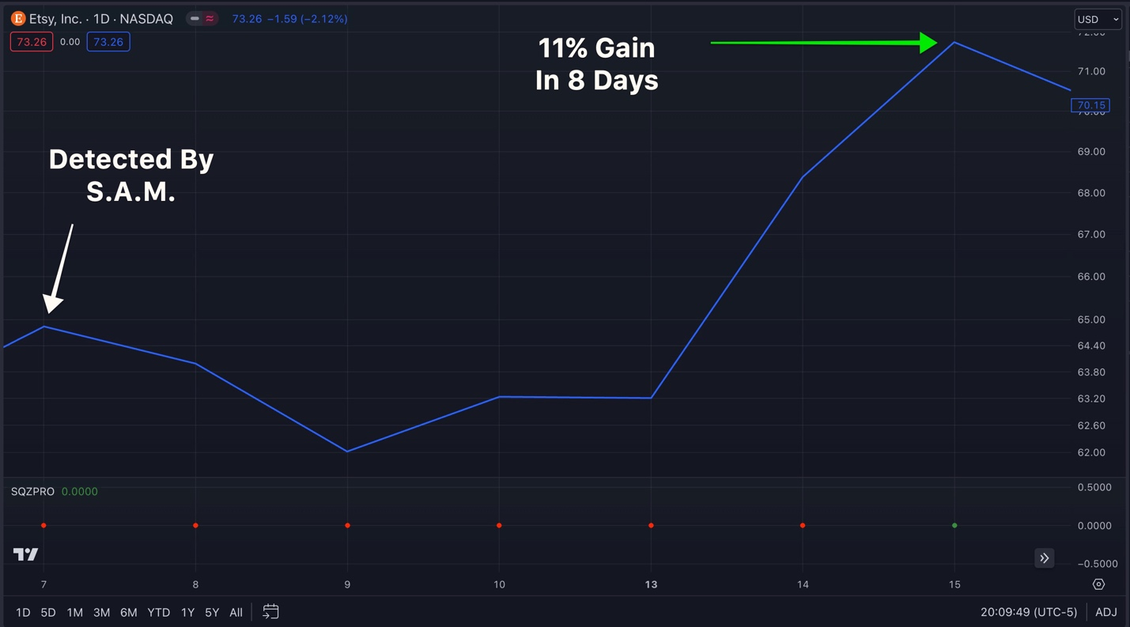

A+ indeed.
But remember, the 11% gain was just on the stock.

We could have actually supercharged this 11% gain...
And made even MORE money...
Super Charging Your Profits Using S.A.M.
You see…
When I trade I always boost my profits using the power of options...
And look…
I know a lot of people are scared of options and they view them as super risky.
But like anything in life… they are risky if you use them the WRONG way.
Heck… lots of people think stocks are less risky than options… but starting out I lost all of my money on STOCKS three separate times.
Yes, options are more volatile, but they give you a huge advantage over stocks...
They allow you to put less money at risk while also targeting higher gains.
And it’s how you’re able make triple or even quadruple digit gains within just mere days, as demonstrated by all the great examples I've shown you today.
With stocks… that would be almost impossible..
But if you use them correctly, like by using them with the power of S.A.M. you can actually win with potentially massive gains.
In fact, options were critical to turning $37K into $2.7 Million for me. Without options, that would have never happened in 4 years.

Here’s the great thing about the way I play options with the help of S.A.M…

All it takes is a small move upward to become big winner.
When a stock surges just 5%, 10%, you can target massive, money-multiplying wins.
Let’s take that 11% winner on ETSY I just showed you...
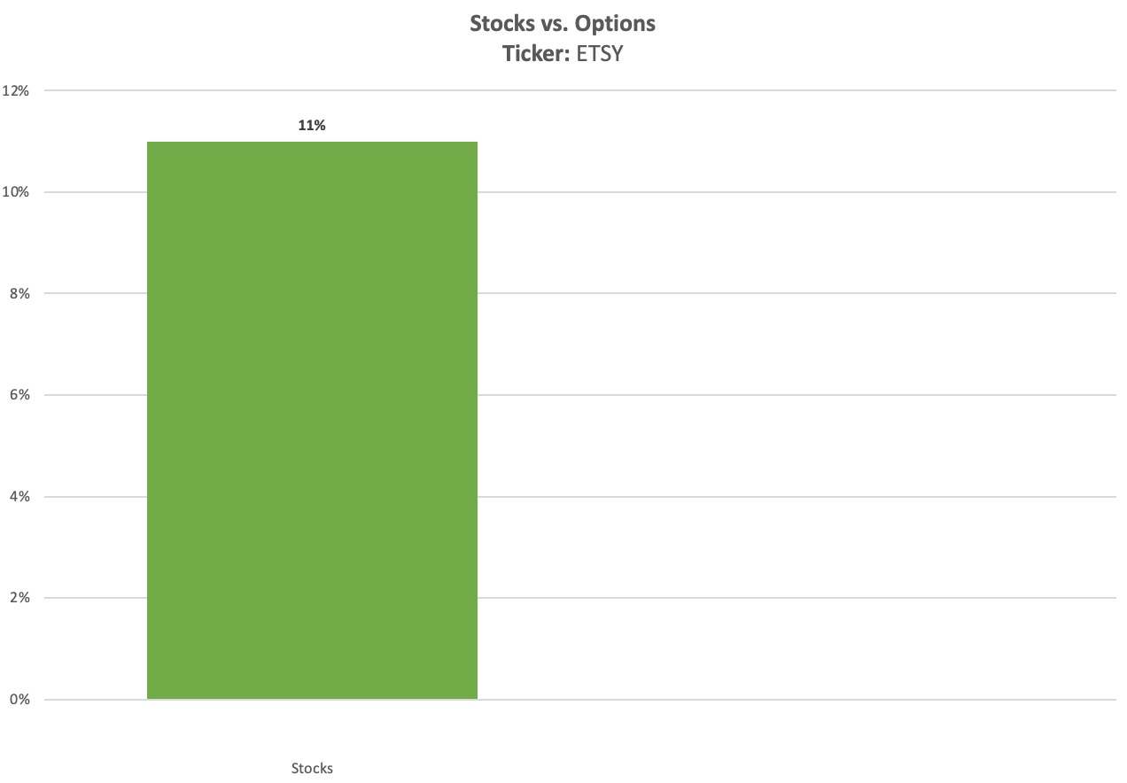
Using the power of options...
That 11% gain could have been boosted...
To a peak 154% return... in 8 days!
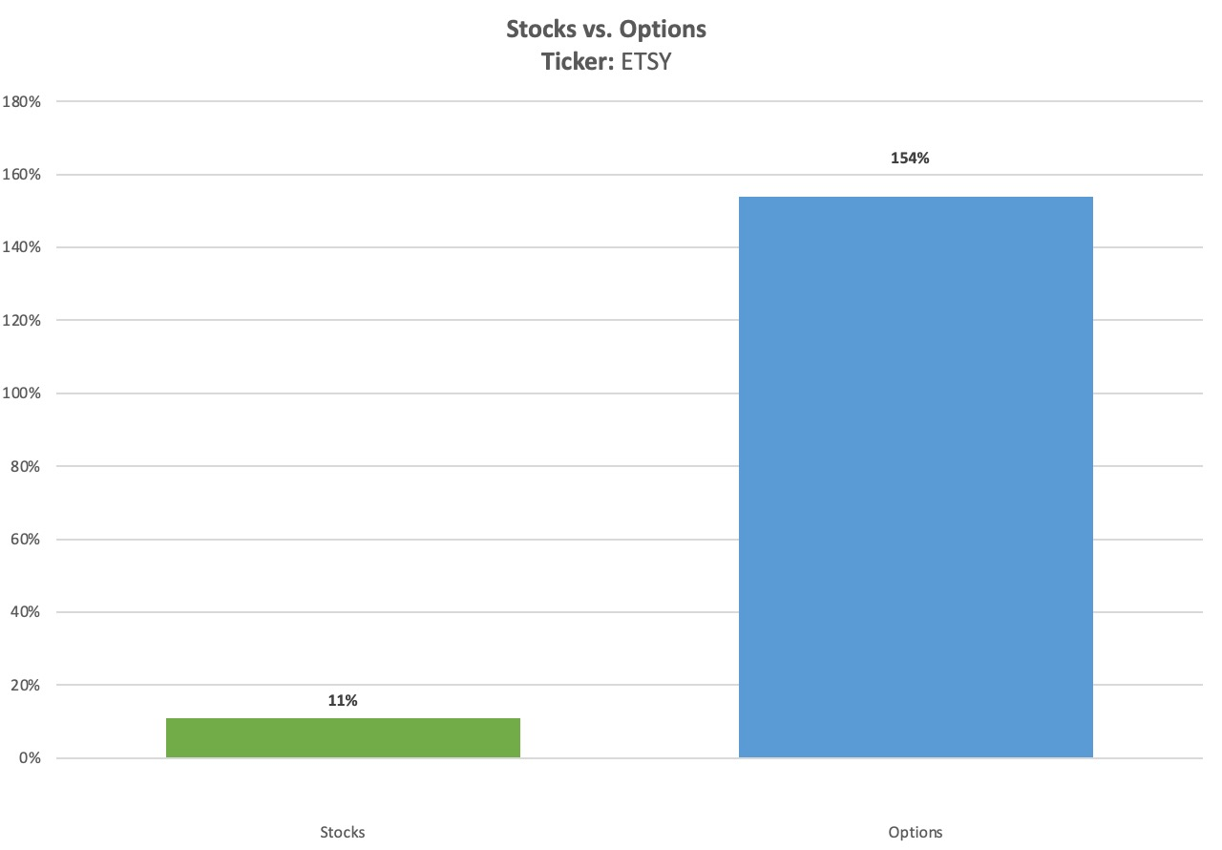
Think about that...
That’s a 14 times larger return from same exact trade setup!
All thanks to power of boosting your profits with options!
Here’s another example...
Let’s look at this 25% gain on the ticker SEDG that S.A.M. would have found...
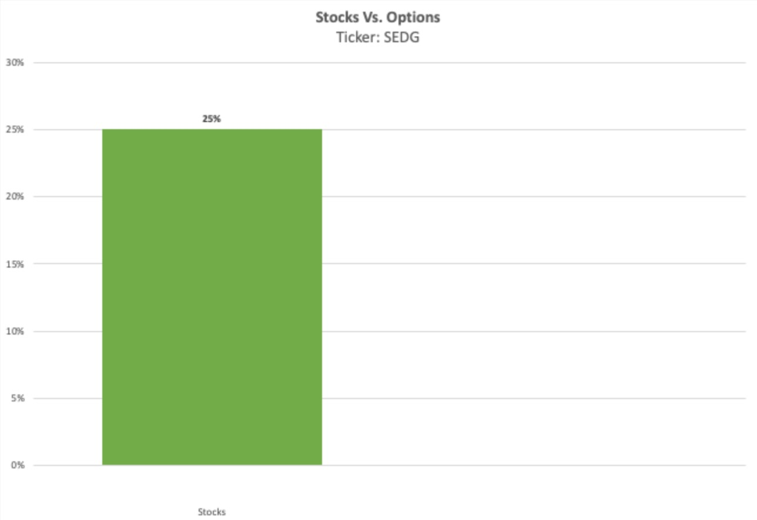
Using the power of options...
That 25% could have been as much as a 389% gain within just 9 days...
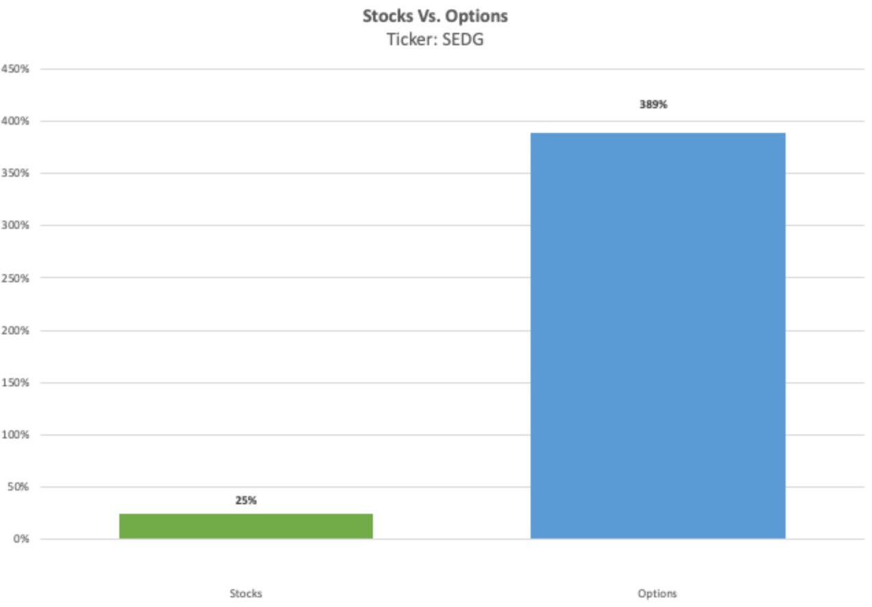
Enough to turn $10,000 into $48,900!
Remember... the average gain of the S&P 500 is 10% per year...
We’re talking about nearly 15x bigger returns with just one trade over 9 days.
Just by combining the power of S.A.M. with options...
But it gets even better...

If you think that 389% exciting...
Take look at this 40% gain on ALGN stock...
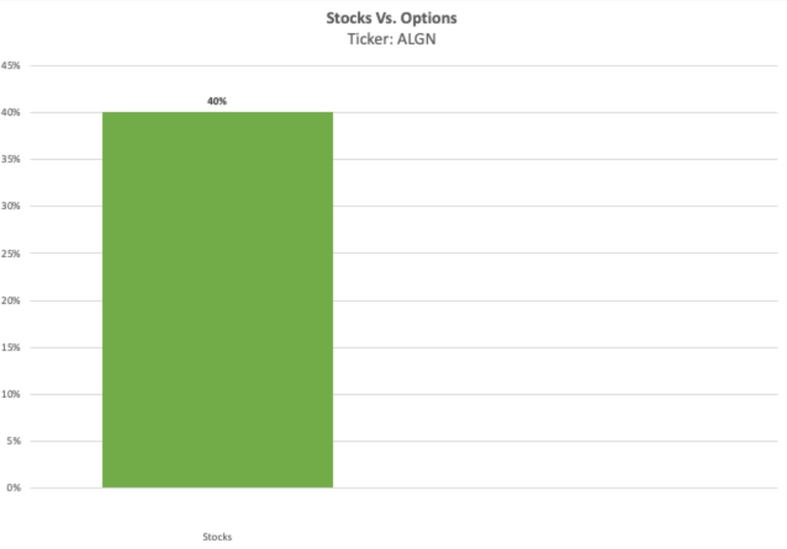
Using options you could have seen a gain as much as 545%...
Which is enough to turn $10,000 into $64,500 in just 15 days!
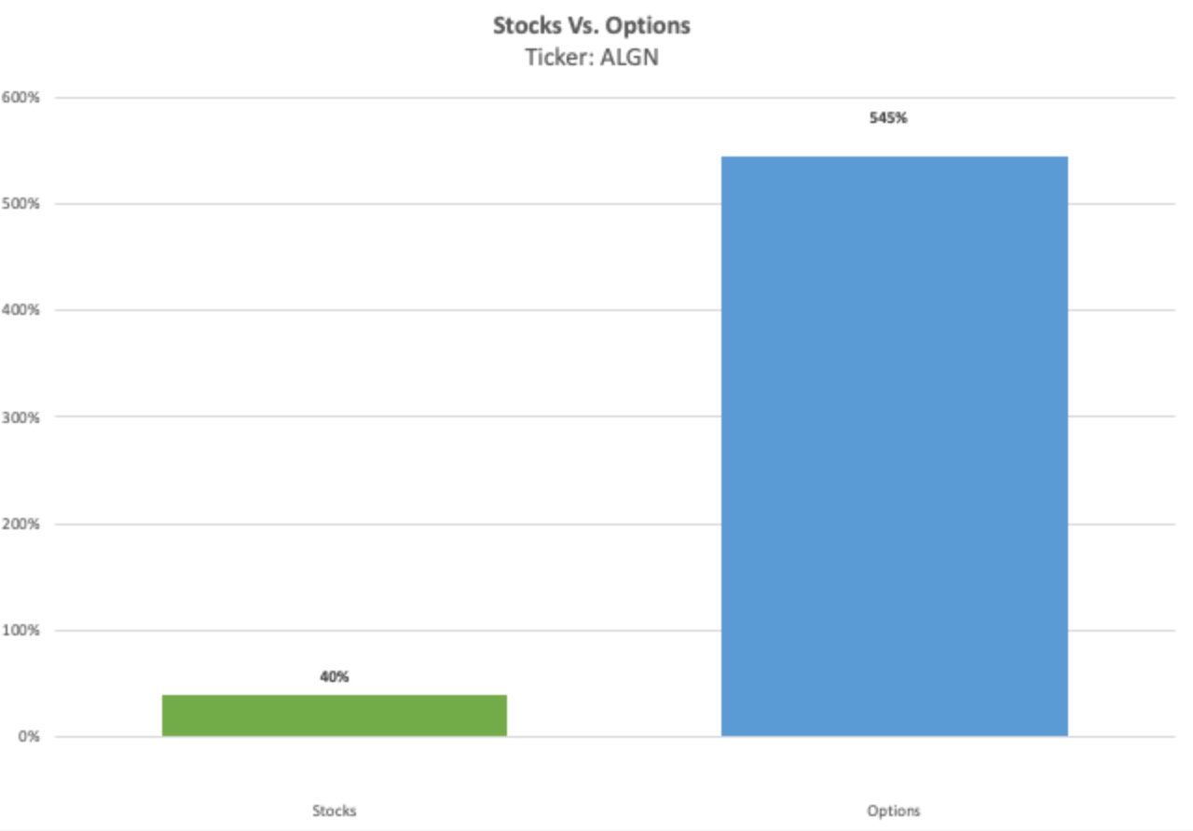
And that 25% example on JNPR that I mentioned earlier?
Well with options that gain could have been as much as 2,250%...
Which is enough to turn $10,000 into $235,000 in just 7 days!

Are we going to hit big double and triple digits every time? Of course not.

But when S.A.M. has the power to find profitable trade setups so consistenly, the sky is the limit.
And one thing that is important to note...
These weren’t some far-fetched options contracts that no one would ever buy...

My research team pulled examples that I would actually be willing to buy with my own real money...
If your risk tolerance is higher than mine...
These returns could even be greater!
Throughout the thousands of trades our 5 year back test found...

We uncovered MASSIVE opportunities to make huge profits with S.A.M.

Like...
- 235% in 2 days...
- 110% in 8 days...
- 215% in 3 days...
- 388% in 14 days...
Just to name a few...
This isn’t a fluke...
With these examples you’ve seen with your own eyes just how this can change how everyday traders approach the market...
Most people don’t bother to take the time to learn how to trade the squeeze...
Or even how to trade options properly...
But now S.A.M. is making this easier than ever!
In fact, we actually built in a feature into S.A.M. that even provides 3 different options contracts for daily setups based on the option selection criteria that I use every day.
I call them “Power Options”...
[Screenshot of suggested options]

And unlike all of the newsletter and recommendation services that are out there...
SAM has a feature available that provides 3 different power options for you to consider based on your risk tolerance level...
Conservative, Moderate and Aggressive...
So you can control how you put S.A.M. to work.
Now...

Before I show you how you can start using S.A.M.
You might be thinking...
What happens when the market is down?
We might be in a bull market today...
But as we’ve seen over the past few years...
Things can change for the worse quickly.
BIG Profits From S.A.M.
(Even When The Market Is DOWN!)

But regardless of what happens...
It’s important to remember that the key to trading is consistency...
And the reality is...
Some days the market will be up...

And somedays the market will down...
Regardless...
As traders, we still want opportunities to make money!
S.A.M. is using the power of AI to find the best trade setups even when the overall market is down.
Down days could be some of the best times to get into trades...

Let’s take another look at that trade up on FSLR from February...

This happened when the market was down more than a quarter of a percent!
But still S.A.M. would have identified a trade setup on the ticker symbol FSLR that very same day...
And within just 2 days you could have made a 250% profit.

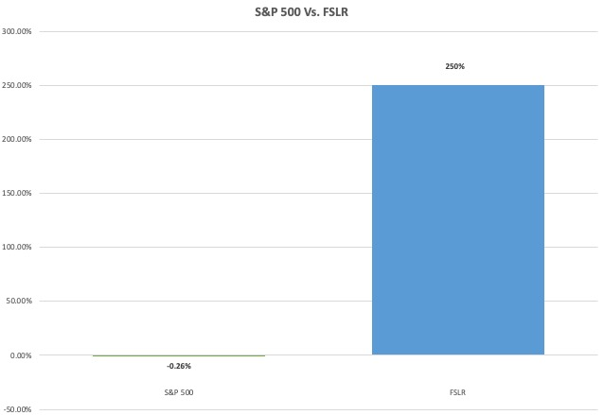

On a day when you would have LOST money if you had parked your money in the S&P 500...
Savvy investors using S.A.M. could have turned a $10,000 investment into $35,000 in a matter of days!
Most traders just give up when the market is in the red...
And I get it..
As a trader...
Nothing is worse than spending all day...
Going through chart after chart...
It’s demoralizing.
But that’s what is great about S.A.M.
It does it for you!
You don’t need to look at a single chart until S.A.M. has already identified a potential setup.

Remember though, you should always do your own due diligence before making an investment
S.A.M. is a research tool specifically designed to help you find squeeze setups in the market and shouldn’t be treated as official recommendations
And how you trade is up to you...

But here’s the thing...
That example I just showed on FSLR...
Wasn’t a fluke.
S.A.M. finds setups on down days all the time.

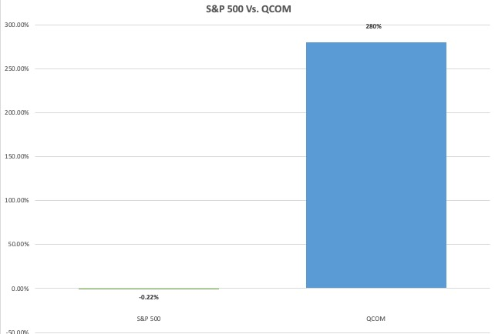

Take a look at back in July 2020
Again here we see the S&P 500 DOWN nearly a a quarter of a percent overnight
But S.A.M. would have identified a trade setup on the ticker QUALCOMM ...
Which could have turned into ANOTHER peak 280% gain...
This is a REAL advantage gang...
Let’s look at one more example quickly from our backtests...
This time on Jul6 2018 when the market was down a full 4% !
And this time S.A.M. found a trade setup on the ticker SEDG..
Investors could have made as much as 389%...
Enough to turn $10,000 into $48,900...
Again just within a matter of days!

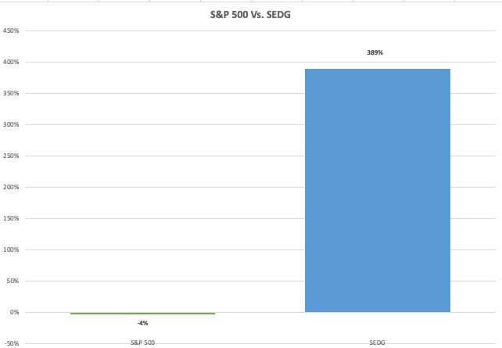
As you can see with these examples...
S.A.M. makes it simple to find winning trade setups in all market conditions...
But remember folks...
It’s this simple because of the power of A.I.
It does all the searching for you...
It looks for the trend...
And it even makes it easy to pull up the chart with just a single click...
It could take hours or even days to manually go through the amount of charts and data that S.A.M. goes through
Remember what I said earlier...
S.A.M. has the power to process up to 5 MILLION market updates... PER SECOND
Allowing you to see the most up to date information available...
By the time you managed to go through charts for every ticker listed on the S&P 500...
You could have missed 10, 20, even 30 new profit opportunities.
A person’s chance to build wealth in the market can come and go within minutes or even seconds...
The market doesn’t wait for anyone.
That’s why I think it’s so important to get S.A.M. in your hands immediately...
As A.I. continues to advance...
The wealth gap between those who use the power of AI...
And those who don’t...
Will grow exponentially.
Millions of investors are going to be left behind...
But that doesn’t need to be case...
We built S.A.M. for you.

We made this AI-Powered Daily Profits Scanner a reality...
And today we’re making this accessible to everyday folks...
Introducing Nate’s Brand-New Research Initiative

I’m happy to announce our latest wealth building initiative called Daily Profits Scanner...

And let me be clear...
Even though we’ve been talking about S.A.M. during this summit...
What I’m offering you today includes even more than access to this A.I.-powered profit scanner.
Yes, first and foremost members of Daily Profit Scanner are going to get access to S.A.M.
Which as I showed...
1) Automatically scans the market for profitable squeeze setups...

2) Tells you which direction a stock’s momentum is trending...
3) AND pulls it up stock’s chart...
Every single day...
In real-time...
Everything you need to find explosive profit opportunities is all in one single screen!
With an added feature S.A.M. even provides 3 Power Options Contracts to consider...
based on your own personal risk tolerance.
It’s all right there...
Done automatically by S.A.M.
But here is the thing though...
I want folks to use the power of artificial intelligence to boost their daily profit opportunities on Day 1.
That’s’ why I’ve put together an exclusive war chest of trainings and bonuses to help founding members get started today...
Starting with my brand-new report...
[Product Graphic]
Finding FAST Profits TODAY: A QuickStart Guide To Using the Daily Profits Scanner

This report is a comprehensive guide to how S.A.M. works...
And how you can use it to super charge your day-to-day investing...
Inside, you’ll find an easy-to-follow guide on what everything means on your screen...
And examples so you can see how these profit opportunities play out.
From start to finish.
It's all there.
[Product Graphic]
I’m also including an exclusive updated 2nd-edition copy of my popular report The $2.7 Million Dollar Profit System...
Which not only goes over exactly how I turned $37k into $2.7 million dollars in 4 years....
But now includes simple tricks and tips on how to simplify my #1 most successful trading approach using S.A.M.
Exclusive to this brand-new 2nd edition that isn’t available anywhere else.
This is the same trading strategy that helped me recently close winners in just 10 months.
Including top gains of 184% on Adobe in less than a month...
A 250% winner on Carvana in just 2 days...
AND a 261% winner on META overnight.
It's my ultimate secret that will change the way that you aim to grow your money.
You’re going to be hard pressed to find a strategy that has enabled me to put up big winner after big winner.
All with real money....
And that was on my own... before S.A.M. even existed!
I believe I’m going to capture a lot more 100% winners using the power of A.I.
And this report will guide you through my favorite strategies.
Here we’ve put together all of the essential details...
All in two convenient reports for our new founding members...
And it doesn’t end there...
I understand that some people want more details than others...
There will be some folks who just want the cliff notes..
And some who want comprehensive instructions...
That’s why I also am pairing that report with my brand-new A.I. Profit Finder Video Masterclass
[Product Graphic]
Which is a 3-part video training course that goes over everything you need to know....
Including Part 1 which goes over the fundamentals of my TPS trading system and how to be successful as a momentum trader...
Then in Part 2 I demonstrate how to take what we learned in part 1...
And how to simplify it using S.A.M.
I walk through every single feature that S.A.M. offers...
And finally in Part 3 I actually demonstrate how to put everything together using REAL examples.
So you can see exactly how I use S.A.M. with my own personal trading.
This masterclass teaches you everything you need to know to start finding profit opportunities using the power of A.I.
All three of these special bonuses that my team and I put together ...
Finding FAST Profits TODAY: A QuickStart Guide To Using the Daily Profits Scanner
The $2.7 Million Dollar Profit System...
AND my A.I. Profit Finder Video Masterclass...
Are included FREE to all founding members who join today.
We’re talking about a war chest of useful trainings and guides valued at $997 ... included for FREE.
But there is one more added feature available that I haven’t mentioned yet...
If you’ve been trading for a while...
You’ve probably heard other traders talk about their “basket of stocks” at one point or another...
These are special “go-to” stocks that a trader turns to over and over again...
A watchlist of volatile stocks used for repeated profits...
And until today, I’ve never made my basket public.
But I’m not just giving away a list of my stocks...
We’ve taken it a step further...
And have built this list directly into S.A.M. ...
So not only will see you see all S&P 500 stocks...
BUT in a separate box...
You can keep an eye on my curated list of my 25 favorite go-to stocks that I watch with every day...
I’ve traded some of these tickers for years!
And using the power of S.A.M....
You’ll know exactly when a setup is forming on my 25 highest conviction stocks.
Right inside of the software itself.
This is your opportunity to see a professional multi-millionaire trader’s private list of stocks in action.
It’s another way that I put my own personal stamp on the software.
We went out of your way to make sure that this next generation trading tool worked with a strategy that has proven to work for everyday traders...
And every day I see messages from my top students whenever they score big wins...
Like Don who made 116% on a Google trade in just 5 days...
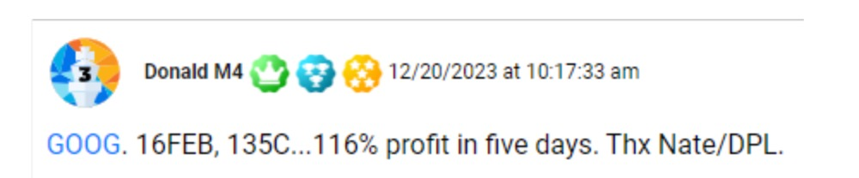
Or Mark who made 170% on his overnight Carvana trade..
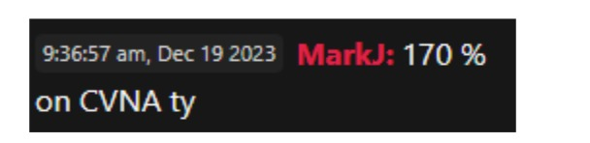
Or Ted who made 186% in 3 days thanks to your AVGO trade...
Which is even better than the 105% I made on that trade.
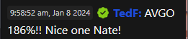
All of thanks to the same strategy that we used to build S.A.M. around.
Reading success stories like these makes this the best job on the planet...
I want to see everyday traders succeed...
And I’m excited to receive the surge of notes that will come in once people start winning with the help of S.A.M.
And today is your best opportunity to get your hands on S.A.M. and all of the founders exclusive bonuses that my team and I put together....
Your Special Founding Member’s Deal:
Given that backtest data showedthat this revolutionary tool could have had an 82% win-rate over the past 5 years...
My publisher plans for us to sell our new Daily Profit Scanner service for as much as $9,997...
And that would still be a bargain.
But in a such a critical moment when millions of traders are on the wrong side of the A.I. Wealth Gap...
We felt that it was important to offer our founding members the best deal we can during this summit.
For the first 70 people who are ready to harness the power of S.A.M....
We’re giving YOU the option to pick what savings and features you wish to take advantage of.

Click on the secure link below this video and choose between 3 membership levels we have available.
You can become a founding member of Daily Profits Scanner for as low as $1,497 today.
That’s an 70%-OFF discount for the first 76 people ready to dive in today...
At that low price, that comes out to less than $5 dollars per day.
Which is a STEAL when you consider that S.A.M. is finding as many as 5 profitable trade setups every day.
Let me tell you...
When it comes to trading squeeze setups...
It doesn’t take much to blow $5 per day out of the water when you’re trading a proven system.
Imagine landing a 2,250% trade in just 7 days...
One gain like that enough to turn $1,000 into $23,500..
That would easily pay for a Daily Profits Scanner membership for life and then some!

But there is a catch though...
If you want S.A.M....
If you want this discount...
If you want the exclusive bonus reports and my AI Profit Finder Masterclass...
Then you must become a founding member TODAY.
Below this video there’s a special link that will take you to a secure order form.
//PICKUP
Next to the chat there is a special link that will take you to a secure order form
// END PICKUP

On it you’ll have the option to pick which features you wanted included in your membership.

We put together 3 plans you can choose your savings based on your needs...
But when you become a full founding member of Daily Profits Scanner you’ll receive:

- Full Access To S.A.M. which automatically scans the S&P 500 and the top index ETFs for squeeze setups and momentum trends in REAL Time using A.I. Updates 5 million times per second.
- Proprietary A+ Algorithm which highlights the higher probability setups in the market
- Nate’s Private Basket Of Stocks... Built directly into S.A.M. so you can track Nate’s highest conviction tickers.
- Power OptionsFinder– which includes 3 options contracts to consider for each daily squeeze setup. One conservative, one moderate and one aggressive.

- Bonus Report #1 Finding FAST Profits TODAY: A QuickStart Guide To Using the Daily Profits Scanner
- Bonus Report #2 The $2.7 Million Dollar Profit System...
- Bonus Video Training: AI. Profit Finder Video Masterclass...
Remember, it cost us $1.8 Million make S.A.M. a reality...
In 2023 alone!
We’re planning to pour millions into it EVERY YEAR as AI continues to evolve.
But for the first 70 viewers today the price to become a founding membership is only $1,497 per year.
[Button]

That’s $4.10 per day to unleash the exponential power of AI into your trading.
Just like Wall Street is doing.
This is wealth building initiative is for the little guy though...
NOT the Wall Street elite.
If offering such a powerful tool at a discounted price is what it takes for us to help close the AI Wealth Gap...
Then so be it.
This is the most consequential moment when it comes to how the future of trading will look.
NOW is the time to put yourself on the right side of the wealth gap....
And in a good position to make money in the markets for years to come.
But there is one more benefit that we’re offering just for our founding members...
Because I understand that some of you watching at home today might still be nervous about embracing the power of AI...
I get it.
That’s why when you join today...
We’ll backing your membership with our 60-Day Money Back Guarantee

*DESIGN THIS AS A CERTIFICATE*
60-Day Money Back Guarantee
If after 60 days you’ve given Daily Profit Scanner a chance and it isn’t for you... simply call our VIP Concierge Squad after your first 60 days and they’ll refund your subscription entirely minus a 10% processing fee.
No questions asked!
/// PICKUP (WE WILL LIKELY USE THIS FIRST)
We’ll backing your membership with our 365 Day Satisfaction Guarantee

*DESIGN THIS AS A CERTIFICATE*
60-Day Satisfaction Guarantee
If during your first 60 days you find that Daily Profit Scanner isn’t for you... simply call our VIP Concierge Squad and we’ll replace your membership for any of our services that the Monument Traders Alliance offers.
No questions asked!
//// pickup
All we ask is you give S.A.M. a real chance before giving up on it...
But I’m confident that once you start using S.A.M...
You’ll never look back.
With 173%, 545% and 2,250% profit potential within 15 Days...
You would be crazy to give up this advantage this powerful...
And as I demonstrated during this summit ...
We’ve built S.A.M. to be easy enough for anyone to use...
But if it doesn’t work out after 60 days...

Your membership is protected by our Money Back Guarantee.
//PICK UP
But if it doesn’t work out during your first 365 days...

Your membership is protected by our satisfaction Guarantee.
/// Pickup

Gang...
You just received the very first look at the next-gen trading research tool that we built to level the playing field for everyday traders...
Throughout this summit...
We’ve seen scores of examples of how S.A.M. can help take your trading to the next level...
And just how accurate it’s setups can be.
Remember our backtest data shows S.A.M. won 8 out of 10 times...
Across 8,915 trades...
And already in 2024 it found an opportunity to land a 2,250% winner over 1 week...
But best of all...
We’ve seen just how much AI can simplify and speed up your trading...
If you’re ready to put yourself on the right side of the A.I. Wealth Gap...
Then click on the link below to take advantage of the Founding Members discount that we put together.
Remember only the first 76 trading enthusiasts today can take advantage of this special 70%-OFF discount.
Thanks for joining me today for this special demonstration...
I’m looking forward to reading everyone’s success stories as they are starting using S.A.M. for themselves.
Click on the link below to become a founding member today!
February 2024

[Button]

John Carter’s historic year https://simplerjohn.medium.com/2020-a-recap-of-my-1270-18-2-million-trading-year-faa24a08c65d
https://www.goldmansachs.com/intelligence/pages/ai-investment-forecast-to-approach-200-billion-globally-by-2025.html
Goldman Sachs - https://www.theinformation.com/articles/how-wall-street-firms-are-warming-to-ai-with-help-from-silicon-valley
#1 use case - https://priceonomics.com/which-industries-are-investing-in-artificial/
Wall Street Report Study https://fortune.com/2023/10/28/artificial-intelligence-bubble-or-real-wall-street-research-reports/
Restrictions for retail traders https://financefeeds.com/ai-in-retail-trading-what-to-know-about-its-growing-impact/
Lifetime employment fact https://www.cbsnews.com/news/american-dream-cost-3-4-million-house-college-cars-retirement/
5,000,000 updates per second (this is what the platform is built on) ... https://www.nxcoredata.com/nxcore-overview/
% of years above 20% https://www.visualcapitalist.com/150-years-of-sp-500-historical-returns/#:~:text=2023%20was%20supposed%20to%20be,rallied%20over%2024%25%20in%202023.

