Million-Dollar Challenge

I Turned $37K Into $2.7 Million in Trading Profits in Just Four Years...

I Invite You to Look Over My Shoulder LIVE as We Seek to Build ANOTHER Million-Dollar Portfolio Together!

Hello, everyone!

Welcome to my Million-Dollar Challenge!

I’m so excited to have you here today... and I’m pumped to reveal the secrets I’ve learned as I’ve gone from having no trading experience whatsoever...

To becoming a multimillionaire Pro Trader.

It’s important you understand... I’m just a regular guy.

I don’t have a Wall Street background.

I’ve never traded on the floor of the New York Stock Exchange...

I haven’t managed a hedge fund or been a VP of a bank or anything like that.

Instead...

I started my career in construction... working long hours remodeling stores for places like Home Depot and McDonald’s...

But in 2016...

With several new mouths to feed... all living in a small, 1,200-square-foot house...

I decided I needed more to provide for my family.

More than that... I needed extra money to ENJOY life with my family.

Because I believe achieving wealth is achieving freedom.

So... I started trading to make extra income.

Listen, everyone... I won’t sugarcoat it.

In the beginning... I was terrible.

I made the same mistakes a lot of people make – maybe mistakes that some of you have made.

I chased the big gains...

My account got blown up several times... my wife even yelled at me on occasion.

And you know what? She was right!

In fact... I was just about to give up.

But then, something changed.

I discovered a rare and unusual trading method that altered my life forever.

A secret so simple, I could use it anywhere.

Heck... I even locked in a 111% win in just a few minutes while waiting in line to pick up my kids at school!

And over time... the results were incredible.

In fact... within the first three years... I had already used this trading secret to turn $37,000 into over $1 million.

And in the fourth year... I made ANOTHER $1.4 million in profits...

That’s a grand total of over $2.7 MILLION in profits.

Here are some shots of my brokerage account – and even my tax returns.

I’m putting all my cards on the table because I want you to know I’m not some “wannabe” who’s come up with a cool new system...

And is showing you a bunch of hypothetical returns.

That’s BS.

I’ve made REAL results... figured out how to achieve success through my past mistakes...

And ultimately discovered how to IMPROVE my life through trading.

And today... I want to teach you to use this exact winning system for yourself.

By the end of this presentation...

You’ll be able to use this very same system – 100% on your own.

You can take the information that I’ll show you in the next few minutes... and start using it at tomorrow’s opening bell.

But... I also want to share with you something brand-new...

Something really BIG.

It’s my new Million-Dollar Challenge, where my goal is to turn another $37,000 stake into $1 million.

But this time, we’ll do it TOGETHER.

100% live... on camera... and you can look right over my shoulder as I make the trades in real time.

In short... I’m putting my OWN money on the line...

And I’ll give you all the paint-by-numbers buy and sell instructions in case you’d like to make the exact same trades in your own account.

Now...

Will I be able to build a million-dollar portfolio in three years this time?

Obviously... there are no guarantees.

But I’ve done it once... and I believe I can do it again.

Because I’ve created a system that’s far more simple and powerful than anything I’ve used before.

If you’ve ever wondered what successful traders do with their OWN money... or how they ACTUALLY make money in the market...

This could be the most important video you’ll ever see.

If you can watch a streaming video... follow a few simple directions... and make a couple of clicks on your computer...

You can start using the exact strategy that helped me build a multimillion-dollar portfolio.

And it all begins right here... right now...

[legal note: from here on... this is the launch promo with tracked changes]

To start things off...

I want to show you that I’m not coming into this Million-Dollar Challenge cold.

You see... I’ve been warming up with a bunch of real trades.

That’s right... real trades... not hypotheticals.

And I want to show you some of the amazing results.

Let’s start with Coinbase on January 27.

Here’s the chart of that trade.

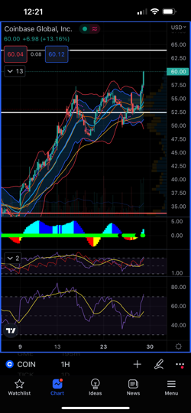

I used my TPS system for this one – and I’ll show you the system in detail today.

I watch for a key signal (you’ll see it in just a few minutes)...

And then make a quick trade.

In this case... I

captured 134% in three days.

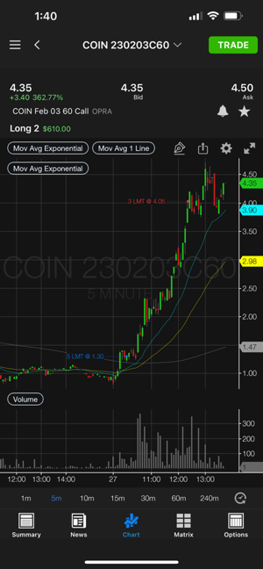

Most people wait all year to get gains like that...

But thanks to the system you’ll see in just a second... I was able to lock in those gains in just a few days...

And the really fun thing is, I make these trades from all over the place.

For this Coinbase trade, I was about to go work out.

I saw the setup... got in... and set my parameters... right before hitting the weights.

It seems too easy...

But when you understand my system for spotting breakout moves...

It’s not a fantasy... It’s just a simple skill that anyone can learn.

And it wasn’t just this Coinbase trade...

Tesla was another top TPS trade I made just a few hours later.

Let’s pull up that chart...

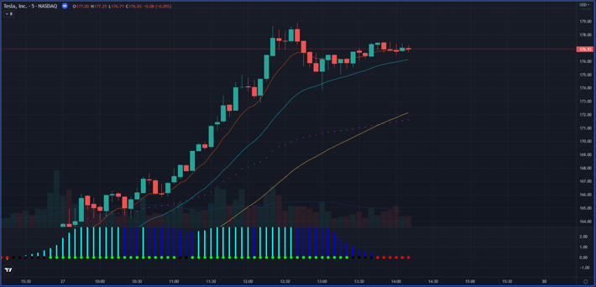

Anything jump out at you?

I guarantee I’ll show you a chart just like this before the end of this presentation...

And you’ll be able to tell me exactly why a big move is coming.

It’s as simple as three letters...

And it’s exactly what I’m going to teach you today.

If you know those three letters... you can spot these breakout opportunities.

And just look what happened next with Tesla...

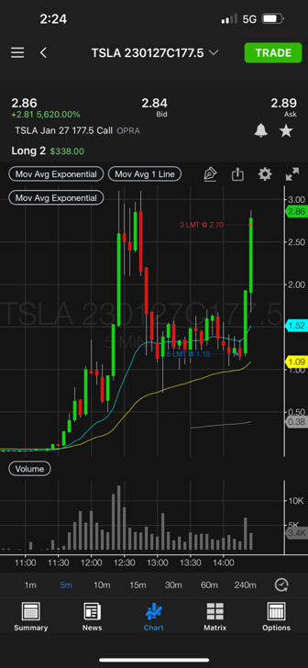

It went vertical for the next few minutes.

It was good for one of the fastest

111% gains I’ve ever made – it happened in just a few minutes!

Again... this was a REAL trade...

But it was made in the strangest place...



This was my view as I closed that trade. I was waiting for my kids in the line at school!

That’s right... you can make these kinds of gains from almost anywhere!

While

most parents were killing time scrolling on social media on their phones...

I doubled my money with just a few taps of my finger!

Now look... I fully acknowledge that I’m human... and I don’t hit winners every single time.

But get this...

Just in the first month of this year, as I dipped my toes back in the water... preparing for this special sprint challenge...

I made a 65% total return over just one month.

The wins just kept on coming...

In fact...

Just a few days later... I locked in three more top winners.

A 190% gain on Carvana...

A 164% gain on Riot...

And a shocking 412% gain on the S&P.

And get this... those were ALL one-day gains...

So I 5X’ed my money... in just one day!

Making big gains fast is the most important

part of what I’ve learned in this journey.

Because, look...

This isn’t about just making money.

It’s about keeping the most valuable resource you’ll ever have...

Time.

You can make more money.

But no matter who you are – even if you are a billionaire...

You can never make more time.

And that’s why I’m so excited to share with everyone the secrets I’ve learned about trading.

So... what do you say...

Are you ready to learn the secret for yourself?

Then... let’s get into it!

In order to find the types of trades I just showed you, all you need are three letters.

T. P. S.

Let’s start with this chart...

It’s Tesla.

And no, the “T” doesn’t stand for Tesla...

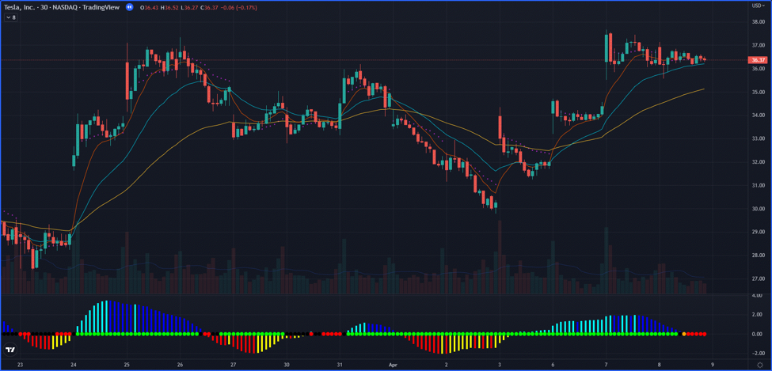

The first part of the system is to find the trend.

Basically... we don’t want to try to fight the direction a stock is going.

Now... keep it simple.

We aren’t trying to draw trend lines or channels or anything like that.

All you are looking for...

Is whether the stock... as it’s going from left to right... is heading up...

Or down.

In the case of Tesla...

[DESIGN – WE CAN PROBABLY USE THE SAME EDITED ANIMATION FROM THE LAUNCH]

It’s going up.

For now, that’s all we need to know when it comes to “T”...

Whether the stock is heading up or down over the last few weeks.

The next letter is “P.”

This is about the pattern.

The core of the system is built on the understanding that stocks don’t just go straight up.

Stocks move up in steps.

First... the stock will go up.

Then it’ll consolidate and trade flat for a bit.

Then it’ll shoot up again.

So... that’s what you look for.

You look for the “rest” period in a stock’s price – that’s the pattern.

[nate shows this on Tesla]

You can see right here... the stock has gone up...

Then it hovers around for a bit...

Then it goes up again.

Sound simple?

That’s why it’s so powerful.

I am not a fan of big, complicated systems. I find that the simpler the strategy, the more consistent it is.

But let me get to the last step.

This is by far the most important part... the “secret sauce,” so to speak.

Because this is the “catalyst” that tells me that the stock has “rested” enough...

And is ready for another breakout.

It’s called...

The squeeze.

See these red dots?

[nate points them out]

What’s happening here is volatility is contracting – or “squeezing” – and building momentum for the next big move.

Think of this like a slingshot.

As volatility pulls back, that means the buying activity on Wall Street is about to slingshot higher.

And that is the moment you want to make your trade.

So it’s as simple as 1, 2, 3.

The trend goes up from left to right.

A pattern forms and shows that the stock is at a great buying level.

Then...

You look for the red dots that indicate the squeeze is on.

And for

Tesla... you can see what happens here.

[nate shows the chart play out]

For me...

It was a 493% gain in just five days.

That’s right...

A 6X gain on that one trade!

And that was just the average gain for that trade.

I let my profits run for part of it... which means my max gains were as much as 1,300% on a portion of that one trade.

All thanks to this simple, “1, 2, 3” TPS system.

And just to be clear... this isn’t something that I’ve come up with out of the blue.

The “squeeze” is actually a well-known indicator.

I won’t bore you with the details...

Anyone who is curious can read all about it in John Carter’s book Mastering the Trade: Proven Techniques for Profiting from Intraday and Swing Trading Setups.

But for any of the technical whiz kids out there...

The squeeze is when the Bollinger Bands drop inside the Keltner Channels.

Now... some of you may be

familiar with those terms...

Other viewers might think I’m basically speaking Greek.

But don’t worry...

you don’t need to know all the details to use this system.

All you need to know is what to look for.

You can see the “squeeze” in many popular trading chart programs – TradingView, in particular, has a couple of different free options to see the squeeze.

It’s built in... so you can see it at a glance.

But just so everyone at least has an idea of what the squeeze is all about...

It’s just one word: volatility.

When a stock shoots up... volatility goes up.

But then during the rest period... volatility slowly goes back down.

Once it does... it starts to “squeeze” the momentum.

You can see it here in the chart.

Once the red dots pop up... then you know it’s time to buy.

Again, it’s like pulling back on a slingshot...

You can only pull it back so far before the built-up energy has to shoot out again.

And when it does...

The probability of a massive surge goes way up... and that gives us a huge advantage in the markets.

And that’s the key to my TPS system...

I’m using proven indicators.

But... for the first time ever...

I’m showing you how to put them together – in a unique way... one that you won’t find anywhere else.

It’s not JUST the trend...

It’s not JUST the pattern...

And it’s not JUST the squeeze.

You need to have them all working together.

And when you do...

It can be INCREDIBLY profitable.

But here’s the beauty of my Million-Dollar Challenge...

I’m not just teaching you this and sending you on your way.

I’ll actually livestream my exact trades so you can see them as I put my OWN money in the market.

And... I’ll give you ALL the details... so you can make the exact same trades in your own account if you choose.

It’s all thanks to the TPS system giving us the edge.

I needed a system that was simple enough to use consistently... and puts the probability on my side.

That’s the key to success...

Get a system that gives you an edge... use it consistently... and little by little, you’ll succeed.

It’s like the group that found the way to get a slight edge in blackjack.

Those guys made millions!

But here’s the thing most people don’t think about...

They didn’t win every time... and neither do I.

But you don’t need to win on every single trade in order to be successful.

And you don’t need to hit massive gains every time, like the top examples I’ve shown you.

If you get an edge, and you stay consistent, you can build a small sum into quite a large one over time.

It’s all about finding an edge... and using it over and over.

And in this case...

It was almost a 500% move!

Every $349 invested would have turned into almost $2,100 on average.

It’s truly amazing...

Now... I’m sure you are ready to see this in action...

So... just as a reminder...

In a few minutes...

I’m going into the market LIVE to demo how I make a real trade.

You can see exactly what it’s like to look over my shoulder as I put my own real money in a trade.

But before I do... I want to show you another top trade and how I found it.

This way you’ll know exactly what I’m looking for when I go live.

This one is Activision.

[DESIGN – WE CAN USE THE FOOTAGE FROM LAUNCH]

So here... you can see the trend moving up...

Then the pattern showing the price consolidation...

Then the three red dots signaling the squeeze.

And now...

Let’s see what happens next...

[plays the chart]

In all... it was good for a 142% overnight gain...

I actually ended up making over $12,000 on just that one trade.

All thanks to my TPS system!

And here’s one more...

It was on Kratos.

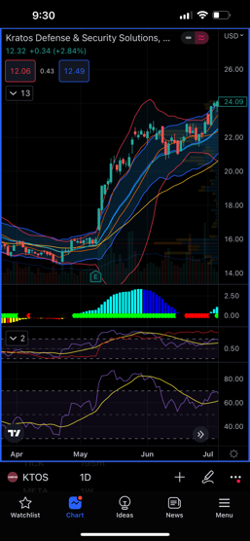

Now... this is actually my favorite one...

I’ll tell you why in a second.

But... let’s go through the process.

[Nate is showing the chart and marking it up]

Here’s

the trend right there.

Next...

Do you see the pattern here? Showing the price consolidation?

And then...

Here are the red dots for the squeeze.

Now... the cool part about this trade is that I got in before my family vacation to Panama City, Florida.

Then... I set an alert for an automatic sell if I were to double my money.

Here’s how it played out.

While I was on vacation... it hit my profit target.

It was a nice 100% win in a little over a week... and made me $9,200.

I was literally on the beach when I took profits... and that one trade paid for my family’s entire vacation... and could pay for several more future vacations.

Here’s a picture of my son that day.



It’s my favorite trade... beause it’s the perfect example of how powerful trading can really be.

Now... I don’t normally swear in front of my wife...

But after I hit that, I said, “Holy... you-know-what... I just made over $9,000!”

It’s ironic... because my wife didn’t know much about what my “hobby” was for the first few years after I started trading.

I would make a few hundred dollars here and there...

But once I developed the system that helped me make consistent wins...

Everything changed.

We got out of our 1,200-square-foot house... and into our dream home (the same one we are living in right now).

And I bought her a new car.

But the most important thing I got wasn’t the money... or the stuff.

I got time.

Time with my family.

Time is the one thing you can’t get back.

Because of trading... we could take that vacation...

And I was able to even MAKE money while spending time with them.

I didn’t even have to get on a computer to close the win. I set it up to do that automatically.

There’s nothing in the world like this.

Now... I have dozens of top examples like these from my own personal trading account.

I want to show you a few more...

But this time... I’m turning the tables.

I’m going to make YOU use the TPS system.

You up for it?

Okay, so let’s look at Tilray...

[DESIGN – WE MIGHT NEED TO HAVE HIM FILM THIS ONE – COULD COMPARE TWO VERSIONS AND SEE WHICH IS BETTER]

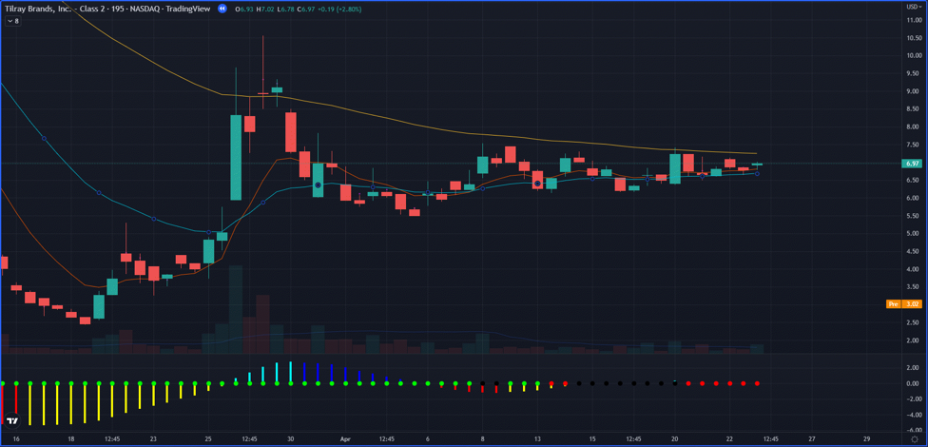

This time...

Can you spot the “T”?

Look... right here...

From left to right.

How about the “P”?

See the stock hovering right here at the same price?

Now... how about the “S”?

Did you see the red dots right here?

If you can see these three simple things... you’re on the path to becoming a profitable trader!

From there...

Here’s what happened...

[nate plays chart]

This one in particular was good for 168% in four days.

Just in case you had some trouble with that one...

Let’s try again...

This one is Vertex Pharmaceuticals.

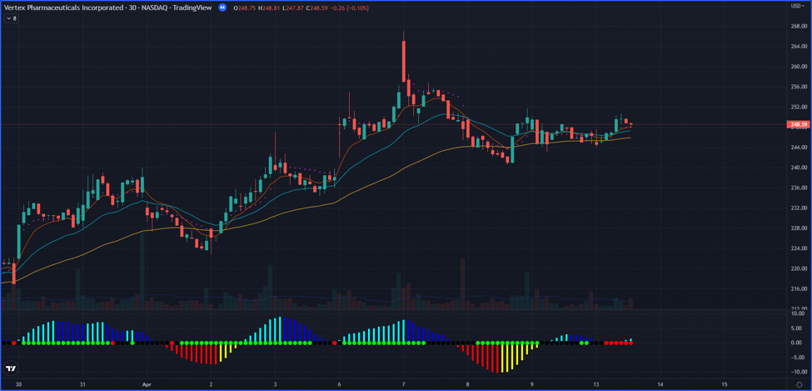

[Nate pulls up chart... again draws on it while Ryan goes through]

Can you spot the trend?

Here’s the movement we look for... from the bottom left to the top right.

How about the pattern?

See it hovering right here?

Now... can you spot the squeeze?

Take a look... the red dots!

It’s all there.

In all... that one was good for a total of 157% over two days.

By now... I’m sure you are a pro at the “1, 2, 3” TPS system.

But just for fun...

Let’s do one more...

Here’s DocuSign...

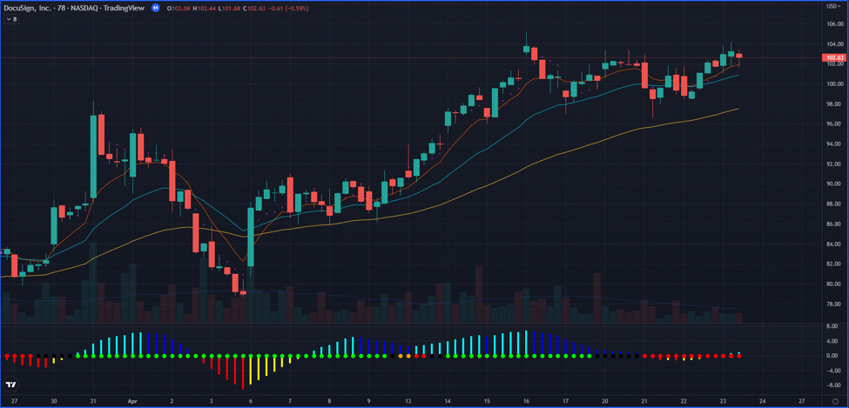

And once again...

You have the trend up...

The pattern... showing it bouncing around the same price...

And the red dots.

How much do you think this one made me?

Well...

It was good for

233% over just six days!

Options

And I want to be clear here...

These are options plays.

Trading options is basically all I do.

If you want to make good money in a short period of time, you need options.

Now... I know a lot of newbies get nervous about options.

But when people say they are afraid of options, I always like to use the analogy of driving.

I ask people: “When you first started driving... were you scared?”

They say “Of course I was. I was petrified.”

But then once you learn... you can’t imagine life WITHOUT driving.

It’s the same way with options.

Honestly... I’ve done better with options than I ever did with stocks.

My first account... I had $1,000...

Lost it all.

And... my huge $15,000 loss in one day was also on STOCKS!

Buying and holding stocks means you have to be married to an idea and a company for years for it to pay off.

Plus you have to take some shots at really risky stocks to give yourself the big upside.

And as we’ve seen in the past few years... the world changes too fast to buy, hold and pray.

Options can often give you the ability to get in... make money fast... and get out.

If you play options right, you can actually have less money at risk than you do with stocks.

And that’s exactly how I was able to log so many top winners.

Like...

{list of wins}

213% on another Tesla trade in two days.

That was good for a nice profit of $5,900.

I had a Match trade that made over 156% in one day...

Then I traded Match again for 153% in five days...

That was over $5,000 on just that one setup!

I mean, the wins just go on and on...

220% in four days on Roku...

75% in one day on Yeti...

418% in one month on AutoZone...

A 136% gain on Tesla... in just one day!

162% same-day gains on Atlassian...

And 308% in three days on the S&P...

I made over $11,357 on just that one trade!

Revealed: My Biggest Secret to Building a Million-Dollar Portfolio

Now... this is a good place to reveal the key lesson I learned that helped me become a millionaire...

You need a system for consistent success...

And you need to STICK to it!

You don’t want to get blown up in any one single play.

I learned that when I lost $15,000 in one day on one investment.

If you lose big... then you have to work twice as hard.

First... to get back to even...

Then... to start making money again.

We know that not every trade will end up working out.

You’ll have losers along the way.

Because no matter how good a trader is... they’ll still have losses.

And that’s why you should never trade more than you can afford to lose.

So... I’ll recommend trades you can get in for as little as $300...

And NO play should take up more than 10% of your portfolio.

(Although you’ll need at least $2,000 to ensure you can make every trade I make.)

So again, the key to trading is having a SYSTEM for consistent success...

And sticking to it.

It’s not about hitting one big winner like you’re playing the lottery...

I don’t want to base my life on luck.

I wanted a SYSTEM that could hand me regular wins...

No matter what... in any situation... in any market.

And that’s what I uncovered.

What I’m trying to show people today is how I built a million-dollar portfolio step by step...

Little by little.

I personally didn’t make a million dollars with one trade.

I took $37K...

And step by step... little by little...

Raked in over

$2.7 million in trading profits over four years.

So... I’m living proof...

It doesn’t matter where you start.

You could start with $37,000 like I did back then...

And like I’m going to this time.

Or you can start with more...

Or less.

But I’m convinced that if you watch me... learn my techniques... and see how I tackle the market LIVE...

You can be successful.

Now...

there’s something you should know about all this.

Monument Traders Alliance put me through the ringer in verifying these claims.

They scoured through pages and pages of brokerage accounts... and scrutinized every transaction.

At one point, they had five different people going through it...

They made sure that I took $37,000...

Grew it to over $1 million...

And raked in over $2.7 million over four years.

Again... here are the tax records and the brokerage statements.

I have to tell you...

It was almost like forensic accounting...

In fact...

I think IRS audits are easier!

But look...

Anyone could backtest trades and find winners looking back... and then claim they could have made a million dollars.

Hypotheticals are easy... and a dime a dozen.

But these were my REAL trades in REAL time... and it was REAL money going in my account.

Now... I told you before...

At a certain point... I had

already made more than I thought was even possible...

So I basically took a step back and retired.

I wanted to spend time with my family and enjoy being with them.

And why wouldn’t I?

That’s the whole point of making money... to enjoy it.

But honestly... I missed the thrill of the chase.

I missed the fun of building a million-dollar account...

Rejoicing when I’d make $1,000 here...

$5,000 there.

Like the time I screamed to my wife on vacation that we’d just made over $9,000!

But... I knew

if I was going to step back into the ring...

It couldn’t JUST be about making myself money.

I wanted to teach people my system.

Sure... I wanted to challenge myself to start all over... and build another million-dollar account.

But I also wanted to invite others to join me on the journey...

See my every move...

Watch my every trade...

And get all the details in REAL TIME in case they wanted to make the trade for themselves.

Why?

I want to share with others the joy of a $9,200 day.

If I can help other people enjoy their first huge payday...

To change their lives in the same way my life was changed through trading...

That’s going to be the biggest reward for me.

And that’s why I’m inviting you to join something brand-new here at Monument Traders Alliance.

I’m going to livestream my every move as I sprint to build another million-dollar portfolio.

It’s called Daily Profits Live.

And for the first time ever... you’ll be able to watch my every move in this Million-Dollar Challenge.

I’m looking to turn $37K into ANOTHER million-dollar portfolio... right before your eyes... 100% live.

Plus... if the setup seems right for you, you can join me in ANY trade I make...

I’ll give you ALL the details for every trade.

Keep in mind...

When I first started trading, I made a big mistake.

I overtraded. I was making up to 20 trades a day.

It was way too much.

And I have since discovered that most of that was a waste of time. I could get the same results with just a handful of trades.

With Daily Profits Live, I’ll likely do two to seven trades per day.

But this is very important... I don’t expect anyone to participate in all of them.

You want to trade at your own pace.

Do it in a way that fits comfortably with your life.

As long as you are discovering how to increase your wealth day after day...

That’s all that really matters.

Get into as many or as few trades as your lifestyle... your schedule... and your own financial goals allow.

Now... it took me three years before.

But look... I think I can beat that this time.

Remember... the first time, I was withdrawing money along the way. I was paying myself...

Paying for a house and a car.

If you add up the gains from just the first two years... I almost hit a million then.

But look... no one can predict the future.

It could take me two years.

It could take me five.

I’m going to follow my proven process... focusing on quality over quantity...

And trust that the results will take care of themselves.

You’ll be able to see me every single day

... LIVE...

See my charts...

And chat with other members and our moderators.

It’s truly one of a kind.

You’re invited to be among the FIRST to watch my Million-Dollar Challenge...

And see my every move as I pursue my goal to build another million-dollar portfolio.

Now...

It’s one thing for me to tell you what it will be like.

But now... I want to give you a taste of what it’s like to watch me LIVE... and look over my shoulder as I make a REAL trade.

Let’s bring up the chart...

[nate pulls up the chart on screen]

Now... before I show you everything...

I want to be clear...

This is just an example of what it will be like in my chat room.

This particular trade is NOT a trade recommendation... This is for educational purposes only.

T

his is just to give you an idea of what it’s like to look over my shoulder...

See the charts as I see them...

And see exactly how I enter a trade.

[Nate walks them through a demo of a live trade... showing the TPS... and how he gets into a trade]

[hopefully nate still has his cool noise when his order is filled]

Now... that noise you hear means my

money is officially on the line.

For this one...

I’m actually going to set it in advance to get out at a certain profit target.

Obviously, these are fast trades... so by the time you see them, they won’t be actionable anymore.

[nate walks through setting up a limit order...]

So... this will be a 100% winner if it hits.

And this is the kind of thing I’m looking for every single day in my video streaming trading room.

For most trades, the goal is to hit 100% in about one to three days.

Will we hit that for every single trade?

Of course not.

I’ll take a fast 30% winner any day.

But the goal is to go for 100% winners.

And just to be clear...

I’ll show you the trades I’m making...

But I won’t make the actual trades for you.

You are in complete control. It’s your money... so it’s always up to you whether you join my trades or not.

Now that you’ve seen exactly what it’s like to look over my shoulder and see me make a live trade...

Let’s talk about how Daily Profits Live will work.

I’ll be live on screen at these times...

{Display on screen}

Mon: 10 a.m. and 1 p.m.
Tues: 3 p.m.
Wed: 10 a.m. and 1 p.m.
Thur: 10 a.m. and 1 p.m.
Fri: 10 a.m. and 1 p.m.

Monday through Friday... 10 a.m. and 1 p.m.... except Tuesdays, when I’ll be live at 3 p.m.

But... this is important...

Don’t feel like you have to join me for every session.

Join me whenever you feel like it’s a good time to take a shot at getting a winner.

Every time I sign on... think of it as a chance you could make money.

A lot of people start off thinking it might be too much...

But by the time they start making trades...

They keep wanting more and more!

In my livestream sessions...

I’ll show you any trade setups I see each day...

I’ll enter some trades... and you can follow right along with me if you choose.

And I’ll also let you know my plan for exiting... including my profit targets... and where my stop losses will be.

When it’s time to exit a trade... you’ll even get a 60-second head start on me!

That way YOU are getting the advantage.

And I’m ALWAYS monitoring the trades – all day... every day.

Even if I’m not live on camera, you can log in and chat with other members.

And if I get in a trade... or out of a trade...

I’ll send you an email alerting you.

Plus... you can sign up for Text Alerts if you choose.

And to be clear...

You can do this from anywhere.

It’s set up to be easy to use...

And FUN!

In addition...

I’ve put together a training series so you have all the tools needed to succeed.

I have these tutorials to train you even more in my TPS system:

- How to Spot the Trend
- Identifying the Pattern Showing Price Consolidation
- And “The Squeeze” and Breakout Trades...

Along with a couple other videos...

- How to Pick the Right Options
- And Navigating the Daily Profits Live Platform...

And a special report:

- “Daily Profits Live Common Trading Techniques and Unique Terms.”

These are meant to help get you up to speed as fast as possible.

Don’t worry if you’ve never traded options before... or if you are a little nervous to get started.

The beauty of watching me live is I can walk you through everything.

And there is no need to trade right away. Practice first on paper. See how it would go if you were using real money.

Gain confidence before you dive in.

And if you have any concerns about trading options, my tutorial How to Pick the Right Options will get you up to speed.

Once you get the hang of it... buying an option is just as easy as buying a stock.

And I will always give you the exact option I’m planning to buy.

That way... you can trade right along with me, if you choose.

We hold your hand... and make it as simple as possible to get started.

Plus... there’s a live chat... so you can always ask moderators any questions you might have.

Now... we can’t give any personal investment advice, of course.

But... you are never alone. We don’t just give you a recommendation and say “see you later!”

You can always ask any questions about the recommendation... or any other general questions...

And we’ve got an entire team readily available to help you.

It’s important to me that everyone learns HOW to trade... along with getting actual recommendations.

That way you can literally earn while you learn!

And the library of trainings will keep growing...

Because if there are questions or topics people seem to have problems with...

I can always create a new training session.

And the beauty of Daily Profits Live... is I can actually do these trainings LIVE for you.

So you can ask questions and get clarification on any of the topics.

It’s truly a learning experience... as well as a chance to get great, up-to-the-minute market analysis and the most timely trade opportunities.

Now, just think about that, everyone...

You can ask about anything you are seeing in the markets that you’d like to learn about.

Now...

You’re getting real-time access to me...

I’ve proven I can take a small portfolio... and grow it into a million dollars.

And... it wouldn’t be realistic to expect me to give this away for free.

And really, for me...

It’s more about making sure anyone who joins me is going to really pay attention.

When you pay... you tend to pay attention.

People tend to not really value the stuff they get for free, and frankly, I don’t want to waste my time if people aren’t going to value my time and effort.

I want to make sure that everyone who joins me is going to take it seriously.

I can help anyone who chooses to join me... but only if they are willing to listen.

I don’t need millions of followers.

I’m happy if I can take a small group of dedicated people and help them learn to become successful traders.

That’s how I’m paying it forward.

And that’s why the retail value for Daily Profits Live will be $5,000.

But... if you are watching this right now... you have the chance to be among the first Charter Members of this brand-new endeavor.

So stay tuned... because I’m going to give you a special deal just for joining this event today.

But before I do...

I want to cover one more thing...

The bulk of the trades in Daily Profits Live will be from the TPS system I just revealed...

But I actually do other types of trades as well.

So... I have an unannounced bonus lesson for you right now...

It’s my favorite way to play earnings... The max gains can be as much as 1,000% – that’s enough to 10X your money in as little as one to three days.

Let me show you how it works...

[DESIGN... USE THE TWILO EXAMPLE FROM LAUNCH]

Twilio made 562% in a day... and as much as 787% on part of the trade.

These are unique setups.

They don’t come around all the time...

I estimate we’ll see about 12 of them in a year.

But if you play them right – you can get dramatic gains.

It’s these little tips and tricks that really set apart the “wannabe” traders... from the people who are making big money.

It’s not hard... I’ve made it easy for anyone starting out.

In fact... I’ve put all the details in my special video...

Ten-Bagger Earnings Plays: How to 10X Your Money on Quarterly Report Surprises.

And look... I’m always on the lookout for other opportunities the market gives... even if they are a little outside the box.

Just at the end of January... the Fed and Jerome Powell gave me a setup that made me over 412% gains in just a day.

So... you never know what kinds of trades will present themselves.

Now... imagine what it would be like to log a 5X gain in just one day...

How much would that change your life?

Well...

Now is your chance to join me as I come out of retirement... and begin my Million-Dollar Challenge.

You’ll be able to look over my shoulder... see my every move...

And if you choose... you can even enter any trade I make... as I make it.

It’s a great opportunity to earn while you learn...

While I challenge myself to build ANOTHER million-dollar portfolio.

Here’s everything you’ll get when you join me today with a one-year subscription to Daily Profits Live:

- Access to my livestreams every day (so you can look over my shoulder for every trade I make)
- Alerts whenever I make trades or update positions
- Live trainings held throughout the year
- Videos breaking down my TPS system...
  - How to Spot the Trend
  - Identifying the Pattern Showing Price Consolidation
  - And “The Squeeze” and Breakout Trades...
- Other videos like...
  - How to Pick the Right Options
  - And Navigating the Daily Profits Live Platform...
- My special report...
  - “Daily Profits Live Common Trading Techniques and Unique Terms”...
- And my bonus training...
  - Ten-Bagger Earnings Plays: How to 10X Your Money on Quarterly Report Surprises.

Remember the story I told you earlier about how I made $9,200 on one trade... while on vacation?

Just that one trade would easily have paid for the $5,000 retail price to join me.

But... as part of this special Charter Offer...

We are going to give you an even better deal.

You can join me for an entire year... and watch me try to build another million-dollar portfolio...

For just $1,997.

Now... that yearly offer is a good deal.

But... we have another very special offer we’d like to share with you.

In fact...

We are going to do something unheard of in the financial research world.

You see...

As I said earlier...

When I decided to get serious and trade with $37,000... in my first year trading, I made $183,000.

But...

It wasn’t until years two and three that I was making the biggest returns...

And hitting my million-dollar goal.

That’s why I want to make it as easy as possible for you to follow me over the long term...

With something I’m calling my “Million-Dollar Club.”

Basically... when you say yes today...

You’ll pay one low price...

And you’ll have access to my livestream for as long as it takes me to fulfill my Million-Dollar Challenge.

That’s right...

You’ll NEVER pay a renewal fee... or any other fee... until I hit the million mark.

Whether it takes me three years like before... or five years... or 10 years.

You’ll pay just $3,400...

And not a penny more.

But keep in mind... this amazing deal is only good as part of this Charter Offer.

You should see a button below...

Click on that button right now... and take advantage of this amazing deal.

But if you are still on the fence...

I should point out one thing...

I’ve just begun my Million-Dollar Challenge in Daily Profits Live...

And already, the top results are far beyond everyone’s expectations.

We logged a nice 19% winner on our first trade in just one day... and some members did even better!

Orwell said they paid for their Million-Dollar Club 10 times over on just day one!

“Hi! For those who are contemplating whether or not to join Daily Profits Live... just Day 1 I already paid for my Million Dollar Club subscription 10X. Nate is a really great teacher. Good luck everyone!” – Orwell

And just recently... I made two winners...

Rick made 285% on my Nvidia play... and 55% on Apple...

“I’m in awe! A huge Tuesday morning on DPS. A 285% gain on NVDA and a 55% gain on AAPL This AM. This is the kind of memorable Tuesday we like. WoW!” – Rick R.

Both were fast, one-day gains!

Another member posted about how much they love the livestream aspect:

“Nate’s service looks great for anyone that wants questions answered with audio and pictures, with sketches on charts live. It provides a little more to help things sink in. One thing I have immediately noticed is how calm he is. If you get jumpy with trades or have stress, I think he would help in that area with just how calm he is.” – Dave M

This member wants to make sure you don’t miss out:

“Cobra announcement: if you did not join Daily Profits Live, you missed out big time. Best thing ever offered! Not joking!”

Then... he posted a few days later that he’d made 50% in one day:

“Just made another 50% with Nate and DPL. This is the REAL deal! WOW! This the happiest I’ve ever been. I love you all. Cobra signing off for a celebration party I just started. 😎 See you tomorrow!”

Another fan realized how valuable the Million-Dollar Club is:

“Hey guys, this is amazing! I wasn’t ready to do the Million Dollar club yesterday because I’ve never seen Nate in action. But can I still get the special?” – Vijay B.

And this member sees the huge value in the education:

“Decided to purchase Nate’s service because I need to learn how to trade, what setups to look for in the charts. I want to be able to stand on my own as well as taking their tips. Nate seems to be a teacher.” – Husky M.

So if you are ready to join my Million-Dollar Challenge...

And join these members who are almost BEGGING you to be with them...

Click on the button below right now.

And to make this a “no-brainer”...

I’m going to make an unprecedented guarantee...

“Win Three Ways” Guarantee

    - Winner Every Day
    - Double-Your-Money Trade Every Week (52 per Year)
    - Monthly Ten-Bagger Earnings Opportunities (12 per Year)

In one year, I’m guaranteeing that you’ll see the chance to get at least one winner every trading day.

Here’s how that will work...

There are 252 trading days in a year.

So I’m making the guarantee that you’ll see at least 252 winners in one year, per my track record.

Now... you don’t have to make every single one of those trades. I’m simply showing how confident I am that I can overdeliver.

It’s your choice how many you participate in.

But on average... I’m guaranteeing I’ll deliver at least one winner every day.

Not only that...

I’m guaranteeing you’ll have the opportunity to see trades with the chance to double your money 52 times this year...

That’s the equivalent of one double-your-money opportunity every week.

Finally...

I’m guaranteeing you’ll have the chance to make at least 12 of my Ten-Bagger Earnings Trades this year.

Any one of these earnings trades could have the potential to 10X your money... or more... in one to three days.

And you’ll get 12 of these types of trades this next year (about one per month).

Now...

If I DON’T deliver on any one of these...

You’ll get an extra year in Daily Profits Live...

100% free.

I can’t think of anything more fair than that.

Just to be clear... because we are offering this special price today... plus this amazing guarantee...

There will be no refunds for this offer.

But remember... you can watch all of my real trades...

You’ll see everything I do...

Plus get all of my videos and reports...

And all of my live trainings.

So again...

Click on the button below.

I’ve shown you I’m the real deal.

You’ve seen the proof I’ve made $2.7 million in trading profits...

I’ve shown you my three-step system for finding terrific trades.

Other members are almost BEGGING you to join them...

And I’ve even given you not one... but THREE guarantees.

Now it’s time to decide if you are serious about changing your finances... and your lifestyle.

I urge you to click the button right now...

And follow my every move as I begin this Million-Dollar Challenge.

If you prefer to speak to someone directly...

Please call our friendly VIP Service Squad at 888.215.5311 or 410.864.3083.

It’s not a call center or anything like that – this is our in-house team, based right here in the U.S...

So feel free to give them a call.

If the lines are busy, just keep calling. They’ll be happy to discuss things with you.

But definitely either call or click on the button below right now to lock in your special price today.

I would love for you to join me for this special Million-Dollar Challenge.

But if you don’t join me...

I wish you nothing but the best.

I hope you’ve learned something valuable today.

A lot of people are probably wondering... “Nate, with your TPS system... can’t I just go on my own and find my own trades?”

My answer...

Yes... absolutely!

You have everything you need.

Just get an account that has the squeeze indicator... and use it to find the right chart setups.

This system works.

But what I’m offering is a chance to take the burden off yourself...

And let me do the hard work for you.

I’ve already made the big mistakes... so you don’t have to.

I want to find the best setups... so you don’t have to go through thousands of stocks every single day to find the right charts.

It’s a lot of work... and I have a whole team around me to help me.

I don’t want you to go it alone...

So... I hope you click on that button below...

And join me in this amazing new livestream platform.

But regardless... I wish you all the best.

Trading has changed my life... and I truly hope it can change yours.

I hope you’ll click on that button below... and I hope to see you at the next livestream in our one-of-a-kind Daily Profits Live.

February 2023

