For the first time ever…
Hermit Millionaire Goes Public With… Stealth Mode Spikes
This Mysterious Market Anomaly Detected:
- 185 Triple-Digit Winners in the Past 24 Months
- Gains As High As 1,140% in 24 Hours
- And Has Just Signaled the Next Potential Windfall As Soon As Tomorrow, 11 a.m. ET
“Not Seen on MSNBC, Bloomberg or Fox Business…”

America’s #1 Options Trader Reveals…
Stealth Mode Spikes
This Mysterious Market Anomaly Predicts Huge Stock Moves in Advance!
Inside: The Blueprint Used to Turn This Anomaly Into Gains As High As 1,140% in Just 24 Hours.
WARNING: Next move to take place tomorrow by 11 a.m. ET.
Narrator:
In this quiet town in rural Georgia, lives the most reclusive trader in America…
He is NOT your typical expert…
He’s never worked a day on Wall Street…
Didn’t graduate with an Ivy League degree…
And yet… starting from scratch, without a single penny of outside investment…
He traded his way to a multi-7 figure account…
Today, he rarely leaves his mansion he bought with his trading profits…

He shuns the spotlight…
And insists he’s no guru…
Just a regular guy who single-handedly brought in almost $3 million in profits in just 4 years…
All from a $37,000 starting stake.
That’s a 7,200% return (numbers that crush entire trading desks at Renaissance, Citadel, and any of Wall Street’s biggest hedge funds)…
Which is what makes his public appearance today so rare, and so special…
The reason?
He claims that with just a few moves, everyday folks can turn today’s volatile markets into a small fortune.
It all has to do with a strange anomaly that appears every morning. You won’t hear it talked about on CNBC, Bloomberg or Fox Business…
And 99% of regular traders don’t even know it exists.
But it could be the single biggest shift in the 210-year history of the New York Stock Exchange.
A financial gamechanger…
According to this trader, every morning, at 9 a.m. Eastern, a small corner of the market creates a unique and unusual way to front-run stock moves as high as 1,000%.
Today, he has finally agreed to step back into the spotlight and reveal the biggest OFF Wall Street story NO ONE is talking about…
And he’s brought receipts…
Ladies and gentlemen… America’s #1 Options Trader Nate Bear…
[END INTRO]
Nate:
Hi, Nate Bear here.
Listen…
With dozens of stocks whipsawing up and down by 100%, 200%, and 500% in recent weeks…
(B-roll charts)
Wall Street talking heads will call today’s market the most volatile ever…
But those same people won’t give you the REAL story.
Because they don’t understand it.
In short, markets have been “hijacked” by a new financial force of nature.
It’s created a completely new and exciting way to make money in this market.
Even while many people are losing money trading the old way, this new force has created an unusual way to profit using the unique code you now see on your screen...
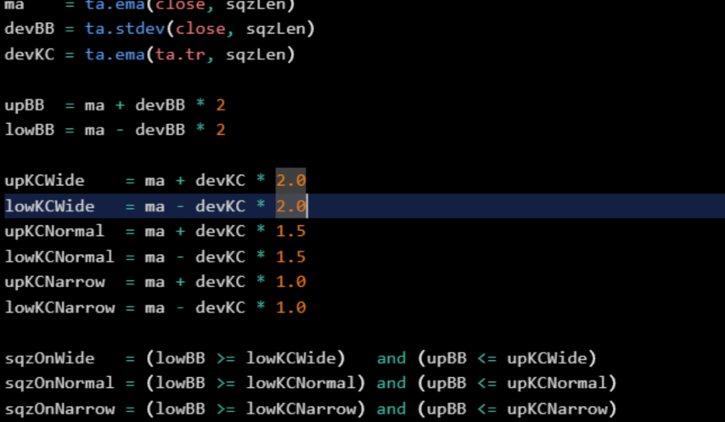
Now, it might look complicated...
But the truth is, you don’t need to be a developer or some financial quant to see money-multiplying returns.
In fact, it’s so simple that everyday Americans like me can use it.
The key is to follow this glowing green bar…
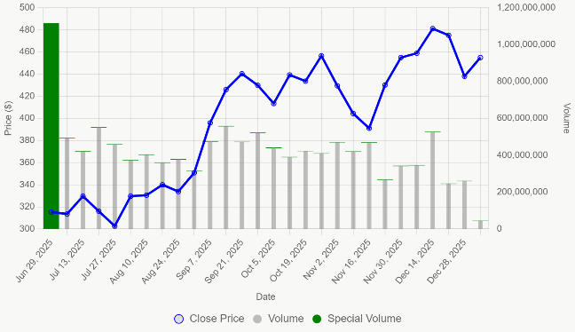
I call it a Stealth Mode Spike.
And it shows the hidden footprints of traders loading into stocks BEFORE 2X, 5X, and even 11X moves.
And listen… now that people like me have made fortunes thanks to this special strategy…
The mainstream Wall Street crowd is finally opening their eyes.
In fact, a landmark report by JPMorgan has just PROVED it crushes traditional investing…
Researchers at Columbia University agree…
LBR Asset Management, a hedge fund ranked in the top 1% globally, used many of the same principles to amass their $145 million fortune…
What’s most impressive?
Tapping into Stealth Mode Spikes is far simpler than anything they do.
It has NOTHING to do with the complicated stuff Wall Street pushes.
It’s not trading dark pools, unusual options, following Wall Street “whales”... nothing like that…
Instead, it’s a simple signal that could help alert you ahead of MASSIVE stock moves.
Which means when you spot a Stealth Mode Spike, you’re able to position yourself EARLY…
BEFORE the price soars.
I know it sounds unbelievable…
But even in chaotic markets, I’m using it to profit long before most investors catch on…
Whether that’s a 1,130% win on RILY in 48 hours…
As high as 1,140% on HIMS overnight…
422% on SPXW in the SAME DAY…
(Start a rolling snapshot of Nate’s 100%+ winner track record)
Or over 185 triple-digit winners in just the last 2 years alone…
Many times in as little as a few hours.
And I want to make one thing clear…
Every single one of these top-performing trades were trades that I not only recommended …
But traded with my real money.
In 2025 alone, Stealth Mode Spikes alerted me to 115 opportunities that more than DOUBLED my investment…
For example, a Stealth Mode Spike hit Tesla in June, and our trade went vertical…
If you knew how to play it, you could have made 325% overnight…
Right alongside me.
Imagine investing $2,000 … and cashing out with $8,500!
That’s how fast you could get paid when you understand how to tap into this anomaly the RIGHT way.
In April, a Stealth Mode Spike also hit shares of a company called HIMS.
I made 1,140% on half of my trade in just 24 hours!

Or look what happened when a Stealth Mode Spike showed up on RILY.
You could have made 500% in just that one day!
To put that into perspective, that’s more than double what Nvidia returned the entire year!!!
Why wait years to see huge returns, if you stand to make bigger gains in a matter of days?
It’s not just me who has taken advantage of these Stealth Mode Spikes.
They’ve handed fast, life-changing gains to hundreds of my followers…everyday folks from all walks of life…
Like Phil Shark, who made 450% on CVNA in less than 24 hours…
Ted F., who made 186% on an AVGO trade that lasted just three days…
Or Mark T., who crushed our official gain and made 2,000% on SMCI in just 2 days!
Now look...
I could go on and on, sharing more top stories like these from my followers...
Or every Stealth Mode Spike that’s alerted me to double, triple, or even 10-bagger winners…
But we’d literally fill up hours.
Let me be clear, though – while the results we’ve seen have been incredible...
No strategy is perfect.
Of course, there will be losers, and past performance isn’t a guarantee of future results.
That being said...
I believe the coming days are set to be the best ever.
Why?
Because we are in the middle of an insanely volatile market…
And as I’m about to show you, volatility is like rocket fuel for Stealth Mode Spikes…
It doesn’t matter if markets are crashing…
It doesn’t matter if analysts have a sell rating on the stock…
It doesn’t even matter if a stock has been red for several weeks in a row.
In fact, that’s what makes a Stealth Mode Spike so effective…
It alerts you to trades BEFORE they skyrocket…
And today, with the markets back in chaos territory…
All my research says the next big Stealth Mode Spike could hit ANY DAY… even as early as tomorrow, at 11 a.m. Eastern.
So today, I’m pulling back the curtain and revealing how to tap into this anomaly and get into trades BEFORE they go vertical.
I’ll show you my 3-step process to tap into a Stealth Mode Spike – right here on camera…
It only takes 1 minute…
Not a second more.
It’s easy.
And has the potential to at least 2X, 5X, or even 10X your money on every trade you make…
All by watching for this green bar.
Once you see how simple it is to use…
You’ll Never Think of Trading the Same Way Again
For example, take a look at what happened on April 27 at 9:38 a.m…
That’s when I spotted a Stealth Mode Spike on the ticker HIMS…

Leading to one of our best trades ever.
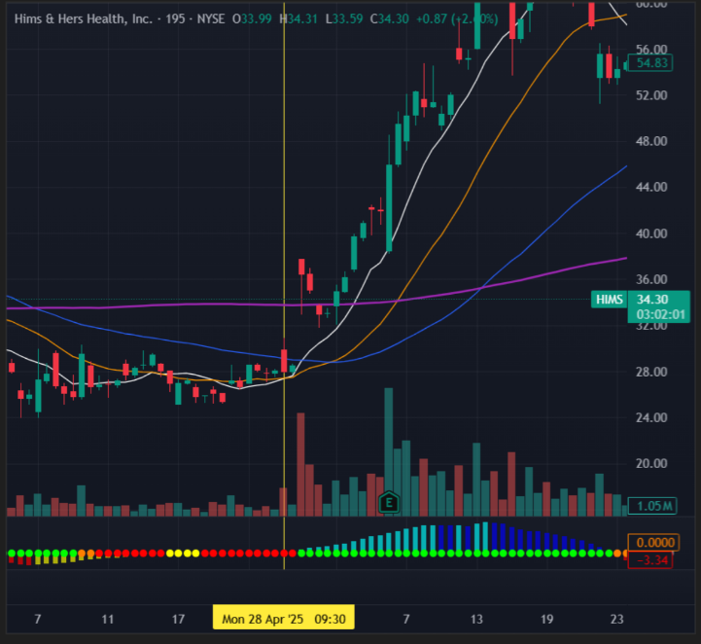
At the time, the stock was in a severe downtrend…
Its share price had just dropped 25%...
Citi had downgraded its rating…
And no trader in their right mind would touch it with a 10-foot pole…
But despite everything, a Stealth Mode Spike appeared, and that meant ONE thing…
A massive move was on the way.
I didn’t hesitate…
I placed my trade…
Within just a matter of hours…
Boom!
Price exploded!
My trade went on a tear.
And I was up as much as 1,140%!
Had you known about my strategy…
You could have seen this move coming a full 3 days in advance… long before anyone else had figured it out.

That’s how fast and powerful this market anomaly can be…
And better yet, it’s repeatable…
Because not long after, another Stealth Mode Spike appeared…
This time, on tech giant Tesla…
Take a look …
In the months leading up, its earnings were down, sales were down, profits were down…
And as you can see on the chart, its stock price had dropped 50%…
But the moment a Stealth Mode Spike appeared, none of that mattered…
I placed a trade…
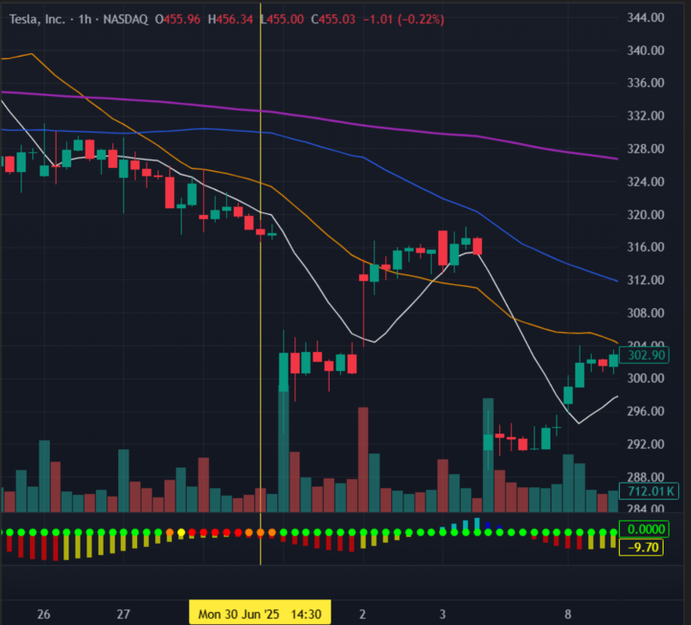
And just 24 hours later, I was up 325%!
Every $1,000 invested, I made $4,250.
We are talking about a stock that looked like it was dead in the water…
Yet off the radar, pressure was building for this stock to make a massive move to the upside.
And that’s the best part of the secret I’ll share with you today.
Most people wouldn’t have seen this opportunity until it moved at least 50%…
The Stealth Mode Spike detected it earlier…
While the massive move was still in stealth mode.
And it could have helped position you before the crowd even knew what was happening…
So when everyone scrambles to chase the move…
You’re already in position to take profits.
And tapping into a Stealth Mode Spike could not be easier…
Open a trade…
Wait for this green bar to spike…
And once it hits our profit target, you close the position.
It’s That Quick and Easy.
With Stealth Mode Spikes, we literally step into the markets one day, and step out the next.
Which means it doesn’t matter what the rest of the market does.
It could be a bear market, bull market…
We could have good news, bad news, or no news whatsoever.
Because this indicator gives us advance notice of when a stock is likely to explode higher…
Not based on “smart money” or institutional buying…
But based on pressure coming from a powerful, hidden corner of the market.
And that’s important…
Because everyone thinks you’ve got to watch what the big boys on Wall Street are doing…
But as you’re about to see, it’s no longer big institutions like JPMorgan that drive those big price swings…
For the first time in the 210 year-history of the New York Stock Exchange, a far more powerful group is now in the driver’s seat…
In fact, if you were watching only what the big institutions were doing, you would have never caught my 823% winner on HIMS overnight…
My 325% winner on Tesla in one day…
Or the 115 trades last year that each delivered a triple-digit return.
And it’s the reason why a mad scramble has been unleashed on Wall Street.
Billion-dollar hedge funds are paying obscene amounts of cash to find out what this powerful group will do next…
That includes Citadel, the richest hedge fund in America…
Virtu Financial, a firm that made money in 1,237 out of 1,238 trading days…
Akuna Capital, Belvedere Trading, Optiver, and more…
Bloomberg Intelligence says 85% of hedge funds and 42% of asset managers are now tracking this new corner of the market…
You have to remember: Wall Street firms employ some of the smartest traders in the world…
So if they’re paying big money to figure out where this powerful group is moving its money…
It’s most likely because they have the power to move stocks, prices, and even entire markets up and down.
This powerful financial group accounts for $600 billion of daily trading volume – yet it only appeared very recently…
So who is this group exactly?
In short, what I am talking about is the shift of power from Wall Street institutions to the mass of retail investors who are now driving stocks higher.
You see, in the past, billions of dollars in money flow was controlled by a small clique of Wall Street insiders - professional funds, banks, and asset managers…
Everyday traders were virtually locked out.
But that’s all changed now…
Brokerage platforms like Robinhood popped up and made trading cheap and easy…
In 2020, when people were sitting at home, demand skyrocketed…
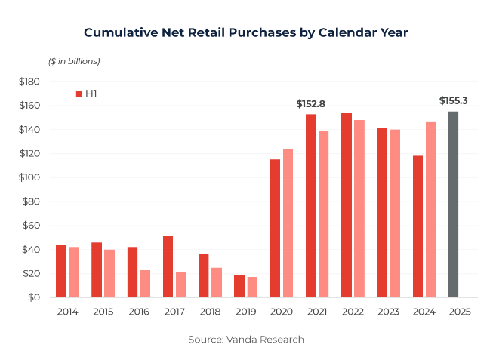
It never stopped.
Just look at the options market…
Six years ago, retail traders made up 10% of demand…
Three years ago, it was 40%...
Last year? Six out of every 10 trades came from the retail crowd .
Bottom line: nothing can stand in the way of this new massive wall of pressure.
Scott Rubner, the head of strategy at Citadel, now calls retail traders the “dominant force in the market.”
The Wall Street Journal agrees – calling 2025 “the year individual investors took over Wall Street.”
Every day, more than $600 billion of buying and selling pressure comes from individual investors.
And here’s the secret…
If you can find out early where this group’s money is flowing, you can get ahead of massive moves in the market.
Because when these individual investors target a stock…
- It doesn’t matter what Wall Street does…
- It doesn’t matter what company earnings look like…
- It doesn’t even matter what any technical indicator says…
All that matters is where the money is flowing!
This Is Unprecedented
And it’s what makes a Stealth Mode Spike so groundbreaking…
Because for everyday traders, it’s impossible to follow the moves of the retail market…
After all, you’re not looking at one or two whales making huge moves…
You’re tracking hundreds of thousands of tiny moves… moves made in stealth.
But very recently, I cracked the code.
After hiring a team of analysts from the most elite financial research firm in the country…
Spending $350,000, upwards of 10 hours a day, 80 hours a week, over the course of 12 months…
Back-testing, forward-testing, and stress-testing thousands of data points…
4,300 publicly traded stocks…
Over 100,000 options contracts…
And training AI to run deep analysis on the entire derivatives market…
I broke through…
I found a loophole that lets me spot exactly WHERE billions in retail money is flowing, BEFORE the explosive move higher.
The result, is this piece of code…
Take a look…
Now, don’t worry if you’re watching and don’t understand what any of this means…
After all, this is the work of some very smart mathematicians…plus a millionaire trader.
So let me show you how this system works in three easy steps…
First, the stock needs to be at maximum velocity.
See, everyone always wants to trade the fastest stocks, in the hottest moving market.
Everyone.
Wall Street, Main Street, billion-dollar hedge funds, down to “mom and pop” investors.
It’s where the action is…
And in times of volatility, it’s a magnet for the retail crowd.
So my first step is to zero in on stocks that are in a trend…
Once I see price clearly trending, it tells me it’s at peak velocity…
Which means traders are likely to come rushing in.
From there, it becomes much easier to spot an explosive move.
Second, my system breaks down the trend for bullish or bearish patterns.
We know the stock is at peak velocity.
Traders are moving truckloads of cash within the stock.
But are they buying or selling?
That’s the second step.
We want to see a pattern tell us which direction the stock is flowing.
Then we want to get on board for the ride.
But there’s one third and final step that filters all the potential candidates down to the single most explosive opportunity.
I call this the trigger.
Essentially, I look for a moment where the stock squeezes… like a spring…
I look at the buying or selling pressure to determine just how strong the squeeze is.
The system then spits out a number from 0 to 100.
0 is the lowest pressure.
100 is the highest pressure.
So the higher the number, the stronger the squeeze…
Taken together these three signals…
- Peak velocity
- A bullish pattern
- And a high pressure squeeze…
Tell us the stock is about to see a major move in price once that squeeze is released.
Which means we need to jump on the opportunity, right away.
This system is highly effective.

And you’ll finally be able to participate in the same moves that have been making Wall Street rich for years…
WITHOUT a billion-dollar trading account…
And WITHOUT any special Wall Street connections…
You can start tapping into the most powerful market phenomenon today…right this moment in fact…with nothing more than an internet connection and regular brokerage account.
Heck, I’m doing it right here from my home in Alpharetta, Georgia…
Almost 1,000 miles from Wall Street.
Bottom line…
This Is the ONLY Way Regular Traders Can Repeatedly Enter Trades Before They Have the Chance to Double, Triple, or Even 10X Within 24 Hours
For example, take a look at what happened with another one of my top-performing trades from April…
That’s when a Stealth Mode Spike told me a MASSIVE move was on the way for B. Riley Financial…
At the time, the company was in a whirlwind of negative press…
The SEC was breathing down its neck…
It was under attack from short sellers on Wall Street …
And its stock price?
DOWN - over 50% in the prior 5 months…
Off the radar, I spotted a mass of retail traders quietly loading positions…
Which told me pressure was building for a huge spike upwards…
Now remember, when we find an optimal situation like this, we’ll often target the stock a few times.
So on April 22, 2024, I placed a trade…
And just 2 days later…
On no news, announcements, or breaking events whatsoever…
Shares exploded.
And our trade turned into a 1,130% gain.
Take a look!
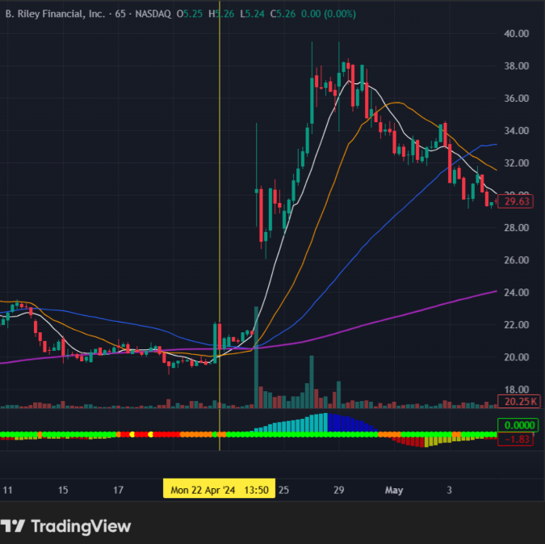
That’s enough to turn $5,000 invested into over $60,000.
And how about this example on Fastly from February 13 of this year…
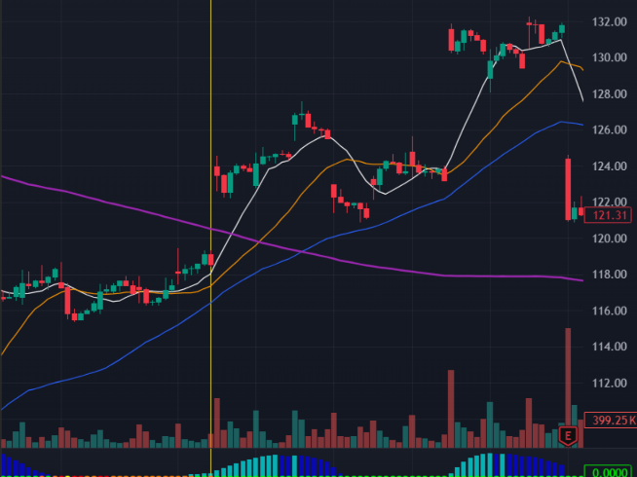
Stock reaches maximum velocity…
The pattern gives us a green light…
A pressure squeeze builds for days…
We enter the trade…
And then…
Boom!
A Stealth Mode Spike sends our trade flying!
Up 316% in just a matter of hours.
Moving on…
Here’s an example of the trade we took on Google literally one day before…
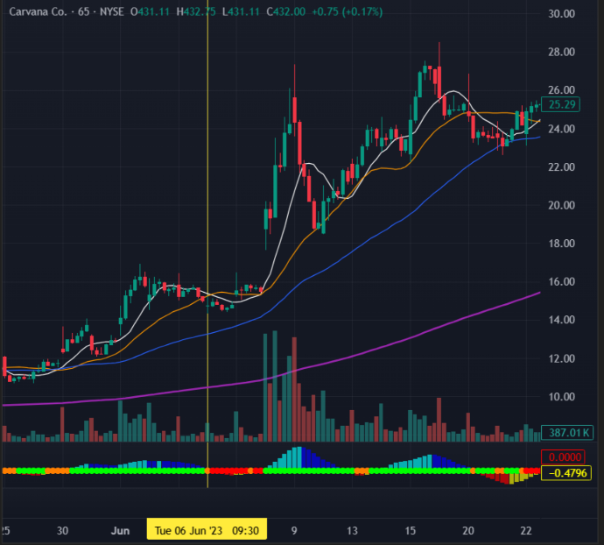
It followed the same familiar setup…
Velocity - check…
Pattern - check…
Squeeze - check…
We enter the trade…
A Stealth Mode Spike appears…
Our trade explodes higher…
And I close my position the same day for a gain of 100%.
To put that in perspective…
The S&P and Nasdaq returned around 20% last year…
It would take your average buy-and-hold investor an entire DECADE to see the same kind of profit.
Which shows you how groundbreaking tapping into just one top-performing Stealth Mode Spike can be…
But Imagine If You Could Do This Not Just Once…But Week In and Week Out
Don’t you think your life would take a turn for the better?
Now, I am not saying we will hit these massive wins every week.
We are swinging for the fences here and sometimes we’ll strike out.
After all, every trading system has down weeks.
But this strategy is about targeting those life-changing home runs.
Usually, I recommend 4-5 trades a day…
And we are winning on a majority of them.
Incredibly, we average a big triple EVERY SINGLE WEEK.
And on occasion, we hit those truly massive home runs like you’ve seen today...

Which can more than make up for the trades that don’t go our way...
And help you achieve greater financial freedom in the process.

Believe me, life becomes a whole lot more exciting once you crack the code to trading.
And the true beauty of this strategy is that it works no matter what…
Even when a stock is heading down.
Here’s an example from June 30 last year…
That’s when a Stealth Mode Spike alerted me to Tesla…
For weeks this stock was rangebound – trading sideways and going nowhere.
For most traders, it’s about as exciting as watching paint dry.
But as you’re about to see, even in quiet times pressure can come out of nowhere…
And this time, it would come to the downside…
In other words, the Stealth Mode Spike told me selling pressure was about to send Tesla stock falling.
So I entered a put trade…
And just 24 hours later…
Boom!
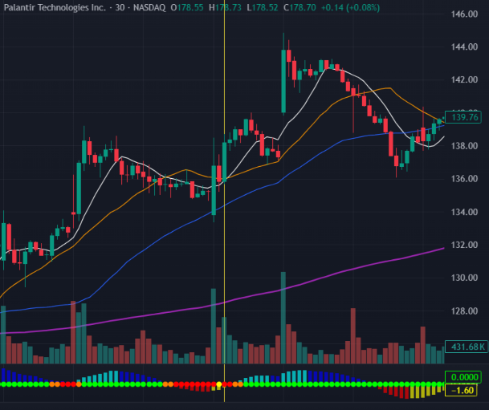
My trade surged 324%.
And just look at that chart – it’s a thing of beauty.
Every $1,000 invested, we get back over $4,200.
And we did it…in just 1 day.
In short…
You wait for one signal…
Place one simple trade…
And potentially walk away with thousands of dollars in profit.
For years, tapping into this market phenomenon has been the single greatest edge the hedge funds, banks, and trading desks had over the regular trader.
But all that changes today.
I Am Putting My System in the Hands of Regular Americans
As I mentioned before, my name is Nate Bear.
I’m famous in the trading world for 3 reasons...
First, starting from scratch, without a single dollar of outside investment, I turned a $37,000 trading account into almost $3 million in just 4 years…
You can see verified, third-party proof of my returns on your screen right now.
Second, I did it with no formal training in finance or trading…
Without any experience in the markets…
Purely self-taught…
With my own money on the line in every trade I took.
And third, I’ve made it my mission to help regular Americans achieve the same financial success through trading.
I’ll share the results from my exclusive circle of students in just a moment…
But here’s the thing... even though I achieved amazing success in my own life…
Recently, I decided to create a strategy for the everyday trader…
One that turns market chaos into profits…
There was just one requirement...
It needed to be simple.
So simple, their lives could flourish.
No more midnight headaches…
No more nail-biting ticker watching…
You just spot the signal, place the trade, and BOOM… profits follow.
The result?
Stealth Mode Spikes.
The Biggest Discovery of My 20-Year Career
With my system, you’ll have the chance to catch moves like…
422 % on SPXW in less than a day…
(Chart)
420% on AVGO in less than a day…
(Chart)…
368% on CNVA in one day…
(Chart)
324% on Tesla in one day…
(Chart)
Or any one of my top-performing recommendations I’ve shown you today.
In fact, since I revealed how this system works to my followers, my inbox has been flooded with ecstatic messages about some of our best trades…
Like Phil who said…
“Nate, thanks for… Carvana Lotto. Took 450% in hours. Happy days.”
Or Camy, who wrote in…
“My Nvidia entry was on 3/21, bought 2 $1,050 calls at $5.47 and $1,000 call at $10.65 and sold yesterday, 3/25 at $23.55…Huge win.”
Folks, that’s an amazing 350% return in 4 days!
And here’s a recent testimonial from Pamela, who said…
“Bought to open 4/25 Netflix 1050 for $3.01, sold to close today at 11.15 for 270% profit.”
She more than tripled her money in a single day!
And this Netflix trade wasn’t a back-tested trade or some kind of simulation…
Pamela was following my step-by-step instructions as I was sending them out LIVE… in real time… starting precisely at 10:39 am on April 21…
That’s when a Stealth Mode Spike alerted me to the opportunity unfolding in Netflix.
For 99% of traders, NOTHING would have even hinted at the fireworks about to erupt...
No earnings reports…
No shareholder meetings…
No surprise announcements…
Nothing like that…
Nothing other than the biggest anomaly in the markets, that is... a Stealth Mode Spike.
For several days, I watched as a squeeze formed – as pressure built up, then coiled back like a spring… ready to explode.
Then, right here…
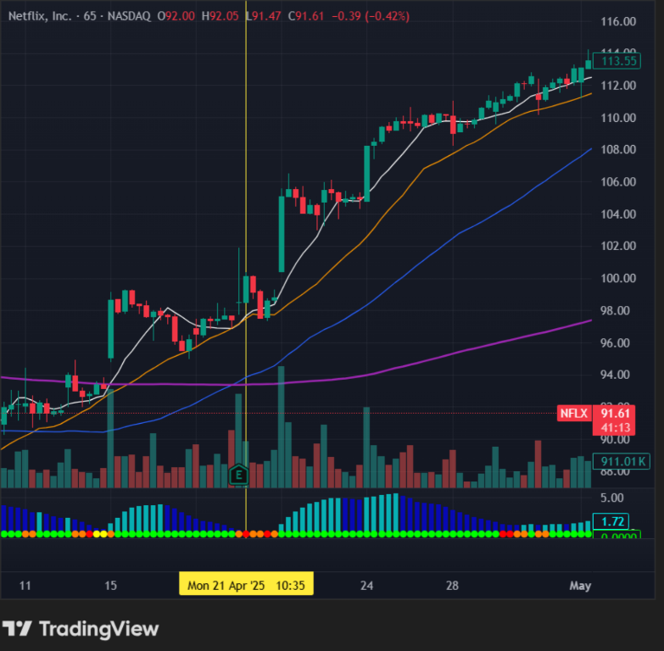
I sent out an alert to all my followers and told them “Get ready”…
Pressure spiked, the move took off, and we were up over 200% in just 24 hours!
That’s enough to turn every $1,000 into more than $3,000 in a single day.
And no, results like these aren’t a fluke… they aren’t an accident… not a coincidence…
In my hand are a stack of pages from countless followers who’ve achieved even greater results…
Like this quick note from Tom:
“HIMS win: bought 4 at .50 sold 3 at 5.85…”
A 1,070% win in just 24 hours!
Then there’s this one from Trader Craig…
“HIMS In at .28 out at 3.16 $4947 profit”
Or how about this amazing message from Steve:
“Good morning, not to brag but because of Nate I was able to hit my first ever 1,000% gain while on the golf course yesterday.”
Just imagine being in their shoes…
And remember…
These results came from people just like you…
Trading through up markets, down markets, sideways markets…
So, while over 90% of regular investors lose money in the markets.
My followers are seeing numbers that blow Wall Street money managers out of the water.
That’s the power of getting into massive stock moves early, while they’re still in stealth mode.
Now listen…
We Are in the Pre-Dawn of a Market Rampage
A market that’s more volatile than at any point I’ve been doing this…
And I’m not the only one who sees it…
Whether it’s The New York Times…
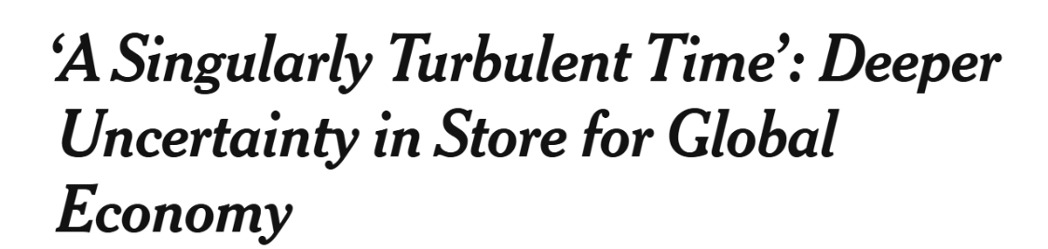
Globe and Mail…
CNBC…
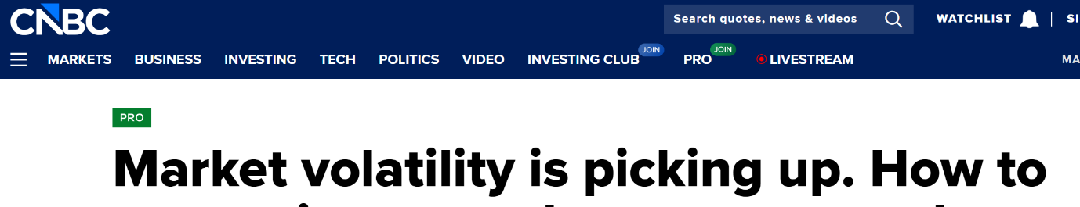
Everyone is sounding alarm bells because volatility is here to stay.
There’s no stopping it…
There’s no escaping it…
It’s time to adapt.
And according to my research, the next 7 days could unleash more explosive moves than ever before…
None more so than the one set to take place tomorrow at 11 a.m. Eastern.
And remember…
Since a Stealth Mode Spike can forecast explosive moves ahead of time, the uncertainty that comes with trading in a volatile market could be a distant memory.
I know it sounds crazy, but just take a look at what happened on August 2, 2024…
That’s when a Stealth Mode Spike alerted me to Lumen Technologies…
Again, this trade followed a predictable pattern...
A squeeze formed on the stock…
Pressure coiled up like a spring…
And that told me it was about to spike higher at ANY moment.
So I send out an alert to my followers…
And proceed to enter the trade myself.
But this time, we’re in for a massive shock…
Out of nowhere, all hell breaks loose.
The Dow drops 1,000 points…
The Nasdaq’s down 3.5%...
The S&P posts its worst day in years.

Household names like Google, Tesla, and Amazon tumbled over 4%...
Even tech giants like Nvidia fell over 15% in one trading session.
It was so bad, University of Michigan Professor Justin Wolfers called it “The Great Recession of August 5.”
My Lumen Technologies trade went against us for more than a day…
But see, that’s the true beauty of tapping into a Stealth Mode Spike…
A trade can go against you for one, two, or even three days…
And you’ll still come out profitable.
Which is exactly what happened here…
Because a handful of days later, I closed out the trade for a solid 224% win.
That’s right – we more than tripled our money through one of the craziest markets in years.
And had you been able to take action on Lumen Technologies…
You could have turned every $1,000 into more than $3,250.
Now of course, there are no guarantees in the markets…
And certainly none when it comes to trading…
Especially trading options, where sometimes the losses can happen as quickly as the gains…
But just imagine how exciting it would be to capture even one of these opportunities.
And not to sound like a parrot here, but I’ll say this a thousand times…
Because I’ve looked at thousands of stocks…
Studied thousands more chart patterns…
And the power of the Stealth Mode Spike is simply undeniable…

No matter how big a company is…
What sector it trades in…
Or how much money it makes…
A Stealth Mode Spike forecasts exactly when a stock is in position to explode higher.
Let me show you how I did it last June with CoreWeave…
Now, going into this trade, most indicators would have told you to avoid this stock…
Its price had dropped over 16%...
Seeking Alpha called it “a time bomb, avoid at all costs”…
Even Motley Fool said to “stay away from CoreWeave stock.”
But when I spotted a Stealth Mode Spike on my trading terminal at precisely 9:30 a.m. on Monday, June 16…
It told me one thing.
Under the radar, pressure was building for a massive explosion…
I didn’t flinch.
I entered the trade, right here…
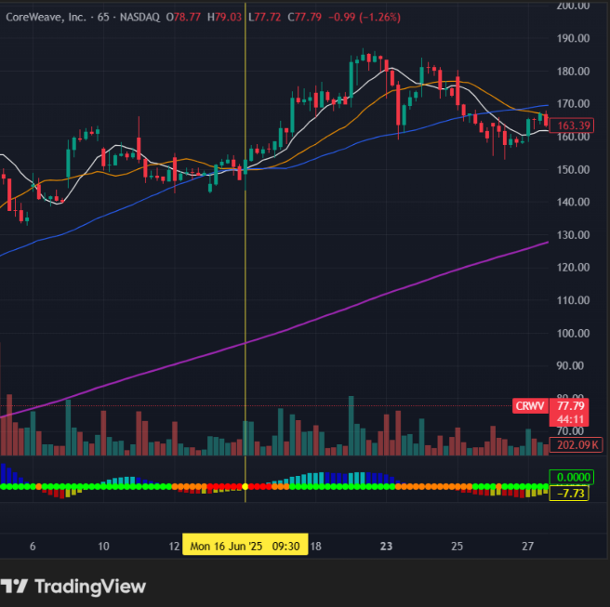
And just 4 days later…
The trade skyrocketed!
Up 254%!
Which means this one trade alone was enough to turn $1,000 into $3,540 without hesitation.

It’s that big.
And I’m not the only one excited about this trading breakthrough…
A JPMorgan Study Proves the Power of This Strategy
Consider this...
JPMorgan is arguably the most powerful financial firm in the world…
They manage $4.6 trillion in assets…
Equivalent to 20% of America’s GDP.
They employ hundreds of Ph.D.s…
Process as many as 29 billion trades in a single day…
Their supercomputers rival anything NASA uses…
And they just broke their own record for the best year ever…
Bringing in $57 billion in profit last year alone.
Bottom line: their market intelligence is unmatched.
So when they hire 2 analysts to discover a new trading edge…
One, a Stanford Ph.D. economist…
The other, a world-renowned Ph.D. physicist who’s been called the “Nostradamus of Wall Street”…
It’s worth paying attention.
And what they found confirmed what I’ve been saying for years…
Tapping into Stealth Mode Spikes is one of the ONLY ways to beat the markets in chaos times.
But while they keep their strategy locked behind their iron curtain…
I am the only person who can tell you everything you need to know to get started today.
Because when you follow the same strategy I use to tap into Stealth Mode Spikes…
You Can Target
The Fastest Wins of Your Life
I’m talking gains of 100% or more in a matter of hours… or even minutes…
With payouts wired instantly to your bank account.
Take a look…
(Chart)
On February 13, a Stealth Mode Spike alerts me to FSLY at precisely 9:44 a.m.…
I enter the trade…
Just a few minutes later…
Bang!
It explodes higher…
I close the trade less that 90 minutes later for a 316% return...
I quadruple my money in a little over an hour.
Or how about this lightning win on AVGO…
(Chart)
Stealth Mode Spike appears at 1:46 p.m.…
And 20 minutes later, I’m out for a 420% win.
Every $1,000 transforms into over $5,000.
And here’s a similar setup on CRCL…
I buy at 11 a.m.…
I sell at 1 p.m.…
I’m up 133% in 2 hours.
Bing bang boom.
You get in, you get out, you get on with your life.
THAT’S the power of a Stealth Mode Spike in action.
And frankly, in the 20 years I’ve been doing this…
I don’t know of any other strategy with the potential to make you so much money, in so little time.
Just Imagine…Entering Trades With Virtually 100% Confidence
Instead of spending hours doing your due diligence…
Doing your research…
And seeing trades go against you big time…
You’ll now have the knowledge to time your entries and exits with laser-like precision.
Now remember, when it comes to investing, there is no crystal ball.
But trading on emotion or chasing the next hot stock is where people blow their accounts.
Meanwhile, we are sticking to a complete strategy that takes that kind of stress out of the equation.
And while there will be losses, they are factored into our strategy.
Which means you’re no longer left wondering...
“Why did that stock explode?”
“Why did price reverse right after I entered?”
“Why does the market feel faster than it used to?”
Instead, you’ll be able to participate in the same moves that have been making Wall Street rich for years.
Like Lyle, who raked in a massive 1,100% return after he started following my system…
Here’s what he wrote in January of ‘24:
“This is a fantastic room to learn in. I cannot say enough about Nate… [you] have really helped me grow as a trader. I have been a long-term investor but just started trading this past September… Still feel as though I am just learning but am now up 1,103%...”
And while there’s no guarantee you’ll see a 1,100% return like Lyle…
After all, results like this are rare…
The fact is, it HAS happened…
Which means there’s a chance it could happen to you too…
As early as tomorrow, at 11 a.m. Eastern, when my system is telling me the next explosive move is set to take off.
And remember every single top-performing trade I’ve shown you today…
Like my 1,400% return on HIMS…
324% on Tesla…
1,130% on B. Riley Financial…
254% on CoreWeave…
232% on Netflix…
And every one of my 185 triple-digit winners I’ve made in the last 2 years…
Wasn’t made in isolation…
I was sending out alerts… LIVE… in real time…
To my exclusive group of followers…
And that’s important…
Because my system has signaled a massive move is on the way for tomorrow at 11 a.m. Eastern…
A squeeze on one stock I’m watching has been building for days…
Take a look at the chart…
(Chart)
Pressure has been coiled like a spring and it’s ready for takeoff.
The Countdown Has Begun
Our next triple-digit winner could be hours away…
Which means we don’t have a moment to waste…
To help you get started on the right foot and claim your first big win, I’d like to invite you to join my flagship trading research service, Daily Profits Live…

This is the ONLY place where I reveal the strategy I use to tap into Stealth Mode Spikes.
And the cornerstone of this service is my live trading room.
Here’s how it works...
Every day the market is open, you’ll get to join me inside an interactive, private trading room, where I share my screen, my charts, my indicators…
And let you watch over my shoulder as I use my system to spot, isolate, and trade Stealth Mode Spikes…
There’ll be daily mentoring…
I’ll walk you through the latest market action…
Discuss opportunities as we’re seeing them in real time…
You’ll get insights from a millionaire trader like you won’t ever hear on CNBC, Bloomberg or Fox Business…
And when it’s time to enter a trade, I’ll take you by the hand and give you the step-by-step instructions you need to place a trade…
You can expect at least 2-3 trades per day.
Many trading services out there may deliver 2-3 recommendations per month...
But in Daily Profits Live, we’re always looking for setups.
And here’s the best part…
How big or small you go is completely up to you…
If you prefer to buy one contract, buy one contract…
And if you want to go big, go big…
You can put on trades in the tens of thousands if that’s what you feel like doing…
Though as with any system – you shouldn’t invest any more than you can afford to lose.
But I can promise you this, you won’t need more than a hundred dollars to make your first trade.
Then, when my system says it’s time to close the trade…
I’ll send out a quick alert telling you to sell your position.
It’s really that straightforward.
You simply go to your brokerage account and hit “buy” when I recommend a trade…
And hit “sell” when it’s time to sell…
And you could be on your way to seeing the fastest results of your life.
I send out these buy and sell alerts over email and mobile app, PLUS I announce them in our live trade room.
And because it’s live, you’ll be able to talk with me and the other members using our real-time chat feature.
See, with Daily Profits Live, I’m out to build a community…
And that’s why every day inside the chat you’ll be able to share trade ideas all-day, discuss the markets, or just have some friendly conversations with the other members in the community.
That engagement and interaction and members learning from one another are the most valuable parts of community.
Many of my members agree – here’s what one recently had to say:
“We get WAY more live time than the schedule… the education and community are WAY more valuable than the cost of this service.” – Nola R.
And while I can’t offer personalized financial advice, you will get all your market questions answered…
From the very basic to the most advanced…
But there’s more…
If we go for a long stretch of time and don’t see a Stealth Mode Spike setting up…
We’ll dive into my other strategies, like Lotto trades, or setups I use when the market is feeling a little slow…
This ensures we’re always in the action, no matter what the market gives us.
And many times these strategies can prove to be just as lucrative…
I’ve personally made a 562% gain on Twilio in one day…
A 125% win on MongoDB in 4 days…
And a 166% return on Atlassian in just a handful of hours.
And don’t worry, you won’t have to spend hours glued to your screen because my system does the heavy lifting for you…
It helps spot the pattern, the squeeze, the entire setup…
All that’s left for you to do is simply decide whether you want to place the trade…
I’ll even give you a 60-second head start before placing my own trade.
See, this trading room is a living testament to my approach to trading – and that is… do the least.
There are no shenanigans…
I don’t throw a bunch of indicators and charts at you…
What do I do instead?
I watch the markets…
And when an opportunity appears – I take action.
Because at the end of the day, those are the only 2 things that move the needle.
And for many of my members, the results have been rapid and pretty dramatic…
Like Quintone, who wrote to tell me about the $5,100 profit he made on the SPY in just 3 hours:
“Thank you, Nate! At 10:51 this morning you said a good point to get a bounce in the SPY, I went in with $685 strike cost $4.2, sold at 1:51 p.m. – 75% and $5,100 profit. Thank you.”
Or Mac, who’s hit his profit target in 19 out of the 24 months he’s been with me:
“This month is my 2-year anniversary with DPL! In the last 24 months I have had only 5 months when I was below my dollar target, however my monthly average is 39% over my monthly goal. The training is unprecedented and has taught me how to trade… Thank you!”
Or how about this email I received from Tyrade, who grew his IRA by almost 50% in just a handful of months:
“Ever since I started to employ things learned in Daily Profits Live, and some trades recommended in other services, I’ve increased my IRA by 45% overall (into 6-figure gains) since attending… at the end of April 2024… Nate rocks.”
Those are just a few of our best notes.
And I’d like to make something clear to everyone watching…
None of these people were professional traders like me…
They were everyday folks, from all walks of life…
And thanks to my guidance, they were finally able to achieve trading success.
And once you experience the results yourself…
I Have No Doubt You’ll Have the Opportunity to Be My Next Success Story
And because I’m so committed to helping you achieve your trading goals…
I’d like to also give you a very special bonus…
Unrestricted access to my 2-hour Video Masterclass that explains everything around Stealth Mode Spikes.
I call it Profit Like a MAIN STREET Millionaire.
I recorded this very recently, and it’s designed to be your complete, one-stop shop class…
I cover each of my system’s 3 components:
How to spot the trend…
How to identify the pattern…
What we look for in a squeeze…

Pitfalls to watch out for…
Entrance criteria…
Exit criteria…
Plus so much more…
And it’s completely on demand – which means you can access it whenever you like on our secure, members-only website…
The value of this Video Masterclass alone is $500.
But don’t worry, you won’t have to pay anywhere NEAR that price today…
Why?
Because it’s essential.
Because to truly understand how my system works you need to watch this class.
But that’s not all…
I also want to send you an exclusive bonus called Options Made Easy.
See, tapping into a Stealth Mode Spike does involve options…
And I understand there are some people who know very little about options or how to trade them…
Options Made Easy is for you…
This is a one-hour video that I put together with my friend and fellow trader Nate G.
If you have no idea what options are, start here…
You’re going to learn about puts and calls…
You’re going to learn why so many profitable traders love to use options…
PLUS how options drive the entire stock market.
This is your all-in-one crash course on options you’ve wished you always had…
And I’m still not done…
Because when you join Daily Profits Live, you’ll also receive access to The Bootcamp Sessions…
This 10-part video series was recently recorded by two of my top students-turned instructors.
This special series is designed for traders from across the spectrum – from beginner all the way to advanced…
It will show you the basics of the stock market…
Dive into technical analysis and reveal how charting and candlesticks work…
Give you a breakdown of the different trading platforms…
They’ll show you real-time applications…
What’s the best course of action when things are quiet?
How do you trade around an earnings situation?
How do you manage risk?
Or your own psychology?
How much capital should you allocate for each trade?
In short, The Bootcamp Sessions are designed to grow you as a trader…
So that by the end of the 10-Part Video Series you’ll have the confidence to make smarter trading decisions in any market…
And if you’re wondering why I’ve chosen two of my top students?
Because in the 20+ years I’ve been doing this…
I haven’t found anyone more methodical than they are…
Not only are they millionaire traders in their own right…
They’ll leave no stone unturned to ensure members get the best possible outcomes.

Believe me, I’m dedicating everything that I have, every hour of my day, to make sure all my members have a chance to succeed in 2026.
So to Recap for Everyone Watching…
Once you decide to become a member of Daily Profits Live today, here’s what you receive…
Complete access to my live daily trading room…
With at least one fully vetted trade idea per day.
And these are the types of trades that have already delivered wins like 1,131% on RILY…
(Chart)
1,140% on HIMS…
(Chart)
422% on SPXW…
(Chart)
And 420% on AVGO…
(Chart)
You’ll receive total access to our members-only chat room, where you can join in the fun, ask questions, and share experiences every day with other members.
You’ll get unrestricted access to my 2-hour video Masterclass Profit Like A MAIN STREET Millionaire.
This will give you the complete breakdown of the 3-part system I use to tap into Stealth Mode Spikes.
You’ll receive my options 101 video – Options Made Easy.
You’ll get the 10-part video series The Bootcamp Sessions…
One of the best resources I know to grow yourself as a trader.
Everything I’ve listed can be accessed through our Daily Profits Live members-only website, including past recordings of our daily trading sessions.

Now, you’re probably asking what this is going to cost…
It should come as no surprise that this isn’t cheap – the retail price for Daily Profits Live is $5,000.
For 12 months of access.
Which is really fair…
After all, you’ve seen all the time, money and resources that went into creating a system that spots massive stock moves days in advance…
You’ve seen the amazing trading room and amazing community I’ve brought together to help you achieve your financial goals…
And you’ve seen how it’s possible in some instances to turn even a $1,000 stake into more than $10,000 in just a couple of days using my strategy…
More than covering the cost of this service.
Just look at what one of my members, Orovena, had to say:
“Hi, for those… members who are contemplating whether or not to join Daily Profits Live… I can share with you just Day 1 already paid for my… subscription 10X! Nate is a really great teacher… Good luck, everyone!”
But here’s the deal, folks…
Right now, I am on a mission.
I want to make 2026 your most profitable year ever…
Seeing the chance of at least 100% gains, week in… week out… faster than you ever thought possible… without being glued to your screen all day.
And because you’re still watching right now…
It shows me you’re serious about your financial future…

That’s why I’m prepared to extend an amazing deal and hand you a 60% discount!
Slashing over $3,000 off the retail price!
You pay just $1,997.
And trust me when I say this is an amazing deal…
The price of Daily Profits Live is only going one way… and it’s not down.
This isn’t one of those Christmas programs where you’re going to get a Christmas deal…
Because by the time Christmas rolls around, the retail price will be closer to $9,000 or $10,000.

But you must act within the next 30 minutes to take advantage of this amazing deal.
Right below this video you should see a button that says “Find out more.”
Go ahead and press that button, and it will take you to the order form.
Once there, you’ll be able to look over the offer one more time, and then take advantage of this special $1,997 price.
And remember, there’s a lot of urgency with today’s opportunity…
You’ve seen the 316% return I made on Fastly in less than 90 minutes…
And the 420% gain on AVGO in 20 minutes…
If you hesitate as little as 10 minutes, you miss out completely…
Which means timing is everything…
And you have to be in position BEFORE this move I’m watching explodes higher…
It could be an hour away…
Or it could be tomorrow at 11 a.m. Eastern…
Neither of those options are a whole lot of time…
So I urge you to act quickly.
But just so there’s no doubt in your mind…
I’m going to put my money where my mouth is and hand you an iron-clad guarantee…
My Double Your Money 52 Times Guarantee
You, see I want people who want to be here, and who want to trade.
And that’s why this performance guarantee starts from the moment you join.
Here’s how it works…
If I don’t give you the opportunity to see at least one triple-digit-winner per week, for 52 weeks, I’ll give you another year of Daily Profits Live completely free.
Let me say that again…
If you don’t see the chance to at least double one of your trades per week, for every single week of the year…
Email me… call me… and I will rush you another year of Daily Profits Live on the house…
Which means I’ll work tirelessly for you for another year, completely free.
I can’t think of anything more fair than that.
Please keep in mind, because of this amazing low price and my performance guarantee, I’m unable to offer any refunds if you change your mind…
But with everything you receive today…
(Shot of everything they receive)
I have no doubt you’ll look back on this day and congratulate yourself for taking this step.
However, there is one catch…
Because I’m giving individual attention to every one of my students, every single day in the trading room…
I can’t let the group get too big.
Which means I’m forced to limit seats to just 100 spots today.
You’ve already seen how the Stealth Mode Spike sets up for us every single day…
(Show a rolling collage of 5 or 6 charts here)
Handing us MULTIPLE opportunities to target double-your-money gains MULTIPLE times per week…
That’s why time is of the essence, and I expect those 100 spots to fill up within the next 12 hours.
All that’s left to do is click the button below this video, and you’ll be taken to a page where you can fill out your personal details…
Take advantage of my special offer and join Daily Profits Live.
Or if you prefer to speak someone directly, please call our U.S. based VIP Service Squad at 888.215.5311 or 410.864.3083.
Best of luck, and I’ll see you on the other side.

February 2026

jpm-momentum-strategies-2015-04-15-1681565.pdf “Our view is that Momentum strategies do provide significant risk premia, and a typical Momentum strategy can outperform a buy-and-hold position in traditional assets on a Sharpe ratio basis.”
Refining and Robust Backtesting of A Century of Profitable Industry Trends
https://wire.insiderfinance.io/trading-with-linda-raschke-mastering-short-term-trading-and-technical-analysis-9208c92ee8af?gi=9f0e89c9f1ff
Citi downgrades Hims & Hers stock citing GLP-1 launch risks By Investing.com
Tesla Earnings 71% Decline Signals Stock’s Very Low Fundamental Value
Tesla Stock Is Up 58% But Elon Musk's Return Could Change That
Tesla Earnings 71% Decline Signals Stock’s Very Low Fundamental Value
Retail Traders Are Driving These Abrupt Swings in Momentum Stocks - Bloomberg
Virtu, Optiver partner to challenge Citadel Securities in US options flow - report
Virtu, Optiver partner to challenge Citadel Securities in US options flow - report
Day Traders as ‘Dumb Money’? The Pros Are Now Paying Attention - WSJ
Retail Trading in Options and the Rise of the Big Three Wholesalers - BRYZGALOVA - 2023 - The Journal of Finance - Wiley Online Library
Everyday Traders Go From Fringe Players to Dominant Market Force - WSJ
Everyday Traders Go From Fringe Players to Dominant Market Force - WSJ
(4) Post | LinkedIn
90% Retail Investors Lose Money - Rediff.com Get Ahead
‘A Singularly Turbulent Time’: Deeper Uncertainty in Store for Global Economy - The New York Times
Prolonged volatility ahead for financial markets - The Globe and Mail
Market volatility is picking up. How to use option spreads to protect and maximize returns
https://www.cnbc.com/2024/08/04/stock-market-today-live-updates.html
Markets News, August 5, 2024: Major Indexes Record Their Biggest One-Day Losses in Nearly Two Years
The Great Recession of August 5, 2024 (with Justin Wolfers) - CAFE
CoreWeave Is A Time Bomb, Avoid At All Costs (NASDAQ:CRWV) | Seeking Alpha
1 Reason to Stay Away From CoreWeave Stock | The Motley Fool
3Q25 Earnings Presentation
J.P. Morgan Shines at Risk Awards
JPMorgan Breaks Its Own Profit Record for Best Year Ever With 18% Jump - Bloomberg
JPMorgan boosts Dimon’s pay to record $43mn
jpm-momentum-strategies-2015-04-15-1681565.pdf
Kolanovic, the ‘Nostradamus’ of Wall Street, fired after predicting stock market storm | Economy and Business | EL PAÍS English
AI Summary of the JP Morgan study from footnote 32: A J.P. Morgan report examined momentum strategies, including oscillators like RSI and MACD, across asset classes (equities, bonds, currencies, commodities) from 1972–2014. Diversified multi-asset strategies incorporating these achieved annualized excess returns of 5–12%, Sharpe ratios over 1, and reduced drawdowns compared to buy-and-hold benchmarks, with positive performance in rising markets and outperformance during corrections. For example, a multi-asset absolute momentum prototype yielded 8.5% annual returns with a 1.21 Sharpe (vs. lower for single assets). Quote: "Our view is that Momentum strategies do provide significant risk premia, and a typical Momentum strategy can outperform a buy-and-hold position in traditional assets on a Sharpe ratio basis."

